Efficacy of Fadenoperation associated to conventional surgery in the treatment of esotropia with distance-near incomitance

.
ABSTRACT

Aims: To evaluate the postoperative outcomes of posterior myopexy in terms of surgical success and stability at short, medium, and long-term follow-up
Study design: Retrospective observational study.
Place and Duration of Study: Ophthalmology Department, Regional Hospital of Kasserine, Tunisia; surgeries performed between 2019 and 2021, with follow-up ranging from 5 months to 2 years (mean: 1.2 years).
Methodology: We retrospectively reviewed the medical records of 20 patients with concomitant esotropia associated with distance-near incomitance and/or medial rectus muscle spasm who underwent posterior myopexy combined with conventional horizontal strabismus surgery. Pre- and postoperative deviations were measured using prism cover testing. Postoperative alignment was assessed at 3, 6, and 12 months of follow-up. Surgical success was defined as a residual deviation ≤ 10 prism diopters (PD). Stability was defined as a difference ≤ 6 PD in distance deviation between 1 and 12 months.
Results: Twenty patients were included (mean surgical age: 8.9 ± 2.1 years; mean follow-up: 1.2 ± 1.1 years), of whom 8 had early esotropia, 11 partially accommodative esotropia, and 1 acquired non-accommodative esotropia. Preoperatively, the mean deviations under full optical correction were 30.4 PD at distance, 37.2 PD at near, with a mean distance–near incomitance of 9 PD. All patients underwent bilateral posterior myopexy, performed as an isolated procedure in 3 cases and combined with horizontal muscle surgery in 17 cases. Postoperatively, the mean residual deviations were ≤ 7.5 PD at all follow-ups, and distance–near incomitance was nearly abolished. Surgical success (residual deviation and incomitance < 10 PD) was achieved in 95% of patients at 3 months and 85% at 12 months, with stable alignment in 19 of 20 cases. No significant intraoperative or postoperative complications were observed, and patients reported high aesthetic and psychological satisfaction
Conclusion: Posterior myopexy combined with conventional horizontal strabismus surgery appears to provide a high rate of surgical success and long-term angular stability in patients with concomitant esotropia associated with distance-near incomitance greater than 10 PD or medial rectus
.

Keywords: [Posterior myopexy; Fadenoperation; Cüppers’ suture procedure; Distance-near incomitance; Partially accommodative esotropia; Non-accommodative esotropia]

1. INTRODUCTION

The Fadenoperation, also referred to as posterior myopexy or Cüppers’ suture procedure, was first introduced in the 1960s by Cüppers (Cüppers, 1981). This technique, applied to a hyperkinetic rectus muscle, restrains its action by modifying the effective lever arm rather than altering muscle force (Scott, 1977). Unlike conventional strabismus procedures that primarily act on active or passive muscle forces, posterior myopexy produces a progressive limitation of motility within the operative field (von Noorden, 1976).
Its main indication is concomitant esotropia with variable deviation, particularly cases presenting with distance–near incomitance, where it is often combined with conventional surgery addressing the minimum distance deviation (Ing & Costenbader, 1976). However, reported outcomes are inconsistent, with a tendency for the effect on distance–near disparity to decrease over time (Kushner, 1999). These discrepancies may be related to the type of strabismus, the surgical technique used, or tissue remodeling processes at the myopexy site (Nishimura & Rosenbaum, 2002).
The purpose of the present study was therefore to evaluate the short-, medium-, and long-term effectiveness of posterior myopexy combined with conventional strabismus surgery in patients with partially accommodative or non-accommodative esotropia associated with distance–near incomitance.

2. material and methods
This is a retrospective study including 20 cases of esotropia surgically treated by a single surgeon. Medical records were reviewed at the Ophthalmology Department of the Regional Hospital of Kasserine over a two-year period, from 2019 to 2021.
Inclusion criteria
-Patients presenting with esotropia
Exclusion criteria
-Incomplete preoperative clinical or orthoptic assessment
-Postoperative follow-up less than three months
-Paralytic or incomitant strabismus
-Strabismus of anatomical origin (muscular and/or orbital)
-Microtropia
-Pure accommodative strabismus
-Incomplete medical records
All patients underwent a detailed medical history, comprehensive ophthalmological examination, preoperative and postoperative sensory and motor orthoptic evaluation. This assessment was completed in all cases by an intraoperative examination under deep general anesthesia.
Management included a medical component aimed at treating amblyopia and improving binocular function, and a surgical component targeting orthotropia.
Surgical procedure
All surgeries were performed under deep general anesthesia by the same surgeon.
1. Surgical equipment
All procedures were performed using an operating microscope. Absorbable sutures (Vicryl 6-0, 3/8 circle, double-armed with spatulated needle) were used for extraocular muscles. Posterior myopexy was performed using non-absorbable 4-0 suture, and conjunctival closure was performed with 10-0 suture.
2. Preoperative tests
2.1. Anesthesia sign
For unilateral or asymmetric bilateral surgery, the anesthesia sign was used to identify the eye to operate on(the eye showing the greatest deviation under deep general anesthesia).
Figure 1
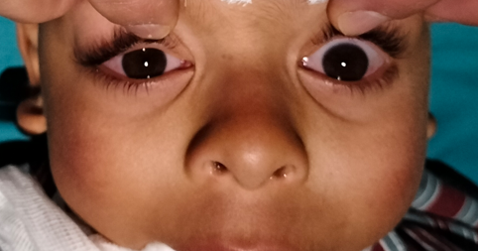

Figure 1 : Bilateral orthotropia observed under general anesthesia in a patient with manifest esotropia.
2.2. Forced duction test
Performed prior to conjunctival incision, this test assessed the mobility of the muscle and its capsulotenon system. It was particularly important in cases of consecutive or residual strabismus to detect conjunctivo-tenon adhesions from previous surgeries.
2.3. Muscle elongation test
Performed systematically, this test allowed evaluation of hypo- or hyper-elongation of the muscle. A hook was placed under the muscle, and movement was referenced to an instrument aligned with the pupillary center or the center-light reflex under the microscope.
3. Surgical protocols
Conventional surgery was performed to correct the minimum distance deviation. Depending on the angle, this consisted of unilateral or bilateral medial rectus recession; when bilateral recession was insufficient, lateral rectus plication was added. In amblyopic cases, a unilateral medial rectus recession combined with lateral rectus plication was performed on the amblyopic eye.
Posterior myopexy (Fadenoperation) was performed using Quéré’s muscle slinging technique with a non-absorbable 5-0 Ethilon suture. Two symmetric scleral passes were made 11.5–14 mm posterior to the medial rectus insertion, near the Tenon’s pulley, beginning 2 mm lateral to the muscle edge. The needle was passed at mid-scleral thickness over 4–5 mm, between the vortex vein and the course of the long posterior ciliary artery. The sling was then passed beneath and above the muscle and tied over its belly. If necessary, medial rectus recession was performed after sling placement, followed by tightening of the suture (figure 2).

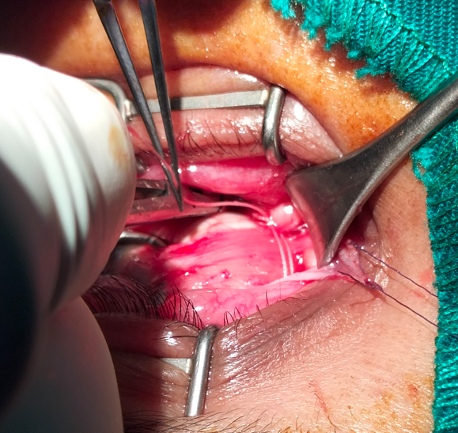

Figure 2: Posterior Myopexy according to Castiella and Polenghi

4-Postoperative evaluation
The surgical success rate was defined as the percentage of patients with a postoperative distance deviation and distance–near incomitance of less than 10 prism diopters (PD)
(Figure 3).


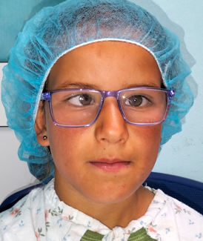
Figure 3. Early esotropia associated with angle variability.
Surgical protocol: bilateral medial rectus recession combined with bilateral Fadenoperation. a: preoperative appearance; b: postoperative day 1; c: 1-year postoperative appearance
c
b
a
Data analysis
Data were entered and analyzed using IBM© SPSS Statistics version 21. Simple and relative frequencies (%) were calculated for qualitative variables. Means, medians, standard deviations, and ranges (minimum–maximum) were calculated for quantitative variables. Associations between qualitative variables were assessed using the χ² test. For quantitative variables, Pearson correlation coefficient was used for normally distributed data and Spearman’s test for non-normal data, ranging from -1 (perfect negative correlation) to +1 (perfect positive correlation). Associations between quantitative and qualitative variables were analyzed using one-way ANOVA (F-test).

3. results

Among the 20 patients, 8 presented with early esotropia (ET), 11 with partially accommodative esotropia (PAET), and 1 with acquired non-accommodative esotropia (ANAET). The preoperative examination of these children, performed under full optical correction, revealed a mean minimum distance deviation of 30.4 PD, a mean minimum near deviation of 37.2 PD, and a mean distance-near incomitance of 9 PD. The mean age at surgery was 8.9 years. All patients were followed for a minimum period of 6 months. The mean follow-up duration was 1.2 years (Table 1).

Table 1: Preoperative clinical data and strabismic angles under full optical correction
 | Value | Unit
Mean Preoperative Angles with FC
-Distance | 30.4 (±3.4) | PD
-Near | 37.2 (±5.8) | PD
-Distance-Near Incomitance | 9 (±3.1) | PD
Mean Surgical Age | 8.9 (±2.1) | years
Mean Follow-up Duration | 1.2 (±1.1) | years
FC: Full Correction; PD: Prism Diopters.
Surgical Protocol:
-Posterior myopexy (retroequatorial myopexy) was performed to correct the distance-near incomitance concurrently with conventional horizontal muscle surgery targeting the minimum distance angle.
-Posterior myopexy was performed as an isolated procedure in 3 cases for deviation angles ranging from 15 to 30 PD (mean 21.6 PD).
-Posterior myopexy combined with horizontal muscle surgery was performed in 17 cases for deviation angles ranging from 20 to 70 PD (mean 42.8 PD).
-Bilateral posterior myopexy was performed in all cases.

Table 2: Surgical protocol according to the clinical type of esotropia (ET)
Surgical Procedure | Early-ET (n=8) | PAET (n=11) | ANAET (n=1)
-Isolated posterior myopexy | 1 | 3 | 0
-Posterior myopexy  + horizontal surgery | 7 | 8 | 1
Postoperatively, the mean distance angle was 6.75 PD (p < 0.001) at 3 months, 6.2 PD at 6 months, and 7.1 PD at 1 year. The mean near angle was 6.7 PD at 3 months, 7.2 PD at 6 months, and 7.1 PD (p < 0.05) at 1 year.The mean distance-near incomitance was nearly eliminated: 0 PD at 3 months, 1 PD at 6 months, and 0.3 PD at 1 year (Figure 3).

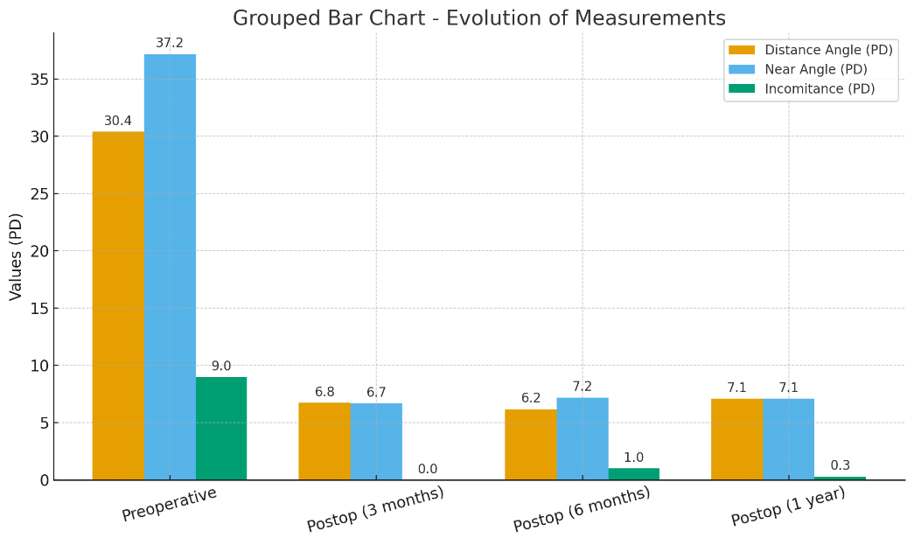
Figure 4. Mean preoperative and postoperative (3, 6, and 12 months) prism diopter (PD) values for the distance deviation, near deviation, and distance-near incomitance.

The success rate, defined as the percentage of patients with a postoperative distance deviation and a distance-near incomitance each less than 10 PD, was 95% at 3 months, 85% at 6 months, and 85% at 1 year, respectively (Figure 3). A satisfactory ocular alignment (deviation ≤ 10 PD for both distance and near) was achieved with a single surgical procedure in 19 patients (95%).
A second surgical intervention was required in one case of acquired non-accommodative esotropia, which recurred 6 months postoperatively. The initial deviation in this case was 45 PD. The reoperation consisted of a bilateral lateral rectus resection for a deviation of 35 PD, which yielded a good surgical outcome.
Aesthetic outcomes:
All patients, including those with a residual angle, reported a high degree of satisfaction.
Psychological outcomes:
A marked improvement was observed in the majority of our patients, characterized by easier social interaction, smiling, the disappearance of feelings of inferiority, and improved behavior and academic performance.
Postoperative diplopia:
No cases of postoperative diplopia were reported.
Complications:
No serious intraoperative complications were observed. Specifically, there were no cases of scleral perforation (even in highly myopic eyes), muscle injury, or significant hemorrhage. No cases of postoperative conjunctival granuloma were observed.

DISCUSSION

The management of esotropia with distance-near incomitance is not yet standardized. Conventional surgery based solely on the distance deviation often leads to undercorrection at near (Oguz et al., 1999; Gharabaghi & Zanjani, 2006). Several surgical approaches have been proposed to address this issue, including augmented medial rectus recession, additional oblique muscle reinsertion, or posterior myopexy. These different procedures have been reported with highly variable success rates (Oguz et al., 1999; De Decker, 1981).
When posterior myopexy is combined with conventional surgery, it mainly acts by restraining muscle action through scleral anchoring behind the arc of contact, thereby reducing incomitance related to medial rectus overaction in its field of action (Bérard et al., 1976; Quéré et al., 1977; Clark et al., 1999). However, Fadenoperation may exert a minor effect on the distance angle, while conventional surgery can also influence distance–near incomitance (Klainguti et al., 1991; Steffen et al., 1998). This overlap makes it difficult to distinguish the individual contribution of each procedure to the final outcome.
Our patients presented with partially accommodative and non-accommodative esotropia associated with distance–near incomitance. This incomitance may result from excessive accommodative convergence in patients with a high AC/A ratio or from non-accommodative convergence spasm with a normal AC/A ratio (Steffen et al., 1998; Stärk et al., 1999). A near deviation greater than 10 PD may become persistent and lead to loss of binocular potential, with an increased risk of suppression, anomalous retinal correspondence, and amblyopia (Leitsch et al., 1990).
Treatment involves full optical correction to address the distance and near deviation as much as possible. The minimum distance angle is managed by conventional surgery, either medial rectus recession or lateral rectus plication (De Decker, 1981; Oguz et al., 1999). Excessive accommodative convergence can be treated either with posterior myopexy or with a near addition of approximately +2.50 to +3.00 D if the AC/A ratio is elevated. A +3.00 D addition to full optical correction is more appropriate in purely accommodative esotropia with convergence excess, which does not require conventional surgery for the distance deviation unlike in our cohort. In contrast, when conventional surgery is indicated for distance deviation, posterior myopexy may be added to simultaneously address accommodative convergence excess (Steffen et al., 1998; Klainguti et al., 1998; Akar et al., 2013).
In our series, consecutive exotropia occurred in 5% of cases, a result comparable to reports in the international literature despite our relatively limited sample size (Happe & Suleiman, 1999; Paliaga & Braga, 1989). This early-onset persistent exotropia likely resulted from surgical overcorrection and required reoperation, occasionally involving removal of the Cüppers’ suture (Happe & Suleiman, 1999). This condition should be differentiated from transient postoperative exotropia, more frequently observed, which is due to hysteresis and transient inhibition of muscles subjected to posterior fixation. The latter tends to regress as muscle function normalizes and may ultimately prove beneficial in the long term (Happe & Suleiman, 1999; Steffen et al., 1998).
The effectiveness of posterior myopexy combined with conventional surgery is known to be unpredictable and to vary over time. Gharabaghi and Zanjani reported satisfactory results in 78% of cases at 10 months (Gharabaghi & Zanjani, 2006). Oguz et al. observed 86% success at 2 years (Oguz et al., 1999). Klainguti et al. reported a 62% success rate at 6 years (Klainguti et al., 1991). In De Decker’s series, 76–86% of patients with convergence excess maintained satisfactory near ocular alignment for 2–3 years postoperatively (De Decker, 1981). Happe and Suleiman described anterior migration of the muscle sclera scar and concluded that posterior myopexy loses effectiveness over time (Happe & Suleiman, 1999). Similarly, Paliaga and Braga reported a progressive decline in long-term efficacy (Paliaga & Braga, 1989).
In our series, the mean postoperative distance deviation remained below 10 PD at 3, 6, and 12 months, with a significant reduction compared to preoperative values. Postoperative distance–near incomitance increased slightly over time but remained below 10 PD at all follow-ups.
Using the predefined surgical success criterion (distance deviation and distance–near incomitance each < 10 PD), our success rates of 95% at 3 months and 85% at 12 months are comparable with published data (Klainguti et al., 1991; Akar et al., 2013). The progressive decline in surgical success over time likely reflects the natural course of esotropia, constant stress exerted by medial rectus contraction on fixation sutures, and tissue remodeling after surgery (Klainguti et al., 1991; Happe & Suleiman, 1999). Furthermore, the force exerted by the muscle on posterior fixation sutures beyond the normal arc of contact can be resolved into a decreasing rotational component and an increasing tearing component as the globe rotates toward the operated muscle. This tearing force may disrupt scleral fixation or cause its progressive anterior migration, thereby diminishing the long-term effectiveness of posterior myopexy (Bérard et al., 1976; Quéré et al., 1977; Clark et al., 1999; Klainguti et al., 1991).

4. Conclusion

Posterior myopexy combined with conventional horizontal strabismus surgery appears to provide a high rate of surgical success and long-term angular stability in patients with concomitant esotropia associated with distance–near incomitance greater than 10 prism diopters or medial rectus spasm. Our findings confirm that this combined approach not only corrects the primary deviation but also attenuates tonic overaction of the medial rectus, thereby improving binocular alignment in different gaze positions. Nevertheless, the gradual decline in success rates observed over extended follow-up highlights the influence of long-term muscle biomechanics, tissue remodeling, and suture migration on surgical outcomes. These results underscore the importance of individualized surgical planning, long-term follow-up, and further prospective studies to optimize the indications, techniques, and durability of posterior myopexy in complex forms of esotropia

Consent

The patients have given their written informed consent on admission to use their data base and files for research work

Ethical approval

Ethical approval: all procedures performed in studies involving human participants were in accordance with the ethical standards of the institutional and/or national research committee and with the 1964 helsinki declaration and its later amendments or comparable ethical standards.
This retrospective analysis did not require ethical approval as it involved only anonymized data from routine clinical practice, with no intervention or identifiable information disclosed
-Patients’ privacy was fully respected.
-There are no identifying details in our study

References

- Cüppers C. The so-called “Fadenoperation”: a new approach to strabismus surgery. Dev Ophthalmol. 1981;2:70-75. doi:10.1159/000400464.
- Scott AB. Posterior fixation sutures. Arch Ophthalmol. 1977;95(5):813-816. doi:10.1001/archopht.1977.04450050087013.
- von Noorden GK. Posterior fixation sutures in strabismus surgery. Am J Ophthalmol. 1976;82(5):736-740. doi:10.1016/0002-9394(76)90023-0.
- Ing MR, Costenbader FD. Posterior fixation sutures in the treatment of esotropia with distance-near disparity. Arch Ophthalmol. 1976;94(5):738-742. doi:10.1001/archopht.1976.03910050102005.
- Kushner BJ. The efficacy of posterior fixation sutures in esotropia with high accommodative convergence/accommodation ratio. Arch Ophthalmol. 1999;117(6):734-738. doi:10.1001/archopht.117.6.734.
- Nishimura J, Rosenbaum AL. Posterior fixation sutures: a review of 91 consecutive cases. J Pediatr Ophthalmol Strabismus. 2002;39(2):81-88. doi:10.3928/0191-3913-20020301-07.
- Bérard PV, Spielmann A, Reydy R. L’opération du fil de Cüppers. Bull Soc Ophtalmol Fr. 1976;12:1111-1116.
- Quéré MA, Clergeau G, Fontenaille N, Pechereau A. La Fadenoperation. Bull Soc Ophtalmol Fr. 1977;77:777-780.
- Clark RA, Isenberg SJ, Rosenbaum AL, Demer JL. Posterior fixation sutures: a revised mechanical explanation for the Fadenoperation based on rectus extraocular muscle pulleys. Am J Ophthalmol. 1999;128(6):702-714. doi:10.1016/s0002-9394(99)00274-1.
- Klainguti G, Chamero J, Deller M. Short- and intermediate-term angular results of Cüppers retro-equatorial myopexy, with or without additional simultaneous recession. Klin Monatsbl Augenheilkd. 1991;198(6):382-385. doi:10.1055/s-2008-1046349.
- Steffen H, Auffarth GU, Kolling GH. Posterior fixation suture and convergence excess esotropia. Strabismus. 1998;6(3):117-126. doi:10.1076/stra.6.3.117.702.
- Stärk N, Vanselow K, Stahl E, Zubcov AA. Retroequatorial myopexy combined with bimedial recession for near-distance disparity esotropia. Ophthalmologe. 1999;96(7):513-521. doi:10.1007/s003470050414.
- Leitsch R, Burke JP, Strachan IM. Convergence excess esotropia treated surgically with Fadenoperation and medial rectus muscle recessions. Br J Ophthalmol. 1990;74(5):278-281. doi:10.1136/bjo.74.5.278.
- Akar S, Gokyigit B, Sayin N, Demirok A, Yilmaz OF. Medial rectus Faden operations with or without recession for partially accommodative esotropia associated with a high accommodative convergence to accommodation ratio. Br J Ophthalmol. 2013;97(1):83-87. doi:10.1136/bjophthalmol-2012-302186.
- Oguz V, Yolar M, Arvas S. Les résultats de l’opération de fil dans les ésotropies avec incomitance loin-près non accommodative. J Fr Ophtalmol. 1999;22(5):456-459.
- Gharabaghi D, Zanjani LK. Comparison of results of medial rectus muscle recession using augmentation, Faden procedure, and slanted recession in the treatment of high accommodative convergence/accommodation ratio esotropia. J Pediatr Ophthalmol Strabismus. 2006;43(2):91-94. doi:10.3928/0191-3913-20060301-09.
- De Decker W. The Faden operation. When and how to do it. Trans Ophthalmol Soc U K. 1981;101(2):264-270.
- Happe W, Suleiman Y. Early and delayed consecutive exotropia following a medial rectus Faden operation. Ophthalmologe. 1999;96(7):509-512. doi:10.1007/s003470050413.
- Paliaga GP, Braga M. Passive limitation of adduction after Cüppers ‘‘Fadenoperation’’ on medial recti. Br J Ophthalmol. 1989;73(8):633-635. doi:10.1136/bjo.73.8.633.

