Case report
Unilateral Exophthalmos as the Initial Presentation of a Carotid-Cavernous Fistula: A CASE REPORT

.
ABSTRACT

Aims: The objective of this report is to describe a rare case of spontaneous carotid-cavernous fistula (CCF) in an elderly woman, highlighting the diagnostic challenges and the role of endovascular management in preventing vision-threatening complications.
Case Presentation:
A 77-year-old woman with no prior medical or surgical history presented with a one-month history of painful redness in the left eye and recurrent severe headaches. Ophthalmic examination revealed reduced visual acuity (<1/10), ptosis, limited abduction, episcleral vessel dilatation, and a poorly reactive mid-dilated pupil. Intraocular pressure and fundus were normal. Initial suspicion of giant cell arteritis was considered, but inflammatory markers were inconclusive. Brain MRI with angiographic sequences revealed arterialization and enlargement of the cavernous sinus, consistent with an indirect CCF. Digital subtraction angiography confirmed the diagnosis, and transvenous endovascular embolization with detachable coils was performed successfully. The postoperative course was favorable, with resolution of ocular redness and pain, progressive recovery of ocular motility, and improvement of visual acuity to 5/10 at three months. No recurrence was observed during six months of follow-up.
Discussion:
Spontaneous CCFs represent approximately 30% of cases and occur predominantly in elderly women. Their pathophysiology involves arteriovenous shunting with venous hypertension transmitted to the superior ophthalmic vein, leading to ocular congestion and potential optic nerve compromise. Clinical manifestations are highly variable, and low-flow indirect fistulas may present with nonspecific findings such as conjunctival injection, headache, and ophthalmoplegia, which can mimic giant cell arteritis or other orbital disorders. MRI may demonstrate indirect signs, but digital subtraction angiography remains the diagnostic gold standard and is essential for therapeutic planning. Endovascular embolization, particularly via the transvenous approach, is currently the treatment of choice, offering high occlusion rates and excellent functional outcomes. Early diagnosis and treatment are crucial to avoid irreversible complications such as secondary glaucoma, ischemic retinopathy, or optic neuropathy.
Conclusion:
Spontaneous carotid-cavernous fistulas are rare but potentially sight-threatening vascular lesions. Their atypical presentation may delay diagnosis, particularly in elderly patients. Recognition of episcleral vessel dilation as a clinical warning sign and timely neuroimaging are essential. Endovascular embolization remains the gold standard treatment, ensuring excellent anatomical and visual

Keywords: [Spontaneous Carotid-Cavernous Fistula, Endovascular Embolization, Ophthalmoplegia, Superior Ophthalmic Vein]

1. INTRODUCTION

Carotid-cavernous fistulas (CCFs) are abnormal arteriovenous communications between the carotid arterial system and the cavernous sinus, leading to orbital venous hypertension and neuro-ophthalmologic complications (Barrow et al., 1985). Direct CCFs are usually traumatic and high-flow, whereas indirect CCFs are spontaneous, low-flow, and more frequently encountered in elderly women (Halbach et al., 1988; Korkmaz et al., 2020). Their clinical presentation is often nonspecific, with ocular redness, cranial nerve palsies, or headache, and may mimic disorders such as giant cell arteritis or thyroid eye disease, contributing to delayed diagnosis (Alurkar et al., 2013; Henderson & Miller, 2018). Imaging, particularly digital subtraction angiography, remains the gold standard for diagnosis and treatment planning (Brinjikji et al., 2017). The objective of this report is to describe a case of spontaneous CCF in an elderly woman initially suspected as giant cell arteritis, and to emphasize the importance of early recognition and timely endovascular management to preserve visual function.
CASE PRESENTATION
A 77-year-old woman, with no notable past medical or surgical history, was referred to our department for evaluation of persistent painful redness of the left eye evolving over one month. The symptoms were associated with recurrent severe unilateral headaches. There was no history of cranial or orbital trauma, neurosurgical procedures, or systemic vascular disease.
On general examination, the patient was afebrile and normotensive. There were no systemic signs of giant cell arteritis such as temporal artery tenderness, jaw claudication, or scalp hyperesthesia.
On ocular examination, best corrected visual acuity was <1/10 in the left eye (OS) and 8/10 in the right eye (OD). The left eye was markedly injected with dilated, tortuous episcleral vessels. A partial ptosis was present, accompanied by restricted ocular motility, predominantly affecting abduction, consistent with an incomplete oculomotor nerve palsy. The pupil was mid-dilated and poorly reactive to light (Figure 1).
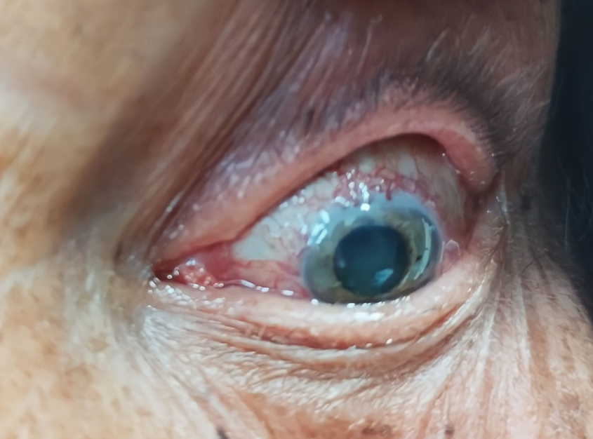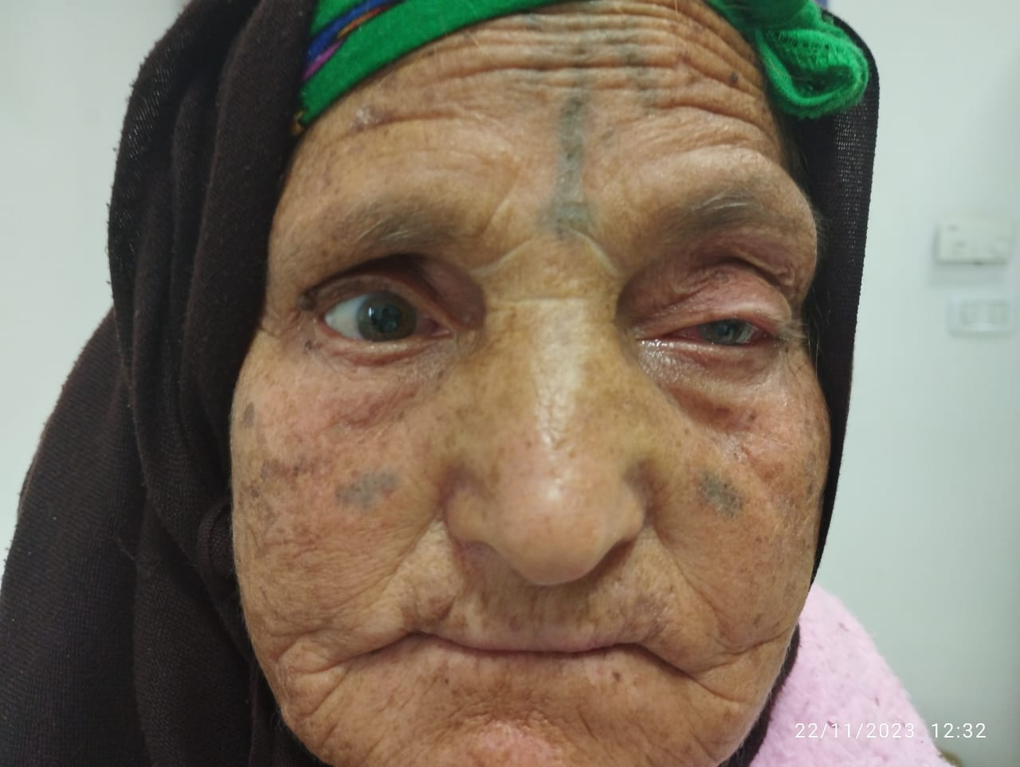

Figure 1: Clinical photograph of the left eye showing marked conjunctival injection with dilated and tortuous episcleral vessels. A partial ptosis is present, associated with restricted ocular motility, predominantly in abduction, consistent with an incomplete oculomotor nerve palsy. The pupil appears mid-dilated and poorly reactive to light.

Slit-lamp biomicroscopy revealed clear cornea, a quiet anterior chamber, and early nuclear lens opacities. The intraocular pressure was 18 mmHg in both eyes. The vitreous was clear, and the fundus examination showed no papilledema, venous congestion, or retinal hemorrhages. (Figure 2). The right eye examination was unremarkable.
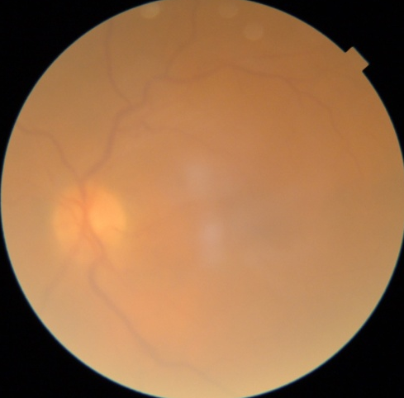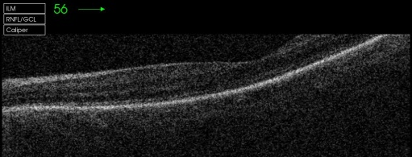
Figure 2: Fundus examination of the left eye demonstrating normal optic disc and retinal findings, with no evidence of papilledema, venous congestion, or retinal hemorrhages.

Given the combination of headache, ocular redness, and oculomotor dysfunction in an elderly patient, giant cell arteritis (Horton’s disease) was initially suspected. Laboratory tests including erythrocyte sedimentation rate (ESR) and C-reactive protein (CRP) were performed, but the results were inconclusive.
To further investigate the vascular etiology, magnetic resonance imaging (MRI) of the brain and orbit with angiographic sequences was obtained. The study demonstrated arterialization and marked dilatation of the cavernous sinus with abnormal vascular shunting, highly suggestive of a spontaneous carotid-cavernous fistula (CCF). No evidence of aneurysm rupture or traumatic lesion was identified. (Figure 3).

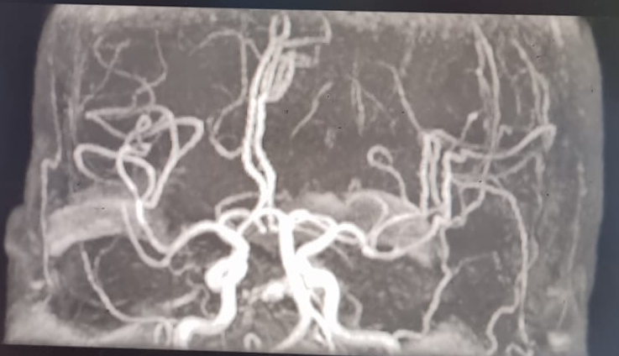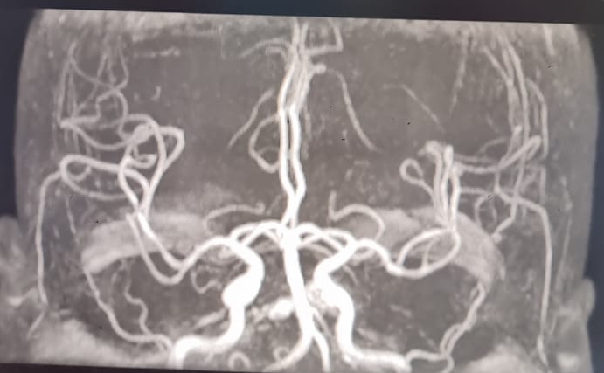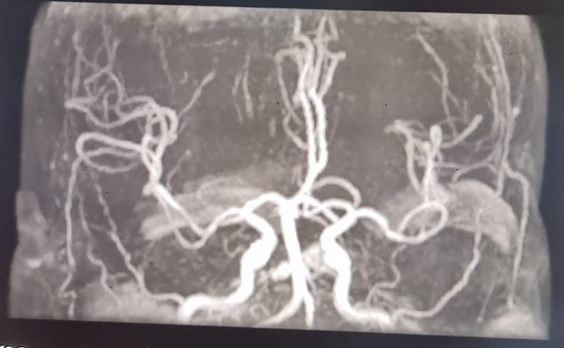

Figure 3: MRI angiography revealing cavernous sinus arterialization and dilatation with abnormal shunting, consistent with a spontaneous carotid-cavernous fistula; no aneurysm or trauma detected.
The patient was subsequently referred to the interventional neuroradiology unit. A diagnostic digital subtraction angiography (DSA) confirmed the presence of an indirect carotid-cavernous fistula with venous drainage into the superior ophthalmic vein. Endovascular embolization via a transvenous approach was performed successfully using detachable coils.
Postoperative course was favorable, with rapid regression of ocular redness and pain within one week. Ptosis and ocular motility improved progressively over one month. At three-month follow-up, best corrected visual acuity improved to 5/10 in the affected eye, intraocular pressure remained within normal limits, and episcleral vascular dilatation had resolved. Fundus examination remained normal. No recurrence was observed during a six-month follow-up period.

3. discussion

Carotid-cavernous fistulas (CCFs) are abnormal arteriovenous communications between the carotid arterial system and the cavernous sinus. Barrow et al. proposed a classification distinguishing direct CCFs (high-flow, usually traumatic) from indirect CCFs (low-flow, often spontaneous) (Barrow et al., 1985). Spontaneous CCFs account for approximately 30% of cases, and they occur predominantly in elderly women, often without a clear triggering event (Korkmaz et al., 2020). Predisposing factors may include cavernous aneurysms and connective tissue disorders such as Ehlers–Danlos syndrome, fibromuscular dysplasia, and pseudoxanthoma elasticum (Halbach et al., 1988).
The pathophysiology involves arterial shunting into the cavernous sinus, resulting in increased venous pressure. This venous hypertension is transmitted to the superior ophthalmic vein and orbital venous system, leading to clinical features such as conjunctival injection, chemosis, episcleral vessel dilation, ptosis, proptosis, and ocular motility disturbances (Gemmete & Ansari, 2010). If untreated, venous congestion may progress to secondary glaucoma, optic neuropathy, or ischemic retinopathy, ultimately causing irreversible visual loss (Miller et al., 2017).
The clinical spectrum is highly variable and depends on flow rate and venous drainage patterns. The classical triad of pulsatile proptosis, chemosis, and ocular bruit is not always present, particularly in low-flow indirect fistulas (Henderson et al., 2018). In our case, the patient presented with ocular redness, headache, and partial oculomotor nerve palsy, a combination that initially suggested giant cell arteritis. However, the presence of dilated episcleral vessels is a key diagnostic clue and should prompt consideration of a vascular etiology (Alurkar et al., 2013).
Diagnostic imaging plays a central role. MRI with angiographic sequences may demonstrate indirect signs such as cavernous sinus enlargement and superior ophthalmic vein dilation, but digital subtraction angiography (DSA) remains the gold standard. DSA not only confirms the diagnosis but also delineates arterial feeders and venous drainage, which is critical for treatment planning (Brinjikji et al., 2017).
Therapeutic management has evolved with advances in endovascular techniques. Transarterial embolization is preferred in high-flow direct CCFs, whereas transvenous embolization is the treatment of choice for indirect CCFs (Gemmete & Ansari, 2010). These techniques achieve high rates of occlusion with low morbidity and often result in significant visual improvement (Brinjikji et al., 2017). In selected cases of low-flow fistulas, spontaneous closure may occur, either spontaneously or following conservative measures such as intermittent carotid compression, although success rates remain modest (Halbach et al., 1988). Surgical approaches, including direct access to the superior ophthalmic vein, are reserved for cases where endovascular treatment is not feasible (Henderson et al., 2018).
Prognosis depends mainly on early recognition and prompt treatment. Delayed diagnosis may lead to severe and irreversible complications, while timely embolization usually results in regression of ocular signs and stabilization or improvement of vision, as seen in our patient (Korkmaz et al., 2020).
This case highlights the diagnostic challenge of spontaneous CCF in elderly women presenting with atypical symptoms. Ophthalmologists should maintain a high index of suspicion for CCF in patients with unexplained ocular redness, ptosis, and episcleral vessel dilation, as early diagnosis and endovascular management remain crucial for favorable visual outcomes.

4. Conclusion

Spontaneous carotid-cavernous fistulas are rare but vision-threatening conditions, particularly in elderly women. Atypical presentations with ocular redness, headache, and ophthalmoplegia may mimic other disorders and delay diagnosis. Early recognition and neuroimaging are essential, as endovascular embolization remains the treatment of choice and offers excellent visual and anatomical outcomes.

CONSENT
All authors declare that ‘written informed consent was obtained from the patient for publication of this case report and accompanying images.
DATA AVAILABILITY
Not applicable
ETHICAL APPROVAL
As per international standards or university standards written ethical approval has been collected and preserved by the author(s).
COMPETING INTERESTS
Authors have declared that no competing interests exist.

References

- Barrow DL, Spector RH, Braun IF, Landman JA, Tindall SC, Tindall GT. Classification and treatment of spontaneous carotid-cavernous sinus fistulas. J Neurosurg. 1985;62(2):248-56. doi:10.3171/jns.1985.62.2.0248.
- Halbach VV, Hieshima GB, Higashida RT, Reicher M, Hardin CW, Wilson CB. Carotid cavernous fistula: indications for urgent treatment. AJNR Am J Neuroradiol. 1988;9(4):741-7. PMID: 2845532.
- Korkmaz O, Dogan EA, Korkmaz M, Dagistan Y, Uysal E, Seflek H. A case of indirect carotid cavernous fistula presenting with proptosis and pulsatile exophthalmos. Gülhane Med J. 2020;62(3):246-9. doi:10.4274/gulhane.galenos.2020.1175.
- Gemmete JJ, Ansari SA. Endovascular techniques for treatment of carotid-cavernous fistula. Neurosurg Clin N Am. 2010;21(3):509-20. doi:10.1016/j.nec.2010.03.003.
- Henderson AD, Miller NR. Carotid-cavernous fistula: current concepts in aetiology, investigation, and management. Eye (Lond). 2018;32(2):164-72. doi:10.1038/eye.2017.240.
- Miller NR, Monsein LH, Debrun GM, Tamargo RJ. Interventional neuroradiology of the orbit. Surv Ophthalmol. 2017;62(3):321-40. doi:10.1016/j.survophthal.2016.11.003.
- Alurkar A, Karanam LS, Nayak S, Ghanta RK. Clinical spectrum of carotid cavernous fistula and outcome following endovascular treatment: a single center experience. Indian J Radiol Imaging. 2013;23(2):121-5. doi:10.4103/0971-3026.113614.
- Brinjikji W, Pereira VM, Campos JK, Cloft HJ, Kallmes DF. Endovascular treatment of carotid cavernous fistulas: a systematic review and meta-analysis. AJNR Am J Neuroradiol. 2017;38(12):2305-12. doi:10.3174/ajnr.A5407.

