Original Research Article

Educational and Workplace Challenges of Nurse Practitioners in India: Findings form a Nationwide Cross-Sectional Survey

ABSTRACT:
Background: The Nurse Practitioner (NP) role is globally recognized for enhancing healthcare delivery and addressing physician shortages. In India, the NP in Critical Care (NPCC) program was initiated in 2016, but implementation has faced multiple barriers.
Methods: A descriptive cross-sectional online survey was conducted in August 2025 among Nurse Practitioners (NPs), NP students, and allied professionals (N = 126). The structured questionnaire explored state-wise respondent distribution, education-related challenges, workplace barriers, and suggestions for strengthening NP roles. Quantitative responses were analyzed using descriptive statistics, while qualitative responses were categorized thematically.
Results: Most respondents were NPs in Critical Care (69%), followed by NP students (19%) and others (12%). Educational challenges included inadequate training (40%), shortage of faculty (31%), curriculum-related issues (22%), and lack of recognition of NP qualifications (32%). Workplace challenges comprised lack of recognition (37%), limited scope of practice (32%), workload (25%), and career progression barriers (21%). Suggestions included government recognition (21%), defining scope of practice (20%), awareness campaigns (16%), faculty training (14%), and structured career pathways (13%). Thematic analysis revealed three dominant themes: (1) Educational Barriers, (2) Workplace Challenges, and (3) Suggestions for Strengthening NP Role. Southern states emphasized curriculum and faculty issues, while northern states highlighted recognition and scope of practice.
Conclusion: Nurse Practitioners in India face systemic educational and workplace barriers. Policy recognition, strengthened educational infrastructure, legal empowerment, and structured career progression pathways are essential for effective NP integration.
Keywords: Nurse Practitioner; Education; Workplace Challenges; Scope of Practice; Advanced Nursing Practice; India

INTRODUCTION
The Nurse Practitioner (NP) role is globally acknowledged as a transformative model in healthcare, bridging physician shortages and improving quality of care across diverse settings. In countries such as the United States, Canada, Australia, and the United Kingdom, NPs are integrated into primary and acute care services with legal authority, structured training, and well-defined scopes of practice. Evidence from these countries demonstrates that NPs provide safe, effective, and cost-efficient care while improving patient satisfaction and health system efficiency¹⁻³ .
In India, the Indian Nursing Council (INC) launched the Nurse Practitioner in Critical Care (NPCC) program in 2016 to address the rising demand for skilled providers in intensive care units (ICUs) and to strengthen advanced nursing practice⁴. The NPCC curriculum was designed as a two-year master’s program for registered nurses, focusing on advanced clinical decision-making, leadership, and evidence-based practice. Despite this significant initiative, the implementation of the NP role in India has been constrained by systemic, educational, and workplace challenges.
Educational challenges include lack of trained NP faculty, inadequate preceptorship models, limited clinical exposure, and poorly structured curricula that fail to meet global standards^{5,6}. Similarly, workplace barriers encompass limited recognition of NP qualifications, undefined scope of practice, resistance from medical professionals, absence of legal authority, and restricted career progression⁷⁻⁹. These challenges have slowed the integration of NPs into the Indian health system, despite their potential to fill critical gaps in care delivery.
Globally, successful NP role implementation has depended on clear policy recognition, legislative authority, standardized education, and structured professional development pathways¹⁰⁻¹². Without these enablers, NPs remain underutilized and face professional identity struggles. India’s situation highlights an urgent need to explore and document the barriers faced by NPs and NP students to guide future policy development and health system reforms.
While some studies have highlighted the emerging NP role in India, there is limited empirical evidence that systematically examines challenges across states and captures the perspectives of practicing NPs and NP students. Understanding these challenges and proposed solutions is essential for ensuring that the NP role evolves in alignment with international best practices while addressing India’s unique health system needs.
Therefore, this study was undertaken to systematically assess:
- State-wise distribution of respondents and categories (NPs, NP students, others).
- Education-related challenges in NP training and professional development.
- Workplace barriers related to scope of practice, recognition, and career growth.
- Suggestions for strengthening NP roles in India.
- State-wise burden of challenges to identify variation across regions.

material and methods

Study Design
A descriptive cross-sectional survey design was adopted to assess the education and workplace challenges of Nurse Practitioners (NPs) and NP students across India. This design was selected as it enables the exploration of opinions, experiences, and challenges at a single point in time¹.

Study Population and Setting
The study population included:
- Nurse Practitioners in Critical Care (NPCC graduates)
- Student NPs currently enrolled in NPCC programs
- Other nursing professionals (e.g., nursing officers, doctoral scholars) with exposure to NP education or practice
The study was conducted nationwide in India through online recruitment.

Sample Size and Sampling
A total of 126 respondents participated. The sample included:
- Nurse Practitioners in Critical Care: 87 (69%)
- NP Students: 24 (19%)
- Nursing Officers: 13 (10%)
- Others (doctoral scholar, MCH officer): 2 (2%)
A convenience sampling technique was used, as participants were recruited through NP professional networks, emails, and social media groups.

Data Collection Tool
A structured self-administered questionnaire was developed using Google Forms. The questionnaire had four sections:
- Demographics: Name, state, designation, email.
- Education-related challenges: Items on training adequacy, faculty availability, curriculum design, recognition of NP qualification.
- Workplace challenges: Scope of practice, workload, legal issues, career progression, recognition.
- Suggestions for strengthening NP role in India.
The tool included both closed-ended questions (for quantitative frequency analysis) and open-ended questions (for thematic analysis). Face validity of the tool was ensured by expert review from two nursing faculty members experienced in advanced practice nursing.

Data Collection Procedure
The survey link was disseminated electronically in August 2025 through email invitations and professional NP networks across India. Respondents completed the questionnaire voluntarily and anonymously within two weeks. Duplicate responses were avoided by restricting one submission per email ID.

Data Analysis
- Quantitative analysis: Descriptive statistics (frequency, percentage) were used to summarize state-wise distribution, respondent categories, and frequency of reported challenges. Data were entered in Microsoft Excel and cross-verified.
- Qualitative analysis: Responses to open-ended questions were transcribed, coded, and analyzed thematically. Common keywords were extracted using frequency counts, and responses were grouped into three major themes: (1) Educational Barriers, (2) Workplace Challenges, and (3) Suggestions for Strengthening NP Role. Illustrative participant quotes were used to support themes.

RESULTS
A total of 126 respondents completed the survey. The findings are presented under respondent profile, education-related challenges, workplace barriers, suggestions, and thematic analysis.

Respondent Profile
Of the 126 respondents, Nurse Practitioners in Critical Care constituted the largest group (n = 87, 69%), followed by NP students (n = 24, 19%) and others including nursing officers and doctoral scholars (n = 15, 12%).
Table 1. State-wise Distribution of Respondents (N = 126)
State | Total | %
Andaman and Nicobar Lslands | 1 | 0.8
Andra Pradhesh | 3 | 2.4
Assam | 1 | 0.8
Bihar | 1 | 0.8
Haryana | 6 | 4.8
Himachal pradesh | 2 | 1.6
Jammu and Kashmir | 2 | 1.6
Jharkhand | 1 | 0.8
Karnataka | 32 | 25.4
Kerala | 1 | 0.8
Maharashtra | 5 | 4.0
Manipur | 1 | 0.8
New Delhi | 9 | 7.1
Puducherry | 3 | 2.4
Punjab | 3 | 2.4
Rajasthan | 1 | 0.8
Tamil Nadu | 30 | 23.8
Telangana | 1 | 0.8
Uttar Pradesh | 4 | 3.2
Uttarakhand | 11 | 8.7
West Bengal | 8 | 6.3

Fig 1- Bar chart showing the total count of entries from various Indian states
Table 2. Category-wise Distribution of Respondents (N = 126)
Designation | Respondents, n (%)
Nurse Practitioner in Critical Care | 87 (69%)
Student Nurse Practitioner in Critical Care | 24 (19%)
Nursing Officer | 13 (10%)
DNP Scholar | 1 (1%)
MCH Officer | 1 (1%)

Education-Related Challenges
The most frequently reported barriers were:
Inadequate training and competency gaps (40%)
Faculty shortages (31%)
Curriculum-related issues (22%)
Lack of recognition of NP qualification (32%)
Table 3. Common Education-related Challenges Reported by Respondents
Theme | Frequency (n)
Inadequate training | 51
Recognition of NP role | 40
Faculty shortage | 39
Curriculum issues | 28
Lack of clarity | 23
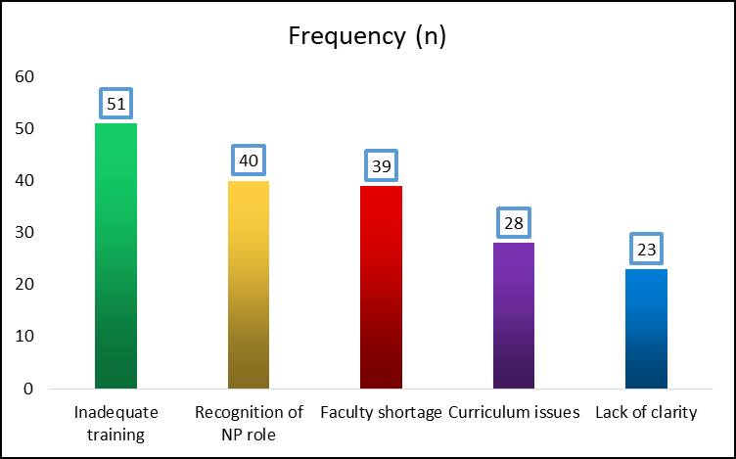
Fig 2- Workplace Challenges
Note: Training, recognition, and faculty shortage were the most common barriers.

Workplace Challenges
Respondents highlighted systemic barriers such as:
Lack of recognition within the health system (37%)
Unclear scope of practice (32%)
Excessive workload (25%)
Poor career progression and legal ambiguity (21%)
Table 4 presents workplace challenges.
Theme | Frequency (n)
Lack of recognition | 46
Limited scope of practice | 40
Workload | 31
Career progression gaps | 27
Legal/policy barriers | 20

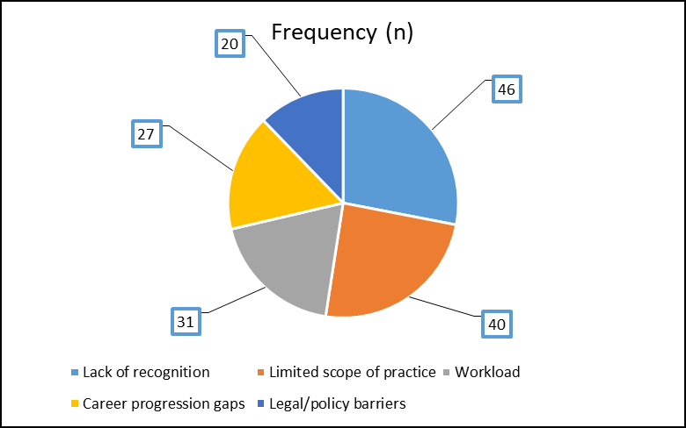
Fig 3- Respondents provided constructive suggestions

Suggestions for Strengthening NP Role
Respondents provided constructive suggestions, the most frequent being:
Government recognition and policy development (21%)
Clear legal definition of scope of practice (20%)
Awareness campaigns (16%)
Faculty training and preceptorship models (14%)
Structured career progression pathways (13%)
Table 5 presents suggestions in detail.
Table 5. Suggestions for Strengthening NP Role in India
Suggested Strategy | Frequency (n)
Government recognition and policy | 26
Clear scope of practice definition | 25
Awareness campaigns | 20
Faculty training and preceptorship | 18
Structured career progression pathway | 16

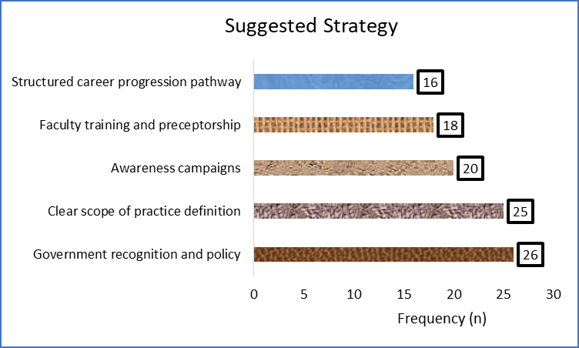
Fig 4- Strategy suggested

Thematic Presentation
Open-ended responses were analyzed thematically. Three dominant themes emerged:
1. Educational Barriers
Subthemes: inadequate training, faculty shortage, curriculum issues, lack of recognition.

Illustrative quotes:
- “Curriculum design, lack of recognition of qualifications, and inadequate training.” (Participant, Tamil Nadu)
- “Training and curriculum design not clear.” (Participant, Haryana)
2. Workplace Challenges
Subthemes: lack of recognition, unclear scope of practice, workload, career stagnation, legal ambiguity.
Illustrative quotes:
- “There is no proper recognition for NPs, no clarity in scope of practice.” (Participant, Puducherry)
- “Recognition and career progression are not established.” (Participant, Haryana)
3. Suggestions for Strengthening NP Role
Subthemes: government recognition, legal authority, awareness campaigns, faculty development, structured career growth.
Illustrative quotes:
- “Establish a clear scope of practice and create NP cadres recognized by government.” (Participant, Tamil Nadu)
- “Medical preceptor supervision is needed.” (Participant, Puducherry)
Table 6. Thematic Analysis of Survey Responses
Theme | Subthemes | Illustrative Quotes
Educational Barriers | Inadequate training; Faculty shortage; Curriculum issues; Lack of recognition | “Curriculum design, lack of recognition of qualifications, and inadequate training.”
Workplace Challenges | Lack of recognition; Unclear scope of practice; Workload; Career progression gaps; Legal ambiguity | “There is no proper recognition for NPs, no clarity in scope of practice.”
Suggestions | Government recognition; Legal authority; Awareness campaigns; Faculty development; Career progression pathways | “Establish a clear scope of practice and create NP cadres recognized by government.”

DISCUSSION
This nationwide survey explored the education and workplace challenges of Nurse Practitioners (NPs) and NP students in India, providing insights into systemic barriers and potential solutions. The findings revealed consistent challenges across states, with differences in emphasis: southern states (Tamil Nadu, Puducherry) highlighted educational barriers such as faculty shortages and curriculum design, whereas northern states (Haryana and others) emphasized workplace challenges, including recognition and scope of practice.

Educational Challenges
In this study, inadequate training, limited faculty availability, and curriculum-related issues were major concerns. Nearly one-third of participants reported lack of recognition of NP qualifications as a significant barrier. These findings align with earlier reports noting that India’s NPCC program lacks sufficient clinical preceptors and standardized training infrastructure, limiting skill acquisition and confidence among graduates^{1,2}.
Globally, successful NP programs are characterized by structured competency-based curricula, faculty development initiatives, and strong preceptorship models^{3,4}. Countries like the United States, Canada, and Australia have demonstrated that investments in NP education directly improve quality of care and system efficiency^{5,6}. India’s challenge lies in scaling faculty training, ensuring curriculum alignment with global benchmarks, and developing national accreditation mechanisms.

Workplace Challenges
Workplace barriers reported in this survey included lack of recognition, undefined scope of practice, workload pressures, and limited career progression. These concerns mirror findings from other Indian studies, where NPs expressed frustration with role ambiguity, limited autonomy, and resistance from medical professionals⁷.
In contrast, international evidence highlights how clearly legislated scopes of practice, supportive policies, and interprofessional collaboration have enabled NPs to thrive and gain patient and institutional acceptance^{8,9}. For example, in the United States, NPs are authorized to diagnose, prescribe, and manage care autonomously, leading to measurable improvements in access and outcomes¹⁰. The absence of such enabling policies in India perpetuates systemic resistance and underutilization of NP potential.

Suggestions for Strengthening the NP Role
Respondents’ recommendations—government recognition, legal definition of scope, faculty training, and structured career pathways—are consistent with global best practices. Similar reforms in South Korea and Taiwan, where NPs were initially underrecognized, eventually led to legal frameworks, role clarity, and successful integration of NPs into the healthcare system^{11,12}.

Awareness campaigns were also strongly emphasized. Studies show that when healthcare teams and the public are informed about NP contributions, acceptance and trust increase significantly. For India, public and interprofessional sensitization may be critical to overcoming resistance and ensuring role legitimacy.

Strengths of the Study
- First survey to capture state-wise variations in NP challenges across India.
- Combines quantitative frequencies with thematic analysis, offering a comprehensive perspective.
- Provides actionable policy and educational recommendations directly from frontline NPs and NP students.
Limitations
- The study used a convenience sampling method via online platforms, which may introduce selection bias. Respondents from states with weaker NP presence may be underrepresented.
- The analysis was primarily descriptive, limiting statistical generalization. Future research should apply inferential statistics to explore associations between demographics and challenges.
- Responses were self-reported, which may be subject to personal bias.
Despite these limitations, the study provides crucial baseline evidence to guide policymakers, educators, and professional bodies in advancing NP implementation in India.

CONCLUSION AND IMPLICATIONS
This study provides national-level insights into the educational and workplace challenges faced by Nurse Practitioners (NPs) and NP students in India. Findings indicate that while the NPCC program (2016) has created a pathway for advanced nursing practice, persistent barriers—such as inadequate training, shortage of faculty, unclear curriculum, lack of recognition, and undefined scope of practice—have hindered its successful implementation.
Key conclusions:
- Educational barriers include inadequate training opportunities, limited preceptorship, and lack of faculty capacity.
- Workplace barriers primarily involve lack of recognition, unclear scope of practice, workload pressures, and restricted career progression.
- Suggestions from respondents—including government recognition, legal authority, faculty training, awareness campaigns, and structured career pathways—highlight clear directions for reform.
- State-wise variation shows that southern states demand curriculum and faculty reforms, while northern states emphasize recognition and policy support.

Implications for Policy
The Ministry of Health and Family Welfare and Indian Nursing Council should prioritize the legal recognition of NPs, establishing a National NP Cadre with clear scope of practice.
Policies must ensure role legitimacy, aligning NP responsibilities with international standards while addressing India’s unique healthcare needs.

Implications for Education
Faculty development programs and preceptorship models are essential to strengthen NP training.
A competency-based national curriculum with standardized clinical hours should be adopted.
Collaboration with global NP education programs can enhance curriculum design and mentorship capacity.

Implications for Practice
Awareness campaigns targeting policymakers, healthcare professionals, and the public can build acceptance of the NP role.
NPs should be integrated into multidisciplinary care teams, particularly in critical care, primary care, and rural health systems where physician shortages are acute.
Structured career pathways—including opportunities for leadership, research, and advanced clinical roles—should be institutionalized to retain skilled NPs.

Final Statement
Addressing these educational and workplace challenges through policy reforms, strengthened education systems, and workplace integration strategies will enable India to harness the full potential of Nurse Practitioners. Doing so can significantly contribute to Universal Health Coverage (UHC), strengthen the health workforce, and improve the quality of care for critically ill patients across the country.
Link to Future Research
The present study provides baseline evidence for the five research initiatives have proposed to the Tamil Nadu Nurses and Midwives Council (TNNMC). Each proposed study builds on these findings and addresses critical gaps identified in this survey:
- Perceptions of Nurse Practitioners Among Physicians, Nurses, and Hospital Administrators (Multicenter) :
Link with current findings: Recognition was the top workplace challenge (26.6%). Our survey shows that lack of acceptance is a system-wide problem.
Why this study: Exploring perceptions of doctors, nurses, and administrators will reveal inter-professional barriers and facilitators, helping design strategies for better NP integration.
2. Policy Analysis of Nurse Practitioner Regulations in India
Link with current findings: Participants emphasized lack of legal clarity and cadre creation.
Why this study: A documentary review and stakeholder analysis will benchmark Indian NP policies against international models, providing policy-level solutions for recognition, scope, and career frameworks.
- Nurse Practitioner Mapping in India
Link with current findings: Our state-wise survey highlighted uneven participation (e.g., Tamil Nadu & Karnataka dominate, other states underrepresented).
Why this study: Mapping NP distribution, roles, and specialties will provide workforce data to guide deployment and equitable distribution.
4. Continuing Nurse Practitioner Education (CNPE) Research
Link with current findings: Education challenges (training modules, curriculum gaps, faculty shortages) were major concerns (25.1% and 17.8%).
Why this study: CNPE research will identify competency needs, CPD/CME priorities, and delivery models (modular courses, simulation, mentorship) to strengthen NP education quality.
5. Development and Validation of the Indian Nurse Practitioner–Physician Integrated Collaborative Care Model (INP-CCM)
Link with current findings: Workplace challenges included scope restrictions and medico-legal ambiguity (22.6% and 5.1%).
Why this study: A collaborative NP–physician model tailored to India can resolve scope-of-practice conflicts, improve recognition, and enhance team-based care outcomes.
Ethical considerations
The study complied with ethical principles of voluntary participation, confidentiality, and beneficence. No patient-level data or sensitive identifiers were collected.
As per the Indian Council of Medical Research (ICMR) National Ethical Guidelines (2017), surveys among healthcare professionals that do not involve vulnerable populations or personal health data are classified as “less than minimal risk” and may be exempt from Institutional Ethics Committee (IEC) review. Accordingly, no formal IEC approval was sought. Informed consent was implied through voluntary completion of the online form.
International guidelines, including U.S. Federal Regulations (45 CFR 46.104) and WHO Ethics Review Committee guidance, similarly recognize such professional surveys as exempt from full ethics review.

REFERENCES
- Indian Nursing Council. Nurse Practitioner in Critical Care Program Guidelines. New Delhi: INC; 2016.
- Maier CB, Aiken LH, Busse R. Nurse practitioners in primary care: International evidence and policy implications. Int J Nurs Stud. 2017;74:1-9. doi:10.1016/j.ijnurstu.2017.05.001
- Woo BF, Lee JX, Tam WW. The impact of advanced practice nursing on quality of care: A systematic review. Int J Nurs Stud. 2017;74:60-70. doi:10.1016/j.ijnurstu.2017.05.010
- Sheer B, Wong FK. The development of advanced nursing practice globally. J Nurs Scholarsh. 2008;40(3):204-211. doi:10.1111/j.1547-5069.2008.00242.x
- Poghosyan L, Nannini A, Stone PW, Smaldone A. Nurse practitioner organizational climate in primary care settings: Implications for professional practice. J Prof Nurs. 2013;29(6):338-349. doi:10.1016/j.profnurs.2012.05.007
- Sangster-Gormley E, Martin-Misener R, Downe-Wamboldt B, DiCenso A. Factors affecting nurse practitioner role implementation in Canadian practice settings: An integrative review. J Adv Nurs. 2011;67(6):1178-1190. doi:10.1111/j.1365-2648.2010.05571.x
- Thomas S, Kuruvilla S. Nurse practitioners in India: Progress and challenges. Indian J Public Health. 2019;63(4):305-309. doi:10.4103/ijph.IJPH_465_19
- Kooienga S, Carryer J. Globalization and advancing primary health care nurse practitioner practice. J Am Acad Nurse Pract. 2010;22(1):22-29. doi:10.1111/j.1745-7599.2009.00464.x
- Delamaire M-L, Lafortune G. Nurses in advanced roles: A description and evaluation of experiences in 12 developed countries. OECD Health Working Papers, No. 54. Paris: OECD Publishing; 2010. doi:10.1787/5kmbrcfms5g7-en
- American Association of Nurse Practitioners. NP Fact Sheet. 2023. Accessed August 25, 2025. https://www.aanp.org/advocacy/advocacy-resource/fact-sheet
- Chang AM, Lam CK, Lam TP. Nurse practitioners in Hong Kong: The way forward. J Clin Nurs. 2010;19(21-22):3072-3080. doi:10.1111/j.1365-2702.2010.03288.x
- Yang CI, Lee LH, Liu YT. Evolution of nurse practitioner education and role development in Taiwan. J Am Assoc Nurse Pract. 2018;30(12):701-707. doi:10.1097/JXX.0000000000000105.

