Insect fauna of Bhimbandh Wildlife Sanctuary, Bihar, India: a baseline assessment

Abstract
This paper presents the list of insects found during the 15 days faunal assessment survey of the Bhimbandh Wildlife Sanctuary (BWS), Bihar. In total, 112 species of insects were documented. A preliminary checklist has been prepared that provides a baseline information for biodiversity studies in the region. These species are distributed across 11 orders and 56 families. Of these, 41 species belonged to order Lepidoptera, 18 to order Coleoptera, 12 to order Hymenoptera, 11 to order Orthoptera, nine to order Hemiptera, eight to order Odonata, six to order Diptera, three to order Blattodea, two to order Mantodea, and one each to order Plecoptera and Dermaptera. The report concludes that this study underscores the need for an integrated, science-backed conservation strategy that prioritizes continued biodiversity monitoring, targeted anti-poaching measures, and active community involvement to safeguard this valuable ecosystem. This checklist is crucial for understanding the health of ecosystem of Bhimbandh wildlife sanctuary.
Keywords: Biodiversity, insects, pollinators, predators, decomposers, Solenopsis invicta, Plutella xylostella, Hyposidra talaca, Leucoma salicis, Neocurtilla hexadactyla, Leptocorisa oratoria, Tetranychus urticae.
Introduction
Insects form the essential pillar of ecosystem services (Sanmartín-Villar and Cordero-Rivera, 2024) and serve as bioindicators of environmental health (Chowdhury et al., 2023). They play a fundamental role in maintaining a healthy ecosystem, yet their diversity remains under-documented. Moreover, the insect biodiversity is threatened globally. The primary drivers of insect species decline include: i) habitat loss due to agricultural expansion and urbanisation; ii) pollution, mainly due to use of synthetic pesticides and fertilisers; iii) biological factors, including pathogens and invasive species; and iv) climate change (Sánchez-Bayo and Wyckhuys, 2019). Given the vital role of insects in ecosystems, documenting their presence across various environments is essential. Such efforts support species conservation and enhance biodiversity in environmental management programs (Verma et al., 2023).
Bhimbandh Wildlife Sanctuary (BWS) hosts a diverse array of wildlife and is particularly renowned for its rich birdlife, with 147 bird species documented (Khan and Pant, 2017). However, no comprehensive checklist of insects specific to the sanctuary is currently available. This checklist aims to document the diverse insect groups present in BWS, providing a foundation for further exploration and study of its entomological diversity.
Materials and Methods
Bhimbandh Wildlife Sanctuary (25.23°N, 86.28°E) is located in the southwest of Munger district in Bihar, India, near the town of Haveli Kharagpur (Fig. 1). It spans an area of approximately 681.99 km² and is characterized by diverse terrain, including the undulating Kharagpur Hills, part of the Chota Nagpur Plateau in southeastern Bihar. The sanctuary lies south of the Ganges River, west of Santhal Pargana, and is surrounded by densely populated non-forestry areas. The sanctuary has a mix of hills, plains, and plateaus, with the Kharagpur Hills forming its core.
The area is covered by tropical dry deciduous forests, with dominant species like Shorea robusta (sal), Diospyros melanoxylon (kendu), Boswellia serrata (salai), Terminalia tomentosa (Asan), Terminalia bellirica (Bahera), Terminalia arjuna (Arjun), and Pterocarpus marsupium (Paisar). The terrain is undulating, with valleys and foothills. Grasslands, wetlands, and geothermal springs are also present (Sinha and Santra, 2019).
The sanctuary's diverse microhabitats support rich biodiversity, warranting further study. A comprehensive biodiversity survey focusing on smaller organisms, such as amphibians, insects, and plants, could reveal endemic subspecies or unique genetic adaptations. The present study is the first attempt to document the insect fauna of Bhimbandh Wildlife Sanctuary (BWS). This paper presents a list of insects seen in the sanctuary during a short faunal survey of a duration of 15 days spanning the last week of March to the first week of April 2025. The insects were photographed and documented during a faunal survey by line transect in the Kharagpur and Mallepur areas of BWS. Digital cameras and smartphone cameras with macro capabilities were used to photograph the insects in their natural habitat.
Identification was done with the help of experts on the field and standard entomological field guides. No specimens were collected, adhering to non-invasive survey protocols.
The sanctuary's diverse microhabitats support rich biodiversity, warranting further study. A comprehensive biodiversity survey focusing on smaller organisms, such as amphibians, insects, and plants, could reveal endemic subspecies or unique genetic adaptations. This study represents the first attempt to document the insect fauna of Bhimbandh Wildlife Sanctuary (BWS)

Results and Discussion
A total of 112 species of insects belonging to 11 orders and 56 families (Table 1). Although the area is highly disturbed due to anthropogenic activities such as mining, deforestation and extremism including poaching, a rich assemblage of insects was found in the area (photos in supplementary file). Lepidopterans were the most dominant group followed by coleoptera (Fig. 2). This dominance pattern is ecologically significant as both orders represent key functional groups essential for ecosystem stability. Lepidoptera serve as primary pollinators, herbivores, and prey species in food webs, while Coleoptera function as decomposers, predators, and soil engineers (Fig. 2).. The prominence of these groups indicates the presence of intact ecological processes including pollination networks, decomposition pathways, and predator-prey dynamics that are fundamental to ecosystem functioningb. Similar findings were reported by (Arya et al., 2021; Balakrishnan et al., 2014; Mathew et al., 2004; Rasheed and Buhroo, 2020). The presence of pollinators, predators, and decomposers highlights the functional diversity of the insect community in the area. The observation of invasive species like Solenopsis invicta and Plutella xylostella indicates potential ecological challenges that warrant further investigation.
​The study's finding of a rich assemblage of 112 insect species, across 11 orders and 56 families, appears paradoxical given the acknowledged "highly disturbed" nature of the area due to human activities. This is not a contradiction but rather a key element of the ecological narrative. The presence of a vibrant insect community, despite pressures from mining, deforestation, and poaching, may indicate a degree of ecological resilience. It is possible that this species richness is sustained by the proliferation of generalist species that are more tolerant of habitat fragmentation and edge effects. For instance, in a study of butterfly populations in nearby Gaya, species like the Common castor and Plain tiger were found to be most abundant in areas under high anthropogenic pressure. The comprehensive inventory of BWS entomofauna, therefore, serves as a critical snapshot of an ecosystem in a state of flux, providing a baseline for monitoring how species composition may shift in response to future disturbances.
​Furthermore, this study addresses a significant gap in both local and global entomological research. A global analysis of insect diversity revealed that many of the world's most dominant and abundant insect families are "dark taxa"—taxonomically neglected and poorly studied. As the first comprehensive inventory of insects in BWS, this research provides crucial baseline data that contributes to a broader, global effort to fill this information void. This elevates the study's contribution from a localized assessment to a document of international scientific relevance, providing a foundation for future conservation and taxonomic efforts (Srivathsan et al., 2023). The ecological health of any ecosystem is directly tied to the functional diversity of its constituent species. The insect community of BWS is not merely rich in numbers but also performs a variety of critical ecosystem services. The report’s mention of pollinators, decomposers, and predators highlights a functionally robust community that is integral to the sanctuary’s overall integrity. The insect inventory of Bhimbandh Wildlife Sanctuary serves as a foundational step in applying the principles of bioindication. The study’s findings—a rich and functionally diverse insect community existing in a disturbed area—provide a baseline for future monitoring efforts. The presence of specific species or groups can now be used to track changes in the ecosystem’s health over time. A decline in certain sensitive Lepidoptera or Coleoptera species could be an early indicator of increasing deforestation or climate stress.
Conservation Imperatives and Recommendations
- Policy and Management Context for Bhimbandh Wildlife Sanctuary: Effective conservation of Bhimbandh Wildlife Sanctuary requires a multifaceted approach that integrates existing policy frameworks with on-the-ground action. The Ministry of Environment, Forests and Climate Change has officially notified an Eco-sensitive Zone (ESZ) extending up to 2 kilometers around the sanctuary's boundary. This notification mandates the preparation of a Zonal Master Plan (ZMP) within a two-year period, which will include a dedicated Tourism Master Plan. The ZMP is designed to regulate and promote activities to safeguard the sanctuary's ecosystem and will likely prohibit new polluting industries, stone quarrying, and brick kilns, mirroring the regulations of other ESZ notifications, such as the one for Kaimur Wildlife Sanctuary in Bihar (Civis.vote. 2025).
- From Policy to Practice: The Need for Community Engagement: Policy documents alone are insufficient for long-term conservation. Their success is predicated on the active participation and education of the local communities that live in and around the sanctuary. A model for such engagement already exists within the Munger district itself. The "Sustainable Agriscapes for Future" program, supported by the International Union for Conservation of Nature (IUCN), has successfully introduced the concepts of Biodiversity Management Committees (BMCs) and Biodiversity Registers to local farmers. This grassroots-level initiative aims to raise awareness about the benefits of a biodiverse landscape and empowers communities to systematically record and manage the species found in their surroundings. The report recommends that this proven model of community-based conservation be integrated into the Zonal Master Plan for BWS, ensuring that conservation efforts are collaborative and sustainable (International Union for Conservation of Nature 2018, October 4).
Conclusion
The comprehensive inventory of insect species in Bhimbandh Wildlife Sanctuary provides a critical scientific baseline for future ecological studies and conservation planning. The findings, which document a rich and functionally diverse entomofauna despite significant human pressures, offer a valuable snapshot of an ecosystem’s capacity for resilience. However, the analysis also reveals a complex web of interconnected threats. Poaching disrupts the food source for decomposer beetles, which are vital for soil fertility, while invasive species present a complicated duality, serving as both potential biocontrol agents for agriculture and as threats to the native insect predator community. The presence of a notorious pest like the Diamondback Moth, which has developed universal insecticide resistance, underscores the need for integrated pest management strategies that extend beyond the sanctuary's boundaries. The study's data, interpreted through the lens of bioindication, provides an invaluable tool for continuous environmental monitoring. The presence and abundance of key insect orders can serve as a dynamic early warning system for habitat degradation and climate stress. As the Bhimbandh Wildlife Sanctuary moves forward with the development of its Zonal Master Plan, this study's findings will be essential. The report concludes that the successful conservation of this natural treasure will depend on a multi-faceted approach that not only implements robust, science-backed policies but also fosters a deep-seated commitment to biodiversity stewardship within the local community.

References
Arya M K, Badoni A, Verma A, Tiruwa A. 2021. An updated checklist of fauna of Binsar wildlife sanctuary of Uttarakhand (Western Himalaya), India. In Biological Diversity: Current Status and Conservation Policies. Volume 1, Eds. Kumar V, Kumar S, Kamboj N, Payum T, Kumar P, Kumari S. pp. 202-222.
Balakrishnan S, Srinivasan M, Mohanraj J. 2014. Diversity of some insect fauna in different coastal habitats of Tamil Nadu, southeast coast of India. Journal of Asia-Pacific Biodiversity 7(4): 408-414.
Chowdhury S, Dubey V K, Choudhury S, Das A, Jeengar D, Sujatha B, Kumar A, Kumar N, Semwal A, Kumar V. 2023. Insects as bioindicator: A hidden gem for environmental monitoring. Frontiers in Environmental Science 11:1146052.
Civis.vote. (2025). Public consultation on [consultation topic or ID 1283]. Civis.vote. https://civis.vote/consultations/1283
International Union for Conservation of Nature. (2018, October 4). Training on biodiversity registers and biodiversity management committees, Munger, Bihar. IUCN. https://iucn.org/news/india/201810/training-biodiversity-registers-and-biodiversity-management-committees-munger-bihar
Khan M S, Pant A. 2017. Conservation status, species composition, and distribution of Avian Community in Bhimbandh Wildlife Sanctuary, India. Journal of Asia-Pacific Biodiversity 10(1):20-26.
Mathew G, Shamsudeen R S M, Chandran R, Brijesh C M, Lin P, Cramer A, Lin E, Lin M. 2004. Insect fauna of Peppara Wildlife Sanctuary , Kerala , India. Zoos’ Print Journal 19(11):1680-1683.
Rasheed R, Buhroo A A. 2020. Updated checklist and diversity of predatory insect fauna with one first report from Kashmir, India. Polish Journal of Entomology 89(3):142-152.
Sánchez-Bayo F, Wyckhuys K A G. 2019. Worldwide decline of the entomofauna: A review of its drivers. Biological Conservation 232:8-27.
Sanmartín-Villar I, Cordero-Rivera A. 2024. Biodiversity and the importance of insect diversity. Biological Invasions and Global Insect Decline In Biological Invasions and Global Insect Decline. Academic Press: Cambridge, MA, USA; Elsevier. pp.19-46.
Sinha S, Santra A. 2019. Estimation of change in forest aboveground carbon in Bhimbandh Wildlife Sanctuary, Bihar, India between 2007 and 2016. Current Science 117(6):1090-1094.
Srivathsan, A., Ang, Y., Heraty, J. M., Hwang, W. S., Jusoh, W. F. A., Kutty, S. N., Puniamoorthy, J., Yeo, D., Roslin, T.,&Meier, R. (2023). Convergence of dominance and neglect in flying insect diversity. Nature ecology&evolution, 7(7), 1012–1021. https://doi.org/10.1038/s41559-023-02066-0
Verma R C, Waseem M A, Sharma N, Bharathi K, Singh S, Anto Rashwin A., Pandey S K, Singh B V. 2023. The Role of Insects in Ecosystems, an in-depth Review of Entomological Research. International Journal of Environment and Climate Change 13(10): 4340-4348.

Table 1. Checklist of insects in Bhimbandh Wildlife Sanctuary
S. No. | Family name | Common name | Zoological name
Order Lepidoptera
1 | Nymphalidae | Blue pansy | Junonia orithya
2 |  | Baronet butterfly | Euthalia nais
3 |  | Chocolate pansy | Junonia iphita
4 |  | Common crow | Euploea core
5 |  | Common glider | Neptis sappho
6 |  | Tawny coster | Acraea terpiscore
7 |  | Danaid eggfly | Hypolimnas misippus
8 |  | Common castor | Ariadne merione
9 |  | Red-eye bush brown butterfly | Heteropsis adolphei
10 |  | Gulf fritillary | Dione vanillae
11 |  | Dark brand bushbrown | Mycalesis mineus
12 | Pieridae | Common emigrant | Catopsilia pomona
13 |  | Common grass yellow | Eurema hecabe
14 |  | Common albatros | Appiasa albina
15 |  | Psyche butterfly | Leptosia nina
16 |  | Lesser gull | Cepora nadina
17 |  | Common wanderer | Pareronia valeria
18 | Lycaenidae | Lesser grass blue | Ziznia otis
19 |  | Common pierrot | Castalius rosimon
20 | Erebidae | Oak moth | Phoberia atomaris
21 |  | Shaded fan-foot | Herminia tarsicrinalis
22 |  | Simplicia | Simplicia bimarginata
23 |  | Tiger moth | Asota ficus
24 |  | Underwing moth | Catocala nupta
25 |  | White satin moth (pest) | Leucoma salicis
26 |  | Yellow belted burnet | Amata phegea
27 | Crambidae | Autocharis | Autocharis fessalis
28 |  | Parotis | Parotis marginata
29 |  | Spotted beet webworm moth | Hymenia perspectalis
30 | Geometridae | Black looper (pest) | Hyposidra talaca
31 |  | Comibaena | Comibaena striataria
32 |  | Lesser cream wave | Scopula prosoeca
33 |  | Maple spanworm moth | Ennomos magnaria
34 | Noctuidae | Oriental armyworm moth | Mythimna separata
35 |  | Semi-looper | Trigonodes hyppasia
36 | Nolidae | Nola | Nola lucidalis
37 | Papilionidae | Common rose | Pachliopta aristolochiae
38 | Plutellidae | Diamondback moth (invasive species) | Plutella xylostella
39 | Pterophoridae | Twin-spot plume moth | Stenoptilia bipunctidactyla
40 | Pyralidae | Indian meal moth | Ploida interpunctella
41 | Tortricidae | Oak leaftier | Acleris semipurpurana
Order Coleoptera
42 | Cleridae | Checkered beetle | Trichodes apiarius
43 | Coccinellidae | Common Australian ladybug | Coelophora inaequalis
44 |  | Lady beetle | Rodatus boucardi
45 |  | Seven spot lady bird | Coccinella septempunctata
46 |  | Spotless lady bug | Cycloneda sanguinea
47 |  | Transverse lady beetle | Coccinella transversalis
48 | Chrysomelidae | Blue flea beetle | Altica corrusca
49 |  | Blue milkweed beetle | Chrysochus cobaltinus
50 | Dystiscidae | Great diving beetle | Dytiscus marginalis
51 | Lampyridae | Firefly | Photinus pyralis
52 | Scarabaeidae | May beetle | Phyllophaga longitarsa
53 | Staphylinidae | Rove beetle | Paederus littoralis
54 | Tenebrionidae | Darkling beetle | Cossyphus limbatus
55 |  | Destructive flour beetle | Tribolium destructor
56 |  | Flour beetle | Tribolium castaneum
57 | Carabidae | Ground beetle | Ophionea indica
58 | Cerambycidae | Burnt pine longhorn beetle | Arhopalus ferus
59 |  | Old house borer | Hylotrupes bajulus
Order Hymenoptera
60 | Apidae | Dwarf honey bee | Apis florea
61 |  | Indian honey bee | Apis cerana indica
62 |  | Rock bee | Apis dorsata
63 | Chrysididae | Cuckoo wasp | Chrysura refulgens
64 | Evaniidae | Blue-eyed ensign wasp | Evania appendigaster
65 | Formicidae | Asian weaver ant | Oecophylla smaragdina
66 |  | Black carpenter ant | Camponotus pennsylvanicus
67 |  | Fire ant (invasive alien species) | Solenopsis invicta
68 | Ichneumonidae | Dusona | Dusona leptogaster
69 | Vespidae | Indian potter wasp | Delta pyriforme
70 |  | Oriental hornet | Vespa orientalis
71 |  | Yellow paper wasp | Polistes carnifex
Order Odonata
72 | Coenagrionidae | Saffron-faced blue dart | Pseudagrion rubriceps
73 |  | Yellow wax tail | Ceriagrion coromandelianum
74 | Gomphidae | Pincertails | Onychogomphus forcipatus
75 | Libellulidae | Brown dusk hawk | Zyxomma petiolatum
76 |  | Crimson marsh skimmer | Trithemis aurora
77 |  | Ditch jewel | Brachythemis contaminata
78 |  | Common picture wing | Rhyothemis variegata
79 |  | Violet dropwing | Trithemis annulata
Order Orthoptera
80 | Acrididae | Chinese grasshopper | Acrida cinerea
81 |  | Pallid-winged grasshopper | Trimerotropis pallidipennis
82 |  | Short-winged grasshopper | Dichromorpha viridis
83 |  | Tree locust | Anacridium flaviscence
84 | Gryllidae | Black field cricket | Teleogryllus commodus
85 | Gryllidae | Two spotted cricket | Gryllus bimaculatus
86 | Gryllotalpidae | Northern mole cricket (pest) | Neocurtilla hexadactyla
87 | Pyrgomorphidae | Big green locust | Phymateus viridipes
88 | Tettigonidae | Black-kneed meadow katydid | Conocephalus melaenus
89 |  | Common true katydid | Pterophylla camellifolia
90 |  | Long legged katydid | Mecopoda niponensis
Order Diptera
91 | Asilidae | Robber fly | Promachus vertebratus
92 | Chironomidae | Black&white midge | Coelotanypus scapularis
93 |  | Poster buzzer midge | Chironomus plumosus
94 | Culicidae | Common house mosquito | Culex pipiens
95 | Muscidae | Housefly | Musca domestica
96 | Tephritidae | Melon fly | Bactrocera cucurbitae
Order Blattodea
97 | Blaberidae | Madagascar hissing cockroach | Gromphadorhina portentosa
98 |  | German cockroach | Blatella germanica
99 | Ectobiidae | Amber wood cockroach | Ectobius vittiventris
Order Hemiptera
100 | Alylidae | Rice ear bug (a pest) | Leptocorisa oratoria
101 | Cicadellidae | Leafhopper | Idiocerus stigmaticalis
102 | Flatidae | Citrus flatid planthopper | Metcalfa pruinosa
103 | Pentatomidae | Brown marmorated stink bug | Halyomorpha halys
104 |  | Green vegetable bug (a pest) | Nazara viridula
105 |  | White spotted stink bug | Eysarcoris ventralis
106 | Pyrrhocoridae | Red cotton stainer | Dysdercus cingulatus
107 | Rhyparochromidae | One-spotted seed bug | Metochus uniguttatus
Order Mantodea
108 | Amelidae | Grey mantis | Ameles decolor
109 | Mantidae | Mexican unicorn mantis | Phyllovates chlorophaea
Order Plecoptera
110 | Perlidae | Stonefly | Acroneuria perplexa
Order Trombidiformes
111 | Tetranychidae | Red spider mite (Pest) | Tetranychus urticae
Order Dermaptera
112 | Labiduridae | Black field earwig | Nala lividipes

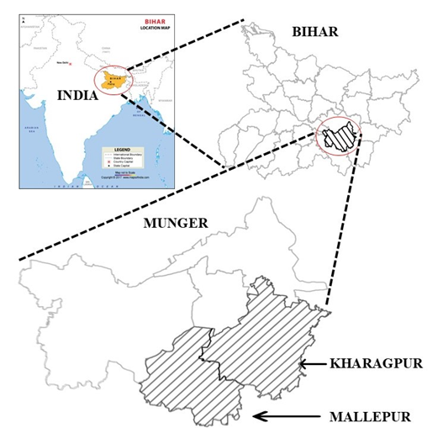
Fig. 1. Map of Study Area.

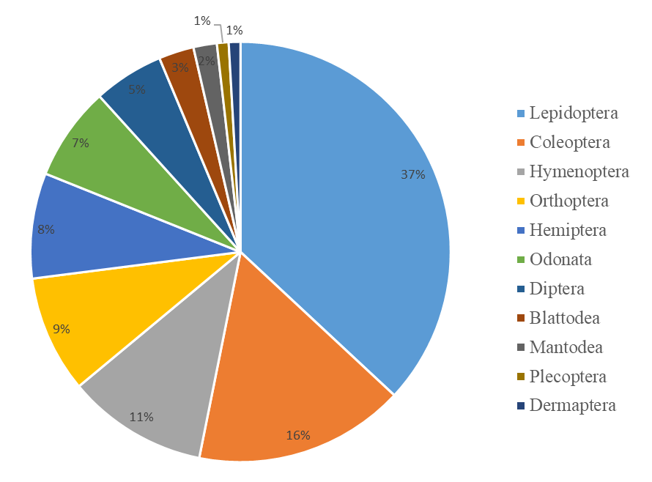

Fig. 2. Percent occurrence of different insect orders in BWS

