Original Research Article
ECTOPARASITES ON CHICKENS AT TWO RURAL COMMUNITIES

ABSTRACT
Poultry keeping in Nigeria encourages ectoparasite infestations on chickens, causing growth retardation, reduced egg-laying, poor feed conversion efficiency, feather loss, lameness, blindness, and reduced market value in affected chickens. A preliminary study of ectoparasites on chickens reared intensively and on free-range at Akwaeze and Ifite-Awka rural communities, respectively, in Anambra southeast Nigeria was done in the rainy season of 2024. The study focused on ectoparasite identification, species prevalence, preferred sites, and noticeable effects on infested chickens. A total of 101 intensively-reared chickens examined comprised 39 broilers, 31 hens, 21 cocks and 10 chicks. Hens were on deep litter while broiler chicks and cocks were on wooden cages. Also, 122 free-range chickens examined comprised 38 cocks, 56 hens and 28 chicks. Head regions, feathers, breast, legs and other external surfaces of chickens were examined visually and physically for ectoparasites and their visible effects. Ectoparasites observed were recovered, photographed for their relative lengths in millimeters, and viewed microscopically for their identification features. Six species of ectoparasites recovered were Wing lice (Lipeurus caponis), Shaft lice (Menapon gallinae), Body lice (Menacanthus stramineus), Chicken mite Dermanyss gallinae), Depluming Mite (Knemidocoptes gallinae), and Stick-tight flea (Echidnophaga gallinacae). Chicken mite, depluming mite and stick-tight flea were observed only on free-range chickens. Overall prevalence of ectoparasites was 61.4% in intensively reared chickens and 68.9% in free-range chickens. Frequency of ectoparasites on preferred sites in intensively-reared chickens were 22.4%, 44.7% and 32.9% for Wing lice, Shaft lice, and Body lice, respectively. Similarly, frequency of ectoparasites on preferred sites among free-range chickens were Wing lice (14.2%), Shaft lice (20.9%), Body lice (27.6%), body mites (10.7%), Feather Depluming mites (7.3%), and Stick-tight fleas on comb (19.3%). Generally, the ectoparasites were more frequently recovered from the wings, followed by the body. The stick-tight flea was observed only on the head while Depluming Mites infested only the wings.Undesirable effects of ectoparasites observed on infested chickens were restlessness, sluggishness, stunting, damaged feathers and feather loss. The study serves to create awareness on the impact of ectoparasite infestations on chickens in the study areas. It also emphasizes the need for better management practices by poultry farmers with regard to sanitation and ectoparasite control to ensure improved poultry production.
Keywords: Chickens, management systems, ectoparasites, damaging effects

INTRODUCTION
Chickens (Gallus gallus domesticus) belong to the group of birds called poultry and modern chickens descending from wild jungle fowls native to Southeast Asia (Okeke et al., 2019). Poultry industry provides humans with animal protein in the form of meat and egg, and is important in revenue generation (Agbo & Onah, 2018). Commercial poultry enterprises confines flock in houses either on battery cages or deep litter (Okechukwu and Ikpeze, 2020) while the subsistent sub-sectors keep chickens on free-range (Nwankwo and Eze, 2020; Odo et al., 2018; Usman et al., 2012). Free-ranging is prevalent in rural areas of many developing countries, including Nigeria due to low input costs and minimal infrastructure requirements (Agu et al., 2021). Free-ranging exposes chickens to various environmental hazards and parasitic infections and infestations Olajide et al., 2020; Obasi et al., 2020). However chickens reared on free-range are more valued for their organic nature, disease resistance, and adaptation to local environments (Nnamdi & Nwafor, 2020). These chickens are known for their hardiness and adaptability to outdoor conditions, making them well suited for extensive systems (Obi & Eze, 2021). They provide a good yield of eggs and meat, and their ability to forage contributes to their overall productivity.
Ectoparasite infestation on chickens have been reported from different locations in Nigeria by several authors including Okechukwu and Ikpeze (2020), Ahaotu et al. (2019), Jamilu et al. (2018), and Ola-Fadunsin et al. (2018), and, Ectoparasitic infestations, especially lice, fleas, mites and ticks pose important health problem in chickens because such as growth retardation, reduced egg-laying, poor feed conversion efficiency, feather loss, lameness, blindness, restlessness and other detrimental conditions on chickens (Ahaotu et al., 2019; Usman et al., 2012; Sabuni et al., 2011; Ikpeze et al., 2008).
This study focused on the ectoparasites found in intensively reared and free-range chickens in Akwaeze and Ifite-Awka, respectively, in Anambra State, South East Nigeria. Ectoparasites recovered from their preferred sites on those chickens will be identified, and their effects reported. Results from this study will serve to create awareness on the impact of ectoparasite infestations on chickens in the study areas. It also emphasizes the need for better management practices by poultry farmers with regard to ectoparasite control for improved poultry production.
MATERIALS AND METHODS
Chickens intensively managed in a farm at Akwaeze (Latitude 6.12°N, Longitude 7.04°E,) and those on Free-range at Ifite-Awka (Latitude 6.24°N; Longitude 7.09°E) were studied for ectoparasitism. Indigenous people of Akwaeze and Ifite-Awka rural community in Anambra State, southeast Nigeria are of Ibo ethnic extraction who have same cultural and traditional heritage and practices.
Intensively reared chickens at Akwaeze are usually procured as day-old chicks from a commercial hatchery at Awka. After brooding, the chicks would be transferred to make-shift wooden cages to be reared to maturity as broilers or cocks or kept on deep litter to be reared as laying hens. Free-range chickens reared in Ifite-Awka are usually procured from Eke-Awka Market as chicks, cockerels, pullets, hens or cocks and allowed to scavenge within or outside the compound of the owners. Ectoparasite infestations of chickens are favoured by confinement and overcrowding in intensive system as well as frequent exposure of free-range chickens to unsanitary environment with refuse dumps almost everywhere, making the area suitable for development of ectoparasites. The benefits of the study were explained to owners of the chickens who gave their consent for the study.
A total of 101 intensively-reared chickens examined for ectoparasites comprised 39 broilers, 31 hens, 21 cocks and 10 chicks. The hens were raised on deep litter while the broiler chicks and cocks were raised on wooden cages (Plate 1). The chickens were observed to be overcrowded in cages placed near the bush, thereby encouraging the spread of ectoparasites among the birds. Similarly 122 free-range chickens comprising 38 cocks, 56 hens and 28 chicks usually attracted to feed on ripe tomatoes (Plate 2) would be enclosed, 10 at a time by the owners, to facilitate examination for ectoparasites.
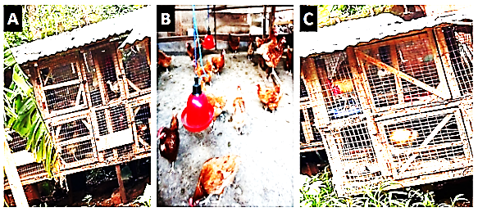
Plate 1: Intensively managed chickens examined for ectoparasites. [A] Broiler chicks on wooden Cage, [B] Hens on deep litter, and
[C] Cocks on wooden Cage
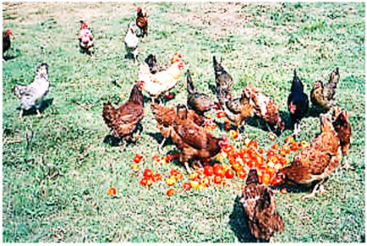
Plate 2: Cross-section of Free-range chickens examined for ectoparasites

The external surfaces of all sampled chickens were inspected for ectoparasites as described by Ikpeze et al. (2008). The head, eyelids, combs, necks, feathers, breast, legs and other external surfaces of the chicken were examined visually for ectoparasites and their effects on preferred sites. Ectoparasites observed were recovered, emptied on a filter paper and photographed, with their relative sizes millimeters. They were also examined under x10 and x40 objective lens, to capture their identification features. Briefly, ectoparasites, mostly lice found on different parts of chickens, were collected using a blunt forceps, and then transferred to a collecting labeled screw-caped jar containing 75% ethanol to which 5 drops of glycerin were added to prevent the specimens from becoming brittle as the alcohol evaporates. The specimens were taken to the Department of Parasitology and Entomology Laboratory, Nnamdi Azikiwe University Awka, and emptied in labeled petri-dishes. Each ectoparasite was mounted on a glass slide stained with lactophenol, viewed under a dissecting microscope for their taxonomic structures used for identification.
RESULTS
Ectoparasites found on chickens: The six species of ectoparasites recovered from chickens studied were identified as Wing lice (Lipeurus caponis), Shaft lice Menapon gallinae, Body lice (Menacanthus stramineus), Chicken mite Dermanyss gallinae, Depluming Mite (Knemidocoptes gallinae), and Stick-tight flea (Echidnophaga gallinacae). These ectoparasites are shown in Plates 3 to 9 inclusive, as follows:
Table 1: Ectoparasites recovered from chickens examined
s/n | Ectoparasites recovered from chickens |  | Poultry Management system
s/n | Common name | Species of ectoparasite | Intensive | Free-range
1 | Wing Louse | Lipereus caponis | Present | Present
2 | Shaft Louse | Menapon gallinae | Present | Present
3 | Body Louse | Menacanthus stramineus | Present | Present
4 | Chicken mite | Dermanyss gallinae | Not observed | Present
5 | Depluming Mite | Knemidocopte gallinae | Not observed | Present
6 | Stick-tight Flea | Echidnophaga gallinacean | Not observed | Present
The six species of ectoparasites identified are presented in the Plates 1 – 9 as follows:
- Wing lice Lipeurus caponis viewed under the microscope with an average length of 2.5mm (Plates 3&4).
- The shaft lice Menapon gallinae recovered from intensively reared chickens; measured between 1.0mm and 1.5mm in length (Plate 5).
- The Body lice Menacanthus stramineus recovered from free-range chickens; measured between 1.5mm and 3.1mm in length (Plate 6)
- Microscopic view of chicken mite Dermanyss gallinae from Free-range chicken (Plate 7).
- Depluming Mites Knemidokoptes gallinae at the base of feathers on the back of free-range chicken (Plate 8).
- Stick-tight fleas Echidnophaga gallinacean on the comb of cock on free-range (Plate 9)
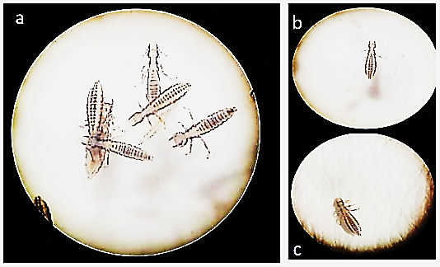
Plate 3: Microscopic views of Wing lice Lipeurus caponis [a, b & c]
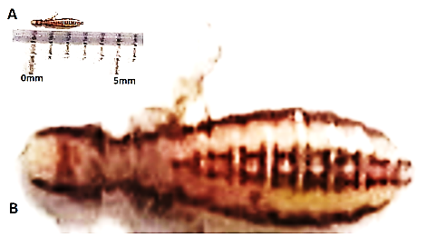
Plate 4: Wing lice Lipeurus caponis (≡ 2.5mm long) enlarged to show the characteristic slender body and head region.

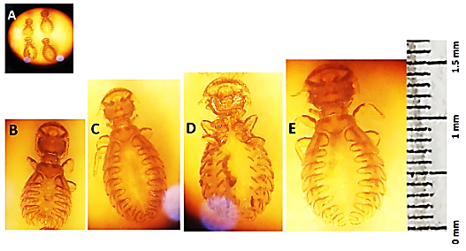
Plate 5: Microscopic view [A] of Shaft lice, Menapon gallinae; different sizes enlarged [B, C, D & E] showing characteristic head and body 1mm to 1.5mm

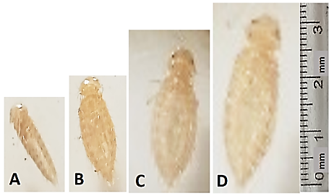
Plate 6: Different sizes of the Body lice, Menacanthus stramineus (1.5mm - 3mm in length). Recovered from free-range chickens

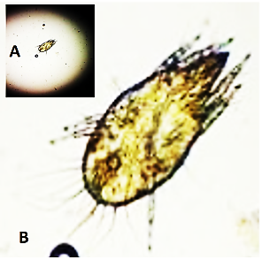
Plate 7: Microscopic view [A] of chicken mite Dermanyss gallinae from Free-range chicken, enlarged [B] to show identification features
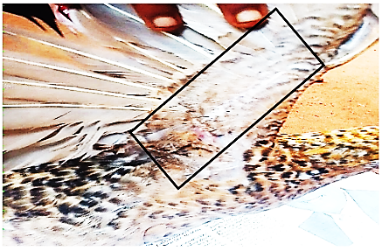
Plate 8: Depluming Mites Knemidokoptes gallinae damaging base of feathers on the back of free-range chicken
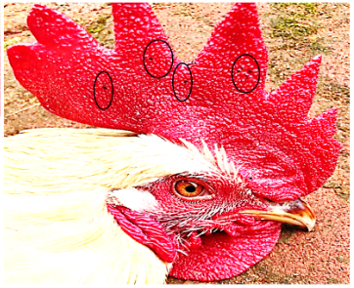
Plate 9: Stick-tight fleas Echidnophaga gallinacean on the comb of a cock
Prevalence of ectoparasites on chickens: Overall prevalence of ectoparasites on chickens examined (Table 1) indicates that 61.4% and 68.9% of intensively and extensively reared chickens were respectively infested with different species of ectoparasites.
Frequency of ectoparasites on preferred sites: Frequency of ectoparasites on preferred sites among intensively-reared chickens is shown in Table 3. Wing lice, Shaft lice, and Body lice accounted for 22.4%, 44.7% and 32.9% of all lice infestations, respectively. Similarly, frequency of ectoparasites on preferred sites among free-range chickens is shown in Table 4. Contribution to all infestations were Wing lice (14.2%), Shaft lice (20.9%), Body lice (27.6%), chicken mites (10.7%), Depluming mites (7.3%), and Stick-tight fleas (19.3%). Generally, ectoparasites were more frequently recovered from the wings, followed by the body. The stick-tight flea was observed only on the head while Depluming Mites infested only the wings.
Effects of ectoparasites on preferred sites: Undesirable effects of ectoparasites observed on infested chickens during the study included restlessness due to irritation, sluggishness, stunting, feather damage and feather loss.
Table 2: Overall prevalence of ectoparasites on chickens examined
Chicken  types | Intensive system |  |  | Extensive system
Chicken  types | Examined (No.) | Infested |  | Examined (no.) | Infested
Chicken  types | Examined (No.) | (No.) | (%) | Examined (no.) | (No.) | (%)
Chicks | 10 | 2 | 20.0 | 28 | 10 | 35.7
Broilers | 39 | 26 | 66.7 | NA | NA | NA
Cocks | 21 | 16 | 76.2 | 38 | 26 | 68.4
Hens | 31 | 18 | 58.1 | 56 | 48 | 85.7
Total | 101 | 62 | 61.4 | 122 | 84 | 68.9
NA: Not applicable
Table 3: Frequency of ectoparasites on preferred sites on intensively-reared chickens
Sites | Frequency (f) of ectoparasites on preferred sites |  |  | Total  (f) | (f) %
Sites | Wing louse | Shaft louse | Body louse | Total  (f) | (f) %
Comb | 0 | 0 | 0 | 0 | 0.0
Wattle | 0 | 0 | 0 | 0 | 0.0
Eyelids | 0 | 0 | 0 | 0 | 0.0
Wings | 20 | 18 | 8 | 46 | 27.05
Body | 10 | 26 | 42 | 78 | 45.9
Shaft | 8 | 32 | 6 | 46 | 27.05
Total (f) | 38 | 76 | 56 | 170 | 100
(f)% | (22.4) | (44.7) | (32.9)
Table 4: Frequency of ectoparasites on preferred sites on free-range chickens
Sites | Frequency (f) of ectoparasites on preferred sites |  |  |  |  |  | Total  (f) | (f) %
Sites | Wing louse | Shaft louse | Body louse | Chicken mite | Depluming Mites | Stick-tight fleas | Total  (f) | (f) %
Comb | 0 | 0 | 0 | 0 | 0 | 46 | 46 | 9.3
Wattle | 0 | 0 | 0 | 0 | 0 | 32 | 32 | 6.5
Eyelids | 0 | 0 | 0 | 0 | 0 | 17 | 17 | 3.4
Wings | 52 | 45 | 88 | 12 | 36 | 0 | 233 | 47.3
Body | 10 | 26 | 42 | 32 | 0 | 0 | 110 | 22.3
Shaft | 8 | 32 | 6 | 9 | 0 | 0 | 55 | 11.2
Total | 70 | 103 | 136 | 53 | 36 | 95 | 493 | 100
(%) | (14.2) | (20.9) | (27.6) | (10.7) | (7.3) | (19.3)

DISCUSSION
The wide range of ectoparasite species found among chickens in this study area have been frequently reported from other regions of Nigeria, probably due to the fact that the species are highly adapted to hot and humid environment in Nigeria (Fabiyi, 2008). Presence of these ectoparasites may also result from inability of some farmers to implement parasite control measure and the occurrence of poor hygiene in chicken houses (Mungube et al., 2015). The predominance of lice can be attributed to their direct mode of transmission through close contact among chickens because we observed that caged birds were overcrowded while free-range chickens were often housed together at night, facilitating the spread of lice. Bala et al. (2011) had reported that chickens packed in same cage in large number than the space can contain enabled ectoparasite to move freely from one chicken to the other at ease. Mite infestations were rare in this study, perhaps due to the habit of mites feeding on host’s blood during the night and hiding in the environment during the day (Okeke et al., 2019). Low mite infestations in free-range systems may be possibly due to the chickens’ grooming behaviours – ‘sand bathing’– which can help reduce mite loads have also been reported.
Overall prevalence of ectoparasites on chickens examined under intensive system in this study, though high, was lower than on free-range chickens (Table 2). Broilers were not encountered among free-range chickens. The fact remains that broilers were seldom kept on free-range because infestation with ectoparasites such as mites and lice can affect their rapid growth and lead to significant health problems. Our result that hens on free-range had highest infestation rate, followed by cocks in intensive management, may be due to the fact that cocks and hens are hardy, and require longer time to mature or lay eggs, respectively. So cocks and hens face the risk of acquiring higher ectoparasite infestation than other groups of chickens.
On the effects of ectoparasites on chickens, the group of Lice reported in this study have the capacity of reproducing quickly and causing large scale outbreaks (Ruff, 2000). They are often found in specific regions of the chicken’s body which provide the warmth and protection necessary for lice to thrive and adapt to live within the feathers and plumage of chickens, where they feed on feathers, dead skin cells, or blood, depending on the species (Okeke et al., 2019). Since lice spend their entire life cycle on the host, chickens infested with lice often exhibit signs of restlessness, constant preening, feather pecking, weakened immune system, and more susceptible to other diseases (Olawale & Nnamdi, 2020).
Mites are well-known feed on the host’s blood during the night and hide in the environment during the day (Okeke et al., 2019). The common red mite (Dermnayssus gallinae) reported in this study is one of the most destructive mites affecting free-range chickens. It is found on domestic fowl throughout the world (Opara et al., 2014) but hides in cracks and crevices during the day and crawls onto the host at night for a blood meal (Okeke et al., 2019)) leading to anemia and weakened immune responses (Olawale & Nnamdi, 2020). Depluming mite (Knemidocoptes gallinae) reported in this study is known to cause severe itching, leading to feather loss as chickens pull out their own feathers to alleviate discomfort (Nnaji & Okeke, 2020). Mite infestations in free-range chickens are often overlooked due to their small size but can lead to significant health issues such as irritation, feather loss, weight loss, and even death in severe cases (Odo et al., 2020). Red Mite (Dermanyssus gallinae) seen in this study has been reported as one of the most destructive mites affecting free-range chickens since it feeds on blood, causing significant blood loss, leading to anemia and even death in severe cases (Olawale & Nnamdi, 2020). Red mites also hide in the coop during the day and feed at night (Okeke et al., 2019)), making it difficult to be sampled from chickens in the daytime.
The stick-tight flea (Echidnophaga gallinacae) reported in this study normally attach to the unfeathered sites such as combs, wattles, nictitating membrane (Ikpeze et al., 2008). Mouthparts of stick-tight fleas embed deeply into the skin of the host to feed for days to weeks thereby inducing irritation, restlessness and anaemia by their sucking activities and, in severe cases, blindness when the nictitating membranes of the host are damaged (Obasi and Nwafor, 2020; Ikpeze et al., 2008).
Infested chickens, especially those with visible signs of feather loss, weight loss, or skin wounds, fetch lower prices in the market because consumers prefer healthy-looking birds (Okeke et al., 2019). As egg production declines due to parasite infestations, farmers experience a direct reduction in income from egg sales. Eggs laid by infested chickens may also be of lower quality, further reducing their marketability and overall farm profitability (Nnaji & Okeke, 2020). Reduced productivity in terms of both egg quantity and quality can lead to long-term financial losses, especially for farmers reliant on egg production as their primary source of income (Olawale and Nnamdi, 2020).
CONCLUSION
The study serves to create awareness on the impact of ectoparasite infestations on chickens in the study areas. It also emphasizes the need for better management practices by poultry farmers with regard to ectoparasite control for improved poultry production.
REFERENCES
Agbo, C. I., & Onah, P. J. (2018). The contribution of chickens to rural livelihoods in Nigeria. Nigerian Journal of Animal Science, 50(2), 115-123.
Agu, J. U., Ezeilo, C. M., & Umeh, M. O. (2021). The role of free-range chickens in household food security in rural Nigeria. Nigerian Journal of Agricultural Sciences, 47(3), 92-105.
Ahaotu, E., Aturuchi, W., Unagu, A., Uzegbu, H. (2019). Economic Importance and Widespread of Ectoparasites Infestation in Indigenous Chickens (Gallus gallus domestics). A study from selected local Government Council and States in Nigeria. Sustainability Agriculture Food and Environment Research, 7(2):17-31.
Bala, A.Y., Anka, S.A., Waziri, A, and Shehu, H. (2011). Preliminary survey of Ectoparasites Infesting Chicken (Gallus domestica) in four areas of Sokoto Metropolis. Nigerian Journal of Basic and Applied Sciences. 19(2):173-180.
Fabiyi, J.P (2008): Arthropod parasite of domestic fowl in the Jos plateau Nigeria tropical .animal helminth production 12:193-194.
Ikpeze, O. O., Amagba, I. C and Eneanya,C . I (2008). Preliminary survey of Ectoparasite of Chickens in Awka, South-Eastern Nigeria. Animal Research International 5(2):848-851.
Jamilu, R.Y., Salusi, U.S and Jacinta, N.I. (2018). Prevalence and host related risk factors of ectoparasites on chickens in Dutsinma Local Government area Katsina State. FUDMA Journal of Agriculture and Agricultural Technology, 4(2):200-206.
Mungube, E.O, Baun, S.M, Tenhagen, B.A, Wamae L,M, Nzioka SM, Muhammed L, Nginyi JM (2008). Prevalence of Parasites of the Local Scavenging Chickens in a Selected Semi-Arid Zone of Eastern Kenya. Tropical Animal Health Production. 40:101-109. https://doi.org/10.1007/s11250-007-9068-3.
Nnadi, P.A and George, S.O. (2010). A cross-sectional survey on parasites of chickens in selected villages in the sub-humid zones of South-Eastern Nigeria. Journal of Parasitology Research, 10(5): 1-6.
Nnaji, F. C., & Okeke, J. O. (2020). Biological control of ectoparasites in poultry systems. Nigerian Veterinary Journal, 54(2), 130-138.
Nnamdi, F. C., & Nwafor, A. J. (2020). Organic nature and disease resistance of free-range chickens: A comparative study with commercial broilers in Nigeria. Nigerian Veterinary Journal, 51(2), 58-67.
Nwankwo, A. O., & Eze, O. P. (2020a). Impacts of chicken farming systems on poultry welfare and productivity: A case study in Nigeria. Nigerian Agricultural Review, 38(1), 48-55.
Nwankwo, A. O., & Eze, O. P. (2020b). Prevalence and impact of ectoparasites on free-range poultry in southeastern Nigeria. Nigerian Journal of Veterinary Parasitology, 44(1), 59-68.
Obasi, P. O., Eze, F. A., & Obi, M. N. (2020). Health challenges associated with free-range poultry in the tropics: A review. Nigerian Journal of Tropical Animal Health, 54(3), 89-96.
Odo, B. C., Nweke, J. O., & Eze, N. P. (2020). Ectoparasitic infestations in free-range chickens in rural Nigeria: Prevalence and control strategies*. Nigerian Journal of Poultry Science, 42(2), 110-118.
Okechukwu, Prisca C and Ikpeze, O.O (2020). Ectoparasites found on Intensively reared chickens at semi urban Emene in South-Eastern Nigeria. The Biomedical Diagnosis, 4(2):92-101 www.thebiomedicaldiagnostics.org.
Olajide, O. A., Iwu, E. O., & Onuoha, R. (2020a). Environmental factors contributing to ectoparasitic infestations in free-range chickens. Nigerian Journal of Ecology, 51(2), 85-93.
Olajide, O. A., Iwu, E. O., & Onuoha, R. (2020b). Free-range poultry and ectoparasite infestation: The case of local chickens in southwestern Nigeria. Nigerian Journal of Veterinary Medicine, 49(4), 111-120.
Olawale, T. A., & Nnamdi, E. P. (2020). The impact of ectoparasites on rural poultry productivity in Nigeria. Nigerian Journal of Agricultural Sciences, 45(4), 101-110.
Ruff, O. Roepstorfi, A., and Permin, A. (2000). Epidemiology of gastrointestinal helminths.of backyard chickens in Denmark. Veterinary Parasitology, 129(3-4), 227-238.
Umeh, C. A., Nwachukwu, M. N., and Ononogbo, J. O. (2020). Control strategies for ectoparasites in free-range chickens: A review. Nigerian Journal of Poultry Research, 68(1), 120-127.
Usmana, M., Fabiyia, J. P., Mohammeda, A.A., Merab, U.M., Mahmudaa, A., Alayandea, M.O. and Danmaigoro, A. (2012). Ectoparasites and haemoparasites of chickens in Sokoto, northwestern Nigeria. Scientific Journal of Zoology, 1(3), 74-78.

