Photo chemically Formed Protocell-like Model “Jeewanu”: A Potential Model in Synthetic Biology and Origin of Life Research

Abstract
The quest to elucidate the origin of life has given rise to numerous models that explore prebiotic chemistry, cellular compartmentalization, and protometabolism. Among these, the Jeewanu model—first introduced by Krishna Bahadur in the 1960s—presents a unique photochemically driven protocell system formed from simple inorganic salts, organic compounds, and solar radiation. Despite historical neglect and scientific skepticism, Jeewanu exhibits several hallmark features of living systems, including self-assembled membranes, catalytic activity, nutrient uptake, and environmentally driven growth and division. This study revisits Jeewanu through the lens of modern synthetic biology, assessing its structural components, functional behaviors, and alignment with contemporary origin-of-life frameworks. Comparative analyses highlight Jeewanu’s potential to bridge metabolism-first and replicator-first models, facilitated by its capacity to generate proton gradients, encapsulate biomolecules, and exhibit vesicle-based dynamics. We further explore its integration into the Design–Build–Test–Learn (DBTL) cycle, where Jeewanu serves as a minimal, bottom-up platform for prototyping artificial cellular systems. Applications in astrobiology, drug delivery, and bioengineering underscore its continued relevance, while ethical and reproducibility challenges warrant careful governance. Our findings advocate for the scientific reevaluation of Jeewanu using current tools in spectroscopy, systems biology, and machine learning to standardize protocols and validate its biogenic properties. By repositioning Jeewanu within the scope of systems chemistry and synthetic biology, this work highlights its value not only as a historical model but also as a contemporary framework for investigating the emergence and engineering of life.

Keywords: Jeewanu, synthetic biology, protocell, origin of life, photochemistry, protometabolism, bottom-up approach, artificial cell systems

1. Introduction
The question of how life originated from non-living matter remains one of the most profound and enduring mysteries in science (Mandelbaum et al., 2022). The transition from simple organic compounds to complex, self-sustaining biological systems is not only fundamental to understanding our own origins but also crucial to fields such as astrobiology, synthetic biology, and systems chemistry (Nganso et al., 2022). Numerous hypotheses have emerged to explain this transition, ranging from the replicator-first theories that emphasize the emergence of informational molecules such as RNA, to metabolism-first approaches that prioritize autocatalytic and energy-transducing systems (Froese et al. 2014; Preiner et al. 2020).
Among the exploratory models developed in the 20th century, the concept of Jeewanu—a term meaning "particles of life" in Sanskrit—holds a unique place. Introduced by Indian chemist Krishna Bahadur in the early 1960s, the Jeewanu were photo chemically synthesized, cell-like vesicles produced under prebiotic conditions from simple inorganic and organic components in the presence of sunlight and minerals (Grote 2011). These particles were observed to exhibit several life-like features such as a semi-permeable membrane, metabolic activity, growth, and division—making them one of the earliest protocell models that attempted to experimentally simulate the transition from chemistry to biology(Choi et al., 2021). Bahadur's work paralleled other early artificial life endeavors, including the coacervates of Oparin and the micellar systems of Fox, though it remained largely under recognized in mainstream scientific discourse (Peretó 2016; Lazcano 2018).
With the advent of synthetic biology as a distinct interdisciplinary field, the principles underlying Jeewanu formation have gained renewed relevance. Synthetic biology today employs both top-down approaches (modifying existing organisms) and bottom-up approaches (constructing life-like systems from non-living components) to study and engineer biological phenomena (Peng et al. 2023; Cubillos-Ruiz et al., 2021). The Jeewanu model, which belongs to the latter category, represents an early attempt at protocell engineering through photochemical routes—a strategy that resonates with recent efforts to mimic early Earth conditions in laboratory settings to study abiogenesis (Dalai and Sahai 2020; Budin et al. 2012).

1.1 Research Gap
While modern protocell research has made significant progress in understanding membrane self-assembly, compartmentalization, and primitive metabolism, few models integrate the photochemical aspect of prebiotic synthesis in as much detail as the Jeewanu. Contemporary studies often focus on lipid-based vesicles or coacervates that replicate individual aspects of cellular life but may not fully capture the energy transduction and self-sustaining behaviors observed in Jeewanu (Szostak 2011; Chen et al. 2022). Moreover, the scientific literature largely lacks a systematic reassessment of Jeewanu in the context of modern synthetic biology frameworks, such as the Design–Build–Test–Learn (DBTL) cycle, or its integration with machine learning, systems biology, and computational modeling (Palacios et al. 2025; Chew and Marucci 2024). There is also a dearth of comparative studies evaluating the Jeewanu model alongside newer synthetic protocell constructs for potential biotechnological applications, including drug delivery, minimal cell design, and artificial photosynthesis.

1.2 Rationale of the Study
This study seeks to address these gaps by (i) critically analyzing the Jeewanu model in light of advancements in synthetic biology and origin-of-life research, (ii) identifying its unique contributions to prebiotic modeling, particularly through photochemical synthesis and metabolic mimicry, and (iii) evaluating its feasibility as a platform for designing next-generation synthetic cells. By bridging historical models with contemporary scientific methodologies, this paper aims to reassess the scientific and philosophical value of the Jeewanu as more than just a historical curiosity, but as a potential foundation for future explorations into synthetic life. Furthermore, in the era of increasing interest in astrobiology and the search for extraterrestrial life, the Jeewanu model may offer insights into the types of proto-organisms that could arise in environments rich in solar energy, simple organics, and catalytic minerals.
In doing so, this research aspires to contribute to the broader discourse on the origins of life, minimal cell systems, and the synthetic reconstitution of biological functions—domains where the Jeewanu could serve as a model system for experimental and theoretical investigations alike.

1.3 Research Objectives
- To examine the structural and functional features of Jeewanu protocells.
- To explore the historical context and origin-of-life relevance of the Jeewanu model.
- To analyze photochemical energy conversion and proto metabolic activity in Jeewanu.
- To evaluate Jeewanu's alignment with the Design–Build–Test–Learn (DBTL) synthetic biology cycle.
- To identify modern applications of Jeewanu-inspired systems in science and technology.
- To highlight limitations and reproducibility issues in Jeewanu experiments.
- To propose modern strategies for revitalizing and validating Jeewanu research.

2. Historical Foundations of the Jeewanu Model
The origin of life has long fascinated scientists, prompting the development of numerous models that attempt to simulate the processes by which life may have emerged from non-living matter. Among these, one of the earliest and most intriguing experimental attempts was undertaken by Indian chemist Krishna Bahadur during the 1960s. Bahadur's research led to the development of microscopic, membrane-bound structures known as "Jeewanu", a Sanskrit term meaning "particles of life." These entities were synthesized photo chemically under conditions that attempted to mimic the prebiotic Earth—utilizing simple inorganic salts, organic precursors such as paraformaldehyde and citric acid, and sunlight as an energy source (Grote 2011).
The photochemical synthesis employed by Bahadur involved exposing aqueous mixtures containing inorganic salts and organic compounds to sunlight in the presence of catalytic agents such as molybdenum and tungsten compounds. Under these conditions, vesicle-like structures were observed to spontaneously form. These structures, the Jeewanu, were notable for displaying several life-like behaviors, such as growth in size, self-replication through division, selective permeability, and catalytic activity. Bahadur reported the presence of amino acids, peptides, nucleic acid bases, and phospholipid-like compounds within these vesicles, which led him to propose that the Jeewanu represented a primitive form of life (Grote 2011).
Conceptually, Bahadur's Jeewanu bear significant resemblance to the coacervate theory advanced by Aleksandr I. Oparin, a Soviet biochemist who postulated that life originated from spontaneously formed droplets of organic molecules that underwent further chemical evolution. Both Jeewanu and coacervates are non-genetic protocell models that emphasize the role of compartmentalization and self-organization under abiotic conditions. However, while coacervates were largely based on the spontaneous aggregation of polymers, Jeewanu introduced a photo chemically-driven synthetic pathway, which more closely aligns with modern prebiotic chemistry and synthetic biology frameworks (Jacoby 2022).
Despite the innovative nature of Bahadur’s work, his experiments were met with considerable skepticism in mainstream scientific circles, particularly in the West. Several factors contributed to this skepticism: (i) the absence of rigorous biochemical characterization tools at the time, (ii) limited peer-reviewed documentation of experimental reproducibility, and (iii) the geopolitical isolation of Indian science from dominant international scientific networks during the Cold War period. Consequently, the Jeewanu experiments were often overlooked in the broader discourse on abiogenesis and synthetic biology (Grote 2011; Jacoby 2022).
Nevertheless, in recent years, there has been renewed interest in historical protocell models like the Jeewanu, as they embody many principles that have resurfaced in contemporary origin-of-life studies. The Jeewanu model offers early empirical evidence that life-like structures with rudimentary metabolic and structural features can emerge from abiotic processes, particularly those driven by light energy—an area of growing importance in photobiological and synthetic cellular systems. In light of emerging interdisciplinary approaches that integrate prebiotic chemistry, systems biology, and synthetic construction, the Jeewanu model deserves reevaluation and reintegration into modern origin-of-life research.
3. Structural and Functional Characteristics of Jeewanu

3.1 Membrane Composition and Morphology
A fundamental characteristic of the Jeewanu model that aligns it with modern protocell systems is its capacity to form self-assembled membrane structures from simple amphiphilic molecules. These membrane-bound vesicles are essential for compartmentalization, a critical feature of cellular life that allows for the maintenance of internal environments distinct from the surroundings, and supports key biological processes such as energy conversion, catalysis, and molecular transport.
The membrane composition of Jeewanu-like protocells primarily consists of amphiphilic molecules, such as fatty acids, phospholipids, and related single-chain lipids, which are considered prebiotically plausible due to their potential availability on early Earth through processes such as Fischer–Tropsch-type synthesis or delivery via meteorites (Budin et al. 2012). These molecules spontaneously assemble into bilayer membranes under aqueous conditions due to hydrophobic interactions, forming vesicular structures capable of encapsulating solutes and biomolecules. The self-assembly process is thermodynamically driven and requires no external biological machinery, which makes it particularly relevant to models of abiogenesis.
Moreover, these membranes exhibit phase transition behaviors, wherein their structural organization shifts in response to changes in temperature, pH, amphiphile concentration, or the presence of divalent metal ions. Such phase transitions give rise to a range of vesicle morphologies, including spherical micelles, multilamellar vesicles, tubules, and even more complex structures such as pearling and helical nanostructures (Chen et al. 2022). These transformations are not merely morphological curiosities but have significant implications for protocell functionality. For example, the formation of pearled structures may facilitate vesicle fission or budding, enabling primitive division—a property observed in some Jeewanu experiments.
Furthermore, these membrane structures demonstrate selective permeability, allowing small molecules and ions to traverse the membrane while retaining larger macromolecules. This semi-permeability is vital for creating a chemical gradient across the membrane, which is a prerequisite for metabolic processes and energy generation. The dynamic nature of such primitive membranes also permits the incorporation of additional lipids or amphiphilic molecules from the surrounding environment, leading to membrane growth, an essential step toward achieving self-replication and evolutionary adaptation.
Collectively, the ability of Jeewanu to form stable, adaptable, and functionally relevant membrane-bound structures establishes a foundational platform for studying protocell behavior under prebiotic conditions. These membrane characteristics not only simulate early cellular environments but also position Jeewanu as a valuable experimental system within the framework of bottom-up synthetic biology.
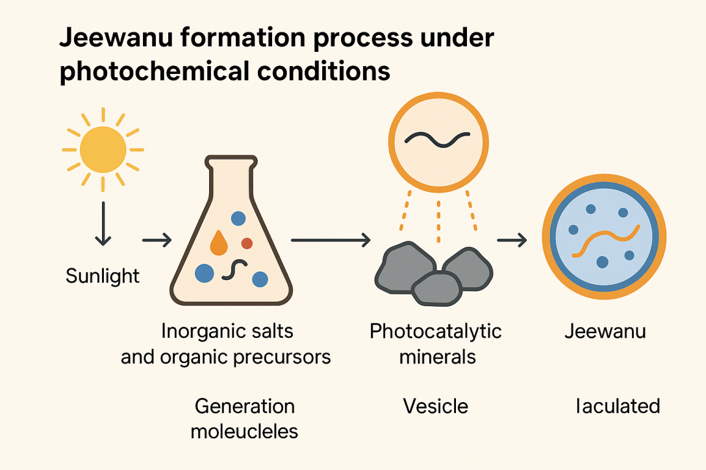
Figure 1. Schematic representation of Jeewanu formation under photochemical conditions, illustrating the role of sunlight, inorganic precursors, and photocatalytic minerals in vesicle generation.

3.2 Protometabolism and Photocatalysis
A critical step in the emergence of life from non-living matter involves the development of protometabolic networks—primitive systems capable of capturing energy from the environment and converting it into chemically useful forms. In the case of the Jeewanu model, the role of photochemistry is particularly significant. The experimental system pioneered by Krishna Bahadur utilized sunlight as a source of energy, reflecting the likely availability of photonic energy on the prebiotic Earth. This approach places the Jeewanu within a rare category of protocell models that incorporate light-driven energy transduction mechanisms to initiate and sustain proto-biological functions.
Recent research in origin-of-life studies has reinforced the plausibility of such mechanisms, highlighting the capacity of photocatalytic minerals to facilitate redox chemistry across protocell membranes. Dalai and Sahai (2020) demonstrated that semiconducting minerals, such as titanium dioxide and zinc sulfide—often present in early Earth environments—can harness sunlight to generate electron-hole pairs, thereby initiating redox reactions. In a prebiotic scenario, these photocatalysts could be embedded within or adjacent to protocell membranes, driving key redox transformations, such as the reduction of nicotinamide adenine dinucleotide (NAD⁺) to NADH, a critical coenzyme in biological metabolism.
This redox conversion is especially noteworthy because it provides a plausible chemical analog to the electron transport chain found in modern organisms. The movement of electrons across a membrane can be coupled to the creation of proton gradients, effectively generating a chemiosmotic potential—the foundational principle behind ATP synthesis in living cells. In the Jeewanu system, though direct evidence for ATP synthesis remains debated, the creation of ATP-like energetic molecules or phosphorylated intermediates may have been facilitated through these primitive redox and proton-transducing mechanisms.
Such processes collectively represent the early form of what can be termed “protometabolism,” a network of simple chemical reactions capable of capturing, storing, and utilizing energy in a regulated manner. This sets the Jeewanu apart from many other prebiotic models that focus solely on structural assembly or encapsulation, by integrating a functional metabolic dimension. The significance of this lies not only in demonstrating a higher level of system complexity but also in supporting the metabolism-first hypothesis of life's origin, which suggests that self-sustaining chemical cycles preceded genetic information in the evolutionary timeline.
Additionally, the light-driven redox chemistry observed in Jeewanu-like systems presents exciting possibilities for synthetic biology, especially in the construction of photoresponsive protocells that mimic photosynthesis. The coupling of membrane-bound energy conversion with internal chemical reactions enables researchers to engineer minimal systems capable of autonomous operation and self-maintenance—essential traits for any form of synthetic life.
In summary, the photocatalytic protometabolism observed in the Jeewanu model represents a critical advance in prebiotic modeling. It demonstrates that not only structural, but also energetic and metabolic functions can arise under plausible early Earth conditions through simple, sunlight-driven chemical systems. This further positions Jeewanu as a valuable experimental platform for exploring the origins of bioenergetics and the early evolution of metabolism.

3.3 Replication and Division
One of the most crucial characteristics distinguishing living systems from non-living matter is the capacity for growth and self-replication. In the context of protocell research, the ability of a model system to grow and divide—without the aid of complex genetic machinery—marks a significant step toward understanding the early emergence of autonomous life. The Jeewanu model, as originally described by Krishna Bahadur, exhibited behavior reminiscent of biological replication, including environmentally-induced growth and division, which supports its classification as a prebiotic cell-like system.
In modern synthetic biology, such processes are often analyzed in terms of membrane dynamics—how amphiphilic molecules self-assemble into vesicular structures and respond to environmental stimuli such as changes in osmotic pressure, solvent availability, and amphiphile concentration. In the Jeewanu model, spontaneous growth was observed when lipidic precursors were added to the surrounding solution, resulting in vesicle enlargement. Similarly, environmental changes such as evaporation—mimicking tidal pools or desiccation-rehydration cycles on early Earth—could induce membrane deformation and subsequent vesicle division, forming smaller daughter vesicles from a larger parent structure (Grote 2011).
These phenomena are supported by contemporary theoretical and computational studies that model protocell behavior based on nonequilibrium thermodynamics and reaction-diffusion systems. Serra and Villani (2017) have demonstrated that self-replication can arise spontaneously in catalytic reaction networks, even in the absence of genetic material. In their framework, replication is not a programmed sequence of steps but an emergent property of autocatalytic cycles, compartmentalization, and nutrient influx. Such models show that structural instabilities in lipid membranes, coupled with the internal buildup of osmotic pressure or chemical gradients, can lead to fission-like behaviors that closely resemble biological cell division.
Within the Jeewanu framework, these replication events were not encoded genetically but driven by physicochemical principles, such as surface tension modulation, energy absorption from sunlight, and material accumulation from the environment. The budding process, where smaller vesicles pinch off from a larger vesicle, is particularly significant. It offers a simple, prebiotic mechanism for population expansion and molecular diversification—essential elements for the onset of Darwinian evolution.
Importantly, the implications of such findings extend beyond prebiotic chemistry. In synthetic biology, the replication of artificial cells without relying on genomic templates opens possibilities for minimal life systems, biosensors, and adaptive drug delivery platforms, where replication can be controlled or triggered by environmental signals. The Jeewanu thus provides an early experimental basis for these advanced applications by showcasing that replication-like behavior is achievable with only basic molecular components and suitable external conditions.
In conclusion, the growth and division behavior of Jeewanu contributes significantly to its status as a protocell model. These processes, grounded in environmental responsiveness rather than genetic programming, demonstrate the feasibility of primitive self-replicating systems—a foundational requirement for the origin of life and the evolution of more complex biological systems.

3.4 Encapsulation and Catalytic Activity
A critical step toward the emergence of functional cellular life is the compartmentalization and catalysis of biochemical reactions within enclosed structures. In biological cells, compartmentalization enables the segregation and regulation of metabolic pathways, while catalytic functions—largely facilitated by enzymes—drive biochemical transformations with high specificity and efficiency. The Jeewanu model provides early experimental evidence of both these features, suggesting its relevance not only as a structural protocell model but also as a functionally active chemical system.
One of the fundamental capabilities observed in the Jeewanu protocells was the encapsulation of biomolecules, including amino acids, peptides, and enzymatically active compounds, within membrane-bound vesicles. The formation of such compartments is believed to have occurred spontaneously during the photochemical synthesis process, where amphiphilic molecules—assembled into bilayer membranes—enclosed aqueous domains containing dissolved solutes and reaction intermediates. This physical segregation created an internal reaction microenvironment, which could sustain chemical transformations distinct from those in the bulk solution (Grote 2011).
Recent studies in synthetic biology reinforce the significance of such semi-permeable protocells. Ji et al. (2021) demonstrated that artificial vesicle models, including those with dynamic membrane interfaces, can effectively encapsulate enzymes and support catalytic reactions triggered by specific physicochemical cues. Their research shows that changes in pH, temperature, or ionic strength can activate or suppress catalytic pathways inside synthetic vesicles, demonstrating a rudimentary form of signal-responsive metabolism. These insights lend further credibility to Bahadur’s observations, suggesting that even in the absence of genetic control, chemical environments inside protocells can be engineered or evolve to facilitate organized reaction networks.
In the context of the Jeewanu, catalytic activity was observed through colorimetric changes, redox reactions, and substrate turnover, indicating that enzymatic or enzyme-like behavior emerged spontaneously under prebiotic conditions. It is plausible that photochemically generated redox-active compounds or mineral catalysts within the vesicles acted as primitive enzymes, facilitating reactions such as amino acid synthesis, peptide bond formation, and nucleotide precursor transformation. This aligns with the metabolism-first hypothesis, which posits that self-sustaining reaction networks could precede the evolution of genetic information in early protocells.
Furthermore, the confinement effect within these protocells plays a vital role. Spatial localization of substrates and catalysts in a limited volume enhances reaction kinetics and specificity, a principle widely exploited in modern nanoreactor designs and synthetic cell engineering. The Jeewanu thus serves as a precursor to these innovations by demonstrating that chemical reactivity can be both spatially and temporally regulated within simple protocell systems.
From a synthetic biology perspective, the ability to design catalytic protocells has far-reaching implications in biotechnology, such as programmable bioreactors, therapeutic delivery systems, and artificial metabolic modules. The Jeewanu model, despite its historical origin, provides a tangible basis for these applications by illustrating how compartmentalized catalysis can emerge spontaneously under energy-rich, prebiotic conditions.
In conclusion, the encapsulation and catalytic capabilities of the Jeewanu protocells mark a significant advancement in modeling early biochemical function. These features underscore the system’s potential as a proto-biological reactor, supporting the hypothesis that life could have originated from simple, energy-driven chemical systems capable of internal reaction control and environmental responsiveness.
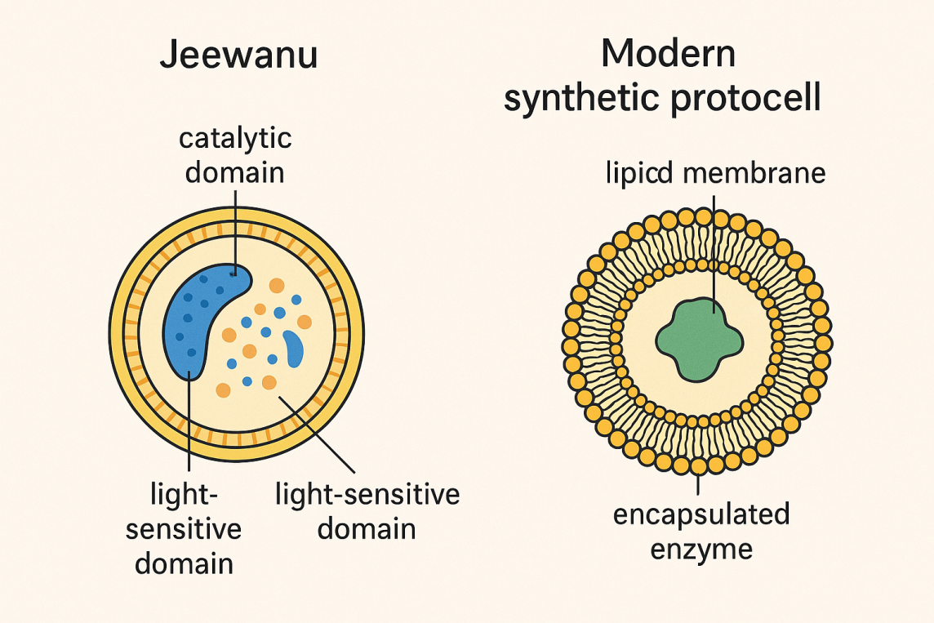
Figure 2. Schematic comparison of Jeewanu and modern synthetic protocell structures, highlighting membrane composition, encapsulated biomolecules, and functional domains.

Table 1: Comparison of Jeewanu Characteristics with Modern Protocell Models
Characteristic | Jeewanu Model | Modern Protocell Models | Remarks
Origin | Photochemical synthesis using sunlight, inorganic salts, and organic precursors | Chemical or biochemical assembly (e.g., fatty acids, RNA, peptides) | Jeewanu integrates environmental energy inputs more directly
Membrane Composition | Amphiphilic molecules forming lipid-like bilayers | Fatty acid vesicles, phospholipids, polymers | Comparable in structural compartmentalization
Energy Source | Solar energy via photocatalytic minerals | Chemical gradients, enzymatic reactions, external energy input | Jeewanu is light-driven, enabling prebiotic plausibility
Metabolic Activity | Redox reactions, NAD⁺ reduction, catalysis by minerals | Encapsulated enzymatic pathways, minimal metabolism | Both demonstrate protometabolism but differ in complexity
Replication/ Division | Spontaneous budding under environmental changes (e.g., evaporation) | Chemically induced division, osmotic stress, or surfactant addition | Jeewanu shows non-genetic, environment-triggered division
Encapsulation | Encapsulates amino acids, peptides, and other biomimetic molecules | Targeted encapsulation of RNAs, enzymes, DNA, or artificial pathways | Modern models allow better control; Jeewanu offers spontaneous encapsulation
Environmental Adaptability | Stable across varying pH and ionic conditions | Tailored for controlled environments or buffers | Jeewanu mimics prebiotic variability more naturally
Information Storage | Suggested presence of nucleic acid precursors | Some contain RNA replicators or DNA plasmids | Modern models include informational systems; Jeewanu remains pre-informational
Reproducibility | Limited independent replication | High reproducibility under lab protocols | Reproducibility is a key limitation of Jeewanu
Technological Integration | Historically experimental; lacks modern instrumentation | Integrated with synthetic gene circuits, modeling, automation | Modern tools enhance scalability and design

4. Integration in Modern Synthetic Biology

4.1 Synthetic Biology Overview
Synthetic biology has emerged as a transformative discipline at the intersection of biology, chemistry, engineering, and computer science, offering powerful frameworks to design and construct novel biological systems or to reconfigure existing ones with enhanced functionalities. At its core, synthetic biology pursues two major approaches for building life-like systems: the top-down and bottom-up strategies. While both aim to understand and replicate biological complexity, their methodologies, design principles, and implications differ significantly.
In the top-down approach, scientists begin with an existing organism—typically a microbial cell—and systematically remove or edit genes to create a minimal or optimized version of life. This technique has been instrumental in producing synthetic genomes, as demonstrated by the synthesis of Mycoplasma mycoides JCVI-syn1.0, a bacterium with a chemically synthesized genome. The top-down strategy benefits from the robustness of evolved cellular machinery and is widely used in industrial biotechnology, metabolic engineering, and biopharmaceutical production (Xiong et al. 2024).
Conversely, the bottom-up approach seeks to construct life-like systems entirely from non-living molecular components, mimicking the putative stages of abiogenesis. This methodology aims to reconstruct minimal cellular life by integrating functional modules—such as membranes, metabolic networks, genetic circuits, and energy systems—into compartmentalized structures that resemble protocells. Bottom-up synthetic biology not only holds promise for artificial life creation but also offers a powerful experimental platform to probe the origin of life and the emergence of biological complexity under prebiotic conditions (Peng et al. 2023).
Within this paradigm, the Jeewanu model finds a natural and compelling position. Originating in the 1960s through the work of Krishna Bahadur, Jeewanu represents one of the earliest attempts to generate self-organizing, cell-like particles from abiotic materials. The model utilized sunlight to photochemically drive the formation of membrane-bound vesicles that exhibited several life-like features including growth, division, selective permeability, and catalytic activity. These behaviors were not externally programmed but emerged from the bottom-up integration of simple molecular precursors, catalytically active minerals, and solar energy. Such spontaneous organization into functional microenvironments reflects the core objectives of modern bottom-up synthetic biology.
Furthermore, current advances in the field increasingly emphasize the design-build-test-learn (DBTL) cycle, where modular components are iteratively optimized to simulate biological processes in minimal systems. The Jeewanu protocells, although developed prior to the formal establishment of synthetic biology, align well with this iterative constructionist logic. They offer a historical precedent and experimental template for exploring how life-like behavior can arise from energy-rich, non-equilibrium chemical systems—especially those lacking genetic material but capable of compartmentalization, metabolism, and growth.
Peng et al. (2023) highlight that successful bottom-up synthetic biology requires not only the assembly of functional modules but also the emergent properties that arise from their interaction—such as dynamic feedback, homeostasis, and environmental responsiveness. These are all properties observed or hypothesized in the Jeewanu particles. Similarly, Xiong et al. (2024) note the shift of synthetic biology from an engineering of parts to a deeper systems-level synthesis of life, which involves recapitulating evolutionary processes in simplified constructs. In this broader view, the Jeewanu model is not merely a historical curiosity but a proto-synthetic system that prefigures and informs contemporary efforts to understand and recreate the early stages of life.
In conclusion, the Jeewanu system exemplifies a bottom-up synthetic biology construct, serving both as a conceptual bridge between abiogenesis theories and modern bioengineering, and as a functional platform to explore the self-organization of life-like systems from prebiotic materials. As synthetic biology continues to evolve toward creating fully artificial cells, the foundational principles demonstrated by the Jeewanu model remain relevant and inspiring.

4.2 Alignment with Design–Build–Test–Learn (DBTL) Cycle
Modern synthetic biology is increasingly structured around the Design–Build–Test–Learn (DBTL) framework, a systematic and iterative cycle derived from engineering disciplines. This approach emphasizes the rational design of biological systems, their physical construction, experimental testing of performance, and learning from the results to inform subsequent design iterations. It facilitates not only precision and reproducibility but also acceleration of innovation across complex biological systems, including minimal cells and protocells. The Jeewanu model, although developed long before the formalization of DBTL, aligns remarkably well with its principles and can be reinterpreted as a proto-DBTL platform for prebiotic and synthetic biology experimentation.
In the Design phase, synthetic biologists specify biological functions—such as compartmentalization, energy capture, or chemical reactivity—and identify molecular components or environmental conditions necessary to achieve those functions. In Bahadur’s original Jeewanu experiments, the functional goals were implicit: creating structures that mimic life-like behavior under sunlight. The use of photochemically active minerals, inorganic salts, and organic precursors represented early decisions in molecular design, intended to emulate plausible prebiotic conditions. Although lacking computational models at the time, Bahadur’s design choices now provide a historical foundation for reverse engineering in current synthetic efforts.
The Build phase involves the actual assembly of designed components into testable systems. For Jeewanu, this included the exposure of aqueous mixtures to sunlight, triggering the formation of vesicle-like particles. These particles demonstrated properties such as selective permeability, catalytic activity, and growth—supporting the utility of photochemical assembly as a synthetic route. In modern terms, this phase can be further enhanced using automated microfluidics, robotic liquid handlers, and in silico models that optimize the stoichiometry and environmental parameters for vesicle formation (Chew and Marucci 2024).
The Test phase focuses on quantifying system behavior. While Bahadur used observational microscopy and rudimentary biochemical assays, today’s tools—such as fluorescence microscopy, mass spectrometry, and microelectrode-based electrophysiology—can enable high-throughput analysis of protocell functions including membrane integrity, enzyme activity, and signal response. These contemporary methods could be used to re-evaluate the Jeewanu system with greater precision and reproducibility.
Most notably, the Learn phase integrates data from experimental testing into machine learning (ML) or statistical models to uncover design rules, optimize outcomes, or predict new configurations. Palacios et al. (2025) emphasize the growing role of machine learning algorithms in the design of synthetic gene circuits, enabling prediction of circuit behavior under diverse conditions. This paradigm can be extended to protocell systems like Jeewanu, where ML could help model photochemical reaction networks, predict vesicle morphology, or suggest optimal catalytic pathways. Such integration transforms Jeewanu from a static historical model into a dynamic testbed for intelligent, iterative synthetic biology.
Moreover, recent advances in the DBTL paradigm have begun incorporating emergent behaviors—such as signal transduction, information processing, and metabolic adaptation—into protocell design. These advances resonate with the reported characteristics of Jeewanu, including light-triggered activity and self-modulating growth. By introducing modules for protocellular communication, energy transduction, or adaptive responses, researchers can engineer increasingly complex behaviors into synthetic cells, a vision already foreshadowed by the multifaceted functionality of the Jeewanu system.
In conclusion, the Jeewanu model, when revisited through the lens of the DBTL framework, stands as an early but significant instance of iterative synthetic exploration. Its alignment with each phase of the cycle—especially in terms of photochemical design and self-organization—demonstrates its potential as a retro-engineered platform for modern synthetic biology. By integrating tools like machine learning and microfluidic screening, future researchers can extend and refine this historical model to explore key principles underlying life’s emergence and engineer novel, autonomous biological systems.
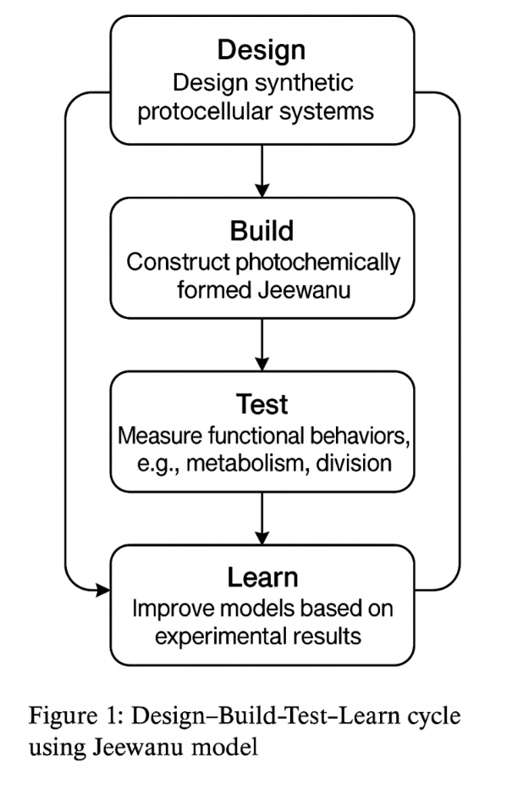
Figure 3. Application of the Design–Build–Test–Learn (DBTL) cycle in the context of Jeewanu research, showcasing its relevance to modern synthetic biology design principles.

5. Jeewanu and Origin of Life Models
The scientific quest to understand the origin of life has been largely shaped by two dominant paradigms: the replicator-first and metabolism-first hypotheses. The former emphasizes the primacy of informational molecules such as RNA or DNA that can store genetic information and replicate with high fidelity (e.g., the RNA world hypothesis), while the latter posits that self-sustaining networks of metabolic reactions likely preceded the emergence of genetic systems (Preiner et al. 2020). Despite decades of research, both models face substantial challenges when treated in isolation—particularly regarding their prebiotic plausibility and capacity for spontaneous emergence.
The Jeewanu model, with its origins in mid-20th-century experimental work by Krishna Bahadur, offers a unique conceptual and empirical bridge between these two schools of thought. Bahadur’s experiments generated membrane-bound vesicles under photochemical conditions, resulting in microstructures that exhibited growth, division, selective permeability, and catalytic activity—all of which are consistent with basic metabolic functionality. Furthermore, reported incorporation of nucleic acid precursors and peptide-like molecules within Jeewanu vesicles suggests an early platform for informational molecule accumulation. This dual capability—rudimentary metabolism alongside potential for molecular replication—positions Jeewanu as a promising hybrid model, integrating key aspects of both the replicator-first and metabolism-first theories.
One of the major contributions of the Jeewanu model to origin-of-life discussions lies in its environmental responsiveness and stability. As noted by Szostak (2011), the early Earth likely presented a physically and chemically heterogeneous environment with fluctuating pH, temperature, salinity, and metal ion concentrations. A robust protocell model must not only self-assemble but also withstand and adapt to such environmental variations. Jeewanu vesicles demonstrated notable stability across a range of such conditions, suggesting that dynamic environmental feedback loops—including wet-dry cycles, solar radiation, and ionic flux—may have played a formative role in protocellular evolution. These fluctuations could have driven cycles of growth and division, selection of more stable structures, and accumulation of functionally advantageous chemistries.
Moreover, the Jeewanu model directly incorporates a crucial factor often underemphasized in early replicator-based models: the role of minerals and ion flux in facilitating both structural integrity and chemical transformations. Stewart and Erastova (2024) highlight the significance of layered mineral surfaces, such as clays and metal sulfides, in catalyzing the formation of proto-biopolymers and stabilizing them against degradation. In Jeewanu synthesis, similar catalytic minerals—such as molybdenum, iron, and tungsten compounds—were used to mediate photochemical reactions. These minerals likely served dual roles: (i) acting as heterogeneous catalysts to drive redox transformations, and (ii) stabilizing membrane structures by mediating ionic interactions with the amphiphilic bilayers. The presence of transmembrane ion gradients further implies a primitive form of chemiosmosis, which may have enabled internal reactions to proceed in an energetically favorable manner.
The integration of metabolic, structural, and catalytic components into a single, responsive, and evolving system is central to current efforts in prebiotic chemistry and synthetic biology. Jeewanu exemplifies this integration by demonstrating that under realistic prebiotic conditions—namely, sunlight exposure, simple organic precursors, and mineral catalysts—a functional protocell can emerge, evolve, and adapt. This aligns with recent interdisciplinary perspectives advocating for a systems-level approach to origin-of-life research, in which compartmentalization, catalysis, environmental responsiveness, and information storage co-evolve rather than emerge sequentially (Preiner et al. 2020).
In conclusion, the Jeewanu model contributes a historically grounded and experimentally testable system that helps bridge the replicator-first and metabolism-first dichotomy. Its capacity for environmentally driven emergence, mineral-facilitated reactions, and proto-metabolic stability makes it an invaluable reference point for contemporary models that seek to unify the physical and chemical origins of life.
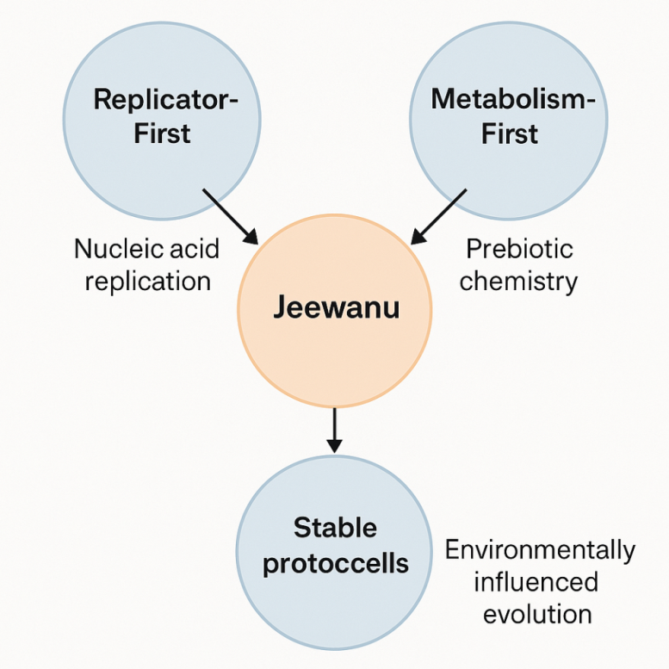
Figure 4. Conceptual diagram positioning the Jeewanu model as an intermediary between the metabolism-first and replicator-first hypotheses in origin-of-life research.

6. Implications for Research and Applications
The study of the Jeewanu model extends beyond its historical relevance and its role in origin-of-life research. As synthetic biology and prebiotic chemistry converge, the Jeewanu protocell gains importance as a foundational construct with implications across a spectrum of scientific and societal domains. These implications encompass theoretical advancements in astrobiology, practical innovations in protocell engineering, and critical considerations in biosecurity and ethical governance.

6.1 Astrobiology
Astrobiology seeks to understand the conditions necessary for life to arise and evolve, both on Earth and elsewhere in the universe. A central component of this field is the use of prebiotic models—experimental systems that simulate how life may have originated under plausible environmental conditions. The Jeewanu model, with its photochemically driven synthesis, spontaneous compartmentalization, and catalytically active microstructures, offers a compelling analog for potential extraterrestrial prebiotic systems.
In many planetary environments—such as the subsurface oceans of Europa and Enceladus, or the surface of Mars—there exists the possibility of simple organic compounds, water activity, and mineral-rich terrains. The Jeewanu model, which relies on light energy, catalytic minerals, and basic molecular precursors, demonstrates how life-like systems could emerge in environments devoid of complex biomolecules or genetic templates, but rich in chemical and energetic gradients. As such, it provides a testable framework to evaluate biosignatures, chemical disequilibria, and vesicular morphologies that might indicate the presence or potential for life beyond Earth.
Moreover, understanding the formation and behavior of Jeewanu-like protocells helps inform the design of space-based life-detection missions, which often rely on detecting patterns of compartmentalization, redox activity, and polymer synthesis as indicators of life or pre-life processes.

6.2 Protocell Engineering
In synthetic biology, the construction of artificial cells—protocells—represents a cutting-edge objective aimed at recreating life-like behaviors from non-living components. Such engineered systems have broad applications in medicine, biotechnology, and environmental science. The Jeewanu model serves as a proto-engineered cell system, offering insights into minimal design strategies for compartmentalization, catalytic function, and environmental responsiveness.
One of the most promising applications of protocell engineering is in targeted drug delivery. Engineered vesicles that mimic cellular membranes can be designed to encapsulate therapeutic agents and release them in response to specific stimuli (e.g., pH, temperature, light). The light-responsive, semi-permeable nature of Jeewanu vesicles provides a natural precedent for such applications, particularly in the development of stimuli-responsive delivery systems that could mimic early protocellular adaptability.
Additionally, protocells based on Jeewanu principles can be tailored for use as biosensors, capable of detecting chemical signals or environmental toxins through embedded catalytic or redox-sensitive elements. These minimal synthetic cells, devoid of complex genetic regulation, offer enhanced safety, lower immunogenicity, and improved tunability compared to living cells, making them attractive for applications in clinical diagnostics and environmental monitoring.
The structural simplicity, robustness, and energy-autonomous behavior observed in Jeewanu also support its potential as a model for autonomous microreactors that can perform localized biochemical reactions or signal amplification in synthetic biochemical circuits.

6.3 Biosecurity and Governance
As synthetic biology advances toward creating increasingly autonomous and life-like systems, it raises significant concerns related to biosecurity, environmental ethics, and governance. The ability to construct synthetic cells, especially those capable of replication and adaptation, necessitates comprehensive frameworks for risk assessment, containment, and societal oversight.
Trump et al. (2021) emphasize the need for anticipatory governance mechanisms that can proactively address the uncertainties and dual-use potential of synthetic life forms. Systems like Jeewanu, which exhibit self-organizing and potentially self-replicating behaviors, highlight the blurring boundaries between chemistry and biology—a challenge for existing regulatory frameworks that are often organism-centric and assume clear distinctions between living and non-living matter.
Furthermore, Porcar and Peretó (2020) argue for the development of ethical guidelines that address not just the risks of synthetic life, but also the philosophical implications of creating life-like systems without evolutionary history. The Jeewanu model, by virtue of its abiotic origin and ambiguous status between life and non-life, poses critical questions: Should synthetic protocells be considered "alive"? What responsibilities accompany their creation and release, even in laboratory settings?
These concerns underscore the need for inclusive dialogue among scientists, ethicists, policymakers, and the public, particularly as models like Jeewanu evolve from experimental curiosities to platforms with real-world applications. Designing bio-confinement strategies, transparent reporting protocols, and international cooperation will be essential to ensuring the safe and responsible advancement of protocell-based technologies.
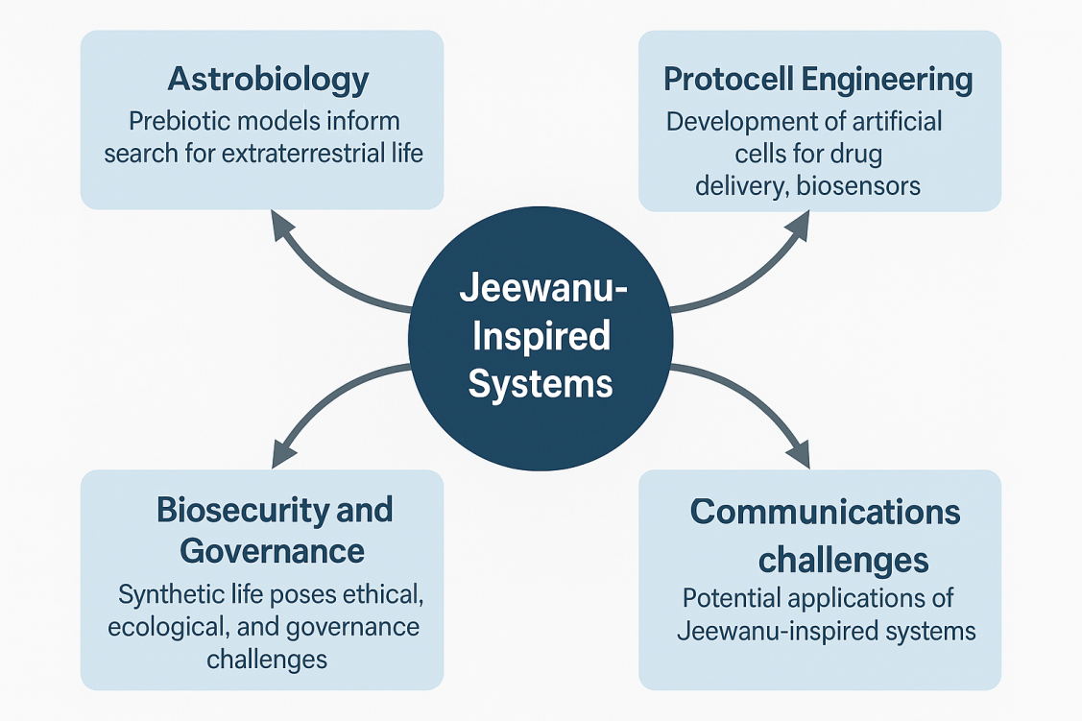
Figure 5. Potential application areas of Jeewanu-based protocell systems, illustrating the translation from prebiotic chemistry to contemporary biotechnology and synthetic biology.

7. Limitations and Challenges
While the Jeewanu model offers compelling insights into the possible pathways of abiogenesis and serves as a foundational construct in protocell research, it is not without its limitations and scientific challenges. As with many pioneering experiments in the mid-20th century, Jeewanu's development occurred in an era lacking the sophisticated instrumentation and analytical rigor available today. This has led to ongoing debates about the interpretability, scientific robustness, and epistemic value of the model within the contemporary framework of synthetic biology and origin-of-life studies.

7.1 Reproducibility of Jeewanu Experiments
A central concern surrounding the Jeewanu model is the limited reproducibility of its experimental outcomes. Although Krishna Bahadur and his team published extensive reports on the formation of membrane-bound vesicles, their composition, and associated life-like behaviors, few independent replications have been documented in peer-reviewed literature. The absence of replication across laboratories—a gold standard in scientific validation—has hindered the integration of Jeewanu into mainstream prebiotic chemistry discourse. Moreover, the lack of standardized protocols, variation in precursor compositions, and uncontrolled exposure to environmental factors such as light intensity and atmospheric gases further compound the problem, making experimental consistency elusive.

7.2 Lack of Full Molecular Characterization
Another key limitation lies in the insufficient molecular characterization of the Jeewanu structures. Bahadur’s experiments predated the development of modern analytical tools such as high-resolution mass spectrometry, nuclear magnetic resonance (NMR) spectroscopy, and cryo-electron microscopy. As a result, critical details about the molecular architecture of the vesicles, the nature and stability of the biomimetic compounds (e.g., peptides, nucleic acid analogs), and the mechanisms driving their metabolic activity remain largely speculative. For instance, while amino acids and nucleotide bases were reportedly present, their stereochemistry, polymerization status, and functional relevance to catalysis or replication were not rigorously established. Without detailed molecular resolution, it is difficult to assess the true biological relevance or chemical novelty of the Jeewanu system.

7.3 Ambiguity in Defining “Life-like” Behavior
Perhaps the most philosophical and conceptual challenge associated with the Jeewanu model is the ambiguity in defining what constitutes “life-like” behavior. The Jeewanu were described as growing, dividing, selectively permeable, and capable of redox-driven catalysis—features that resemble cellular life. However, none of these attributes individually, nor in combination, definitively meet all established biological criteria for life, such as information storage, evolution, and homeostasis. This leads to an ongoing ontological debate: Are Jeewanu merely complex chemical systems, or do they represent a rudimentary form of life?
This ambiguity is not unique to Jeewanu but is common across all protocell models that operate without a genetic framework. Yet, it raises important epistemological and ethical questions about classification, modeling, and interpretation. As synthetic biology moves toward constructing ever more life-like systems, there is a pressing need for refined criteria to demarcate “proto-life” from “non-life”—a task made more urgent by the development of artificial cells with autonomous behaviors.
In conclusion, while the Jeewanu model offers a historically significant and functionally intriguing view into prebiotic protocell formation, its broader scientific acceptance is constrained by limitations in reproducibility, analytical depth, and definitional clarity. Addressing these challenges through modern experimental replication, advanced molecular techniques, and conceptual frameworks will be essential to validate the model and determine its continued relevance in the evolving discourse on the origin of life and synthetic biology.

8. Conclusion
The Jeewanu model, conceived during the mid-20th century by Krishna Bahadur, stands as a pioneering effort to explore the boundary between chemistry and biology through the photochemical formation of protocell-like structures. Despite its origins in a period with limited technological resources, the Jeewanu model remarkably anticipated many principles that are central to contemporary synthetic biology: compartmentalization, protometabolism, catalytic function, and environmentally responsive self-organization.
This research revisited Jeewanu through the lens of modern scientific advancements and evaluated its relevance in the context of origin-of-life models, bottom-up synthetic biology, and protocell engineering. Positioned at the intersection of the replicator-first and metabolism-first paradigms, Jeewanu offers a compelling hybrid framework that supports the emergence of life-like behaviors in the absence of genetic material. Furthermore, the model highlights the importance of photochemistry, mineral-mediated catalysis, and ionic gradients, all of which align with current theoretical and experimental approaches to abiogenesis.
While the Jeewanu system presents unresolved challenges, such as the reproducibility of experiments, lack of high-resolution molecular characterization, and ambiguity in defining life-like behavior, these issues are not insurmountable. With the advent of microfluidics, systems-level modeling, machine learning, and advanced spectroscopic tools, there is substantial opportunity to revitalize and reengineer the Jeewanu system under standardized, analytically rigorous conditions. Re-examining this model through the Design–Build–Test–Learn (DBTL) cycle also enhances its potential as a modular platform for iterative synthetic experimentation.
Beyond its scientific implications, Jeewanu also contributes to broader discussions in astrobiology, bioethics, and governance. As we move closer to designing minimal or artificial cells, the philosophical and regulatory dimensions of life creation become increasingly relevant, underscoring the need for responsible innovation.
In summary, Jeewanu is not merely a historical curiosity but a foundational and underutilized model that can inform both our understanding of life’s beginnings and the creation of novel synthetic systems. By integrating engineering principles, computational modeling, and experimental rigor, future studies can transform Jeewanu into a robust, forward-looking platform that continues to advance the frontiers of synthetic biology and origin-of-life research.

9. References
Budin, I., Debnath, A., &Szostak, J. W. (2012). Concentration-driven growth of model protocell membranes. Journal of the American Chemical Society, 134(51), 20812–20819. https://doi.org/10.1021/ja3085138
Chen, Z., Fan, Y., Chen, Y., Zhang, L., Liu, L., & Wang, Y. (2022). Pearling and helical nanostructures of model protocell membranes. Nano Research, 15(10), 9180–9190. https://doi.org/10.1007/s12274-022-4383-9
Chew, Y. H., &Marucci, L. (2024). Mechanistic Model-Driven Biodesign in Mammalian Synthetic Biology. In Methods in Molecular Biology, 2643, 153–178. https://doi.org/10.1007/978-1-0716-3164-4_11
Dalai, P., &Sahai, N. (2020). A Model Protometabolic Pathway across Protocell Membranes Assisted by Photocatalytic Minerals. The Journal of Physical Chemistry C, 124(22), 11924–11936. https://doi.org/10.1021/acs.jpcc.0c01068
Grote, M. (2011). Jeewanu, or the 'particles of life': The approach of Krishna Bahadur in 20th century origin of life research. Journal of Biosciences, 36(4), 563–574. https://doi.org/10.1007/s12038-011-9091-5
Jacoby, F. R. (2022). Exploratory modeling and indeterminacy in the search for life. European Journal for Philosophy of Science, 12(2), 27. https://doi.org/10.1007/s13194-022-00441-1
Ji, Y., Mu, W., Wu, H., &Qiao, Y. (2021). Directing Transition of Synthetic Protocell Models via Physicochemical Cues-Triggered Interfacial Dynamic Covalent Chemistry. Advanced Science, 8(21), 2101444. https://doi.org/10.1002/advs.202101444
Palacios, S., Collins, J. J., & Del Vecchio, D. (2025). Machine learning for synthetic gene circuit engineering. Current Opinion in Biotechnology, 83, 102950. https://doi.org/10.1016/j.copbio.2024.102950
Peng, L., Zhang, Z., Wang, X., Zhang, Q., & Liu, Y. (2023). Theoretical perspective on synthetic man-made life: Learning from the origin of life. Quantitative Biology, 11, 1–13. https://doi.org/10.1007/s40484-023-00384-4
Porcar, M., &Peretó, J. (2020). Manufactured life: The scientific and social challenges of synthetic biology. Metode Science Studies Journal, 10, 45–51. https://doi.org/10.7203/metode.10.15876
Preiner, M., Asche, S., Becker, S., Cernak, T., Klingl, A., Schmitz, M., & Xavier, J.C. (2020). The future of origin of life research: Bridging decades-old divisions. Life, 10(3), 20. https://doi.org/10.3390/life10030020
Serra, R., &Villani, M. (2017). Models of self-replication. In Understanding Complex Systems (pp. 63–80). Springer. https://doi.org/10.1007/978-3-319-66969-5_5
Stewart, S. V., &Erastova, V. (2024). Understanding the Role of Layered Minerals in the Emergence and Preservation of Proto-Proteins and Detection of Traces of Early Life. Accounts of Chemical Research, 57(4), 689–699. https://doi.org/10.1021/acs.accounts.3c00695
Szostak, J. W. (2011). An optimal degree of physical and chemical heterogeneity for the origin of life? Philosophical Transactions of the Royal Society B: Biological Sciences, 366(1580), 2894–2901. https://doi.org/10.1098/rstb.2011.0140
Trump, B. D., Florin, M.-V., Perkins, E., &Linkov, I. (2021). Biosecurity for synthetic biology and emerging biotechnologies: Critical challenges for governance. In NATO Science for Peace and Security Series C: Environmental Security (pp. 21–38). Springer. https://doi.org/10.1007/978-94-024-2081-2_3
Trump, B. D., Galaitsi, S., Pollock, M., &Linkov, I. (2021). Promoting effective biosecurity governance: Using tripwires to anticipate and ameliorate potentially harmful development trends. In NATO Science for Peace and Security Series C: Environmental Security (pp. 39–57). Springer. https://doi.org/10.1007/978-94-024-2081-2_4
Xiong, Y., Ma, X., Chen, D., Guo, Y., & Zhao, G. (2024). Synthetic biology enablement: From academic development to industrial transformation. Bulletin of Chinese Academy of Sciences, 39(1), 87–101. https://doi.org/10.16418/j.issn.1000-3045.20231206001
Mandelbaum, E., Dunham, Y., Feiman, R., Firestone, C., Green, E. J., Harris, D., ... & Quilty‐Dunn, J. (2022). Problems and mysteries of the many languages of thought. Cognitive Science, 46(12), e13225.
Choi, Y. K., Kern, N. R., Kim, S., Kanhaiya, K., Afshar, Y., Jeon, S. H., ... & Im, W. (2021). CHARMM-GUI nanomaterial modeler for modeling and simulation of nanomaterial systems. Journal of chemical theory and computation, 18(1), 479-493.
Cubillos-Ruiz, A., Guo, T., Sokolovska, A., Miller, P. F., Collins, J. J., Lu, T. K., & Lora, J. M. (2021). Engineering living therapeutics with synthetic biology. Nature Reviews Drug Discovery, 20(12), 941-960.
Nganso, E. N., Yonkeu, R. M., Filatrella, G., & Yamapi, R. (2022). Multi-rhythmic oscillations and correlated noise effects of a self-sustaining biological system. Nonlinear Dynamics, 108(4), 4315-4334.

