Original Research Article

Ginkgo biloba Mitigates Methamphetamine-Induced Oxidative Stress and Hepato-Ileal Toxicity in Wistar Rats

Abstract

Background: Methamphetamine is an active central nervous system stimulant known for its great ability to cause addiction as well as neurotoxicity, often used illicitly for its euphoric effects. On the other hand, Ginkgo biloba is a traditional herbal remedy with many therapeutic benefits. It has been reputed for its hepatoprotective, anti-inflammatory effects, cognitive-enhancing, and antioxidant properties. It has been reported as one of the most sold plants due to its rich content in various bioactive substances.
Objective: The present study investigated the attenuating ability of Ginkgo biloba extract on methamphetamine-induced mucosal oxidative stress and hepato-ileal toxicity in male Wistar rats.
Methodology: Sixty (60) male Wistar rats were unsystematically distributed into five (5) sets of twelve each. First group (the normal control) received normal rat chow; Group 2 received Ginkgo biloba (50 mg/kg body weight); Third group received Methamphetamine (2.0 mg/kg body weight); fourth group received Ginkgo biloba (50 mg/kg body weight) +Methamphetamine (2.0 mg/kg body weight); Group 5 received Ginkgo biloba (100 mg) +Methamphetamine (2.0 mg/kg body weight). Each animal was allowed unhindered access to clean drinking water and normal rat chow ad libitum within 28 days. After this, animals were euthanized, and tissues and blood samples were obtained for histological and biochemical examinations.
Result: The outcomes suggested increased levels of oxidative stress markers and liver enzymes, with cytoarchitecture distortion of intestinal and liver tissues in the methamphetamine-treated groups. On the other hand, the Ginkgo biloba supplementation group showed noticeable improvement, with recovery of intestinal and liver tissues, and notable modulation in liver enzyme activities/levels, as well as up-regulation of in vivo antioxidant armories.
Conclusion: From our investigation, it may be assumed that the presence of rich bioactive chemicals in Ginkgo biloba may be responsible for the modulatory effects on liver enzyme activities/levels that may confer protective effects on the liver and ileal epithelium and may also possibly up-regulate antioxidant defenses in the liver, stomach, and ileum, as found in the animal model used in the study.
Keywords: Methamphetamine, Gingko biloba, oxidative stress, liver enzymes, hepato-ileal protection, Wistar rats.

Introduction:
Methamphetamine (METH) is a synthetically produced, powerful, and highly compelling central nervous system (CNS) stimulant (1). In the CNS, METH increases the amount of monoamine neurotransmitters (dopamine, norepinephrine, and serotonin) in the synaptic cleft, leading to increased excitation of the post-synaptic neurons; this produces reinforcing effects like personal bliss, excitement, and neuromotor mobilization (2). METH is in popular usage among adolescents/youths, with increased public health threats and global concerns (3, 4, 5, and 6). METH has currently been reported as the next highest commonly misused or abused substance globally after cannabis (7). Recent research documented that in every seventeen persons aged (15-64) years globally, one (1) must have used drugs illegally in the past (8). METH has different pharmacokinetic characteristics in its different ways of use. Various routes of administration of METH include swallowing, injection, snorting, smoking (9), and anal insertion (10). Oral ingestion is more prevalent among METH users (11) and this method of administration delivers the substance directly to the upper and lower digestive tracts, as it has to undergo metabolism and absorption in the different parts of the digestive tracts. The ingestion of METH, even at small doses, has the same negative effects on health as ingesting cocaine or amphetamines (12). METH sharply increases oxidative stress, glutamate neurotransmission, and neuro-inflammation (13), these are known to affect the lungs, liver, muscle, kidneys, vasculature, and intestinal tract, leading to organ malfunction and the release of cytotoxins into the circulation, including inflammatory mediators. More so, one of the adverse effects of METH-mediated release of neurotransmitters is the production of reactive oxygen species (ROS) and reactive nitrogen species (RNS) that may lead to injury and destruction of intestinal neurons, resulting in gastrointestinal malfunction (14).
This study investigated the active ingredients and phytochemical properties present in Ginkgo biloba to envisage a possible modulatory effect on gut tissues exposed to METH at graded doses. Ginkgo biloba has been described as one of the top-selling medicinal plants (15), with documented evidence as a class of agents used in prophylactic or curative therapy caused by toxic agents (16). According to (17), the leaf extracts of Ginkgo biloba can be used in the management of mental illnesses such as difficulties in learning and memory. The extract has been clinically proven effective as a nutraceutical and medication for the improvement of memory and increased physical and mental activity. In 2012, (18) Ginkgo biloba was reported as a protective agent against gastrointestinal injury caused by irradiation. Ginkgo biloba supplement has been documented (19) to exhibit encouraging bio-functions against progressive loss of nerve cells and peripheral arterial disease. Sadowska-Krep (20) reported that Ginkgo biloba, an additive, could improve physical activity and provide brain protection.
Considering that the upper and lower alimentary tracts are the first tissues that substances (METH and Ginkgo biloba) have direct or indirect contact with, it is suspected that their contact may produce either positive or negative effects on the tissues/organs of the body. The liver is considered an essential organ of the body; it sits at the centre of all metabolisms and other vital functions (21). When the liver is overwhelmed due to inappropriate exposure to METH use, it is suspected that it can result in hepatotoxicity that can further deteriorate gut epithelial tissues and many vital body organs, which can result in liver dysfunction. Therefore, these liver enzyme activity levels are a hallmark of liver dysfunction. Thus, this research aims to study whether Ginkgo biloba can mitigate methamphetamine-induced oxidative stress on the mucosa and hepato-ileal injury in male Wistar rats.

Materials and Methods
Chemicals
The chemicals were obtained from Ranox Laboratories (Dagenham, England) and Sigma (Poole, England). Methamphetamine (10 g) was purchased from the office of the National Drug Law Enforcement Agent (NDLEA). The Ginkgo biloba supplement was obtained from Nutrifirst Biotech Inc. (Qingdao, Shandong, China). The chemicals were stored below 25°C for the study.
Experimental animals
Sixty (60) male Wistar rats with an initial weight of 180-200 g were obtained from the animal house, Department of Physiology, Faculty of Basic Medical Sciences, PAMO University of Medical Sciences, Port-Harcourt, Rivers State, Nigeria. The animals were acclimated for seven days before the experiment under experimental control conditions.
Ethics, Approval, and Consent to Participate
Ethical approval was given by the PAMO University of Medical Sciences Animal Research Ethics Committee (Approval number: PUMS/REC/2023008). The OECD guideline was strictly adhered to. The experiment was conducted in strict adherence to the National Research Council regulations for the handling of laboratory animals.
Experimental protocol
The 60 male Wistar rats were shared in five (5) groups (n = 12) at random: First group (the normal control) was given normal rat chow; Second group was given Ginkgo biloba (50 mg/kg) body weight in line with method (22); Third group was given Methamphetamine (2.0 mg/kg body weight in line with method (23); Fourth group was given Ginkgo biloba (50 mg) + Methamphetamine (2.0 mg/kg body weight, low dose); Fifth group was given Ginkgo biloba (100 mg) + Methamphetamine (2.0 mg/kg body weight, high dose). The administration was by orogastric intubation, and all were given unrestricted access to rat food and clean drinking water for 28 days.
Blood sampling and evaluation of liver enzymes
Venous blood samples were collected through cardiac puncture under thiopentone sodium anesthesia (Rolex Medica, GMBH, Germany), given at 60 mg/kg body weight. The blood samples were collected into test tubes and allowed to stand for 30 minutes to clot before being centrifuged at 300 x g for 10 minutes. The serum was extracted and stored at 4 ºC for further evaluation of aspartate aminotransferase (AST), alanine aminotransferase (ALT), and alanine phosphatase (ALP) enzyme levels. ALP level was analyzed according to the optimized standard method recommended by the Deutsche Geseiischage fur Klinische Chemic DGKC (1972), using P-nitrophenyl phosphate as substrate while evaluating the phenol liberated by the enzyme. The quantity of AST, ALT, and ALP were evaluated in line with the method of (24), using the Aspartate Aminotransferase Activity Assay Kit, Alanine Aminotransferase Activity Assay Kit, and Alkaline Phosphatase Activity Assay Kit, respectively. Enzyme activity was represented in International Units per liter (IU/L). All analyses were evaluated for accuracy by concurrent analyses of AMES control sera for AST, ALT, and ALP.

Methamphetamine-induced oxidative stress
Antioxidant status and oxidative stress assays
The rats were tranquilized with ketamine (70 mg/kg) and sacrificed by cervical dislocation, after which the liver, stomach, and ileum were collected and washed several times with phosphate-buffered saline to remove any blood debris or clots, kept frozen at -20 °C, and then homogenized. After centrifuging the homogenates, the resulting supernatant was put into Eppendorf tubes and used to test for the activity of nitric oxide (NO), catalase (CAT), superoxide dismutase (SOD), GSH, and malondialdehyde (MDA).

Malondialdehyde estimation
Malondialdehyde (MDA) activity was measured using a modified version of (25). When MDA, a byproduct of Lipid Peroxidation (LPO), is heated with thiobarbituric acid (TBA) in the presence of an acid, it forms a pink-reddish complex at 532 nm.

Estimation of Catalase
Catalase (CAT) activity was determined based on a modified procedure of (26).
On subjection to heat in the presence of hydrogen peroxide (H₂0₂), dichromate in acetic acid is frequently reduced to chromic acetate, with per chromic acid acting as an unstable intermediate. The amount of chromic acetate that is produced is measured.

Estimation of Superoxide dismutase
Superoxide dismutase (SOD) activity was evaluated by measuring the repression of nitro blue tetrazolium (NBT) photoreduction by SOD radicals, following a modified version of procedure (27).

Estimation of Nitric oxide level (NO)
Nitrate level was estimated using the method and principle of (28). By measuring its stable breakdown products, nitrate (NO3-) and nitrite (NO2-), nitric oxide (NO) is frequently measured indirectly. This is usually done using the Griess reaction.

Estimation of Reduced Glutathione Level (GSH)
Reduced glutathione level was estimated based on a modified procedure of (29).
The most commonly used method to estimate GSH levels is the colorimetric assay, also known as Ellman's reagent. Ellman's reagent reacts with free thiol groups in GSH to give a yellow-colored product, 5-thio-2-nitrobenzoic acid (TNB), and was estimated spectrophotometrically at 412 nm. The amount of GSH present in the sample is directly linked with the color's intensity.

Histological analysis
Histological preparation was performed following the method of (30). The stomach tissue was quickly excised and fixed in 10% buffered formalin to preserve structural integrity. Tissue samples were then sectioned at a thickness of 5 µm and later stained with hematoxylin and eosin (H&E) to highlight cellular and tissue morphology. A light microscope was used to evaluate the stained sections, and photomicrographs were taken for additional examination.

Statistical Analysis
GraphPad Prism software version 9.02 was utilized for the results. The outcomes were presented as mean ± standard error of the mean (SEM). Analysis of variance (ANOVA) was used for comparisons. The Tukey test was used where the F value was significant. Statistical difference was described as a probability level of p<0.05.

Results
Oxidative stress marker and antioxidant levels in the liver
The outcome of oxidative stress marker, malondialdehyde (MDA), and antioxidant levels in the liver following the administration of methamphetamine (METH) and Ginkgo biloba (GB), low dose (LD) and high dose (HD) to the experimental group is presented in Figure 1 (A-E).
The METH-only treatment group showed a notable increase (P<0.001) in quantity of MDA as compared with the first group, GB, and METH+ GB (LD) as well as METH + GB (HD) treatment groups. However, a notable reduction (p<0.05) in the MDA level in both METH+ GB (LD & HD) occurred as compared to the METH-only treated group (Figure 1A). Similar trends were observed in SOD, CAT, GSH, and NO levels (Figure 1B-E), respectively.

MDA and antioxidant levels in the stomach
The result of malondialdehyde (MDA), superoxide dismutase (SOD), catalase (CAT), glutathione (GSH), and nitric oxide (NO) in the stomach following the administration of methamphetamine (METH) and Ginkgo biloba (GB) to the experimental animal is represented in Figure 2 (A-E). The METH-only treatment group showed a notable increase (P<0.001) in the quantity of MDA when contrasted with the first group, GB, and METH+ GB (LD) as well as METH + GB (HD) treatment groups. In comparison to the METH-only experimental group, the MDA level was remarkably reduced (p<0.05) in both treated METH+ GB (LD & HD) groups (Figure 2A).
SOD levels were notably reduced (P<0.001) in METH-only treatment animals in contrast to the first group, GB, METH+ GB (LD), and METH + GB (HD) treatment groups; similar trends were seen in CAT, GSH, and NO levels, respectively; however, the quantity of SOD, CAT, GSH, and NO were remarkably higher (p<0.05) in the METH+ GB (LD & HD) treated groups than in the METH-only treated group (Figure 2B-E).

MDA and antioxidant levels in the ileum
The result of malondialdehyde (MDA), superoxide dismutase (SOD), catalase (CAT), glutathione (GSH), and nitric oxide (NO) in the ileum following the administration of methamphetamine (METH) and Ginkgo biloba (GB) to the experimental animal is represented in Figure 3 (A-E). The METH-only treatment group showed a remarkable rise (P<0.05) in the quantity of MDA in contrast with the first group, GB, and METH+GB (LD) as well as METH+GB (HD) treatment groups. In contrast to the METH-only experimented animals, the quantity of MDA was notably reduced (p<0.05) in both METH+GB (LD & HD) groups (Figure 3A).
The GB treatment group showed a remarkable rise (P<0.001) in SOD level when compared with control, METH-only, and METH+GB (LD) as well as METH+GB (HD) treatment groups. However, there was a notable drop (p<0.05) in the SOD level in METH-only, and METH+GB (LD & HD), contrary to GB-treated and control groups respectively. CAT, GSH, and NO levels showed comparable patterns (Figure 3B-E).

Liver Enzymes activity
The result of liver enzymes activities namely aspartate aminotransferase (AST), alanine aminotransferase (ALT), and alanine phosphatase (ALP), following methamphetamine (METH) and Ginkgo biloba (GB) administration to the experimental animal is represented in Figure 4(A-C).
The METH-only treatment group showed a remarkable rise (P<0.001) in AST level in contrast to control, GB, and METH+GB (LD) as well as METH+GB (HD) treatment groups. However, there was no remarkable change in the AST level in METH+GB (LD & HD) as compared to the control and GB-treated group (Figure 4A). A similar trend was observed in ALT and ALP levels, with remarkable reductions (p<0.05) in treatment groups METH+GB (LD & HD) respectively (Figure 4B-C).

Effect of Methamphetamine and Ginkgo biloba on the liver of experimental animals
The liver photomicrograph in the first group and experimental animals is represented in Figure 5A-E. The centrilobular area (A1) and portal area (A2) of the liver in control revealed a normal hepatic lobule with the central vein (CV), hepatocytes (green arrow), sinusoids (red arrow), and Kupffer cells (black arrow). The portal area demonstrated the portal vein (PV, red arrow), hepatic artery (HA, green arrow), and bile duct (BD, blue arrow) all intact. (B1&B2) showing the centrilobular area and portal area of the liver in the Ginkgo biloba-only treated group
In the methamphetamine-treated group, the centrilobular area (C1) showed spotty fibrosis (red arrow), congested central veins, and sinusoids (black arrowhead).The edematous portal area (C2, red arrowhead) with lymphocytic infiltration (blue arrow). The Methamphetamine+Ginkgo biloba (50 mg/kg) treated group (D1) showed mild focal disruption of the central vein (red arrow); the portal area (D2) showed normal plates of hepatocytes and portal triad. The Methamphetamine + Ginkgo biloba (100 mg/kg) treated group (E1&E2) showed normal centrilobular and portal areas, with noticeable hepatocyte recovery (black arrow) in the group.
Figure 5: A liver photomicrograph illustrating the hepatocytes induced by methamphetamine and the attenuating effect of Ginkgo biloba

Impact of Ginkgo biloba and methamphetamine on ileal section photomicrographs in the experimental and control groups of rats
Photomicrograph of ileum sections in control and experimental groups (Figure 6A-E) The surface epithelium (A1, x100) and mucosa (A2, x400) of the ileum in control showed normal cytoarchitecture, with prominent payer’s patches (black arrow), tall villi (red arrow), and intestinal glands (green arrow) in lamina propria. In the group that received only Ginkgo biloba treatment, a section of the ileum's surface epithelium and mucosa (B1, x100) displayed normal cytoarchitecture with noticeable payer's patches (black arrow). Tall villi (red arrow), atypical villous epithelium (green arrow; E2, x400), and mild villous epithelium dysplasia (blue arrow) were observed in the METH+GB (HD)-treated group (E1, x100).

Figure 6: An ileal photomicrograph illustrating the attenuating effect of Ginkgo biloba and the tissue damage caused by methamphetamine.

Discussion
The outcome of our study implies that methamphetamine (METH) administration on Wistar rats produced adverse effects on the liver, stomach, and ileum. For instance, the oxidative stress markers showed elevated levels in the animals treated with METH; the liver enzyme levels were elevated; and the liver tissues under microscopic examinations showed significant alterations, particularly the centrilobular and portal areas of the liver. Also, the microscopic examinations of sections of the ileum showed dysplastic columnar epithelium with Goblet cell hypertrophy. On the other hand, the group of animals treated with Ginkgo biloba extract (EGb761) appeared to express a healthy impact on oxidative stress markers in the liver and ileum tissues of animals. In particular, the ileum and liver's epithelial tissues showed a discernible recovery, and the levels of liver enzymes were considerably lowered to almost normal.
From the results obtained in the study, there was an observable, remarkable rise in gastric mucosal malondialdehyde (MDA), and decreased levels of SOD, CAT, GSH, and NO in the METH-experimental animals. This portends a harmful effect of METH on the liver and intestinal tissues, with attendant gastric mucosal damage, oxidative stress induction, and inflammation of tissues. Similar reports of oxidative stress caused by METH leading to tissue damage have been made by (31, 32). On the other hand, Ginkgo biloba supplementation appeared to mitigate the impact of METH on the gastric tissues of treated animals. Of note was the elevated level of GSH, which has earlier been reported to play a role in improving antioxidant capacity, especially on stress-induced gastric mucosal damage (34). Also, our result showed a noticeable improvement in SOD and CAT levels, with a modulating effect on NO levels that play a key role in vasodilatation and anti-inflammatory processes in tissues.
METH administration showed some negative impact on the liver. For instance, the levels of malondialdehyde (MDA), a highly reactive molecule that can damage cells and tissue, were significantly increased. Conversely, the oxidative stress and the body’s antioxidant defense system (SOD, CAT, GSH, and NO) levels were greatly reduced. This could potentially cause damage to cells, tissue, and organs that contribute to various health issues, as reported by (35). On the other hand, Ginkgo biloba supplementation appeared to reverse the adverse effects of METH on the liver tissues by reducing MDA levels and up-regulating the SOD, CAT, GSH, and NO levels in a concentration-dependent manner. Similar outcomes were reported in the works of (35).
The effect of METH administration at the ileum section of the gut showed elevated levels of MDA in the animals. This also supports the detrimental effect of METH on the gut physiology. On the other hand, the anti-oxidative stress and anti-inflammatory markers (SOD, CAT, GSH, and NO) levels in the ileum section of the gut were significantly reduced. This implies increased oxidative stress and damage to the tissue. However, Ginkgo biloba supplementation appeared to reverse this trend, resulting in increased levels of (GSH, SOD, CAT, and NO). The apparent ameliorative effect of Ginkgo biloba on the anti-inflammatory and anti-oxidative stress markers provides a modulation as well as enhancement of the tissue antioxidant capacity. Our findings concur with those reported by (36, 37, 38, and 39).
The results of the liver enzyme activity obtained showed elevated levels of ALT, ALP, and AST, which point to a possible hepatocellular injury or bile duct damage with apparent distortion on the liver tissue. By lowering the levels and activity of the liver enzymes in a dose-dependent manner, Ginkgo biloba supplementation at both high and low doses seemed to alleviate the negative impact of METH on the liver enzymes.
The microscopic examinations of the ileum and liver tissues treated with METH showed significant alterations. For instance, in the liver, the centrilobular and portal areas were noticeably distorted. At the ileum section, there was also noticeable dysplastic columnar epithelium with Goblet cell hypertrophy when compared to the normal control and Ginkgo biloba groups, respectively. Microscopic analysis of the animal tissues treated with high and low doses of Ginkgo biloba and co-administered with METH showed some improvement in the villous and columnar epithelium, suggesting that the ileum cytoarchitecture was recovering.

Conclusion
The research results show that methamphetamine (METH) application to Wistar rats induced oxidative damage and tissue injury in the liver, stomach, and ileum. Elevated oxidative stress markers, increased liver enzyme levels, and histopathological alterations, such as centrilobular and portal area distortion in the liver and dysplastic columnar epithelium with Goblet cell hypertrophy in the ileum, were observed. Ginkgo biloba extract (EGb761) supplementation showed a protective effect by reducing oxidative stress, restoring antioxidant enzyme levels (SOD, CAT, GSH, NO), and improving liver and ileum tissue integrity. Ginkgo biloba's dose-dependent ameliorative effects point to a possible function in reducing tissue inflammation and oxidative damage brought on by METH.
A limitation of this investigation was the inability to examine the particular pathways or mechanisms by which Ginkgo biloba regulates inflammatory enzymes and enhances antioxidant defenses. Further investigation into these processes will shed more light on their protective properties.

COMPETING INTERESTS DISCLAIMER:
Authors have declared that they have no known competing financial interests OR non-financial interests OR personal relationships that could have appeared to influence the work reported in this paper.

Declaration of Interest Statement
Conflicts of interest
The authors have declared no conflicts of interest in the present study

References
- Peerzada H, Gandhi JA, Guimaraes AJ, Nosanchuk JD, Martinez LR. Methamphetamine administration modifies leukocyte proliferation and cytokine production in murine tissues. Immunobiology. 2013;218(8):1063-8.
- Der-Ghazarian TS, Charmchi D, Noudali SN, Scott SN, Holter MC, Newbern JM, Neisewander JL. Neural circuits associated with 5-HT1B receptor agonist inhibition of methamphetamine seeking in the conditioned place preference model. ACS Chem Neurosci. 2019;10(7):3271-83.
- Jatau AI, Sha’aban A, Gulma KA, et al. The burden of drug abuse in Nigeria: a scoping review of epidemiological studies and drug laws. Public Health Rev. 2021;42:1603960.
- Dumbili EW, Ebuenyi ID. Methamphetamine (Mkpulummiri) use in eastern Nigeria: a new addition to drug users’ repertoire. Afr J Drug Alcohol Stud. 2021;20(1).
- Harada T, Kanamori S, Baba T, et al. Sociodemographic profiles and determinants of relapse risks among people with substance use disorders in the Philippines. Drug Alcohol Depend. 2023;251:110924.
- National Center for Drug Abuse Statistics. National Center for Drug Abuse Statistics (NACDAS). 2023.
- Radfar SR, Rawson RA. Current research on methamphetamine: epidemiology, medical and psychiatric effects, treatment, and harm reduction efforts. Addict Health. 2014;6(3–4):146–54.
- World Drug Report. United Nations Office on Drugs and Crime. World Drug Report (WDR). 2021. Available from: https://www.unodc.org/unodc/en/data-and-analysis/wdr2021.htm
- Rawson RA, Gonzales R, Marinelli-Casey P, Ang A. Methamphetamine dependence: A closer look at treatment response and clinical characteristics associated with route of administration in outpatient treatment. Am J Addict. 2007;16(4):291–9.
- Salamanca SA, Sorrentino EE, Nosanchuk JD, Martinez LR. The effects of methamphetamine on the host immune system: Implications for infectious disease. Front Neurosci. 2015;8:445. doi: 10.3389/fnins.2014.00445.
- Chomchai C, Chomchai S. Global patterns of methamphetamine use. Curr Opin Psychiatry. 2015;28(4):269–74.
- Ujumadu V. Mkpurummiri: The drug destroying Igbo youths. Vanguard; 2021.
- Yamamoto BK, Bankson MG. Amphetamine neurotoxicity: Causes and consequences of oxidative stress. Crit Rev Neurobiol. 2005;17(1-2):87-117. doi:10.1615/CritRevNeurobiol.v17.i1-2.50.
- Stevens OW, LaSarge CL, Dupree JL, Wilson WA. Methamphetamine and its relationship with neurotoxicity, oxidative stress, and neuroinflammation. J Neurosci Res. 2018;96(3):361–73. doi: 10.1002/jnr.24154.
- Tousson E, Masoud A, Elatrsh AM, Mostafa T. Oral supplementation of aqueous Ginkgo biloba extract inhibits oxidative stress and hippocampus injury associated with methotrexate injection. J Biosci Appl Res. 2016;2(10):651-60.
- Emine E, Sezin G, Mehmet Y. Protective effects of Ginkgo biloba extract on toxic agent-induced organ damage: A review of experimental studies. Toxicol Ind Health. 2019;35(4):271–80. doi:10.1177/0748233719830147.
- Singh SK, Srivastav S, Castellani RJ, Plascencia-Villa G, Perry G. Neuroprotective and antioxidant effect of Ginkgo biloba extract against AD and other neurological disorders. Neurotherapeutics. 2019 Jul;16(3):666-74. doi: 10.1007/s13311-019-00767-8. PMID: 31376068; PMCID: PMC6694352.
- El-Sheikh MM. The role of some natural products in protecting against the effect of gamma irradiation on the gastrointestinal tract in rats. 2012.
- Cicero AFG, Fogacci F, Banach M. Botanicals and phytochemicals active on cognitive decline: The clinical evidence. Pharmacol Res. 2017;130:204-12.
- Sadowska-Krępa E, Kłapcińska B, Pokora I, Domaszewski P, Kempa K, Podgórski T. Effects of six-week Ginkgo biloba supplementation on aerobic performance, blood pro/antioxidant balance, and serum brain-derived neurotrophic factor in physically active men. Nutrients. 2017 Jul 26;9(8):803. doi: 10.3390/nu9080803. PMID: 28933745; PMCID: PMC5579597.
- Ozougwu JC, Eyo JE, Clarence OK, Soniran O, Kelechukwu DM. Investigation of the antihepatotoxic effects of Allium sativum extracts against acetaminophen-intoxicated Rattus norvegicus. World J Med Sci. 2014;11(3):397-404.
- Chan PC, Xia Q, Fu PP. Ginkgo biloba leaf extract: biological, medicinal, and toxicological effects. J Environ Sci Health C. 2007;25(3):211-44.
- Funahashi M, Kohda H, Shikata I, Kimura H. Potentiation of lethality and increase in body temperature by combined use of d-methamphetamine and morphine in mice. Forensic Sci Int. 1988 Mar;37(1):19-26. doi: 10.1016/0379-0738(88)90103-x. Erratum in: Forensic Sci Int 1988 Jul-Aug;38(1-2):155. PMID: 3350457.
- Reitman S, Frankel S. A colorimetric method for the determination of serum glutamic oxaloacetate and glutamic transaminases. Am J Clin Pathol. 1957;28(1):56-63.
- Mateos R, Goya L, Bravo L. Determination of malondialdehyde (MDA) by high-performance liquid chromatography in serum and liver as a biomarker for oxidative stress. Curr Protoc Toxicol. 2020;86(1):e96. doi: 10.1002/cptx.96.
- Singh R, Kumar V, Sharma S. A novel fluorescence-based method for catalase activity determination: Applications in oxidative stress research. Anal Biochem. 2023;635:114458.
- Munteanu IG, Apetrei C. Analytical methods used in determining antioxidant activity: A review. Int J Mol Sci. 2021;22(7):3380. doi: 10.3390/ijms22073380.
- Bryan NS, Grisham MB. Methods to detect nitric oxide and its metabolites in biological samples. Free Radic Biol Med. 2007;43(5):645–57. Available from: https://pubmed.ncbi.nlm.nih.gov/17664129/.
- Noeman SA, Hamooda HE, Baalash AA. A reliable spectrophotometric method for measuring reduced glutathione in tissues: Optimization and validation. J Biochem Technol. 2022;36(3):215-22.
- Ismail HT, El-Meligy MM. Histopathological techniques and their applications in tissue morphology studies. J Histol Methods. 2022;46(2):112-20. doi: 10.1016/j.jhistmeth.2022.01.004.
- Davidson M, Mayer M, Habib A, Rashidi N, Filippone RT, Fraser S, et al. Methamphetamine induces systemic inflammation and anxiety: The role of the gut–immune–brain axis. Int J Mol Sci. 2022;23(19):11224. doi:10.3390/ijms231911224.
- Shrestha P, Katila N, Lee S, Seo JH, Jeong JH, Yook S. Methamphetamine-induced neurotoxic diseases, molecular mechanism, and current treatment strategies. Biomed Pharmacother. 2022;154:113591. doi: 10.1016/j.biopha.2022.113591.
- Chen L, Zhang C, Han Y, Meng X, Zhang Y, Chu H, et al. Ginkgo biloba extract (EGb) inhibits oxidative stress in Neuro 2A cells overexpressing APPsw. Biomed Res Int. 2019;2019:7034983. doi:10.1155/2019/7034983.
- Wen S, Liao T. Ephedrine causes liver toxicity in SD rats via oxidative stress and inflammatory responses. Hum Exp Toxicol 2021;40(1):16-24.
- Yang X, Li D, Zhang M, Feng Y, Jin X, Liu D, et al. Ginkgo biloba extract alleviates fatty liver hemorrhagic syndrome in laying hens via reshaping gut microbiota. J Anim Sci Biotechnol 2023;14(1):97. https://doi.org/10.1186/s40104-023-00900-w
- Gupta A, Patel N, Rajput D, Patil UK. A comprehensive review on the molecular mechanism of Ginkgo biloba Linn. activity in various metabolic syndromes. Pharmacol Res - Mod Chin Med. 2024;11:100446. doi: 10.1016/j.prmdc.2024.100446.
- Chen G, Xu J, Wu M, Li H, Yang Q, Feng L. Extract of Ginkgo biloba leaves (EGb) decreases lipid oxidation in fish feed and meat and enhances growth and antioxidant capacity in Jian carp (Cyprinus carpio var. Jian). Fishes. 2023;8(11):564. doi:10.3390/fishes8110564.
- Achete de Souza T, de Almeida FM, de Azevedo TS, dos Santos MM. Protective effects of Ginkgo biloba on gastric tissue in an experimental model of oxidative stress. J Med Plants Res 2020;14(6):260-70.
- Biernacka P, Adamska I, Felisiak K. The potential of Ginkgo biloba as a source of biologically active compounds—A review of the recent literature and patents. Molecules. 2023;28(10):3993. doi:10.3390/molecules28103993.
Figure 1: Oxidative stress marker and antioxidant levels in the liver
Liver antioxidant levels in Control-[1], Ginkgo biloba-[2], Methamphetamine-[3], METH+GB(LD)-[4], and METH+GB(HD)-[5] treated groups of rats; A = MDA Level, **#p<0.001 vs. [1,2,4&5]; B = SOD Level, *#p<0.001 vs. [1,2]; *p<0.05 vs. [3]; C = CAT Level, **p<0.001 vs. [1&2], *#p<0.05 vs. [3]; D = GSH Level, *#p<0.001 vs. [1&2], *p<0.05 vs. [3]; E = NO Level, *p<0.05 vs. [1], **p<0.001 vs. [1,2,4,&5] **#p<0.05 vs. [3], *#p<0.05 vs. [3&4]. Values are mean ± SEM, n = 12.

Figure 2: MDA and antioxidant levels in the stomach
Stomach antioxidant levels in Control-[1], Ginkgo biloba-[2], Methamphetamine-[3], METH+GB(LD)-[4], and METH+GB(HD)-[5] treated groups of rats. A = MDA Level, **p<0.001 vs. [1, 2, 4&5]; *P<0.05 vs. [3], #p<0.05 vs. [3]. B = SOD Level, **p<0.001 vs. [1, 2, 4&5]; *#p<0.05 vs. [3]. C = CAT Level, *p<0.05 vs. [1, 2, 4&5]; #p<0.05 vs. [3]; D = GSH Level, **p<0.001 vs. [1, 2, 4&5]; **p<0.05 vs. [3] and **# vs. [3&2]. E = NO Level, *p<0.05 vs. [1, 2, 4&5], #p<0.05 vs. [3]. Values are mean ± SEM, n = 12

Figure 3: MDA and antioxidant levels in the ileum
Ileum antioxidant levels in Control-[1], Ginkgo biloba-[2], Methamphetamine-[3], METH+GB(LD)-[4], and METH+GB(HD)-[5] treated groups of rats. A = MDA Level, *#p<0.05 vs. [1,2,4&5]; B = SOD Level, **p<0.001 vs. [1,3,4&5], *p<0.05 vs. [1&2] *#p<0.05 vs. [2&3], *P<0.05 vs. [4]; C = CAT Level, **#p<0.001 vs. [1,2,4&5], *p<0.05 vs. [3]; E = NO Level, **p<0.05 vs. [1,2,4&5], ##p<0.05 vs. METH. #p<0.05 vs. [3&4] Values are mean ± SEM, n = 12

Figure 4: Liver Enzymes activity
Liver Enzymes Levels in Control-[1], Ginkgo biloba-[2], Methamphetamine-[3], METH+GB(LD)-[4], and METH+GB(HD)-[5] treated groups of rats. A = AST Level, **#p<0.001 vs. [1,2,4&5]; B = ALT Level, *p<0.05 vs. [1,2,4&5], #p<0.05 vs. [3], *#p<0.05 vs. [3,4&5]; C = ALP Level, **#p<0.05 vs. [1,2.4&5]; *#p<0.05 vs. [1]. Values are mean ± SEM, n = 12
Figure 5: Photomicrograph of the liver showing the graphical representation of Methamphetamine-induced hepatoxicity and the attenuating effect of Ginkgo biloba
Photomicrograph of the liver in the control and experimental groups (Figure 5A-E). (A = control); A1 = centrilobular area, green arrow = normal hepatic lobule with central vein (CV), hepatocytes; red arrow = normal sinusoids; black arrow = Kupffer cells. A2 = portal area; red arrow = portal vein, green arrow = hepatic artery (HA); blue arrow = bile duct (BD) all intact. B = Ginkgo biloba group; B1 = centrilobular area, B2 = portal area.C = METH; C1 = centrilobular area, red arrow = spotty fibrosis, black arrow = congested central veins, and sinusoids; C2 = portal area, red arrow = edematous, blue arrow = lymphocytic infiltration. D = METH+GB, LD; D1 = centrilobular area, red arrow = mild focal disruption of the central vein, D2 = normal plates of hepatocytes and portal triad. E = METH+ GB, HD E1&E2 = normal centrilobular and portal areas, black arrow = hepatocytes recovery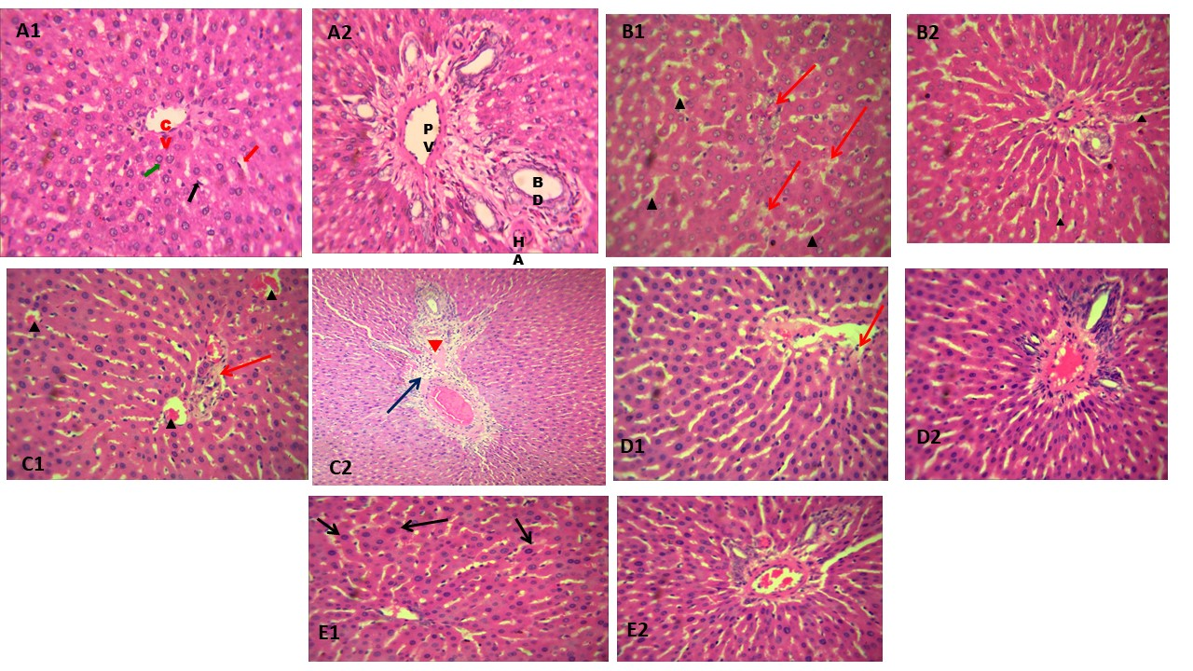

Figure 6: Photomicrograph of the ileum showing the graphical representation of methamphetamine-induced tissue damage and the attenuating effect of Ginkgo biloba.
Photomicrograph showing sections of the ileum in control and experimental groups A1&A2 – D1&D2 (Figure 6) A = control; A1&A2 = sections of ileum viewed at X100 and X400, black arrow = normal Payer’s patches; red arrow = normal tall villi; green arrow = intestinal glands in lamina propria. B = Ginkgo biloba group: B1&B2 = sections of ileum viewed at X100 and X400, black arrow = prominent Payer’s patches, blue arrow =villi with normal simple columnar epithelium. C = METH; C1&C2 = sections of ileum viewed at X100 and X400, red arrow =atypical short villi, black arrow =goblet cell hypertrophy; blue arrow =dysplastic columnar cells making up the enterocytes’ (villous) epithelium. D = METH+GB, LD; D1&D2 = sections of ileum viewed at X100 and X400, red arrow = tall villi, blue arrow = typical villous epithelium (blue arrow; green arrow = atypical dysplastic columnar epithelium. E = METH+ GB, HD E1&E2 = sections of ileum viewed at X100 and X400, red arrow = tall villi; green arrow = atypical villous epithelium; blue arrow = mild dysplasia of the villous epithelium.
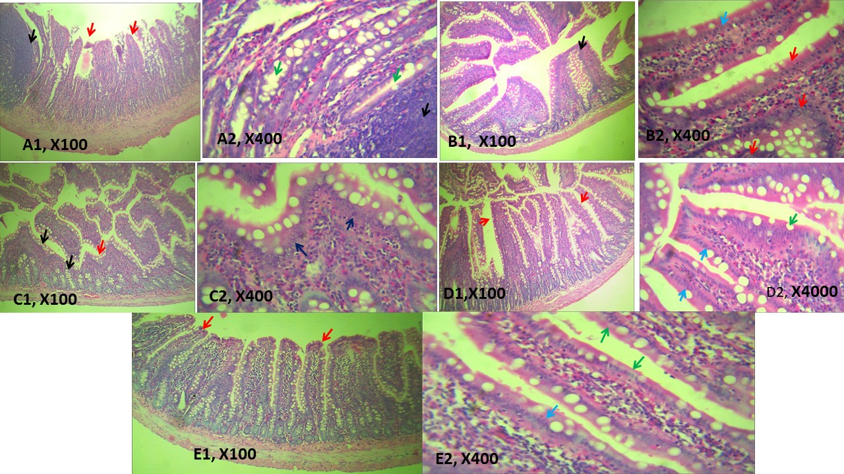

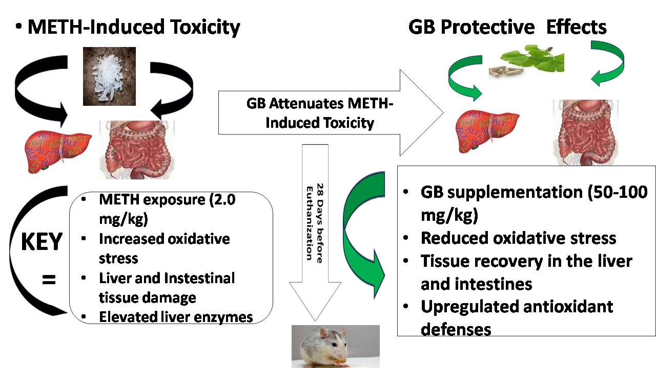

Figure 7: Graphical Abstract
The abstract illustrates the methamphetamine-induced toxicity effects on the stomach, liver, and ileum in Wistar rats, and the mitigating effect of Ginkgo biloba on the animal tissues. The schematic depicts the experimental design, methamphetamine (2.0mg/kg) administration, and Ginkgo biloba (50 mg/kg and 100 mg/kg) supplementation. Arrows indicate methamphetamine-induced oxidative stress, liver and intestinal tissue damage, and elevated liver enzyme levels/activity. On the other hand, Ginkgo biloba has protective effects, leading to reduced levels of oxidative stress markers, tissue recovery in the liver and intestines, and up-regulated antioxidant defenses.

