Psychopathological Issues in Children Living with HIV : A Report on 15 Cases Followed at the Albert Royer National Children's Hospital (CHNEAR) in Dakar.

Abstract
Introduction : West Africa remains behind in the global AIDS response, particularly among children and adolescents living with HIV (CEaHIV). These children and adolescents constitute a specific population due to the multiple psychological challenges, including the disclosure of their HIV status, the impact of infection on their quality of life, and their mental health. Few studies have examined the psychological difficulties of this segment of the population. This motivated the completion of this work, the aim of which was to evaluate the quality of life and the prevalence of depression in our study population.
Patients and Methods : This was a mixed-method cross-sectional study over a 6-month period (July 1 to December 31, 2022). The survey was done randomly, from the active consultation queue, there were no exclusion criteria. Data collection was conducted using a sociodemographic interview guide and two assessment scales (Kovacs and Beck's CDI and PedsQL).
Results : The sample consisted of 15 children with a male-to-female sex ratio of 1.5. The average age was 15 years, with a range of 10 to 18 years. Depression was found in 60% of the children and in orphans (56%), with a female predominance (67%).
Conclusion : This study aimed to highlight the direct and indirect determinants of psychological problems among EAvHIV. The explicitly established link between mental state and physical condition requires collaboration between the various stakeholders involved in childhood. For more effective support, professionals other than psychiatrists could be trained in the use of the CDI and PedsQL. This would allow for early detection of depression in this vulnerable population.
Keywords : HIV, children, quality, depression, Dakar.

Introduction
Globally, 1.7 million children aged 10 to 19 were living with HIV in 2022. In West and Central African countries, the number of children and adolescents living with HIV was estimated at 300,000. In Senegal, the UNICEF report mentioned approximately 6,000 EAvHIV. These children constitute a specific vulnerable population. Indeed, this age corresponds to transitions marked by overwhelming physical and psychological changes, influenced by several factors (individual, familial, and environmental) [1, 2].
EAvHIV must face the multiple psychological challenges of comprehensive care, including disclosure of HIV status, treatment adherence, and the risk of stigmatization. Studies examining the impact of this condition on the mental health of children and adolescents remain rare in our country [3].
This work highlighted the psychological impact and psycho-pathological issues faced by this juvenile population.

Patients and Methods
This study was conducted at the Mother-Child Unit of the Albert Royer National Children's Hospital. This center is classified as level 3 on the Senegalese health map and provides care to children aged 0 to 15 years. It comprises several units, including the Child and Adolescent Neuropsychiatry Department. The latter offers psychosocial support. Follow-up is provided by a neuropsychiatrist and a psychologist during consultations. These meetings are held at the request of the family or healthcare staff.
This is a cross-sectional study with a mixed design conducted over a six-month period (July 1 to December 31, 2022). The population consists of EAvHIV patients aged 10 to 18 years.
The survey is conducted randomly, based on the active consultation queue, there were no exclusion criteria.
Data collection was conducted using a sociodemographic interview guide administered to the children and two assessment scales. These were the Kovacs and Beck Children's Depression Inventory (CDI) and the Pediatric Quality of Life Questionnaire (PedsQL).
The interview guide was a unique questionnaire, designed specifically for this research. The questionnaire was administered on paper and lasted an average of 15 minutes, with respect for anonymity and confidentiality. It included several sections exploring marital status, education level, and experience of the illness.
The CDI is an adaptation of the Beck Inventory for children aged 7 to 17. Developed by Kovacs and Beck, the best-known version includes 27 items. It was administered individually. Scoring ranges from 0 to 2. The higher the score, the greater the severity of depression.
The PedsQL is an instrument that assesses health-related quality of life (QOL) in diverse pediatric populations. It has two parts : one administered to the child and the other for parents. The test items are grouped into four domains.
The administration time was approximately 5 minutes. Scores are linearly transformed onto a scale between 0 and 100, summed, and divided by the number of items completed; higher scores are associated with better health-related quality of life. The results are combined into three different scores : global (average of the 23 items); physical health (means of physical functioning items) and psychosocial health (means of emotional, social, and academic functioning items).
A global score between 0 and 60 indicates low functioning, between 61 and 80 indicates intermediate functioning, and above 80 indicates high functioning.
Reliability: Adequate to excellent internal consistency, for questionnaires completed by the child/adolescent (α=.61-.91) and by the parent (α=.58-.92).
Validity: Supported by significant correlation with indicators of morbidity and disease burden, as well as known-group validity studies revealing that the PedsQL has a strong ability to distinguish healthy children from those with acute or chronic conditions. The data were processed as follows:
- Qualitative analysis: based on clinical assessments during interviews with the children
- Quantitative analysis: The collected data were anonymized, coded, and analyzed using Polaris Office Editor version 8.5.03.
Results
The study population consisted of 15 children and 11 parents or guardians.
Boys were more prevalent, with 60% and a male-to-female sex ratio of 1.5.
The average age was 15 years, with a range of 10 to 18 years; 53.3%, or 8 children, were over 16 years old. The age distribution is shown in Figure 1.

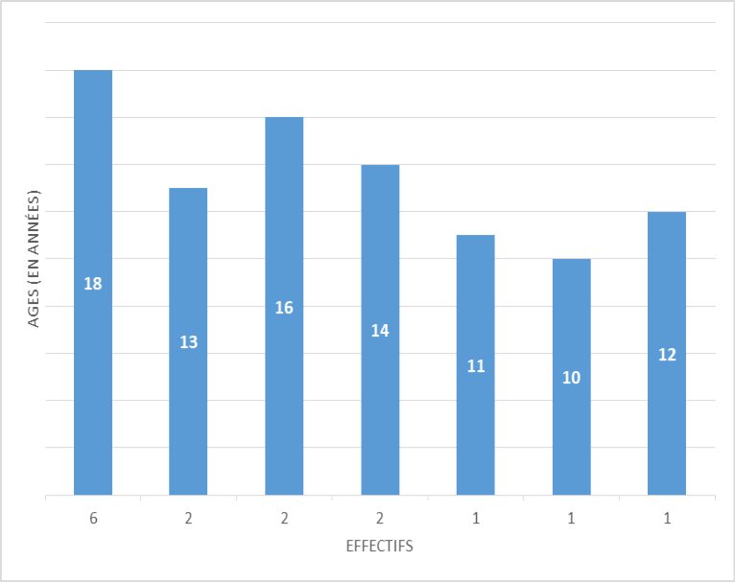

Figure 1 : Distribution of patients according to age.

Out-of-school children represented 33% (n=5). The results are presented in Figure 2.

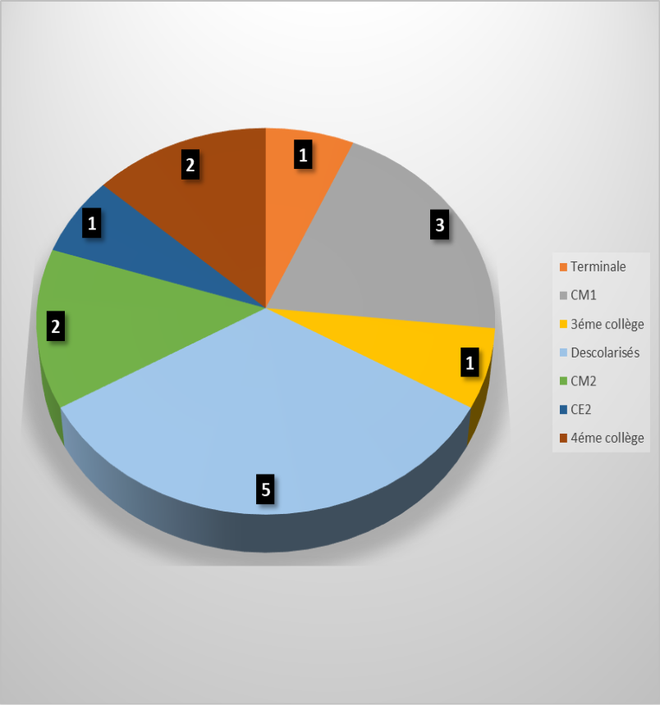

Figure 2 : Distribution of patients according to education.
The ages at which the diagnosis was made ranged from 11 to 14 years. 53.3% (8 cases) had HIV status known between 12 and 13 years. One child, or 6%, was unaware of their HIV status. He was 10 years old.
The children were orphans in 46.6% of cases (n = 7). They had lost their fathers in 20% of cases (n = 3), and maternal orphans accounted for 27% (n = 4).
According to the CDI, depression was found in 60% of cases (n = 9). It predominated in females at 67% (n = 6), and boys represented 33% (n = 3).
Among the depressed patients, 55% (n = 5) were between 16 and 18 years old.
The correlation between depressed children and orphans showed that the latter accounted for 56% of cases of depression.
The PedsQL assessment in children reported poor quality of life in 20% of cases (n=3) and moderate quality of life in 60% of cases (n=9). Interviews were not conducted in 26% of parents (n=4).
A comparison was made between the scores obtained from the children and the parents. The latter reported poor or intermediate quality of life in their children.
The correlation between the PedsQL scores and age revealed that all patients with poor quality of life, or 20% of the sample, were between 16 and 18 years of age.
All female patients had either poor or intermediate quality of life. They represented 40% of cases (n=9). The correlation between PedsQL scores and gender is illustrated in Figure 3.

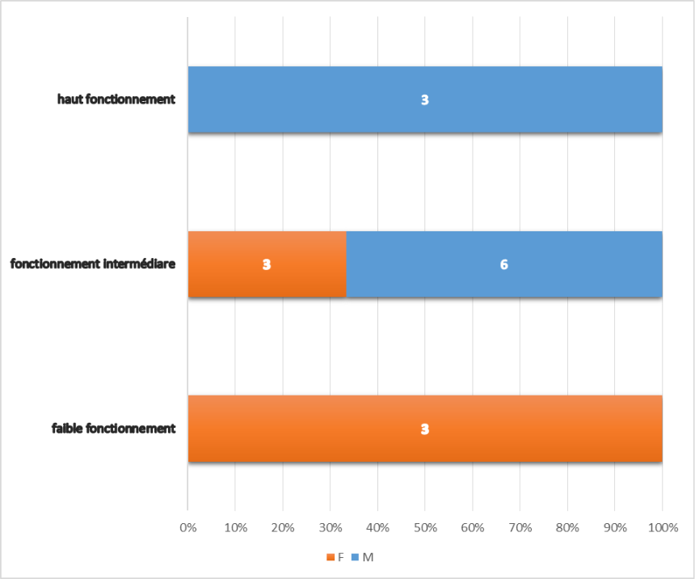

Figure 3 : Distribution of patients according to quality of life and gender.

The correlation between PedsQL scores and orphan/non-orphan status showed that all orphans had a poor or intermediate quality of life, representing 47% of cases (n=7).
Among patients with a poor quality of life (low functioning), orphans represented 67% of cases (i.e., two-thirds).
Discussion
- Limitations of the work : administering questionnaires in a national language can induce translation bias. We attempted to minimize this by retaining a single administrator. The CDI questions are not always adapted to cultural perceptions of depressive symptoms. According to Dugas and Bouvard, a literature review indicates that a score greater than or equal to 15 would be synonymous with a depressive state. However, a more in-depth clinical examination in parallel would allow for a correlation between CDI and psychiatric clinical assessment [4].
In addition, the limited sample size precludes generalization of the results. This small sample could be explained, among other factors, by the psychiatric liaison work carried out on an ad hoc (non-regular) basis. This is done in collaboration with the neuropsychology unit and the care team of the Esther mother/child unit of the CHNEAR. The neuropsychiatrist's activity includes, on the one hand, investigation and neuropsychological care. Cases are not systematically referred. They are only referred if pediatricians suspect an alteration in psychological functioning. Following this, a specialized assessment is carried out by the psychiatrist who offers a space for consultation for care indications in complex situations and, if necessary, psychotherapeutic follow-up.
- Distribution of children by sex : the male predominance could be explained by the slight preponderance of boys in the Senegalese population among those under 19, i.e. 50.6%. These figures are comparable to those of Thiam who, in his study, obtained similar results, i.e. 14 boys out of 11 girls [5, 6].
- Distribution of children by age : more than half of the children were between 16 and 18 years old. The average age was 15 years old with extremes of 10 and 18 years old. And the lower the age, the smaller the number. This result is similar to that reported by Proulx-Boucher with an average age of 14.24 years old and extremes of 10 and 18 years old [7].
- Distribution by school status : This high school dropout rate could be explained by the family and social difficulties that some HIV-infected children may encounter. Studies have shown that they drop out of school more frequently. They are more likely to be in the wrong grade for their age or to have repeated a grade. An inferiority complex encourages these children's disinterest in school life. In addition, they often face other vulnerability factors (frequent somatic illnesses, parental death) that cause school absenteeism, which ultimately leads to dropping out. Infants and children with HIV are susceptible to cognitive delays compared to HIV-negative children [8, 9].
- Distribution by age at which HIV status was disclosed : The ages at which children were informed of their diagnosis ranged from 11 to 14 years. Most children learned their HIV status between the ages of 12 and 13. In our series, only one child had not yet been informed of their HIV status (they were 10 years old). This observation is consistent with WHO recommendations, which suggest that it be made before the age of 12. The later it is made, the more likely it is to occur in traumatic situations, accidentally, or in an ill-prepared manner [10].
Obstacles to the diagnosis disclosure process have been reported in several studies. They primarily involve parents or guardians, who cite a fear of rejection from the adolescent. They fear that the adolescent will be surprised by the news of a serious illness without being prepared for it. This could lead to family secrets being revealed or the child disclosing their status to those around them. Other studies also mention the immaturity of the adolescent in receiving his diagnosis (orphan, young age, mental or cognitive retardation) [11].
- Distribution of children according to depressive experience (CDI score) : this study shows that HIV infection can increase the risk of developing depression. Indeed, it is the most common psychiatric diagnosis among people living with HIV. The clinical presentation of depressive syndromes is not specific and remains very classic. The stigma and social discrimination experienced by people living with HIV are thought to favor its occurrence [12].
- Correlation between depressive state and quality of life according to age : the older the children, the more depressive symptoms they presented. Psychological realities are perceived or experienced differently depending on the age of the affected or infected child. The poor QOL among 16- to 18-year-olds suggests that children, at a certain level (from age 16), better understand what is happening to them. Adolescence is a crucial period of development. Often, HIV infection leads to a mismatch between physical development and age. This growth retardation is a source of insecurities and discomfort. It is therefore difficult for adolescents to participate in social activities at this age. On the cusp of sexual development, they may resent their parents for transmitting the disease to them [13].
QOL and Depressive Status of EAvHIV by Gender: Among the children who presented with depression, 67% were girls. Furthermore, no girls in the sample presented with good QOL. These results suggest that girls were more vulnerable than boys. This reflection is consistent with the Yélomé study, where 82.8% of EAvHIV were female, presenting with depressive symptoms (with irritability and guilt) [14].
- Correlation between QOL, depression, and orphan status of EAvHIV: We were unable to find any documents allowing us to compare our results. However, these figures could be explained by the fact that in child psychology, the absence of a parental figure is a factor of psychological imbalance. For Dolto : "The child needs both to structure his intelligence and his emotions. Between three people, thoughts and feelings circulate. When there are two of you, it acts as a mirror and creates a fatal reciprocal dependence." Thus, when, due to illness or death, this were to be lacking, this situation would lead to instability in the child characterized by a lack of reference points and difficulties in structuring himself [15].
- Comparison of QOL between children's scores and those of parents : by comparing the two assessments, that is, how does the child perceive himself ? And how does the parent perceive it ? we noted that no child in our series had a good quality of life according to the parents (while 3 children had high functioning according to the PedsQL administered to them directly). This observed discrepancy suggests that parents are often overprotective of their HIV-infected children. Indeed, the child's physical impact shows us a parent (or guardian) who painfully experiences the fact of not having been able to protect them from the virus [16].
This suffering of the mother is all the more significant because the child is a part of her, both physically and psychologically, and she does not know how to support him. It is therefore essential to examine the child's emotional needs. These needs risk biasing the assessments of healthcare staff due to the attention directed towards the parent's suffering [9].
The non-assessment of QOL in 26% of parents is explained by the fact that there were 4 children who came alone for consultation without an accompanying person, considering themselves capable of managing their follow-ups alone.

Conclusion :
A child with HIV is affected physically (in the body) but also psychologically. The explicitly established link between mental state and physical condition requires collaboration between various stakeholders involved in childhood. For more effective support, professionals other than psychiatrists could be trained in the use of the CDI and PedsQL. This would allow for early detection of depression in this vulnerable population.

REFERENCES
[1]- UNAIDS. HIV estimates for children dashboard (global/regional level). UNICEF, 2023.
[2]- Giedd J N. "Structural Magnetic Resonance Imaging of the Adolescent Brain." Annals of the New York Academy of Sciences. 2004 : 77-85.
[3]- Romer D. "Adolescent Risk Taking, Impulsivity, and Brain Development: Implications for Prevention." Developmental Psychobioly. 2010 ; 52 (3) : 263-76.
[4]- Bouvard M. Assessment scales and questionnaires for children and adolescents. Paris : Elsevier Masson ; 2008.
[5]- National Agency for Statistics and Demography. Directory of the population of Senegal. Dakar (SN): NASD; 2022.
[6]- Thiam L, Coly I J, Diouf F N, et al. Children living with HIV in Ziguinchor/Senegal : epidemiological, clinical, therapeutic, and developmental aspects. Therapeutic Medicine/Pediatrics. 2021 ; 23(1) : 56-62.
[7]- Proulx-Boucher K, Blais M, Fernet M, et al. Silence and Disclosure in Families of Adolescents Living with HIV Since Birth : A Qualitative Exploration. Pediatric and Child Health. 2011 ; 16(7) : 404-08.
[8]- Parchure R, Vijaya J, Kulkarni S, et al. Educational Outcomes of Children Infected and Affected by HIV in Their Families in Maharashtra, India. Studies on Vulnerable Children and Youth. 2016 ; 11(4) : 332–338.
[9]- Zinyemba T, Pavlova M, Groot W. Effects of HIV/AIDS on Children's Educational Attainment: A Systematic Literature Review. Journal of Economic Surveys; 2020 :34 :35-84. Enter the abbreviation of the journal
[10]- Dahourou D, Masson D, Dago-Akribi H, et al. HIV disclosure to the child/adolescent in central and francophone Africa. Bulletin of Society Pathological Exotic. 2019 ; 112 (1) :14-21.
[11]- Boudarse K. Psychosis and care. A reading from Winnicott. Dialogue. 2012 ; 1 :7-18.
[12] -Robertson K, Bayon C, Molina J M, et al. Screening for neurocognitive impairment, depression, and anxiety in HIV infected patients in Western Europe and Canada. AIDSCare. 2014 : 1555-6.
[13] - Delaroche P. Adolescence, Clinical and therapeutic issues. Paris, Nathan ; 2000 : 128.
[14] - Yelomé D M, Houessou P, Fiossi-Kpadonou H, et al. Individual factors and resilience of orphans and children infected with HIV/AIDS in the city of Cotonou. Editions francophone universitaires d'Afrique. 2022 : 291-318.
[15] - Grignon O. The contribution of Françoise Dolto to psychoanalysis. Conference in Dijon, June 20, 1997. Paris : Le Coq-héron. 2002 ; 168 : 13-36.
[16] - Dago-Akribi H. Children and HIV : From Somatic to Psychological. Experiences in Abidjan. Face to Face : A Look at Health. 2007 ; 10 : 8-9.

