Second-Line Treatment Use among people living HIV Followed up in a health center in Senegal from 2019 to 2023

Abstract:
Background: HIV drug resistance necessitates second-line antiretroviral therapy (ART) in resource-limited settings. This study assessed the epidemiology of second-line ART use in a decentralized Senegalese HIV care center. Patients and methods: A retrospective cross-sectional study (2019-2023) included 400 PLHIV records from Cardinal Hyacinthe Thiandoum Health Center. Data on sociodemographics, clinical parameters, and ART history were analyzed using SPSS. Results : Among 400 PLHIV, 20 (5.0%, 95% CI : 4-6%) required second-line ART. Most were women (80%), mean age 58.5±15.5 years. Main switch reasons were treatment failure (55%) and intolerance (45%). Mean viral load pre-switch was 68,387±15,879 copies/mL ; mean CD4 count was 293±60 cells/μL. All patients received AZT+3TC+LPV/r. Conclusion : Decentralized HIV care with reinforced therapeutic education may reduce second-line ART needs, preserving resources for complex cases.
Keywords: HIV, second-line ART, drug resistance, Senegal, decentralized care

Introduction
The emergence and transmission of drug-resistant strains of the human immunodeficiency virus (HIV) have resulted in a significant loss of antiretroviral treatment efficacy. These resistant strains have now become a major public health concern in most low- and middle-income countries (1).
Antiretroviral treatment failure poses a constant threat at both the individual and collective levels, as it can lead to the spread of drug-resistant viruses. The prevalence of primary resistance has been estimated at 10.2% in Europe (2) and 12.2% in North America (3). Among patients experiencing virological failure under treatment, the prevalence of acquired resistance to antiretroviral therapy (ART) reached 56% (4).
In Africa, this prevalence rangs from 17% in West Africa to 23% in Southern Africa (5,6).
The general objective of this work is to analyze the epidemiology of second-line treatment use among people living with HIV (PLHIV) at the aforementioned center located in Dakar, Senegal.
Patients and Methods :
Study setting : This study was conducted at a Health Promotion Center located in Dakar, in the Northern District.
Study design : We carried out a retrospective cross-sectional study from January 2019 to December 2023, based on medical records of PLHIV.
Inclusion criteria: All PLHIV records followed at the CHT during the study period under one of the following protocols were included.
Table I: First-line protocol
 | Second-line  Preferred | Second-line  Alternative
Adults, Adolescents | AZT+3TC+LPV/r | AZT (or ABC) +
Women of | Or | 3TC+DRV/r
childbearing âge | ABC+3TC+LPV/r | (or RAL ou LPV/r)
Under contraception | AZT+3TC+DTG | AZT (or ABC) +
 | Or | 3TC+ATV/r
 | ABC+3TC+DTG | (or LPV/r ou DRV/r)
Non-inclusion criteria : These were PLHIV records under treatment that were incomplete at the time of initiation of second-line therapy, as well as those transferred to the service already on a second-line protocol at the time of the study.
Data collection : The data collected included : address, occupation, age, sex, marital status, sexual orientation, adherence before initiation of second-line therapy, viral load and CD4 count, and year of initiation of second-line therapy.
Data analysis : Data were collected using the KoboCollect application and analyzed with SPSS software, version 2.0, year 2011. Frequencies were calculated for qualitative variables, and means with standard deviations for quantitative variables. Results were estimated with a 95% confidence interval.
Results
Frequency of second-line treatment use
Out of 400 PLHIV records regularly followed, only 20 were on second-line treatment, representing a prevalence of 5.00% (95% Confidence Interval: 4%–6%).
Distribution by residence
The majority of patients, 65%, came from the urban area, while 35% were from the semi-urban area. One patient resided outside Senegal. Figure 1 illustrates the distribution of patients according to residence.
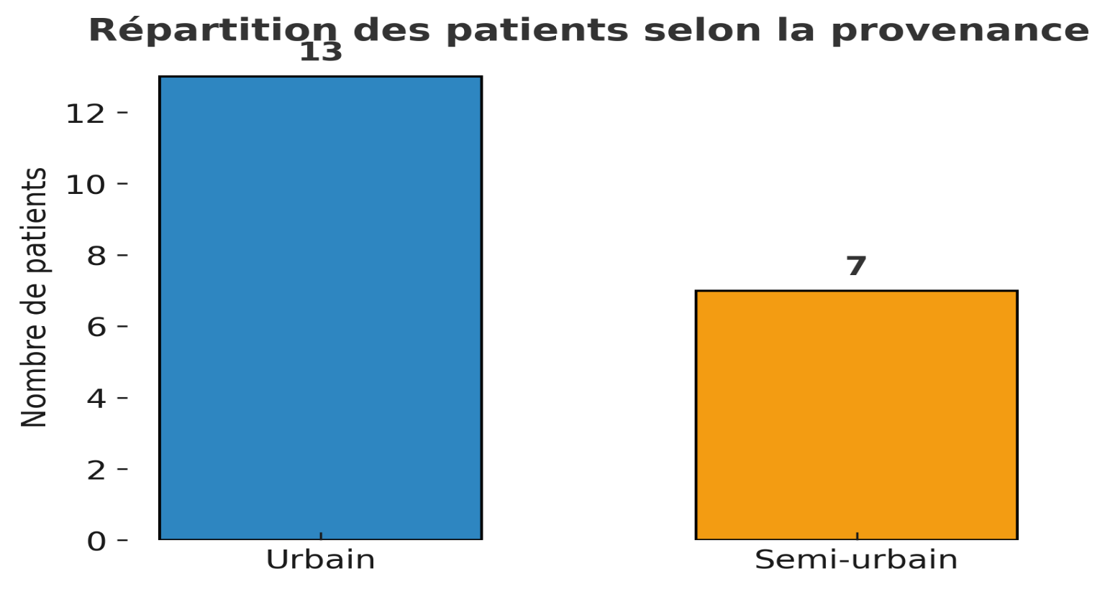
Figure 1: Distribution of patients by residence
Distribution of patients over time
The majority of patients in our study were initiated on second-line treatment in 2023.
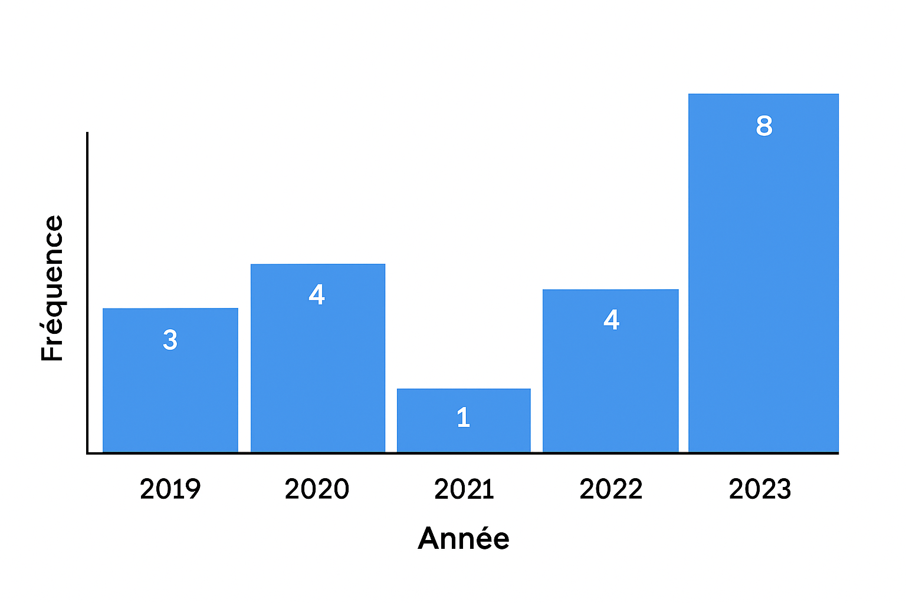

Figure 2: Distribution of patients by year of treatment initiation

Sex: The study population was predominantly female (80%), with a sex ratio of 4:1 (F/M).
Age: The mean age was 58.45 years (±15.45 years), ranging from 43 to 74 years. The age group [50–60] was the most represented, with 11 cases.
Distribution of patients by occupation
The majority of patients were unemployed, representing 25%, while 20% worked in the informal sector (Figure 3).

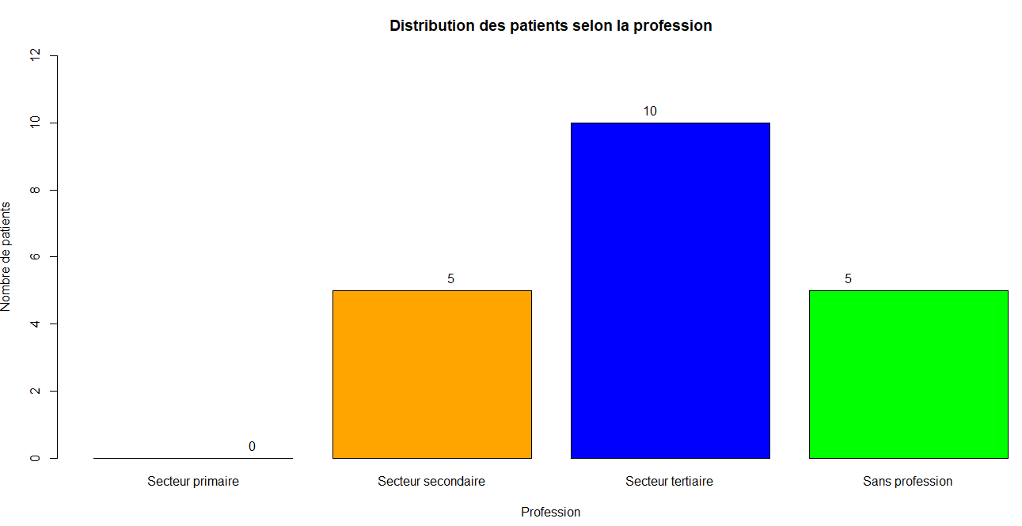 Figure 3: Distribution by occupation (tangerine color is the secondary sector; blu color is the tertiary sector, the green is for no professional activity)

Distribution of patients by sexual orientation
Ninety percent (90%) of patients were heterosexual, 5% were men who have sex with men (MSM), and 5% reported abstinence.
By marital status
The marital status of patients was varied, as shown in Table II, with 55% of patients being married.

Table II: Distribution of patients by marital status
marital status | Number | PErcentage (%)
Married | 11 | 55
Divorced | 4 | 20
Widowed | 3 | 15
Single | 2 | 10
Total | 20 | 100

Distribution by serotype: The majority of patients were HIV-1 positive (Table III).
Table III: Distribution of patients by HIV type
SErotype | number | Percentage (%)
VIH1 | 11 | 55
VIH2 | 6 | 30
VIH1 and 2 | 3 | 15
Total | 20 | 100

Distribution of patients by protocol used: All patients were on AZT+3TC+LPV/r.
Distribution by associated comorbidities
five patients had diabetes as a comorbidity, representing 25%, one patient had high blood pressure.
Reason for initiation of second-line treatment
Treatment failure was the main reason for switching to a second-line protocol. Table IV shows the distribution of patients according to the reason for initiation of the second-line protocol.
Table IV: Distribution of patients by reason for initiation of second-line treatment
 | Number | Percentage
First-line treatment failure | 11 | 55
Intolerance | 9 | 45
Total | 20 | 100

Adherence before second-line treatment
The majority of patients were adherent (60%), and 40% of patients were non-adherent to treatment.
Virological and immunological parameters
The mean viral load was high at 68,387 copies (±15,879). The mean CD4 count was 292.88 (±60.14) showed in (Table V).
Table V: Mean virological and immunological parameters for patients regardless of serotype
 | Mean | Standard deviation
Viral load | 68387.00 | 15879.14
CD4 | 292.88 | 60.14

Discussion
in our study, we found an overall prevalence of 5.00%. In the study by Dia N. et al. in 2015 in saint louis, senegal, the prevalence was 28.63% (8). in Bamako in 2018, Maiga A. estimated the prevalence of second-line ARV use at 16.66% (9). This difference can be explained by better patient understanding and engagement in their care. strengthening therapeutic education likely improved adherence and consequently reduced resistance.
approximately 90% of patients lived in the Dakar region. this result is similar to that observed by D. ba at the institute of social hygiene (ihs), dakar, where 70% of patients came from the dakar region (10). This may be explained by the availability of care sites accessible to the population in the capital. Females represented 80% of the study population. indeed, d. ba at institute of social hygiene, S. Ba, N. M. Badiane, S. E. Hawes et al. in senegal, and O. Djibo in Mali reported frequencies of 66%, 66.3%, and a sex ratio f/m of 2.54, respectively. this female predominance could be explained by the feminization of the hiv epidemic globally and particularly in africa (5, 10, 11, 12).
The mean age in our series was 58.45 years. Most authors in senegal have observed a younger population under 20 years. Our results can be explained by the overall predominance of patients in their sixties in our cohort and the fact that all young adults followed in our facility received good therapeutic education and actively participated in their care (6, 8, 13).
Most patients in our cohort were housewives. however, various professional categories were represented. similar results were observed by f. touré at the point g hospital center in mali with 39.2% (10).
married individuals accounted for 55% of our study population. similar frequencies were observed by O. Djibo and f. touré, who found 66.8% and 63.5% married participants, respectively, in their studies. poor adherence in many couples could explain these results. due to the anatomy and physiology of the female genital organ, women are generally more exposed (10, 12).
The main reason for initiating second-line treatment was first-line protocol failure in 55% of cases. this failure was both virological and immunological. this factor was observed by Mbange a. et al. in Dakar and Saint Louis, highlighting the importance of patient monitoring. although patients attended their consultation appointments regularly, some reported not taking their medication as prescribed. poor therapeutic adherence is a risk factor for resistance (13).
HIV-1 infection was most prevalent in our cohort, accounting for 55% of cases. our results were similar to those observed by dia et al. in senegal, with 83.58% of patients infected with hiv-1. in the cohorts of f. touré in mali and g. sarr in senegal, hiv-1 was present in 98% and 64.83% of cases, respectively. this can be explained by the rarity of hiv-2 infection in our cohort (8, 12, 13).
Twenty-five percent of our patients had a comorbidity. indeed, the incidence of diabetes among plhiv in the early 2010s was close to that of the general population, 10.8% versus 8%. a recent meta-analysis of 44 studies highlighted that diabetes incidence remains high among patients on art worldwide, at 13.7 per 1,000 person-years, with significant geographical disparities: 19.1 per 1,000 person-years in the americas, 15.9 in africa, and 8 in europe (13).
The mean viral load was 68,387 copies/ml, indicating therapeutic failure according to the adopted definition of virological failure. the viral load in our series was higher compared to that observed in the series by o. djibo at the chu of point g in 2023, f. touré in bamako in 2022, and g. sarr in ziguinchor in 2020. however, in a multicenter comparative study conducted in senegal in 2020, A. Mbange, A. Diouara, H. Ndiaye Et Al. Found virological failures with viral loads as high as those observed in our study population. our high viral loads could be explained by physicians’ reluctance to switch patients to second-line treatment, as they were not specialists and lacked basic training in the management of plhiv (9, 10, 11, 13).
Conclusion
Our retrospective cross-sectional study focused on the descriptive epidemiology of second-line ART use among patients followed at the Center in Dakar, Senegal. The study highlighted the predominance of females (16 cases, representing 80% of the study population), patients over 58 years old, and residents living near the facility. Diabetes was the only comorbidity identified. The majority of patients (60%) were adherent; however, all experienced virological failure, with a mean viral load of 68,387 copies/ml. Our results are not generalizable due to the small sample size and the recruitment method of the included patients. Therefore, a multicenter study is needed to better understand the epidemiology of PLHIV in decentralized care sites. Based on these findings, we formulate the following recommendations for all stakeholders involved in the care of PLHIV and for health authorities. These involve coordinated and integrated measures/strategies aimed at preventing the need for second-line treatment.

References
1. Doualla-Bell F, Turner D, Loemba H, et al. HIV Antiretroviral Resistance - Implications for Low-Income Countries. Med Sci. 2004;20(10):882-6.
2. Muller F, Taverne B. Perceptions of Antiretroviral Treatment Failure Among Patients and Healthcare Professionals in Dakar. Bull Soc Pathol Exot. 2014;107(4):281-5.
3. Hofstra LM, Sauvageot N, Albert J, et al. Transmission of HIV Drug Resistance and the Predicted Effect on Current First-line Regimens in Europe. Clin Infect Dis. 2016;62(5):655-63.

4. Assoumou L, Charpentier C, Recordon-Pinson P, et al. Prevalence of HIV-1 drug resistance in treated patients with viral load >50 copies/mL: a 2014 French nationwide study. J Antimicrob Chemother. 2017;72(6):1769-73.
5. Ngo-Giang-Huong N, Huynh THK, Dagnra AY, et al. Prevalence of pretreatment HIV drug resistance in West African and Southeast Asian countries. J Antimicrob Chemother. 2023;74(2):462-7.
6. Dia N, Lo S, Dia A, et al. Second-line antiretroviral therapy: Prevalence and epidemioclinical, therapeutic, and outcome aspects in 2015 of patients living with HIV followed in rural areas. Med Mal Infect. 2018;48(4, S1):S151-2.
7. Abdourhamane Alhousseini MAIGA. ARV Treatment Resistance Profiles in HIV-1 Infected Patients with Second-Line Virological Failure: A Report of 309 Cases in Bamako, Mali. [Pharmacy Thesis]. University of Science, Technology, and Technology of Bamako, Faculty of Pharmacy; 2018. Available at: https://www.mcours.net/cours/pdf/hasclic5/hassaaeclic233.pdf
8. Demba BA. Changes in ARV Treatments in Patients Followed at the Dakar Institute of Social Hygiene. [FMPOS] [Medical Thesis]: CHEIKH ANTA DIOP, DAKAR; 2012. Available at: http://bibnum.ucad.sn/viewer.php?c=thm&d=thm%5f48114

9. Ba S, Dia-Badiane NM, Hawes SE, et al. HIV-2 infection in Senegal: virological failure and resistance to antiretrovirals (ARVs). Pan Afr Med J. 2019;33:222.
10. Djibo O. Factors associated with non-adherence to ARV therapy among PLHIV followed in the Infectious and Tropical Diseases Department of the Point-G University Hospital. Doctorate of Medicine. [FACULTY OF MEDICINE AND ODONTOSTOMATOLOGY]: University of Sciences, Techniques and Technologies of Bamako; 2023
11. Ekollo Mbange A, Malick Diouara AA, Diop-Ndiaye H, et al. High HIV-1 Virological Failure and Drug Resistance among Adult Patients Receiving First-Line ART for At least 12 Months at a Decentralized Urban HIV Clinic Setting in Senegal before Test-and-Treat. Infect Dis (Auckl). 2021;33:222. 14:11786337211014504.
12. TOURE Fadimata Mohomodou ATTAHER. Study of the cohort of patients monitored under ARV treatment at the Infectious and Tropical Diseases Department of Point G University Hospital from March 2021 to February 2022. Doctorate of Medicine. [Faculty of Medicine and Odontostomatology]: University of Sciences, Techniques and Technologies of Bamako; 2022
13. Sarr GD. HIV infection in subjects aged 60 years and older monitored in the Ziguinchor region: epidemiological, clinical, therapeutic and evolutionary aspects. 2020 [cited 23 Oct 2023]; Available at: http://rivieresdusud.uasz.sn/xmlui/handle/123456789/1675
14. Nansseu JR, Bigna JJ, Kaze AD, et al. Incidence and Risk Factors for Prediabetes and Diabetes Mellitus Among HIV-infected Adults on Antiretroviral Therapy: A Systematic Review and Meta-analysis. Epidemiology. 2018 2025];29(3):431

