Case report
Hepatic amebiasis simulating pleural effusion, diagnostic difficulties

ABSTRACT:
Introduction: Hepatic amebiasis is a serious illness that can be life-threatening if not treated appropriately. It can be complicated by pleural effusion, which in some cases complicates the diagnosis. We report the case of a 43-year-old patient with hepatic amebiasis revealed by a pleural effusion.
Observation: This 43-year-old patient was a known alcoholic and a 10-year tobacco addict who had not weaned himself off the 10 pack-year habit. He had no history of tuberculosis, and had been delirious for a month, after which an undocumented treatment had been prescribed. He was admitted to hospital with diffuse pain associated with a deterioration in general condition, including physical asthenia, non-selective anorexia and weight loss. He also had tenderness of the right hypochondrium in a context of fever of allegation with no fixed schedule, associated with chills and profuse sweating, all of which had been evolving for 1 month. On admission, physical examination revealed a right basal pleural effusion syndrome, a systemic inflammatory response syndrome, clinical anemia and altered general condition. Laboratory findings included hyponatremia, hyperleukocytosis with neutrophil predominance, normocytic anemia and increased C-reactive protein. Chest X-ray revealed a right basal pleural effusion, confirmed by computed tomography scan (CT scan), with the presence of a liver abscess. Amebic serology came back positive. Surgical drainage was performed, yielding brown pus. The patient was put on metronidazole. We noted a good clinical and biological evolution.
Conclusion: Hepatic amebiasis is a rare but serious condition. It may complicate amebic dysentery. It requires appropriate treatment to prevent complications.

Key words: amebiasis; hepatic; pleural effusion

INTRODUCTION
Liver abscesses are a public health problem in developing countries, with morbidity and mortality sometimes linked to delayed diagnosis and the severity of the disease. Amebic liver abscess is the most frequent extrahepatic localization of amebiasis [1]. In intertropical Africa, hospitalization rates vary from 1% to 2% [2,3]. Amebic abscess is the most frequent type of liver abscess in tropical zones. It represents the main extra-intestinal complication of amebiasis, occurring in 3% to 9% of cases [4]. Hepatic amebiasis is one of the emerging infections that can mimic or be complicated by pulmonary involvement, which may be contiguous or secondary. In certain situations, this pleuropulmonary involvement may lead to a misdiagnosis of liver disease, hence the need for appropriate diagnostic management [5]. We report the case of a 43-year-old patient hospitalized in internal medicine for pleurisy revealing hepatic amebiasis.

CASE PRESENTATION
This 43-year-old patient was a known alcoholic and a 10-year tobacco addict who had not weaned himself off the habit (10 pack-years). He had no history of tuberculosis and had been suffering from delirium for a month, after which an undocumented treatment had been prescribed. He was admitted to hospital with diffuse pain associated with a deterioration in general condition, including physical asthenia, non-selective anorexia and weight loss. He also had tenderness of the right hypochondrium in a context of fever of allegation with no fixed schedule, associated with chills and profuse sweating, all of which had been evolving for 1 month.
On admission, physical examination revealed a right basal pleural effusion syndrome, a systemic inflammatory response syndrome, clinical anemia and altered general condition. Laboratory tests revealed hyponatremia at 121 meq/l, hyperleukocytosis at 30300 elements/µl with neutrophil predominance, normocytic anemia with HGB at 7.9g/dl, and increased C-reactive protein. The pleural puncture fluid was macroscopically purulent. It was exudative, with a leukocyte count of 60,000 and red blood cell count of 25,000, and a protein count of 132g. Culture was negative. GenXpert was also negative. Chest X-ray revealed a right basal pleural effusion (figure 1). Computed tomography revealed an encysted right pleurisy with peripheral contrast and a posterobasal focus of condensation in the lower lobe of the homolateral lung, and a voluminous liver abscess pushing back the diaphragm (figures 1, 2, 3). Surgical drainage was performed. A voluminous abscessed collection was found perioperatively, with brown pus. Echocardiography revealed a medium-sized pericardial effusion opposite the right ventricle. Amebic serology came back positive with an estimated titre of 1/2560 (1/80). The patient was started on metronidazole. We noted a good clinical and biological evolution with a decrease in hyperleukocytosis to 20,000 elements/µl and HGB to 11.9g/dl.
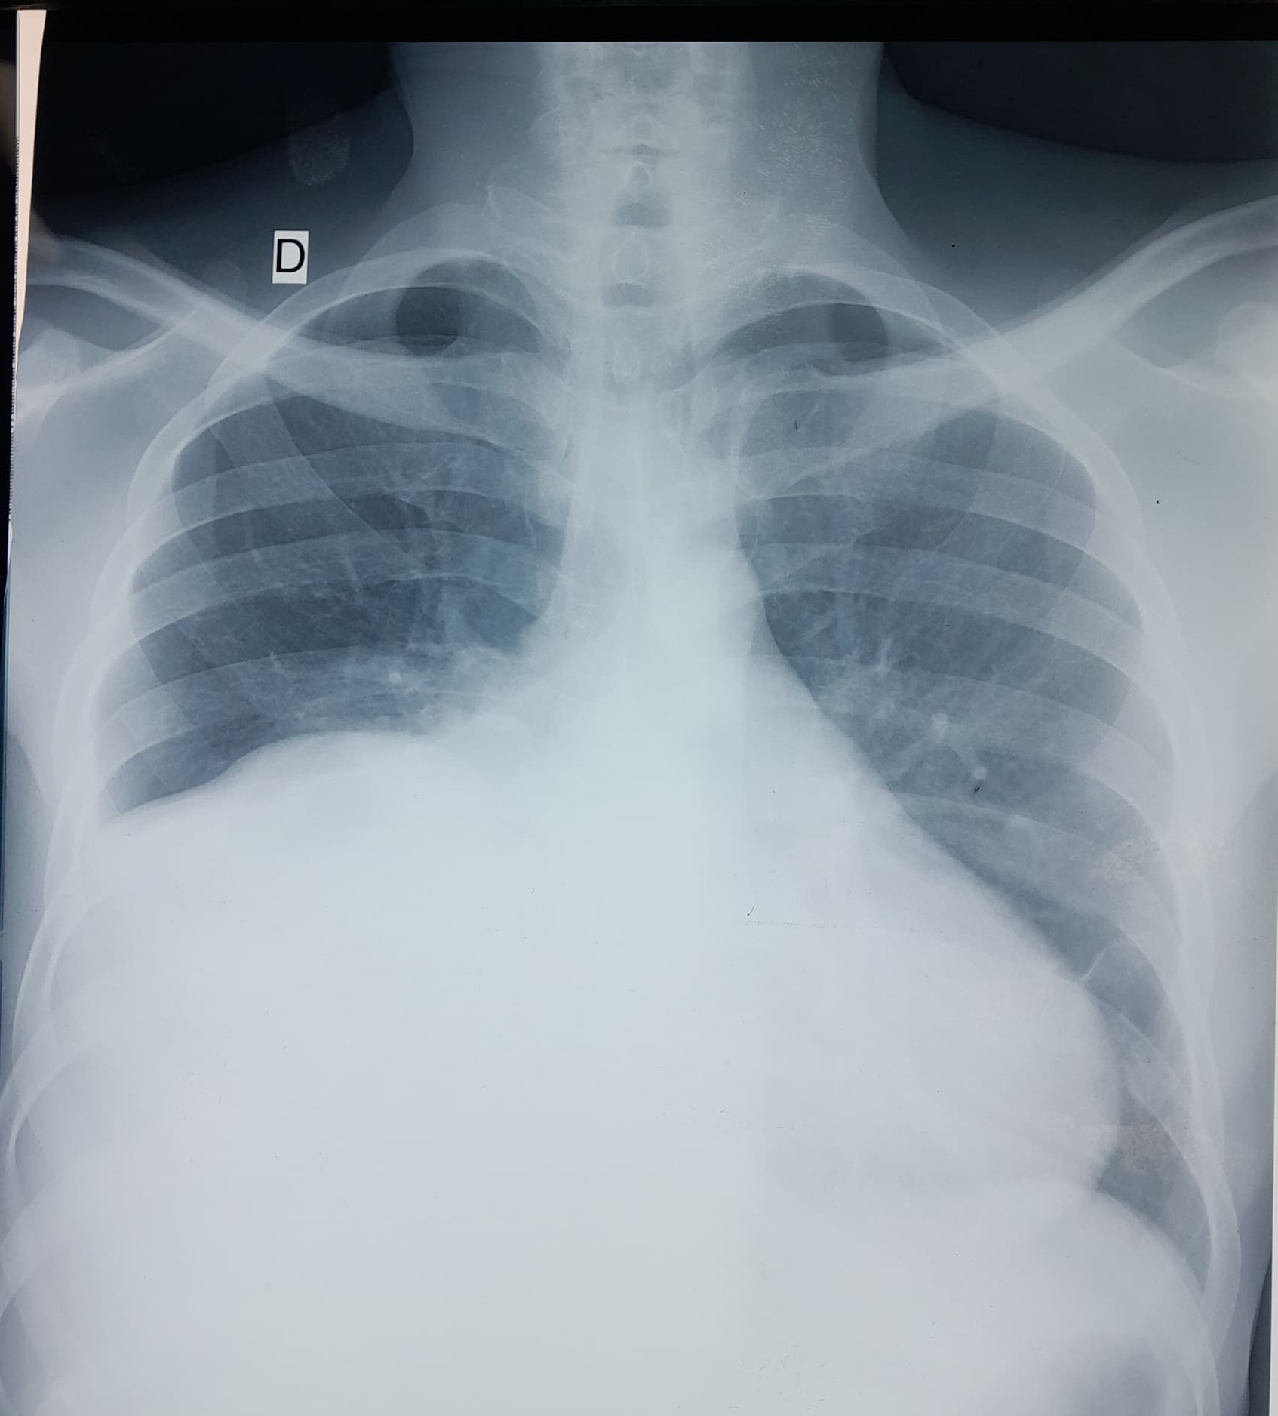
Figure 1: Radiographic image showing the appearance of a right basal pleural effusion (blue arrows).
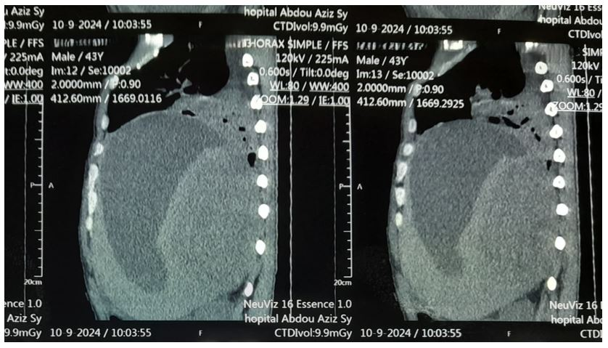
Figure 2: Large intrahepatic abscessed collection
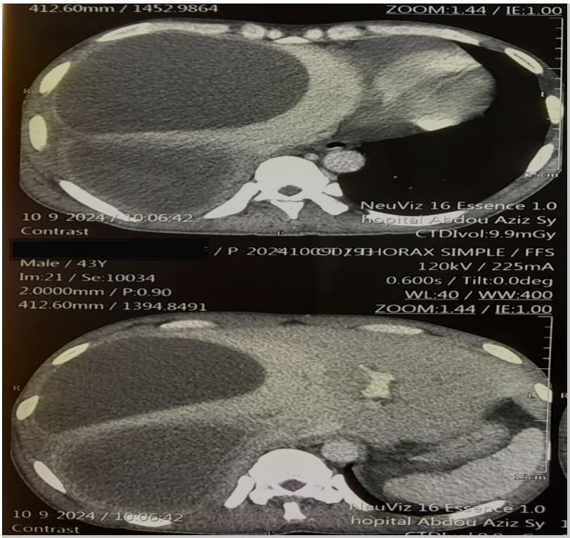
Figure 3: Amebic liver abscess as hypodense intrahepatic images (blue arrows)

DISCUSSION
Hepatic amebiasis is the most frequent extra-intestinal complication of Entamoeba histolytica infection, a parasite endemic in many tropical and subtropical regions. Although rare, pleuropulmonary involvement is a severe form of the disease. In our case, the originality lies in the initial revelation of the pathology by pleurisy, whereas the hepatic signs were clinically discrete or even absent [1,2].
In epidemiological terms, it is estimated that around 50 million people are infected with E. histolytica every year, 10% of whom develop an invasive form, mainly liver abscesses [3]. The latter are most common in adult males, mainly between the ages of 18 and 50, with a predominance in India, Mexico, West Africa, Central America and South-East Asia [6]. In Africa, hepatic amebiasis accounts for 30-50% of hospitalized infectious hepatopathies [5]. Hepatic localizations, although less frequent (5-10% of amebic abscesses), are often under-diagnosed due to their misleading clinical presentation [7].
In Senegal, several hospital studies confirm the endemicity of hepatic amebiasis. Sankalé documented 223 cases between 1960 and 1970 in Dakar [8]. Diouf reported 145 cases between 1983 and 1993 at Dakar's Principal Hospital [9], and Niang recorded 37 amebic abscesses out of 54 cases of liver abscesses between 1995 and 2005 [10]. A study of 48 patients at CHU Aristide Le Dantec showed a prevalence of 0.72%, with 96.9% of amoebic serologies positive, underlining the frequency but also the frequent delays in diagnosis [11].
Extension of liver abscesses into the pleural cavity may occur by direct trans-diaphragmatic contiguity, particularly when the abscess is located in the right lobe, in a sub-diaphragmatic situation. This propagation may lead to an inflammatory pleural reaction, serofibrinous or purulent effusion, or even amebic empyema. Pleurisy may precede liver signs or be isolated, making diagnosis difficult [12,13].
Functional thoracic signs are dominated by right basithoracic pain, fever, dyspnea and sometimes cough. Biologically, a non-specific inflammatory syndrome is common. Standard microbiological examinations of pleural fluid are often negative or show sterile flora, which should alert to a non-bacterial etiology [14].
Diagnosis is based on imaging (ultrasound, CT scan), which reveals liver abscesses, and on amoebic serology, which is highly sensitive in extra-intestinal forms. Pleural puncture may reveal sterile exudative fluid, but direct evidence of the parasite is rare [15,16].
Treatment is based on metronidazole at a curative dose for 10 days, followed by a contact amebicide such as paromomycin to eradicate cystic forms. Percutaneous drainage may be necessary in cases of large collections or poor clinical evolution [17,18].
Recognition of this atypical form is crucial. Any febrile right pleurisy in a patient from an endemic zone or with a digestive history should raise the suspicion of complicated hepatic amebiasis, even in the absence of obvious abdominal manifestations [19].

CONCLUSION:
Hepatic amebiasis is a rare desease, sometimes difficult to diagnose. It may be complicated by pleurisy. Diagnosis is based on imaging combined with microbiological analysis. Early treatment improves prognosis.

REFERENCES

1. Khim G, Em S, Mo S, Townell N. Liver abscess: diagnostic and management issues found in the low resource setting. British Medical Bulletin. 11 déc 2019;132(1):45‑52.
2. Diallo VMPC, Déguénonvo LF, Manga NM, Ka D, Diop SA, Seck A, et al. Characteristics of Liver Abscess in Department of Infectious Diseases at Fann Teaching University Hospital in Dakar, Senegal. AID. 2018;08(01):23‑31.
3. Nasrallah J, Akhoundi M, Haouchine D, Marteau A, Mantelet S, Wind P, et al. Updates on the worldwide burden of amoebiasis: A case series and literature review. Journal of Infection and Public Health. oct 2022;15(10):1134‑41.
4. Lardière-Deguelte S, Ragot E, Amroun K, Piardi T, Dokmak S, Bruno O, et al. Abcès hépatiques : diagnostic et prise en charge. Journal de Chirurgie Viscérale. sept 2015;152(4):233‑46.
5. Rydzak CE, Lima AS, Meirelles GSP. Endemic Thoracic Infections in Sub-Saharan Africa. Radiologic Clinics of North America. mai 2022;60(3):461‑79.
6. Maria Kozielewicz D, Sikorska K, Stalke P. Liver abscesses – from diagnosis to treatment. ceh. 2021;7(4):329‑36.
7. Ekabe CJ, Kehbila J, Clinton NA. Giant Amoebic Liver Abscess: A Rare Diagnosis in a Rural Setting of Sub-Saharan Africa. Silveira JF, éditeur. Journal of Parasitology Research. 19 oct 2021;2021:1‑7.
8. Sankalé M. L’amibiase hépatique en milieu africain. Médecine d’Afrique Noire. 1972;19(4):227–33.
9. Diouf B. L’amibiase hépatique au Sénégal : à propos de 145 cas. Médecine d’Afrique Noire. 1995;42(1):21–6.
10. Niang EH. Profil évolutif des abcès amibiens du foie au CHU de Dakar. Rev Médecine Trop. 2006;66(4):412–6.
11. Sylla K. Étude épidémioclinique des abcès hépatiques au CHU Aristide Le Dantec. Thèse de Médecine. UCAD; 2019.
12. Ooi LL, Ho YH, Yap CK, Tan P. Pyogenic liver abscess—a tropical centre’s experience in management. Eur J Surg. 1998;164(4):265–70.
13. Ravdin JI, et al. Clinical manifestations of amebic liver abscess and its pulmonary complications. Rev Infect Dis. 1986;8(2):228–38.
14. McLaughlin J, etc. Pleural effusion in hepatic amebiasis. Chest. 1981;79(4):456–8.
15. Sharma MP, Ahuja V. Management of amoebic liver abscess. Arch Med Res. 2000;31(4 Suppl):S38–41.
16. Wuerz T, Kane JB, Boggild AK, et al. A review of amoebic liver abscess for clinicians in a nonendemic setting. Can J Gastroenterol. 2012;26(10):729–33.
17. Misra SP, Misra V, Dwivedi M, et al. Percutaneous drainage vs. metronidazole for liver abscess: a randomized clinical trial. Trop Gastroenterol. 2011;32(3):167–9.
18. Choudhuri G, et al. Current management of amebic liver abscess: clinical review. Trop Gastroenterol. 2010;31(3):151–6.
19. Ali IK, Clark CG, Petri WA Jr. Molecular epidemiology of Entamoeba histolytica. Trends Parasitol. 2008;24(6):278–83.

