Original Research Article

Design and Implementation of an IoT-Based Smart Shoe (ESP32, Ultrasonic, GPS) with Blynk–Twilio Emergency Alerts to Enhance Independence of the Visually Impaired

.
ABSTRACT

The work designs and implements a low-cost Internet of Things smart shoe to enhance safety and independence for visually impaired users by unifying ultrasonic obstacle sensing, Global Positioning System (GPS) geolocation, audio–haptic feedback, and multi-channel emergency alerts through Blynk and Twilio. The platform centers on an ESP32 microcontroller that interfaces with an ultrasonic sensor, a GPS receiver, an emergency push button, a buzzer, and a vibration motor. Firmware developed in the Arduino IDE parses GPS data and manages sensing, actuation, and cloud notifications. Functional verification under indoor and outdoor conditions evaluates threshold-based obstacle warnings and the end-to-end alert pipeline that delivers GPS-tagged push or email notifications and short message service (SMS). The prototype consistently triggered audio–haptic cues when distance fell below a 40 cm safety threshold and sent alerts with coordinates when the emergency button was pressed, demonstrating a coherent device-to-cloud-to-caregiver flow without reliance on vision-based sensing. The findings indicate that an ESP32–ultrasonic–GPS architecture with Blynk–Twilio alerts is feasible and replicable for assistive footwear, advancing user safety and independence while keeping complexity and bill of materials practical. Future development should add detection of holes and elevation changes, improve robustness in obstructed environments, and optimize energy use to extend operating time.

Keywords: IoT smart shoe, ESP32, ultrasonic obstacle detection, GPS geolocation, assistive technology, visually impaired users, Blynk Cloud, Twilio SMS

1. INTRODUCTION

People with visual impairments face substantial mobility challenges in dynamic, real-world environments where obstacles, complex traffic patterns, and changing surface conditions demand information that is reliable, timely, and spatially accurate to support safe and independent travel. Traditional aids, such as the white cane and guide dogs, provide valuable near-field feedback but often offer limited information about distant or non-obvious hazards and subtle terrain variations, which can constrain safe navigation in unfamiliar settings and undermine confidence in independent ambulation (Horton et al., 2017). To enrich perception without overloading remaining senses, tactile and haptic feedback have emerged as important design strategies for conveying spatial information, underscoring the relevance of human–computer interaction (HCI) principles in assistive technologies (Horton et al., 2017). In parallel, a growing body of obstacle-detection devices and wearables for visually impaired users leverages ultrasonic sensing to deliver non-visual cues—audio and vibration—to support independent mobility (Aguilar-Amador & Reyes-Duke, 2023; Singh et al., 2024). Recent studies also highlight that multimodal feedback, when complemented by location awareness, can enhance users’ ability to orient and respond to nearby hazards (Aguilar-Amador & Reyes-Duke, 2023; Dhou et al., 2022; Kaplan & Pyayt, 2024).
The specific problem addressed in this study is the lack of a low-cost wearable platform that unifies ultrasonic obstacle detection, audio–haptic feedback, and multi-channel GPS-based emergency alerts within a single, ready-to-deploy IoT architecture. Many prior works treat these elements in isolation—for example, smart shoes or canes for obstacle detection (Parmar & Inkoolu, 2017; Singh et al., 2024), GPS-enabled location services (Dhou et al., 2022), or digital audio–haptic systems (Kaplan & Pyayt, 2024)—rather than delivering a cohesive platform capable of triggering cloud-routed emergency alerts that include precise GPS coordinates for remote responders (Wu et al., 2018). This fragmentation motivates the present work, which consolidates these capabilities into an ESP32-based smart-shoe platform that deliberately avoids camera- or AI-dependent pipelines in favor of simplicity, cost-effectiveness, and reliability in user-centered, real-world deployment (Aguilar-Amador & Reyes-Duke, 2023; Dhou et al., 2022; Singh et al., 2024).
Proposed solution. We design and implement an IoT smart shoe that (i) employs an ESP32 microcontroller to coordinate ultrasonic obstacle sensing and GPS-derived location data, (ii) provides audio–haptic feedback (buzzer and vibration motor) to convey immediate environmental information in an intuitive and unobtrusive manner, and (iii) integrates cloud-based emergency alerts via Blynk Cloud and Twilio to transmit GPS coordinates and status to trusted contacts or emergency services. The justification for this approach lies in the practical need for affordable, simple, and dependable assistive solutions—particularly for visually impaired users—while enabling rapid, geolocated emergency response through coordinated alerts. These choices align with evidence on the feasibility of non-vision modalities for mobility assistance (Aguilar-Amador & Reyes-Duke, 2023; Dhou et al., 2022; Singh et al., 2024) and the effectiveness of audio–haptic channels for orientation and mobility (Horton et al., 2017; Kaplan & Pyayt, 2024), and they are reinforced by IoT literature on cloud-enabled safety communications (Wu et al., 2018).
Scope. This study is strictly bounded to the integration of ESP32, a single ultrasonic sensor for obstacle detection, a GPS module for geolocation, a user-activated emergency push button, and audio–haptic actuators (buzzer and vibration motor), with Blynk–Twilio services for alert delivery; vision-based technologies (camera/LiDAR/SLAM/AI) are explicitly excluded. Accordingly, the work aims to enhance HCI aspects such as safety, independence, and more predictable footing during daily navigation.

2. Related Work

Research on assistive technologies for people with visual impairments increasingly converges on three technical pillars—ultrasonic sensing, IoT/embedded control, and GPS/GNSS location awareness—tied together by cloud-based notification services for rapid emergency response. This section synthesizes prior work across four clusters: (a) ultrasonic-based assistive tools, (b) IoT and embedded controllers for assistive devices, (c) GPS/GNSS for location tracking and emergency response, and (d) IoT notification services (Blynk/Twilio) with reliability and privacy considerations.

2.1 Ultrasonic-Based Assistive Tools for the Visually Impaired

Ultrasonic sensors are widely adopted in smart canes and smart shoes to detect near-field obstacles and convey non-visual feedback. A smart cane using ultrasonic sensing with auditory and haptic cues demonstrates effective obstacle detection and meaningful mobility support beyond traditional aids (Kazi et al., 2023). An Arduino Nano + HC-SR04 stick that triggers a buzzer upon obstacle detection similarly facilitates safer movement in basic navigation scenarios (Turnip et al., 2023). Despite these gains, low-cost ultrasonic modules typically face constraints in effective range and precision, and performance can degrade with soft, angled, or absorptive surfaces—motivating careful sensor placement and, where possible, complementary modalities in wearable layouts (Zhao et al., 2022).

2.2 IoT and Embedded Controllers for Assistive Devices

The IoT paradigm enables real-time sensing, processing, and connectivity in lightweight assistive platforms. The ESP32 is frequently chosen thanks to on-chip Wi-Fi/Bluetooth, modest compute, and mature SDK support. An IoT-enabled navigation aid using ESP32 illustrates how embedded controllers anchor end-to-end assistive workflows (Roy & Shah, 2022). At the same time, the power budget is a practical constraint for continuous sensing/communication wearables; duty-cycling sensors, batching transmissions, and using low-power modes are standard considerations, with power limitations in continuous use explicitly noted (Roy & Shah, 2022). These insights inform smart-shoe designs that must remain low-power yet responsive for timely haptic/audio cues and emergency signaling.

2.3 GPS/GNSS for Location Tracking and Emergency Response

GPS/GNSS is central to assistive wearables by enabling geolocated alerts, caregiver awareness, and safer independent travel. The integration of GPS in wearable platforms to transmit location data to caregivers or emergency services in near real-time has been emphasized, with reported improvements in perceived safety and user independence (Raji et al., 2024). When fused with ultrasonic sensing, GPS allows situational escalation—from local obstacle warnings to remote emergency notifications if the user requests help. Reliability, however, can be challenged by busy urban environments or poor sky view, requiring thoughtful alert logic (e.g., retries, last-known fixes) and clear user feedback (Raji et al., 2024; Roy & Shah, 2022).

2.4 IoT Notification Services and Reliability/Privacy Considerations

Cloud-routed alerts are the “last mile” of an assistive system’s value proposition. Services like Blynk and Twilio enable push/SMS/email notifications—optionally including GPS coordinates—to reach trusted contacts quickly. The use of Twilio-based SMS to carry geolocation data for faster responses in safety scenarios has been demonstrated (Sen et al., 2018). At the same time, privacy and data protection are paramount: location traces and personal identifiers must be handled with strict access control and secure transmission (Alfiqi & Sembiring, 2023; Bhavani & Ananthakumaran, 2021). Reliability considerations (delivery guarantees, retries, fallbacks) further influence end-to-end latency and user trust, especially under network variability.

2.5 Synthesis and Positioning

The literature reveals a fragmentation where many systems optimize single elements—ultrasonic obstacle detection (Kazi et al., 2023; Turnip et al., 2023), GPS-enabled tracking (Raji et al., 2024), or audio/haptic feedback—yet few merge these into a single, low-cost, ready-to-deploy IoT platform with multi-channel, GPS-tied emergency alerts. The present work addresses this gap by integrating ESP32-based ultrasonic sensing, audio–haptic feedback, and GPS-backed alerts via Blynk/Twilio within one smart-shoe design. This positioning aims to improve obstacle awareness, geolocated emergency response, and overall independence, while keeping the solution simple, affordable, and field-reliable for everyday use.

2.6 Comparative Summary of Prior Studies

This section presents a concise comparative summary of prior studies to contextualize design choices and to highlight common trade-offs (ultrasonic range/precision, power budget, GPS reliability) and the gap addressed by a unified ESP32-based, audio–haptic, GPS-alert IoT approach.

Table 1. summarizes representative prior works across platforms, sensing methods, feedback channels, and alert features.

Method | Platform / Controller | Sensor / Method | Feedback | Location / Alert Feature | Key Findings
Kazi et al., 2023 | Arduino Nano | HC-SR04 ultrasonic | Buzzer & vibration | GSM/GPS emergency alerts | Effective obstacle detection; supports safer navigation
Turnip et al., 2023 | Arduino Nano | HC-SR04 ultrasonic | Buzzer | None | Basic detection mechanism that guides users
Raji et al., 2024 | Not specified | Ultrasonic + GPS | Audio & haptic | GPS tracking; caregiver notification | Real-time data integration improves safety & independence
Roy & Shah, 2022 | ESP32 | Ultrasonic detection + GPS | Haptic | SMS alerts via Twilio | IoT-enabled navigation aid demonstrates practical integration
Shariff et al., 2020 | Arduino | Ultrasonic sensors | Audio alerts | SMS-based alerts | Explores multi-sensor integration toward comprehensive devices

3. Methodology

An engineering approach oriented to the needs of blind or low-vision users guided the development of a low-cost and reliable IoT smart shoe. The workflow covered a literature review, requirements definition, hardware design and assembly, firmware development, cloud integration with Blynk and Twilio, and functional testing in indoor and outdoor conditions. The research workflow appears in Figure 1.

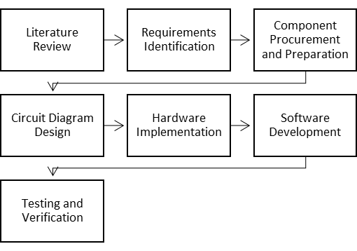
Fig. 1. Research Methodology

The system architecture targets a wearable platform with an ESP32 controller that integrates an ultrasonic sensor for near-field obstacle detection, a GPS module for geolocation, an emergency push button as a user-initiated trigger, and buzzer for audio plus a coin vibration motor for haptic feedback. For connectivity, Blynk Cloud bridges device–app data streams and events and Twilio delivers SMS containing GPS coordinates to trusted contacts. The system concept and block design that map components, signals, and data flows are shown in Figure 2 and Figure 3. The complete system architecture is shown in Figure 4.
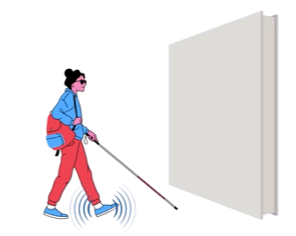
Fig 2. Concept of Smart Shoes

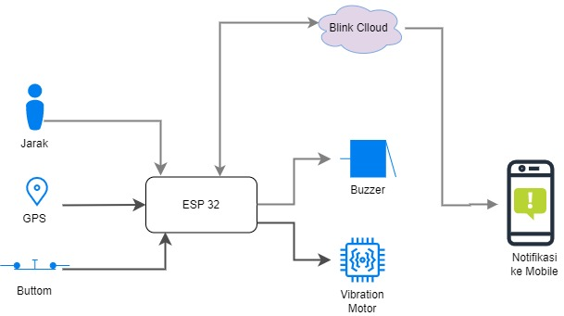
Fig. 3. Design Blocks for a Smart Shoe

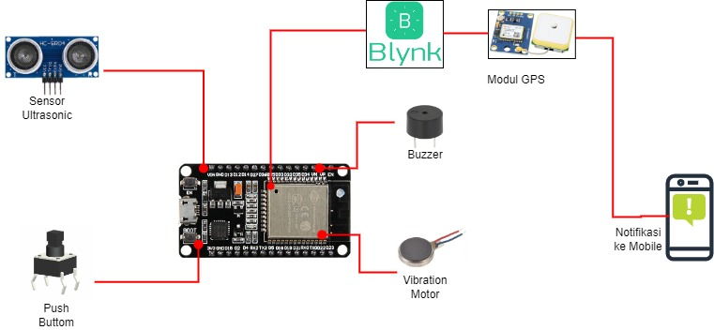
Fig. 4. Architecture of the Smart Shoe System

Hardware assembly followed the documented wiring plan. The ultrasonic module connects to ESP32 Trigger and Echo GPIO pins with regulated VCC and GND. The GPS module of Neo-6M class interfaces via UART on ESP32 TX and RX to stream NMEA sentences. The emergency button is attached to a GPIO with the proper pull-up or pull-down. The buzzer is driven by a GPIO with optional PWM. The vibration motor is switched through a small driver or transistor to meet current demands. The wiring ensures a deterministic sensor → controller → actuator path that is maintainable and replicable.

Firmware was developed in Arduino IDE using TinyGPS++ for GPS parsing and Blynk for cloud connectivity. The setup() routine initializes the serial monitor, pin mappings, the GPS UART on pins 16 and 17, the Blynk connection, and Twilio parameters. The loop() routine monitors the emergency button, computes ultrasonic distance, drives buzzer and vibration, and triggers notifications. For user safety, the distance threshold is configured so that when distance is below 40 cm the audio and haptic feedback activate immediately. The emergency alert mechanism uses a Blynk event for push or email and a Twilio SMS with latitude and longitude from the GPS module to enable fast location-aware response.

Cloud integration was designed so escalation occurs only when the emergency button is pressed. Blynk data streams carry distance and location states and trigger application notifications. Twilio sends SMS containing GPS coordinates to predefined caregivers. The communication path remains lightweight and easy to replicate, consistent with the constraints of battery-powered edge devices.

Functional testing verified the intended behavior and responsiveness. Audio and haptic feedback must engage below the threshold distance. GPS behavior was checked under open-sky and obstructed environments and coordinates were confirmed to be attached to outgoing alerts. Notification delivery was observed through Blynk and Twilio. End-to-end reliability was validated by checking Wi-Fi stability, application updates, and SMS routing. User-centered observations ensured HCI principles are satisfied, including clear cues, minimal intrusiveness, and a single-action emergency trigger. Figures 1 through 4 should be placed immediately after the first references to provide visual context.

4. results and discussion

The ESP32-based smart shoe prototype was successfully developed through two main stages: the first stage involved initial assembly on a breadboard to validate the basic functionality of each component, followed by full integration onto a PCB to achieve a more stable, compact, and portable physical form (Figure 5). The system includes an ultrasonic sensor for near-field obstacle detection, a GPS module for location tracking, a user-activated emergency button, and non-visual actuators in the form of a buzzer and a vibration motor.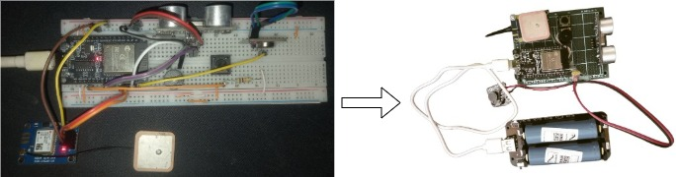

Fig. 5. Transition from the initial breadboard-based prototype (left) to the final PCB-based form (right)

The system is configured with a detection threshold of 40 cm, which automatically activates audio and haptic feedback when an object is detected within this range. If the emergency button is pressed, the system sends a notification to trusted contacts via push/email using Blynk and an SMS containing the user's GPS coordinates through the Twilio service (Figure 6).
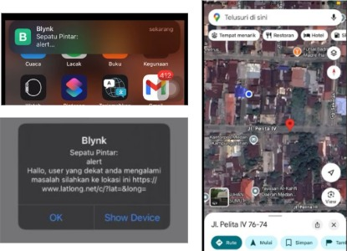
Fig. 6. Emergency alert notification sent via the Blynk application to the designated caregiver or monitoring party.

The final assembled prototype was then mounted onto a shoe and worn by a test subject during field testing (Figure 7), demonstrating that the system workflow—from sensor → controller → actuator → cloud communication—operated cohesively as designed and is ready for replication in real-world implementation.
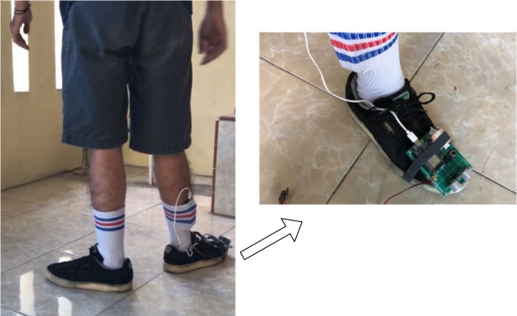

Fig. 7. Smart shoe worn by the test subject during simulated field testing

The findings of this study reinforce the wearable system approach for visually impaired users and surpass previous solutions that were partial in nature. Studies by Kazi et al. (2023) and Turnip et al. (2023) demonstrated that obstacle detection using ultrasonic sensors and buzzer feedback can assist user navigation, yet lacked location reporting systems or cloud integration. Raji et al. (2024) emphasized the importance of GPS-based location tracking to enhance user safety but did not implement direct integration with on-site obstacle detection. Meanwhile, Roy and Shah (2022) employed ESP32 and Twilio for SMS delivery, but did not combine it with real-time feedback or a wearable interface. This study presents a comprehensive and ready-to-deploy IoT platform featuring multichannel alerts and addresses technical limitations such as sensor sensitivity to object angle and surface type, as outlined by Zhao et al. (2022), through optimized threshold tuning and sensor positioning.

Scientifically, this research contributes to the development of assistive IoT technology by integrating sensing, actuation, and communication within a compact and energy-efficient wearable system. The concept aligns with human–computer interaction (HCI) principles in inclusive technology design, as emphasized by Horton et al. (2017) and Kaplan & Pyayt (2024), and is supported by Aguilar-Amador & Reyes-Duke (2023) regarding the importance of multimodal feedback for visually impaired users. Practically, the results show that the system can be replicated with low cost and architectural simplicity, making it a viable solution for broader community adoption. Existing limitations, such as the inability to detect road holes or elevation changes and the 40 cm detection range, present opportunities for future development in sensor integration and power management. Overall, the findings support the core objective of enhancing the safety and independence of visually impaired users in daily mobility through a simple, functional, and affordable technological solution.

5. Conclusion
The study delivered a working iot smart shoe that integrates an esp32 controller, an ultrasonic range sensor for near-field obstacle detection, a gps module for geolocation, a user-activated emergency button, and audio–haptic feedback through a buzzer and a vibration motor, with cloud alerts sent via blynk and twilio. Functional verification in indoor and outdoor settings showed behavior consistent with the design: a 40 cm safety threshold reliably triggered local audio–haptic cues, and pressing the emergency button sent push or email notifications and sms containing coordinates when connectivity was available. The interaction design kept cognitive load low through automatic cues and a single clear action for emergency escalation, supporting the goal of safer and more independent mobility for visually impaired users. Limitations include the absence of hole or elevation-change detection, the effective range of ultrasonic sensing, dependence on network quality for timely alerts, and reduced gps fidelity in obstructed environments. Future work should refine sensor placement and adaptive thresholds, explore lightweight sensor fusion and richer feedback patterns, improve energy management for longer operation, harden the enclosure, and conduct usability studies with visually impaired participants in field scenarios.

COMPETING INTERESTS DISCLAIMER:
Authors have declared that they have no known competing financial interests OR non-financial interests OR personal relationships that could have appeared to influence the work reported in this paper.

References

Aguilar-Amador, C. S., & Reyes-Duke, A. M. (2023). Wearable Object Detection System for People with Blindness and IoT Monitoring. Proceedings of the 21th LACCEI International Multi-Conference for Engineering, Education and Technology (LACCEI 2023): “Leadership in Education and Innovation in Engineering in the Framework of Global Transformations: Integration and Alliances for Integral Development.” https://doi.org/10.18687/LACCEI2023.1.1.1287
Alfiqi, R., & Sembiring, J. P. (2023). Technology for SMS-based assistive device for the visually impaired. Journal of Soft Computing Exploration, 4(4), 177–185. https://doi.org/10.52465/joscex.v4i4.225
Bhavani, R., & Ananthakumaran, S. (2021). Development of a smart walking stick for visually impaired people. Turkish Journal of Computer and Mathematics Education (TURCOMAT), 12(2), 999–1005. https://doi.org/10.17762/turcomat.v12i2.1112
Dhou, S., Alnabulsi, A., Al-Ali, A. R., Arshi, M., Darwish, F., Almaazmi, S., & Alameeri, R. (2022). An IoT Machine Learning-Based Mobile Sensors Unit for Visually Impaired People. Sensors, 22(14), 5202. https://doi.org/10.3390/s22145202
Horton, E. L., Renganathan, R., Toth, B. N., Cohen, A. J., Bajcsy, A. V., Bateman, A., Jennings, M. C., Khattar, A., Kuo, R. S., Lee, F. A., Lim, M. K., Migasiuk, L. W., Zhang, A., Zhao, O. K., & Oliveira, M. A. (2017). A review of principles in design and usability testing of tactile technology for individuals with visual impairments. Assistive Technology, 29(1), 28–36. https://doi.org/10.1080/10400435.2016.1176083
Kaplan, H., & Pyayt, A. (2024). Fully Digital Audio Haptic Maps for Individuals with Blindness. Disabilities, 4(1), 64–77. https://doi.org/10.3390/disabilities4010005
Kazi, W., Limu, T. J., & Md. Rakibuzzaman. (2023). Smart Cane: A Low Cost Assistive Device for the Visually Impaired. EAI Endorsed Transactions on Internet of Things, 8(4), e5. https://doi.org/10.4108/eetiot.v8i4.1707
Parmar, V. S., & Inkoolu, K. S. (2017). Designing Smart Shoes for Obstacle Detection: Empowering Visually Challenged Users Through ICT. In R. Bernhaupt, G. Dalvi, A. Joshi, D. K. Balkrishan, J. O’Neill, & M. Winckler (Eds.), Human-Computer Interaction – INTERACT 2017 (Vol. 10515, pp. 258–266). Springer International Publishing. https://doi.org/10.1007/978-3-319-67687-6_17
Raji, R. K., Han, J. L., Li, Z., & Gong, L. (2024). Review of development trends in smart shoe applications. Sensor Review, 44(3), 290–300. https://doi.org/10.1108/SR-04-2023-0093
Roy, M., & Shah, P. (2022). Internet of Things (IoT) Enabled Smart Navigation Aid for Visually Impaired. In L. Barolli, F. Hussain, & T. Enokido (Eds.), Advanced Information Networking and Applications (Vol. 451, pp. 232–244). Springer International Publishing. https://doi.org/10.1007/978-3-030-99619-2_23
Sen, A., Sen, K., & Das, J. (2018). Ultrasonic Blind Stick for Completely Blind People to Avoid Any Kind of Obstacles. 2018 IEEE SENSORS, 1–4. https://doi.org/10.1109/ICSENS.2018.8589680
Shariff, A. F., B.S, A., Radhika, M., & S, S. (2020). BLIND ASSISTANCE USING ARTIFICIAL INTELLIGENGE. International Journal of Engineering Applied Sciences and Technology, 5(3), 396–401. https://doi.org/10.33564/IJEAST.2020.v05i03.063
Singh, B., Ekvitayavetchanuku, P., Shah, B., Sirohi, N., & Pundhir, P. (2024). IoT-Based Shoe for Enhanced Mobility and Safety of Visually Impaired Individuals. EAI Endorsed Transactions on Internet of Things, 10. https://doi.org/10.4108/eetiot.4823
Turnip, M. T. B., Gunawan, A. A. N., Adnyana, I. G. A. P., Supardi, I. W., & Trisnawati, N. L. P. (2023). Obstacle Detection Stick for the Visually Impaired Using HC-SR04 Ultrasonic Sensor and Arduino Nano Microcontroller-based Raindrop Sensor. Journal of Engineering Research and Reports, 25(3), 1–6. https://doi.org/10.9734/jerr/2023/v25i3886
Wu, F., Wu, T., & Yuce, M. R. (2018). An Internet-of-Things (IoT) Network System for Connected Safety and Health Monitoring Applications. Sensors, 19(1), 21. https://doi.org/10.3390/s19010021

