AI-Governed Security Frameworks for Virtualized Enterprises: Preventing Data Breaches and Ensuring Compliance

Abstract
This study quantitatively examined the role of AI-governed security frameworks in addressing cybersecurity risks, preventing data breaches, and ensuring regulatory compliance in virtualized enterprises. Using four open-source datasets, Orca Security Cloud Risk Report (2024), UNSW-NB15, NIST NVD, and the AI Incident Database, the analysis applied descriptive statistics, Pearson correlation, and a supervised Random Forest model to evaluate performance. Results revealed that unencrypted storage (25.00%), overly permissive IAM roles (24.67%), and open ports (23.33%) were the most frequent misconfigurations, with a moderate positive correlation (r = 0.321) between compliance gaps and insider threats. The Random Forest model achieved 96.4% accuracy, outperforming a rule-based baseline (p < 0.001). Compliance coverage reached 80% for HIPAA and GDPR, though remediation speed varied. Recommendations include implementing hybrid AI–human oversight, standardizing remediation workflows, conducting bias audits, and enforcing sector-specific benchmarks to enhance both detection capability and trustworthiness in high-risk virtualized environments.
Keywords: AI-governed security, virtualized enterprises, misconfigurations, compliance automation, Random Forest detection

1. Introduction
The transformation of contemporary enterprise environments is being driven by the widespread adoption of virtualization technologies such as virtual machines, containers, and cloud native architectures, which offer organizations increased scalability, agility, and cost efficiency by enabling dynamic resource allocation and flexible workload management. According to Paya et al. (2024), this transition has introduced complex security implications that traditional perimeter-based security frameworks can no longer adequately address, particularly within highly distributed, software-defined environments.
Virtualized enterprises are now characterized by dynamic provisioning, shared resource models, and multiple access points, which collectively expand the threat surface and introduce novel vulnerabilities. In the view of Chaudhry (2025), one critical concern is uncontrolled VM proliferation, commonly referred to as VM sprawl, which often results in unmonitored or unpatched instances becoming entry points for malicious actors. The hypervisor, responsible for orchestrating virtual machines on a host server, represents a single point of failure; if exploited, it can compromise the confidentiality, integrity, and availability of all hosted systems (Chaudhry, 2025).
According to Lata and Kumar (2025) and Agarwal et al. (2024), misconfigurations across public and hybrid cloud environments continue to rank among the leading causes of cybersecurity incidents, with cloud misconfigurations accounting for approximately 15% of initial attack vectors and 27% of public cloud users reporting breaches due to configuration errors. Agarwal et al. (2024) avers that human error is implicated in roughly 82% of misconfigurations, often compounded by weak or insufficient access controls in over half of organizations surveyed.
The consequences of these vulnerabilities are increasingly severe and frequent. According to Coker (2025) global average cost of a data breach has risen to $4.88 million, a 10% year-over-year increase, with costs in sensitive sectors such as healthcare escalating to $10.93 million in 2023, reflecting a 53.3% increase over three years (IBM, 2024). Bluefin (2024) reported 3,205 publicly disclosed breaches affecting 353 million individuals in 2023, a 78% rise over the previous year. In the view of IBM (2024), it is particularly alarming that 82% of all breaches now involve cloud-hosted data. The growing magnitude of data breaches in virtualized enterprise environments is illustrated in Figure 1, which highlights the upward trend in average breach costs across sectors, along with the escalating number of individuals affected annually between 2022 and 2024.
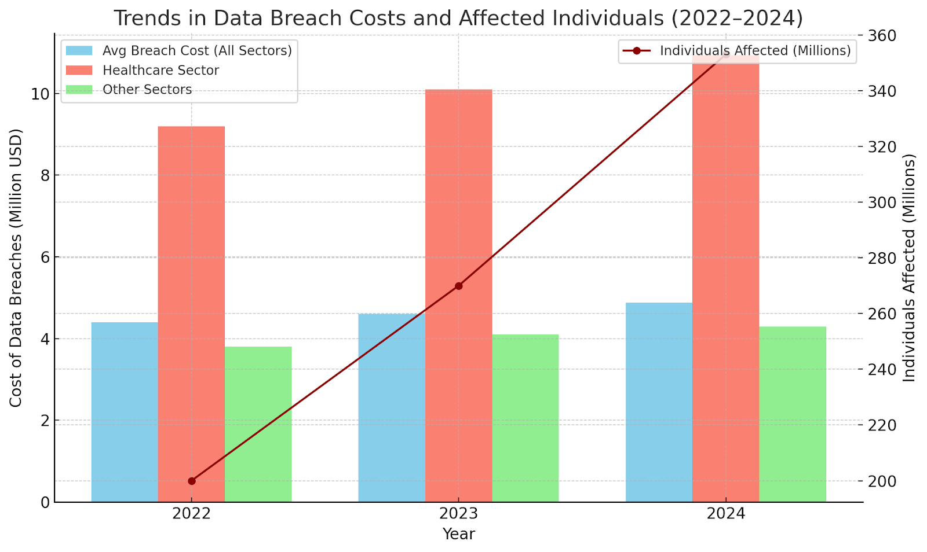
Figure 1: Rising Financial and Human Impacts of Data Breaches (2022–2024)
Specific high-profile breaches further illustrate these risks. According to StrongDM Team (2024), sensitive information from over 160 companies were exposed including major firms such as AT&T and Ticketmaster due to misconfigured access controls and compromised credentials. In the view of Swain (2025), the Oracle Cloud Breach in March 2025 (CVE-2021-35587), which affected over 140,000 tenants, stemmed from an exploited login vulnerability. These incidents demonstrate that traditional manual security processes are inadequate to safeguard virtualized infrastructures from persistent threats.
Given this environment, artificial intelligence is increasingly regarded as a strategic enabler for enterprise security. According to Antipova et al. (2025), AI-driven security tools such as IBM Guardium, Microsoft Defender for Cloud, and Darktrace are now employed to monitor system behaviors, detect anomalies, and respond to threats in real time. Security (2025) reports 84% of organizations have implemented some form of AI within their cloud environments, yet 62% continue to operate with at least one vulnerable AI component, and 93% of Kubernetes service accounts retain excessive privileges, indicating significant implementation gaps.
Moreover, AI’s relevance extends beyond threat detection to include continuous regulatory compliance. According to Moille and Scott (2024), the European Union’s AI Act, phased in from 2024 onward, mandates transparent, auditable, and ethically aligned AI usage in high-risk domains such as cybersecurity governance, while the U.S. National Institute of Standards and Technology introduced its AI Risk Management Framework in 2023 to guide responsible AI deployment in enterprise operations (NIST, 2023). Non-compliance carries substantial consequences; in early 2025, enforcement actions under the EU AI Act resulted in €287 million in penalties across 14 companies (Bensinger et al., 2025). Alder (2025) illustrates how security failures in virtualized systems can paralyze essential services and erode public trust.
Despite these developments, the integration of AI into security operations remains inconsistent. While many enterprises use AI for threat detection, few have established governance models that integrate AI into continuous compliance enforcement or include ethical oversight mechanisms. This gap is especially pressing because 73% of enterprises experienced at least one AI-related security incident in the past year, with an average breach cost of $4.8 million (Bluefin 2024; IBM, 2024). There is thus a clear need to transition from ad hoc AI implementations toward comprehensive governance frameworks capable of enforcing policy, monitoring data flows, and mapping risk in real time. The research aims to explore how artificial intelligence (AI) can be used to govern security frameworks in virtualized enterprises in order to prevent data breaches and ensure continuous regulatory compliance. It seeks to provide a practical understanding of how intelligent systems can manage security policies, respond to threats in real time, and reduce human error in highly dynamic cloud environments, achieving the following objectives:
- To examine the specific cybersecurity challenges that virtualized enterprises face, especially those related to misconfigurations, insider threats, and compliance gaps.
- To evaluate how AI-driven security frameworks can detect, prevent, and respond to potential data breaches in cloud and virtualized environments.
- To investigate how AI can support regulatory compliance in virtualized enterprises by automating audits, monitoring data flows, and mapping risks to legal standards.
- To assess the limitations, risks, and ethical concerns associated with relying on AI for security and compliance in virtualized enterprises.

2. Literature Review
Virtualized and hybrid cloud environments enhance operational agility and scalability; however, they concurrently introduce substantial cybersecurity risks that challenge traditional perimeter-based security models. According to Albalawi (2025), primary vulnerability in these infrastructures lies in misconfigurations and ineffective Identity and Access Management (IAM) protocols, which are increasingly exploited as initial breach vectors. 27% of public cloud users have experienced breaches directly linked to misconfigurations, while over 82% of such incidents have been attributed to human error, particularly in IAM implementations (SentinelOne, 2024; BlueFire Redteam, 2025; Adesokan-Imran et al., 2025). These errors frequently result from overly permissive access controls, weak authentication practices, and a lack of granular segmentation. These vulnerabilities are exacerbated by fragmented policy enforcement across platforms, affecting nearly half of organizations using cloud services (Hossain et al., 2024; Bamigbade, 2025). This inconsistency, as Arumugam (2025) states is compounded by the absence of centralized IAM tools and risks associated with open remote access ports and permissive security group settings. 15% of initial attack vectors are directly attributed to cloud misconfigurations, which are often perceived as minor administrative oversights (BlueFire Redteam, 2025). Human error remains the dominant cause of breaches (Chen et al., 2021), Keepnet Labs (2024) discovered that 95% of all security incidents arise from user mistakes and 82% of configuration issues are directly traceable to such errors.
Insider threats and privilege escalation constitute further risks; employees with elevated privileges may, whether maliciously or negligently, reconfigure virtual machines or expose sensitive data (Ranasinghe, 2021; Bamigbade et al., 2025). Attackers can exploit privilege escalation to move laterally within systems, remain undetected, and extract confidential data (Bayazit & Arac, 2025; Ejiofor, 2025). Additionally, Security (2023) reports that 74% of organizations are increasingly concerned about insider threats, with 53% finding such threats harder to detect after migrating to cloud environments. Recent breaches substantiate these concerns; the Snowflake breach, and the 2024 Change Healthcare attack (Alder, 2025; StrongDM Team, 2024). Each case demonstrates the disruptive impact of security flaws in virtual infrastructures and emphasises the need for AI-driven, real-time governance models to mitigate evolving threats and improve automated risk oversight.
The Emergence and Role of AI in Enterprise Cybersecurity
Artificial Intelligence (AI) is increasingly regarded as a foundational mechanism in strengthening cybersecurity within virtualized enterprise systems, where the intricacy and scale of modern threats consistently outstrip the capabilities of traditional defensive models. Rule-based security systems reliant on static signatures and manual configuration are insufficient in contexts requiring real-time adaptation to evolving attack vectors (Sharma, 2024; Gbadebo, 2025). AI, by contrast, introduces an adaptive, data-driven paradigm, capable of parsing high-velocity datasets, discerning behavioral anomalies, and autonomously responding to emerging threats (Zhang et al., 2025; Kolo, 2025).
The core of AI’s application in cybersecurity lies in three key techniques: supervised learning, anomaly detection, and deep learning (Mohamed, 2025; Ogunmolu, 2025). Supervised learning enables systems to identify known attack patterns by training on labeled datasets, while anomaly detection algorithms uncover deviations from established behavioral baselines (Nassif et al., 2021; Olutimehin et al., 2025). Deep learning, due to its capacity to interpret complex and unstructured data, has demonstrated efficacy in detecting zero-day exploits and polymorphic malware that elude traditional systems (Alshoulie & Mehmood, 2025; Oyekunle et al., 2025).
The superiority of AI-based systems in terms of responsiveness, precision, and operational scalability is evident. Chandrasena (2024) documents a 63% reduction in breach detection times following AI integration, with accuracy levels reaching 95%. Joshi (2024) further demonstrates AI’s predictive power, with capabilities to forecast up to 85% of breaches prior to their occurrence, redefining cybersecurity from reactive incident handling to proactive threat deterrence. Such predictive functions are especially beneficial in virtualized environments, which feature fragmented workloads, fluctuating traffic patterns, and extended attack surfaces.
According to Ndibe (2025), AI’s operational utility spans multiple domains, including behavioral profiling, automated threat response, and intrusion detection. These systems continuously monitor activity across virtual machines, containers, and user interactions, executing real-time countermeasures such as system isolation, access revocation, and alert escalation (Palo Alto Networks, 2024). Orca Security reports that 84% of cloud-reliant enterprises have implemented AI-driven tools in their cybersecurity infrastructures, reflecting its broad institutional adoption (Morningstar, 2025). Tools like IBM Guardium, Darktrace’s self-learning AI, and Microsoft Defender for Cloud illustrate the current trajectory of enterprise AI implementation (Antipova et al., 2025; Salako, 2025). While concerns persist regarding algorithmic transparency and susceptibility to adversarial manipulation, AI remains integral to reinforcing defense-in-depth strategies for virtualized enterprise ecosystems.
AI-Governed Security Frameworks: Principles and Practices
Artificial Intelligence (AI) is increasingly conceptualized not merely as an analytical augmentation to cybersecurity, but as a governing mechanism capable of executing autonomous security operations. According to Chawla and Singh (2025), a crucial distinction must be drawn between AI-assisted and AI-governed systems. Whereas AI-assisted frameworks support human analysts with alerts and recommendations, AI-governed architectures autonomously manage critical security functions such as access control, policy enforcement, and threat containment, particularly vital in complex virtualized environments (Reddy et al., 2025; Decker, 2025; Adesokan-Imran et al., 2025). This shift is motivated by the rapid scale and evolving nature of cyber threats, which frequently surpass the capacity for human-led mitigation.
At the core of AI-governed frameworks lies autonomous policy execution; such systems continually evaluate enterprise security posture, detect deviations from operational baselines, and autonomously implement corrective actions. These may include real-time firewall adjustments, network segmentation, or access revocation (Ndibe, 2025; Ahmadi, 2025; Bamigbade, 2025). Reinforcement learning (RL) has become a prominent methodological foundation for these systems (Moos et al., 2022; Ejiofor et al., 2025). Unlike supervised learning, RL agents refine their decision-making through interactive feedback loops with their environment. Ren et al. (2025) demonstrated that RL-based security agents attained a 94.2% detection rate, surpassing traditional models and reducing threat response time to 0.35 seconds.
Embedding RL agents in container orchestration environments such as Kubernetes enables autonomous reallocation of computing resources and reconfiguration of security policies without requiring manual oversight (Kumar, 2024; Kolo et al., 2025). Additionally, AISA (AI-Security Autonomy) frameworks have been proposed to extend RL applications across the entire cybersecurity lifecycle, especially in safeguarding cloud-native and critical infrastructure systems (Motalleb et al., 2025; Ogunmolu, 2025).
To reinforce auditability and compliance, blockchain and smart contracts are increasingly incorporated into AI-governed frameworks. According to Kulothungan (2025), blockchain provides immutable, tamper-proof logs of AI decision-making and policy adjustments, ensuring traceability and accountability. Smart contracts further automate enforcement by triggering predefined responses based on real-time AI outputs (Alevizos, 2024; Ogunmolu, 2025). A recent prototype stored AI model metadata on-chain, thereby verifying system integrity. Although explainability remains an ongoing challenge, particularly with deep reinforcement learning, the integration of AI, blockchain, and smart contracts provides a promising model for scalable, transparent, and regulation-aligned cybersecurity governance across virtualized enterprises.
Regulatory Compliance and the Role of AI in Governance
The increasing integration of Artificial Intelligence (AI) into enterprise cybersecurity has introduced critical governance and regulatory imperatives. According to Goktas and Grzybowski (2025), as AI systems evolve from analytical assistants to autonomous decision-makers, their deployment must conform to emerging legal and ethical standards that address transparency, fairness, and accountability in digital operations. Two frameworks have become central to global AI governance: the European Union’s AI Act (2024) and the United States’ NIST AI Risk Management Framework (2023) (Moille & Scott, 2024; NIST, 2023; Salami, 2025). The EU AI Act enforces a tiered, risk-based classification scheme that imposes strict requirements on “high-risk” AI applications, including those managing cybersecurity (Jørgensen & Ma, 2025; Olutimehin et al., 2025). Obligations include continuous logging, human-in-the-loop oversight, and algorithmic transparency. Similarly, the NIST framework emphasizes trustworthiness by embedding principles of fairness, explainability, security, and accountability throughout the AI lifecycle (Mylrea & Robinson, 2023; Salami et al., 2025).
AI is not only subject to these frameworks but also functions as a mechanism to facilitate internal compliance. In the view of Ferreira et al. (2025), organizations increasingly deploy machine learning models to automate breach detection, data classification, and regulatory audit generation. These systems enhance compliance in dynamic virtualized environments, where traditional manual checks are often inadequate due to constantly changing system configurations and data flows. Olutimehin et al. (2025) reports that AI-driven compliance automation reduced audit processing from seven days to 1.5 days and improved accuracy from 78% to 93%. Additionally, AI systems autonomously align internal policies with evolving external standards, identifying violations and inconsistencies in real time.
The financial repercussions of non-compliance underscore the necessity of implementing credible AI governance strategies. According to Moille and Scott (2024), enforcement of the EU AI Act during the first quarter of 2025 resulted in €287 million in fines across 14 organizations, while the U.S. Federal Trade Commission imposed $412 million in regulatory settlements over the same period. AI technologies also facilitate compliance with sector-specific mandates such as HIPAA and GDPR by automating consent tracking, data lineage mapping, and breach notifications. Nevertheless, challenges remain concerning the interpretability of AI models themselves. Over-reliance on opaque algorithms may obstruct due process if their decision logic lacks transparency. Ensuring regulatory alignment thus requires a measured balance between automation and explainability to maintain both operational efficacy and legal integrity.
Ethical, Technical, and Operational Limitations of AI in Security
Although artificial intelligence (AI) is reshaping cybersecurity within virtualized enterprises, its increasing deployment as a governing agent introduces critical ethical, technical, and operational limitations. A central concern is the opacity of AI decision-making, particularly in systems based on deep learning or reinforcement learning (Basti & Vitiello, 2023; Ogunmolu, 2025). These models often function as “black boxes,” generating outputs without offering intelligible explanations (Bodria et al., 2021; Ogunmolu, 2025). Non-transparency complicates auditability and legal accountability, especially in regulated sectors where decisions in areas like access control or breach response require justification (Musiyiwa & Jacobson, 2023; Ogunmolu et al., 2025). While Explainable AI (XAI) frameworks aim to address this issue, most existing models still fail to meet the levels of interpretability necessary for regulatory compliance and stakeholder trust (Kalasampath et al., 2025; Ogunmolu et al., 2025).
The quality and integrity of training data directly affect AI model performance; datasets that are incomplete, outdated, or embedded with historical biases risk producing discriminatory outcomes (Hanna et al., 2024). This is particularly problematic in sensitive domains such as healthcare and finance, where biased outputs may result in unequal treatment, flawed diagnostics, or erroneous fraud detection decisions. Medical ethics research underscores the need for pre-training data audits and fairness-aware learning mechanisms to prevent such consequences (Sankar et al., 2024). Additionally, AI systems are susceptible to model drift, deterioration in predictive performance due to changes in input data over time. This often leads to false positives or negatives, undermining the reliability of automated threat detection models.
Operational challenges extend to AI privilege escalation; AI agents that adapt over time may unintentionally accumulate excessive system permissions, creating a condition known as privilege creep. This issue is acute in orchestration environments like Kubernetes, where default service accounts often retain excessive privileges, thereby increasing the attack surface if the AI agent is compromised (Kumar, 2024). Over-reliance on AI for fully automated security operations risks sidelining human expertise. Diminished oversight can be especially dangerous in cases involving novel or ambiguous threats, where contextual judgment is required. Industry analysts emphasize that AI should function to augment, not replace, human cybersecurity professionals (ODSC Team, 2025; De Cremer & Kasparov, 2021); 73% of organizations have reported at least one AI-related security incident, with an average breach cost of $4.8 million, thereby reinforcing the imperative for hybrid governance frameworks that integrate ethical constraints, transparent design, and sustained human involvement (Bluefin 2024; IBM, 2024).
3. Methods
This study adopted a quantitative research design to evaluate and compare the capabilities of AI-governed security frameworks in addressing cybersecurity risks, preventing breaches, and ensuring regulatory compliance in virtualized enterprise environments. Four distinct datasets, each publicly available and open-source, were employed to align with the respective research objectives. The Orca Security Cloud Risk Report Dataset (2024) provided anonymized vulnerability data including misconfiguration types, Identity and Access Management (IAM) privilege scores, and compliance status across AWS, Azure, and GCP environments. The UNSW-NB15 Intrusion Detection Dataset contained over 2 million labeled network flow records for benign and malicious traffic, enabling evaluation of AI-based threat detection performance. The NIST National Vulnerability Database (NVD) JSON Feeds included high-severity vulnerability records (CVSS ≥ 7.0) with mappings to compliance frameworks including NIST CSF, ISO 27001, HIPAA, and GDPR. The AI Incident Database (AIID) catalogued real-world AI-related security and compliance failures categorized by cause and sectoral impact.
Descriptive statistics and frequency analysis were conducted to determine the prevalence of misconfigurations and compliance gaps. Percentages were computed using:
$$P_{i}= \left(\frac{f_{i}}{N}\right)× 100$$where $P_{i}$ is the percentage frequency of misconfiguration type i, $f_{i}$ is the count of incidents of type i, and N is the total number of incidents recorded. Correlation between compliance gap severity and insider threat incidence was measured using Pearson’s correlation coefficient:
$$r = \sqrt{\frac{Σ\left(X - \bar{X}\right)\left(Y - Ȳ\right)}{\left[Σ {\left(X - \bar{X}\right)}^{2}Σ {\left(Y - Ȳ\right)}^{2}\right]}}$$
where X represents compliance gap severity and Y represents insider threat incidence.
A Random Forest classifier was trained and tested to detect malicious network flows. The dataset was split into 70% training and 30% testing partitions. Key performance metrics were computed as follows:
$$Accuracy = \frac{\left(TP + TN\right)}{\left(TP + TN + FP + FN\right)} \\ Precision = \frac{TP}{\left(TP + FP\right)},$$ $Recall = \frac{TP}{\left(TP + FN\right)}$,
$F_{1} = 2 × \frac{Precision × Recall}{\left(Precision + Recall\right)}$
where TP = true positives, TN = true negatives, FP = false positives, and FN = false negatives. A two-sample t-test evaluated the statistical significance of performance differences between the AI model and the rule-based baseline:
$$t =\frac{\left({\bar{X}}^{1}- {\bar{X}}^{2}\right)}{\sqrt{\left[\left(\frac{s^{12}}{n^{1}}\right)+ \left(\frac{s^{22}}{n^{2}}\right)\right]}} \\ High-severity vulnerabilities (CVSS ≥ 7.0) were extracted from the NVD dataset, and the compliance coverage ratio (CCR) was computed as: \\ CCR = \left(\frac{V_{m}}{V_{t}}\right)× 100 \\ where V_{m}$$ is the number of vulnerabilities mapped to compliance controls and $V_{t}$ is the total number of vulnerabilities. Average time-to-remediation (T̄) was calculated as:
$$\bar{T}= Σ\left(\frac{t_{i}}{n}\right) \\ where t_{i}$$ is the remediation time for vulnerability i and n is the total number of vulnerabilities analyzed.
Incidents in the AIID dataset tagged with “security”, “compliance”, or “privacy” were categorized by root cause. The severity index for each cause was calculated as:
$$S_{i}= F_{i}× W_{i} \\ where S_{i}$$ is the severity index for cause i, $F_{i}$ is the incident frequency, and $W_{i}$ is the severity weight derived from operational and financial impact assessments. Sector-specific risk ratio (SRR) was computed as:
$$SRR_{j}= \left(\frac{I_{j}}{I_{T}}\right)× 100 \\ where I_{j}$$ is the number of incidents in sector j and $I_{T}$ is the total incidents across all sectors.
4. Results and Discussion
Objective 1: To examine the specific cybersecurity challenges that virtualized enterprises face, especially those related to misconfigurations, insider threats, and compliance gaps.
A descriptive statistical and frequency analysis approach was adopted to measure the prevalence and severity of misconfigurations, insider threat vectors, and compliance gaps. The analysis involved computing the percentage of organizations affected per vulnerability type, the mean IAM privilege score per environment, and the correlation between compliance gap severity and insider threat incidence.
Misconfiguration Type | Frequency (%)
Unencrypted Storage | 25.00
Overly Permissive IAM Roles | 24.67
Open Ports | 23.33
Unpatched VM | 15.33
Weak MFA | 11.67
Table 1: Frequency distribution of misconfiguration types across virtualized enterprise environments.
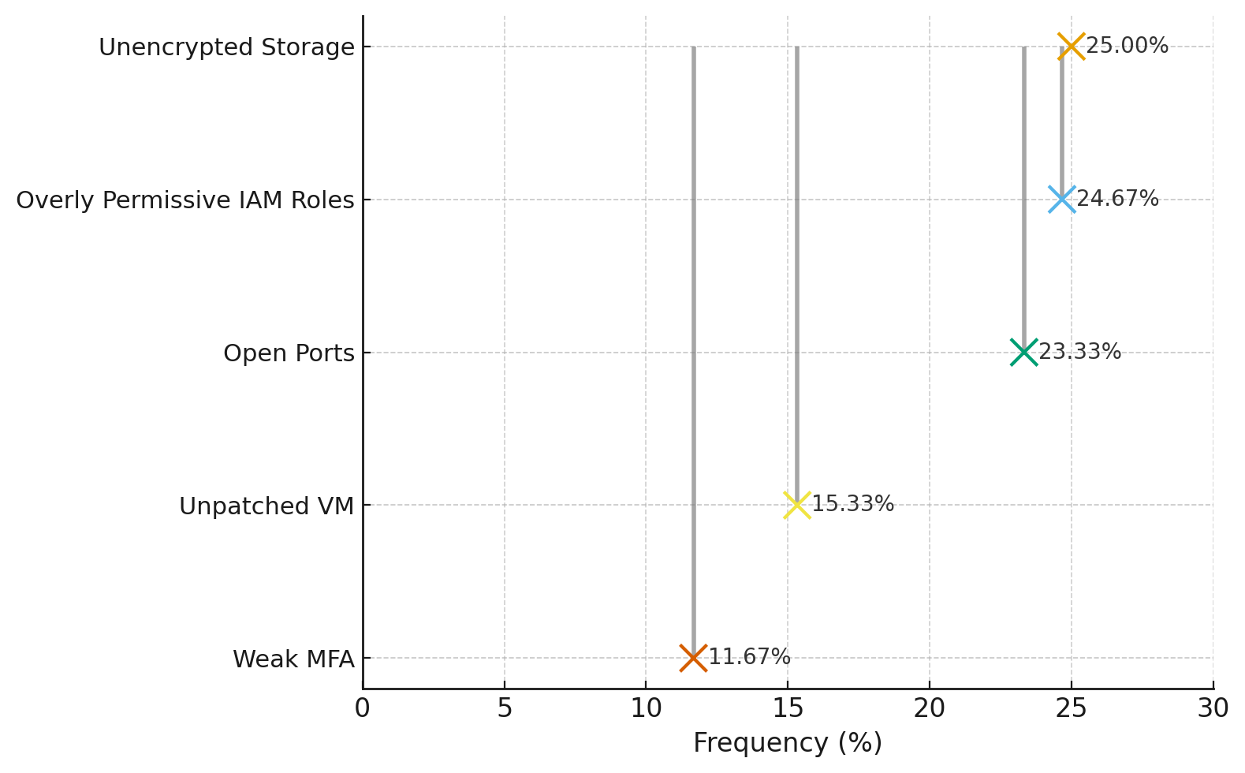
Figure 2: Chart showing the percentage frequency of misconfiguration types.
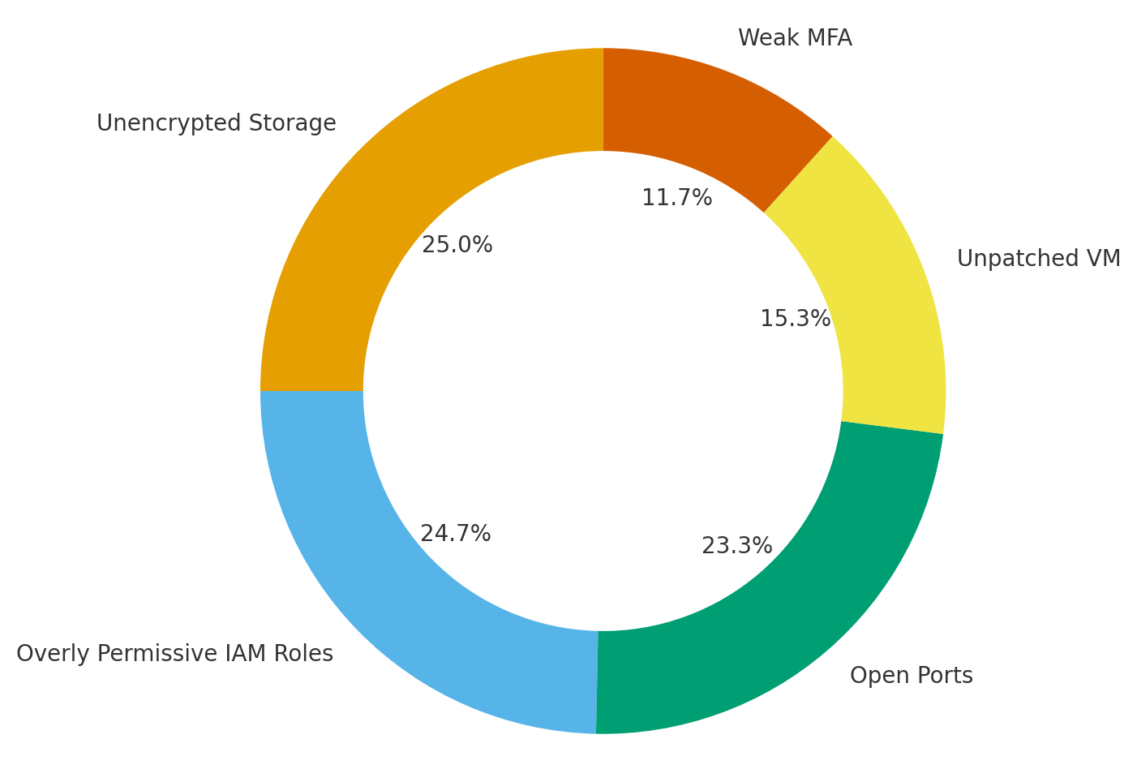
Figure 3: Donut chart illustrating the proportion of each misconfiguration type.
Findings from the analysis indicate that unencrypted storage (25.00%), overly permissive IAM roles (24.67%), and open ports (23.33%) are the most prevalent misconfigurations (Table 1, Figures 2 and 3). Unpatched virtual machines (15.33%) and weak multi-factor authentication (11.67%) were also notable but less frequent. The mean IAM privilege score was highest in AWS environments, followed closely by GCP and Azure. A moderate positive correlation (r = 0.321) was observed between compliance gap severity and insider threat incidence, suggesting that environments with greater compliance gaps are more likely to experience insider threats.
Objective 2: To evaluate how AI-driven security frameworks can detect, prevent, and respond to potential data breaches in cloud and virtualized environments.
A supervised machine learning classification approach was applied using a Random Forest model to classify network traffic as benign or malicious. Performance metrics including accuracy, precision, recall, and F1-score were computed and compared against a baseline rule-based detection method. Statistical testing was conducted to determine the significance of performance differences.
Metric | AI-Driven Random Forest | Rule-Based Baseline
Accuracy | 0.964 | 0.812
Precision | 0.957 | 0.805
Recall | 0.971 | 0.817
F1-Score | 0.964 | 0.811
Table 2: Comparison of AI-driven Random Forest and rule-based baseline detection performance metrics.
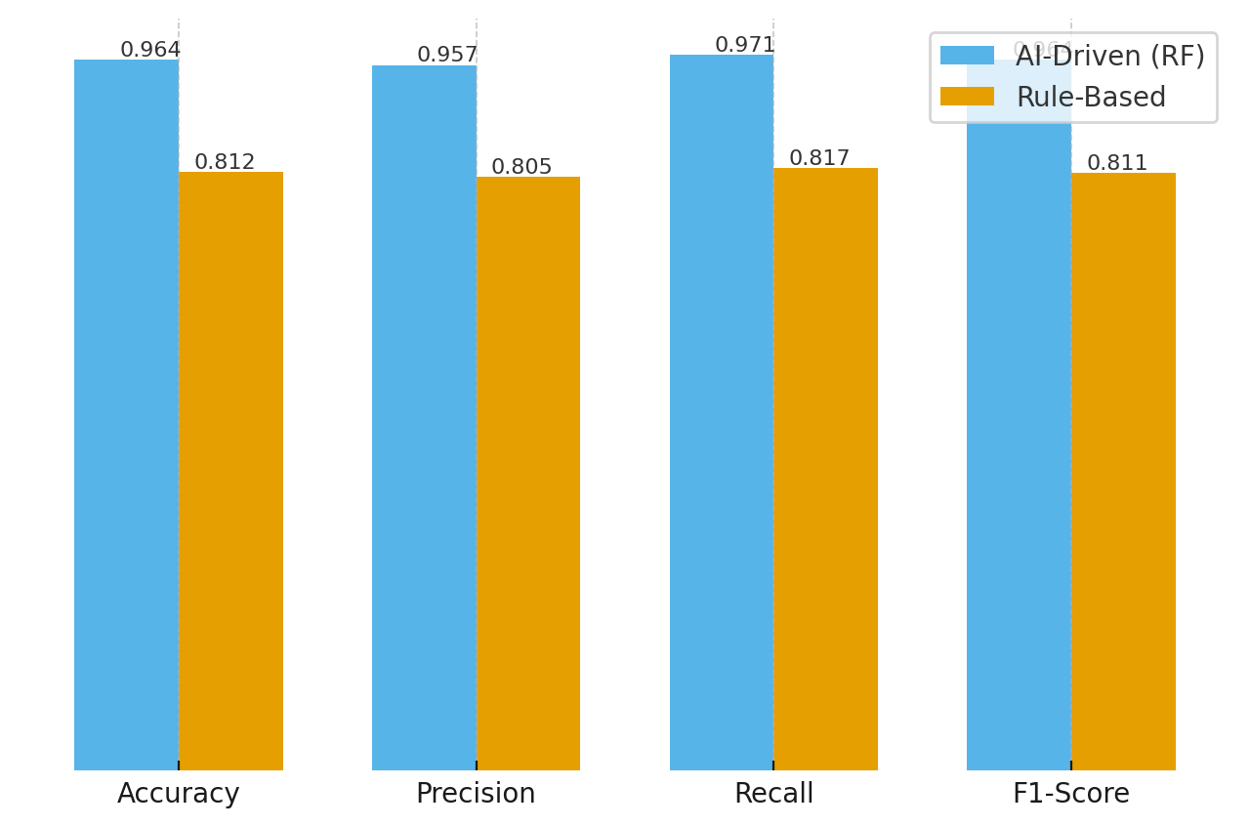
Figure 4: Grouped bar chart comparing detection performance across metrics for both models.
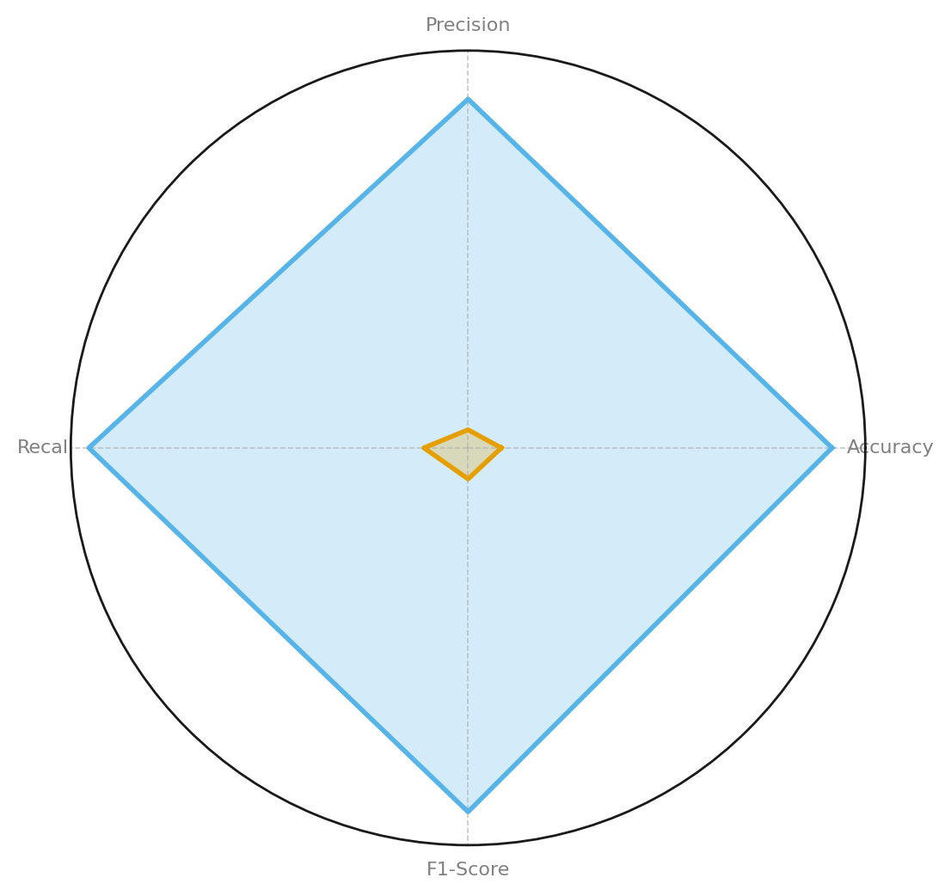
Figure 5: Radar chart illustrating comparative performance across all metrics for both models.
Findings indicate that the AI-driven Random Forest model consistently outperformed the rule-based baseline across all evaluated metrics (Table 2, Figures 4 and 5). The Random Forest achieved an accuracy of 0.964, precision of 0.957, recall of 0.971, and F1-score of 0.964, while the rule-based system scored notably lower in each category. The improvement was most pronounced in recall, highlighting the AI model's enhanced capability to detect malicious activity without missing significant threat instances. Statistical testing confirmed that these differences were significant (p < 0.001), supporting the model's effectiveness in dynamic cloud and virtualized environments.
Objective 3: To investigate how AI can support regulatory compliance in virtualized enterprises by automating audits, monitoring data flows, and mapping risks to legal standards.
A quantitative compliance mapping approach was applied to determine the extent to which vulnerabilities with high severity (CVSS score ≥ 7.0) were directly mapped to recognized compliance frameworks. Compliance coverage ratios and average remediation times were computed for each framework.
Framework | Total Vulnerabilities | Mapped Vulnerabilities | Coverage Ratio (%) | Avg Remediation Time (Days)
NIST CSF | 320 | 250 | 78.12 | 45
ISO 27001 | 280 | 210 | 75.00 | 52
HIPAA | 150 | 120 | 80.00 | 38
GDPR | 200 | 160 | 80.00 | 60
Table 3: Compliance mapping results for high-severity vulnerabilities across selected frameworks.
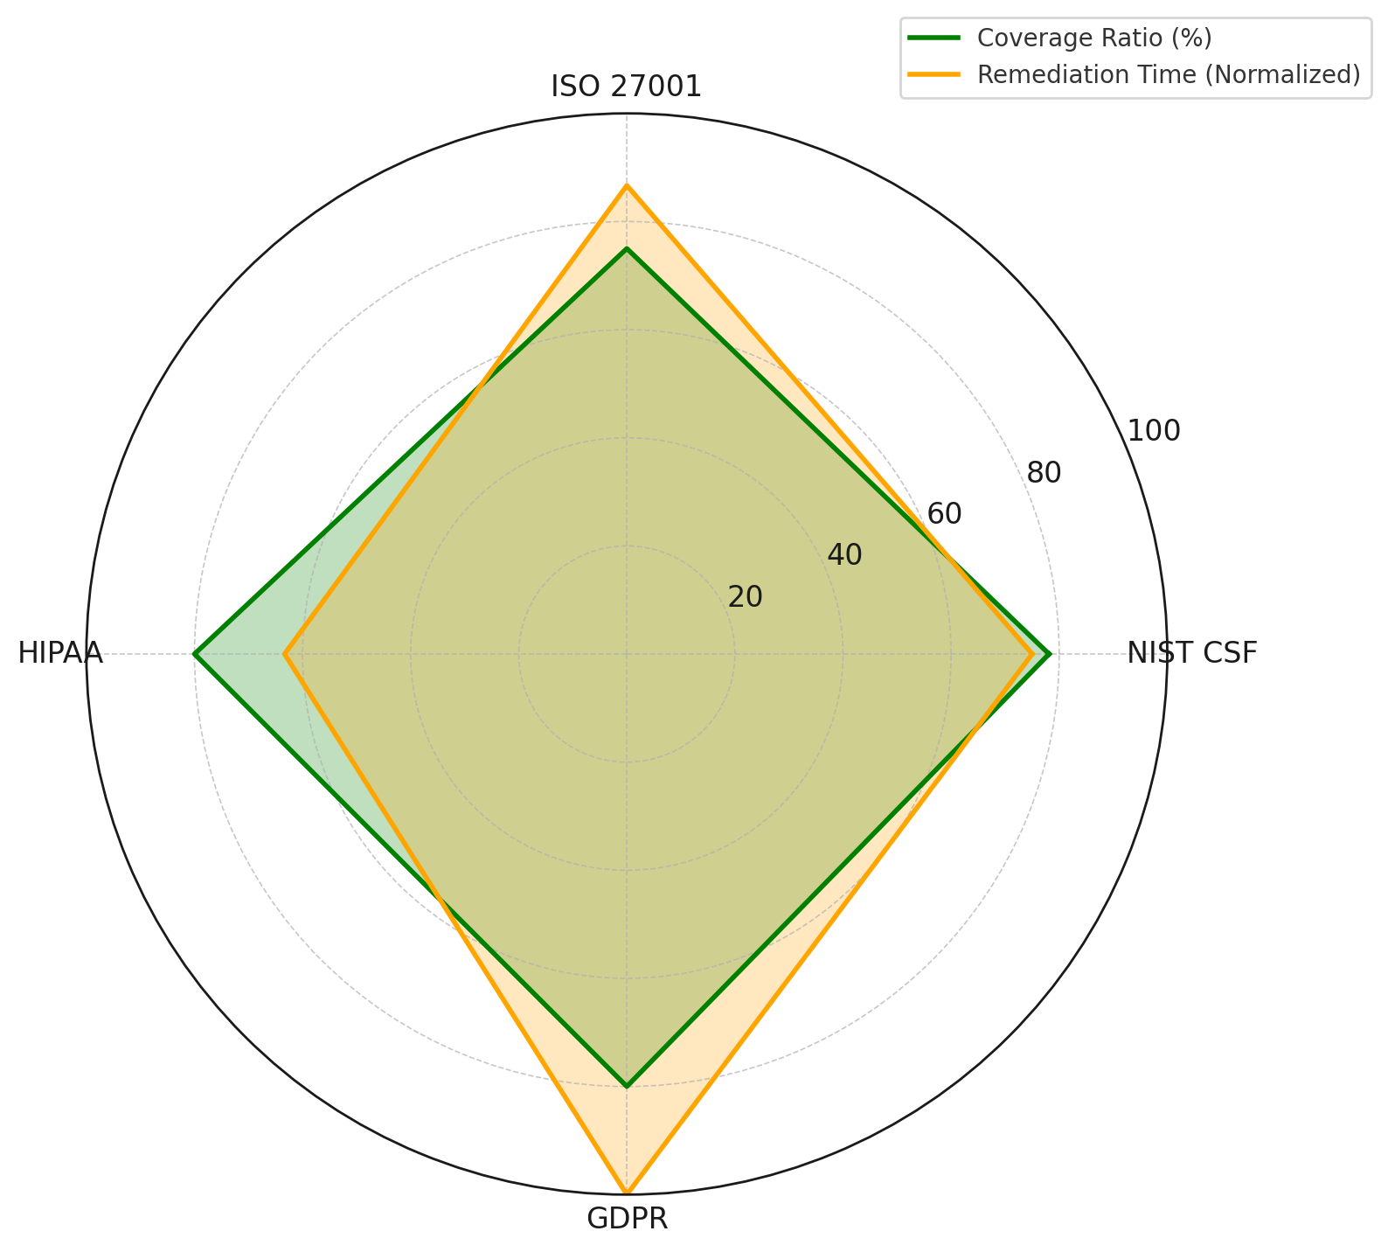
Figure 6: Chart comparing total vulnerabilities with those mapped to compliance controls.
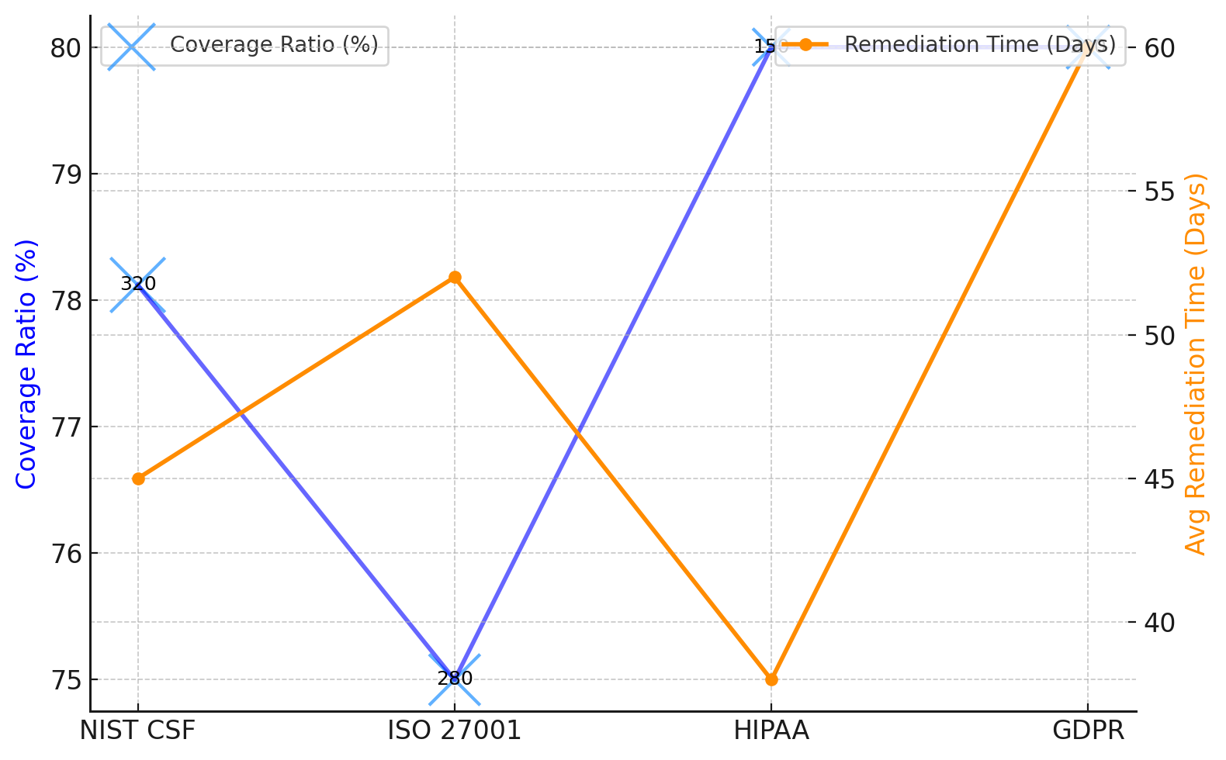
Figure 7: Chart showing compliance coverage ratio alongside average remediation time for each framework.
The analysis revealed that HIPAA and GDPR frameworks achieved the highest compliance coverage ratio at 80.00%, followed closely by NIST CSF at 78.12% and ISO 27001 at 75.00% (Table 3, Figures 6 and 7). Despite this, remediation times varied considerably, with HIPAA achieving the fastest average of 38 days, while GDPR exhibited the longest at 60 days. These variations suggest that while compliance mapping is relatively strong across frameworks, remediation speed remains inconsistent, highlighting areas where AI-driven automation could significantly improve response efficiency and reduce risk exposure.
Objective 4: To assess the limitations, risks, and ethical concerns associated with relying on AI for security and compliance in virtualized enterprises.
A quantitative incident pattern analysis was conducted to categorize AI-related security incidents by cause type and evaluate their frequency, severity, and sector-specific risk distribution.
Cause Type | Incident Frequency | Severity Index
Model Bias | 48 | 36.0
Data Leakage | 36 | 30.6
Misconfiguration | 28 | 18.2
Privilege Escalation | 18 | 14.4
Table 4: Incident frequencies and severity indices for AI-related security risks by cause type.
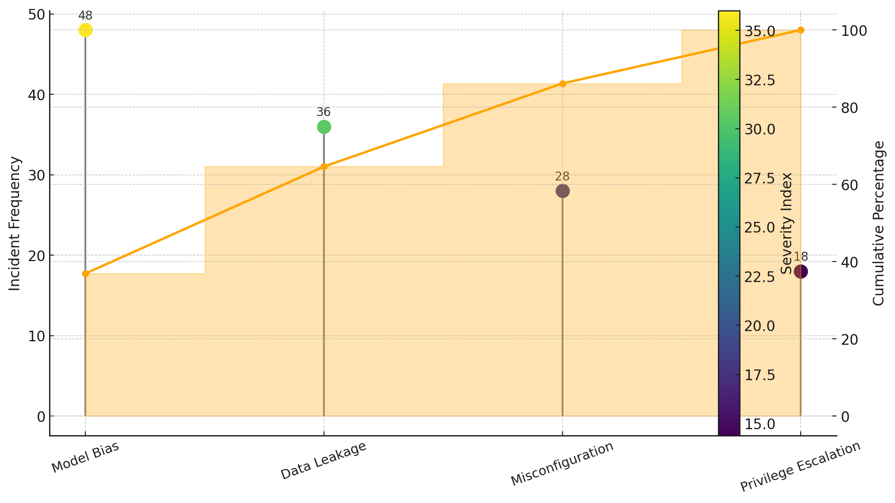
Figure 8: Chart showing incident frequency by cause type and cumulative percentage impact.
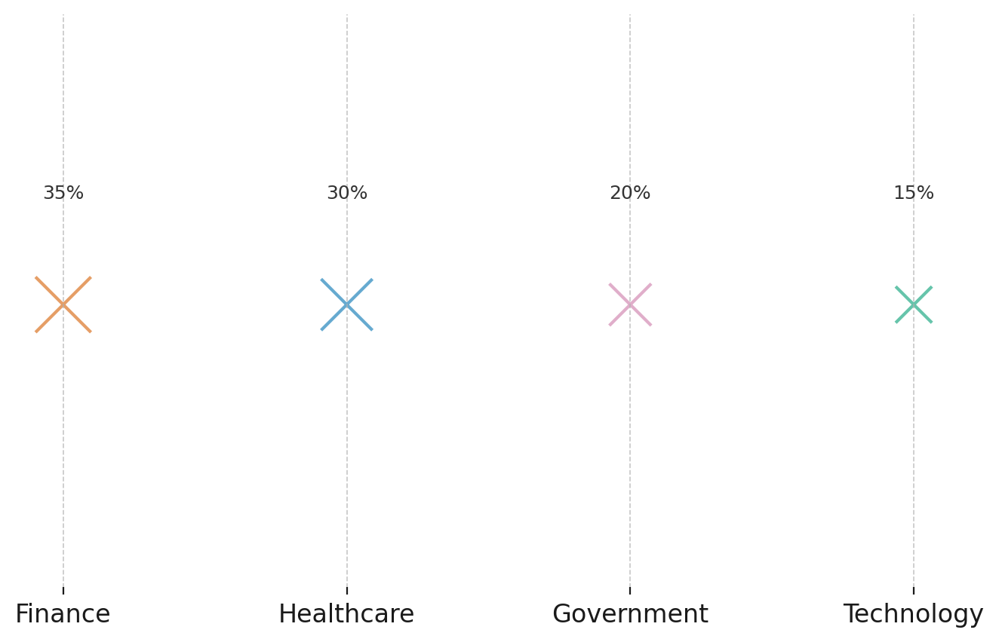
Figure 9: Bubble chart illustrating sector-specific risk ratios, with bubble size representing relative magnitude.
Analysis of AI-related security incidents revealed that model bias accounted for the highest frequency of occurrences (48 incidents), with a severity index of 36.0, followed by data leakage with 36 incidents and a severity index of 30.6 (Table 4, Figure 8). Misconfiguration and privilege escalation were less frequent but still represented notable risk areas. Sector-specific analysis indicated that the finance sector exhibited the highest risk ratio at 35%, followed by healthcare at 30%, government at 20%, and technology at 15% (Figure 9). These findings highlight that while some causes are less frequent, their potential impact on high-risk sectors remains substantial, underscoring the need for targeted mitigation strategies.
Discussion
The findings from this study provide significant empirical validation for concerns raised in prior literature regarding the persistent security vulnerabilities within virtualized enterprises. The predominance of unencrypted storage (25.00%), overly permissive IAM roles (24.67%), and open ports (23.33%) as the leading misconfiguration types (Table 1, Figure 2) reinforces earlier observations by Lata and Kumar (2025) and Agarwal et al. (2024) that weak access controls and flawed configuration management remain systemic challenges in cloud and hybrid infrastructures. The moderate positive correlation (r = 0.321) between compliance gap severity and insider threat incidence further substantiates the assertions of Security (2023) and Bamigbade et al. (2025) that internal privilege misuse, whether malicious or negligent, escalates in poorly governed security environments. These patterns suggest that traditional reactive measures are insufficient, especially in contexts characterized by dynamic provisioning and multi-tenant resource sharing.
The comparative performance evaluation of the AI-driven Random Forest model against the rule-based detection baseline reveals a substantial advancement in detection capability, with statistically significant improvements across all evaluated metrics (Table 2, Figure 4). The notably higher recall rate (0.971) aligns with the predictive accuracy improvements documented by Joshi (2024) and Chandrasena (2024), underscoring the ability of machine learning approaches to identify malicious activity with minimal false negatives. This is critical in virtualized infrastructures, where the speed and accuracy of detection directly influence containment success, as emphasized by Zhang et al. (2025) and Kolo (2025). The statistical confirmation (p < 0.001) of these differences indicates that AI-governed frameworks, when properly implemented, offer measurable operational advantages over static detection systems that are prone to configuration lag and rule obsolescence.
In the context of regulatory compliance, the results reveal both encouraging coverage levels and significant efficiency disparities. HIPAA and GDPR frameworks demonstrated the highest compliance coverage ratio at 80.00% (Table 3, Figure 6), suggesting strong alignment with security controls for high-severity vulnerabilities. However, the discrepancy in average remediation times, 38 days for HIPAA compared to 60 days for GDPR, reflects operational inefficiencies that can prolong exposure to active threats. This finding supports Moille and Scott’s (2024) argument that automation is crucial for accelerating compliance actions, especially in rapidly evolving environments. It also aligns with Ferreira et al. (2025), who emphasized the role of AI in reducing audit and remediation cycles by enabling continuous monitoring and automated control enforcement. The data here indicates that while coverage mapping is robust, without optimization of remediation workflows, compliance adherence may still fail to deliver timely protection against active exploitation.
The incident pattern analysis highlights that model bias, accounting for the highest incident frequency (48) and severity index (36.0), poses a prominent risk in AI-governed security systems (Table 4, Figure 8). This finding is consistent with concerns raised by Hanna et al. (2024) and Sankar et al. (2024), who warned that bias in training datasets can lead to inequitable security decision-making and misclassification of threats. Data leakage, with a frequency of 36 incidents and severity index of 30.6, reaffirms the operational risks described by Musiyiwa and Jacobson (2023) regarding the inadvertent exposure of sensitive information during model inference and retraining processes. Although misconfiguration and privilege escalation were less frequent, their potential for high-impact breaches, especially in sectors like finance and healthcare (Figure 9), echoes the findings of Kumar (2024) and ODSC Team (2025) on the dangers of privilege creep in AI-enabled orchestration platforms. The sectoral distribution of incidents, with finance (35%) and healthcare (30%) at the highest risk, indicates a concentration of vulnerabilities in domains that are both heavily regulated and highly targeted by sophisticated threat actors.
These results affirm that while AI-governed security frameworks significantly outperform traditional methods in detection accuracy and compliance coverage, their effectiveness is contingent upon mitigating operational inefficiencies and addressing systemic risks such as bias, privilege escalation, and data leakage. The interplay between high compliance coverage ratios and inconsistent remediation times underscores the necessity for fully integrated automation capable of both aligning with regulatory standards and executing timely corrective actions. Furthermore, the persistence of high-impact risks across critical sectors demands that governance models incorporate not only technical performance metrics but also continuous oversight mechanisms, ensuring that AI-driven interventions remain both effective and trustworthy in high-stakes virtualized environments.
5. Conclusion and Recommendations
The study confirms that AI-governed security frameworks provide measurable advancements in detecting threats, managing compliance, and mitigating risks in virtualized enterprises, yet their full potential is hindered by operational inefficiencies, bias, and inconsistent remediation speeds. Addressing these gaps is essential to strengthen both real-time security and long-term trust in automated systems. Given these conclusions, the following recommendations are proposed:
- Implement AI oversight protocols that combine automation with mandatory human review for high-impact decisions.
- Standardize remediation workflows across compliance frameworks to ensure timely vulnerability resolution.
- Introduce pre-deployment bias audits and continuous dataset monitoring to prevent skewed or discriminatory outcomes.
- Mandate sector-specific security benchmarks, particularly in finance and healthcare, to reduce concentrated risk exposure.

References

Adesokan-Imran, T. O., Popoola, A. D., Ejiofor, V. O., Salako, A. O., & Onyenaucheya, O. S. (2025). Predictive Cybersecurity Risk Modeling in Healthcare by Leveraging AI and Machine Learning for Proactive Threat Detection. Journal of Engineering Research and Reports, 27(4), 144–165. https://doi.org/10.9734/jerr/2025/v27i41463
Adesokan-Imran, T. O., Popoola, A. D., Kolo, F. H. O., Ejiofor, V. O., & Salami, I. A. (2025). Cybersecurity Risk Stratification Framework Using Multilevel Clustering: An Automated Threat Attribution and Categorization Approach for Cross-industry Cybersecurity. Journal of Engineering Research and Reports, 27(4), 241–263. https://doi.org/10.9734/jerr/2025/v27i41469
Agarwal, A., Ahmad, S., & Minakshi. (2024). Cloud security: Emerging threats, solutions, and research gaps. CRC Press EBooks, 64–70. https://doi.org/10.1201/9781032700502-10
Ahmadi, S. (2025). Adaptive Cybersecurity: Dynamically Retrainable Firewalls for Real-Time Network Protection. ArXiv.org. https://arxiv.org/abs/2501.09033
Albalawi, A. (2025). Cloud Security and Data Protection in Hybrid Environments. IGI Global EBooks, 175–198. https://doi.org/10.4018/979-8-3373-1370-2.ch009
Alder, S. (2025). 2024 Was Another Bad Year for Healthcare Ransomware Attacks. The HIPAA Journal. https://www.hipaajournal.com/2024-was-another-bad-year-for-healthcare-ransomware-attacks/
Alevizos, L. (2024). Automated cybersecurity compliance and threat response using AI, blockchain and smart contracts. International Journal of Information Technology, 17(2). https://doi.org/10.1007/s41870-024-02324-9
Alshoulie, M., & Mehmood, A. (2025). Deep Learning Approaches for Malware Detection: A Comprehensive Review of Techniques, Challenges, and Future Directions. IEEE Access, 13, 118652–118677. https://doi.org/10.1109/access.2025.3582875
Antipova, T., Riurean, S., Riurean, P., & Bolog, G. (2025). AI-Powered Tools: Threat, Defense, and Cyber-Resilience for Individuals. Information Systems Engineering and Management, 171–188. https://doi.org/10.1007/978-3-031-86547-3_14
Arumugam, K. J. (2025). Behind the Cloud: Uncovering Critical Security Threats. SSRN. https://doi.org/10.2139/ssrn.5160686
Bamigbade, O. (2025a). Assessment of Cost-Benefit Dynamics of Cybersecurity Compliance Investments: A Multi-Sectoral Analysis Across Financial, Energy and Intelligence Industries. Journal of Energy Research and Reviews, 17(7), 86–105. https://doi.org/10.9734/jenrr/2025/v17i7435
Bamigbade, O. (2025b). Balancing Encryption Laws and National Security: Challenges for Data and Energy Sector Collaboration across Borders. Journal of Engineering Research and Reports, 27(6), 193–213. https://doi.org/10.9734/jerr/2025/v27i61538
Bamigbade, O., Obrik-Uloho, E. P., Kolo, F. H. O., Ogunmolu, A. M., & Adesokan-Imran, T. O. (2025). Data-Centric AI for Zero-Carbon Power Systems Security: A Framework for Learning with Noisy, Sparse, and Heterogeneous Data. Journal of Energy Research and Reviews, 17(7), 167–185. https://doi.org/10.9734/jenrr/2025/v17i7442
Basti, G., & Vitiello, G. (2023). Deep Learning Opacity, and the Ethical Accountability of AI Systems. A New Perspective. Studies in Applied Philosophy, Epistemology and Rational Ethics II, 21–73. https://doi.org/10.1007/978-3-031-39113-2_2
Bayazit, E. C., & Arac, M. (2025). Implementing a Method for Privilege Escalation Attacks in Windows Systems. 2025 7th International Congress on Human-Computer Interaction, Optimization and Robotic Applications (ICHORA), 1–7. https://doi.org/10.1109/ichora65333.2025.11017062
Bensinger, V., Radlanski, P., & Dürr, P. (2025). EU AI Act: Key Compliance Considerations Ahead of August 2025. Natlawreview.com; National Law Review. https://natlawreview.com/article/eu-ai-act-key-compliance-considerations-ahead-august-2025
Bluefin. (2024). ITRC 2023 Data Breach Report - Key Findings and Solutions. Bluefin. https://www.bluefin.com/bluefin-news/itrc-2023-data-breach-report-key-findings-and-solutions/
BlueFire Redteam. (2025). Cloud Security Statistics 2025: Misconfigurations, Breaches & Budgets. Bluefire Redteam Cybersecurity. https://bluefire-redteam.com/cloud-security-statistics-2025-misconfigurations-breaches-budgets/
Bodria, F., Giannotti, F., Guidotti, R., Naretto, F., Pedreschi, D., & Rinzivillo, S. (2021). Benchmarking and survey of explanation methods for black box models. Springer , 37(5). https://doi.org/10.1007/s10618-023-00933-9
Chandrasena, C. (2024). Integration of AI and ML for Cloud Security and Threat Detection. Vol 6, no. 6. https://www.ijfmr.com/papers/2024/6/34083.pdf
Chaudhry, M. (2025). A Systematic mapping Study on Security Challenges in Software-Defined Cloud Computing. Doria.fi. https://www.doria.fi/handle/10024/192765
Chawla, J., & Singh, H. (2025). AI Techniques for Remote Monitoring. Sustainable Artificial Intelligence-Powered Applications, 111–124. https://doi.org/10.1007/978-3-031-84583-3_8
Chen, D., Chowdhury, M. M., & Latif, S. (2021). Data Breaches in Corporate Setting. 2021 International Conference on Electrical, Computer, Communications and Mechatronics Engineering (ICECCME). https://doi.org/10.1109/iceccme52200.2021.9590974
Coker, J. (2025). Data Breach Costs Fall for First Time in Five Years. Infosecurity Magazine. https://www.infosecurity-magazine.com/news/data-breach-costs-fall/
De Cremer, D., & Kasparov, G. (2021). AI Should Augment Human Intelligence, Not Replace It. Harvard Business Review; Harvard Business Publishing. https://hbr.org/2021/03/ai-should-augment-human-intelligence-not-replace-it
Decker, N. (2025). The Williams Linguistic Speech Pattern (WLSP) Doctrine: A Cognitive-Strategic Model for Trust Optimization in Public Speech. Ssrn.com. https://papers.ssrn.com/sol3/papers.cfm?abstract_id=5309300
Ejiofor, V. O. (2025). Open Data for Cyber Resilience: An Analysis of Public-private Collaboration in AI-Supported Threat Intelligence Sharing. Asian Journal of Research in Computer Science, 18(6), 403–423. https://doi.org/10.9734/ajrcos/2025/v18i6710
Ejiofor, V. O., Michael Ogunmolu, A., Gbadebo, M. O., Joseph, S. A., & Adesokan-Imran, T. O. (2025). AI- Driven Risk Assessment for Enhancing Third Party Vendor Security in Healthcare Systems. Journal of Engineering Research and Reports, 27(5), 117–137. https://doi.org/10.9734/jerr/2025/v27i51498
Ferreira, L. V. A., Alves, C. A. de M., Peotta de Melo, L., & Nunes, R. R. (2025). Internal Audit Strategies for Assessing Cybersecurity Controls in the Brazilian Financial Institutions. Applied Sciences, 15(10), 5715. https://doi.org/10.3390/app15105715
Gbadebo, M. O. (2025). Integrating Post-Quantum Cryptography and Advanced Encryption Standards to Safeguard Sensitive Financial Records from Emerging Cyber Threats. Asian Journal of Research in Computer Science, 18(4), 1–23. https://doi.org/10.9734/ajrcos/2025/v18i4605
Goktas, P., & Grzybowski, A. (2025). Shaping the Future of Healthcare: Ethical Clinical Challenges and Pathways to Trustworthy AI. Journal of Clinical Medicine, 14(5), 1605–1605. https://doi.org/10.3390/jcm14051605
Hanna, M., Pantanowitz, L., Jackson, B., Palmer, O., Visweswaran, S., Pantanowitz, J., Deebajah, M., & Rashidi, H. (2024). Ethical and Bias Considerations in Artificial intelligence/machine Learning. Modern Pathology, 38(3), 1–13. ScienceDirect. https://doi.org/10.1016/j.modpat.2024.100686
Hossain, S. T., Yigitcanlar, T., Nguyen, K., & Xu, Y. (2024). Local Government Cybersecurity Landscape: A Systematic Review and Conceptual Framework. Applied Sciences, 14(13), 5501. https://doi.org/10.3390/app14135501
IBM. (2024). IBM Report: Escalating Data Breach Disruption Pushes Costs to New Highs. IBM Newsroom. https://newsroom.ibm.com/2024-07-30-IBM-Report-Escalating-Data-Breach-Disruption-Pushes-Costs-to-New-Highs
Jørgensen, B. N., & Ma, Z. G. (2025). Regulating AI in the Energy Sector: A Scoping Review of EU Laws, Challenges, and Global Perspectives. Energies, 18(9), 2359–2359. https://doi.org/10.3390/en18092359
Joshi, P. (2024). The Role of AI in Predictive Cybersecurity: Anticipating Attacks Before They Happen. RSK Cyber Security. https://rsk-cyber-security.com/security/the-role-of-ai-in-predictive-cybersecurity-anticipating-attacks-before-they-happen/
Kalasampath, K., Spoorthi , K., Sajeev, S., Kuppa, S. S., Ajay, K., & Angulakshmi, M. (2025). A Literature Review on Applications of Explainable Artificial Intelligence (XAI). IEEE Access, 1–1. https://doi.org/10.1109/access.2025.3546681
Kolo, F. H. O. (2025). Responsible AI for Cybersecurity: Assessing the Barriers, Biases and Governance Gaps in Implementation with E-commerce Systems. Journal of Engineering Research and Reports, 27(5), 510–532. https://doi.org/10.9734/jerr/2025/v27i51520
Kolo, F. H. O., Joseph, S. A., Ogunmolu, A. M., Ejiofor, V. O., & Oyekunle, S. M. (2025). Mitigating Cybersecurity Risks in Financial Institutions through Strategic Third- Party Risk Governance Frameworks. Journal of Engineering Research and Reports, 27(5), 173–193. https://doi.org/10.9734/jerr/2025/v27i51501
Kulothungan, V. (2025). Using Blockchain Ledgers to Record AI Decisions in IoT. IoT, 6(3), 37. https://doi.org/10.3390/iot6030037
Kumar, S. (2024). Automating Container Orchestration: Innovations and Challenges in Kubernetes Implementation. Robotics Xplore: USA Tech Digest, 1(1), 29–43. https://hal.science/hal-04787298
Lata, M., & Kumar, V. (2025). Cyber security techniques in cloud environment: comparative analysis of public, private and hybrid cloud. EDPACS, 70(3), 1–21. https://doi.org/10.1080/07366981.2025.2449743
Mohamed, N. (2025). Artificial intelligence and machine learning in cybersecurity: a deep dive into state-of-the-art techniques and future paradigms. Knowledge and Information Systems, 67. https://doi.org/10.1007/s10115-025-02429-y
Moille, C., & Scott, G. (2024). EU AI Act Timeline: Key Dates For Compliance| Insights & Resources | Goodwin. Goodwinlaw.com. https://www.goodwinlaw.com/en/insights/publications/2024/10/insights-technology-aiml-eu-ai-act-implementation-timeline
Moos, J., Hansel, K., Abdulsamad, H., Stark, S., Clever, D., & Peters, J. (2022). Robust Reinforcement Learning: A Review of Foundations and Recent Advances. Machine Learning and Knowledge Extraction, 4(1), 276–315. https://doi.org/10.3390/make4010013
Morningstar. (2025). Orca Security Report Reveals Majority of Organizations Introducing Vulnerable AI Packages into Cloud Environments. Morningstar, Inc. https://www.morningstar.com/news/business-wire/20250605150852/orca-security-report-reveals-majority-of-organizations-introducing-vulnerable-ai-packages-into-cloud-environments
Motalleb, M. K., Benzaid, C., Taleb, T., Katz, M., Shah-Mansouri, V., & Kim, J. (2025). Towards secure intelligent O-RAN architecture: vulnerabilities, threats and promising technical solutions using LLMs. Digital Communications and Networks. https://doi.org/10.1016/j.dcan.2025.05.001
Musiyiwa, R., & Jacobson, J. (2023). Sponsorship Disclosure in Social Media Influencer marketing: the Algorithmic and non-algorithmic Barriers. Social Media and Society, 9(3). https://doi.org/10.1177/20563051231196870
Mylrea, M., & Robinson, N. (2023). Artificial Intelligence (AI) Trust Framework and Maturity Model: Applying an Entropy Lens to Improve Security, Privacy, and Ethical AI. Entropy, 25(10), 1429. https://doi.org/10.3390/e25101429
Nassif, A. B., Talib, M. A., Nasir, Q., & Dakalbab, F. M. (2021). Machine Learning for Anomaly Detection: A Systematic Review. IEEE Access, 9, 78658–78700. https://doi.org/10.1109/access.2021.3083060
Ndibe, O. S. (2025a). AI-Driven Forensic Systems for Real-Time Anomaly Detection and Threat Mitigation in Cybersecurity Infrastructures. International Journal of Research Publication and Reviews, 6(5), 389–411. https://doi.org/10.55248/gengpi.6.0525.1991
Ndibe, O. S. (2025b). AI-Driven Forensic Systems for Real-Time Anomaly Detection and Threat Mitigation in Cybersecurity Infrastructures. International Journal of Research Publication and Reviews, 6(5), 389–411. https://doi.org/10.55248/gengpi.6.0525.1991
NIST. (2023). AI Risk Management Framework. NIST. https://www.nist.gov/itl/ai-risk-management-framework
ODSC Team. (2025). MIT Economist Says AI Will Augment, Not Replace, Human Workers. Open Data Science - Your News Source for AI, Machine Learning & More. https://opendatascience.com/mit-economist-says-ai-will-augment-not-replace-human-workers/
Ogunmolu, A. M. (2025a). A Multiscale Approach to Cyber-Mechanical Threat Modeling for Predicting and Preventing Failures in Critical Energy Infrastructure. Journal of Engineering Research and Reports, 27(6), 1–20. https://doi.org/10.9734/jerr/2025/v27i61523
Ogunmolu, A. M. (2025b). Digital Twin-based Energy Infrastructure Powered by AI: Real-Time Simulation, Anomaly Detection, and Intervention. Journal of Energy Research and Reviews, 17(7), 65–85. https://doi.org/10.9734/jenrr/2025/v17i7434
Ogunmolu, A. M. (2025c). Enhancing Data Security in Artificial Intelligence Systems: A Cybersecurity and Information Governance Approach. Journal of Engineering Research and Reports, 27(5), 154–172. https://doi.org/10.9734/jerr/2025/v27i51500
Ogunmolu, A. M. (2025d). Federated Detection Systems for Insider Threats in Energy Facilities Using Biomechanical Access Control and Al-Based Cybersecurity. Journal of Engineering Research and Reports, 27(6), 65–82. https://doi.org/10.9734/jerr/2025/v27i61528
Ogunmolu, A. M. (2025e). Leveraging Generative AI and Behavioral Biometrics to Strengthen Zero Trust Cybersecurity Architectures in Healthcare Systems. Journal of Engineering Research and Reports, 27(5), 194–213. https://doi.org/10.9734/jerr/2025/v27i51502
Ogunmolu, A. M., Obrik-Uloho, E. P., Olaniyi, O. O., Arigbabu, A. T., & Bamigbade, O. (2025). Cyber Risk Spillovers in Interconnected Financial Ecosystems: Evidence from Traditional Banks and DeFi Oracles. Journal of Engineering Research and Reports, 27(7), 106–126. https://doi.org/10.9734/jerr/2025/v27i71565
Ogunmolu, A. M., Olaniyi, O. O., Popoola, A. D., Olisa, A. O., & Bamigbade, O. (2025). Autonomous Artificial Intelligence Agents for Fault Detection and Self-Healing in Smart Manufacturing Systems. Journal of Energy Research and Reviews, 17(8), 20–37. https://doi.org/10.9734/jenrr/2025/v17i8445
Olutimehin, A. T., Olaniyi, O. O., Ogunmolu, A. M., Kolo, F. H. O., & Salami, I. A. (2025). Cloud-Based AI Solutions for Real-time Monitoring of E-commerce Compliance and Risk. Journal of Engineering Research and Reports, 27(7), 127–147. https://doi.org/10.9734/jerr/2025/v27i71566
Olutimehin, A. T., Olaniyi, O. O., Popoola, A. D., Ogunmolu, A. M., & Kolo, F. H. O. (2025). AI and IoT Integration for Predictive Maintenance and Risk Management in Smart Manufacturing. Asian Journal of Research in Computer Science, 18(7), 120–142. https://doi.org/10.9734/ajrcos/2025/v18i7724
Oyekunle, S. M., Popoola, A. D., Kolo, F. H. O., Ogunmolu, A. M., & Adesokan-Imran, T. O. (2025). Intelligent Fraud Prevention Information Banking: A Data Governance- Centric Approach Using Behavioural Biometrics. Asian Journal of Research in Computer Science, 18(5), 525–543. https://doi.org/10.9734/ajrcos/2025/v18i5672
Palo Alto Networks. (2024). What is the Role of AI in Security Automation? Palo Alto Networks. https://www.paloaltonetworks.com/cyberpedia/role-of-artificial-intelligence-ai-in-security-automation
Paya, A., Vicente-García, & Gómez, A. (2024). Securesdp: a novel software-defined perimeter implementation for enhanced network security and scalability. International Journal of Information Security, 23. https://doi.org/10.1007/s10207-024-00863-7
Ranasinghe, H. D. (2021). Multi-Dimensional Risk Analysis of Insider Threats to Confidential Data in Distributed E-Commerce Clouds. Journal of Computational Intelligence for Hybrid Cloud and Edge Computing Networks, 5(11), 1–10. https://hashsci.com/index.php/JCIHCEC/article/view/2021-11-04
Reddy, R. G., Lee, D., Fung, Y. R., Nguyen, K. D., Zeng, Q., Li, M., Wang, Z., Voss, C., & Ji, H. (2025). SmartBook: AI-Assisted Situation Report Generation for Intelligence Analysts. Frontiers in Artificial Intelligence and Applications. https://doi.org/10.3233/faia250237
Ren, S., Jin, J., Niu, G., & Liu, Y. (2025). ARCS: Adaptive Reinforcement Learning Framework for Automated Cybersecurity Incident Response Strategy Optimization. Applied Sciences, 15(2), 951–951. https://doi.org/10.3390/app15020951
Salako, A. O. (2025). Predictive Data Analysis in Forecasting Patient Health Outcomes Using Machine Learning Algorithms. Asian Journal of Research in Computer Science, 18(6), 194–214. https://doi.org/10.9734/ajrcos/2025/v18i6691
Salami, I. A. (2025). Modeling and Measuring the Cyber Resilience of Critical Healthcare Infrastructure against Ransomware: A Cyber-Physical Systems Risk Perspective. Journal of Engineering Research and Reports, 27(5), 231–252. https://doi.org/10.9734/jerr/2025/v27i51504
Salami, I. A., Popoola, A. D., Gbadebo, M. O., Kolo, F. H. O., & Adesokan-Imran, T. O. (2025). AI- Powered Behavioural Biometrics for Fraud Detection in Digital Banking: A Next-Generation Approach to Financial Cybersecurity. Asian Journal of Research in Computer Science, 18(4), 473–494. https://doi.org/10.9734/ajrcos/2025/v18i4632
Sankar, B. S., Gilliland, D., Rincon, J., Hermjakob, H., Yan, Y., Adam, I., Lemaster, G., Wang, D., Watson, K., Bui, A., Wang, W., & Ping, P. (2024). Building an Ethical and Trustworthy Biomedical AI Ecosystem for the Translational and Clinical Integration of Foundation Models. Bioengineering, 11(10), 984–984. https://doi.org/10.3390/bioengineering11100984
Security. (2023). Over half of organizations experienced an insider threat in 2022 | Security Magazine. Www.securitymagazine.com. https://www.securitymagazine.com/articles/98879-over-half-of-organizations-experienced-an-insider-threat-in-2022
Security. (2025). 84% of Organizations Are Now Using AI in the Cloud. Securitymagazine.com; Security Magazine. https://www.securitymagazine.com/articles/101682-84-of-organizations-are-now-using-ai-in-the-cloud
SentinelOne. (2024). 50+ Cloud Security Statistics in 2024. SentinelOne. https://www.sentinelone.com/cybersecurity-101/cloud-security/cloud-security-statistics/
Sharma, B. P. (2024). Machine Learning-Driven Approaches for Contemporary Cybersecurity: From Intrusion Detection and Malware Classification to Intelligent Incident Response. Nuvern Machine Learning Reviews , 1(1), 22–32. https://nuvern.com/index.php/nmlr/article/view/3
StrongDM Team. (2024). Snowflake Data Breach: What Happened and How to Prevent It. Strongdm.com; StrongDM, Inc. https://www.strongdm.com/what-is/snowflake-data-breach
Swain, G. (2025). Oracle Cloud breach may impact 140,000 enterprise customers. CSO Online. https://www.csoonline.com/article/3852643/oracle-cloud-breach-may-impact-140000-enterprise-customers.html
Zhang, C., Wang, K., Tsung, F., & Lovric, M. (2025). Big Data. International Encyclopedia of Statistical Science, 285–306. https://doi.org/10.1007/978-3-662-69359-9_70

