Integrated Detection and Text Recognition with YOLO-OCR for Seaport Applications
Original Research Article

Abstract
2 An inventive real-time computer vision architecture is presented in this study, which
3 combines PaddleOCR for text recognition with YOLO for object identification in mar-
4 itime scenarios. The appropriately trained YOLO model is configured to recognize text
5 targets and ships. Thus, in order to maximize inference speed and minimize computing
6 complexity, the number of output layers is decreased to two and the default YOLO
7 model’s smallest detection scale (P3) is eliminated. With these changes to the archi-
8 tecture, the system can process data more quickly while still achieving high detection
9 accuracy for real-time applications in marine environments with limited bandwidth.
10 Prior to optical character recognition (OCR), the system first identifies and filters
11 text-containing regions before executing a specific pretreatment pipeline that consists
12 of grayscale conversion, contrast enhancement, and noise filtering. This customized
13 pipeline enables resilience in low-quality video frames and different illumination sce-
14 narios, which are frequently seen in harbor surveillance film. In operational seaport
15 contexts, the resulting framework facilitates ongoing, automated ship monitoring, of-
16 fering a scalable and effective solution for visual data extraction, ship identification,
17 and compliance verification.
18 Port Automation, Object Detection, Text Recognition, Maritime Surveillance, YOLOv5,
19 PaddleOCR.

20 1 Introduction
21 Seaports are crucial hubs for international logistics because more than 80% of world trade is
22 conducted by sea [1]. However, as demand has increased, complex problems have surfaced,
23 including restricted physical growth capacity, high operating costs, port congestion, and
24 emission regulations. These constraints have led to a need for more data-driven, intelligent
25 solutions in seaport operations.

26 Advanced artificial intelligence (AI) capabilities have shown great promise to revolution-
27 ize logistics management, especially in the areas of machine learning and computer vision
28 [2]. Contemporary ports produce enormous amounts of data by implementing technology
29 like digital surveillance, autonomous systems, and Internet of Things sensors. This data-
30 rich environment is perfect for implementing sophisticated visual analytics technologies that
31 increase operational efficiency, decrease human error, and improve decision-making.
32 This work proposes an integrated visual recognition system that responds to industry
33 needs by combining YOLOv5 for object identification and PaddleOCR for text recognition.
34 Ships are automatically identified by the system, which then uses live photos to derive
35 their names or registration numbers. Its scalable and effective digital port management
36 solution combines reliable OCR capabilities with fast, single-stage object identification. By
37 reducing the amount of physical interaction required for visual inspection operations, this
38 technology lowers dangers and enables faster and more accurate completion of maritime
39 activities. The suggested approach may also have broader applications in port security,
40 maritime surveillance, and non-contact customs inspections.

41 2 Literature Review
42 Two crucial computer vision tasks that are incorporated into the proposed approach are
43 text recognition and object identification. A dependable system that can identify ships
44 and interpret the textual information associated with them, such as registration names and
45 serial numbers, might be created with the aid of this hybrid technique. To achieve this,
46 the project makes use of YOLOv5 for object detection and PaddleOCR for text recognition,
47 both of which have shown state-of-the-art performance in their respective domains.

48 2.1 Object Detection
49 Deep learning-based generic object recognition has gained significant attention in computer
50 vision and machine learning, and it has been the subject of much research in the last 10 years
51 [3]. Significant advancements have been made throughout time in object detecting systems’
52 efficiency and accuracy. Crucially, there are two main categories of contemporary object
53 detection algorithms: one-stage and two-stage detectors. When it comes to the system’s
54 overall adaptability for real-time or embedded applications, as well as its detection speed
55 and accuracy, this classification is crucial.
56 Two-Stage Detectors: There are several variations of two-stage object detection algo-
57 rithms, with the most notable being the R-CNN family, including R-CNN [4], Fast R-CNN
58 [5], and Faster R-CNN [6]. The original R-CNN marked a major breakthrough in modern
59 object detection by integrating two key principles: region proposal and convolutional neural
60 networks (CNNs). It detects objects by first generating region proposals or anchor boxes
61 to locate potential objects, and then classifies those regions using features extracted by a
62 CNN. This approach achieved state-of-the-art performance at the time. However, due to its
63 multi-step training pipeline and the separate processing of region proposals and classifica-
64 tion, R-CNN models exhibit high computational and memory demands. To address these
65 limitations, Fast R-CNN was introduced as an optimized framework that significantly im-

66 proved both speed and efficiency. It employed a single-step training process and incorporated
67 a multi-task loss function, allowing the model to simultaneously train the classification and
68 bounding box regression heads. This effectively eliminated the need for separate training
69 stages and reduced overall complexity.
70 Despite these improvements, the region proposal stage remained a major bottleneck,
71 primarily due to its reliance on the selective search algorithm, which is computationally
72 expensive and slow. To overcome this, Faster R-CNN was developed, introducing a novel
73 component known as the Region Proposal Network (RPN). The RPN replaced the traditional
74 selective search algorithm, enabling the model to generate region proposals directly and
75 efficiently. This integration made Faster R-CNN both faster and more accurate, marking
76 another significant step forward in object detection technology.
77 One-Stage Detectors: One-stage object detection algorithms perform detection in a single
78 pass through the network, making them significantly faster than two-stage approaches. The
79 most notable one-stage detectors include YOLO (You Only Look Once) [7], SSD (Single
80 Shot MultiBox Detector) [8], and RetinaNet [9].
81 YOLO was the first algorithm to reframe object detection as a direct regression prob-
82 lem—simultaneously predicting bounding boxes and class probabilities in a single forward
83 pass. This innovation greatly accelerated detection speed and made real-time processing
84 possible. The original YOLO model could process images at 45 frames per second (FPS),
85 while a smaller version achieved up to 155 FPS, making it ideal for real-time applications
86 such as video surveillance or autonomous navigation.
87 Despite its impressive speed, the YOLO architecture exhibits certain limitations. In
88 particular, it tends to underperform in detecting small objects and is more prone to localiza-
89 tion errors when compared to two-stage detectors such as Faster R-CNN. These limitations
90 primarily stem from design decisions aimed at maximizing inference speed. However, succes-
91 sive versions of YOLO—including YOLOv4, YOLOv5, and YOLOv8—have demonstrated
92 notable improvements in both accuracy and computational efficiency. It is important to note
93 that each version of YOLO includes multiple model variants, differentiated by the number
94 of parameters, computational requirements, and performance characteristics. The choice of
95 model should be guided by the specific task and the level of accuracy required. For this study,
96 YOLOv5s has been selected due to its balance between accuracy and speed. With approxi-
97 mately 7.2 million parameters and achieving an accuracy of around 36.7% mAP@0.5 on the
98 COCO dataset, YOLOv5s provides real-time inference capabilities, making it particularly
99 well-suited for the application at hand.
100 SSD, on the other hand, uses a dense set of default boxes and combines predictions
101 from multiple feature maps at different resolutions. This multi-scale approach allows SSD
102 to effectively detect objects of varying sizes, distinguishing it from YOLO in its handling of
103 small and large objects. RetinaNet introduced a novel focal loss function, which addresses the
104 extreme foreground-background class imbalance in dense object detection. This innovation
105 enables RetinaNet to achieve accuracy levels comparable to, and sometimes exceeding, those
106 of two-stage detectors—making it one of the most accurate one-stage detectors to date.
107 Pros and Cons in Context of this Project: A crucial consideration in the field of object
108 text detection and recognition is the trade-off between processing speed and detection ac-
109 curacy, particularly in real-world logistical settings like seaports. Two-stage detectors, like
110 Faster R-CNN, provide a high degree of precision, but they are less appropriate for real-time

111 deployment scenarios because to their computational cost and slower inference time.
112 For real-time tasks including logistics automation, ship number recognition, and tracking,
113 a one-stage detection strategy using YOLO (You Only Look Once) is employed in this project
114 due to its remarkable speed and efficiency. Thanks to YOLO, which scans the entire image
115 in a single pass, item detection and recognition can be done almost instantly. In dynamic
116 environments where prompt choices are crucial, such as seaports, this is a huge advantage.
117 One-stage detectors are perfect for real-world applications due to their speed advantage,
118 even if they typically offer slightly lower accuracy than two-stage devices. For example,
119 the system must instantly recognize ship names and registration numbers in real-time video
120 feeds from port surveillance cameras. YOLO’s high frame rate and quick reaction are quite
121 helpful in this situation.
122 Thus, the suggested system prioritizes scalability and real-time speed over slight accuracy
123 benefits, which is a sensible and sensible choice in the context of smart port operations.

124 2.2 OCR Text Recognition
125 Text Recognition Using OCR: Optical Character Recognition (OCR) is a technology used
126 to detect and extract text from images through a series of image processing and recognition
127 algorithms [10]. It converts visual text into machine readable formats, enabling further pro-
128 cessing such as data extraction, speech synthesis, or execution of machine level instructions.
129 OCR achieves this by mimicking the optical mechanisms of the human eye. Although its
130 performance heavily depends on the quality and clarity of the input, OCR is capable of rec-
131 ognizing both printed and handwritten text. This technology enables the transformation of
132 various document types including scanned PDFs or images captured by digital devices—into
133 editable and searchable formats. Modern OCR systems follow a pipeline approach: first
134 detecting text regions within an image, then recognizing and converting those regions into
135 machine-readable characters. This facilitates intelligent interaction with visual data.
136 PaddleOCR is an open-source Optical Character Recognition (OCR) tool developed by
137 PaddlePaddle, Baidu’s deep learning platform [11]. It offers a high-performance, lightweight
138 solution for multilingual text recognition, supporting over 80 languages. Designed to detect
139 both horizontal and multi-directional text, PaddleOCR can independently identify text in
140 images, making it ideal for real-world applications such as label reading, license plate recog-
141 nition, and document scanning. Thanks to its modular architecture, PaddleOCR is easy to
142 customize and can be seamlessly integrated with object detection frameworks like YOLO.

143 2.3 Existing Methods
144 Several academic projects have explored the integration of object detection and text recog-
145 nition for various purposes—ranging from task automation and simplification of complex
146 processes to enhancing safety and security measures. One notable example is the develop-
147 ment of an Automatic Container Code Recognition (ACCR) system, designed to streamline
148 the inspection and verification of container codes [12]. This system leverages the high accu-
149 racy of the Faster R-CNN architecture, a two-stage detector that combines region proposal
150 mechanisms with convolutional neural networks. In this approach, each character in a valid
151 container code—consisting of four capital letters followed by seven digits—is treated as a

152 distinct object. The model is trained to detect 26 alphabetic characters (A–Z) and 10 numer-
153 ical digits (0–9) as separate classes. Additionally, a binary search tree algorithm is employed
154 to assemble and validate recognized characters efficiently.
155 The use of Faster R-CNN is crucial for achieving the precision required in this applica-
156 tion. Through its Region Proposal Network (RPN), the model effectively learns the ”ob-
157 jectness” of regions within an image and generates refined bounding boxes for character
158 detection. The incorporation of anchors—rectangular windows of varying sizes and aspect
159 ratios—enables robust detection of characters across multiple scales and positions. While the
160 system achieved high accuracy, its two-stage detection approach is computationally more in-
161 tensive compared to faster, one-stage frameworks like YOLO. Nonetheless, it demonstrates
162 the effectiveness of combining region-based detection and character-level classification in
163 achieving high-precision recognition of structured alphanumeric data, which is especially
164 valuable in industrial settings like port logistics and container management.
165 Another similar study, introduced in [13], proposed a road safety surveillance tool de-
166 signed to monitor traffic and enforce helmet laws. The system integrates the complementary
167 capabilities of YOLO and OCR for real-time object detection and license plate recognition.
168 It features a user-friendly PyQt graphical interface that allows bike owners to register their
169 vehicles, which are then stored in a CSV file. A key component of the system is its use
170 of YOLOv5 to analyze video frames in real time, detecting motorcycles, helmets, and li-
171 cense plates. In cases where a rider is not wearing a helmet, the model extracts the license
172 plate text using OCR and cross-references it with the registered vehicle data to identify
173 the offender. Once a match is confirmed, the system automatically generates an electronic
174 violation report and issues a fine. The violators are easily contacted, and reports are sent
175 directly to their Gmail addresses. As a result, the overall goal of enhancing road safety is
176 significantly achieved.

177 3 Proposed Methodology
178 The proposed approach leverages the precise text recognition capabilities of PaddleOCR
179 and the real-time object detection capabilities of the lightweight YOLOv5s. The hybrid
180 architecture concurrently detects and extracts pertinent textual information, including ship
181 names and visual IDs, from still photos or video feeds, forming the basis of an effective and
182 domain-specific framework for seaport logistics.
183 This model’s lightweight design makes it appropriate for deployment in resource-constrained
184 contexts. Its accuracy and processing speed balance enable real-time handling of high-
185 throughput image streams. The system employs a two-stage pipeline, first identifying textual
186 sections and then performing recognition, to improve accuracy and efficiency. This approach
187 overcomes the drawbacks of traditional OCR frameworks, which are often designed for in-
188 puts with large amounts of text. In contrast, maritime images are often sparse and visually
189 complex, with only identifying numbers or ship names included as text.
190 1. Object-Level Text Localization: A custom-trained YOLOv5s model detects object
191 categories—Ship, Text and Text. Detected text regions are treated as discrete objects,
192 allowing for precise spatial localization within complex scenes.

193 2. Region-Based Text Recognition: The localized regions are cropped, undergo a
194 dedicated preprocessing pipeline, and are then passed to PaddleOCR for recognition.
195 This improves recognition accuracy by concentrating solely on pertinent image portions,
196 while lowering computing cost in comparison to full-frame OCR. Localized OCR combined
197 with object detection offers a scalable, effective way to improve situational awareness in
198 automation workflows and seaport surveillance without sacrificing real-time performance.

199 3.1 System Design Architecture
200 The project started with a thorough strategy and system architecture design, where the
201 main functionalities and overall interaction flow were carefully created. Particular focus
202 was placed on streamlining the OCR extraction procedure to guarantee highly accurate and
203 efficient text recognition. The design prioritized scalability, accuracy, and performance to
204 facilitate seamless operation and flexibility. The flowchart is depicted in Figure 1 and reflects
205 the methodical structuring of the workflow and component interactions.
Data Collection
YOLO
Integration
Detection
Text Class
Region
Ship Class
Pre Processing
Text
Recognition
Output
Figure 1: Methodology.

206 3.2 Data Collection and Annotation
207 The dataset for this project was constructed using a combination of publicly available re-
208 sources and manually curated images sourced from the internet. This approach aimed to
209 ensure that the model could generalize effectively across diverse scenarios. One of the main

210 challenges was the absence of any existing dataset specifically tailored to the project’s re-
211 quirements, while alternative commercial datasets were either inaccessible or prohibitively
212 expensive. A total of 600 images were collected and divided into 500 for training, 60 for vali-
213 dation, and 60 for testing. Annotation was performed using Roboflow, with objects classified
214 into Two categories: Ship and Text. To enhance variability and mitigate the risk of overfit-
215 ting, Roboflow’s augmentation tools were employed during preprocessing. Techniques such
216 as rotation, binarization, and other transformations were applied to increase the dataset’s
217 diversity and improve the model’s ability to generalize to unseen data.

218 3.3 Training YOLOv5s
219 By default, YOLOv5 is configured with nc=80, corresponding to 80 output classes in its
220 prediction layer. While this configuration is appropriate for general-purpose object detection,
221 it introduces unnecessary computational overhead for the target application, where most of
222 these classes are irrelevant. To optimize the model for the specific requirements of this
223 work, the prediction layer was reconfigured with nc=2, focusing exclusively on two relevant
224 classes: Ship, and Text. In addition, the smallest detection scale (stride 8, corresponding
225 to a grid resolution of 80 × 80) was removed. This layer, typically designed for detecting
226 small objects, is not critical for the types of targets in the maritime context. The model
227 retains only the stride 16 (40 × 40) and stride 32 (20 × 20) layers, which are more effective for
228 detecting medium to large objects such as vessels markings. These architectural adjustments
229 significantly reduce computational complexity, minimize the risk of misclassification, and
230 mitigate overfitting due to excessive model capacity. Consequently, the modified model
231 achieves higher detection accuracy while maintaining real-time processing efficiency.
232 The training process of the customized YOLOv5s model follows its standard two-stage
233 structure, comprising the Backbone and the Head. The curated dataset is first passed through
234 the Backbone, which extracts multi-scale features from the input images, capturing both fine-
235 grained and semantic information. These features are then forwarded to the Head, which
236 generates detection outputs. In this implementation, the final prediction layer—originally
237 designed for multi-class object detection—has been modified to support only the two target
238 classes. This revised layer performs both object classification and bounding box regression,
239 tailored to the maritime domain. As a result, the model outputs streamlined, application-
240 specific detection results with enhanced relevance and computational efficiency.

241 3.4 YOLO Performance Evaluation
242 Its implementation and assessment results show the whole performance of the pipeline, in-
243 cluding object identification, text recognition, and real-time operation. Even in a variety
244 of dynamic scenarios, the YOLOv5s model’s detection accuracy for the given objects Ship
245 and Text is high. The successful recognition of the alphanumeric data in the clipped Text
246 objects with the incorporation of OCR allows for the precise extraction of pertinent textual
247 information.
248 Fig.2 illustrates the accuracy of the object detection model across varying confidence
249 thresholds. A high F1 score (blue line) indicates strong overall performance and balanced
250 precision and recall.

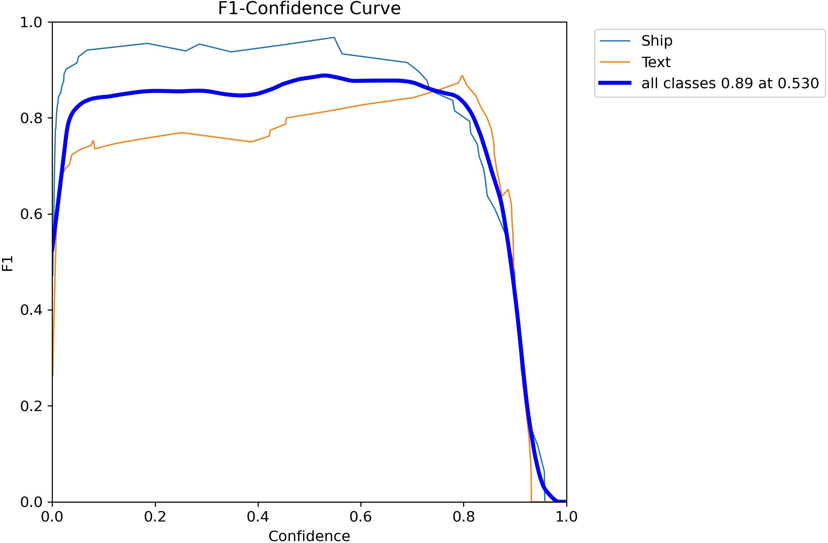

Figure 2: F1-score of the model across different confidence levels.

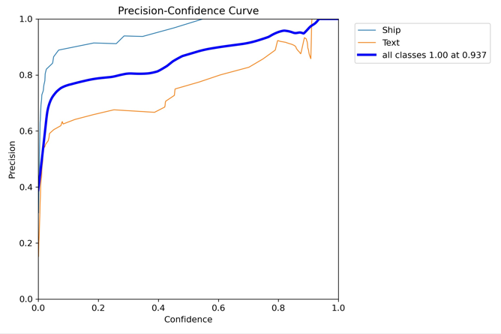

Figure 3: Precision Curve.

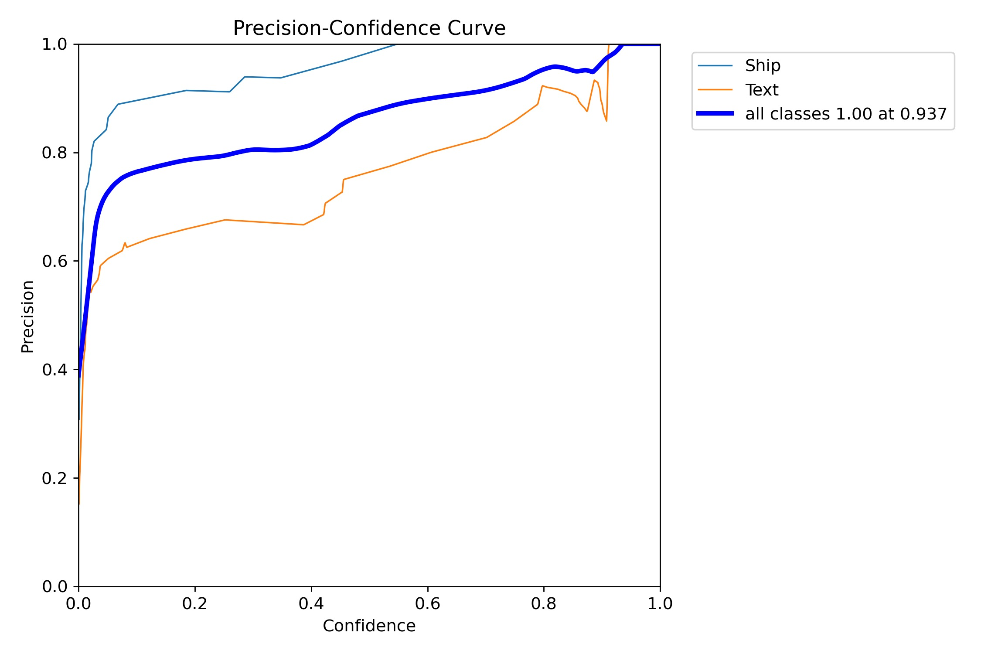

251 Fig. 3 illustrates the Precision-Confidence (P) Curve, which visualizes the relationship
252 between the model’s precision and the confidence threshold used for object detection. Similar
253 to the F1 curve, a consistently high blue line indicates strong overall detection accuracy across
254 all object classes at specific confidence levels (peaks). However, the precision for individual
255 object classes varies, reflecting differences in detection confidence and model certainty.
256 Fig. 4 presents the Recall-Confidence (R) Curve, an important metric that plots re-
257 call (true positive rate) against varying confidence thresholds. This curve provides insights
258 into how the model’s ability to identify relevant objects changes with different confidence
259 levels. It highlights the trade-off between confidence and recall, where increasing the confi-
260 dence threshold may reduce false positives but also lower recall. In the graph, confidence is
261 represented on the X-axis and recall on the Y-axis.
262 Figure 5 depicts the training curves which is the model’s performance as it learns from
263 the training data. The horizontal axis (X-axis) represents the number of training iterations
264 (epochs), while the vertical axis (Y-axis) indicates the loss values. A decreasing loss value re-
265 flects the model’s improved ability to align its predictions with the actual ground truth data.
266 Overall, the findings support the technological viability of the proposed OTDR system as a
267 promising solution for digitizing key aspects of port operations, particularly in automating
268 the detection and recognition of ships identification marks.

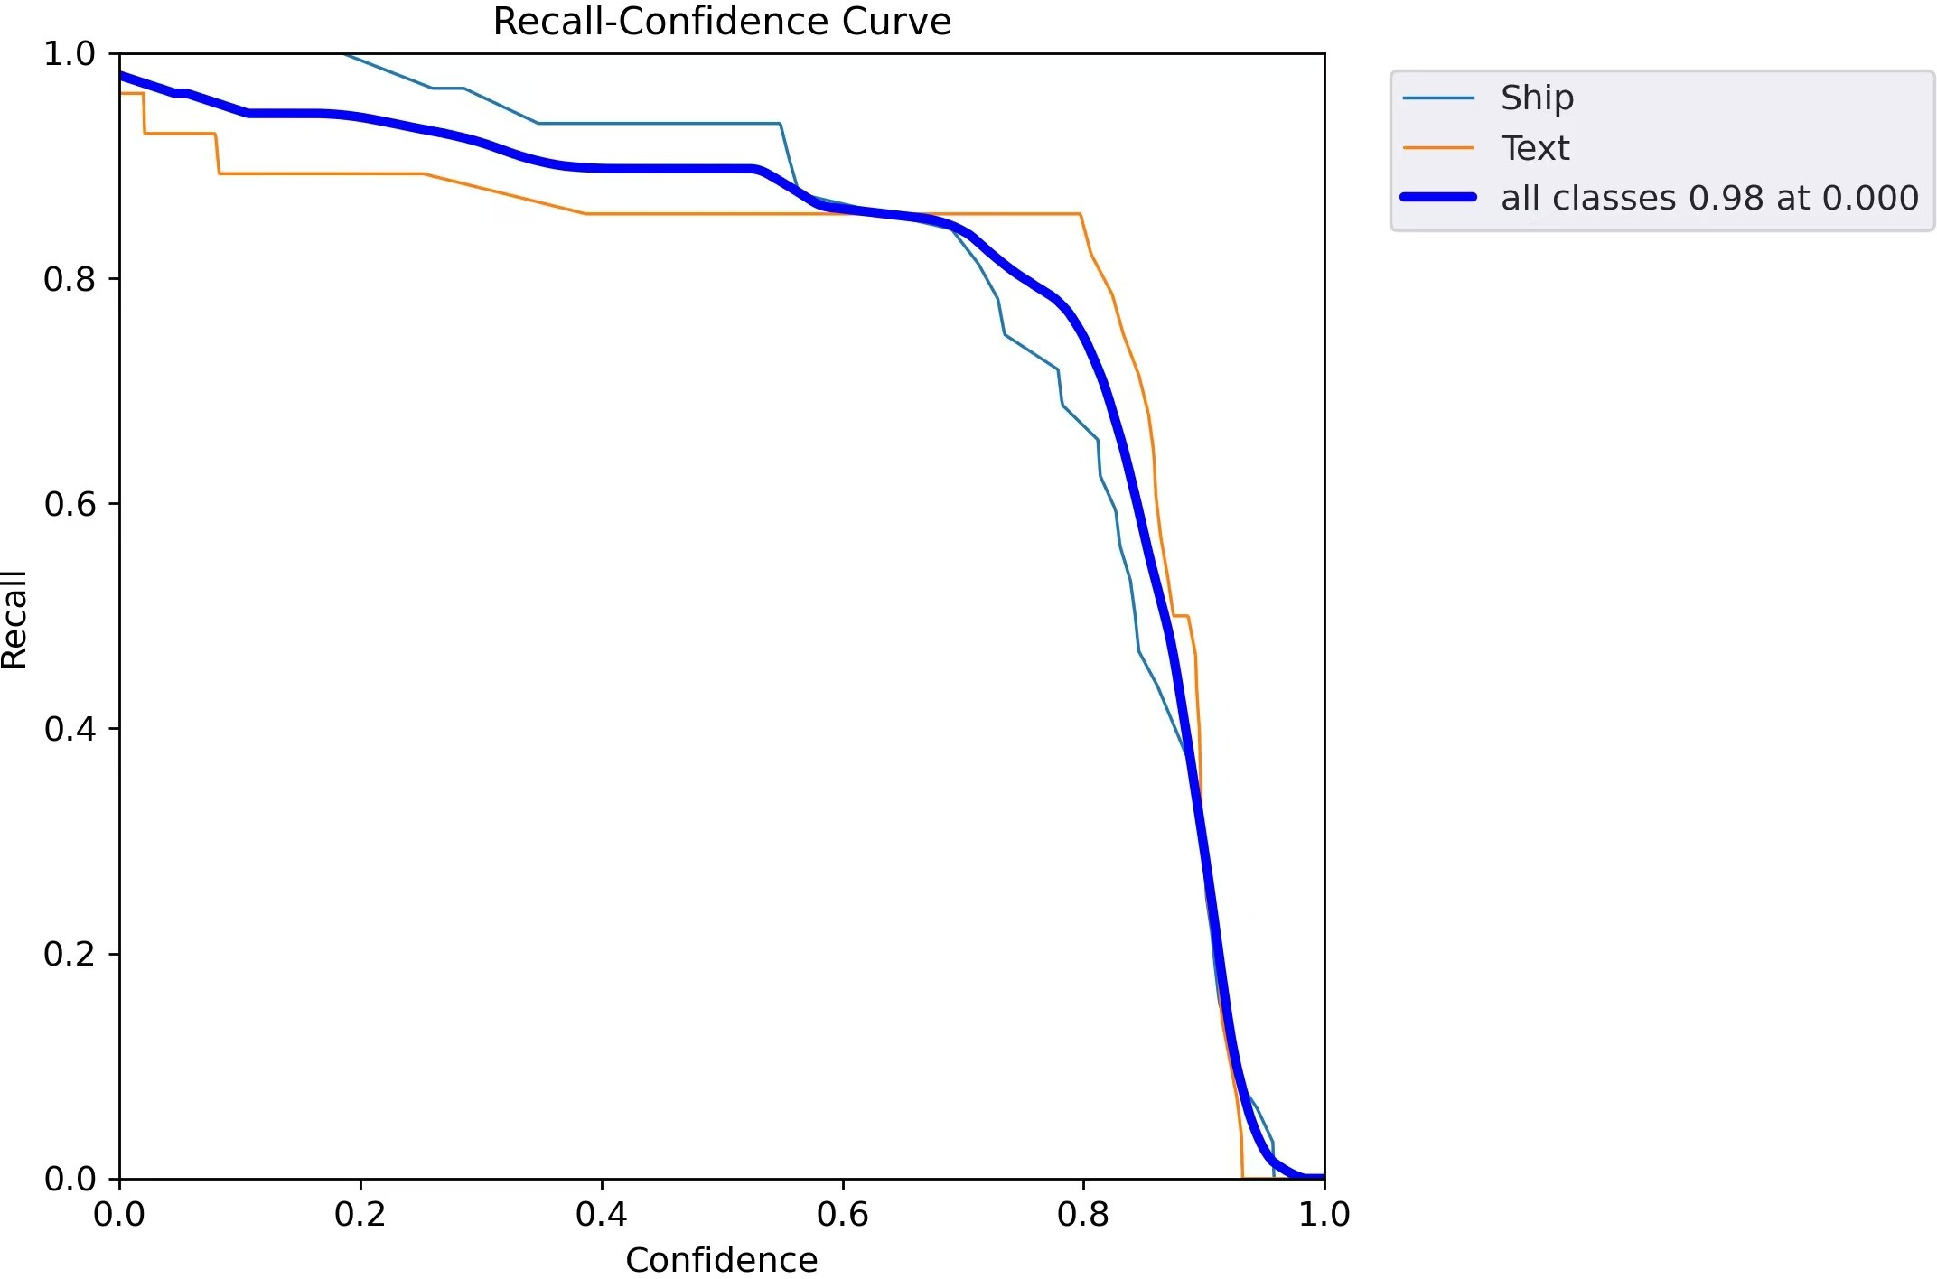

Figure 4: Recall Curve.

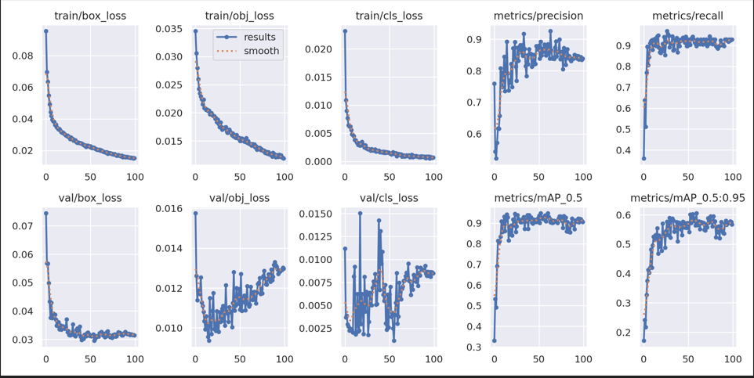
Figure 5: Final Result Graph.

269 3.5 Text Recognition Using PaddleOCR
270 As illustrated in Figure 1, once the YOLOv5s model detects an object classified as Text,
271 the corresponding region is cropped and passed into the recognition pathway powered by
272 PaddleOCR. Prior to recognition, the cropped region undergoes a series of preprocessing
273 operations integrated into the pipeline to enhance and standardize the text regions. These
274 preprocessing steps include deskewing to correct orientation distortions, erosion to eliminate
275 minor artifacts, noise reduction to enhance image clarity, and illumination normalization
276 to mitigate lighting inconsistencies. The refined image is subsequently passed to the Pad-
277 dleOCR engine, which performs accurate and efficient text extraction.
278 3.6 Deployment
279 The system is designed for flexible deployment, capable of processing various types of input
280 including static images, live camera feeds, and video frames. The complete end-to-end
281 pipeline is illustrated in Figure 1. Initially, the input is passed to the YOLOv5 model, which
282 detects and classifies objects based on the predefined training classes. If the detected object
283 is identified as a ship, the result is sent directly to the output module for visualization. In
284 cases where the detected object is classified as text, the corresponding region is routed to
285 a preprocessing module, where enhancement techniques are applied to improve text clarity.
286 The enhanced region is then forwarded to the PaddleOCR engine, which extracts the textual
287 content and sends the recognized text to the output module for display. This modular

288 architecture ensures efficient handling of both object detection and text recognition tasks.
289 4 CONCLUSION
290 This study presents a lightweight and efficient object-text detection framework specifically
291 designed for seaport logistics and maritime surveillance applications. The proposed sys-
292 tem integrates a modified YOLOv5s-based object detector with a PaddleOCR-powered text
293 recognition pipeline to enable precise localization and interpretation of textual and non-
294 textual entities under complex environmental conditions. To achieve reliable results, archi-
295 tectural optimizations were applied to the YOLO model, including the reduction of object
296 classes and the elimination of the smallest detection scale. These adjustments significantly
297 lower computational power demands while maintaining a high level of accuracy. Such re-
298 finements are especially advantageous for edge deployments and real-time applications in
299 bandwidth-constrained or resource limited environments commonly found in seaport logis-
300 tics. To further enhance recognition accuracy, especially in low-light and degraded image
301 conditions, the pipeline incorporates domain specific preprocessing techniques prior to OCR.
302 This results in improved text clarity and robustness in diverse imaging scenarios, thereby
303 increasing the reliability of automated visual inspection tasks such as ship name and iden-
304 tification number. The experimental results demonstrate that the system achieves a strong
305 balance between speed and precision, making it well-suited for practical deployment in dy-
306 namic maritime contexts. Moreover, the modularity of the proposed architecture allows for
307 easy adaptation and integration with other monitoring and data processing systems within
308 the logistics chain. In future work will aim to explore the integration of object and text
309 tracking mechanisms to enhance temporal consistency and reduce recognition latency across
310 video frames. Additionally, the extension of this framework to incorporate multimodal sensor
311 data—such as LiDAR, radar, or AIS (Automatic Identification System) to further improve
312 situational awareness and operational safety in seaport environments. Expanding the sys-
313 tem’s adaptability to multilingual text and variable weather conditions will also be considered
314 to broaden its global applicability.
335 References

336 | [1] | T. H. Nguyen and S. J. Kim, “Artificial intelligence-based smart port: A review of key
337 |  | technologies and applications,” IEEE Access, vol. 8, pp. 132908–132924, 2020.
338 | [2] | Z. Pan, L. Zhang, and L. Li, “Application of deep learning in intelligent logistics: A
339 |  | review,” IEEE Access, vol. 9, pp. 33807–33824, 2021.
340 | [3] | Z. Zhao, P. Zheng, S. Xu, and X. Wu, “Object detection with deep learning: A review,”
341 |  | IEEE Trans. Neural Netw. Learn. Syst., vol. 30, no. 11, pp. 3212–3232, Nov. 2019.
342 | [4] | R. Girshick, J. Donahue, T. Darrell, and J. Malik, “Rich feature hierarchies for accu-
343 |  | rate object detection and semantic segmentation,” in Proc. IEEE Conf. Comput. Vis.
344 |  | Pattern Recognit. (CVPR), 2014, pp. 580–587.
345 | [5] | R. Girshick, “Fast R-CNN,” in Proc. IEEE Int. Conf. Comput. Vis. (ICCV), 2015,
346 |  | pp. 1440–1448.
347 | [6] | S. Ren, K. He, R. Girshick, and J. Sun, “Faster R-CNN: Towards real-time object
348 |  | detection with region proposal networks,” in Adv. Neural Inf. Process. Syst. (NeurIPS),
349 |  | vol. 28, 2015.
350 | [7] | M. A. Nazir, S. M. Sharif, and M. Y. Javed, “YOLO object detection: A review of
351 |  | versions from YOLOv1 to YOLOv5,” ACM Comput. Surv., vol. 55, no. 1, pp. 1–35,
352 |  | 2021.
353 | [8] | W. Liu, D. Anguelov, D. Erhan, C. Szegedy, S. Reed, C.-Y. Fu, and A. C. Berg, “SSD:
354 |  | Single shot multibox detector,” in Proc. Eur. Conf. Comput. Vis. (ECCV), 2016, pp. 21–
355 |  | 37.
356 | [9] | T.-Y. Lin, P. Goyal, R. Girshick, K. He, and P. Dolla´r, “Focal loss for dense object
357 |  | detection,” in Proc. IEEE Int. Conf. Comput. Vis. (ICCV), 2017, pp. 2980–2988.

358 [10] R. Smith, “An overview of the Tesseract OCR engine,” in Proc. 9th Int. Conf. Document
359 Analysis and Recognition (ICDAR), vol. 2, 2007, pp. 629–633.
360 [11] PaddleOCR, “PaddleOCR: An open-source toolkit for optical character recognition,”
361 GitHub Repository, 2020. [Online]. Available: https://github.com/PaddlePaddle/
362 PaddleOCR
363 [12] N. Chen, X. Ding, and H. Zhang, “Improved Faster R-CNN identification method for
364 containers,” Int. J. Embedded Syst., no. May, pp. 308–317, 2020.
365 [13] H. Krishnan R, I. J., and V. S. Devi, “Enhancing road safety with real-time helmet
366 detection and e-challan issuance using YOLO and OCR,” Int. Res. J. Modernization
367 Eng. Technol. Sci., vol. 6, no. 5, pp. 1–8, May 2024.

