Original Research Article
Neem-Mediated Silver Nanoparticles: Characterization and Biological Applications Against Mosquito Larvae and Pathogenic Bacteria

Abstract
Nanotechnology provides promising strategies for sustainable solutions in healthcare and environmental management. In this study, silver nanoparticles (AgNPs) were synthesized via a green route using aqueous leaf extract of Azadirachta indica (Neem), a medicinal plant known for its wide pharmacological spectrum.
The biosynthesis was confirmed by a visible color change due to surface plasmon resonance, with UV–Visible spectroscopy showing an absorption peak at 458–459 nm. Fourier Transform Infrared (FTIR) spectroscopy revealed hydroxyl, carbonyl, and amine groups, indicating that phytochemicals served as reducing and stabilizing agents. Scanning Electron Microscopy (SEM) demonstrated predominantly spherical AgNPs with sizes ranging from 20–50 nm.
Biological evaluations indicated that neem-mediated AgNPs exhibited potent larvicidal activity against Culex quinquefasciatus. Probit analysis revealed LC₅₀ values of 0.0279 mg/L for AgNPs compared with 0.1985 mg/L for neem extract, highlighting the superior efficacy of the nanoparticles. Antibacterial assays showed stronger inhibition zones for AgNPs than for neem extract, with maximum activity observed against Staphylococcus aureus.
These findings demonstrate the potential of neem-mediated AgNPs as eco-friendly agents for mosquito vector control and antibacterial therapy. The dual efficacy underscores their promise as sustainable alternatives in integrated vector management and infection control, warranting further in vivo evaluation and environmental safety studies.
Keywords: Green synthesis, Silver nanoparticles, Azadirachta indica, Larvicidal activity,
Antibacterial activity
Graphical Abstract

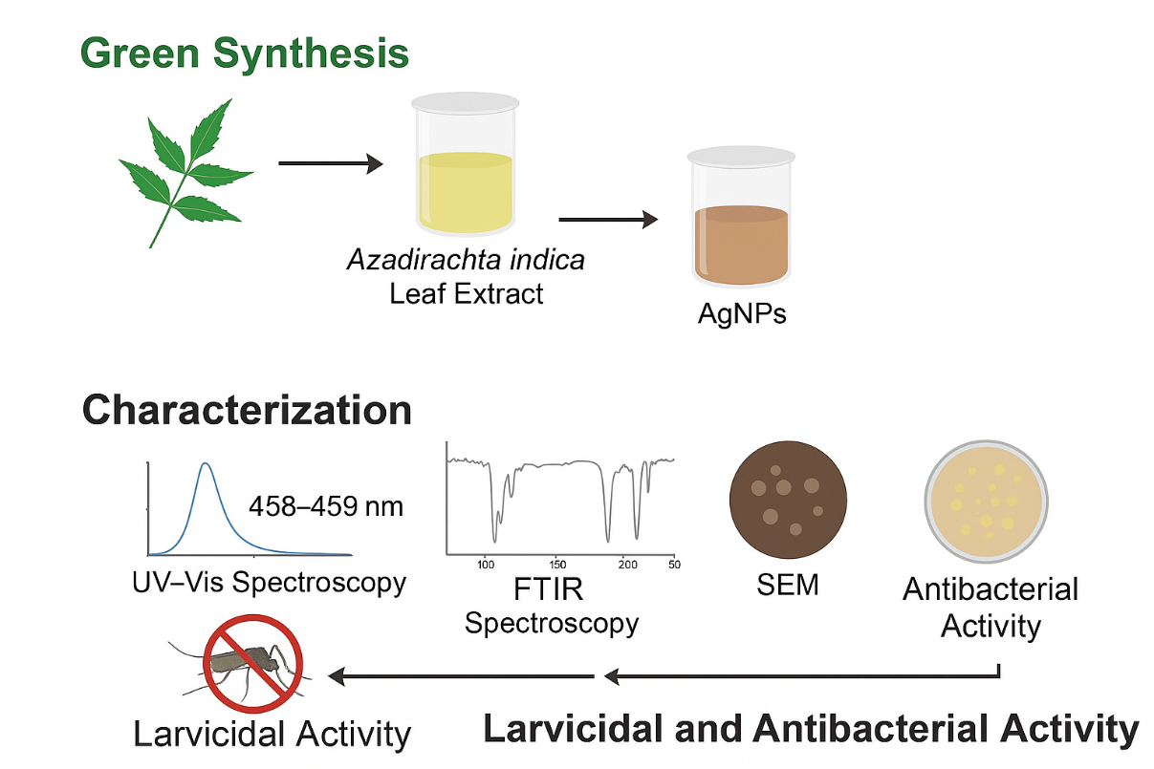

Introduction
Nanotechnology is now recognized as a transformative discipline with far-reaching impact on medicine, agriculture and environmental remediation. At the nanometre scale, materials acquire optical, electronic and physicochemical traits that are unattainable in their bulk form, a direct consequence of the dramatic rise in surface-to-volume ratio (Kharisov et al., 2013; Sharma et al., 2003). Silver nanoparticles (AgNPs) are among the most widely studied metallic systems because of their pronounced catalytic, antimicrobial and larvicidal attributes (Chandrasekaran et al., 2009; Ojemaye et al., 2019).
Conventional routes to AgNPs frequently require toxic reagents, high energy input or extreme conditions. In contrast, plant-mediated or “green” synthesis capitalises on the intrinsic reducing and stabilising power of phytochemicals, delivering a low-cost, low-risk and sustainable manufacturing platform (Roopan et al., 2013; Narayanan & Sakthivel, 2011). The same secondary metabolites that drive nanoparticle formation can also confer additional bioactivity, thereby amplifying the therapeutic or pesticidal value of the final product (El-Sayed, 2007).
A particularly rich source of such metabolites is Azadirachta indica (Neem), an evergreen member of the Meliaceae family that thrives in tropical and subtropical zones. Its leaves, seeds, bark and oil accumulate limonoids—most notably azadirachtin, nimbin and salannin—that underpin a broad pharmacological spectrum spanning antibacterial, antifungal, antiviral and insecticidal actions (Acharya et al., 2017; Rathinavelu et al., 2019; Hashmat et al., 2012; Khan et al., 2015). Commercial formulations such as Neemix and Aza-Direct already exploit these properties for crop and vector protection.
Mosquito-borne diseases—including malaria, dengue and filariasis—continue to exert a heavy global burden. Larvicidal interventions that interrupt juvenile development are a cornerstone of integrated vector management, and neem-based preparations have repeatedly demonstrated high potency against multiple vector species (Poopathi & Abidha, 2010; CDC, 2020). Neem-derived AgNPs appear to synergise the intrinsic toxicity of the phytochemicals with the well-documented antimicrobial action of silver, offering a dual-function platform for mosquito control and antibacterial therapy at a time when antibiotic resistance is escalating (Jindal et al., 2015; Yuan et al., 2017).
Precise physicochemical profiling—size, shape and colloidal stability—is essential, as these parameters govern biological uptake, dispersion and persistence. Prior reports confirm that neem-templated AgNPs remain stable under physiological conditions and retain strong bioactivity, underscoring their promise as next-generation, environmentally benign larvicides and antimicrobials (Poulose et al., 2014; Kumar et al., 2015).
This investigation therefore aimed to synthesise AgNPs using Azadirachta indica leaf extract under ambient conditions, to characterise the resulting nanomaterial, and to quantify its efficacy against mosquito larvae and clinically relevant bacteria. The findings are expected to advance the development of safer, greener tools for vector control and infection prevention.

Material and Method
Materials
In compliance with institutional, national, and international guidelines for research involving plant material, leaves of Azadirachta indica were collected from a wild population within the Obafemi Awolowo University campus, Ile-Ife, Nigeria (coordinates: 7.51946, 4.52610). The species is not listed as threatened on the IUCN Red List of Threatened Species and is not included under the Convention on International Trade in Endangered Species of Wild Fauna and Flora (CITES). The collected specimen was deposited at the Herbarium of the Department of Botany, Obafemi Awolowo University, Ile-Ife, where it was identified and authenticated by Mr. G. Ademoriyo. A voucher specimen was assigned the number IFE-18415.
Silver nitrate (AgNO₃) was obtained from Sigma Chemical Company St Louis, USA., Muller Hinton agar (MHA), filter paper (Whatman No. 1), and all other reagents used were of analytical grade.
Preparation of Neem Extract
Different concentrations of neem leaf powder (1 g, 5 g, and 10 g) were weighed and each dispersed into 100 ml of distilled water. The suspensions were stirred continuously using a glass rod and allowed to stand for several hours at room temperature. The mixtures were filtered using Whatman No. 1 filter paper to obtain the aqueous neem extracts (Bhaskara Rao et al., 2010).
Preparation of Silver Nitrate Solution
A 1 mM silver nitrate solution was prepared by dissolving 0.01698 g of AgNO₃ in 100 ml of distilled water in a volumetric flask. The solution was stored in an amber container and kept away from sunlight to prevent photodegradation (Balagurunathan et al., 2011).
Green Synthesis of Silver Nanoparticles
For the synthesis of silver nanoparticles (AgNPs), 1 ml of neem extract was added dropwise to 40 ml of 1 mM AgNO₃ solution. The mixture was then exposed to direct sunlight. A gradual color change from yellow to brownish pink within 5 minutes indicated the reduction of Ag⁺ ions to silver nanoparticles. After 30 minutes, the color stabilized, and whitish precipitates were observed at the bottom of the beaker. The suspension darkened after 24 hours, suggestive of nanoparticle formation (Roopan et al., 2013).
Characterization of Silver Nanoparticles
UV–Visible Spectroscopy
The synthesized AgNPs were analyzed using a UV–Visible double-beam spectrophotometer (Shimadzu UV-1800) in the range of 200–900 nm at a resolution of 1 nm, with distilled water as the blank. Absorption spectra were used to confirm nanoparticle formation based on surface plasmon resonance peaks (Balagurunathan et al., 2011).
Fourier Transform Infrared (FTIR) Spectroscopy
FTIR analysis was carried out using Cary 630 (Perkin Elmer) to identify functional groups in the neem extract responsible for reducing and stabilizing the silver nanoparticles. The spectra were recorded in the range of 4000–400 cm⁻¹ at 4 cm⁻¹ resolution (Bhaskara Rao et al., 2010).
Scanning Electron Microscopy (SEM)
The morphology and size of the AgNPs were examined using SEM (Model JOEL-JSM 7600F). Samples were mounted on stubs and sputter-coated with platinum to enhance conductivity. The coated samples were then examined under high vacuum, providing images of particle shape and size distribution (Poulose et al., 2014).
Antibacterial Activity
Test Microorganisms
The antibacterial activity of neem extract and AgNPs was assessed against Staphylococcus aureus, Pseudomonas spp., and Klebsiella pneumoniae.
Well Diffusion Method
Antibacterial assays were performed using the agar well diffusion method (El-Sayed, 2007). Bacterial suspensions were standardized to 0.5 McFarland’s standard and inoculated onto sterile Mueller Hinton agar plates using sterile swabs. Wells of 6 mm diameter were bored into the agar using a cork borer. Each well was filled with different concentrations of neem extract and AgNPs. Gentamycin served as the positive control, while distilled water served as the negative control. Plates were incubated at 37°C for 24 h, after which inhibition zones were measured in millimeters.
Larvicidal Activity
Test Organism
Larvae of Culex quinquefasciatus were cultured and maintained in an insectarium at the Drug Research and Production Unit, Obafemi Awolowo University, Ile-Ife, under ambient conditions. Larvae were continuously fed until they reached late third and early fourth instar stages.
Larval Bioassay
Larvicidal activity was evaluated following the World Health Organization (WHO, 1996) protocol. Ten larvae were placed into separate beakers containing 100 ml of deionized water, into which different concentrations (1 g/dl, 5 g/dl, and 10 g/dl) of neem extract and neem-mediated AgNPs were introduced. Each experiment was performed in triplicate, with deionized water serving as the negative control. Mortality was recorded after 24 h and 48 h. Larvae were considered dead if they failed to respond to probing.
Dose–Response Bioassay and Statistical Analysis
Mortality percentages were calculated, and the median lethal concentration (LC₅₀) was estimated using probit analysis (Finney, 1971). Data were expressed as mean ± standard deviation (SD). Statistical analyses were performed using SPSS software.

Results and Discussion

In this study, silver nanoparticles (AgNPs) were synthesized using Azadirachta indica leaf extract under ambient conditions, characterized to confirm their formation and stability, and evaluated for their biological efficacy against mosquito larvae and clinically significant bacteria.

Biosynthesis and Characterization of Silver Nanoparticles
The biosynthesis of silver nanoparticles (AgNPs) using aqueous neem (Azadirachta indica) leaf extract was successfully achieved. A gradual change in solution color from colorless to yellowish brown and finally to dark brown was observed within minutes of exposure to sunlight, indicating the reduction of silver ions (Ag⁺) to AgNPs. This color transition is attributed to the excitation of surface plasmon resonance (SPR) of silver nanoparticles, confirming nanoparticle formation (Aisida et al., 2019; Samson et al., 2021).

UV–Visible Spectroscopy
The UV–Vis spectra of the biosynthesized AgNPs showed characteristic SPR absorption peaks around 458–459 nm (Figure 1), which is consistent with the typical absorption range of silver nanoparticles (390–470 nm). The increase in absorbance with higher extract concentration suggests efficient nanoparticle synthesis and stability (Aisida et al., 2019).

Fourier Transform Infrared (FTIR) Analysis
FTIR spectra of neem extract showed functional groups such as hydroxyl (O–H) stretching (3276 cm⁻¹), C–H stretching of aromatic compounds (2918 cm⁻¹), and carbonyl (C=O) stretching (1722 cm⁻¹) (Figure 2a). After nanoparticle formation, shifts in absorption bands were observed, including peaks at 3645 cm⁻¹, 3198 cm⁻¹, 1781 cm⁻¹, 1718 cm⁻¹, 1625 cm⁻¹, and 1032 cm⁻¹, corresponding to O–H, C=O, C=C, and C–N vibrations (Figure 2b). These functional groups indicate the presence of phytochemicals such as phenolics, amines, and proteins, which act as reducing and stabilizing agents during AgNP synthesis (Subapriya & Nagini, 2005; Verma & Singh Mehata, 2016; Bharat et al., 2018; Adriana et al., 2021).

Scanning Electron Microscopy (SEM)
SEM micrographs revealed that the AgNPs ranged in size between 20–50 nm, predominantly spherical in shape, although some cuboidal particles were also observed (Figure 3). Aggregation was noted, which is typical of biologically synthesized nanoparticles due to capping biomolecules from plant extracts (Elemike et al., 2014).

Antibacterial Activity
The antibacterial efficacy of neem extract and biosynthesized AgNPs was tested against Staphylococcus aureus, Pseudomonas spp., and Klebsiella pneumoniae (Figure 4). The well diffusion assay showed that AgNPs exhibited larger zones of inhibition compared to neem extract, with the strongest activity against Staphylococcus aureus (24 mm at 10 µl concentration). In contrast, neem extract demonstrated moderate antibacterial activity, particularly against Pseudomonas spp.. Gentamycin, used as the positive control, generally produced higher inhibition zones; however, AgNPs displayed competitive antibacterial potential, especially against Gram-positive strains (Figure 4).
The superior antibacterial performance of AgNPs is attributed to their ability to penetrate bacterial cell walls and interact with intracellular components such as DNA and proteins, causing structural alterations and functional disruptions (Elemike et al., 2014). Moreover, the presence of phytochemicals from neem likely enhanced the antimicrobial potency through synergistic effects.

Larvicidal Activity
The larvicidal potential of neem extract and neem-mediated AgNPs was evaluated against Culex quinquefasciatus larvae. Mortality rates were dose-dependent, with higher concentrations producing greater larval death. At 10 mg/L AgNPs, mortality reached 90% after 24 h, while neem extract at the same concentration showed significantly lower mortality. Probit analysis revealed LC₅₀ values of 0.1985 mg/L for neem extract and 0.0279 mg/L for AgNPs after 24 h, demonstrating the superior efficacy of AgNPs. Mortality in controls did not exceed 2%, confirming experimental validity (Figure 5).
The enhanced larvicidal activity of AgNPs may be due to their small size, which allows better penetration into larval cuticles and tissues, disrupting cellular structures and interfering with biological processes (Hasan & Ansari, 2011; Haldar et al., 2013). Neem-derived compounds, particularly azadirachtin, are known to disrupt insect molting and growth, leading to developmental delays and death (Lai et al., 2014). Plant-mediated AgNPs have been reported to be safe for non-target aquatic organisms, supporting their potential use in eco-friendly vector control (Rawani et al., 2013).

Conclusion
This study demonstrated that neem leaf extract can be used for the green synthesis of silver nanoparticles, which were confirmed by UV–Vis, FTIR, and SEM analyses. Neem-mediated AgNPs exhibited strong larvicidal activity against C. quinquefasciatus larvae and significant antibacterial activity against human pathogenic bacteria, with higher efficacy than neem extract alone. These findings support the potential application of neem-based AgNPs as eco-friendly larvicides and antibacterial agents. Further in vivo studies are recommended to evaluate toxicity, dosage optimization, and long-term environmental safety.

Highlight
Green synthesis of silver nanoparticles was achieved using Azadirachta indica extract.
Nanoparticles were characterized by UV–Vis, FTIR, and SEM, confirming stability and size.
Neem-mediated AgNPs showed strong larvicidal activity against Culex quinquefasciatus.
The AgNPs exhibited enhanced antibacterial activity compared to neem extract alone.

Ethics: No ethical clearance needed for this work
Consent to participate: Not Applicable
Consent to publish Declaration: All authors agreed to publication of this manuscript

References
Acharya, P., Roy, A., & Shrivastava, A. (2017). Neem (Azadirachta indica) and its potential for disease control. Journal of Pharmacognosy and Phytochemistry, 6(5), 1669–1675.
Adriana, M. M., Rodríguez, F. J., & Quintero, D. R. (2021). FTIR analysis of functional groups involved in green synthesis of nanoparticles. Journal of Molecular Structure, 1245, 131011. https://doi.org/10.1016/j.molstruc.2021.131011
Aisida, S. O., Madubuonu, N., Ezema, F. I., & Ahmad, I. (2019). Biosynthesis of silver nanoparticles using plant extracts and their applications: A review. Journal of Nanoscience and Nanotechnology, 19(5), 2510–2521. https://doi.org/10.1166/jnn.2019.16143
Balagurunathan, R., Radhakrishnan, M., Rajendran, R. B., & Velmurugan, D. (2011). Biosynthesis of gold nanoparticles using Streptomyces viridogens and their application in catalysis. Research Journal of Nanoscience and Nanotechnology, 1(1), 17–25.
Bharat, M., Sharma, N., & Singh, A. (2018). Functional group analysis in green synthesized silver nanoparticles. Applied Surface Science, 449, 469–478.
Bhaskara Rao, K. V., Rajeswari, A., & Venkateswarlu, P. (2010). Phytochemical constituents of neem responsible for the reduction of silver ions. Asian Journal of Chemistry, 22(2), 1235–1242.
Centers for Disease Control and Prevention (CDC). (2020). Mosquito control: Larviciding. Retrieved from https://www.cdc.gov/mosquitoes/mosquito-control/larviciding.html
Chandrasekaran, S., Gnanasekar, S., & Natarajan, K. (2009). Antibacterial properties of silver nanoparticles synthesized from Azadirachta indica. Journal of Biomedicine and Biotechnology, 2009, 1–6. https://doi.org/10.1155/2009/581406
Elemike, E. E., Onwudiwe, D. C., & Ekennia, A. C. (2014). Phytosynthesis of silver nanoparticles using aqueous leaf extract of Azadirachta indica and their antibacterial activities. Applied Nanoscience, 4(6), 819–826. https://doi.org/10.1007/s13204-013-0269-1
El-Sayed, M. A. (2007). Some interesting properties of metals confined in time and nanometer space of different shapes. Accounts of Chemical Research, 34(4), 257–264. https://doi.org/10.1021/ar000110a
Finney, D. J. (1971). Probit analysis (3rd ed.). Cambridge University Press.
Haldar, K., Yadav, K., & Chandra, R. (2013). Insecticidal and larvicidal activities of biosynthesized silver nanoparticles using neem extract. Parasitology Research, 112(7), 2551–2560. https://doi.org/10.1007/s00436-013-3192-6
Hasan, S. S., & Ansari, M. S. (2011). Potential of neem-based products in mosquito control programs. International Journal of Mosquito Research, 1(3), 34–40.
Hashmat, I., Azad, H., & Ahmed, A. (2012). Neem (Azadirachta indica) and its potential for medicinal use. Pharmacognosy Reviews, 6(11), 45–50. https://doi.org/10.4103/0973-7847.95849
Jindal, A., Yadav, K., & Kumar, A. (2015). Green synthesis and characterization of silver nanoparticles using neem extract and their larvicidal activity. Journal of Environmental Biology, 36(3), 743–748.
Khan, M., Sultana, S., & Sharma, R. (2015). Pharmacological properties of Azadirachta indica: An overview. International Journal of Pharmaceutical Sciences Review and Research, 32(1), 230–236.
Kharisov, B. I., Rasika Dias, H. V., Kharissova, O. V., Manuel, Y., & Méndez, U. O. (2013). Green synthesis of nanoparticles. Sustainable Chemical Processes, 1(1), 1–24. https://doi.org/10.1186/2043-7129-1-1
Kumar, P., Senthil, K., & Prasad, R. (2015). Biological synthesis of nanoparticles using neem and their biomedical applications. Journal of Saudi Chemical Society, 19(3), 311–317. https://doi.org/10.1016/j.jscs.2012.04.002
Lai, D., Wen, L., & Li, S. (2014). Azadirachtin-induced apoptosis in insect cells. Pesticide Biochemistry and Physiology, 113, 60–66. https://doi.org/10.1016/j.pestbp.2014.05.004
Narayanan, K. B., & Sakthivel, N. (2011). Green synthesis of biogenic metal nanoparticles by terrestrial and aquatic phototrophic and heterotrophic eukaryotes and biocompatible agents. Advances in Colloid and Interface Science, 169(2), 59–79. https://doi.org/10.1016/j.cis.2011.08.004
Ojemaye, M. O., Adewuyi, A., & Fatoki, O. S. (2019). Environmental applications of silver nanoparticles: Green synthesis and toxicity. Chemosphere, 223, 295–306. https://doi.org/10.1016/j.chemosphere.2019.02.095
Poopathi, S., & Abidha, S. (2010). Mosquitocidal properties of neem products against Culex quinquefasciatus. Parasitology Research, 106(6), 1425–1432. https://doi.org/10.1007/s00436-010-1813-1
Poulose, S., Panda, T., Nair, P. P., & Theodore, T. (2014). Synthesis of silver nanoparticles: Mechanism and antibacterial applications. International Nano Letters, 4(2), 2–12. https://doi.org/10.1007/s40089-014-0093-y
Rawani, A., Ghosh, A., & Chandra, G. (2013). Mosquito larvicidal activities of synthesized silver nanoparticles using neem (Azadirachta indica) leaf extract against Culex quinquefasciatus. Parasitology Research, 112(4), 1451–1459. https://doi.org/10.1007/s00436-013-3294-1
Rathinavelu, A., Kanthimathi, S., & Kanchana, K. (2019). Neem and its therapeutic potential: A review. Journal of Pharmacognosy and Phytochemistry, 8(2), 2252–2258.
Roopan, S. M., Bharathi, A., Prabhakarn, A., Rahuman, A. A., & Velayutham, K. (2013). Green synthesis of silver nanoparticles using plant extracts and their applications: A review. Industrial Crops and Products, 43, 631–639. https://doi.org/10.1016/j.indcrop.2012.09.002
Samson, R., Annamalai, P., & Kumar, S. (2021). Optical and antimicrobial properties of green synthesized silver nanoparticles. Materials Today: Proceedings, 44, 2564–2570. https://doi.org/10.1016/j.matpr.2020.12.911
Sharma, V. K., Yngard, R. A., & Lin, Y. (2003). Silver nanoparticles: Green synthesis and antimicrobial activities. Advances in Colloid and Interface Science, 145(1–2), 83–96. https://doi.org/10.1016/j.cis.2008.09.002
Subapriya, R., & Nagini, S. (2005). Medicinal properties of neem leaves: A review. Current Medicinal Chemistry – Anti-Cancer Agents, 5(2), 149–156. https://doi.org/10.2174/1568011053174828
Verma, A., & Singh Mehata, M. (2016). Controllable synthesis of silver nanoparticles using neem extract and their characterization. Journal of Nanostructure in Chemistry, 6(1), 61–69. https://doi.org/10.1007/s40097-015-0170-0
Yuan, Y., Liu, C., Qian, J., & Wang, J. (2017). Silver nanoparticles: Synthesis, properties, and therapeutic applications. International Journal of Nanomedicine, 12, 5135–5146. https://doi.org/10.2147/IJN.S134526

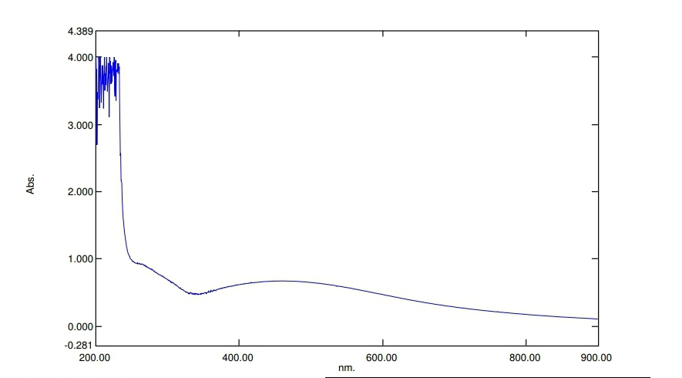
Figure 1: UV spectral of Azadirzctha indica -silver Nanoparticle
The characteristic surface plasmon resonance (SPR) absorption band of biosynthesized neem-AgNPs was obtained at 458nm.

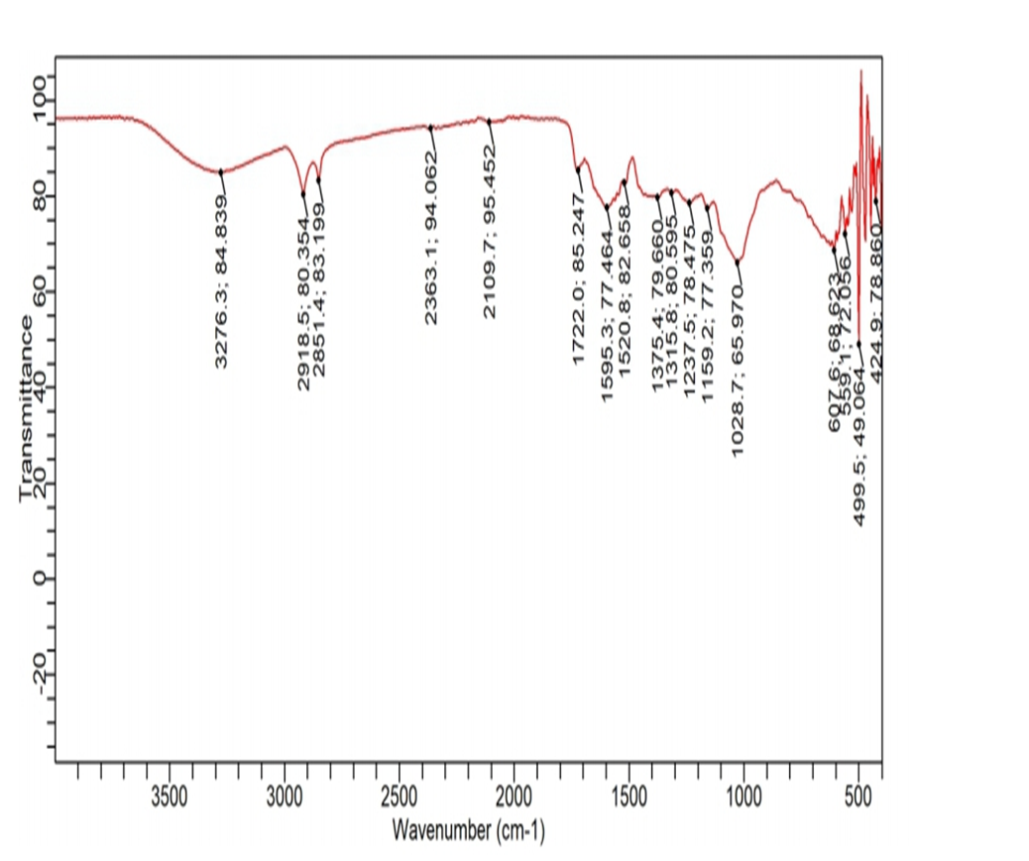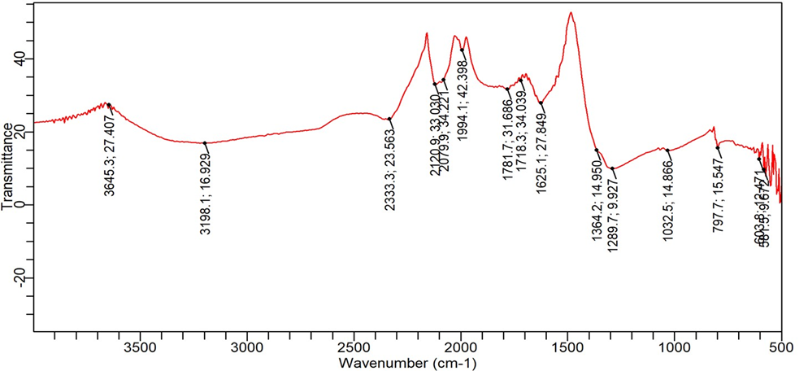
A
B
Figure 2: FTIR spectrum of Azadirzctha indica and Azadirzctha indica -silver nanoparticles
The spectrum analysis was carried out on aqueous neem extract and Neem-silver nanoparticle extract has seen in figure 2 A and B respectively. Different spectral were observed as seen from the figure showing that nanoparticles were formed.
It can be seen from Figure the range of first broad spectra lies between 3276.3 cm-1 to 2918.5 cm-1. This peak is attributed to the O–H stretching modes of vibration in hydroxyl functional group in alcohols and N–H stretching vibrations in amides and amines observed at 2109.7. A carbonyl group C=O is observed at 1722.0

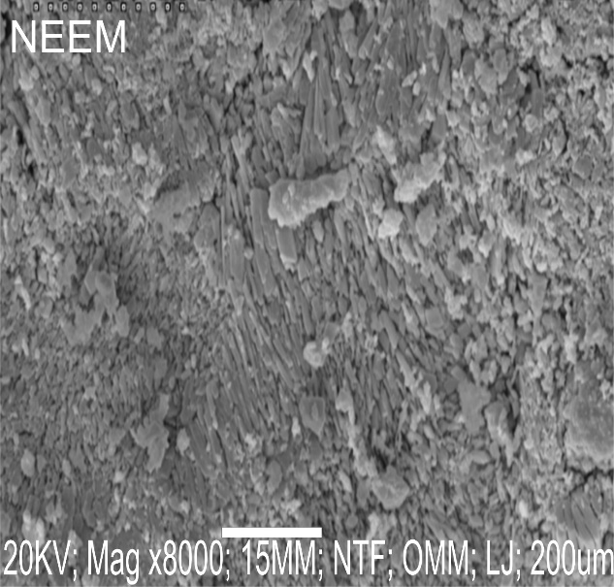

Figure 3: SEM micrograph of Azadirzctha indica -silver nanoparticle
The micrograph of silver nanoparticle of Azadirzctha indica extract was measured by SEM. The synthesized AgNPs are present in aggregate form. The nanoparticles that were observed by SEM were ranged in size from 20-50-nm in which majority of them were in spherical shapes, however some other shapes such as cuboidal were also observed

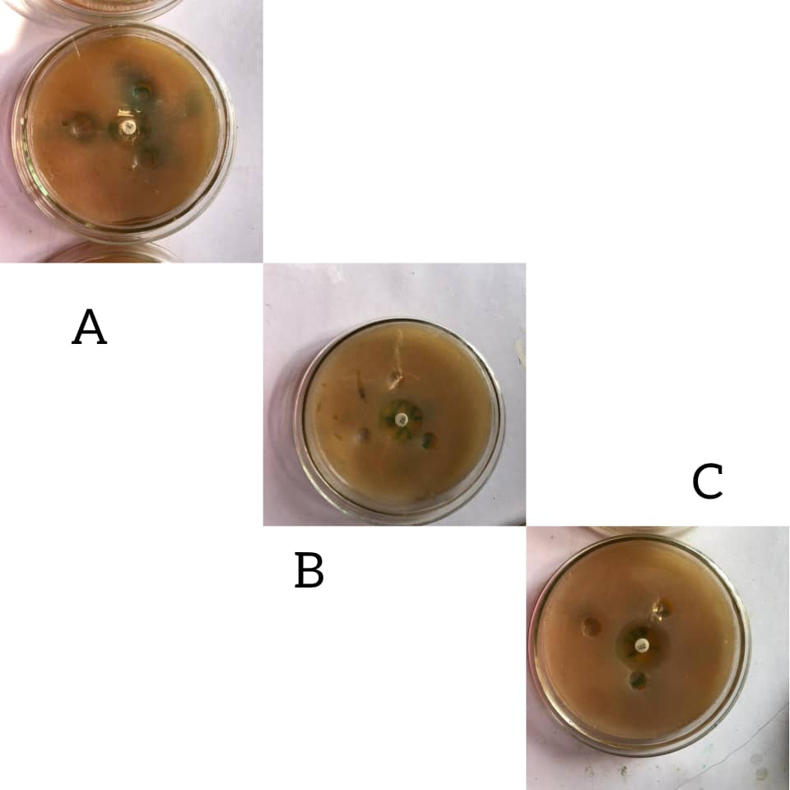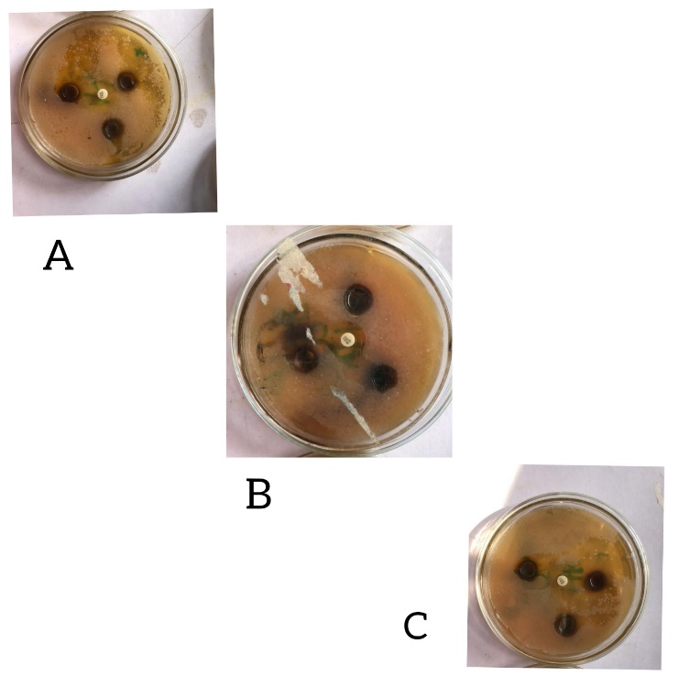
ii
i
Figure 4: Zone of inhibition of Azadirachta indica extract and Azadirachta indica-silver nanoparticles against human pathogenic bacteria. (A) Klebsiella pneumoniae (B)Pseudomonas spp (C) Staphylococcus aureus

Figure 5: Larvicidal activity of of Azadirachta indica leaf extract and Azadirachta indica leaf extract-AgNO₃ Nanoparticles.
The same concentration of extract was used for the experiment. of Azadirachta indica leaf extract possese some larvicidal activity while Azadirachta indica leaf extract-AgNO₃ Nanoparticles shows more potency

Table 1: Bacterial growth inhibition zone of Azadirachta indica leaf extract and Azadirachta indica leaf extract-AgNO₃ Nanoparticles.

Bacterial | Neem-AgNPs |  |  | Extract(MM) |  |  | Gentamyin(MM)
 | 1mM | 5mM | 10mM | 1mM | 5mM | 10mM
Staphylococcus aureus | 15 | 16 | 24 | - | - | 13 | 20
Pseudomonas spp | 13 | 14 | 16 | - | 13 | 14 | 17
Klebsiella pneumoniae | 14 | 15 | 16 | - | - | 10 | -

