**Assessment and Delineation of GPS Based Soil Fertility Maps of Agriculture College Farm, Pune.**

**ABSTRACT**

Present soil survey was carried out during 2024 in College of Agriculture, Pune (Maharashtra) India by using Global Positioning System (GPS). Fertility maps were prepared with 160 geo-referenced soil samples collected by randomized method. Out of 160 soil samples, 127 samples from Agronomy Farm and 33 samples were collected from Modi Baugh and Pathology Farm by using standard soil sampling procedure and were analysed for chemical properties at College of Agriculture, Pune with an objective to assess the soil nutrient status and delineate soil fertility maps of Agriculture College farm, Pune. The pH and EC of soils of Agronomy Farm was found in between 7.63 to 8.96 (mean 8.11) and 0.20 to 0.78 dS m-1 with mean 0.41 dS m-1 respectively. The organic carbon and calcium carbonate content of the Agronomy Farm was ranged from 0.10 to 0.73 per cent with mean 0.39 per cent and 10.25 to 27.5 per cent with mean 18.53 per cent respectively. The available nitrogen, phosphorous and potassium of Agronomy Farm was found to be between 75.27 to 326.11 kg ha-1 (mean 195.31 kg ha-1), 6.57 to 60.08 kg ha-1 (mean 31.82 kg ha-1) and 114.24 to 1005.76 kg ha-1 (mean 422.24 kg ha-1) respectively. The available sulphur ranged between 16.21 to 26.46 mg kg-1 (mean 21.44 mg kg-1).

The soils of Modi Baugh and Pathology Farm showed pH and EC from 7.52 to 8.45 with mean 7.85, and 0.21 to 0.64 dS m-1 with mean 0.45 dS m-1 respectively. The organic carbon content and calcium carbonate ranged from 0.17 to 0.62 per cent with mean 0.32 and 8.5 to 25.5 per cent with mean 14.1 per cent respectively. The available nitrogen, phosphorous and potassium of Modi Baugh and Pathology Farm ranged from 125.44 to 301.06 kg ha-1 (mean 222.76 kg ha-1), 13.14 to 31.6 (mean 20.17 kg ha-1) and 166.72 to 919.52 kg ha-1 (mean 400.10 kg ha-1) respectively. The available sulphur in soils ranged between 18.50 to 25.39 mg kg-1 (mean 22.31 mg kg-1).

Based on the GPS locations of samples and soil test results, soil fertility maps of Agriculture College Farm, Pune were prepared by using Arc-GIS 10.8.2 for soil pH, EC, OC, CaCO3, available N, P, K and S.

*Keywords: GIS, GPS, macronutrients, soil fertility maps*

1. **INTRODUCTION**

An essential component of the global ecology is soil. Soil is a natural mix of organic matter and weathered rock that forms on the Earth’s surface. It is a basic or foundation for all crop production. It is biologically active and capable and home to a large range of living organisms including earthworm, soil microbes, and growing plant roots. All life on Earth is supported and nourished by soil, which is known as

the “soul of infinite life.” In general, a country’s socioeconomic development and life support system capacity are determined by how well its land is used. The greatest possible production of food, fiber and fuel from each farmed land area per unit of time is necessary to address the nation’s severe population crises. To be compared to the total number of farms in a given area, the results of a soil test conducted on a single farm must be comprehensive. Although sampling every farm to assess the soil fertility status of every farm would be ideal, this is not feasible due to the significant cost, difficulty, and time required, particularly considering the vast number of small farms found in many developing countries. Therefore, we require systematic soil sample from data to gather knowledge about the entire region. Soil fertility map for nitrogen, phosphorous, and potassium were developed between 1975 and 1980 utilizing soil test result collected by soil testing laboratories around the country.

Crop availability is significantly impacted by the parent material, organic matter, calcium carbonate, soil response, texture, and mineralogical composition. According to (Nayyar *et al.,* 1999), calcareous soils with high pH and little organic matter are more likely to have micronutrient shortages. Major nutrients, also known as macronutrients, get their name from the fact that they are needed in significant amounts C, H, O, N, P, K, Ca, Mg, and S are among them. Among these, C, H, and O make up 90 to 95 per cent of the plant’s dry matter weight and are obtained from carbon dioxide (C02) and water (H2O).

Global Positioning System (GPS) and Geographic Information systems (GIS) are also essential tools for determining the soil’s spatial variability. Spatial data can be collected, stored, retrieved, transformed, and shown using a powerful set of tools known as GIS (Das *et al.,* 2004). GPS- assisted soil sample collection is crucial for creating thematic soil fertility maps. Anywhere in the world, a GPS device can accurately determine the latitude and longitude of the location, it provide soil nutrient status of various site for the future supervision, it is extremely important in agriculture (Mishra *et al.,* 2014). Thematic maps pertaining to agriculture that are produced using GPS tool enable in the development of site-specific nutrient management plan for the region as well as soil fertility, land use, and land cover.

The Global Positioning System (GPS) technology is a satellite-based navigation system that uses signals from satellite in orbit to tell users where they are. Locating satellites that transmit signals to the device is how a GPS system operates. After that, they locate your on earth based on the positions of satellites. Geographic Information System (GIS), gathers information about the earth’s surface and transforms it into information that can be shared, analyzed, and understood. GIS is mostly used for predicting, weather patterns, land information management, and resource exploitation. The preparation of soil fertility maps is now possible through the applications of modern technologies such as GPS and GIS. The United States military administrated the Global Positioning System, a space-based navigation and tracking system that accurately determines the location of the object on earth's surface using geographical coordinates. A Geographic Information System (GIS) is a computer system used for capturing, querying and displaying geographic data. It is easy to change the data regarding to fertility status of an area even after the soil fertility maps are prepared

**2. MATERIALS AND METHODS**

**2.1 Location of the Study Area**

The campus of Agriculture College Farm, Pune is located in between latitude N 180 32’17.268’’ and longitude E 73050’37.2084’’and it covers total area of 42 ha. The elevation is 557.7 m above mean sea level. The College of Agriculture, Pune is situated at the Ganeshkhind Road, Shivaji Nagar, Pune. The Research Farm is under culturable command area since 1907 and present study was, therefore, undertaken to prepare detailed soil survey of College of Agriculture Farm, Pune. The base map of Agriculture College Farm, Pune was depicted in fig. 1.

**2.2 Soil Sample Preparation and Laboratory Analysis**

Geo-referenced surface (0 - 22.5 cm) soil samples were collected randomly from College of Agriculture Farm, Pune. The latitude and longitude of sampling sites were recorded with the help of Differential Global Positioning System. The soil samples were collected by using randomization method i.e 100 m apart. From 160 locations soil samples were collected and evaluated. Record of surveyed field i.e latitude, longitude were taken using GPS. The soil samples were collected with the help of wooden and plastic instruments to avoid iron contamination. After collecting the soil samples, they were brought to the laboratory. These samples were dried under shade, pounding completed by using wooden pestle and morter and passed through sieve 2 mm and 0.5 mm. The sieved samples were preserved in clean plastic bags for further analytical work with the proper labelling. All the precautions were followed as per the procedure described by Jackson (1973) and standard procedure outlined by Page *et al*., (1982) was used to estimate chemical properties of soil. Soil samples were analyzed for pH, EC, organic carbon, calcium carbonate, available nitrogen, available phosphorous, available Potassium and available sulphur. The geospatial analysis of the study area was carried out using ArcGIS 10.8.2.

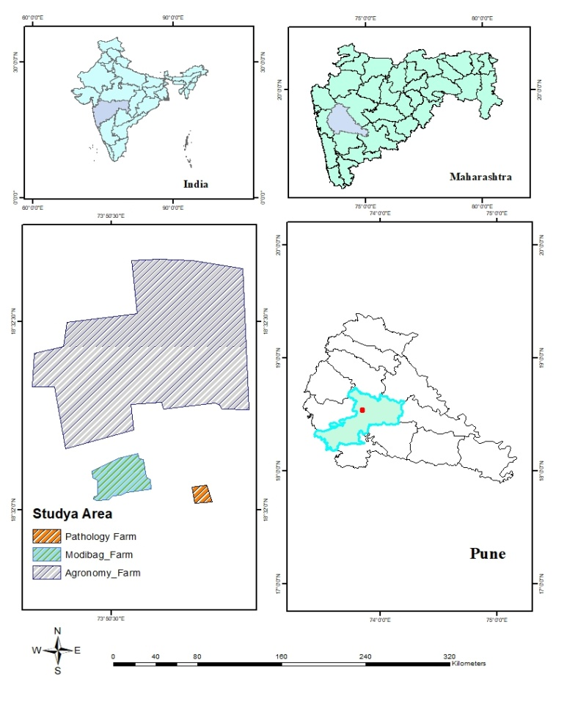

**Fig.1 Study area of College of Agriculture Farm, Pune**

**3. RESULTS AND DISCUSSION**

**3.1 Soil reaction**

Soil pH data are presented in Table 1. A total of 127 soil samples from the Agronomy Farm were analyzed, revealing a pH range of 7.63 - 8.96, with a mean of 8.11. Among these, 9.44 per cent of samples were slightly alkaline, 87.42 per cent moderately alkaline and 3.14 per cent strongly alkaline. The spatial variability across the farm is illustrated in Figure 2.

27 samples from Modi Baugh Farm and 6 from Pathology Farm were analyzed, with pH values ranging from 7.52 - 8.45 and an average of 7.85 pH evaluations are presented in table 2. According to the results of the analysed soils, 75.75 per cent of samples were slightly alkaline, and 24.25 per cent were moderately alkaline. Figure 3 depicts the geographic distribution of pH for these farms.

Most soils across the Agriculture College Farm, Pune, are moderately alkaline, likely influenced by parent material, rainfall, topography, and prolonged irrigation of medium-deep black soils. Similar findings were reported by Nalawade and Palwe (2014) at ARS, Savale Vihir Farm, MPKV, Rahuri. The elevated pH is possibly due to basaltic parent material rich in basic cations (Patil *et al.,* 2019).

**3.2 Electrical Conductivity (EC)**

The soil Electrical Conductivity (EC) data are presented in Table 1. A total of 127 samples from the Agronomy Farm showed EC values ranging from 0.20 to 0.78 dS m-¹, with an average of 0.41 dS m-¹. These values fall within the normal range, suitable for healthy plant growth. The highest EC recorded was 0.78 dS m-¹, and the lowest was 0.20 dS m-¹. Spatial variability across the farm is depicted in Figure 4, showing most soils with EC within the normal range.

For the Modi Baugh and Pathology Farms, 33 soil samples exhibited EC ranging from 0.21 to 0.64 dS m-¹, with a mean of 0.45 dS m-¹ (Table 2). All samples from these farms also fell within the normal EC range, indicating favourable conditions for plant development. Figure 5 illustrates spatial variability across these farms.

The normal EC values are likely due to careful irrigation management and the non-saline nature of the soils, as indicated by low soluble salt content. Excessive leaching of salts to lower soil horizons and removal of bases through percolation and drainage help maintain normal EC levels (Satish *et al.*, 2018). Similar findings were reported by Golhar and Chaudhari (2013) in Jalgaon district and by (Salma *et al.,* 2019), who noted that low EC prevents salt accumulation at greater depths.

**3.3 Organic Carbon**

Organic carbon content in Agronomy Farm soils ranged from 0.10 % to 0.73 %, with a mean of 0.39 % (Table 1). Among 127 samples, 13.39 per cent were very low, 39.37 per cent low, 38.58 per cent moderate and 8.66 per cent moderately high in organic carbon. Higher and lower values were 0.73 % and 0.10 %, respectively. Figure 6 highlights spatial variability, showing predominantly low organic carbon in the western zone.

There were 27 samples taken from the Modi Baugh Farms and the 6 samples taken from the Pathology Farm. The organic carbon ranged from 0.17 % to 0.62 %, averaging 0.32 per cent (Table 2). Out of these, 18.18 per cent had very low, 57.58 per cent low, and 24.24 per cent moderate organic carbon content. Figure 7 demonstrates spatial variability, with most soils showing low organic carbon.

Low organic carbon may be due to minimal FYM and crop residue application, rapid decomposition under high temperatures, and low vegetation cover. These findings align with reports by (Naiknaware *et al*., 2020) and Gosavi and Chaudhari (2016) from similar agro-climatic zones in Maharashtra.

**3.4** **Calcium carbonate**

Calcium carbonate content in Agronomy Farm soils ranged from 10.25 % to 27.5 %, with a mean of 18.53 per cent (Table 1). Among samples, 36.22 per cent fell into the moderate category, while 63.78 per cent exhibited very high CaCO₃ levels. Figure 8 depicts the spatial distribution, showing higher CaCO₃ in the western zone.

From Modi Baugh and Pathology Farms, CaCO₃ ranged from 8.5 % to 25.5 %, with an average of 14.10% (Table 2). Among these, 57.58 per cent showed high, 24.24 per cent very high, and 18.18 per cent moderate CaCO₃ content. Figure 9 illustrates spatial variability, with most areas classified as high.

These patterns align with findings by (Patil *et al.*, 2017) and (Magare *et al.*, 2023). The semi-arid climate, characterized by low rainfall and high evaporation, promotes CaCO₃ precipitation. The soils’ basaltic origin further contributes to these levels (Verma *et al*., 2012).

**Table 1: Chemical properties of soils from Agronomy Farm**

|  |  |  |  |  |
| --- | --- | --- | --- | --- |
| **Particulars** | **pH (1:2.5)** | **EC (dS m-1)** | **Organic carbon (%)** | **CaCO3 (%)** |
| **Range** | 7.63 - 8.96 | 0.20 - 0.78 | 0.10 - 0.73 | 10.25 - 27.5 |
| **Mean** | 8.11 | 0.41 | 0.39 | 18.53 |
| **Categories** | Slightly alkaline  12  (9.44%) | Normal  127  (100%) | Very Low  17  (13.39%) | Moderate  46  (36.22%) |
| Moderately alkaline  111  (87.42%) | Low  50  (39.37%) | Very high  81  (63.78%) |
| Strongly alkaline  4  (3.14%) | Moderate  49  (38.58%) |
| Moderately High  11  (8.66%) |

**Table 2: Chemical properties of soils from Modi Baugh and Pathology Farm**

|  |  |  |  |  |
| --- | --- | --- | --- | --- |
| **Particulars** | **pH (1:2.5)** | **EC (dS m-1)** | **Organic carbon (%)** | **CaCO3 (%)** |
| **Range** | 7.52 - 8.45 | 0.21 - 0.64 | 0.17 - 0.62 | 8.5 - 25.5 |
| **Mean** | 7.85 | 0.45 | 0.32 | 14.1 |
| **Categories** | Slightly alkaline  25  (75.75%) | Normal  33  (100%) | Very Low  6  (18.18%) | Moderate  6  (18.18%) |
| Moderately alkaline  8  (24.25%) | Low  19  (57.58%) | High  19  (57.58%) |
| Moderate  8  (24.24%) | Very high  8  (24.24%) |

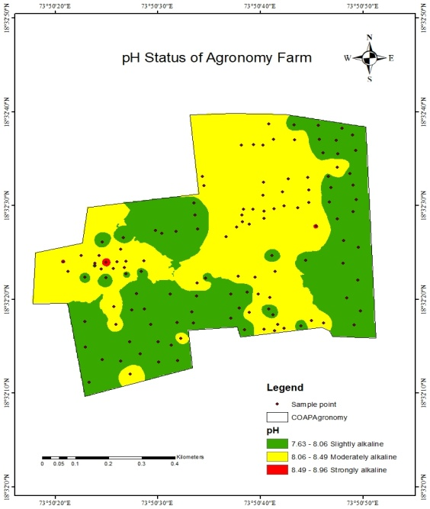 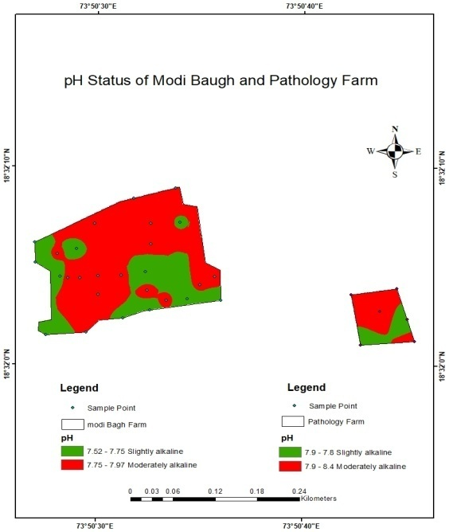

pH of Modi Baugh andPathology Farm

pH of Agronomy Farm

**pHofAgronomyFarm**

**Fig 2: pH of Agronomy Farm Fig 3: pH of Modi Baugh and Pathology Farm**

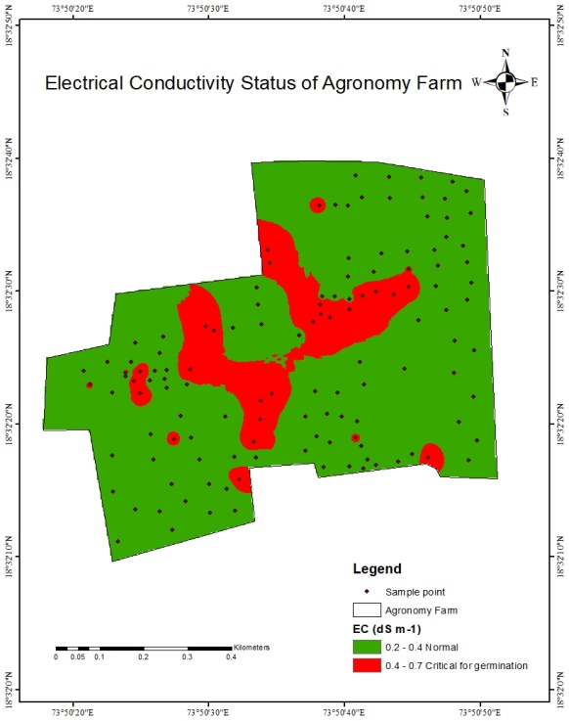 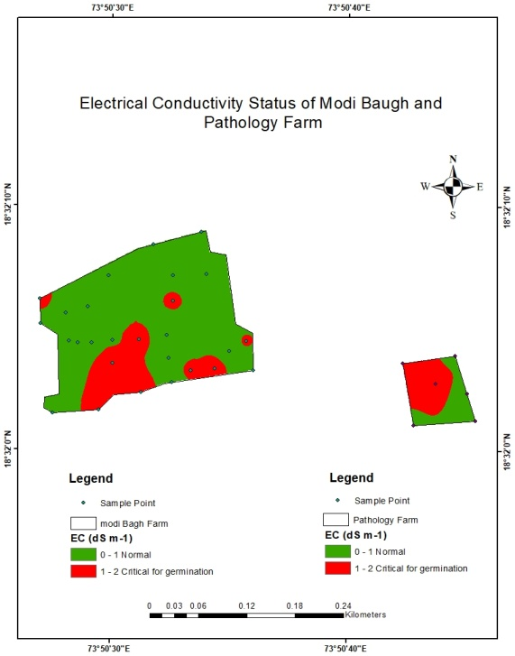

Electrical Conductivity of Modi Baugh and Pathology Farm

Electrical Conductivity of Agronomy Farm

**Fig 4: EC of Agronomy Farm Fig 5: EC of Modi Baugh and Pathology Farm**

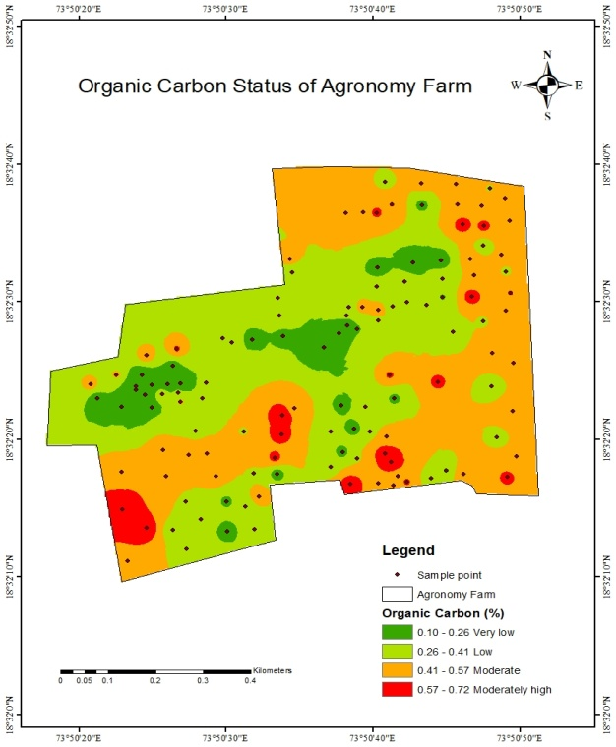 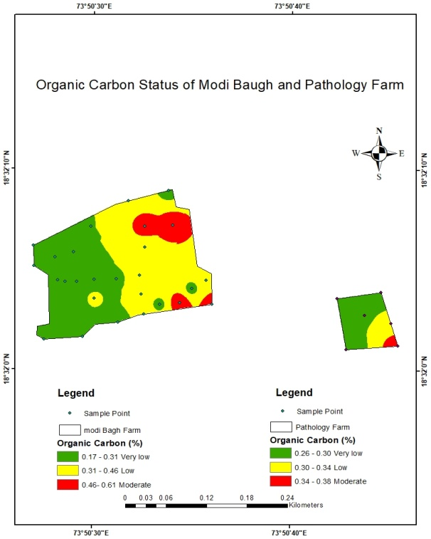

**Fig 7: Organic carbon status of Modi Baugh and Pathology Farm**

**Fig 6: Organic carbon status of Agronomy Farm**

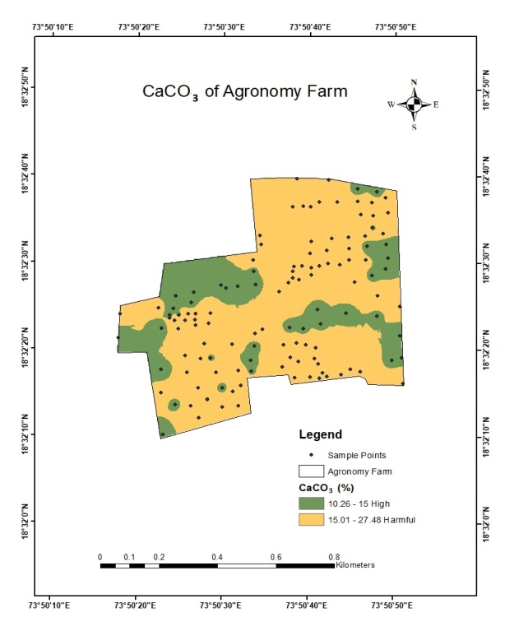 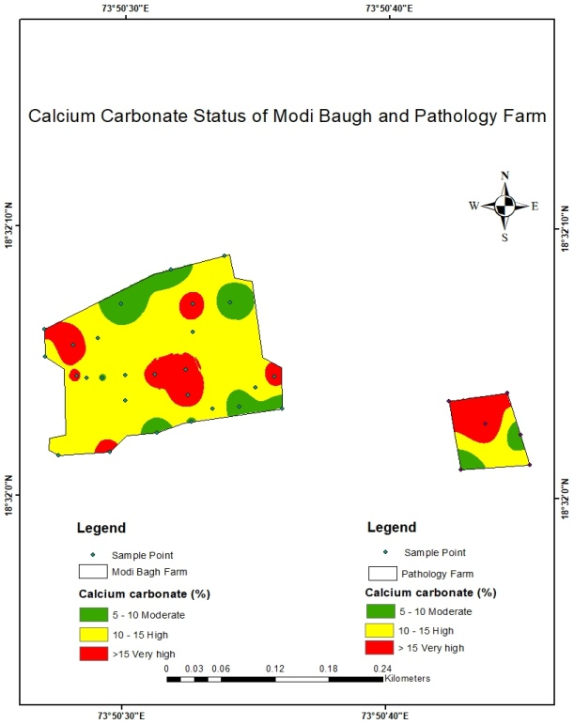

Very high

Calcium Carbonate status of Agronomy Farm

**Fig. 8: CaCO3 status of Agronomy Farm Fig 9: CaCO3 status of Modi Baugh and**

**Pathology Farm**

**3.5 Available Nitrogen**

Available nitrogen data from 127 soil samples of Agronomy Farm ranged from 75.27 to 326.11 kg ha-1, with a mean of 195.31 kg ha-1. The majority of samples 86.61 per cent were very low, 8.66 per cent were low, and 4.72 per cent were in the moderate category. The low nitrogen status can be attributed to the light texture and alkaline nature of soils, which reduce nitrogen retention. Figure 10 highlighted spatial variation, with the north zone showing moderate nitrogen levels. The highest nitrogen levels may have resulted from high fertilizer application, while nitrogen losses due to volatilization, leaching, and microbial fixation further reduce its availability. Sharma *et al.,* (2008) reported similar findings.

33 samples from the Pathology and Modi Baugh Farm were analyzed for available nitrogen and the samples ranged from 125.44 to 301.06 kg ha-1 with the average mean 222.76 kg ha-1 for available nitrogen. There are, 87.88 per cent of samples were low, 9.09 per cent were very low, and 3.03 per cent were moderate. The geographic variations were shown in figure 11 indicated medium nitrogen levels in the central and western zones. Low nitrogen could be due to inadequate or imbalanced fertilization, and the use of complex fertilizers instead of straight ones. Also, low nitrogen-use efficiency due to environmental losses plays a significant role. (Prem *et al.,* 2011) and (Kumar *et al.*, 2019) noted that high temperatures accelerate decomposition of organic matter, further reducing nitrogen availability.

**3.6 Available Phosphorus**

In Agronomy Farm, phosphorus levels ranged from 6.57 to 60.08 kg ha-1, with average mean 31.82 kg ha-1. 50.39 per cent of samples were classified as very high, 19.69 per cent were moderate, 7.87 per cent were high, and 4.73 per cent were moderately high. High phosphorus content likely resulted from the regular application of phosphate fertilizers, leading to buildup (Sharma *et al*., 2011) reported similar trends. The geographic variation (figure 12) showed moderately high phosphorus in the north zone.

The six samples analysed from the Pathology Farm and 27 samples from the Modi Baugh Farms showed available phosphorous from 13.14 - 31.6 kg ha-1 with the average mean 20.17 kg ha-1. Most samples 66.67 per cent were moderate, followed by 21.21 per cent moderately high, and 6.06 per cent each in high and low categories. Figure 13 showed variability, with moderate to moderately high phosphorus across the area. Soil pH, organic matter, texture, and management practices influence phosphorus availability. At higher pH, phosphorus precipitates as calcium phosphate, reducing its availability. Similar observations were reported by (Sonawane *et al.,* 2020) and (Ingle *et al.,* 2022)

**3.7 Available Potassium**

Available Potassium content from Agriculture College Farm, Pune presented in table 3. The soil samples from an Agronomy Farm showed available potassium from 114.24 - 1005.76 kg ha-1 with the average mean of 422.24 kg ha-1. Most samples 62.99 per cent showed very high content, followed by 11.81 per cent moderately high, 10.24 per cent moderate, 9.45 per cent high, and 5.51 per cent low. Figure 14 showed widespread very high potassium zones, likely due to the presence of potassium-rich minerals like illite and feldspar.

Six samples from the Pathology Farm and twenty seven samples from the Modi Baugh Farm were analysed and soil samples ranged from 166.72 - 919.52 kg ha-1 with the average mean 400.10 kg ha-1 for available potassium. About 60.61 per cent of samples had very high potassium, followed by 18.18 per cent moderate, 15.15 per cent moderately high, and 6.06 per cent high. Figure 15 showed high potassium levels across most regions. Rainfall-induced leaching and mineral-rich parent rocks explain this. Black soils, rich in micaceous minerals, tend to hold more potassium than red soils. These results align with findings from (Leelavathi *et al.*, 2009) and (Patil *et al.*, 2016).

**3.8 Available Sulphur**

The soils available Sulphur content values were presented in table 3 and 4. Among the soil samples analyzed from Agronomy Farm showed range from 16.21 - 26.46 mg kg-1 with the average mean of 21.44 mg kg-1. 75.59 per cent sample showed high and 24.41 per cent samples showed moderately high content of available sulphur. The spatial variability of the farm was depicted in figure 16, most of the samples showed high sulphur content.

The soil samples analysed for available Sulphur from the Modi Baugh and Pathology Farm were ranged from 18.50 - 25.39 mg kg-1 with the average mean 22.31 mg kg-1. About 78.79 per cent of samples were high, and 21.21 per cent moderately high (figure 17). It might be due to the sulphur in the soil is predominantly linked with organic matter (Nor *et al.,* 1981) and soils have moderate to moderately high organic carbon levels. Organic matter releases the mineralizable S in a proportionate amount present in the soil due to the greater plant and microbial activity. (Gyawali *et al.,* 2016) and (Singh *et al.,* 2015) observed that the higher the soil organic carbon, the higher was the available sulphur content.

**Table 3: Status of available macronutrients (N, P, K, and S) in soils of Agronomy Farm**

|  |  |  |  |  |
| --- | --- | --- | --- | --- |
| **Particulars** | **N (kg ha-1)** | **P (kg ha-1)** | **K (kg ha-1)** | **S (mg kg-1)** |
| **Range** | 75.27 - 326.11 | 6.57 - 60.08 | 114.24 -1005.76 | 16.21 - 26.46 |
| **Mean** | 195.31 | 31.82 | 422.24 | 21.44 |
| **Categories** | Very Low  11  (8.66%) | Very Low  2  (1.57%) | Low  8  (6.29%) | Moderately High  31  (24.41%) |
| Low  110  (86.62%) | Low  20  (15.75%) | Moderate  13  (10.24%) | High  96  (75.59%) |
| Moderate  6  (4.72%) | Moderate  25  (19.69%) | moderately High  15  (11.81%) |
| moderately High  6  (4.73%) | High  12  (9.44%) |
| High  10  (7.87%) | Very High  80  (62.99%) |
| Very High  64  (50.39%) |

**Table 4 Status of available macronutrients (N, P, K, and S) in soils of Modi Baugh and Pathology Farm**

|  |  |  |  |  |
| --- | --- | --- | --- | --- |
| **Particulars** | **N (kg ha-1)** | **P (kg ha-1)** | **K (kg ha-1)** | **S (mg kg-1)** |
| **Range** | 125.44 - 301.06 | 13.14 - 31.6 | 166.72 - 919.52 | 18.50 - 25.39 |
| **Mean** | 222.76 | 20.17 | 400.10 | 22.31 |
| **Categories** | Very Low  3  (9.09%) | Low  2  (6.06%) | Moderate  6  (18.18%) | Moderately High  7  (21.21%) |
| Low  29  (87.88%) | Moderate  22  (66.67%) | moderately High  5  (15.15%) | High  26  (78.78%) |
| Moderate  1  (3.03%) | moderately High  7  (21.21%) | High  2  (6.06%) |
| High  2  (6.06%) | Very High  20  (60.61%) |

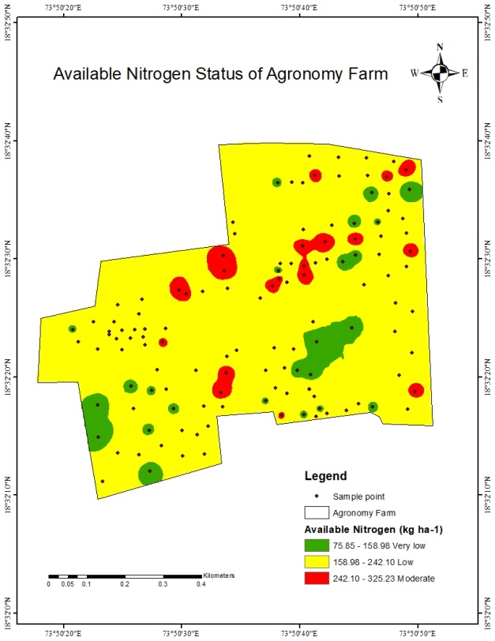 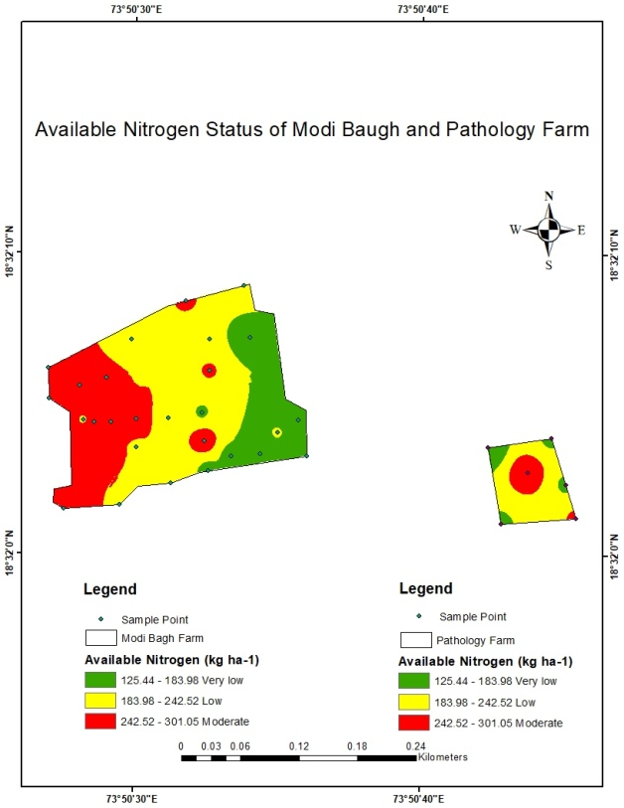

Available Nitrogen content of Modi Baugh and Pathology Farm

Available Nitrogen content of Agronomy Farm

**Fig 11: Available Nitrogen content of** **Modi Baugh and Pathology Farm**

**Fig 10: Available Nitrogen content of** **Agronomy Farm**

**Agronomy Farm**

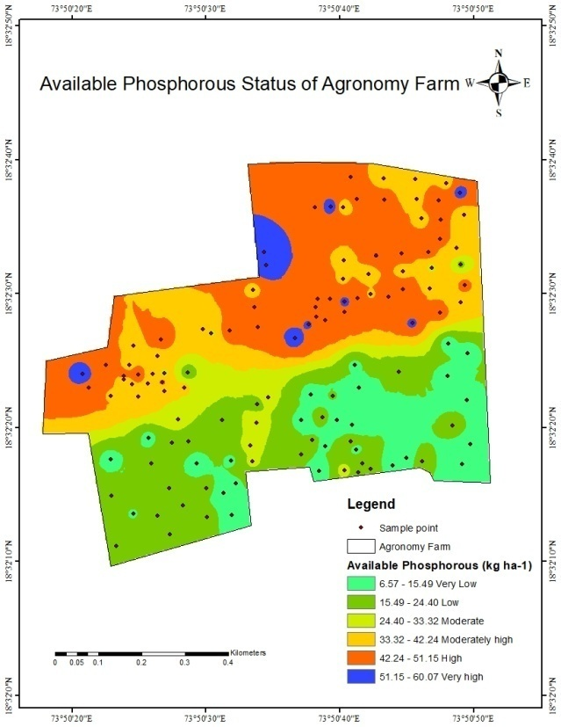 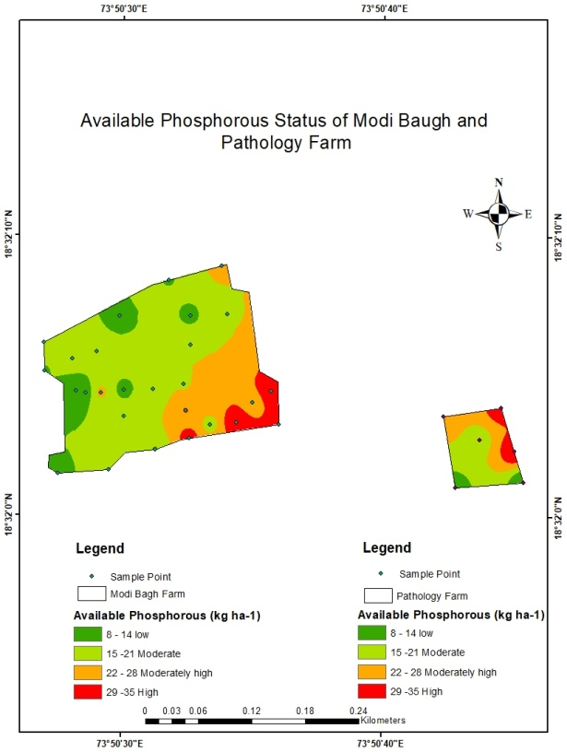

Available Phosphorous Content of Modi

Baugh and Pathology Farm

Available Phosphorous Content of Agronomy Farm

**Fig 12: Available Phosphorous content of**

**Fig 13: Available Phosphorous content of** **Modi**

**Baugh and Pathology Farm**

**Agronomy Farm**

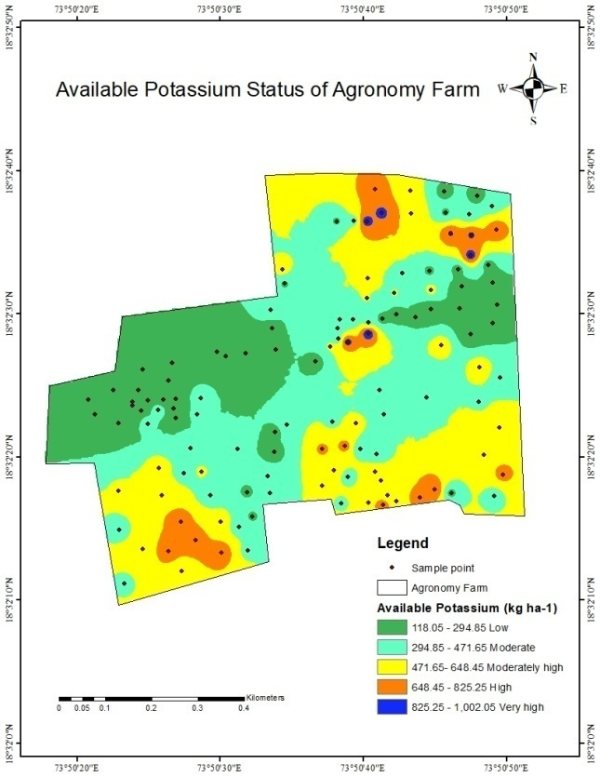 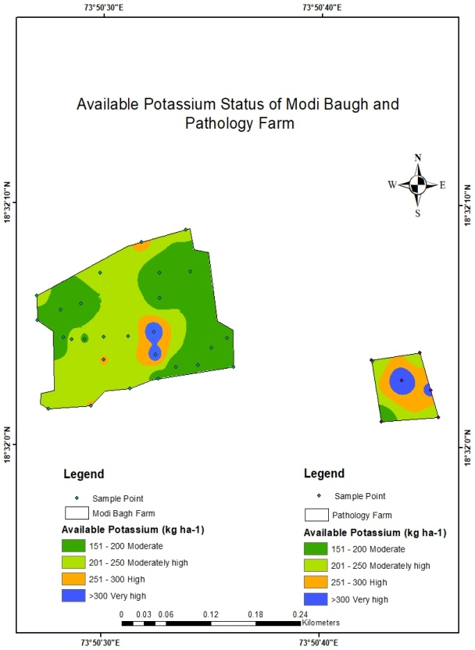

Available Potassium Content of Modi Baugh and Pathology Farm

Available Potassium Content of Agronomy Farm

**Fig 15: Available Potassium content of Modi Baugh and Pathology Farm**

**Fig 14: Available Potassium content of Agronomy Farm**

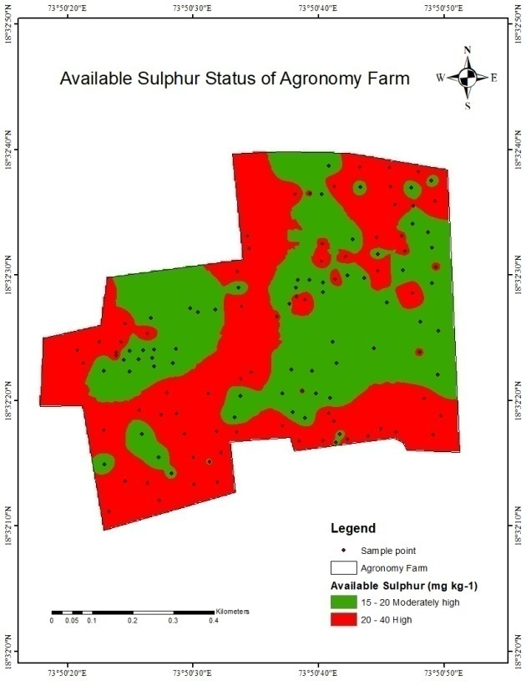 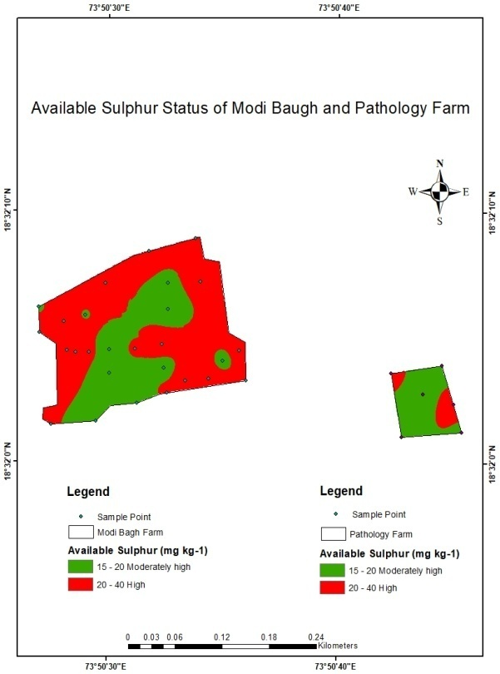

Available Sulphur Content of Modi Baugh and Pathology Farm

Available Sulphur Content of

AgronomyFarm

**Fig 16: Available Sulphur content of**

**Fig 17: Available Sulphur content of Modi Baugh and Pathology Farm**

**Agronomy Farm**

**4. CONCLUSION**

It is concluded that the soils of the Agronomy Farm were slightly alkaline to strongly alkaline in reaction, normal in electrical conductivity, very low to moderately high in organic carbon content, the calcium carbonate was categorized under moderate to very high content, available nitrogen varied from very low to moderate, available phosphorous ranged between very low to very high, available potassium varied from low to very high, available sulphur of these soils was moderately high to high.

The soil samples from Modi Baugh and Pathology Farm were slightly alkaline to moderately alkaline in reaction, normal in electrical conductivity, organic carbon content was very low to moderate, the calcium carbonate content was categorized under moderate to very high, available nitrogen varied from very low to moderate, available phosphorous ranged between low to high, available potassium varied from moderate to very high, available sulphur content was moderately high to high.

**REFERENCES**

1. Das, D. K. (2004) Role of geo-informatics in sustainable agriculture: Research, extension and service to the farmers. Chairman’s address- In Proceedings of the symposium Geo informatics Applications for Sustainable Development pp. 1-11.
2. Golhar, N. P. and Chaudhari, P. R. (2013) Level of significance of various physical and chemical parameters of soils through Electrical Conductivity, Journal of Chemical, Biological and Physical Science 3, 2051-2057.
3. Gosavi, N. I. and Chaudhari, R. D. (2016) GPS-GIS based soil fertility maps of Shirpur tehsil of Dhule District (M.S.), India. Asian Journal of Soil Science 11, 353 357.
4. Gyawali, C. Mohammad., B, Daljit., D, Dev R and Rishi., B. (2016) Spatial distribution of physico-chemical properties and macronutrients in rice growing soils of Haryana. The Ecoscan 10, 365-370.
5. Ingle, S. N., Gadge, P. S., Thaokar, A. C. and Sahare, V. (2022) Perpendicular distribution of macro nutrients and micronutrients of Ghatpipariya village of Dhanora block in Seoni district, Madhya Pradesh, India. International Journal of Agricultural Science 7, 162 171.
6. Jackson, M. L. (1973) Soil Chemical Analysis. Prentice Hall Pvt. Ltd., New Delhi 69-182.
7. Kumar S. (2019) Characterization, classification and evaluation of soils under Sugarcane Cultivation. Master Thesis, Soil Science, CCS HAU, Hisar.
8. Leelavathi, G. P., Naidu, M. V. S., Ramavatharam, N. and Sagar, G. K. (2009) Studies on genesis, classification and evaluation of soils for sustainable land use planning in Yerpedu mandal of Chittoor district, Andhra Pradesh. *Journal of the Indian Society of Soil Science* 57, 109-120.
9. Magare, P. N., Charjan, Y. D., Wankhade, R. S. and Lawhale, A. S. (2023) Assessment of nutrients and heavy metal status in soils of Akola, Maharashtra. The Pharma Innovation Journal 12, 1690-1694.
10. Mishra, A., Pattnaik, T., Das, D. and Das, M. (2014) Soil fertility maps preparation using GPS and GIS in Dhenkanal District, Odisha, India. International Journal of Plant and Soil Science 3, 986-994.
11. Naiknaware, V. V. and Abed, S. (2020) Physico-Chemical Analysis of Soil Samples from Beed District, Maharashtra. Chemistry Journal 6, 2581-7507.
12. Nalawade, A. S. and Palwe, C. R. (2014) Assessment of GIS-GPS based soil fertility map of Agriculture Research Station, Savale vihir Farm, M.P.K.V., Rahuri, Maharashtra. Bioinfolet 11, 300-301.
13. Nayyar, V. K. Takkar, P. N., Bansal, R. L., Singh, S. P., Kaur, N. P. and Sadana., U. S. (1990). Micronutrients in soils and crops of Punjab department of soils. Research Bulletin, Department of Soils, Punjab Agricultural University, Ludhiana, 146.
14. Nor, Y. M. (1981) Sulphur mineralization and adsorption in soils. Plant Soil 60, 451-459.
15. Page, A. L., Millar, R. H. and Kenny, D. R. (1982) Methods of Soil Analysis. American Society of Agronomy Madison, Wisconsin, United States of America. pp. 1159.
16. Patil, A. H., Kumbhar, A.V. and Nale, V. N. (2017) GIS-GPS Based Soil Fertility Maps of Agriculture College Farm, Kadegaon District Sangli: Maharashtra. International Journal of Engineering Science and Computing. 7, 15426-15430.
17. Patil, P. B., Jatkar, P. R. and Adsul, P. B. (2019). Physico-chemical properties in soils from Washi tahsil of Osmanabad district. Journal of Pharmacognosy and Phytochemistry 8 , 149-151.
18. Patil, P. L., Kuligod, V. B., Gundlur, S. S., Jahnavi, K., Nagaral, I. N., Shikrashetti, P., Geethanjali, H. M. and Dasog., G. S. (2016) Soil fertility mapping in Dindur sub watershed of Karnataka for site specific recommendations. *Journal of the Indian Society of Soil Science* 64, 311- 318.
19. Salma, D., Munaswamy, V., Giridhara, K. T., Sumathi, V. and Reddy, B. R. (2019) GPS and GIS based Soil Fertility Maps and Identification of Soil Related Constraints for Chickpea Growing Soils of Owk Mandal, Kurnool District (A.P), India. International Journal of Current Microbiology and Applied Sciences 8, 1241-1247.
20. Satish, S., Naidu, M. V. S. and Ramana, K.V. (2018) Genesis and classification of Bengal gram growing soils in Brahmanakotkur watershed of Andhra Pradesh. International Journal of Pure and Applied Biosciences 6, 614-624.
21. Sharma, P. K., Sood, A., Setia, R. K., Tur, N. S., Mehra, D. and Singh, H. (2008) Mapping of micronutrients in soils of Amristrar district (Punjab) - A GIS approach. Journal of Indian Society of Soil Science 56, 34-41.
22. Singh, A, Phogat., V. K, Dahiya R. and Batra., S. D. (2015) Impact of long-term zero till wheat on soil physical properties and wheat productivity under rice–wheat cropping system. Soil and Tillage Research 140, 98-105.
23. Sonawane. R. V. and Gadekar, D. J. (2020) Analysis of chemical properties of soil under sugarcane crop: A case study of Khandala, Shrirampur, Ahmednagar district, Maharashtra State, India. Our Heritage 68, 6522-6547.
24. Verma, T. P., Singh, S. P, Ramgopal, R. P Dhankar, Rao R. V. S. and Lal., T. (2012) Characterization and evaluation of soils of Trans Yamuna area in Etawah district, Uttar Pradesh for sustainable land use. Agropedology 22, 26-34.