Original Research Article
Assessment of Phytolith-Occluded Carbon Sequestration Potential in Uncultivated Grasses of Coimbatore, India

.
ABSTRACT

The present study evaluates the carbon sequestration potential of five uncultivated grass species, Cenchrus ciliaris (L.), Setaria verticillata (L.) P. Beauv., Paspalum sumatrense Roth., Panicum maximum Jacq., and Hackelochloa granularis (L.) Kuntze through analysis of carbon stock, phytolith content, phytolith morphotypes, and Phytolith-occluded carbon (PhytOC) in both above-ground biomass (AGB) and below-ground biomass (BGB). The study was conducted in Coimbatore, Tamil Nadu, India. Biomass quantification revealed values ranging from 1.208 ± 0.010 kg/m² to 2.007 ± 0.005 kg/m² across the species. Phytoliths were extracted using the dry ashing method in a muffle furnace followed by acid digestion. Results indicated that phytolith content was consistently higher in BGB compared to AGB in all species, with significant variation ranging from 0.1984 ± 0.0013 mg/g to 0.3384 ± 0.0044 mg/g. Notably, Setaria verticillata exhibited the highest PhytOC content in AGB, while Panicum maximum showed the highest PhytOC in BGB. The average PhytOC content in BGB ranged from 0.08% to 0.340%, highlighting its role in long-term carbon storage. Among all species, Cenchrus ciliaris displayed the greatest diversity of phytolith morphotypes, suggesting a higher capacity for silicon and carbon interaction. This study underscores the significant role of uncultivated grasses in carbon sequestration through phytolith formation and organic carbon occlusion. Given the stability and longevity of PhytOC in soils, these grasses represent a promising, nature-based solution for mitigating climate change. Promoting the conservation and restoration of such grasslands could enhance terrestrial carbon sinks and support sustainable land management practices.

Keywords: Phytolith-occluded Carbon; Carbon Sequestration; Uncultivated Grasses; Above-ground and Below-ground Biomass; Phytolith Morphotypes

1. INTRODUCTION

The increase in atmospheric carbon dioxide (CO₂) concentrations combined with land-use changes has significantly altered natural biogeochemical cycles over the past three centuries (Janes-Bassett et al., 2021). These changes have impacted the cycling and storage of terrestrial carbon, making it imperative to understand terrestrial carbon dynamics for effective climate change mitigation. Terrestrial biogeochemical carbon sequestration is recognized as a promising strategy to slow the rapid rise of atmospheric CO₂ levels and mitigate associated climate impacts (Qi et al., 2017).
Recent studies highlight the occlusion of carbon within phytoliths as a stable and long-term carbon sequestration mechanism (Chen et al., 2018; Yang et al., 2018; Liu et al., 2020). Phytoliths are microscopic silica bodies deposited intra- or extracellularly in living plants through the absorption of soluble silica from groundwater. After plant senescence, these siliceous structures accumulate in the soil, where their inorganic nature confers resistance to decomposition, enabling long-term preservation (Han et al., 2018; Parr & Sullivan, 2011; Parr et al., 2010; Piperno, 2006). Phytoliths exhibit diverse sizes and morphologies (Sharma et al., 2019; Shakoor et al., 2014). During phytolith formation, approximately 0.2% to 5.8% of organic carbon becomes occluded within these silica bodies, thus protecting it from microbial degradation and other post-depositional processes (Zhang et al., 2019; Piperno, 2006). This occluded organic carbon, termed PhytOC, is recognized as a vital and stable component of the global carbon cycle and represents a safe carbon sink (Li et al., 2014).
Phytoliths occur widely across the plant kingdom, produced by diverse angiosperms, gymnosperms, and pteridophytes. Species of the family Equisetaceae (pteridophytes) are notable for their high silicon accumulation, while monocotyledons generally deposit more silica than dicotyledons. Among these, the Poaceae family (grasses) is the heaviest phytolith producer (Shakoor et al., 2014). Grasses play a critical ecological, agricultural, and economic role and contribute significantly to global phytolith production (Hartley et al., 2015; Song et al., 2016). Recent research has demonstrated that grasses influence biogeochemical cycles of carbon and silicon through the production of PhytOC (Liu et al., 2020; Song et al., 2012).
While many studies have focused on phytoliths and PhytOC in cultivated grasses such as rice and maize, there remains limited research on uncultivated grass species. Therefore, the present study aims to assess the carbon stock, phytolith content, morphotypes, and PhytOC in both above-ground and below-ground biomass of five uncultivated grasses Cenchrus ciliaris L., Setaria verticillata (L.) P. Beauv., Paspalum sumatrense Roth., Panicum maximum Jacq., and Hackelochloa granularis (L.) Kuntze in Coimbatore, Tamil Nadu, India.

2. material and methods

2.1 Sample Collection
Samples were collected from five distinct sites within the Coimbatore district, Tamil Nadu, India (Figure 1). At each site, three quadrats measuring 50 cm × 50 cm were randomly established to obtain triplicate samples (n = 3). Grass species were identified and authenticated by the Botanical Survey of India, Southern Regional Centre, Tamil Nadu Agricultural University Campus, Coimbatore. The species studied were Cenchrus ciliaris (L.), Setaria verticillata (L.) P. Beauv., Paspalum sumatrense Roth., Panicum maximum Jacq., and Hackelochloa granularis (L.) Kuntze.
2.2 Estimation of Biomass
Fresh weight of the grass samples was measured on-site using a portable balance. Samples were then oven-dried at 105°C for 24 hours until a constant dry weight was achieved, and the dry biomass was recorded.
2.3 Estimation of Organic Carbon
Approximately 1 g of oven-dried, ground plant material was placed in pre-weighed crucibles. These were ashed in a muffle furnace at 550°C for one hour, then allowed to cool inside the furnace. The crucibles containing ash were weighed to calculate the ash percentage using the formula (Allen et al., 1986):
Ash % = (W3 - W1 / W2 - W1) × 100
Where,
𝑊1 = Weight of empty crucible
𝑊2 = Weight of oven-dried sample + crucible
𝑊3 = Weight of ash + crucible
Organic carbon content (C, %) was calculated as:
C % = (100 – Ash % ) × 0.58
where 0.58 represents the carbon fraction in ash-free stem, branch, and foliage material.

Figure 1. Map showing the location of sampling sites.
2.4 Estimation of Phytolith Content
Phytoliths were extracted from plant material using a dry ashing and acid digestion method following Rajendiran et al. (2016). One gram of dried plant sample was placed in a silica crucible and heated in a muffle furnace at 500°C for 8 hours. After cooling, the ash was transferred to test tubes and treated sequentially with 20 ml of 10% HCl and 20 ml of 15% H₂O₂ to remove carbonates and organic residues. Both treatments were conducted in a water bath at 70°C for 20 minutes, followed by centrifugation at 3500 rpm for 5 minutes. The precipitate was repeatedly washed with distilled water and centrifuged until the supernatant was clear. Finally, 1 ml of 100% ethanol was added, and the sample was air-dried. The dried phytoliths were weighed to determine phytolith content.
2.5 Preparation of Microscope Slides
Extracted phytoliths were mounted on clean glass slides, stained with a drop of 0.5% Safranin solution, and spread evenly using a needle. Slides were air-dried and observed under a trinocular microscope at 1000× magnification for morphotype analysis.
2.6 Estimation of Phytolith-Occluded Carbon (PhytOC)
Dried phytolith samples were treated with 1 mol/L hydrofluoric acid (HF) at 55°C for 60 minutes to remove silica. Samples were then dried at 45°C. The organic carbon content released from phytoliths was quantified using the potassium dichromate oxidation method (Walkley-Black method) as described by Li et al. (2013).
2.7 Statistical Analysis
Data were analyzed using one-way analysis of variance (ANOVA) to test for significant differences among means, with the Least Significant Difference (LSD) test applied at P < 0.05. Correlation analysis between carbon stock and PhytOC was performed using SPSS software (version 21, IBM Corp., Chicago, USA). All values are presented as means ± standard deviation of triplicate determinations.
3. results and discussion

3.1 Biomass
As shown in Figure 2, the biomass of the five grass species ranged from 1.208 ± 0.010 Kg/m² to 2.007 ± 0.005 Kg/m², following the trend: Hackelochloa granularis (L.) Kuntze < Paspalum sumatrense Roth. < Cenchrus ciliaris (L.) < Setaria verticillata (L.) P. Beauv. < Panicum maximum Jacq.

Among the species studied, Panicum maximum Jacq. exhibited the highest biomass, whereas Hackelochloa granularis (L.) Kuntze had the lowest. These variations are likely influenced by differences in environmental conditions under which the species were grown. A similar pattern was noted by Odiwe et al. (2016), who observed that Panicum maximum Jacq. produced the highest dry matter compared to Axonopus compressus and Cynodon dactylon.

3.2 Organic Carbon in AGB and BGB

The average organic carbon content in the Above-Ground Biomass (AGB) ranged from 45.94% to 50.28%, following the order: Setaria verticillata < Hackelochloa granularis < Paspalum sumatrense < Cenchrus ciliaris < Panicum maximum (Figure 3).

In the Below-Ground Biomass (BGB), organic carbon content ranged from 34.65% to 40.93%, with the trend: Paspalum sumatrense < Hackelochloa granularis < Cenchrus ciliaris < Panicum maximum < Setaria verticillata.

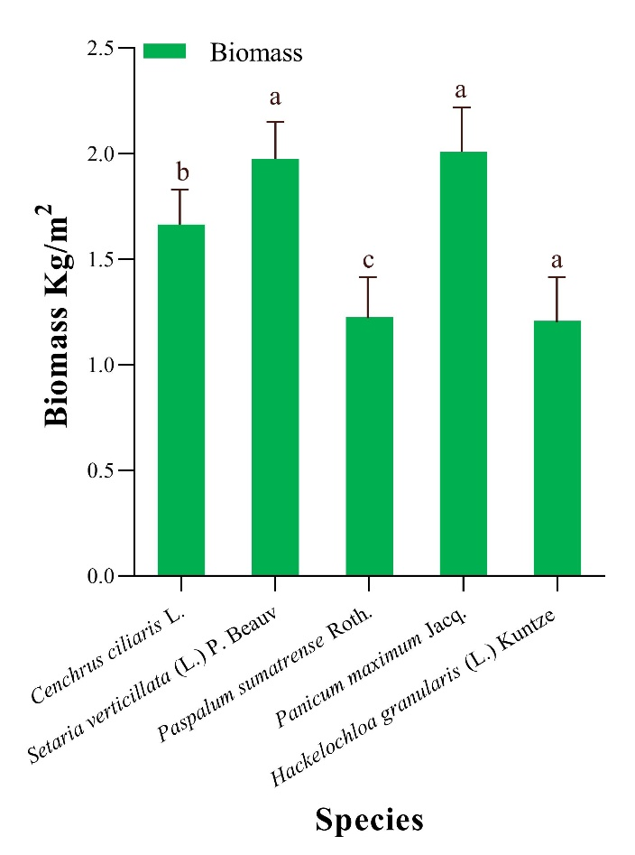

Figure 2. Biomass of selected grass species. Based on the LSD test, various lowercase letters indicate significant differences at the P = 0.05 level; error bars represent standard error (n = 3).

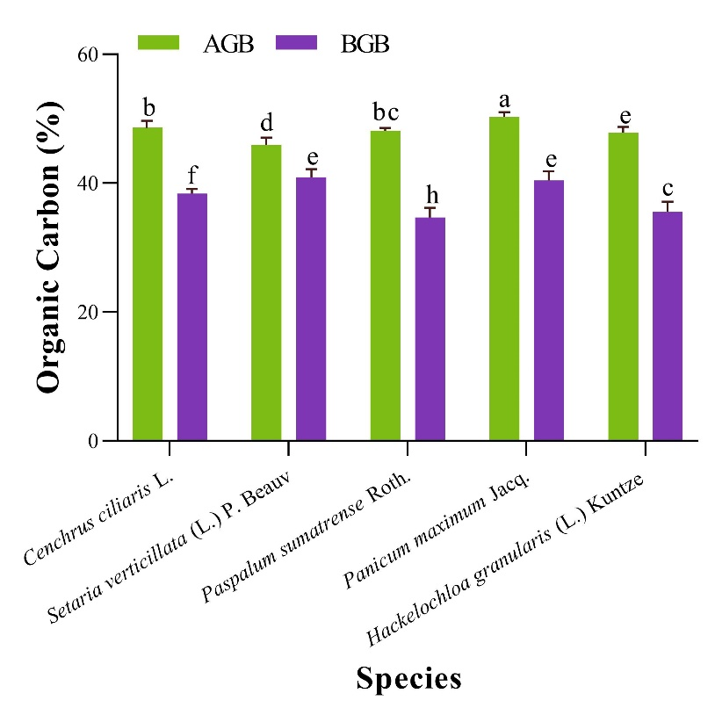
Figure 3. Organic carbon of selected grass species. Based on the LSD test, various lowercase letters indicate significant differences at the P = 0.05 level; error bars represent standard error (n = 3)

Among the species, Panicum maximum Jacq. showed the highest organic carbon in AGB (50.28 ± 0.04%), while Setaria verticillata recorded the highest in BGB (40.93 ± 0.95%). These differences highlight significant species-specific variations.
Trees typically store more carbon than grasslands under stable conditions. However, under vulnerable or stressed environmental conditions, grasslands contribute more significantly to carbon sequestration, particularly via underground biomass (Kerlin, 2018). The findings of this study align with Odiwe et al. (2016), confirming that Panicum maximum Jacq. stores more carbon in AGB than BGB.
When compared to certain tree species reported by Jana et al. (2009), Shorea robusta (47.45%), Albizia lebbek (47.12%), Tectona grandis (45.45%), and Artocarpus integrifolia (43.33%). The present study reveals higher AGB carbon content in grass species such as Setaria verticillata (45.94%), Hackelochloa granularis (47.80%), Paspalum sumatrense (48.13%), Cenchrus ciliaris (48.61%), and Panicum maximum (50.28%).
3.3 Phytolith Content in AGB and BGB
Phytolith content was consistently higher in BGB compared to AGB across all five species, with values significantly varying between 0.1984 ± 0.0013 mg/g and 0.3384 ± 0.0044 mg/g. The trend in BGB was: Setaria verticillata < Panicum maximum < Hackelochloa granularis < Cenchrus ciliaris < Paspalum sumatrense (Figure 4).
In AGB, phytolith content ranged from 0.0536 ± 0.0003 mg/g to 0.1604 ± 0.0026 mg/g, with the order: Cenchrus ciliaris < Panicum maximum < Setaria verticillata < Paspalum sumatrense < Hackelochloa granularis.
The higher concentration in BGB may be due to phytolith translocation from roots to other plant parts. Environmental variables also likely influence phytolith deposition and variation among and within species (Li et al., 2017). Paspalum sumatrense exhibited the highest phytolith content in BGB, while Hackelochloa granularis had the highest in AGB consistent with findings from Li et al. (2022) and Chen et al. (2018).

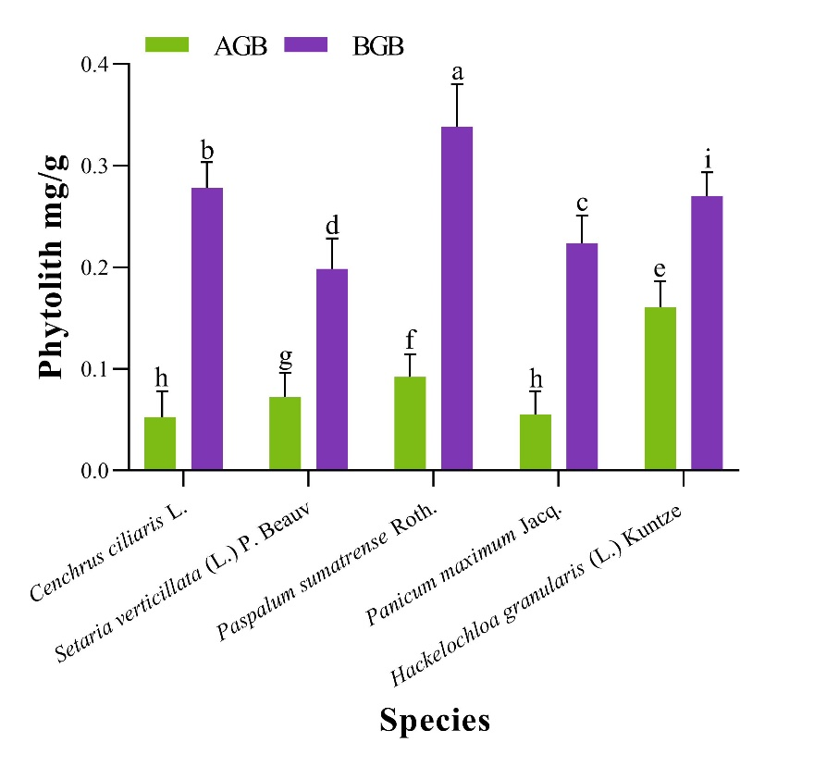
Figure 4. Phytolith content of selected grass species. Based on the LSD test, various lowercase letters indicate significant differences at the P = 0.05 level; error bars represent standard error (n = 3).

3.4 Phytolith-Occluded Carbon (PhytOC) in AGB and BGB
PhytOC was highest in AGB for Setaria verticillata, and in BGB for Panicum maximum (Figure 5). BGB PhytOC content ranged from 0.08% to 0.34% following the trend: Setaria verticillata < Hackelochloa granularis < Paspalum sumatrense < Cenchrus ciliaris < Panicum maximum.
In AGB, PhytOC ranged from 0.06% to 0.19%, with the trend: Hackelochloa granularis < Paspalum sumatrense < Cenchrus ciliaris < Panicum maximum < Setaria verticillata.
Interestingly, PhytOC was generally higher in AGB than in BGB, contrary to Qi et al. (2017), who observed higher PhytOC in BGB within steppe ecosystems. These discrepancies could be attributed to environmental and physiological differences among species.
A weak positive correlation was found between PhytOC and organic carbon (R² = 0.3355, P > 0.05) (Figure 6), indicating that organic carbon in plant tissues contributes only marginally to PhytOC formation. Organic carbon in plants originates from photosynthesis and is subject to decomposition, while PhytOC represents a stable form of carbon trapped within phytoliths and is more resistant to degradation (Chen et al., 2018; Qi et al., 2021).
3.5 Morphotypes of Phytoliths in AGB and BGB
Phytolith morphology followed ICPN 2.0 nomenclature and previous studies (Ball et al., 2019; Zucol et al., 2019; Novello et al., 2018; Piperno, 2006). A wide range of morphotypes was observed across species, Cenchrus ciliaris - 27 types, Setaria verticillata - 24 types, Paspalum sumatrense - 21 types, Panicum maximum and Hackelochloa granularis - 20 types each (Table 1).
Phytolith diversity was highest in AGB for Cenchrus ciliaris, Paspalum sumatrense, and Panicum maximum, while Setaria verticillata showed greater diversity in BGB. Hackelochloa granularis displayed nearly equal distribution in both.
Common morphotypes across all species included Bilobate (Dumb Bell), Bilobate with nodular shank, Polylobate, Cross, Saddle, Globular/Spheroidal, Rectangular, and Rod-shaped. Less common types included Globular granulated, Crenate, Clavate, Favose (Honeycomb), Mesophyll, Jigsaw-shaped, and Hairbase phytoliths. Rare forms like Fan-shaped, Amoeboid, Papillae, Sinuate, Tracheids, Verucate, and Columellate were also observed.
Phytolith morphogenesis is highly sensitive to environmental parameters like temperature, moisture, CO₂ concentration, soil pH, and nutrient availability (Li et al., 2017).

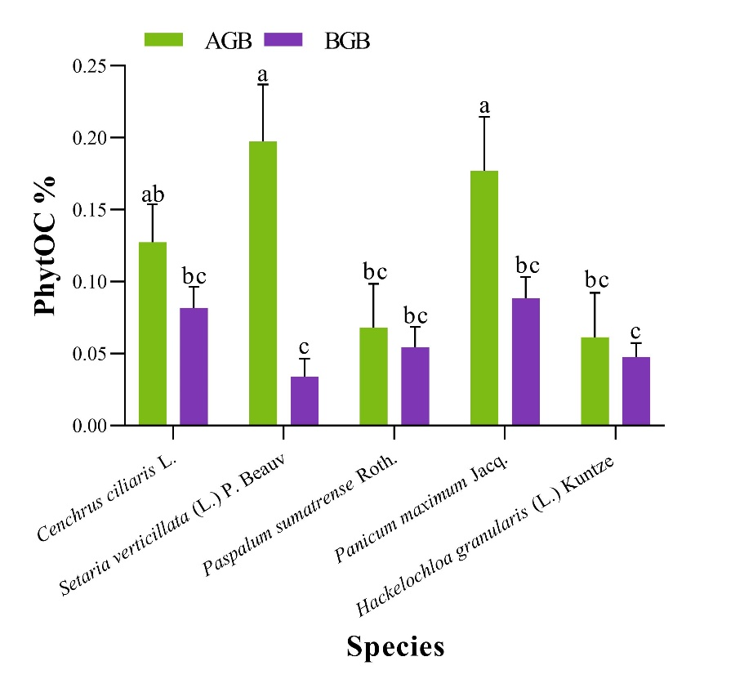

Figure 5. PhytOC content of selected grass species. Based on the LSD test, various lowercase letters indicate significant differences at the P = 0.05 level; error bars represent standard error (n = 3).

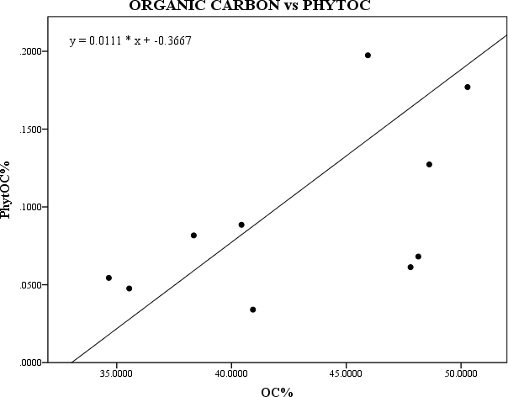
R²=0.3355, P>0.05
Figure 6. Relationship between organic carbon and PhytOC.

Table 1 Number of Morphotypes of Phytoliths in AGB and BGB of selected grasses identified.
Sl. No | Name of the species | Plant part | No. of Morphotypes identified
1 | Cenchrus ciliaris (L.) | AGB | 16
1 | Cenchrus ciliaris (L.) | BGB | 14
2 | Setaria verticillata (L.) P. Beauv | AGB | 12
2 | Setaria verticillata (L.) P. Beauv | BGB | 18
3 | Paspalum sumatrense Roth. | AGB | 18
3 | Paspalum sumatrense Roth. | BGB | 9
4 | Panicum maximum Jacq. | AGB | 17
4 | Panicum maximum Jacq. | BGB | 10
5 | Hackelochloa granularis (L.) Kuntze | AGB | 14
5 | Hackelochloa granularis (L.) Kuntze | BGB | 14

4. CONCLUSION
This study assessed the biomass, organic carbon content, phytolith abundance, phytolith morphotypes, and PhytOC levels in both AGB and BGB of five uncultivated grass species in Coimbatore, Tamil Nadu, India. The key findings include, 1) Higher phytolith content in BGB than AGB across species, 2) Diverse morphotypes in different plant parts, especially in Cenchrus ciliaris (AGB), Setaria verticillata (BGB), and Paspalum sumatrense (AGB), 3) Highest PhytOC sequestration in Panicum maximum (BGB) and Setaria verticillata (AGB), and 4) Lowest PhytOC in Hackelochloa granularis (AGB) and Setaria verticillata (BGB).
These uncultivated grasses demonstrate substantial potential for carbon sequestration, particularly through stable PhytOC, highlighting their role in climate change mitigation. Sustainable grassland management and restoration could enhance this capacity and provide an alternative approach to long-term carbon storage. Further research should investigate how environmental factors such as temperature, precipitation, and soil properties influence phytolith and PhytOC formation.

References

- Allen, S. E., Grimshaw, H. M., & Rowland, A. P. (1986). Chemical analysis. Methods in plant ecology. Black Well, 285-344.
- Ball, T., Albert, R. M., Vrydaghs, L., & Cummings, L. S. (2019). International Code for Phytolith Nomenclature (ICPN) 2.0, 1–11.
- Chen, C., Huang, Z., Jiang, P., Chen, J., & Wu, J. (2018). Belowground Phytolith-occluded carbon of Monopodial bamboo in China: an overlooked carbon stock. Frontiers in plant science, 9, 1615.
- Han, N., Yang, Y., Gao, Y., Hao, Z., Tian, J., Yang, T., & Song, X. (2018). Determining phytolith-occluded organic carbon sequestration using an upgraded optimized extraction method: indicating for a missing carbon pool. Environmental Science and Pollution Research, 25(24), 24507-24515.
- Hartley, S. E., Fitt, R. N., McLarnon, E. L., & Wade, R. N. (2015). Defending the leaf surface: intra-and inter-specific differences in silicon deposition in grasses in response to damage and silicon supply. Frontiers in Plant Science, 6, 35.
- Jana, B. K., Biswas, S., Majumder, M., Roy, P. K., & Mazumdar, A. (2009). Carbon sequestration rate and aboveground biomass carbon potential of four young species. Journal of Ecology and Natural Environment, 1(2), 15-24.
- Janes-Bassett, V., Bassett, R., Rowe, E. C., Tipping, E., Yumashev, D., & Davies, J. (2021). Changes in carbon storage since the pre-industrial era: A national scale analysis. Anthropocene, 34, 100289.
- Kerlin, K. (2018). Grasslands more reliable carbon sink than trees. Science and Climate.
- Li, B., Song, Z., Li, Z., Wang, H., Gui, R., & Song, R. (2014). Phylogenetic variation of phytolith carbon sequestration in bamboos. Scientific reports, 4(1), 1-6.
- Li, R., Chen, X., Wen, M., Vachula, R. S., Tan, S., Dong, H., ... & Xu, M. (2022). Phytolith‐occluded carbon in leaves of Dendrocalamus Ronganensis influenced by drought during growing season. Physiologia Plantarum, 174(5), e13748.
- Li, R., Fan, J., Carter, J., Jiang, N., & Gu, Y. (2017). Monthly variations of phytoliths in the leaves of the bamboo Dendrocalamus ronganensis (Poaceae: Bambusoideae). Review of Palaeobotany and Palynology, 246, 62-69.
- Li, Z., Song, Z., & Jiang, P. (2013). Biogeochemical sequestration of carbon within phytoliths of wetland plants: a case study of Xixi wetland, China. Chinese Science Bulletin, 58(20), 2480-2487.
- Liu, L., Song, Z., Yu, C., Yu, G., Ellam, R. M., Liu, H., ... & Wang, H. (2020). Silicon effects on biomass carbon and phytolith-occluded carbon in grasslands under high-salinity conditions. Frontiers in Plant Science, 11, 657.
- Novello, A., Bamford, M. K., van Wijk, Y., & Wurz, S. (2018). Phytoliths in modern plants and soils from Klasies River, cape region (South Africa). Quaternary International, 464, 440-459.
- Odiwe, A. I., Olanrewaju, G. O., & Raimi, I. O. (2016). Carbon Sequestration in Selected Grass Species in a Tropical Lowland Rainforest at Obafemi Awolowo University, Ile-Ife, Nigeria. Journal of Tropical Biology and Conservation, 13(1), 1-12.
- Parr, J. F., & Sullivan, L. A. (2011). Phytolith occluded carbon and silica variability in wheat cultivars. Plant and Soil, 342(1), 165-171.
- Parr, J., Sullivan, L., Chen, B., Ye, G., & Zheng, W. (2010). Carbon bio‐sequestration within the phytoliths of economic bamboo species. Global Change Biology, 16(10), 2661-2667.
- Piperno, D. R. (2006). Phytoliths: a comprehensive guide for archaeologists and paleoecologists. Rowman Altamira.
- Qi, L., Li, F. Y., Huang, Z., Jiang, P., Baoyin, T., & Wang, H. (2017). Phytolith-occluded organic carbon as a mechanism for long-term carbon sequestration in a typical steppe: The predominant role of belowground productivity. Science of the Total Environment, 577, 413-417.
- Qi, L., Sun, T., Guo, X., Guo, Y., & Li, F. Y. (2021). Phytolith‐occluded carbon sequestration potential in three major steppe types along a precipitation gradient in Northern China. Ecology and Evolution, 11(3), 1446-1456.
- Rajendiran, S., Coumar, V., Dotaniya, M. L., & Kumar, A. (2016). Carbon occlusion potential of rice phytoliths: implications for global carbon cycle and climate change mitigation. Applied Ecology and Environmental Research, 14(2), 265-281.
- Shakoor, S. A., Bhat, M. A., & Mir, S. H. (2014) Research and Reviews: Journal of Botanical Sciences.
- Sharma, R., Kumar, V., & Kumar, R. (2019). Distribution of phytoliths in plants: A review. Geology, Ecology, and Landscapes, 3(2), 123-148.
- Song, Z., McGrouther, K., & Wang, H. (2016). Occurrence, turnover and carbon sequestration potential of phytoliths in terrestrial ecosystems. Earth-Science Reviews, 158, 19-30.
- Song, Z., Wang, H., Strong, P. J., Li, Z., & Jiang, P. (2012). Plant impact on the coupled terrestrial biogeochemical cycles of silicon and carbon: implications for biogeochemical carbon sequestration. Earth-Science Reviews, 115(4), 319-331.
- Yang, X., Song, Z., Liu, H., Van Zwieten, L., Song, A., Li, Z., ... & Wang, H. (2018). Phytolith accumulation in broadleaf and conifer forests of northern China: implications for phytolith carbon sequestration. Geoderma, 312, 36-44.
- Zhang, X., Song, Z., Hao, Q., Wang, Y., Ding, F., & Song, A. (2019). Phytolith-occluded carbon storages in forest litter layers in southern China: Implications for evaluation of long-term forest carbon budget. Frontiers in plant science, 10, 581.
- Zucol, A. F., Patterer, N. I., Moya, E., & Pepi, M. G. F. (2019). Phytolith analysis of the main species of Distichlis sp. (Chloridoideae: Poaceae) distributed in South America. Review of Palaeobotany and Palynology, 269, 42-54.

