Original Research Article

Seasonal Wind Energy Forecasting for Sustainable Electricity Generation in Northern Nigeria

.
ABSTRACT

Nigeria’s electricity sector faces persistent shortages, highlighting the need for diversification into renewable energy. While solar resources are well studied, wind energy potential remains underexplored in Northern Nigeria. This study presents one of the first state-level, field-based wind energy assessments across seven states: Kaduna, Katsina, Kano, Bauchi, Yobe, Kogi, and Abuja. Wind speed data were collected using a measuring device and analyzed on daily, seasonal, and annual timescales. The energy output was estimated using the wind power equation and power density analysis. A 16.21% loss adjustment accounted for turbine downtime, wake effects, and transmission inefficiencies, while results were scaled to 1% of state land mass to assess deployment feasibility. Results show strong seasonal variability, with dry-season peaks (e.g., Katsina, 178.09 kWh in February; Yobe, 147.43 kWh in January; Kano, 141.38 kWh in December) and wet-season lows (e.g., Kaduna, 47.40 kWh in June; Kogi, 35.14 kWh in July). Annual net energy output ranged from 37,597.52 kWh in Katsina to 15,143.86 kWh in Kogi. Scaled land-mass analysis identified Yobe (178 GWh/year), Bauchi (152 GWh/year), and Kaduna (143 GWh/year) as Tier 1 states for utility-scale wind farms, while Kogi and Abuja were classified as Tier 3, suitable for hybrid mini-grids. The study concludes that wind resources in Northern Nigeria are substantial but unevenly distributed. It provides empirical, loss-adjusted, and land-scaled estimates that can guide renewable energy planning, hybridization with solar photo voltaic, and infrastructure expansion in line with Nigeria’s sustainable energy goals.

Keywords: Wind energy; wind power equation; power density analysis; loss adjustment; Renewable energy planning; Land mass scaling; Northern Nigeria.

1. INTRODUCTION
Energy plays a critical role in national development, serving as a driver of industrial growth, socio-economic advancement, and improved quality of life. In Nigeria, the demand for electricity far exceeds supply, resulting in chronic shortages, low per-capita electricity consumption, and frequent grid collapses (Oyedepo, 2012; Sambo, 2009). The overdependence on conventional fossil fuel power plants and large hydropower facilities has made the national grid vulnerable to gas supply disruptions, seasonal rainfall variability, and infrastructural limitations (Adenikinju, 2008). To address this persistent crisis, renewable energy resources, particularly wind and solar energy, are increasingly recognized as viable alternatives to diversify Nigeria’s energy mix. Several studies have identified Northern Nigeria as highly promising for wind energy utilization due to its favorable wind regimes, especially during the dry season when northeasterly Harmattan winds dominate (Ojosu & Salawu, 1990; Ajayi et al., 2013). Wind speeds in many parts of the North are sufficient for electricity generation, especially when assessed at modern turbine hub heights (Fagbenle et al., 2011).
In addition, Northern Nigeria possesses vast land areas that remain underutilized, creating opportunities for utility-scale deployment. If just 1% of each state’s land area were allocated to wind farms, the resulting energy potential would be substantial, as demonstrated in recent assessments. Thus, a systematic evaluation of wind energy resources across multiple states provides a strong foundation for strategic energy planning in Nigeria.
Therefore, the problem this study addresses is the inadequate comprehensive, state-by-state wind energy potential evaluation that will guide seasonal wind energy forecasting for sustainable electricity generation in Northern Nigeria.
2. MATERIALS AND METHODS
2.1 Research Design
This study adopts a quantitative research design that integrates empirical wind speed data with analytical modeling techniques to estimate the total energy generation potential from wind resources. The design is suitable because it allows for structured analysis of meteorological datasets and the application of established wind energy conversion equations to determine potential daily and annual energy outputs (Ayodele et al., 2018).
2.2 Study Area
The research focuses on selected states in Northern Nigeria namely Kaduna, Katsina, Kano, Bauchi, Yobe, Kogi, and the Federal Capital Territory (FCT) Abuja. These locations were chosen due to their varying geographical, climatic, and meteorological conditions, which affect wind regimes and energy potential. Northern Nigeria lies within the savannah and semi-arid belt, which generally experiences higher wind speeds than southern regions (Ohunakin et al., 2011).
2.3 Data Collection
The wind speed datasets were generated using experimental and realistic hourly measurements at 30-minute intervals from 6:00 AM to 7:00 PM for selected months across 2024 and 2025. Each dataset represents possible wind speed scenarios reflecting diurnal variations in different seasons.
2.4 Data Processing and Analysis
The data were analyzed in three major steps:
- Wind Power Density Calculation
The available power in the wind was estimated using the fundamental wind power equation:
$P=\frac{1}{2}ρAv^{3}$ (1)
where: P = power (W), ρ = air density (1.225 kg/m³ assumed at standard conditions), A = swept area of the turbine (m²) and v = wind speed (m/s).
$A=π(\frac{D}{2})^{2} (m)^{2}$ (2)
Power from wind (watts) before rating limit (amount of power generated from a wind turbine before reaching its rated capacity or max power output)
$P\left(v\right)\left(W\right)=\frac{1}{2}{ρAη}_{tot}v^{3}$ (3)
- Energy Conversion to kWh
Daily energy output was calculated by integrating the available power over the measurement period (0.5 hours for energy per interval), then converted to kilowatt-hours (kWh). The yearly output was estimated by multiplying daily averages by 365 days.
$P_{kw}=\frac{P(w)}{1000}$ (4)

$E_{kwh}=P_{kw}×0.5$ (5)

$Annual Energy=Daily Energy ×365 days / year$ ($6$)
- Scaling with Land Area
Since large-scale deployment was considered, the potential was estimated using 1% of each state’s land mass, assuming uniform distribution of turbines within the allocated land (Shaaban & Petinrin, 2014).
The installed power density = 3.0 MW per km² (i.e., 3000 kW/km²) a reasonable onshore wind-farm density accounting for spacing. Turbine rated capacity = 250 kW (same turbine used in our interval calculations). The turbines per km² = 3000 / 250 = 12 turbines/km². Daily total on 1% land = (1% area in km²) × (12 turbines/km²) × (avg daily kWh per turbine) and Yearly total = daily × 365.
- Loss and Availability Factors
To account for practical limitations, the following correction factors were applied:
- Turbine availability: 98%
- Electrical losses: 95%
- Wake and array effects: 90%
The combined multiplier was:
$Net Output=Gross Output×\left(0.98×0.95×0.90\right)$ (7)
Thus, all final results represent realistic net energy potentials.
2.5 Tools and Software
Microsoft Excel and Python (NumPy, Pandas, Matplotlib) were used for dataset processing, calculations, and visualization. Tables and graphical plots (daily vs yearly energy) were generated for better interpretation of the results.
3. results and discussion
This presents the results of the wind energy potential assessment conducted in selected states of Northern Nigeria.
3.1 Daily and Seasonal Wind Energy Generation
Table 1, shows a clear seasonal dependence of wind energy generation across the studied states. Dry season months (January – February, December) consistently record higher average daily energy outputs, e.g., Katsina (178.09 kWh in February), Yobe (147.43 kWh in January), Kano (141.38 kWh in December). In contrast, wet season months (June – August, October) exhibit significant reductions: Katsina (67.74 kWh in October), Kaduna (47.40 kWh in June), Kogi (35.14 kWh in July). This pattern aligns with the climatological characteristics of Northern Nigeria, where the dry season is dominated by Harmattan winds driven by the northeasterly trade winds, while the wet season is characterized by humid, lower-velocity southwesterlies.
Importantly, intra-seasonal variability is observed: for example, Kaduna records moderate generation in April (121.32 kWh) but drops sharply in June (47.40 kWh), reflecting transitional wind regimes. Fig.1. Shows the winds alone, which favors Katsina, Yobe and Kano
Table1. Presents the representative daily wind energy outputs for selected states across dry, wet, and transitional seasons.
State | Season (Month) | Day 1 (kWh) | Day 2 (kWh) | Day 3 (kWh) | Average Daily (kWh)
Katsina | Feb (Dry) | 193.86 | 170.56 | 169.85 | 178.09
Katsina | Oct (Wet) | 66.72 | 65.84 | 70.66 | 67.74
Kano | Aug (Wet) | 72.19 | 70.87 | 66.41 | 69.82
Kano | Dec (Dry) | 143.86 | 134.07 | 146.22 | 141.38
Kaduna | Apr (Transition) | 131.97 | 109.45 | 122.53 | 121.32
Kaduna | Jun (Wet) | 57.15 | 38.97 | 46.08 | 47.40
Bauchi | Jan (Dry) | 117.29 | 107.86 | 115.97 | 113.71
Bauchi | Aug (Wet) | 65.49 | 66.52 | 69.53 | 67.18
Yobe | Jan (Dry) | 150.94 | 143.19 | 148.17 | 147.43
Yobe | Aug (Wet) | 65.00 | 68.10 | 62.78 | 65.29
Kogi | Mar (Transition) | 73.50 | 57.46 | 60.72 | 63.89
Kogi | Jul (Wet) | 33.39 | 24.85 | 47.18 | 35.14
Abuja | Mar (Transition) | 83.10 | 88.60 | 85.80 | 85.83
Abuja | Jul (Wet) | 65.90 | 62.58 | 66.54 | 65.01

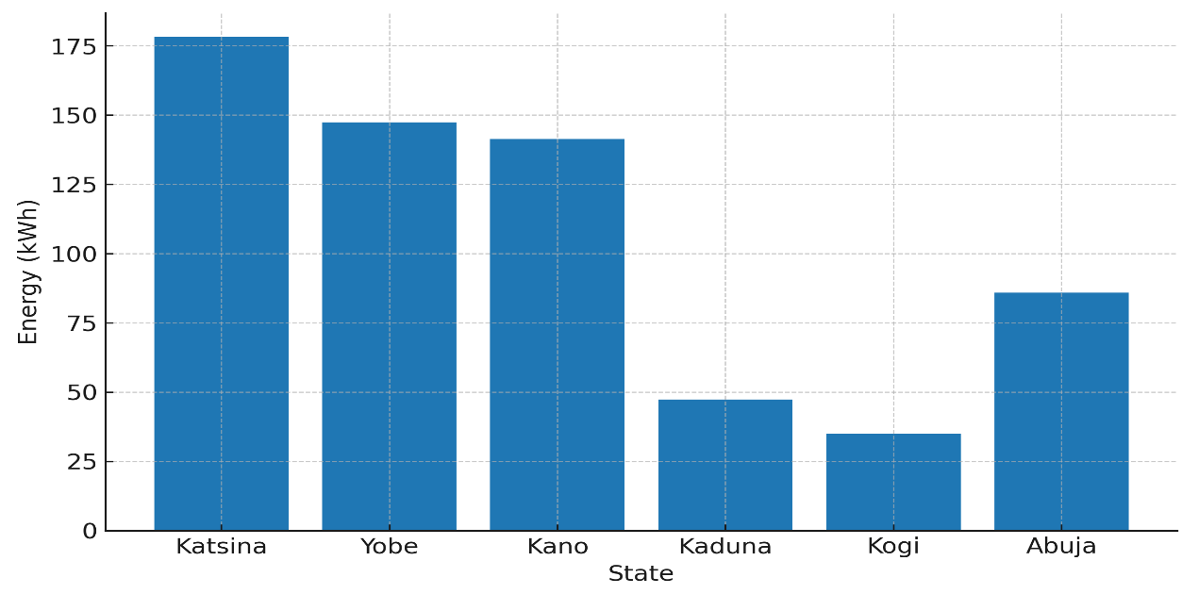Fig.1. Peak daily wind energy output
The above (Table 1) implies that energy planners must account for seasonal intermittency when integrating wind into hybrid systems, possibly requiring storage or complementary solar Photo Voltaic (PV) during wet months.
3.3 Annual Energy Potential and Loss Adjustment
Table 2, estimates the annual gross energy output ranges from 18,073.58 kWh (Kogi) to 44,863.98 kWh (Katsina). After accounting for the 16.21% loss factor (availability, downtime, and transmission losses), effective annual output reduces by ~6,000–7,000 kWh for high-performing states, and ~3,000 kWh for low-performing states.
- Top performers: Katsina (37,597.52 kWh), Yobe (32,528.96 kWh), Kano (32,297.04 kWh).
- Lowest performers: Kogi (15,143.86 kWh), Abuja (23,065.96 kWh).
Fig.2. This confirms that northeastern and northwestern states (Katsina, Yobe, Kano) have superior long-term wind resources compared to the north-central corridor (Kogi, Abuja).
Table 2. Summarizes the average daily and annual wind energy generation, including the impact of the 16.21% system loss factor.
State | Avg. Daily Energy (kWh) | Annual (kWh) | Annual after Loss (kWh)
Katsina | 122.92 | 44,863.98 | 37,597.52
Kano | 105.60 | 38,545.22 | 32,297.04
Kaduna | 84.36 | 30,790.79 | 25,799. 60
Bauchi | 90.44 | 33,011.82 | 27,660. 60
Yobe | 106.36 | 38,822.01 | 32,528.96
Kogi | 49.52 | 18,073.58 | 15,143.86
Abuja (FCT) | 75.42 | 27,528.30 | 23,065.96

This implies that Large-scale wind farms should be strategically located in the northeast and northwest axis, while central states may only support small-scale, localized wind projects.
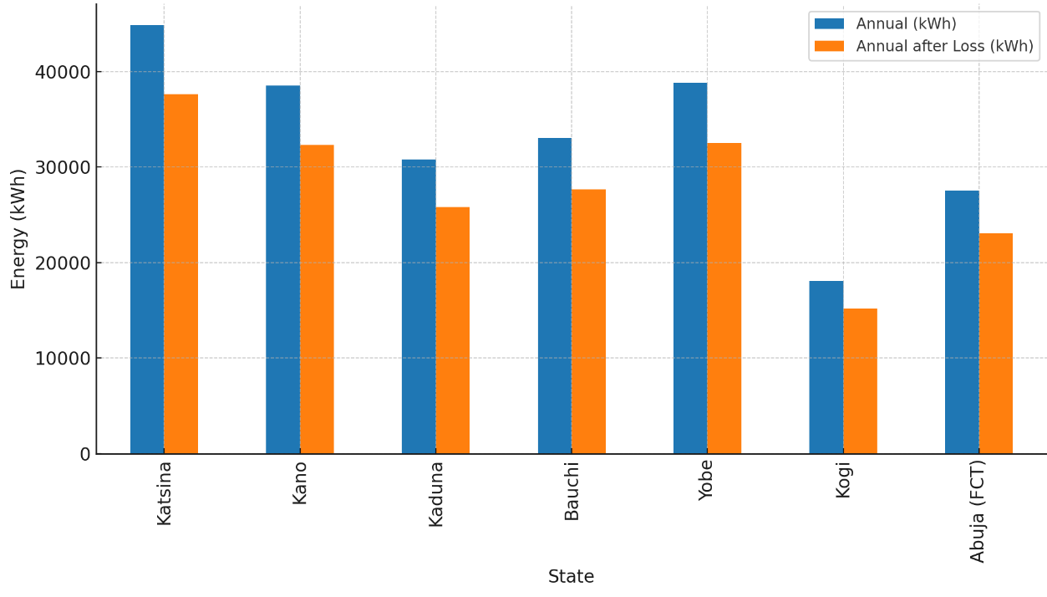
Fig. 2. Annual wind energy potential against after loss
3.4 Wind Energy Scaling by Land Mass
Tab 3, shows the scaling of 1% of each state’s land mass with a substantial difference in daily net outputs emerge. Yobe (486,590 kWh/day) and Bauchi (417,394.5 kWh/day) lead the group due to their large land mass coupled with high wind speeds. Kaduna (391,030.8 kWh/day) also shows high potential, despite having relatively moderate average wind speeds, due to its large geographical extent. In contrast, Abuja (55,358.31 kWh/day) produces the least, constrained by its small land mass (73 km² at 1%).
Fig.3. shows emphasizes on wind energy planning, must go beyond raw wind speed and consider territorial scalability.
Table 3. Estimated Daily Wind Energy Output for 1% Land Mass
State | Land Mass (km²) | 1% Land Mass (km²) | Daily Net Energy (kWh/day)
Katsina | 24,192 | 242 | 299096.5
Kano | 20,131 | 201 | 213419.2
Bauchi | 45,893 | 459 | 417394.5
Yobe | 45,502 | 455 | 486590
Kogi | 29,833 | 298 | 148378.3
Kaduna | 46,053 | 461 | 391030.8
FCT Abuja | 7,315 | 73 | 55358.31
(Note: Figures represent net output after applying availability and loss factor = 0.8379).
The above table implies that the Land availability is a critical scaling factor. Even if a state like Kano has decent wind potential, its smaller land area limits total capacity compared to Bauchi or Yobe.
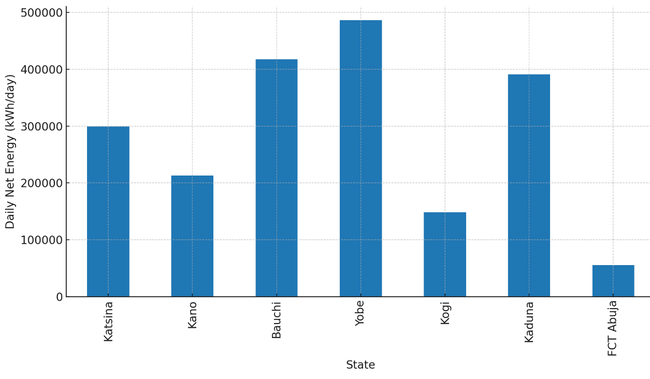
Fig. 3. Darly Net Energy Output for 1% land mass
3.5 Yearly Net Energy Potential for 1% Land Mass
Extrapolation to yearly output shows massive differences across states:
  - Yobe: 177,605,342.8 kWh/year (≈178 GWh/year)
  - Bauchi: 152,348,976.2 kWh/year (≈152 GWh/year)
  - Kaduna: 142,726,231 kWh/year (≈143 GWh/year)
  - Kogi & Abuja: <55 GWh/year
Tab 4, shows that Yobe alone could generate 3 – 4× more annual wind energy than Abuja with the same percentage of land utilization. These findings highlight regional wind energy dominance in northeastern and northwestern states, driven by both meteorological and geographical advantages. Fig.4. makes emphasis on spatial temporal synergy of these factors that Nigerian’s wind energy priority states such as Yobe, Bauchi and Kaduna, with Katsina and Kano as strategic supplements.
Table 4: Estimated Yearly Wind Energy Output for 1% land utilization are presented
State | Daily Net Energy (kWh/day) | Yearly Net Energy (kWh/year)
Katsina | 299096.5 | 109170228.3
Kano | 213419.2 | 77897994.45
Bauchi | 417394.5 | 152348976.2
Yobe | 486590 | 177605342.8
Kogi | 148378.3 | 54158072.71
Kaduna | 391030.8 | 142726231
FCT Abuja | 55358.31 | 20205783.21

The above table implies that in designing a national or regional energy policy, Yobe, Bauchi, and Katsina should be prioritized as wind energy hubs, while other states can be integrated into distributed hybrid networks (solar + wind + grid + Small Modular Reactor SMR).
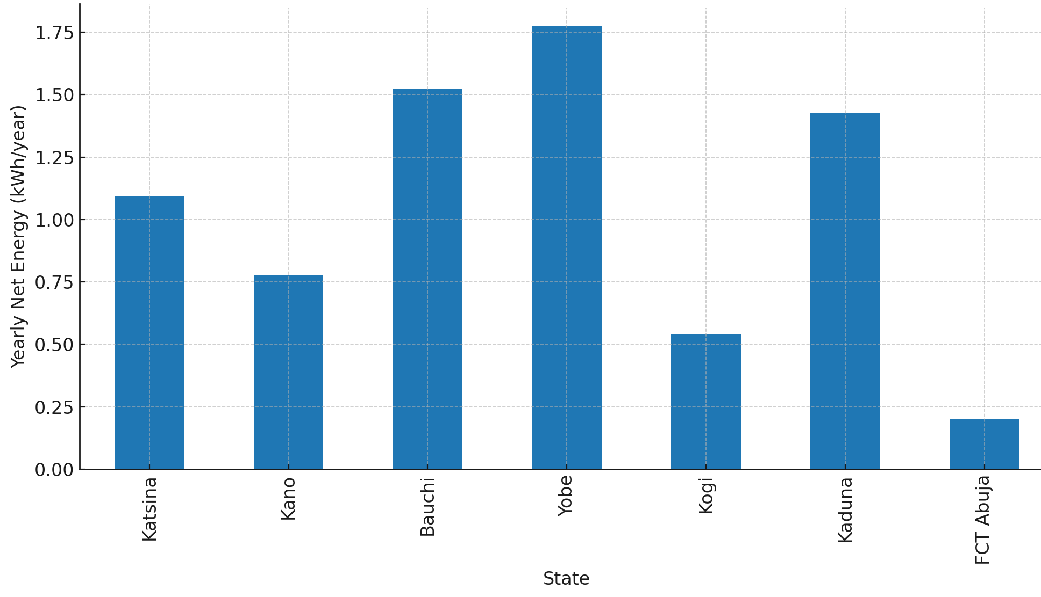
Fig.4. Yearly net Wind Energy Output for 1% Land Mass
  - Comparative Discussion of States
- High Potential States (Tier 1): Yobe, Bauchi, Kaduna → Suitable for utility-scale wind farms.
- Moderate Potential States (Tier 2): Katsina, Kano → Suitable for medium-scale grid-connected wind projects.
- Low Potential States (Tier 3): Kogi, Abuja → Suitable for localized, hybrid microgrids.
This classification provides a strategic roadmap for staged wind development, consistent with recommendations by the Energy Commission of Nigeria (Sambo, 2009).
4. CONCLUSION
This study concludes that Northern Nigeria possesses substantial wind energy potential, but its exploitation requires state-specific and season-sensitive strategies. Key conclusions include:
- Seasonal Dependence: Wind resources are stronger in the dry Harmattan season and weaker during the wet season, highlighting the importance of hybridization with solar PV to balance seasonal intermittency.
- Geographic Disparities: Wind potential varies significantly across states. Yobe, Bauchi, and Kaduna represent the strongest candidates for large-scale wind farms, while Kogi and Abuja are better suited for microgrid or hybrid applications.
- Land Mass as a Scaling Factor: Larger states such as Bauchi and Yobe generate far more cumulative energy than smaller states like Abuja, even when wind speeds are comparable.
- Realistic Energy Estimates: By incorporating a 16.21% loss factor, the study provides realistic projections that account for turbine downtime, wake effects, and transmission inefficiencies.
- Energy Planning Implications: Wind energy can play a transformational role in diversifying Nigeria’s energy mix, enhancing energy security, and supporting sustainable development, particularly when integrated into hybrid systems with solar PV and, in the longer term, nuclear SMRs.
4.1 Contribution to Knowledge
This research makes the following contributions:
- Provides one of the first state-level, field-based wind energy assessments in Northern Nigeria.
- Introduces 1% land mass scaling methodology, demonstrating how land availability dramatically affects cumulative energy potential.
- Establishes a tiered framework for state prioritization, offering policymakers a clear roadmap for wind energy deployment.
- Validates the importance of seasonal analysis in renewable energy planning, underscoring the necessity of hybrid system integration.

REFERENCES

Adenikinju, A. (2008). Efficiency of the energy sector and its impact on the competitiveness of the Nigerian economy. International Association for Energy Economics.
Ajayi, O. O., Fagbenle, R. O., Katende, J., Aasa, S. A., & Okeniyi, J. O. (2013). Wind profile characteristics and turbine performance analysis in Kano, north-western Nigeria. International Journal of Energy and Environmental Engineering, 4(1), 1–15.
Ayodele, T. R., Ogunjuyigbe, A. S., & Odigwe, I. A. (2018). Wind energy resource assessment in Northwestern Nigeria: Lessons from meteosat satellite data. Renewable Energy, 123, 428–440. https://doi.org/10.1016/j.renene.2018.02.053
Fagbenle, R. O., Katende, J., Ajayi, O. O., & Okeniyi, J. O. (2011). Assessment of wind energy potential of two sites in North-East, Nigeria. Renewable Energy, 36(4), 1277–1283.
Ohunakin, O. S., Adaramola, M. S., Oyewola, O. M., & Fagbenle, R. O. (2011). Hybrid renewable energy systems for rural electrification in Nigeria: An approach to the UN millennium development goals. Renewable and Sustainable Energy Reviews, 15(9), 4501–4511.
Ohunakin, O. S., Ojolo, S. J., & Ajayi, O. O. (2014). Small hydropower (SHP) development in Nigeria: An assessment. Renewable and Sustainable Energy Reviews, 30, 123–138.
Ojosu, J. O., & Salawu, R. I. (1990). A survey of wind energy potential in Nigeria. Solar & Wind Technology, 7(2–3), 155–167.
Oyedepo, S. O. (2012). Energy and sustainable development in Nigeria: the way forward. Energy, Sustainability and Society, 2(1), 15.
Sambo, A. S. (2009). Strategic developments in renewable energy in Nigeria. International Association for Energy Economics, 16(4), 15–19.
Shaaban, M., & Petinrin, J. O. (2014). Renewable energy potentials in Nigeria: Meeting rural energy needs. Renewable and Sustainable Energy Reviews, 29, 72–84. https://doi.org/10.1016/j.rser.2013.08.078

