Birth preparedness and complication readiness in Ghanaian hospitals. A systematic review of organisational strategies

Abstract
This review examined evidence after 2017 on birth preparedness and complication readiness in Ghanaian hospitals, focusing on organisational strategies that shape counselling, planning, referral, and blood readiness. Facility linked data from Accra showed high overall preparedness near seventy eight percent with strong facility delivery and insurance coverage, but weaker donor identification and incomplete danger sign literacy. Rural district studies reported about twenty three percent poor preparedness, rare referral plans, and wide variation in transport and donor arrangements. In northern Ghana fewer than fifteen percent met an adequacy threshold and preparedness correlated with education, danger sign knowledge, and adequate antenatal contacts. These patterns indicate that facility contact alone did not secure complete planning without structured counselling, item level tracking, working referral protocols, and active blood liaison. Priority actions are a standard preparedness checklist and dashboard, group antenatal sessions and maternal clubs, written day and night transport and referral plans by thirty two to thirty six weeks, and antenatal donor identification with social protection support.
Keywords: Birth preparedness, Complication readiness, Ghana, Hospitals, Organisational strategy
1.0 Introduction
Birth preparedness and complication readiness is a package of planning and counselling actions embedded in facility based maternity care (Wondu Feyisa Balcha et al., 2024). Its purpose is to ensure that women and families anticipate routine needs for birth and can act rapidly if complications arise. Within the World Health Organization model of intrapartum care, preparedness aligns with woman centred communication, shared decision making and continuity between antenatal and intrapartum services, which are positioned as core features of quality care in facilities (World Health Organisation, 2018). In hospital settings the content of preparedness plans is usually documented in antenatal records and includes choice of facility and skilled attendant, funds for routine and emergency care, transport arrangements for labour and for emergencies, a birth companion, help at home, and identification of a compatible blood donor (Gilbert Ti-enkawol Nachinab et al., 2023). These elements are visible in Ghana facility studies and are consistent with current guidance. Recent Ghana evidence shows marked variation in preparedness even among women linked to facilities(Lori et al., 2022; Saaka & Alhassan, 2021; Abel & Tandoh, 2025)). An urban facility study in Accra that enrolled three hundred postnatal women at a regional hospital and a polyclinic found that approximately seventy eight percent met a composite preparedness threshold (Klobodu et al., 2020). Independent predictors included at least four antenatal contacts, employment and participation in maternal health clubs. The same study reported that some items were much less complete than others, with very high insurance coverage but only about half of women identifying a blood donor, which points to both organisational and social bottlenecks inside hospital linked care (Klobodu et al., 2020). It also noted inconsistency in how preparedness is defined and measured across studies, which complicates benchmarking for managers (Klobodu et al., 2020).
Findings from disadvantaged districts underscore these gradients. A multi district Ghana study that sampled women at facility clinics in three rural districts reported substantial shortfalls in preparedness, with social patterning by education, marital status and antenatal contact frequency (Oduro et al., 2023). In northern Ghana, an analytical cross sectional study of six hundred postpartum women found that fewer than fifteen percent met an adequacy criterion for preparedness, and that higher education and knowledge of danger signs were important predictors (Saaka & Alhassan, 2021; Oduro et al., 2023). Together these studies indicate that facility contact alone does not guarantee adequate planning and that organisational strategies inside hospitals must address social determinants of readiness.
There is emerging facility based evidence on how reorganising services can strengthen preparedness behaviours (Sinha et al., 2024). A cluster randomised trial in the Eastern Region showed that group antenatal care delivered through hospital clinics improved recognition of pregnancy danger signs and raised scores on a birth preparedness scale relative to standard individual care, illustrating that managerial choices about how clinics are organised can shift preparedness processes (Kukula et al., 2024). Ghana’s participation in the WHO Quality of Care Network provides an enabling policy and management platform for hospital level strategies (Kodom & Netangaheni, 2024). Since the network’s launch in 2017 Ghana has achieved most implementation milestones and participating facilities have recorded a decrease in institutional stillbirth rates, reflecting strengthened leadership, action, learning and accountability processes that can be used to standardise counselling content, documentation and referral readiness (Blerta Maliqi et al., 2024).
Despite this momentum, hospital managers still lack a consolidated, practice oriented synthesis of which organisational strategies reliably improve key preparedness processes such as coverage of counselling, completion of birth plans, partner engagement and referral readiness, and how effects vary by social factors (Breneol et al., 2022; Sambah et al., 2025). The variability in indicator definitions across Ghana studies further limits learning across facilities. A systematic review focused on Ghanaian hospitals is therefore warranted to appraise and integrate post 2017 evidence and to map actionable strategies that align profit and purpose in maternal services while advancing equity.
2.0 Research Methods
This systematic review assessed studies from 2017 onward in Ghanaian hospitals that described or evaluated organisational strategies for birth preparedness and complication readiness. Eligible populations included pregnant or postpartum women, partners and facility staff involved in organisational change. Interventions comprised structured counselling, group antenatal care, birth plan tools, staff coaching and supervision, emergency drills and referral protocols, partner engagement approaches, decision aids, digital reminders, and communication protocols, with comparators that included usual care or earlier periods. Primary outcomes covered counselling coverage, completed birth plans including transport and blood donor arrangements, documented referral planning, partner participation, readiness drills, facility readiness scores, and timely presentation for complications, with equity reported using the PROGRESS Plus lens. MEDLINE, Embase, CINAHL, Web of Science, Scopus, Global Health, and relevant Ghana repositories were searched. Two reviewers independently screened records, extracted data, and appraised quality using the Mixed Methods Appraisal Tool and RoB two. Random effects meta-analysis was undertaken when outcomes were comparable, otherwise findings were synthesised narratively, and qualitative evidence was thematically synthesised with CERQual. Subgroup and sensitivity analyses explored context, certainty was summarised with GRADE, ethics approval was not required, and results were prepared for journal and policy dissemination.
3.0 Conceptual Review- Consolidated Framework for Implementation Research CFIR 2.0
The study used the updated Consolidated Framework for Implementation Research CFIR 2.0 as the primary concept. CFIR 2.0 is well suited to a hospital focused review because it explains how organisational context, actors and processes shape the adoption and sustained use of service changes (Schweidenback et al., 2024). It organises determinants in five domains. Intervention characteristics such as perceived advantage of structured counselling or group antenatal care. Outer setting such as national quality policies and patient needs (Zarbiv et al., 2025). Inner setting such as leadership engagement, resources, and communication climate within maternity units. Characteristics of individuals such as skills and role identity of midwives and managers. Implementation process such as planning, training, audit and feedback (Tukisi et al., 2025). This structure maps directly to birth preparedness and complication readiness strategies in hospitals and supports a coherent synthesis of which organisational levers work and why.
To anchor what high quality practice should look like in maternity services, pair CFIR 2.0 with the World Health Organization intrapartum care guideline that defines a positive childbirth experience and specifies respectful communication, decision support, companionship and continuity of care in facilities (World Health Organization, 2018). These features include the counselling and planning elements at the heart of birth preparedness and complication readiness, so they provide a service standard against which organisational strategies can be judged.
Birth readiness
Birth readiness is usually defined within the broader birth preparedness and complication readiness construct that expects women, families, providers, and facilities to anticipate normal birth and emergencies through discrete plans such as identifying a delivery facility, arranging transport, securing funds, identifying potential blood donors, choosing a birth companion, and improving recognition of obstetric danger signs(Limenih et al., 2019; Aziz et al., 2020). Conceptualizations in recent empirical work often treat the identification of both facility and transport as the minimum operational threshold for being prepared, and they link preparedness to subsequent institutional delivery (Rajvanshi et al., 2021). At the service delivery level, current guidance on intrapartum care frames readiness as part of person centered care with explicit calls for facility protocols, trained staff, and quality indicators that support shared decision making and timely escalation of care (Ahmed et al., 2023).
Globally, coverage of facility based care at birth remains uneven and this shapes both the meaning and the impact of birth readiness (Tomlin et al., 2020). In 2023, an expected 86 percent of worldwide births were under the watch of skilled health personnel, but only 64 percent of births took place in health facilities in sub-Saharan Africa, whereas over 90 percent took place in Eastern Europe and Central Asia, East Asia and the Pacific, and Latin America and the Caribbean (World Health Organization, 2018a). Urban and wealth gradients remain large, with a 27 percentage point urban rural gap in facility births in sub Saharan Africa and a difference of about 47 percentage points between the richest and poorest quintiles (Bobo et al., 2021). These structural coverage patterns set the boundary conditions for what hospital readiness can achieve for maternal and newborn outcomes.
Evidence from hospital and facility linked studies shows wide variation in the proportion of women who are birth ready, and the specific components achieved, across regions (Ihomba et al., 2020). A hospital based study at Korle Bu Teaching Hospital in Accra reported that 78 percent of pregnant women met a multi component readiness threshold, with high reported preparation for funds and transport but much lower preparation for a blood donor (Klobodu et al., 2020). In Ethiopia, a facility based cross sectional study among antenatal clients at Debre Tabor found that 32.2 percent were prepared overall, and that identification of a skilled attendant and transport lagged behind saving money and selecting a birth facility (Negash Dechasa et al., 2022). A synthesis focused on Africa has repeatedly identified education, adequate antenatal contacts, and danger sign knowledge as consistent determinants of readiness (Aziz et al., 2020).
In Nigeria, a tertiary hospital study in Kano observed that about 77.6 percent of women were prepared, suggesting that even in settings with constrained resources, intensive facility contact can raise readiness levels when hospital counseling and planning are routine parts of antenatal services (Abubakar et al., 2023). South Asian evidence is similarly mixed. In high priority districts of Uttar Pradesh, India, 61.8 percent of recently delivered women had identified both facility and transport during pregnancy, and those who had done so were about seven times more likely to deliver in a health facility than those without a plan (Rajvanshi et al., 2021). An India focused systematic review reported that only about half of pregnant women demonstrated awareness of birth preparedness, underscoring persistent knowledge to practice gaps that hospital counseling must address (Rajvanshi et al., 2021).
Recent community based data from Somaliland illustrate this gap directly (Report & Newell-Jones, 2025). Only 25 percent of recently delivered women met a readiness threshold despite higher levels of reported knowledge, and readiness was much more likely among women who gave birth in health institutions, again pointing to the reinforcing role of facility contact (Ayehu et al., 2025). Interventional and organizational studies suggest that hospital based strategies can shift these metrics (Samardzic et al., 2020). One cluster-randomized trial that was conducted in the Eastern Region of Ghana found that group antenatal care in facilities afforded women greater knowledge of danger signs and higher cumulative scores of birth preparations than individualized antenatal care, suggesting that structured sessions, backed by peer support, inserted within hospital workflows, can increase readiness without additional infrastructure (Kukula et al., 2024). These findings are consistent with guidelines encouraging facilities to adapt intrapartum and antenatal models to embed counseling, shared planning, and protocols as part of regular practice.
Finally, health system context can blunt hospital efforts when physical access to hospital services is limited. In the United States, for example, the 2024 March of Dimes report documented that over one in three counties lacked a birthing facility or obstetric clinician, a pattern of maternity care deserts that constrains the translation of individual and facility level readiness into safe, timely care at birth (Merchan, 2024).
Figure 1: Birth reediness across selected settings
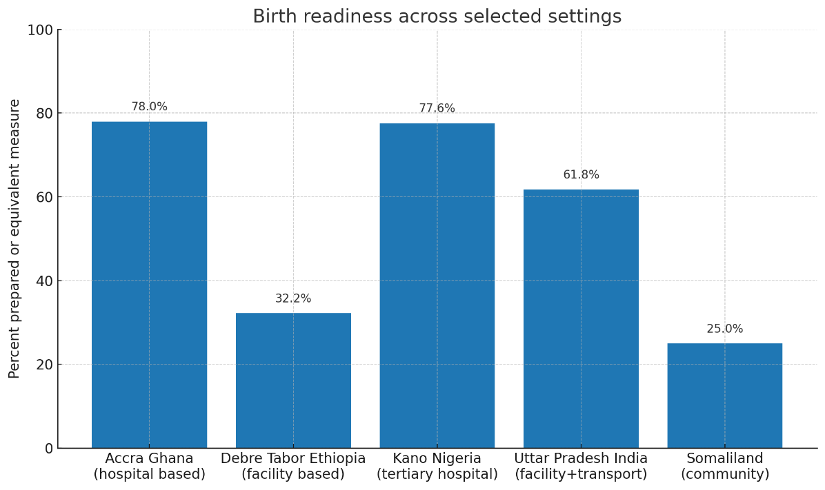
Source: (Merchan, 2024)
Taken together, the literature since 2017 shows that hospital linked birth readiness varies widely across settings but is consistently associated with improved use of institutional delivery and with proxy indicators of safer care (Stierman et al., 2021). The strongest and most actionable determinants in the hospital orbit are adequate antenatal contacts, structured counseling on danger signs and planning steps, and simple but explicit planning for transport and funds (Emeh et al., 2021). Organizational strategies that integrate group antenatal care, standardize counseling content, and operationalize protocols for emergency escalation appear to improve readiness and can be implemented within existing hospital workflows, while broader gains will continue to depend on regional coverage of skilled attendance and facility births and on the reduction of access barriers outside the hospital.
Birth readiness in Ghana
The evidence since 2017 shows that birth preparedness and complication readiness within Ghanaian hospitals is feasible and improves proximate behaviours when organisational strategies are explicit, resourced, and embedded in routine antenatal care (Oduro et al., 2023). Urban facility data from Accra indicate high overall preparedness with notable gaps in specific components such as identification of a blood donor, which signals that hospitals should prioritise item specific counselling and documentation rather than rely on composite scores alone (Ebenezer Afrifa-Yamoah et al., 2024). At the other end of the spectrum, facility linked samples in disadvantaged districts and in northern Ghana report markedly lower adequacy, with education, marital status, antenatal contact intensity, and danger sign knowledge emerging as consistent determinants (Abanga et al., 2025). These gradients imply that contact with facilities is necessary but insufficient unless hospitals organise care to address social barriers inside the service pathway (Schwarz et al., 2022). Equity sensitive planning prompts in registers, targeted support for women with fewer contacts, and flexible approaches to partner involvement are therefore managerial priorities.
Organisational redesign can shift these outcomes. A recent cluster randomised trial in the Eastern Region shows that group antenatal care delivered in facility clinics improves knowledge of danger signs and increases birth preparedness relative to individual care (Kukula et al., 2024). Group based sessions appear to create a social learning environment that strengthens planning behaviours while remaining compatible with normal clinic operations, which makes them attractive for hospital managers seeking scalable strategies. Implementation planning should specify staff roles, session cadence, and fidelity checks to preserve effect as models are scaled.

The national quality platform provides a conducive outer setting. Ghana’s participation in the WHO Quality of Care Network has been associated with strengthened leadership, action, learning, and accountability mechanisms and with reductions in institutional stillbirths in participating facilities (Blerta Maliqi et al., 2024). Hospitals can align birth preparedness work with this architecture by adopting standard counselling content, a one page birth plan in the record, monthly audit of plan completeness, and quarterly drills that include referral and blood bank liaison (Nyirenda et al., 2025). Such alignment reduces duplication, improves measurement discipline, and increases the likelihood of sustained practice.
Global coverage trends put these facility strategies in perspective. Skilled birth attendance and facility delivery have risen worldwide, but substantial regional, wealth and urban rural gaps persist (Abredu et al., 2024). Where facility delivery coverage is low, the marginal effect of hospital based readiness on timely care will be limited by structural access barriers even when counselling and plans are strong. This underscores the need for hospital managers to pair internal process improvements with robust referral communication and community linkages so that plans translate into timely arrival. Finally, measurement inconsistency remains a barrier to organisational learning. Studies use varied definitions of what counts as being prepared, which complicates synthesis and local benchmarking (Willmington et al., 2022). Hospitals in Ghana should agree a parsimonious indicator set that captures coverage of counselling on danger signs, documented birth plans that include transport and blood donor arrangements, documented referral readiness, partner participation, and timeliness of arrival for complications. Embedding these indicators in routine dashboards within the Quality-of-Care Network would enable cross facility comparison and iterative improvement.
Complication readiness in hospitals
Complication readiness is the organisational capacity of a hospital to recognise obstetric or newborn danger quickly and to mount an effective, timely response (Letose et al., 2020). It brings together standardised clinical protocols, competent teams, reliable supplies and equipment, blood availability, real time monitoring tools, and referral communication arrangements. Current World Health Organization guidance frames this capacity inside evidence based intrapartum care and respectful communication and requires timely escalation when labour deviates from normal (Oladapo et al., 2018). The WHO Labour Care Guide complements this by specifying bedside monitoring and decision prompts that help teams detect deterioration early and act without delay.
Operationally, complication readiness in hospitals can be organised around five domains(World Health Organisation, 2018). First, triage and surveillance systems that identify emergencies on arrival and during labour, for example the use of structured triage, early warning charts and the WHO Labour Care Guide record (World Health Organization, 2012). Second, the availability and functionality of emergency obstetric and newborn care signal functions such as parenteral antibiotics, uterotonics, anticonvulsants, assisted vaginal birth, manual removal of placenta, removal of retained products, neonatal resuscitation, and where designated, caesarean section and blood transfusion. Third, staff capability and team processes, including on call rosters, simulation drills, audit and feedback, and clear role assignments for rapid response. Fourth, supplies, equipment, and blood readiness, which require routine stock checks, maintenance, and formalised linkages to blood services. Fifth, communication and referral, including written protocols, tested transport arrangements, and counter referral feedback to ensure continuity of care (World Health Organization, 2012). These elements and their measurement are described across recent implementation manuals and empirical assessments and provide a practical indicator set for hospital dashboards such as frequency of drills, time to clinical review, time to treatment, time to transfer, stock availability, and proportion of cases managed with all required signal functions.

Complication readiness also depends on a supportive outer setting (Oduro et al., 2023). Since 2017 the Network for Improving Quality of Care for Maternal and Newborn Health has provided countries, including Ghana, with a platform for leadership, action, learning, and accountability in hospitals (Dube et al., 2024). Network reports document progress on instituting standards and show associations with improved facility outcomes, which makes the network a suitable vehicle for institutionalising drills, referral protocols, and blood readiness audits within routine quality cycles (Wakaria et al., 2017). Recent multi country experience papers further highlight that respectful care and communication with women and companions are not optional extras but integral to safe emergency response because they reduce delay in consent and improve adherence to advice (Muhayimana & Kearns, 2024). Equity considerations remain central. Hospitals should disaggregate readiness and response indicators by residence, education, age and other relevant characteristics to ensure that improvements close gaps rather than raise averages alone.

Birth preparedness and complication readiness in Ghanaian hospitals
In two urban facilities in Accra, overall birth preparedness among recent mothers was high at about 78 percent. Facility delivery was the norm at 98.3 percent, and most women had at least four antenatal contacts at 61.3 percent (Klobodu et al., 2020). However, preparedness showed uneven depth. The most common action was holding valid health insurance at 90.4 percent, while arranging a potential blood donor was much lower at 50.4 percent and comprehensive knowledge of all danger signs reached only 58 percent (Chauhan et al., 2018). In multivariable analysis, four or more antenatal visits, being employed, and belonging to maternal health clubs were associated with markedly higher odds of being prepared (Aaron Asibi Abuosi et al., 2024). These facility based results indicate that contact intensity and social support operated as leverage points for preparedness within hospital antenatal ecosystems.
Figure 2: Birth preparedness components among mothers.
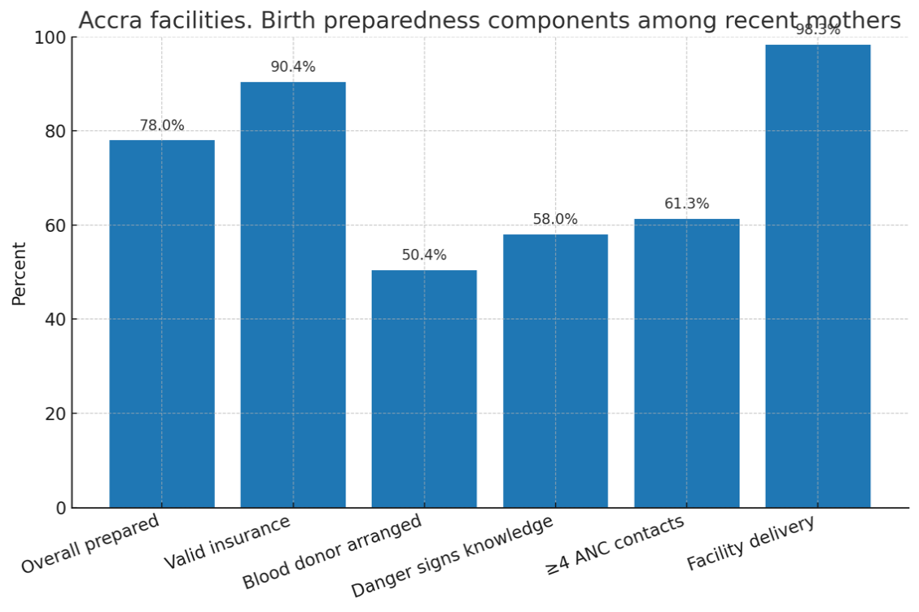
Source: (Aaron Asibi Abuosi et al., 2024)
Findings from disadvantaged rural districts that refer to hospitals reveal different constraints that hospitals must plan around (Nwana et al., 2022). Although most women had identified a delivery place at 93.2 percent and a companion at 95.8 percent, the ability to secure a blood donor varied extensively by district from 10.7 percent to 91.1 percent, and about one in five women showed poor overall preparedness at 22.6 percent (The World Bank, 2022). Educational level, marital status, and the frequency of antenatal contacts were associated with preparedness, and transport planning was inconsistent across districts, for example 30.9 percent in one forest district against 83.6 percent in a savannah district for daytime transport arrangements (Oduro et al., 2023). These data highlight that even where women intend to reach hospitals, gaps in emergency readiness can delay timely care.
Figure 3: Facility-Linked preparedness components
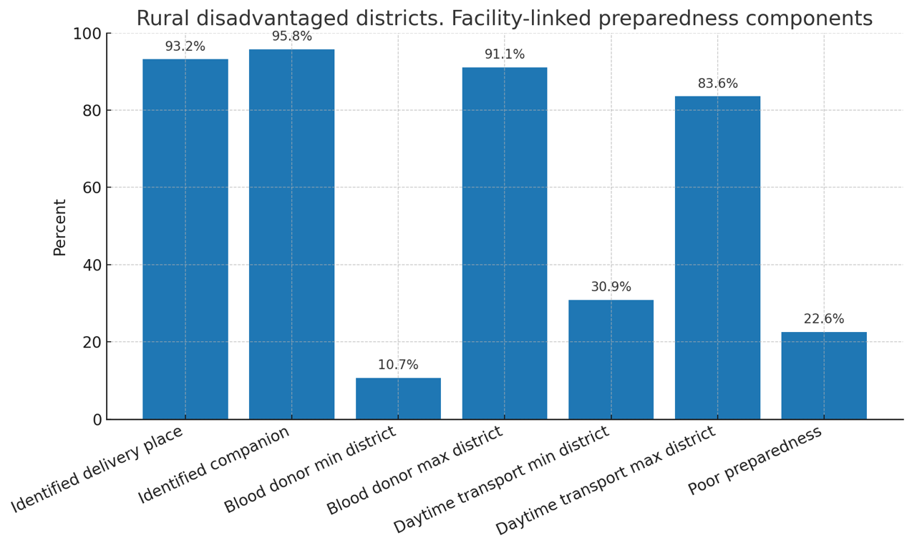
Community based evidence from northern Ghana complements the hospital linked picture by showing weak upstream preparation among postpartum women who later present to facilities (Kassim et al., 2023). Fewer than 15 percent met a standard threshold for adequate preparedness based on five core actions. Only 30.5 percent had identified a facility for delivery or emergencies, less than 18 percent had arranged transport, and 32.7 percent had saved funds (Kassim et al., 2023). Knowledge of danger signs and higher education were strong predictors of better preparation.
Figure 4: Northern Ghana postpartum women
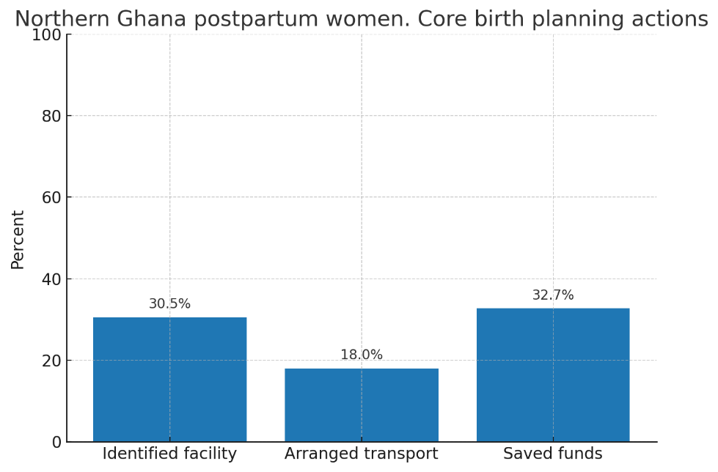

These findings imply that hospitals inherit risk from low preparedness at community level and underscore the value of hospital antenatal education that prioritizes danger sign literacy and actionable planning for transport and blood (Nyirenda et al., 2025). Taken together, Ghanaian hospitals face a dual task. Urban facilities can sustain high coverage by institutionalizing maternal clubs, tracking antenatal contact completeness, and integrating a simple preparedness checklist that includes a plan for blood (Klobodu et al., 2020). Rural referral hospitals must coordinate with primary level clinics to strengthen transport schemes and to normalize early identification of a potential donor, since these items are the most variable and time sensitive. Evidence from the cited studies justifies these operational priorities and provides measurable indicators that hospital managers can use to monitor progress.
Organisational strategies
- Standardised BPCR checklists embedded in antenatal and delivery workflows: Hospitals should operationalise a single BPCR checklist that nurses and midwives complete at booking and recheck at each contact through to admission. A standard tool makes the five core elements visible to staff and women and it enables real time tracking of whether a woman has identified a facility and skilled attendant, transport, funds and a potential blood donor (Actis Danna et al., 2020). The Accra study recommended development of a simple monitoring tool for BPCR and emphasised that such instruments must be coupled with continuous professional development and supportive supervision to be effective (Mainprice Akuoko Essuman et al., 2023). Embedding the checklist in routine notes and morning reviews institutionalises accountability and reduces missed counselling opportunities. Facilities should audit completion rates monthly and feed back to units.
- Facility led emergency referral and transport readiness: Hospital managers should institute written referral plans that specify who calls which transport resource, the expected response time, and the escalation pathway. Evidence from four disadvantaged rural districts showed that only 12.8 percent of women had an emergency referral plan and that the proportion with transport arrangements varied widely across districts which indicates a systems gap (Oladapo et al., 2018). Facilities can respond by negotiating memoranda with the ambulance service and trusted commercial transporters and by maintaining an on call driver list with petty cash procedures for urgent deployment(Oladapo et al., 2018). Clear referral algorithms should be displayed in triage and labour wards and drills should be conducted quarterly. Routine case reviews must include a check on whether referral plans were in place at the last antenatal visit.
- Blood availability through proactive donor mapping and transfusion governance: Hospitals should integrate donor identification into antenatal counselling and maintain a ward level ledger that links each high-risk woman to at least one screened potential donor. The rural districts assessment reported marked variation in the proportion of women who had identified a blood donor which underscores the need for a facility protocol that standardises this practice (Gbadamosi et al., 2023). Transfusion committees should meet monthly to review stock levels, crossmatch turnaround times, and instances where donor unavailability delayed care. Blood bank contacts must be posted in labour and theatre areas and night staff must know the after-hours access procedure. Hospitals serving high obstetric volumes should explore rotational blood drives aligned to antenatal clinic days.
- Intensified danger sign and BPCR counselling with competency-based staff training: Midwives should be trained to deliver focused BPCR counselling that links specific danger signs with concrete plans for where to go, how to go, and how to pay. The Kassena Nankana study found very low adequacy of BPCR and showed that knowledge of danger signs had a strong positive association with being adequately prepared which means counselling quality is decisive (Saaka & Alhassan, 2021). Facilities should adopt short competency-based refreshers and supportive supervision since frequent antenatal attendance alone did not guarantee adequate preparedness. Job aids with local language phrasing and teach back techniques should be used at every contact. Managers should audit documentation that a woman can name three danger signs and has completed all five BPCR elements.
- Financial readiness supports integrated with counselling: Hospitals should incorporate simple financial planning prompts into the BPCR checklist and link women to existing fee exemptions and social welfare mechanisms. In the Accra analysis, difficulty with financing emerged among the significant exposures associated with BPCR outcomes which suggests that counselling that ignores affordability leaves women unprepared (Oduro et al., 2023). Practical steps include advising on small progressive savings, clarifying what the national insurance covers, and providing a one-page estimate of likely non covered costs for normal delivery and for common emergencies. Facilities can establish a transparent emergency fund for destitute cases with clear eligibility rules overseen by management. Social workers should attend high risk antenatal clinics to pre clear support.
- Data driven supportive supervision and continuous quality improvement: Hospital leadership should use ward registers and the BPCR checklist to generate monthly indicators such as proportion of women with complete BPCR, proportion with named transport and proportion with identified donor. These data should inform targeted mentorship in units with deficits and should be discussed in maternal death and near miss reviews. The Accra study explicitly called for supportive supervision alongside the monitoring tool which signals that data without coaching will not shift practice (Oduro et al., 2023). Facilities should set quarterly improvement aims and run small tests of change such as reminder stamps in antenatal booklets or SMS prompts before the third trimester. Publishing run charts on ward noticeboards promotes transparency and staff motivation.
Recommendations
- Standardise measurement and governance through a hospital BPCR checklist and dashboard: Every antenatal clinic should open a single birth preparedness and complication readiness checklist at booking and recheck it at each contact, then aggregate a monthly dashboard that reports coverage of counselling, completion of birth plans, transport identified, funds set aside, and a potential blood donor recorded. In Accra facilities, authors explicitly called for a simple monitoring tool and found sizeable gaps within the BPCR bundle, for example strong insurance possession but weaker donor identification, which argues for item level tracking rather than relying on composite scores. Disadvantaged districts show wide variation across the same items, so a common indicator set will reveal where to focus supportive supervision. The national Quality of Care Network provides an existing platform for leadership, learning, and accountability that can hold these indicators and sustain review cycles.
- Redesign antenatal delivery models to raise planning quality and contact completeness: Hospitals should scale group antenatal care alongside routine one to one visits and structure eight contact schedules that reserve time for teach and plan activities. In Ghana’s Eastern Region, a cluster randomised trial showed that group antenatal care increased BPCR scores compared with individual care, indicating that a facilitated peer model strengthens learning and planning without major new infrastructure. The Accra study also found that four or more antenatal contacts predicted higher preparedness, which supports a dual approach that both improves content quality and protects contact completeness. Facilities can protect fidelity by training midwives in small group facilitation, using a standard session guide, and auditing completion of the BPCR elements at contact six and at the thirty two to thirty six week review.
- Institutionalise referral and transport readiness before term and test the system quarterly: Every woman should leave the thirty two to thirty six week visit with a written plan that names the delivery facility, the day and night transport option, a contact person, and the escalation facility if referral becomes necessary. In three disadvantaged districts, only about one in eight women had any referral plan and transport planning varied from about thirty one percent to about eighty four percent by district, which signals a systems gap that hospitals can close through clear protocols and memoranda with ambulances and vetted transporters. Managers should run quarterly drills that simulate night time emergencies and measure time from call to arrival and time to transfer. Data from drills and from real cases should feed ward reviews within the Quality-of-Care Network process so that delays are analysed and corrected.
- Build blood readiness through antenatal donor identification and active linkage to blood services: Hospitals should make donor identification a standard antenatal task by the third trimester and maintain a ledger that links high risk women to potential donors, with clear after hours procedures posted in labour, theatre, and the blood bank. Accra facilities reported that only about half of women had arranged a donor, and rural districts showed extreme variation across sites, which together justify a formal protocol and stronger liaison with the National Blood Service. Transfusion committees should review stock sufficiency, crossmatch times, and cases where blood unavailability contributed to delay, and they should schedule rotational blood drives aligned to high volume clinic days. Recording donor identification alongside other BPCR items will allow managers to see whether blood readiness improves as counselling and follow up are institutionalised.
- Target equity sensitive counselling and financial support to groups at highest risk of low preparedness: Ghana studies show consistent social gradients in preparedness. In the Kassena Nankana district fewer than fifteen percent met adequacy criteria, and knowledge of danger signs and higher education predicted readiness. In the rural district study, poor preparedness was more common among women with less education and among single mothers, and many reported limited financial support during pregnancy. Hospitals should therefore flag these characteristics at booking, add one extra counselling session focused on practical planning, invite a trusted companion, and link eligible women to fee exemptions or social welfare. Teach back on priority danger signs should be audited at each contact. Routine dashboards should disaggregate indicators by education and marital status to verify that gaps narrow over time, not only averages improving.
Conclusion
This review concluded that birth preparedness and complication readiness in Ghanaian hospitals was feasible but uneven across settings. In two Accra facilities seventy eight percent of recent mothers were classified as prepared with 98.3 percent facility delivery and 90 percent insurance yet only 50 percent had a blood donor and 58 percent knew all danger signs. Preparedness in Accra correlated with at least four antenatal contacts employment and membership in maternal health clubs. Across three disadvantaged districts 22.6 percent of women had poor preparedness and there was no difference between prenatal and postnatal samples. Referral planning was rare at 12.8 percent and transport and donor arrangements showed extreme district variation from about 31 to 84 percent for transport and 10.7 to 91.1 percent for donor identification. Despite near universal National Health Insurance registration many women reported a lack of financial support which varied sharply by district. In northern Ghana fewer than fifteen percent met an adequacy threshold and knowledge of danger signs and higher education were strong predictors of readiness. These patterns suggested that frequent contact without organised counselling tracking transport and blood arrangements did not ensure complete readiness. Hospitals should adopt a standard checklist and a monthly dashboard for routine monitoring as recommended by the Accra investigators. Managers should strengthen the quality of antenatal counselling and support maternal clubs since these were associated with higher preparedness. Facilities should require written referral and day and night transport plans by thirty-two to thirty-six weeks and formalise ambulance linkages to address the documented gaps. Antenatal donor identification and stronger liaison with blood services should be institutionalised to close the donor readiness deficit. Future research should agree on a small consensus indicator set and pragmatically evaluate hospital level strategies while disaggregating outcomes by education and marital status.

References
Aaron Asibi Abuosi, Emmanuel Anongeba Anaba, Anita Anima Daniels, Asiwome, A., & Akazili, J. (2024). Determinants of early antenatal care visits among women of reproductive age in Ghana: evidence from the recent Maternal Health Survey. BMC Pregnancy and Childbirth, 24(1). https://doi.org/10.1186/s12884-024-06490-3
Abanga, E. A., Ziblim, A. M., & Boah, M. (2025). Antenatal care quality and pregnancy outcomes in the northern region of Ghana: a mixed-methods analysis. BMC Pregnancy and Childbirth, 25(1). https://doi.org/10.1186/s12884-025-07915-3
Abel, L. N., & Tandoh, M. A. (2025). Assessing Preparedness for Nutritional Emergencies in Rural and Urban Healthcare Facilities: A Hospital‐Based Cross‐Sectional Study. Health Science Reports, 8(3). https://doi.org/10.1002/hsr2.70594
Abredu, J., Dwumfour, C. K., Boo Alipitio, Mawusi Alordey, Veronica Millicent Dzomeku, & Witter, S. (2024). A scoping review of the residual barriers to skilled birth attendance in Ghana: A conceptual framework and a fish bone analysis. PLOS Global Public Health, 4(2), e0002902–e0002902. https://doi.org/10.1371/journal.pgph.0002902
Abubakar, D., Aremu-Kasumu, Y. B., Musa Yakubu, Fasanu, O. T., & Baidoo-Adeiza, S. O. (2023). Birth Preparedness and Complication Readiness among Antenatal Attendees in a Tertiary Hospital in Northern Nigeria. International Journal of Maternal and Child Health and AIDS, 13, e017–e017. https://doi.org/10.25259/ijma_659
Actis Danna, V., Bedwell, C., Wakasiaka, S., & Lavender, T. (2020). Utility of the three-delays model and its potential for supporting a solution-based approach to accessing intrapartum care in low- and middle-income countries. A qualitative evidence synthesis. Global Health Action, 13(1), 1819052. https://doi.org/10.1080/16549716.2020.1819052
Ahmed, S. A. E., Mahimbo, A., & Dawson, A. (2023). Quality intrapartum care expectations and experiences of women in sub-Saharan African Low and Low Middle-Income Countries: a qualitative meta-synthesis. BMC Pregnancy and Childbirth, 23(1). https://doi.org/10.1186/s12884-022-05319-1
Alamrew, A., Sisay, A., Ayele, M., Shitie Lake, E., Kumie, G., Hailu Mossie, H., Emagneneh, T., & Mulugeta, C. (2024). Determinants of birth preparedness and complication readiness practice among reproductive-age women in Africa a systematic review and meta-analysis. BMC Public Health, 24(1). https://doi.org/10.1186/s12889-024-20654-y
Ayehu, T., Tiruneh, G. T., Tesfaye, C., Belete, M., Fesseha, N., Semahegn, A., Tadesse, H., Mirkuzie, A. H., Aklilu, Y., Zenebe, M., Yasin, M., Mohammed, A., Hamza, A., Mohammed, O., Embiale, W., Argaw, M. D., & Emaway, D. (2025). Facility readiness and experience of women and health care providers in receiving and delivering obstetric care in comprehensive health posts in Ethiopia: a mixed method study. BMC Health Services Research, 25(1). https://doi.org/10.1186/s12913-025-12453-x
Aziz, M. M., Shams El-Deen, R. M., & Allithy, M. A. (2020). Birth preparedness and complication readiness among antenatal care clients in Upper Egypt. Sexual & Reproductive Healthcare, 24, 100506. https://doi.org/10.1016/j.srhc.2020.100506
Blerta Maliqi, Cocoman, O., Dohlsten, M., Dussey, S., Hinton, R., Mannah, M. T., Moise Muzigaba, Tala Rammal, Jesca Sabiiti, Yaqub, N., & Banerjee, A. (2024). Strengthening the policy, implementation, and accountability environment for quality care: experiences from quality of care network countries. Frontiers in Health Services, 3. https://doi.org/10.3389/frhs.2023.1292510
Bobo, F. T., Asante, A., Woldie, M., Dawson, A., & Hayen, A. (2021). Spatial patterns and inequalities in skilled birth attendance and caesarean delivery in sub-Saharan Africa. BMJ Global Health, 6(10), e007074. https://doi.org/10.1136/bmjgh-2021-007074
Breneol, S., Curran, J. A., Marten, R., Minocha, K., Johnson, C., Wong, H., Langlois, E. V., Wozney, L., Vélez, C. M., Cassidy, C., Juvekar, S., Rothfus, M., Aziato, L., Keeping-Burke, L., Adjorlolo, S., & Patiño-Lugo, D. F. (2022). Strategies to adapt and implement health system guidelines and recommendations: a scoping review. Health Research Policy and Systems, 20(1). https://doi.org/10.1186/s12961-022-00865-8
Chauhan, R., Kumar, R., & Thakur, S. (2018). A study to assess the knowledge, attitude, and practices about blood donation among medical students of a medical college in North India. Journal of Family Medicine and Primary Care, 7(4), 693–697. https://doi.org/10.4103/jfmpc.jfmpc_54_17
Dube, A., Kondwani Mwandira, Akter, K., khatun, F., Lemma, S., Seruwagi, G., Yusra Ribhi Shawar, Nehla Djellouli, Mwakwenda, C., English, M., & Colbourn, T. (2024). Evaluating theory of change to improve the functioning of the network for improving quality of care for maternal, newborn and child health. PLOS Global Public Health, 4(8), e0003532–e0003532. https://doi.org/10.1371/journal.pgph.0003532
Ebenezer Afrifa-Yamoah, Nunfam, V. F., Kwanin, B. A., & Frimpong, K. (2024). Ecology of emergency care in lower-tier healthcare providers in Ghana: an empirical data-driven Bayesian network analytical approach. Internal and Emergency Medicine, 19(8), 1–13. https://doi.org/10.1007/s11739-024-03607-6
Emeh, A. N., Atem, A. N., Humphrey, A. A., Gilbert, T. N., & Landis, F. C. (2021). Antenatal care and determinants of obstetric danger signs awareness of immediate postpartum women at Buea Regional Hospital, Cameroon. Pan African Medical Journal, 38. https://doi.org/10.11604/pamj.2021.38.247.20977
Gbadamosi, F. I., Popoola, Y., Olaniyan, F., Ridwan Olamilekan Adesola, & Unim, B. (2023). Rural-urban variation in willingness to donate blood in Ibadan Region, Nigeria. PubMed, 59(2), 114–121. https://doi.org/10.4415/ann_23_02_04
Gilbert Ti-enkawol Nachinab, Vida Nyagre Yakong, Joshua Dindiok Dubik, Kokui Dziedzom Klutse, Mubarick Nungbaso Asumah, Beatrice Nyarko Bimpong, Mensah, C., & Cynthia Anane Sarpong. (2023). Perceptions on Birth Preparedness and Complication Readiness: Perspectives of Pregnant Women. SAGE Open, 13(4). https://doi.org/10.1177/21582440231207136
Ihomba, P. K., Nyamari, J. M., Murima, F. N., & Were, T. (2020). Birth Preparedness and Complication Readiness among Women with Pregnancy and Childbirth related Complications at Kenyatta National Teaching and Referral Hospital, Kenya. The East African Health Research Journal, 4(1), 26–32. https://doi.org/10.24248/eahrj.v4i1.618
Kassim, A. B., Newton, S., Dormechele, W., Rahinatu, B. B., Yanbom, C. T., Yankson, I. K., & Otupiri, E. (2023). Effects of a community-level intervention on maternal health care utilization in a resource-poor setting of Northern Ghana. BMC Public Health, 23(1). https://doi.org/10.1186/s12889-023-16376-2
Klobodu, C., Milliron, B.-J., Agyabeng, K., Akweongo, P., & Adomah-Afari, A. (2020). Maternal birth preparedness and complication readiness in the Greater Accra region of Ghana: a cross-sectional study of two urban health facilities. BMC Pregnancy and Childbirth, 20(1). https://doi.org/10.1186/s12884-020-03263-6
Kodom, R. V., & Netangaheni, R. T. (2024). Challenges in accessing patient-centered care and patient empowerment in selected Ghanaian hospitals. Health SA Gesondheid, 29. https://doi.org/10.4102/hsag.v29i0.2623
Kukula, V. A., Awini, E., Ghosh, B., Apetorgbor, V., Zielinski, R., Amankwah, G., Ofosu, W. K., James, K., John, Lori, J. R., & Moyer, C. A. (2024). Effect of group antenatal care versus individualized antenatal care on birth preparedness and complication readiness: a cluster randomized controlled study among pregnant women in Eastern Region of Ghana. BMC Pregnancy and Childbirth, 24(1). https://doi.org/10.1186/s12884-024-06743-1
Letose, F., Admassu, B., & Tura, G. (2020). Birth preparedness, complication readiness and associated factors among pregnant women in Agnuak zone, Southwest Ethiopia: a community based comparative cross-sectional study. BMC Pregnancy and Childbirth, 20(1). https://doi.org/10.1186/s12884-020-2766-9
Limenih, M. A., Belay, H. G., & Tassew, H. A. (2019). Birth preparedness, readiness planning and associated factors among mothers in Farta district, Ethiopia: a cross-sectional study. BMC Pregnancy and Childbirth, 19(1). https://doi.org/10.1186/s12884-019-2325-4
Lori, J. R., Williams, J. E. O., Kukula, V. A., Apetorgbor, V. E. A., Awini, E. A., Amankwah, G., Zielinski, R., Lockhart, N., James, K. H., & Moyer, C. A. (2022). Group Antenatal Care in Ghana: Protocol for a Cluster Randomized Controlled Trial. JMIR Research Protocols, 11(9), e40828. https://doi.org/10.2196/40828
Mainprice Akuoko Essuman, Nii Armah Addy, Essien-Baidoo, S., Irene Esi Donkoh, Botchway, F., Justice Afrifa, Agyeman, P., Leticia Awontayami Amaama, Amoah, S., Felix, & Richard K.D. Ephraim. (2023). Self-reported continuing professional development needs of medical laboratory professionals in Ghana. Human Resources for Health, 21(1). https://doi.org/10.1186/s12960-023-00859-9
Merchan, D. (2024, September 11). New report finds alarming decline in US maternity care access. ABC News; ABC News. https://abcnews.go.com/US/new-report-finds-alarming-decline-us-maternity-care/story?id=113584528
Muhayimana, A., & Kearns, I. (2024). Healthcare providers’ perspectives on sustaining respectful maternity care appreciated by mothers in five hospitals of Rwanda. BMC Nursing, 23(1). https://doi.org/10.1186/s12912-024-02017-5
Negash Dechasa, A., Mulaw Endale, Z., Sertsu Gerbi, A., Bekele Sime, H., & Ayanaw Kassie, B. (2022). Preference of birth attendant gender and associated factors among antenatal care attendants at Debre Markos town public health facilities, Northwest Ethiopia: A cross-sectional study design 2021. SAGE Open Medicine, 10, 205031212211350. https://doi.org/10.1177/20503121221135024
Nwana, N., Chan, W., Langabeer, J., Kash, B., & Krause, T. M. (2022). Does hospital location matter? Association of neighborhood socioeconomic disadvantage with hospital quality in US metropolitan settings. Health & Place, 78, 102911. https://doi.org/10.1016/j.healthplace.2022.102911
Nyirenda, M., Jacobs, C., Makasa, M., & Hazemba, A. N. (2025). Knowledge and practices of birth preparedness and complication readiness among pregnant women in Eastern Province, Zambia: A qualitative study. PLOS Global Public Health, 5(7), e0004975. https://doi.org/10.1371/journal.pgph.0004975
Oduro, A., Anyorikeya, M., Ansah, P., Oladokun, S., Ernest Maya Tei, Oduro-Ayeh, R., Welaga, P., & Deh, S. Y. (2023). Birth preparedness and complications readiness among women in disadvantaged rural districts of Ghana. BMC Pregnancy and Childbirth, 23(1). https://doi.org/10.1186/s12884-023-06041-2
Oladapo, O., Tunçalp, Ö., Bonet, M., Lawrie, T., Portela, A., Downe, S., & Gülmezoglu, A. (2018). WHO model of intrapartum care for a positive childbirth experience: transforming care of women and babies for improved health and wellbeing. BJOG: An International Journal of Obstetrics & Gynaecology, 125(8), 918–922. https://doi.org/10.1111/1471-0528.15237
Rajvanshi, D., Anthony, J., Namasivayam, V., Dehury, B., Banadakoppa Manjappa, R., Prakash, R., Chintada, D. R., Khare, S., Avery, L., Crockett, M., Isac, S., Becker, M., Blanchard, J., & Halli, S. (2021). Association of identification of facility and transportation for childbirth with institutional delivery in high priority districts of Uttar Pradesh, India. BMC Pregnancy and Childbirth, 21(1). https://doi.org/10.1186/s12884-021-04187-5
Report, B., & Newell-Jones, K. (2025). Empowering communities to collectively abandon FGM/C in Somaliland. https://www.orchidproject.org/wp-content/uploads/2017/10/AA-Empowering-communities-to-collectively-abandon-FGMC-in-Somaliland.pdf
Saaka, M., & Alhassan, L. (2021). Prevalence and predictors of birth preparedness and complication readiness in the Kassena-Nankana district of Ghana: an analytical cross-sectional study. BMJ Open, 11(3), e042906. https://doi.org/10.1136/bmjopen-2020-042906
Samardzic, M. B., Doekhie, K. D., & Wijngaarden, J. D. H. (2020). Interventions to improve team effectiveness within health care: A systematic review of the past decade. Human Resources for Health, 18(2), 1–42. https://doi.org/10.1186/s12960-019-0411-3
Sambah, F., McBain-Rigg, K., Abdul-Aziz Seidu, & Emeto, T. I. (2025). Healthcare providers and policymakers’ perspectives on enablers and barriers to hypertension management in Ghana: a qualitative study. Deleted Journal, 22(1). https://doi.org/10.1186/s12982-025-00691-7
Schwarz, T., Schmidt, A. E., Bobek, J., & Ladurner, J. (2022). Barriers to Accessing Health Care for People with Chronic conditions: a Qualitative Interview Study. BMC Health Services Research, 22(1), 1–15. https://doi.org/10.1186/s12913-022-08426-z
Schweidenback, J., Rangachari, P., D’Amato-Palumbo, S., & Gladstone, J. (2024). Integrating the Consolidated Framework for Implementation Research (CFIR) and Tensions into a Novel Conceptual Model for Telehealth Advancement in Healthcare Organizations. Journal of Healthcare Leadership, Volume 16, 501–510. https://doi.org/10.2147/jhl.s497875
Sinha, T. P., Sanjeev Bhoi, Sharma, D., Chauhan, S., Magan, R., Sahu, A. K., Bhargava, S., Nayar, P. D., Kannan, V., Rakesh Lodha, Garima Kacchawa, Arora, N. K., Moji Jini, Sinha, P. K., Verma, S., Goyal, P., Viswanathan, K. V., Kemba Padu, Boro, P., & Kumar, Y. (2024). Strengthening facility-based integrated emergency care services for time sensitive emergencies at all levels of healthcare in India: An implementation research study protocol. Health Research Policy and Systems, 22(1). https://doi.org/10.1186/s12961-024-01183-x
Stierman, E. K., Ahmed, S., Shiferaw, S., Zimmerman, L. A., & Creanga, A. A. (2021). Measuring facility readiness to provide childbirth care: a comparison of indices using data from a health facility survey in Ethiopia. BMJ Global Health, 6(10), e006698. https://doi.org/10.1136/bmjgh-2021-006698
The World Bank. (2022). Ghana - Demographic and Health Survey 2022. Microdata.worldbank.org. https://microdata.worldbank.org/index.php/catalog/6122
Tomlin, K., Berhanu, D., Gautham, M., Umar, N., Schellenberg, J., Wickremasinghe, D., & Marchant, T. (2020). Assessing capacity of health facilities to provide routine maternal and newborn care in low-income settings: what proportions are ready to provide good-quality care, and what proportions of women receive it? BMC Pregnancy and Childbirth, 20(1). https://doi.org/10.1186/s12884-020-02926-8
Tukisi, K. P., van Rensburg, Z. J., & Jacobs, W. (2025). Midwifery manager’s experiences of knowledge and skills utilization by midwife specialists in the public health sector of South Africa. BMC Nursing, 24(1). https://doi.org/10.1186/s12912-025-03116-7
Wakaria, E. N., Rombo, C. O., Oduor, M., Kambale, S. M., Tilock, K., Kimani, D., Makokha, E., Mwamba, P. M., & Mwangi, J. (2017). Implementing SLMTA in the Kenya National Blood Transfusion Service: lessons learned. African Journal of Laboratory Medicine, 6(1). https://doi.org/10.4102/ajlm.v6i1.585
Willmington, C., Belardi, P., Murante, A. M., & Vainieri, M. (2022). The contribution of benchmarking to quality improvement in healthcare. A systematic literature review. Biomed Central (BMC) Health Services Research, 22(1), 1–20. https://doi.org/10.1186/s12913-022-07467-8
Wondu Feyisa Balcha, Amlaku Mulat Awoke, Assefa Tagele, Geremew, E., Giza, T., Betelhem Aragaw, & Daniel, N. (2024). Practice of Birth Preparedness and Complication Readiness and Its Associated Factors:A Health Facility-Based Cross-Sectional Study Design. Inquiry, 61. https://doi.org/10.1177/00469580241236016
World Health Organisation. (2018). WHO recommendations Intrapartum care for a positive childbirth experience Executive summary. https://iris.who.int/bitstream/handle/10665/272447/WHO-RHR-18.12-eng.pdf
World Health Organization. (2012). Triage and emergency assessment. Nih.gov; World Health Organization. https://www.ncbi.nlm.nih.gov/books/NBK143755/
World Health Organization. (2018a). Births attended by skilled health personnel. Www.who.int. https://www.who.int/data/nutrition/nlis/info/births-attended-by-skilled-health-personnel
World Health Organization. (2018b). WHO recommendations: intrapartum care for a positive childbirth experience. Www.who.int. https://www.who.int/publications/i/item/9789241550215
Zarbiv, G., Perlman, S., & Ellen, M. E. (2025). Barriers and facilitators for implementation of continuity of midwife care: A review of reviews. Women and Birth, 38(2), 101892. https://doi.org/10.1016/j.wombi.2025.101892

