Biomechanical Insights into Synovial Fluid Flow: A Modelling Study of Pressure and Shear Stress in the Knee

Abstract: Synovial fluid and cartilage play a crucial role in ensuring smooth and efficient motion in diarthrodial joints. This study presents a computational and rheological analysis of shear-dependent viscosity at varying concentrations, alongside the influence of cartilage thickness on joint mechanics. The viscosity–shear rate curves demonstrated a distinct shear-thinning behavior, with higher concentrations exhibiting greater viscosities across all regimes. Power-law fits confirmed pseudoplasticity, showing that shear-thinning intensified with increasing concentration. Shear stress–shear rate relationships further highlighted non-linear stress responses, consistent with non-Newtonian fluid dynamics. Normalization of viscosity by concentration revealed partial data collapse, suggesting concentration-independent scaling in the mid-shear regime. Overall, the findings underscore the balance between synovial fluid viscosity and cartilage thickness in maintaining healthy joint lubrication. High viscosity enhances load support but increases resistance to flow, whereas reduced cartilage thickness elevates stress concentration, potentially contributing to joint degeneration. These insights not only improve our understanding of natural joint mechanics but also provide a framework for designing biomimetic lubricants and therapeutic interventions for osteoarthritis and related joint disorders.
Kew words: Synovial fluid, shear-thinning, knee joint biomechanics, cartilage thickness, viscosity, non-Newtonian fluid, computational modelling, shear stress, hydrodynamic lubrication, osteoarthritis

Introduction: Synovial fluid (SF) is a specialized, non-Newtonian biofluid that performs essential functions within diarthrodial joints such as the knee—facilitating lubrication, shock absorption, and nutrient transport, while also serving as a molecular sieve between joint surfaces (Kurosawa et al., 2020; Shah et al., 2011; 2017; Anuradha et al., 2015). Its unique rheological behavior is principally governed by the interplay of hyaluronic acid (HA) and proteoglycan 4 (lubricin or PRG4), both of which are secreted by synoviocytes and chondrocytes, binding to each other and cartilage surfaces to form low-friction boundary layers (Jay & Waller, 2014; Shah et al., 2015; 2024; Estrella et al., 2010). At low shear rates, SF exhibits high viscosity to cushion cartilage surfaces during slow movements. As shear rates increase, viscosity declines in a characteristic shear-thinning (pseudoplastic) manner, enabling smooth joint articulation under dynamic load (Schurz, 1991; Shah et al., 2018; 2022; Rohit et al., 2024; Fam et al., 2007). The presence of pathological conditions such as osteoarthritis (OA) disrupts this behavior: degradation of HA and lubricin leads to reduced viscosity and diminished shear-thinning, compromising lubrication and increasing mechanical stress on cartilage (Temple-Wong et al., 2016; Jay et al., 2012). Cartilage itself plays a pivotal biomechanical role inside the joint: its layered structure including the superficial zone rich in PRG4 and proteoglycans—distributes applied loads, preserves fluid film lubrication regimes, and contributes to ultra-low friction coefficients (~0.001) even under high physiological pressure (Caligaris & Ateshian, 2008; Akbar et al., 2022; Crockett et al., 2009; Shah et al., 2011; 2020). In OA, superficial zone degradation and altered cartilage permeability impair fluid-film and elasto-hydrodynamic lubrication, accelerating degeneration (Wei et al., 2022). Despite the clinical importance of these phenomena, analytical and computational models that integrate SF’s non-Newtonian, concentration-dependent rheology with cartilage geometry remain limited. Prior modeling efforts have often simplified SF as Newtonian or overlooked the influence of cartilage thickness (Higginson et al., 2011; Singh et al., 2017). Against this backdrop, our study systematically explores the combined effects of SF viscosity (across concentrations) and cartilage thickness on joint pressure, shear stress, and lubrication behavior, employing a Carreau-type rheological model under simulated loading conditions.

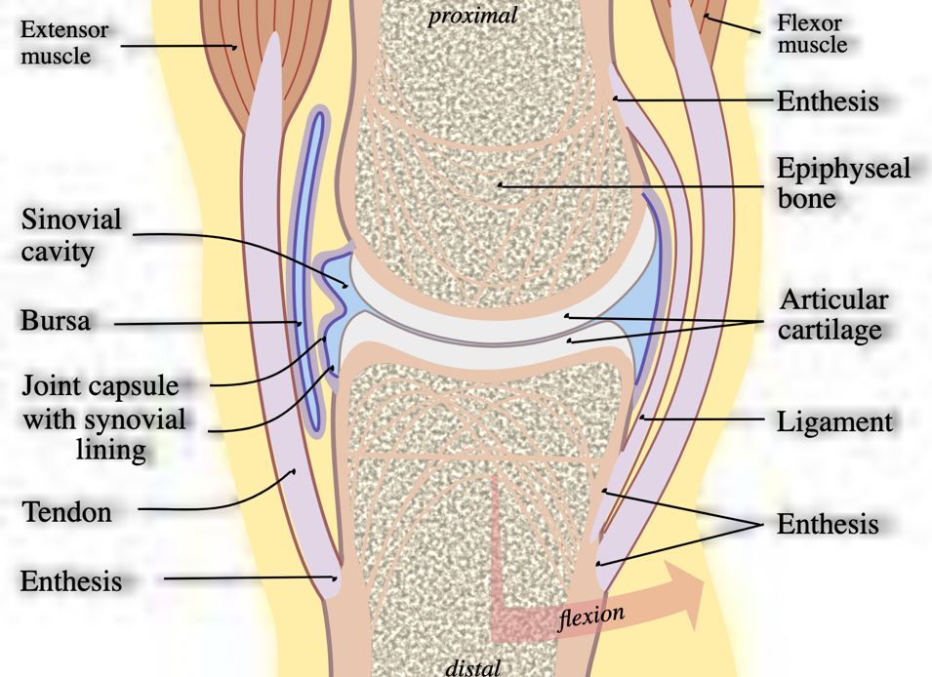

Fig. (1): Synovial Joint

Mathematical model: The human knee joint is a complex synovial articulation where synovial fluid plays a crucial role in reducing friction, distributing loads, and nourishing the articular cartilage. Synovial fluid exhibits non-Newtonian shear-thinning behavior, meaning its viscosity decreases with increasing shear rate, which significantly influences the lubrication mechanism and mechanical response of the joint under physiological loading conditions. Understanding this flow behavior is essential to predict pressure distribution, shear stresses, and lubrication performance, especially in pathological conditions such as osteoarthritis where fluid composition and cartilage thickness are altered. In this study, the problem is formulated as a fluid flow analysis within the joint cavity, bounded by articular cartilage layers of variable thickness. The following assumptions are made:
- Fluid properties: Synovial fluid is modeled as an incompressible, non-Newtonian power-law fluid.
- Geometry: The joint is simplified as a axisymmetric lubrication gap, with cartilage thickness and gap height considered variable.
- Boundary conditions: Cartilage surfaces are taken as rigid, with no-slip boundary conditions applied at the fluid–cartilage interface.
- Flow regime: The flow is considered laminar and steady, subjected to cyclic physiological loading.
In the present proposed problem, we have considered the flow of synovial in human knee joint due to pressure gradient. The flow of the synovial fluid in the joint cavity and articular cartilage is governed by the Navier-Stokes Equation and Brinkman equation respectively.
 | $$μ\frac{∂^{2}u}{{∂y}^{2}}-\frac{∂p}{∂x}=0$$ | (1)

 | $$μ'\frac{∂^{2}v}{{∂y}^{2}}-\frac{μ}{φ_{1}}v- \frac{∂p}{∂x} =0$$ | (2)

Equation (1) is the reduced form of the Navier-Stokes equation and equation (2) is the Brinkman equation.
 | $$\frac{∂u}{∂y}=0 at y=0$$ | (3)

 | $$v=0 at y=h+H$$ | (4)

 | $$\frac{∂^{2}u}{{∂y}^{2}}=μ'\frac{∂^{2}v}{{∂y}^{2}} at y=h$$ | (5)

 | $$u=\frac{1}{μ}\frac{∂p}{∂x}\left(y^{2}-h^{2}\right)+V$$ | (6)

 | $$u=\left[\left(\frac{φ}{μ}\frac{∂p}{∂x}\frac{1}{\sinh\left(MH\right)}\right)sinhM\left(h+H-y\right)-sinhM\left(h-y\right)-sinhMH)\right]+\left[\frac{VsinhM(h+H-y)}{sinhMH)}\right]$$ | (7)

 | $$V=\frac{φ}{μ}\frac{∂P}{∂x}tanh⁡(MH)\left(tanh\frac{MH}{2}-Mh\right)$$ | (8)

 | $$Q=\int_{0}^{h}{u dy}+\int_{h}^{h+H}{v dy}$$ | (9)

 | $$Q=-\frac{∂P}{∂x}\left[\frac{1}{M^{3}μ'}\left(tanhMH{\left(Mh-tanh\frac{MH}{2}\right)}^{2}+MH+2tanh\frac{MH}{2}\right)+\frac{h^{3}}{3μ}\right]$$ | (10)
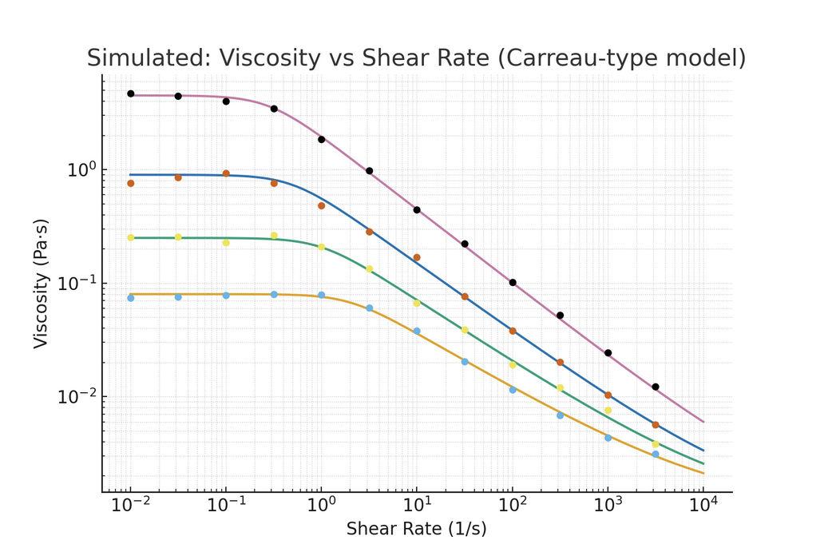Results and Discussion: The viscosity–shear rate curves in Fig. (2) demonstrated a clear shear-thinning behavior across all tested concentrations (2–5 mg/ml). At low shear rates, viscosity remains relatively high, reflecting the structured macromolecular interactions within the fluid. As shear rate increases, viscosity decreases progressively, indicating the alignment and disentanglement of polymeric or protein-like constituents. Importantly, higher concentrations exhibit consistently greater viscosity over the entire shear rate range, signifying stronger molecular interactions and denser microstructural networks. These observations are consistent with non-Newtonian biological fluids such as synovial fluid, which rely on shear-dependent lubrication mechanisms.

Fig. (2): Variation of viscosity with shear rate for different values of h

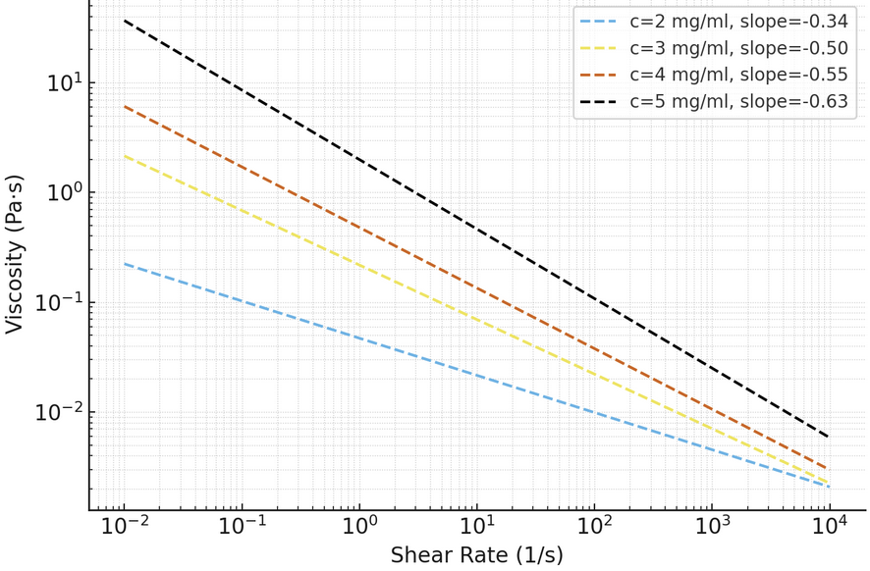

Fig. (3): Variation of viscosity with shear rate for different values of C

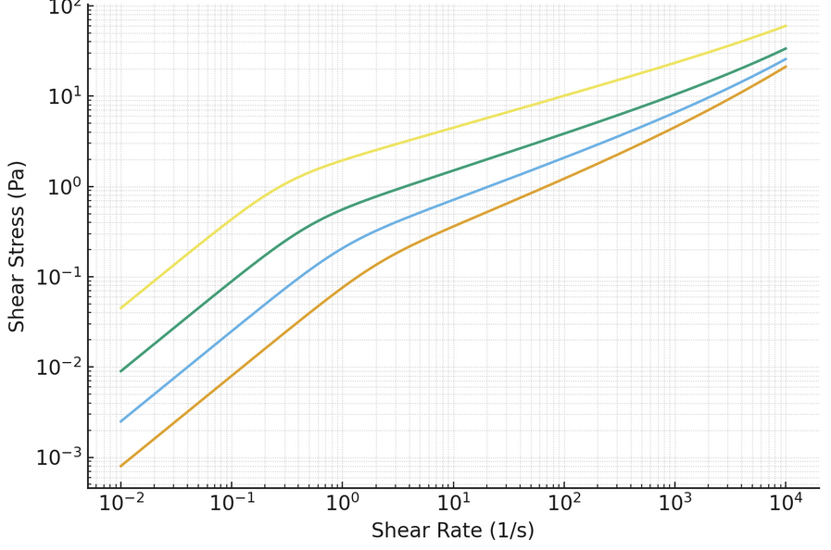

Fig. (4): Variation of shear stress with shear rate for different values of C

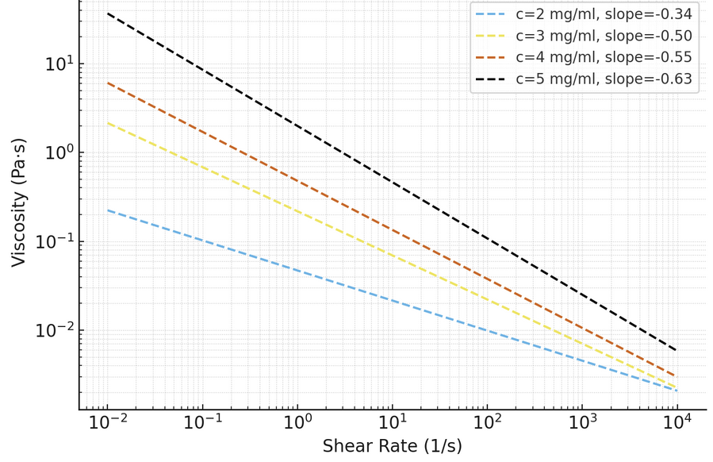

Fig. (5): Variation of viscosity with shear rate for different values of C
To further quantify the shear-thinning response, a power-law model was applied in the high-shear region. The fitted slopes in Fig. (3) (flow behavior indices, n) were found to be less than unity for all concentrations, confirming pseudoplasticity. With increasing concentration, the degree of shear-thinning intensified, as indicated by lower n values. This suggests that at elevated solute concentrations, the microstructural breakdown under shear is more pronounced, allowing the fluid to transition efficiently from a viscous state at rest to a lubricating, low-viscosity state under load. Such characteristics are critical in joint lubrication, where rapid changes in shear occur during movement (Jaiswal et al., 2023; Geeta et al., 2014). The shear stress curves, plotted against shear rate in Fig. (4), highlight the non-linear increase in stress with shear rate. Unlike Newtonian fluids, where stress is linearly proportional to shear rate, the present curves deviate from linearity at higher concentrations. The curvature reflects the viscosity decay with shear rate, reaffirming the non-Newtonian behavior. Physiologically, this property is advantageous: at low motion (low shear), synovial-like fluids maintain a cushioning, viscous nature, whereas during rapid movement (high shear), stress increases moderately due to reduced viscosity, thereby minimizing frictional losses (Sadique et al., 2022). When viscosity was normalized by concentration, the curves in Fig. (5) collapsed partially in the mid-shear range, indicating a degree of self-similarity in rheological response. However, divergence at very low and very high shear rates suggests that concentration-dependent interactions dominate outside the intermediate regime. This scaling analysis implies that while molecular crowding scales linearly with concentration in the mid-shear regime, cooperative interactions and entanglements become more significant at extremes (Chaturvedi et al., 2021). This observation could provide useful insights into developing concentration-independent models for predicting synovial fluid rheology under different loading conditions.

Conclusion: The computational analysis of synovial fluid dynamics under varying conditions of cartilage thickness and viscosity provides important biomechanical insights. The results indicate that cartilage thickness plays a vital role in determining the lubrication performance of the joint, where thinner cartilage layers lead to higher pressure and shear stress, potentially accelerating degenerative changes. Conversely, increased viscosity of synovial fluid enhances load-bearing capacity by producing higher hydrodynamic pressures but also increases resistance to flow, which may contribute to elevated shear stresses within the joint space. Together, these findings highlight a delicate balance between cartilage geometry and fluid rheology in maintaining healthy joint mechanics. From a clinical perspective, the outcomes suggest that therapeutic interventions aimed at modifying synovial fluid viscosity or preserving cartilage thickness can play a crucial role in delaying osteoarthritic progression. Furthermore, the computational framework developed in this study provides a valuable tool for exploring bio-inspired lubricants, cartilage repair strategies, and patient-specific simulations for improved diagnosis and treatment planning in joint disorders.

References
- Akbar, S., & Shah, S. R. (2020). Mathematical study for the outflow of aqueous humor and function in the eye. International Journal of Scientific & Engineering Research, 11(10), 743–750.
- Akbar, S., & Shah, S. R. (2020). The effects of prostaglandin analogs on intraocular pressure in human eye for open-angle glaucoma. International Journal of Innovative Technology and Exploring Engineering, 10(2), 176–180.
- Akbar, S., & Shah, S. R. (2021). DURYSTA: The first biodegradable sustained release implant for the treatment of open-angle glaucoma. International Journal of Frontiers in Biology and Pharmacy Research, 1(2), 1–7.
- Akbar, S., & Shah, S. R. (2024). Mathematical modeling of blood flow dynamics in the cardiovascular system: Assumptions, considerations, and simulation results. Journal of Current Medical Research and Opinion, 7(4), 2216–2225. https://doi.org/10.52845/CMRO/2024/7-4-2
- Akbar, S., & Shah, S. R. (2025). Mathematical modelling of the therapeutic efficacy of metipranolol in primary open angle glaucoma management. International Journal of Innovative Science, Engineering & Technology, 12(01), 69–86.
- Akbar, S., Alshehri, M., Sharma, S. K., Gupta, P., & Shah, S. R. (2024). A mathematical study for promoting disability inclusion in glaucoma: A comprehensive approach. Journal of Disability Research, 3, 1–12. https://doi.org/10.57197/JDR-2023-0062
- Akbar, S., Jaiswal, K. M., Sadique, M., & Shah, S. R. (2024). Exploring capillary-tissue fluid exchange: Insights into red cell deformation in narrow vessels and its clinical implications. International Journal of Fauna and Biological Studies, 11(3), 4–14. https://doi.org/10.22271/23940522.2024.v11.i3a.1021
- Akbar, S., Sharma, R. K., Sadique, M., Jaiswal, K. M., Chaturvedi, P., Kumar, V., & Shah, S. R. (2024). Computational analysis of clot formation risk in diabetes: A mathematical modeling approach. BIBECHANA, 21(3), 233–240.
- Alshehri, M., Sharma, S. K., Gupta, P., & Shah, S. R. (2024). Empowering the visually impaired: Translating handwritten digits into spoken language with HRNN-GOA and Haralick features. Journal of Disability Research, 3, 1–21. https://doi.org/10.57197/JDR-2023-0051
- Alshehri, M., Sharma, S., Gupta, P., & Shah, S. R. (2023). Detection and diagnosis of learning disabilities in children of Saudi Arabia with artificial intelligence. Research Square, 1–22. https://doi.org/10.21203/rs.3.rs-3301949/v1
- Anamika, & Shah, S. R. (2017). A mathematical model of blood flow through diseased blood vessel. International Journal of Emerging Trends and Technology in Computer Science, 6(3), 282–286.
- Anamika, & Shah, S. R. (2017). Mathematical and computational study of blood flow through diseased artery. International Journal of Computer Science, 5(6), 1–6.
- Anamika, & Shah, S. R. (2017). Mathematical and computational study of blood flow through diseased artery. International Journal of Computer Sciences, 5(6).
- Anuradha, Anamika, & Shah, S. R. (2017). Bio-computational analysis of blood flow through two-phase artery. International Journal of Engineering Science and Computing, 7(6), 13397–13401.
- Arvind, & Shah, S. R. (2024). Investigating heat flow from skeletal muscles to skin surface: A theoretical model of thermal dynamics in the hypodermis layer. International Journal of Engineering Sciences & Research Technology, 13(10).
- Arya, D., & Shah, S. R. (2024). Addressing educational challenges in Nainital through strategic human resource management: Recruitment, training, and retention solutions. International Journal of Research in Human Resource Management, 6(2), 320–324.
- Arya, D., & Shah, S. R. (2024). Enhancing educational outcomes: The impact of human resource management practices on educator satisfaction in Dehradun. International Journal of Management (IJM), 15(5), 172–186. https://doi.org/10.5281/zenodo.14043040
- Arya, D., & Shah, S. R. (2024). Human resource management strategies for improving educational outcomes in Bihar. International Journal of Humanities Social Science and Management, 4(4), 955–963.
- Arya, D., & Shah, S. R. (2024). Optimizing educational outcomes: The role of human resource management in Jharkhand’s education system. International Journal of Novel Research and Development, 9(8), b51–b57.
- Arya, D., & Shah, S. R. (2024). Strategic human resource management in Almora’s education system: Enhancing recruitment, training, and retention. International Journal of Scientific and Research Publications, 14(12). https://doi.org/10.29322/IJSRP.14.11.2024.p15525
- Arya, S., Majhi, L., & Shah, S. R. (2024). Exploring Shilajatu's therapeutic potential in diabetes management: A comprehensive study integrating Ayurvedic wisdom and modern science. International Journal of Science and Research, 13(5), 1374–1380. https://dx.doi.org/10.21275/SR24522110012
- Caligaris, M., & Ateshian, G. A. (2008). Effects of sustained interstitial fluid pressurization under migrating contact area, and boundary lubrication by synovial fluid, on cartilage friction. Osteoarthritis and Cartilage, 16(10), 1220–1227. https://doi.org/10.1016/j.joca.2008.01.016
- Chaturvedi, P., & Shah, S. R. (2023). Mathematical analysis for the flow of sickle red blood cells in micro-vessels for biomedical application. Yale Journal of Biology and Medicine, 96(1), 13–21. https://doi.org/10.59249/ATVG1290
- Chaturvedi, P., & Shah, S. R. (2023). Role of crizanlizumab for sickle red cells disease. International Journal of Biology, Pharmacy and Allied Sciences, 12(3), 1147–1157. https://doi.org/10.31032/IJBPAS/2023/12.3.6946
- Chaturvedi, P., & Shah, S. R. (2024). Assessing the clinical outcomes of voxelotor treatment in patients with sickle cell disease. International Journal of Applied Sciences and Biotechnology, 12(01), 46–53. https://doi.org/10.3126/ijasbt.v12i1.64057
- Chaturvedi, P., Akbar, S., Kumar, R., & Shah, S. R. (2021). Prospective of hydroxychloroquine and zinc with azithromycin for nanoparticles blood flow in COVID-19 patients. International Journal of Nanotechnology in Medicine & Engineering, 6(1), 1–7.
- Chaturvedi, P., Kumar, R., & Shah, S. R. (2021). Bio-mechanical and bio-rheological aspects of sickle red cells in microcirculation: A mathematical modelling approach. Fluids, 6, 322, 1–15.
- Choudhary, M., Kumar, V., Caplash, S., Yadav, B. K., Kaur, S., Shah, S. R., & Arora, K. (2024). Fabrication of nanomolecular platform-based immunosensor for non-invasive electrochemical detection of oral cancer: An in vitro study. Talanta Open, 10, 100352.
- Crockett, R., Grubelnik, A., Roos, S., Dora, C., & Born, W. (2009). Biotribology of synovial joints: A review of synovial fluid constituents and their role in lubrication. Musculoskeletal Surgery, 93(3), 147–152. https://doi.org/10.1007/s12306-009-0051-y
- Estrella, R. P., Whitelock, J. M., Packer, N. H., & Karlsson, N. G. (2010). The glycosylation of human synovial lubricin: Implications for its role in inflammation. Biochemical Journal, 429(2), 359–367. https://doi.org/10.1042/BJ20100227
- Fam, H., Bryant, J. T., & Kontopoulou, M. (2007). Rheological properties of synovial fluids. Biorheology, 44(2), 59–74. https://doi.org/10.3233/BIR-2007-44104
- Geeta, Siddiqui, S. U., & Shah, S. R. (2014). Effect of body acceleration and slip velocity on the pulsatile flow of Casson fluid through stenosed artery. Advance in Applied Science Research, 5(3), 213–225.
- Geeta, Siddiqui, S. U., & Shah, S. R. (2015). A biomechanical approach to the effect of body acceleration through stenotic artery. Applied Mathematics and Computation, 109(1), 27–41.
- Geeta, Siddiqui, S. U., & Shah, S. R. (2015). A computational analysis of a two-fluid non-linear mathematical model of pulsatile blood flow through constricted artery. E-Journal of Science and Technology, 10(4), 65–78.
- Geeta, Siddiqui, S. U., & Shah, S. R. (2015). A mathematical model for two-layered pulsatile blood flow through stenosed arteries. E-Journal of Science and Technology, 1(10), 27–41.
- Geeta, Siddiqui, S., & Shah, S. R. (2013). Mathematical modelling of blood flow through catheterized artery under the influence of body acceleration with slip velocity. Application and Applied Mathematics: An International Journal, 8(2), 481–494.
- Gurjar, P. S., & Shah, S. R. (2025). Mathematical modelling of atmospheric pollutant dispersion under steady state conditions with constant eddy diffusivity. Research Review International Journal of Multidisciplinary, 10(5), 240–247. https://doi.org/10.31305/rrijm.2025.v10.n5.024
- Guru Datt, M., Arya, S., & Shah, S. R. (2024). Ayurvedic approaches to maintaining healthy and narrowed arteries. International Journal for Research & Development in Technology, 21(6), 21–30.
- Higginson, G. R., Unsworth, A., & Wright, V. (2011). A model for synovial fluid film lubrication. Proceedings of the Institution of Mechanical Engineers, Part H: Journal of Engineering in Medicine, 225(6), 579–586. https://doi.org/10.1177/2041303310397080
- Jaishwal, K. M., & Shah, S. R. (2025). Effect of cartilage thickness and viscosity on synovial fluid flow: Insights from a computational model. International Research Journal of Modernization in Engineering Technology and Science, 7(4), 10914–10925.
- Jaiswal, K. M., & Shah, S. R. (2024). The role of synovial fluid dynamics in osteoarthritis: A mathematical modeling perspective. Research Review International Journal of Multidisciplinary, 9(12), 155–164.
- Jaiswal, K. M., Sadique, M., Akbar, S., & Shah, S. R. (2024). Unveiling capillary-tissue fluid exchange: Understanding red blood cell deformation in constricted vessels and its clinical significance. Materials Plus, 3(1), 1–9. https://doi.org/10.37256/3120244770
- Jay, G. D., & Waller, K. A. (2014). The biology of lubricin: Near frictionless joint motion. Matrix Biology, 39–40, 17–24. https://doi.org/10.1016/j.matbio.2014.08.008
- Jay, G. D., Elsaid, K. A., Kelly, K. A., Anderson, S. C., Zhang, L., Teeple, E., ... & Warman, M. L. (2012). Prevention of cartilage degeneration and restoration of chondroprotection by lubricin tribosupplementation in the rat following anterior cruciate ligament transection. Arthritis & Rheumatism, 64(4), 1162–1171. https://doi.org/10.1002/art.33444
- Jeya Suriya Lenin, S., & Shah, S. R. (2024). Mathematical analysis of stem cell dynamics in acute myeloid leukemia: Towards precision medicine strategies. International Journal of Science and Research, 13(05), 528–535. https://doi.org/10.21275/SR24509000022
- Kasturia, P., Sharma, R. K., Chaturvedi, P., Dohre, R., & Shah, S. R. (2024). Efficacy of venetoclax and azacitidine for targeting leukemic stem cell in acute myeloid leukemia. International Journal of Biology, Pharmacy and Allied Sciences, 13(6), 3072–3090. https://doi.org/10.31032/IJBPAS/2024/13.6.8960
- Kaur, A., & Shah, S. R. (2025). A mathematical modeling approach to air pollution dispersion for enhancing community health and environmental safety. International Journal of Innovative Research in Technology, 11(12), 3929–3933. https://doi.org/10.21474/IJAR01/20846
- Kaur, A., & Shah, S. R. (2025). A mathematical modeling approach to air pollution dispersion for predicting pollutant distribution from point sources. International Journal of Advanced Research, 13(4), 1349–1353. http://dx.doi.org/10.21474/IJAR01/20846
- Kaur, A., & Shah, S. R. (2025). Spatiotemporal modelling of atmospheric pollution: A computational approach with advection-diffusion equation. International Journal of Research and Innovation in Applied Science, 10(5), 469–473. https://doi.org/10.51584/IJRIAS.2025.100500042
- Kausar, S., Naqvi, N., Akbar, S., Shah, S. R., Abbas, K., Alam, M., & Usmani, N. (2025). Socioeconomic indicators and their impact on mental health: A data-driven approach using Python and R. International Journal of Epidemiology and Health Sciences, 6, e92, 1–22. https://doi.org/10.51757/IJEHS.6.2025.720978
- Kumar, A., & Shah, S. R. (2024). Hemodynamic simulation approach to understanding blood flow dynamics in stenotic arteries. International Journal of Scientific Research in Science and Technology, 11(6), 630–636. https://doi.org/10.32628/IJSRST241161116
- Kumar, J. P., Sadique, M., & Shah, S. R. (2022). Mathematical study of blood flow through blood vessels under diseased condition. International Journal of Multidisciplinary Research and Development, 9(6), 31–44.
- Kumar, K., Sharma, M. K., Shah, S. R., & Dohare, R. (2023). Vector-borne transmission dynamics model based Caputo fractional-order derivative. Indian Journal of Theoretical Physics, 71(3&4), 61–76.
- Kumar, P., & Shah, S. R. (2021). A hydromechanical perspective to study the effect of body acceleration through stenosed artery. International Journal of Mathematical Engineering and Management Sciences, 6(5), 1381–1390.
- Kumar, R., & Shah, S. R. (2017). A mathematical approach to study the blood flow through tapered stenosed artery with the suspension of nanoparticles. Destech Transactions on Engineering and Technology Research, 1, 1–6.
- Kumar, R., & Shah, S. R. (2017). Study of blood flow with suspension of nanoparticles through tapered stenosed artery. Global Journal of Pure and Applied Mathematics, 13(10), 7387–7399.
- Kumar, R., & Shah, S. R. (2018). Performance of blood flow with suspension of nanoparticles through tapered stenosed artery for Jeffrey fluid model. International Journal of Nanoscience, 17(6), 1850004, 1–7.
- Kumar, R., & Shah, S. R. (2020). Mathematical modeling of blood flow with the suspension of nanoparticles through a tapered artery with a blood clot. Frontiers in Nanotechnology, 2, Article 596475, 1–5.
- Kumar, R., Anamika, & Shah, S. R. (2017). Mathematical modelling of blood flow through tapered stenosed artery with the suspension of nanoparticles using Jeffrey fluid model. International Journal of Development Research, 7(6), 13494–13500.
- Kumar, R., Shah, S. R., & Stiehl, T. (2024). Understanding the impact of feedback regulations on blood cell production and leukemia dynamics using model analysis and simulation of clinically relevant scenarios. Applied Mathematical Modelling, 129, 340–389. https://doi.org/10.1016/j.apm.2024.01.048
- Kumar, V., & Shah, S. R. (2021). Mathematical model to study the heat transfer between core and skin. SRMS Journal of Mathematical Sciences, 7, 7–22.
- Kumar, V., & Shah, S. R. (2022). A mathematical approach to investigate the temperature distribution on skin surface with sinusoidal heat flux condition. International Journal of Multidisciplinary Research and Development, 9(5), 141–146.
- Kumar, V., & Shah, S. R. (2022). A mathematical study for heat transfer phenomenological processes in human skin. International Journal of Mechanical Engineering, 7(6), 683–692.
- Kumar, V., & Shah, S. R. (2022). Thermobiological mathematical model for the study of temperature response after cooling effects. SSRG International Journal of Applied Physics, 9(2), 7–11.
- Kumar, V., & Shah, S. R. (2024). Dispersion of pharmaceutical agents in constricted and bent arteries: Insights from numerical and computational simulations. International Journal of Advanced Research in Social Sciences and Humanities, 8(2), 17–31.
- Kumar, V., & Shah, S. R. (2024). Mathematical modeling of mechanical forces and chemical reaction dynamics for restoring shape memory in sickle-cell red blood cells. Research Review International Journal, 9(12), 31–44. https://doi.org/10.31305/rrijm.2024.v09.n12.005
- Kumar, V., & Shah, S. R. (2025). A meta-analytical and quantitative study of biosensor technologies in cancer diagnostics. International Journal of Advanced Research and Interdisciplinary Scientific Endeavours, 2(6), 722–727. https://doi.org/10.61359/11.2206-2532
- Kumar, V., & Shah, S. R. (2025). Assessing the clinical outcomes of hydroxyurea treatment in patients with sickle cell disease. International Journal of Progressive Research in Engineering Management and Science, 5(3), 1089–1097.
- Kumari, N., & Shah, S. R. (2024). Examining women’s representation in disaster risk reduction strategies across South Asia. International Journal of Disaster Management, 2(1), 1–3.
- Kurosawa, H., Murakami, T., & Ikeda, H. (2020). Synovial fluid and joint lubrication. In Joint Biomechanics and Osteoarthritis (pp. 45–62). Springer. https://doi.org/10.1007/978-981-15-4443-7_4
- Mahesh, & Arya, S., & Shah, S. R. (2024). Optimizing cardiovascular health: Ayurvedic insights into blood flow through normal and stenosed arteries. International Journal of AYUSH, 13(5), 18–35.
- Mahesh, Arya, S., & Shah, S. R. (2024). Optimizing cardiovascular health: Ayurvedic insights into blood flow through normal and stenosed arteries. International Journal of AYUSH, 13(5), 18–35.
- Majhi, L., & Shah, S. R. (2024). The bioinspired significance of black cohosh in Ayurvedic women’s health: Balancing hormones naturally. International Journal of Research and Analytical Reviews, 11(4), 749–759.
- Malik, M. Z., Kumar, R., & Shah, S. R. (2020). Effects of (un)lockdown on COVID-19 transmission: A mathematical study of different phases in India. medRxiv, 1–13. https://doi.org/10.1101/2020.08.19.20177840
- Maurya, K., & Shah, S. R. (2024). Mathematical modeling of blood flow dynamics in catheterized narrow arteries: Impact of non-Newtonian blood behavior and catheter dimensions. International Research Journal of Modernization in Engineering Technology and Science, 6(12), 3368–3378.
- Mishra, S. R., & Shah, S. R. (2025). Analytical study of atmospheric pollution dispersion with distance-dependent wind and constant removal dynamics. International Journal of Scientific Research in Science and Technology, 12(3), 64–68.
- Naveen, & Shah, S. R. (2025). Modeling urban air quality: Impact of spatial wind variation and constant removal on pollution dispersion in Delhi. International Journal of Scientific Research in Science, Engineering and Technology, 12(3), 17–24.
- Parambath, A. B., Arora, K., & Shah, S. R. (2024). Quantitative analysis of hematopoietic and leukemic stem cell dynamics in acute myeloid leukemia: A mathematical approach. International Journal of Mathematics and Computer Research, 12(09), 4422–4435. https://doi.org/10.47191/ijmcr/v12i9.02
- Parambath, A. B., Kandankel, P., & Shah, S. R. (2024). Dynamic modeling of cytokine-dependent proliferation rates over time in cancer: Insights from scientific analysis. Journal of Mathematical Techniques and Computational Mathematics, 3(7), 1–9.
- Prachi, Arya, S., & Shah, S. R. (2024). Exploring the diagnostic and therapeutic implications of tridosha imbalances on dream phenomena in working women: An Ayurvedic perspective. International Journal of AYUSH, 13(9), 55–75.
- Prachi, Arya, S., & Shah, S. R. (2024). Investigating dream phenomena in Ayurveda for women: Diagnostic and therapeutic insights into tridosha imbalances. International Journal of Ayurveda and Pharma Research, 12(8), 73–81.
- Sadique, M., & Shah, S. R. (2022). Mathematical model to study the effect of PRG4, hyaluronic acid and lubricin on squeeze film characteristics of diseased synovial joint. International Journal of Mechanical Engineering, 7(6), 832–848.
- Sadique, M., & Shah, S. R. (2022). Mathematical study for the synovial fluid flow in osteoarthritic knee joint. Journal of Engineering and Applied Sciences, 17(2), 15–21.
- Sadique, M., & Shah, S. R. (2023). Mathematical model to study the squeeze film characteristics of synovial joints in diseased human knee joint. World Scientific Annual Review of Biomechanics, 1(2330004), 1–21. World Scientific Publishing Company. https://doi.org/10.1142/S2810958923300044
- Sadique, M., & Shah, S. R. (2024). The role of mathematics in the development of biomedical robotics and devices for healthcare. International Journal of Research in Computer Applications and Robotics, 12(12), 1–15.
- Sadique, M., Jaishwal, K. M., & Shah, S. R. (2024). Assessing the influence of glucosamine supplementation on synovial fluid dynamics in osteoarthritic knee joints. International Journal of Applied Sciences and Biotechnology, 12(2), 84–91. https://doi.org/10.3126/ijasbt.v12i2.65009
- Sadique, M., Jaiswal, K. M., & Shah, S. R. (2023). Mathematical modelling and analysis of squeeze film lubrication in hip joint: A comprehensive sphere–plate model investigation. https://doi.org/10.22541/au.169783564.46816055/v1
- Sadique, M., Sharma, S. K., Islam, S. M. N., & Shah, S. R. (2023). Effect of significant parameters on squeeze film characteristics in pathological synovial joints. Mathematics (MDPI), 11(1468), 1–23. https://doi.org/10.3390/math11061468
- Schurz, J. (1991). Rheology of synovial fluids and substitute polymers. Biorheology, 28(1–2), 171–188. https://doi.org/10.3233/BIR-1991-281-219
- Sengar, N., & Shah, S. R. (2024). Analysing the socio-economic conditions and challenges faced by domestic women helpers in India’s informal labour market. International Journal of Advance Research, 12(11), 898–910. https://doi.org/10.21474/IJAR01/19900
- Sengar, N., & Shah, S. R. (2024). Examining the domestic adversities imposed by patriarchy on working women: A sociological perspective. International Journal of Social Sciences and Management, 11(4), 95–105.
- Sengar, N., & Shah, S. R. (2024). Women in the informal labor sector: The situation of domestic helpers in Indian households. International Journal of Social Science and Economic Research, 9(11), 5581–5596.
- Shah, R. R., & Shah, S. R. (2024). Assessment of road user costs for arterial streets in Ghaziabad city: An analysis of vehicle operation, accident impacts, and travel time efficiency. International Journal of Architecture, 10(2), 1–10.
- Shah, S. R. (2009). Analysis of non-Newtonian fluid flow in a stenosed artery. International Journal of Physical Sciences, 4(11), 663–671.
- Shah, S. R. (2010). A study of effects of magnetic field on modified Power-law fluid in modeled stenosed artery. Journal of Bioscience and Technology, 1(4), 187–196.
- Shah, S. R. (2011). Capillary-tissue diffusion phenomena for blood flow through a stenosed artery using Herschel-Bulkley fluid. International Journal of Research in Biochemistry and Biophysics, 1(1), 1–8.
- Shah, S. R. (2011). Effects of acetylsalicylic acid on blood flow through an artery under atherosclerotic condition. International Journal of Molecular Medicine and Advances Sciences, 7(6), 19–24.
- Shah, S. R. (2011). Impact of radially non-symmetric multiple stenoses on blood flow through an artery. International Journal of Physical and Social Sciences, 1(3), 1–16.
- Shah, S. R. (2011). Mathematical analysis of blood flow through atherosclerotic arterial segment having non-symmetric mild stenosis. International Journal of Research in Pure and Applied Physics, 1, 1–5.
- Shah, S. R. (2011). Non-Newtonian flow of blood through an atherosclerotic artery. Research Journal of Applied Sciences, 6(1), 76–80.
- Shah, S. R. (2011). Response of blood flow through an atherosclerotic artery in the presence of magnetic field using Bingham plastic fluid. International Journal of Pharmaceutical and Biomedical Research, 2(3), 96–106.
- Shah, S. R. (2011). Role of non-Newtonian behavior in blood flow through normal and stenosed artery. Research Journal of Biological Sciences, 6(9), 453–458.
- Shah, S. R. (2011). Study of modified Casson’s fluid model in modeled normal and stenotic capillary-tissue diffusion phenomena. International Journal of Computational Engineering & Management, 11, 51–57.
- Shah, S. R. (2012). A biomechanical approach for the study of deformation of red cells in narrow capillaries. IJE: Transaction A: Basics, 25(4), 303–313.
- Shah, S. R. (2012). A biomechanical approach for the study of two-phase blood flow through stenosed artery. Journal of Engineering and Applied Sciences, 7(2), 159–164.
- Shah, S. R. (2012). A case study of non-Newtonian viscosity of blood through atherosclerotic artery. Asian Journal of Engineering and Applied Technology, 1(1), 47–52.
- Shah, S. R. (2012). Performance study on capillary-tissue diffusion phenomena for blood flow through stenosed blood vessels. American Journal of Pharmtech Research, 2(2), 695–705.
- Shah, S. R. (2013). A mathematical model for the analysis of blood flow through diseased blood vessels under the influence of porous parameter. Journal of Biosciences and Technology, 4(6), 534–541.
- Shah, S. R. (2013). An innovative solution for the problem of blood flow through stenosed artery using generalized Bingham plastic fluid model. International Journal of Research in Applied and Natural Social Sciences, 1(3), 97–140.
- Shah, S. R. (2013). An innovative study for non-Newtonian behavior of blood flow in stenosed artery using Herschel-Bulkley fluid model. International Journal of Biosciences and Biotechnology, 5(5), 233–240.
- Shah, S. R. (2013). Effects of antiplatelet drugs on blood flow through stenosed blood vessels. Journal of Biomimetics, Biomaterials and Tissue Engineering, 18, 21–27.
- Shah, S. R. (2014). Effect of clopidogrel on blood flow through stenosed artery under diseased condition. International Online Medical Council (International Journal of Pharmacy Teaching and Practices), 5(1), 887–893.
- Shah, S. R. (2014). Performance modeling and analysis of magnetic field on nutritional transport capillary tissue system using modified Herschel-Bulkley fluid. International Journal of Advanced Research in Physical Sciences, 1(1), 33–41.
- Shah, S. R. (2015). A mathematical study of blood flow through radially non-symmetric multiple stenosed arteries under the influence of magnetic field. International Journal of Advanced Research in Biological Sciences, 2(12), 379–386.
- Shah, S. R. (2015). A mathematical study of blood flow through stenosed artery. International Journal of Universal Science and Engineering, 1(1), 26–37.
- Shah, S. R. (2015). A study of blood flow through multiple atherosclerotic arteries. International Journal for Mathematics, 1(12), 1–6.
- Shah, S. R. (2015). Mathematical study of blood flow through atherosclerotic artery in the presence of porous effect. International Journal of Modern Sciences and Engineering Technology, 2(12), 12–20.
- Shah, S. R. (2017). Significance of aspirin on blood flow to prevent blood clotting through inclined multi-stenosed artery. Letters in Health and Biological Sciences, 2(2), 97–100.
- Shah, S. R. (2021). Clinical influence of hydroxychloroquine with azithromycin on blood flow through blood vessels for the prevention and treatment of COVID-19. International Journal of Biology, Pharmacy and Allied Sciences, 10(7), 2195–2204.
- Shah, S. R. (2022). Study of dispersion of drug in blood flow with the impact of chemical reaction through stenosed artery. International Journal of Biosciences, 21(3), 21–29.
- Shah, S. R. (2025). Optimization of luspatercept treatment for beta-thalassemia transmission control using pure fraction mathematical modeling. Advances in Biomedical and Health Sciences, 4(1), 11–18. https://doi.org/10.4103/abhs.abhs_27_24
- Sharma, R. K., Akbar, S., Kumar, V., Jaiswal, K. M., Kumar, V., Upadhyay, A. K., Sadique, M., Chaturvedi, P., Singh, A., & Shah, S. R. (2024). Optimizing cardiovascular performance following myocardial infarction: The significance of nitroglycerin in regulating blood flow. Janaki Medical College Journal of Medical Sciences, 12(2), 32–45. https://doi.org/10.3126/jmcjms.v12i2.62479
- Siddiqui, S. U., & Shah, S. R. (2004). Study of blood flow through a stenosed capillary using Casson’s fluid model. Ultra Science: International Journal of Physical Sciences, 16(2), 133–142.
- Siddiqui, S. U., & Shah, S. R. (2006). Effect of shape of stenosis on the resistance to flow through an artery. Reflection Des ERA, 1(3), 257–272.
- Siddiqui, S. U., & Shah, S. R. (2006). Herschel-Bulkley fluid model for stenosis shape aspects of blood flow through an artery. Ultra Science: International Journal of Physical Sciences, 18(3), 407–416.
- Siddiqui, S. U., & Shah, S. R. (2011). A comparative study for the non-Newtonian behaviour of blood flow through atherosclerotic arterial segment. International Journal of Pharmaceutical Sciences Review and Research, 9(2), 120–125.
- Siddiqui, S. U., & Shah, S. R. (2011). Two-phase model for the study of blood flow through stenosed artery. International Journal of Pharmacy and Biological Sciences, 1(3), 246–254.
- Siddiqui, S. U., & Shah, S. R. (2012). Achievement of Pentoxifylline for blood flow through stenosed artery. Journal of Biomimetics, Biomaterials and Tissue Engineering, 13, 81–89.
- Siddiqui, S. U., & Shah, S. R. (2016). A physiologic model for the problem of blood flow through diseased blood vessels. International Journal of Advances in Applied Sciences, 5(2), 58–64.
- Siddiqui, S. U., & Shah, S. R. (2016). A physiologic model for the problem of blood flow through diseased blood vessels. International Journal of Advances in Applied Sciences, 5(2), 58–64.
- Siddiqui, S. U., Singh, A., & Shah, S. R. (2015). Effects of inclined multi-stenoses arteries on blood flow characteristics using Bingham plastic fluid. International Journal for Mathematics, 1(12), 7–14.
- Siddiqui, S. U., Singh, A., & Shah, S. R. (2015). Mathematical modelling and analysis of blood flow through diseased blood vessels. International Journal of Engineering and Management Research, 5(6), 366–372.
- Siddiqui, S. U., Singh, A., & Shah, S. R. (2016). Mathematical modeling and numerical simulation of blood flow through tapered artery. International Journal of Innovative Science, Engineering & Technology, 3(2), 710–717.
- Siddiqui, S. U., Singh, A., & Shah, S. R. (2016). Mathematical modeling of peristaltic blood flow through a vertical blood vessel using Prandtl fluid model. International Journal of Mathematics and Computer Research, 4(9), 710–717.
- Siddiqui, S. U., Singh, A., & Shah, S. R. (2016). Performance of blood flow through two-phase stenosed artery using Herschel-Bulkley model. International Journal of Applied and Pure Science and Agriculture, 2(2), 228–240.
- Siddiqui, S. U., Singh, A., & Shah, S. R. (2017). A mathematical model to study the similarities of blood fluid models through inclined multi-stenosed artery. International Journal of Engineering Research and Modern Education, 2(1), 108–115.
- Singh, A., & Shah, S. R. (2024). Influence of transverse magnetic field on steady blood flow in a stenosed artery: Numerical and analytical insights. International Journal of Mathematical Archive, 15(8), 1–10.
- Singh, A., & Shah, S. R. (2025). Enhanced pumping of blood flow in peristaltic transport of non-Newtonian fluids. Research Review International Journal of Multidisciplinary, 10(1), 216–225. https://doi.org/10.31305/rrijm.2025.v10.n1.026
- Singh, A., Anamika, & Shah, S. R. (2017). Mathematical modelling of blood flow through three-layered stenosed artery. International Journal for Research in Applied Science and Engineering Technology, 5(6), 1–6.
- Singh, A., Babu P, A., Arora, K., & Shah, S. R. (2024). Examining the risk of clot formation in diabetes through computational analysis: An approach using mathematical modeling. International Journal of Applied Sciences and Biotechnology, 12(2), 92–99. https://doi.org/10.3126/ijasbt.v12i2.65863
- Singh, N., & Shah, S. R. (2024). Comparative analysis of blood viscosity and flow dynamics in normal and diabetic patients. International Journal of Recent Scientific Research, 15(9), 4982–4988.
- Singh, N., & Shah, S. R. (2024). Exploring acute lymphoblastic leukaemia dynamics through mathematical modeling of hematopoietic disruption. International Research Journal of Modernization in Engineering Technology and Science, 6(7), 3971–3981.
- Singh, P., Solanki, R., Tasneem, A., Suri, S., Kaur, H., Shah, S. R., & Dohare, R. (2024). Screening of miRNAs as prognostic biomarkers and their associated hub targets across hepatocellular carcinoma using survival-based bioinformatics approach. Journal of Genetic Engineering and Biotechnology, 22(1), 1–10. https://doi.org/10.1016/j.jgeb.2023.100337
- Singh, S. (2010). A mathematical model for modified Herschel-Bulkley fluid in modeled stenosed artery under the effect of magnetic field. International Journal of Bioengineering and Technology, 1(1), 37–42.
- Singh, S. (2010). Influence of magnetic field on blood flow through stenosed artery using Casson’s fluid model. International Journal of Bioengineering, Cardio Pulmonary Sciences and Technology, 1, 1–7.
- Singh, S. (2010). Numerical modelling for the modified Power-law fluid in stenotic capillary-tissue diffusion phenomena. Archives of Applied Science Research, 2(1), 104–112.
- Singh, S. (2011). A two-layered model for the analysis of arterial rheology. International Journal of Computer Science and Information Technology, 4, 37–42.
- Singh, S. (2011). Clinical significance of aspirin on blood flow through stenotic blood vessels. Journal of Biomimetics, Biomaterials and Tissue Engineering, 10, 17–24.
- Singh, S. (2011). Effects of shape of stenosis on arterial rheology under the influence of applied magnetic field. International Journal of Biomedical Engineering and Technology, 6(3), 286–294.
- Singh, S. (2011). Numerical modeling of two-layered micropolar fluid through a normal and stenosed artery. International Journal Engineering, 24(2), 177–187.
- Singh, S. (2011). The effect of saline water on viscosity of blood through stenosed blood vessels using Casson’s fluid model. Journal of Biomimetics, Biomaterials and Tissue Engineering, 9, 37–45.
- Singh, S., & Shah, R. R. (2010). A numerical model for the effect of stenosis shape on blood flow through an artery using power-law fluid. Advance in Applied Science Research, 1, 66–73.
- Singh, S., & Shah, S. R. (2025). Understanding blood flow in stenosed arteries: Newtonian and non-Newtonian fluid comparisons. Research Review International Journal of Multidisciplinary, 10(1), 203–215. https://doi.org/10.31305/rrijm.2025.v10.n1.025
- Singh, V., & Shah, S. R. (2024). Enhancing cardiovascular health: The positive impact of yoga on blood flow and circulation. Indian Journal of Yoga Exercise & Sport Science and Physical Education, 9(2). https://doi.org/10.58914/ijyesspe.2024-9.2.4
- Singh, V., & Shah, S. R. (2024). The multifaceted health benefits of yoga: A comprehensive review of physical, mental, and quality of life improvements. International Journal of AYUSH Case Reports, 8(3), 436–447.
- Singh, V., & Shah, S. R. (2025). Holistic benefits of yoga: A dual approach to cardiovascular health and obesity control. International Journal of Yoga and Allied Sciences, 14(1), 118–130.
- Singh, V., & Shah, S. R. (2025). Integrating evidence-based teaching in yoga and Ayurveda: Bridging tradition with modern pedagogy. International Journal of Yogic, Human Movement and Sports Sciences, 10(1), 141–145.
- Somveer, & Shah, S. R. (2024). Bioinspired mathematical modeling of chemical dispersion in narrow and curved arteries: A computational approach. International Journal of Mathematical Archive, 15(11), 1–9.
- Temple-Wong, M. M., Ren, S., Quach, P., Hansen, B. C., Chen, A. C., Hasegawa, A., & Sah, R. L. (2016). Hyaluronan concentration and size distribution in human knee synovial fluid: Variations with age and cartilage degeneration. Arthritis Research & Therapy, 18, 18. https://doi.org/10.1186/s13075-016-0922-4
- Upadhyay, A. K., & Shah, S. R. (2025). Modeling and analysis of atmospheric pollution dispersion under distance-dependent wind and constant removal. International Research Journal of Modernization in Engineering Technology and Science, 7(5), 547–552.
- Wei, X., Gao, J., & Messner, K. (2022). Role of superficial zone protein and cartilage structure in the progression of osteoarthritis. Journal of Orthopaedic Research, 40(1), 24–32. https://doi.org/10.1002/jor.24994
- Yadav, P., & Shah, S. R. (2024). Female domestic laborers in the urban informal economy: A case analysis of Delhi. International Research Journal of Modernization in Engineering Technology and Science, 6(8), 216–225.
- Yadav, P., Sengar, N., & Shah, S. R. (2024). Economic conditions and age profile of women domestic workers in Delhi’s urban informal sector. International Journal of Research Publication and Reviews, 15(8), 494–500.
- Yadav, P., Sengar, N., & Shah, S. R. (2025). An analysis of occupational health risks and outcomes among female agricultural laborers in India. International Journal of Progressive Research in Engineering Management and Science, 5(2), 1202–1211.
- Yadav, P., Sengar, N., & Shah, S. R. (2025). Analysing occupational health issues among female farm laborers in India. International Journal of Science and Management Studies, 8(2), 105–114. https://doi.org/10.51386/25815946/ijsms-v8i2p105

