Case report

Should high dose corticosteroids be abandoned in the treatment of post traumatic optic neuropathy? :A case report

ABSTRACT

Aims: Post-traumatic optic neuropathy (TON) is an uncommon but potentially devastating complication of head trauma. Its management remains controversial, and the role of systemic corticosteroids is increasingly questioned. The aim of this report is to describe the clinical presentation and spontaneous recovery in a patient with TON.
Presentation of Case: We report the case of a 27-year-old male who sustained a head trauma following a road traffic accident, resulting in bilateral severe visual loss. Initial ophthalmologic examination revealed visual acuity limited to light perception in both eyes, with a relative afferent pupillary defect and normal anterior segments. Fundus examination showed a normal optic disc in the right eye and sectoral pallor in the left eye. Electrophysiological testing demonstrated delayed and reduced visual evoked potentials, and optical coherence tomography confirmed optic nerve fiber loss. Magnetic resonance imaging revealed an edematous contusion of the optic nerve within the optic canal, associated with a temporal contusion. Conservative management with close monitoring was adopted. At one-month follow-up, visual acuity improved to 10/10 in the right eye, while the left eye remained stable at light perception.
Discussion: TON primarily affects young adults, most often following high-energy trauma. Visual prognosis depends largely on initial visual acuity. The pathophysiology may involve optic canal fracture, microvascular injury, or direct nerve contusion. Management remains debated: neither surgical decompression nor high-dose systemic corticosteroids have demonstrated clear benefit, and corticosteroids may even be harmful. Our case illustrates the potential for spontaneous visual recovery under observation alone.
Conclusion: High-dose systemic corticosteroids are not recommended in TON due to their lack of efficacy and possible harmful effects. Careful monitoring and individualized management appear to be the safest strategy until further evidence clarifies optimal treatment.

Keywords: [Traumatic optic neuropathy, Visual outcome, Optic nerve injury, Corticosteroids, Conservative treatment]

1. INTRODUCTION

Post-traumatic optic neuropathy (TON) is a well-recognized cause of visual impairment following head trauma. Despite its clinical relevance, radiological evidence of a lesion along the visual pathway is detected in only approximately 5% of affected patients (Levin, 1999). The optimal management of TON remains a subject of debate, with available therapeutic options yielding unsatisfactory outcomes. High-dose systemic corticosteroids, once widely advocated, are now regarded as ineffective and potentially harmful (Steinshapir, 2020). The objective of this study is to report the clinical features and the spontaneous favorable course observed in a case of traumatic optic neuropathy.

PRESENTATION OF CASE
We report the case of a 27-year-old male patient, with no significant past medical history, who sustained a road traffic accident resulting in head trauma. The trauma was associated with an initial loss of consciousness and a sutured eyebrow laceration. Following the injury, the patient experienced a persistent bilateral decrease in visual acuity.
Initial ophthalmologic examination revealed best-corrected visual acuity limited to light perception in both eyes. The anterior segment and intraocular pressure were within normal limits. Assessment of pupillary responses demonstrated a relative afferent pupillary defect associated with poorly reactive mydriasis. Extraocular motility was normal. Fundus examination showed a normal optic disc in the right eye, while the left eye exhibited sectoral optic disc pallor (Figure 1).

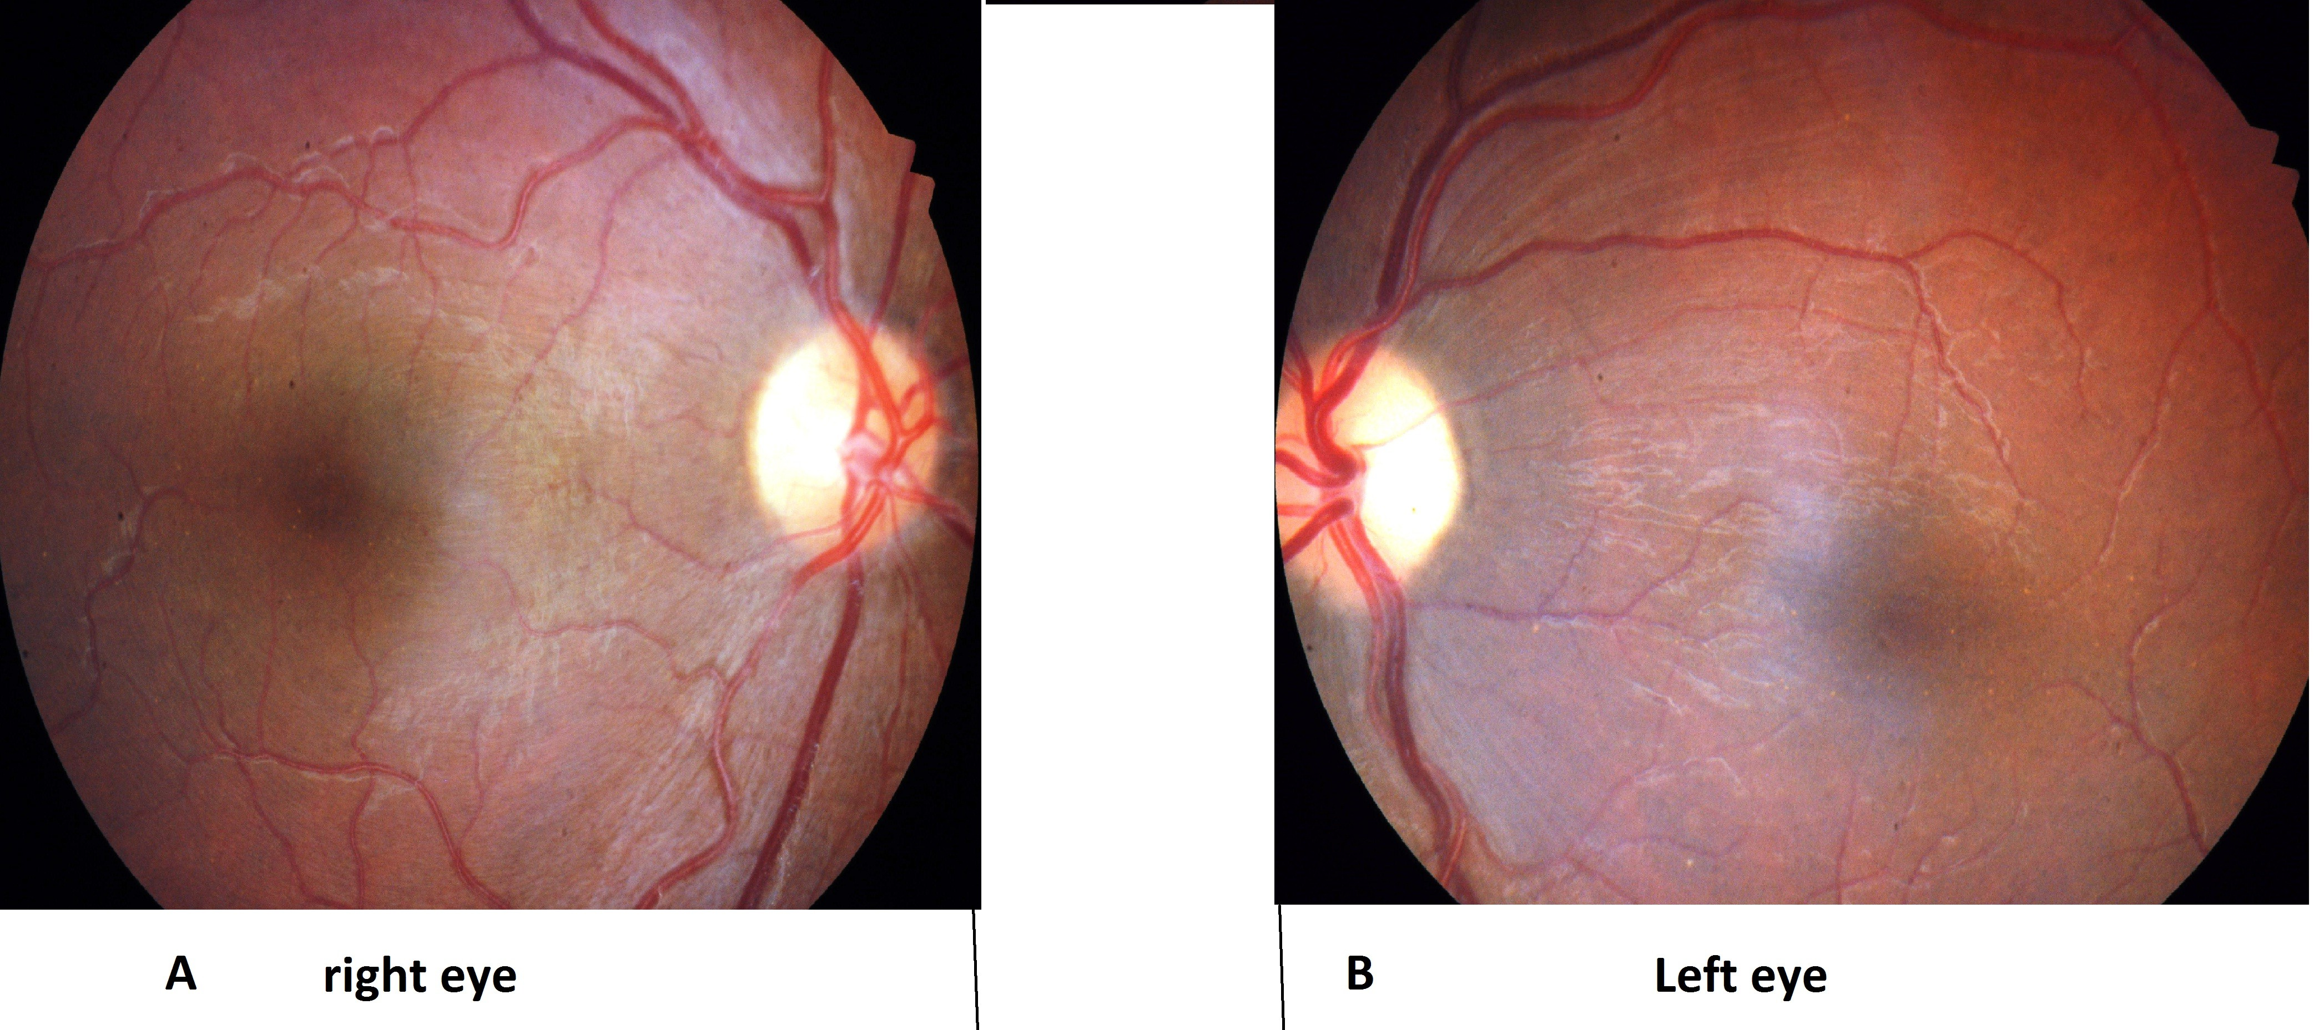

Figure 1. Fundus examination showing sectoral optic disc pallor in the left eye.

The profound bilateral visual impairment (meeting the criteria for legal blindness) precluded visual field testing.
Electrophysiological evaluation using visual evoked potentials (VEPs) revealed delayed responses with reduced amplitudes (Figure 2):
- Right eye: preserved waveforms with P100 latency delay at 30° and 60° checkerboard stimulation; hypovolted, disorganized responses to both checkerboard and flash stimuli.
- Left eye: severely reduced and disorganized responses to checkerboard and flash stimuli.
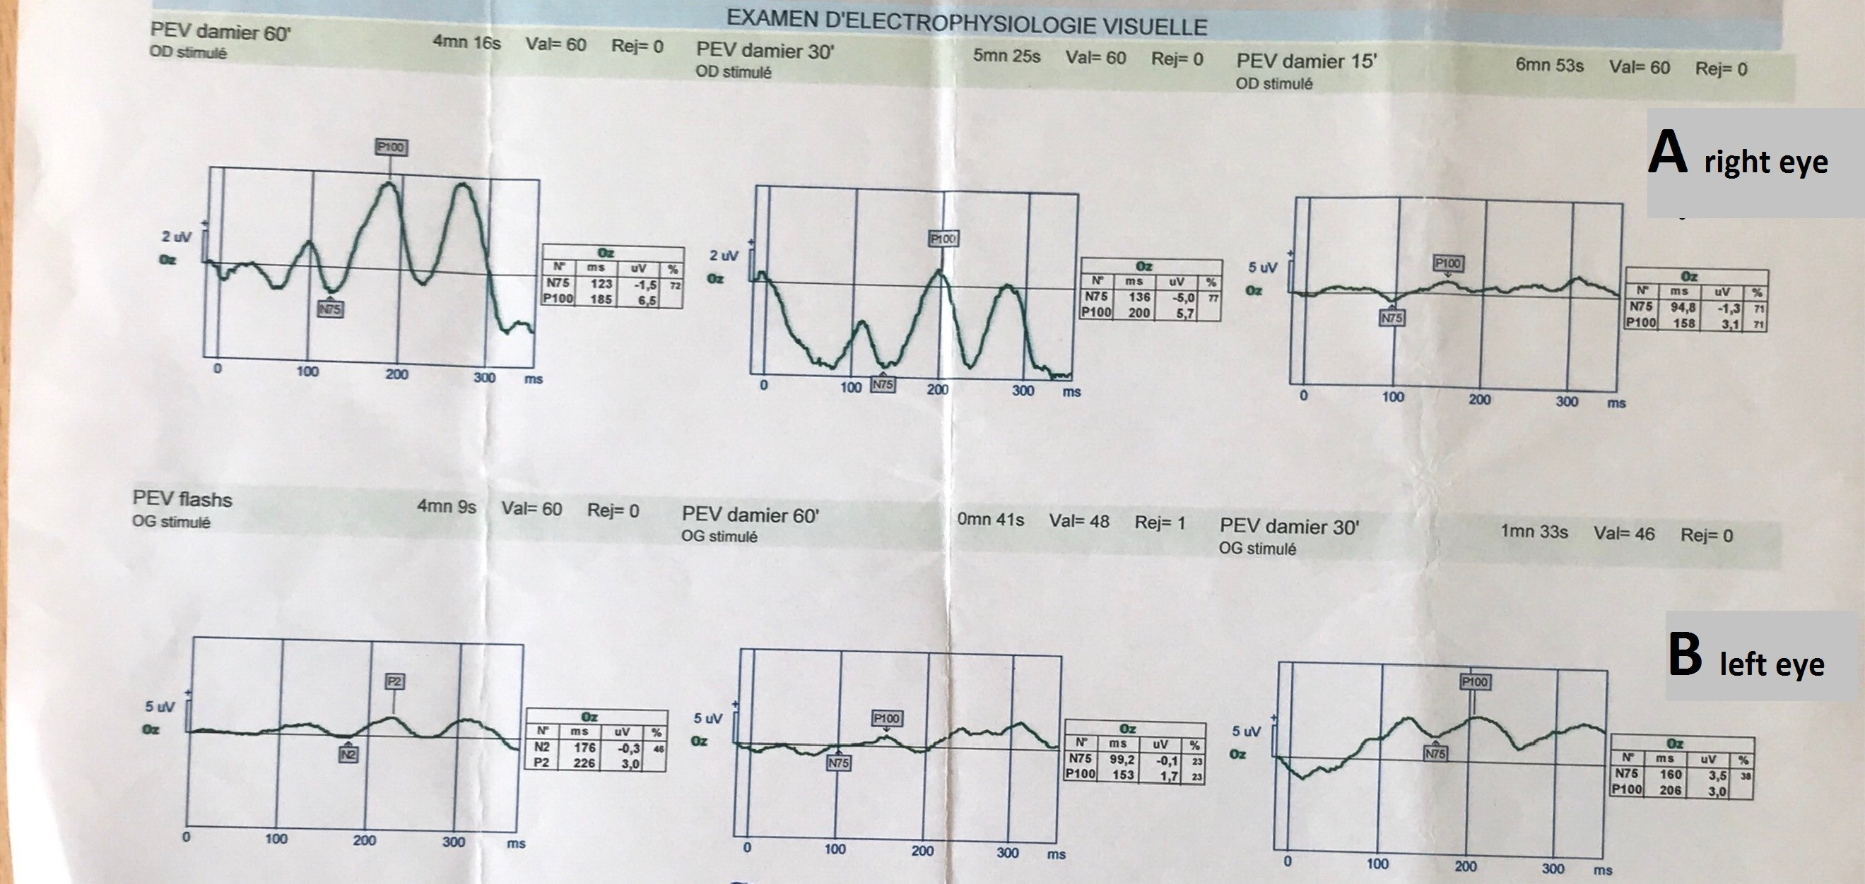

Figure 2. Visual evoked potentials (VEP). Delayed responses with reduced amplitudes were observed:
(A) Right eye: preserved waveform with P100 latency delay at 30° and 60° checkerboard stimulation; hypovolted and disorganized responses to both checkerboard and flash stimuli.
(B) Left eye: markedly reduced and disorganized responses to checkerboard and flash stimuli.

Magnetic resonance imaging (MRI) revealed an edematous contusion of the optic nerve within the optic canal measuring 4 mm in its long axis, associated with a temporal edemato-hemorrhagic contusion measuring 20 mm (Figure 3).

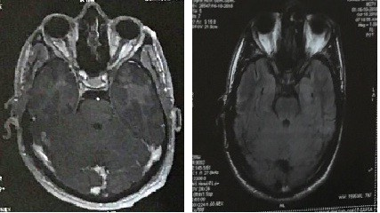

Figure 3. Axial MRI demonstrating an edematous contusion of the optic nerve before and after gadolinium contrast administration.
Given these findings, a conservative approach with close observation was adopted. Follow-up at one month showed significant functional recovery in the right eye, with visual acuity improving to 10/10, while the left eye remained stable with only light perception.

3.discussion

Post-traumatic optic neuropathy predominantly affects young adults, most frequently males under the age of 30 who are victims of violent trauma. Road traffic accidents represent the leading cause, with loss of consciousness reported in approximately 45% of cases (Steinsapir & Goldberg, 1994). The degree of visual impairment is highly variable and does not necessarily correlate with the severity of the trauma. Nevertheless, absence of light perception at presentation is observed in about 40% of cases, and initial visual acuity remains the most reliable predictor of final visual outcome (Levin et al., 1999).
The pathophysiology of TON involves several possible mechanisms, including optic canal fracture, disruption of the optic nerve microvasculature, neuronal stretching, or direct contusion of the nerve (Anderson et al., 1982). In our patient, the findings were most consistent with an optic nerve contusion.
The management of TON remains controversial, and no universally accepted guidelines exist. Various therapeutic approaches have been proposed, including surgical decompression, high-dose corticosteroid therapy, or a combination of both. However, surgical decompression of the optic nerve within the canal has not been shown to provide a significant advantage over observation alone and carries the risk of iatrogenic complications (Spoor & Hartel, 1990). Surgical intervention is generally reserved for specific cases, such as optic canal fractures with bone fragments compressing the nerve or hematomas of the optic sheath.
Similarly, the role of systemic corticosteroids in the acute phase has been increasingly questioned. Since the recommendations of the International Optic Nerve Trauma Study (Levin et al., 1999), high-dose corticosteroid therapy has largely fallen out of favor. Its initial use was extrapolated from studies in spinal cord injury, but subsequent randomized controlled trials failed to demonstrate any consistent benefit in TON. Moreover, recent reports have highlighted potential harm; for example, Steinshapir (2020) emphasized that high-dose corticosteroids may even increase short-term mortality following head trauma.
In our case, a conservative strategy of close clinical monitoring without intervention was chosen. Remarkably, the patient exhibited substantial visual recovery in the right eye, with visual acuity improving from light perception to 10/10 within one month, while the left eye remained stable at light perception. This spontaneous recovery further underscores the unpredictable natural course of TON and the need for individualized management strategies.

4. Conclusion

The management of post-traumatic optic neuropathy remains challenging and controversial. Current evidence discourages the use of high-dose systemic corticosteroids, as they appear to be ineffective and may even be associated with increased morbidity and mortality in patients with head trauma. Observation and individualized patient-centered management remain the most reasonable approach until more conclusive therapeutic strategies become available.

CONSENT
All authors declare that ‘written informed consent was obtained from the patient for publication of this case report and accompanying images.
DATA AVAILABILITY
Not applicable
ETHICAL APPROVAL
As per international standards or university standards written ethical approval has been collected and preserved by the author(s).

References

-Sabates NR, Gonce MA, Farris BK. Neuro-ophthalmological findings in closed head trauma. J Clin Neuroophthalmol. 1991;11(4):273–277.
-Roberts I, Yates D, Sandercock P, et al. Effect of intravenous corticosteroids on death within 14 days in 10,008 adults with clinically significant head injury (MRC CRASH trial): a randomised placebo-controlled trial. Lancet. 2004;364(9442):1321–1328.
-Rajiniganth MG, Gupta AK, Gupta A, Bapuraj JR. Traumatic optic neuropathy: visual outcome following a combined therapy protocol. Arch Otolaryngol Head Neck Surg. 2003;129(11):1203–1206.
-Levin LA, Beck RW, Joseph MP, Seiff S, Kraker R; International Optic Nerve Trauma Study Group. The treatment of traumatic optic neuropathy: the International Optic Nerve Trauma Study. Ophthalmology. 1999;106(7):1268–1277.
-Milea D. Neuropathie optique post-traumatique: faut-il éviter la corticothérapie à hautes doses? J Fr Ophtalmol. 2006;29(7):757–761.

