PERFORMANCE OF SOME SELECTED NATURAL DYE AND THEIR MIXTURE AS PHOTOSENSITIZERS IN THE
FABRICATION OF DSSCs

ABSTRACT
Performance of some selected natural dye and their mixture as photosensitizer in the fabrication of dye sensitize solar cell (DSSC) was examined. Six different cells of DSSC was fabricated using natural dye extracts from four different plant leaves; Bush or Wild mango leaf (WM), Mucuna pruriens (MS) leaf, Sand cherry (SC) leaf and African velvet tamarinds (AV) leaf. The fifth solar cell was fabricated using a mixture of only two of the dyes Mucuna pruriens and sand cherry (Co-MS) while the sixth cell was the mixture of four of the sample dyes (AV, SC, MP and WP) (Co-All) as the photosensitizer. These natural dyes from plants were extracted using ethanol as solvent employing the crude extraction method. The DSSC were successfully fabricated using Doctor Blade’s technique for the deposition of the TiO₂ on a transparent Fluorine-doped Tin Oxide (FTO) coated glass substrates. The structural analysis from XRD pattern of the samples showed prominent polycrystalline films with sharp and narrow diffraction peak intensities observed at (200), (210) and (310), (511) respectively, corresponding to 2θ values of 23.09º, 25.56º and 38.33º, 66.59º with an oriented growth of hexagonal structures, respectively. AV dye has the highest absorbance and reflectance value of 0.99 a.u and 0.21 a.u while Co-All has the peak transmittance value of 0.85a.u in the UV-Vis region of the electromagnetic spectrum. AV dye has the least band gap value of 2.32eV while WM has the most bandgap value of 4.50eV. The I-V characteristics of the fabricated films were analyzed under light illumination intensity of 1000W/cm² and dark illumination. The result showed that the efficiency of DSSC under light illumination is higher than that under dark illumination. Mucuna pruriens single dye produced the highest efficiency value of 0.14% while AV has the least value of 0.006%. Co-All has a slight higher conversion efficiency value of 0.029% under standard light illumination when compared to the Co-MS with value of 0.025%. The conversion efficiency of the dyes is not improved by co-sensitization.

Keywords: Titanium oxide;African velvet, wild mango, mucuna pruriens, and sand cherry leaves; DSSCs, bandgap, cell-efficiency.

- INTRODUCTION
Energy generation and distribution have been the major problem many of the developing countries in the world are facing today. This problem has caused a lot of migration of people and investors from one country to the other and from cities to the other. This has lead to wastage of some natural resources in different areas and such areas lags behind in terms of development and utilization of their natural resources. Electricity plays a very important role in the overall socio-economic and technological development of every nation of which total power failure adversely affects the economic growth and development of the country. Presently, to stop the menace of power shortage in the system and enhance socio-economic growth of nations, many researchers have resorted into searching for alternative forms of power generation to avert the problem.
Renewable energy is energy that is collected from renewable resources like sunlight, wind, rain, tides, waves, biomass and geothermal heat, which can be naturally replenished on a human timescale. Electrification with renewable energy is more efficient, reliable and also leads to significant reductions in primary energy requirements (Quaschning, 2013). Solar energy is a renewable energy source used currently by many nations of the world because its source is readily available. It is an energy generated from the sun and converted into usable forms using different technologies like Photovoltaic. A Photovoltaic system consists of series of solar cells joined together to form panel which generates electricity from the sun. The solar cell is a photonic device which operates on photoelectric effect by converting radiant and direct energy from the sun into electricity. Solar cell is a photoelectric cell whose electrical characteristics like current, voltage and resistance performance varies on exposure to sunlight. The monocrystalline silicon/polycrystalline silicon solar cells currently employed in industrial applications have achieved a photovoltaic conversion efficiency of more than 25 percent many decades ago (Green, 2016). However, such silicon-based solar cells are characterized by a high cost, harsh preparation conditions, and serious environmental pollution. The silicon solar cells made up the first generation of solar cells, which made up the 90% of the world PV market currently (Kerbs, 2009). In the quest to produce an alternative energy sources with limited resources, intensive research has been performed by researchers and still ongoing. The second generation solar cells still have lower efficiency though they have low cost of production and are easier to fabricate , lighter and more flexible due to their thin construction. Further attempt to reduce the cost of PV cell gave rise to the third generation solar cell. Dye sensitized solar cells (DSSC) and organic PV cells constitute the third generation solar cell even though that they have lower efficiency but their cost of fabrication is low (kerbs, 2009). O’Regan and Grätzel were the first to report on DSSC in their 1991 research. Long-term stability is one of the main challenges of DSSC and also electrolyte leakage, dye de-absorption, and degradation of the dye itself are considered the most important parameters affecting the cell stability (Sarwar et al., 2017). Many Researchers have been focusing on the modification of each component of the DSSC with the aim to improve the photovoltaic conversion efficiency by using different forms of nanostructured semiconducting particle or varying the natural dyes used as the photosensitizer. The performance of DSSC based natural sensitizer depends mainly on the molecular structure of the photosensitizer. The effective photosensitizer to be used must have ability to adhere strongly onto the surface of the semiconductor oxide through anchoring group (Cherepy, et al., 1997). According to Syafinar, et al., (2015) the efficiency of DSSCs improves when ethanol is used as a solvent compared to that achieved when distilled water is used. In this research, ethanol was used in the extraction of dyes of African velvet (AV), Mucuna pruriens (MS), Sand cherry (SC), Wild mango (WM) and thin films of Titanium oxide (TiO₂) using the Dr. Blade’s method to examine their properties for device apllpication.

- material and methods
2.1 chemicals and materials

The following materials were used in this research for the fabrication of the natural dye sensitized solar cells: Sand cherry leaf, Mucuna pruriens leaf, Wild mango leaf and African Velvet leaf, distilled water, 1600ml of ethanol, electronic weighing balance, aluminum foil, sieve, Fluorine doped tin oxide (FTO) substrate; with a sheet resistance of 16.6/sq, and 3mm thickness, titanium dioxide (Degussa P25), nickel dichloride, lead (pencil), triodide solution, filter paper, digital multimeter, petri-dish, nose mask, lab coat, masking tape, latex hand glove, beakers, ceramic mortar and pestle, cotton wool, glass stirring rod, ultrasonicator (JL-60DTH), temperature control furnace, detergent, UV-Vis (UV-1800), solar simulator machine, X-Ray Diffraction machine, blender, and spatula.

2.2 Dye Extraction
In the preparation of natural dye solution, the selected plant leaves collected were first washed with ordinary water, and then rinsed with distilled water and later with ethanol. The samples were allowed to dry under room temperature for four days. The dried samples were then blended separately using blender. 5g each of WM, MP and SC leaves were soaked in 80ml of ethanol in three separate beakers while 7g of AV tarmarind leaf was soaked in 80ml of ethanol. A Co-MS was prepared by soaking 2.5g each of the samples in 80ml of ethanol and a Co-All was prepared by soaking 1.30g each of MP, WM, AV and SC leaf in 90ml of ethanol making a total sample of 5.20g. Each of these samples was covered with an aluminum foil and soaked for 2hours 15mins for maximum dye extraction. The amount of ethanol and weight of the leaf used is based on the texture of different plant leaves since some leaves are more fibrous, lighter and drier than others. MP (chlorophyll) and SC (anthocyanin) leaf were co-sensitized due to the behaviour and position of different leaf pigments in the electromagnetic spectrum. The collected dye were filtered first with sieve, then with filter paper and preserved for use.
2.3 Preparation of FTO glass
The FTO glass to be used was cleaned with ethanol and dried in a temperature controlled unit for 30 minutes at temperature of 60⁰C in a furnace. The conducting side of the substrate was determined using a digital multimeter. The TiO₂ paste was prepared by stirring continuously 1gram of TiO₂ powder in a ceramic mortar using pestle for about 45minutes with gradual addition of 15ml of ethanol to separate aggregate particles and achieve homogeneity. To produce a uniform and homogeneous suspension, 1 ml of ethanol was added and the mixture was grounded before the addition of another 1ml of the solution. The process continued until the 15ml of ethanol solution was used up. The grinding and stirring process lasted for about 45 minutes. Dried particles of TiO₂ collected at the sides of the mortar and on the pestle were removed and returned to the center of the mortar using a flexible spatula. Another conductive glass was used to produce the counter electrode. A digital multimeter was used to check for the conductive face of this glass. The conductive face of the glass substrate was all coated using a pencil made of lead
2.4 Deposition of TiO₂
Doctor Blade method of deposition technique was used here. The two parallel edges of the conducting face of the FTO were covered with a masking tape, covering about 0.15 to 0.2cm of the FTO substrate before the deposition of the TiO₂ on the FTO substrate. A transparent fluorine-doped tin oxide conducting glass with average dimension of 2.35cm by 2.50cm was used as substrate for the deposition of TiO₂. Few drops of the TiO₂ solution were uniformly placed on the substrate and a glass stirring rod was used to spread the material uniformly on the FTO glass, sliding over the uncovered portion of the glass. Immediately after the deposition, all the deposited samples were allowed to dry at ambient temperature for 45minutes. The scotch tape was then carefully removed and the electrode sintered at the temperature of 450ºC for 30minutes using a temperature control furnace. The sintered TiO₂ coated conductive glass substrate was allowed to gradually cool down inside the furnace before it was removed to avoid cracking. All these were done to promote electrical contact and mechanical adhesion on the glass

2.5 Dye Sensitization of the TiO₂ Deposited Substrate
The two parallel edges of the conducting face of all the working electrodes were covered with scotch tapes to avoid dye impregnation around those areas. Each of the working electrodes were gradually placed inside the beaker with the TiO₂ deposited surface faced up to avoid scratching and the dyes poured into the beakers with the name of the dye labeled on it. The beakers were covered with an aluminum foil and the impregnation process lasted for 24 hours for the dye molecules to naturally absorb onto the TiO₂ particle. The dye-stained TiO₂ film was carefully removed after 24 hours using tongs, and the samples were placed inside a petri dish with the sensitized surface facing up ready for characterization.

2.6 Assembly of dye sensitized solar cells (DSSC)
The liquid electrolyte solution was prepared by dissolving 0.5M of potassium iodiode salt (KI) and 0.05M of iodide (I₂) into acetonitrile. Each of the dye sensitized TiO₂ electrode sample were displayed on a laboratory table such that the deposited film side faced up, and the counter electrode was placed on top such that the conductive side of the counter electrode made direct contact with the TiO₂ film. The two opposing glass slides were offset such that all of the TiO₂ was covered by the counter electrode, and about 0.2cm from the two parallel edges of the part of the glass not coated with TiO₂ was exposed. The two parallel edges of the glass slides was joined together with a Crocodile clips, and the liquid iodide redox electrolyte was injected through the edges of the slides to form a complete dye sensitized solar cell.

2.7 Characterization of the samples

The current-voltage characteristics of the fabricated cells were determined using a solar simulator under dark and light illumination, the sample structural properties were determined using X-Ray Diffraction (XRD) machine, while the amount of spectra absorbed by each sample is obtained using Ultraviolet Visible Spectrophotometer (UV-Vis) machine.

3. results and discussion

3.1 Optical properties of fabricated cells
The optical analysis of the samples revealed the interaction of the fabricated cells with incident light. The optical absorbance of the cell at various wavelength was measured while the transmittance and reflectance of dye were calculated using the absorbance value.
Fig.1 represents the graph of the measured absorbance of the deposited DSSC films against wavelength. The figure showed that all the individually sensitized cells, have their peak absorbance within the ultraviolet-visible region of the wavelength spectrum. African velvet dye has the highest absorbance of 0.99a.u at the wavelength of 355-385nm which continuously drop sharply towards the Infra-red region as the wavelength of radiation increases. It was observed that Wild mango and Sand cherry showed an increase in their absorbance between wavelength of 600-750nm, respectively, though their peak lies in the ultraviolet-visible region. For the co-sensitized dyes, Co-All has the highest peak absorbance value of 0.28 a.u in the ultraviolet while Co-MS has an absorbance value of 0.19. There is an increase in the absorbance peak value when all the sample dyes were co-sensitized than when only two of the dyes were co-sensitized. This phenomenon exhibited by the co-sensitized dyes has been explained by Isah et al., (2017) to be as a result of dye synergy absorption effect due to co-sensitization.

Figure 2: shows the optical transmittance of all the deposited films which indicates that the cells have a gradual transmittance in the ultra-violet region which increases steadily to a peak transmittance value in the ultraviolet to infra-red region of the electromagnetic spectrum as the case may be. For the individual samples, African velvet dye extract produced the highest peak value of 0.84a.u in the Infra-red region. For the co-sensitized dyes; the Co-All had the highest transmittance value of 0.85a.u in the visible region of the electromagnetic spectrum when compared with Co-MS. Generally, Co-All has the highest transmittance value in the visible region for all the fabricated dyes. This transmittance value of the fabricated cells position the films as an efficient material for promoting sustainability in the window environment to maintain indoor brightness as observed by Xianhu et. al., (2025).
From fig 3: the reflectance peaks of the various dye extracts differs within the range of 0.19 to 0.21a.u as observed for all the dyes in the UV-Visible region of the electromagnetic spectrum. For the individually sensitized dyes, AV dye showed a peak reflectance of 0.21a.u in the visible region and a steady decreases in the visible and infra red region. The SC dye, WM dye and MP dye with reflectance peak of 0.20, 0.199 and 0.198a.u, respectively remained constant throughout the UV-Vis region and decreases in the infra-red region.

For the co-sensitized cells also in fig 3: Co-All has a peak value of 0.195a.u in the UV region and this continuously decreases in the visible-infra red region as the wavelength of radiation increases while the Co-MS dyes has a peak reflectance of 0.18 in the UV region which decreases slightly and remained constant in the Vis-NIR region. It is very obvious that all the deposited dye samples exhibited very poor reflection of light throughout the UV-Vis-NIR region of the electromagnetic spectrum. This feature of poor reflection exhibited by all the dye samples makes the material a very essential material for use as an anti-reflective coating on solar cells fabrication in order to achieve high efficiency as observed by Jero, et al., ( 2020).

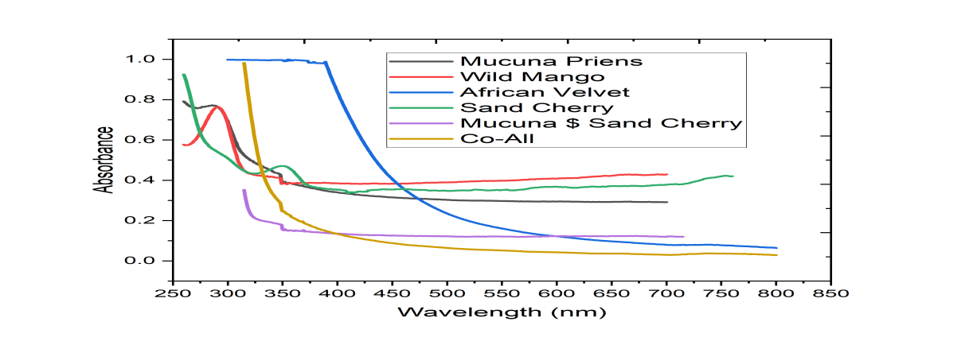
Fig 1. shows the optical absorbance of the dye cells.

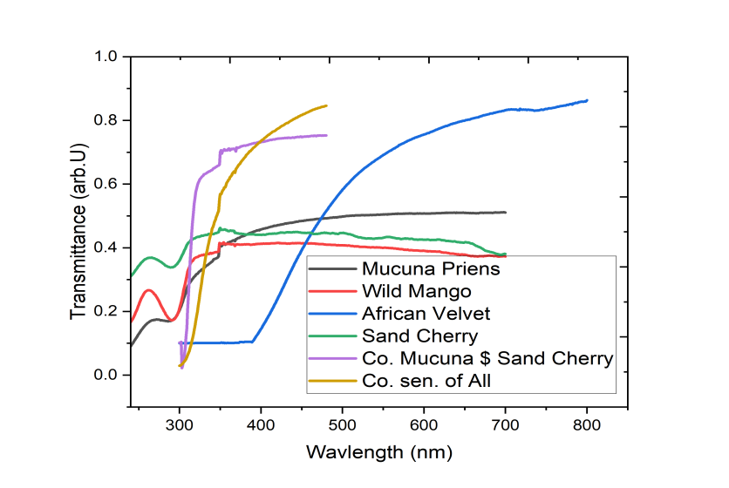
Fig 2 shows the optical transmittance of the dye cells

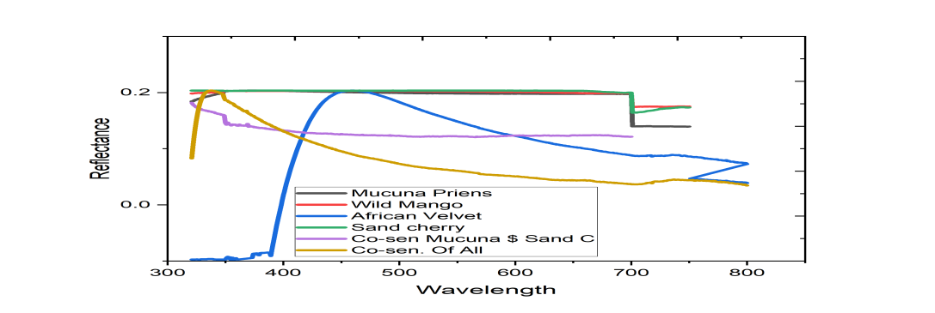
Fig 3 shows the optical reflectance of the dye cells

Fig 4 shows the tauc plots of the square of absorption coefficient (αhν)² against photon energy (hν) for each of the dye samples. The bandgap energy of the films estimated through the Tauc’s relation as used in (Nwori et al., 2021).

$hv$=β($hν -Eg$)^{n} 1.
Where n is the band transition factor which has values 0.5 for direct allowed band transition, 2 for indirect band electronic transition, 1.5 for direct forbidden band transition and 3 for indirect forbidden band transition, β is a constant known as band trailing parameter, h is the plank constant, v is the frequency and α is the absorption coefficient. The absorption coefficient (α) for the films was calculated using the formula given by Srivastava et al., (2013).
$α=\frac{A}{λ}$ 2.
The results obtained for bandgap energies are as follows; AV 2.32 eV, MP film is 3.53 eV, SC film is 3.56 eV, WM film is 4.50 eV, Co-MS film is 3.95 eV and Co.All film is 3.52eV. From the result, it was observed that; for the individual samples, AV cell has the least optical energy band gap of 2.32eV while WM has the highest optical band gap value of 4.50eV. For the co-sensitized dyed cells; the Co-All the samples has the least optical bandgap energy with the value of 3.52eV and Co-MS value is 3.95eV.

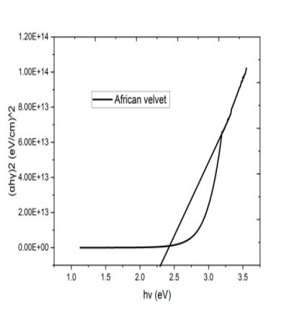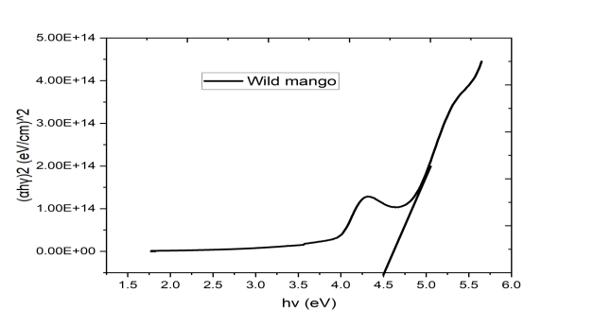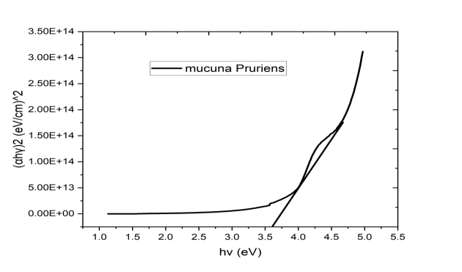
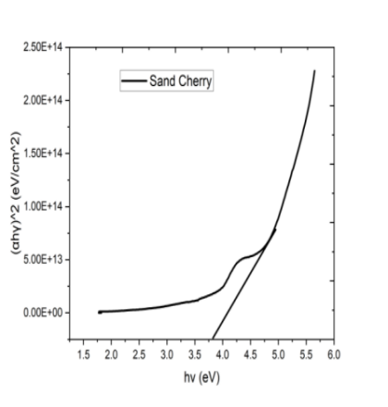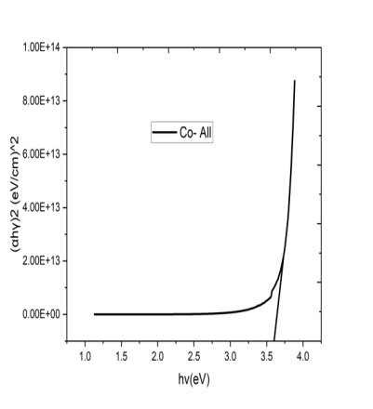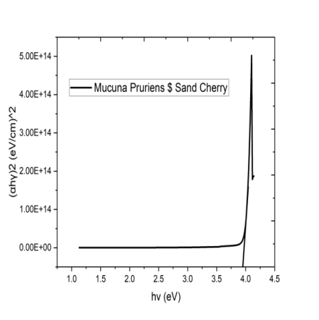
Fig 4: Optical energy band gap plot of AV,WM, MP, SC, Co-All and Co-MS

3.2: Structural Analysis of the fabricated dye sensitized solar cells

The XRD pattern showed irregular polycrystalline structures that have a fairly randomly oriented peak. The figures shows that the deposited films have a crystalline structure with prominent intense peak at 2θ values of 25.56º which aligned with the hexagonal structure obtained by Ikhioya, et. al., (2022)

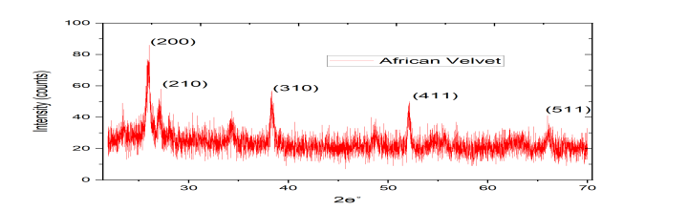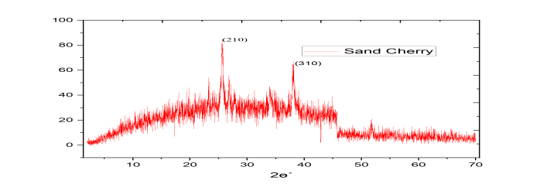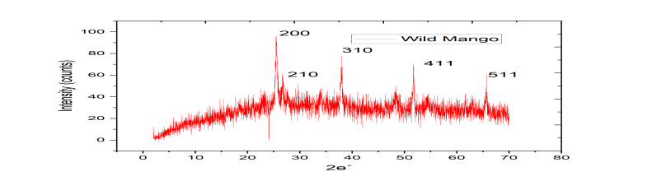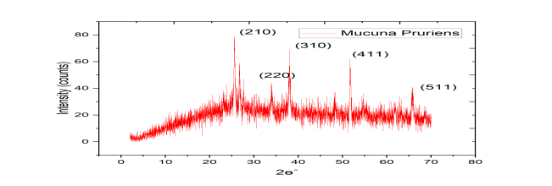
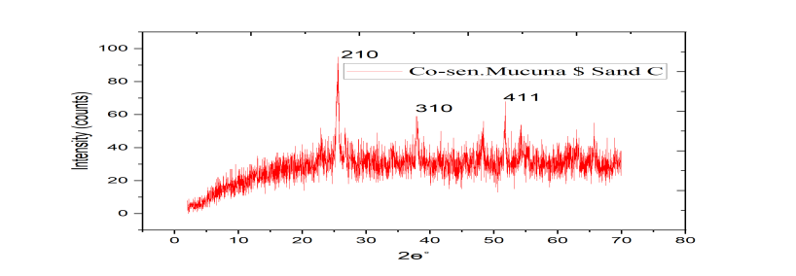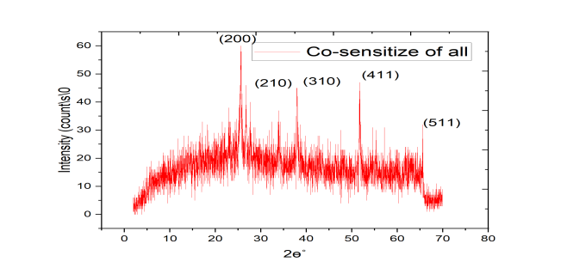
Figures 5: XRD spectra of AV,SC,WM,MP,Co-MS and Co-All dye
3.3 Current-voltage characterization of the deposited films.
The current-voltage (I-V) characterizations of the cells were determined under dark and light illumination intensity using a solar simulator. The illumination intensity used was at 1000mW/cm². The value for the maximum current, J_{mp} ,maximum voltage, V_{mp} open circuit voltage V_{oc}, short-circuit current I_{SC}, were obtained from the plots of current density and voltage. The fill factor, FF which is a figure of merit for the solar cell, and the solar cell photoelectric conversion efficiency were also calculated using equation as in (Isi et. al., 2021 and Emmanuel et al., 2022).

FF = $\frac{ Vmp x Jmp}{Voc x Jsc}$ = $\frac{P_{m}}{V_{OC ×J_{SC}}}$ 3
The photoelectric conversion efficiency was also calculated using;
η = $\frac{Jsc x Voc x FF}{P_{in}}$ x100 4

Where $P_{in}$ is the solar illumination intensity used. From the table 1, it can be observed that the efficiency of these fabricated dyes are still lower than the current efficiency of the existing DSSC.

Table 1. Summary of the PV parameters and performance of the I-V Curves
Samples | V_{mp}  mV | J_{mp}  mA/cm² | V_{oc}  mV | J_{sc}  mA/cm² | P_{mp}  mAV/cm² | FF | Efficiency Ƞ (%)
AV Dark | 328.59 | 0.000219 | 395.05 | 0.0004 | 0.072 | 0.407 | 0.0019
AV Light | 406.91 | 0.000563 | 484.47 | 0.0012 | 0.229 | 0.394 | 0.0062
MP Dark | 28.99 | 0.132 | 58.84 | 0.266 | 3.827 | 0.244 | 0.1007
MP Light | 31.96 | 0.163 | 53.184 | 0.27 | 5.209 | 0.363 | 0.1371
SC Dark | 338.49 | 0.000385 | 392.96 | 0.0007 | 0.130 | 0.509 | 0.0034
SC Light | 409.37 | 0.0011 | 481.00 | 0.0002 | 0.450 | 4.927 | 0.0119
WM Dark | 319.7 | 0.002 | 394.71 | 0.0043 | 0.639 | 0.378 | 0.0168
WM light | 415.39 | 0.0064 | 483.52 | 0.013 | 2.658 | 0.423 | 0.0699
Co. MS dark | 382.15 | 0.0023 | 424.81 | 0.0037 | 0.879 | 0.559 | 0.0232
Co.MS light | 385.41 | 0.0025 | 482.25 | 0.0077 | 0.963 | 0.259 | 0.0254
Co.All Dark | 369.29 | 0.000332 | 484.28 | 0.0009 | 0.122 | 0.268 | 0.0032
Co.All light | 459.44 | 0.00243 | 588.08 | 0.0009 | 1.116 | 2.028 | 0.0293
*I-V characteristic calculation

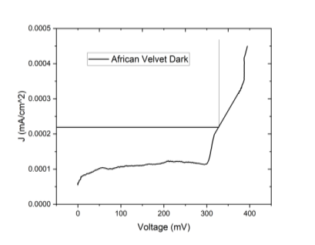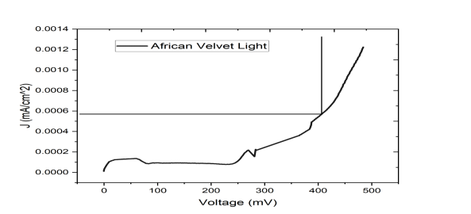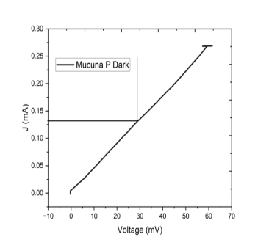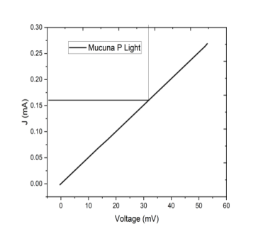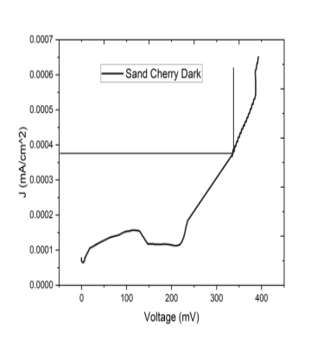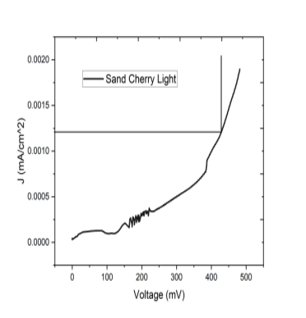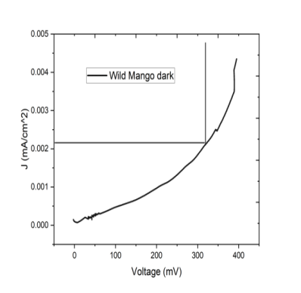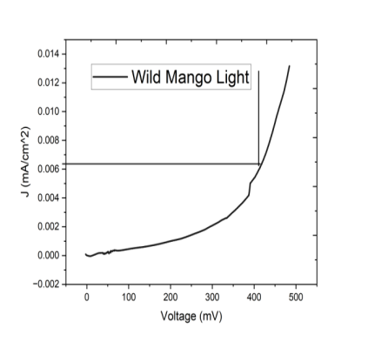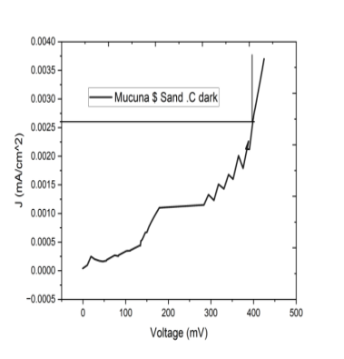
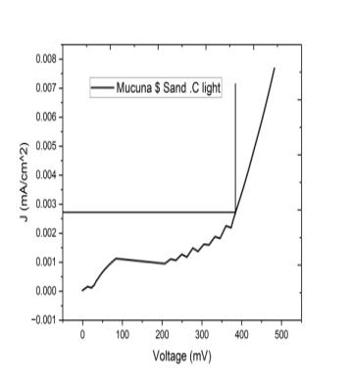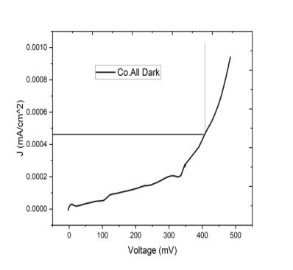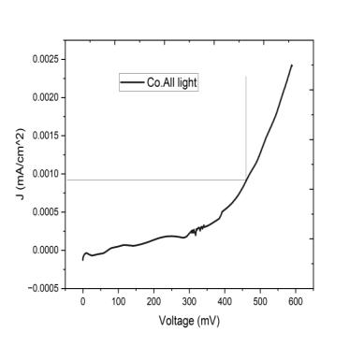
Fig 6: I-V characteristic of AV, MP, SC, WM, Co-MS and Co-All in dark and light illumination

4 CONCLUSION

Dye sensitized solar cells (DSSC) thin film structures of TiO2 deposited on FTO glass substrate using the method of Dr. Blading techniques have been successfully fabricated in this work for possible applications. The dyes of African velvet (AV), Sand cherry (SC), Mucuna pruriens (MP), Wild mango (WM), co-sensitized dyes of sand cherry and Mucuna pruriens (Co-MS), and co- sensitized dye of all the samples (Co-ALL) used as photo-sensitizer on the deposited films were extracted using ethanol. The deposited samples were subjected to different characterization techniques to determine their optical, structural and photovoltaic properties. The optical analysis on the film showed that single dye of African velvet dye has the highest peak absorbance and reflectance value for the deposited dyes which is more than that of the co-sensitized dyes of Co-MS and Co-All while the co-sensitized dye of all the samples (Co-ALL) has the highest peak transmittance value. The high absorbance spectra of the fabricated dyes made the cells an excellent material to beused as anti-reflecting surface for the fabrication of DSSC. The bandgap energies of the deposited dyes are; AV 2.32eV, SC 3.56eV, MP 3.53eV, WM 4.50eV, Co-MS 3.95eV and Co- All 3.52eV. This wide bandgap values These bandgap values positioned the cells as an excellent material for DSSC fabrications in; indoor lighting, transparent solar cell used in window for light transmission and flexible electronics. The structural analysis shows that all the dye samples have a polycrystallinestructure, and their corresponding peaks aligned with the hexagonal structure , this positioned the solar cell as a good material for solar energy harnessing. The I-V characterization carried out under dark and light illumnation revealed that the efficiency of the cell efficiency of the dyes under direct illumination is higher than that under dark illumination. Also, the efficiency of a single dye Mucuna pruriens is higher than that of the co-sensitized dyes which showed that co- sensitization of the dyes under the study did not actually improve the conversion efficiency of the cells.

REFERENCES
Cherepy, N. J., Smested, G. P., Gratzel, M. & Zhang J.Z. (1997). Ultra fast Electron
injection: implication for photoelectrochemical Cell Utilizing an Anthocyanin Dye sensitized TiO2 Nanocrystaline electrode. Journal of Physical Chemistry.B 101,9342-9351.
Emmanuel, O. C., Donald, O. N., & Ikhioya, I. L. (2022). Effect of Doping and Co-sensitization on the Photovoltaic Properties of Natural Dye-sensitized Solar Cells. SSRG International Journal of Applied Physics, 9(3), 44- 54.
Green, M. A. (2016). commercial progress and challenges for photovoltaics. Nature energy journal pp.4
Ikhioya, I. L., Akpu, N. I. & Ochai-Ejeh, F. U. (2022). Influence of erbium (Er) dopant on the enhanced optical properties of electrochemically deposited zinc oxide (ZnO) films for high- performance photovoltaic systems. Optik, 252, 168486.
Isi, P.O., Ekpunobi, A.J. & Okoli, D.N. (2021). Optical and electrical properties of fabricated solar cells based on extract from bush tea (hyptissuaveolens). Journal of Applied physics (IOSR- JAP), 13(4): 01-07
Isah, K. U., Sadik, A. Y., & Jolayemi, B. J. (2017). Effect of Natural Dye Co-Sensitization on the Performance of Dye-Sensitized Solar Cells (DSSCS) Based on Anthocyanin and Betalain Pigments Sensitisation. European Journal of Applied Sciences 9 (3): 140-146.
Kerbs, F. C. (2009). Polymer Solar Cell Molecules Prepared using Roll-to-roll Methods: Knife-over-edge Coating and Screen Printing. J. Solar Energy Material and Solar Cells 93(4), 465-473 Jeroh, M. D., & Okoli, D. N. (2012). Optical and structural properties of amorphous
antimony sulphide thin films: Effect of dip time. Adv. Appl. Sci. Res, 3(2), 793-800.
Nwori, A. N., Okoli, N. L., Okereke, N. A., Ottih, I. E., & Ezenwaka, L. N. (2022).
Optical Properties of Electrodeposited CdMnS Thin Film Semiconductor
Alloys for Optoelectronics Applications: Effect of Deposition Potential. Journal of Nano and materials science Research,1,58-67.O'regan, B., & Grätzel, M. (1991). A low-cost, high-efficiency solar cell based on dyesensitized colloidal TiO2 films. nature, 353(6346), 737-740.
Quaschining, V. (2013). Renewable energy system. Technology calculation- stimulation.
Retrived from https://www.osti.gov/Renewable-energy-system- Technology-calculation-
stimulation on 21 April 2024.
Sarwar, S., Kwan-Woo, K., Jisu, H., Chi-Hwan, H., Yongseok, J. & Sungjun, H. (2017). Improved long-term stability of dye sensitized solar cell by zeolite additive in electrolyte.
https://doi.org/10.1016/j.electacta.2017.05.191. (retrieved) on 10 August 2023.
Srivastava, M., Singh, J., Mishra, R. K., & Ojha, A. K. (2013). Electro-optical and magnetic properties of monodispersed colloidal Cu2O nanoparticles. Journal of Alloys and Compounds, 555, 123– 130. Doi:10.1016/j.jallcom.2012.12.049.
Syafinar, R., Gomesh, N., Irwanto, M., Fareq, M. & Irwan, Y. M. (2015). Optical characterization using nature-based dye extracted from hibiscus’s flower. ARPN Journal of Engineering and Applied Sciences, 10(15), 6336-6340

