Evaluation of the thermal performance of a locally designed and manufactured optimized roasting oven

Abstract
The present work concerns an experimental study of the energy performance of a prototype optimized oven developed by local craftsmen. The Water Boiling Technique (WBT) is the method used to evaluate the energy efficiency of the oven. The temperatures of the oven walls and the ambient temperature were measured to evaluate energy losses by convection into the environment. The oven's heat balance was used to determine the amount of energy lost through the smoke. The results showed that a large amount of thermal energy is lost through the smoke (50% of the energy generated by gas combustion). Losses through the walls were reduced to 8%. The oven's efficiency reached 42%. This is in line with the standard efficiency of optimized gas ovens (between 40 and 50%). Losses related to fumes remain considerable, hence the need to work on reducing them for better oven optimization.
Keywords: roasting oven, WBT, heat balance, thermal performance, efficiency

Introduction
The Rio Earth Summit, held in 1992, marked a major turning point in how we think about sustainable development [1]. It emphasized that environmental protection and natural resource management are not simply ecological concerns, but essential conditions for ensuring a better future for all, particularly for the most vulnerable populations. Including these principles in development programs not only improves living conditions, but also ensures that resources are sustainable for future generations. In many developing countries, biomass is the main source of energy used for cooking meals [2][3][4]. In Burkina Faso, 90.1% of households use solid fuels (wood and wood products) as their main source of cooking energy [5], and this situation is not expected to change significantly in the coming decades [6]. This high degree of dependence has a negative impact on forest resources. Between the years 1992 and 2002, the rate of deforestation was estimated at 107,626 ha/year [7]. To answer this question, research in recent years has focused on developing more efficient cooking technologies. Significant advances have made it possible to move from traditional three-stone stoves (3PT), which lose 85–90% of their energy to the environment [8], to improved stoves (IS). The latest stoves incorporate various techniques designed to increase energy efficiency.
According to Kailasnath et al. [9], a well-designed stove must take the following factors into account:
• The quality of combustion, which depends on the type of fuel used and its position in the stove.
• Construction materials: traditional stoves are generally made of clay, bricks, and cement. For several decades, metal has been the preferred material used in the manufacture of IS, due to its low thermal inertia, portability, and compatibility with the incorporation of optimization materials. Improved stoves now incorporate insulation and high-density rocks [10], such as granite, which have excellent heat storage properties. These innovations reduce fuel consumption by more than 78% compared to traditional fireplaces. Furthermore, Derese T. N. et al. [11] developed improved biogas stoves in Ethiopia for cooking traditional Injera bread. Performance tests showed that these systems offer energy savings of 40 to 50% compared to 3PT stoves.
The standard Water Boiling Test (WBT) method is widely used to evaluate the performance of stoves and ovens. It simulates the cooking process to determine the efficiency of the fuel in heating water in a pot, as well as the emissions produced during this operation [12–15].
In the case of ovens, an energy balance is necessary to estimate their performance, taking into account wall losses and smoke losses. Several studies have been conducted in this regard:
The studies conducted by SEGBEFIA E. K. M. et al. [16] compared the thermal performance of two improved clay stove models with that of a traditional stove (reference model). The performance indicators (specific boiling time, thermal efficiency, and specific consumption) of the two stoves were evaluated using the WBT. The obtained results showed that the specific consumption of the improved clay stove (single pot) is equivalent to 0.08 ± 0.01 kg/l and that of the improved multi-pot clay stove is 0.09 ± 0.01 kg/l compared to 0.33 ± 0.03 kg/l (reference stove). The boiling times were 10.24 minutes, 11.47 minutes, and 13.26 minutes for the single-pot improved clay stove, the multi-pot improved clay stove, and the standard stove, respectively. The energy efficiencies in percentage terms are 18 ± 0.03, 22.05 ± 1.18 and 20.15 ± 1.41 for the reference stove, the improved multi-pot stove and the improved single-pot stove, respectively.
William FOTSEU et al. [17] characterized and improved a “Dolo” cooking stove equipped with a vegetable oil burner (JATROPHA). They measured the energy performance of this prototype and compared the results with the performance of an improved stove using the WBT. Their work shows that the thermal efficiency of this stove is 28% compared to 35% for the improved stove built with bricks (a mixture of clay, cow dung, and straw). Changes to this prototype, in particular installing baffles to direct the flow of hot combustion gases and insulating the walls of the cookstove with a 10 cm thick layer of sand, the efficiency was increased from 28% to 43%.
In some other studies on gas stoves, other WBT standars were used to figure out how well the stoves worked. For example, Khan et al. [18] looked at how well a LPG stove worked with various types of burners. To check this out, they did the WBT based on Indian standards. The method consisted of heating a quantity of water taken at ambient temperature T1 to boiling point. To do this, the mass of the gas cylinder was weighed before the start and at the end of the test to determine the mass of gas consumed. When the final temperature T2 of the water reached 80°C, the burners were turned off. Energy efficiency is then calculated by comparing the energy received by the load (stove and water) to the total energy generated by the mass of LPG consumed. Their study shows that energy efficiency increases with the insulation of the cooker enclosure. In addition, the design and materials of the burners have a significant impact on the efficiency of the cookers. Their results also demonstrated that the use of flat-head brass burners achieves an efficiency of around 58%, as opposed to around 50% for flower-head burners.
Gohil Pankaj et al. [19] studied the thermal performance of conventional LPG cookers using the WBT according to the Indian standard protocol: IS 4246:2002. The principle of their test consisted of boiling a quantity of water taken at a temperature T1. The water is heated to 80°C, at which point stirring begins. Stirring continues until the burners are extinguished. The burners are extinguished when the water temperature reaches T2= 90°C +1°C. The mass of gas consumed is determined before and after the test. The burner is preheated for 5 minutes before starting the WBT. The calculated energy efficiency is 66.27%.
Abasiryu T. et al. [20] evaluated the energy efficiency of four types of solid fuel stoves. To do this, they used the TEE on different stoves, including: the 3PT stove, the metal wood-burning stove, the metal charcoal stove, and the fired clay charcoal stove. The boiling time and fuel mass flow rate of each stove were also determined. The results obtained show efficiencies of 9.46%, 11.64%, 17.6%, and 20.02% respectively for the 3PT stove, the metal stove, the fired clay stove, and the oven.
In general, it is important to carry out an energy assessment to evaluate the performance of ovens. Indeed, in ovens, wall heat loss and heat loss through smoke must be taken into account. Several studies have evaluated the efficiency of ovens through a heat balance. We can note the following:
Manhiçiao et al. studied the energy efficiency of a wood-fired bakery oven in Mozambique [19]. In their study, they evaluated the efficiency of ovens based on their specific consumption. The investigations focused on wood-fired ovens, as these are the most commonly used in the country. The results obtained reveal a specific consumption of 0.55 kg of wood/kg of baked wheat flour for the indirect oven and 0.9 kg of wood/kg of wheat flour for the semi-indirect oven, with an average standard value of 0.55 kg of wood/kg of flour.
Anthony A. Bantu et al. [21] have evaluated the energy efficiency of an oven using the high-density heat of granite rocks. The theoretical results of the energy balance showed that 65% of the energy generated by coal combustion is lost through the gases produced by combustion and the oven walls.

Anielo Falciano et al.[22] carried out an energy assessment of a traditional wood-fired pizza oven during their research. The results revealed that the energy generated by combustion was distributed as follows: 46% lost through smoke, 26% lost to the environment through the walls, 28% stored in the bricks, and 12% useful energy (absorbed by the load).
The work conducted by Abdoulaye O et al. [23], who studied the performance of a traditional oven built from compacted clay, using plant waste as fuel and reaching temperatures above 1000°C. To do their study, they carried out a heat balance of the oven when cooking corn. Their study showed that 53% of the energy generated by the fuel is loss through the smoke, 23% is stored in the oven mass, and the oven's efficiency is 10%, which is in line with predictions in the literature.
Gael L. Sawadogo et al. [24] studied energy losses during the operation of a grill oven through an energy balance. To do this, four (04) kilograms of charcoal were placed in the oven for combustion. After the experiment, it appeared that out of 3 kg of charcoal burned, 1.47 kg was loss through the oven walls, which corresponds to nearly 50% of the total energy generated by combustion.
Serge IGO et al. [25] used the Water Boiling Test (WBT) to show that locally made uninsulated roasting ovens (commonly used in Burkina Faso) have yields of around 19%, losses through smoke estimated at 55% and losses through metal walls of 36%. Subsequently, another study was conducted on the same prototype oven, simply insulated with glass wool [26]. The results showed that the oven's yield is 35% with energy losses through the insulated walls of 22% and losses through smoke estimated at 50%.
David NAMOANO et al., [27] have conducted a numerical study to optimize the roasting ovens commonly used in Burkina Faso and, above all, to reduce the temperature of the external walls. The results obtained showed that double insulation of the oven walls with optimal thicknesses of 3 cm of glass wool and 15 mm of plywood improves heat transfer in the roasting oven and limits the external temperature to a maximum of 70°C. In this study, we will use the water boiling test (WBT) to evaluate the thermal performance of this kind of double-insulated oven that has been developed.
2. Materials and methods
2.1. Materials
In this study, we used the following equipment:
- A prototype roasting oven. We designed an optimized roasting oven by inserting double insulation between the walls of the metal oven model, composed of 3 cm of glass wool and 1.5 cm of plywood.
This device has a parallelepiped shape with dimensions (L x W x H = 1 m x 0.84 m x 0.72 m) and is topped with a chimney 12 cm high and 5 cm in diameter. Combustion is ensured by two steel axial burners. The oven can hold up to 20 kg of meat.

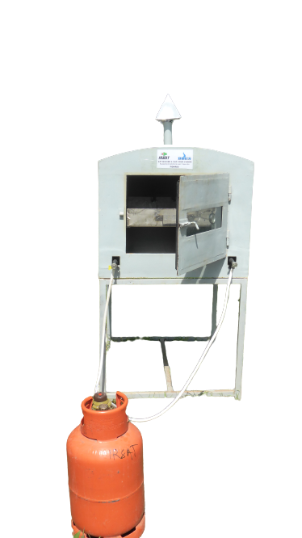

Figure 1: Double-insulated roasting oven connected to a butane gas cylinder
-A steel tray or pan (Figure 2) containing 20 liters of water.
-Measuring equipment comprising 3 m long type K precision thermocouples: ±1.5 °C connected to a temperature recorder (data logger) shown in Figure 3 and a precision balance: ±1 g (Figure 4).
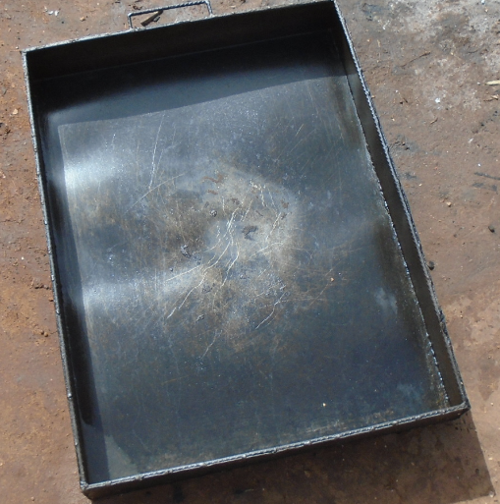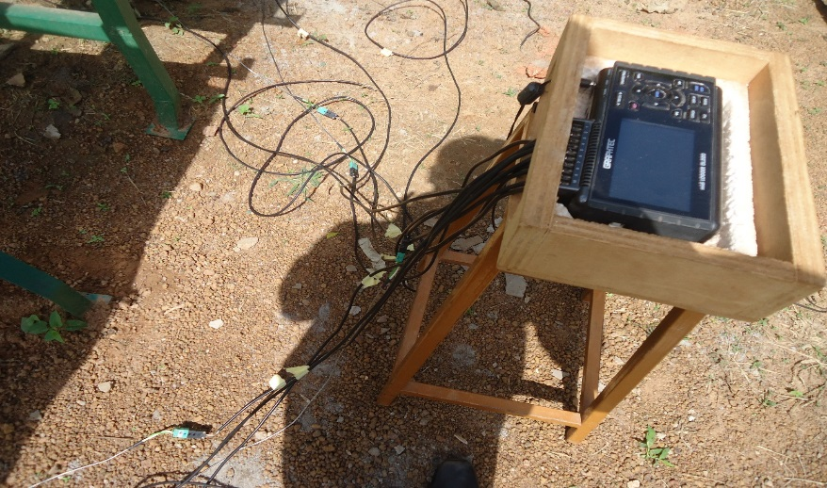
Figure 2 : Steel tray or pan
Figure 3: Data loger connected thermocouples

Figure 4: precision balance

2.2. Methods
2.2.1. Efficiency evaluation of the oven
The method used to determine the thermal performance of the roasting oven is based on the heat balance from the TEE. To achieve this, the methodology adopted is as follows: twenty (20) liters of water are heated to a boiling point until they reach a temperature of 90°C. At the end of the boiling process, the quantity of water remained in the container is measured to determine the mass of evaporated water. The mass of fuel is weighed before and after the operation. The difference between the two weights gives the mass of fuel consumed during the experimental procedure. A thermocouple is placed in the middle of the tray to continuously measure the water temperature. The temperature of the cavity, the outer walls of the oven, and the ambient air are also monitored by thermocouples. The test is repeated three times in the same conditions to obtain average values. Figure 5 shows the experimental setup.
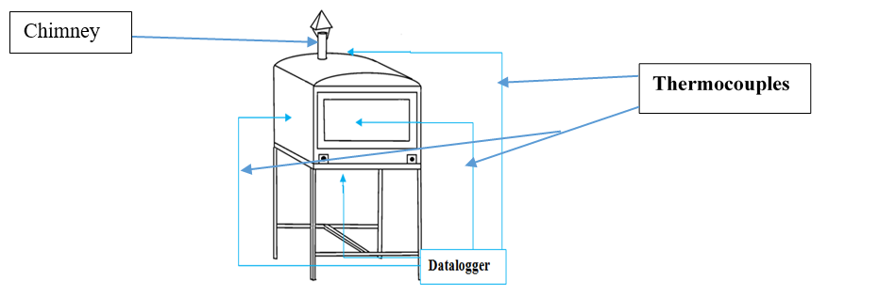
Figure 5: Diagram experimental setup

2.2.2. Oven heat balance
Based on the WBT data, the thermal and energy balance of the ovens is established and illustrated below (Figure 6).

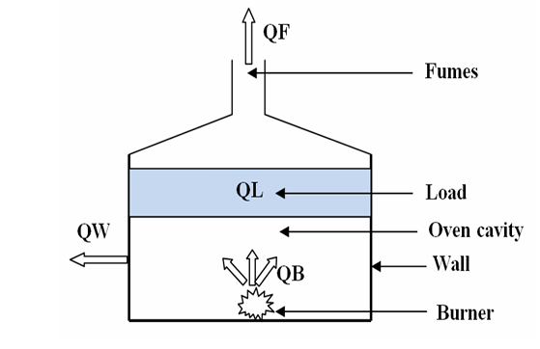
Figure 6: Energy balance of the oven

Q_{B}: Energy generated by combustion in joules (J);
Q_{L}: Energy consumed by the load (water) in joules (J);
Q_{w}: Energy lost through the walls in joules (J);
Q_{F}: Energy lost through the smoke in joules (J).
In the energy balance, we consider other types of energy losses to be negligible (losses during burner shutdowns or start-ups, losses due to air renewal, etc.).
The energy balance of the oven is given by equation (01):
(01)
From equation (01), the energy lost through smoke can be calculated by:
(02)
The different quantities of energy are calculated as follows:
- The energy generated by combustion (Q_{B}) is calculated by taking a mass balance of the fuel (wood or butane gas, depending on the oven) before and after each experiment to obtain the mass of fuel consumed (Mc). The energy supplied by the fuel is then:
(03)
E_{g}: Calorific value of fuel (J/kg)
M_{C}: Mass of fuel consumed (kg)
-The energy consumed by the load (Q_{L}) is obtained by:
(04)
Avec et
M_{water}: mass of water boiled (heated) in kg;
M_{Str}: mass of water evaporated;
C_{water}: heat capacity of water in J/ (kg .C);
M_{tray}: mass of the water tray in kg;
C_{steel}: heat capacity of the steel tank in J/ (kg. °C);
L_{Str}: latent heat of vaporization of water in J/kg;
T₁: initial temperature of the water in °C;
T₂: final temperature of the water in °C.
- Energy lost through the walls (Q_{w}) is mainly due to convection from the external walls to the environment. As the wall temperature varies over time, Q_{w} can be estimated using the following formula:
(05)
With
• T_{w}: Average wall temperature (°C),
• T_{a}: Ambient temperature (°C),
• S_{w}: Total wall surface area (m²),
• h: Natural convection coefficient (W/m²·°C),
• t: Heating duration (s).
The coefficient h is estimated according to Hottel and Woertz [8]:
(06)
Where V is the wind speed (m/s).
The energy efficiency of the roasting oven is calculated using the following formula:

(07)

The parameters used to calculate the oven's efficiency are listed in Table 1 [27].

Table 1: Constants used for calculation
Mass of water (kg) | C_{water} (water) (kJ/kg/°C) | E_{g}(kJ/Kg) | Mass of tray (kg) | C_{steel}(tray) (kJ/kg/°C) | L_{Str}(water) (kJ/kg) | Wind speed (m/s)
20 | 4 ,18 | 49000 | 9,15 | 0,48 | 2260 | 3

3. Results and Discussions
3.1. Water and cavity temperature evolution
Figure 7 shows the evolution of water, ambient air, and roasting cavity temperatures over time.

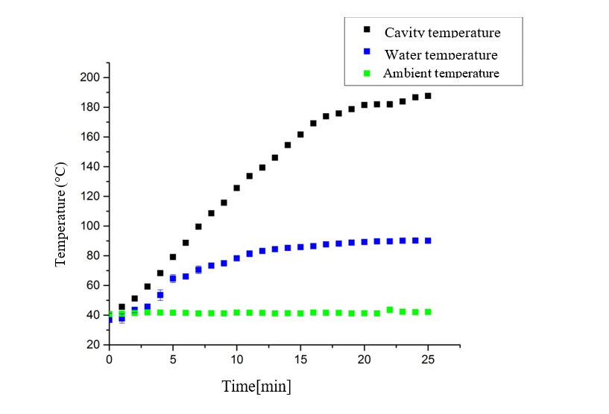
Figure 7: Evolution of cavity, water, and ambient air temperatures over time
We note that the temperature of the oven cavity and the water increase regularly until the flame is extinguished, with the water temperature reaching 90°C. The ambient temperature remains practically constant at around 42°C. The time taken to heat the water and reach 90°C is approximately 25 minutes. The maximum cavity temperature is significant (190°C). These results are consistently with our numerical results [27] and can be attributed to the effect of the double insulation limiting energy losses through the external walls, resulting in a heat gain inside the oven compared to the non-insulated condition.
3.2. Temperature evolution of the cavity and outer wall
Figure 8 shows the temperature evolution of the cavity and outer wall over time.

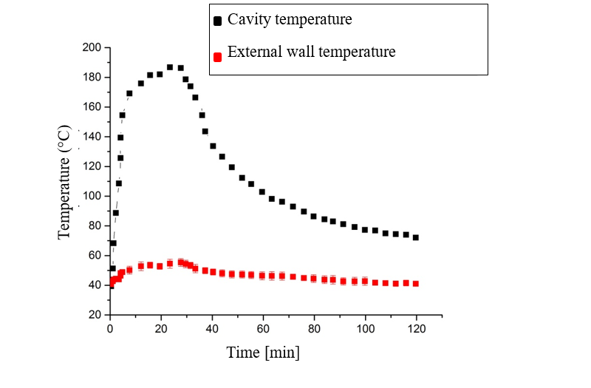
Figure 8: Evolution of cavity and outer wall temperatures over time
As in the case above, the temperature profiles of the cavity and external wall evolve in almost the similar way. However, it can be seen that during cooling, the cavity temperature remains above that of the external wall. The maximum temperature of the external wall is approximately 55°C, which limits the safety risks related to heatstroke for users.
Furthermore, the maximum temperature difference between the external wall and the ambient environment is approximately 13°C, as shown in Figure 9.

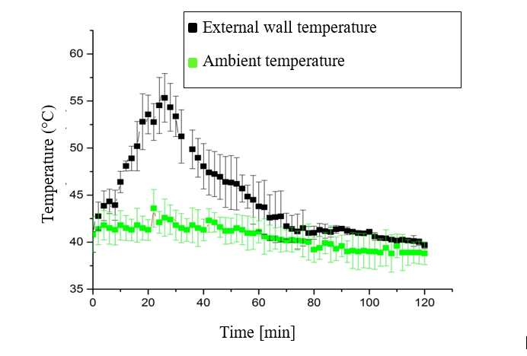
Fig. 9: External wall and ambient air temperature evolution over time
In our previous studies, this difference reached 25°C [6]. These results are consistent with our previous results and are linked to the overall improvement in the thermal performance of the optimized rotisserie due to double insulation [27].
3.3. Yield
The oven yield and the parameters used to calculate it are shown in Table 2.
The oven's efficiency and the parameters used to calculate it are shown in Table 2.
Table 2: Yield calculation
Experience | T₁ (°C) | T₂ (°C) | M_{g} (kg) | M_{water} (kg) | E (%)
1 | 35,5 | 90 | 0,26 | 0,15 | 40
2 | 36 | 90 | 0,24 | 0,16 | 43
3 | 36,5 | 90 | 0,24 | 0,17 | 43
Average | 36±0,5 | 90 | 0,24± 0.02 | 0,16± 0.01 | 42 ± 2

3.4. Results of the thermal and energy balance
Using the same methods as those used to establish the thermal and energy balance of the roast oven insulated only with glass wool, the thermal and energy balance of the optimized roast oven was calculated and recorded in Table 3.
Table 3: Energy balance of the roasting oven

Parameter | Q_{B} | Q_{L} | Q_{w} | Q_{F}
Energy (kJ) | 12086 | 5113 | 910 | 6062
Energy percentage (%) | 100% | 42% | 8% | 50%

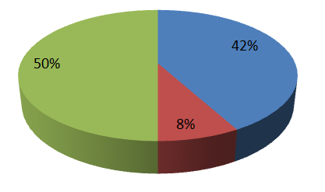
Useful energy
Heat loss through walls
Smoke heat loss

Figure 10: Energy balance diagram
As the results show, the oven's efficiency is 42%. Heat loss through the walls is 8% and heat loss through smoke is 50%. This efficiency corresponds to the standard values for optimized gas ovens. The standard efficiency of optimized gas ovens is around 40 to 50% [14]. Heat loss through the walls has decreased significantly, while heat loss through smoke remains high. These results corroborate our previous results, which showed that smoke heat losses for the uninsulated oven and the oven simply insulated with 3 cm of glass wool are 55% and 50%, respectively, and wall heat losses are 26% and 15%, respectively [25 ,27]. The drop in wall heat loss has increased the oven's efficiency.
4.Conclusion
This work was devoted to the experimental study of the energy performance of a double-insulated optimized roasting oven prototype. The optimized roasting oven was made by double-insulating the walls of a basic uninsulated model with 3 cm of glass wool and 1.5 cm of plywood. The study was conducted by establishing the thermal and energy balance based on the TEE. The results obtained corroborated the numerical results obtained in our previous study [6]. Indeed, we note that:
- External wall temperatures remain below 60°C, ensuring user safety and improved thermal comfort.
- Improved yield of the optimized roasting oven prototype, which reaches 42%. - The main heat losses remain those through smoke (50% of energy consumed).
- Wall heat losses are relatively low (8%).
The results show the need to optimize the oven by conducting work to reduce heat losses through smoke.

ABBREVIATIONS
C_{steel}: Specific Heat of Vessel, KJ. Kg⁻¹. K⁻¹
C_{w}: Specific Heat of Water, KJ. Kg⁻¹. K⁻¹
E: Oven Efficiency, %
Eg: Calorific Value of Fuel, KJ. Kg⁻¹
h: Natural Convection Coefficient, W. m-². K⁻¹
LPG : Liquefied Petroleum Gas
M_{w}: Quantity of Water, Kg
Mg: Mass of Gas Consumed, Kg
M_{v}: Weight of Vessel, Kg
Me: Quantity of Water Evaporated, Kg
L_{Str}: Latent Heat of Vaporization of Water, KJ. Kg-1
Q_{B}: Energy Supplied by the Burner, KJ
Q_{F}: Energy Lost by Fumes, KJ
Q_{L}: Energy Consumed by the Load KJ,
Q_{w}: Energy Lost by Walls KJ,
S_{w}: External Walls Surface m²,
T₁: Initial Temperature of Water (°C),
T₂: Final Temperature of Water (°C),
Ta: Ambient Temperature, °C
T_{w}: Walls Temperature, °C
V: Wind Speed, m.s⁻¹

COMPETING INTERESTS DISCLAIMER:
Authors have declared that they have no known competing financial interests OR non-financial interests OR personal relationships that could have appeared to influence the work reported in this paper.

References
[1] Ministry of Environment, Energy, Water and Sanitation, “National REDD+ Strategy of Burkina Faso,” 2022 Report. http://www.pifburkina.org/. https://redd.unfccc.int/media/4928_1_sn-redd_2b_version_finale_05-10-22_revue.pdf
[2] S. A. S. Usama Al-Mulali; Gerald Goh Guan Gan Muhammad Shahbaz, “The impact of biomass energy consumption on pollution: evidence from 80 developed and developing countries,” Environ. Sci. Pollut. Res., vol. 25, pp. 22641–22657, 2018, doi: https://doi.org/10.1007/s11356-018-2392-5.
[3] H. Amadou Mounkaila, M. Soulé, and E. Osuagwu, “Potential Biomass Resources for Sustainable Bioenergy Planning in West Africa: An Overview from Niger,” Energy Sustain. Dev., vol. 6, no. May 2023. http://dx.doi.org/10.21203/rs.3.rs-2943477/v1
[4] M. Bildirici and F. Özaksoy, “Woody Biomass Energy Consumption and Economic Growth in Sub-Saharan Africa,” Procedia Econ. Financ., vol. 38, no. October 2015, pp. 287–293, 2016, doi: 10.1016/S2212-5671(16)30202-7.
[5] United Nations, “Demographic Yearbook,” Newyork, 2019. https://unstats.un.org/unsd/demographic-social/products/dyb/dybsets/2019.pdf
[6] J. Arevalo, “Improving woodfuel governance in Burkina Faso: The experts’ assessment,” Renew. Sustain. Energy Rev., vol. 57, pp. 1398–1408, 2016, doi: 10.1016/j.rser.2015.12.178.
[7] “Readiness Preparation Plan For REDD Table Of Contents,” Ouagadougou, 2012. https://www.forestcarbonpartnership.org/system/files/documents/RPP%20Burkina%20English-%20FINAL%20June%202012.pdf.
[8] R. C. MacCarty N, Ogle D, Still D, Bond T, “A laboratory comparison of the global warming impact of five major types of biomass cooking stoves,” Energy Sustain Dev, vol. 1, no. 12, pp. 56–65, 2008, doi: https://doi.org/10.1016/S0973-0826(08)60429-9.
[9] K. B. Sutar, S. Kohli, M. R. Ravi, and A. Ray, “Biomass cookstoves: A review of technical aspects,” Renew. Sustain. Energy Rev., vol. 41, pp. 1128–1166, 2015, doi: 10.1016/j.rser.2014.09.003.

[10] A. A. Bantu, G. Nuwagaba, S. Kizza, and Y. K. Turinayo, “Design of an Improved Cooking Stove Using High Density Heated Rocks and Heat Retaining Techniques,” Hindawi J. Renew. Energy, vol. 2018, no. 103, p. 9, 2018, doi: https://doi.org/10.1155/2018/9620103.
[11] D. T. Nega, B. Mulugeta, and S. W. Demissie, “Energy for Sustainable Development Improved biogas ‘Injera’ bakery stove design, assemble and its baking pan fl oor temperature distribution test,” Energy Sustain. Dev., vol. 61, pp. 65–73, 2021, doi: 10.1016/j.esd.2020.12.009.
[12] D. J.-F. R. Beritault, “Study of local cooking habits and adapted water boiling test,” Group for the Environment, Renewable Energy and Solidarity, Cambodia, August 2014. Ref.: 2014_08_DBT_AdaptedWBT_Eng_Vf.https://www.geres.eu/wpcontent/uploads/2019/10/study-of-local-cooking-habits-and-adapted-water-boiling-test_geres_aug2014.pdf.
[13] Global Alliance for Clean Cookstoves, “Stove Emissions and Efficiency Under Controlled Laboratory Conditions,” 2014. https://cleancooking.org/wp-content/uploads/2021/07/414-1.pdf.
[14] APROVECHO, “Comparative tests of 10 models of wood-fired cookers of the ‘Rocket stove’ type. Tests carried out according to the water boiling test protocol,” 2013. https://fr.scribd.com/document/62240870/AprovechoCharcoalRocketStove
[15] F. A. Manhiça, “Efficiency of a Wood-Fired Bakery Oven – Improvement by Theoretical and Practical,” Chalmers University Of Technology, August 7, 2022. https://doi.org/10.1111/1750-3841.16268.

[16] E. Kafui, M. Segbefia, K. Wala, and W. Atakpama, “Comparison of the performance of two types of traditional improved stoves: Togolese clay stove and Malagasy stove,” J. Rech. Sci. Univ. Lomé, vol. 20, no. 1, p. 11, 2019.
[17] V. Jatropha, W. Fotseu, J. Blin, L. Sana, and S. Sidibe, “Characterization and improvement of a “dolo” cooking stove equipped with an oil burner,” CIFEM 2012 pp. 274–279, 2012. https://www.researchgate.net/publication/270566962.
[18] M. Y. Khan and A. Saxena, “Performance Of LPG Cooking Stove Using Different Design Of Burner Heads,” Int. J. Eng. Res. Technol., vol. 2, no. 7, pp. 656–659, 2013.
[19] Thirumalaikumaran. A, S.Ravi, R.Senthil, “Experimental Study of LPG Gas Stove by Improving Thermal Efficiency Using Different Burners with Wire Mesh and Wind Shield,” MESH2022, January 2022. https://www.researchgate.net/profile/Thirumalaikumaran-a?_tp=eyJjb250ZXh0Ijp7ImZpcnN0UGFnZSI6InB1YmxpY2F0aW9uIiwicGFnZSI6InB1YmxpY2F0aW9uIn19.
[20] T. Abasiryu, A. Ayuba, and A. E. Zira, “Performance evaluation of some locally manufactured cookstoves in Mubi,” A, NIGERIA. December 2015. Nigerian Journal of Technology Vol. 35(1), pp. 48–53, 2016. http://dx.doi.org/10.4314/njt.v35i1.8.
[22] F. Aniello, P. Masi, and M. Moresi, “Semiempirical modeling of a traditional wood-fired pizza oven in quasi-steady-state operating conditions,” J. Food Sci., pp. 1–17, 2023, doi: 10.1111/1750-3841.16532.
[23] A. Ouédraogo, F. P. Kiéno, T. Daho, J. D. Bathiébo, and R. Ouédraogo, “Quasi-static thermal balance of an artisanal clay oven,” J. Soc. Ouest-Afr. Chim., vol. 024, pp. 65–72, 2007.
[24] G. L. Sawadogo, S.W.Igo, D.Ouedraogo, “Experimental and Numerical Study of Energy Losses in a Barbecue Oven in Burkina Faso,” Open J. Energy Effic., vol. 9, no. 03, pp. 31–52, 2020, doi: 10.4236/ojee.2020.91003
[25] S. W. Igo, N. Kokou, A. Compaoré, P. Kalifa, G. L. Sawadogo, D. Namoano, “Experi-mental Analysis of the Thermal Performance of a Metal Fired-wood Oven”, Iranian (Iranica) Journal of Energy & Environment, Vol. 11, no.3. PP.225-230, 2020, doi: 10.5829/ijee.2020.11.03.08.
[26] S.W.Igo, D.Namoano,A. Compaoré, G.L.Sawadogo, D.Ouedraogo and J.D.Bathiebo, “Study and analysis of Energy use efficiency of a local gas roasting oven.”Journal of Energy Research and Reviews, vol.6,no.04,pp.30-37,2020, doi:10.9734/JENRR/2020/v6i430177.
[27] D.Namoano,W.R.Ouedraogo,O.Ouédraogo,D. Ouedraogo, G. L Sawadogo, A. Com-paoré and S. W Igo “Optimizing the thermal envelope of a typical roasting oven in Burkina Faso”, Journal of Chemical, Biological and Physical Sciences, Vol. 14, No. 3, PP.270-285. DOI: 10.24214/jcbps.C.14.3.2784.

