Multi-Scale Seismic Tomography in Rift Zones: Implications for Lithospheric Evolution in the Afar Region

Abstract
The Afar Depression, a nascent oceanic basin within the East African Rift system, offers a unique natural laboratory to investigate the interplay between mantle dynamics and continental breakup. This study employs seismic travel-time tomography to elucidate the interplay between deep mantle dynamics and surface tectonics beneath the Afar region, encompassing northern Ethiopia, Eritrea, Djibouti, northwestern Somalia, and southern Yemen. Utilising 17,476 first arrival P-waves from 2,911 earthquakes recorded at 114 seismic stations between 1976 and 2023, a 3D P-wave velocity model is developed to a depth of 70 km. The analysis incorporated three different grid resolutions (0.25°, 0.5°, and 1.0°) to optimise the balance between detailed resolution and robust structural imaging. Checkerboard and structural reconstruction tests confirm good resolution across most of the study area. The resulting tomographic images reveal significant velocity heterogeneity throughout the region, with prominent low-velocity zones (LVZs) beneath tectonically active areas including the Afar Depression, Red Sea Rift, Gulf of Aden Rift, and Main Ethiopian Rift. These LVZs extend from shallow depths to 70 km, suggesting the presence of thermally perturbed lithosphere, partial melting, and active magmatism. Conversely, high-velocity zones (HVZs) predominate beneath the more stable Nubian, Arabian, and Somalian plates, indicating cooler, thicker lithosphere. The spatial distribution of earthquakes along boundaries between velocity anomalies further supports the relationship between seismic activity and tectonic stress at interfaces between hot, weak mantle material and cooler, stronger lithosphere. Our findings contribute to the understanding of how mantle dynamics influence continental breakup and incipient seafloor spreading in plume-assisted rift systems, supporting models of passive upwelling beneath magmatic segments driven by far-field stresses and buoyancy-related processes.
Keywords: Seismic tomography; P-wave; Continental rifting; lithosphere; Afar region.

1 INTRODUCTION
Continental break-up represents a critical phase in Earth's tectonic evolution, where sustained extensional forces gradually thin and rupture the rigid lithosphere, ultimately forming new oceanic basins. The East African Rift (EAR) exemplifies this process as an active continental rift system potentially evolving toward seafloor spreading. Within this system, the Main Ethiopian Rift (MER) extends northeastward into the Afar Depression (AD), a tectonically complex region encompassing northern Ethiopia, Eritrea, Djibouti, and northwestern Somalia (Fig. 1a). The AD is characterised by extensive Oligocene flood basalts (Kieffer et al., 2004; Civiero et al., 2015) and intense volcanism, phenomena often linked to hot mantle upwelling—a process capable of triggering volcanism even at distances removed from active plate boundaries (Morgan, 1971). A key element in this tectonic setting is the African Superplume, a Large Low Shear Velocity Province anchored at the core-mantle boundary beneath southern Africa (Yuan and Li, 2020). Evidence suggests that this superplume has ascended toward the lithospheric base beneath regions including Ethiopia, the Gulf of Aden, the Red Sea, and Arabia (Schilling, 1973; Li et al., 2008; Mulibo and Nyblade, 2013; Lim et al., 2020). Notably, the uplift of the Ethiopian Plateau, averaging around 2.5 km in elevation, is likely a surface expression of this mantle upwelling, while the extensive volcanism observed across the EAR and adjacent plateaux underscores the dynamic influence of mantle processes on surface tectonics (Keranen et al., 2009). Ongoing continental break-up in the region appears to be driven by a synergistic effect of far-field tectonic stresses (Menzies et al., 1997) and magma-assisted rifting (Buck, 2004).
To unravel the connections between deep mantle processes and surface tectonics, geophysical studies have focused on crustal structure and seismic properties. Receiver function analyses across the Afar region (e.g., Dugda et al., 2005; Stuart et al., 2006; Hammond et al., 2011; Kibret et al., 2019; Kumar et al., 2021; Wang et al., 2021; Ahmed et al., 2022) reveal a thinned crust (15–45 km) with localised zones of extreme thinning (21–38 km) beneath active spreading centers. Elevated Vp/Vs and Poisson’s ratios in these areas further imply pervasive partial melting of the crust, likely induced by mantle-derived magmatism. Moreover, seismic tomography studies—employing both body-wave (e.g., Benoit et al., 2006; Koulakov 2007; Bastow et al., 2005, 2008; Hansen and Nyblade, 2013; Civiero et al., 2015, 2016; Lim et al., 2020) and surface-wave (e.g., Sebai et al., 2006; Guidarelli et al., 2011; Gallacher et al., 2016; Chambers et al., 2019) analyses—consistently identify low-velocity anomalies within the upper mantle beneath Afar, indicative of thermal and compositional variations associated with mantle upwelling. For instance, Civiero et al. (2015) used relative p-wave travel-time analysis to identify two low-velocity clusters (200–800 km depth) beneath Afar and west of the MER, while Lim et al. (2020) detected a 100–300 km deep low-velocity anomaly beneath the Arabian shield, which they interpreted as a northward flow of plume material from the upper mantle. Despite consensus on the role of mantle upwelling, debates persist regarding the number, geometry, and vertical extent of these upwellings.
In contrast to earlier investigations that primarily emphasised mantle features (Lim et al., 2020), experiments such as the Ethiopia Afar Geoscientific Lithospheric Experiment (EAGLE) have been specifically designed to probe both the crust and the upper mantle (Mackenzie et al., 2005; Maguire et al., 2006). The EAGLE deployment, targeting a transitional segment of the MER valley(Kendall et al., 2005), has provided critical data that underpin subsequent crustal tomography studies (e.g., Daly et al., 2008; Guidarelli et al., 2011; Kim et al., 2012; Stork et al., 2013). Understanding the lithospheric thickness and the depth at which decompression melting begins is crucial for comprehending thermal structure of the mantle, assessing the extent of plume influence, and reconstructing deformation history of the lithosphere (Huismans and Beaumont, 2011). The unique tectonic setting of the Afar region makes it an ideal natural laboratory for studying variations in seismic velocities as the lithosphere transitions from continental rifting to incipient seafloor spreading. In this study, we employ seismic travel-time tomography to construct a three-dimensional (3D) P-wave velocity model of the crust and uppermost mantle (extending to a depth of 70 km) beneath northern Ethiopia, Eritrea, Djibouti, northwestern Somalia, and southern Yemen (Fig. 1a). By integrating earthquake data from the International Seismological Centre (ISC) with advanced tomographic inversion techniques, we map regional velocity variations and correlate them with tectonic and magmatic features. This work aims to advance our understanding of how mantle dynamics and lithospheric processes interact during continental break-up in plume-assisted rift systems.

2 TECTONIC SETTING
The tectonic evolution of the Afar region is shaped by mantle dynamics and the interaction of the African and Eurasian plates, generating far-field stresses that initiate extension and facilitate seafloor spreading in the Gulf of Aden and Red Sea, with propagation into the AD (Menzies et al., 1997). Afar uniquely marks the convergence of three tectonic plates—the Arabian, Nubian, and Somali—and is intersected by three distinct rift systems: the northern segment of the MER, the southern Red Sea Rift (RSR), and the Gulf of Aden Rift (GAR). This arrangement, commonly referred to as the Afar Triple Junction, features northern and eastern rift arms that extend into the Red Sea and Gulf of Aden, respectively (Fig. 1b), where rifting has progressed to the stage of seafloor spreading. In contrast, the southern branch, represented by the MER, appears as a series of exposed rift valleys that extend southward toward Mozambique (Chorowicz, 2005). The MER itself bifurcates the Ethiopian Plateau into the Eastern Ethiopian Plateau (or Abyssinian Massif) and the Western Ethiopian Plateau (or Harar Massif) (Fig. 1a). Although far‐field stresses alone might not suffice to rupture the robust continental lithosphere, mantle upwelling provides the thermal support required for lithospheric weakening, thereby facilitating the development of the EAR (Buck, 2004). This process is further accompanied by vigorous volcanic activity along the roughly 2,500‐km length of the rift system (Ebinger and Sleep, 1998).
Approximately 25 million years ago, a segment of the Ethiopian Plateau subsided into the AD, covering an area of nearly 200,000 km² (Chorowicz, 2005). This subsidence not only delineated the western and eastern margins of the depression but also produced rugged, faulted terrains that form its principal escarpments (Fig. 1a). With elevation ranges spanning from –120 to 1,000 meters above sea level (Beyene and Abdelsalam, 2005), is widely interpreted as a consequence of the separation between the Arabian and Nubian plates, a process that likely followed the upwelling of a mantle plume during the Oligocene (Bosworth et al., 2005). Since about 3 million years ago, successive rifting episodes and intrusions of magma have further localised extensional deformation into discrete magmatic segments (Ebinger and Casey, 2001; Beutel et al., 2010). This evolving rift dynamics has also isolated tectonic blocks, such as the Danakil and Ali-Sabieh blocks (Fig. 1b), which has evolved independently and contribute to the continued widening of the AD (Doubre et al., 2017; Kidane, 2016). Notably, the GAR penetrates Afar at the Gulf of Tadjura, signifying the onset of continental break-up, while the Danakil Rift connects with the GAR in central Afar via a series of en-echelon and overlapping grabens (Zwaan et al., 2020). Integrative deformation and geodetic studies, supported by geodynamic modelling (e.g., McClusky et al., 2010; Koptev et al., 2018; Civiero et al., 2019; Khalil et al., 2020), have further illuminated the complex kinematics underlying this dynamic tectonic setting.
Global crustal models such as CRUST 1.0 (Laske et al., 2012) provide critical insights into crustal parameters, enhancing understanding of the region’s tectonic framework. By comparing the topography of study area (Figs. 1a and 2a) with Moho depth distributions from CRUST 1.0 (Fig. 2b), distinct patterns emerge. The Ethiopian Plateau (EEP and WEP) and Yemen Highlands exhibit high elevations, indicative of thick continental crust, while the AD and parts of the Gulf of Aden lie at or below sea level, reflecting significant crustal thinning. These topographic variations, sculpted by tectonic and volcanic activity, produce steep escarpments and rugged terrain along major rift margins. The Moho depth distribution complements these observations, revealing deeper Moho beneath the highlands and shallower depths in rifted zones, consistent with isostatic compensation principles—thicker crust supports elevated topography, while thinner crust correlates with subsidence. In the Afar region and Gulf of Aden, shallow Moho depths align with ongoing continental break-up in the EAR system and seafloor spreading in the Red Sea and Gulf of Aden, underscoring the dynamic crustal deformation in this tectonically active domain.

3 DATA AND METHODOLOGY

3.1 Data
The present study utilises earthquake arrival time data obtained from the International Seismological Center (ISC) archives, covering the period from 1976 to 2023. The dataset focuses on earthquakes with magnitude (m_{b}) exceeding 1.0, located within a region bounded by latitudes 7°–17° N and longitudes 38°–47° E, with focal depths ranging from the surface to 67 km (Fig. 1b). Only events that recorded three or more arrival times are included, resulting in a total of 17,476 first-arrival P-wave observations from 2,911 earthquakes, as recorded by a network of 114 seismic stations. The station lists is available in the supplementary information.

3.2 Methodology

3.2.1 Model Parameterization
A 3D grid mesh is constructed beneath the study area using the ak135 velocity model as a reference. The grid spans latitudes 7°–17° N and longitudes 38°–47° E, with vertical discretisation from 2 km down to 70 km depth (Fig. 3, gold circles). The subsurface velocity structure is represented by assigning specific velocity values at the nodes where gridlines intersect, with the assumption that velocity remains constant within each cell. This approach permits the approximation of ray paths as straight-line segments within individual cells. To determine velocities at arbitrary points within a cell, trilinear interpolation is applied, leveraging the velocities at the eight surrounding grid vertices (Thurber, 1983; Zhao et al., 1994; Haslinger et al., 1999). To evaluate the influence of cell size on anomaly imaging, we considered three sets of equilateral grids with resolutions of 0.25º, 0.5º, and 1.0º spacing in both latitude and longitude directions for the same depth layers (Fig. 4).

3.2.2 Forward Calculation
The calculation of earthquake-to-station raypaths and corresponding absolute travel times is performed using the ISC hypocentral parameters in conjunction with a ray tracing algorithm (Osagie and Okwokwo, 2022), which accounts for variations in station elevation. A two-point ray shooting technique (Kim and Baag, 2002) is adopted for up-going rays, supplemented by a distinct routine to handle boundary refractions. This iterative forward modelling process, applied in previous studies (e.g., Osagie and Kim, 2013; Osagie et al., 2017), refines ray trajectories to optimise source-receiver connections while minimising travel-time. The computed raypaths, which are discretised at 5 km intervals, are constrained to remain within the lower portions of each model layer, where rays either reflect or refract at layer interfaces. Partial derivatives of travel-time are determined both analytically for the hypocentral parameters, following Engdahl and Lee (1976), and numerically for velocity parameters, using the approach of Thurber (1983). With focus on events within 1100 km from a seismic station, our computed epicentral distances range from 2 to 1,006 km. We visualised the computed raypaths in Figure 3, distinguishing P phases (green lines) and P_{n} phases (black lines) as they propagate from earthquake hypocenters (red circles) to seismic stations (blue triangles) within the model volume.

3.2.2 Inversion
The inversion process is exclusively based on first-arrival P-wave data and implemented using the LSQR (Least Squares QR Factorization) algorithm (Paige and Saunders 1982) and regularised with damping and smoothing constraints (Zhao, 2004). We conducted multiple inversions across the three equilateral grids (0.25º, 0.5º, and 1.0º) using varying damping parameters. The optimal damping parameter for each grid size is determined through the L-curve method, which plots the mean solution amplitude against residual misfit and identifies the point of maximum curvature as the optimal balance between stability and data fit (Fig. 6). Here, the curvature (κ) at any point is calculated using the parametric relation (Eq. 1) which involves first derivatives (x′, y′) and second derivatives (x′′, y′′) with respect to the damping parameter (t).
 | $κ\left(t\right)=$ $\frac{\left|x^{'}y^{''} - y^{'}x^{''} \right|}{{\left[{\left(x^{'}\right)}^{2} + {\left(y^{'}\right)}^{2}\right]}^{3/2}}$ | (1)
Given the discrete nature of our data, we approximated these derivatives using finite differences (Eqs. 2 and 3).
 | $f^{'}\left(t_{i}\right)$ ≈ $\frac{f\left(t_{i+1}\right) - f\left(t_{i-1}\right)}{t_{i+1}- t_{i-1}}$ | (2)
 | $f^{''}\left(t_{i}\right)$ ≈ $\frac{f\left(t_{i+1}\right) - 2f\left(t_{i}\right) + f\left(t_{i-1}\right)}{{\left[(t_{i+1}- t_{i-1})/2\right]}^{2}}$ | (3)
Optimal damping parameters of 8, 15, and 20 are obtained for the 0.25°, 0.5°, and 1.0° grids, respectively. As expected from fundamental principles in inverse theory, we note that the optimal damping parameter increases with increasing grid cell size. Additionally, a 3% velocity perturbation (Δv_{p}) is applied to the P-wave velocities, and only those grid cells intersected by at least 10 rays are included in the final inversion, following the hit count metric proposed by Haslinger et al. (1999). A Python implementation of the L-curve analysis is provided in the supplementary information.

4 RESULTS

4.1 Travel-time Residual Analysis
Travel-time residuals calculated in this study are compared with the results published by the ISC (available in supplementary information). Residuals for corresponding events and arrivals calculated in this study (RCAL) and those from the ISC (RISC) are listed in columns 9 and 10, respectively. Average residual values at four back-azimuthal directions (NE, SE, SW and NW) from each station is also available in the supplementary information. The comparison reveals a strong correlation between the average residual values computed in this study (AVRC) and those from the ISC (AVRI), underscoring the reliability of the travel-time residual estimation process. This provides a robust foundation for subsequent tomographic analysis.

4.2 Analysis of Resolution
To assess the resolution limits of the dataset and the efficacy of the inversion process, we conducted two synthetic tests—the Checkerboard Resolution Test (CRT) and the Structural Reconstruction Test (SRT). In both tests, random noise with a standard deviation of 0.1 seconds is added to the synthetic data to simulate observational uncertainties.

4.2.1 Checkerboard Resolution Test (CRT)
We used the CRT (Lévěque et al., 1993) with alternating slowness anomalies (±3%) to assess ray coverage adequacy and quantify horizontal smearing and vertical leakage. The three grid cell sizes (Fig. S1) are tested across six depth layers (5–70 km). At shallow depths (5-20 km), the 0.25° grid provided minimal smearing between adjacent cells, though its resolution diminished in the southern Red Sea region. In contrast, the 0.5° and 1.0° grids yielded progressively smoother anomaly patterns, with the coarsest grid effectively capturing large-scale tectonic features. At greater depths (35–70 km), coarser grids attempted to resolve intricate structures that became increasingly blurred in finer models. Vertical cross-sections (Figs. S2 and S3) revealed that, while overall leakage was minimal, the 0.25° grid tended to amplify leakage in layers deeper than 35 km, whereas the larger grid sizes mitigated leakage at the expense of finer vertical detail.

4.2.2 Structural Reconstruction Test (SRT)
The SRT, conducted within the well-resolved region identified by the CRT, introduced synthetic anomalies (Fig. 8: top left and Fig. 3: light blue and purple columns) of different geometries—rectangular (A1 and A2 with a +3% perturbation) and cylindrical (B1 and B2 with a –3% perturbation). A1 has dimensions of 260 km length, 120 km width, and 65 km vertical extent, buried at 15 km depth, while A2 has dimensions of 200 km length, 100 km width, and 64 km vertical extent, positioned at a shallower depth of 5 km. Anomaly B1 has a radius of 65 km and extends vertically for 60 km from a burial depth of 15 km, while B2, which is larger in radius at 150 km but has a smaller vertical extent of 35 km is buried deeper at 30 km depth. The recovered anomalies (Fig. 8) reveals that the synthetic anomalies are generally recovered within the well-resolved regions, consistent with their depths of burial and vertical extent. Anomaly A1, aligned with the RSR, is recovered with good fidelity in both shape and amplitude through its 65 km vertical extent, whereas A2 along the GAR was well-resolved in shallow layers but deteriorated beyond 50 km depth. Similarly, the cylindrical anomaly B1 maintained its circular shape in the mid-crustal ranges, while B2 showed robust recovery in the mid-depth interval (35–50 km) but suffered some vertical smearing beyond its original extent. Overall, these tests confirm the robustness of the inversion within the well-resolved zones and illuminate the trade-offs inherent in different grid resolutions.

4.3 Tomographic Inversion
Figures 9–11 present seismic tomographic cross-sections, including horizontal slices and vertical profiles along east-west and north-south orientations. In these images, low-velocity zones (LVZs) are depicted in red and high-velocity zones (HVZs) in blue. The images compare these anomalies at three grid resolutions—0.25° × 0.25°, 0.5° × 0.5°, and 1.0° × 1.0°. In the horizontal cross-sections, purple triangles mark seismic stations, and yellow circles indicate earthquake locations within 0.5 km of each depth layer. In the vertical cross-sections, black circles denote earthquake focal depths within 5 km of each cross-section, and the depth axis is exaggerated approximately 10 times to enhance visualisation. The final inversion produced a 3D velocity perturbation model (Fig. 12). The absolute P-wave velocity model is used to derive S-wave velocity, density, and Poisson's ratio for the three grid cells (available in the supporting information) using established empirical relationships (Ludwig et al., 1970; Brocher, 2005).

4.3.1 Horizontal Cross-sections
Figure 9 displays the inversion results across six depth layers using three grid cell sizes. At shallower depths (5–20 km), the 0.25° grid reveals a complex pattern of velocity anomalies while the 0.5° grid presents a smoother version. The 1.0° grid shows broad, diffuse LVZs in the rift zones and less defined red HVZs on the surrounding plates. At intermediate depths (35–50 km), the complex pattern of velocity anomalies remains apparent in the 0.25° grid, including an extensive LVZ beneath the Arabian Plate (35 and 50 km), an elongated LVZ along the Northern Plateau (50 km), and patches of HVZs marking the margins of the Nubian and Arabian plates (35 km). The 0.5° and 1.0° grids show broader LVZs beneath the Northern Plateau, the Arabian Plate, and rift zones, with HVZs beneath the Nubian Plate and parts of the Ali-Sabieh Block (35 km). The 70 km depth section reveals a dramatic contrast, displaying a complex pattern of velocity anomalies across all grid cell sizes. The 0.25° grid still shows LVZs within the AD and rift areas, though reduced in scope, while HVZs are observed in the Nubian, Arabian, and Somalian plates, reflecting a high-velocity lithospheric mantle. The broad LVZ seen beneath the Arabian Plate at 35 and 50 km is absent at this depth, but a continuous LVZ is observed within the Ethiopian Plateaux (Abyssinian Massif and Harar Massif). Both the 0.5° and 1.0° grids show HVZs covering larger plate areas.

4.3.2 Vertical Cross-sections
Figure 10 displays East-West vertical cross-sections (EWVCs) along latitudes 9°–16° N, using grid cell sizes of 0.25°, 0.5°, and 1.0°. In the 13°–16° N sections (Fig. 10a), pronounced LVZs dominate the central and eastern portions, particularly between 0-50 km depth. These LVZs are prominent near the Gulf of Aden (13° N), beneath Jazirat Jabal Zuqar (15° N), and parts of Yemen 13° and 15° N), including the southern city of Mudiyah (14° N), suggesting the presence of thermally perturbed lithosphere or partial melting associated with rifting processes. LVZs also appear at depths across all grid resolutions, including beneath AD western encampment (AWE), extending towards Assab in Eritrea, the Red Sea, and southern Yemen (13° N). Also in these sections, HVZs are particularly noticeable in the western portions, especially beneath Eritrea (Er), the Red Sea (R), and parts of northern Ethiopia. These HVZs appear to be more continuous and well-defined at depths greater than 30 km, potentially representing more stable, cooler lithospheric blocks or preserved continental fragments. The transition between low and high-velocity zones often appears sharp, possibly indicating major tectonic boundaries. In the 9°–12° N sections (Fig. 10b), LVZs appear more distributed and less continuous compared to the northern sections. The LVZs are less extensive but still evident beneath Djibouti (Dj) and the Gulf of Aden (GA), reaching depths of ~40 km. Particularly notable are the LVZs that appear to be vertically oriented, suggesting possible magmatic conduits or zones of weakness associated with rifting. These features are especially evident in the vicinity of the MER and the AD. On the other hand, HVZs are observed beneath Ethiopia (Et) and Somalia (So) at depths >40 km, potentially reflecting cooler, thicker continental lithosphere south of the main rift zones.
Figure 11 illustrates North-South vertical cross-sections (NSVCs) along longitudes 39°–46° E, viewed from the east, using the same set of grid cell sizes. In the 39°–42° E sections (Fig. 11a), LVZs are concentrated beneath the AD (AEE and AWE) and the MER, extending from shallow depths (around 0–20 km) to deeper levels (up to 70 km or more). These cross-sections also show HVAs at shallow depths (0–30 km) in stable regions like the Western Ethiopia Plateau (WEP) and parts of Eritrea (Er) and Ethiopia (Et), suggesting thicker, cooler crust or lithospheric mantle outside the main rift zones. However, these HVAs become less prominent at deeper levels, where LVZs become more pronounced. Moving eastward, in the 43°–46° E sections (Fig. 11b), the velocity structure shows a notable change with more extensive LVZs, especially beneath the Afar Triangle and Gulf of Aden (GA), with large red patches extending from the surface to depths of 50–70 km, aligned with the Red Sea (R) and Gulf of Tadjoura (GT), indicating asthenospheric upwelling and magma presence. On the other hand, HVAs are similarly located at shallow depths, particularly around Berbera (Be) in Somalia and parts of Yemen (Ye) near the Gulf of Aden, indicating stable, older lithosphere not affected by rifting. However, these blue regions are often fragmented or absent at deeper levels (below 30–40 km), where LVZs dominate, reflecting the thinning of the lithosphere and the rise of hot mantle material in the rift zones.

5 DISCUSSIONS

5.1 Effect of Cell Size on Resolution
Our analysis comparing tomographic results across grid resolutions of 0.25°, 0.5°, and 1.0° reveals notable differences in the resolved velocity structures. The multi-scale approach distinguishes fine-scale local features from broader regional patterns, enhancing confidence in the geological significance of persistent anomalies. The 0.25° grid excels in resolving detailed variations in the shallow crust (5–20 km), capturing small-scale features such as magmatic intrusions and fault zones. However, this fine resolution can also introduce artifacts at greater depths (35–70 km) due to data uncertainties and limited ray path coverage (Rawlinson et al., 2010). In contrast, the 0.5° grid provides a balanced view, clearly delineating major anomaly patterns at shallow depths while offering a robust depiction of deeper structures. The 1.0° grid, while smoothing out finer details, effectively highlights large-scale tectonic features, making it more suitable for imaging deeper levels (e.g., 70 km), where seismic wavelengths are longer, and resolution limitations are inherent due to data sparsity (Nolet, 2008).

5.2 Earthquake Focal Depths and Velocity Anomalies
The spatial distribution of earthquake focal depths (Fig. 9: yellow circles, Figs. 10 and 11: black circles) provide additional context for the velocity anomalies. Earthquakes predominantly occur in the shallow to mid-crustal layers and tend to cluster near the boundaries between low and high-velocity zones (Fig. 10: 12°-14° N, Fig. 11: 41°-46°E, such as the RSR and GAR. This pattern suggests that seismicity is closely linked to the mechanical contrasts at interfaces between thermally weakened, upwelling mantle regions and the surrounding cooler, more rigid lithosphere, consistent with models of rifting and faulting (e.g., Keir et al., 2009).

5.3 Low Velocity Zones (LVZs)
The tomographic images reveal significant seismic velocity heterogeneity, characterised by distinct low velocity zones (LVZs) across the upper mantle (5–70 km). These LVZs likely result from a combination of compositional variations, active rifting, magmatic intrusions, elevated thermal conditions, and partial melting. At shallow depths (5–20 km), LVZs are concentrated beneath tectonically active regions such as the AD, RSR, GAR, and MER (Fig. 9: 5 km; Fig. 10: 13° and 15° N; Fig. 11: 41°–43° E). This is consistent with previous studies (e.g., Bastow et al., 2005) that associate shallow LVZs with rift-related magmatism and crustal thinning. At intermediate depths (35–50 km), LVZs beneath parts of the AD and southern part of the Red Sea broaden beneath the Arabian Plate (Fig. 9; 35 and 50 km, Fig. 10: 13°-15° N; Fig. 11: 43°–45° E), suggesting a passive upwelling mechanism that feeds the rift segments (Bastow et al., 2005; Hammond et al., 2013). The progressive deepening and lateral expansion of these anomalies imply a continuous influence from a mantle plume, with observations of a northward plume flow further supporting this interpretation (Chang and Van der Lee, 2011; Civiero et al., 2015; Emry et al., 2019). This is evident in the shallower representation of LVZs beneath the Arabian Plate compared to the AD. The transition from shallow to deeper LVZs suggests a continuous mantle plume influence, as noted by Ebinger and Sleep (1998), driving lithospheric thinning and rifting. Additionally, specific LVZ features at 50 km and 70 km may indicate secondary plume activities or the shallower manifestations of deeper mantle anomalies.
Decompression melting, as proposed by Hansen and Nyblade (2013), drives elevated topography (Fig. 2a) in Afar and the Arabian Plate, influenced by variations (Fig. 2b) in lithospheric thickness (Daradich et al., 2003; Hopp et al., 2004; Lim et al., 2020). More so, mantle upwellings have been suggested to migrate toward areas with thinner lithosphere following their interaction with the rigid lithosphere beneath the MER (e.g., Benoit et al., 2006; Bastow et al., 2008). This phenomenon may explain the presence of the LVZ, as indicated by the CRUST 1.0 model (Fig. 2b), which reveals regions of thinner lithosphere beneath the WEP. The LVZ at 50 km along the Northwest Plateau, and at 70 km along the Southeast Plateau (Fig. 9: 0.5° and 1.0° grids) which appears to extend into the Northwest Plateau through a section of the AD, may represent secondary plumes or shallow manifestations of broader mantle anomalies discussed in previous studies (e.g., Hammond et al., 2013; Civiero et al., 2015; Emry et al., 2019). These could be fed by a deeper ponded plume (e.g., Benoit et al., 2006; Bastow et al., 2008), destabilizing into upper-mantle plumelets due to chemical heterogeneity and internal heating, as modeled by Civiero et al. (2019). Shear wave LVZs trending along the MER beneath the Boset volcanic zone, as imaged by (Gallacher et al., 2016; Chambers et al., 2019), further support mantle upwelling and decompression melting driving regional tectonics.

5.4 High Velocity Zones (HVZs)
High velocity zones (HVZs) are predominantly observed in areas underlain by thicker, more stable crust. At shallow depths (5–20 km), HVZs are prominent beneath the Nubian Plate and parts of the Arabian Plate, suggesting the presence of cooler, rigid lithospheric blocks. Dugda et al. (2005) identified HVZs beneath the Ethiopian Plateau, attributing them to stable Precambrian lithosphere, while Bastow et al. (2008) reported HVZs within 50 km of the EAR shoulders. In contrast, HVZs within the AD and Gulf of Aden are less extensive at shallow depths, potentially reflecting intact crustal segments or fault-bounded blocks. At greater depths (35–70 km), HVZs become more pronounced beneath the Nubian Plate and Southeast Plateau (Fig. 9: 50 km), indicative of stable lithospheric mantle or even oceanic crust signatures. In regions like the Danakil Depression, where the crust is where crust is ~16 km thick (Hammond et al., 2011), HVZs contribute to faster P-wave velocities, likely due to shallower mantle peridotite (Fig. 9: 70 km) or solidified mafic intrusions (Chambers et al., 2019; Prodehl et al., 1997; Prodehl et al., 1997). These denser, mafic rocks, as suggested by Stuart et al. (2006), modify the crust beneath Afar, consistent with high Vp/Vs ratios attributed to melt in the lower crust and upper mantle (Hammond et al., 2013; Kumar et al., 2021; Wang et al., 2021). The transition between low and high-velocity zones appears more distinct at the 50 km depth, possibly indicating major lithospheric boundaries or different degrees of mantle modification. At 70 km depth, the broad HVZs beneath the Nubian and Arabian plates indicate the presence of stable lithospheric blocks at this depth.

5.5 Thermal Contribution and Geodynamical Implications
Temperature variations have a profound effect on the seismic properties of upper mantle materials, often exceeding the impact of compositional differences or crustal thickness variations (Christensen and Mooney, 1995; Goes et al., 2000). The mantle beneath the EAR is estimated to be approximately 140 °C warmer than the global average (Rooney et al., 2012), a condition that likely promotes the formation of upper-mantle plumelets beneath Afar and the MER (Civiero et al., 2019). Geochemical analyses further indicate that mafic lavas in the region are sourced from the asthenosphere (Kendall et al., 2005; Rooney et al., 2005). In our study, the LVZs along the Northwest Plateau are interpreted as indicators of active melting, while deeper LVZs beneath the AD support the notion of passive upwelling feeding rift segments (Bastow et al., 2005). The spatial variability in melt production, with less chemically evolved melts in Afar compared to the MER (Rooney et al., 2013), underscores the significant role of thermal anomalies in modulating lithospheric dynamics. The transition from continental rifting to incipient seafloor spreading in Afar is facilitated by sustained tensional stress and along-axis segmentation (Menzies et al., 1997). Figure 9 at 10 km depth shows dominant LVZs in Afar, extending into the Ali-Sabieh Block, indicative of rift broadening, enhanced by melting in the uppermost mantle (35 and 50 km). The undulating Moho depth beneath the MER (Fig. 2b) is proposed to have areas of 2–7% melt accumulation (Armitage et al., 2015, 2018), suggesting localisation of partial melt closer to the Moho than at greater depths (Chambers et al., 2019). These integrated processes offer a plausible mechanism for the ongoing transition from continental rifting to incipient seafloor spreading in the Afar region.

6 CONCLUSIONS
This study provides seismic tomographic investigation of the crust and upper mantle beneath northern Ethiopia, Eritrea, Djibouti, northwestern Somalia, and southern Yemen, elucidating the intricate tectonic evolution associated with continental break-up in the Afar region. By leveraging dataset of first-arrival P-wave travel times from 1976 to 2023, recorded at 114 seismic stations, a 3D P-wave velocity model is constructed to a depth of 70 km. The methodological framework, which incorporated a multi-resolution grid parameterization and robust inversion techniques, including the LSQR algorithm and L-curve regularization, enabled the delineation of significant seismic heterogeneity. The finer resolution (0.25°) reveals detailed low-velocity zones (LVZs) beneath the region, especially at shallower depths (5-20 km), while coarser resolutions (0.5° and 1.0°) highlight broader geodynamical trends. The salient findings of this study include:
- Distinct LVZs appear in the uppermost mantle beneath Afar and western Ethiopian Plateaux, respectively. This is consistent with the findings in previous studies that suggest the existence of more than one plume in the upper mantle beneath the region.
- Localised LVZs in the uppermost mantle beneath Afar Depression and southern part of the Red Sea broaden and deepen beneath the Arabian Plate. This large plume is risen more towards the crust beneath the Arabian Plate than beneath the Afar.
- High-velocity zones (HVZs) beneath segments of Afar support compositional effects and the existence of focused diapiric thermal upwellings from the upper mantle.
- The HVZs at shallow depths beneath the Nubian Plate and parts of the Arabian Plate suggest the existence of cooler, thicker crust less influenced by rifting. There is also evidence of stable lithospheric blocks at greater depths (70 km or below).

Declaration of competing interest
The author declares no conflicts of interest relevant to this study.

Data Availability
The arrival-time data are downloaded from the ISC-EHB Bulletin (http://www.isc.ac.uk/iscbulletin/). Supplementary information provided in this study are available at https://data.mendeley.com/datasets/stswy64tcs/1.

References
Ahmed, A., Doubre, C., Leroy, S., Keir, D., Pagli, C., Hammond, J. O. S., Ayele, A, de Berc, M. B, Grunberg, M., and Vergne, J. (2022). Across and along-strike crustal structure variations of the western Afar margin and adjacent plateau: Insights from receiver functions analysis. Journal of African Earth Sciences, 192, 104570. doi:https://doi.org/10.1016/j.jafrearsci.2022.104570.
Armitage, J. J., Ferguson, D. J., Goes, S., Hammond, J. O., Calais, E., Rychert, C. A., and Harmon, N. (2015). Upper mantle temperature and the onset of extension and break-up in Afar, Africa. Earth Planetary Science Letters, 418, 78-90. doi:http://dx.doi.org/10.1016/j.epsl.2015.02.039.
Armitage, J. J., Petersen, K. D., and Pérez‐Gussinyé, M. (2018). The role of crustal strength in controlling magmatism and melt chemistry during rifting and breakup. Geochemistry, Geophysics, Geosystems, 19(2), 534-550. doi:https://doi.org/10.1002/2017GC007326.
Bastow, I., Nyblade, A., Stuart, G., Rooney, T., and Benoit, M. (2008). Upper mantle seismic structure beneath the Ethiopian hot spot: Rifting at the edge of the African low‐velocity anomaly. Geochemistry, Geophysics, Geosystems, 9(12). doi:https://doi.org/10.1029/2008GC002107.
Bastow, I. D., Keir, D., and Daly, E. (2011). The Ethiopia Afar Geoscientific Lithospheric Experiment (EAGLE): Probing the transition from continental rifting to incipient seafloor spreading. Volcanism evolution of the African lithosphere, 478, 1-26. doi:https://doi.org/10.1130/2011.2478(04).
Bastow, I. D., Stuart, G. W., Kendall, J.-M., and Ebinger, C. J. (2005). Upper-mantle seismic structure in a region of incipient continental breakup: northern Ethiopian rift. Geophysical Journal International, 162(2), 479-493. doi:https://doi.org/10.1111/j.1365-246X.2005.02666.x.
Benoit, M. H., Nyblade, A. A., and VanDecar, J. C. (2006). Upper mantle P-wave speed variations beneath Ethiopia and the origin of the Afar hotspot. Geology, 34(5), 329-332. doi:https://doi.org/10.1130/G22281.1.
Beutel, E., van Wijk, J., Ebinger, C., Keir, D., and Agostini, A. (2010). Formation and stability of magmatic segments in the Main Ethiopian and Afar rifts. Earth Planetary Science Letters, 293(3-4), 225-235. doi:https://doi.org/10.1016/j.epsl.2010.02.006.
Beyene, A., and Abdelsalam, M. G. (2005). Tectonics of the Afar Depression: A review and synthesis. Journal of African Earth Sciences, 41(1-2), 41-59. doi:10.1016/j.jafrearsci.2005.03.003.
Bosworth, W., Huchon, P., and McClay, K. (2005). The red sea and gulf of aden basins. Journal of African Earth Sciences, 43(1-3), 334-378. doi:10.1016/j.jafrearsci.2005.07.020.
Brocher, T. M. (2005). Empirical relations between elastic wavespeeds and density in the Earth's crust. Bulletin of the Seismological Society of America, 95(6), 2081-2092. doi:10.1785/0120050077.
Buck, W. (2004). Rheology and deformation of the lithosphere at continental margins. In G. D. Karner, B. Taylor, N. W. Driscoll, and D. L. Kohlstedt (Eds.). New York: Columbia University Press.
Chambers, E. L., Harmon, N., Keir, D., and Rychert, C. A. (2019). Using ambient noise to image the northern East African Rift. Geochemistry, Geophysics, Geosystems, 20(4), 2091-2109. doi:https://doi.org/10.1029/2018GC008129.
Chang, S.-J., and Van der Lee, S. (2011). Mantle plumes and associated flow beneath Arabia and East Africa. Earth Planetary Science Letters, 302(3-4), 448-454. doi:10.1016/j.epsl.2010.12.050.
Chorowicz, J. (2005). The east African rift system. Journal of African Earth Sciences, 43(1-3), 379-410. doi:10.1016/j.jafrearsci.2005.07.019.
Christensen, N. I., and Mooney, W. D. (1995). Seismic velocity structure and composition of the continental crust: A global view. Journal of Geophysical Research: Solid Earth, 100(B6), 9761-9788.
Civiero, C., Armitage, J. J., Goes, S., and Hammond, J. O. S. (2019). The seismic signature of Upper‐Mantle Plumes: application to the Northern East African Rift. Geochemistry, Geophysics, Geosystems, 20(12), 6106-6122. doi:10.1029/2019GC008636.
Civiero, C., Goes, S., Hammond, J. O. S., Fishwick, S., Ahmed, A., Ayele, A., Doubre, C., Goitom, B., Keir, D., and Kendall, J. M. (2016). Small‐scale thermal upwellings under the northern East African Rift from S travel time tomography. Journal of Geophysical Research: Solid Earth, 121(10), 7395-7408. doi:10.1002/2016JB013070.
Civiero, C., Goes, S., Hammond, J. O. S., Fishwick, S., Ahmed, A., Ayele, A., Doubre, C., Goitom, B., Keir, D., and Kendall, J. M. (2015). Multiple mantle upwellings in the transition zone beneath the northern E ast‐A frican R ift system from relative P‐wave travel‐time tomography. Geochemistry, Geophysics, Geosystems, 16(9), 2949-2968. doi:10.1002/2015GC005948.
Daly, E., Keir, D., Ebinger, C., Stuart, G., Bastow, I., and Ayele, A. (2008). Crustal tomographic imaging of a transitional continental rift: The Ethiopian rift. Geophysical Journal International, 172(3), 1033-1048. doi:10.1111/j.1365-246X.2007.03682.x.
Daradich, A., Mitrovica, J. X., Pysklywec, R. N., Willett, S. D., and Forte, A. M. (2003). Mantle flow, dynamic topography, and rift-flank uplift of Arabia. Geology, 31(10), 901-904. doi:10.1130/G19661.1.
Doubre, C., Deprez, A., Masson, F., Socquet, A., Lewi, E., Grandin, R., Nercessian, A., Ulrich, P., De Chabalier, J., and Saad, I. (2017). Current deformation in Central Afar and triple junction kinematics deduced from GPS and InSAR measurements. Geophysical Journal International, 208(2), 936-953. doi:10.1093/gji/ggw434.
Dugda, M. T., Nyblade, A. A., Julia, J., Langston, C. A., Ammon, C. J., and Simiyu, S. (2005). Crustal structure in Ethiopia and Kenya from receiver function analysis: Implications for rift development in eastern Africa. Journal of Geophysical Research: Solid Earth, 110(B1). doi:10.1029/2004JB003065.
Ebinger, C., and Casey, M. (2001). Continental breakup in magmatic provinces: An Ethiopian example. Geology, 29(6), 527-530. doi:10.1130/0091-7613(2001)029<0527:CBIMPA>2.0.CO;2.
Ebinger, C. J., and Sleep, N. (1998). Cenozoic magmatism throughout east Africa resulting from impact of a single plume. Nature, 395(6704), 788-791.
Emry, E. L., Shen, Y., Nyblade, A. A., Flinders, A., and Bao, X. (2019). Upper mantle Earth structure in Africa from full‐wave ambient noise tomography. Geochemistry, Geophysics, Geosystems, 20(1), 120-147. doi:10.1029/2018GC007804.
Engdahl, E., and Lee, W. (1976). Relocation of local earthquakes by seismic ray tracing. Journal of Geophysical Research, 81(23), 4400-4406. doi:10.1029/JB081i023p04400.
Gallacher, R., Keir, D., Harmon, N., Stuart, G., Leroy, S., Hammond, J. O. S., Kendall, JM., Ayele, A., Goitom, B., and Ogubazghi, G. (2016). The initiation of segmented buoyancy-driven melting during continental breakup Nat Commun, 7(1), 1-9. doi:10.1038/ncomms13110.
Goes, S., Govers, R., and Vacher, P. (2000). Shallow mantle temperatures under Europe from P and S wave tomography. Journal of Geophysical Research: Solid Earth, 105(B5), 11153-11169. doi:10.1029/1999JB900300.
Guidarelli, M., Stuart, G., Hammond, J. O. S., Kendall, J. M., Ayele, A., and Belachew, M. (2011). Surface wave tomography across Afar, Ethiopia: Crustal structure at a rift triple-junction zone. Geophys Res Lett, 38(24). doi:https://doi.org/10.1029/2011GL046840.
Hammond, J. O. S., Kendall, J.-M., Stuart, G.W., Ebinger, C.J., Bastow, I.D., Keir, D., Ayele, A., Belachew, M., Goitom, B., and Ogubazghi, G. (2013). Mantle upwelling and initiation of rift segmentation beneath the Afar Depression. Geology, 41(6), 635-638. doi:10.1130/G33925.1.
Hammond, J. O. S., Kendall, J. M., Stuart, G., Keir, D., Ebinger, C., Ayele, A., and Belachew, M. (2011). The nature of the crust beneath the Afar triple junction: Evidence from receiver functions. Geochemistry, Geophysics, Geosystems, 12(12). doi:10.1029/2011GC003738.
Hansen, S. E., and Nyblade, A. A. (2013). The deep seismic structure of the Ethiopia/Afar hotspot and the African superplume. Geophysical Journal International, 194(1), 118-124.
Haslinger, F., Kissling, E., Ansorge, J., Hatzfeld, D., Papadimitriou, E., Karakostas, V., Makropoulos, K., Kahle, H-G., and Peter, Y. (1999). 3D crustal structure from local earthquake tomography around the Gulf of Arta (Ionian region, NW Greece). Tectonophysics, 304(3), 201-218. doi:10.1016/S0040-1951(98)00298-4.
Hopp, J., Trieloff, M., and Altherr, R. (2004). Neon isotopes in mantle rocks from the Red Sea region reveal large-scale plume–lithosphere interaction. Earth Planetary Science Letters, 219(1-2), 61-76. doi:10.1016/S0012-821X(03)00691-5.
Huismans, R., and Beaumont, C. (2011). Depth-dependent extension, two-stage breakup and cratonic underplating at rifted margins. Nature, 473(7345), 74-78. doi:10.1038/nature09988.
Keir, D., Hamling, I. J., Ayele, A., Calais, E., Ebinger, C., Wright, T. J., Jacques, E., Mohamed, K., Hammond, J. O. S., and Belachew, M. (2009). Evidence for focused magmatic accretion at segment centers from lateral dike injections captured beneath the Red Sea rift in Afar. Geology, 37(1), 59-62. doi:10.1130/G25147A.1.
Kendall, J.-M., Stuart, G., Ebinger, C., Bastow, I., and Keir, D. (2005). Magma-assisted rifting in Ethiopia. Nature, 433(7022), 146-148.
Keranen, K. M., Klemperer, S. L., Julia, J., Lawrence, J. F., and Nyblade, A. A. (2009). Low lower crustal velocity across Ethiopia: Is the Main Ethiopian Rift a narrow rift in a hot craton? Geochemistry, Geophysics, Geosystems, 10(5). doi:10.1029/2008GC002293.
Khalil, H. M., Capitanio, F. A., Betts, P. G., and Cruden, A. R. (2020). 3‐D Analog Modeling Constraints on Rifting in the Afar Region. Tectonics, 39(10), 1-23. doi:10.1029/2020TC006339.
Kibret, B. A., Ayele, A., and Keir, D. (2019). Crustal thickness estimates beneath four seismic stations in Ethiopia inferred from p-wave receiver function studies. Journal of African Earth Sciences, 150, 264-271.
Kibret, B. A., Ayele, A., and Keir, D. (2022). Modelling S-Wave Velocity Structure Beneath the Central Main Ethiopian Rift Using Receiver Functions. Frontiers in Earth Science, 10, 773783. doi:10.3389/feart.2022.773783.
Kidane, T. (2016). Strong clockwise block rotation of the Ali-Sabieh/Aïsha Block: evidence for opening of the Afar Depression by a ‘saloon-door’mechanism. Geological Society, London, Special Publications, 420(1), 209-219. doi:10.1144/SP420.10.
Kieffer, B., Arndt, N., Lapierre, H., Bastien, F., Bosch, D., Pecher, A., Yirgu, G., Ayalew, D., Weis, D., and Jerram, D. A. (2004). Flood and shield basalts from Ethiopia: magmas from the African superswell. Journal of Petrology, 45(4), 793-834. doi:10.1093/petrology/egg112.
Kim, S., Nyblade, A. A., Rhie, J., Baag, C.-E., and Kang, T.-S. (2012). Crustal S-wave velocity structure of the Main Ethiopian Rift from ambient noise tomography. Geophysical Journal International, 191(2), 865-878. doi:https://doi.org/10.1111/j.1365-246X.2012.05664.x.
Kim, W., and Baag, C.-E. (2002). Rapid and accurate two-point ray tracing based on a quadratic equation of takeoff angle in layered media with constant or linearly varying velocity functions. Bull. Seism. Soc. Am, 92(6), 2251-2263. doi:https://doi.org/10.1785/0120000059.
Koptev, A., Burov, E., Gerya, T., Le Pourhiet, L., Leroy, S., Calais, E., and Jolivet, L. (2018). Plume-induced continental rifting and break-up in ultra-slow extension context: Insights from 3D numerical modeling. Tectonophysics, 746, 121-137. doi:10.1016/j.tecto.2017.03.025.
Koulakov, I. Y. (2007). Structure of the Afar and Tanzania plumes based on the regional tomography using ISC data. Paper presented at the Doklady Earth Sciences.
Kumar, U., Legendre, C., and Huang, B. (2021). Crustal structure and upper mantle anisotropy of the Afar triple junction. Earth, planets space, 73(1), 1-17. doi:10.1186/s40623-021-01495-0.
Laske, G., Masters, G., Ma, Z., and Pasyanos, M. (2012). CRUST1. 0: A New Global Crustal Model at 1x1 Degrees. Retrieved from https://igppweb.ucsd.edu/~gabi/crust1.html. Retrieved 25/03/2022 https://igppweb.ucsd.edu/~gabi/crust1.html.
Lévěque, J.-J., Rivera, L., and Wittlinger, G. (1993). On the use of the checker-board test to assess the resolution of tomographic inversions. Geophysical Journal International, 115(1), 313-318.
Li, C., van der Hilst, R. D., Engdahl, E. R., and Burdick, S. (2008). A new global model for P wave speed variations in Earth's mantle. Geochemistry, Geophysics, Geosystems, 9(5). doi:10.1029/2007GC001806.
Lim, J. A., Chang, S. J., Mai, P. M., and Zahran, H. (2020). Asthenospheric flow of plume material beneath Arabia inferred from S wave travel-time tomography. Journal of Geophysical Research: Solid Earth, 125(8), 1-18. doi:10.1029/2020JB019668.
Ludwig, W., Nafe, J., and Drake, C. (1970). Seismic refraction (A. E. Maxwell Ed. Vol. 4). New York: Wiley-Interscience.
Mackenzie, G., Thybo, H., and Maguire, P. (2005). Crustal velocity structure across the Main Ethiopian Rift: results from two-dimensional wide-angle seismic modelling. Geophysical Journal International, 162(3), 994-1006. doi:10.1111/j.1365-246X.2005.02710.x.
McClusky, S., Reilinger, R., Ogubazghi, G., Amleson, A., Healeb, B., Vernant, P., Sholan, J., Fisseha, S., Asfaw, L., and Bendick, R. (2010). Kinematics of the southern Red Sea–Afar Triple Junction and implications for plate dynamics. Geophys Res Lett, 37(5). doi:10.1029/2009GL041127.
Menzies, M., Gallagher, K., Yelland, A., and Hurford, A. J. (1997). Volcanic and nonvolcanic rifted margins of the Red Sea and Gulf of Aden: crustal cooling and margin evolution in Yemen. Geochimica et Cosmochimica Acta, 61(12), 2511-2527. doi:10.1016/S0016-7037(97)00108-7.
Morgan, W. J. (1971). Convection plumes in the lower mantle. Nature, 230(5288), 42-43.
Mulibo, G. D., and Nyblade, A. A. (2013). The P and S wave velocity structure of the mantle beneath eastern Africa and the African superplume anomaly. Geochemistry, Geophysics, Geosystems, 14(8), 2696-2715. doi:10.1002/ggge.20150.
Nolet, G. (2008). A breviary of seismic tomography : imaging the interior of the earth and sun. Cambridge, UK ; New York: Cambridge University Press.
Osagie, A., Nawawi, M., Khalil, A. E., and Abdullah, K. (2017). Regional travel-time residual studies and station correction from 1-D velocity models for some stations around Peninsular Malaysia and Singapore. NRIAG Journal of Astronomy Geophysics, 6(1), 19-29. doi:10.1016/j.nrjag.2016.11.002.
Osagie, A. U., and Kim, W. (2013). Relocation of Earthquakes that Occurred Beneath Parkfield Region of California using VELHYPO. IOSR Journal of Applied Geology and Geophysics, 1(3), 66-81.
Osagie, A. U., and Okwokwo, I. O. (2022). Travel-time Residual Estimation for some Seismic Stations within Southeast Asia using a New Ray Tracing Algorithm. IOSR Journal of Applied Geology and Geophysics (IOSR-JAGG), 10(1), 12-20. doi:10.9790/0990-1001011220.
Paige, C. C., and Saunders, M. A. (1982). LSQR: An algorithm for sparse linear equations and sparse least squares. ACM Transactions on Mathematical Software, 8(1), 43-71.
Perry, H., Jaupart, C., Mareschal, J. C., and Shapiro, N. (2006). Upper mantle velocity‐temperature conversion and composition determined from seismic refraction and heat flow. Journal of Geophysical Research: Solid Earth, 111(B7). doi:10.1029/2005JB003921.
Prodehl, C., Fuchs, K., and Mechie, J. (1997). Seismic-refraction studies of the Afro-Arabian rift system—a brief review. Tectonophysics, 278(1-4), 1-13. doi:10.1016/S0040‐1951(97)00091‐7.
Rawlinson, N., Pozgay, S., and Fishwick, S. (2010). Seismic tomography: a window into deep Earth. Physics ofthe Earth and Planetary Interiors, 178, 101–135. doi:10.1016/j.pepi.2009.10.002.
Rooney, T. O., Herzberg, C., and Bastow, I. D. (2012). Elevated mantle temperature beneath East Africa. Geology, 40(1), 27-30. doi:10.1130/G32382.1.
Rooney, T. O., Mohr, P., Dosso, L., and Hall, C. (2013). Geochemical evidence of mantle reservoir evolution during progressive rifting along the western Afar margin. Geochimica et Cosmochimica Acta, 102, 65-88. doi:10.1016/j.gca.2012.08.019.
Schilling, J. (1973). Afar mantle plume: rare earth evidence. Nature Physical Science, 242(114), 2-5.
Sebai, A., Stutzmann, E., Montagner, J.-P., Sicilia, D., and Beucler, E. (2006). Anisotropic structure of the African upper mantle from Rayleigh and Love wave tomography. Physics of the Earth Planetary Interiors, 155(1-2), 48-62. doi:10.1016/j.pepi.2005.09.009.
Stork, A. L., Stuart, G. W., Henderson, C. M., Keir, D., and Hammond, J. O. S. (2013). Uppermost mantle (Pn) velocity model for the Afar region, Ethiopia: an insight into rifting processes. Geophysical Journal International, 193(1), 321-328. doi:https://doi.org/10.1093/gji/ggs106.
Stuart, G., Bastow, I., and Ebinger, C. (2006). Crustal structure of the northern Main Ethiopian Rift from receiver function studies. Geological Society, London, Special Publications, 259(1), 253-267. doi:10.1144/GSL.SP.2006.259.01.20.
Thurber, C. H. (1983). Earthquake locations and three‐dimensional crustal structure in the Coyote Lake area, central California. Journal of Geophysical Research, 88(B10), 8226-8236.
Wang, T., Gao, S. S., Yang, Q., and Liu, K. H. (2021). Crustal structure beneath the Ethiopian Plateau and adjacent areas from receiver functions: Implications for partial melting and magmatic underplating. Tectonophysics, 809, 228857. doi:10.1016/j.tecto.2021.228857.
Wessel, P., Luis, J. F., Uieda, L., Scharroo, R., Wobbe, F., Smith, W. H. F., and Tian, D. (2019). The generic mapping tools version 6. Geochemistry, Geophysics, Geosystems.
Yuan, Q., and Li, M. (2020). Origin of the vast height difference between the African and Pacific LLSVPs. doi:10.21203/rs.3.rs-59076/v1.
Yuan, Q., and Li, M. (2022). Instability of the African large low-shear-wave-velocity province due to its low intrinsic density. Nature Geoscience, 1-6. doi:10.1038/s41561-022-00908-3.
Zhao, D. (2004). Global tomographic images of mantle plumes and subducting slabs: insight into deep Earth dynamics. Physics of the Earth Planetary Interiors, 146(1-2), 3-34. doi:10.1016/j.pepi.2003.07.032.
Zhao, D., Hasegawa, A., and Horiuchi, S. (1992). Tomographic imaging of P and S wave velocity structure beneath northeastern Japan. Journal of Geophysical Research, 97(B13), 19909-19928. doi:10.1029/92JB00603.
Zhao, D., Hasegawa, A., and Kanamori, H. (1994). Deep structure of Japan subduction zone as derived from local, regional, and teleseismic events. Journal of Geophysical Research, 99(B11), 22313-22329. doi:10.1029/94JB01149.
Zhao, D., Horiuchi, S., and Hasegawa, A. (1990). 3-D seismic velocity structure of the crust and the uppermost mantle in the northeastern Japan arc. Tectonophysics, 181(1-4), 135-149. doi:10.1016/0040-1951(90)90013-X.
Zwaan, F., Corti, G., Keir, D., and Sani, F. (2020). A review of tectonic models for the rifted margin of Afar: implications for continental break-up and passive margin formation. Journal of African Earth Sciences, 164, 103649. doi:10.1016/j.jafrearsci.2019.103649.

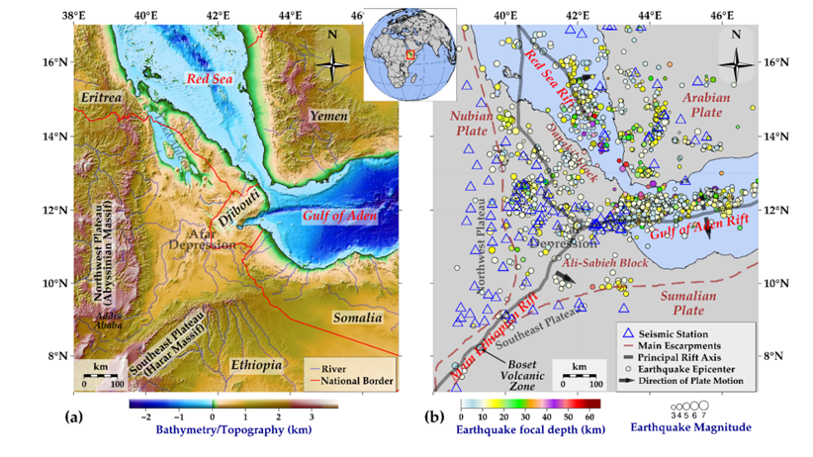

Figure 1 (a) Location map of the study region, (b) Tectonic setting of the region showing earthquake epicenters (circles increasing with magnitude between mb 3.0 and 7.0) and seismic stations (blue triangles).

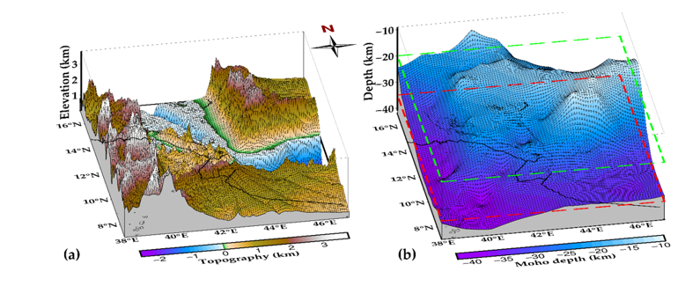

Figure 2 (a) A three-dimensional topography of the study region, (b) Moho depths (CRUST1.0 model) of the study region. Green and red dotted lines are boundaries based on the ak135 model of the crust.

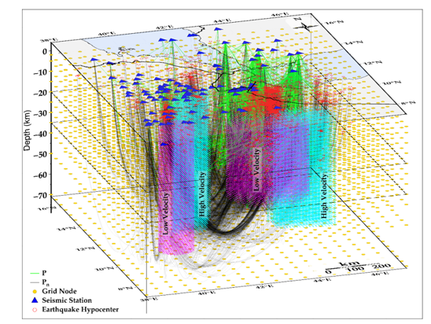

Figure 3 The study area showing raypaths for P (blue lines) and P_{n} (black line) phases from earthquake hypocenters (red circles) to seismic stations (blue filled triangles). Gold circles are grid nodes. The purple and light blue columns are artificial low- and high-velocity anomalies for synthetic reconstruction tests. The ak135 model is used to calculate the raypaths (depth axis is about 11 times exaggerated).

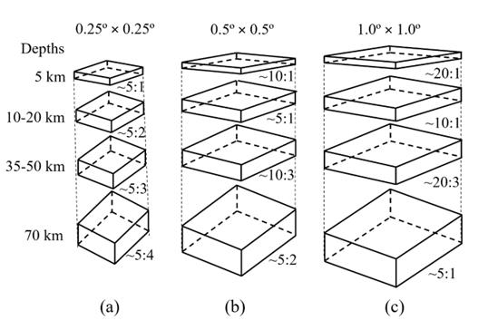

Figure 4 A schematic representation of widths to height ratios (not to scale) for (a) 0.25º, (b) 0.5º, and (c) 1.0º equilateral grid cells at different depths.

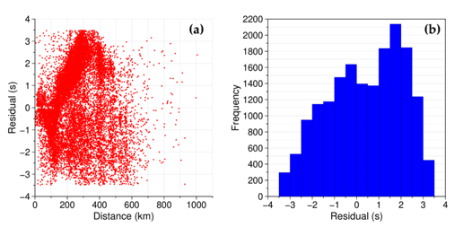

Figure 5 (a) Distribution of travel-time residuals, (b) Histogram of traveltime residuals with an interval of 0.5 seconds.
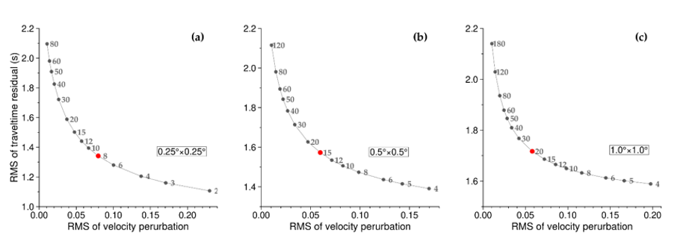

Figure 6 Trade-off curve of RMS of traveltime residual and velocity perturbation for (a) 0.25º, (b) 0.5º, and (c) 1.0º equilateral grid cells.

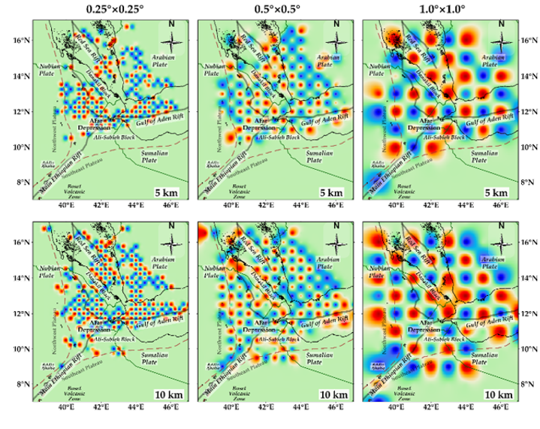
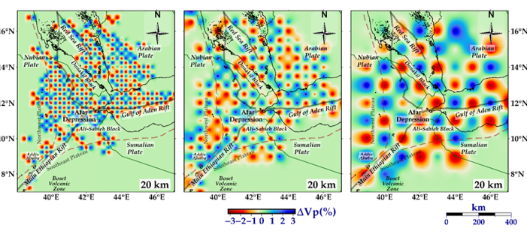

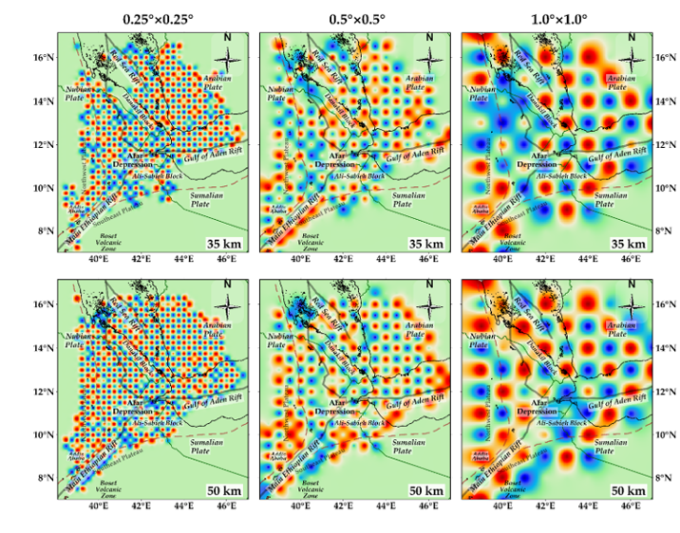

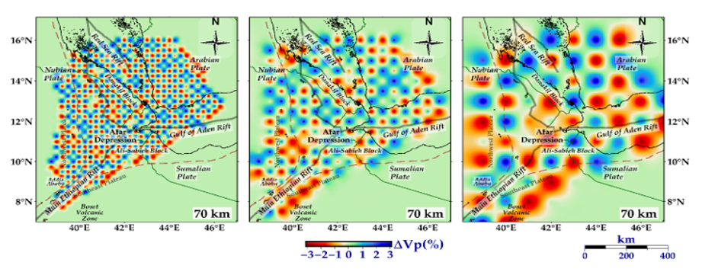

Figure 7 Comparison of checkerboard resolution test results at different depth layers using 0.25º, 0.5º, and 1.0º equilateral grids, and adding random noise with a standard deviation of 0.1 seconds. Purple triangles are seismic stations while yellow circles represent earthquake locations within 0.5 km of the depth.

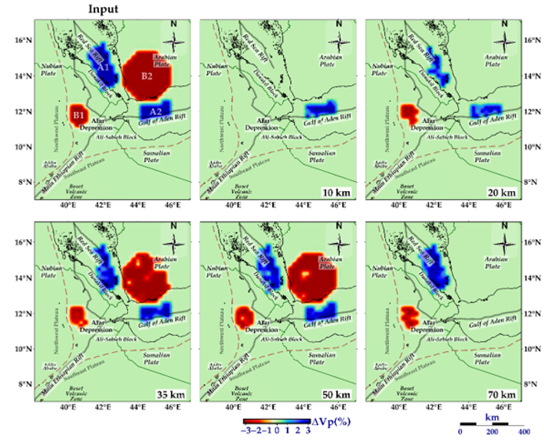

Figure 8 Structural reconstruction test results of introducing high-velocity (A1 and A2) and low-velocity (B1 and B2) synthetic anomalies, and adding random noise with a standard deviation of 0.1 seconds. The first figure (top left) is the input while the other figures are outputs at different depth layers.

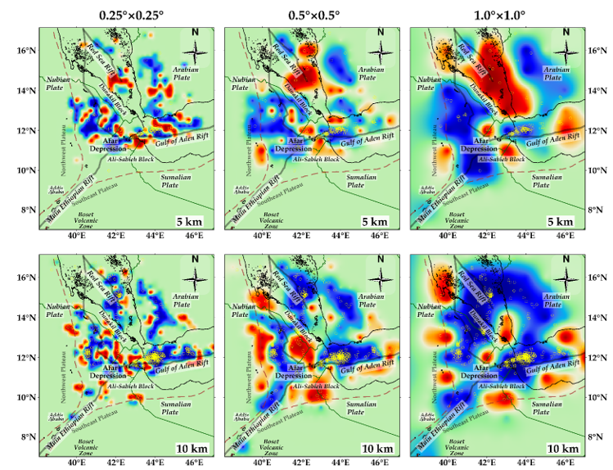
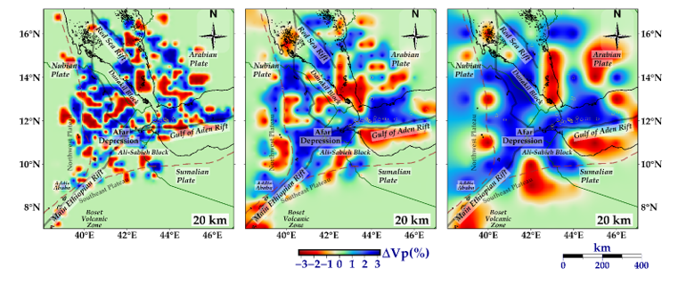

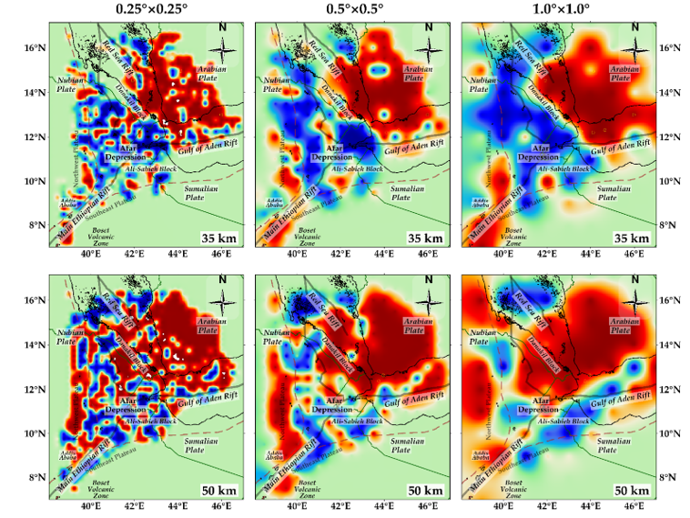

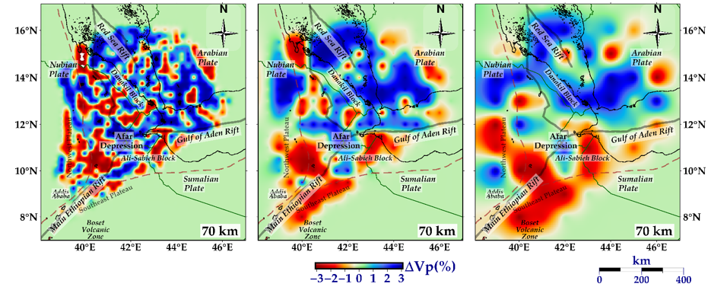
Figure 9 Comparison of inversion results at different depth layers using 0.25º, 0.5º, and 1.0º equilateral grids. Purple triangles are seismic stations while yellow circles represent earthquake locations within 0.5 km of the depth.
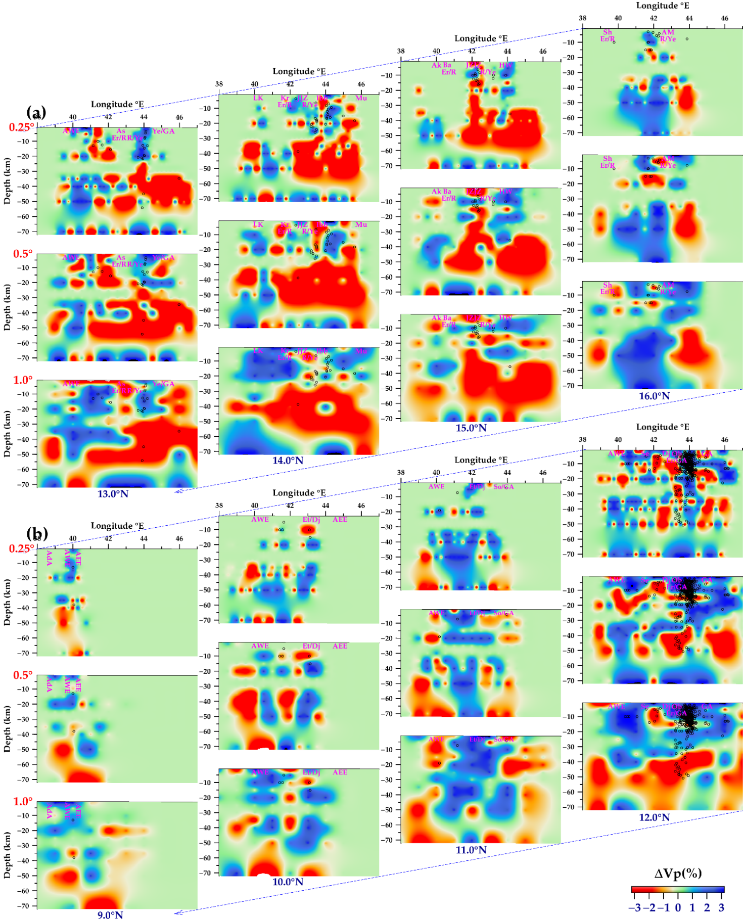
Figure 10 Comparison of inversion results using the 0.25º, 0.5º, and 1.0º equilateral grids at several East-West vertical cross-sections along latitudes (a) 13º-16º N, and (b) 9º-12º N. The depth axis is about 10 times exaggerated. Black circles represent earthquake focal depths within a horizontal distance of 5 km from the cross-section. AdA (Addis Ababa), AEE (Afar depression eastern encampment), Ak (Akilo in northern Eritrea), AM (Al Madasikah in southern Yemen), As (Assab in Eritrea), AWE (Afar depression western encampment), Ba (Badeda, a coastal city in Eritrea), Dj (Djibouti) Er (Eritrea), Et (Ethiopia), GA (Gulf of Aden), HW (Haraz Wildlife Sanctuary in southern Yemen), Ibb (name of a city in southern Yemen), JJZ (Jazirat Jabal Zuqar, an Island in the Red Sea between Eritrea and Yemen), JZJZ (Jabel Zubair Jabal Zubayr, an Island in the Red Sea between Eritrea and Yemen), Kr (Krum in northern Eritrea), LK (Lake Karum, in northern Ethiopia), Mu (Mudiyah city in southern Yemen), Ob (Obock in northern Djibouti), R (Red Sea), Se (Serdo in northern Ethiopia), So (Somalia), Sh (Sheib in northern Eritrea), Ye (Yemen). The forward slash between the character symbols denotes their boundar.

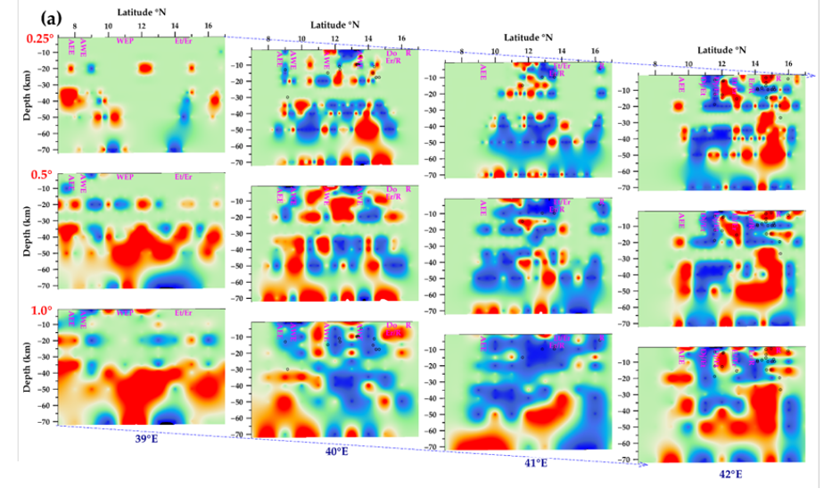
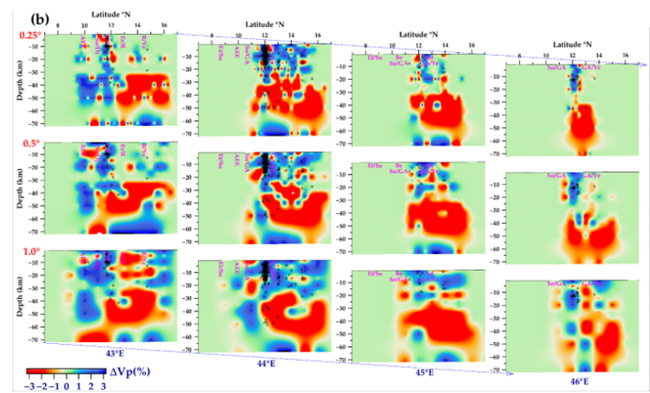

Figure 11 Comparison of inversion results using the 0.25º, 0.5º, and 1.0º equilateral grids at several North-South vertical cross-sections along longitudes (a) 39º-42º E, and (b) 43º-46º E. The depth axis is about 10 times exaggerated. Black circles represent earthquake focal depths within a horizontal distance of 5 km from the cross-section. Ad (Aden port city in southernmost Yemen), AEE (Afar depression eastern encampment), AWE (Afar depression western encampment), Be (Berbera in Somalia), Dj (Djibouti) Do (Doleh in northern Eritrea), Er (Eritrea), Et (Ethiopis), GA (Gulf of Aden), GT (Gulf of Tadjoura), R (Red Sea), Se (Serdo in northern Ethiopia), So (Somalia), WEP (Western Ethiopia Plateau), Ye (Yemen). The forward slash between the characters denotes their boundary.

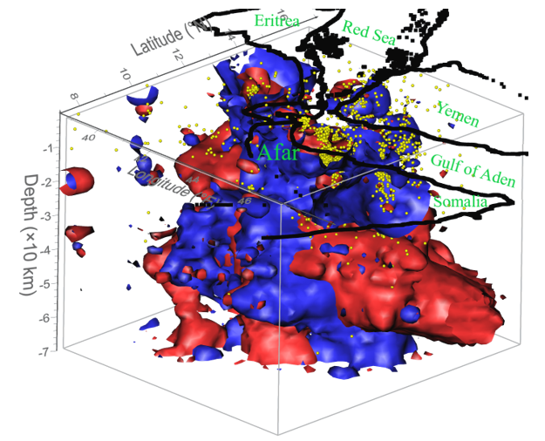

Figure 12 The final 3D model of velocity perturbation, featuring 0.25º grid cell resolution for depths of 5–20 km and 0.5º grid cell resolution for depths of 35–70 km. Red areas indicate low-velocity zones (LVZs), while blue areas indicate high-velocity zones (HVZs). Yellow spheres mark the locations of earthquake hypocenters. The depth axis is exaggerated approximately 10 times.

