Physicochemical characterization of the groundwater of the continental terminal 3 of the Tillabéri region in Niger : case of certain villages in the rural communes of Dantchandou, Hamdallaye and Simiri.

ABSTRACT
Water is an essential element for life and for the real and sustainable socio-economic development of a country. However, the insufficiency of water for human consumption may direct authorities towards sustaining water. The objective of this work is to analyze the physicochemical parameters of the groundwater of the Continental Terminal 3 aquifer in order to determine its quality, the mechanism of mineralization origin, understand its hydrochemical facies, and its suitability for irrigation. We analyzed the water from several localities. The results obtained from the analysis of physicochemical parameters show that high sulfate levels were recorded in the villages of Dey Tagui (270 mg/L), Guilliyeni (300 mg/L), and Boundo (310 mg/L). Slightly elevated fluoride levels were recorded in Guilliyeni (1.56 mg/L) and Boundo (1.57 mg/L). Slightly high nitrate levels in the village of Sini Bangou (53.24 mg/L) and finally very high total iron levels in Datché (1.37 mg/L). The principal component analysis and ascending hierarchical classification show that the mineralization of these waters would be linked to a slow process which is hydrolysis by water-rock contact, degradation of organic matter, oxidation-reduction and anthropogenic activities. The hydrochemical facies show that the calcium bicarbonate facies and the sodium and potassium chloride facies equally predominate over the other facies. The suitability of the waters for irrigation shows that more than 60% of these waters are excellent for irrigation. The waters of the CT3 aquifer are sheltered for human consumption.
INTRODUCTION
Water is an essential element for life and for the real and sustainable socio-economic development of a country [1]. Several activities are carried out with this natural resource. The shortage of water for human consumption has led authorities to turn to groundwater. This natural resource is used in several activities such as human consumption, animal watering, irrigation, and industrial activities. Groundwater is often the only permanent resource in the Sahel [2]. Furthermore, several phenomena threaten this groundwater resource. For example, climate variability and human activities affect groundwater quality [3]. Indeed, in developing countries, obtaining clean water for human consumption has become a serious problem due to a lack of environmental protection [4]. The Tillabéri region, located in southwest Niger, is rich in groundwater potential. Several activities are carried out using this natural resource. The populations of rural communes use these groundwaters mainly for consumption, domestic activities and sometimes irrigation at the level of the rural commune of Dantchandou. Groundwaters are quite often influenced by mineralization whose origin is diverse as shown by several studies. It could be due to the water-rock contact time, hydrolysis and dissolution of certain elements, rain leaching, anthropogenic activities ([5]; [6]; [7]; [8]). The quality of the water is sometimes degraded. It is in this context that this study is carried out which is to analyze the physicochemical parameters of the groundwater of the continental terminal 3 aquifer in order to see especially the quality of these waters, the mechanism of the origin of the mineralization, to know the hydrochemical facies and the suitability of these waters for irrigation.
MATERIALS AND METHODS
PRESENTATION OF THE STUDY AREA
The Tillabéri region is located in the far west of Niger between 11°50 and 15°45 North latitudes and 0°10 and 4°20 East longitudes [9]. The geological formation of this region can be divided into two zones: the part west of the river constituting the crystalline basement zone and the part east of the river consisting of the western end of the Iullemeden sedimentary basin [10]. The Continental Terminal 3 (CT3) phreatic system consists of a set of sand lenses of variable grain size and silty to silty-clayey formation. It appears to form a system in apparent hydraulic continuity across the entire Continental Terminal in the form of an unconfined aquifer [11]. Thus, the water from the structures taken from the rural communes of Dantchandou and Hamdallaye located in the department of Kollo (Tillabéri region) and Simiri in the department of Ouallam (Tillabéri region) captures the water table of continental terminal 3.
METHODOLOGY
The criteria for selecting a structure to sample focused on water from structures intended primarily for consumption and also for other uses such as irrigation and animal watering. This sampling campaign was carried out in September 2020 during the piezometric mission of the Tillabéri Regional Directorate of Hydraulics and Sanitation. Samples were taken from 16 structures including CT3, including seven (7) cemented wells (CW) in the rural commune of Dantchandou; three artesian boreholes (AB) in the rural commune of Dantchandou; four cemented wells (CW) in the rural commune of Hamdallaye; and two cemented wells (CW) in the rural commune of Simiri. The water sampling and physicochemical parameter analysis method used is the protocol described by Jean RODIER [12]. A GARMIN GPS was used to record the coordinates of the sampled structures. The measurement of physical parameters was carried out in the field such as electrical conductivity (EC) and temperature (T) using a HANNA brand conductivity meter; pH using a Palintest brand pH meter, and Turbidity (Turb.) by a Palintest brand turbidimeter. After collection, the samples were stored in a cooler at a temperature of approximately 4°C. Then sent to the water analysis laboratory of the Regional Directorate of Hydraulics and Sanitation of Tillabéri approximately 48 hours after sampling for analysis of chemical parameters: TAC, HCO₃⁻, Cl⁻, F⁻, SO₄²⁻, NO₃⁻, NO₂⁻, Na⁺, K⁺, total iron (Fet), Ca²⁺, Mg2⁺. The Cl⁻, F⁻, SO₄²⁻, NO₂⁻ ions by colorimetry using a DR 2800 direct reading spectrophotometer. NO3⁻ and Fet ions by colorimetry using a DR 2000 direct reading spectrophotometer. Na⁺ and K⁺ ions by atomic adsorption using a JENWAY flame spectrophotometer. And by volumetry the TAC (Complete Alkalimetry Title), TH (Hydrotimetry Title) and Ca²⁺ using a digital titrator. Mg²⁺ ions were determined by calculation from TH and Ca²⁺ and HCO₃⁻ from TAC. The data from the analyses of certain physicochemical parameters obtained were compared with the WHO guide values [13] for human consumption water. The coordinates obtained by GPS were mapped using ArcGis 10.1 software, it is widely used in the geographic information system. The physicochemical data were processed using SPSS 20 software which is used in hydrochemistry by applying hydrochemical methods (principal component analysis and ascending hierarchical classification) to see the origin of the mineralization of the water on the one hand and on the other hand the Piper diagram using the DIAGRAMME software to characterize the different facies of the water taken and the suitability of the water for irrigation using the Wilcox diagram.
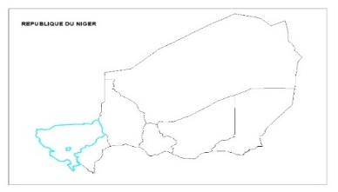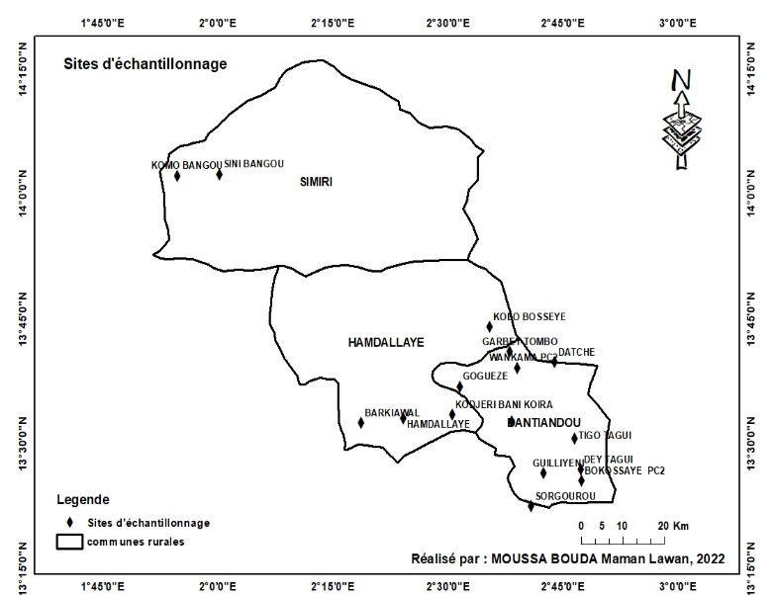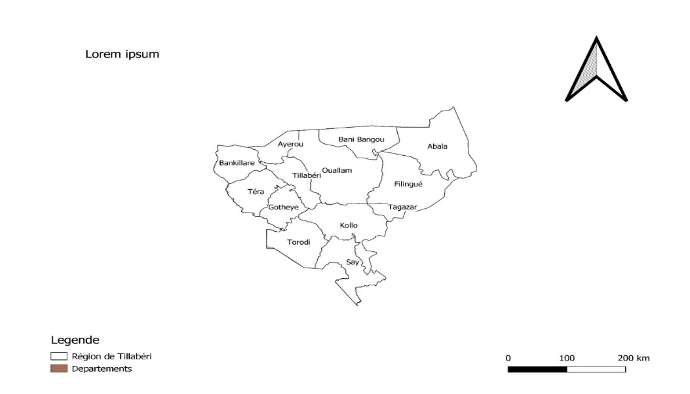
Figure 1 : Sites of the prélévements preprelevements d’échantillonnage
Figure 1 : Sampling Sites
RESULTS
Physicochemical Parameters
The overall results for the physical parameters are shown in Table I, and the chemical parameters are shown in Table II.
Table I: Physical Parameters
Villages | Types of works | CE  $$(μs.{mL}^{-1})$$ |  | T  (°C) | pH | Turbidity  (NTU)
Barkiawal | PC |  | 170 | 31,4 | 6,38 | 0,49
Bokossey PC2 | PC |  | 480 | 32,3 | 5,64 | 1,72
Boundo | FE |  | 1330 | 32,7 | 7,48 | 0,47
Datché | PC |  | 227 | 32,4 | 6,54 | 9,49
Dey Tagui | FE |  | 1350 | 36,1 | 7,47 | 0,01
Garbey Tombo | PC |  | 250 | 29,9 | 5,48 | 2,6
Goguezé | PC |  | 120 | 31,8 | 6,24 | 58,6
Guilleyni | FE |  | 1350 | 36,7 | 7,46 | 0,01
Hamdallaye | PC |  | 170 | 31,4 | 6,38 | 2,59
Kodjiri Bani Koira | PC |  | 110 | 31,3 | 6,46 | 0,48
Kolo Bosseye | PC |  | 270 | 32,3 | 6,1 | 0,29
Sorgourou | PC |  | 150 | 31,9 | 5,7 | 0,99
Tigo Tagui | PC |  | 90 | 32 | 6,14 | 1,93
Wankama PC2 | PC |  | 700 | 30,7 | 6,22 | 3,86
Komo Bangou | PC |  | 250 | 31,4 | 6,03 | 2,03
Sini Bangou | PC |  | 150 | 31,4 | 5,6 | 21,7
OMS 2017 |  |  | 180-1000 | - | 6,5-8,5 | 6

Table II : Chemical parameters (en mg/L)
Villages | TH | TAC | HCO₃ ⁻ | Cl⁻ | SO₄²⁻ | F⁻ | NO₃⁻ | NO₂⁻ | Na⁺ | K⁺ | Fe_{t} | Ca²⁺ | Mg²⁺
Barkiawal | 30 | 27,5 | 33,55 | 1,9 | 0 | 0,81 | 14,52 | 0,1221 | 5,45 | 1,5 | 0,28 | 10 | 1,215
Bokossey PC2 | 22 | 19 | 23,18 | 110 | 85 | 0,11 | 19,8 | 0,5808 | 107,5 | 1 | 0,04 | 1,2 | 4,617
Boundo | 240,5 | 247 | 301,34 | 47 | 310 | 1,57 | 5,28 | 0,0033 | 215,52 | 9,44 | 0,15 | 42 | 32,9265
Datché | 96 | 94 | 114,68 | 4,8 | 0 | 0,18 | 3,08 | 0,6897 | 3,4 | 4,5 | 1,37 | 31,4 | 4,2525
Dey Tagui | 150 | 245,5 | 299,51 | 71,5 | 270 | 1,47 | 1,76 | 0,0429 | 238 | 8 | 0,09 | 34 | 15,795
Garbey Tombo | 40 | 35 | 42,7 | 21,5 | 0 | 0,00 | 28,16 | 0,0429 | 24,5 | 3 | 0,07 | 10 | 3,645
Goguezé | 50 | 75 | 91,5 | 1 | 5 | 0,00 | 6,16 | 0,0264 | 20,5 | 1,5 | 0 | 14 | 3,645
Guilliyeni | 210 | 220 | 268,4 | 250 | 300 | 1,56 | 3,52 | 0,0726 | 283 | 8 | 0,12 | 49 | 21,2625
Hamdallaye | 19 | 43 | 52,46 | 9,6 | 2 | 0,16 | 14,52 | 0,5049 | 22 | 8,5 | 0,09 | 7,2 | 0,243
Kodjiri Bani Koira | 39,5 | 27,5 | 33,55 | 13,8 | 0 | 0,06 | 14,96 | 0,0297 | 3,91 | 6 | 0,07 | 13,8 | 1,215
Kolo Bosseye | 103 | 110 | 134,2 | 5,9 | 5 | 0,05 | 7,48 | 0,0297 | 15,23 | 3 | 0,04 | 28 | 8,019
Sorgourou | 30 | 41 | 50,02 | 2,4 | 0 | 0,03 | 36,52 | 0,165 | 21,5 | 2,5 | 0,07 | 9,4 | 1,5795
Tigo Tagui | 25 | 20 | 24,4 | 0,6 | 0 | 0,08 | 11 | 0,2376 | 1,65 | 0,5 | 0,22 | 6,4 | 2,187
Wankama PC2 | 165 | 57,5 | 70,15 | 103,5 | 135 | 0,35 | 11,44 | 0,099 | 89,65 | 6,5 | 0,08 | 39 | 16,4025
Komo Bangou | 60 | 20 | 24,4 | 13,1 | 10 | 0,01 | 53,24 | 0,0627 | 14 | 7 | 0,06 | 16 | 4,86
Sini Bangou | 40 | 50 | 61 | 7 | 6 | 0,07 | 24,2 | 0,0495 | 23,5 | 1 | 0,22 | 10,8 | 3,159
OMS 2017 | - | - | - | 250 | 250 | 1,5 | 50 | 3 | 200 | 12 | 0,3 | - | -

Descriptive Analyses
The descriptive analyses of four physical parameters (EC, pH, T, and Turb.) and thirteen chemical parameters (TAC, TH, HCO₃⁻, SO₄²⁻, Cl⁻, NO₃⁻, Na⁺, K⁺, Ca²⁺, Mg²⁺, F⁻, NO₂⁻, and Fet) are reported in Tables III and IV.

Table III: Description of Physical Parameters
Parameters | EC(µS/cm) | T (°C) | pH | Turbidity (NTU)
OMS 2017 | 180-1000 | - | 6,5-8,5 | 6
Average | 447,94 | 32,13 | 6,19 | 6
Standard deviation | 469,806 | 1,857 | 0,54 | 14
Minimum | 90 | 30 | 5 | 0,1
Maximum | 1350 | 37 | 7 | 58

Table III presents the descriptive statistics of the physical parameters. Electrical conductivity ranges from 90 to 1350 µS/cm with a mean of 447.94 µS/cm and a standard deviation of 469.806 µS/cm. The temperature of these waters ranges from 30 to 37°C with a mean of 32.13°C and a standard deviation of 1.857°C. The pH of these waters ranges from 5 to 7 with a mean of 6.19 and a standard deviation of 0.54. Finally, turbidity ranges from 0.1 to 58 NTU with a mean of 6 NTU and a standard deviation of 14 NTU.
The descriptive analysis of the chemical parameters is presented in Table IV. The Na⁺ ions are predominated by the major cations, they vary from 2 to 283 mg/L with an average of 68 mg/L and a standard deviation of 93 mg/L. Then the Ca²⁺ ion which varies from 1 to 49 mg/L with an average of 20.06 and a standard deviation of 14 mg/L. Then the Mg²₊ ions which vary from 0 to 33 mg/L with an average of 7 mg/L and a standard deviation of 9 mg/L. Finally, the K⁺ ions vary from 0 to 9 mg/L and an average of 4 mg/L and a standard deviation of 3.05 mg/L. Regarding the major anions, they are predominated by the HCO₃⁻, they vary from 23 to 301 mg/L with an average of 101 mg/L and a standard deviation of 98 mg/L. Next come the SO₄²⁻ ions, which range from 0 to 310 mg/L with a mean of 70 mg/L and a standard deviation of 116 mg/L. Then come the Cl⁻ ions, which range from 1 to 250 mg/L with a mean of 41 mg/L and a standard deviation of 66 mg/L. Finally, the NO₃⁻ ions range from 2 to 53 mg/L with a mean of 16 mg/L and a standard deviation of 13 mg/L. Regarding the minor ions, the Fet range from 0 to 1 mg/L with a mean of 0.0625 mg/L. The F⁻ and NO₂⁻ ions all range from 0 to 1 mg/L.

Table IV: Chemical Parameters (in mg/L)
Parameters | Minimum | Maximum | Average | Ecart-type | OMS 2017
Number of observations | 16 | 16 | 16 | 16
TH | 19 | 240 | 82 | 71 | -
TAC | 19 | 247 | 83 | 81,08 | -
HCO₃⁻ | 23 | 301 | 101 | 98 | -
Cl⁻ | 1 | 250 | 41 | 66 | 250
SO₄²⁻ | 0 | 310 | 70 | 116 | 250
F⁻ | 0 | 1 | 0 | 0 | 1,5
NO₃⁻ | 2 | 53 | 16 | 13 | 50
NO₂⁻ | 0 | 1 | 0 | 0 | 3
Na⁺ | 2 | 283 | 68 | 93 | 200
K⁺ | 0 | 9 | 4 | 3,05 | 12
Fe_{t} | 0 | 1 | 0,0625 | 0 | 0,3
Ca²⁺ | 1 | 49 | 20,06 | 14 | -
Mg²⁺ | 0 | 33 | 7 | 9 | -

Application of Hydrochemical Methods
Multidimensional analysis (PCA, CHA) allows us to highlight points with similar chemistry, these points being agglomerated into groups created by multidimensional analysis [14]. This method facilitates the overall interpretation of a large amount of existing data [6].
Principal Component Analysis: PCA
Principal component analysis was performed on 16 samples and 14 parameters (EC, pH, T, Turb, TH, HCO3-, SO42-, Cl-, NO3-, Na+, K+, F-, NO2- and Fet).
Correlation
The correlation between the elements taken two by two in the table below (Table V) shows that: EC correlates strongly with T (0.805); pH (0.695); TH (0.886); with HCO₃⁻ (0.899); Cl⁻ (0.729); with (SO42⁻ (0.992); F⁻ (0.912); with Na+ (0.978); K⁺ (0.670). Temperature correlates with pH (0.767); TH (0.649); HCO3- (0.826); Cl- (0.707); with SO₄²⁻ (0.797); F⁻ (0.785); Na⁺(0.858). pH correlates with the following elements: TH (0.701); HCO3⁻ (0.789); SO₄²⁻(0.701); F⁻ (0.735); Na⁺(0.669). Total hardness TH correlates with the following elements: HCO3- (0.869); Cl- (0.607); SO42⁻ (0.885); F⁻ (0.797); Na⁺ (0.810); K⁺ (0.686). HCO₃- correlates with the elements: SO₄²⁻ (0.884); F⁻ (0.876); Na⁺ (0.863); K⁺ (0.606). Cl⁻ correlates with SO₄²⁻ (0.735); Na⁺ (0.806). SO₄2⁻ correlates with the elements F⁻ (0.913); Na⁺ (0.979); K⁺ (0.652). F⁻ correlates with the following elements: Na⁺ (0.890); K⁺ (0.602).
Factorial axes
The principal component analysis retains the factorial axes F1, F2 and F3 which express 81.88% of the variables expressed are represented in Table V. F1 has an eigenvalue of 11.524 with a variance of 64.023% of the total variance expressed. F1 includes in the constitution of its axis almost all the elements, i.e. a rate of 83.33% of the expressed variables. The F1 axis reflects the mineralization by the dissolution of these elements by a slow process called hydrolysis caused by water-rock contact. This mineralization of water is marked by the water-rock residence time phenomenon. F2 has an eigenvalue of 1.925 with a variance of 10.692%. The F2 axis has four (4) elements which enter into the constitution of its axis, i.e. a rate of 11.11% of the expressed variables. F2 is marked by the presence of nitrites which could be due to anthropogenic activities and the presence of Fet by the oxidation-reduction phenomenon. Finally, for the F3 axis with an eigenvalue of 1.290 and a variance of 7.165%. Two elements enter into its constitution, i.e. a rate of 11.11% of the total variables expressed, Turb. (-0.798) and NO₂⁻ (0.498) which shows that they evolve in the opposite direction. Thus, the correlation between Turbidity and NO₂⁻ is not good (-0.067) so they are independent of each other. The presence of NO₂⁻ may be due to contamination by infiltration of wastewater, septic tanks [15].
Table V: Factorial axes
Components | eigenvalues | % of variance | % cumulative
F1 | 11,524 | 64,023 | 64,023
F2 | 1,925 | 10,692 | 74,715
F3 | 1,290 | 7,165 | 81,880
Table VI: Component Matrix
Variables | F1 | F2 | F3
CE | 0,977 | -0,114 | 0,077
T | 0,842 | 0,065 | -0,080
pH | 0,786 | 0,468 | -0,003
Turb | -0,233 | 0,186 | -0,798
TH | 0,931 | 0,003 | -0,058
HCO₃⁻ | 0,945 | 0,091 | -0,178
Cl⁻ | 0,706 | -0,138 | 0,233
SO₄²⁻ | 0,973 | -0,130 | 0,044
F⁻ | 0,924 | -0,069 | 0,007
NO₃⁻ | -0,531 | -0,486 | 0,367
NO₂⁻ | -0,170 | 0,695 | 0,498
Na⁺ | 0,949 | -0,136 | 0,068
K⁺ | 0,687 | -0,054 | 0,320
Fe_{t} | -0,026 | 0,902 | 0,115

The component diagram shows (Figure 2) that the NO₃⁻, NO₂⁻ and Fet ions are scattered compared to the others which have grouped together and form a sort of cluster. These are: CE, T, pH, HCO₃⁻, TH, Cl⁻, SO₄²⁻, F⁻, K⁺, Na⁺. These elements could be marked by the same phenomenon.
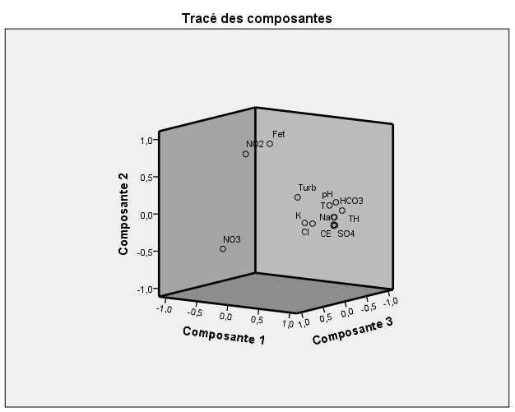

Figure 2: Component diagram
Ascending hierarchical classification
The dendrogram (Figure 3) of the CT3 waters presents two classes of variables. The first class includes NO2-, total iron, F⁻, K⁺, pH, Mg²⁺, NO₃⁻, T, and Ca²⁺. The second class consists of Cl⁻, SO₄²⁻, Na⁺, HCO₃⁻, and CE.
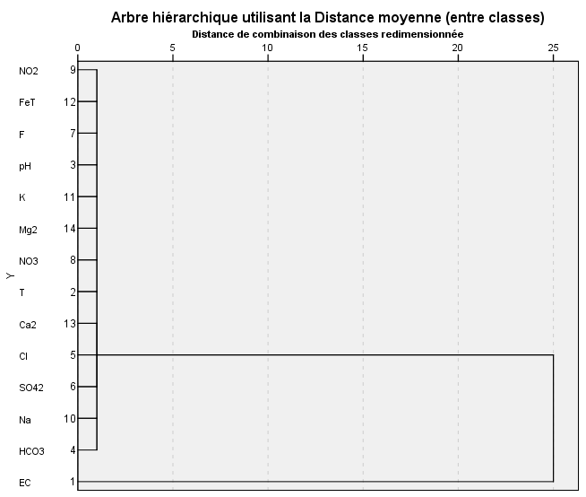
Figure 3: Dendrogram of CT3 waters
Table VII: Correlation matrix
 | CE | T | pH | Turb. | TH | HCO₃⁻ | Cl⁻ | SO₄²⁻ | F⁻ | NO₃⁻ | NO₂⁻ | Na⁺ | K⁺ | Fe_{t}
CE | 1
T | 0,805 | 1
pH | 0,695 | 0,767 | 1
Turb | -0,280 | -0,120 | -0,115 | 1
TH | 0,886 | 0,649 | 0,701 | -0,190 | 1
HCO₃⁻ | 0,899 | 0,826 | 0,789 | -0,104 | 0,869 | 1
Cl⁻ | 0,729 | 0,707 | 0,419 | -0,230 | 0,607 | 0,500 | 1
SO₄²⁻ | 0,992 | 0,797 | 0,701 | -0,242 | 0,883 | 0,884 | 0,735 | 1
F⁻ | 0,912 | 0,785 | 0,735 | -0,285 | 0,797 | 0,876 | 0,598 | 0,913 | 1
NO₃⁻ | -0,431 | -0,485 | -0,547 | -0,136 | -0,486 | -0,577 | -0,283 | -0,443 | -0,490 | 1
NO₂⁻ | -0,164 | -0,122 | 0,133 | -0,067 | -0,256 | -0,192 | 0,000 | -0,176 | -0,215 | -0,119 | 1
Na⁺ | 0,978 | 0,858 | 0,669 | -0,226 | 0,810 | 0,863 | 0,806 | 0,979 | 0,890 | -0,414 | -0,126 | 1
K⁺ | 0,670 | 0,413 | 0,509 | -0,320 | 0,686 | 0,606 | 0,413 | 0,652 | 0,602 | -0,170 | -0,017 | 0,596 | 1
Fe_{t} | -0,125 | -0,018 | 0,398 | 0,041 | 0,050 | 0,036 | -0,147 | -0,161 | -0,102 | -0,249 | 0,537 | -0,184 | -0,038 | 1

Hydrochemical Facies
Figure 4 presents the Piper diagram of the CT3 waters. It shows four hydrochemical facies, as shown in the Piper diagram. Thus, the calcium bicarbonate and sodium chloride and potassium facies all have a proportion of 31.25%, and the calcium chloride and magnesium sulfate and sodium bicarbonate and potassium facies also all have a proportion of 18.75%.
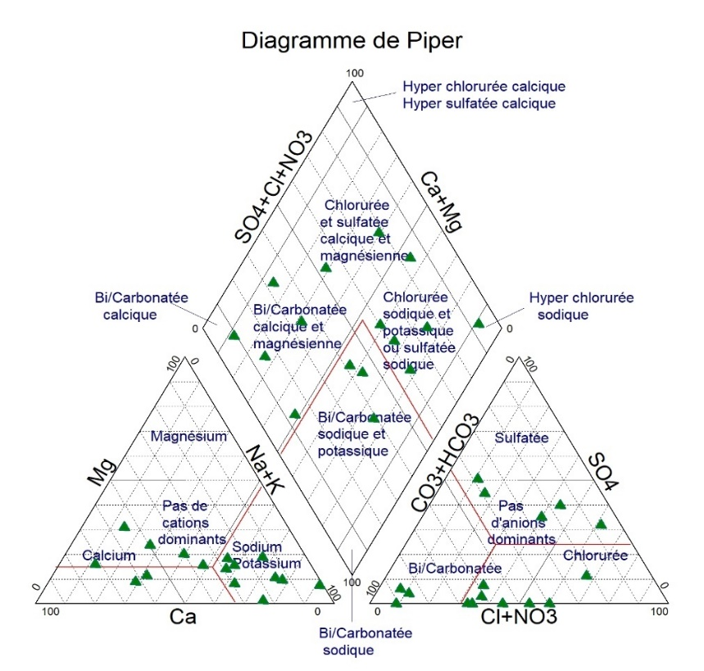

Figure 4: Piper diagram of the analyzed waters
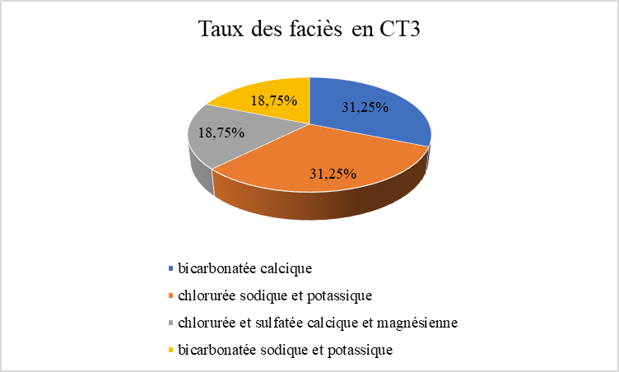

Figure 5: Percentage distribution of facies in CT3 waters
Water suitability for irrigation
Waters captured by CT 3 are divided into two classes (Figure 6). The first class, with 0 < CE ≤ 500 µS/cm and a Na+ percentage between 10 and 80%, is in the excellent class for irrigation, i.e., a rate of 75%. The second class, with 500 < CE < 2000 µS/cm and 60% < Na ≤ 100%, is the class that is suitable for irrigation, i.e., a rate of 25%.

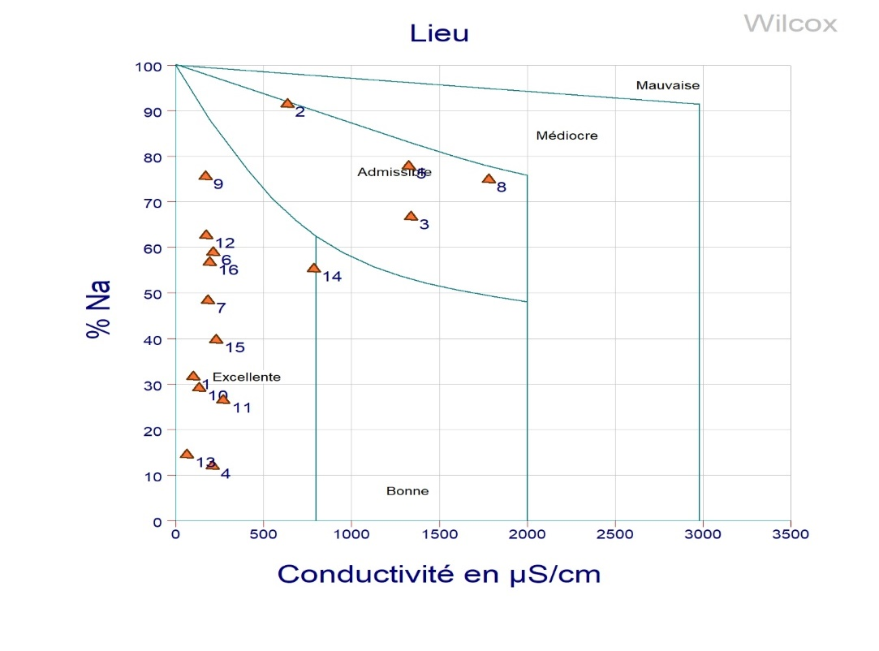

Figure 6: Wilcox diagram showing the suitability of water for irrigation

Figure 7: Proportion of water suitability for irrigation
DISCUSSION
Physicochemical parameters
The values of the physical parameters generally comply with the standards set by WHO 2017 for drinking water. EC values are higher than the range recommended by WHO 2017 (180-1000 µS/cm) at Boundo (1330 µS/cm), Dey Tagui, and Guilliyeni all have 1350 µS/cm, this value is slightly higher than the WHO 2017 guideline value. These waters come from artesian boreholes and are highly mineralized. The temperature of these waters reflects that of a semi-arid zone. The pH of these waters is generally slightly acidic except at Boundo (7.48); Dey Tagui (7.47) and Guilliyeni (7.46), which are alkaline. The weakly acidic pH of the water could be due to the release of H⁺ ions or the degradation of organic matter. The alkaline pH of the water could be due to the hydrolysis of certain elements. This is shown by the study by [16], which found pH values ranging from 5.6 to 9.59 in the structures tapping the Korama aquifer in Zinder.
Regarding chemical parameters, the WHO 2017 standard is also generally respected. Furthermore, high levels of sulfate SO42- are recorded in the locality of Dey Tagui (270 mg/L), Guilliyeni (300 mg/L), and in the locality of Boundo (310 mg/L), which exceed the WHO standard (250 mg/L). These sulfate ion contents could be due to the dissolution of gypsum and which promotes the mineralization of water, as shown by the studies of [6] in Téra on the base. High levels of fluoride ions F- at Boundo and Guilliyeni respectively 1.57 mg/L and 1.56 mg/L which exceed the WHO standard (1.5 mg/L). The work [17] showed high F- contents in the waters which capture the continental Intercalaire Hamadien/continental terminal which varies between 1.64 and 3.28 mg/L and shows that these contents could be due to the dissolution of natural minerals in the rocks and soils with which the water interacts. The nitrate content in the village of Komo Bango (53.24 mg/L) slightly exceeds that of the WHO (50 mg/L). This content could be due to human activities. High Na⁺ levels were recorded in the locality of Guilliyeni (283 mg/L) which exceeds the WHO guideline value (200 mg/L). This could be due to the dissolution of sodium salts. In the locality of Datché, high Fet levels were recorded (1.37 mg/L) which exceed the WHO guideline value (0.3 mg/L). The presence of high iron levels gives the water a reddish color and an unpleasant taste [17]. This could be due to the nature of the geological formation of the environment (ferruginous sandstone) or the phenomenon of oxidation-reduction or the development of certain ferruginous bacteria which can increase the corrosion of boreholes [17]. But in the case of Datché it is a cemented well, so these high total iron levels could be linked to the geological nature of the environment.
Principal Component Analysis
Regarding the correlation matrices, very good correlations were obtained between certain elements. Thus, two elements that exhibit good correlations show that they are driven by the same phenomenon. The selected factorial axes (F1, F2, and F3) reflect the phenomenon of water mineralization. The F1 axis groups together all the elements (CE, T, pH, HCO₃⁻, TH, Cl⁻, SO₄²⁻, F⁻, K^{+,} Na⁺). It reflects mineralization, which could be due to a slow process called hydrolysis caused by water-rock contact. The F2 axis groups together two elements (NO₂⁻ and Fet). The presence of NO₂⁻ could be due to anthropogenic activities. Fet could be due to redox or the geological nature of the environment. The F2 axis reflects mineralization, which could be due to anthropogenic activities, redox, or the nature of the environment. This is consistent with numerous studies on the origin of water mineralization ([5]; [6]; [7]; [8]).
Ascending Hierarchical Classification
The first class includes NO₂⁻, total iron, F⁻, K⁺, pH, Mg²⁺, NO₃⁻, T, Ca²⁺. It highlights the phenomenon of mineralization through the degradation of organic matter, the dissolution of certain elements, and the oxidation-reduction phenomenon. The second class consists of Cl⁻, SO₄^{2-,} Na⁺, HCO₃⁻, and CE. These elements in this class account for the mineralization of CT3 waters through the hydrolysis phenomenon. This is consistent with several studies ([5]; [6]; [7]; [8]).
Hydrochemical Facies
The analyzed waters that capture CT3 present four (4) facies with a predominance of calcium bicarbonates and sodium and potassium chlorides. This could be due to the high bicarbonate and calcium levels on the one hand, and chloride, sodium, and potassium on the other.
Suitability of Water for Irrigation
Electrical conductivity and sodium percentage determine the water's class for use in irrigation. Waters with high EC and high sodium percentages tend to be less suitable for irrigation. These waters are generally excellent for irrigation.
CONCLUSION
Analysis of the physicochemical parameters of the CT 3 aquifer shows that it generally meets the WHO 2017 guideline values for human consumption. Furthermore, high sulfate levels were recorded in the villages of Dey Tagui (270 mg/L), Guilliyeni (300 mg/L) and Boundo (310 mg/L). Slightly high fluoride levels were recorded in Guilliyeni (1.56 mg/L) and Boundo (1.57 mg/L). Slightly high nitrate levels were recorded in the village of Sini Bangou (53.24 mg/L) and finally, very high total iron levels were recorded in Datché (1.37 mg/L). Principal component analysis and ascending hierarchical classification show that the mineralization of these waters would be linked to a slow process which is hydrolysis by water-rock contact, degradation of organic matter, oxidation-reduction and anthropogenic activities. The hydrochemical facies show that the calcium bicarbonate facies and the sodium and potassium chloride facies equally predominate over the other facies. The suitability of the waters for irrigation shows that more than 60% of these waters are excellent for irrigation.
Bibliographic References
[1] BELGHITI M.L., CHAHLAOUI A., BENGOUMI D., EL MOUSTAINE R., 2013. Study of the Physicochemical and Bacteriological Quality of Plio-Quaternary Groundwater in the Meknes Region (Morocco). Larhyss Journal, ISSN 1112-3680, No. 14, June 2013, pp. 21-36
[2] Guillaume FAVREAV, 2000. CHARACTERIZATION AND MODELING OF A RISING GROUNDWATER TABLE IN THE SAHEL: Dynamics and Geochemistry of the Natural Piezometric Depression of the Dantiandou Kori (Southwestern Niger). Thesis prepared at the Montpellier Institute of Research for Development and the University of Montpellier XI – Orsay. 353 pages
[3] Md. Bodrud-Doza, A.R.M. Towfiqul Islam, Fahad Ahmed, Samiran Dasd, Narottam Saha, M. Safiur Rahman, 2016. Characterization of groundwater quality using water evaluation indices, multivariate statistics and geostatistics in central Bangladesh. http://dx.doi.org/10.1016/j.wsj.2016.05.001
[4] MEHOUNOU José Papin1, JOSSE Roger Gérard, Pierre DOSSOU-YOVO, Serge Freddy SENOU, TOKLO Rock Modéran, 2016. Physicochemical and microbiological characterization of groundwater and surface water in the cotton production area of Aplahoué. http://dx.doi.org/10.4314/jab.v103i1.6
[5] Haoua AMADOU, Mahaman Sani LAOUALI and Abdou Salam MANZOLA, 2014. Physicochemical and bacteriological analyses of water from three aquifers in the Tillabery region: Application of multivariate statistical analysis methods. Larhyss Journ al, ISSN 1112-3680, No. 20, December 2014, pp. 25-41
[6] Abdou BABAYE, 2012. Assessment of Groundwater Resources in the Dargol Basin (Liptako-Niger) online thesis, downloaded from: https://orbi.uliege.be/bitstream/2268/149855/1/TheseABDOUBABAYE_Vcorrigee_Definitive.pdf
[7] Rabilou SOULEY MOUSSA, Malam Alma Maman Mousbahou, Mahaman Sani Lawali, Natatou Ibrahim, 2018. Physicochemical Characterization of Groundwater in the Basement of the Zinder Region (Niger) During the Rainy and Dry Seasons. Journal Scientific September 2018 edition Vol. 14, No. 27 ISSN: 1857-7881 (Print) e-ISSN 1857-7531
[8] Abdel Kader HASSANE SALEY, 2019. Doctoral thesis. Assessment of water resources in the Continental Intercalaire/Hamadien aquifer in the Tahoua region (Iullemeden basin, Niger): climatic and anthropogenic impacts. HAL Id: tel-02089629<< https://tel.archives-ouvertes.fr/tel-02089629 >>
[9] INS, Regional Directorate of Tillabéri, 2016. Monograph of the Tillabéri region.
[10] Ibrahim MAINASSARA, 2010. Water resources in the Tillabéri region (southwest Niger) and their potential for development through irrigated agriculture. Thesis for the specialized master's degree in integrated water resources management.
[11] MAXIME MONFORT, 1997. Study of the relationships between the aquifers of the continental terminal north of Niamey (Niger): Geological, geochemical and hydrodynamic approach. DIPLOMA OF ADVANCED STUDIES (D.E.A.)
[12] Jean RODIER, Bernard Legube, Nicole Merlet. Water Analysis, 9th edition DUNOD
[13] WHO, 2017. Guidelines for drinking-water quality: 4th ed. incorporating the first addendum ISBN 978-92-4-254995-9
[14] BRGM, 1990. Design of a groundwater quality monitoring network.
[15] Rodrigue Kotchi OROU, Kalpy Julien COULIBALY, Germaine Adjoua TANOH, Ernest Kouassi AHOUSSI, Patrice Eugène Koman KISSIEDOU, Drissa Tanina SORO, and Nagnin SORO, 2016. Quality and vulnerability of alterite aquifer waters in the sub-prefectures of Grand-Morie and Azaguié in the department of Agboville in the south-east of Ivory Coast. ISSN 1813-3290, http://www.revist.ci
[16] Rabilou Souley Moussa, Maman Mousbahou Malam Alma, Mahaman Sani Laouali, Ibrahim Natatou, and Habou Issa, 2018. Comparative Study of the Physicochemical Quality of Korama Aquifer Waters (Superficial Korama and Deep Korama) in the Zinder Region (Niger) During the Rainy and Dry Seasons.
[17] Rabilou Souley Moussa, Maman Mousbahou Malam Alma, Mahaman Sani Laouali, Ibrahim Natatou, and Habou Issa, 2018. Physicochemical Characterization of Waters from the Continental Intercalaire / Hamadien and Continentalsiems Terminal Aquifers in the Zinder Region (Niger)

