Efficacy of Datura metel L. Seed Powder as a Bio-rodenticide and its Humaneness in Albino Mice

Abstract
Rodent infestation inflicts damage on agricultural produce and also affects human health (spread of zoonotic diseases) and facilities. These combined effects necessitate effective and environmental friendly management practices and strategies. This study was carried out to assess the rodenticidal effect of powdered Datura metel seeds and its humaneness in Albino mice.
Forty-five albino mice were randomly allocated into three treatment groups including control and acclimatized for 7 days. They were fed with different treatment levels of commercial rat feed and powdered Datura metel seeds powder (100:0, 90:10, and 60:40). Their behavioral changes were examined, daily-feed-intake and body-weight measurement were recorded, blood samples were drawn from individual animals for evaluation of haematological and biochemical parameters, mortality rates were recorded. Tissue histopathology (kidney, liver and heart) were was done using standard method. Data were analysed in SPSS and mean separated using DMRT at α = 0.05.
The result showed no significant difference in the mean daily-feed-intake across the groups (p˃0.05). Mean body weight was significantly reduced compared to control (p˂0.05). All hematological parameters reduced significantly except red blood cell with no significant difference. The mean serum enzymes (AST, ALT, and ALP) were significantly increased compared to control (p˂0.05). There was significant increase in K⁺, Cl⁻, and HCO₃⁻ compared to control (3.47±0.06, 2.19±0.36; 62.87±0.84, 57.60±1.00; 26.93±0.81, 24.53±0.79)mmol/L, respectively. Internal organs examined revealed histopathological changes and alterations in their physiological functions were identified.
Conclusively, Datura metel seeds powder possess rodenticidal properties, indicating its potential as a natural rodent population control agent.
Keywords: Datura metel, Hematological parameters, Humaneness, Serum biochemistry, Rodenticidal effect, Environment-friendly

- Introduction
Rodents are significant pest in agricultural and urban environments (Jokic et al., 2010) as their infestation is considered as one of main pests problems to humans. They are notorious for causing extensive damage to crops, stored food, and infrastructure, leading to economic losses. According to recent global statistics, rodent infestations are responsible for 5–15% of post-harvest grain losses annually, especially in developing countries (Capizzi et al., 2014). Beyond agricultural damage, rodents are vectors of zoonotic diseases, including leptospirosis, hantavirus, and plague, posing threats to public health and safety (Blasdell et al., 2022).These dual impacts on food security and human health underscore the need for effective and sustainable rodent management strategies.
Conventional control methods predominantly rely on synthetic rodenticides due to their fast action and ease of application. However, the continued use of these chemicals has resulted in several challenges, including environmental contamination, bioaccumulation in food chains, non-target organism toxicity, and the emergence of resistant rodent populations (Broughton et al., 2022; Rached et al., 2020). Also, the effectiveness of chemical rodenticides in managing rodent populations is often undermined by the problem of bait shyness, which refers to the situation where rodents become cautious and avoid consuming baits, particularly those containing toxic substances, due to learning and adaptation. This behavior renders chemical rodenticides less reliable, as their application is frequently followed by recolonization of the affected area shortly after treatment. As a result, the use of chemical rodenticides can lead to a cycle of repeated treatments and might fail to provide a long-term solution to rodent infestations.
These issues compromise ecosystem stability and to this effect, there is a need for development of alternative control methods, resolving into the quest for eco-friendly rodent population management strategies (Dalecky et al., 2023), such as plant derived biopesticides which contain bioactive compound that can be used to attain lethality of the rodent pests. Among these, Jimsonweed seeds derived from Jimsonweed plant (Datura metel) is a toxic wild shrub prevalent in tropical regions worldwide. This plant contains toxic compounds in all its parts, including roots, stems, leaves, and seed pods, in which the seed pods are considered as the most toxic part of the plant. The toxic constituents comprise various alkaloids, notably atropine, hyoscyamine, and scopolamine (Kamarul zaman and Azzeeme, 2019) and have been studied for their toxic effects on pests. Rodenticidal potential of yellow oleander (Thevetia neriifolia) seeds have been evaluated in wild female african giant rats (Cricetomys gambianus) (Fayinminnu et al., 2017; Badmus and Adeyanju, 2024; Badmus et al., 2024). This study was aimed to evaluate the potential of Datura metel seed powder and its humaneness as a bio-rodenticide in albino mice to develop an economical, safe, and environment friendly bio-rodenticide.
- Materials and Methods
2.1 Experimental Site
The experiment was conducted at Nathaniel Idowu Research Complex, Central Animal house, Department of Anatomy, University of Ibadan, Ibadan.
2.2 Collection of Ethical Approval
Ethical approval letter for this present study was collected from Animal Care and Use Research Ethics Committee (ACUREC), Department of Veterinary Pathology, Faculty of Veterinary Medicine, University of Ibadan, Ibadan, Oyo State. The Number assigned was UI-ACUREC/128-0924/03
2.3 Collection of Experimental Animals
Forty-five (45) female albino mice (Mus musculus) were obtained from the Anatomy Department, University of Ibadan, Ibadan, Oyo State. Prior to the experiment, the animals were weighed and housed in a cleaned and prepared plastic cage. The experimental mice were divided into 3 replicates (two treatment groups and one control group), each replicate had 3 cages and each cage had five mice. The age of the mice used for this experiment was 8 weeks. The cages were carefully organized and provided with drinkers that allowed easy access to water and feeders designed to minimize feed waste.
2.4 Acclimatization of Experimental Animals
Experimental animals were acclimatized for a period of one week before experimentation and they were fed commercial diet ad libitum and given fresh water once a day from a hanging water feeder, ensuring a constant supply of food and water. Beddings of the animals were changed in three days and they were weighed after the Acclimatization period.

2.5 Experimental Procedures
2.5.1 Collection and identification of plant materials
The plant material used for this experiment was Datura metel and the e plant part of interest was the seeds. The seeds were collected at Akinyele area, Akinyele Local govt, Ibadan and was taken to the Department of Botany Herbarium, University of Ibadan, for identification.
2.5.2 Drying and Preparation of Datura metel Seeds Powder
Datura metel seeds collected was air dried for fifteen days in the Department of crop Protection and Environmental Biology. The dried seeds were weighed in grams and then ground into fine powder with a size reduction machine.
    - Formulation of Experimental Feed
Commercial rat feed was thoroughly mixed with Datura metel seeds powder and was combined in the following ratio
Group A: Commercial rat feed only (Control group)
Group B: 90% of Commercial rat feed + 10% of Datura metel seed powder
Group C: 60% of Commercial rat feed + 40% of Datura metel seeds powder
Each of the concentrations was then formulated into feed pellet, labelled accordingly and stored in a dry place.
2.5.4 Administration of Experimental Feed
At the end of the acclimatization period, the animals were weighed and the three treatment groups A (control group), B and C with each treatment group having five animals. 25g of experimental feed was appropriately supplied to each of the replicates every morning and water was provided ad libitum. They were continuously fed for the period of twenty-one (21) days.

2.5.5 Data Collection
During the period of experiment, body weight measurements of the rats were recorded every 3 days, using a digital weighing scale and daily feed intake of each of the replicate (mean daily feed intake) was determined during the experimental period.
2.5.6 Collection of Blood Samples for Haematological and Serum Biochemistry Analysis
2.5.6.1 Blood Sample Collection and Analysis
The experimental animals were anesthetized with chloroform, and blood samples were collected through ocular puncture using heparinized capillary tubes. The collected blood samples (2 ml in EDTA bottles and 3 ml in plain bottles) were stored at 4°C and transported to Trudiag Medical Laboratory, Adeoyo State Hospital, Ibadan.
2.5.6.2 Hematological Analysis

The following hematological parameters were determined using standard methods: Packed Cell Volume (PCV), Hemoglobin, Red Blood Cell (RBC) count, White Blood Cell (WBC) count and and platelets.

2.5.6.3 Serum Biochemistry Analysis
The following serum biochemical parameters were determined using the procedure described by Reitman and Frankle (1957):
Alkaline Phosphatase (ALP), Alanine Aminotransferase (ALT), Aspartate Aminotransferase (AST), Urea, Creatinine

2.5.6.4 Tissue Harvesting and Histological Analysis
The animals were sacrificed via cervical dislocation, and tissue samples were collected from the kidney, liver, and heart. The tissues were preserved in 10% buffered formalin and transported to the Department of Veterinary Pathology, Faculty of Veterinary Medicine, University of Ibadan, for histological analysis.

2.6 Data Analysis
The data collected were analyzed using descriptive statistics and ANOVA. Means were separated using Duncan Multiple Range Test (DMRT) at level of significance (α) of 0.05.

- Results and Discussion
3.1 Effect of Datura metel seed powder on daily feed intake and body weight of the experimental animals
The result of the present study shows variation in the Mean Daily Feed Intake (%) of the female Laboratory mice per group. There is significant difference in the mean daily feed intake across the groups including control throughout the experimental period (F= 16.192, df =8, p <0.05).
The result of the present study shows the variation in the Mean Body Weight (g) of the female Laboratory mice per group. At day seven of the experimental period, the group that received the lowest concentration of the experimental feed (10% Datura metel seeds powder) had the same mean weight (21.133± 0.667) with the group that received the highest concentration of experimental feed (40% Datura metel seeds powder) had the lowest mean weight and in comparison with control at week one (Table 1). However, there is significant difference in the mean body weight across the treatment groups including control (F = 11.538, df =8, p< 0.05).
At day 10, the group that received the lowest concentration of experimental feed had the highest mean weight (21.533±0.240) while the group that received the highest concentration of experimental had the lowest mean weight (21.267±0.176). There is significant difference in the mean body weight across the treatment groups including control (F =12.362, df = 8, p<0.05).
At day thirteen, the group that received the lowest concentration of the experimental feed recorded the highest mean weight (21.667±0.176) while the group that received the highest concentrations of experimental feed recorded the lowest mean weights (21.200±0.116). There is statistical significant difference in the mean weight across the treatment groups including control (F = 18.510, df = 8, p < 0.05).
At day sixteen, the group that received the lowest concentration of experimental feed recorded the highest mean body weight (21.467±0.176)g while the group that received the highest concentration of the experimental feed had the lowest mean body weight (21.067±0.176). There was statistical significant difference across the experimental groups in comparison with the control group (F = 14.067, df = 8, p<0.05).
At day nineteen, the group that received the lowest concentration of experimental feed had the highest mean body weight (21.200±0.000) while the group that received the highest concentration of experimental feed had lowest mean body weight (20.733±0.133). There was statistical significant difference across the experimental groups in comparison with the control group (F = 27.487, df = 8, p<0.05).
At day twenty two, the group that received the lowest concentration of experimental feed had the highest mean body weight (20.867±0.133) while the group that received the highest concentration of experimental feed had lowest mean body weight (20.333±0.240). There was statistical significant difference across the experimental groups in comparison with the control group (F = 65.143, df = 8, p<0.05).
At day twenty five, the group that received the lowest concentration of experimental feed had the highest mean body weight (20.400±0.200) while the group that received the highest concentration of experimental feed had lowest mean body weight (19.533±0.437). There was statistical significant difference across the experimental groups in comparison with the control group (F = 37.107, df = 8, p<0.05).
At day twenty eight, the group that received the lowest concentration of experimental feed had the highest mean body weight (20.333±0.176) while the group that received the highest concentration of experimental feed had lowest mean body weight (19.333±0.333). There was statistical significant difference across the experimental groups in comparison with the control group (F = 41.624, df = 8, p<0.05).
Table 1: Mean Daily Feed Intake (MDFI) (%) and Mean Body Weight (g) of the Experimental Animals in each group during the experimental period
Group | MDFI (%) | Mean Body Weight (MBW) (g)
 |  | MBW1 | MBW2 | MBW3 | MBW4 | MBW5
1 | 100.00±0.00a | 23.13±0.67a | 23.33±0.47a | 23.40±0.42a | 23.60±0.58a | 24.07±0.58a
2 | 99.56±0.44a | 21.13±0.07b | 21.53±0.24b | 21.67±0.18b | 21.47±0.18b | 21.20±0.00b
3 | 79.14±0.44a | 21.13±0.13b | 21.27±0.18b | 21.20±0.12b | 21.07±0.18b | 20.73±0.13b
Means with different alphabets across the column are statistically significantly different (p <0.05). Group 1 (100% of Commercial rat feed only); Group 2 (90% of Commercial rat feed + 10% of Datura metel seed powder); Group 3 (60% of Commercial rat feed + 40% of Datura metel seed powder).

The result of the present study showed that seeds powder of Datura metel had rodenticidal effect on the species of rodent used (Mus musculus). This aligns with the previous findings reported by Imo et al. (2019) who stated that Datura metel leaves ethanolic extract incorporated in the commercial rat feed had rodenticidal effects on laboratory rodent used as the experimental animal. Also, it was reported that consumption of the seeds accidentally led to the death of the animals (Tijani et al., 2015; Al-Shaik and Sablay, 2005).
It was also reported that the Rodenticidal effect of the leaves extract was dosage-dependent as highest number of mortality in the experimental animals used was recorded in the highest level of concentration of feed (Raheem et al., 2018).
3.2 Effect of Datura metel Seed Powder on Hematology Parameter of the Experimental Animal per group during the experimental period.

The result of the present study shows that there were variations in the mean PCV (%) values across the experimental groups (Fig. 1). The group that received the lowest concentration of the experimental feed (10 % Datura metel seeds powder) had the highest mean PCV (26.33±2.042) while the group that received the highest concentration had lowest mean PCV (24.80±1.377). There was significant difference across the treatment groups including the control group (F = 5.678, df =8, p< 0.05).
Variations were observed in mean Hb (g/L) and PLT (%) values of the experimental animals. The group that received the lowest concentration of the experimental feed recorded the lowest mean Hb (8.66±0.622) and mean PLT (7.47±0.82) values, while the group fed with the highest concentration of experimental feed had the highest mean Hb (9.79±0.414) and mean PLT value (8.40±0.84). There was statistical significant different across the experimental groups and in comparison with the control (F = 4.313, df = 8, p<0.05 and F= 4.253, df= 8, p<0.05) respectively.
Also, variations were observed in the mean values of RBC (%) and mean values of WBC (%) across the treatment groups (Figure 1). The experimental group that received the lowest concentration of experimental feed recorded the highest mean RBC (15.76±1.689) and WBC (6.46±0.182), while the group that received the highest concentration of the feed had the lowest mean RBC (15.36±0.774) and WBC (6.40±0.180). The difference recorded across the treatment group in comparison with the control was not statistically significant for RBC (F = 0.398, df = 8, p>0.05), while the difference was statistically significant for WBC (F=67.137, df= 8, p<0.05).
There were observed variations in the mean MCV, MCH and MCHC across the experimental groups (Figure 1). The treatment group that received the lowest concentration of experimental feed recorded the lowest mean MCV value (16.20±0.579), mean MCH value (4.80±0.262) and mean MCHC value (31.20±0.327). There was no significant difference in the mean Hb between the group that received the highest concentration of the experimental feed and the control group. However, there was statistical significant difference in the mean MCV, MCH and MCHC across the treatment groups including the control (F =20.998, df =8, p <0.05, F =14.166, df =8, p <0.05, F =3.67, df =8, p <0.05).
For Lymphocytes, (LYM %), the group fed with the lowest concentration of experimental feed recorded the lowest mean LYM value (39.87±0.215) while the group fed with the highest concentration of the feed had the highest mean LYM (40.27±0.384) (Figure 1). However, there was significant difference in the mean LYM across the treatment groups in comparison with the control (F =19.209, df = 8, p<0.05).
For Neutrophil (NEUT %), the treatment group that received the lowest concentration of the experimental feed recorded the lowest mean NEUT (59.07±0.228) while the group fed with the highest concentration had the highest mean NEUT (59.40±0.335) (Figure 1). There was statistically significant difference in the mean NEUT values across the treatment groups including the control (F =39.845, df =8, p<0.05.

Figure 1: Hematological parameters of the experimental animals during the experimental period

The results from this study showed that some hematological parameters of the experimental animals were significantly affected by the experimental feed supplied during the period of the experiment. This is in line with the findings of Arowora et al. (2017) who reported in a research that extract of Datura metel plant adversely affected blood counts and hematological parameters of Wistar rats.

3.3 Effect of Datura metel seed powder on serum biochemical parameters of the experimental
animals per group

The result shows that there was variation in the mean Urea, Creatinine (Cr), Total Protein (TP), Albumin and Globulin across the treatment groups of the Experimental animals (Table 2).
For Urea (mg/dl), the group that received the lowest concentration of the experimental feed had the lowest mean value (2.06±0.026) while the group fed with the highest concentration of the feed had the highest mean (2.23±0.129) (Table 2). The difference in the mean Urea (mg/dl) recorded across the treatment groups including the control was statistically significant (F =1.494, df =8, p<0.05).
The mean Creatinine (mg/dl) recorded in the group fed with the lowest concentration of the experimental feed was the lowest (1.46±0.014) while the highest was recorded in the group that received the highest concentration of the feed (2.03±0.038) (Table 2). There was statistical significant difference in the mean Cr recorded across the treatment groups with the control (F = 151.761, df =8, p<0.05).
The mean Globulin (mg/dl) recorded in the group fed with the lowest concentration of the experimental feed was the lowest (0.45±0.11) while the highest was recorded in the group that received the highest concentration of the feed 1.45±0.34)(Table 2). However, there was statistical significant difference in the mean Albumin recorded across the treatment groups with the control (F =16.337, df =8, p<0.05).
Table 2: Mean Serum biochemistry parameters of the experimental animal per group during the experimental period
GROUP | Urea (mg/dl) | Creatinine (mg/dl) | Globulin (mg/dl)
1 | 2.29±0.99b | 1.59±0.11a | 2.13±0.51a
2 | 2.06±0.26a | 1.46±0.14b | 0.45±0.11b
3 | 2.23±0.13c | 2.03±0.38c | 1.45±0.34a
Means with different alphabets across the column are statistically significantly different (p <0.05). Group 1 (100% of Commercial rat feed only); Group 2 (90% of Commercial rat feed + 10% of Datura metel seed powder); Group 3 (60% of Commercial rat feed + 40% of Datura metel seed powder).
The result shows that there was variation in the mean serum enzyme and protein across the treatment groups of the Experimental animals (Figure 2).
The mean Total Protein (TP)(mg/dl), the group that received the lowest concentration of the experimental feed had the lowest mean TP value (3.38±0.083), while the group that received the highest concentration of the experimental feed recorded the highest mean value (4.06±0.171) (Figure 2). There was statistical significant difference in the mean TP recorded across the treatment groups with the control (F =31.772, df =8, p<0.05).
The mean Albumin (mg/dl) recorded in the group fed with the lowest concentration of the experimental feed was the lowest (2.13±0.131) while the highest was recorded in the group that received the highest concentration of the feed (2.29±0.219) (Figure 2). However, there was statistical significant difference in the mean Albumin recorded across the treatment groups with the control (F =2.29, df =8, p<0.05).
The group that received the lowest concentration of experimental feed had the lowest mean Aspartate Aminotransferase (AST) (50.27±0.502) mg/dl while the group that received the highest concentration recorded the highest mean value (63.47±0.980) mg/dl (Figure 2). There was statistical significant difference in the mean AST recorded across the experimental groups with the control (F =401.351, df =8, p<0.05).
Similarly, for Alanine Aminotransferase (ALT), the group that received the lowest concentration of experimental feed recorded the lowest mean ALT value (44.20±0.921) mg/dl while the group that received the highest concentration recorded the highest mean value (54.07±1.152) mg/dl (Figure 2). There was statistical significant difference in the mean ALT recorded across the experimental groups including the control (F = 208.472, df =8, p<0.05).
Also, for Alkaline Phosphatase (ALP), the group that received the lowest concentration of the experimental feed recorded the lowest mean (ALP) (47.73±0.907) mg/dl while the group that received the highest concentration recorded the highest mean value (58.00±0.724) mg/dl (Figure 2). There was statistical significant difference in the mean ALP recorded across the experimental groups with the control (F =347.349, df =8, p<0.05).
The mean GLU (mg/dl) recorded in the group fed with the lowest concentration of the experimental feed was the lowest (48.60±0.872) while the highest was recorded in the group that received the highest concentration of the feed (52.00±0.1.138) (Figure 2). There was statistical significant difference in the mean Albumin recorded across the treatment groups with the control (F =57.73, df =8, p<0.05).

Figure 2: Serum biochemical parameters of the experimental animals during the experimental period

The result of the present shows there was variation in each of the serum electrolytes of the female laboratory mice used for the study (Table 3).
The mean sodium ion (Na⁺)(mmol/L)values, the group that received the lowest concentration of the experimental feed recorded the lowest mean (72.80±4.059) while the group that received the highest experimental feed recorded the highest mean Na⁺ (85.53±2.600) . There was significant difference in the mean sodium ion across the experimental group including the control (F= 6.317, df =8, p<0.05).
The mean Potassium ion ( K⁺ ) (mmol/L), the group that received the lowest concentration of the experimental feed had the lowest mean K⁺ values (2.47±0.072) while the group fed with the highest concentration of the feed had the highest mean K⁺ (3.47±0.059) (Table 2). However, there was significant difference in the mean K⁺ across the treatment groups including the control (F =135.324, df = 8, p<0.05 ).
For the mean Chloride ion (Cl⁻ ) (mmol/L), the group that received the lowest concentration of the experimental feed recorded the lowest mean Cl⁻ values (58.73±1.067) while the group fed with the highest concentration of the feed had the highest mean Cl⁻ (62.87±0.839) (Table 2). There was significant difference in the mean Cl⁻ across the treatment groups with control (F =8.09, df = 8, p<0.05 ).
The mean HCO3⁻ (mmol/L), the groups fed with the lowest concentration of the experimental feed had the lowest mean HCO3⁻ value (24.60±0.773) while the group fed with the highest concentration of the experimental feed had the highest mean HCO3⁻ value (26.93±0.808) (Table 3).There was statistical significance difference across the experimental groups compared with the control (F = 3.000, df =8, p<0.05).

Tables 3: Mean Serum Electrolytes of the female Experimental animal per group during the experimental period
GROUP | Na⁺ (mmol/L) | K⁺ (mmol/L) | Cl⁻ (mmol/L) | HCO₃ – (mmol/L)
1 | 84.53± 0.76a | 2.19± 0.36a | 57.60± 1.00b | 24.53± 0.79b
2 | 72.80± 4.06b | 2.47± 0.07a | 58.73± 1.07b | 24.60± 0.77b
3 | 85.53± 2.60a | 3.47± 0.06b | 62.87± 0.84a | 26.93± 0.81a
Means with different alphabets across the column are statistically significantly different (p <0.05). Group 1 (100% of Commercial rat feed only); Group 2 (90% of Commercial rat feed + 10% of Datura metel seed powder); Group 3 (60% of Commercial rat feed + 40% of Datura metel seed powder).
It was also revealed from the result of this study that Datura metel seeds powder adversely affected the serum biochemical parameters including the liver enzymes and showed significant changes in these parameters both at lowest and highest level of concentration of the experimental feed. This corroborates with the findings of Imo et al. (2019) who reported in his findings that the leaves extract affects the kidney and liver function of the experimental animals used.
Tijani et al. (2015) and Imo et al. (2019) previously reported in a research that Datura metel leave extract has caused a lot of health poisoning and adverse effects to animals used for the experiment, humans and domesticated animals (when accidentally ingested).Increased ALT, AST and ALP levels in the liver was observed and death was recorded in some severe cases. This was also confirmed in this present study as these parameters were altered in comparison with the control.
In addition, Datura metel seed powder showed some signs of toxicity including weight loss, imbalanced gait, and reduced appetite in the experimental animal, especially at the highest level of formulation. This is in agreement with Alam et al. (2020) who reported that Datura metel seed extract used on Wistar rat resulted in toxic signs and mortality at higher dosages.
Other signs of Datura metel toxicity include appetite suppression, decreased interest in food, gastrointestinal disturbances which may manifest as reduced food intake, drowsiness, agitation which are consistent with the anticholinergic effects of the alkaloids found in Datura metel (Komal and Saini, 2018; Murch et al., 2009). However, the toxicity signs observed in the present study included reduced appetite and imbalanced gait, followed by subsequent recuperation within hours.
3.4 Effect of Datura metel seed powder on Kidney, Heart, and Liver of the experimental animals during the experimental period
The histomicrographs of the liver of the Experimental animals from each of the treatment groups showed there were observable lesions in the groups that received the lowest and the highest concentration of the experimental feed, which include multi focal inflammation, random single-cell necrosis with focal areas of coagulative necrosis, severe vascular congestion and binucleation of the hepatocyte (Plate 1). However, there were no visible lesions in the heart of the control group fed with 0% Datura metel seeds powder (Plate 1).
The histomicrographs of the hearts of the female experimental animals from each of the treatment groups show that there were observable lesion in the groups that received the lowest and highest concentrations of the experimental feed, which include focal myocardial necrosis, perivascular and interstitial focal inflammation, mild fibrosis and distention of the interstitium, severe lymphocytic infiltration mixed with macrophages and capillary congestion. (Plate 2). Meanwhile, the histomicrograph obtained from the liver of the control group fed with with 0% Datura metel seeds powder shows no visible lesions in the heart of the experimental animals (Plate 2).
The histomicrograph of the kidney of the female Experimental animal from each groups show that there were observable lesions in the groups that received the lowest and the highest concentrations of the experimental feed, which include severe glomerular atrophy, disappearance of glomerular tuft, vascular congestion, widening of the Bowman’s space and mild interstitial lymphoplasmacytic nephritis (Plate 3). However, the histomicrograph obtained from the kidney of the control group fed with 0% Datura metel seeds powder shows no visible lesions in the kidney of the experimental animals (Plate 3).
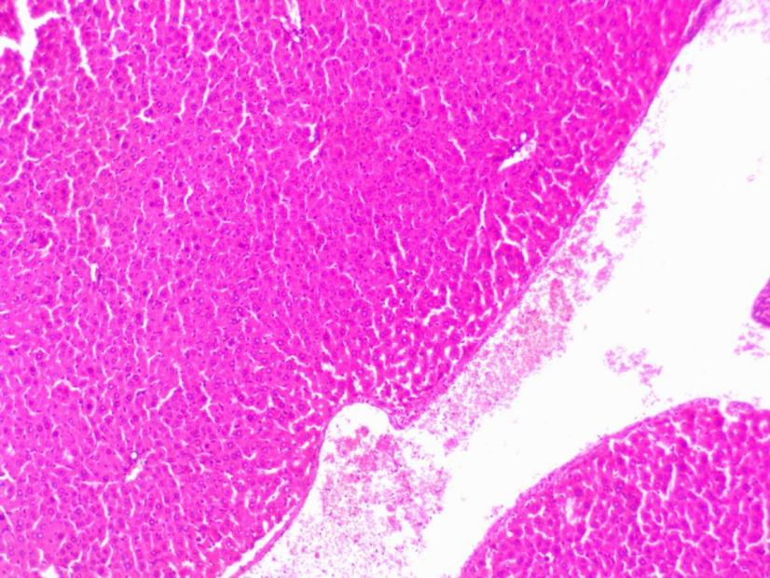
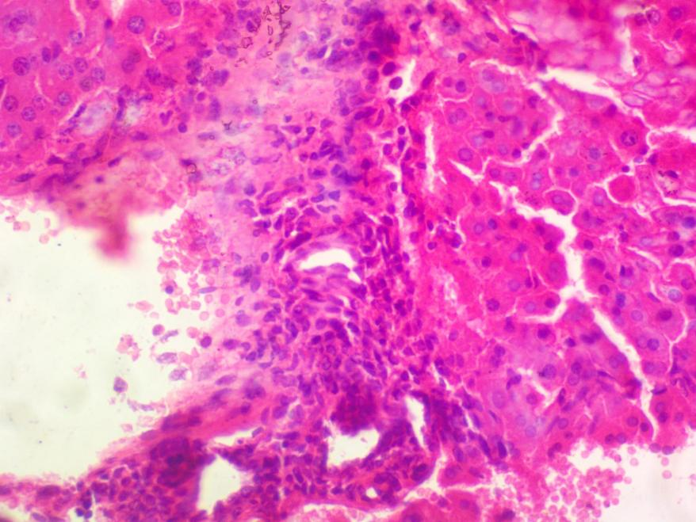
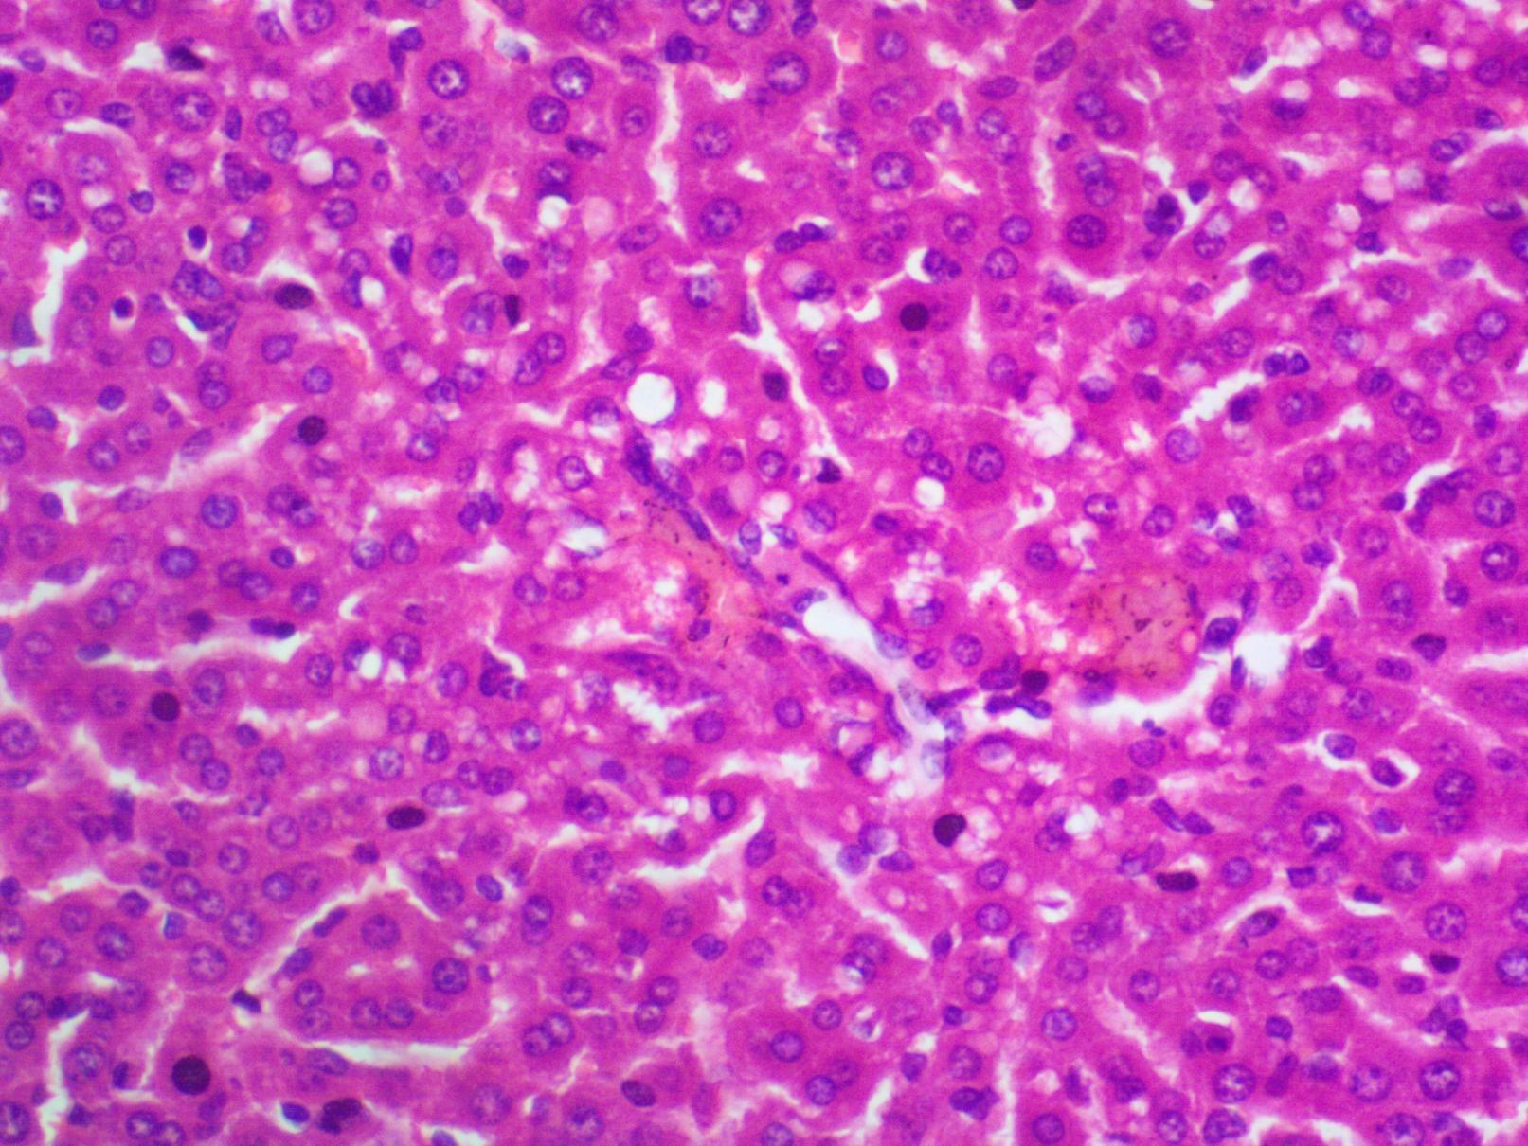
A
B
C

Plate 1 Histomicrograph of the liver of experimental animals fed with (A) CRF only (Control); (B) Lowest conc. (Treatment 1) (C) highest conc. of the experimental feed (X400)
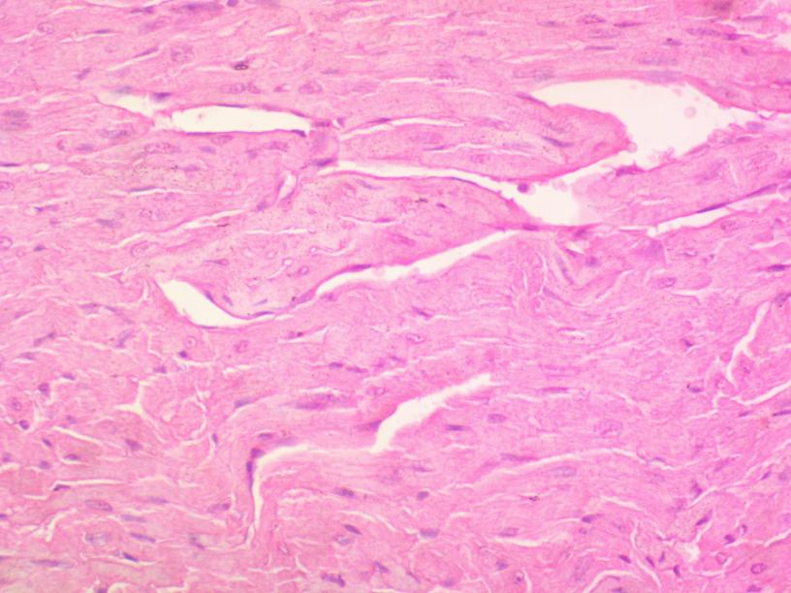
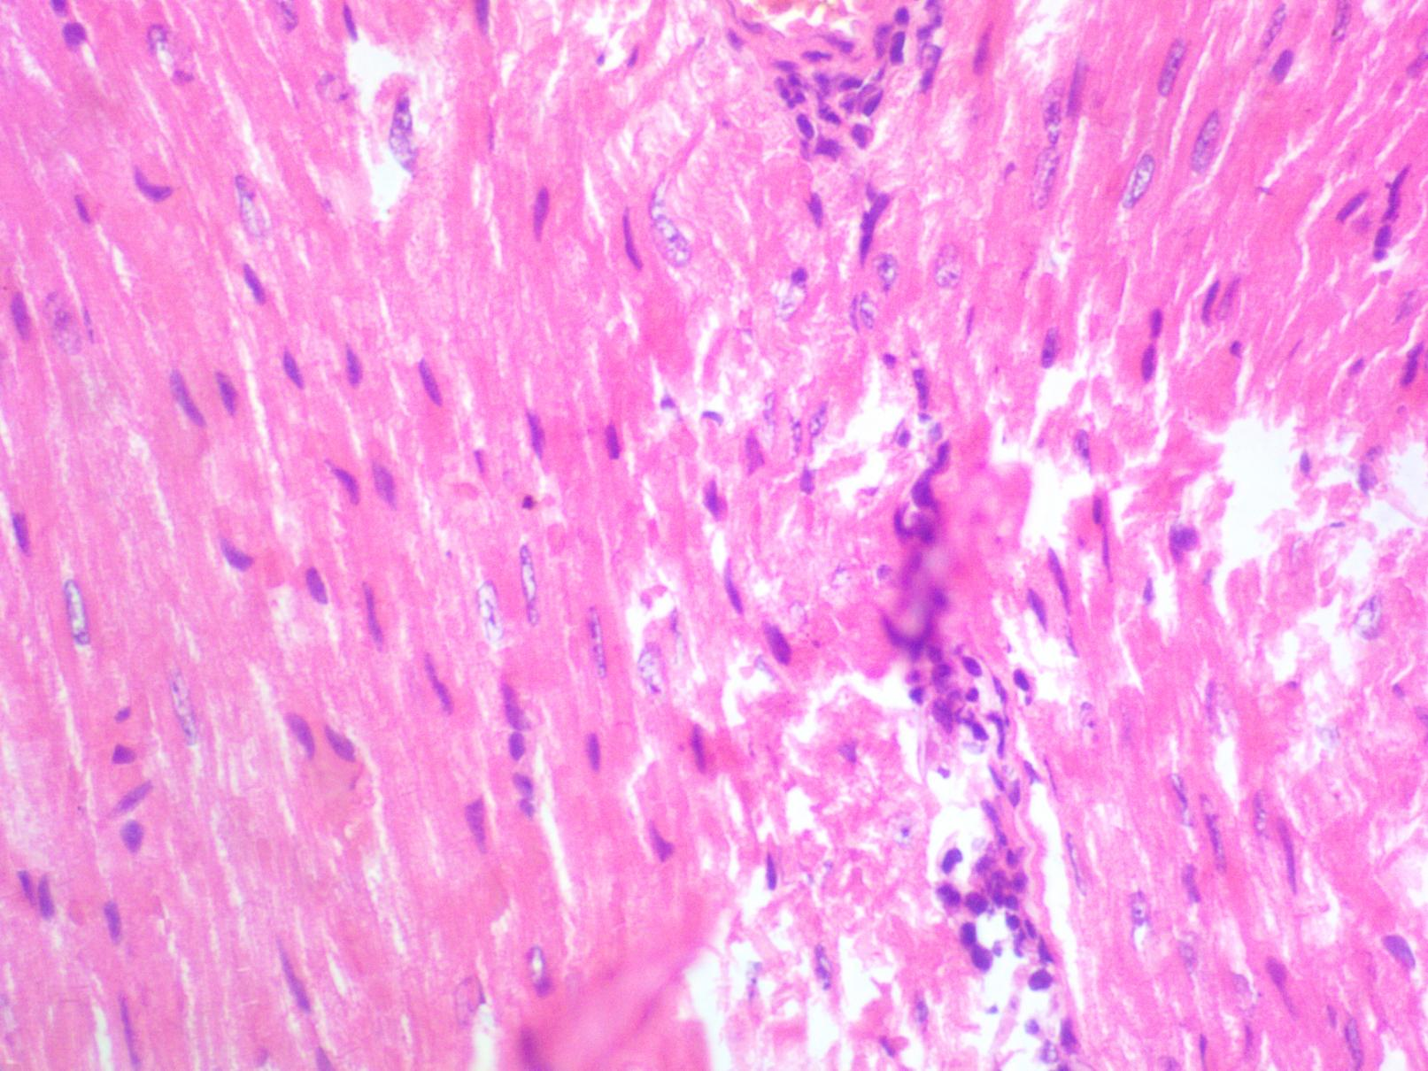
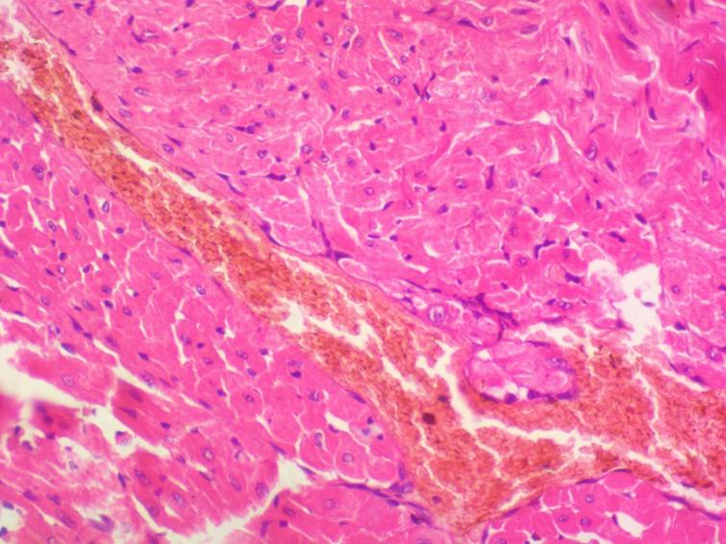
A
B
C

Plate 2 Histomicrograph of the heart of experimental animals fed with (A) CRF only (Control); (B) Lowest conc. (Treatment 1) (C) highest conc. of the experimental feed (X400)

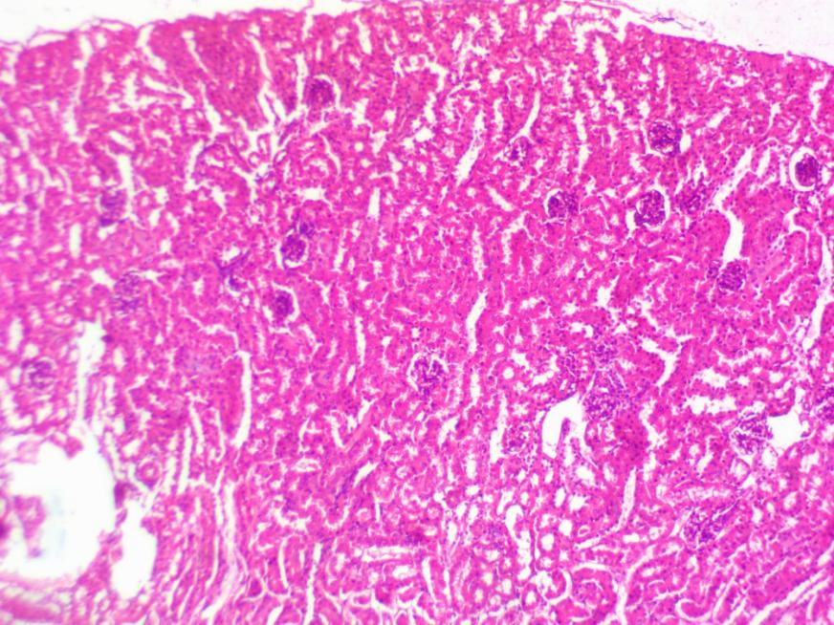
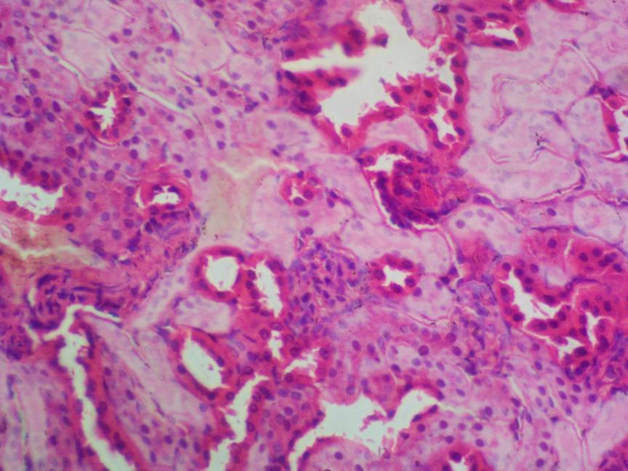
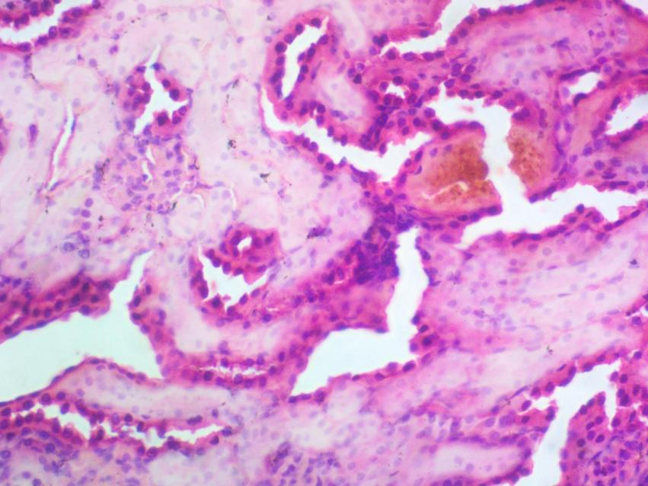
A
B
C

Plate 3 Histomicrograph of the kidney of experimental animals fed with (A) CRF only (Control); (B) Lowest conc. (Treatment 1) (C) highest conc. of the experimental feed (X400)

The result from this research revealed that there was significant adverse effect in the heart, liver and kidney of the experimental animals fed with the experimental feed in comparison with the control group. The heart of the experimental animal fed with the lowest and highest level of experiment feed showed that Datura metel seeds powder induced cell inflammatory, necrotic changes at higher doses, myocardial vacuolation, fibrosis and other degenerative changes. This is in agreement with the findings of Tijani et al. (2015) from a research that the leaf extract of Datura metel at higher dosages adversely affected the heart Wistar rats used as experimental animals.
Also, lesions were observed on the kidney and liver of the experimental animals used, as there were prominent glomerular atrophy, interstitial nephritis, renal injury and cell necrosis as well as severe vascular congestion at higher doses on the kidney and liver of the experimental animals respectively. This corroborates with the findings of Alam et al. (2020) in his research, who stated similar observations on the organs of the animals used and reported the plants nephrotoxicity.
In addition, it was stated by Sanni and Omotoyinbo (2016) that alkaloids were present in all the parts of Datura metel plant but the active phytochemicals were mostly abundant in leaves of the plant. It was recorded that the leaf contain the highest amount of toxic alkaloids this part has been utilized in various toxicity studies. Also the stems were also reported to contain these toxic alkaloids found in seeds, leaves and flowers (Kuang et al., 2008) and can make them possess effective rodenticidal effect as they have been stated to have poisoned livestock in the past.

Conclusion
The mortality observed in the present study, the effect on hematological and serum biochemical parameters, and also internal organ damage suggest that Datura metel seeds powder has rodenticidal properties at higher dosages, indicating its potential as a natural control agent.

References
Alam, W., Khan, H., Khan, S., Ali, N., Sharif, N., Ghafar, R., & Daglia, M. (2021). Evaluation of hepatoprotective effects of crude methanolic extract of datura metel l. in mice. Cellular and Molecular Biology. 67(1): 171-176.
Al-Shaikh, A.M. and Sablay, Z.M. (2005). Hallucinogenic plant poisoning in children. Saudi medical journal, 26: 118-12
Arowora, K., Imo, C., Ezeonu, C., & Muhammad, Z. (2017). Effects of ethanolic extracts of datura metel on blood lipid profile of male albino rats. International Journal of Scientific Reports. 2(10): 248.
Badmus, H.A. and Adeyanju, T. J. (2024). Effect of Yellow Oleander (Thevetia neriifolia Tuss.) Seed Powder on Hematology and Serum Biochemistry in wild female African Giant Rat (Cricetomys gambianus W.). Nigerian Journal of Pure and Applied Sciences. 37 (2): 5003-50012. https://doi.org/10.48198/NJPAS/24.A14
Badmus, H.A., Fayinminnu, O.O. and Adeyanju, T.J. (2024). Evaluation of rodenticidal potential of yellow oleander (Thevetia neriifolia Tuss.) Seed powder in wild female African Giant Rat (Cricetomys gambianus W.). Ife Journal of Science. 26 (3): 847-854. https://dx.doi.org/10.4314/ijs.v26i3.22

Blasdell, K.R., Morand, S., Laurance, S.G.W., and Firth, C. (2022). Rats and the city: Implications of urbanization on zoonotic disease risk in Southeast Asia. PNAS. 119 (39). 10.1073/pnas.2112341119.

Broughton, R.K., Searle, K.R. Walker, L.A., Potter, E.D., Pereira, M.G., Carter, H., Sleep, D., Noble, D.G., Butler, A., AND Johnson, C. (2022). "Long-term trends of second generation anticoagulant rodenticides (SGARs) show widespread contamination of a bird-eating predator, the Eurasian Sparrowhawk (Accipiter nisus) in Britain. Environmental Pollution. DOI: 10.1016/j.envpol.2022.120269
Capizzi, D., Bertolino, S., and Mortelliti, A. (2014). Rating the rat: Global patterns and research priorities in impacts and management of rodent pests. Mammal Review. 44: 148-162
Dalecky, A., Garba, M., Danzabarma, A., Etougbetche, J., Badou, S., Dossou, H. and Meheretu, Y. (2023). Rodent proliferation in urban and agricultural settings of sub-saharan africa – part 2. towards Integrated Management strategies.
Fayinminnu O. O., Ogunwole O. A., and Gbemilade T. A. (2017). Evaluation of the Effects of Drying Methods on Phytochemicals in Thevetia neriifolia Parts as a Potential Rodenticide. Biotechnology Journal International. 17(2): 1-11
Imo, C., Arowora, K., Ezeonu, C., Yakubu, O., Nwokwu, C., Azubuike, N., & Sallah, Y. (2019). Effects of ethanolic extracts of leaf, seed and fruit of datura metel l. on kidney function of male albino rats. Journal of Traditional and Complementary Medicine: 9(4): 271-277.
Jokic, G., Vuksa, P., and Vuksa, M. (2010). Comparative efficacy of conventional and new rodenticides against Micotus arvalis (Pallas, 1778) in wheat and alfalfa crops. Crop Protection. 29 (5): 487-491.
Kamarul Zaman, M.A. and Azzeme, A.M. (2019). Plant toxins: alkaloids and their toxicities. GSC Biological and Pharmaceutical Sciences, 6(2): 21-29.
Komal, K. and Saini, M. (2018). Effect of Datura metel (Dhatura) seeds in experimentally induced diarrhoea. International Journal of Research in Ayurveda and Pharmacy. 9(3): 96-98.
Kuang, H., Yang, B., Xia, Y., & Wang, F. (2008). Chemical constituents from the flower of Datura metel L. Archives of Pharmacal Research. 31(9)
Murch, S., Alan, A., Cao, J., & Saxena, P. (2009). Melatonin and serotonin in flowers and fruits of Datura metel L. Journal of Pineal Research. 47(3): 277-283
Rached, A., Rizk, G., Mahamat, A., Khoury, G., Harran, E., and Lattard, V. (2022). Investigation of anticoagulant rodenticide resistance induced by vkorc1 mutations in rodents in lebanon. Scientific Reports. 12(1).
Raheem, M., Sulaiman, F., Abdulrahim, H., Olatunde, A., Yusuf, K., Mukadam, A., & Odeniran, T. (2018). Assessment of environmental factors on secondary metabolites and toxicological effects of Datura metel leaves extracts. Annals of Science and Technology. 3(2), 8-19.
Reitman, S. and Frankle, (1957). A colorimetric method for the determination of serum glutamic oxalacetic and glutamic pyruvic transaminases. Am. J. Clin. Pathol.
Sanni, D. and Omotoyinbo, O. (2016). Inhibitory effect of extracts from &amp;lt;i&amp;gt;datura metel; leaf on mushroom tyrosinase. American Journal of Life Sciences. 4(2), 47.
Tijani, A., Eyineyi, U., Ibrahim, J., and Okhale, S. (2015). Neuro-toxicological impacts of Datura metel Linn. (family: solanaceae) leaves extract in mice. The Journal of Neurobehavioral Sciences. 2(3), 97.

