EFFECT OF AFTER-MEAL CONSUMPTION OF SOFT DRINKS ON THE GLYCEMIC INDEX AND GLYCEMIC LOAD OF FRIED YAM

ABSTRACT

Background: The rising prevalence of diet-related metabolic disorders such as diabetes mellitus has intensified interest in how meal combinations influence postprandial glycemic responses. This study investigated the effect of after meal consumption of soft drink on the glycemic index (GI) and glycemic load (GL) of fried yam, a commonly consumed carbohydrate-rich food in Nigeria.

Methods: A total of 15 healthy adult volunteers with a mean age of 21 ± 2 years and a mean body mass index (BMI) of 24.06 ± 4.23 kg/m² were recruited from among the students and staff of Confluence University of Science and Technology (CUSTECH) Osara, Kogi state. On the day one, the volunteers were served with standardized portions (50g equivalent of carbohydrate) of fried yam with water. On the other day fried yam with soft drink were served after fasting blood sugar were measured using glucometer. Post prandial blood glucose levels were measured at 30 minutes regular intervals over two hours Incremental Area Under the Curve (iAUC), GI and GL were calculated using trapezoidal rule.

Results: The results revealed that fried yam alone produced a moderate GI (68.18 ± 37.30 %) and a high GL (34.12 ± 18.70) consistent with its starchy composition. When combined with soft drink the GI and GL values increased significantly to 113.29 ± 52.40 % and 56.71 ± 26.20 (p < 0.001) indicating an additive glycemic effect of the double-carbohydrate meal, producing a sharper and more sustained postprandial glucose rise. This outcome suggests that the combination of high-glycemic staple foods with sugar-sweetened beverages markedly worsens glycemic responses, potentially contributing to hyperglycemia and long-term metabolic risks especially diabetes mellitus.

Conclusion: The study concludes that frequent consumption of fried yam with soft drinks may predispose individuals to poor glycemic control, highlighting the need for dietary modifications and public health interventions to reduce the burden of diet-induced metabolic disorders.
Key words: Glycemic index, glycemic load, after-meal, post prandial and soft drink.

INTRODUCTION
Diet plays a crucial role in the regulation of blood glucose levels, particularly among individuals at risk of metabolic disorders such as diabetes mellitus. The glycemic index (GI) and glycemic load (GL) are key parameters that measure how carbohydrate-containing foods impact blood glucose levels. GI refers to ranking of foods that have the ability to raise blood glucose concentrations, relative to a standard food (glucose or white bread) (Jenkins et al., 1981). The GI Task Force (2002) defined Glycemic index (GI) as “the incremental area under the curve for the increase in blood glucose after the ingestion of 50g of glycemic carbohydrates of a test food in 2-hours for the healthy and 3-hours for diabetic individuals from the start of the test meal, as compared with ingestion of the same quantity of glycemic carbohydrate from glucose taken with 300 ml of water over a 10-15 minute period, which is in accordance to a defined laboratory procedure in the same individual under the same condition using fasting blood glucose concentrations as baseline.” (Foster-Powell et al., 2002). The consumption of high glycemic load (HGI) diets has detrimental health consequences. Studies has shown that this type of diets is contributing to the increase in the prevalence of obesity (Ebbeling et al., 2012: Ma et al., 2005; Ludwig, 2002), which might lead to the alteration of the oxidative state and inflammatory markers, in addition to favoring lipogenesis, hyperglycemia, hyperinsulinemia, reduction of insulin sensibility, hypertriglyceridemia and decrease the concentration of HDL-cholesterol in the blood (Shikany et al., 2009). The Joint FAO/WHO expert in 1998 endorsed GI usefulness in diet planning caption “Carbohydrates in Human Nutrition” due to its beneficial effects to health (Riccardi et al., 2008). Eating habit characterized by the consumption of high glycemic index (HGI) and high glycemic load (HGL) food is a measure that incorporates both the quality and quantity of dietary carbohydrate (Hu et al., 2001).
The consumption of carbohydrate-rich foods, such as yam (Dioscorea spp.), is common in many parts of the world, especially in Africa, Asia, and the Caribbean. Yam serves as a staple food due to its high energy content, micronutrient composition, and dietary fiber (Afoakwa and Sefa-Dedeh, 2002). However, dietary habits, including postprandial beverage consumption may alter the metabolic response to these foods.
Soft drinks, which are typically high in refined sugars and devoid of fiber, have gained significant popularity as post-meal beverages. Studies have shown that their consumption can influence postprandial blood glucose levels, insulin response, and overall metabolic health (Malik et al., 2010; Hu and Malik, 2010).
The rising prevalence of diabetes and other metabolic disorders necessitates an in-depth understanding of dietary patterns and their metabolic consequences. While fried yam is considered a high GI food due to its method of processing (Oboh et al., 2010), the concurrent intake of soft drinks with it may further elevate its glycemic response (Brand-Miller et al., 2003). The high sugar content in soft drinks can lead to rapid glucose absorption, potentially elevating the GI and GL of a meal.
Despite the common practice of consuming soft drinks after meals (Omuemu and Oko-oboh, 2015), there is a paucity of scientific studies investigating how mix meals affects blood glucose response (Eniola and Ajani, 2022). The need to explore this relationship is paramount for public health and nutritional planning. Understanding this relationship is crucial in developing dietary guidelines, especially for individuals with diabetes or those at risk of metabolic disorders. Hence, this study aimed at investigating the effect of post prandial consumption of soft drink on the GI and GL of fried yam.
MATERIALS AND METHODS
STUDY AREA
The study was carried out Confluence University of science and Technology (CUSTECH) Osara, Kogi state. CUSTECH is located along Okene – Lokoja – Abuja Road in Osara Town, Adavi Local Government Area of Kogi State. The University is located at a geographical coordinate of 7°40’38.6″N 6°24’59.7″E, which is about 40 km to the State capital, Lokoja and 25 km to the commercial city of the State, Okene (Confluence University of Science and Technology, 2022).

STUDY PARTICIPANTS
The participants who volunteered in this study were students and staff of CUSTECH. A total of 15 participants (7 males and 8 females) were recruited. This is in accordance to GI Task Force, (2002) that suggests a minimum of 10-20 subjects to be recruited based on the willingness to comply with the protocol, inclusion and exclusion criteria (Evans and Gajere, 2017). Anthropometric data, demographic data and lifestyle factors were obtained from the questionnaire issued for the study. Healthy adults aged 18–27 years, with no history of diabetes, cardiovascular disease, metabolic disorders, who are non-smokers and non-alcoholics with normal range of BMI (18.5–24.9 kg/m²) (Table 1) and with no use of medications affecting glucose metabolism were included in this study. While volunteers who were pregnant or lactating women, those with gastrointestinal disorders affecting digestion and those that were allergic to any of the study food components were excluded from this study.
Table 1: Mean Values of Age and Anthropometric Parameters of the Participants (n = 15)
Variables | Mean values ± Standard deviation
Age (years) | 21 ± 2
Weight (kg) | 69.53 ± 12.6
Height (cm) | 169.82 ± 7.76
Body Mass Index (kg/m²) | 24.06 ± 4.23

STUDY DESIGN
A crossover design was used in this study such that each participant serves as his/her own control. This can also be termed as within-subject experimental design, meaning the same group of participants will consume different meal variations and have their blood glucose levels measured post-consumption. It focuses on measuring glycemic index (GI) and glycemic load (GL) under different meal conditions.
MEAL PREPARATIONS
The standard glucose was prepared by dissolving 50g of pure glucose in 350ml of water. Fried yam was prepared by peeling the yam, sliced and then deep-fried for 15 minutes until light brown and was served with stew. All meals were prepared in the same way they are prepared for eating in the homes as described by Evans and Gagere, 2017 with slight modification. Each participant was served 175g of the fried yam (50g carbohydrate equivalent) (Omorigie and Osagie, 2008).

BLOOD GLUCOSE TEST
The blood samples from volunteer subjects were collected through prickling using lancet (D NOTEC) and analyzed using ACCu-Chek glucometer to determine the Fasting Blood Glucose (FBG) levels and recorded in mmol/L. This procedure was repeated at 30 minutes regular interval for 2 hours for the post-prandial blood glucose level measurements. GI was determined according to the guideline of Wolever et al, 2003.

CALCULATION OF GLYCEMIC INDEX:

The glycemic index was calculated geometrically using the method described by FAO (1998) as the incremental area under the blood glucose response curve of a 50g carbohydrate portion of the test food (iAUC) expressed as a percent of the same amount of the carbohydrate from a standard food (iAUCS) taken by the same subject. Glucose-D was used as a reference food. The area under the curve is calculated as the incremental area under the blood glucose response curve. Where 50g is the available glycemic Carbohydrate (known as Glucose reference test). The GI for each food was calculated using the formula:

$$GI=\frac{incremental area under the curve of the test food}{Incremental area under the curve of the glucose standard } x 100$$

CALCULATION OF GLYCEMIC LOAD (GL):
The glycemic load (GL) was calculated using the following formula:

$$GL=\frac{GI x Amount of CHO served (g)}{100}$$
Where GL = Glycemic load, GI = Glycemic Index, Amount of CHO served = Food served in gram (g)
The systemic classification of foods into low, moderate and high glycemic load is as follows: High GL (≥20), moderate GL (11-19) and low GL (0-10) CHO (Dona et al., 2010; Barclay et al., 2005).
foods.
STATISTICAL ANALYSIS
Data analysis and visualization were done using the SPSS IBM package version 27.0 (SPSS, Inc. Chicago, USA). Descriptive statistics was used for all categorical data variables. Paired sample T test was used to compare the means for statistical differences. Statistical significance was taken as p values < 0.001.

Results
The result as shown in the figure 1 shows that the glucose standard meal peaked at 60 minutes post prandial (9.50mmol/L), the fried yam with soft drink peaked at 30 minutes post prandial (8.40mmol/L) while the highest value reached by the fried yam and water at 30 minutes was around 7.40mmol/L.
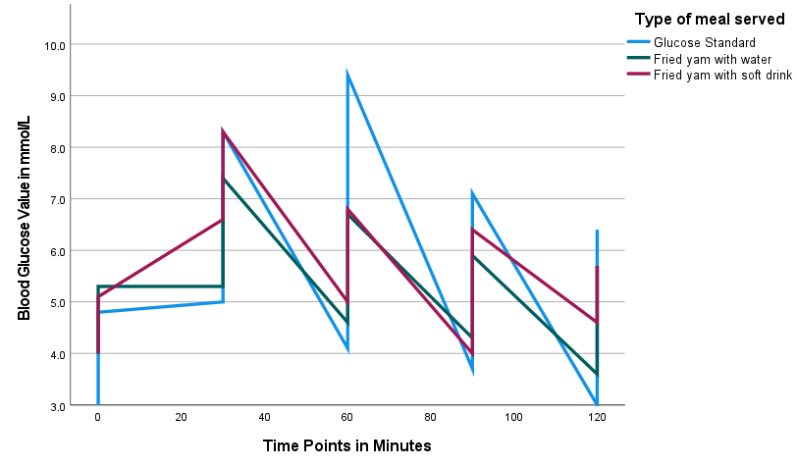
Fig 1: Showing the plot of post prandial blood glucose level of glucose standard, fried yam consumed with water and fried yam consumed with soft drink (Values are means n = 15)

Table 2: Showing the mean values of incremental Area Under the Curve (iAUC) of the glucose standard, fried yam consumed with water and fried yam consumed with soft drink
Type of meal served | iAUC values
Glucose standard | 165.97 ± 64.06
Fried yam with water | 96.00 ± 38.69
Fried yam with soft drink | 165.59 ± 44.92
Value = Mean ± Standard deviation (n = 15).

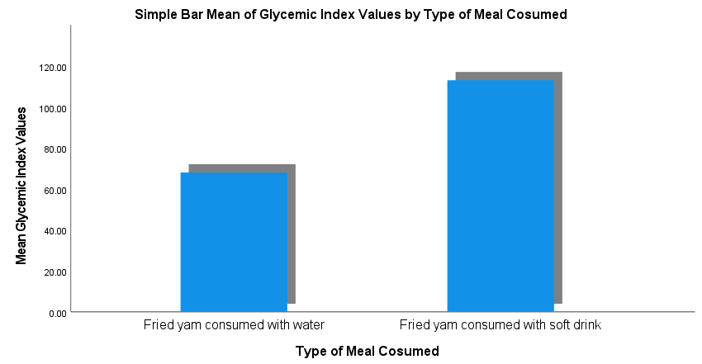Fig 2: Showing glycemic indices of fried yam consumed with water and fried yam consumed with soft drink.

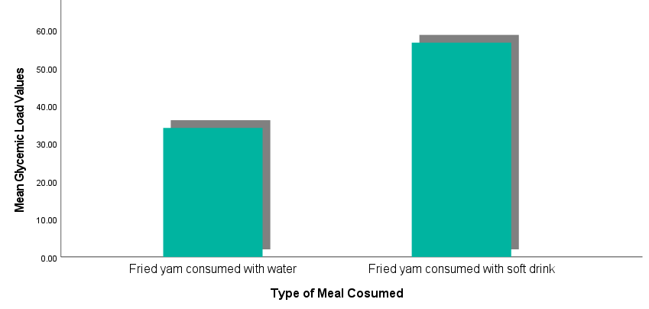
Fig 3: Showing glycemic Loads of fried yam consumed with water and fried yam consumed with soft drink.

The results in the table 3 and 4 show extremely significant increase in the glycemic index and glycemic load of fried yam when consumed with soft drink compared to when consumed with water as p value less than 0.001 in both cases.

Table 3: Showing the result of paired sample T test of the glycemic indices of the fried yam consumed with water compared to the fried yam consumed with soft drink.
Meal combination | GI (%) | P value
Fried yam with water | 68.18 ± 37.30 | 0.0001
Fried yam with soft drink | 113.29 ± 52.40 | 0.0001
Value = mean ± Standard deviation (n = 15)

Table 4: Showing the result of paired sample T test of the glycemic Load of the fried yam consumed with water compared to the fried yam consumed with soft drink.
Meal combination | GL | P value
Fried yam with water | 34.12 ± 18.70 | 0.0001
Fried yam with soft drink | 56.71 ± 26.20 | 0.0001
Value = mean ± Standard deviation (n = 15)

DISCUSSION
The study participants, with a mean age of 21±2 years and a mean BMI of 24.06 ± 4.23 kg/m², represent a healthy, young adult population. This demographic is ideal for assessing acute glycemic responses, as it minimizes confounding factors associated with pre-existing metabolic conditions or age-related changes in glucose metabolism (Eniola and Ajani, 2022). The homogeneity of the study cohort, achieved through strict inclusion and exclusion criteria, enhances the internal validity of the findings, allowing for a clearer attribution of observed glycemic changes to the dietary interventions of the present study.
The results of this study show that fried yam, when consumed with water, produces a moderate glycemic index (GI) of 68.18±37.30% and a high glycemic load (GL) of 34.12±18.70. This finding is consistent with the known properties of starchy tuber crops, which are rich in complex carbohydrates that are digested and absorbed over a period of time (Nnadi, 2021). Although the GI of fried yam falls within the moderate range (Brand-Miller et al., 2003), its high carbohydrate density results in a significant GL, indicating a substantial impact on overall blood glucose levels per serving. This aligns with previous research on the glycemic properties of staple foods in Nigeria, which has shown that while some traditional carbohydrate-rich foods may have a moderate GI, their typical large portion sizes often result in a high GL (On-Nom et al., 2022). However, this finding is in contrast to the finding of Evans and Gajere, 2017, who based on their findings classified fried yam as a HGI food.
The incremental Area Under the Curve (iAUC) serves as a comprehensive measure of the total glucose exposure following a meal. The most striking finding from this study is the near-identical iAUC values for the fried yam consumed with a soft drink (165.59±44.92) and the glucose standard (165.97±64.06). This indicates that the addition of a soft drink effectively transformed the meal's metabolic impact to that of a pure sugar load, subjecting the body to a comparable cumulative glucose burden as if it had consumed a bolus of pure glucose. This finding is particularly significant given that iAUC is a more precise measure of the total glycemic response than GI alone (Wolever et al., 2003). In stark contrast, fried yam consumed with water resulted in a significantly lower iAUC (96.00±38.69), demonstrating that the carbohydrate source alone, when not accompanied by rapidly digestible sugars, produces a less severe glycemic response. This finding is consistent with studies that have highlighted the importance of a meal's composition, not just its individual components, in determining the total glucose exposure (Malik et al., 2010).
The observed sharper and more sustained postprandial glucose rise from the fried yam and soft drink combination has significant metabolic implications. Chronic and repeated postprandial hyperglycemia, even in normoglycaemic individuals, can lead to increased oxidative stress, inflammation, and insulin resistance over time (Kim et al., 2019). These physiological changes are recognized as key risk factors for the development of chronic metabolic diseases, including type 2 diabetes and cardiovascular disease (Ludwig, 2002). The elevated GI and GL values from this meal combination serve as a quantitative measure of its potential to contribute to a state of poor glycemic control, thereby increasing long-term health risks for frequent consumers.
This study underscores the critical importance of meal combinations in determining the glycemic response of staple foods.
CONCLUSION
The findings demonstrated that combining a high glycemic staple food like fried yam with a high-sugar beverage such as a soft drink significantly worsens its overall glycemic impact. These results highlight the need for public health interventions and dietary education campaigns to raise awareness about the metabolic consequences of consuming high-GI foods with sugar-sweetened beverages. Future research should investigate the long-term metabolic effects of such dietary patterns and explore healthier post-meal beverage alternatives to help mitigate the rising burden of diet-related metabolic disorders.
CONSENT
Volunteers were appraised both verbally and in writing. The research protocol was clearly explained to the volunteers after which they all voluntarily signed informed consent form. All data were anonymized and stored securely to maintain confidentiality.
ETHICAL APPROVAL
All authors hereby declared that all experiment have been examined and approved by the research ethics committee of CUSTECH and have therefore been performed in accordance with the established ethical standards. The guidelines in the Helsinki declaration (Puri et al., 2009) were strictly followed.
REFERENCES
Afoakwa, E.O., & Sefa-Dedeh, S. (2002). Viscoelastic properties and changes in pasting characteristics of trifoliate yam (Dioscorea dumetorum) starch after harvest. Food Chemistry, 77, 203-208.
Barclay, A. W., Petocz, P., & McMillan-Price, J. (2005). Glycemic index and glycemic load: The new and the old. Nutrition Research Reviews, 18(2), 163-174. https://doi.org/10.1079/NRR2005114
Brand-Miller, J., Wolever, T.M.S., Foster-Powell, K. and Colagiuri, S. (2003) The New Glucose Revolution: The Authoritative Guide to the Glycemic Index—The Dietary Solution for Lifelong Health. Diabetes Care, 26(11), 3209-3210.
Confluence University of Science and Technology. (2022). About us. CUSTECH website. Retrieved from https://www.custech.edu.ng
Dona, A. C., Guilhem, P., Robert, G. G., & Philip, W. K. (2010). Digestion of starch: In vivo and in vitro kinetic models used to characterize oligosaccharide or glucose release. Carbohydrate Polymers, 80(3), 599–617. https://doi.org/10.1016/j.carbpol.2010.01.002
Ebbeling, C. B., Swain, J. F., Feldman, H. A., Wong, W. W., Hachey, D. L., Garcia-Lago, E., & Ludwig, D. S. (2012). Effects of Dietary Composition on Energy Expenditure During Weight-Loss Maintenance. JAMA. 77(5), 1130-1136.
Eniola, O. A., & Ajani, S. R. (2022). Glycaemic Indices of Commonly Consumed Single and Mixed Meals as Eaten by Apparently Healthy Young Adults in Southwestern Nigeria. Journal of Food and Nutrition Sciences.(10) 106-114. doi: 10.11648/j.jfns.20221004.12
Evans, E. C., & Gajere, Y. (2017). The glycemic index and load of different Nigerian food forms. International Research Journal of Biochemistry and Bioinformatics, 7(1), 1-11. https://doi.org/10.14303/irjbb.2017.010
Food and Agriculture Organization of the United Nations, World Health Organization. Carbohydrate in Human Nutrition. Rome. Italy: FAO/WHO, (1998).
Foster-Powell, K., Holt, S. H., & Brand-Miller, J. C. (2002). International table of glycemic index and glycemic load values: 2002. The American journal of clinical nutrition, 76(1), 5–56. https://doi.org/10.1093/ajcn/76.1.5
Hu, F. B., & Malik, V. S. (2010). Sugar-sweetened beverages and risk of obesity and type 2 diabetes: epidemiologic evidence. Physiology & behavior, 100(1), 47–54. https://doi.org/10.1016/j.physbeh.2010.01.036
Hu, F. B., Manson, J. E., Stampfer, M. J., Colditz, G., Liu, S., Solomon, C. G., & Willett, W. C. (2001). Diet, lifestyle, and the risk of type 2 diabetes mellitus in women. N Engl J Med. 345(11), 790-7. doi: 10.1056/NEJMoa010492. PMID: 11556298.
Jenkins, D. J., Wolever, T. M., & Taylor, R. H. (1981). Glycemic index of foods: a physiological basis for carbohydrate exchange. American Journal of Clinical Nutrition, 34(3), 362-366. https://doi.org/10.1093/ajcn/34.3.362
Kim, J. S., Nam, K., & Chung, S. J. (2019). Effect of nutrient composition in a mixed meal on the postprandial glycemic response in healthy people: a preliminary study. Nutrition research and practice, 13 (2), 126-133.
Ludwig, D. S. (2002). The glycemic index: Physiological mechanisms relating to obesity, diabetes, and cardiovascular disease. JAMA, 287(18), 2414-2423. https://doi.org/10.1001/jama.287.18.2414
Ma Y., Olendzki B., Chiriboga D., Hebert J. R., Li, Y., Li, W., Campbell, M., Gendreau, K., & Ockene, I. S. 2005). Association between dietary carbohydrates and body weight. Am J Epidemiol, 161(4):359-67. doi: 10.1093/aje/kwi051. PMID: 15692080; PMCID: PMC1199523.
Malik, V. S., Popkin, B. M., Bray, G. A., Després, J. P., & Hu, F. B. (2010). Sugar-sweetened beverages, obesity, type 2 diabetes mellitus, and cardiovascular disease risk. Circulation, 121(11), 1356–1364. https://doi.org/10.1161/CIRCULATIONAHA.109.876185
Nnadi, I. M. (2021). Effect of Low Glycaemic Index and Glycaemic Load Mixed Meals on Postprandial Plasma Glucose in type 2 Diabetes Patients. Nigerian Journal of Nutritional Sciences, 42 (2), 161-170.
Oboh, H., Osagie, A., & Omotosho, A. (2010). Glycemic response of some boiled legumes commonly eaten in nigeria. Diabetologia Croatica. 39. 125-131.
Omoregie, E. S., & Osagie, A. U. (2008). Glycemic Indices and Glycemic Load of Some Nigerian Foods. Pakistan Journal of Nutrition, 7(5), 710-716.
Omuemu, V., & Oko-oboh, A. (2015). Meal pattern and soft drink consumption among in-school adolescents in Benin-city, Edo state, nigeria. 14. 72-81.
On-Nom, N., Chamchan, R., Charoensiri, R., Kongkachuichai, R., & Chupeerach, C. (2022). The Developed Ready to Eat Meal affected to Blood Glucose and Insulin in Healthy Subjects: Glycemic Index Study. Current Research in Nutrition and Food Science Journal, 10 (1), 231-239.
Puri, K. S., Suresh, K. R., Gogtay, N., & Thatte, U. (2009). Declaration of Helsinki, 2008: Implications for stakeholders in research. Journal of Postgraduate Medicine, 55(2), 131–134. https://doi.org/10.4103/0022-3859.52846
Riccardi, G, Rivellese, A. A., & Giacco, R. (2008). Role of glycemic index and glycemic load in the healthy state, in prediabetes, and in diabetes. Am J Clin Nutr. 87(1), 269S-274S. doi: 10.1093/ajcn/87.1.269S. PMID: 18175767.
Shikany, J. M., Phadke, R. P., Redden, D. T., & Gower, B. A. (2009). Effects of low- and high-glycemic index/glycemic load diets on coronary heart disease risk factors in overweight/obese men. Metabolism. 58(12):1793-801. https://pmc.ncbi.nlm.nih.gov/articles/PMC2936248/
Wolever, T. M., Vorster, H. H., Björck, I., Brand-Miller, J., Brighenti, F., Mann, J. I., Ramdath, D. D., Granfeldt, Y., Holt, S., Perry, T. L., Venter, C., & Xiaomei Wu (2003). Determination of the glycaemic index of foods: interlaboratory study. European journal of clinical nutrition, 57(3), 475–482. https://doi.org/10.1038/sj.ejcn.1601551

