Original Research Article

Lamivudine Resistance Polymorphism in Hepatitis B Virus, among Pregnant Women Attending Secondary Health Care Facilities in Nasarawa State, Nigeria

.
ABSTRACT

Aims: This study investigated lamivudine resistance polymorphism in HBV among pregnant women attending Secondary Healthcare facilities in Nasarawa State, Nigeria.
Study design: Cross sectional study.
Place and Duration of Study: Department of Microbiology, Nasarawa State University, between December 2024 and June 2025.
Methodology: A total of 15 seropositive samples of pregnant women attending the secondary Health facilities in Nasarawa State, Nigeria were collected and HBV genotypes and lamivudine resistance gene were detected using polymerase chain reaction (PCR) method. The polymorphism in lamivudine resistance in HBV was detected using Restriction fragment length polymorphism (RFLP).
Results: The prevalence of HBV genotype E (7, 58.3%) was found to be higher than genotype A (1, 8.3%). Most notably, 5(83.3%) of the HBV resistance to lamivudine were due to YMDD without substitution of the amino acid while 1(16.7%) of the HBV resistance to lamivudine was due to YvDD variant as a result of the substitution of the methionine with valine. Hepatitis B Virus genotype E was more prevalent among the pregnant women in the study area. In addition, the virus was carrier of YMDD mutation in the lamivudine resistance gene.
Conclusion: The high prevalence of genotype E and alarming rates of lamivudine-resistant HBV strains among pregnant women highlight an urgent need to update clinical guidelines by adopting high-barrier antiviral drugs and implementing routine genotyping and resistance testing to ensure effective prophylaxis.
Keywords: Polymorphism, Lamivudine, Hepatitis, Pregnant, Women, Gene, Resistance.

1. INTRODUCTION

Hepatitis B Virus (HBV) represents a significant and persistent global health challenge, particularly in regions of high endemicity [1, 2]. Mother-to-child transmission (MTCT) is a primary route of infection, with an estimated 65 million women of reproductive age living with HBV worldwide. Alarmingly, approximately 90% of infected mothers transmit the virus to their children during birth, establishing a cycle of chronic infection [3].
This burden is disproportionately high in Africa, where prevalence rates range from 7% to 26%, with the highest concentrations found in Sub-Saharan Africa [2, 4, 5]. In these endemic settings, MTCT accounts for nearly half of all chronic HBV infections, which are strongly associated with high adult mortality when acquired at birth or in early childhood [6]. The consequences of infection are severe, potentially leading to maternal complications such as coagulation defects, postpartum hemorrhage, and organ failure, as well as adverse neonatal outcomes including stillbirth, neonatal death, and progressive liver disease [7].
Despite the availability of effective preventive measures, including vaccination and antiviral therapy, the prevalence of HBV among pregnant women in Sub-Saharan Africa has remained stable at 5–8% for years [8, 9]. This stagnation suggests a critical gap in early intervention strategies.
HBV is genetically diverse, classified into ten major genotypes (A-J) with distinct geographical distributions [10, 11]. While genotype C is prevalent in the Asia-Pacific region [12, 13], genotypes E and A are dominant in Nigeria [11, 14]. However, the phylogenetic relationship between these circulating genotypes and their associated antiviral resistance profiles remains poorly characterized, particularly within the vulnerable demographic of pregnant women.
Therefore, this study aims to investigate the genetic variability and antiviral resistance profiles of HBV isolates from pregnant women attending antenatal care facilities in Nasarawa State, Nigeria.

2. material and methods
2.1 Blood collections
A total of 15 HBV-seropositive blood samples from pregnant women were analyzed in this study. These samples were obtained from a previous study conducted by Agondo et al., 2025 [15] at antenatal care centers in secondary healthcare facilities within Nasarawa State, Nigeria. Following collection, the samples were stored at -80°C until DNA extraction.
2.2 DNA Extraction
Genomic DNA was extracted from the blood samples using the Quick-DNA Miniprep Plus Kit (Zymo Research, supplied by Inqaba West Africa) according to the manufacturer's instructions, with modifications for dried blood spot (DBS) elution. Briefly, dried blood spot papers were immersed in buffer and vortexed. A 400 µL aliquot of this buffer was transferred to a 1.5 mL microcentrifuge tube. Then, 20 µL of Proteinase K and 400 µL of Biofluid (Red) Solution were added to the tube, mixed, and incubated at 55°C for 20 minutes. Following incubation, 420 µL of Genomic Binding Buffer was added and mixed thoroughly by vortexing.
The mixture was loaded into a Zymo-Spin IIC-XLR column seated in a collection tube and centrifuged at 12,000 × g for 1 minute. The flow-through was discarded. The column was placed in a new collection tube, and 400 µL of DNA Pre-Wash Buffer was added before centrifuging at 12,000 × g. This was followed by the addition of 500 µL of DNA Wash Buffer and another centrifugation step at 12,000 × g. The column was transferred to a clean 1.5 mL microcentrifuge tube, and DNA was eluted by adding 50 µL of DNA Elution Buffer directly to the column matrix, followed by a final centrifugation at maximum speed for 1 minute. The eluted DNA was stored at -20°C for subsequent quantification and amplification.

2.3 DNA Quantification
DNA concentration and purity (A260/A280 ratio) were assessed using a NanoDrop 1000 spectrophotometer. Following a blank measurement with normal saline, 2 µL of each extracted DNA sample was loaded onto the pedestal for measurement.
2.4 HBV Genotyping by Semi-Nested Polymerase Chain Reaction
HBV genotyping was performed by semi-nested polymerase chain reaction (PCR) on an ABI 9700 thermocycler, using primers listed in Table 1.
The primary (Nest 1) PCR was performed in a 30 µL reaction volume containing 2X master mix, 0.2 µM of each forward and reverse primer, approximately 30 ng of template DNA, and nuclease-free water. The thermocycling conditions were: 30 cycles of denaturation at 94°C for 20 s, annealing at 55°C for 20 s, and extension at 72°C for 1 minute.
For the secondary (Nest 2) PCR, each sample was amplified in two separate reactions: Mix A: Targeting genotypes A–F, using a common universal sense primer (B2) and Mix A primers.
Mix B: Targeting genotypes D–F, using a common universal antisense primer (B2R) and Mix B primers.
Each 2 µL aliquot of the Nest 1 product was added to a new tube containing the respective inner primer pairs, 2X master mix, and water. The thermocycling protocol for Nest 2 consisted of an initial denaturation at 95°C for 10 min; 20 cycles of 94°C for 20 s, 58°C for 20 s, and 72°C for 30 s; followed by 20 final cycles of 94°C for 20 s, 60°C for 20 s, and 72°C for 30 s.
PCR amplicons were resolved by electrophoresis on a 1.5% agarose gel at 120 V for 20 minutes and visualized under a gel documentation system. HBV genotypes were determined based on the presence of genotype-specific band sizes.

2.5 Detection of Lamivudine Resistance by RFLP-PCR
The lamivudine resistance-associated region of the HBV polymerase gene was amplified by PCR using specific primers HB3F (5’-GCCAAGTCTGTACAACATCTTGAG-3’) and HB3R (5’-AGTTGGCGAGAAAGTGAAAGCCTG-3’).
Reactions were performed on an ABI 9700 thermal cycler (Applied Biosystems) in a 30 µL volume containing 2X DreamTaq Green Master Mix (Taq polymerase, dNTPs, MgCl₂; Inqaba Biotec, South Africa), 0.5 µM of each primer, and template DNA.
The thermocycling protocol consisted of: Initial denaturation: 95°C for 5 min, 35 cycles of: Denaturation, 95°C for 30 s, Annealing: 52°C for 30 s, Extension: 72°C for 30 s, Final extension: 72°C for 5 min. The resulting amplicons were digested with the restriction endonuclease FokI (Jardi et al., 1999) [16] to identify resistance-associated mutations. Digestion was carried out in a 20 µL reaction volume by incubating the PCR product with the enzyme at 55°C for 1.5 hours.
The digested products were resolved by electrophoresis on a 1% agarose gel at 130 V for 30 minutes and visualized using a blue light transilluminator. The presence of lamivudine resistance was determined by analyzing the resulting restriction fragment length polymorphism (RFLP) pattern.

Table 1: List of primers used for the amplification of the s gene of Hepatitis B Virus
 | First PCR
Nest I | P1b: 5-TCA CCA TAT TCT TGG GAA CAA GA-3
 | S1-2: 5-CGA ACC ACT GAA CAA ATG GC-3
 | Second
Nest II | PCR Mix A
 | B2: 5-GGC TCM AGT TCM GGA ACA GT-3
 | BA1R: 5-CTC GCG GAG ATT GAC GAG ATG T-3
 | BB1R: 5-CAG GTT GGT GAG TGA CTG GAG A-3
 | BC1R: 5-GGT CCT AGG AAT CCT GAT GTT G-3
 | Mix B
 | BD1: 5-GCC AAC AAG GTA GGA GCT-3
 | BE1: 5-CAC CAG AAA TCC AGA TTG GGA CCA-3
(Naito et al., 2001) [17]

3. results and discussion
3.1 Prevalence of Hepatitis B Virus Genotypes
HBV genotyping via PCR was successful in 12 out of 15 samples. Genotype E was the most prevalent, identified in 7 samples (58.3%), followed by genotype A in 5 samples (41.7%). No other genotypes were detected. Representative results are shown in Plate 1, and the prevalence is summarized in Figure 1.

3.2 Genetic Variability Associated with Lamivudine Resistance
The presence of the HBV polymerase gene region (HB3) associated with lamivudine resistance was detected by PCR in genotyped, seropositive samples (Figure 2). This gene was amplified in 6 out of 8 samples tested, yielding a prevalence of 75.0%.
To identify specific resistance mutations, the HB3 amplicons were subjected to Restriction Fragment Length Polymorphism (RFLP) analysis using the FokI restriction enzyme (Plate 3). The RFLP patterns revealed that the majority of resistance cases (5 out of 6; 83.3%) were not linked to the classic YMDD motif mutation. In one sample (1 out of 6; 16.7%), resistance was conferred by a YMDD mutation, specifically a substitution of methionine (M) with valine (V), resulting in a YVDD variant (Figure 3).

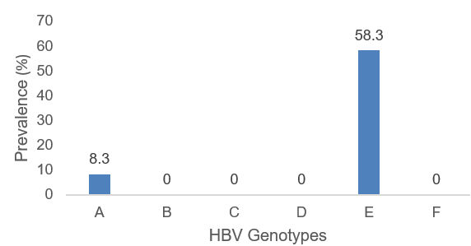
Figure 1: Prevalence of Hepatitis B Virus genotypes among pregnant women

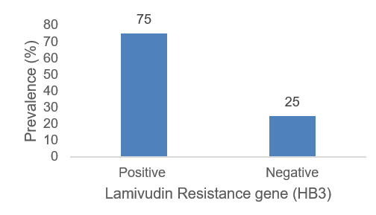
Figure 2: Prevalence of Lamivudine Resistance gene (HB3) in Hepatitis B Virus
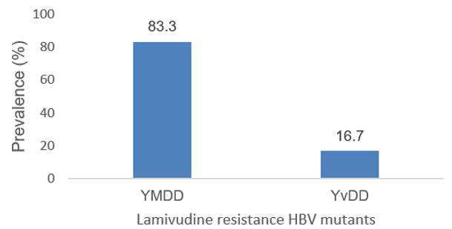
Figure 3: Prevalence of Lamivudine Resistance (HB3) variants in Hepatitis B Virus
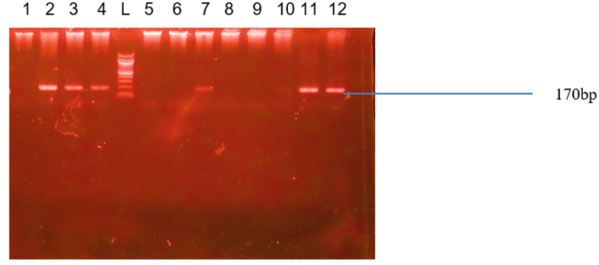

Plate 1: Agarose gel electrophoresis showing DNA band representing HBV genotypes E. Lane 2-4, 7, 10-11 and 12 represent HBV genotypes E while lane L represents the 100bp ladder.

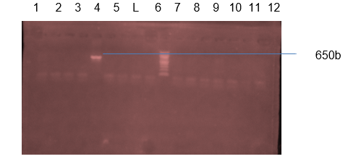

Plate 2: Agarose gel electrophoresis showing DNA band representing HBV genotypes A. Lane 1 represent HBV genotype A while lane L represents the 100bp ladder.

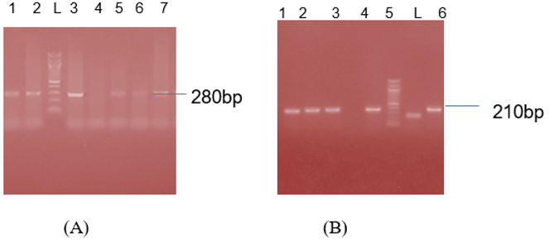

Plate 3: (A) represent the undigested wild type lamivudine gene. Lane 1-3, 5-7 represent the lamivudine gene at 280bp, (B) represent the FolkI digested lamivudine gene. Lane 1-3, 5 and 7 represent the YMDD variant that resisted digestion, lane 6 represents the digested lamivudine resistant mutant (YvDD). Lane L represents the 100bp molecular ladder.

This study provides critical insights into the genotypic profile and lamivudine resistance-associated mutations of Hepatitis B Virus (HBV) among pregnant women in Nasarawa State, Nigeria. The key findings reveal a high prevalence of genotype E, a significant rate of potential lamivudine resistance, and the presence of both classic and atypical drug resistance mutations, which have substantial implications for public health and clinical management in the region.
Our genotyping results indicate that genotype E is the predominant circulating genotype (58.3%), followed by genotype A (41.7%), while other genotypes (B, C, D, etc.) were not detected. This finding aligns perfectly with the established geographical distribution of HBV genotypes across Africa. As previously documented by Kramvis (2014) [11] and Pennap et al. (2019) [14], genotype E is highly prevalent and dominates the HBV genetic landscape in West and Central Africa, a finding reinforced by a study in Burkina Faso (Lingani et al., 2018) [18]. The public health significance of this finding stems from growing evidence that HBV genotypes can influence disease progression and the risk of developing hepatocellular carcinoma (HCC) [19]. Therefore, the predominance of genotype E in Nasarawa State could be a key determinant of the clinical outcome of chronic HBV infection in this population, necessitating further studies.
A striking and concerning finding of this study is the high prevalence (75.0%) of the HB3 gene region associated with lamivudine resistance among the successfully amplified samples. This alarming rate is consistent with a recent study from Colombia, which found an 82.4% prevalence of lamivudine resistance mutations among co-infected patients, suggesting a wider and global issue of resistance [20]. Within these resistant strains, Restriction Fragment Length Polymorphism (RFLP) analysis further revealed that the classic YMDD mutation was the dominant variant. The high rate of potential pre-treatment resistance is likely driven by the unofficial or suboptimal use of antivirals and the community transmission of pre-existing resistant strains, a significant challenge highlighted in recent reviews of HBV in Africa [21].
The dominance of the YMDD mutation is of particular clinical importance. As demonstrated in a research by Amini-Bavil-Olyaee et al. (2008) [22], mutations within the YMDD motif of the polymerase gene directly alter the enzyme's function, affecting viral replication fidelity and fitness. This can lead to breakthrough infections, viral rebound, and treatment failure. Our results suggest that the YMDD variant could be a significant driver of HBV infection and persistence among pregnant women in the study area. The presence of these mutations before the initiation of therapy underscores the critical need for routine resistance testing before commencing antiviral treatment. This is especially crucial for pregnant women, where the primary goal is to effectively suppress viral load to prevent mother-to-child transmission (MTCT). Relying on lamivudine without prior genotypic testing could lead to poor maternal outcomes and a high risk of immunoprophylaxis failure in newborns, contrary to the latest international guidelines (World Health Organization, 2024) [23]..

4. Conclusion
This study revealed a high prevalence of genotype E (58.3%), with genotype A (41.7%) among pregnant women in Nasarawa State, Nigeria, confirming the region-specific genotypic distribution. Most notably, a strikingly high rate (75.0%) of lamivudine resistance-associated mutations was identified, with the classic YMDD variant being the dominant form. These results highlight a serious public health challenge, as the prevalence of pre-treatment resistance threatens the efficacy of standard antiviral prophylaxis. This underscores the urgent need to update clinical guidelines by adopting high-barrier antiviral drugs and implementing routine genotyping and resistance testing.

Consent

All authors declare that ‘written informed consent was obtained from the patient (or other approved parties) for publication of this case report and accompanying images. A copy of the written consent is available for review by the Editorial office/Chief Editor/Editorial Board members of this journal.

Ethical approval

Appropriate ethical committee approval was obtained prior to start of the research and is available for review.

Disclaimer (Artificial intelligence)
Author(s) hereby declare that NO generative AI technologies such as Large Language Models (ChatGPT, COPILOT, etc.) and text-to-image generators have been used during the writing or editing of this manuscript

References

1. Lavanchy, D., & Kane, M. (2016). Global epidemiology of hepatitis B virus infection. Hepatitis B virus in human diseases, 187-203.
2. Mustapha, G. U., Ibrahim, A., Balogun, M. S., Umeokonkwo, C. D., & Mamman, A. I. (2020). Seroprevalence of hepatitis B virus among antenatal clinic attendees in Gamawa Local Government Area, Bauchi State, Nigeria. BMC infectious diseases, 20, 1-6.
3. Wakjira, M., Darega, J., Oljira, H., & Tura, M. R. (2022). Prevalence of hepatitis B virus and its associated factors among pregnant women attending antenatal care in Ambo town, Central Ethiopia: a cross-sectional study. Clinical Epidemiology and Global Health, 15, 101054.
4. Spearman, C. W., Afihene, M., Ally, R., Apica, B., Awuku, Y., Cunha, L., & Sonderup, M. W. (2017). Hepatitis B in sub-Saharan Africa: strategies to achieve the 2030 elimination targets. The lancet gastroenterology & hepatology, 2(12), 900-909.
5. Song, D. S., Jang, J. W., Yoo, S. H., Kwon, J. H., Nam, S. W., Bae, S. H., ... & Yoon, S. K. (2021). Improving the prediction of relapse after nucleos (t) ide analogue discontinuation in patients with chronic hepatitis B. Clinical Infectious Diseases, 73(4), e892-e903.
6. Asaye, Z., Aferu, T., Asefa, A., Feyissa, D., Regasa, T., Kebede, O., Feyisa, D. & Feyisa, M. (2021). Prevalence of hepatitis b virus among pregnant women on antenatal care follow-up at mizan-tepi university teaching hospital and mizan health center, southwest ethiopia. International journal of general medicine, 195-200.
7. Umer, A., Teklemariam, Z., Ayele, F., & Mengesha, M. M. (2023). Prevalence of hepatitis B infection and its associated factors among pregnant mothers attending antenatal care at public hospitals at Hararghe, Eastern Ethiopia. Frontiers in Global Women's Health, 4, 1056488.
8. Hassan, M., Awosan, K. J., Nasir, S., Tunau, K., Burodo, A., Yakubu, A., & Oche, M. O. (2016). Knowledge, risk perception and hepatitis B vaccination status of healthcare workers in Usmanu Danfodiyo University Teaching Hospital, Sokoto, Nigeria. Journal of Public Health and Epidemiology, 8(4), 53-59.
9. Magaji, F. A., Okolo, M. O., Hassan, Z., Shambe, I. H., Pam, V. C., Ocheke, A. N. & Cohn, S. E. (2020). Prevalence of hepatitis B virus infection among pregnant women in Jos, Nigeria. Annals of African Medicine, 19(3), 176-181.
10. Sunbul, M. (2014). Hepatitis B virus genotypes: global distribution and clinical importance. World journal of gastroenterology: WJG, 20(18), 5427.
11. Kramvis, A. (2014). Genotypes and genetic variability of hepatitis B virus. Intervirology, 57(3-4), 141-150.
12. Velkov, S., Ott, J. J., Protzer, U., & Michler, T. (2018). The global hepatitis B virus genotype distribution approximated from available genotyping data. Genes, 9(10), 495.
13. Kyaw, Y. Y., Lwin, A. A., Aye, K. S., Thu, H. M., Htun, M. M., Soe, H. O., ... & Cheong, J. (2020). Distribution of hepatitis B virus genotypes in the general population of Myanmar via nationwide study. BMC infectious diseases, 20, 1-11.
14. Pennap GR, Mohammeda HI, Oti VB and Adoga MP (2019). Genotype distribution of hepatitis B virus in a subset of infected young people in Central Nigeria. Scientific African 5, e00122
15. Agondo DI, Ngwai YB, Bolarinwa OF, Okpaleke NB, Danjuma J, Imokhe GA, Igbawua NI and Tama SC (2025). Prevalence of Hepatitis B virus among pregnant women attending antenatal care in Secondary Healthcare facilities in Nasarawa State, Nigeria. Journal of Advances in Microbiology, 25(5):57-64.
16. Jardi, R., Buti, M., Rodriguez-Frias, F., Cotrina, M., Costa, X., Pascual, C. Esteban, R. & Guardia, J. (1999). Rapid detection of lamivudine-resistant hepatitis B virus polymerase gene variants. Journal of virological methods, 83(1-2), 181-187.
17 Naito, H., S. Hayashi, and K. Abe. (2001). Rapid and specific genotyping system for hepatitis B virus corresponding to six major genotypes by PCR with type-specific primers. J. Clin. Microbiol.39:362-364.
18. Lingani, M., Akita, T., Ouoba, S., Sanou, A. M., Sugiyama, A., Tarnagda, Z., Ohisa, M., Tinto, H., Mishiro, S & Tanaka, J. (2018). High prevalence of hepatitis B infections in Burkina Faso (1996–2017): a systematic review with meta-analysis of epidemiological studies. BMC Public Health, 18(1), 551.
19. Stockdale, A. J., Kreuels, B., Henrion, M. Y., Giorgi, E., Kyomuhangi, I., de Martel, C., Hutin, Y & Geretti, A. M. (2020). The global prevalence of hepatitis D virus infection: systematic review and meta-analysis. Journal of hepatology, 73(3), 523-532.
20. Bautista-Amorocho, H., Silva-Sayago, J. A., & Picón-Villamizar, J. (2023). High frequency of Lamivudine and Telbivudine resistance mutations in hepatitis B virus isolates from human immunodeficiency virus co-infected patients on highly active antiretroviral therapy in Bucaramanga, Colombia. Frontiers in Microbiology, 14, 1202342.
21. Wondmeneh, T. G., & Mekonnen, A. T. (2024). Epidemiology of hepatitis B virus infection among pregnant women in Africa: a systematic review and meta-analysis. BMC Infectious Diseases, 24(1), 921.
22. Amini-Bavil-Olyaee S, Hosseini SY, Sabahi F and Alavian S-M (2008). Hepatitis B virus (HBV) genotype and YMDD motif mutation profile among patients infected with HBV and untreated with lamivudine. International Journal of Infectious Diseases, 12:83-87.
23. World Health Organization. (2024). introducing a framework for implementing triple elimination of mother-to-child transmission of HIV, syphilis and hepatitis B virus: policy brief. World Health Organization.

