Beyond the Pandemic: A Retrospective Analysis of Emergency Remote Teaching in English-Medium Instruction Context

Abstract
Background: The COVID-19 pandemic catalysed an unprecedented global shift from traditional classroom instruction to Emergency Remote Teaching (ERT), fundamentally altering educational paradigms worldwide. While extensive research has examined immediate pandemic responses, limited investigation has explored retrospective student perceptions in English-Medium Instruction (EMI) contexts.
Objective: This study investigates Turkish and Turkish Cypriot students' retrospective perceptions and attitudes toward online learning during the COVID-19 pandemic within an EMI framework at Eastern Mediterranean University, Cyprus.
Methods: A retrospective quantitative survey design employed a validated 28-item Likert-scale questionnaire administered to 102 EMI students aged 18-30. Data collection utilized descriptive statistics, cross-tabulation analysis, and independent t-tests to examine demographic influences on learning perceptions.
Results: Findings revealed heterogeneous student experiences characterized by moderate satisfaction levels. While 52% of participants acknowledged online education's flexibility advantage, significant challenges emerged across multiple domains. Technical literacy deficits affected 48% of students, with poor technological skills identified as the primary obstacle. Male students tended to report higher levels of satisfaction than female students related to interaction/emotional engagement (57% vs 43%), enjoyment of the online environment (58% vs 40%) and fewer technical difficulties than females. Health-related issues were significant too, with 63% reporting physical discomfort, 52% experiencing visual discomfort, and 52% having concentration difficulties.
Conclusions: The current study notes that ERT implementation was imperative to maintain education during a health crisis. However, it also exposed deficiencies in digital literacy, pedagogy, and student support structures. In terms of a retrospective perspective, the results show no evidence that the outbreak of the pandemic has a lasting beneficial effect on quality of online learning and teaching, and that the time and distance since the initial disruption of education does not appear to have changed any of our initial concerns about e-learning. This study has implications for future planning related to educating in times of crisis, as well as a need for a wider digital transformation strategy in higher education.
Keywords: Emergency Remote Teaching, English-Medium Instruction, COVID-19, Student Perceptions, Digital Education, Higher Education

1. Introduction
The global COVID-19 pandemic incited a massive change within educational delivery systems, forcing institutions across the world to quickly redirect students away from face-to-face learning to Emergency Remote Teaching (ERT) (Hodges et al., 2020). This rapid move meant that ERT was not only underprepared, but thinking time and theoretical perspectives were also minimal. The rapid shift created a dissimilarity between ERT and well-planned online learning programs (Bozkurt et al., 2020). While any emergency response will be justified in terms of immediate actions and closure response documentation, there is, (and continues to be), a vast amount of research into various aspects of educational quality and learning outcomes and experiences for students.
There are many hurdles to clear for students learning in English-Medium Instruction (EMI) situations, with some students also needing to deal with complex language and cultural issues as well as new technological contexts (Akbana et al., 2021). Learning, and developing knowledge in a new language, moving away from a prior language, content learning, language learning, and digital literacy issues means students are confronted with a more complex reality of learning rather than online education concerns. The demographic of Turkish and Turkish Cypriot students studying in EMI contexts must therefore take into consideration, prior language and content proficiency levels, access to technology and support systems, and their cultural situatedness in terms of responding to and functioning in a developing digital learning environment.
Eastern Mediterranean University (EMU) was ranked within the top 1000 universities in the world and second in Turkey. It offered a unique opportunity to consider EMI that often occurs in chaotic situations or crisis modes. EMU exemplifies a governmental supported institution, with a diverse international student body, meaning their experience during the pandemic offers profound insight into understanding the complexities of emergency remote education in multi-lingual, multi-cultural situations.
While lots of participants' immediate responses to the pandemic, and initial responses to Emergency Remote Teaching (ERT) have been the subject of research, limited investigation has examined retrospective perceptions - how students reflect and evaluate their emergency remote learning experiences after reverting back to normalcy. Students' retrospective perceptions are important for several reasons, as student retrospective perceptions can demonstrate if remote learning, shaped by a crisis, impacts their learning and how we can prepare in the future if the need arises.
This study will address several deficiencies in the ERT literature by examining Turkish and Turkish Cypriot students' retrospective perceptions of their online learning experiences within an EMI context. Inclusive analysis of students' expressions of their attitudes, perceived strengths and perceived challenges for online ERT learning facilitates this research and extends evidence-informed thinking and practice for emergency educational responses as well as forethoughts and perceptions of needs for future crisis responses in international higher education.
2. Literature Review
2.1 Theoretical Framework: Community of Inquiry Model
The Community of Inquiry (COI) framework developed by Garrison et al. (1999) provides an interesting conceptualization of online learning environments. Garrison et al. (1999) suggest that educational experiences can be meaningful through patterns of intentional interactions related to three presences that highlight their interdependence: cognitive presence (critical thinking and knowledge construction), social presence (relationships and learning communities), and teaching presence (designing instructional and directing learning).
Cognitive presence includes higher order learning including creative thinking, problem solving, and critical thinking, perspectives critical for competitive advantage in the globalized 21st century (Garrison, 2016). Social presence is the degree to which learners feel part of a learning community where they share and express ideas and engage in meaningful dialogue (Garrison et al., 1999). Teaching presence in the COI framework involves the balance of course design, instructional facilitation, and deliberate instructional interaction requiring the educator to allow autonomy to the learner while simultaneously having the intention to direct the learner (Zhao & Sullivan, 2017).
The COI framework is relevant to emergency remote teaching (ERT) contexts in practice because it emphasizes intentional design and sustained action - areas that are frequently lacking in emergency situations. In learning environments, the empirical research demonstrates that online learning requires a thoughtful integration of all three presences identified in the COI framework; deficiencies observed in any one domain will negatively impact educational outcomes (Kim & Kim, 2021).
2.2 Emergency Remote Teaching: Distinguishing Features and Challenges
Emergency Remote Teaching is not the same as online learning; Emergency Remote Teaching lacks theoretical basis, preparation time and resources (Adedoyin & Soykan, 2023). Online learning of quality includes piloting, evaluation of experience and provide a balanced educational experience. Hodges et al. (2020) state that ERT has the intonation of an emergency situation to put the learners first, that educational continuity is more valuable in keeping education alive, than maximising student learning outcomes. Hodges et al. (2020) stress that ERT should not be evaluated like conventional online or distance education the aim is not necessarily considerations taken to harness the best of careful and planned pedagogical approaches. Nonetheless, this does not detract from exploring the levels of engagement and understanding learning outcomes for ERT in student learning and in efficacy for institution purposes.
There has been research to see challenges with Emergency Remote Teaching with evidence across a range of contexts (Erarslan, 2021; Ferri et al., 2020) and challenges have been identified below:
- Underdeveloped Technological Infrastructure: Lack of connectivity, device unaffordability and tech support issues continue to limit opportunities to participate effectively as an emergency measure (Mbiydzenyuy, 2020).
- Underdeveloped Digital Literacy: Lack of digital pedagogical knowledge/skills by both students and educators threatening effective engagement online, participation and learning outcomes (Adedoyin & Soykan, 2023).
- Pedagogical Adaptation: Educators can struggle to "translate" offline methodologies/learning face to face into online engagement and tend to fall back on Professor-based pedagogies (boredom), while this limits interaction and engagement (Crawford et al., 2020).
- Displacement of Social Presence and Reduced Interaction: Opportunities for f2f communications do not exist in the same casual spontaneous interaction they can almost become with peers as f2f learning reduces peer to peer and relationship development in learning (Saputra et al., 2021).
2.3 Student Perceptions and Attitudes in Online Learning
Student perceptions are important in learning outcomes, engagement, and persistence in online environments (Liaw et al., 2007). Attitude research demonstrates strong correlation with second language learning experience, and a positive perception of online learning can contribute positively to academic achievement; however, if these perceptions are negative, learners can lose their motivation and make little to no academic progress (Gardner, 1985).
In academic environments, student satisfaction in online learning environments goes beyond the actual learning outcome and can be influenced by technology capabilities (or lack thereof), instructor support, the quality of course content, and opportunities for socially interacting with other students (Baber, 2020). Research supports that online learning should include explicit goals and clarifications, engaging design of content, and a constant presence from the instructor (Sharpe & Benfield, 2005).
While considering gender, there appears to be confusing patterns regarding gender differences in perceptions of online learning across different study contexts. In some networks, males are found to prefer learning through technology-based methods (Nistor, 2013), but other researchers suggest that female students will often show a higher level of engagement and levels of satisfaction (Richardson & Woodley, 2003). Together, the mixed results in the literature signify the influence that contextual factors have on responses to technology acceptance and on learning preferences.
As explanations of other learner characteristics, age can also change perceptions of online learning. While younger online students can be more technologically fluent, they may also experience more distractions and face additional challenges of self-regulations (Smart & Cappel, 2006). On the other hand, mature students may be less technologically prepared but may demonstrate stronger higher motivation and self-direction, even if they are initially resistant to using technology.
2.4 EMI-Specific Challenges in Online Contexts
English-Medium instruction adds multiple layers of complexity to online learning environments as students attempt to navigate the different demands of language, content, and technology simultaneously (Said et al., 2021). Studies have shown that EMI students might confront specific issues in online formats:
Linguistic Demands: A decrease in non-verbal communication, limited time to seek clarification and a reduced opportunity to explain problems creates an additional layer of comprehension difficulties for students who do not speak English as their first language (Sayer & Braun, 2020).
Willingness to Communicate: The online environment may either encourage or deter a student's willingness to communicate and participate in their learning, depending on their self-confidence and competence in using technology (Said et al., 2021).
Culture Change: Students from high-context cultures may struggle with the explicitness required in online contexts and thereby disengage (Despagne, 2010).
2.5 Health and Wellbeing Considerations
Increased screen time and the home-based learning environment both raise new health concerns not typically associated with traditional learning. Data indicates increased reports of physical discomforts, and psychological stress, and ongoing concerns with vision and posture from online learners (Daniel, 2020; Khatatbeh et al., 2024).
The heightened psychological stress incurred by social isolation, limited communication with peers or faculty, and uncertain expectations in academic trajectories during pandemic times adds to these health concerns and exacerbates challenges to the wellbeing of students (Yan, 2020).
3. Methodology
3.1 Research Design
Utilizing secondary data, this study used quantitative survey techniques to examine the perceptions of Turkish and Turkish Cypriot students regarding their online learning experiences primarily associated with the transition to online learning during the COVID-19 pandemic. The retrospective approach to design enables participants to reflect and share their views and expectations of what was experienced relative to the online learning experiences of adolescence and higher education after engaging in traditional face-to-face instruction to create a sense of temporal distance crucial for the reporting of balanced reflections on their educational adaptations during the pandemic.
The research addressed three primary questions:
- What were students' perceptions and attitudes toward learning English and/or content in English online?
- What were the perceived strengths of online classes from students' perspectives?
- What were the identified weaknesses and challenges of online learning from students' viewpoints?
3.2 Research Context
The study was conducted at Eastern Mediterranean University (EMU), a governmental institution in Northern Cyprus ranked among the world's top 1000 universities. EMU serves a diverse international student body across 141 programs, requiring English proficiency verification through IELTS or TOEFL examinations for enrolment. The EMI context necessitates that all students demonstrate functional English competency for academic success.
During the pandemic period (March 2020 - June 2021), EMU transitioned entirely to online delivery using various platforms including Zoom, Microsoft Teams, and institutional learning management systems. Students experienced both synchronous and asynchronous instruction depending on course requirements and instructor preferences.
3.3 Participants
The study employed convenience and purposive sampling to recruit 102 Turkish and Turkish Cypriot students who experienced online EMI instruction during the pandemic. Heumann and Shalabh (2016) guideline suggesting 100 participants as sufficient for population representation supported this sample size determination.
Demographic characteristics included:
- Gender: 65% female (n=65), 35% male (n=37)
- Age: 43% aged 18-20 (n=44), 57% aged 21-30 (n=58)
- English Proficiency: 7% A1 (n=7), 16% A2 (n=16), 40% B1 (n=41), 37% Upper B1 (n=38)
- Technology Competency: 40% advanced (n=41), 56% medium (n=57), 4% poor (n=4)
All participants confirmed online English language or EMI content learning during COVID-19, ensuring relevant experiential backgrounds for retrospective evaluation.
3.4 Instrumentation
Data collection was based on a set of fixed attitude measurement questions, below which followed a set of demographic details based on the suggestions of Taherdoost (2022). The instrument comprised 2 sections to collect demographic and attitude data (i.e., attitude was gauged on Likert-scale response options on a range; 1 - 5).
Section A explored the demographics of the participants including personal ones (i.e., age, gender, nationality) and self-ratings based on English proficiency, technological proficiency, and at least basic acknowledgement that the participant enrolled in formal online learning during the pandemic.
Section B included a total of twenty-eight Likert-scale items, utilizing the 5-point scale, and was categorized into three areas of research question, in consideration of anchoring strategies that enhance reliability (Gehlbach & Barge, 2012).
Research question one included questions across four distinct subsections of instructor roles and learner goals (1-2), interaction and communication styles (3-6), availability of learning resources and materials (7-9), and learner satisfaction (10-11). Research question two included three fairly focused items (12-14) on the learners perceived advantages of online learning, in particular flexible learning and accessibility.' Research question three included items on four distinct and unique challenge categories, with technical issues and digital literacy (15-19), financial and infrastructure (20-21), learning environment (22-24), and health and wellbeing (25-28).
3.5 Validity and Reliability
Content validity was determined by a thorough expert review of the questionnaire. The supervising professor and two experts in the disciplinary field of education performed a systematic review of each item considering relevance, clarity, and coverage to determine whether the questionnaire variables satisfactorily addressed the research questions and constructs. Face validity was established by having 15 students complete a pilot test with the sample population characteristics, which resulted in only minor alterations to some of the wording for clarity. The questionnaire was also professionally translated into Turkish so that participants would find it easy to answer correctly and comprehend. Back-translation procedures were performed to ensure there was a version of Turkish that would be a satisfactory linguistic equivalent, and we wanted participants to formulate the same conceptual meaning when switching between differing versions. Survey reliability analysis resulted in a Cronbach's alpha coefficient of 0.810, indicating strong internal consistency among the 28 items, clearly meeting the minimum level of reliability described in the social sciences, and confirming that the instrument produced reliable and repeatable measures through the diverse and unique population of Islamic educational leaders as survey participants.
3.6 Data Collection Procedures
Data collection was facilitated via an online survey using Google Forms, and the survey was designed to allow participants to choose between English or Turkish to enhance participants’ understanding and the accuracy of their responses. The survey had all necessary introductory materials including a well-developed cover page explaining the research purpose and participants’ expectations, informed consent in forms which clearly specified their participation was voluntary and confidentiality was guaranteed, and complete contact information for the researchers, should participants have questions. Quality assurance processes were in place throughout data collection, specifically, several preliminary measures were taken, including removing incomplete responses during data screening, eliminating survey responses that did not meet the inclusion criterion, ensuring participants had emergency remote teaching experience during the pandemic. The online survey was used to provide maximum accessibility for participants to participate in a survey that was easy to complete whilst keeping data collection a secure and trustworthy process.
3.7 Data Analysis
Quantitative analysis used SPSS version 29 for complete statistical analysis. A consideration of multiple analytical approaches was used so that student experience gain was communicated in both breadth and depth from the perspectives of emergency remote teaching. This provided a comprehensive analysis. The way this analysis was undertaken included descriptive statistics; frequencies, percentages, means and standard deviations, that were used for all variables, which provided an initial understanding of patterns of response, and central tendencies in the sample population. Cross-tabulated analyses to assess if there were relationships between demographic variables and measures of perception also demonstrated instances when students had different experiences by gender, age, proficiency in English, or technology proficiency levels. An independent t-test was undertaken to examine the group comparison, by gender, across the attitude domains for gender-based comparisons, this further validated where male and female students perceived differences in their experiences. A reliability analysis through Cronbach's alpha calculation in SPSS provided internal consistency verification, ensuring that this instrument produced consistent and reliable results across the varied participant population. The levels of statistical significance were set at p < 0.05 for all inferential procedures, were appropriate to allow for confidence in meaningfully interpreting differences among populations and relationships among variables.
3.8 Ethical Considerations
The Eastern Mediterranean University received institutional ethical approval from the Scientific Research and Publication Ethics Board (BAYEK) to provide assurance that it adhered to its established protocols for safeguarding its participants. The coverage of ethical issues related to participant perspectives and ethical regulations pertaining to safeguarding person participants were planned for and addressed throughout the research study. Various informed consent processes were deliberately developed to ensure that all participants were aware of every aspect of their participation in the research study including meaningfully explaining the research study goals and processes; clarifying the voluntary nature of participation and right to withdraw from participation free of blame, and assurance that the participants' data would be kept confidential and anonymous. Participants were also provided with contact information in case they had queries or complaints, and reasonable estimates for the time to complete each part of their agreement to participate in the research study, so that they could make an informed decision about whether or not, they would participate. In conclusion to the ethical issues, the management of ethical concerns were maintained throughout the research study to ensure participant rights and the integrity of the research project, while facilitating open and honest two-way communication between the researcher and participants.
4. Results
4.1 Overall Perception Patterns
Analysis of student perceptions toward online EMI learning revealed moderate satisfaction levels with significant variation across domains. Anchor item analysis demonstrated mixed experiences, with mean scores ranging from 2.82 to 4.22 on the five-point scale.
Figure 1 illustrates the distribution of mean satisfaction scores across all core learning domains (n=102), clearly demonstrating the moderate satisfaction levels and highlighting the variation between different aspects of the online learning experience.
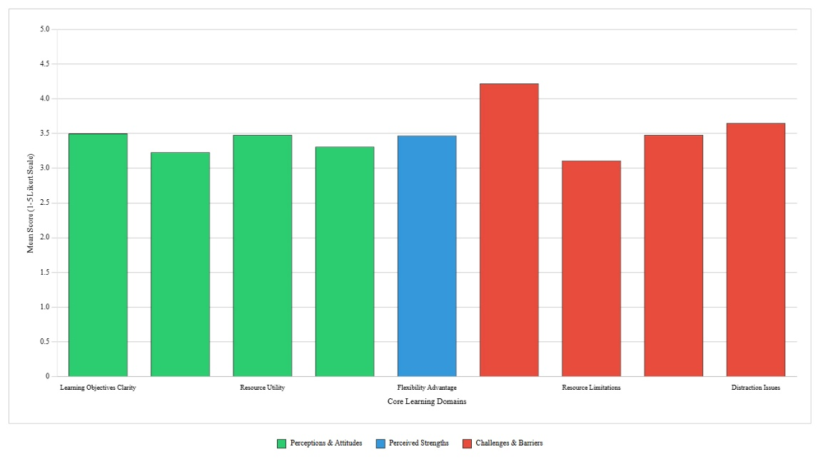
Figure 1: Student Perceptions Across Core Learning Domains.

Research Question 1: Student Perceptions and Attitudes
Four key domains emerged from student attitude analysis:
Learning Objectives and Instructor Clarity: Half of participants (50%) agreed that learning objectives were clearly communicated (M=3.50, SD=1.05), indicating moderate instructor effectiveness in goal articulation. However, learning activity design received lower ratings, with only 25% satisfaction (M=2.82, SD=1.12), suggesting misalignment between instructional activities and diverse learning preferences.
Interaction and Communication: Online discussion encouragement received moderate approval (49%, M=3.23, SD=1.25), while immediate feedback provision showed higher satisfaction (53%, M=3.44, SD=1.10). Communication options received the lowest ratings in this domain (39%, M=3.07, SD=1.31), indicating inadequate technological affordances for student-instructor and peer interaction.
Learning Resources and Accessibility: Online resources were rated most favourably among perception measures (54%, M=3.48, SD=1.07), with interactive video features receiving comparable approval (50%, M=3.48, SD=1.06). However, access to comprehensive knowledge resources received lower ratings (43%, M=3.29, SD=1.17).
Learning Environment Quality: This domain received the lowest satisfaction ratings, with only 42% finding the online environment enjoyable (M=3.31, SD=1.30). Comfort with asking questions showed moderate approval (50%, M=3.27, SD=1.35).
4.2 Perceived Strengths and Benefits
Research Question 2: Online Learning Advantages
Flexibility emerged as the primary perceived advantage of online education, with 52% of participants agreeing that online education offered greater flexibility than traditional instruction (M=3.47, SD=1.41). Supporting findings included:
- Geographic Accessibility: 51% appreciated the ability to engage in coursework from any location (M=3.66, SD=1.12)
- Self-Paced Learning: 59% valued studying at their own speed in a stress-reduced environment (M=3.65, SD=1.26)
These findings align with established online learning literature emphasizing flexibility as a primary motivational factor for digital education adoption.
4.3 Challenges and Barriers
Research Question 3: Perceived Weaknesses and Obstacles
Challenge analysis revealed four primary concern categories:
Technical Infrastructure and Digital Literacy: Technology importance received universal acknowledgment (78%, M=4.22, SD=0.97), yet technical implementation created significant barriers. Poor technological skills affected 48% of participants (M=3.32, SD=1.21), representing the highest-rated obstacle. Insufficient engagement affected 36% (M=3.23, SD=1.10), while peer communication deficits impacted 42% (M=3.30, SD=1.24).
Financial and Resource Constraints: Equipment inadequacy affected 41% of participants (M=3.25, SD=1.22), while institutional resource limitations received moderate recognition (38%, M=3.11, SD=1.21).
Learning Environment Deficiencies: Boredom affected 52% of participants (M=3.48, SD=1.33), while 50% experienced reduced academic participation (M=3.49, SD=1.21). Social isolation impacted 46% (M=3.25, SD=1.45).
Health and Wellbeing Concerns: Physical health impacts were pronounced, with 63% reporting back pain from prolonged sitting (M=3.80, SD=1.30), 52% experiencing eye strain (M=3.51, SD=1.32), and 52% encountering concentration difficulties (M=3.65, SD=1.17). These findings highlight previously underexplored consequences of extended online learning engagement.
4.4 Demographic Influence Analysis
Gender-Based Differences
Statistical analysis revealed significant gender disparities across multiple domains of online learning experience, with male students consistently reporting higher levels of satisfaction and engagement compared to their female counterparts. In terms of interaction and communication patterns, male students reported substantially higher interaction levels at 57% compared to 43% for female students, suggesting gender-based differences in online participation patterns that may reflect cultural, technological, or pedagogical factors influencing engagement in virtual learning environments. Learning environment satisfaction also showed significant gender differences, with males reporting more enjoyment of the online environment at 58% versus 40% for female students, suggesting that males may be uniquely able to adapt and enjoy alternatively designed higher education that needs further exploration and potential intervention.
Female students consistently reported higher instances of challenges in many areas, including technical challenges at 46% for females versus 45% for males, environment (55% for females versus males at 40%), and health challenges (58% for females compared to males at 42%). Notably, only one survey item achieved statistical significance at p < 0.05, specifically comfort with online questioning, where gender differences were most pronounced and statistically validated.
Age-related variations revealed that older students in the 21-30 age group demonstrated superior adaptation success across several key measures compared to their younger counterparts aged 18-20. The older cohort showed higher learning environment satisfaction at 51% versus 40% for the younger group, increased flexibility appreciation at 56% compared to 51%, reduced environmental challenges at 45% versus 55%, and fewer health-related concerns at 48% compared to 57% for younger students. These patterns suggest that life experience and maturity may facilitate online learning engagement through enhanced self-regulation skills and clearer goal orientation.
Technology competency emerged as a critical factor significantly influencing student experiences across all measured domains. Advanced and medium technology users demonstrated superior adaptation compared to those with poor technological skills, with better resource utilization rates of 47% for advanced users and 51% for medium users compared to only 42% for poor users. Technical challenges were experienced at substantially different rates, with 48% of advanced users and 43% of medium users reporting difficulties compared to 75% of poor users. Similarly, environmental difficulties affected 47% of advanced users and 49% of medium users versus 75% of poor users, while health issues impacted 48% of advanced users and 54% of medium users compared to 75% of poor users, demonstrating the profound impact of technological competence on overall learning experiences.
Figure 2 provides a comprehensive visualization of how technology competency levels create divergent learning experiences across multiple domains, with the dramatic separation of the poor users' trajectory clearly illustrating the amplified challenges faced by technologically disadvantaged students.
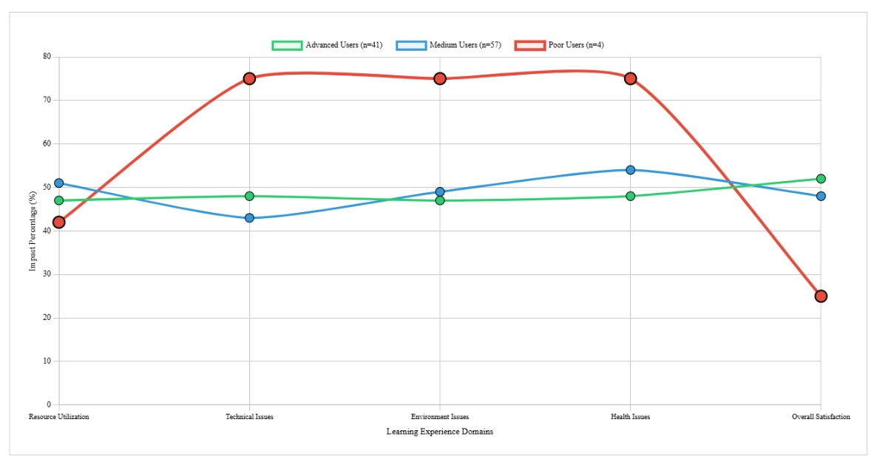
Figure 2. Comprehensive Digital Divide Impact Analysis.

English proficiency correlations revealed unexpected patterns that challenge conventional assumptions about language competency in online learning contexts. Paradoxically, A1 students with the lowest proficiency levels showed higher satisfaction with activity design at 43% compared to higher proficiency levels, suggesting that beginners may have fewer expectations or comparison frameworks that could lead to disappointment. On the other hand, the higher proficiency students showed more participation in discussion and teacher dialogue. Moreover, the students’ comfort with discussion and dialogue was positively correlated with their English proficiency levels. Therefore, language competency is a major factor in student engagement within online learning environments in EMI contexts.
4.5 Qualitative Insights
Five respondents provided open-ended answers which could be coded with additional themes:
Negative experiences: Some of the participants referred to issues, which affected their understanding ("I remember about 15% of content"), contextual necessities external to their studies ("I needed a classroom"), and systemic contextual necessities ("sudden unique changes in systematic processes occurred that interfered with efficiency").
Positive Experiences: Some students appreciated encouragement from the instructor and increased confidence levels while others indicated that differences in their experience were based on the instructor.
Mixed Experiences: Several responses mentioned ambivalence ("both good and bad") and context-dependency ("depends on the teacher"), which supports the quantitative finding of variability in student experience.
5. Discussion
The results of this retrospective study offer important insights into the challenging landscape of emergency remote teaching in English-Medium Instruction contexts and their institutional patterns that go beyond simple pandemic reactions and really expose more fundamental issues around crisis-responsive educational design. Quite moderate levels of satisfaction across all perception areas along with knowing health impacts were significant and equity issues means that emergency remote teaching may indeed have done its job, in that it kept education happening during periods of crisis, while also exposing serious fragilities in digital education infrastructure, educator readiness, and institutional structures and support that exist from the minute crises passes and beyond.
A key theoretical consideration emerging is the relevance of the Community of Inquiry (CoI) framework within ERT environments. Findings suggest that an emergency implementation curtailed some of the intentionality and design principles in respect to quality online education. Essentially, the measures of learning activity design and environmental engagement were both very low, indicating that higher-order learning processes properly considered were not a significant part of ERT. The transition to ERT often reflected models of information transmission, resulting in experiences with reduced cognitive challenge and environmental engagement, and a lack of opportunities for creative engagement. We can now conclude that the opportunities for these experiences characterised poor-to-little thinking and problems solving moments that might suggest a quality educational experience.
Of equal concern, with less peer interaction and learning communication means that the creation of community and collaboration even in hastily implemented online situations presents an enormous opportunity, and a significantly pulsated barrier to hurdle. The gender differences in interaction means that developing social presence might be oriented in relation to individual experiences and characteristics, comfort with technology, and cultural differences in communication. Significant gaps in activity design and facilitation of the environment, along with qualitative data suggesting that experiences "vary according to teacher," raise questions about earlier literature that the quality of instructor preparedness, and pedagogical learning adaptation may be significant influencers. These findings contextualize the other qualitative experiences which suggest that teaching presence was incomplete, when considering dimensions of emergency shifts.
The finding that flexibility was the primary perceived benefit, at the same time that students were most dissatisfied with learning situation, represents a strong paradox and suggests that there are difficult links between student freedom as autonomous learners with structured learning work burden. This finding is relevant to the self-determination theory, whereby autonomy exists as a fundamental human motivation and need yet, the finding in this case study revolves around the idea that distance or delay in activity and landscape might compensate for certain learning environment deficiencies without addressing some of the broad issues related to the quality of education overall.
If anything, the higher levels of satisfaction among self-paced learners demonstrates that student ability to take agency in adjusting learning tempo and conditions is likely to be a key factor contributing to online learning experience success. However, that related satisfaction factor is still likely not enough to stand in the way of other system level challenges around interaction, engagement and consideration of pedagogical design.
The clear impact of technology competency on learning prompts important equity questions that go beyond issues of access to considerations of competency, confidence, and cultural comfort with technology-mediated learning environments. The evidence, shown for example in the comparison of advanced users and poor users of technology (20-30% higher rates of challenge by poor technology users across all domains), suggests that ERT implementation may have created, rather than diminished, educational inequality to the point of creating a digital divide compounding the disadvantage faced by vulnerable student groups. This technological stratification is compounded further when we add the gender difference in technical challenges and health impacts suggesting for certain groups of students, intersectionality may be contributing to disadvantage multiplicatively rather than additively. The 4% of students in the data that identified themselves as poor technology users experienced significantly higher rates of challenge across all domains show how even small populations of technology disadvantage experience an disproportionate degree of barriers that may essentially contravene their educational experiences and subsequent longer-term academic paths.
Figure 3 illustrates the important equity paradox this research uncovered: only 4% of the student population identified as poor users of technology, yet 75% of the challenges poor users experienced compared to advanced users raised questions about how emergency remote teaching can create significant barriers for small, but highly vulnerable, student populations.
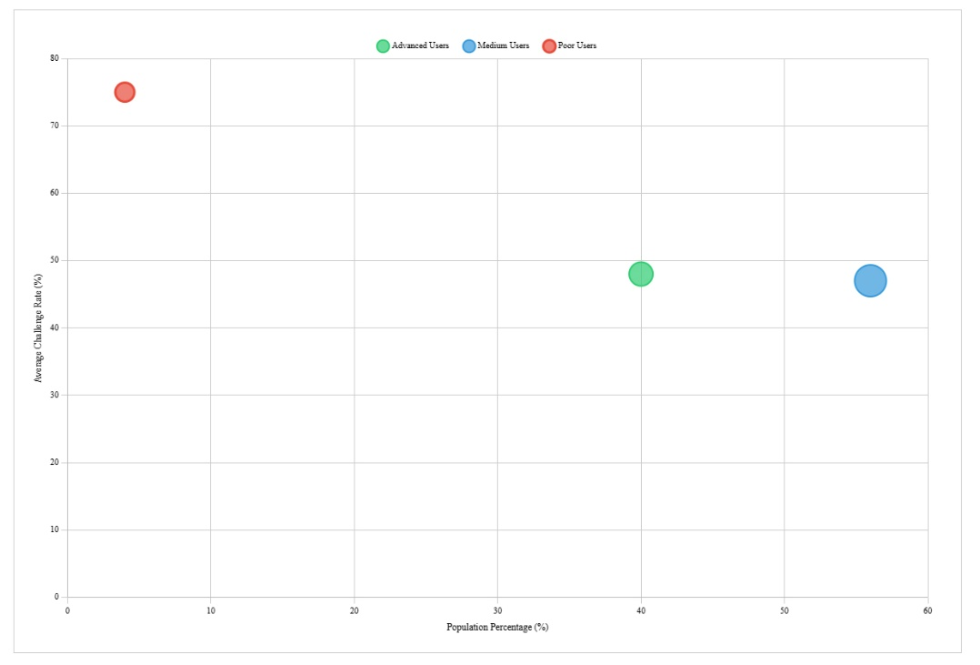
Figure 3. Technology Competency Distribution & Impact Severity.

The significant detrimental health impacts documented in this study represent a critical phenomenon that has been overlooked in much educational technology research, as over 60% of participants reported experiencing health-related physical pain and 52% reported issues with concentration indicative of problems related to concentration and well beyond transient adjustment related issues. The findings indicate the emergent, permanent, and potentially different health risks associated with new modes and behaviours of engagement in online learning that warrant significant study in their own right so that they may be designed thoughtfully in the appropriate educational practices and included in any educational design or crisis interventions. The higher rates of health associated impacts reported by female-students and younger students insinuate a difference in vulnerability that poses additional challenges and layers of inequality, which is compounded with technology and social risks and creates further disadvantage for certain demographic profiles.
The findings related to English proficiencies reveal minimally unanticipated patterns that counter normative assumptions related to language learning in online environments with the satisfaction reported from A1-level students suggest that beginners may adopt fewer expectations around, or frameworks to compare the learning experience with that would lead to disappointment; and that advanced students likely do a much more critical evaluation of pedagogical approaches. The relationship between English proficiency and comfort in communication confirms the important role of language proficiency in online learning engagement for students in EMI contexts, with implications for international universities serving complex linguistic student populations, and suggestions for differentiated support strategies that address students' different levels of language proficiency and technological proficiencies.

The retrospective nature of this study affords some unique insight into some of the longer-term legacies of experiences of educational emergency as apparent through the profound concerns about educational quality, and deficits of interaction and health impacts that suggest initial pandemic disruption might have created a much longer-term scepticism or suspicion about online learning modalities that may be long lasting and an obstacle for future engagement in online programs that could be implemented with planning. Ultimately, this dimension of time indicates that rather than being short-term emergency implementations, the experiences of students with online learning, may persist for much longer periods and shape student values and beliefs into resistances to educational technology that far exceed the period of immediate crisis, and could impact on long-term institutional change aimed at creating technology enhanced solutions for educational delivery.
The institutional implications identified suggest significant challenges for crisis preparation relating to all aspects of work context, ways of working, faculty development, student support services, and comprehensive quality assurance mechanisms. While there were moderate levels of satisfaction reported for the institutional resources that facilitated student engagement, the significant issues reported by students suggest that even with significant resources universities faced considerable challenges in implementation during emergent transitions. The variation of student experiences that depended on the teacher, highlights the impact teacher development and pedagogical support plays in relation to educational technology, not to mention the finding that instructors who provided encouragement had an influence on student confidence suggesting that social-emotional support might well be of equivalent important to the Learning Technology Functionality in online learning success.
Cross-cultural considerations emerge as particularly significant in this study's focus on Turkish and Turkish Cypriot students within an international university context, with gender disparities in participation and satisfaction potentially reflecting cultural expectations about communication styles, authority relationships, and technology use that extend beyond individual preferences to encompass broader social and cultural frameworks. The age-related differences in adaptation success suggest that life experience and maturity may facilitate online learning engagement through enhanced self-regulation skills and clearer goal orientation, yet these advantages appear insufficient to overcome systemic barriers related to technology access, pedagogical design, and institutional support.
Several important limitations constrain the generalizability of these findings and highlight areas requiring further investigation. The convenience sampling approach and single institution focus limit broader applicability across diverse institutional contexts and cultural settings, while the retrospective design may introduce memory bias and temporal confounding that could influence participants' recollections of their emergency remote teaching experiences. The relatively small sample size restricts demographic subgroup analysis and statistical power for examining complex interactions among variables, particularly for the smallest technology competency group. Future research should explore longitudinal designs tracking student perceptions across extended time periods, comparative studies examining different institutional contexts and cultural settings, and mixed methods approaches providing deeper qualitative insights into the nuanced experiences of students navigating emergency remote teaching in multilingual, multicultural educational environments. Investigation of specific intervention strategies addressing the challenges identified in this study would provide valuable practical guidance for institutional improvement efforts and crisis preparedness planning.
6. Conclusions and Implications
This retrospective analysis of Turkish and Turkish Cypriot students' online learning experiences during COVID-19 reveals a complex landscape of benefits, challenges, and unintended consequences that extend well beyond immediate pandemic responses, providing crucial insights into the multifaceted impact of emergency educational transitions on student wellbeing, learning outcomes, and institutional effectiveness. The study's most significant contribution lies in documenting the persistent nature of ERT-related concerns and demonstrating how emergency remote teaching, while successfully maintaining educational continuity during crisis periods, simultaneously exposed critical vulnerabilities in digital education infrastructure and pedagogical preparedness that continue to influence student attitudes and institutional capabilities long after the immediate crisis has subsided.
The moderate satisfaction levels across all perception domains, combined with the identification of significant health impacts and equity concerns, indicate that emergency implementations create their own set of challenges and unintended consequences requiring systematic attention that extends far beyond technological infrastructure provision. The findings contribute substantially to educational technology theory by demonstrating that emergency implementations significantly compromise the balanced integration of cognitive, social, and teaching presence outlined in the Community of Inquiry framework, suggesting that crisis contexts require adapted theoretical approaches that acknowledge the constraints and limitations inherent in emergency educational responses. The significant influence that technology competency has on learning experiences lend empirical validation to broaden conceptualizations of the digital divide causative factors beyond access issues alone, to include technology competency, confidence and cultural congruence, while the contradiction of flexibility where students value freedom and autonomy, while simultaneously needing structures and support revealed important implications for self-determination theory in educational technology scenarios.

The consequential implications for higher education institutions are comprehensive and complex, and result in calls for comprehensive and systemic crisis responsive learning plans that consider pedagogical training, student support services and health consideration protocols in addition to Nexus component of technology infrastructure. The data that teacher effectiveness was an important contributor to student experiences emphasize the important reminder of faculty development importance in educational technology use; while the gender, age and technology competency findings indicate the need for targeted intervention support initiatives to assist vulnerable student groups to access their opportunities to learn via staged preassessment protocols to identify at-risk students, with additional provision of technical and academic support. The evidence of significant physical and psychological health impacts described in this study indicates online learning design needs systematic consideration for health, and institutions need to develop health monitoring protocols for their edtech provision, with guidelines around ergonomics and break periods to address extended periods of screen time. The moderate level of satisfaction in three areas of learning indicates the need for systemic quality monitoring systems that can quickly identify if a learning experience is pedagogically impaired during emergency transitions, so institutions can maintain quality crisis response and maintain continuity in educational learning experiences.
Policy implications extend to national and international levels, supporting arguments for increased investment in digital infrastructure, teacher training, and student technology competency development as essential components of educational resilience. Policymakers should prioritize equitable access to high-quality internet connectivity and technological devices as fundamental educational rights, while institutions serving international student populations must address the EMI-specific challenges identified in this study through specialized support services that simultaneously address linguistic, cultural, and technological adaptation needs. The documented challenges support arguments for legislative frameworks requiring educational institutions to maintain crisis-responsive capabilities including technological infrastructure, pedagogical training, and student support services that can be rapidly deployed during emergency situations.
Educational technology development must prioritize user-centred design approaches that incorporate ergonomic considerations and extended-use protocols, with developers focusing on user wellbeing alongside functional requirements. The technology competency findings highlight the need for educational platforms designed for diverse skill levels with comprehensive onboarding and support features, while the social presence deficiencies identified in this study suggest that developers should prioritize community-building features and collaborative learning tools that facilitate meaningful interaction and relationship building in digital environments.
Future research priorities should encompass longitudinal impact studies examining student attitudes and learning outcomes across extended time periods to provide insights into the lasting effects of emergency educational transitions, coupled with intervention development and testing focused on specific strategies to address identified challenges including health protocols, equity interventions, and pedagogical training programs. Cross-cultural comparative analysis examining emergency remote teaching experiences across diverse cultural and institutional contexts would enhance understanding of generalizable versus context-specific findings, while mixed-methods exploration providing deeper qualitative investigation of student experiences, particularly regarding the intersection of linguistic, technological, and cultural factors in EMI contexts, would provide valuable insights for international education policy and practice.
A unique natural experiment of educational change was created globally by the COVID-19 pandemic that offered unique opportunities to observe large-scale educational technologies that involved large-scale rapid implementation and yielded lessons that reach far beyond immediate crisis mitigation. We believe the retrospective frame provided by this research shows that time alone does not make significant changes to the latent issues of a sudden emergency educational transition; students, for example, have concerns about educational quality, relational deficits, and health issues that will linger long after they return to conventional teaching modalities. These lingering concerns bring forward possibilities of views of educational reactions to imposed change that will benefit from critical reflection, and potentially influence future choices about educational outcomes, expectations, and the role technology can or should play in these conversations.
The world is not relinquishing technology; the same can be said about the needs and problems facing students and institutions alike. The lessons learned from participants’ experiences of emergency remote teaching and learning represents a greater opportunity to have rigorous, reflective discussion about the intentional and considered integration of educational technologies that emphasize the significant promise of educational technology and yet recognize the inherent limitations of digital learning environments. Success in this environment will take a sustained commitment to attend to pedagogy, student wellbeing, equity, and institutions’ adequate constant readiness and support that goes beyond providing technology, in order to inform a balanced approach to educational technology integration as it relates to – including unique interactions between – pedagogy, technology, and the salient human needs that exist in the educational landscape.
The experiences of Turkish and Turkish Cypriot students, who participated in this research, constitute a case study of resilience, adaptation, and critically evaluating educational innovation when pressures are at their height, which will definitely provide guidance on how we enact more beneficial, equitable, and sustainable means of engaging with educational technologies as a wider international higher education network. The research brought to life the promise and shortcomings of emergency educational responses, while still providing sound rationale to keep student wellbeing, educational quality, and equitable access front and centre of educational technologies use, whether initiated for planned or strategic purposes, or in reaction to perceived threats. In the end, the research has shown that for educational technology to effect positive change, consideration must be given to the complex relationship between technology affordances, pedagogical design, and institutional arrangement and student needs. Future educational technology efforts need to think holistically about the human factors that are needed, in addition to technology, to provide inclusive educational environments to serve different student communities effectively.

References
Adedoyin, O. B., & Soykan, E. (2023). Covid-19 pandemic and online learning: the challenges and opportunities. Interactive Learning Environments, 31(2), 863-875. https://doi.org/https://doi.org/10.1080/10494820.2020.1813180
Akbana, Y. E., Rathert, S., & Ağçam, R. (2021). Emergency remote education in foreign and second language teaching. Turkish Journal of Education, 10(2), 97-124. https://doi.org/https://doi.org/10.19128/turje.865344
Baber, H. (2020). Determinants of students’ perceived learning outcome and satisfaction in online learning during the pandemic of COVID-19. Journal of Education and e-Learning Research, 7(3), 285-292. https://doi.org/http://dx.doi.org/10.20448/journal.509.2020.73.285.292
Bozkurt, A., Jung, I., Xiao, J., Vladimirschi, V., Schuwer, R., Egorov, G., Lambert, S., Al-Freih, M., Pete, J., & Olcott Jr, D. (2020). A global outlook to the interruption of education due to COVID-19 pandemic: Navigating in a time of uncertainty and crisis. Asian Journal of Distance Education, 15(1), 1-126. https://doi.org/http://dx.doi.org/10.5281/zenodo.3878572
Crawford, J., Butler-Henderson, K., Rudolph, J., Malkawi, B., Glowatz, M., Burton, R., Magni, P. A., & Lam, S. (2020). COVID-19: 20 countries’ higher education intra-period digital pedagogy responses. Journal of applied learning & teaching, 3(1), 1-20. https://doi.org/http://dx.doi.org/10.37074/jalt.2020.3.1.7
Daniel, S. J. (2020). Education and the COVID-19 pandemic. Prospects, 49(1), 91-96. https://doi.org/https://doi.org/10.1007/s11125-020-09464-3
Despagne, C. (2010). The difficulties of learning English: Perceptions and attitudes in Mexico. Comparative and International Education, 39(2). https://doi.org/https://doi.org/10.5206/cie-eci.v39i2.9154
Erarslan, A. (2021). English language teaching and learning during Covid-19: A global perspective on the first year. Journal of Educational Technology and Online Learning, 4(2), 349-367. https://doi.org/https://doi.org/10.31681/jetol.907757
Ferri, F., Grifoni, P., & Guzzo, T. (2020). Online learning and emergency remote teaching: Opportunities and challenges in emergency situations. Societies, 10(4), 86. https://doi.org/https://doi.org/10.3390/soc10040086
Gardner, R. C. (1985). Social psychology and second language learning: The role of attitudes and motivation. (No Title). https://doi.org/https://doi.org/10.1037/h0083787
Garrison, D. R. (2016). E-learning in the 21st century: A community of inquiry framework for research and practice. Routledge. https://doi.org/https://doi.org/10.4324/9781315667263
Garrison, D. R., Anderson, T., & Archer, W. (1999). Critical inquiry in a text-based environment: Computer conferencing in higher education. The Internet and higher education, 2(2-3), 87-105. https://doi.org/https://doi.org/10.1016/S1096-7516(00)00016-6
Gehlbach, H., & Barge, S. (2012). Anchoring and adjusting in questionnaire responses. Basic and Applied Social Psychology, 34(5), 417-433. https://doi.org/https://doi.org/10.1080/01973533.2012.711691
Heumann, C., & Shalabh, M. S. (2016). Introduction to statistics and data analysis. Springer. https://doi.org/https://doi.org/10.1007/978-3-319-46162-5
Hodges, C., Moore, S., Lockee, B., Trust, T., & Bond, A. (2020). The difference between emergency remote teaching and online learning. Educause review, 27(1), 1-9. https://doi.org/https://doi.org/10.1163/9789004702813_021
Khatatbeh, H., Amer, F., Ali, A. M., Albashtawy, M., Kurnianto, A., Abu-Abbas, M., Al Omari, O., Al-Awamleh, R. A., Al-Dwaikat, T., & Hammoud, S. (2024). Challenges of distance learning encountering nursing students after the COVID-19 pandemic: a study from the Middle East. BMC Nursing, 23(1), 574. https://doi.org/10.1186/s12912-024-02236-w
Kim, S., & Kim, D.-J. (2021). Structural relationship of key factors for student satisfaction and achievement in asynchronous online learning. Sustainability, 13(12), 6734. https://doi.org/https://doi.org/10.3390/su13126734
Liaw, S.-S., Huang, H.-M., & Chen, G.-D. (2007). Surveying instructor and learner attitudes toward e-learning. Computers & Education, 49(4), 1066-1080. https://doi.org/https://doi.org/10.1016/j.compedu.2006.01.001
Mbiydzenyuy, N. E. (2020). Teaching and Learning in resource-limited settings in the face of the COVID-19 pandemic. Journal of Educational Technology and Online Learning, 3(3), 211-223. https://doi.org/https://doi.org/10.31681/jetol.732077
Nistor, N. (2013). Stability of attitudes and participation in online university courses: Gender and location effects. Computers & Education, 68, 284-292. https://doi.org/https://doi.org/10.1016/j.compedu.2013.05.016
Richardson, J. T., & Woodley, A. (2003). Another look at the role of age, gender and subject as predictors of academic attainment in higher education. Studies in Higher Education, 28(4), 475-493. https://doi.org/https://doi.org/10.1080/0307507032000122305
Said, M. M., Rita, F., Sri Arfani, H., Basri, H., & Weda, S. (2021). Efl students’ willingness to communicate in online learning at higher educationin indonesia. Multicultural Education, 7(5), 340-346. https://doi.org/https://doi.org/10.5281/ZENODO.4818789
Saputra, W. N. E., Wahyudi, A., Supriyanto, A., Muyana, S., Rohmadheny, P. S., Ariyanto, R. D., & Kurniawan, S. J. (2021). Student Perceptions of Online Learning during the COVID-19 Pandemic in Indonesia: A Study of Phenomenology. European Journal of Educational Research, 10(3), 1515-1528. https://doi.org/https://doi.org/10.12973/eu-jer.10.3.1515
Sayer, P., & Braun, D. (2020). The disparate impact of COVID‐19 remote learning on English learners in the United States. TESOL Journal, 11(3). https://doi.org/https://doi.org/10.1002/tesj.546
Sharpe, R., & Benfield, G. (2005). The student experience of e-learning in higher education. Brookes eJournal of Learning and Teaching, 1(3), 1-9.
Smart, K. L., & Cappel, J. J. (2006). Students’ perceptions of online learning: A comparative study. Journal of Information Technology Education: Research, 5(1), 201-219. https://doi.org/http://dx.doi.org/10.28945/243
Taherdoost, H. (2022). Designing a questionnaire for a research paper: A comprehensive guide to design and develop an effective questionnaire. Asian Journal of Managerial Science, 11(1), 8-16. https://doi.org/https://doi.org/10.51983/ajms-2022.11.1.3087
Yan, Z. (2020). Unprecedented pandemic, unprecedented shift, and unprecedented opportunity. Human behavior and emerging technologies, 2(2), 110. https://doi.org/https://doi.org/10.1002/hbe2.192
Zhao, H., & Sullivan, K. P. (2017). Teaching presence in computer conferencing learning environments: Effects on interaction, cognition and learning uptake. British Journal of Educational Technology, 48(2), 538-551. https://doi.org/https://doi.org/10.1111/bjet.12383

