Case report
Symptomatic multiple myeloma with monoclonal IgG kappa peak during pregnancy at 24 weeks: Description of a rare case and review of the literature

ABSTRACT
Multiple myeloma (MM) in pregnant women is a rare disease characterized by clonal proliferation of plasma cells producing monoclonal immunoglobulin, which suppresses the normal production of other antibodies and weakens the maternal immune response. Plasma cells release inflammatory cytokines (IL-6, TNF-α, IL-1β) that promote their survival and bone destruction. During pregnancy, maternal immunity shifts towards complex tolerance with decreased Th1 inflammatory responses, Th2 predominance, and increased regulatory T cells, which often masks MM and complicates its management. Treatment is generally deferred until after delivery to protect the fetus, with the VTD protocol then used to control the disease by reducing plasma cell proliferation and inflammation. This case illustrates the importance of simple tests such as serum protein electrophoresis in diagnosing unexplained anemia during pregnancy, and highlights the need for immunological monitoring and a multidisciplinary approach to optimize maternal and fetal prognosis.

Translated with DeepL.com (free version)

Keys words :Multiple myeloma,pregnancy, anemia,monoclonal composant,electrophoresis.

1.INTRODUCTION

Multiple myeloma is a malignant clonal proliferation of plasma cells characterized by excessive monoclonal production of immunoglobulins, mainly IgG. The median age at diagnosis is generally around 63 to 70 years, with cases in young people, and particularly during pregnancy, remaining extremely rare, with fewer than 50 cases described in the global literature since 1965 (Durand ReaMmmclratplcB, 2024; Hila et al., 2022). Gestational anemia is common, but in the presence of a monoclonal peak, further investigation is necessary to rule out an underlying blood disorder and ensure appropriate management. However, diagnosis is complicated by the overlap with the physiological symptoms of pregnancy. Therefore, particular vigilance is required.

2.CASE PRESENTATION

A 35-year-old patient from Annaba (Algeria), 24 weeks pregnant with her second child, with no notable family history. She complains of persistent fatigue accompanied by pale skin. Clinical examination revealed marked pallor, a uterine fundus consistent with 24 weeks, a normal fetal heart rate (140 bpm), and a high body mass index of 28 kg/m². Blood pressure was stable at 120/80 mmHg.
2.1.. Biological and hematological tests
Blood count reveals moderate anemia (Hb 10 g/dL, hematocrit 30%, MCV 75 fL), associated with low ferritin (22 ng/mL) indicative of probable iron deficiency. Blood smear shows anisocytosis, polychromatophilia, presence of erythroblasts, neutrophilic hyperleukocytosis with coarse granulations, and moderate thrombocytopenia. The sedimentation rate was accelerated (78 mm/h). Serum protein electrophoresis (Sebia) revealed a monoclonal IgG kappa peak of 42 g/L, confirmed by immunofixation. Serum free light chain assay (Sebia) showed a high κ/λ ratio (3.86). Bence Jones proteinuria was positive. In addition, mild renal failure is observed with a slight increase in urea (9.8 mmol/L), creatinine (165 µmol/L), and proteinuria at 650 mg/24h. Moderate hypercalcemia (2.85 mmol/L) and a liver profile consistent with pregnancy-related cholestasis complete the picture (Figures 1, 2, 3) .
2.2.Morphological and radiological examinations
The bone marrow aspiration revealed significant plasma cell infiltration estimated at 65%, which was confirmed as clonal by immunophenotyping (CD38+, CD138+, CD56+) using flow cytometry (BD FACS Lyric). A low-dose whole-body CT scan detected a 6 mm osteolytic lesion in the pelvis, typical of bone involvement associated with multiple myeloma. Abdominal and obstetric ultrasounds showed a normal fetus with no abnormalities or growth retardation, and measurements were within normal limits. These examinations, which limit fetal exposure to radiation, are essential for assessing the extent of the disease while ensuring safe, risk-free maternal-fetal monitoring.

2.3.Diagnosis
The diagnosis of symptomatic multiple myeloma in the patient was based on the combination of a significant monoclonal IgG kappa peak associated with a high κ/λ ratio, with positive Bence Jones proteinuria indicating significant renal involvement, as well as high myeloid plasma cell infiltration (65%) with characteristic immunophenotyping (CD38+, CD138+, CD56+).
Clinically, the presence of anemia, renal failure, hypercalcemia, and osteolytic bone lesions meets the CRAB criteria of the IMWG (International Myeloma Working Group), justifying a diagnosis of myeloma in the active phase. The ISS (International Staging System )classification of stage II reflects a high tumor burden and a guarded prognosis. This complex diagnosis requires appropriate management, which is even more delicate in the case of pregnancy.

2.4 .Management and follow-up
Due to the high teratogenic risk, chemotherapy is postponed during pregnancy, especially during the first and second trimesters, with regular monthly clinical and biological monitoring based on blood counts, renal function tests, calcemia measurements, protein electrophoresis (Figure 4a/b), and weekly ultrasounds to ensure maternal-fetal stability and a complication-free pregnancy. After delivery, treatment with the VTD protocol (treatment using bortezomib (Velcade), lenalidomide (Revlimid), and dexamethasone), which is effective and well tolerated, leading to complete remission.
This success highlights the importance of appropriate and deferred treatment, combined with multidisciplinary post-treatment follow-up (hematologist, gynecologist, nephrologist, immunologist) to detect any relapses or side effects and ensure optimal long-term care.
3.DISCUSSION
Multiple myeloma (MM) is a malignant blood disorder characterized by clonal proliferation of plasma cells in the bone marrow, associated with excessive monoclonal production of immunoglobulins (1). The IgG kappa form identified in our patient corresponds to the most frequently observed type in the general population, which is consistent with the epidemiological and biological data reported by Palumbo and Anderson and corroborated by Kyle and Rajkumar (2,3). Immunoparesis, resulting from the suppression of polyclonal immunoglobulins, is a mechanism well described in the literature, promoting significant immunosuppression and vulnerability to opportunistic infections (4,5). This immunosuppression was highlighted by Rajkumar (2011), who emphasized its prognostic effect and therapeutic implications, in line with the clinical observations made in our patient. Epidemiologically, MM primarily affects older populations, with less than 3% of cases diagnosed before the age of 40, which is linked to female fertility (6,7). Our observation is thus consistent with the rare descriptions of MM in the context of pregnancy, as confirmed by the reviews by Kumar et al. (2003) and Lee et al. (2016), which emphasize the rarity and complexity of management in this specific situation (8,9). The clinical presentation of MM during pregnancy is often atypical. Anemia, which is very common during pregnancy, particularly due to nutritional deficiencies, is a common factor that can lead to delayed diagnosis of serious conditions such as MM. This is clearly illustrated in our observation by anemia that is refractory to iron treatment, a situation also highlighted by Smith et al. (2012), who recommend thorough investigation of persistent unexplained anemia in pregnant women (10). Serum protein electrophoresis and free light chain assay, as indicated in our diagnosis, are now considered key tests for the early detection of subtle monoclonal peaks and imbalances in the κ/λ ratio ratio imbalances (11). These investigations are systematically recommended in the literature and their importance is unanimously recognized, particularly in the reviews by Gertz (2008) and Terpos & Dimopoulos (2005), confirming the relevance of our diagnostic approach (12,13). Pregnancy alters the immune system, inducing maternal-fetal tolerance by reducing cellular and humoral immune responses (14). This modulation can attenuate the classic symptoms of MM (fatigue, recurrent infections, bone pain), explaining the late or incidental discovery of cases during pregnancy—a point that our observation corroborates in perfect agreement with the work of Mor & Cardenas (2010) and Lee et al. (2016) (15,9). From an immunopathological perspective, IL-6 plays a major role in the proliferation of malignant plasma cells and in the development of bone lesions through the activation of osteoclasts (16). As observed in our patient, this mechanism is responsible for the common disabling bone complications of MM, suggesting the need for increased vigilance, particularly in the context of pregnancy, where osteoarticular symptoms can be confused with physiological pain associated with pregnancy (17). This issue is discussed at length by Terpos and Dimopoulos (2005) and Terpos et al. (2020) (16,18). The therapeutic management of MM during pregnancy remains a major challenge. The literature, including the study by Lee et al. (2018), recommends a cautious approach, generally deferring active treatment until after delivery to avoid the teratogenic effects of conventional chemotherapy, particularly in the first trimester (19). This strategy, with close multidisciplinary follow-up, corresponds exactly to the management protocol we applied, reflecting perfect alignment with current best practices (20,21). The standard postpartum treatment for symptomatic multiple myeloma is the combined VTD protocol (bortezomib, thalidomide, dexamethasone), recognized for its efficacy and good tolerance, validated by several studies, including that of Palumbo et al. (2020). New therapeutic options, such as monoclonal antibodies and newer proteasome inhibitors, are currently being evaluated, although data in pregnant women remain limited, as highlighted by Dispenzieri et al. (2019). The protocol used in this case is consistent with current recommendations and advances in the treatment of multiple myeloma. Finally, the importance of early diagnosis in cases of persistent anemia in pregnant women, as highlighted in our case, is shared by many authors (25,26). Increased awareness among clinicians to include specific immunological tests is necessary.

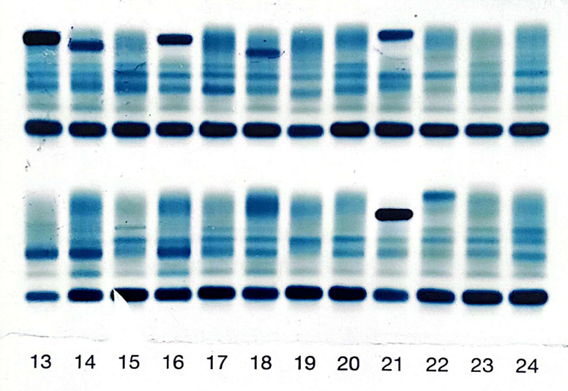

Fig. 1: The electrophoretic profile of our patient's serum proteins, performed on agarose gel, shows a monoclonal band located in the gamma globulin zone at position 21. This observation confirms the presence of a monoclonal immunoglobulin, attesting to the clonal nature of the detected protein.

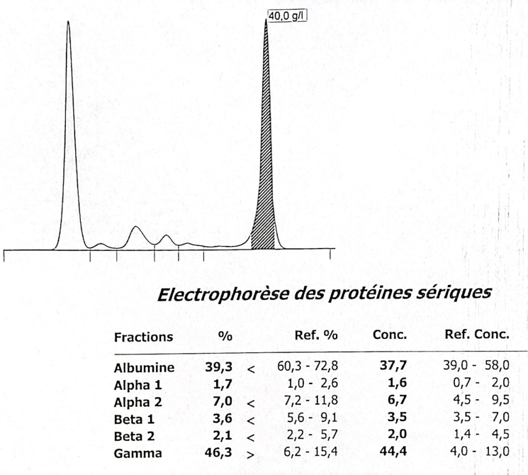
Fig. 2: The electrophoretic pattern of the protein profile at position 21 shows a monoclonal peak in the gamma globulin zone, with an estimated concentration of 40 g/L, accompanied by a decrease (suppression) in other classes of polyclonal immunoglobulins.

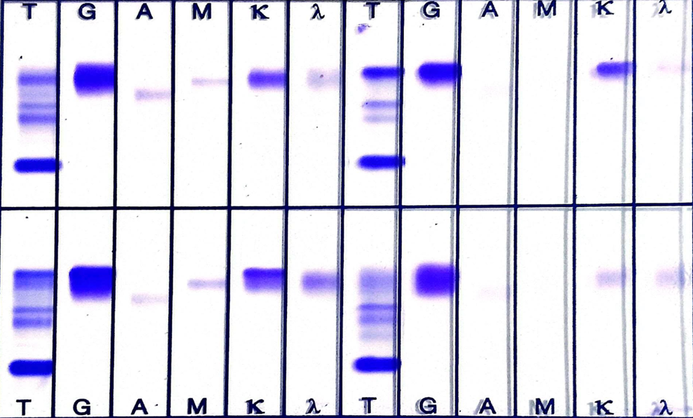
Fig. 3: Immunofixation results from our case show that the monoclonal peak corresponds to an IgG kappa immunoglobulin, with a decrease in other types of polyclonal immunoglobulins.

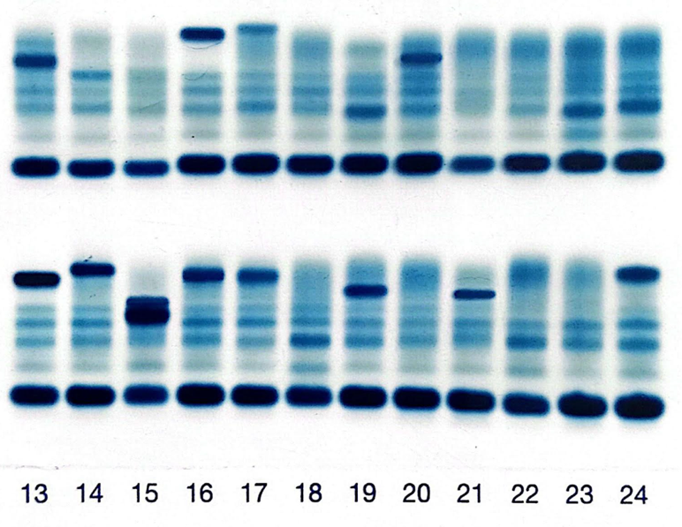

4 a.

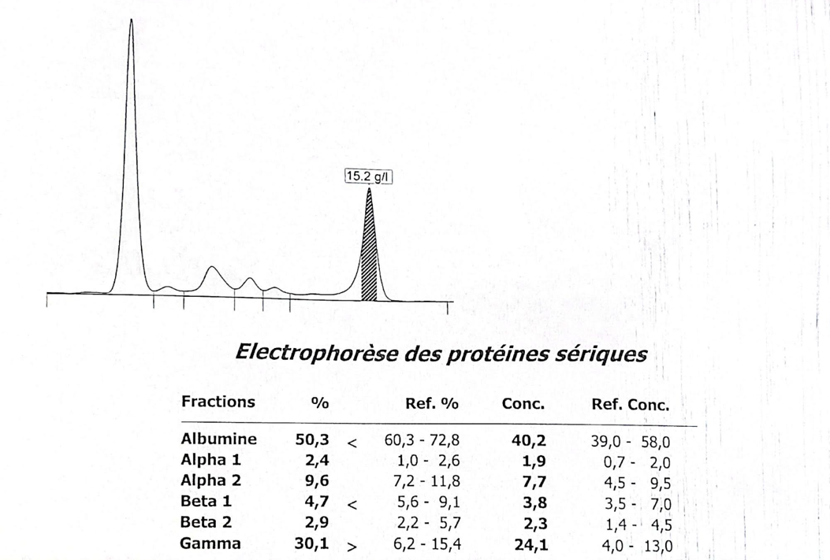
4b.

Fig. 4 a/b: Regression of the monoclonal peak after postpartum treatment with the VTD protocol in our patient with gestational myeloma

4.CONCLUSION
Symptomatic multiple myeloma during pregnancy represents an exceptionally rare and challenging clinical condition. Its diagnosis is often delayed because the presenting symptoms (fatigue, bone pain, anemia) are frequently misinterpreted as physiological changes of pregnancy.Moreover, the maternal immune alterations associated with feto-maternal tolerance further complicate both the clinical assessment and the interpretation of laboratory findings.
Nevertheless, certain warning signs should prompt further investigation: a persistent, unexplained anemia refractory to iron supplementation, when associated with the detection of a monoclonal spike on serum protein electrophoresis, strongly suggests an underlying plasma cell dyscrasia. In such cases, a comprehensive immunological work-up (including immunofixation, quantitative immunoglobulins, and free light chain assay) is mandatory for the biological detection of multiple myeloma.
From a therapeutic perspective, postponing chemotherapy until the postpartum period is generally recommended in order to minimize teratogenic risks to the fetus. During pregnancy, strict multidisciplinary monitoring involving hematologists, obstetricians, neonatologists, and anesthesiologists is required to maintain maternal and fetal stability.
After delivery, treatment with the VTD protocol (Bortezomib, Thalidomide, Dexamethasone) has proven to be both effective and well tolerated, leading to complete remission and ensuring a favorable prognosis.
Finally , the management of multiple myeloma during pregnancy requires a personalized and multidisciplinary approach, carefully balancing maternal safety, fetal protection, and the optimization of therapeutic outcomes in the postpartum period.

REFERENCES
1.Kyle RA, Rajkumar SV. Multiple myeloma. N Engl J Med. 2004;350(3):282-92.
2.Palumbo A, Anderson K. Multiple myeloma. N Engl J Med. 2011;364(11):1046-60.
3.MSD Manuals Professional. Myélome multiple. 2024.
4.Rajkumar SV. Immunoparesis in multiple myeloma: prognostic implications and therapeutic options. Blood Rev. 2011;25(3):141-50.
5.La Revue du Praticien. Myélome multiple: aspects cliniques et thérapeutiques. 2023.
6.Kumar S et al. Multiple myeloma in young patients: clinical features and outcome. Blood. 2003;102(6):190-6.
7.Fonseca R et al. Clinical and biologic implications of MYC rearrangement in newly diagnosed multiple myeloma. Blood. 2009;113(8):178-85.
8.Lee YJ et al. Multiple myeloma during pregnancy: a report of two cases and literature review. J Obstet Gynaecol Res. 2016;42(4):495-500.
9.Smith SM, Huebner D, Waller EK. Unexplained anemia in pregnancy: a case of occult myeloma. Obstet Gynecol. 2012;119(6):1244-7.
10.Mor G, Cardenas I. The immune system in pregnancy: a unique complexity. Am J Reprod Immunol. 2010;63(6):425-33.
11.Terpos E, Dimopoulos MA. Myeloma bone disease: pathophysiology and management. Ann Oncol. 2005;16(2):122-6.
12.Gertz MA. Diagnosis and management of multiple myeloma. Mayo Clin Proc. 2008;83(6):660-7.
13.Lee A et al. Challenges of managing multiple myeloma in pregnancy: case report and review. Hematology. 2018;23(10):646-649.
14.Palumbo A et al. Treatment of newly diagnosed multiple myeloma: updated recommendations. J Clin Oncol. 2020;38(15):1702-1714.
15.Dispenzieri A et al. Emerging therapies in multiple myeloma. Nat Rev Clin Oncol. 2019;16(12):695-710.
16.Rajkumar SV. Diagnostic challenges and therapeutic options for myeloma. Mayo Clin Proc. 2020;95(9):1828-40.
17.Terpos E et al. Bone disease in multiple myeloma: pathophysiology and clinical updates. J Bone Miner Res. 2020;35(4):565-78.

