LAND USE TRANSITIONS AND BAMBOO BASED LIVELIHOOD DIVERSIFICATION IN KARBI ANGLONG, NORTHEAST INDIA
ABSTRACT:
Land use transitions in ecotonal regions of Northeast India reflect the interplay of ecological resources, industrial demand, and livelihood change. This study analyses three decades of land use and land cover (LULC) change in Karbi Anglong district, Assam, with a focus on bamboo utilization. Multi-temporal satellite data (1993, 2014, and 2023/24) were classified using the Random Forest algorithm. The 2023/24 classification was validated with 700 ground-truth samples, achieving an overall accuracy of 93.57% and a Kappa coefficient of 0.87, indicating “almost perfect” agreement. Results reveal three distinct phases of transformation: (i) 1993 – natural abundance, when bamboo was embedded in forest/jhum systems and served both subsistence and early industrial extraction; (ii) 2014 - plantation expansion, driven by industrial demand from the Jagiroad Paper Mill and state subsidies, during which bamboo emerged as a major land cover class (24.8%) largely at the expense of forests and shifting cultivation; and (iii) 2023/24 - post-mill diversification, marked by stabilization of bamboo (25%), expansion of rubber, tea, and arecanut plantations, and continued growth of built-up areas. These transitions demonstrate how industrial dependence reshaped landscapes and livelihoods, generating both opportunities and vulnerabilities. The findings call for integrated land use policies that conserve forest cover, promote diversified livelihoods, and sustain bamboo as an ecological and cultural resource in the region.
Keywords: Land use transition; Bamboo utilization; Remote sensing and GIS; Plantation expansion; Shifting cultivation decline; Karbi Anglong (Northeast India)

- INTRODUCTION
Land use and land cover (LULC) transitions are among the most visible indicators of human–environment interactions, reflecting changing livelihood strategies, market forces, and ecological pressures (Lambin & Meyfroidt, 2010). Across the tropics, transitions from shifting cultivation to plantations, commercial agriculture, or built-up areas have reshaped forest landscapes, often creating trade-offs between economic opportunity and ecological resilience (Fox et al., 2009; Meyfroidt, 2016). In South and Southeast Asia, the expansion of plantations and the decline of traditional land-use systems are strongly tied to industrial demand, rural development policies, and demographic change (Mertz et al., 2009).
In Northeast India, land use dynamics are especially complex because of the coexistence of shifting cultivation, forest-based livelihoods, and emerging plantation economies. Bamboo, in particular, has played a pivotal role in shaping both landscapes and livelihoods. As one of the fastest-growing and most versatile non-timber resources, bamboo provides construction material, household goods, and cultural value while also serving as a raw material for industries such as paper and pulp (Belcher, 1999; Nath et al., 2015). However, the sustainability of bamboo as a livelihood resource depends on broader land-use dynamics, including the pressures of industrial extraction, forest conversion, and market fluctuations.
Karbi Anglong district in Assam represents a critical case for examining such transitions. The district experienced three decades of dramatic land-use change, closely tied to the rise and fall of the Jagiroad Paper Mill, once a major consumer of bamboo in the region. The establishment of bamboo plantations on former jhum fields, the decline of forest cover, and the subsequent diversification into alternative crops such as rubber, tea, and arecanut illustrate the multiple pathways through which livelihoods and landscapes have evolved. At the same time, population growth and infrastructure development have contributed to steady expansion of built-up areas, adding to ecological stress.
While earlier research has documented bamboo’s ecological and cultural importance in Northeast India (Bystriakova & Kapos, 2006; Nath & Das, 2011), few studies have systematically examined land-use transitions over multiple decades in relation to industrial demand and livelihood shifts. This paper addresses that gap by analysing land use and land cover change in Karbi Anglong from 1993 to 2023/24. Using multi-temporal remote sensing data, transition matrices, and field-based narratives, the study identifies three distinct phases of transition: (i) natural abundance (1993), (ii) plantation expansion (2014), and (iii) post-mill diversification (2023/24).
The objectives of the study are:
- To map and quantify land use and land cover changes in Karbi Anglong across three decades.
- To examine the drivers and socio-ecological implications of bamboo utilization across different phases.
- To discuss the policy implications of land use transitions for sustainable bamboo management and diversified rural livelihoods.
By situating bamboo within broader trajectories of land-use change, this study contributes to understanding how industrial dependence and livelihood diversification shape ecotonal landscapes in Northeast India.
2. MATERIALS AND METHODS
2.1 STUDY AREA
Karbi Anglong, the largest district in Assam, Northeast India, covers an area of approximately 10,434 km² and is characterized by hilly terrain, dense forests, and a mosaic of shifting cultivation, plantations, and agricultural land. The district is ecologically significant, forming part of the Indo-Burma biodiversity hotspot, and socio-culturally diverse, inhabited predominantly by the Karbi and other tribal communities. Bamboo has historically been central to household subsistence, cultural practices, and industrial supply chains. The district’s land-use dynamics are strongly influenced by the Jagiroad Paper Mill (operational until 2017), government plantation schemes, and the gradual decline of jhum (shifting cultivation). The geographical location and multi-functional role of bamboo make Karbi Anglong a representative case for studying land-use transitions in ecotonal landscapes. The study area map is shown in Figure 1.
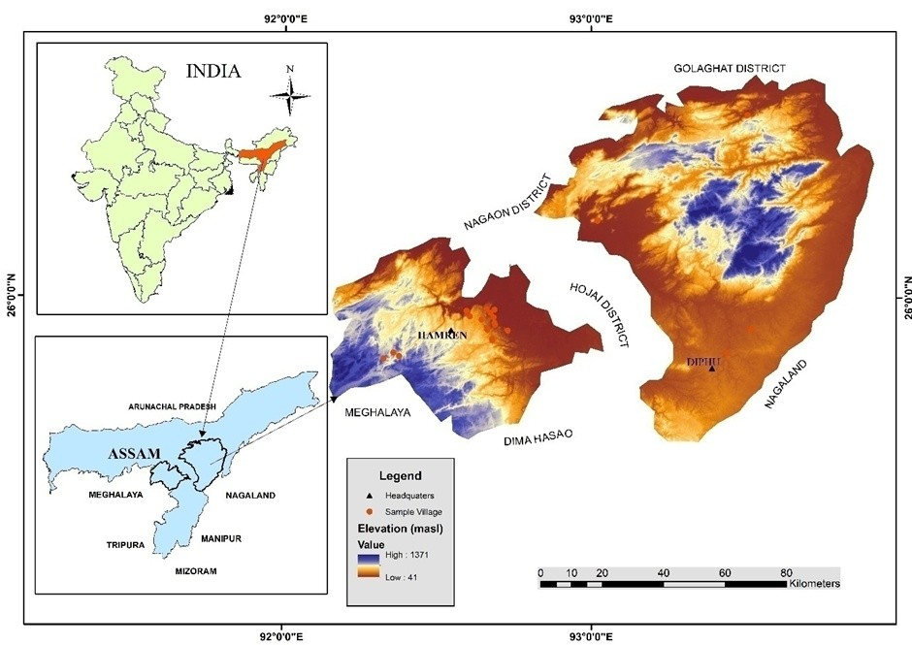
Figure 1. Location Map of Study Area

2.2 DATA SOURCES
The study employed multi-temporal satellite imagery and field-based information for land use and land cover (LULC) analysis:
- 1993: Landsat 5 TM (30 m resolution).
- 2014: Landsat 8 OLI (30 m resolution).
- 2023/24: Sentinel-2 MSI (10 m resolution).
Ground-truth data were collected from field surveys between 2019 and 2024 across ten villages representing different land-use contexts (reserve forests, plantations, and homesteads). Ancillary data, including topographic maps and local knowledge, were used to support classification and validation.
2.3 LAND USE CLASSIFICATION
Supervised classification was performed using the Random Forest algorithm, with class definitions adapted to the ecological and socio-economic conditions of each reference year. For 1993, five land cover categories were identified: water bodies, forest, jhum fields, agriculture, and built-up areas. Bamboo was not distinguished separately in this period due to spectral limitations and was included within the broader forest category. For 2014, six categories were classified: water bodies, other forest/plantation, jhum fields, agriculture, built-up areas, and bamboo. By this stage, bamboo emerged as a distinct land cover class due to its expansion as plantations under industrial demand. For 2023/24, classification was refined to capture emerging land-use diversification, resulting in seven categories: bamboo, non-bamboo forest/plantations, rubber, tea and arecanut, agriculture, built-up areas, and water bodies.
The classifications were carried out using multi-temporal satellite imagery (Landsat TM 1993, Landsat OLI 2014, and Sentinel-2 MSI 2023/24), supported by ground-truth data, field observations, and ancillary sources. The evolution of land cover categories across the three phases reflects the changing ecological role of bamboo and the broader trajectory of land-use transition in Karbi Anglong.
2.4 ACCURACY ASSESSMENT
The classification accuracy of the 2023/24 map was assessed using 700 ground-truth points collected during field surveys. A confusion matrix was generated to calculate producer’s and user’s accuracy for bamboo and non-bamboo classes, along with overall accuracy and Kappa coefficient as showed in Table 1 and Table 2. The classification achieved an overall accuracy of 93.57% and a Kappa coefficient of 0.87, indicating “almost perfect” agreement (Congalton, 1991). Producer’s accuracy was 93.94% for bamboo and 93.24% for non-bamboo, while user’s accuracy was 92.54% and 94.52%, respectively. These results confirm the reliability of the classification for analysing land-use transitions.

Table 1. Confusion Matrix for land cover classification (n=700)
Reference Data | Classified as Bamboo | Classified as non-bamboo | Total Reference | Producer’s Accuracy (%)
Bamboo | 310 | 20 | 330 | 93.94%
Non-Bamboo | 25 | 345 | 370 | 93.24%
Total Classified | 335 | 365 | 700 | —
Note. Data generated by the author from accuracy assessment of the 2023/24 land-use classification (Sentinel-2 MSI).
Table 2. Accuracy statistics of classification
Class | User’s Accuracy (%) | Producer’s Accuracy (%)
Bamboo | 92.54 | 93.94
Non-Bamboo | 94.52 | 93.24
Overall Accuracy | 93.57% | —
Kappa Coefficient | 0.87 (Almost Perfect) | —
Note. Data generated by the author from accuracy assessment of the 2023/24 land-use classification.

2.5 LAND USE TRANSITION ANALYSIS
To assess changes over time, post-classification comparison was used to generate transition matrices for 1993–2014 and 2014–2023/24. These matrices quantified conversions between land cover categories, such as forest to bamboo, jhum to bamboo, and forest to built-up. Spatial overlays and change maps were prepared to visualize the magnitude and direction of transitions. The analysis was supported by household narratives that contextualized the socio-economic drivers of land use change, particularly the influence of industrial demand, subsidies, and the post-mill diversification process.
3. RESULTS
3.1 PHASE I: NATURAL ABUNDANCE (1993)
In 1993, Karbi Anglong’s landscape was dominated by forests (49%) and shifting cultivation or jhum fields (26%), with smaller areas under built-up land (12%), agriculture (9%), and water bodies (5%) (Table 3; Figure 2). Bamboo was not separated as an independent land cover category in this period due to spectral limitations but was widely embedded within forest areas and around settlements, as confirmed by field accounts. Bamboo during this phase played a dual role such as sustaining household needs (construction, storage, handicrafts, rituals) and increasingly serving industrial demand following the establishment of the Jagiroad Paper Mill in 1985.
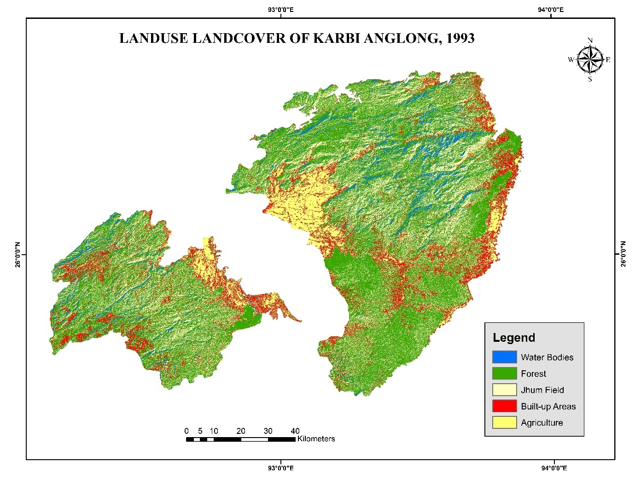
Figure 2. Land use Land cover map of Karbi Anglong, 1993

Table 3. Land use Land cover distribution in Karbi Anglong, 1993
Category | Area (ha) | % of Total
Water Bodies | 49,319.1 | 5%
Forest | 510,688 | 50%
Jhum Field | 270,777 | 26%
Built-up Areas | 122,058.5 | 12%
Agriculture | 89,051.4 | 9%
Note. Data generated by the author from classified land-use maps (Landsat TM, 1993).
3.2 PHASE II: PLANTATION EXPANSION (2014)
By 2014, land use patterns reflected the strong influence of industrial demand and subsidy-driven plantation expansion. Bamboo emerged as a distinct land cover class, occupying 257,955 ha (24.8%) of the district. This expansion occurred largely at the expense of jhum fields, which declined sharply from 270,777 ha in 1993 to 75,980 ha in 2014 (–18.7 percentage points). Forest cover also decreased (–5.6 percentage points), while built-up areas grew modestly to 12.3% (Table 4; Figure 3).
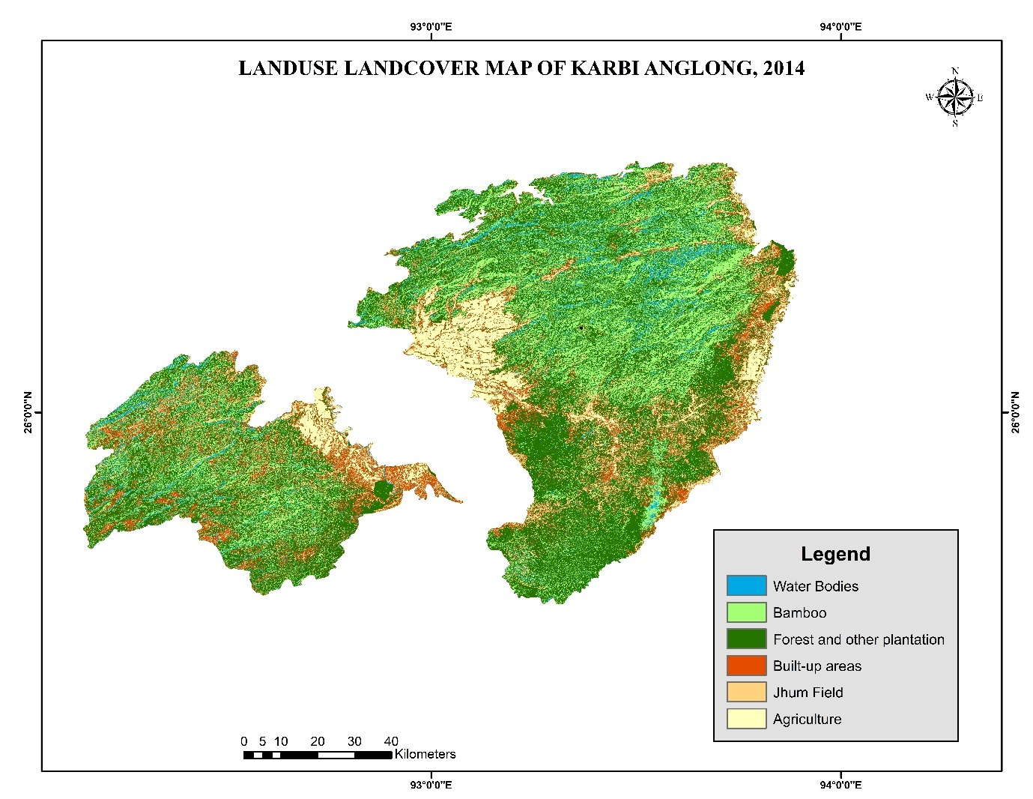
Figure 3. Land use Land cover map of Karbi Anglong, 2014

Table 4. Land use and land cover distribution, 2014
Category | Area (ha) | % of Total
Water Bodies | 47,739.6 | 4.58
Other Forest/Plantation | 452,025.0 | 43.38
Jhum Field | 75,980.3 | 7.29
Built-up Areas | 128,161.4 | 12.30
Agriculture | 80,033.1 | 7.68
Bamboo | 257,954.6 | 24.76
Note. Data generated by the author from classified land-use maps (Landsat OLI, 2014).

Table 5. Estimated land use/land cover transition matrix (1993–2014) in Karbi Anglong (Area in hectares)
From \ To | Water Bodies | Forest | Jhum Field | Built-up Areas | Agriculture | Bamboo
Water Bodies | 47,739.6 | – | – | – | – | –
Forest | – | 452,025.0 | – | 19,146.1 | – | 43,503.9
Jhum Field | – | – | 75,980.3 | – | – | 214,450.7
Built-up | – | – | – | 122,058.5 | – | –
Agriculture | – | – | – | – | 80,033.1 | –
Note. Data generated by the author from post-classification comparison of land-use maps (1993–2014).
Transition matrix analysis highlights that the majority of new bamboo plantations were established on former jhum fields (214,451 ha), with additional conversions from forest areas (43,504 ha). This confirms that bamboo expansion was closely tied to the decline of shifting cultivation and partial forest conversion under industrial demand (Table 5). The 2014 phase represents the height of plantation-based bamboo economy, where subsidies and industrial procurement reinforced bamboo’s role as both a livelihood and commercial crop.
3.3 PHASE III: POST-MILL DIVERSIFICATION (2023/24)
The closure of the Jagiroad Paper Mill in 2017 marked a turning point in land use trajectories. The 2023/24 Sentinel-2 classification shows that bamboo stabilized at 258,243 ha (25% of the district), while new land-use categories emerged, reflecting diversification into cash crops such as rubber (13.3%) and tea/arecanut (9.5%) (Table 6; Figure 4). Built-up areas expanded further to 14.4%, reflecting population growth and infrastructure development. Agriculture occupied 10.4%, while non-bamboo forests accounted for 27%.
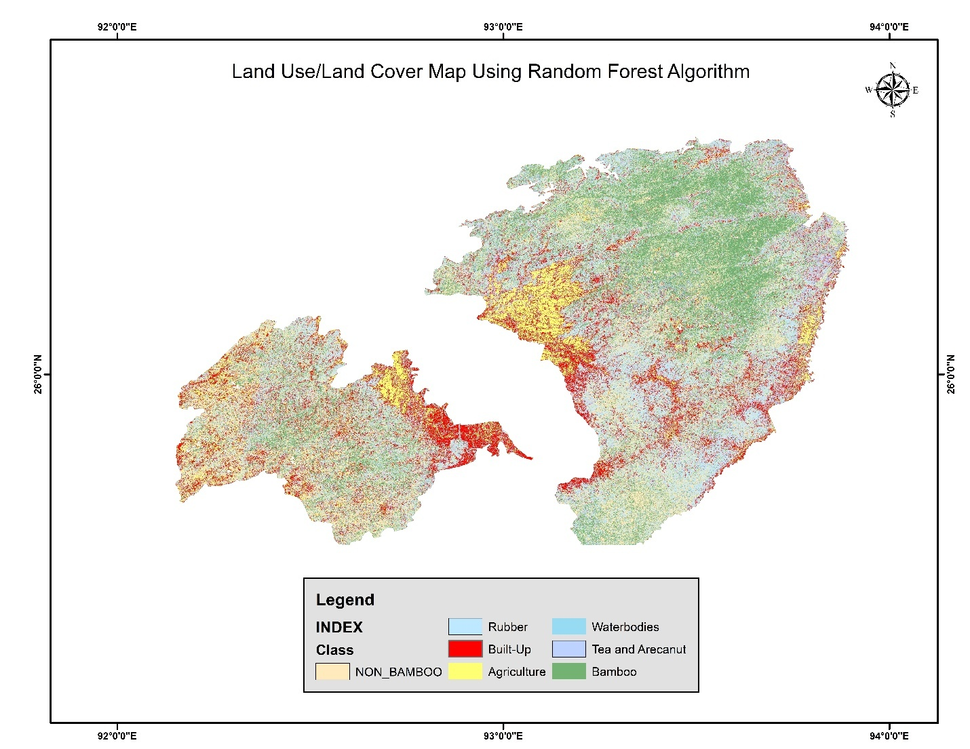
Figure 4. Land Use/Land Cover Map Using Random Forest Algorithm
Table 6. Land use and land cover distribution in Karbi Anglong, 2023-2024
Class | Area (ha) | Area (km²) | Percentage (%)
Bamboo | 258,243 | 2,582 | 24.75
Non-Bamboo | 281,438 | 2,814 | 26.97
Rubber | 138940 | 1389 | 13.31
Built-up | 150,561 | 1,505 | 14.42
Water Bodies | 6,790 | 68 | 0.65
Agriculture | 108,095 | 1,081 | 10.36
Tea and Arecanut | 99,361.11 | 993.61 | 9.52
Note. Data generated by the author from classified land-use maps (Sentinel-2 MSI, 2023/24).

Comparative analysis across the three phases (1993, 2014, and 2023/24) shows the near-disappearance of jhum cultivation, stabilization of bamboo plantations, and steady expansion of built-up land (Figure 5). The diversification into rubber, tea, and arecanut underscores household adaptation strategies in the post-industrial context, reducing reliance on bamboo alone while reshaping the district into a multi-crop, market-oriented landscape.

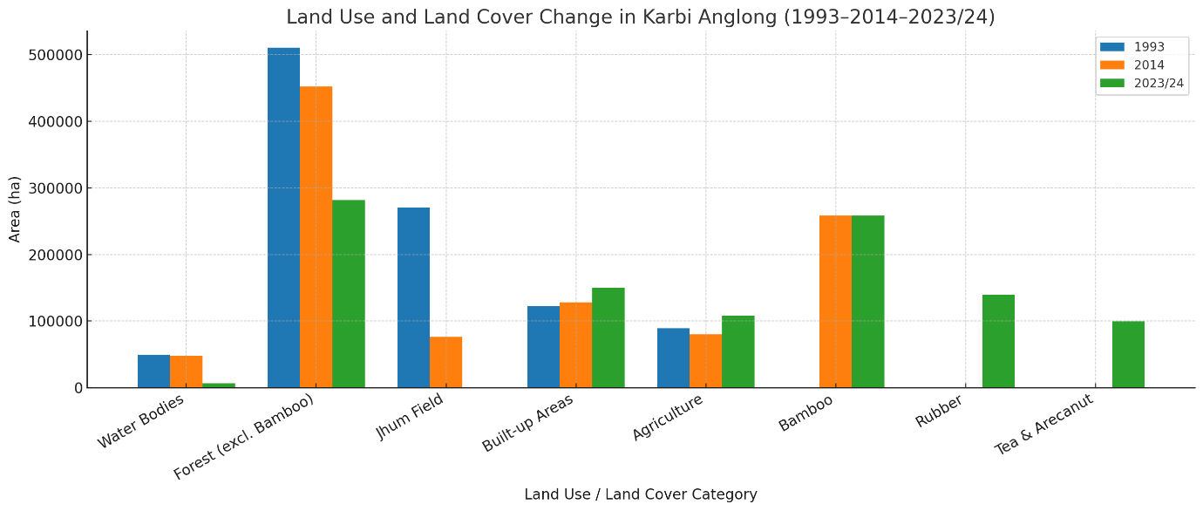
Figure 5. Comparative land use and land cover in Karbi Anglong, 1993, 2014, and 2023/24.
3.4 SYNTHESIS: A THREE-PHASE TRAJECTORY
The analysis reveals a clear trajectory of land use transition in Karbi Anglong:
- Phase I (1993): natural bamboo abundance within forest–jhum systems;
- Phase II (2014): plantation expansion under industrial demand, with bamboo emerging as a dominant land-use class;
- Phase III (2023/24): post-mill diversification, with bamboo stabilizing but increasingly complemented by rubber, tea, and arecanut plantations.
These transitions (Figure 5) demonstrate that while bamboo remains ecologically and culturally significant, its economic role has weakened, creating vulnerabilities but also opening pathways for livelihood diversification.
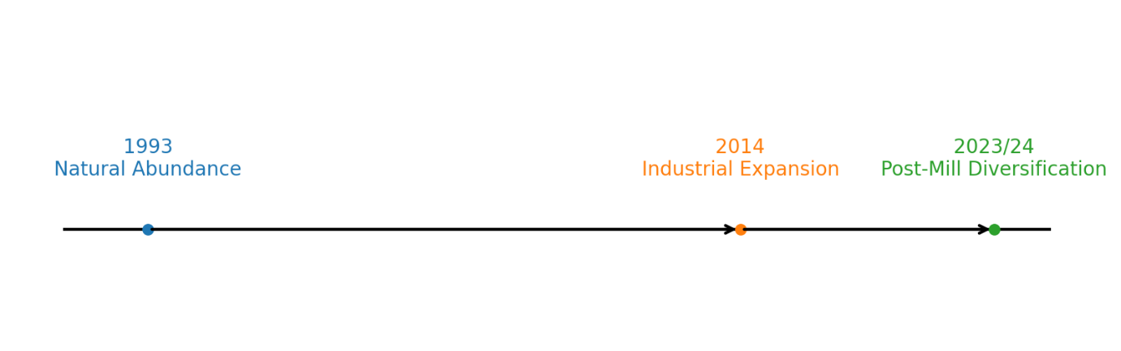
Figure 6. Conceptual timeline of bamboo utilization transitions in Karbi Anglong (1993–2023/24).
4. DISCUSSION
4.1 LAND USE TRANSITIONS AND SHIFTING CULTIVATION DECLINE
The findings demonstrate a clear transition from a forest–jhum dominated landscape in 1993 to plantation-based and diversified systems in 2014 and 2023/24. The near disappearance of shifting cultivation reflects broader regional trends across Northeast India, where state policies, industrial demand, and demographic pressures have contributed to the decline of jhum (Ramakrishnan, 1992; Mertz et al., 2009). In Karbi Anglong, bamboo plantations replaced much of the shifting cultivation area, a trajectory also reported in Mizoram and Nagaland, where subsidies and market incentives promoted permanent plantations over rotational agriculture (Deb et al., 2013). While such transitions enhanced land tenure security and market integration, they also eroded traditional knowledge and ecological resilience associated with jhum systems.
4.2 BAMBOO EXPANSION AND INDUSTRIAL DEPENDENCE
The plantation boom that shows from LULC in 2014 highlights how industrial demand, particularly from the Jagiroad Paper Mill, reshaped land-use systems. Similar dynamics have been observed in other parts of Asia, where paper and pulp industries drove bamboo expansion at the expense of mixed forests (Lou et al., 2015; Nath et al., 2015). In Karbi Anglong, this industrial dependence generated short-term livelihood gains but created structural vulnerability after the mill’s closure in 2017. The stabilization of bamboo around 25% of the district in 2023/24, despite declining industrial demand, suggests resilience at the household and cultural level, but weakened economic viability at the regional scale. This echoes findings from China and Vietnam, where bamboo remains socially embedded but its market role fluctuates with industrial cycles (Belcher, 1999; Fu, 2001).
4.3 POST-MILL DIVERSIFICATION AND LIVELIHOOD STRATEGIES
The post-mill diversification into rubber, tea, and arecanut reflects adaptive strategies to reduce dependence on a single commodity. Such livelihood diversification is consistent with broader agrarian transitions in South and Southeast Asia, where households increasingly adopt plantation crops in response to market opportunities (Hall, 2011). However, the ecological costs are significant, rubber and tea plantations, like bamboo monocultures, simplify landscapes and reduce biodiversity (Fox et al., 2009). Built-up expansion, which reached 14.4% by 2023/24, adds further pressure by fragmenting habitats and altering hydrological regimes. The Karbi Anglong case thus illustrates both the opportunities of livelihood diversification and the risks of ecological homogenization.
4.4 POLICY AND SUSTAINABILITY IMPLICATIONS
The three-phase trajectory underscores the need for integrated land-use policies in ecotonal districts like Karbi Anglong. First, conservation of remaining forests is critical, as continuous decline threatens biodiversity and ecosystem services. Second, bamboo management must move beyond industrial supply toward community-based, diversified value chains (e.g., furniture, handicrafts, bamboo-based housing), which can enhance economic resilience. Third, diversification into multiple crops should be guided by land-use planning that balances income opportunities with ecological integrity. These lessons resonate with global debates on sustainable transitions in resource-dependent regions, where balancing economic, social, and ecological goals remains a central challenge (Meyfroidt, 2016; Gómez-Limón & López, 2020).
5. CONCLUSION
This study traced three decades of land use and land cover (LULC) transition in Karbi Anglong, Northeast India, highlighting the evolving role of bamboo in shaping both ecological and livelihood systems. Using multi-temporal satellite data (1993, 2014, 2023/24), validated classification, and transition matrix analysis, the results reveal a three-phase trajectory: (i) 1993 – natural abundance, when bamboo was embedded in forest–jhum mosaics and supported subsistence alongside emerging industrial demand; (ii) 2014 – plantation expansion, driven by the Jagiroad Paper Mill and subsidy programs, where bamboo emerged as a major land cover class at the expense of forests and shifting cultivation; and (iii) 2023/24 – post-mill diversification, marked by stabilization of bamboo (25% of district area) but diversification into rubber, tea, and arecanut plantations, alongside continued built-up growth.
These transitions underscore the dual nature of bamboo, resilient as a cultural and ecological resource, yet vulnerable as an economic commodity tied to industrial cycles. The decline of jhum cultivation reflects broader agrarian shifts in Northeast India, while the post-industrial diversification demonstrates household adaptation strategies but raises ecological concerns about plantation-driven landscape simplification and forest loss.
The findings highlight three policy priorities. First, protecting residual forests to safeguard biodiversity and ecosystem services. Second, revitalizing bamboo-based value chains beyond industrial pulp, focusing on housing, furniture, handicrafts, and climate-resilient uses. Third, integrated land-use planning to balance livelihood diversification with ecological integrity, ensuring that plantation expansion does not undermine long-term sustainability.
By situating bamboo within a broader trajectory of land-use transitions, this study contributes to understanding how industrial demand, livelihood strategies, and ecological pressures interact in ecotonal landscapes. The Karbi Anglong case offers insights not only for bamboo-dependent regions in India but also for other resource-based landscapes in Asia undergoing similar transitions.

References
Belcher, B. (1999). A production-to-consumption systems approach: Lessons from the bamboo and rattan sectors in Asia. Center for International Forestry Research (CIFOR).
Bystriakova, N., & Kapos, V. (2006). Bamboo biodiversity: Africa, Madagascar and the Americas. UNEP-WCMC/INBAR.
Congalton, R. G. (1991). A review of assessing the accuracy of classifications of remotely sensed data. Remote Sensing of Environment, 37(1), 35–46. https://doi.org/10.1016/0034-4257(91)90048-B
Deb, S., Sundriyal, R. C., & Dasgupta, S. (2013). Shifting cultivation (jhum) in Northeast India: Policy issues and options. International Journal of Agricultural Sustainability, 11(2), 146–158. https://doi.org/10.1080/14735903.2012.738872
Fox, J., Fujita, Y., Ngidang, D., Peluso, N. L., Potter, L., Sakuntaladewi, N., ... & Thomas, D. (2009). Policies, political-economy, and swidden in Southeast Asia. Human Ecology, 37(3), 305–322. https://doi.org/10.1007/s10745-009-9240-7
Fu, M. (2001). Bamboo resources utilization and development in China. Journal of Bamboo and Rattan, 1(2), 153–164. https://doi.org/10.1163/156915901753693247
Gómez-Limón, J. A., & López, M. G. (2020). Building a composite indicator to measure environmental sustainability using alternative weighting methods. Sustainability, 12(11), 4398. https://doi.org/10.3390/su12114398
Hall, D. (2011). Land grabs, land control, and Southeast Asian crop booms. Journal of Peasant Studies, 38(4), 837–857. https://doi.org/10.1080/03066150.2011.607706
Lambin, E. F., & Meyfroidt, P. (2010). Land use transitions: Socio-ecological feedback versus socio-economic change. Land Use Policy, 27(2), 108–118. https://doi.org/10.1016/j.landusepol.2009.09.003
Lou, Y., Li, Y., & Fu, Q. (2015). Bamboo resources and utilization in China. In W. Liese & M. Köhl (Eds.), Bamboo: The plant and its uses (pp. 27–39). Springer. https://doi.org/10.1007/978-3-642-53927-8_2
Mertz, O., Padoch, C., Fox, J., Cramb, R. A., Leisz, S., Lam, N. T., & Vien, T. D. (2009). Swidden change in Southeast Asia: Understanding causes and consequences. Human Ecology, 37(3), 259–264. https://doi.org/10.1007/s10745-009-9245-2
Meyfroidt, P. (2016). Approaches and terminology for causal analysis in land systems science. Journal of Land Use Science, 11(5), 501–522. https://doi.org/10.1080/1747423X.2015.1117530
Nath, A. J., & Das, A. K. (2011). Carbon storage and sequestration in bamboos of Northeast India. International Journal of Ecology and Environmental Sciences, 37(2), 117–122.
Nath, A. J., Lal, R., & Das, A. K. (2015). Managing woody bamboos for carbon farming and carbon trading. Global Ecology and Conservation, 3, 654–663. https://doi.org/10.1016/j.gecco.2015.03.002
Ramakrishnan, P. S. (1992). Shifting agriculture and sustainable development: An interdisciplinary study from North-Eastern India. UNESCO-MAB, Paris and Parthenon Publishing Group, UK.

