Condition of Housing Infrastructure and Its Impact on Sustainable Urban Development: Assessing Progress Toward SDG 11 in Sokoto Metropolis, Nigeria

Abstract
The functionality of infrastructure is determined by its condition, adequacy, and efficiency, all of which contribute to its sustainability. This study examines basic housing infrastructure in Sokoto Metropolis, focusing on the condition of access roads, water supply, waste disposal, fire rescue services, drainage, and street lighting. These components are essential to urban sustainability, aligning with Sustainable Development Goal (SDG) 11, which promotes inclusive, safe, resilient, and sustainable cities. In rapidly urbanizing areas like Sokoto, infrastructure often lags behind urban growth, intensifying the challenges related to urban sustainability. To assess these issues, the study employed both primary and secondary data. Primary data was gathered through structured questionnaires administered to heads of households, while secondary data was obtained from the Sokoto State Primary Health Care Development Agency. A multistage stratified sampling method ensured representative coverage across three zones: the Historical Urban Core, Government Reservation Area, and Sub-Urban Areas. From a total of 264,031 households, 382 respondents were selected using the Krejcie and Morgan (1970) sample size table (as 13 questionnaires were invalid). Neighborhoods and respondents were randomly chosen. Data analysis involved descriptive statistics and the use of the Relative Importance Index (RII) to rank infrastructure needs. The study found that the condition of infrastructure in Sokoto Metropolis is generally poor, with waste management emerging as the most urgent issue. This reflects broader infrastructure gaps likely caused by insufficient facilities, weak policy enforcement, and rapid urbanization. The study recommends that the Sokoto State Government align its housing infrastructure planning and budgeting with the UN 2030 Development Agenda to address these challenges effectively.
Keywords: Housing, Infrastructure, development, Sustainability.

Introduction
Infrastructure directly or indirectly influences all 17 of the Sustainable Development Goals (SDGs), providing essential services that include water, waste management, transport, energy, and telecommunications. It underpins urban functionality and development by facilitating access to resources, enhancing mobility, enabling service delivery, and fostering economic growth. Infrastructure thus plays a critical role in shaping the built environment and has far-reaching implications for environmental quality, service provision, and socio-economic inclusion.
Among the core dimensions of urban infrastructure is housing infrastructure, which is central to the sustainability, safety, and livability of cities. The availability and functionality of housing infrastructure determine the degree to which the built environment supports inclusive and resilient communities. Its condition significantly influences not only daily living standards but also public health, environmental sustainability, and social cohesion. As Asikhia & Uyoyoghene, (2011) argue, one of the most visible and measurable indicators of urban development is the state of its infrastructure.
The functionality of infrastructure depends on its condition, adequacy, and efficiency, which collectively define its sustainability. This study focuses on basic housing infrastructure, which includes access roads, water supply, waste disposal systems, fire rescue services, drainage, and street lighting. These infrastructures are physically integrated into the built environment and directly tied to urban sustainability outcomes, particularly in the context of SDG 11, which emphasizes making cities inclusive, safe, resilient, and sustainable.
In fast-urbanizing cities like Sokoto Metropolis, where urban growth often outpaces infrastructure development, the impact of housing infrastructure on urban sustainability is particularly pronounced. The challenges of inadequate or poorly maintained infrastructure, ranging from open drains and illegal waste dumps to erratic water supply and electricity shortages, can severely hinder urban resilience. Despite international commitments to the Sustainable Development Goals (SDG 11), many African cities continue to experience severe infrastructure inequality, particularly in the housing sector (Sietchping & Omwamba, 2020). Reconnaissance survey in the study area depicts challenges to achieving inclusive, sustainable urban development. It is against this background that this study attempts to investigate the condition of some housing infrastructure and evaluate its impact on sustainable urban development in the study area.
Literature Review
Urban sustainability is broadly defined as the ability of cities to maintain environmental, social, and economic health over time. It is closely tied to the quality of housing infrastructure. This review examines the relationship between housing infrastructure and urban sustainability, with a focus on three key domains: environmental impact, service provision, and socio-economic inclusion.
Sustainable urban housing relies heavily on the availability of essential services such as clean water supply, reliable electricity, adequate sanitation, and accessible transportation networks. Without these services, housing cannot meet the basic standards of habitability, safety, or dignity. Numerous studies have highlighted the persistent deficits in these critical services across Nigerian cities, particularly within low-income neighborhoods and peri-urban settlements (Ademiluyi & Raji, 2008). Adam et. al., (2024) report that the inadequate provision of urban infrastructure in southeastern Nigeria has led to deteriorating living conditions, increased health risks, and limited access to economic opportunities. Adeyanju, (2025) further observes that the disparity in service provision between formal and informal settlements contributes to deepening social inequalities and undermines efforts toward inclusive urban development. According to UN-Habitat (2006), such service deficits are a major barrier to achieving SDG 11, which aims to make cities inclusive, safe, resilient, and sustainable. According to Emmanuel (2024), urban challenges in Sokoto metropolis are exacerbated by weak urban governance, poor investment in public infrastructure, and uncoordinated spatial planning, as reflected in similar studies on northern Nigeria’s urban centres.
Poor housing infrastructure is a key driver of unplanned urban sprawl, often leading to environmental degradation, insufficient drainage systems, and inefficient energy usage. This assertion is consistent with the findings from several Nigerian urban studies (Bhattarai & Conway, 2020 and Ebraheem et. al., 2024). However, UN-Habitat (2006) emphasizes that without proper urban design and regulated housing development, cities often face cumulative environmental and social risks. These issues are further intensified by rapid population growth, limited enforcement of urban planning policies, and inadequate investment in infrastructure, as observed in related assessments of northern Nigerian cities (Emmanuel, 2024). Similarly, Sulayman & Christianah, (2021) note that the absence of integrated planning in housing delivery contributes to the proliferation of informal settlements that lack basic infrastructure, exacerbating the vulnerability of residents to environmental hazards. These studies collectively underscore the critical need for coordinated urban housing strategies that prioritize sustainability, resilience, and environmental stewardship.
The quality and availability of housing infrastructure play a crucial role in promoting social equity and fostering economic inclusion. Abubakar (2020) identified growing housing deficit driven by rapid urban migration, high population growth, and insufficient public investment as factors that resulted in the proliferation of overcrowded dwellings and informal settlements in the Sokoto metropolis. These informal areas typically lack basic infrastructure and legal recognition, leaving residents excluded from essential public services, formal land tenure systems, and institutional support. This scenario reflects a broader pattern observed across many Nigerian cities, where informal housing continues to expand due to the inability of formal housing systems to meet demand (Ajanlekoko, 2001; Alcorn, & Karner, 2021). Scholars have argued that the absence of secure tenure and infrastructure not only entrenches poverty but also perpetuates spatial and social inequality (Akponzele & Dinye, 2025).
Existing literature confirms that the quality of housing infrastructure is central to achieving urban sustainability. Environmental risks, infrastructural deficiencies, and social inequalities linked to poor housing all threaten long-term urban resilience. It also exposed disparity in service provision between formal and informal settlements and the absence of integrated planning.

Materials and Methods
The study area
Sokoto Metropolis lies between latitudes 12°46′N and 13°08′N and longitudes 5°14′E and 5°30′E, with an average elevation of 272 meters above sea level. Based on a massive influx of people into Sokoto, its population as of the year 2020 rose to 641,249, and the projected figure for the year 2035 indicates that Sokoto metropolis will have a population of 1,082,496 (United Nations, Department of Economic and Social Affairs, Population Division [UNDESA, 2020]). The population is predominantly Hausa-Fulani, alongside other ethnic groups such as Gobirawa, Zabarmawa, Kabawa, Adarawa, Nupes, Yorubas, and Igbos (Mamman, 1989). Hausa is the main language spoken, and residents are engaged primarily in trade, livestock rearing, and employment in both public and private sectors. Geographically, the metropolis spans Sokoto North and South Local Government Areas, extending into peripheral zones of Kware, Wamakko, Dange-Shuni, and Bodinga LGAs. The indigenous people adopted nucleated settlement patterns typical of Hausa/Fulani in Northern Nigeria.
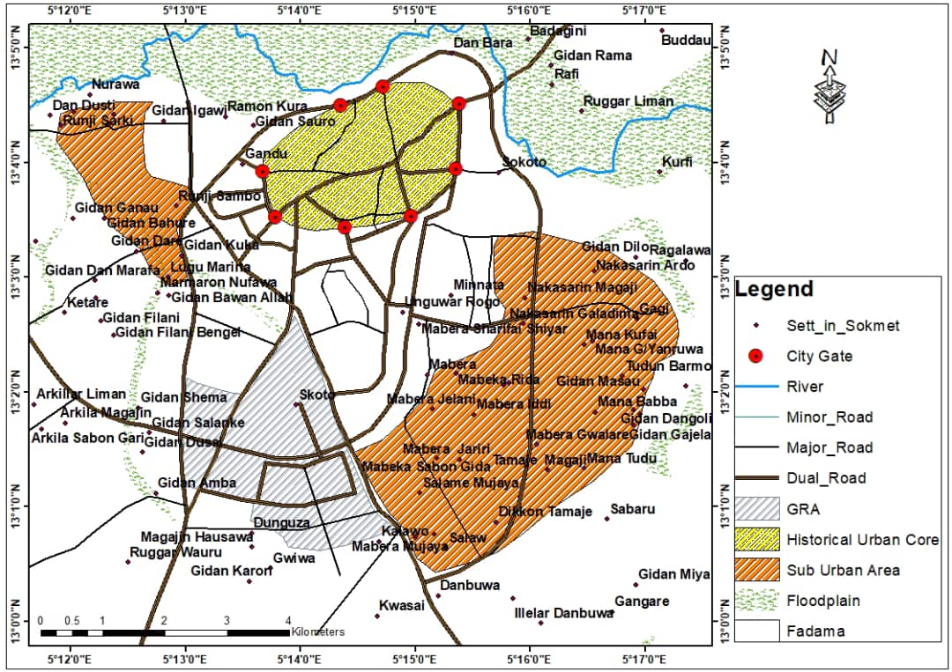
Figure 1 Map showing the Morphology of the Study area
Source: Adapted from Abubakar, 2020

Methodology
Data for this study were collected from both primary and secondary sources. Primary data was obtained through an interview schedule using a questionnaire. Secondary data was obtained from the Sokoto State Primary Health Care Development Agency. A Structured Questionnaire was used to obtained information from sampled heads of households. This study employed a multistage sampling technique involving stratification to ensure representative data collection across the Sokoto Metropolis. Out of a total of 264,031 households, the metropolis was stratified into three zones: Historical Urban Core (145,217 households), Government Reservation Area (26,403 households), and Sub-Urban Areas (92,410 households). Using proportional allocation, 382 respondents were selected 211 from the Historical Urban Core, 38 from the Government Reservation Area, and 133 from the Sub-Urban Areas. Having determined the sampling frame, the Krejcie & Morgan (1970) table was used to determine the sample of respondents. Based on the table, the sample size for this study was 382 respondents. Simple descriptive statistics were used to analyze data. However, the Relative Importance index (RII) was also used to rank infrastructure.
The 2019 SDG index and dashboard, endorsed by the UN Statistical Commission, was adopted to measure the progress. This sampling approach is consistent with those used in African urban housing studies, such as Yaode (2015), which recognize the tripartite structure of African cities comprising the historical inner city, colonial-era GRAs, and rapidly expanding suburban zones. Neighborhoods within each zone were selected through simple random sampling, while individual respondents were identified using a random number generator.
Results and Discussions
Infrastructure such as access roads, drainage, waste management, streetlights, and fire rescue are designed, constructed, and managed to meet present needs without compromising the ability of future generations to meet theirs. The results were presented in graphs, tables, and thus discussed.

Condition of access roads in the neighborhoods
This study investigates the condition of access roads in the neighborhood of Sokoto metropolis. The findings in Table 1 reveal that 1.1% of the respondents rated the condition to be very Good, 30.9% rated the condition as good, 28.7% of the respondents rated the condition to be fair, and 19.2% of the respondents described the condition to be very poor. The implication of the poor access roads would affect virtually all human aspects of life including responses to hospital and fire emergencies, distortion of urban aesthetics, among others. Recently, one interesting observation from the field was that, currently, Sokoto State has embarked on the construction and rehabilitation of roads within the metropolis, as shown in Plate 1.
Table 1: Conditions of Access Roads in the Neighborhoods
Variable | Frequency | Percentage (%)
Very Good  Good  Fair  Poor  Very Poor  Total | 4  114  106  71  74  369 | 1.1  30.9  28.7  19.2  20.1  100
Source: Fieldwork, 2025
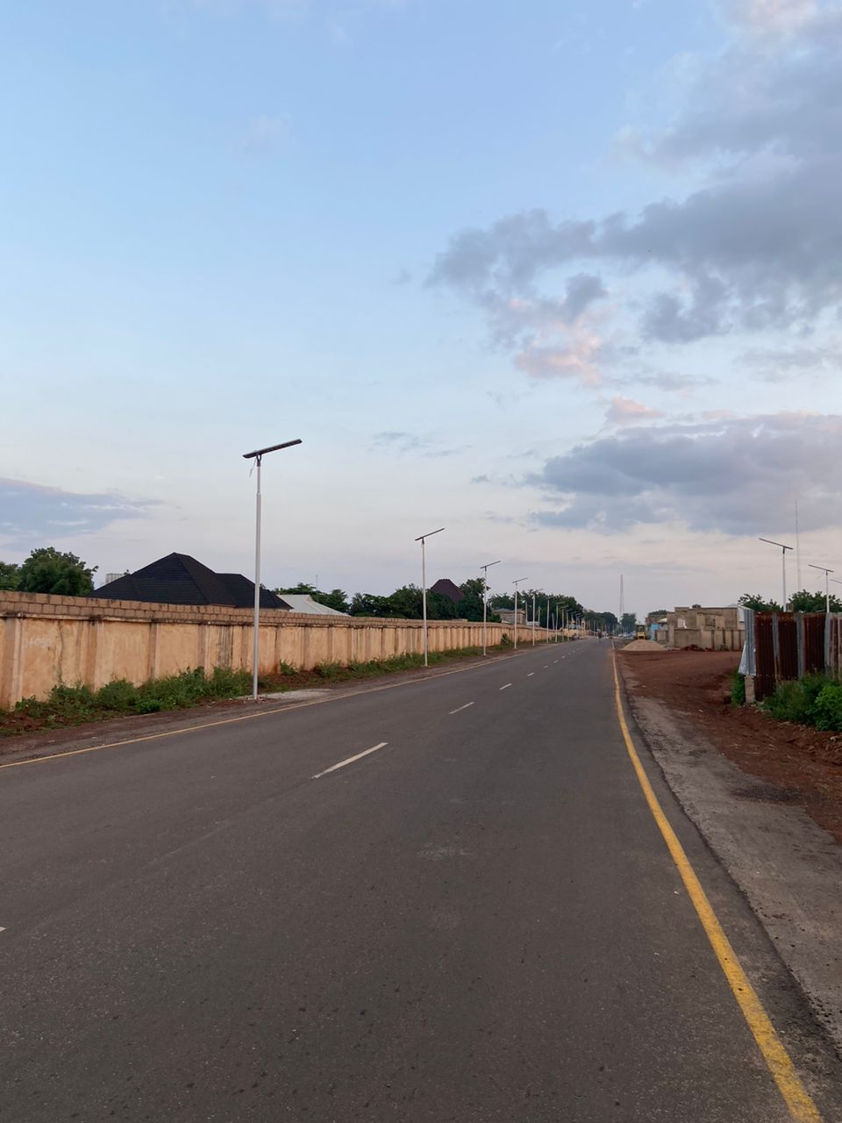
Audu & Badema (2022) in their assessment of population growth on housing demand in Sokoto found out that the study area is growing rapidly; this fast population growth is responsible for the dilapidated condition of some infrastructure. The housing demand in the Sokoto metropolis is on the increase because of population growth. It is forecast that the rent values will continue to rise further in the future.

Plate 1: New Constructed Road at Gwiwa Area (SUA)
It is pertinent to note that the major roads in the study area are in good condition, these include: Kano road, Kalambaina road, Ahmadu Bello way and EmirYahaya road, eastern and western bypass roads. The poor condition of roads is evident within the neighborhoods of SUA and the inner city.

Condition of the drainage in the neighborhoods of the study area
Drainage infrastructure is a pivotal facet within urban settings, influencing habitability and resilience. The result from Table 2 reveals that only 4.1% of drainages are in very good condition, and 21.7% are in good condition, while 33.3% of respondents rated drainages as fair. The result further reveals that 18.2% of respondents rated it poor, while 22.8% described it as very poor. Lack of drainage causes a serious perennial challenge as it causes flooding, which affects properties and livelihoods, as well as causing the spread of waterborne diseases due to stagnation of runoff water. Another implication is on the destruction of the roads because of high water flow due to the absence of drainages, thereby washing away part of the road and resulting in early deterioration.
Table 2: Condition of Drainages in the Neighborhoods
Variable | Frequency | Percentage (%)
Very Good  Good  Fair  Poor  Very Poor  Total | 15  80  123  67  84  369 | 4.1  21.7  33.3  18.2  22.8  100
Source: Fieldwork, 2025
Yanda & Matazu (2017) in their appraisal of the condition of drainages along selected areas and roadways in Sokoto metropolis described the condition of the drainage in the study area to be poor. According to them, apart from the unavailability of a drainage system, the metropolis is faced with a lack of good design, blockages of the existing ones, and disposal of solid waste material in gutters, which result in tremendous environmental challenges. Some places were flooded, making the roads practically impossible for motorists. In many instances, rainfall submerged the access roads, halting vehicular movement.
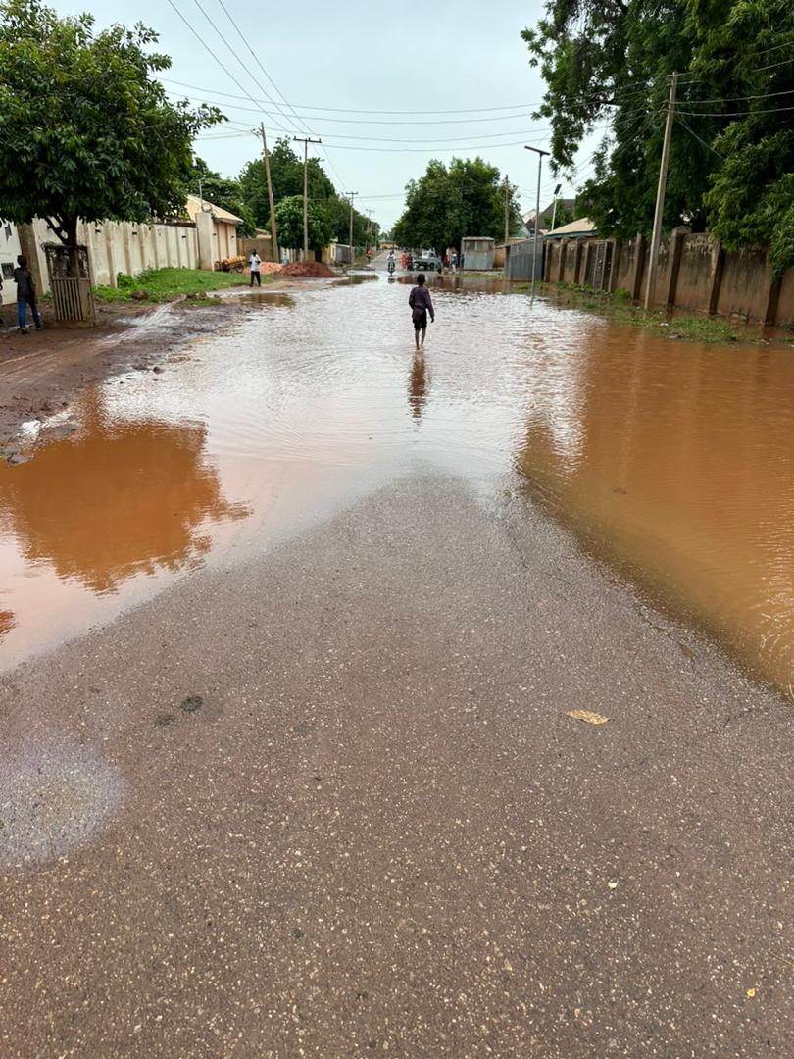

Plate 2: New Constructed Road Flooded at Besse Road (SUA) due to lack of Drainages
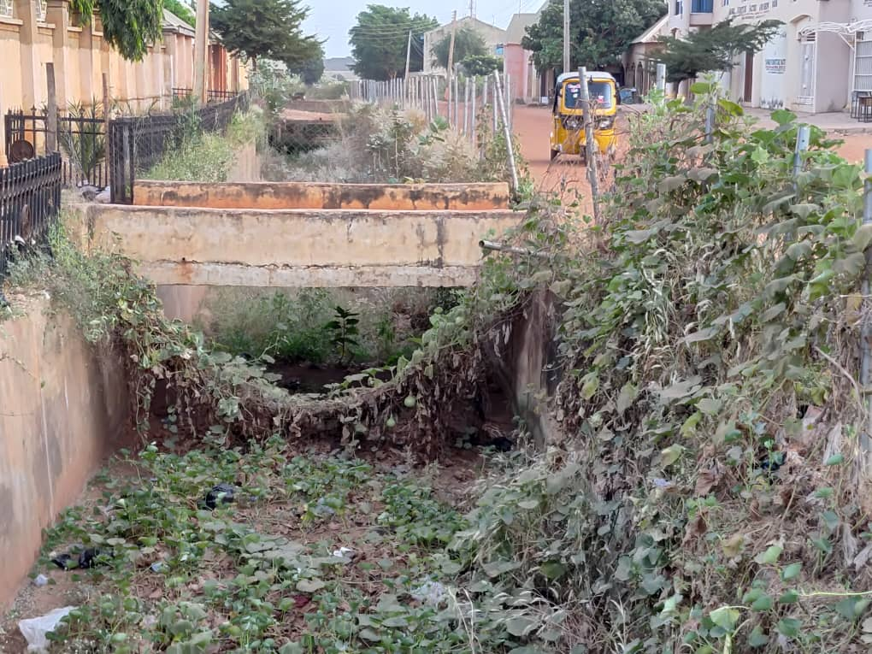
Observation from the field also depicts some improvement in the condition of drainage in the study area as a result of a project by the Nigeria Erosion and Watershed Management Project (NEWMAP) initiated by the Federal Government of Nigeria and funded by the World Bank and International Development Fund (IDB). The project was implemented at Mabera and Tudun Wada area of Sokoto metropolis and has tremendously reduced incidents of flooding and destruction to lives and properties in Mabera and Tudun Wada areas (Plates 3 and 4).

Plate 3: Drainage Project by NEWMAP at Mabera Area
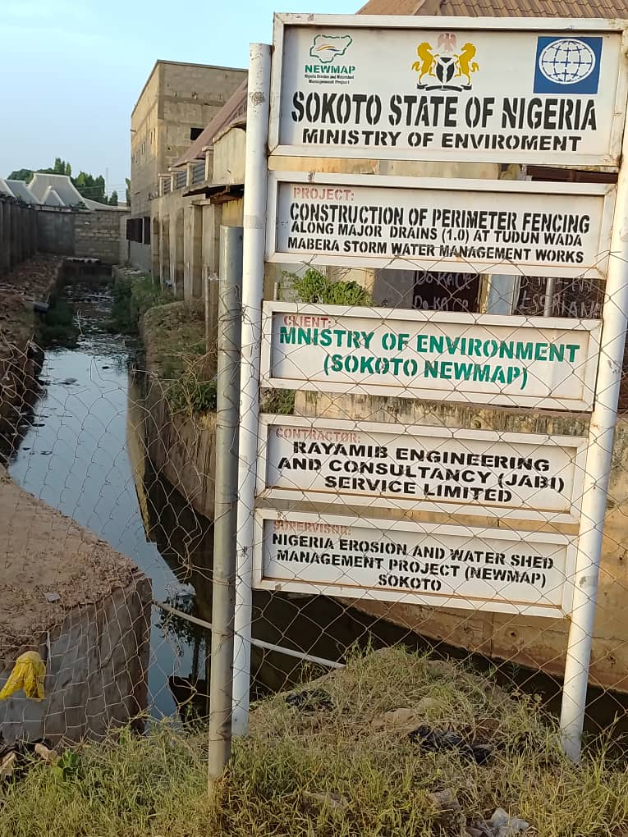

Plate 4: Projects by NEWMAP in the Tudun Wada area

Condition of the water supply in the neighborhoods
The condition of water supply in the neighborhoods was examined on the basis of the quality, availability, and sustainability. The major supply source of water in the study area is from the Sokoto State Water Board (SSWB). The study findings reveal that the water supply in the study area was rated to be very good by 10% of respondents. However, 24% of the respondents rated it to be good, 36% of respondents rated the condition of water supply as fair, while 15% of the respondents rated the condition as poor, and 15% of respondents rated it as very poor.

Table 3 Condition of Water Supply
Variable | Frequency | Percentage (%)
Very Good  Good  Fair  Poor  Very Poor  Total | 39  89  132  55  54  369 | 10  24  36  15  15  100
Source: Fieldwork, 2025
Inferred from the above, one may conclude that the condition of the water supplied could be rated as poor. Rating the condition of water supply in the study area as poor is a recipe for the outbreak of waterborne diseases. The condition of water must be good or very good to be fit for consumption. Anything below the standard is a compromise in the condition of the water (WHO, 2022).

Condition of waste management in the neighborhoods
The condition of waste management in neighborhoods refers to the systems and practices in place for the collection, disposal, and processing of waste generated by residents.

Refuse collection used by households
Refuse collection refers to the process of collecting and disposing of waste or garbage from residential, commercial, and industrial areas. It is an essential public service that helps to maintain cleanliness, prevent the spread of diseases, and protect the environment. Typically, refuse collection is carried out by municipal or local government authorities or private waste management companies. Data in Figure 2 shows that 37% of the respondents affirmed that refuse in their neighborhoods is being collected by government, 15% admit that their refuse is being collected by private waste collection firms, while 21% are disposed within compound and 27% at unauthorized dumpsites.

Figure 2 Refuse Disposal Means Used by Household
Source: Fieldwork, 2025
The study also discovered that there is inconsistent collection of refuse as shown in Figure 2, and this results in overflowing of bins or dumpsters where they exist, and sometimes practically impossible, thereby halting vehicular movement, particularly along Sultan Bello and Ahmad Rufai roads of the inner part of the study area. The resultant effect of this is the poor condition of waste management, as affirmed by Abubakar (2021) in his study of poor waste management in Sokoto metropolis. Also, Ahmed et. al., (2021) contest that the study area is characterized by inefficient collection, insufficient coverage of the collection system, and improper disposal methods. This is well evident as observed by this study and depicted in plate 5.
Table 4 Waste Management
Variable | Frequency | Percentage (%)
Very Good  Good  Fair  Poor  Very Poor  Total | 17  62  52  93  145  369 | 5.0  16.8  14.0  25.2  39.0  100
Source: Fieldwork, 2024
Table 4 shows that waste management in the study area was rated Very Good by 4.6% of the respondents, it was also rated good by 16.8% of the respondents, and 14% of the respondents rated the condition of waste management in the study area as fair. It was rated poor by 25.2% of respondents, 39.0% of respondents described the conditions under which waste is managed in the study as very poor.

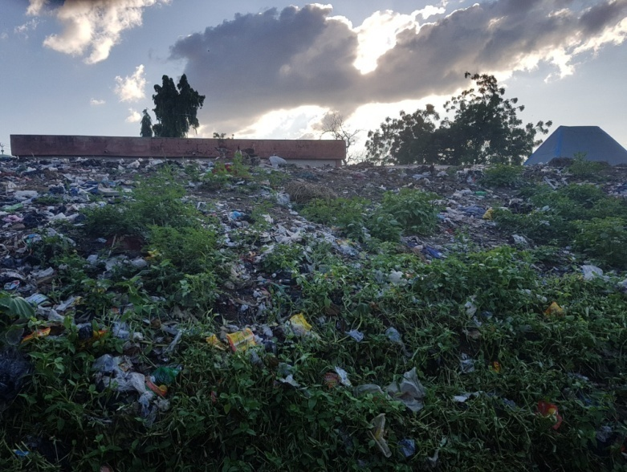

Plate 5 Improper Waste Disposal in Sokoto Metropolis
The study examined the poor environmental condition of sanitation about solid waste generation and disposal and reveals that the unauthorized dumping site in the newly established areas leads to poor conditions of waste management. It is sufficed to say that, the condition of waste management in the study area is very poor, and this can perhaps lead to unhealthy environmental challenges. This has massive implications on human health, sanitation, and environmental sustainability.
Condition of street lighting in the neighborhoods
This study investigates lightning installed along streets and roads to provide illumination for the benefit of pedestrians, cyclists, and motorists. The aim is to enhance visibility, crime deterrence, and traffic safety. Table 4 reveals that 30% of the respondents rated the condition of streetlight as very good, 20.1% as good, 25.7% as fair, and 24.2% as poor. Inferred from the study findings, which indicate availability of streetlights in the study area, the condition of streetlights in the neighborhood of the study area could be regarded as good. This could be as a result of efforts made by the Sokoto state government and the Federal government of Nigeria through the National Rural Electrification Agency. Similarly, the Sokoto state government has been investing in the provision of streetlights in the metropolis. In the year 2022, the state government spent ₦ 1,065,845,375 and ₦ 1,950,000,000 in the year 2023 and also ₦ 1,950,000,000 in the year 2024 on streetlights (Dataset Sokoto State, 2024). This has improved the availability and condition of streetlights in the study area.
Table 5 Condition of Streetlights
Variable | Frequency | Percentage (%)
Very Good  Good  Fair  Poor  Very Poor  Total | 15  62  123  74  94  369 | 30.0  20.1  25.7  20.1  4.1  100
Source: Fieldwork, 2025
However, Tosin et. al. (2020) described that the streetlights in the study area are being faced with challenges of theft of batteries and high temperature, which makes equipment maintenance difficulty, thereby undermining sustainability. Nonetheless, this position has been improved through the innovation of Light Emitting Diode (LED) solar-powered streetlights with inbuilt batteries.

Condition of fire rescue services
Fire rescue services are services put in place to prevent and mitigate fire incidents to save lives and prevent damage to critical infrastructure. Table 6 .6 shows that 3.3% of respondents rated fire rescue services in their neighborhoods as very good, 7.3% as good, 24.1% as fair, 14.1% as poor, while 51.2% of respondents rated the condition of fire rescue services as very poor.
Table 6 Condition of Fire Rescue Services
Variable | Frequency | Percentage (%)
Very Good  Good  Fair  Poor  Very Poor  Total | 12  27  89  52  189  369 | 3.3  7.3  24.1  14.1  51.2  100
Source: Fieldwork, 2024

Relative Importance Index (RII) of Housing Infrastructure
To determine the significant impact of infrastructure on the physical settings of the built environment, Relative Importance Index (RII) was used to rank the basic housing infrastructure, which includes: water supply, waste management, fire rescue services, drainages, and street lighting in order to discover the most critical issues facing housing infrastructure in the study area. Thus, a rating scale was employed. The rating was conducted from very good, good, fair, and poor to very poor.
Table 7 Relative Importance Index of housing infrastructure
 | (5) | (4) | (3) | (2) | (1) | Total  Weighted  Score | Total  (N) | A*N | Mean | Ranking
 | VG | G | F | P | VP
Access Road | 04 | 114 | 106 | 71 | 74 | 1010 | 369 | 1845 | 0.5474 | 5th
Drainage | 15 | 80 | 123 | 67 | 84 | 982 | 369 | 1845 | 0.5322 | 4th
Water supply | 39 | 89 | 132 | 55 | 54 | 1111 | 369 | 1845 | 0.6021 | 3rd
Waste Management | 17 | 62 | 112 | 93 | 85 | 940 | 369 | 1845 | 0.5094 | 1st
Streetlights | 15 | 62 | 123 | 74 | 94 | 934 | 369 | 1845 | 0.5062 | 6th
Fire rescue service | 12 | 27 | 89 | 52 | 189 | 728 | 369 | 1845 | 0.3945 | 2nd
Source: Fieldwork, 2024
The Relative Importance Index found that waste management is the first and most critical infrastructure requiring attention based on the responses of the respondents. It is followed by fire rescue services, which ranked second, while water supply in the study area was ranked third. The fourth critical issue is the condition of drainage, while access road ranked fifth and streetlights ranked sixth. According to this study, the biggest problem is waste management. This can be due to inadequate infrastructure (including recycling facilities) as observed by this study, policy and regulatory issues due to lack of enforcement, and rapid urbanization and population growth without policy reforms. This problem is followed by fire rescue services. The third in the ranking is water supply in the study area. The fourth in the ranking is drainage, which this study depicts as a relative availability, while access roads and streetlights were ranked fifth and sixth, respectively. Based on the aforementioned analysis, most infrastructure examined is not in good shape and requires either provision or maintenance.
Conclusion
This study concludes that the state of infrastructure in the study area is generally poor, with waste management identified as the most critical issue requiring urgent attention. This study also reflects infrastructure gaps which will affect sustainable urban development in the study area.
Recommendations
- In the provision of housing infrastructure, Sokoto state government should be guided by UN development agenda (2030) in the annual budget proposal and its implementation.
- The condition of waste management in the study area is very poor, government should provide a means of waste recycling so as to reduce indiscriminate waste disposal.
- Ensure that infrastructure projects consider population growth and urbanization trends.
- Government should prioritize the provision and maintenance of essential services such as fire rescue, water supply, drainage, access roads, and street lighting through coordinated government and community efforts.
- Public Private Partnerships can help bridge funding gaps and bring innovation to infrastructure delivery and maintenance.

COMPETING INTERESTS DISCLAIMER:
Authors have declared that they have no known competing financial interests OR non-financial interests OR personal relationships that could have appeared to influence the work reported in this paper.

References
Abubakar R. (2020). Spatio-Temporal and Demographic Analysis of Slums in Sokoto Metropolis (1994-2019), An unpublished MSc. Dissertation, Department of Geography, UsmanuDanfodiyo University, Sokoto.
Abubakar, R. (2021). Socio economic status of slums dwellers in Sokoto metropolis, Nigeria.Sokoto journal of Geography and the Environment 3(1), 19-32.
Adam, o. B., Enemi, a. G., & Zakari, m. (2024). Implication of rural urban migration on public amenities in FCT, Abuja Nigeria. Unizik journal of Educational Research and Policy Studies, 18(3).
Ademiluyi, I. A. (2010). Public housing delivery strategies in Nigeria: A historical perspective of policies and programmes. Journal of sustainable development in Africa, 12(6), 153-161.
Adeyanju, O. I., Akpotu, E., Efeni, O. S., & Obomejero, J. (2025). Green Building Strategies for Climate Resilience in Flood-Prone Areas in Nigeria: A Review. African Research Reports, 1(3), 74-84.
Ahmed, A., Eniolorunda, N. B, Yakubu, F, M, & Samuel, I. (2021) Waste Management and Control Problems in Sokoto Metropolis: Projected Mitigation on the Syndrome Athens Journal of Sciences, 8: 1-20 https://doi.org/10.30958/ajs.X-Y-Z 1
Ajanlekoko, K.S. (2001). Sustainable housing development in Nigeria - The financial and infrastructural implication. Paper Presented at the International Conference on Spatial Information for Sustainable Development in Nairobi, Kenya, 2–5 October 2001. [Online]. Available at: http://cepnigeria. com [Accessed on 13 November, 2022].
Akponzele, R., & Dinye, R. D. (2025). Urbanization without Belonging: Land Tenure Insecurity among Migrants in Ghana. Asian Journal of Education and Social Studies, 51(7), 948-966.
Alcorn, L. G., & Karner, A. (2021). Integrating formal and informal transit into one hybrid passenger transport system in Lagos, Nigeria. Transportation, 48(3), 1361-1377.
Asikhia, M. O., & Uyoyoghene, O. T. (2011). Urban infrastructure and quality of life: A case study of Warri Metropolis. The Nigerian Journal of Research and Production 19 (2), November.
Audu, I. A., & Badema, A. (2022). Assessment of Population Growth on Housing Demand in Sokoto Metropolis. Journal homepage: www. ijrpr. com ISSN, 2582, 7421.
Bhattarai, K., & Conway, D. (2020). Urban growth. In Contemporary environmental problems in Nepal: Geographic perspectives (pp. 201-334). Cham: Springer International Publishing.
Dataset, Sokoto State Government Annual Report, 2024.
Ebraheem, A. K., Almosawi, F. M., & Alkinani, A. S. (2024). The Impact of Unregulated Urban Sprawl on Public Services and Quality of Life in Baghdad: A Case Study of Al-Dora District Using Spatial Analysis. International Journal of Sustainable Development & Planning, 19(12).
Emmanuel, A. (2024). Presidential and parliamentary government system on individual insecurity divinity in Nigeria.
Krejcie, R.V., & Morgan, D.W., (1970). Determining Sample Size for Research Activities.
Sietchiping, R., & Omwamba, J. (2020). The future of urban policy in Africa. Localization of SDG 11 and the new urban agenda. In Local governance in the new urban agenda (pp. 275-291). Cham: Springer International Publishing.
Sulyman, A. O., & Christianah, O. A. (2021). Assessing Informal Settlements in Selected Cities in Nigeria’s North-Central Region. ARUA CoE Urbanization and Habitable Cities, and Centre for Housing and Sustainable Development (CHSD) University of Lagos Akoka, Lagos Nigeria.
Tosin, F. B., Odunfa, V. O., Ibisola, A. S., & Ibuoye, A. A. (2021). Basic residential neighborhood infrastructure financing in Nigeria urban cities: Community development associations (CDAs)-based approach. Journal of Infrastructure, Policy and Development, 5(1), 1242.
UN-HABITAT (2006), National experiences with shelter delivery for the poorest groups. UN Habitat, Nairobi.
United Nations, Department of Economic and Social Affairs, Population Division ([UNDESA], 2020). World Population Prospects, New York.
World Health Organization. (2022). Guidelines for drinking-water quality: incorporating the first and second addenda. World Health Organization.
Yanda, M., & Matazu, M. A. (2017). An appraisal of drainage conditions along selected areas and roadways in Sokoto metropolis. Journal of engineering, entrepreneurship & environmental studies, 1.
Yoade A. O. (2015), Physical characteristics of core area of Ife-Ile, Nigeria, Analele Universitatii din Oradea, Seria Geografie 25(2): 137-147.

