Original Research Article
Concentration of acrylamide in selected foods vended in informal settlements of Nairobi City County

ABSTRACT
Aims: To determine the concentration of acrylamide (AA) in selected foods vended in informal settlements of Nairobi City County
Study design: Analytical cross-sectional
Place and Duration of Study: Kibera Informal settlements, Nairobi City County, Kenya, May 2021.
Methodology: Sample: A total of 162 food samples were collected. They included potato chips (25 samples), crisps (22), bhajia (20), chapatti (27), mandazi (24), samosa (25) and coffee (19) samples. Sampling techniques: County sampled purposively. Villages sampled randomly while the samples were collected using convenience sampling. Data collection tools: food samples were collected in the vendors’ original packaging material. Samples analysis: High Performance Liquid Chromatography-Ultraviolet (LC-UV) laboratory procedure was used. One-way ANOVA was used to test for differences in mean AA concentration in different food groups. Tukey-Kramer post hoc test was used to identify specific differences between AA means.

Results: The highest AA level was found in crisps (246.9µg/kg) and the least.in mandazi (44.1µg/kg). Coffee had the highest average AA (130.28µg/kg). Mandazi had both the least (44.1µg/kg) AA amount and the least (69.47µg/kg) AA average. None of the samples of chips, crisps, bhajia and coffee exceeded the Benchmark levels. All the samples of chapatti and Samosa exceeded the Benchmark levels. Mandazi had 95.8% of its samples exceeding the Benchmark level. There was a statistically significant difference (p = .001) between AA means. AA content was statistically significantly higher in coffee as compared to other food samples. AA content was statistically higher (p =.04) in crisps as compared to mandazi. There was no statistically significant difference between the means of the rest of the groups

Conclusion: AA was detected in all food samples analyzed. All the samples of chapatti and Samosa, and most of the samples of Mandazi exceeded the Benchmark levels. Therefore, the food vendors should put in place AA mitigation measures to minimize AA formation in food and to adhere to the set Benchmark levels for AA in food.
Keywords: Acrylamide, Acrylamide level, concentration, Maillard reaction, Vendors, food samples, Benchmark levels, mitigation

- INTRODUCTION

Acrylamide (AA) is a colorless, odorless compound and has been classified as causing gene toxicity and a Group 2A carcinogen (EFSA, 2015; IARC, 1994; Ubaoji & Orji, 2016). The health issues related to AA contribute largely to the disease burden in the world (WHO, 2020). Dietary AA is the main source of AA exposure in humans (Adani et al., 2020). It occurs when people consume food that has high content of carbohydrates and asparagine and heated to high temperatures above 120ºc during cooking. AA forms naturally when there is a reaction between reducing sugars and amino acid asparagine. This chemical process is called the Maillard reaction and it contributes to favourable changes in color, aroma and flavor in food as well as the undesirable change of forming AA (Hamzalıoglu et al., 2019; EFSA, 2015; Murkovic, 2019). Asparagine is present in high levels in potatoes while grains and coffee contain it in lesser amounts (EFSA, 2015; FDA, 2017; Hamzalıoglu et al., 2019). The conversion rate of asparagine to AA is highly affected by reducing sugars. Wheat is rich in reducing sugars (Hamzalıoglu et al., 2019). Food processing conditions such as the length of time and temperature applied as well as the final moisture content greatly influences AA formation. In cooking temperatures between 150-170ºc, there is moderate increase in AA formation. Increase in frying temperatures especially above 175ºc in chips results in linear increase in AA formation. Also, increasing frying time at the same cooking temperature also increases AA (Hamzalıoglu et al., 2019).
The topmost sources of dietary AA include potato products like potato crisps and chips; cereal grain products for instance wheat bread, and; roasted coffee (Elias et al., 2017; Esposito et al., 2017; Hamzalıoglu et al., 2019; Mojska & Gielecinska, 2013). Chips, crisps and wheat breads are major foods consumed throughout the world especially among young people (EFSA, 2015; WHO, 2020). These foods, heated to high temperatures during cooking, are therefore the basis for this research.
The benchmark levels for AA in chips and potato crisps are 500µg/kg and 750µg/kg, respectively (EC, 2017/2158/EU). However, they can contain above 1000 ppb (1000 µg/kg) of AA (Khan et al., 2018; Ubaoji & Orji, 2016). In some instances, breads such as crisp bread can contain up to 674µg/kg (EFSA, 2015). Soft wheat breads contain up to 126 µg/kg of AA with a benchmark level of 50µg/kg whereas other wheat products can contain up to 400µg/kg with a benchmark level of 300µg/kg (EC, 2017/2158/EU). Other soft grain breads can contain up to 200µg/kg with a benchmark level of 100µg/kg (EFSA, 2015; EC, 2017/2158/EU). Abong’ et al. (2021a) found AA concentration of 354.18µg/kg in street chips in Nairobi which was lower than the benchmark level (500µg/kg) for chips. Abong’ et al. (2020) found mean AA content of 5428µg/kg in non-branded crisps which is seven times higher than the benchmark level of 750µg/kg for crisps.
AA presence in food was demonstrated in the year 2002 and it was found to be in significant amounts in commonly consumed foods (Rifai & Saleh, 2020; Tareke et al., 2002). In food, even the same food, the concentration of AA differs depending on the method used to cook the food (Kotemori et al., 2018b). In studies by a number of researchers, the main contributors of dietary AA are chips and potato crisps, cereal grain breads, biscuits and coffee (Dybing et al., 2005; EFSA, 2015; Hogervorst et al., 2007). A study conducted in Estonia found the highest mean amount of dietary AA in coffee substitutes and potato crisps at 721µg/kg and 529µg/kg respectively. Chips had 299µg/kg, wheat-based breakfast cereals at 221µg/kg, coffee at 210µg/kg among others. The indicative value was exceeded for Chips (14%), potato crisps (9%), vegetable-based baby food (55%), infant processed cereal-based foods (15.8%) and one wheat-based product (Elias et al., 2017).
AA in food can generally be minimized using various ways which include cooking food under maximum temperatures of 175ºc (EC, 2017/2158/EU). There is also need to use raw food varieties that are low in carbohydrates and asparagine when preparing food under temperatures higher than the maximum recommended temperatures. Other mitigation measures include proper storage of food materials, soaking and blanching of potato-based raw food before frying (FDA, 2016; Halford, 2019). There is however limited data on the concentrations of AA in the rest of these foods in Nairobi. This study therefore aimed at determining AA concentration in selected plant-based foods.
In informal settlements in Nairobi, potato fried and wheat- based products that are cooked under high heat are among the most sold food (Owuor et al., 2017). Together with coffee, these food items, are substantial contributors of dietary AA (Elias et al., 2017; Hamzalıoglu et al., 2019). In the Kenyan constitution, Article 43, it is the right of everyone to have food that is adequate and of acceptable quality (Government of Kenya- GoK, 2010). Also, Kenya has several relevant food laws and regulations. However, food processing contaminants such as AA have not been adequately addressed. Nevertheless, the National Food safety policy shows the national government’s efforts to address food safety issues in various ways including training and capacity building, education and communication and monitoring and evaluation, among others (GoK, 2021). Therefore, the objective of this study was to determine the concentration of acrylamide (AA) in selected foods vended in informal settlements of Nairobi City County

- material and methods
The study design applied to determine the concentration of AA in selected foods in Kibera slum was analytical cross-sectional. The design is significant in collecting data from respondents at a particular time (Schmidt & Brown, 2021).
The study was done in Kibera informal settlement, Nairobi City County. The food samples were collected using convenient sampling at different locations (villages), on different days and at different times of the day (Stratton, 2021). A total of 162 food samples which included potato chips (25 samples), crisps (22), bhajia (20), chapatti (27), mandazi (24), samosa (25) and coffee (19 samples) were collected from the vendors. In a study on acrylamide in snack foods in India, Murugan et al. (2018) collected a total of 51 food samples from at least 5 different snack foods. In Ethiopia, Deribew and Woldegiorgis (2021) collected 30 samples each from 3 different heat-treated foods for acrylamide analysis. The foods in this study were selected because they fall in the class of the topmost dietary acrylamide sources which are potato fries, cereal grain products and roasted coffee (EFSA, 2015; Elias et al., 2017; Esposito et al., 2017; Mojska & Gielecinska, 2013; Hamzalıoglu et al., 2019). Also, chips, crisps and wheat breads are major foods that are consumed the world over especially among young people (EFSA, 2015; WHO, 2020).
One food sample for each of the selected foods were bought from the same vendor depending on what the vendor was selling before moving to the next vendor. The procedure continued until the required sample size was reached. Brewed coffee was transferred immediately to sterile plastic bottles. The solid food samples (potato based and wheat based) were collected in the vendors’ original packaging material and later put in plastic bags. The food samples were transported in carrier bags to the laboratory and stored in the freezer before analysis.
Laboratory analysis of food samples was conducted at Kenyatta University Food and Nutrition Laboratory. The system used for analysis, High Performance Liquid Chromatography-Ultraviolet (LC-UV), has been used in various studies in analyzing acrylamide levels in food (FDA, 2013; Granby, 2019; Alfarhani, 2017; Murugan et al., 2018; Oroian et al., 2015; Sarion et al., 2020).

Figure 1. Summary of food analysis in the Laboratory
Analysis by HPLC-UV was done using a Shimadzu HPLC instrument. Satisfactory resolution of chromatograms was obtained by using 30% (v/v) HPLC grade water and 70% (v/v) acetonitrile. High performance liquid chromatography column temperature was maintained at 25ºC to get stable acrylamide retention time of 5.7 minutes. The flow rate was sustained at 0.5ml/min and detection of acrylamide was done at UV wavelength 202 nm. Triple analysis of the solution was done to obtain 3 values per sample. The average result value was used as a representative value for the concentration of acrylamide in the solutions. At the desired retention time, clear chromatograms were obtained from all the solutions. Recovery of the method was calculated by analyzing acrylamide content in the spiked and unspiked samples. The average recovery of acrylamide from spiked samples at 0.05- 1.0mg/L was between 99.33 and 107.4%. This range is within the range (75-110%) that all methods for analysis of acrylamide must meet as set by EC (2017/2158/EU).
A calibration curve from the standard solution was constructed as shown in Figure 2. The curve was found linear at six standard concentrations ranging from 0.05 to 1.0mg/L. The linear regression analysis was utilized in the calculation of R² (coefficient of determination) which was found to be 0.999. Being higher than 0.995, over the range of 50- 1000µg/L, it indicates excellent linearity. European commission (EC) also set the limit of detection at 20µg/kg (2017/2158/EU).
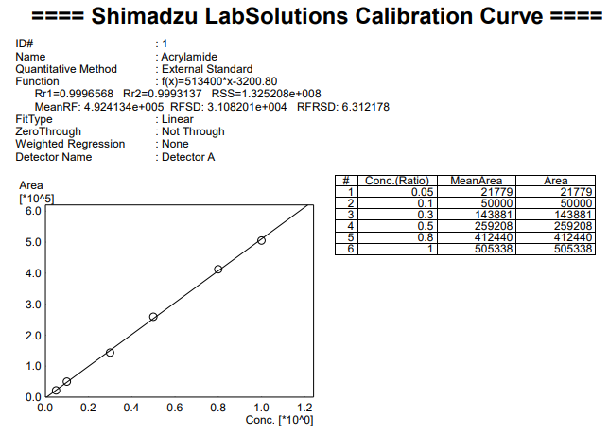
Figure 2. Calibration curve for acrylamide standard (50-1000µg/L)
Quantitative data was entered followed by analysis using the SPSS (Statistical Package for Social Sciences) software version 20. Descriptive statistics including mean, range, percentages and frequencies were used to summarize data. One-way ANOVA was used to test for differences in mean acrylamide concentration in different food groups. Tukey-Kramer post hoc test was used to identify the specific differences between acrylamide means. The results were presented using tables and charts.
- Results and discussion

Results
A total of 162 food samples were obtained which included potato chips (25), crisps (22), bhajia (20), chapatti (27), mandazi (24), samosa (25) and coffee (19). The study considered the concentration of acrylamide in the selected food. Acrylamide was detected in all the food samples analyzed (Table 1).
Table 1. Acrylamide concentration in selected foods in micrograms per kilogram (µg/kg)
Food type | n | Mean Acrylamide content ± SD (µg/kg) | Range (µg/kg) | Benchmark level (µg/kg) | Samples exceeding Benchmark level (%)
Chips | 25 | 85.91 ± 33.85 | 47.3- 186.2 | 500 | 0
Crisps | 22 | 99.33 ± 48.05 | 59.9-246.9 | 750 | 0
Bhajia | 19 | 78.27 ± 9.61 | 60.9-180.4 | 750 | 0
Chapati | 27 | 88.04 ± 36.68 | 57.9- 187.5 | 50 | 100
Mandazi | 23 | 73.56 ± 9.23 | 44.1-167.7 | 50 | 95.8
Samosa | 25 | 77.39 ± 12.38 | 61.5-108.9 | 50 | 100
Coffee | 19 | 130.28 ± 49.35 | 64.0-226.9 | 400-850 | 0
The highest acrylamide level was found in crisps (246.9µg/kg). The least amount was found in mandazi at (44.1µg/kg). Coffee had the highest average acrylamide amount (130.28µg/kg) and also the second highest (226.7µg/kg). Mandazi had both the least (44.1µg/kg) acrylamide and the least (69.47µg/kg) acrylamide average. None of the samples of chips, crisps, bhajia and coffee exceeded the Benchmark levels. However, all the samples of chapatti and Samosa exceeded the Benchmark levels. Mandazi had 95.8% of its samples exceeding the Benchmark level (Table 1).
Clear chromatograms for the internal standard (acrylamide) and acrylamide in food samples were obtained (Figure 3 to 10). Figure 3 shows clear chromatograms of acrylamide standard at concentrations 0.8mg (0.8 ppm/L) and 1.0mg/L (1 ppm). Clear chromatograms for acrylamide in food samples detected within the desired retention time show that standard acrylamide was detected (Figures 4 to 10). This confirms that what was detected within the desired retention time was indeed acrylamide.
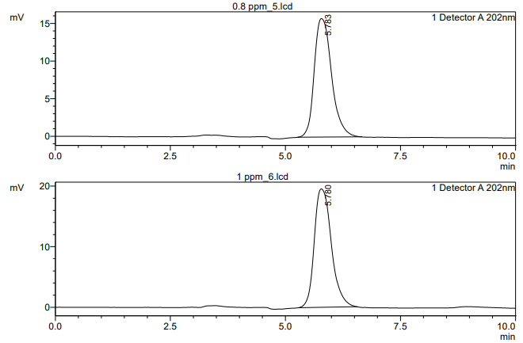
Figure 3. Chromatogram of acrylamide standard
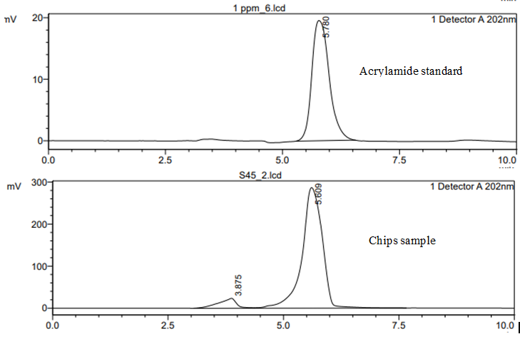

Figure 4. Chromatogram of Chips (68.0µg/kg) as compared to standard acrylamide

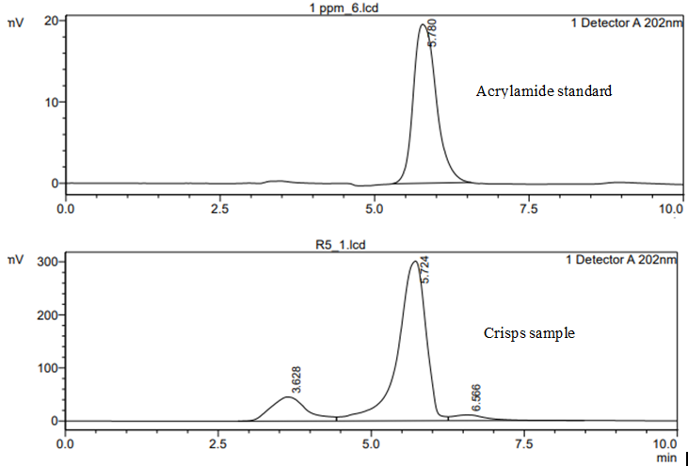
Figure 5. Chromatogram of Crisps (75.9µg/kg) as compared to standard acrylamide

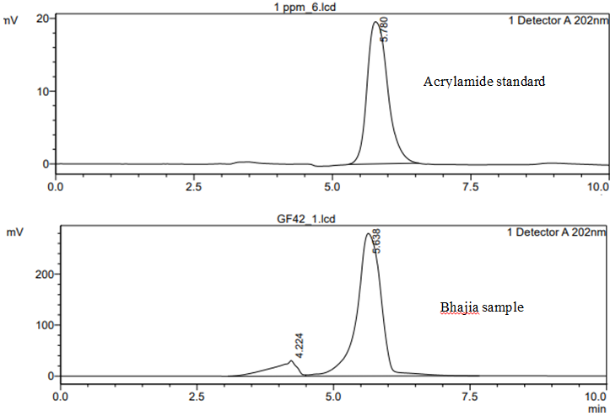Figure 6. Chromatogram of Bhajia (70.0µg/kg) as compared to standard acrylamide
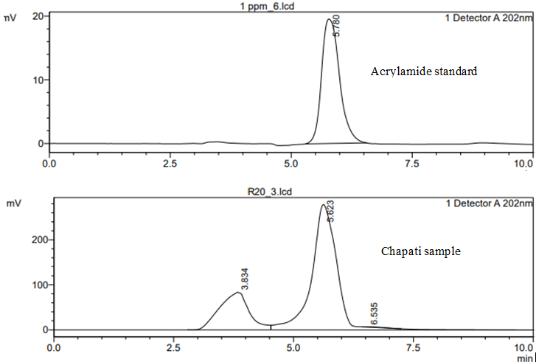

Figure 7. Chromatogram of Chapati (77.8µg/kg) as compared to standard acrylamide

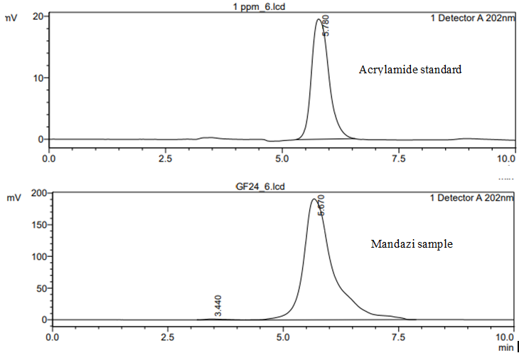Figure 8. Chromatogram of Mandazi (67.4µg/kg) as compared to standard acrylamide
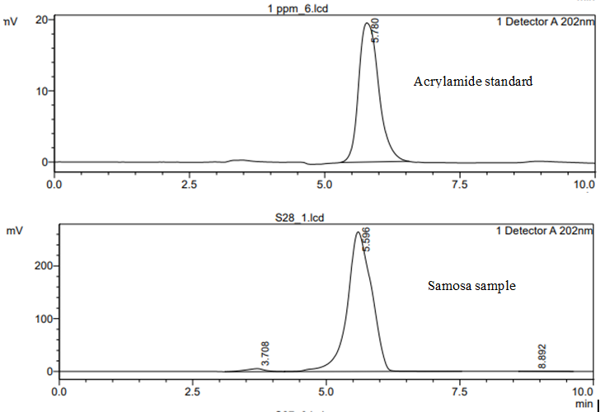Figure 9. Chromatogram of Samosa (66.2µg/kg) as compared to standard acrylamide

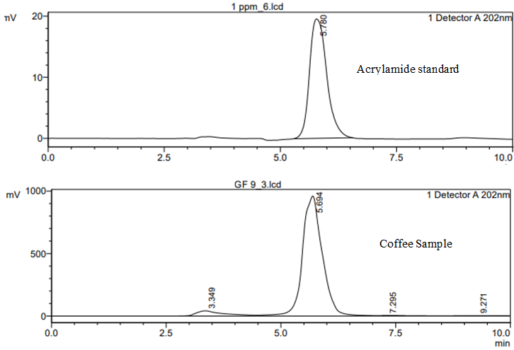
Figure 10. Chromatogram of Coffee (226.0µg/kg) as compared to standard acrylamide
ANOVA test was conducted to test for difference between means of acrylamide in the selected foods. For Bhajia and Mandazi, one outlier was removed from each of them for the purpose of running the ANOVA test (Table 2).

Table 2. Difference between means in Acrylamide content (95% Level of confidence)
Food type | N | Mean Acrylamide content (µg/kg) | Standard Deviation | Df | F | Sig
Chips | 25 | 85.91 | 33.85 | (6, 153) | 8.175 | 0.000
Crisps | 22 | 99.33 | 48.05 | (6, 153) | 8.175 | 0.000
Bhajia | 19 | 72.69 | 9.61 | (6, 153) | 8.175 | 0.000
Chapati | 27 | 88.04 | 36.68 | (6, 153) | 8.175 | 0.000
Mandazi | 23 | 69.47 | 9.23 | (6, 153) | 8.175 | 0.000
Samosa | 25 | 77.39 | 12.38 | (6, 153) | 8.175 | 0.000
Coffee | 19 | 130.28 | 49.35 | (6, 153) | 8.175 | 0.000
When the outliers for Bhajia and Mandazi were removed, the mean acrylamide content of Bhajia dropped from 78.27 µg/kg to 72.69 µg/kg and that of Mandazi from 73.56 µg/kg to 69.47µg/kg. However, the mean acrylamide content of coffee remained the highest (130.28µg/kg) and that of mandazi remained the lowest (69.47µg/kg). From the one-way ANOVA results, there was a statistically significant difference (p = .001) between acrylamide means (Table 2). Based on this statistically significant difference, Tukey-Kramer post hoc test was conducted to locate the specific differences between acrylamide means (Table 3).
Table 3. Specific differences between acrylamide means
Food type | Food type | Significance (95% CI)
Coffee | Chips | .001
 | Crisps | .044
 | Bhajia | .001
 | Chapatti | .001
 | Mandazi | .001
 | Samosa | .001
Crisps | Mandazi | .039

Tukey-Kramer post hoc test revealed that acrylamide content was statistically significantly higher in coffee (130.28 ± 49.35 µg/kg) as compared to chips (85.91 ± 33.85 µg/kg , p = .001), crisps (99.33 ± 48.05 µg/kg , p = .044), bhajia (72.69 ± 9.61 µg/kg , p = .001), chapatti (88.04 ± 36.68 µg/kg , p = .001), mandazi (69.47 ± 9.23 µg/kg , p = .001) and samosa (77.39 ± 12.38 µg/kg, p = .001). Additionally, acrylamide content was statistically higher (99.33 ± 48.05 µg/kg, p = .039) in crisps as compared to mandazi (69.47 ± 9.23 µg/kg). There was no statistically significant difference between the means of the rest of the groups.
Discussion
Like in a study conducted by ObedMainya et al. (2019) in Kisii, Kenya, acrylamide was found in all the samples analyzed in this study. This is because cooking of these foods involves high temperatures- low moisture conditions. Acrylamide levels ranged from 44.1µg/kg in a mandazi sample to 246.9µg/kg in a sample of crisps. Coffee had the highest mean acrylamide amount (130.28µg/kg). This is consistent with a Romanian market study where coffee had the highest average acrylamide concentration (199µg/kg) (Pogurschi et al., 2021). Coffee beans are roasted under high temperatures during coffee processing hence the high acrylamide content as compared to the other food samples.
Acrylamide content for potato products ranged from 47.3-186.2µg/kg. Based on the Benchmark level (500- 750 µg/kg) as per the European legislation, depending on the potato product, this is below the set level. The figures are in agreement with those of a study by Hu et al. (2017) on thermally processed foods where potato products had acrylamide content ranging from 11 to 3649µg/kg. The results fall within the stated range. However, the results differ with those reported by Alyousef et al. (2016) in Syria where different potato products had acrylamide content ranging from 396 to 1844µg/kg. This study site being a slum, food could be prepared for a short time and under low heat to minimize on cost.
Acrylamide amounts for potato chips samples ranged from 47.3-186.2µg/kg with a mean of 85.91µg/kg. Based on the Benchmark level (500µg/kg) as per the European legislation, the average is 82.82% less. This was inconsistent with a study conducted in Romanian market where potato chips had a higher average of acrylamide content of 134µg/kg (Pogurschi et al., 2021). In a study done in Nairobi by Abong’ et al. (2021a) on acrylamide in street chips, the mean (354.18µg/kg) widely differs from the mean (85.91µg/kg) for this study. However, acrylamide range for the current study falls within the range (43-714µg/kg) for acrylamide content reported by Abong’ et al. (2021a). It also differs from findings of another study conducted in Syria with acrylamide ranging from 396-1844µg/kg (Alyousef et al., 2016). The varying acrylamide content in this could also be due to differences in maturity of potatoes, storage and cooking conditions among others (Keramat et al., 2011; Rydberg et al., 2005; Yang et al., 2016).
The current study results show acrylamide levels within the range (36µg/kg to 1411µg/kg) reported in Ethiopian study by Deribew and Woldegiorgis (2021) for acrylamide in chips. In this study, none of the samples analyzed exceeded the Benchmark level by EU (EC, 2017/2158/EU). Mihai et al. (2021) analyzed 8 samples of chips and reported acrylamide levels ranging from 31.45 to 371.30µg/kg with a mean of 107.19µg/kg. Though the mean was high in the study, the range fitly accommodates values obtained in this study. As in this study, none of the samples analyzed by Mihai et al. (2021) had acrylamide values more than the EC Benchmark level of 500µg/kg. The low values could be related to cooking conditions such as temperature and cooking time as noted by Rydberg et al. (2005), Keramat et al. (2011) and Yang et al. (2016). In separate studies conducted in Spain, Korea and Cyprus, mean acrylamide contents in chips reported were 303µg/kg, 372µg/kg and 383µg/kg, respectively (Mesias et al., 2019; Kafouris et al. 2018; Lee & Kim, 2020). Michalak et al. (2019) also found a mean of 377 ± 86µg/kg in their chips samples. All these values are higher than the value found in this study. ObedMainya et al. (2019) reported extremely high (5056.8µg/kg) value for potato chips as compared to the results of the current study.
Crisps had acrylamide amounts ranging from 59.9-246.9µg/kg with a mean of 99.33µg/kg. This average is 86.76% less when compared to the Benchmark level (750µg/kg) as specified in the European legislation for potato crisps (EC, 2017/2158/EU). The findings of the study agree with a study by ObedMainya et al. (2019) in Kisii, Kenya where acrylamide was detected in all the samples analyzed. However, results of the said study were as high as 127.4604mg/kg (127460.4µg/kg) compared to the results of the present study. In another study conducted in Nairobi, acrylamide contents in crisps were too high with a mean of 5428µg/kg for non-branded crisps compared to the findings of the present study (Abong’ et al., 2020). In Spain, Mesias et al. (2020) also reported higher levels of acrylamide with a mean of 644 ± 387µg/kg in potato crisps. Michalak et al. (2019) also reported a higher figure of 546 ± 68µg/kg. In an Ethiopian study by Deribew and Woldegiorgis (2021), mean acrylamide content for crisps was too high (1,298 ± 929µg/kg) and most (57%) of the samples exceeded the EU Benchmark level (750µg/kg). Another study conducted in Korea found a high mean acrylamide content of 546 ± 353µg/kg as compared to the mean in this study. However, the values obtained in this study fall within the range of 14 to 1435µg/kg in crisps (Lee and Kim, 2020). In Cyprus and Romania, acrylamide content was also higher than the figure found in this study (Kafouris et al., 2018). Mihai et al. (2021) analyzed crisps samples and found acrylamide levels higher than 400µg/kg. In addition, 19% of their samples had acrylamide content that surpassed the EC Benchmark level (750µg/kg).
Bhajia had acrylamide average value of 78.27µg/kg with the lowest amount being 60.9µg/kg and the highest was 180.4µg/kg. This average is 84.35% less when compared to the Benchmark level (500µg/kg) as specified in the European legislation (EC, 2017/2158/EU). The low acrylamide value could be attributed to the setting of the study where resource maximization to make maximum profit is crucial. Hence, cooking time is reduced as much as possible.
In wheat products, acrylamide ranged from 44.1 to 187.5µg/kg with an average of 79.66µg/kg. The average is 59.32% higher than the benchmark level of 50µg/kg for wheat breads (EC, 2017/2158/EU). The acrylamide results for wheat breads were within the range (10-305µg/kg) reported by Hu et al. (2017). They were also consistent with results by Alyousef et al. (2016) where acrylamide in bread ranged from 19±1.73–263±3.60µg/kg. In this category, acrylamide content was the highest in chapatti followed by samosa while the least was in mandazi samples. The difference in acrylamide content in this food category may be explained by the different cooking methods used since chapatti is pan fried whereas samosa and mandazis are deep fried.
Chapatti samples’ acrylamide amounts ranged from 57.9-187.5 µg/kg with an average of 88.04µg/kg. This average is 76% high as compared with the Benchmark level (50µg/kg) as specified in the European legislation for wheat breads (EC, 2017/2158/EU). Michalak et al. (2019) reported mean acrylamide content that was 10% higher than the EC Benchmark level. This was quite low as compared to the value in this study. In India, chapattis that were prepared using locally available wheat varieties were found to have different means. They were 58 ± 1.5, 47.2 ± 2.2, 45.8 ± 0.8 and 52.5 ± 2.5µg/kg (Mulla et al., 2010). The mean values were a bit low as compared to the mean value for this study. The difference could be related to cooking conditions such as temperature and cooking time as noted by Rydberg et al. (2005), Keramat et al. (2011) and Yang et al. (2016). Michalak et al. (2019) also found lower (55 ± 24µg/kg) acrylamide amount in soft bread but found a higher level (312 ± 56µg/kg) in crisp wheat bread.
Mandazi samples had acrylamide amounts ranging from 44.1-167.7µg/kg with average acrylamide level of 73.56µg/kg. This average is 47% high when compared to the Benchmark level (50µg/kg) as specified in the European legislation for wheat breads (EC, 2017/2158/EU). Additionally, Samosa samples had acrylamide ranging from 61.5-108.9µg/kg with a mean of 77.39µg/kg. This value is 54% high when compared to the Benchmark level (50µg/kg) as specified in the European legislation for wheat breads (EC, 2017/2158/EU). The high values may be as a result of poor knowledge on acrylamide formation and mitigation among the respondents.
Coffee samples contained acrylamide ranging from 64.0-226.9µg/kg with an average value of 130.28µg/kg. This average is 73.9% less than the Benchmark level (400µg/kg) as specified in the European legislation (for roast coffee) (EC, 2017/2158/EU). The low acrylamide content in the brewed coffee in this current study may be because the study was conducted in a slum area where resource maximization is crucial. Hence, most vendors may use little ground coffee to brew coffee. These results are however supported by results from a study by Alyousef et al. (2016) in Syria where acrylamide in coffee ranged from 64±3.05–121±4.58µg/kg.
From one-way ANOVA, there was statistically significant difference between acrylamide means. This result agrees with that reported by Alyousef et al. (2016) where there was significant difference in acrylamide levels between and within food products analyzed. Tukey-Kramer post hoc test revealed that acrylamide content was statistically significantly higher in coffee as compared to chips, crisps, bhajia, chapatti, mandazi, and samosa. Additionally, acrylamide content was statistically significantly higher (p = .039) in crisps as compared to mandazi. This may be because of the desired cooking endpoints where crisps are cooked until dry and crispy as compared to mandazi which is cooked to mostly a light brown colour. There were no statistically significant differences between the means of the rest of the groups. These results vary from those reported by Dimitrieska-Stojkovikj et al. (2019) where significantly higher acrylamide levels were found in chips as compared to other foods (p< 0.05). However, it agrees with the result that acrylamide content was statistically significantly higher in crisps as compared to mandazi. Michalak et al. (2019) also reported that mean acrylamide content was higher in crisps as compared to chips and soft wheat bread. That study also reported statistically significantly higher mean acrylamide levels in chips and potato crisps as compared to soft wheat bread. The differences could imply a difference in cooking methods, cooking temperature and time and the desired cooking endpoints.

Conclusion

Acrylamide was detected in all food samples analyzed. The highest mean was found in coffee and the least in mandazi. All samples of chapatti and Samosa exceeded Benchmark levels. Coffee had statistically significantly higher mean acrylamide concentration as compared to other selected food samples. Food vendors should implement acrylamide mitigation measures to minimize formation in food and to adhere to the set Benchmark levels in food.

CONSENT
All authors declare that ‘written informed consent was obtained from the study participants to be part of this study. A copy of the consent form is available for review by the Editorial office/Chief Editor/Editorial Board members of this journal.
ETHICAL APPROVAL
All authors herewith declare that the study was approved by Kenyatta University Ethics Review Committee.
Disclaimer (Artificial intelligence): Author(s) hereby declare that NO generative AI technologies such as Large Language Models (ChatGPT, COPILOT, etc.) and text-to-image generators have been used during the writing or editing of this manuscript.

References

EFSA (2015). Scientific Opinion on acrylamide in food. EFSA Journal, 13(6). https://doi.org/10.2903/j.efsa.2015.4104
International Agency for Research on Cancer [IARC] (1994). Some Industrial Chemicals. Acrylamide. IARC monographs on the evaluation of carcinogenic risk to humans, 60: 387-433.
Ubaoji, K. I., & Orji, V. U. (2016). A REVIEW ON ACRYLAMIDE IN FOODS:
SOURCES AND IMPLICATIONS TO HEALTH, Mgbakoigba, Journal of African Studies; 6 (1).
World Health Organization (2020). Noncommunicable diseases. https://www.who.int/health-topics/noncommunicable-diseases#tab=tab_1.
Adani, G., Filippini, T., Wise, L. A., Halldorsson, T. I., Bláha, L., & Vinceti, M. (2020). Dietary Intake of Acrylamide and Risk of Breast, Endometrial, and Ovarian Cancers: A Systematic Review and Dose–Response Meta-analysis. Cancer Epidemiology, Biomarkers & Prevention, 29(6), 1095–1106. https://doi.org/10.1158/1055-9965.epi-19-1628
Hamzalıoğlu, A., Mogol, B. A., & Gökmen, V. (2019). Acrylamide: An Overview of the Chemistry and Occurrence in Foods. In: Melton L, Shahidi F, Varelis P, editors. Encyclopedia of food chemistry. Oxford: Academic Press, 492–499.
Murkovic M, Pedreschi F, and Ciesarova Z (2019). Process Contaminants: A Review . In: Melton L, Shahidi F, Varelis P, editors. Encyclopedia of food chemistry. Oxford: Academic Press, 500–24.
FDA (2017). Acrylamide and diet, food storage, and food preparation. https://www.fda.gov/food/process-contaminants-food/acrylamide-and-diet-food-storage-and-food-preparation.
Elias, A., Roasto, M., Reinik, M., Nelis, K., Nurk, E., & Elias, T. (2017). Acrylamide in commercial foods and intake by infants in Estonia. Food Additives & Contaminants: Part A, 34(11), 1875–1884. https://doi.org/10.1080/19440049.2017.1347283.
Esposito, F., Nardone, A., Fasano, E., Triassi, M., & Cirillo, T. (2017). Determination of acrylamide levels in potato crisps and other snacks and exposure risk assessment through a Margin of Exposure approach. Food and Chemical Toxicology, 108, 249–256. https://doi.org/10.1016/j.fct.2017.08.006.
Mojska, H., & Gielecinska, I. (2013). Studies of acrylamide level in coffee and coffee substitutes: influence of raw material and manufacturing conditions. Rocz Panstw Zakl Hig, 64 (3):173‒181. PMID: 24325083.
European Commission (2017). Commission Regulation (EU) 2017/2158 of 20 November 2017 Establishing Mitigation Measures and Benchmark Levels for the Reduction of the Presence of Acrylamide in Food. European Commission, Brussels. http://data.europa.eu/eli/reg/2017/2158/oj.
Khan, M. M., ALOthman, Z. A., Naushad, M., Alomary, A. A., & Alfadul, S. M. (2018). Monitoring of acrylamide carcinogen in selected heat-treated foods from Saudi Arabia. Food Science and Biotechnology, 27(4), 1209–1217. https://doi.org/10.1007/s10068-018-0358-5.
Abong’ G. O., Miriti J. W., Okoth M. W., Kabira J. N (2021a). Acrylamide Intake in Nairobi Kenya: A case of French Fries Consumers. East African Journal of Science, Technology and Innovation, 2 (Special issue); 1-13. EISSN: 2707-0425
Rifai, L., & Saleh, F. A. (2020). A Review on Acrylamide in Food: Occurrence, Toxicity, and Mitigation Strategies. International Journal of Toxicology, 39(2), 93–102. https://doi.org/10.1177/1091581820902405
Tareke, E., Rydberg, P. A., Karlsson, P., Eriksson, S., & Törnqvist, M. (2002). Analysis of Acrylamide, a Carcinogen Formed in Heated Foodstuffs. Journal of Agricultural and Food Chemistry, 50(17), 4998–5006. https://doi.org/10.1021/jf020302f.
Kotemori, A., Ishihara, J., Nakadate, M., Sawada, N., Iwasaki, M., Sobue, T., & Tsugane, S. (2018b). Validity of a Self-administered Food Frequency Questionnaire for the Estimation of Acrylamide Intake in the Japanese Population: The JPHC FFQ Validation Study. Journal of Epidemiology, 28(12), 482–487. https://doi.org/10.2188/jea.je20170186.
Dybing, E., Farmer, P. B., Andersen, M., Fennell, T. R., Lalljie, S. P. D., Muller, D. R., Olin, S. S., Petersen, B., Schlatter, J., Scholz, G., Scimeca, J., Slimani, N., Törnqvist, M., Tuijtelaars, S., & P, V. (2005). Human exposure and internal dose assessments of acrylamide in food. Food and Chemical Toxicology, 43(3), 365–410. https://doi.org/10.1016/j.fct.2004.11.004.
Hogervorst, J. G. F., Schouten, L. J., Konings, E. J. M., Goldbohm, R., & Van Den Brandt, P. A. (2007). A Prospective Study of Dietary Acrylamide Intake and the Risk of Endometrial, Ovarian, and Breast Cancer. Cancer Epidemiology, Biomarkers & Prevention, 16(11), 2304–2313. https://doi.org/10.1158/1055-9965.epi-07-0581.
FDA (2016). Guidance for Industry: Acrylamide in Foods. https://www.fda.gov/regulatory-information/search-fda-guidance-documents/guidance-industry-acrylamide-foods.
Halford, G. H. (2019). Managing Acrylamide at the Agricultural Stage: Variety Selection, Crop Management, and the Prospects for Solving the Acrylamide problem through Plant Breeding and Biotechnology. In: Melton L, Shahidi F, Varelis P, editors. Encyclopedia of food chemistry. Oxford: Academic Press, 559–568.
Owuor, S., Brown, A., Crush, J., Frayne, B. & Wagner, J. (2017). The Urban Food System of Nairobi, Kenya (rep., pp. i-71). Waterloo, ON: Hungry Cities Partnership. Hungry Cities Report, No. 6.
Government of Kenya (GoK) (2010). The Constitution of Kenya 2010. Nairobi: Government Printer.
Government of Kenya (GoK) (2021). The National Food Safety Policy. (Accessed 11th April 2023). https://kilimo.go.ke/wp-content/uploads/2022/02/Draft-Food-Safety-Policy-2021.pdf.
Schmidt, & Brown, J. M. (2021). Evidence-Based Practice for Nurses. Jones & Bartlett Learning.
Stratton, S. J. (2021). Population Research: Convenience Sampling Strategies. Prehospital and Disaster Medicine, 36(4), 373–374. https://doi.org/10.1017/s1049023x21000649.
Murugan, M. P., Govindaswamy, A., Semwal, A. D., & Sharma, G. (2018). HPLC-UV Quantitative Analysis of Acrylamide in Snack Foods of India. Defence Life Science Journal, 4(1), 45–54. https://doi.org/10.14429/dlsj.4.12190.
Deribew, H., & Woldegiorgis, A. Z. (2021). Acrylamide levels in coffee powder, potato chips and French fries in Addis Ababa city of Ethiopia. Food Control, 123, 107727. https://doi.org/10.1016/j.foodcont.2020.107727.
FDA (2013). Detection and Quantitation of Acrylamide in Foods. https://www.fda.gov/food/process-contaminants-food/detection-and-quantitation-acrylamide-foods.
Granby, K. (2019). Guidance document on analyses of acrylamide in food including analyses in the low concentration range. Technical University of Denmark. https://backend.orbit.dtu.dk/ws/portalfiles/portal/193196480/2019_Guidance_document_Acrylamide_.pdf.
Alfarhani, B. F. (2017). Analysis of Acrylamide Levels in Various Food Types in the Iraqi Markets Using Chromatography Techniques, Journal of Materials and Environmental Sciences, 8 (S); 4969-4973.
Oroian, M., Amariei, S., & Gutt, G. (2015). Acrylamide in Romanian food using HPLC-UV and a health risk assessment. Food Additives & Contaminants Part B-surveillance, 8(2), 136–141. https://doi.org/10.1080/19393210.2015.1010240
Sarion, C., Dabija, A., Oroian, M., Negoiță, M., & Codină, G. G. (2020). Evaluation of acrylamide levels in cereal products from the Romanian market during the 2017 and 2018 period. The Eurobiotech Journal, 4(3), 127–133. https://doi.org/10.2478/ebtj-2020-0014.
Pogurschi, E., Zugravu, C., Ranga, I. N., Trifunschi, S., Munteanu, M., Popa, D., Tudorache, M., & Custura, I. (2021). Determination of Acrylamide in Selected Foods from the Romanian Market. Foods, 10(9), 2110. https://doi.org/10.3390/foods10092110.
Hu, F., Jin, S., Zhu, B., Chen, W., Wang, X., Liu, Z., & Luo, J. (2017). Acrylamide in thermal-processed carbohydrate-rich foods from Chinese market. Food Additives & Contaminants Part B-surveillance, 10(3), 228–232. https://doi.org/10.1080/19393210.2017.1329233.
ObedMainya, N., Kituyi, L., & Wanjau, T. (2019). ANALYSIS OF LEVELS OF ACRYLAMIDE IN (SOLANUM TUBEROSUM) POTATO CHIPS AND CRISPS. International Journal of Advanced Research, 7(1), 321–327. https://doi.org/10.21474/ijar01/8330.
Alyousef, H. A., Wang, H., Al-Hajj, N. Q. M., & Koko, M. Y. (2016). Determination of acrylamide levels in selected commercial and traditional foods in Syria. Tropical Journal of Pharmaceutical Research, 15(6), 1275. https://doi.org/10.4314/tjpr.v15i6.21.
Keramat, J., Le-Bail, A., Prost, C., & Jafari, M. (2011). Acrylamide in Baking Products: A Review Article. Food and Bioprocess Technology, 4(4), 530–543. https://doi.org/10.1007/s11947-010-0495-1
Rydberg, P. A., Eriksson, S., Tareke, E., Karlsson, P., Ehrenberg, L., & Törnqvist, M. (2005). Factors That Influence the Acrylamide Content of Heated Foods. In Springer eBooks (pp. 317–328). https://doi.org/10.1007/0-387-24980-x_24.
Yang, Y., Achaerandio, I., & Pujolà, M. (2016). Influence of the frying process and potato cultivar on acrylamide formation in French fries. Food Control, 62, 216–223. https://doi.org/10.1016/j.foodcont.2015.10.028.
Mihai, A., Negoiță, M., & Horneț, G. (2021). Assessment of acrylamide in potato chips and French fries consumed by the Romanian population. Journal of Food Processing and Preservation, 46(6). https://doi.org/10.1111/jfpp.15957.
Mesías, M., Delgado-Andrade, C., Holgado, F., & Morales, F. J. (2019). Acrylamide content in French fries prepared in food service establishments. Lebensmittel-Wissenschaft & Technologie, 100, 83–91. https://doi.org/10.1016/j.lwt.2018.10.050.
Kafouris, D., Stavroulakis, G. E., Christofidou, M., Iakovou, X., Christou, E., Paikousis, L., Christodoulidou, M., Ioannou-Kakouri, E., & Yiannopoulos, S. Y. (2018). Determination of acrylamide in food using a UPLC–MS/MS method: results of the official control and dietary exposure assessment in Cyprus. Food Additives & Contaminants: Part A, 35(10), 1928–1939. https://doi.org/10.1080/19440049.2018.1508893.
Lee, S., & Kim, H. J. (2020). Dietary Exposure to Acrylamide and Associated Health Risks for the Korean Population. International Journal of Environmental Research and Public Health, 17(20), 7619. https://doi.org/10.3390/ijerph17207619.
Michalak, J., Czarnowska-Kujawska, M., & Gujska, E. (2019). Acrylamide and Thermal-Processing Indexes in Market-Purchased Food. International Journal of Environmental Research and Public Health, 16(23), 4724. https://doi.org/10.3390/ijerph16234724.
Abong, G. O., Ogolla, A., Okoth, M. W., De Meulenaer, B., Kabira, J. N., Karanja, P. N., & Liesbeth, J. (2020). Dietary acrylamide intake by potato crisps consumers: A case of Nairobi County. Open Agriculture, 5(1), 871–878. https://doi.org/10.1515/opag-2020-0086
Mesías, M., Delgado-Andrade, C., & Morales, F. J. (2020). Are Household Potato Frying Habits Suitable for Preventing Acrylamide Exposure? Foods, 9(6), 799. https://doi.org/10.3390/foods9060799
Mulla, M., Bharadwaj, V. R., Annapure, U. S., & Singhal, R. S. (2010). Effect of damaged starch on acrylamide formation in whole wheat flour based Indian traditional staples, chapattis and pooris. Food Chemistry, 120(3), 805–809. https://doi.org/10.1016/j.foodchem.2009.11.016.
Dimitrieska-Stojkovikj, E., Angeleska, A., Stojanovska-Dimzoska, B., Hajrilai-Musliu, Z., Koceva, D., Uzunov, R., Ilievska, G., Stojković, G., & Jankuloski, D. (2019). Acrylamide Content in Food Commodities Consumed in North Macedonia and Its Risk Assessment in the Population. Journal of Food Quality and Hazards Control. https://doi.org/10.18502/jfqhc.6.3.1383.

