The toxicity OF weed CRUSH (Paraquat dichloride) a glyphosate on the histopathological effects on JUVENILE Clarias GARIEPINOUS
ABSTRACT
Fish are particularly sensitive to a wide variety of agrochemicals including glyphosate herbicide that may arise from not only deliberate discharge of these chemicals into waterways but also from approved agricultural practices. In the present study, the toxicity of weed crush (Paraquat dichloride) an herbicide was investigated with emphasis on histopathological effects. Clarias gariepinus juvenile (mean body weight of 3.54±1.61g) and averaged average length 6.55±2.23 cm were exposed to 0,0.06, 0.08, 0.1, 0 .12, and 0.14ml herbicide per litre of water (ml/l) weed crush (Paraquat dichloride). The lethal concentration (LC₅₀) value of glyphosate was 0.007ml/l for 96 h of exposure. Glyphosate concentration corresponding to the 96 h LC₅₀ values for juvenile Clarias gariepinus was used to study the effects of glyphosate exposure for 4 days in inducing histopathological changes of gills. In the gills, filament cell proliferation, lamellar fusion, lamellar cell hyperplasia, and epithelial lifting were observed. The changes in gills occur predominantly in the 96 h exposure. Respiratory stress, erratic swimming and instant death of fish were observed in exposed fish, which varied with the concentration of the toxicant and this showed that mortality increased with increase in concentration. Glyphosate is highly toxic to Clarias gariepinus, which are more susceptible to this herbicide; therefore their use near fish farm or in area close to aquatic environment should be discouraged.
Keywords: Paraquat dichloride, histopathological effects, Clarias gariepinus juvenile
INTRODUCTION
Toxicity testing of herbicides on animal has been used for a long time to detect the potential hazards posed by herbicides to man [1]. Agrochemical products use in agriculture is a very common worldwide practice that causes contamination of water bodies. Herbicides are widely used for the control of water plants, which may impede the flow of water during the summer, when sudden heavy rain can cause flooding [2]. While the direct effect of herbicides addition is the loss of macrophytes, non-target organisms such as fish may also be affected through loss of habitat and food supply [4] Herbicides are generally applied in spring or early summer, which often coincide with the breeding season of many fish species. Some of these fishes breed in aquatic habitats receiving the runoff drained from the cultivation fields. (Giddings et al., 2004). Herbicide at high concentration is known to reduce the survival, growth and reproduction of fish and can produce many visible effects on them [1]. The constant flow of agricultural effluent discharge into water bodies often leads to a variety of pollutant accumulation, which becomes apparent when considering toxic pollution.
The use of herbicides to control weeds has been recognized as a part of agricultural practices throughout the world. Unfortunately, the indiscriminate use of these herbicides to improve agricultural production and yield may have impacts on non-target organisms, especially aquatic life forms and their environment. Fish are one of the most widely distributed organisms in an aquatic environment and being susceptible to environmental contamination may reflect the extent of the biological effects of environmental pollution in waters. Due to the different pollutants entering the aquatic ecosystems, the organisms there are subjected to environmental stresses which may be deleterious to them, to a population or to a community and eventually causing an alteration in the structure of natural ecosystems [5]. The use of herbicides to control aquatic weeds has applied in fish management where they are used in aquatic habitats especially rice fields and some fish farms. After spraying on crops, it can enter watercourses, because of its high mobility through soil [6]. Herbicide is used in agriculture, forestry and for other functions such as the control of vegetation, industrial and urban sites but agricultural use dominates the market. Increased uses of herbicide on crops will result in increased input to agro-ecosystems with concomitant increases in the potential for exposure in the environment particularly in aquatic organisms such as fish [7].
Weed crusher (Paraquat dichloride)
Weed crusher is a commonly used Paraquat variant in Nigeria. It’s used to control to grass and other weeds in maize, cowpea, wheat cotton, and fruit and plantation crops such as cocoa, rubber, palm fruit and sugarcane. Its contains 276g of Paraquat Dichloride (200g Paraquat ion) per liter
aim and objective
The aim and objective of this project is to assess the toxicity of weed crush (Paraquat dichloride) on the gills of Clarias gariepinus juvenile and to be able to determine the level of concentration of herbicide that will affect the behavioral activities of the fish.
MATERIALS AND METHOD
Study Area
The study was carried out in the Fish farm, Department of Fisheries Technology, Federal Polytechnic Ado Ekiti.
Experimental Fish
For this research work, Two hundred and forty (240) apparently healthy juveniles Clarias gariepinus of (mean body weight of 3.54±1.61g) and averaged 6.55±2.23 cm standard length were purchased from reputable fish farm and transported to Fisheries Technology Department Fish Farm and used for the experiment. The fish were acclimated to laboratory conditions in a glass aquarium tank for 14 days at a room temperature of 28±2⁰C and were fed with commercial fish-feed twice daily. The water in each glass tanks was replaced with tap water from the laboratory every 48 hours.

BIOASSAY
A 96 –hour short-term static bioassay was conducted using the fingerlings of Clarias gariepinus as test organisms. This was done in order to study the toxicity of weed crush (Paraquat dichloride) on fish, and determine the toxicity effect of this chemical on the physic chemical parameter of the water used.
EXPERIMENTAL SETUP
A total of twelve (12) plastic tanks of 30 liters capacity were used. The plastic tanks were washed thoroughly and then filled with 20 liters of water. All the plastic tanks were labeled. The C. gariepinus juveniles were weighed with an electronic scale and were distributed uniformly into the experimental tanks containing 10 juveniles per tank. The feeding stopped 24 hours prior to the commencement of the study to minimize the production of waste materials and reduce ammonia build up in the container.
PREPARATION OF STOCK SOLUTION CONCENTRATION
Using syringe, 0.1 ml of the test chemical was diluted with 9.9 ml water which gives 10 ml of solution. From the solution, 0.6, 0.8 1.0 1.2 and 1.4 ml stock concentration were used respectively and are represented as 0.06, 0.08, 0.1, 0 .12, and 0.14ml. which were later converted to ml/l and are represented as 0.003, 0.004, 0.005, 0.006 and 0.007ml/l
RANGE – FINDING TEST
This is a form of preliminary test that was carried out by filling twelve plastic tank with 20 liters each. For the range finding test, two control and five test treatments in duplicates (12 plastics tanks of 20 litres of water respectively were set up. Twelve plastics tanks of 30 liters capacity were filled with water. The controls and five test concentrations in duplicates of 0.8, 1.0, 1.2, 1.4 and 1.6ml and were represented as 0.08, 0.1, 0.12, 0.14, and 0.16 ml which were converted to ml/l and are represented as 0.004, 0.005, 0.006, 0.007. and 0.008ml/l respectively. Clarias gariepinus were stocked in each plastic tank for 24 hours prior to the introduction of the herbicide to the water. The range finding test lasted for 96 hours and observations were made at six-hour interval. The behavioral activities of the fishes were properly monitored and recorded.
DEFINITIVE TEST
Result from range finding tests provided guide for the concentration level to be used in definitive test. The definitive test was carried out by filling twelve plastics tanks with 20 liters of water each. The test was carried out using concentrations of herbicide earlier determined from the range finding test. Five concentrations of herbicide representing ten treatments and two controls were used on juveniles Clarias gariepinus. The concentrations used were 0.06, 0.08, 0.1, 0 .12, and 0.14ml herbicide per liter of water (ml/l). The response of the fish to slight stimuli was used as an index for toxicity while non-response of fish to the treatments estimated to be lethal to 50% of the test organism after 96 hours of exposure.
FISH BEHAVIOUR
The behavior activities of Clarias gariepinus juveniles after exposure of different concentrations of detergent were critically observed. The number of dead and living organisms in each concentration was counted after 24 hours; mortality rate was the criteria used for toxicity.
DETERMINATION OF LETHAL CONCENTRATION
The LC₅₀ value was determined using probit analysis as described by Finney, 1971.
REMOVAL OF GILLS
One sample each Gills of juvenile Clarias gariepinus were removed each tank after 96 hours for examination with the aid of dissecting tool by removing the operculum and carefully pooling out the gill with forceps after which it was preserved with formalin before taking to the laboratory for histological analysis
RESULT
No recognizable changes were observed in the gills of the control fish. Each gill consisted of a primary lamellar filament and secondary lamellae (Plate 1). The primary lamellar epithelium was one or two cell layers thick. Chloride cells were visible along the primary lamellar epithelium, especially at the basis of secondary Lamellae. Light microscopic study of the gills of Clarias gariepinus exposed to glyphosate showed several pathological changes and their frequencies increased with increasing the exposure time. At different concentrations of glyphosate for 96 h exposure, there were cellular infiltration, irregular lamella (Plate 2-6) epithelium and neurosis of the gill.

Plates

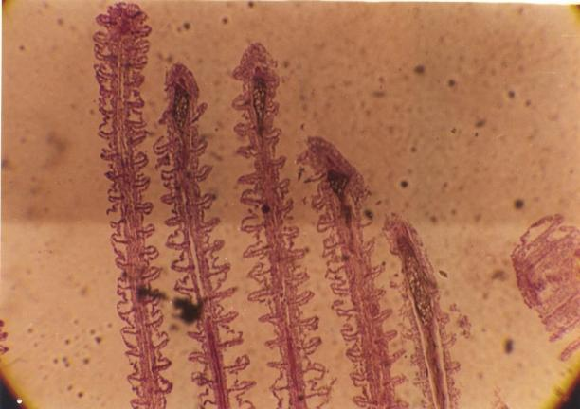
Section of fish Gill from control
Plate 1: Section of Fish Gill from the Control Group
This section of a transverse section through the gill shows normal appearance of primary lamellar epithelium, no pathological damage.

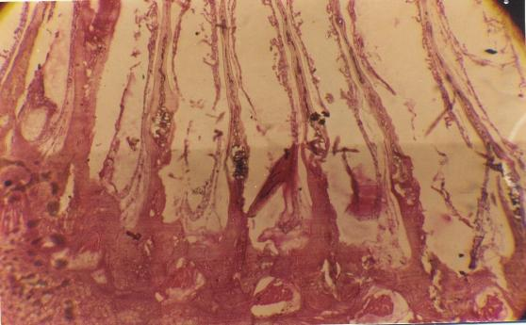
Plate 2: Section of Gill of Fish exposed to herbicide
This section shows moderately severe distortions in the appearance of the gills. There is irregular thickening of primary lamellar epithelium, distortions in the chloride cells which are indistinguishable from the epithelial and pillar cells at 0.003ml/l of the concentration

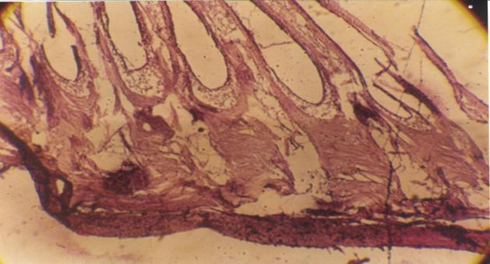
Plate 3: Section of Gill of Fish exposed to herbicide
This section shows severe distortions in the appearance of the gills. Severe tissue damage is visible at 0.004ml/l level of concentration of herbicide.

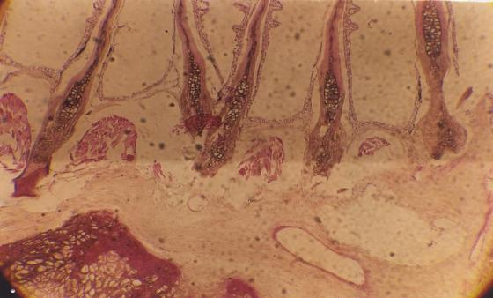
Plate 4: Section of Gill of Fish exposed to herbicide.
This section shows abnormal and irregular thickening of the primary lamellar epithelium at 0.005ml/l of the concentration.

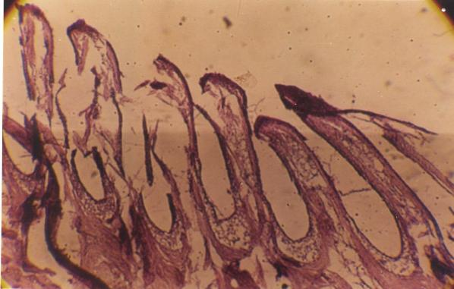
Plate 5 Section of Fish Gill from the Group Exposed to herbicide
This section shows severe distortion in the appearance of the gills. The primary lamellar epithelium, chloride cells pillar cells and epithelial cells are essentially indistinguishable in the distortion as seen in this view at the level of 0.006ml/l of the concentration

DISCUSSION
The study was carried out to evaluate the acute toxicity of glyphosate on the juvenile of Clarias gariepinus. This present study showed that exposure of the juvenile catfish to glyphosate resulted in increased mortality rate and decreased survival rate at different level of concentrations which is probably as a result of deformed gill. The LC₅₀ value obtained showed that Clarias gariepinus is sensitive to glyphosate herbicide. Varying LC₅₀ values have been obtained from different investigation on exposure of the same organisms to different herbicides. The differences in the values may be as a result of variation in the nature of herbicide, age of organism and environmental condition[8]. This study shows that sublethal concentrations of drysate (glyphosate) is toxic to Clarias gariepinus. This is in line with previous researcher [9] . Who observed that herbicides are toxic to fish. Changes in fish gills lead to an overall reduction in the efficiency of gill filaments to aid in diffusion of oxygen across the gill lamellae which resulting in the development of a hypoxic condition within the fish
The LC₅₀ value was obtained based on probit analysis (using Biostat Pro 5.9.8 2015) and was found to be 0.0072 ml/l for 96 h of exposure to the glyphosate herbicide. The median lethal concentration (LC₅₀) value reported in the present study for commercial formulation of glyphosate is higher than 1.05 mgL⁻¹ and 13.6 mgL⁻¹ reported by (Ayoola 2008) when Oreochromis niloticus and Prochilodus lineatus were exposed to glyphosate and glyphosate-based herbicides respectively [10].
CONCLUSION
Based on the outcome recorded in this study, glyphosate is found to be toxic and posed stress to Clarias gariepinus and the effect increased with increase concentration of glyphosate. Histology observation further revealed that sublethal concentrations of glyphosate damage the gills, Hence affecting the life span of the fish resulting in the increase in mortality which is directly proportional to the increase in the concentration of the herbicide.

RECOMMENDATION
- Biological methods should be used as an alternative to chemical methods of controlling weeds.
- Government and other relevant bodies should enlighten farmers and public on the implication of herbicide to aquatic biota.
- The use of glyphosate near aquatic environment should be monitored to ensure that farmers use appropriate concentration that will not kill non-target organisms.
REFERENCE
1] Rahman MZ, Hossain ZM, Ellah MFR, Ahmed GU. 2002 Effect of Diazinon 60EC on Anabus testudineus, Channa punctatus and Barba desgomonous. NAGA. The CLARM quarterly. pp; 25:8-11.
2] Annune PA, Hbele SON, Oladimeji AA (1994). Acute toxicity of cadmium to juveniles of Clarias gariepinus (Tuegls) and Oreochromis niloticus (Trewavas) J. Environ. Sci. Health, A29: 1357-1365.
3] Ervnest H (2004). A Textbook of modern toxicology(3rd ed), John Wiley&sons Hoboken, New Jersey.ISBN 0-471-26508-X 557pp.
4] Giddings, J.M., Anderson, T.A., Hall Jr., L.W., Kendall, R.J., Richards, R.P., Solomon, K.R. and Williams, W.M., 2004. A probabilistic aquatic ecological risk assessment of atrazine in north American surface waters. SETAC Press, Pensacola, FL, USA.
5] Imoobe, T.O.T. and Adeyinka, M.L., 2010. Zooplankton based assessment of the trophic state of a tropical forest river. Int. J. Fish Aquacult., 2: 64-70.
6] Waring CP, Moore A (2004). The effect of atrazine on Atlantic salmon (Salmo salar) smolts in fresh water and after sea water transfer. Aquat. Toxicol. 66: 94-104.
7] Mortensen,D.A., Egan, J.F., Maxwell,B.D.,Ryan, M.R and Smith, R.G(2012) Navigation a critical juncture for sustainable weed management. Bioscience 62,75-84.
8] Olorunfemi, J.O. Olomukoro, O.A. Anani, Acute toxicity of produced water on Clarias gariepinus juveniles, Studia Universitatis Vasile Goldis 24 (3) (2014).
9] Ayoola, S.O. (2008a).Toxicity of glyphosate herbicideon Nile tilapia (Oreochromisniloticus) juvenile. African Journal of Agricultural Research, 3, 825-834.
10] Langiano VC, Martinez CB (2008) Toxicity and effects of glyphosatebased herbicide on the Neotropical fish Prochilodus lineatus. Comparative Biochemistry and Physiology 147: 222-231.

