Social Entrepreneurship among Tribal Women in Gajapati District, Odisha: Barriers, Opportunities, and Pathways to Empowerment

Abstract
This study examines the status of social entrepreneurship among tribal women in Gajapati district, Odisha, focusing on six blocks named as Guma, Nuagada, R. Udayagiri, Mohana, Rayagada, and Kasinagar. Drawing on primary data from 200 respondents, the research explores the types of enterprises operated by women, the barriers they face, and the opportunities available for scaling up social enterprises. A mixed-methods approach combining structured surveys, semi-structured interviews, and focus group discussions was used to collect and analyze data. Findings indicate that tribal women are engaged primarily in agriculture-related enterprises, non-timber forest product (NTFP) processing, handicrafts, tailoring, and petty businesses, often supported through Self-Help Groups (SHGs). The major challenges include limited access to institutional credit, weak market linkages, poor infrastructure, and gender-related restrictions on mobility. At the same time, opportunities exist in the form of SHG federations, government livelihood missions, NGO facilitation, and growing access to digital markets. The paper argues that strengthening SHG federations, introducing gender-sensitive financial products, developing value chains, and promoting digital literacy can significantly empower tribal women entrepreneurs in Gajapati.
Keywords: Social Entrepreneurship, Tribal Women, SHGs, Empowerment, Livelihoods
1. Introduction
Tribal communities in India have traditionally held a distinct yet vulnerable role within the country’s socio-economic structure. Despite their rich cultural traditions, strong connections to natural resources, and resilient community networks, they continue to face systemic exclusion from mainstream development efforts. Limited access to education, healthcare, financial resources, and markets has perpetuated cycles of poverty and marginalization. Women within these communities often shoulder a disproportionate share of the burden. Tribal women play a crucial role in maintaining household economies, relying on agriculture, forest-based livelihoods, livestock rearing, and artisanal work to ensure their daily survival. Their contributions are critical, yet they are rarely fully recognized or sufficiently supported by institutions, policies, or development initiatives.(S. Acharya, 2018; Patnaik, 2016)
In Odisha, which has one of the largest tribal populations in India, the situation is especially significant. The state’s diverse tribal communities depend heavily on natural resources for their livelihoods, with women serving as the primary managers of household food security. They farm small plots of land, gather forest products, weave, and participate in local crafts. For many families, the survival of children, elders, and entire households depends on women’s ability to supplement their meager incomes through these activities.(S. Biswal, 2013; Pathi et al., 2021) However, their efforts often go unnoticed in traditional economic measures and are undervalued socially. The ongoing lack of recognition not only hampers their individual advancement but also the overall development of their communities.
Over the past two decades, there has been growing recognition of the role that collective action can play in empowering women and strengthening rural economies. Among these, the concept of social entrepreneurship has emerged as an innovative and inclusive approach to addressing persistent poverty.(Naik & Panda, 2023; Pathi et al., 2021) Unlike traditional entrepreneurial models, which focus primarily on maximizing profit, social entrepreneurship seeks to balance financial sustainability with community welfare. It emphasizes building enterprises that respond to local needs, create employment, and improve quality of life, while also generating modest but reliable incomes. This model holds particular relevance in tribal regions, where market isolation, resource dependency, and vulnerability to exploitation limit opportunities for conventional economic ventures.(Naik & Panda, 2023)
Self-Help Groups (SHGs) have become prominent platforms for women to engage in collective social entrepreneurship. Across India, especially in states like Odisha, SHGs have organized women into groups that save money, access microcredit, and start small businesses. These groups often begin with simple income-generating activities such as food processing, weaving, mushroom farming, or petty trading. Besides earning money, they also foster a sense of solidarity, improve women's bargaining power within families, and increase their visibility in community decisions. (S. N. Biswal et al., 2023)In tribal areas, where patriarchal norms and social barriers are strong, SHGs often serve as the first official space where women can speak, plan, and act together.(Behera, n.d.)
Odisha’s Mission Shakti program has played a central role in institutionalizing this movement. Launched to empower women through SHG-based development, it has brought together millions of women across the state. Many of these groups are engaged in small enterprises supported by microfinance, skill training, and market linkages. Yet, while the reach of Mission Shakti is impressive, the depth of transformation remains uneven. For many women, the transition from subsistence-level group activities to sustainable and scalable social enterprises continues to be fraught with challenges. Lack of access to capital, inadequate market exposure, limited training in business management, and weak institutional support restrict their ability to move beyond basic survival strategies.(Behera, n.d.)
The Gajapati district of southern Odisha provides a compelling context to explore these dynamics. With its predominantly tribal population and hilly terrain, the district faces acute development challenges. Infrastructure is limited, communication networks are weak, and dependence on agriculture and forest resources remains high. At the same time, the district has seen active mobilization of women into SHGs under Mission Shakti and other government and non-government initiatives.(Patnaik, 2016) Gajapati thus stands at the intersection of vulnerability and potential: while tribal women here face barriers rooted in poverty and social exclusion, they also represent one of the most active bases of collective women’s enterprises in the state.
This study builds on fieldwork carried out across six blocks of Gajapati district—Guma, Nuagada, R. Udayagiri, Mohana, Rayagada, and Kasinagar. A sample of 200 tribal women was engaged to understand the scope and limitations of their enterprise activities. The study investigates the types of enterprises women are currently engaged in, the barriers that restrict their growth, the enabling factors that support their success, and the broader pathways to empowerment that emerge from their collective participation. By situating the lived experiences of tribal women within the broader framework of social entrepreneurship, the study seeks to illuminate both the struggles and the possibilities inherent in this approach.(Pradhan & Patnaik, n.d.)
An important dimension that emerges is the dual nature of empowerment through enterprise. On the one hand, economic benefits are critical. For many women, earnings from SHG activities make the difference between food sufficiency and hunger, between sending children to school and pulling them out to work, or between accessing healthcare and foregoing it. Even modest incomes can have transformative effects on household well-being.(Patel & Giri, 2019) On the other hand, the significance of women-led enterprises extends beyond material gains. The process of coming together, sharing knowledge, negotiating with institutions, and collectively managing an enterprise fosters self-confidence, leadership skills, and solidarity. Women who previously had little voice in community or household decisions often find themselves speaking up, taking initiative, and challenging restrictive social norms.(Kumar, 2016)
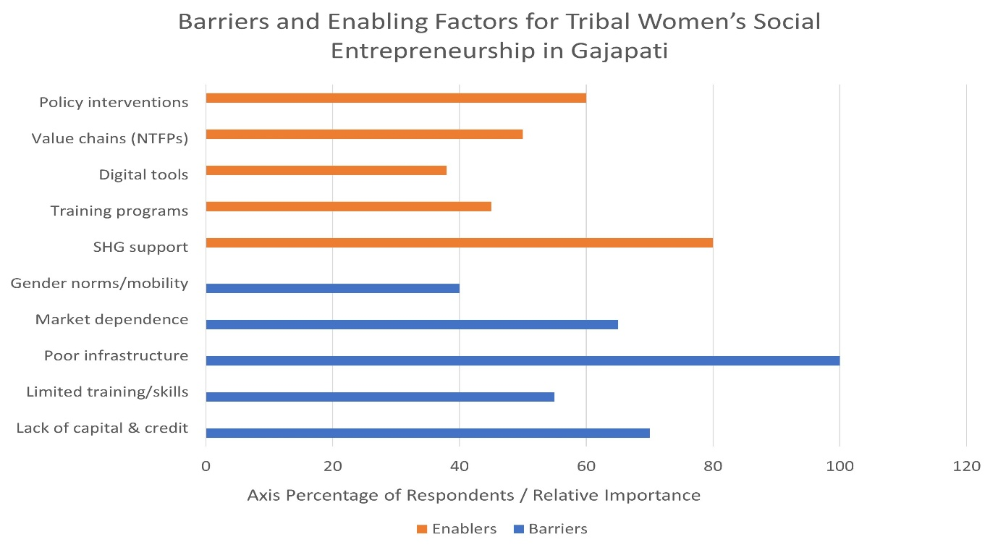
Figure 1: Barriers and Enablers of Tribal Women’s Social Entrepreneurship in Gajapati District
In tribal contexts such as Gajapati, this shift is particularly powerful. The entrenched marginalization of these communities means that women’s empowerment carries implications not only for gender equality but also for community development as a whole. Social enterprises led by tribal women have the potential to create a ripple effect: improving household incomes, fostering local resilience, and building bridges between tribal communities and wider markets. When supported adequately, these enterprises can serve as models of sustainable and inclusive development, grounded in local knowledge and cultural practices.
The introduction of this study thus frames social entrepreneurship not merely as an economic activity but as a pathway to broader social change.(Pathi et al., 2021) It recognizes the limitations that women face but also underscores their agency, resilience, and creativity. By analyzing the experiences of tribal women in Gajapati district, the study seeks to highlight both the obstacles that must be addressed and the opportunities that can be nurtured. The findings aim to contribute to ongoing discussions on rural development, women’s empowerment, and inclusive growth, while offering practical insights into how policy and practice can better support tribal women’s collectives in building sustainable futures.(Naik & Panda, 2023; Pathi et al., 2021)

2. Literature Review
2.1 Social Entrepreneurship in Rural India
Social entrepreneurship in India has grown steadily as an innovative approach to addressing the complex challenges of rural poverty and social exclusion. Unlike conventional businesses that are primarily driven by profit motives, social enterprises combine business strategies with social goals, seeking to generate both financial returns and community benefits. This hybrid model is particularly suited for rural contexts where formal markets are underdeveloped, infrastructure is weak, and social inequalities remain deeply entrenched.(Kumar, 2016)
In rural India, social entrepreneurship has been applied to diverse areas such as healthcare, education, sustainable agriculture, renewable energy, and women’s empowerment. For instance, enterprises that promote solar lighting in off-grid villages not only provide affordable electricity but also improve children’s education and reduce household dependence on kerosene. Similarly, ventures in sustainable agriculture and organic farming create market linkages for small farmers while encouraging environmentally responsible practices. These examples illustrate how social enterprises act as catalysts of change by embedding economic activity within social transformation.(Naik & Panda, 2023)
For women in particular, social entrepreneurship has opened new possibilities of empowerment. In many rural areas, women face constraints of limited mobility, low literacy, and entrenched patriarchal norms. Conventional employment opportunities often remain inaccessible to them. Social enterprises, however, create workspaces that are closer to home, culturally acceptable, and designed around collective participation. By engaging in activities such as food processing, handicrafts, textile production, or community-based tourism, rural women are able to generate incomes that supplement household earnings. Importantly, the impact extends beyond the monetary. Women who once had little say in household decisions begin to exercise greater control over finances, send their children to school, and access healthcare with more confidence.(Pathi et al., 2021)
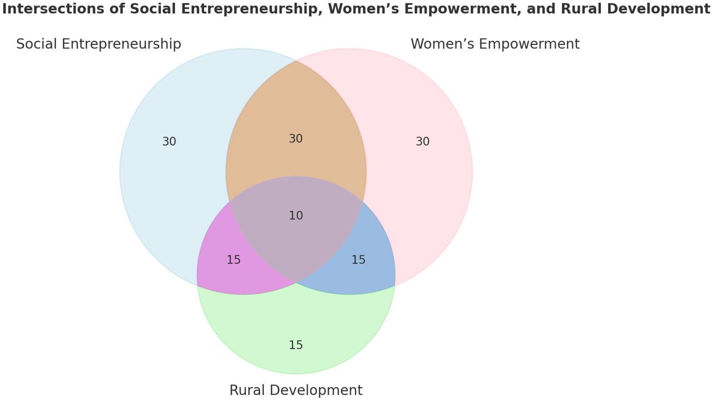
Figure 2: Intersections of Social Entrepreneurship, Women’s Empowerment, and Rural Development
Another critical dimension of social entrepreneurship is its ability to build networks of solidarity.(Roy & Mohanty, 2020) Many women participate through collectives or cooperatives, where peer learning, mutual support, and shared responsibility create a strong foundation for both enterprise sustainability and social empowerment. These collective structures also act as platforms for women to develop leadership skills, challenge traditional gender roles, and gain recognition within their communities. In this sense, social entrepreneurship in rural India is not just about livelihood creation but also about fostering agency, dignity, and social mobility for marginalized women.(S. P. Mishra et al., 2024)
Despite these positive trends, challenges persist. Access to capital, especially beyond microcredit, remains limited for rural enterprises. Many women lack exposure to larger markets, and their enterprises are confined to low-value local demand. Skill gaps in financial literacy, quality control, and business management hinder scalability. Infrastructural bottlenecks such as poor roads, inadequate storage facilities, and weak digital connectivity further restrict growth. Thus, while social entrepreneurship in rural India has demonstrated strong potential, realizing its full transformative power requires sustained support in terms of training, institutional linkages, and enabling policies.(S. P. Mishra et al., 2024)
2.2 Tribal Women and SHGs in Odisha
Odisha, with its rich tribal heritage, provides a unique context for understanding the intersection of social entrepreneurship, women’s empowerment, and rural development. The state has one of the largest populations of Scheduled Tribes in India, many of whom depend on forests, shifting cultivation, and small-scale agriculture for survival. In such settings, women play an indispensable role in household and community economies. They gather minor forest produce such as sal leaves, tamarind, honey, and medicinal plants; cultivate paddy and millets; and engage in local craft traditions. However, despite their immense contribution, tribal women often face systemic disadvantages, including illiteracy, limited access to health services, and exclusion from decision-making processes.
Self-Help Groups (SHGs) have emerged as one of the most effective strategies for improving women’s access to resources and collective agency in Odisha. (Roy & Mohanty, 2020)By pooling small savings, SHGs enable women to create a fund from which members can borrow at low interest rates, reducing dependence on exploitative moneylenders. Over time, many SHGs have transitioned from purely financial collectives into entrepreneurial platforms. Women have initiated a range of enterprises such as leaf-plate making, mushroom cultivation, poultry farming, weaving, pickle and spice processing, turmeric and ginger cultivation, and goat rearing. These activities not only supplement household income but also strengthen women’s bargaining power within their families.(S. P. Mishra et al., 2024)
In Gajapati district, where the majority of the population is tribal, SHGs have taken up enterprises deeply rooted in local resources and traditions. For example, leaf-plate making has become a popular activity because of the abundance of sal leaves in the forests. Similarly, turmeric cultivation has gained prominence as women capitalize on local agro-climatic conditions to produce a crop with high market demand. Poultry rearing and goat farming provide additional income and serve as financial buffers during times of crisis. While these ventures may appear modest in scale, they play a critical role in building resilience against poverty and food insecurity.(Nayak, n.d.)
However, the journey from subsistence activity to sustainable enterprise is far from straightforward. One of the primary challenges faced by tribal women’s SHGs in Odisha is limited market access. Products such as leaf plates or turmeric are often sold to middlemen at low prices, which reduces profit margins and discourages scaling up. (S. N. Biswal et al., 2023; Roy & Mohanty, 2020)Lack of proper storage, transportation, and processing facilities means that many products cannot be marketed in larger urban centers where demand and returns would be higher. Training gaps in areas such as quality control, packaging, branding, and digital literacy also restrict competitiveness.(Roy & Mohanty, 2020)
Infrastructure in remote districts like Gajapati further compounds these challenges. Poor road connectivity makes it difficult for women to transport goods to markets. Inadequate access to electricity and water limits the scope of processing activities. Health and childcare responsibilities also place additional burdens on women, making it difficult for them to devote time consistently to enterprise activities.(Naik & Panda, 2023)
Despite these obstacles, SHGs have demonstrated remarkable resilience and adaptability. Through peer learning and collective action, many groups have been able to innovate and diversify. Women have begun experimenting with value addition, such as producing turmeric powder instead of raw turmeric, or stitching decorative designs on leaf plates to fetch higher prices.(S. P. Mishra et al., 2024) With targeted training and support from government programs, NGOs, and microfinance institutions, such initiatives could be scaled up to significantly enhance women’s income.
More importantly, SHGs in Odisha have created a platform for women’s social empowerment. Meetings, trainings, and collective enterprise management expose women to new ideas and strengthen their confidence. For many tribal women, participation in SHGs represents their first opportunity to engage with institutions such as banks, government offices, or markets. The ability to handle money, interact with officials, and make collective decisions gradually challenges restrictive gender norms. Over time, women gain greater voice not only in household decisions but also in community-level processes.(Lund & Mishra Panda, 2022)
Thus, the experience of SHGs in Odisha reveals both the promise and the limitations of women-led social enterprises. On the one hand, they provide tribal women with access to savings, credit, and livelihood opportunities, while also fostering solidarity and empowerment. On the other hand, their sustainability is constrained by structural barriers such as poor market linkages, infrastructural deficits, and limited skills. Bridging this gap requires a holistic approach that combines financial support with capacity building, infrastructure development, and strong institutional partnerships.(Jena, 2013; PADHI, n.d.)
2.3 Theoretical frameworks
The present study is guided by three interrelated theoretical perspectives that provide a comprehensive lens to examine the dynamics of tribal women’s social entrepreneurship in Gajapati district. These frameworks help in understanding not only the economic dimensions of enterprise but also the broader processes of empowerment, agency, and community development that accompany women’s participation in collective enterprises.(Jena, 2013)
First, the Capability Approach provides a foundational perspective for analyzing women’s empowerment through entrepreneurship. This approach emphasizes the importance of expanding individuals’ real choices and freedoms, rather than measuring development solely through income or material resources. For tribal women in Gajapati, the significance of enterprise extends beyond financial gain.(Jena, 2013; Pattanaik et al., 2025) By participating in income-generating activities, women gain the capability to send their children to school, access healthcare, invest in improved housing, or simply exercise greater autonomy in daily decisions. Thus, enterprise participation is viewed not only as an economic intervention but as a pathway to enhancing women’s substantive freedoms and enabling them to lead lives they value.(Behera, n.d.; Pattanaik et al., 2025)
Second, the Social Capital Theory provides another critical lens for understanding the functioning of Self-Help Groups (SHGs) and collective enterprises. Social capital refers to the networks, trust, norms, and relationships that enable individuals to act together more effectively. In rural and tribal contexts, where formal institutions are often weak, the strength of community ties becomes essential for building and sustaining enterprises. SHGs, by design, cultivate trust among members through collective savings, joint decision-making, and shared responsibilities. These networks reduce transaction costs, facilitate information sharing, and create safety nets that allow women to take calculated risks. In Gajapati, where remoteness and infrastructural deficits limit formal support, the social capital generated within SHGs becomes a powerful enabler of entrepreneurship. It is through these bonds of solidarity that women can negotiate with markets, banks, and government agencies that were previously inaccessible to them.(Pradhan & Patnaik, n.d.)
Third, the Empowerment Framework offers an analytical tool to assess the outcomes of women’s participation in social enterprises. Empowerment is understood here as a process involving access to resources, exercise of agency, and achievement of valued outcomes. For tribal women, access to resources may mean small loans, training, or exposure to markets. Agency is reflected in their ability to make decisions, manage enterprises, and challenge gender norms. Achievements, in turn, include both tangible outcomes such as increased income and intangible ones such as enhanced confidence, recognition, and leadership roles. This framework helps capture the multi-dimensional nature of empowerment, going beyond simplistic economic indicators to include social and psychological transformation.(Mohanty & Das, 2021)
Together, these three frameworks complement one another. The Capability Approach underscores the expansion of women’s freedoms, the Social Capital Theory highlights the role of networks and collective strength, and the Empowerment Framework provides a structured way to measure the process and outcomes of change. When applied collectively, they enable a holistic understanding of how tribal women in Gajapati navigate barriers, mobilize resources, and create new possibilities for themselves and their communities.
Despite the relevance of these frameworks, a notable research gap persists in the literature. While studies have examined SHGs and women’s empowerment in Odisha more broadly, few empirical investigations have been conducted at the block level in Gajapati district. Most existing research focuses on state-level trends or aggregates data across multiple districts, thereby overlooking the unique socio-economic conditions and challenges specific to individual blocks such as Guma, Nuagada, R. Udayagiri, Mohana, Rayagada, and Kasinagar. This study seeks to address that gap by employing a mixed-methods approach that combines quantitative data from 200 tribal women with qualitative insights drawn from field observations and interviews. By grounding the analysis in block-level realities, the research aims to generate nuanced insights that are both academically significant and practically relevant for policy and program design.(Devi & Dhal, 2020)

3. Objectives
The primary objective of this study is to examine the barriers, opportunities, and pathways of social entrepreneurship among tribal women in six blocks of Gajapati district. By focusing on both the challenges and the enabling factors, the study seeks to generate a comprehensive understanding of how women in these communities navigate enterprise activities within the broader socio-economic context.
More specifically, the study aims to map the range of enterprises that tribal women are currently managing, capturing both traditional livelihood practices and emerging entrepreneurial ventures. It further seeks to identify the key barriers that restrict the growth and sustainability of these enterprises, including financial, infrastructural, and socio-cultural constraints. At the same time, the research explores enabling factors such as the role of Self-Help Groups, training programs, government initiatives, and the growing use of digital tools in shaping women’s entrepreneurial journeys. Building on these insights, the study also intends to recommend policy strategies and practical interventions that can strengthen women’s collective enterprises and contribute to their empowerment.

4. Methodology
4.1 Study Area
The present research was conducted in six blocks of Gajapati district in southern Odisha, namely Guma, Nuagada, R. Udayagiri, Mohana, Rayagada, and Kasinagar. These blocks were purposively selected to capture the diversity of socio-economic conditions within the district. Nuagada and Mohana are predominantly remote and forest-dependent regions where communities rely heavily on shifting cultivation, collection of non-timber forest products, and subsistence farming. In contrast, Rayagada and Kasinagar are relatively more connected, with emerging market linkages and semi-urban characteristics that provide some scope for trade and small businesses. Guma and R. Udayagiri represent mixed agricultural zones where both farming and small-scale enterprises coexist. This geographical and socio-economic diversity allows the study to examine tribal women’s entrepreneurship across different contexts, highlighting both commonalities and local variations.(Mohanty & Das, 2021)
4.2 Sampling and Data Collection
The study engaged a total sample of 200 tribal women who were directly involved in entrepreneurial activities, either individually or through Self-Help Groups. A multi-stage purposive sampling method was adopted to ensure adequate representation of enterprise types, block-level variations, and household conditions. At the first stage, active SHGs across the six blocks were identified with the help of local facilitators and community leaders. From these groups, women who were managing or participating in small enterprises such as leaf-plate making, poultry, spice cultivation, or petty trade were selected. Households engaged in enterprise outside formal SHG structures were also included to capture a wider spectrum of entrepreneurial experiences.(Pattanaik et al., 2025)
Data collection relied on both quantitative and qualitative methods to ensure depth and reliability. Structured questionnaires were administered to all 200 respondents to generate quantitative information on enterprise type, income levels, barriers faced, and support systems accessed. To complement this, 30 semi-structured interviews were conducted with selected women entrepreneurs, providing richer narratives about their motivations, struggles, and achievements. In addition, six focus group discussions (one in each block) were organized to capture collective perspectives, peer learning experiences, and shared community challenges. This triangulation of methods enabled a more holistic understanding of women’s social entrepreneurship in Gajapati.(B. Mishra, 2018; Patnaik, 2016)
4.3 Data Analysis
The collected data were analysed using a combination of quantitative and qualitative approaches. Quantitative data from the questionnaires were processed using descriptive statistics to map enterprise types, income variations, and participation patterns across blocks. Block-wise comparisons were made to highlight geographical differences in opportunities and constraints. In addition, chi-square tests were applied to examine associations between categorical variables such as enterprise type and barriers encountered.
On the qualitative side, interview transcripts and focus group discussions were subjected to thematic coding. Emerging themes such as financial barriers, social constraints, role of SHGs, training needs, and empowerment outcomes were identified and analysed through narrative techniques. This allowed the study to integrate statistical trends with lived experiences, creating a balanced account that reflects both measurable patterns and subjective realities of tribal women entrepreneurs.
4.4 Ethical Considerations
Ethical sensitivity was prioritized throughout the research process. Written or verbal consent was obtained from all participants after explaining the purpose and scope of the study in accessible terms. For respondents with limited literacy, consent was taken verbally in the presence of community witnesses. Interviews and discussions were conducted in local languages, with the assistance of interpreters where necessary, to ensure clarity and comfort for participants. Confidentiality was maintained by anonymizing data and avoiding disclosure of personal identifiers. The study also respected cultural norms and community protocols, conducting discussions at times and locations convenient to the women and ensuring that their participation was voluntary. These measures helped to build trust and foster genuine engagement with the respondents, making the research both ethically sound and contextually sensitive.(B. Mishra, 2018)
5. Results
5.1 Socio-Demographic Profile
The socio-demographic characteristics of the respondents provide important context for understanding women’s participation in social enterprises. The majority of the women interviewed were in the age group of 25 to 45 years, reflecting the active working-age population that is typically engaged in livelihood activities. Education levels were found to be modest, with nearly half of the respondents (48%) reporting primary education, while 18 percent were illiterate. Secondary and higher levels of education were limited, highlighting the educational disadvantage faced by tribal women in Gajapati district.(Empowerment & Improvement, 2023) The average household size was 5.3 members, consistent with the joint family patterns prevalent in tribal societies. Landholding patterns showed that 62 percent of respondents were marginal farmers owning less than one acre of land, reinforcing their dependence on supplementary income from small-scale enterprises.
Block Name | Respondents (n) | Age group 25 to 45 (%) | Illiterate (%) | Primary education (%) | Secondary & above (%) | Average household size | Marginal farmers (<1 acre) (%)
Nuagada | 35 | 68 | 24 | 52 | 24 | 5.7 | 74
Mohana | 32 | 65 | 21 | 49 | 30 | 5.5 | 70
R.Udayagiri | 33 | 70 | 15 | 50 | 35 | 5.3 | 61
Guma | 34 | 66 | 16 | 46 | 38 | 5.2 | 60
Rayagada | 33 | 72 | 10 | 45 | 45 | 5 | 53
Kasinagar | 33 | 69 | 11 | 47 | 42 | 5.1 | 55

Table 1: Socio-demographic profile of different blocks
5.2 Types of Enterprises
The types of enterprises varied across the six blocks, reflecting differences in resource availability, local skills, and market linkages. In the remote blocks of Nuagada and Mohana, women were primarily engaged in traditional forest and agro-based enterprises such as leaf-plate making, preparation of millet-based foods, turmeric and ginger processing, and weaving. In the mixed agricultural blocks of Guma and R. Udayagiri, women had diversified into small-scale livestock and allied activities such as poultry farming, goat rearing, mushroom cultivation, and running petty shops.(A. Acharya, 2015; S. P. Mishra et al., 2024) In the relatively better-connected blocks of Rayagada and Kasinagar, women’s collectives showed stronger engagement in semi-urban enterprises such as tailoring, handicraft production, papad and pickle units, and vegetable vending in local markets. This distribution highlights how enterprise choices are shaped by both ecological resources and infrastructural conditions.
Block Name | Major Enterprises
Nuagada | Leaf-plate making, millet foods, turmeric & ginger processing, weaving
Mohana | Leaf-plate making, millet foods, turmeric & ginger processing, weaving
R. Udayagiri | Poultry, goat rearing, mushroom cultivation, and petty shops
Guma | Poultry, goat rearing, mushroom cultivation, and petty shops
Rayagada | Tailoring, handicrafts, papad/pickle units, vegetable vending
Kasinagar | Tailoring, handicrafts, papad/pickle units, vegetable vending

Table 2: Enterprise types by different blocks
5.3 Barriers
Despite their active engagement in enterprises, women across the district reported facing significant barriers. Access to finance emerged as the most critical constraint, with 70 percent of respondents noting inadequate access to credit for scaling up their activities. Market-related challenges were also prominent, with 65 percent of women depending heavily on middlemen to sell their products, which reduced profit margins and limited bargaining power. (S. P. Mishra et al., 2024)Skill and knowledge gaps persisted, as 55 percent of respondents had never received formal training in entrepreneurship or business management. Social barriers also restricted opportunities; around 40 percent of women indicated limitations on mobility, as cultural norms and family responsibilities often prevented them from traveling outside their villages to explore better markets. Infrastructural bottlenecks, such as poor road connectivity, a lack of storage facilities, and limited access to transport, were reported across all six blocks, further constraining enterprise growth.
Block | Finance (% lacking credit) | Market dependence on middlemen (%) | No formal training (%) | Mobility restrictions (%) | Infrastructure constraints (reported %)
Nuagada | 75 | 70 | 60 | 45 | 100
Mohana | 72 | 68 | 58 | 44 | 100
R. Udayagiri | 68 | 66 | 55 | 40 | 100
Guma | 69 | 64 | 54 | 38 | 100
Rayagada | 65 | 62 | 50 | 35 | 100
Kasinagar | 63 | 61 | 48 | 34 | 100

Table 3: Barriers reported by block
5.4 Enabling Factors
Alongside these barriers, several enabling factors were identified that facilitated women’s entrepreneurial efforts. Self-Help Groups played a foundational role by providing access to savings, credit, and collective platforms for enterprise management. NGO interventions, particularly in Mohana and Nuagada, offered skill-development programs in areas such as food processing and weaving, which helped women diversify their activities. Technology also emerged as an enabling factor, though unevenly distributed. About 38 percent of respondents reported access to smartphones, which they used for communication and, in some cases, for sales through WhatsApp groups and digital marketplaces. This trend was especially visible in the relatively better-connected blocks of Rayagada and Kasinagar, where digital access supported women in reaching customers beyond their immediate communities.
5.5 Impact on Empowerment
The impact of enterprise participation on women’s empowerment was reflected in both economic and social dimensions. In terms of income, the average monthly earnings from enterprises ranged between ₹2,000 and ₹5,000, depending on the scale and type of activity. While modest, these earnings made an important contribution to household budgets, often covering food, school expenses, or healthcare needs. Beyond financial outcomes, women reported significant shifts in their social roles and personal confidence. About 62 percent of respondents noted that their participation in enterprises had enhanced their decision-making power within the household, particularly in matters related to children’s education, household expenditure, and savings.(Padhee, 2010; Pathi et al., 2021) Nearly half of the women (47%) reported improved self-confidence and recognition within their families and communities. These findings suggest that while economic benefits remain limited, the empowerment effects of social entrepreneurship are substantial, particularly in enhancing agency and social visibility.
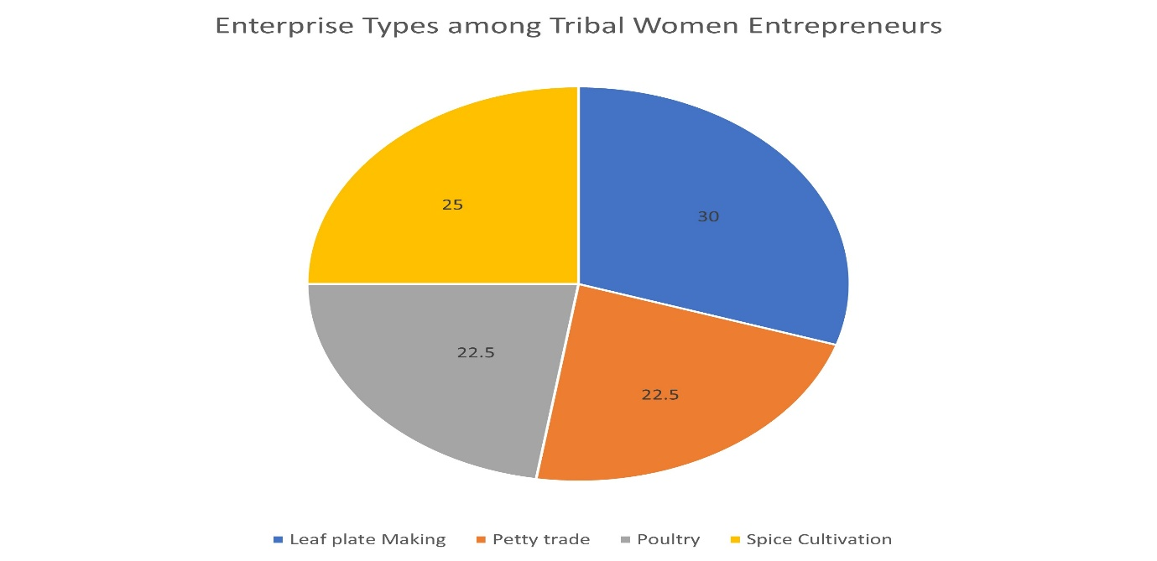
Figure 3: Explaining Enterprise Types among Tribal Women Entrepreneurs
6. Discussion
The study reveals that enterprises managed by tribal women in Gajapati district are generally small in scale and largely survival-oriented, reflecting the modest resources and limited opportunities available to them. While most ventures begin as extensions of household or community-based activities, they nonetheless demonstrate strong potential for growth when provided with the right support systems. A closer look at block-level variations highlights important differences in enterprise patterns. In the more market-linked blocks of Rayagada and Kasinagar, women have been able to diversify into activities such as tailoring, handicrafts, papad and pickle units, and vegetable vending, which connect more directly with semi-urban demand. In contrast, the forest-dependent blocks of Nuagada and Mohana are characterized by enterprises rooted in local ecological resources, such as leaf-plate making, millet-based foods, and turmeric and ginger processing. These products, while traditional and eco-friendly, carry significant untapped market potential if linked effectively with wider value chains. The agricultural blocks of Guma and R. Udayagiri occupy an intermediate position, where women’s activities combine livestock rearing, mushroom cultivation, and small petty shops, balancing subsistence and market-oriented livelihoods.
Three key insights emerge from this analysis. First, Self-Help Groups (SHGs) continue to serve as highly effective entry platforms for women to access credit, build solidarity, and begin entrepreneurial activities. However, the SHG model alone remains insufficient for scaling up enterprises to sustainable levels, particularly when it comes to accessing larger markets or expanding production. Second, existing financial products are poorly aligned with the needs of tribal women entrepreneurs. Credit flows remain small, irregular, and often burdened with repayment schedules that do not match seasonal income patterns, creating stress rather than support. Third, digital technologies are beginning to create new opportunities, as evidenced by the use of smartphones and WhatsApp for small-scale sales in Rayagada and Kasinagar. Yet, these opportunities remain limited by low levels of digital literacy, inadequate logistics for delivery, and weak internet connectivity in remote areas.
Taken together, the findings suggest that while tribal women’s enterprises currently operate at a basic survival level, they represent important seeds of transformation. With targeted interventions in finance, market linkages, capacity building, and digital inclusion, these small ventures can evolve into resilient social enterprises that not only enhance women’s incomes but also contribute to sustainable and inclusive development in Gajapati district.

8. Conclusion
The study highlights that tribal women in Gajapati district are engaged in a wide range of entrepreneurial activities, ranging from forest-based products like leaf plates, turmeric, and millet foods to livestock rearing, tailoring, handicrafts, and petty trade. These enterprises reflect both the resource base of the region and the resilience of women who strive to support their households despite limited means. However, the analysis also shows that systemic barriers—such as inadequate access to finance, poor market linkages, low levels of training, infrastructural deficits, and restrictive social norms—prevent these ventures from moving beyond subsistence levels.
At the same time, the findings make it clear that there is strong potential for growth if appropriate institutional and policy support is provided. Strengthening Self-Help Groups and federations, designing gender-sensitive financial products, expanding digital inclusion, and developing structured value chains for local resources can transform these small-scale efforts into sustainable enterprises. Such interventions would not only generate stable incomes but also expand women’s choices, enhance their decision-making power, and increase their visibility in both households and communities.
Ultimately, the strengthening of tribal women’s entrepreneurship must be understood not only as an economic imperative but also as a critical pathway to empowerment and inclusive development. By enabling tribal women to build viable enterprises, policymakers and development practitioners can contribute to breaking cycles of marginalization and fostering more resilient, equitable, and sustainable communities in regions such as Gajapati.

7. Policy Recommendations
The findings of this study point to the need for targeted and context-sensitive policy interventions to strengthen the entrepreneurial ecosystem for tribal women in Gajapati district. A priority is to strengthen existing Self-Help Groups by federating them into larger producer collectives. While SHGs serve as effective entry points, their small size often limits market access and bargaining power. Federations can enable bulk procurement of raw materials, collective branding, and better negotiation with buyers, thereby improving sustainability.
Second, the establishment of block-level resource centres would provide much-needed training and capacity building. These centres could focus on skill development in packaging, branding, quality assurance, and digital literacy skills that are currently beyond the reach of most tribal women but are essential for scaling up enterprises.(Padhee, 2010)
Third, financial support mechanisms need to be redesigned in a gender-sensitive manner. Many women face difficulty accessing formal credit due to collateral requirements and rigid repayment structures. Introducing collateral-free loans, flexible repayment schedules aligned with seasonal incomes, and low-interest credit products would make finance more accessible and supportive of women’s entrepreneurial needs.
Fourth, there is a strong case for developing structured value chains for non-timber forest products (NTFPs) such as turmeric, ginger, and millet, which are abundant in forest-dependent blocks like Nuagada and Mohana. By facilitating aggregation, processing, certification, and marketing, these value chains can transform locally available products into high-value commodities in regional and national markets.
Fifth, digital platforms need to be leveraged more effectively for marketing and payments. Expanding access to smartphones, improving internet connectivity, and providing digital literacy training can help women bypass middlemen and reach customers directly. Integrating logistics solutions with these platforms would further enhance their effectiveness.(Pradhan & Patnaik, n.d.)
Finally, policy efforts must address the social barriers that restrict women’s mobility and participation. Community-level gender sensitization programs can play an important role in challenging restrictive norms, fostering supportive family environments, and encouraging men to share domestic responsibilities. Only when these cultural constraints are reduced will women be able to fully exercise their agency and take advantage of economic opportunities.
Together, these measures can create an enabling ecosystem that moves tribal women’s enterprises beyond survival strategies and towards sustainable, scalable social entrepreneurship.

COMPETING INTERESTS DISCLAIMER:
Authors have declared that they have no known competing financial interests OR non-financial interests OR personal relationships that could have appeared to influence the work reported in this paper.

References
Acharya, A. (2015). Socio-Cultural Constraints Of Economic Development In Rural Odisha.
Acharya, S. (2018). Empowering tribal women through entrepreneurship: A study of self help groups in Gajapati district of Odisha. Indian Research Journal of Extension Education, 18(2), 26–30.
Behera, K. (n.d.). Education is an Essential Tool for Survivality: An Empirical Study of Transgender in Kandhamal District of Odisha. Dr. Rashmi Pramanik, 275.
Biswal, S. (2013). Elementary education of tribal girls’ in odisha: problems and prospects. Department of Sociology, School of Social Sciences and International Studies ….
Biswal, S. N., Mishra, S. K., & Sarangi, M. (2023). Does Women’s Empowerment Influence Multidimensional Poverty? Empirical Insight from Rural Odisha of India. Pertanika Journal of Social Sciences & Humanities, 31(2).
Devi, S. K., & Dhal, N. (2020). Socio-economic Initiative of the Government and its efficacy on Tribal Women. International Journal of Recent Technology and Engineering (IJRTE).
Empowerment, O. P. T. G., & Improvement, L. (2023). Programme (OPELIP).
Jena, S. K. (2013). Indigenous Knowledge Innovation (IKI)–An Approach for Sustainable SMEs in Handicraft Sectorof KBK Districts of Odisha.
Kumar, P. P. (2016). REGIONAL DISPARITY IN DEVELOPMENT OF ODISHA ECONOMY: CHALLENGES AND WAY FORWARD. Alatoo Academic Studies, 4, 185–201.
Lund, R., & Mishra Panda, S. (2022). Encountering and Engaging with Modernity: Vulnerability and Exclusion of Youth in Odisha. In Social Exclusion and Policies of Inclusion: Issues and Perspectives Across the Globe (pp. 175–191). Springer.
Mishra, B. (2018). Social Exclusion and Household Poverty among the Vulnerable Tribal Groups in Odisha. IASSI-Quarterly, 37(1), 90–107.
Mishra, S. P., Mishra, D. P., & Mohapatra, S. (2024). Women empowerment gaining right trajectory: a perspective from MSME, Odisha, India. Journal of Economics, Management and Trade, 30(3), 10–29.
Mohanty, B., & Das, S. (2021). Regional Disparity and Women in Local Government: Implications for Sustainable. Women Reinventing Development: The Odisha Experience, 41, 1–210.
Naik, B., & Panda, S. (2023). Empowerment of tribal communities through innovation and entrepreneurship: A path to sustainable progress. International Journal of Research and Review, 10(11), 334–343.
Nayak, S. (n.d.). Empowering Tribal Women in India: Issues, Constraints & Challenges.
Padhee, U. (2010). Implementation of the Livelihood Policies in the Extremist affected areas: A case study of the Orissa Tribal Empowerment and livelihood Programme in the Left-wing Extremism (Naxalism) affected districts of Orissa state, India. India (Doctoral Dissertation, Doctoral Dissertation, University of Birmingham).
PADHI, A. (n.d.). GENDER INVOLVEMENT IN AGRICULTURE AND ALLIED ACTIVITIES IN RAYAGADA DISTRICT OF ORISSA.
Patel, A., & Giri, J. (2019). Climate change, migration and women: analysing construction workers in Odisha. Social Change, 49(1), 97–113.
Pathi, P., Pathi, M., Mahanta, K., & Santakar, C. (2021). Documentation & Video Documentation of Success Stories of Selected Tribal Development Schemes of Past 3 Years on Storyline Platform.
Patnaik, C. P. (2016). Self Help Group, Micro Entrepreneurship & Women Empowerment in Gajapati District of Odisha. International Journal of Innovative Research & Practices.
Pattanaik, K., Mohapatra, S. S., Jasmine, J., & Das, S. (2025). Gender-Integrated Sustainable Livelihoods for Rural India. Women Empowerment in Agriculture: A Pathway Towards Sustainable Development, 314.
Pradhan, S. K., & Patnaik, J. (n.d.). Entrepreneurial Empowerment of Tribal Women through Self Help Groups in Gajapati District of Odisha.
Roy, S., & Mohanty, R. P. (2020). Microfinance models in improving’quality of life’: empirical analysis on Indian perspective. International Journal of Business Innovation and Research, 21(1), 23–55.

