Constructing a Collaborative Ecosystem for Holistic Student Development in Higher Education: Integrating Logistics, Student Affairs, and Digital Governance

.
ABSTRACT

The increasing complexity of student needs and the acceleration of digital transformation in higher education have revealed critical limitations in traditional student development models. Typically fragmented across logistics, student affairs, and information technology systems, these subsystems often lack integration, resulting in inefficient service delivery and disjointed student support. This study proposes a triadic collaborative framework that unifies these subsystems into a cohesive ecosystem for holistic student development. Drawing on theories of educational ecology, holistic governance, and smart campus design, the framework emphasizes three integration pathways: shared vision alignment, structural coupling, and operational coordination. Through this lens, the paper analyzes institutional barriers—including functional misalignment, data silos, governance inertia, and professional discourse gaps—that undermine effective collaboration. It also presents actionable strategies such as redesigning performance incentives, establishing interoperable digital infrastructures, and cultivating a culture of cross-functional engagement. This integrative model provides strategic insights for universities aiming to build student-centered, data-informed governance structures. The findings hold particular relevance for institutions navigating digital transformation while seeking to enhance whole-person education in the post-pandemic era.

Keywords: Higher education governance, Collaborative student development, Smart campus, System integration, Digital transformation

1. INTRODUCTION

In recent years, the governance of higher education has undergone a profound transformation, driven by both policy imperatives for integrated student support and the accelerating adoption of digital technologies(Shen, 2023; Wu et al., 2024;Palma et al., 2023). The traditional approach—where logistics, student affairs, and information systems operated in silos—has proven increasingly inadequate in meeting the evolving and multidimensional needs of students (Ling et al., 2022; Metsäpelto et al., 2022;Bai et al., 2025). These divisions often result in duplicated efforts, fragmented interventions, and missed opportunities to support students holistically throughout their academic journey.At the same time, the vision of “all-staff, all-process, and all-domain education” has become a strategic directive across many universities, particularly in China and other East Asian contexts. However, realizing this vision requires more than rhetorical alignment; it demands a structural rethinking of how various subsystems within the university contribute to student development—not as auxiliary service providers, but as integral parts of an interconnected ecosystem (Xiang et al., 2024; Liu et al., 2021). Existing literature has highlighted the potential of smart campuses and AI-enabled platforms to reshape education delivery and institutional governance (Wang et al., 2024; Hou, 2024). However, research on how non-academic subsystems—such as logistics, student support services, and IT infrastructure—can be integrated into a coherent governance model for student development remains limited (Flori et al., 2025). Few studies have examined how to overcome entrenched institutional boundaries, incompatible data systems, or the lack of shared educational responsibility among departments (Zhao et al., 2023; Liu, 2024).

This paper addresses that gap by constructing a triadic framework that integrates logistics, student affairs, and information systems into a collaborative student development ecosystem. Drawing on educational ecology and holistic governance theories, it explores the underlying logic of inter-system integration, analyzes institutional tensions in current practices, and proposes actionable strategies for building a coordinated and data-driven student support model (Afzaal et al.,2021; Gil et al., 2021). In doing so, it seeks to move beyond technical integration and toward a cultural, structural, and procedural transformation of the university as a developmental community.

2. Theoretical Framework

This study is grounded in three interrelated theoretical perspectives: educational ecology, holistic governance, and smart campus architecture. Together, they offer a conceptual lens for understanding how diverse subsystems within a university can be integrated to serve a shared developmental goal.

（1）Educational ecology, first proposed by Bronfenbrenner (1979) and later adapted for institutional environments, views student development as a product of dynamic interactions across multiple nested systems. Within a university, this includes not only academic instruction, but also the socio-technical environments formed by logistics, administration, and digital platforms. Ecological thinking urges a shift from linear, input-output models of education to complex, system-oriented frameworks that emphasize interaction, adaptation, and feedback.

（2）Holistic governance extends this systems perspective into the realm of institutional design and decision-making. Rather than treating governance as the domain of formal administrative hierarchies, holistic governance emphasizes the coordination of actors, processes, and information flows across functional boundaries. It is particularly relevant in the context of higher education, where departmental autonomy often leads to governance fragmentation and accountability silos (Hou, 2024; Liu, 2023).

（3）Smart campus architecture provides the technological infrastructure necessary for such integration. Drawing from advances in AI, big data, and cloud computing, smart campus models aim to centralize services, personalize learning, and optimize operations through real-time data processing and predictive analytics (Wang et al., 2024; Su, 2023；Lin, 2020). However, the deployment of smart technologies alone does not guarantee coordination. Without institutional alignment and shared educational values, digital platforms risk becoming isolated tools rather than catalysts for systemic change.

By weaving these three perspectives together, this study constructs an analytical framework for diagnosing fragmentation in current student development systems and for designing integrative strategies that are both technologically supported and institutionally sustainable.

3. Fragmentation and Coordination Challenges Integration Pathways for a Collaborative Student Development Ecosystem

Despite growing consensus on the importance of whole-person education, many universities continue to operate under governance structures that separate student development into isolated administrative functions. Logistics departments, student affairs offices, and information centers often operate independently, each guided by distinct priorities, technologies, and evaluation metrics. This institutional segmentation results in disjointed services, inefficient information flows, and an overall lack of coherence in addressing student needs.

One core challenge lies in the disalignment of functional logics. While logistics prioritizes service efficiency and cost control, student affairs emphasizes moral development and emotional support, and IT departments focus on technical stability and security. The absence of a unified educational vision leads to role confusion, duplicated interventions, or worse, gaps in support—especially in complex student cases involving health, behavior, or academic risk.Another barrier is the lack of integrated data systems. Although many campuses have adopted digital platforms for student records, facility management, and early warning systems, these tools often lack interoperability. Data silos emerge when departments restrict access, use incompatible formats, or fail to develop shared indicators of student development(Li & Zhang, 2024). Consequently, the capacity for holistic decision-making—such as identifying at-risk students based on behavioral patterns across systems—remains limited (Zhao et al., 2024; Liang, 2023).Organizationally, the absence of cross-functional coordination mechanisms also hinders collaboration. Meetings across departments are rare or perfunctory, and shared governance bodies for student development are often symbolic rather than functional. Without institutionalized processes for horizontal dialogue and joint accountability, most coordination depends on informal relationships or temporary taskforces, which lack continuity and authority.Finally, the professional discourse gap between departments makes collaboration even harder. Different systems develop distinct terminologies, epistemologies, and standards of judgment, making it difficult to form common interpretations of student needs or appropriate interventions. In some cases, educational work is narrowly understood as the responsibility of teachers or counselors, sidelining other actors who interact with students daily.

Together, these challenges illustrate how structural fragmentation undermines the promise of integrated student development and underscore the urgent need for a cohesive framework that bridges institutional, technical, and cognitive divides.

4. Integration Pathways for a Collaborative Student Development Ecosystem

Creating an integrated student development ecosystem requires more than co-locating departments or deploying shared platforms. It demands a reconfiguration of how institutions define educational responsibility, how subsystems interact structurally, and how processes align in practice. Based on the diagnosis of fragmentation, this study proposes a three-layered pathway toward integration: shared vision alignment, structural coupling, and operational coordination (Wang & Zhao, 2024).

The first layer centers on establishing a shared developmental vision across departments. While logistics, IT services, and student affairs may differ in their functional focus, they all contribute—directly or indirectly—to students’ learning environments and life experiences. A collaborative ecosystem begins with recognizing this shared purpose and cultivating a common language that frames all work through the lens of student growth. This does not require eliminating departmental distinctions, but rather reorienting them around a unifying educational mandate.

The second layer involves reconfiguring organizational structures and workflows to promote systemic connectivity. This may include creating hybrid teams that bring together staff from logistics, counseling, and IT to co-design support strategies; integrating key performance indicators (KPIs) that reflect cross-departmental outcomes; and establishing liaison roles that mediate between systems. Structural integration is not merely a managerial task—it also shapes how professionals perceive their roles and responsibilities within the broader institutional mission.

The third layer focuses on building agile and responsive coordination mechanisms. Effective integration requires real-time data sharing, streamlined communication channels, and reflexive protocols that allow for timely joint interventions. For instance, when early warning signs emerge—such as abnormal dormitory access patterns or declines in digital engagement—systems must respond collaboratively to diagnose and support students. Coordination should be embedded not just in crisis response, but in ongoing developmental planning and monitoring.

Ultimately, the goal is to create an institutional environment in which support for student development is not confined to any single unit, but distributed across a well-synchronized ecosystem. Integration, in this sense, is not a one-time reform, but an ongoing institutional learning process—one that evolves as student needs change and new tools become available.The proposed integration framework can be visualized through a triadic pathway model that connects shared vision, structural coupling, and operational coordination (Fig. 1).
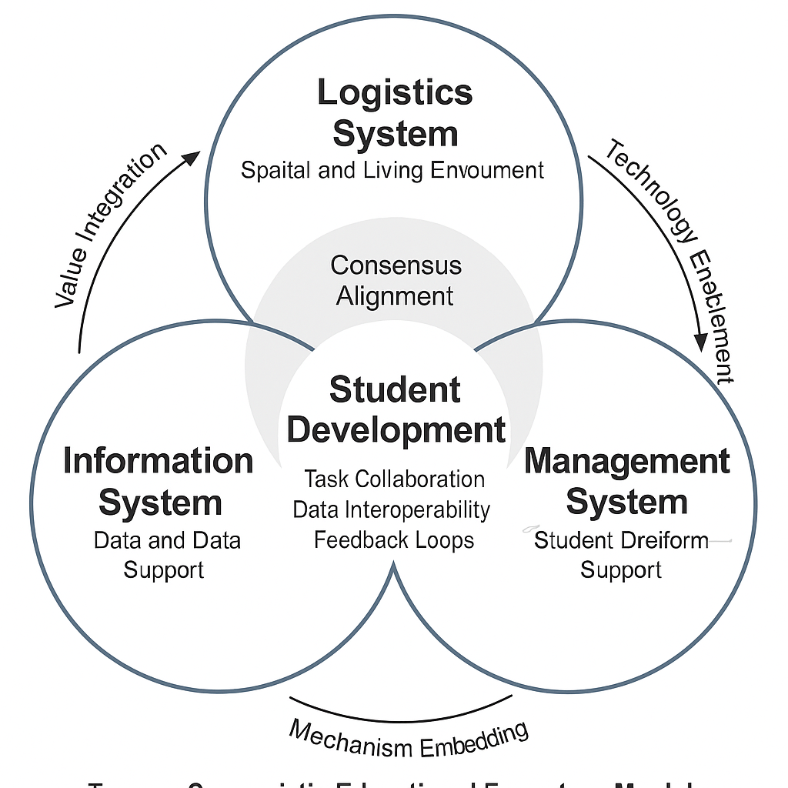

Fig. 1. Integration Pathway for Collaborative Student Development Ecosystem

5. Risks and Implementation Barriers

While the rationale for integration is widely acknowledged, the implementation of a collaborative student development ecosystem is fraught with practical difficulties and institutional resistance. These challenges differ from the previously discussed structural fragmentation; they emerge dynamically during reform attempts, often rooted in path dependencies, professional boundaries, and governance inertia(Han, 2023).

One major barrier is goal misalignment across departments. Although most agree on the overarching aim of student-centered education, different units operationalize this goal in conflicting ways. Logistics departments prioritize efficiency and safety; student affairs emphasize emotional growth and moral development; IT teams focus on system stability and data security. Without a mechanism to reconcile these competing logics, collaborative initiatives often stall at the planning stage or devolve into parallel actions.A second challenge lies in institutional resistance to resource redistribution. Integrated ecosystems require cross-departmental sharing of personnel, budgets, data, and responsibilities. Yet existing systems are often organized around strict lines of administrative control, making any shift toward shared governance a potential threat to established power structures. Reallocation of resources—especially data access and staffing—can trigger defensive responses from departments that fear loss of autonomy or performance visibility.From a technical standpoint, data integration remains a persistent hurdle. Although most universities now have digital platforms for various services, these systems often lack interoperability. Legacy systems, incompatible data formats, and restricted access protocols create informational silos that hinder joint analysis and coordinated intervention. The absence of shared indicators of student well-being further limits data-driven governance.Cultural and communicative barriers also complicate collaboration. Professional discourse divergence—where departments use different vocabularies, norms, and evaluation criteria—makes it difficult to develop mutual understanding or trust. Even when goals are aligned on paper, differing assumptions about what constitutes “student success” or “effective support” can lead to miscommunication and fragmented action.Finally, institutional incentives rarely reward cross-functional collaboration. In most universities, performance evaluations and promotions are tied to departmental metrics. There are few formal mechanisms for recognizing or incentivizing collaborative behavior. Without dedicated time, resources, and symbolic recognition, frontline staff are unlikely to invest in initiatives that fall outside their immediate job scope.

These implementation barriers highlight the importance of designing not only integration plans, but also supportive infrastructures—both material and cultural—that enable sustained cross-system collaboration.

- Strategic Recommendations

Building a truly effective collaborative student development ecosystem requires more than technical interoperability or administrative mandates. It calls for deep structural adjustments, cross-cultural understanding, and sustained institutional commitment. Based on the integration pathways proposed earlier and the risks identified, the following recommendations are offered to guide implementation (Xu, 2024).

6.1 Institutionalize shared governance mechanisms.
Establish formal structures that bring together representatives from logistics, student affairs, and information technology on a regular basis. Rather than relying on ad hoc taskforces or informal coordination, universities should embed joint decision-making bodies into their governance architecture. These structures should have clearly defined responsibilities, access to relevant data, and the authority to make cross-departmental policy adjustments.

6.2 Redesign evaluation and incentive systems.
To overcome motivational barriers, institutions must revise performance metrics to recognize collaborative contributions. This can include cross-departmental KPIs, shared accountability for student outcomes, and reward systems that value inter-unit cooperation. Without such incentives, collaboration risks remaining a rhetorical commitment rather than a practical norm.

6.3 Build interoperable digital infrastructures.
Universities should prioritize the development of open data standards, cross-platform APIs, and unified data governance protocols. This includes designing dashboards that integrate behavioral, logistical, and engagement data to provide a multidimensional view of student well-being. Emphasis should also be placed on data privacy, consent, and ethical use—especially as predictive analytics and AI become more prevalent.

6.4 Promote inter-professional learning and communication.
Departments must learn to speak with, rather than past, each other. Institutions can foster this by organizing workshops, joint training programs, and staff rotation schemes that encourage shared understanding and mutual respect. Creating a common vocabulary around student development—grounded in institutional values—can help reduce professional silos and cognitive dissonance.

6.5 Encourage pilot programs and institutional experimentation.
Rather than aiming for immediate large-scale transformation, universities should support localized pilot projects that test new models of integration. These can serve as “safe zones” for innovation, allowing teams to experiment, iterate, and scale successful practices. Crucially, such pilots must be supported by leadership and accompanied by mechanisms for feedback and learning.

Together, these strategies aim to move beyond surface-level integration and foster the kind of cultural and institutional transformation required for sustainable, student-centered governance in the digital era.

7. Conclusion and Future Research Strategic Recommendations

As universities face mounting pressure to deliver holistic, student-centered education in an increasingly complex and digital environment, the integration of logistics, student affairs, and information systems has become not only desirable but essential. This paper has argued that student development must be understood as a systemic endeavor—one that transcends traditional administrative boundaries and reimagines support functions as active participants in the educational mission.

Drawing on theories of educational ecology, holistic governance, and smart campus design, the study has outlined a conceptual framework for constructing a collaborative student development ecosystem. It has identified key barriers to integration, including goal misalignment, data fragmentation, institutional inertia, and professional silos. In response, it has proposed a multi-layered strategy that encompasses governance reform, incentive restructuring, technological interoperability, and cultural transformation.

While the framework provides a theoretical foundation and strategic roadmap, several limitations remain. The analysis is primarily conceptual and would benefit from empirical validation across diverse institutional contexts. Future research should explore how these integration models operate in practice—especially in terms of student outcomes, staff engagement, and long-term institutional adaptability. Comparative studies across cultural and governance regimes could further enrich the understanding of what enables or hinders ecosystemic collaboration in higher education.Ultimately, the transition toward integrated student development is not a linear process, nor is it a purely technical challenge. It requires a paradigm shift in how universities understand their own internal ecology—a shift from managing systems in parallel to orchestrating them in concert for the benefit of student flourishing.

COMPETING INTERESTS DISCLAIMER:
Authors have declared that they have no known competing financial interests OR non-financial interests OR personal relationships that could have appeared to influence the work reported in this paper.

References

- Bronfenbrenner, U. (1979). The ecology of human development: Experiments by nature and design. Harvard University Press.
- Han, G. (2023). Management innovation and student support strategies in Chinese universities. Journal of Modern Higher Education Management, 15(2), 45–58.
Hou, H. (2024). Holistic governance in the era of generative AI: Toward integrative institutional transformation. AI & Society, 39(1), 22–38.
- Li, N., & Zhang, Q. (2024). Cybersecurity frameworks for higher education in the era of big data. Chinese Journal of Information Security, 20(3), 66–75.
Liang, Q. (2024). Smart libraries and data governance in Chinese universities: Pathways and prospects. Education and Information Technologies, 29(3), 255–274.
- Lin, S. (2020). Evolution of university logistics research in China: Cooperation, development, and future directions. Research on Higher Education Logistics, 10(4), 12–25.
- Liu, J. (2024). Algorithmic governance in higher education: Spatial logic and risk mitigation. Smart Education and Society, 9(2), 76–90.
- Shen, N. (2023). Digitally empowered university governance: Structures and pathways. Digital Higher Education Studies, 8(1), 41–56.
Su, X. (2023). Exploring AI-powered smart campus models: Practice and possibilities. Modern Distance Education Research, 3(2), 21–34.
- Wang, S., & Zhao, J. (2024). Lab-based student safety governance in smart campus contexts. Higher Education Laboratory Management, 12(1), 11–27.
- Wang, S., Zhao, J., & Lin, X. (2024). Building digital twins for intelligent campus management: Insights from recent university cases. Smart Learning Environments, 11(1), 1–19.
- Xu, Y. (2024). Digital technology and ideological-political education in Chinese universities. Technology and Ideological Education, 5(2), 65–81.
- Zhao, J., Liu, W., & Li, Y. (2024). Visual analytics and data governance in smart campus systems: Enhancing education management through big data. Journal of Educational Technology Development, 19(1), 44–58.
- Ling, X., Chen, J., Chow, D. H., Xu, W., & Li, Y. (2022). The “trade-off” of student well-being and academic achievement: A perspective of multidimensional student well-being. Frontiers in psychology, 13, 772653.
- Metsäpelto, R. L., Poikkeus, A. M., Heikkilä, M., Husu, J., Laine, A., Lappalainen, K., ... & Suvilehto, P. (2022). A multidimensional adapted process model of teaching. Educational assessment, evaluation and accountability, 34(2), 143-172.
- Bai, J., Chen, W., Niu, H., Zhu, Q., Zhao, X., & Dong, Y. (2025). Multidimensional factors of depressive symptoms among Chinese undergraduate students: a cross-sectional study using binary logistic regression. Frontiers in Psychiatry, 16, 1546197.
- Xiang, Y., Ma, Y., Ji, M., & Su, Y. (2024). Interconnected knowledge: Examining the evolution of graduate student innovation ecosystems. Journal of the Knowledge Economy, 15(3), 14036-14075.
- Liu, H., Kulturel-Konak, S., & Konak, A. (2021). Key elements and their roles in entrepreneurship education ecosystem: Comparative review and suggestions for sustainability. Sustainability, 13(19), 10648.
- Wu, C., Zhang, H., & Carroll, J. M. (2024). AI governance in higher education: Case studies of guidance at big ten universities. arXiv preprint arXiv:2409.02017.
- Palma, A., Mourato, J., Vinagre, J., Almeida, F., & Pessoa, A. M. (2023). Student Participation: Issues for the Governance of Higher Education. Societies, 13(5), 115.
- Afzaal, M., Nouri, J., Zia, A., Papapetrou, P., Fors, U., Wu, Y., ... & Weegar, R. (2021). Explainable AI for data-driven feedback and intelligent action recommendations to support students self-regulation. Frontiers in Artificial Intelligence, 4, 723447.
- Gil, P. D., da Cruz Martins, S., Moro, S., & Costa, J. M. (2021). A data-driven approach to predict first-year students’ academic success in higher education institutions. Education and Information Technologies, 26(2), 2165-2190.
- Flori, M., Raulea, E. C., & Raulea, C. (2025). Innovative leadership and sustainability in higher education management. Computers and Education Open, 100272. 20.

