The effect of servant leadership on organizational commitment with the mediation role of trust to managers

.

ABSTRACT

Aims: Attention to the subject of servant leadership has increased in recent years, and various commercial, non-profit, educational, and government organizations have used the principles of servant leadership to manage their organizations. The main goal of this research is to measure servant leadership on organizational commitment with the mediating role of trust in high school principals in Tehran province.
Study design: The current research is applied in terms of purpose and descriptive research in terms of correlational data collection.
Place and Duration of Study: The statistical population of this research is 750 employees and principals of high schools in Tehran province, and 211 people were selected by cluster method using the limited population formula.
Methodology: The research tools are three servant leadership questionnaires from the article of Wang and Zhen, 2014, Allen and Mayer's organizational commitment, and McAllister's employee trust questionnaire, while verifying their validity and then reliability using Cronbach's alpha coefficient, respectively, for leadership Servant (0.924), organizational commitment (0.914) and employees' trust in the manager (0.818) were calculated. Descriptive statistics and inferential statistics (structural equations) were used to analyze the findings.
Results: The research results confirmed all the research hypotheses and showed that servant leadership has an effects organizational commitment of high school employees in Tehran province with the mediating role of employees' trust in the manager.

Keywords: servant leadership, organizational commitment, employees' trust in managers

1. INTRODUCTION

Organizations and managers are fully aware that they are facing a fast and complex change and this unknown movement towards the future is accompanied by the demand of people for more participation at all organizational levels and surprisingly changes the perceptions of leadership, especially in communication roles (George, 2003). It has become between a follower and a leader. Most of the theories are based on the importance of the leader's role towards the followers to fulfill the mission of the organization, and here is the question of what effect the leader can have on the job attitudes of the employees (Patiar, Wang, 2020).
Although several factors affect employees’ attitudes and behavior, research shows that these attitudes are influenced by leadership style in most fields. Servant leadership style as a new approach may be beneficial for organizational leaders in terms of improving the performance of organization members by developing their work attitudes and behaviors such as job satisfaction and organizational commitment (Fogarty, 2016).
This leadership style is not only a humanitarian style based on moral principles, but it is even expected to be useful for increasing mental strength and job satisfaction, and productivity in the organization. In behavioral sciences, much research has been done about organizational commitment as one of the types of commitment (commitment to the profession, commitment to the union, commitment to work, etc.). Organizational commitment, like other concepts of organizational behavior, has been defined in different ways (Daraba, D., Wirawan, H., Salam, R., & Faisal, M. 2021). The common point of these definitions is that they all consider it as a kind of connection and connection with the organization. Organizational commitment is considered as an emotional and psychological dependence on the organization, based on which a person who is strongly committed determines his identity with the organization, participates in the organization and gets involved in it, and enjoys being a member of the organization (Alfoqahaa, Jones, 2020).
Regarding whether the organizational commitment is an attitude a behavior or both, it should be said that in the past, organizational commitment referred to conscientiousness and honesty in the organization, which by accepting the organization's goals and values, the employees' job satisfaction from the organization or the desire to cooperate It was related to the organization. Organizational commitment, like job satisfaction, requires feelings of job success (Wirawan, Jufri, Saman, 2020). Despite this, since organizational commitment deals with employees' attitudes toward the organization: it may be related to variables of attention to employees such as absenteeism, leaving work, and also job satisfaction (Jiang, Zhao, 2017). When employees show commitment to their organization, employees attachment to the organization increases and they show extra effort for the organization's goals beyond their job description and continue working for the organization. And with more commitment and responsibility, they reduce the unnecessary costs of the organization (Kjellstrom, Stålne, Tornblom, 2020).
Servant leadership theory as an effective ethical style in leadership and management is very important among leadership theories, which can be considered as one of the ideal styles in considering human factors. The traditional theories of leadership were based on a hierarchical model where power existed at the top of the organization pyramid and dictated orders from top to bottom, and followers at lower levels as organizational members are required to follow these orders. Apart from this, the changing work environment has prompted many researchers to review the traditional leadership theories and offer theories appropriate to this period and the composition of the workforce. The servant leader increases the trust of the followers by solving the crisis problem and in addition, step by step by sympathizing with the followers and understanding their conditions, and gaining trust, it is servant leadership behavior (Nor-Aishah, Ahmad, Thurasamy, 2020).
Organizations need leaders who are present at the bottom of the organizational pyramid and the lower levels of the organization and serve their followers. As a result, the inverted pyramid model can be considered the essence of servant leadership. Servant leadership can be considered a long-standing perspective that has been gradually revived and finally presented as an ideal and transformational approach to responding to the increasing needs of human resources development in a changing business environment. Successful leadership is primarily responsive to the needs of others. Therefore, focusing on serving others is one of the priorities of the servant leader, the servant leader emphasizes the importance of follower development and its comprehensive needs (Katarzyna, Qaisar, 2023).
Trust is a level of self-confidence that a person observes in an ethical, fair, and predictable way to qualify another, and positive expectations are created in the person. Trust in the leader includes two basic bases, which are cognitive trust and emotional trust. Cognitive trust is for trusting the other party, such as: the ability to take responsibility, reliability, trust, and predictability, and emotional trust, which is related to emotional investment, interaction,n an emphasis on empathy, understanding, and dependence based on common grounds for is the other side. When followers trust their leader, this action leads to higher commitment, which leads to higher levels of job satisfaction and improved performance (Adiguzel, Ozcinar, Karadal, 2020).
Therefore, trust in the leader plays a very important role for the followers, and in fact, the main idea of trust in the leader is the leader's character, which makes the followers understand the characteristics of their leader, such as ability, honesty, trust and confidence, benevolence at work, service and .... they find out. Now, the main issue is whether servant leadership has a significant effect on organizational commitment through the mediating role of trust in managers.

1.1 The relationship between servant leadership, organizational commitment, and trust in managers

Organizations that think about their development strategies know that development should start with leaders and human resources. Because people are considered the main capital of organizations. Among them, successful organizations are those whose leaders can mobilize this valuable capitals and develop their competence and commitment (Pablo et al, 2021).
No organization can be successful unless the members and employees of the organization have some kind of commitment toward it and strive to achieve its goals. Servant leadership with an impact on organizational commitment is one of the factors that affect efficiency and effectiveness, which is one of the most important goals of an organization. The organization is influential and steps should be taken to strengthen it (Leider, Harper, Shon, Sellers, Castrucci, 2021). On the other hand, simultaneously with the privatization and miniaturization of government institutions and the development of small businesses, new trends such as managers have noticed ethics and responsibility (commitment). No organization can succeed unless the members and employees of the organization have some kind of commitment toward it and strive to achieve its goals. There are many reasons why an organization should increase the level of organizational commitment of its members (Ludwikowska, Tworek 2022).
Servant leadership looks at leadership from a different point of view, servant leadership is not about recognition, position, prestige, or glory and position servant leadership is about how to control subordinates, but about leadership that uses position. Self and working together with subordinates as partners to achieve organizational goals empower subordinates. In this study of servant leadership, trust is essential as a variable, and servant leaders gain the trust of their subordinates, as a result, since servant leadership shows more employee trust, it can contribute greatly to the development of the commitment of employees to the organization (Marques, Reis, Gomes, 2018).
The primary motivation for servant leadership is the desire to serve others effectively to achieve group goals. Great leaders act as servants to meet the needs of employees. Servant leaders believe that serving others is the most glorious and best reward of leadership. According to Jim Stewart, the root of leadership lies in the commitment to serve. When subordinates trust their leader, this leads to higher commitment to responsibilities, increased target commitment, higher level to responsibilities, increased target commitment, higher level of job satisfaction, reduced concern about leaving the service, and improved performance (Patiar, Wang, 2020). Without a doubt, the creation of a trust is the main pillar of governance and the basis of its legitimacy in any military system, and its distortion will shake the foundation of any military system in the long run, in such a way that the gross mistakes of political leaders concerning citizens and the lack of attention to the issue of service, to The public trust, is damaged, which ultimately leads to the reduction of the legitimacy of the political system, considering that trust in executive organizations requires the creation of trust between the employees and managers of the executive departments, therefore it is very important to pay attention to the creation of trust within the organization (Katarzyna, Qaisar, 2023).

For optimal management, it is necessary to create trust in the organization as one of the most important social capitals, and this causes a bond of empathy between the employees and managers of executive departments. The subject of trust has important theoretical and practical importance for the study of executive organizations. Trust is a facilitating phenomenon that makes organizations more productive. Trust leads to effective performance because it encourages the exchange of relevant and appropriate information between employees and organizations. Management thinkers consider trust as an important factor in cooperation and conflict, leadership styles, participation, and organizational growth (Pablo et al, 2021).

Despite the extensive literature that exists about the applications of trust in organizational life, few systematic types of research have been conducted in the field of factors affecting intra-organizational trust. Studies show that several factors are effective in creating trust in the organization. Levin has shown that the role of a servant leader is important in creating a culture of trust; In an organization, there is trust that managers do what they say (credibility) and behave in a predictable way (stability). The manager's behavior is more important than any other factor that exists in a group or organization, in determining the levels of trust. Curtis-Smith perceives participative leadership, people's decisions, organizational support, performance feedback, and situational improvement are all related to trust (Patiar, Wang, 2020).
In addition to this, employees' positive evaluations of supervisors' performance will lead to higher levels of organizational trust. Norsehouse (2001) confirmed the relationship between performance and trust by emphasizing consistency and stability. Since servant leadership has a strong effect on cohesion, investigating the relationship between servant leadership and trust is valuable research. Relationships based on trust and service are the foundations for effective servant leadership. Greenleaf believes that trust is a turning point for servant leadership because the legitimacy of leadership begins with trust. He pointed out that only people can be trusted who have solid experience in serving their organizations. He confirmed that in servant leadership, a person is worthy of leadership who is trusted because of his high position as a servant. Servant leaders are trusted because they empathize with followers and are fully accepted by followers. They are trusted because of their credibility, which comes from their exceptional intuition, and because they are role models for others (Ludwikowska, Tworek 2022).

Trust and respect increase in a situation where in society, the responsibility of each person towards others and the responsibility of everyone towards one person are unlimited. Greenleaf showed that organizational trust is created when the trustees (leaders) are accepted as servants for this reason. who understand the organization and are concerned about all the people of the organization. He pointed out that leaders are responsible for the levels and types of organizational performance that deserve to be trusted. Therefore, according to Green Leaf, servant leadership is both the result and the introduction of trust in leadership and organizational trust. This is possible. It is because servant leadership increases the correct understanding of leadership. The two concepts of honesty and truthfulness are among the inseparable features of servant leadership. The concept of honesty is closely related to the concept of trust (Marques, Reis, Gomes, 2018).
Many researchers consider value creation for the community, conceptual skills, empowerment, helping the growth and development of subordinates, and ethical behavior among the dimensions of servant leadership. Another concept that is closely related to trust is the characteristic of leadership credibility. Credibility is a feature or power that causes trust. Credibility is how to gain the trust of stakeholders through leaders. Authentic leaders have personal habits and values, characteristics and competencies and abilities that provide the trust and commitment of those who obey them. Trust is one of the social capitals that creates and maintains unity in organizations and creates democratic values in the organization. Also, trust can increase the legitimacy and effectiveness of the organization. Servant leadership requires gaining the trust of subordinates (Palomino, Manrique-de-Lara, 2020).
Trust is a stable assurance based on a person's honesty, ability, or character. Trust is the passion and interest of one group for the sensitive actions of another group. Creating trust is one of the essential characteristics of leadership, especially servant leadership. Managers' reputation for service affects followers' trust and confidence in certain decisions in any situation. Also, trust is the most important factor in interpersonal communication. Trust is an important concept to study, and it is the main key to developing interpersonal relationships (Tims, Bakker, Xanthopoulou, 2011). The low level of trust causes the employees to divert the flow of information in the organization and suspicion and skepticism spread among the employees open and honest communication in the organization is lost and the decisions of the organization are not of the desired quality. Trust is a multi-level concept. The interactions of different levels of colleagues, teams, and, levels within the organization are related (Eva, Robin, Sendjaya, van Dierendonck, and Lidene. ,2019).
The atmosphere of trust is created when the managers do what they have committed to do and their behavior is predictable. "Russell" believes that trust is the essence of servant leadership. Greenleaf believes that servant leadership can be both the introduction and the fruit of organizational trust. Paying attention to others in servant leaders and prioritizing the interests of the followers over the personal interests of the leader plays an essential role in creating an atmosphere of trust in the organization. The success of management and leadership depends on trust; Because it plays an important role in the development of relationships. Trust between two people is formed in a reciprocal process and starts with the expectations of one person about the other's behavior Eva, Robin, Sendjaya, van Dierendonck, and Lidene. 2019).
According to the theory of social exchange, followers imagine their relationship with their leader beyond an economic contract and based on trust, goodwill and understanding of mutual belonging. When people trust each other, they are sure that control is not necessary, because the other person will fulfill his obligations. Also, Pillai and Williams argue that when the distribution of results and organizational effects are considered fair, higher levels of trust will probably occur. According to Joseph and Winston, there is a strong relationship between servant leadership and trust in the supervisor and trust in the organization. They also believe that servant leadership affects organizations and helps to build trust between individuals and organizations (Patiar, Wang, 2020).
Also, the researchers state that the theory of servant leadership and trust are related to the relationship between leaders and employees on the one hand and the relationship between leaders and the organization on the other hand; that there is a positive correlation between employees' perception of servant leadership and trust in the supervisor, so that employees' perception of servant leadership results in higher levels of trust in the supervisor, while the perception of lack of servant leadership behavior causes the relationship between leaders and employees to disappear in theory Trust and leadership become servants. In general, the theory of trust shows that the supervisor's behavior has a significant role in the development of trust in the supervisor (Ludwikowska, Tworek 2022).
Therefore, servant leadership is considered as an important variable in creating understanding, developing, and maintaining trust in the organization. Also, the results of Layden et al.'s research showed that servant leadership is an important predictor for social civic behavior, intra-job performance, and organizational commitment and has a positive effect on social civic behavior. Considering the mentioned issues, the importance of paying attention to servant leadership, trust (trust in the organization and trust in the supervisor) and social civil behavior are very clear. If the employees in the organization feel justice and fairness in the consequences, procedures, and organizational interactions, they will feel more secure to create trust in the supervisor and trust in the organization and finally civil and social behaviors, and as a result, the related consequences will appear in the organization (Katarzyna, Qaisar, 2023).

2. material and methods

Considering that the current research examines the effect of servant leadership on organizational commitment and the mediating role of trust in managers and develops practical knowledge about the quality of effectiveness and the relationship between these 3 variables, it is practical in terms of its purpose. The current research is considered descriptive research because it describes the status of variables and the effects of relationships between them, and because it tests the simultaneous relationships between variables by using correlation analysis, regression analysis, and structural equations, it is of the correlation type. A questionnaire was used to collect information, so this research can be classified as field research. According to the research variables, the statistical population in this study is all managers and employees of high schools in Tehran province, who were selected from 5 districts. There are 158 people from the northwest, 235 people from the center, 100 people from the west, 206 people from the east, and 51 people from the south, totaling 750 people. The non-probability sampling method is available and the minimum sample size according to Cochran's formula, the limited population is estimated to be 211 people.
$$n=\frac{Z_{\frac{a}{2}}^{2}.S_{X}^{2}.N}{e^{2}.N-e^{2}+(Z_{\frac{a}{2}}^{2}.S_{X}^{2})}$$
$$n=\frac{(1/96)^{2}×(0/436)^{2}×750}{(0/05)^{2}×(750)-(0/05)^{2}+((1/96)^{2}×(0/436)^{2})}=211$$

Table 1: sample allocation to selected units
number of samples | Number of communities | District
48 | 158 | North
69 | 235 | Center
26 | 100 | West
52 | 206 | East
16 | 51 | South
In this research, in order to collect information for analysis, 3 types of questionnaires have been used, the questions of this questionnaire using the existing literature in the field of servant leadership, including 30 items in the form of six dimensions including: service delivery, trust and humility, insight, empowering and The mediating variable of managers' trust includes: 4 items taken from the research (Wong and Chen, 2014) and for organizational commitment from the standard questionnaire (Allen and Mayer, 1993) which has 3 dimensions of emotional commitment, continuous commitment, normative commitment including 24 items and McAllister's questionnaire was used for the variable of employees' trust in managers, which has two dimensions of emotional trust and cognitive trust and includes 10 items.
To measure the variables from a five-scale Likert spectrum for the variables of servant leadership and managers' trust (completely agree-agree-no opinion-disagree-completely disagree) and for the variable of organizational commitment from a spectrum of 7 options (strongly disagree, somewhat disagree, slightly disagree, theoretical I do not have it, I slightly agree, I somewhat agree) are used and the respondents are asked to specify their opinions in the framework of the questions.
Table 2: number of variables questions
Question No. | factor | Variables
1-5 | serving | Servant leadership
6-11 | modesty | Servant leadership
7-15 | Trust | Servant leadership
16-19 | insightful | Servant leadership
20-22 | Empowerment | Servant leadership
23-25 | Team maker | Servant leadership
1-8 | Emotional | Commitment
9-16 | continuous | Commitment
17-24 | normative | Commitment
1-6 | Emotionally oriented | Trust of employe to management
7-10 | Knowledge oriented | Trust of employe to management

In this research, Cronbach's alpha method was used to determine the reliability of the test.
For this purpose, a preliminary sample consisting of 30 questionnaires was pre-tested and then, using the data obtained from these questionnaires and with the help of SPSS statistical software, the reliability coefficient was calculated for this instrument using Cronbach's alpha method.

Table 3: Reliability of research variables
Result | α | Number questions | Variables
Accept | 924/0 | 30 | Servant leadership
Accept | 914/0 | 24 | Organizational commitment
Accept | 818/0 | 10 | Employee trust to manager

3. results and discussion

Every research needs a theoretical framework, based on the theoretical framework, variables such as independent, dependent, and moderating variables that are thought to play a role in answering and solving the research problem are identified, and these factors help in hypothesizing and testing them. Therefore, the theoretical framework is a logical network, the development of the findings, described and complete between the variables that have been provided through processes such as interviews, observations, and literature review.
The research conceptual model shows the effect of servant leadership on organizational commitment with the mediating role of trust in managers, which is designed according to theoretical foundations and research literature. The independent variable of the servant leader has six dimensions or characteristics, service delivery, empowering, trust, group builder, visionary, humble and for the dependent variable i.e., organizational commitment, including: emotional commitment, continuous commitment and normative commitment and the mediating variable of managers' trust, trust Emotional and cognitive trust.
Trust
Servant leadership
commitment
Figure 1: conceptual model of research (Kwong & Zhen, 2014)

  - Examining the research model in standard mode
The graph below shows the relationship between research variables.
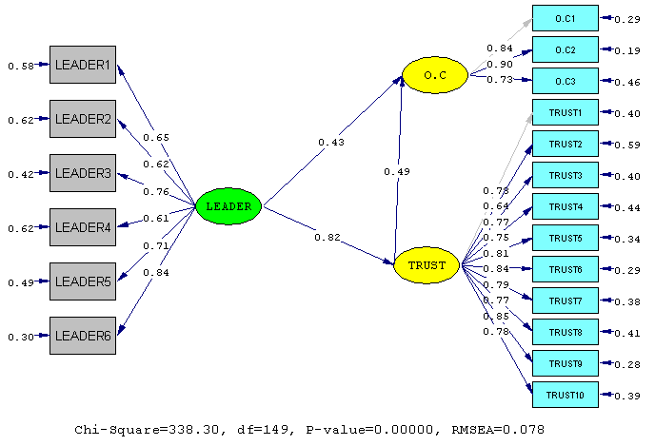
Figure 2: Research model test (standard mode)

  - Examining the research model in standard mode
The graph below shows the relationship between research variables.
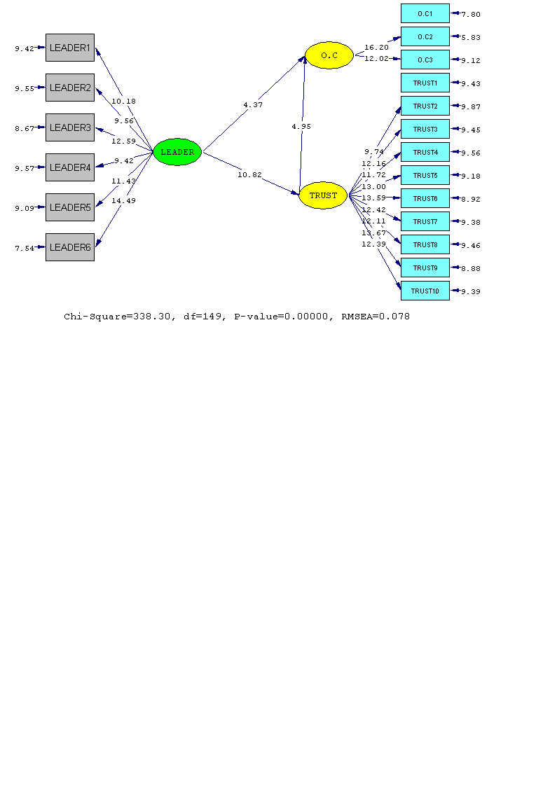
Figure 3: Research model test (significant numbers mode)
After the estimation of the parameters for a formulated and specified model is obtained, it should be determined how well the data fits the model, that is, how well the theoretical model is supported by the sample data. A number of tests are used to determine how well the model describes the observed relationships between measurable variables. The following table represents the types of fit and significance indicators of the model.

Table 4: significant indicators and model fit
Results | The amount obtained in the model | Approved Scale | index
Accept | 078/0 | be smaller than 0.1 | RMSEA | Significant indicators
Accept | 27/2 | be equal to and less than 5 |  | Significant indicators
Accept | 86/0 | be greater than 0.8 | GFI | Fit indices
Accept | 97/0 | be greater than 0.8 | NNFI | Fit indices
Accept | 96/0 | be greater than 0.8 | NFI | Fit indices
Accept | 98/0 | be greater than 0.8 | CFI | Fit indices
Accept | 98/0 | be greater than 0.8 | IFI | Fit indices

According to the obtained results, it can be said that the research model is confirmed in terms of significant indicators and fit.

4. Conclusion

In this section, the results obtained from the application of inferential methods in the form of structural equation models are presented.

Hypothesis 1: Servant leadership plays an effective role in the organizational commitment of employees.
According to the research model in the mode of significant numbers, it can be seen that the t-statistic between the two variables of servant leadership and organizational commitment is equal to 4.37. And since this value is outside the range [1.96 & 1.96], this hypothesis is confirmed, considering the standard coefficient, it can be said that the role of servant leadership in organizational commitment is equal to 0.43.

Hypothesis 2: Servant leadership plays an effective role in employees' trust in managers.
According to the research model in the mode of significant numbers, the t-statistic between the two variables of servant leadership and employee trust is equal to 10.82. And since this value is outside the range [1.96 & 1.96], this hypothesis is confirmed, according to the standard coefficient, it can be said that the role of servant leadership in employee trust is equal to 0.82.

Hypothesis 3: Employees' trust in managers plays an effective role in employees' organizational commitment.
According to the research model in the case of significant numbers, the t-statistic between the two variables of employees' trust in managers and employees' organizational commitment is equal to 4.95. And since this value is outside the range [1/96 & 1/96], this hypothesis is confirmed, according to the standard coefficient, it can be said that the role of employees' trust in managers in employees' organizational commitment is equal to 49 / is 0.

Hypothesis 4: Employees' trust in managers plays a mediating role in the effect of servant leadership on organizational commitment.
According to the research model in the case of significant numbers, the t statistic between the two variables of servant leadership and employees' trust in managers, as well as employees' trust with organizational commitment of employees is higher than 1.96, so it can be said that trust is a mediator between Servant leadership and organizational commitment have two variables. And this hypothesis is confirmed, the effect of servant leadership on organizational commitment through trust is equal to the product of two paths:
40/0=49/0*82/0

4.1 Suggestion per hypothesis

The test of the first hypothesis of the research confirmed the effect of servant leadership on the organizational commitment of high school employees in Tehran province. Therefore, it is suggested to the managers of the organization that to improve the organizational commitment of the employees through features such as service, which is the interest towards the subordinates and employees and encouraging them and to serve rather than being served, a model in helping and serving others and encourage others to do this. It is suggested that managers pay special attention to the identification of capabilities (growth of others, encouragement to learn, efforts for development and skills). With the appreciation of capable employees, he provided the grounds for their advancement

The test of the second hypothesis of the research confirmed the effect of servant leadership on employees' trust in high school principals in Tehran province. Therefore, it is suggested to the managers of the organization, managers are accepted as servants when they understand the organization and are concerned about all the employees of the organization. Consider honesty and truthfulness as one of your characteristics to gain the trust of employees. The managers of the organization trust their employees and give them permission to implement their new ideas, even if this action does not lead to good results. The managers of the organization should include their visions in the vision of the organization with a sense of partnership with the employees.

The test of the third hypothesis of the research confirmed the effect of employees' trust in managers on the organizational commitment of high school employees in Tehran province. Therefore, it is suggested that the relations between the members of the organization and the employees be fair. The existence of an atmosphere of justice in the organization and the employees' high sense of the level of justice is one of the important motivational forces in the organization that helps to promote honest relationships and ultimately trust. It is suggested that the management of the organization should make the employees feel that their needs are taken care of and that they have the social support of the management and that the managers feel responsible for their needs. It is suggested that managers promote and increase the existence of an atmosphere of trust in the organization. Managers should provide development opportunities for employees by observing factors such as service compensation system. It is suggested that the salary and bonus payment system should be reviewed and the number of employees received should be proportional to the amount of their data to the organization and the amount of their effort in the organization. The reward system should encourage a high level of trust in the organization by rewarding trust-building behaviors and punishing untrustworthy behaviors. In fact, the service compensation system should be designed in such a way that it respects best effort and progress.

The test of the fourth hypothesis of the research confirmed the trust of employees in managers in the effect of servant leadership on the organizational commitment of high school employees in Tehran province with the role of mediator. although, based on this research, the origin of trust and its type can be different, but what is important is that without trust, organizational commitment, as a result, the possibility of cooperation and interaction between members of the organization is lost. Therefore, it is recommended that supervisors increase their positive and honest behaviors, which can build trust among subordinates. Since the cognitive dimension of trust is achieved when a person is influenced by educational and professional training, experiences or functional roles of a trusted person, it seems that the higher the level of education of supervisors, the more professional make them stand out and be selected from experienced people who share their positive experiences with their subordinates, ultimately, their subordinates will have more cognitive trust in them and they will consider him a worthy person for this position. Also, in this direction, supervisors should be reliable role models in performing functional roles.

COMPETING INTERESTS DISCLAIMER:
Authors have declared that they have no known competing financial interests OR non-financial interests OR personal relationships that could have appeared to influence the work reported in this paper.

References

1.Adiguzel, Z., Ozcinar, M. F., & Karadal, H. (2020). Does servant leadership moderate the link between strategic human resource management on rule breaking and job satisfaction?. European Research on Management and Business Economics, 26(2), 103-110.

2.Alfoqahaa, S., & Jones, E. (2020). Leading at the edge of chaos: historical perspectives on the qualities of leadership for cultural diversity and conflict resolution. International Journal of Public Leadership, 16(2), 217-248.

3.Avolio, B. J., Walumbwa, F. O., & Weber, T. J. (2009). Leadership: Current theories, research, and future directions. Annual review of psychology, 60, 421-449.

4.Daraba, D., Wirawan, H., Salam, R., & Faisal, M. (2021). Working from home during the corona pandemic: Investigating the role of authentic leadership, psychological capital, and gender on employee performance. Cogent Business & Management, 8(1), 1885573.

5.George, B. (2003). Authentic leadership: Rediscovering the secrets to creating lasting value (Vol. 18). John Wiley & Sons.

6.Fogarty, S. (2016). Is Servant Leadership Effective in Motivating Volunteers. Theological Education in a Cross-Cultural Context: Essays in Honor of John and Bea Carter. WIPF & STOCK, 225.

7.Jiang, W., Zhao, X., & Ni, J. (2017). The impact of transformational leadership on employee sustainable performance: The mediating role of organizational citizenship behavior. Sustainability, 9(9), 1567.

8.Leider, J. P., Harper, E., Shon, J. W., Sellers, K., & Castrucci, B. C. (2016). Job satisfaction and expected turnover among federal, state, and local public health practitioners. American journal of public health, 106(10), 1782-1788.

9.Ludwikowska, K., & Tworek, K. (2022). Dynamic capabilities of IT as a factor shaping servant leadership influence on organizational performance. Procedia Computer Science, 207, 34-43.

10.Piwowar-Sulej, K., & Iqbal, Q. (2023). Leadership styles and sustainable performance: A systematic. Journal of Cleaner Production, 382, 134600.

11.Kjellström, S., Stålne, K., & Törnblom, O. (2020). Six ways of understanding leadership development: An exploration of increasing complexity. Leadership, 16(4), 434-460.

12.Marques, T., Reis, N., & Gomes, J. F. (2018). Responsible leadership research: A bibliometric review. BAR-Brazilian Administration Review, 15.

13.Eva, N., Robin, M., Sendjaya, S., Van Dierendonck, D., & Liden, R. C. (2019). Servant leadership: A systematic review and call for future research. The leadership quarterly, 30(1), 111-132.

14.Nor-Aishah, H., Ahmad, N. H., & Thurasamy, R. (2020). Entrepreneurial leadership and sustainable performance of manufacturing SMEs in Malaysia: The contingent role of entrepreneurial bricolage. Sustainability, 12(8), 3100.

15.Ruiz-Palomino, P., Yáñez-Araque, B., Jiménez-Estévez, P., & Gutiérrez-Broncano, S. (2022). Can servant leadership prevent hotel employee depression during the COVID-19 pandemic? A mediating and multigroup analysis. Technological Forecasting and Social Change, 174, 121192.

16.Ruiz-Palomino, P., Gutierrez-Broncano, S., Jimenez-Estevez, P., & Hernandez-Perlines, F. (2021). CEO servant leadership and strategic service differentiation: The role of high-performance work systems and innovativeness. Tourism Management Perspectives, 40, 100891.

17.Patiar, A., & Wang, Y. (2020). Managers' leadership, compensation and benefits, and departments’ performance: Evidence from upscale hotels in Australia. Journal of Hospitality and Tourism Management, 42, 29-39.

18.Ruiz-Palomino, P., & Zoghbi-Manrique-de-Lara, P. (2020). How and when servant leaders fuel creativity: The role of servant attitude and intrinsic motivation. International Journal of Hospitality Management, 89, 102537.

19.Tims, M., Bakker, A. B., & Xanthopoulou, D. (2011). Do transformational leaders enhance their followers' daily work engagement?. The leadership quarterly, 22(1), 121-131.

20.Wirawan, H., Jufri, M., & Saman, A. (2020). The effect of authentic leadership and psychological capital on work engagement: the mediating role of job satisfaction. Leadership & Organization Development Journal, 41(8), 1139-1154.

