ASSESSMENT OF LIVELIHOOD DIVERSIFICATION STRATEGIES OF ARTISANAL FISHERFOLKS IN THE RIVER-RINE AREA OF ONDO STATE, NIGERIA

ABSTRACT
Empirical evidences following some studies on the Lake basin has showed that livelihood diversification among fishing households is an established fact of the fishers’ struggles to improve their well-being (Tafida, 2010). The study assessed the livelihood diversification strategies of artisanal fisherfolks in the river-rine area of Ondo state. The study specifically describe the socio-economic characteristics of the respondents; determine the profitability of artisanal fish production in the study area; identify diversification strategy adopted by artisanal fisherfolks in the study area; examine factors that determine fisherfolks choice of livelihood diversification strategy in the study area; determine the impact of diversification strategy adopted on the fisherfolks welfare and describe the constraints of artisanal fish production in the study area. Cross-sectional data were used for this study. Primary data were collected through administration of a well-structured questionnaire on the sampled fisherfolks. Multistage sampling procedure was employed to select 150 respondentsfor the study. The analytical tools employed were; descriptive statistics, propensity score matching. Net profit analysis and multinomial logit model. Result showed that poultry, crop production, trading and government job are what fisherfolks diversify into while age of fisherfolks, years of fishing, number of gears, belonging to cooperative society, monthly income, and level of education were significant factors affecting the ability of artisanal fisherfolks to diversify in the study area. These factors were significant at 1%, 5% and 10% when tested. The result further showed that fisherfolks in the study area earns #168,863 on average per month. The impact of diversification on fisherfolks’ welfare is seen in the ability of those that diversify to have a car, marry more wives, send their children to school and spend more on feeding. The study recommends that Government and private agency should help provide emergency intervention to deal with flood and erosion in the study area so as to allow them carry out their activities during raining season. This is necessary as many of the fisherfolks said erosion and flooding is one major issue faced in the area.

Key words: livelihood, diversification, artisanal, fisherfolks, River-rine

1. INTRODUCTION
Nigeria is a maritime state where 9 of the 36 federal states have a coastline in the AtlanticOcean. The coastal federal states of Nigeria are Ogun, Lagos, Ondo, Delta, Bayelsa, Rivers, AkwaIbom and Cross River states, found in the southern part of the country. The importance of the fisheries sector to individuals and the economy of many developed and developing countries cannot be overemphasized. It is notable that fish provides more than 60% of the world supply of protein, especially in the developing countries (Sofia, 2018). The fisheries subsector of the Nigeria agriculture is the essential tool for rural development through its provision of income, high quality protein, and socioeconomic development of fishing communities in Nigeria (Olaoye,et al. 2016). Fishing community is a community that is important in relation to the utilization of marine resources, but most of them are still underserved communities. Fishing communities are still the dominant communities of poor people inhabiting thecoastal areas, especially in developing country like Nigeria. Food and agriculture organization (FAO 2018) states that the poverty of fishermen is a very serious matter. In Nigeria as presented by (Araoye,2002), that the fishing community in Nigeria is the poorest communities. Fishing is one of the oldest livelihood income generating activities of man since the world was created (Cristopher et al 2003). Fishing industry in Nigeria dates back to the pre-colonial era where basically small-scale fishing (artesian) has been the major source of food for the inhabitant of coastal and river-rine areas. It is also provides employment and economic benefit to those engaged in artesian fishery activities. Artesian fisheries utilize open access resources in which the only human intervention is the harvesting of fish stocks (Ajenifuya, 2008). Furthermore, based on the concept of Sustainable Livelihood, a household perpetuate life and livelihood rests on livelihood assets owned or accessible. The assets include human capital assets, capital assets of natural resources; financial capital assets; social capital assets; and physical capital assets (Shivakoti and Smith-vogt, 2009). For many fishermen to survive or push out of poverty line the issue of economic diversification came in, Diversification is a process by which households engage in multiple income generating activities (Ellis, 2009). It is widely seen in the 1 academic literature and international development arena as a strategy for spreading risk and reducing vulnerability. In the context of fisheries, diversification is promoted as a means for reducing dependence on the resource, making restrictive management easier and less controversial for those affected by such measures (Smith et al 2007).This often interprets diversification as job-substitution (stop fishing, do something else) rather than adding other activities to an income-portfolio. With the tendency for increasing pressure on fishery resources, it becomes ever more necessary to address in a coherent way diversification and its links with both poverty reduction and responsible fisheries (Coulhard,2005). Implications of the development of alternative or complementary activities alongside a main, resource-dependent activity such as fishing may echo those experienced by sectors such as agriculture and pastoralism. However, many characteristics of the fishing activity and of those who engage in it are particular to the sector. General poverty alleviation policies and fisheries management schemes have been found to lack the necessary differentiation and to fail to cater for the specific needs of fishing communities (Smith et al., 2010).

2. METHODOLOGY
2.1. The study area
This study was carried out at the river-rine area of Ondo state, Nigeria. Ondo state was created on 3rd of February 1976 from the former western state. The state covers a land of 14,793 square kilometers with its administrative capital at Akure. The population of the state in the 2006 census reported in 2007 put the figure at 3,442,024 (Ondo State Bureau of Statistics, 2018). Ondo state is located in the southern region of Nigeria. The state is made up of 18 Local Government Areas, and is bounded in the north by Ekiti and Kogi states, in the east by Edo state. In the west by Osun and Ogun states, in the South by Atlantic Ocean. Ondo state is located entirely within the tropics (National Population Census (NPC), 2006). The climate of Ondo, like other states in the southwestern part of Nigeria, is that of tropical rain forest type, with distinct wet and dry seasons. The tropical climate of the state is broadly divided into two: dry season (Harmattan season) and raining season. The latitude of Ondo state nigeria is 7.100005, and the longitude is 4.841694. Ondo state is located in Nigeria in the cities place category with the gps coordinates of 7° 6' 0.0180'' N and 4° 50' 30.0984'' E. The annual rainfall varies from 2,000mm in the southern areas to 1,150mm in the northern areas. In the south, the mean monthly temperature is 27 degree Celsius, while the mean relative humidity is over seventy five percent. (75%). The older sand ridge develop brown and orange sandy soils, while the most recent ones near the coast have light grey sandy soils. In the northern part of the state, the mean monthly temperature and its range are about 30 degree Celsius. The mean monthly relative humidity is less than seventy percent (70%). Soils here are skeletal in nature and are of comparatively recent origin (Falodun, 2017) Agriculture (including fishing) constitutes the main occupation of the people of the state. Indeed, Ondo state is the leading cocoa producing state in Nigeria. Other agricultural produce include yams, cassava and palm produce (Ondo State Ministry of Information, 2019). The riverine area of Ondo State are Ilaje and Ese-Odo Local Government which share boundary with the Atlantic ocean in the tropics.

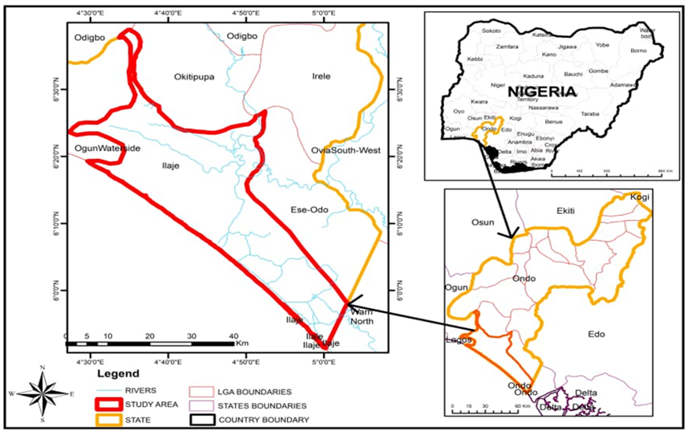
Fig 1. Map of the study area
2.2. Objective of the study
The main objective of the study is to assess the artisanal fisherfolks livelihood diversification strategies in the river-rine area of Ondo state, Nigeria.
The specific objectives are to:
1. describe the socio-economic characteristics of artisanal fisherfolks in the river-rine area of Ondo state;
2. determine the profitability of artisanal fish production in the study area;
3. identify diversification strategies adopted by the artisanal fisherfolks in the study area;
4. examine factors that determine fishefolks choice of livelihood diversification strategies in the study area.
5. determine the impact of diversification strategy adopted on the fisherfolks welfare; and;
6. describe the major constrains of artisanal fish production in the study area.
2.3 data analysis and model specification
Descriptive statistics
To achieve objective (1), (3), and objective (6) a descriptive statistics was used. Descriptive statistics such as percentages and frequencies was used to analyze their socio-economic characteristics while descriptive statistics such as tables was used to analyze their constraints.
Net profit
The net profit margin, or simply net margin, measures how much net income or profit is generated as a percentage of revenue. it is the ratio of net profits to revenues for a company or business segment. Net profit margin is typically expressed as a percentage but can also be represented in decimal form. The net profit margin illustrates how much of each naira in revenue collected by a company translates into profit.
Net Profit margin = Net Profit Total revenue x 100………… 1
Net profit is calculated by deducting all company expenses from its total revenue. The result of the profit margin calculation is a percentage – for example, a 10% profit margin means for each ₦1 of revenue the company earns ₦0.10 in net profit. Revenue represents the total sales of the company in a period.
Multinomial logit model
To achieve objective 4 multinomial logit models was used; this is used to separate the determinant of livelihood strategies into few model scenarios. Since there is more than one strategy choice to choose from, that the fishermen does not pick one does not mean he is non adopter or it does not determine his livelihood strategies.Hence, non-adopter or of one does not necessarily put the farmer in non-adopter category (Greene, 2003). This support the model appropriateness.
This model is
Ui=βiXi+εi……………………………………………………………………2
This implies that utility, Ui, choosing a particular strategy is a stochastic linear function of Xi . in
this multinomial logit model, the probability of choosing a given, j, is equal to the probability that the utility of that particular strategy or adoption is greater than or equal to the utilities of all other strategies and adoptions. The model is shown below
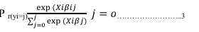
Source: Greene 2003
Where,
βj = vector of coefficients of each explanatory variable,
Xi (j) =dependent variables that is jth adopted strategy option
Xi= explanatory variables
i = ith explanatory variable
For this study, the strategy options or response probabilities is four based on the number of income respondent we have: (Ojo, et al.,2019)
Yi = four unordered number of income sources adopted by the respondents:
Yo = adopted one source of income (no diversification)
Y1 = adopted two income sources;
Y2 = adopted three income sources:
Y3 = adopted four income sources;
The dependent variables will therefore be the log of one alternative relative to the base alternative.
The explanatory variables will include;
Xi = age of fisherfolks (years)
X2 = household size
X3 = years in fishing
X4 = number of gear
X5 = belong to a cooperative society
X6 = monthly income
X7 = educated

Propensity score matching
The impact of a treatment for an individual i , noted δ i , is defined as the difference between the
potential outcome in case of treatment and the potential outcome in absence of treatment:
δi = Y 1 i − Y 0
In general, an evaluation seeks to estimate the mean impact of the program, obtained by
averaging the impact across allthe individuals in the population.
This parameter is known as Average Treatment Effect or ATE:
ATE = E( δ) = E(Y 1 − Y 0)
Where E represents the average (or expected value). Another quantity of interest is the Average
Treatment Effect on the Treated, or ATT, which measures the impact of the program on those individuals who participated:
ATT = E(Y 1 − Y 0 | D = 1)
Finally, the Average Treatment Effect on the Untreated (ATU) measures the impact that the
program would have had on those who did not participate:
ATU = E(Y 1 − Y 0 | D = 0)
The problem is that all of these parameters are not observable, since they depend on counterfactual outcomes.
For instance, using the fact that the average of a difference is the difference of the averages, the ATT can be rewritten as:
ATT = E(Y 1 | D = 1)– E(Y 0 | D = 1)
the second term(Y 0 | D = 1 ) , is the average outcome th at the treated individuals would
have obtained in absence of treatment, which is not observed. However, we do observe the term ,
that is,E(Y 0 | D = 1 ) the value of Y 0 for the untreated individuals. Thus, we can calculate:
Δ= E(Y 1 | D = 1) – E(Y 0 | D = 0)
What is the difference between Δ and the ATT? Adding and subtracting the term:
E(Y 0 | D = 1)
Δ= E(Y 1 | D = 1) − E(Y 0 | D = 1) + E(Y 0 | D = 1) – E(Y 0 | D = 0)
Δ= ATT + E(Y 0 | D = 1) – E(Y 0 | D = 0)
Δ= AT T + SB
The second term, SB, is the selection bias: the difference between the counterfactual for treated
individuals and the observed outcome for the untreated individuals. If this term is equal to 0, then
the ATT can be estimated by the difference between the mean observed outcomes for treated and
untreated:
ATE= E(Y/D=1) – E(Y/D=0)

3.0 RESULTS AND DISCUSSION
3.1. Socio-economic characteristics
The results of the socio-economic characteristics showed the mean ages of 47. Majority (44.0%) of the respondents were observed to be between 41 and 50 years. This is an indicator that majority of the respondents were still within the economically active age. It also implies that respondent were agile and active to carry out the rigors of fish farming. This result actually goes in line with Olayemi (2004) who stated that for farmers to be productive in farm chores, they must be young and active in order to contribute meaningful labor input into all stages of production for efficient output realization which in turn result in consumption and income opportunities with proportional household welfare. majority (97.5%) of fish famers in this area is male with. The domination of male respondents among the fishers can be as result of males having greater access to farm than females. It could also be the result of the tedious nature of fish farming. This implies that fish farming is mostly done by male farmers who could have access to resources and are thus instrument to fish production than their female counterparts. It could also be that male farmers are more into fish catching while the females are into processing and marketing. Afolami et al(2015) stated that domination by male respondents among farmers could be the result of males having greater access to farm land than females and the tedious nature of farming. 43.9% of households in the study area had between one to five persons in their households, 33.8% had between six to ten (10) persons in their households, about 20.9% had between eleven to fifteen while 0.7% has between sixteen and above twenty (20). The average household size for the study area was 5. This is corroborated by the work of Ojo and Ogunyemi (2014) who found that farming household size is in average of one to five persons per family. Years of experience of the fishermen was found to be high, majority (41.3%) has close to 21-30 years of experience in the business. This might be the reason why many of them do not want to diversify to other areas. About (13.3%) and (24.0%) of the respondent have 1-10 and 11-20 years of experience respectively, this show that many fisherfolks in the area are highly experienced and started fishing business very early in life. Those with 31-40 and above 40 years of experience were found to be (19.3%) and (2.0%) respectively, this might be because of old age. As age set in the level of productivity drops and farmer tends to stop farming. The result shows that fisherfolks in the area are experienced and active. According to Inoni and Oyaide (2007) fishers, particularly those in the motorized sector of the artisanal fishery, require adequate experience to be able to exploit more valuable fish species in deeper waters. 88.7% of the fisherfolks belong to one form of association. Such association includes; cooperative society, fishermen association etc. this might be to help them in marketing so that they can have uniform prices across board, or help them in saving money for future use. The function of the association can extend to helping in giving market information, bringing fisherfolks closer to buyers or for association sake. Very few fisherfolks in the study area 11.3% do not belong to any association. According to Amos (2013), membership of association is of immense benefits to members, it gives opportunity for bulk purchase of inputs at discounted rates and helps members secure credit facilities as at when due. majority (43.3%) earns around (₦900,000-₦1.199,999), this shows that many of the respondents in the study area earns more than many civil servant in the state, this further explain why many of them do not want to diversify because it’s obvious that their income from fishing activities is high and other sources might not give them something close. Its appears most of the income earn goes to fueling, feeding, transportation etc. about (14.7%) earn above (₦1,499,000) a month, this can be those who diversify their sources of income or those who have more gears or employ more people to work with them. (8.0%) and (1.3%) are the lowest and account for those who earn (₦300,000-₦599,999) and below (₦300,000) respectively. This observation is in agreement with Anyanwu et al. (2009) who reported that an average fisherman along River Niger in Onitsha, Nigeria made a gross profit margin of about ₦96000 per month in a year. In addition Tietze et al.(2000) and AER (2003) in their studies of selected coastal Asian and African countries noted that the savings rate and the amounts saved were generally higher in fishing villages than in neighboring farming villages. majority (32%) of the respondents that diversify makes above (₦499,999) monthly from other sources, this is very low compare to the income of fish farmers monthly income, although it can be an additional income. About (22.5%) earn between (₦300,000 ₦399,999) and (10.0%) earn between (₦400,000-₦499,999) from other sources in a month. (15%) account for those that earn between (₦100,000 – ₦199,999) from other sources every month. The lowest category are those who earn between (₦200,000-₦299,999) from other sources a month with (5.0%). This suggest that income from other sources for many that diversify is still high and above (100,000) for majority of the fish farmers that diversify. This result aggress with A Kigbu et al. (2014) who reveals that most fish farmers are full time farmers while the little that diversify makes little from other sources compared to fishing activities. He further put it that (75%) of fishermen income comes from fishing activities while only (25%) comes from other sources.
3.2. Profitability of artisanal Fish Production
Net profit method was employed to estimate the profitability of fish farming in the study area. Table 1 shows the net profit where total returns is (₦1,089,133.00) in a month. The cost of doing fishing business in the study area (variable cost) as fuel has the highest running cost with (76.20%), the cost of fuel alone is at (₦701,295.00) this was discussed by Amanda et al (2017) when they did a profitability study on fish farming along coastal areas in brazil and found out that more than (70%) of total revenue of farmers goes to fueling and they suggested that government should further subsidize fuel for them or come up with a plan to help out. Cost of labor took (12.36%) at a figure of (₦113,713.00) in the running cost, this suggests that the labor either hired or family source are well paid which is a good source of motivation for productivity. The last cost of running artisan fishing business in the study area is food, this amount to (11.44%) at a figure of (₦105,262.00) per month. This reveals that cost of feeding during the business is not much; this might be because each labor ate at home before coming to open water to fish. The overall result shows that the average profit from artisanal fish production in the study area was (N 168, 863.00), this reveals that artisanal fish farming in the study area is highly profitable. The profit level also show why many fish farmers in the study area choose fishing as their only business and stay with it for years. This result is in line with the findings of Adewumi et al(2012) in his study around Asa river in kwara state which reveals that artisanal fishing is a profitable business. Results of their profitability analysis showed that an average fisherolks makes a net profit of ₦52883.99/month. Compare to my findings, an average fisherman makes a net profit of N 168863.00/month. From the results shows that average profit from fish production in the study area was N 168863.00. It shows that the cost of fuel represents 76.2% of TVC, cost of food represents 11.44% of the TVC while cost of labour represents 12.36% of TVC.

Table 1: Average Monthly Costs and Returns for Fish Production
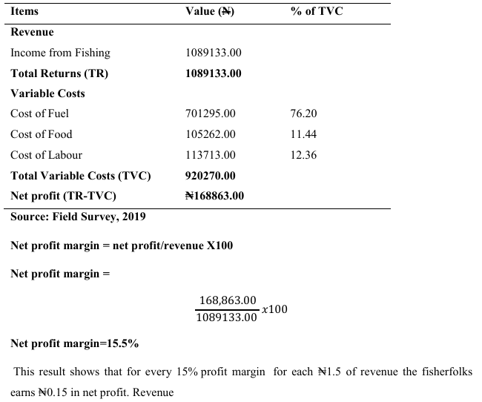

3.3. Diversification strategies adopted by artisanal fisherfolks in the study area
Table 2 shows the diversification strategies adopted by artisanal fishermen in the study area. From the descriptive statistics majority (37.5%) of the artisanal fishfolks adopt poultry e.g. rearing birds as their alternative source of income. This can be explained by availability, raw food for birds or technical knowhow by the respondents. Cultivation stood at second place with 35.0% of respondents involved in cultivation. The availability of family land and nearest to water should be the reasons many result to cultivation of land in the study area, in addition, to further increase income many will choose go into farming. Trading is 17.5%, this suggest that most of the artisanal fisherfolks don’t get involve much in trading. Just (10%) of the respondents choose government job as a means to diversify. This is showed in the income level of the artisanal fisherfolks as many fish farmers make more income than many civil servant in the area, those that diversify to government work might be doing so due to passion. Cost of transportation and time spent might be another source of discouragement to fish farmers in the study area to embrace government job. This is in line with the findings of Funmilayo (2016) that the fishers diversified more into poultry (73.53%) in the dry season and crop farming (98.04%) in the wet season. Corroborating this result is the study of Babatunde and Qaim (2009) which found farming as the most important income generating source for poorest households. This might also be due to the fact that rural dwellers are mostly agrarian who views farming as a normal way of life. Crop farming also helps the fishermen cope with food insecurity. This implies that fisher folks derive more benefits and values (food and income) from farming activities than non-farming activities. As such, agricultural activities should be given priority in any intervention to boost diversification of fisher folks in fishing communities. Also in Funmilayo (2016) findings the least diversification activity in the study area was petty trading, with 9.80% diversification in the dry season and 7.35% diversification in the wet season. This implies that fishermen utilizes the available land for crop farming and exploit the forest for game in order to provide food for the family and sell the excess if available.

Table 2. Diversification Strategies Adopted by Artisanal Fishermen
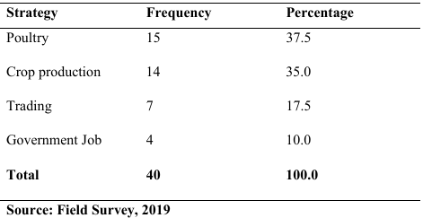

3.4. Factors that Determine Diversification among the Artisanal Fishermen in the study area.
Six variables were statistically significant in the model, they include age, years of fishing, no of gears, belong to a cooperative, monthly income and level of education. These variables are said to be the determinant of a fish farmer diversifying his livelihood. Age The age of sampled fisherfolks is significant and negatively influenced the extent of diversification among the fish farmers at p≥0.10. This presupposes that, as the age of fish farmers in the study area increases, the likelihood of them diversifying their livelihood decrease. In other words, multiplicity of activities increases with advancing age. Years in fishing The years of fishing is significant and positively influenced the extent of diversification among fish farmers at p≥0.05. This result shows that as the year of fishing experience increases the like hood of diversifying might increase.This can be as a result of fishermen not getting use to change anymore. Inoni and Oyaide (2007) already stated that for a fish famer to increase production, years of experience is very important. Then more experienced fishermen should have more income and stable on the business which will affect them from embracing other sources of income while the less experience fish farmer may want to add more alternative sources in other to argument his daily income. It’s also possible that has years of fishing increases fish famers has access to loan, get more fishing gears and employ more people which will make him become a full time farmer or less concern about diversification. No of gears The coefficient of number of gears is found negatively significant at p≥0.01. This shows that the like hood of not diversifying as number of gears increases is low. This implies that many fisherfolks with many fishing gears has tendency to diversify their source of income. This can be attributed to the fact that the rich want to get richer because number of gears means they will have to employ more labors and make more money, this might be the fuel behind them looking at other sources of income. Amada et al. (2016), suggested that fishing gear increases the fish farmers income and productivity. This means that fisher men with more fishing gears have tendency to look at other sources of income.
Belong to a cooperative Belonging to a cooperative society is one of the factors influencing or determining whether a fish farmer will diversify or not. The coefficient of belonging to a cooperative society is significant at p≥0.01 and negative. This shows that the like hood of not diversifying for fish farmers that belong to a cooperative society is low. Cooperative society helps farmers with loan, savings and information, this might be reason many fish farmers will embrace change and diversify their livelihood. The influence of cooperative society can also be seen in the quest to belong or not be left out on what others are doing. Amos (2012) in his findings concluded that farmers that belong to cooperative society embrace change easily and do more in terms of productivity. The more a fish farmer gets along with a cooperative society the more his likelihood to diversify. Monthly income The monthly income is found significant at p≥0.05 and positive. The fisherfolks likelihood of diversification increase with high income. This suggest that artisanal fisherfolks with high income does not really have interest in diversification since their income is enough, and if they want to diversify it might not be as those with low income. The likelihood of diversification increases with high income of artisanal fish farmers. According to Anyanwu et al. (2009) who reported that an average fisherman along River Niger in Onitsha, Nigeria made a gross profit margin of about N96000 per month in a year. In addition, Tietze et al. (2000) and AER (2003) in their studies of selected coastal Asian and African countries noted that the savings rate and the amounts saved were generally higher in fishing villages than in neighboring farming villages. The authors further reported that in most of the countries studied, households in farming villages were as indebted as or more indebted than households in fishing villages. These reports are contrary to the popular belief that fisher folks are among the poorest of the rural population in coastal areas of the world. This implies that many fish farmers with high income might stick to the business and not diversify as those with low income. Fish farmer with high income will definitely have more workers and fishing gear, more management work to do which might affect them or gave them lesser time to explore other sources of income. Level of education Years of education of the fisherfolks were negative and significant at p≥0.05 . This implies that as the years of education of the fisherfolks in the study area increase the likelihood of diversifying their livelihood increases. Education is an important factor influencing the extent of livelihood diversification. This result is consistent with the results from other studies on diversification behavior in Africa (Awudu and CroleRees, 2001; Winters et al., 2009; Oluwatayo, 2009; Idowu et al., 2011), where education was found to be a key determinant of the diversification of income-generating activities. Education enhanced the potential of the respondents and made them grab available opportunities with little or no stress.

Table 3. Factors Determining Diversification among the Artisanal Fishermen
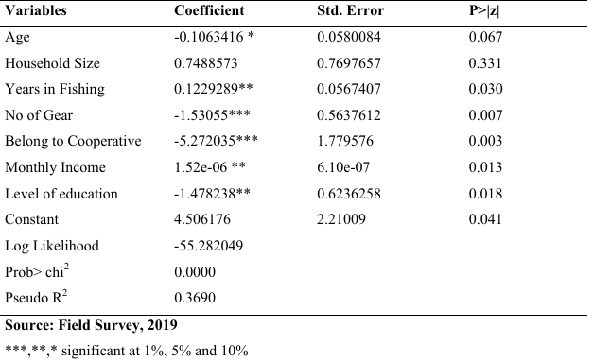

3.4. Impact of diversification strategy adopted on the fisherfolks welfare
The impact of diversification was measured on the fishermen welfare as show in table 4, from the study, diversification has impact on the fish farmers ability to have a car, marry more wives, spend more on children education spend more on food and own a landed property. The probability of having a car increases by 0.2 when the farmer diversifies. This suggests that fish farmers that diversify have the capacity to buy a car ahead of those that did not diversify. The ability to marry more wives increases as the fish farmer increases his level of income through diversification because the farmer feels he has more money to take care of the wives or believes that that will supply him with more family labors. As diversification increases, fish farmers begin to spend more on children education, this can implies that those fish farmers that diversify has access to better education for their children as they have the capacity to send their children to private schools or best public schools since they have the money to pay. Those who do not diversify spent on the average ₦45283 on food more than those that diversify, that implies that with diversification, fish farmers can spend less on food from the income they have from other sources. Those that do not diversify will have to spend more from their fishing activities on food. The study further reveals that the probability of having landed properties increases by 0.17 when the fishermen do not diversify. This might be as result of general believe by the fish farmers on the study area that landed property is very important. Adepoju and Obayelu(2013) stated that Income from non-farm activities as well as income from a combination of non-farm and farming activities, impacted welfare positively relative to income from farming activities only. This is expected as agriculture in the rural areas of Nigeria is largely characterized by low capital involvement, use of crude implements, poor infrastructural and storage facilities and human drudgery which ultimately leads to lower average earnings. Hence, nonfarm activities and a combination of farm and non-farm activities were pursued as strategies to increase household welfare in the study area. Further, the private sector should be encouraged to create income generating activities in the rural areas to enhance their livelihood diversification activities and ultimately their living standard.

Table 4. Impact of Diversification on the Fishermen Welfare (Nearest Neighbor Method)
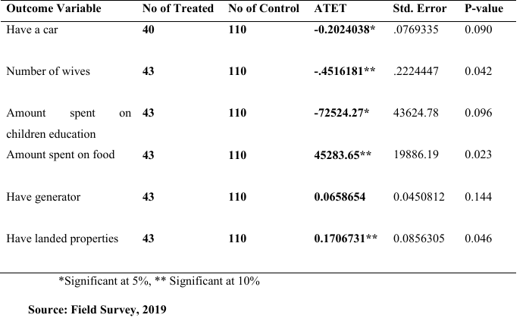

3.5. Major constrains of fish farming in the study area
Livelihood diversification is an important survival strategy for the rural households in developing countries. However, there are several constraints to successful livelihood diversification. Identification of the constraints for a particular agro-ecological region is crucial for program planning and policy formulation. This study has identified some of the socio economic, technological, institutional and policy constraints encountered by fishermen in the coastal area of Ondo state. The constraints identified by fisherfolks are presented in Table 5. From Table 5, the 150 respondents agrees that flood and erosion is major constraints in the study area, that is (100%) of the total respondents. This shows that during raining season the catch might be very low as fishrfolks has to battle with flood and erosion in the area. That further suggests that catches should be low during this period. Another constraint faced by the community is inadequate government assistance, as seen on the table below, about 98% of the respondents agreed that government intervention is not enough. This is further revealed in government interference in their business and making decisions. About 97% of them says government interference in fishing activities affects them while about 98.6% says that government decisions and implementation is not enough. Modern preservation like the use of refrigerator was absent in the community and over 97% of the respondents see this as a constraints; this can be attributed to the lack of electricity in the fishing community as more than 97% of them see that as a big problem. Flood and erosion, unavailability of loan, inadequate government assistance, government interference, lack of recognition in decision making and implementation, modern preservation and lack of electricity are seen as the major constraints of artisanal fisherfolks in the study area. This was similar to Funmilayo (2016) findings who identity similar constraints to artisanal fishefolks in Oyan and Ikere gorge dams.

Table 5. Major Constrains on Fish Farming
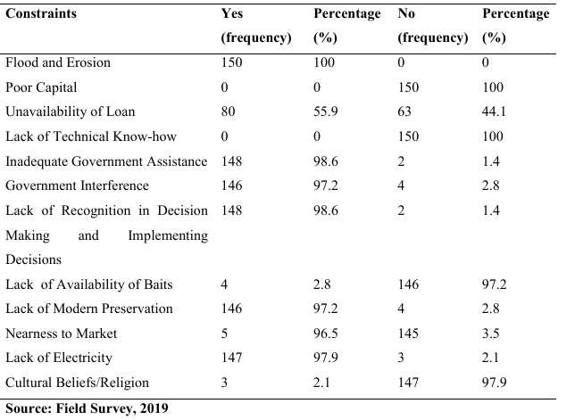

4. SUMMARY
The study was designed to assess the livelihood diversification strategies of artisanal fisherfolks in the riverine area of Ondo state. The study specifically describe the socio-economic characteristics of the respondents; determine the profitability of fish production in the study area; identify diversification strategy adopted by artisanal fisherfolks in the study area; examine factors that determine fisherfolks choice of livelihood diversification strategy in the study area; determine the impact of livelihood diversification strategy adopted on the fisherfolks welfare and describe the constraints ofartisanal fish farming in the study area. Cross-sectional data was used for this study. Primary data was collected through administration of a well-structured questionnaire on the sampled fisherfolks. Multistage sampling procedure was employed to select 200 respondents for the study. The analytical tools employed were; descriptive statistics, propensity score matching. Net profit analysis and multinomial logit model. The result of the analysis of the socio-economic characteristics revealed that the respondents had mean ages of 46.99. Majority (44.0%) of the respondents were observed to be between 41 and 50 years. majority of fishfolks in this area are male (97.5%) with high education and were married. Findings shows that level of education in the study area was high with over (45%) of the respondents having secondary education. More than (73%) of the farmers practice full time farming and the average income of artisanal fisherfolks in the study area is about (₦900000 ₦1,199,999) for majority (43.3%). Many of the respondents (60%) have at least two fishing gears and majority (43%) has close to 21-30 years experience in fishing business. The result reveals that fuel has the highest running cost with (76.20%), follow by Cost of labor (12.36%) and feeding at (12.36%). The net profit analysis shows that artisanal fisherfolks are profitable in the study area as average fisherfolk makes (N 168,863.00.) in a month. Also, the result of descriptive statistics of diversification strategy shows that most of the fisherfolks that diversify prefer poultry business with poultry accounting for (37.5%) of the total respondents, the next diversification goes to cultivation at (35.0%) . about (17.5%), of the respondents choose trading as method of diversification while (10%) pick government job as a method of their own diversification. Result further shows the factors that determine diversification using multinomial logit model. From the analysis age of fisherfolks, years of fishing, number of gears, belonging to cooperative society, monthly income, and level of education are significant factors affecting the ability of artisanal fisherfolk to diversify in the study area. These factors were significant at 1%, 5% and 10% when tested. The impact of diversification on fisherfolk welfare is seen in the ability of those that diversify to have a car, marry more wives, send their children to school and spend more on feeding. Those that did not diversify (that is, those that only take artisanal fishing as their only job) appear to have the capacity to own a land ahead of those who diversify. The major constraints encountered by fisherfolksin the study area are: Flood and erosion, unavailability of loan, inadequate government assistance, government interference, lack of recognition in decision making and implementation, modern preservation and lack of electricity.

4.1. CONCLUSION
The study assesses the livelihood diversification strategies of artisanal fisherfolks in the riverine area of Ondo state. From the study, the level of diversification is still low in the study area, not up to 30% of the fisherfolks choose to diversify their livelihood. Those that diversify their livelihood was found to be better in terms of welfares as they have more purchasing power and access more welfare packages. The result also show that diversification is one major way out of poverty in the study area as income will increase which will in one way or the other increase the household purchasing power and ability to spend. The socio- economic factors such as; age of farmers, years of fishing, number of gears, belonging to cooperative society, monthly income, and level of education has significant effect on the ability or willingness of fish farmers in the study area to diversify.
4.2. RECOMMENDATIONS
The following policy and recommendations were proffered based on the findings of this study:
1. There is urgent need to facilitate the development of social infrastructure e.g. electricity by government among communities in the study area.
2. Literacy level in the study area is high among fisherfolks, this will help government to quickly educate more fisherfolks on the need to diversify to better help their welfares
3. Government and private agency should help provide emergency intervention to deal with flood and erosion in the study area so as to allow them carry out their activities during raining season. This is necessary as many of the fisherfolks said erosion and flooding is one major issue faced in the area.
4. The availability of wind in the area is a big encouragement for government and private individual to harness it and turn it into electricity through wind turbine. This will help counter the problem of electricity in the area and open the way for modern preservation.
Contributions to knowledge
This study provided empirical evidence on the livelihood diversification of artisanal fisherfolks in Ondo state, Nigeria. The study further provided empirical information on determinants of diversification and impact of diversification on the welfare of fish farmers in Ondo state.

CONSENT
All information here is written by me the author and necessary consent where obtained

COMPETING INTERESTS DISCLAIMER:
Authors have declared that they have no known competing financial interests OR non-financial interests OR personal relationships that could have appeared to influence the work reported in this paper.

REFERENCES
Abdulai, A., & CroleRees, A. (2001). Determinants of income diversification amongst rural households in Southern Mali. Food policy, 26(4), 437-452.
Abiodun, J. A., & Niworu, A. M. (2004). Fisheries Statistical Bulletin Kainji Lake, Nigeria. ISSN: 1119- 1449. Kainji Lake fisheries management and conservation unit. Technical report Series, 23, 1-23.
Allison, E. H., & Ellis, F. (2001). The livelihoods approach and management of small-scale fisheries. Marine policy, 25(5), 377-388.
Allison, E. H., & Mvula, P. (2002). Fishing livelihoods and fisheries management in Malawi. Overseas Development Group (No. 23). LADDER Working Paper, University of East Anglia.
Allison, E. H., Béné, C., & Andrew, N. L. (2011). 12 Poverty Reduction as a Means to Enhance Resilience in Small-scale Fisheries. Small-scale fisheries management: frameworks and approaches for the developing world, 216.
Alwang, J., Siegel, P. B., & Jorgensen, S. L. (2001). Vulnerability: a view from different disciplines (Vol. 115, p. 60). Social protection discussion paper series.
Araoye, P. A. (2002). Man-made lakes, ecological studies and conservation needs in Nigeria. Revista de biología tropical, 50(3-4), 857-864.
Austin, P. C. (2007). A critical appraisal of propensity-score matching in the medical literature from 1996 to 2003. Stat Med.
Austin, P. C. (2011). An introduction to propensity score methods for reducing the effects of confounding in observational studies. Multivariate behavioral research, 46(3), 399-424.
Barrett, C. B. (2005). Rural poverty dynamics: development policy implications. Agricultural Economics, 32, 45-60.
Barrett, C. B., Reardon, T., & Webb, P. (2001). Nonfarm income diversification and household livelihood strategies in rural Africa: concepts, dynamics, and policy implications. Food policy, 26(4), 315-331.
Béné, C., & Friend, R. M. (2011). Poverty in small-scale fisheries: old issue, new analysis. Progress in Development Studies, 11(2), 119-144.
Béné, C., & Obirih-Opareh, N. (2009). Social and economic impacts of agricultural productivity intensification: the case of brush park fisheries in Lake Volta. Agricultural Systems, 102(13), 1-10.
Béné, C., Neiland, A., Jolley, T., Ovie, S., Sule, O., Ladu, B., ...& Quensiere, J. (2003). Inland fisheries, poverty, and rural livelihoods in the Lake Chad Basin. Journal of Asian and African Studies, 38(1), 17-51.
Coulthard, S. (2005). The interplay between fishing access and the ability to adapt: Insights from a South Indian fishery Paper presented at the International Conference on “People and the Sea”, 7-9 July 2005. Amsterdam, Netherlands.
Ellis, F. (2000). Rural livelihoods and diversity in developing countries. Oxford university press.
Ellis, F., & Allison, E. (2004). Livelihood diversification and natural resource access. Overseas Development Group, University of East Anglia.
Ellis, F., & Freeman, H. A. (2004). Rural livelihoods and poverty reduction strategies in four African countries. Journal of development studies, 40(4), 1-30.
Gordon, A., & Pulis, A. (2010). Livelihood Diversification and fishing communities. Greene, W. H. (2003). Econometric Analysis, 5th edn Prentice-Hall. Upper Saddle River, NJ.
Haylor, G., Briggs, M. R. P., Pet-Soede, L., Tung, H., Yen, N. T. H., Adrien, B.,& Savage, W. (2003). Improving coastal livelihoods through sustainable aquaculture practices-a report to the collaborative APEC Grouper Research and Development Network.
Hill, N. A. O. (2005). Livelihoods in an artisanal fishing community and the effect of ecotourism (Doctoral dissertation, Department of Environmental Science and Technology, Imperial College London).
Hill, N. A., Rowcliffe, J. M., Koldewey, H. J., & Milner‐Gulland, E. J. (2012). The interaction between seaweed farming as an alternative occupation and fisher numbers in the Central Philippines. Conservation Biology, 26(2), 324-334.
Ireland, C., Malleret, D., & Baker, L. (2004). Alternative sustainable livelihoods for coastal communities. A review of experience and guide to best practice. IUCN Eastern Africa Regional Programme, Nairobi, Kenya. I-viii+ 48pp.
Konan A.(2007). Amelioration de l’environnementpolitiqueetinstitutionnel pour le développement des systèmes de congestion en pêchecontinentale au Burkina Faso, au Mali, en Côte d’Ivoire et au Ghana. Pilot Project Terminal Report. Sustainable Fisheries Livelihoods Programme (SFLP). Rome, FAO/DFID.
Nakai, J. (2018). Food and Agriculture Organization of the United Nations and the Sustainable Development Goals. Sustainable Development, 22.
Olaoye, O. J., Idowu, A. A., Omoyinmi, G. A. K., Akintayo, I. A., Odebiyi, O. C., &Fasina, A. O. (2012). Socio-economic analysis of artisanal Fisher folks in Ogun water-side local government areas of Ogun state, Nigeria. Global Journal of Science Frontier Research Agriculture & Biology, 12(4), 9-22.
Panayotou, T. (1982). Management concepts for small-scale fisheries: economic and social aspects (p. 53). Rome: FAO.
Pittaluga, F., Braimah, L. I., Bortey, A., Wadzah, N., Cromwell, A., Dacosta, M., ...&Salvati, N. (2003). Poverty profile of riverine communities of southern Lake Volta.
Pollnac, R. B., Pomeroy, R. S., &Harkes, I. H. (2001). Fishery policy and job satisfaction in three Southeast Asian fisheries. Ocean & Coastal Management, 44(7-8), 531-544.
Pomeroy, R. S., Ratner, B. D., Hall, S. J., Pimoljinda, J., &Vivekanandan, V. (2006). Coping with disaster: rehabilitating coastal livelihoods and communities. Marine Policy, 30(6), 786793.
Pomeroy, R., Nguyen, K. A. T., & Thong, H. X. (2009). Small-scale marine fisheries policy in Vietnam. Marine Policy, 33(2), 419-428.
Reardon, T., Taylor, J. E., Stamoulis, K., Lanjouw, P., &Balisacan, A. (2000). Effects of non‐farm employment on rural income inequality in developing countries: an investment perspective. Journal of agricultural economics, 51(2), 266-288.
Rubin, D. B., & Thomas, N. (2000). Combining propensity score matching with additional adjustments for prognostic Association, 95(450), 573-585. covariates. Journal of the American Statistical
Salas, S. (2000). Fishing strategies of small-scale fishers and their implications for fisheries management (Doctoral dissertation, University of British Columbia).
Sarch, M. T., & Allison, E. H. (2001). Fluctuating fisheries in Africa's inland waters: well adapted livelihoods, maladapted management.
Schafer, J. L., & Kang, J. (2008). Average causal effects from nonrandomized studies: a practical guide and simulated example. Psychological methods, 13(4), 279.
Shivakoti, G. P., & Schmidt-Vogt, D. (2009). Livelihood change and livelihood sustainability in the uplands of Lembangsubwatershed, West Sumatra, Indonesia, in a changing natural resource management context. Environmental management, 43(1), 84-99.
Sievanen, L., Crawford, B., Pollnac, R., & Lowe, C. (2005). Weeding through assumptions of livelihood approaches in ICM: Seaweed farming in the Philippines and Indonesia. Ocean & Coastal Management, 48(3-6), 297-313.
Silva, P. (2006). Exploring the linkages between poverty, marine protected area management, and the use of destructive fishing gear in Tanzania. World Bank Policy Research Working Paper, (3831).
SOFIA, F. (2018). The State of World Fisheries and Aquaculture 2018-Meeting the sustainable development goals. Fisheries and Aquaculture Department, Food and Agriculture Organization of the United Nations, Rome.
Start, D. (2001, May). Rural diversification: what hope for the poor. In ODI Meeting on Rural Development Food Security: Towards a New Agenda (Vol. 16).
Tafida, A,A., (2010) “Assets accessibility and its relevance to Livelihood diversity and poverty alleviation among the artisanal fishers in Kainji Lake basin Nigeria,” Nigerian Journal of Fisheries Technology, 1(2),61-66.
Tafida, A. A., &Galtima, M. (2016). Environmentally Induced Alternative Livelihood Strategies among the Artisanal Fishers of the Kainji Lake Basin, Nigeria. International Journal of Environmental Science and Development, 7(1), 36.
Walpole, M. J., & Goodwin, H. J. (2000). Local economic impacts of dragon tourism in Indonesia. Annals of tourism research, 27(3), 559-576.
Welcomme, R. (2008). World prospects for floodplain fisheries. Ecohydrology& Hydrobiology, 8(2-4), 169-182.
Whittingham, E., Campbell, J., &Townsley, P. (2003). Poverty and reefs. Intergovernmental Oceanographic Commission of UNESCO.

