MEASURING SUCCESS IN INCLUSIVE EDUCATION THROUGH UNESCO’S INCLUSION AND EQUITY FRAMEWORK

Abstract

This study explored the degree of implementation of inclusive education in selected public schools using a Parallel Convergent Mixed Methods Research Design. Quantitative data were collected through survey questionnaires adapted from UNESCO’s Inclusion and Equity Review Framework, focusing on two components: Structures and Systems and Practices. Complementing this, qualitative data were gathered through semi-structured interviews with purposively selected teachers, SPED coordinators, and administrators to capture lived experiences and contextual insights. Quantitative results revealed a very high extent of implementation, with schools fully adopting systems that support vulnerable learners, foster collaboration across institutions, and ensure equitable distribution of resources. Indicators such as flexible learning arrangements, family engagement, and inter-school cooperation consistently scored within the “Fully Implemented” range, reflecting strong institutional support for inclusive education. The integration of special provisions, including SPED units and partnerships with mainstream schools, further emphasized efforts toward inclusivity. Qualitative findings, however, highlighted persistent challenges: inadequate structural and policy support, lack of infrastructure and learning resources, and overburdened teachers with limited training. Despite these systemic gaps, teachers demonstrated resilience by fostering informal collaboration with parents and peers and applying innovative inclusive strategies such as differentiated instruction and individualized support plans. The convergence of findings underscores both strengths and challenges in inclusive education implementation. While schools exhibit commendable progress in fostering equity and inclusivity, sustaining these efforts requires systemic reforms, stronger resource allocation, and continuous teacher capacity-building. Ultimately, the study affirms that inclusive education thrives through collaboration, flexibility, and shared responsibility across stakeholders.

Keywords: Inclusive education, UNESCO’s Inclusion Framework, Equity

Introduction

The United Nations Educational, Scientific and Cultural Organization (UNESCO) is a specialized agency of the United Nations dedicated to promoting global peace and sustainable development through education, science, and culture. One of its key missions is to ensure inclusive and equitable quality education and lifelong learning opportunities for all. This commitment is reflected in the fourth goal of the 17 Sustainable Development Goals (SDGs) set for 2030: "Ensure inclusive and equitable quality education and promote lifelong learning opportunities for all." UNESCO advocates for educational policies that foster equal opportunities, eliminate barriers, and empower marginalized groups, including learners with disabilities and those from disadvantaged backgrounds.
In line with this, inclusive education is a cornerstone of this mission, ensuring that every learner, regardless of ability, background, or circumstance, has access to quality education in an environment that supports their development. It recognizes diversity as a strength and promotes teaching strategies that accommodate a wide range of learning needs. This approach is vital not only for individual empowerment but also for social cohesion and national development. By fostering inclusivity, education systems contribute to reducing inequality, enhancing economic productivity, and creating societies that value and respect diversity.
In support of this global mandate, the Philippines has taken significant steps to promote inclusive education. The country implemented the K to 12 Basic Education Curriculum, extending the basic education cycle from 10 to 12 years to align with international standards. It also enacted the Universal Access to Quality Tertiary Education Act (RA 10931), which provided free tuition and miscellaneous fees for students in state universities and colleges (SUCs), local universities and colleges (LUCs), and state-run technical-vocational institutions. Additionally, the Alternative Learning System (ALS) was established to provide out-of-school youth and adults with flexible non-formal education programs tailored to their needs, enabling them to complete basic education or acquire skills for employment (Congress of the Philippines, 2016). Republic Act No. 11650 was also enacted in 2022, mandating the establishment of Inclusive Learning Resource Centers (ILRCs) in every school district to provide specialized services for learners with disabilities. The Department of Education (DepEd) is responsible for developing the law’s implementing rules and regulations (IRR) and piloting ILRCs in select regions. Additionally, phased training programs for teachers and administrators have been introduced to promote inclusive teaching practices (Congress of the Philippines, 2022).
Despite these advancements, significant challenges remain in ensuring equal access to quality education for all. Many students with disabilities face systemic barriers, including inadequate school infrastructure, a lack of trained personnel, and insufficient learning materials. For instance, in 2022, no budget was allocated for special education (SPED) in 2023 due to inadequate documentation to support the funding request. The allocation for SPED in 2024 was only ₱30 million—a small fraction of the ₱700 billion Department of Education (DepEd) budget. For 2025, while the total education budget increased to ₱793.74 billion, there was no explicit emphasis on SPED funding, highlighting a gap in prioritization and advocacy (Cariaso, 2024).
More so, the implementation of inclusive education remains inconsistent with the lack of the Implementing Rules and Regulations for Republic Act No. 11650. There is also an evident need for infrastructure, such as ramps, accessible restrooms, and assistive technologies, to accommodate students with disabilities. Teachers frequently receive insufficient training on inclusive teaching strategies, leading to challenges in addressing the diverse needs of learners. Furthermore, large class sizes and unfavorable teacher-to-student ratios hinder personalized instruction for students requiring additional support.
Systematic assessments to evaluate alignment with international benchmarks, such as UNESCO’s Inclusion and Equity Framework, are limited. Adhering to UNESCO’s Inclusion and Equity Framework in the implementation of inclusive education is crucial for ensuring that education systems are designed to support all learners. This framework emphasizes the importance of removing physical, systemic, and attitudinal barriers that prevent equitable access to education. By following UNESCO’s guidelines, schools and policymakers can establish a more inclusive learning environment where students, regardless of their circumstances, receive appropriate support tailored to their specific needs.
Furthermore, adherence to this framework ensures that inclusive education policies are effectively monitored and continuously improved to align with international best practices. It promotes data-driven decision-making, encouraging governments to track the progress of inclusive education initiatives and make necessary adjustments to improve learning outcomes for all students.
This framework provides critical guidelines to ensure accessible, high-quality education for all, yet research examining how Philippine schools adhere to these principles remains scarce. Additionally, gaps in data collection and reporting on the enrollment, retention, and performance of learners with disabilities exacerbate the difficulty of identifying and addressing systemic issues. These challenges are compounded by a lack of interagency coordination, inconsistent funding allocations, and limited community engagement in fostering inclusive education practices.
In this context, this study seeks to evaluate the implementation of inclusive education in the National Capital Region, specifically at Lawang Bato Elementary School in Valenzuela City. By assessing its alignment with UNESCO’s Inclusion and Equity Framework, this research aims to identify discrepancies between policy and practice and provide actionable insights to bridge existing gaps. The findings will contribute to the broader discourse on inclusive education in the Philippines, offering evidence-based recommendations for policymakers, educators, and stakeholders to enhance the accessibility and quality of education for all learners.

Methodology
This study employed a Parallel Convergent Mixed Methods Research Design, which involved the simultaneous collection and separate analysis of both quantitative and qualitative data to provide a comprehensive understanding of inclusive education implementation. By conducting both strands concurrently, the design allowed for the comparison and integration of numerical trends and lived experiences, strengthening the validity and depth of the findings. This approach ensured that while the quantitative data captured patterns, frequencies, and relationships among variables, the qualitative data offered rich, contextual insights into the day-to-day realities of teachers navigating inclusive practices.
The primary instrument utilized in this study was a survey questionnaire, which was carefully adapted to suit the objectives of the research. The questionnaire was designed to gather relevant data on the implementation of inclusive education, particularly in relation to structures, systems, and practices within schools.
The instrument drew from UNESCO’s Inclusion and Equity Review Framework (Modified), a globally recognized tool for assessing inclusion in education. While the original framework consists of four components, only two were incorporated in this study, as they directly align with the research objectives:
      - Structure and Systems – This section focuses on the institutional mechanisms that support inclusive education. It examines resources, leadership roles, policies, and the system’s overall capacity to accommodate diverse learners.
      - Practices – This part emphasizes the actual implementation of inclusive strategies in schools. It assesses how teachers, staff, and other stakeholders apply equitable teaching methods and foster supportive learning environments for all students.
By adapting this framework, the study ensured that the instrument was both reliable and contextually appropriate, allowing for a systematic assessment of how inclusive education is implemented in practice.
However, in this study, the researcher only focused on the Structure and systems and Practices components of the UNESCO’s Inclusion and Equity Review Framework.
To complement the quantitative data, the researcher also developed a semi-structured interview guide tailored to capture the lived experiences of teachers implementing inclusive education. The interview guide consisted of open-ended questions aligned with the study’s core objectives and was designed to elicit in-depth insights on themes such as institutional support, teacher training, classroom strategies, collaboration with stakeholders, and encountered challenges. The guide allowed for flexibility, enabling follow-up questions based on participants’ responses, thereby enriching the data collection process. This dual-instrument approach supported the study’s use of a Parallel Convergent Mixed Methods Design, ensuring that statistical trends were triangulated with meaningful narratives to produce a holistic analysis of inclusive education implementation.
Prior to the actual data collection, the researcher first sought permission from the Division Office of the Department of Education in Valenzuela and subsequently from the school principal of the selected research locale. Upon approval, the researcher conducted an orientation session with the respondents to explain the purpose of the study, the nature of their participation, and to assure them of confidentiality and voluntary involvement.
The data gathering process was conducted in two parts—quantitative and qualitative. For the quantitative phase, the researcher distributed survey questionnaires incorporating selected components of UNESCO’s Inclusion and Equity Review Framework, specifically focusing on the Structure and Systems and Practices dimensions. Participants were provided a printed copy of the framework and asked to circle their level of progress in the third column based on their school’s current practices. This helped identify key areas of strength and concern related to inclusive education implementation. They were also encouraged to write specific comments or recommendations aligned with each assessed item, highlighting both challenges and potential solutions.
In the qualitative phase, semi-structured interviews were conducted with five purposively selected participants who held roles relevant to inclusive education implementation—such as SPED coordinators, school administrators, and classroom teachers with inclusion experience. These interviews were guided by a researcher-made interview protocol, which explored their lived experiences, challenges faced, support mechanisms available, and strategies used in promoting inclusive education. Each interview was conducted face-to-face in a quiet, secure space within the school premises, recorded with permission, and later transcribed for thematic analysis. The integration of both methods provided a robust understanding of inclusive education practices from both systemic and personal viewpoints.
For the quantitative data, various statistical tools were employed to analyze the responses obtained through the survey questionnaire. Descriptive statistics such as frequency and percentage distribution were used to identify the most and least frequently cited facilitating and hindering factors in implementing inclusive education. Weighted means were applied to determine the average level of progress for each assessed component—specifically "Structures and Systems" and "Practices” in alignment with UNESCO’s Inclusion and Equity Framework. The standard deviation was calculated to measure the variation or consistency in responses across participants. To compare group means, inferential statistics were also applied: the independent t-test was used to examine significant differences in perceptions based on binary variables such as gender, while Analysis of Variance (ANOVA) was utilized to identify any statistically significant differences in perceptions across multiple demographic categories such as age, educational attainment, and years of exposure to inclusive education settings.
For the qualitative data, responses gathered from the researcher-made semi-structured interview guide were subjected to thematic analysis. The interview transcripts were carefully reviewed, coded, and grouped into emerging themes that aligned with the research objectives. This process helped to uncover in-depth insights into the challenges, strategies, and institutional factors affecting the implementation of inclusive education. The qualitative treatment provided a narrative layer to support and enrich the quantitative findings, consistent with the study’s parallel convergent mixed-methods design, wherein both types of data were collected and analyzed independently and later merged for triangulation and interpretation.
For data collection, the researcher ensured strict adherence to the Data Privacy Act of 2012, prioritizing the confidentiality and anonymity of all participants. Compliance measures included assigning codes or identity numbers in place of actual names, thereby protecting the personal information of respondents throughout the study. Before any data collection began, formal permission was secured from the appropriate city administrators and school heads. Informed consent was also obtained from all participants, clearly stating the purpose of the study, the voluntary nature of their participation, and their right to withdraw at any time without consequences.
To further ensure ethical compliance, all interview recordings and transcripts were handled with strict confidentiality. Recordings were stored in password-protected digital folders accessible only to the researcher. Transcribed data were anonymized by removing names and other identifying information before analysis. Hard copies of the questionnaires and consent forms were kept in a locked cabinet, while electronic files were secured using encryption. After the completion of the study, raw data—including recordings, notes, and responses—will be safely disposed of by permanently deleting digital files and shredding physical documents, ensuring that no sensitive information can be retrieved or misused.
These measures safeguarded participants’ privacy and upheld the ethical standards required in conducting research in educational settings.
Result
Both quantitative and qualitative data were gathered and analyzed independently. The quantitative data, obtained through structured survey questionnaires, present a numerical overview of the respondents' demographic characteristics. Meanwhile, the qualitative data, collected through in-depth interviews with five participants, provide descriptive insights regarding the degree of implementation of inclusive education, focusing on structures and systems that support equity and access. The analysis covers four key areas: high-quality support for vulnerable learners; collaboration among services and institutions; distribution of human and financial resources; and the role of special provisions such as special schools and units. The integration highlights converging and diverging results across strands, as well as the unique insights each method contributes to understanding the current state of inclusive education implementation.
Table 1.
Degree of the Extent of the Implementation of Inclusive Education in Terms of High-Quality Support for Vulnerable Learners
Indicators | Weighted Mean | Modal Response | Verbal Interpretation
To what extent are systems in place for identifying vulnerable learners? | 3.43 | Very High Extent | Fully Implemented
To what extent are flexible arrangements available to support individual learners? | 3.47 | Very High Extent | Fully Implemented
To what extent are families engaged as partners in their children’s education? | 3.43 | Very High Extent | Fully Implemented
To what extent are learners consulted about their need for support? | 3.37 | Very High Extent | Fully Implemented
Composite Mean | 3.43 | Very High Extent | Fully Implemented
Legend: 3.25 – 4.00 (Very High Extent/Fully Implemented), 2.50 – 3.24 (High Extent/Partially Implemented), 1.75 – 2.49 (Moderate Extent/Minimally Implemented), and 1.00 – 1.74 (Low Extent/Not Implemented)

Table 1 presents the degree of the extent of the Implementation of inclusive education, focusing on the provision of high-quality support for vulnerable learners. The results indicate that, overall, there is a very high extent of implementation in this area, with a composite mean of 3.43, suggesting that the relevant practices are fully implemented across the schools surveyed.
All four indicators received verbal interpretations of “Very High Extent” and modal responses aligned with full implementation. Specifically, the availability of flexible arrangements to support individual learners obtained the highest mean of 3.47, indicating that schools prioritize differentiated strategies and accommodations to address diverse student needs.
The systems for identifying vulnerable learners and engaging families as partners both garnered weighted means of 3.43, reflecting strong institutional practices that recognize the importance of early identification and family involvement in inclusive education. Similarly, the indicator on consulting learners about their support needs scored 3.37, the lowest among the four but still within the range of very high extent, demonstrating that schools consistently seek learner input in tailoring support interventions.
These findings collectively show that schools are actively implementing inclusive education practices that ensure vulnerable learners receive individualized and meaningful support. The high composite mean reinforces that there is a strong commitment to inclusive values and systems that promote equity, participation, and learner voice.
Table 2.
Degree of the Extent of the Implementation of Inclusive Education in Terms of Collaboration Among Services and Institutions for Coordinating Inclusive and Equitable Policies and Practices
Indicators | Weighted Mean | Modal Response | Verbal Interpretation
To what extent does the school collaborate with relevant sectors (e.g., | 3.40 | Very High Extent | Fully Implemented
To what extent is there cooperation between schools and other learning centers? | 3.57 | Very High Extent | Fully Implemented
To what extent do institutions in the district share a common understanding of inclusion and equity? | 3.43 | Very High Extent | Fully Implemented
To what extent are inclusive and equitable practices applied across education providers? | 3.47 | Very High Extent | Fully Implemented
Composite Mean | 3.47 | Very High Extent | Fully Implemented
Legend: 3.25 – 4.00 (Very High Extent/Fully Implemented), 2.50 – 3.24 (High Extent/Partially Implemented), 1.75 – 2.49 (Moderate Extent/Minimally Implemented), and 1.00 – 1.74 (Low Extent/Not Implemented)
Table 2 illustrates that degree of the extent of the Implementation of inclusive education through collaboration among services and institutions is rated to a very high extent, with a composite mean of 3.47, indicating full implementation of practices that foster coordination across various stakeholders. Among the indicators, the item “To what extent is there cooperation between schools and other learning centers?” garnered the highest mean of 3.57, highlighting that schools are strongly engaged in fostering active partnerships with neighboring institutions and alternative education providers. This collaboration enhances the reach and consistency of inclusive practices.
The statement “To what extent are inclusive and equitable practices applied across education providers?” followed closely with a mean of 3.47, suggesting that inclusive values are not confined to individual schools but are integrated throughout the broader educational network. The indicator “To what extent do institutions in the district share a common understanding of inclusion and equity?” received a mean of 3.43, demonstrating strong alignment and shared philosophies among district-level institutions regarding inclusivity. Lastly, “To what extent does the school collaborate with relevant sectors (e.g., health, social services)?” received a slightly lower, yet still high, mean of 3.40, reflecting that schools are effectively engaging with external sectors to ensure a comprehensive support system for learners.
Overall, all items received a modal response of “Very High Extent” and a verbal interpretation of “Fully Implemented.” These results confirm that inclusive education in the surveyed schools is strongly supported by well-established collaborative frameworks, both within the education sector and with external institutions. Such systemic coordination ensures that policies and practices are aligned, equitable, and responsive to diverse learner needs.
Table 3 (see next page) presents the degree of implementation of inclusive education in terms of how human and financial resources are distributed to support vulnerable learners. The overall composite mean is 3.29, with a verbal interpretation of "Very High Extent", indicating that the practices related to resource distribution are fully implemented across the participating schools.
Table 3.
Degree of the Extent of the Implementation of Inclusive Education in Terms of Distribution of Human and Financial Resources to Support Vulnerable Learners
Indicators | Weighted Mean | Modal Response | Verbal Interpretation
To what extent are resources distributed to benefit vulnerable learners? | 3.27 | Very High Extent | Fully Implemented
To what extent are resources used flexibly to support participation and learning? | 3.30 | Very High Extent | Fully Implemented
Composite Mean | 3.29 | Very High Extent | Fully Implemented
Legend: 3.25 – 4.00 (Very High Extent/Fully Implemented), 2.50 – 3.24 (High Extent/Partially Implemented), 1.75 – 2.49 (Moderate Extent/Minimally Implemented), and 1.00 – 1.74 (Low Extent/Not Implemented)

The item "To what extent are resources used flexibly to support participation and learning?" received a weighted mean of 3.30, the highest among the two indicators. This suggests that schools are making strong efforts to adapt and utilize available resources—such as teaching staff, materials, or funding—in ways that enhance the participation and academic success of students who may require additional support.
Meanwhile, the indicator "To what extent are resources distributed to benefit vulnerable learners?" garnered a mean score of 3.27, which also falls within the "Very High Extent" range. This reflects that schools are intentionally allocating their resources to prioritize the needs of learners who are at risk of exclusion due to disabilities, socioeconomic challenges, or learning difficulties.
The findings suggest a strong institutional commitment to equitable resource allocation and adaptive resource use, reinforcing the idea that inclusive education is not only a matter of policy but is actively practiced through thoughtful and targeted resource management.
Table 4.
Degree of the Extent of the Implementation of Inclusive Education in Terms of the Role of Special Provisions (Such as Special Schools and Units) In Promoting Inclusion and Equity in Education
Indicators | Weighted Mean | Modal Response | Verbal Interpretation
To what extent do special schools promote inclusion in coordination with mainstream schools? | 3.40 | Very High Extent | Fully Implemented
To what extent do students from special schools participate in mainstream school activities? | 3.43 | Very High Extent | Fully Implemented
To what extent is expertise from special education shared with mainstream teachers? | 3.33 | Very High Extent | Fully Implemented
Composite Mean | 3.39 | Very High Extent | Fully Implemented
Legend: 3.25 – 4.00 (Very High Extent/Fully Implemented), 2.50 – 3.24 (High Extent/Partially Implemented), 1.75 – 2.49 (Moderate Extent/Minimally Implemented), and 1.00 – 1.74 (Low Extent/Not Implemented)
Table.4 presents the degree of implementation of inclusive education with a focus on the role of special provisions—such as special schools and special education (SPED) units—in promoting inclusion and equity. The composite mean for all indicators is 3.39, with a modal response of “Very High Extent” and a verbal interpretation of “Fully Implemented”, indicating that the collaborative and integrative roles of these specialized institutions are strongly practiced in the participating schools.
Among the indicators, the item “To what extent do students from special schools participate in mainstream school activities?” received the highest weighted mean of 3.43, signifying that learner enrolled in special schools are actively participating in academic and non-academic activities alongside their mainstream peers. This highlights efforts to foster inclusive interactions and shared learning experiences across diverse student populations.
The statement “To what extent do special schools promote inclusion in coordination with mainstream schools?” followed closely with a weighted mean of 3.40, reflecting that special schools are not functioning in isolation but are instead actively working in tandem with mainstream institutions to promote inclusion. This coordination ensures smoother transitions, greater awareness, and shared responsibility for inclusive practices.
The item “To what extent is expertise from special education shared with mainstream teachers?” had a weighted mean of 3.33, which still falls within the “Very High Extent” category. This suggests that while collaboration is evident, there may be less consistency in the formal sharing of knowledge and strategies from SPED professionals to general education teachers, indicating a possible area for further development.
The results highlight those special provisions are not only supporting learners with additional needs in specialized settings but are also contributing meaningfully to the broader inclusive education framework by fostering collaboration, sharing expertise, and promoting integrated learning opportunities.
Furthermore, the qualitative findings drawn from in-depth interviews with teachers, analyzed through thematic analysis, to explore their lived experiences and perspectives on implementing inclusive education.
Thematic Analysis: Lived Experiences of Teachers in
Implementing Inclusive Education
Theme 1: Inadequate Structural and Policy Support
Teachers commonly emphasized the lack of clear policies, referral systems, and structural guidelines necessary for inclusive education to function effectively.
Theme 2: Lack of Infrastructure and Learning Resources
Many participants pointed out that the absence of accessible facilities, adapted equipment, and proper materials restricts effective inclusive learning.
Theme 3: Overburdened and Undersupported Teachers
There is a strong sentiment among teachers being left to navigate inclusive education demands alone, without proper support, training, or manpower.
Theme 4: Informal but Crucial Peer and Parent Collaboration
Despite the systemic deficiencies, collaboration with fellow teachers and parents was consistently seen as a vital lifeline.
Theme 5: Promising Inclusive Practices Emerging from Individual Initiatives
Although formal systems are lacking, several educators demonstrated effective inclusive practices such as peer support, lesson modifications, and individualized plans.
Discussion
Based on the result of the study, it shows that schools are doing well in putting inclusive education into practice, especially when it comes to supporting vulnerable learners. There are systems in place that focus not just on identifying students who need extra help, but also on working closely with their families and listening to the students themselves. This kind of approach shows that schools understand the importance of flexibility and personal attention in helping every learner succeed. The strong involvement of both teachers and families, along with efforts to give students a voice in their own support, reflects a caring and inclusive school culture. These findings suggest that schools are not just following policy; they’re genuinely trying to create environments where every learner feels supported and valued. However, keeping this momentum will depend on continued collaboration, training, and making sure these systems stay responsive to changing needs.
As UNESCO (2020) states, engaging both families and learners in identifying and addressing educational needs is a hallmark of inclusive systems. This approach recognizes that inclusive education is not solely the responsibility of schools, but a shared endeavor that thrives on the active participation of all stakeholders. When families are involved as partners, they provide valuable insights into learners’ backgrounds, strengths, and challenges, which can lead to more personalized and effective support strategies. Likewise, when students are consulted about their own needs and experiences, they are empowered to take ownership of their learning journey, increasing their motivation and sense of belonging. This collaborative model not only enhances the responsiveness of support systems but also promotes equity by ensuring that diverse perspectives are included in decision-making processes.
Furthermore, the findings highlight those collaborative partnerships across institutions and sectors are deeply embedded in the inclusive education practices of the surveyed schools. This strong interconnection suggests that inclusive education is not seen as the sole responsibility of schools but as a shared commitment among various educational and social actors. Such collaboration fosters consistency in values and practices, enabling a more unified approach to addressing the diverse needs of learners. The implication is clear: when schools work hand-in-hand with other learning centers, district offices, and service providers, they build a more sustainable and responsive support system for all students. This approach not only reinforces policy implementation but also nurtures a culture of shared responsibility and mutual accountability, which are essential to creating inclusive, equitable, and learner-centered environments.
Downes et al. (2017) emphasize that achieving meaningful inclusion requires more than isolated efforts within individual schools; it necessitates a systemic approach that promotes multi-sectoral alignment and ensures the consistent application of inclusive principles across all levels of the educational ecosystem. This includes collaboration not only among schools but also with social services, health sectors, and community organizations, forming an integrated support network around each learner. Such alignment enables smoother transitions, more effective interventions, and a holistic understanding of students’ needs. When institutions share a common language and vision of inclusion and equity, they are better equipped to implement coherent policies and practices that address disparities and promote inclusive learning environments for all.
On the other hand, the results emphasize the importance of strategic and responsive resource management in creating inclusive learning environments. The schools' ability to deploy resources flexibly and equitably demonstrates a proactive stance toward ensuring that no learner is left behind, particularly those facing vulnerabilities. This level of implementation implies that school systems are not only aware of the diverse needs within their student population but are also capable of mobilizing both financial and human assets to address these effectively. The strong support for adaptive resource use signals institutional readiness to uphold inclusive education principles, suggesting that policies are being translated into meaningful practices. Moreover, this approach fosters an environment where learners are more likely to thrive academically and socially, due to the sustained commitment to meeting their unique needs.
Javier (2023) and Magsambol (2024) have both highlighted that funding limitations and inadequate staffing remain persistent barriers to the full implementation of inclusive education in the Philippine context. Their findings suggest that many schools struggle with insufficient financial support from local and national governments, which in turn restricts their ability to provide necessary accommodation, specialized learning materials, and assistive technologies for students with diverse learning needs. Likewise, the shortage of trained personnel—such as special education teachers, learning support aides, and guidance counselors—undermines the capacity of schools to deliver individualized and responsive instruction. These constraints often result in overburdened educators and under-resourced classrooms, making it difficult to translate inclusive education policies into consistent practice. The concerns raised by Javier and Magsambol underscore the critical need for systemic reforms that prioritize sustainable investments in both human and financial resources. Without addressing these foundational gaps, efforts to create equitable and inclusive learning environments risk being superficial or short-lived, particularly in underserved and rural areas.

Also, the results suggest that inclusive education efforts are being strengthened through meaningful integration between special education provisions and mainstream schooling practices. The active participation of students from special schools in regular school events demonstrates a cultural shift toward normalizing diversity within the learning environment. Furthermore, the collaborative relationships between special and mainstream institutions reflect an evolving system that values coordinated support over segregated instruction. However, while sharing of SPED expertise is evident, further structured professional development and mentorship mechanisms may enhance mainstream teachers’ capacity to accommodate diverse learners. These findings align with the broader vision of inclusive education as a shared institutional responsibility, reinforcing the need for sustained inter-school collaboration and continuous capacity building.
Sahani and Patel (2023) argue that genuine inclusion requires seamless collaboration, not parallel systems—a sentiment that reflects a growing consensus in inclusive education literature. Their perspective highlights the limitations of operating special education as a separate, self-contained system, which often results in isolation rather than integration. Instead, they emphasize the importance of establishing interconnected structures where special education supports and mainstream education function as a unified system. This means encouraging regular communication between special and general educators, co-developing strategies for differentiated instruction, and ensuring shared accountability for all learners' success. When collaboration is fluid and systemic, it fosters environments where all students—regardless of ability—can participate meaningfully in the same educational community. This view supports policy reforms and institutional practices that prioritize inclusive teaching models, co-teaching arrangements, and professional development programs that empower educators to work cohesively, rather than in silos.
Lastly, thematic analysis of teachers’ lived experiences in implementing inclusive education revealed five interrelated findings: first, teachers consistently pointed to inadequate structural and policy support, including the absence of clear referral systems, individualized education plan (IEP) protocols, and division-level guidance, particularly for non-SPED teachers. Second, there was a widespread lack of infrastructure and learning resources, such as accessible facilities and specialized materials for students with sensory and physical needs. Third, teachers reported being overburdened and under-supported, often taking on responsibilities beyond their job descriptions without sufficient training or manpower. Fourth, despite institutional gaps, informal collaboration with co-teachers and parents emerged as a vital support system. Lastly, some educators demonstrated proactive efforts by engaging in differentiated instruction, peer-led support, and ad hoc IEP creation, signaling a personal commitment to inclusive values. These findings highlight the resilience of educators and the urgent need for systemic reforms to ensure the sustainability and effectiveness of inclusive education practices.
Conclusion
The findings of this study affirm that schools are making commendable progress in operationalizing inclusive education, particularly in supporting vulnerable learners. The systems established are not limited to identification and intervention but extend toward active collaboration with families and engagement with learners themselves. This participatory model reflects a deep understanding that inclusivity is not achieved through standardized approaches but through flexible, responsive, and learner-centered practices. By prioritizing the voices of students and their families, schools foster a culture of respect, empathy, and shared responsibility, ensuring that learners are not passive recipients of support but active participants in shaping their educational experiences.
Moreover, the results underscore that inclusive education is being strengthened through broad-based partnerships across institutions, communities, and social sectors. Schools are not acting in isolation; instead, they demonstrate a systemic approach where collaboration with district offices, service providers, and other learning centers ensures coherence and sustainability. This aligns with the principle that meaningful inclusion requires a multi-sectoral framework, enabling consistency in values and strategies across the educational ecosystem. Such systemic collaboration reflects a shift from compliance-driven implementation to a genuine commitment to equity and inclusivity.
Equally significant is the evidence that schools are adopting flexible and equitable resource management practices. By strategically deploying financial, human, and material resources, they signal institutional readiness to address diverse learner needs. However, persistent challenges related to funding constraints, inadequate staffing, and limited specialized resources remain pressing barriers. As emphasized in previous studies, without consistent government investment and structural reforms, the efforts of school’s risk being unsustainable. Addressing these gaps requires not only policy alignment but also stronger advocacy for financial and human capital support at both national and local levels.
Additionally, the integration of special education provisions into mainstream settings highlights a positive cultural shift toward normalizing diversity in schools. Active collaboration between special and general education institutions reinforces the vision of inclusivity as a shared responsibility rather than a parallel system. While expertise-sharing and participation in joint activities are promising practices, further professional development and structured mentorship opportunities are crucial for sustaining teacher capacity and ensuring long-term impact.
In conclusion, inclusive education in the studied schools demonstrates both promise and complexity. The commitment of educators, families, and institutions reveals a strong foundation for inclusive practices. Yet, sustaining these gains requires systemic reforms, continuous capacity building, and sustained investments in resources. Only through such comprehensive and collaborative efforts can schools fully realize the vision of equitable, inclusive, and learner-centered education for all.

COMPETING INTERESTS DISCLAIMER:
Authors have declared that they have no known competing financial interests OR non-financial interests OR personal relationships that could have appeared to influence the work reported in this paper.

References
Congress of the Philippines. (2016, July 25). Republic Act No. 10931. Retrieved November 28, 2024, from http://www.senate.gov.ph/republic_acts/ra%2010931.pdf

Congress of the Philippines. (2022, March 11). REPUBLIC ACT NO. 11650. Supreme Court E-Library. Retrieved November 29, 2024, from https://elibrary.judiciary.gov.ph/thebookshelf/showdocs/2/94483

Cariaso, N. J. S. B. (2024, September 25). DepEd, DA welcome House approval of proposed 2025 budget. Philstar.com. https://www.philstar.com/nation/2024/09/26/2388000/deped-da-welcome-house-approval-proposed-2025-budget

Downes, P., Nairz-Wirth, E., & Rusinaite, V. (2017). Structural indicators for inclusive systems in and around schools. Analytical Report. In Publications Office of the European Union eBooks. https://doi.org/10.2766/20050

Javier, M. (2023). Challenges of Inclusive Education Program implementation: towards an Action Plan development. Psychology and Education: A Multidisciplinary Journal, 11(6). https://ejournals.ph/article.php?id=2158

Magsambol, B. (2024, December 3). With no published IRR, 2-year-old inclusive education law remains unimplemented. RAPPLER. https://www.rappler.com/philippines/delayed-publication-irr-inclusive-education-law-hinders-implementation/

Sahani, R. S., & Patel, H. B. (2023). Inclusive Education: Meaning, Concept & Objectives. Journal of Emerging Technologies and Innovative Research, 10(4). https://www.jetir.org/papers/JETIR2304592.pdf

UNESCO (2020), A Guide for ensuring inclusion and equity in education.
https://doi.org/10.54675/MHHZ2237

Appendices

APPENDIX A
QUESTIONNAIRE
Dear Participant,
Thank you for agreeing to participate in this study. The goal of this study is to determine the extent to which the current inclusive education practices of the Department of Education particularly in Lawang Bato Elementary School in Valenzuela City, align with UNESCO’s Inclusion and Equity Framework. This questionnaire is divided into the following parts:
- Participant Profile: This section collects basic information about your background to better understand the context of your responses.
- UNESCO’s Inclusion and Equity Review Framework: This part evaluates inclusive education practices in terms of concepts, policy statements, structure and systems, and practices.
Confidentiality: Your responses will be kept strictly confidential and used solely for research purposes. No identifying information will be disclosed in the study's findings.
Thank you for your valuable time and insights. Your participation is essential in promoting inclusive education practices!
- Profile of the Respondents
Instructions: Kindly provide accurate information by filling out the details below. All responses will be treated with strict confidentiality and used solely for research purposes.

SECTION 1: DEMOGRAPHIC INFORMATION

- Name (Optional): ____________________________________________
- Age:
⃝ 20-29 years old
⃝ 30-39 years old
⃝ 40-49 years old
⃝ 50 and above
- Gender:
⃝ Male
⃝ Female
- Highest Educational Attainment:
⃝ Bachelor’s Degree
⃝ Master’s Degree
⃝ Doctorate Degree

SECTION 2: PROFESSIONAL BACKGROUND

- Years of Experience in Inclusive Education:
⃝ 1-3 years
⃝ 4-6 years
⃝ 7-10 years
⃝ More than 10 years
- Have you undergone training in inclusive education?
⃝ Yes
⃝ No

- UNESCO’s Inclusion and Equity Review Framework
SECTION 1. STRUCTURES AND SYSTEMS
Areas to be Examined | High Extent | Average Extent | Low Extent | None at All
- High-quality Support for Vulnerable Learners
        - To what extent are the systems for identifying vulnerable learners?
  - To what extent are the flexible arrangements for ensuring that support is available to individuals when necessary?
  - To what degree are the families seen as partners in supporting their children’s education?
  - To what extent are learners themselves asked about their need for support?
- All Services and Institutions involved with Learners and their Families work together in Coordinating Inclusive and Equitable Educational Policies and Practices
  - To what extent do the school collaborate with other relevant sectors, such as health and social work?
  - To what extent is there effective cooperation between schools and other centers of learning?
  - To what degree do institutions and services within districts have a shared understanding of inclusion and equity, and work together?
  - To what extent do the education providers apply inclusive and equitable education practices?
- Resources, both Human and Financial, are Distributed in ways that Benefit Potentially Vulnerable Learners
  - To what extent are all learners seen as being of equal importance educationally?
  - To what extent are available resources used flexibly, and targeted to support participation and learning?
- There is a Clear Role for Special Provision, such as Special Schools and Units, in Promoting Inclusion and Equity in Education
  - To what extent do special schools and units have a common understanding of inclusion and equity?
  - To what extent do students from special schools and units have opportunities to take part in activities within mainstream schools?
  - To what degree is the expertise made available in special settings also made available to teachers in other schools?

SECTION 2. PRACTICES
Areas to be Examined | High Extent | Average Extent | Low Extent | None at All
- Schools and other Learning Centers have Strategies for Encouraging the Presence, Participation and Achievement of all Learners from their Local Community
        - To what degree do teachers use a range of pedagogical strategies to cater to learner differences?
  - To what extent are there effective procedures for taking account of students’ views regarding their learning and aspirations?
  - To what degree do school leaders support the presence, participation, and achievements of all learners?
- Schools and Other Learning Centers Provide Support for Learners who are at Risk of Underachievement, Marginalization or Exclusion
  - To what extent are teachers skilled in assessing the progress of individual students and in supporting their development?
  - To what extent do teaching and non-teaching staff take account of the cultures, identities, interests and aspirations of all their students in order to enhance their learning?
  - To what extent do teaching and non-teaching staff in schools, and other centers of learning, work closely with families in ensuring support for students?
- Teachers and support staff are prepared to respond to learner diversity during their initial training
  - To what extent does the teacher education curriculum for all teachers emphasize the principle of inclusion?
  - To what extent are teacher trainees guided to develop positive attitudes towards student diversity?
  - To what extent are teacher trainees helped to develop teaching pedagogies that respond positively to student diversity?
- Teachers and support staff have opportunities to take part in continuing professional development regarding inclusive and equitable practices
  - To what extent do schools and other centers of learning have effective staff development programs related to inclusive practices?
  - To what extent do teachers have opportunities to see one another working in order to share ideas and practices?
  - To what extent are there opportunities for teachers to attend in-service courses and benefit from customized school support regarding the development of inclusive practices?

Interview Guide Questions

How do teachers and staff describe their experiences, challenges, and best practices in implementing inclusive education in terms of structures, systems, and classroom practices?
Part 1: Background and Context
- Can you briefly describe your role in the school and how long you have been involved in implementing inclusive education?
- What kinds of learners with diverse needs do you currently accommodate in your classroom or school?
Part 2: Experiences with Inclusive Education Structures
- How would you describe the current structural support for inclusive education in your school (e.g., facilities, resources, policies)?
- What kinds of support or barriers have you encountered related to physical or institutional structures?
- In what ways do the school’s infrastructure and resources help or hinder the inclusion of learners with disabilities?
Part 3: Systems and School-Wide Support
- How do school-wide systems (e.g., policies, leadership, collaboration, training) support or challenge inclusive education practices?
- Can you share any system-level practices (e.g., IEP processes, team planning, referrals) that work well in supporting inclusion?
- What changes would you recommend at the school or division level to better support inclusive education systems?
Part 4: Classroom Practices
- How do you modify or adapt your teaching strategies to support learners with diverse needs in your classroom?
- What classroom management approaches do you find most effective in an inclusive setting?
- Can you share a successful experience you’ve had implementing inclusive practices in the classroom?
- What specific challenges do you face in delivering inclusive education at the classroom level?
Part 5: Best Practices and Insights From your experience,
- what are the best practices that contribute to the success of inclusive education?
- How do you work with other staff or stakeholders (e.g., parents, SPED teachers, therapists) in supporting inclusive practices?
- What advice would you give to fellow educators who are just beginning to implement inclusive education?
Part 6: Reflection and Recommendations
- What motivates you to continue implementing inclusive education despite the challenges?
- What forms of professional development or support do you think are most needed?
- If you had the opportunity to change one thing to improve inclusive education in your school, what would it be?

APPENDIX B

Raw Data (SPSS)
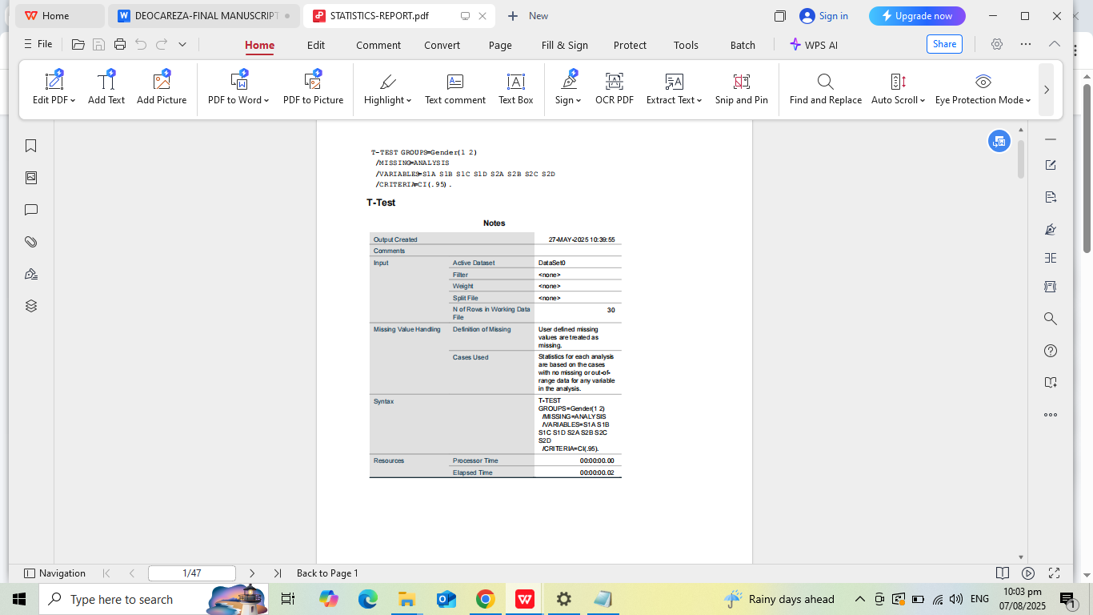

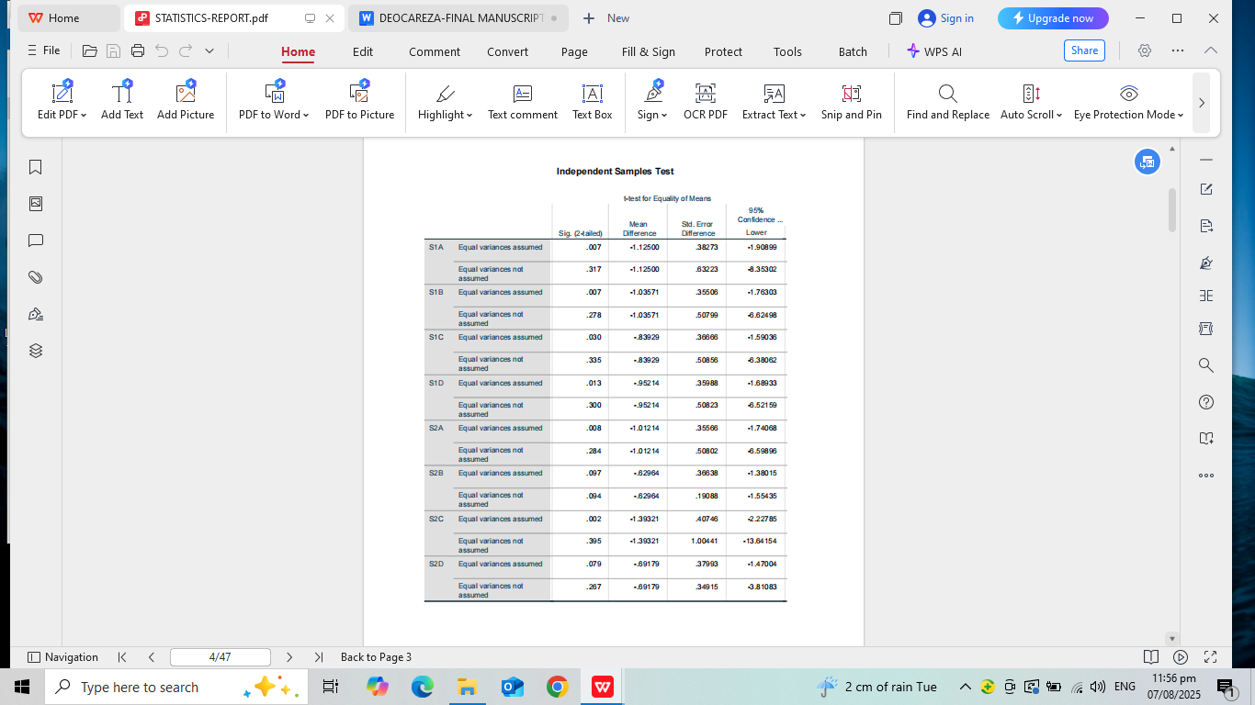

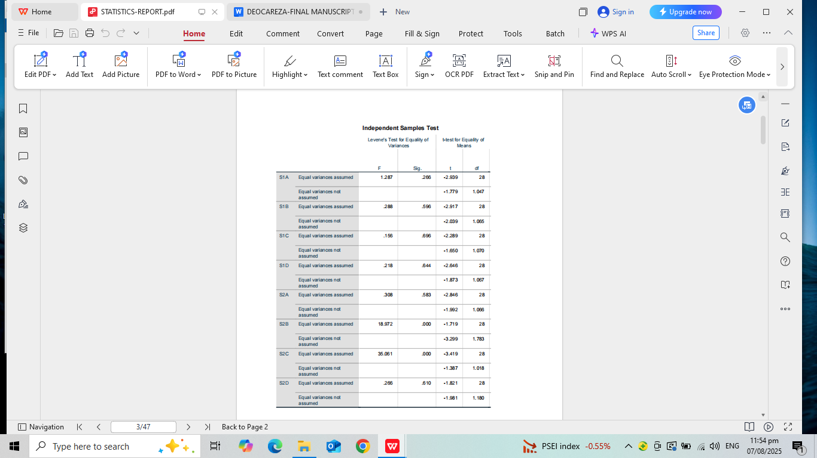

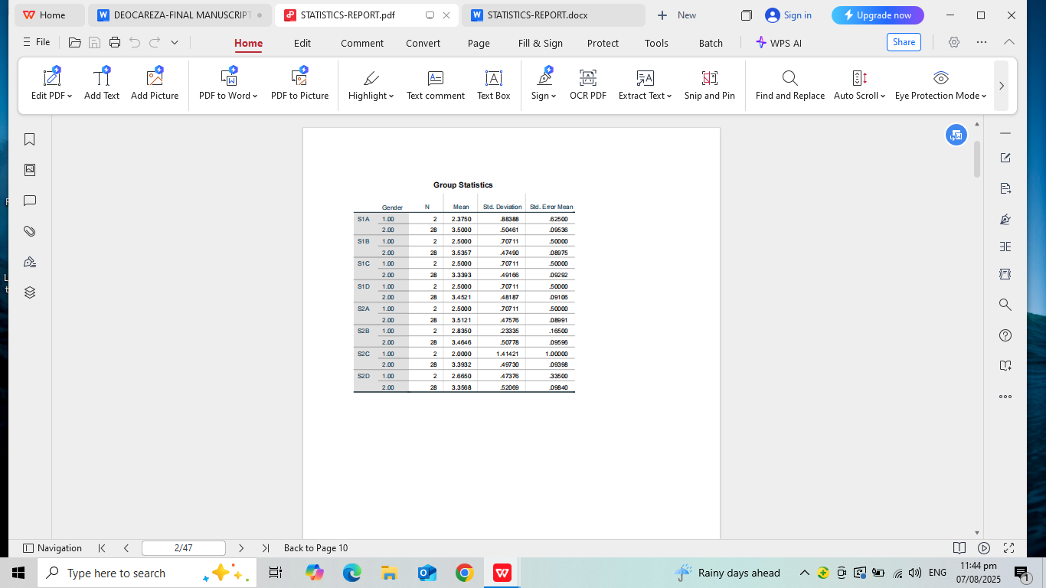

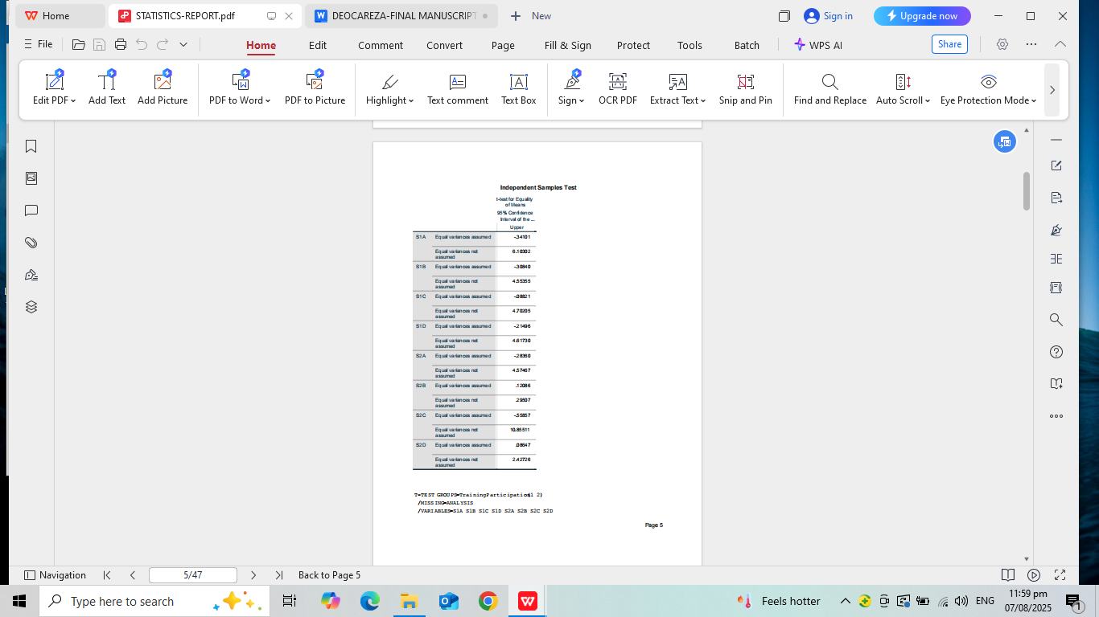

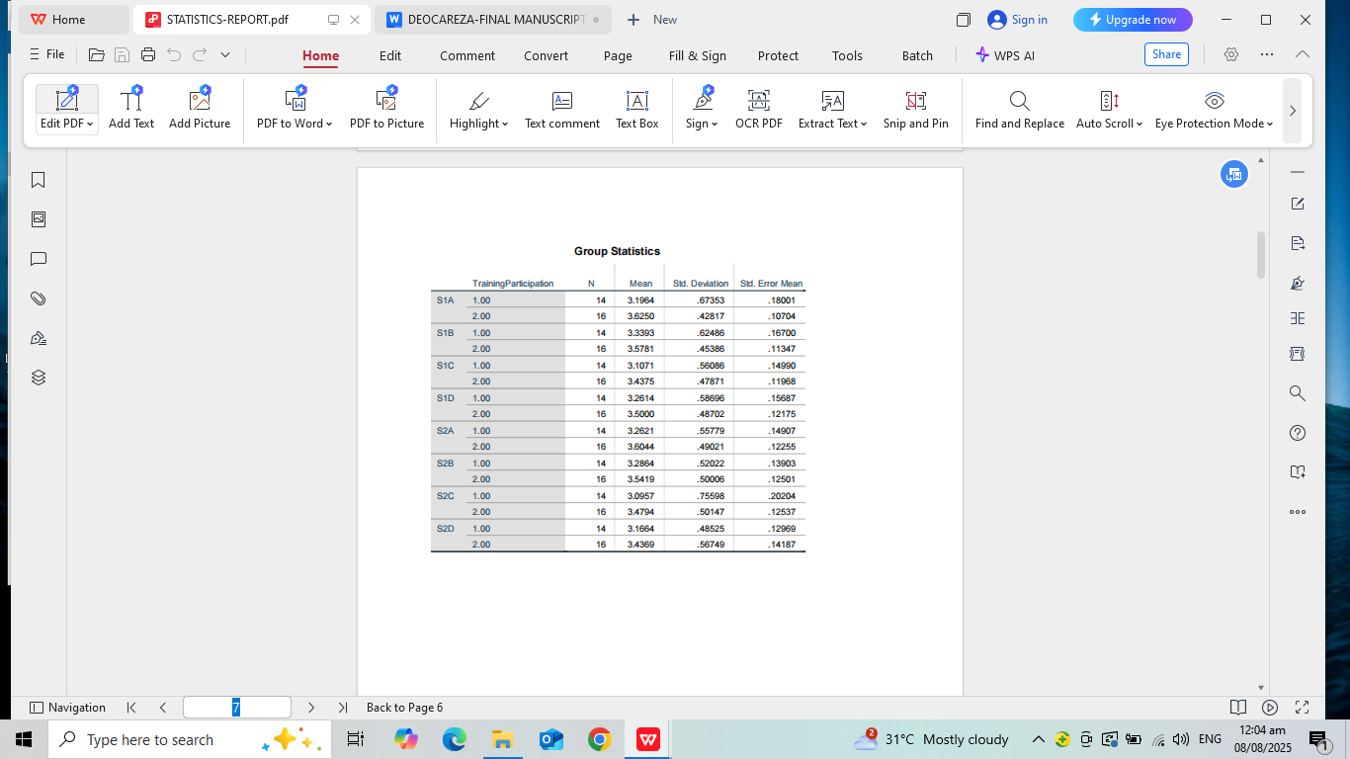

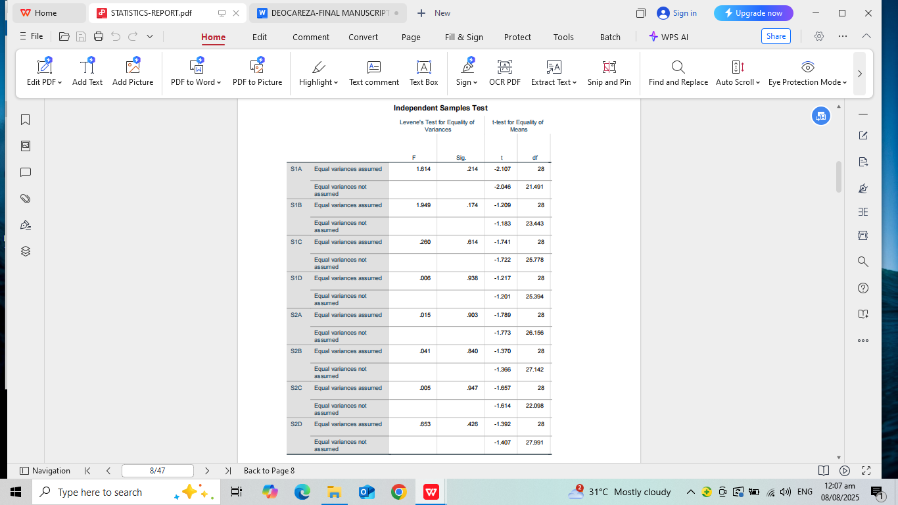

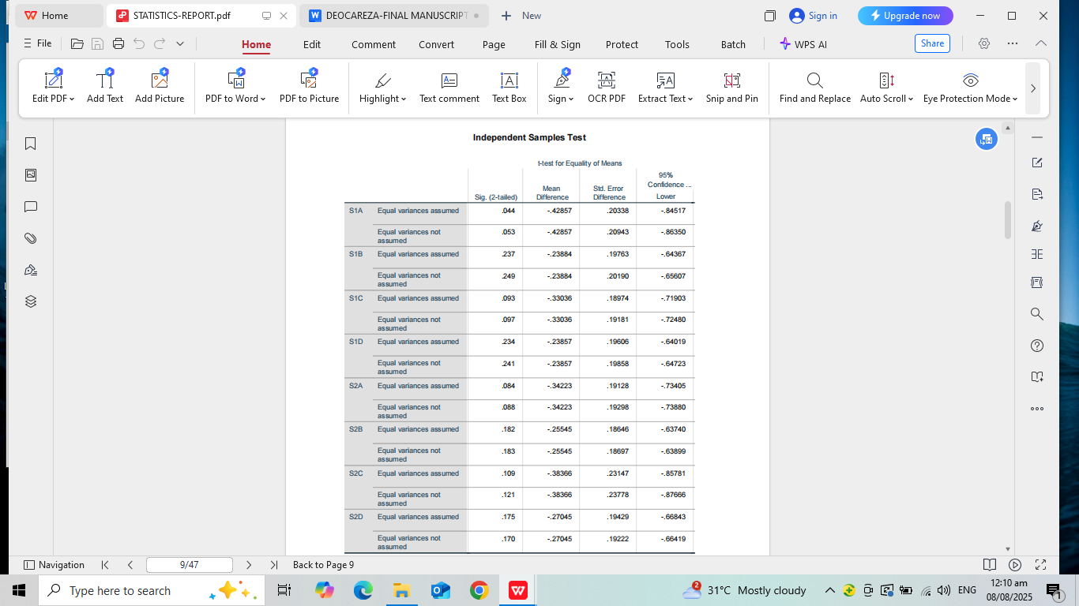

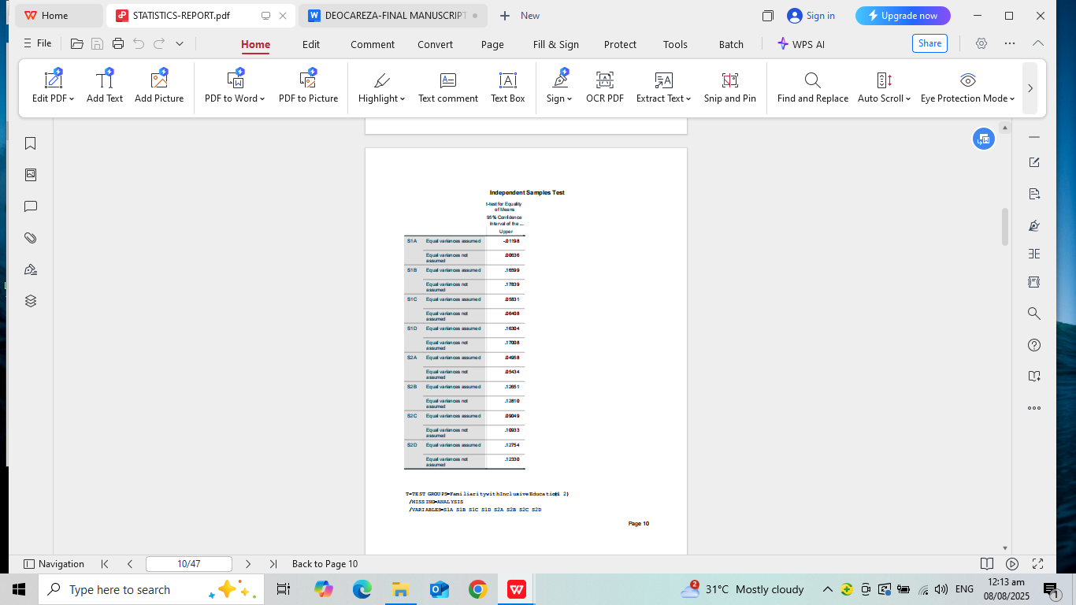

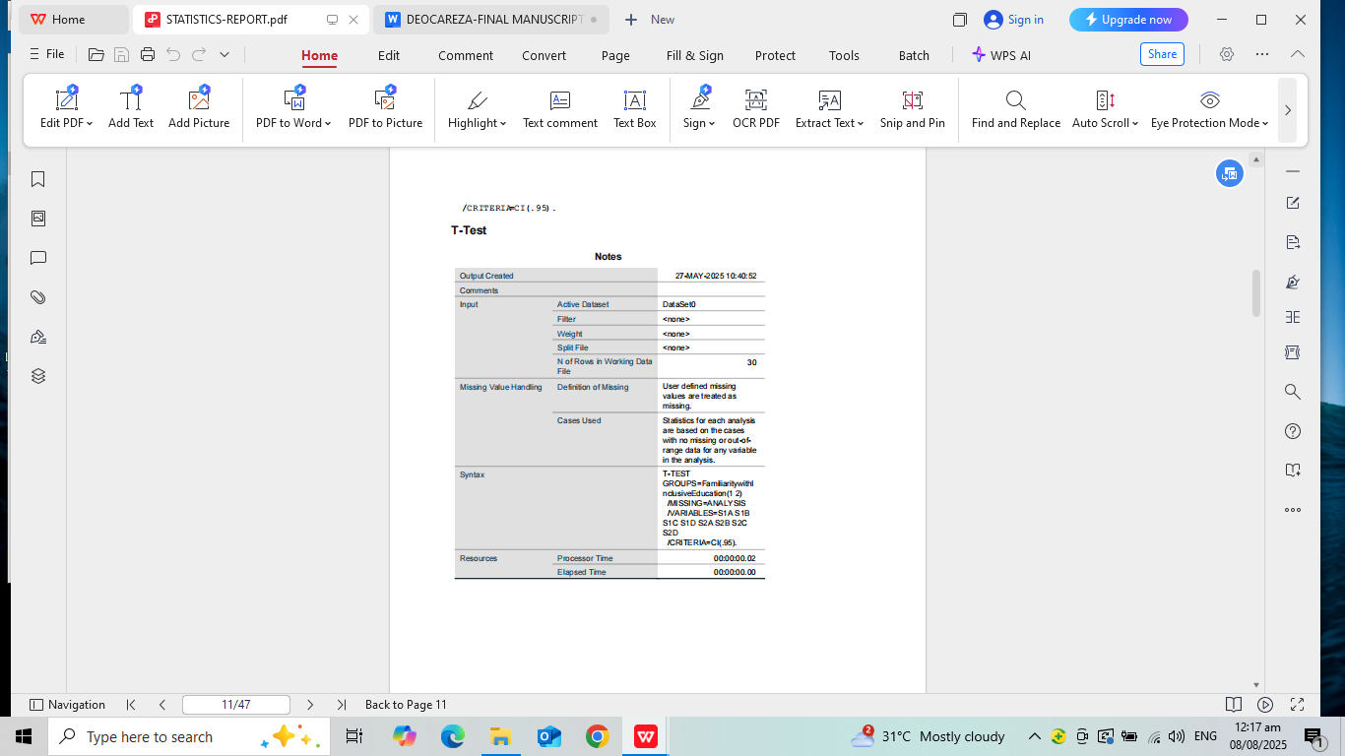

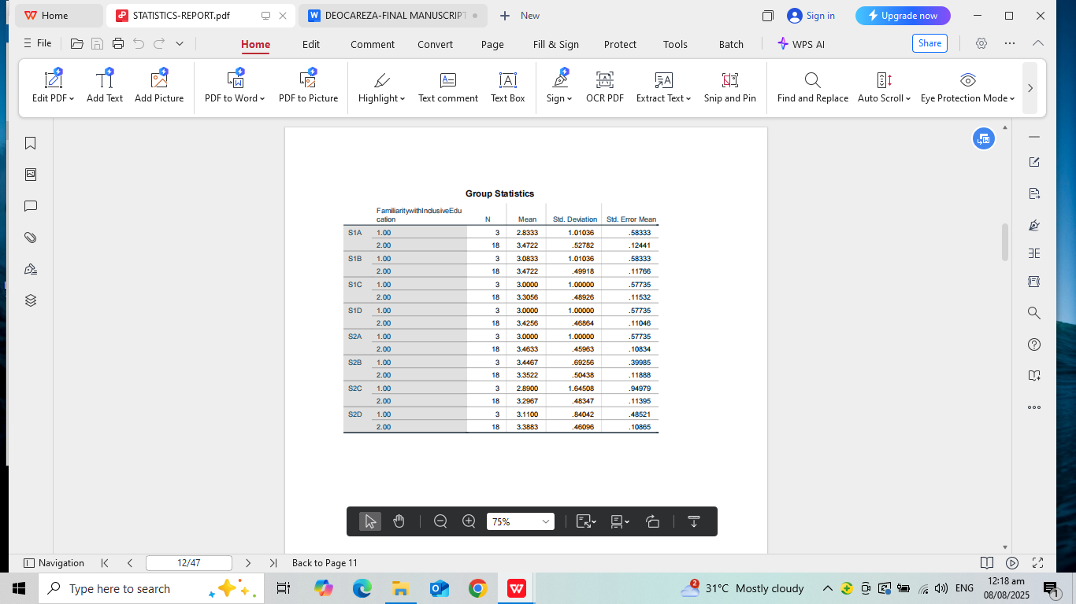

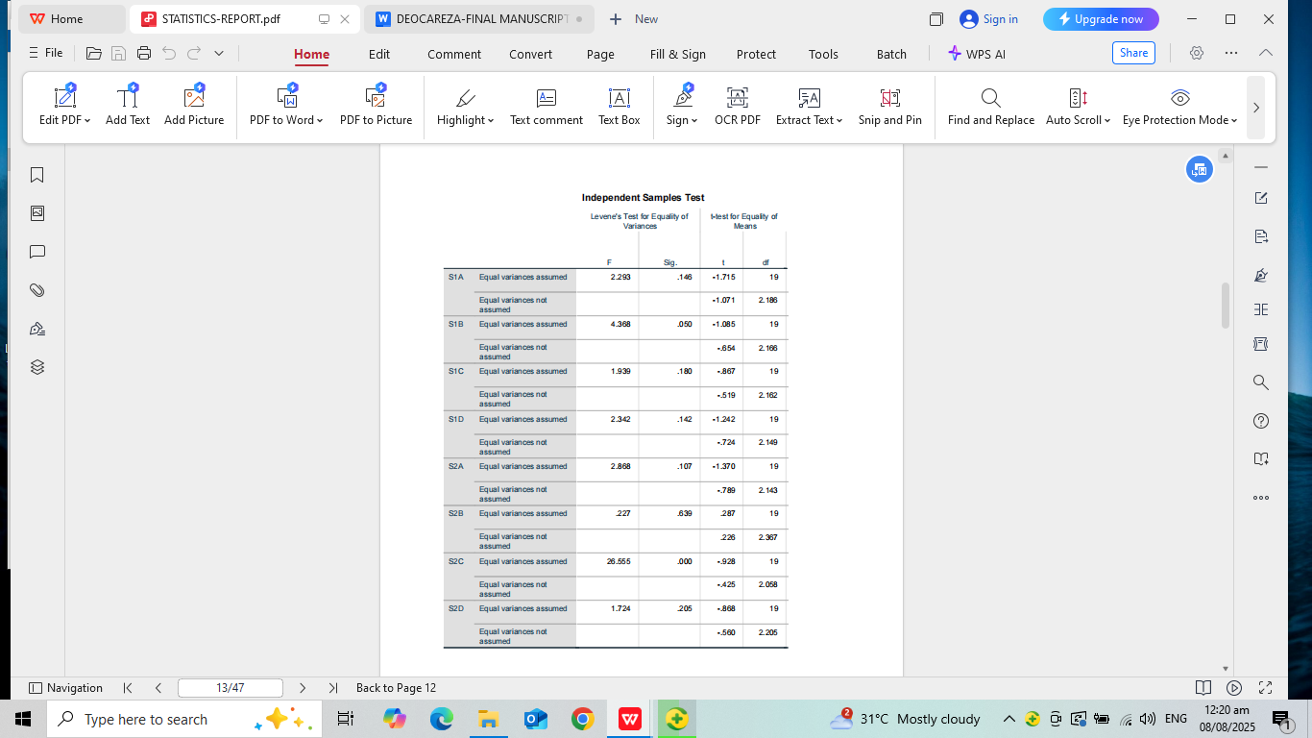

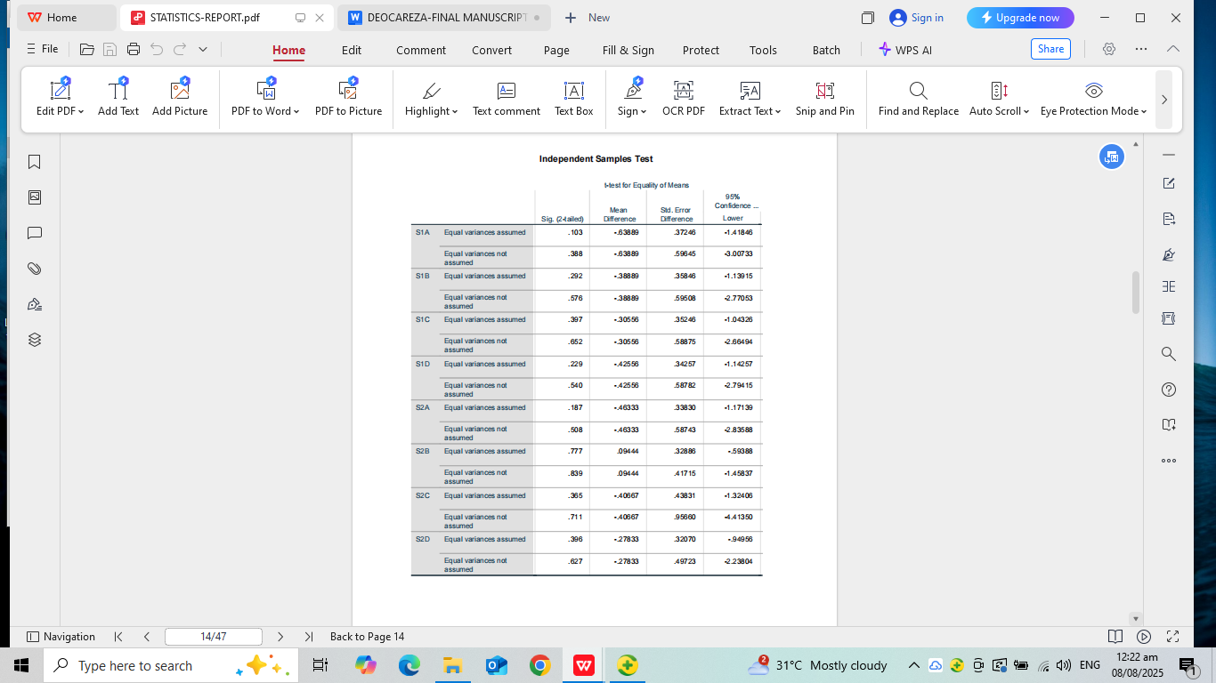

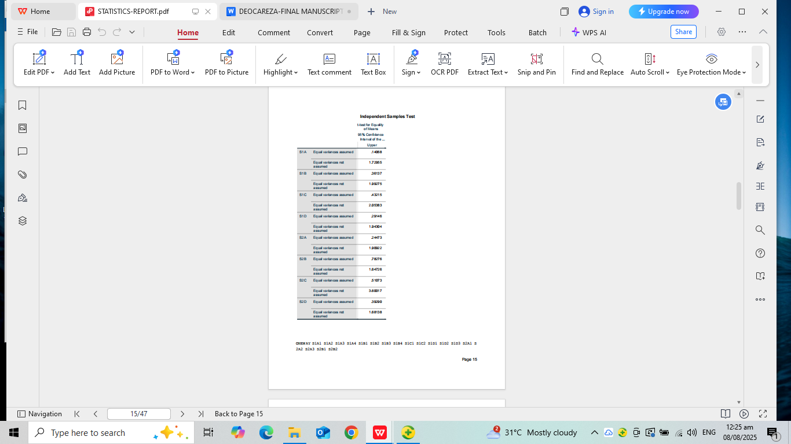

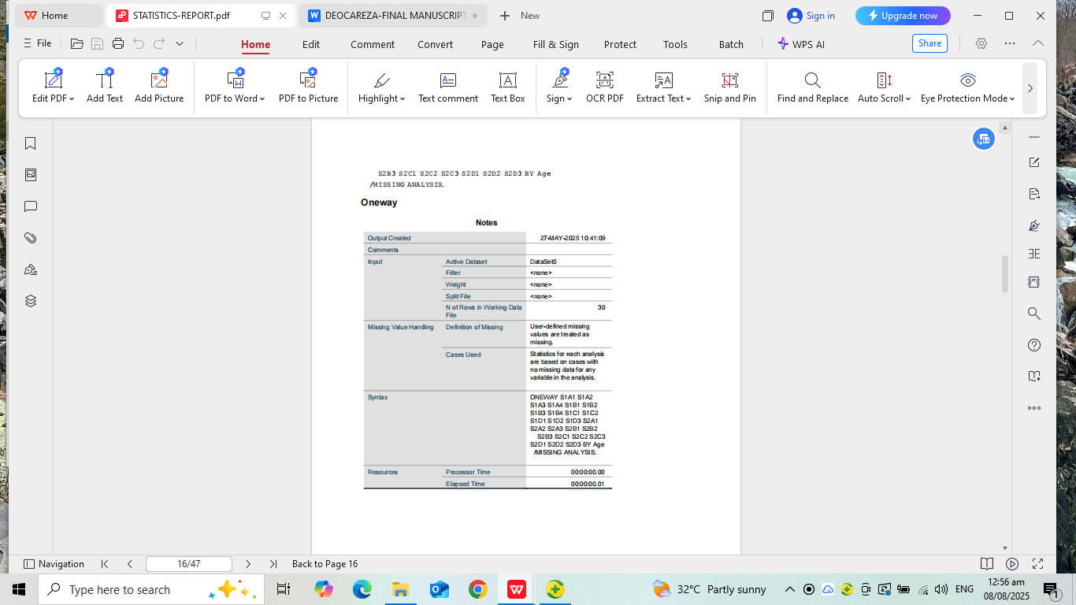

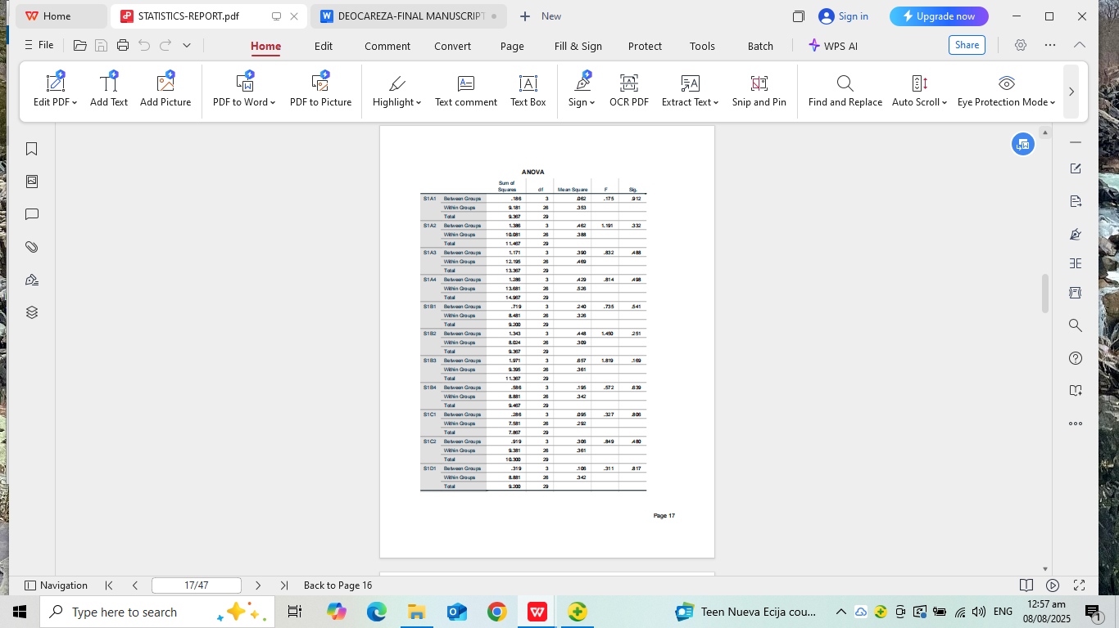

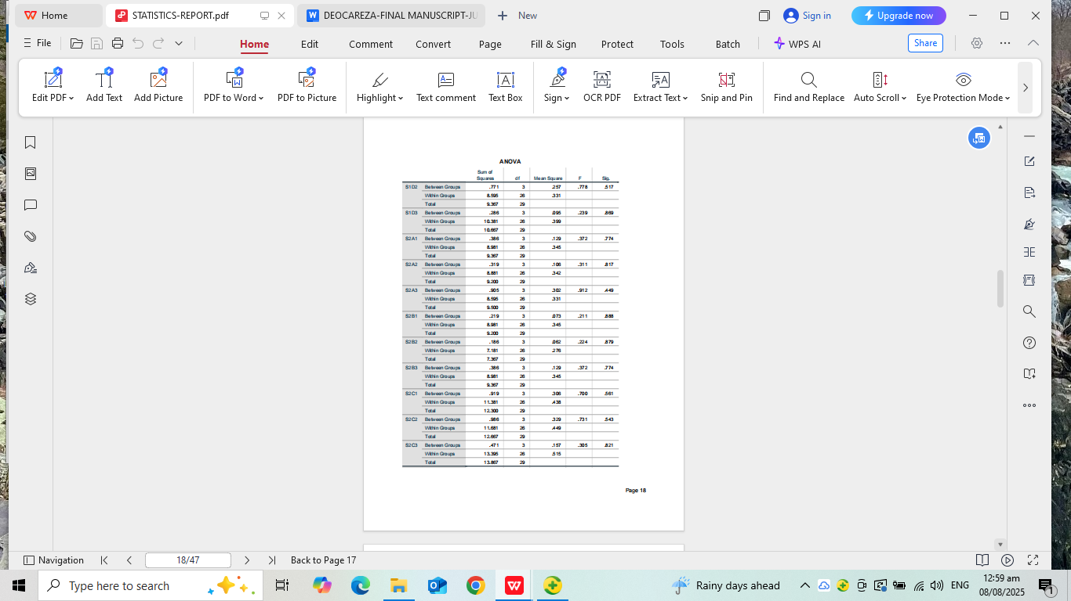

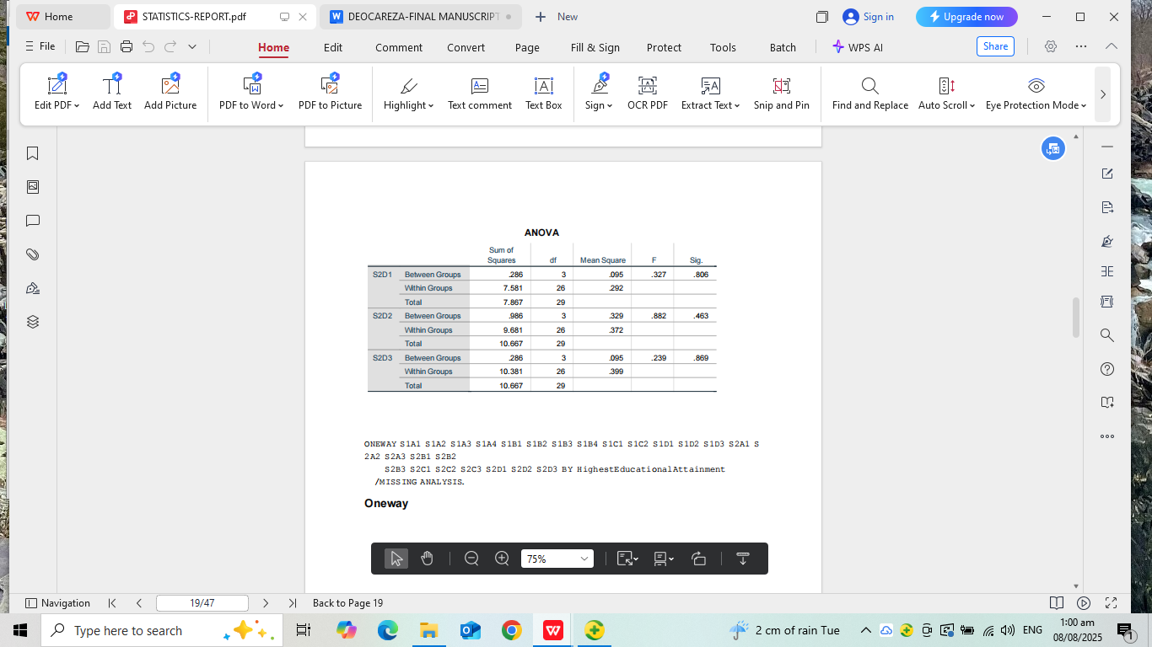

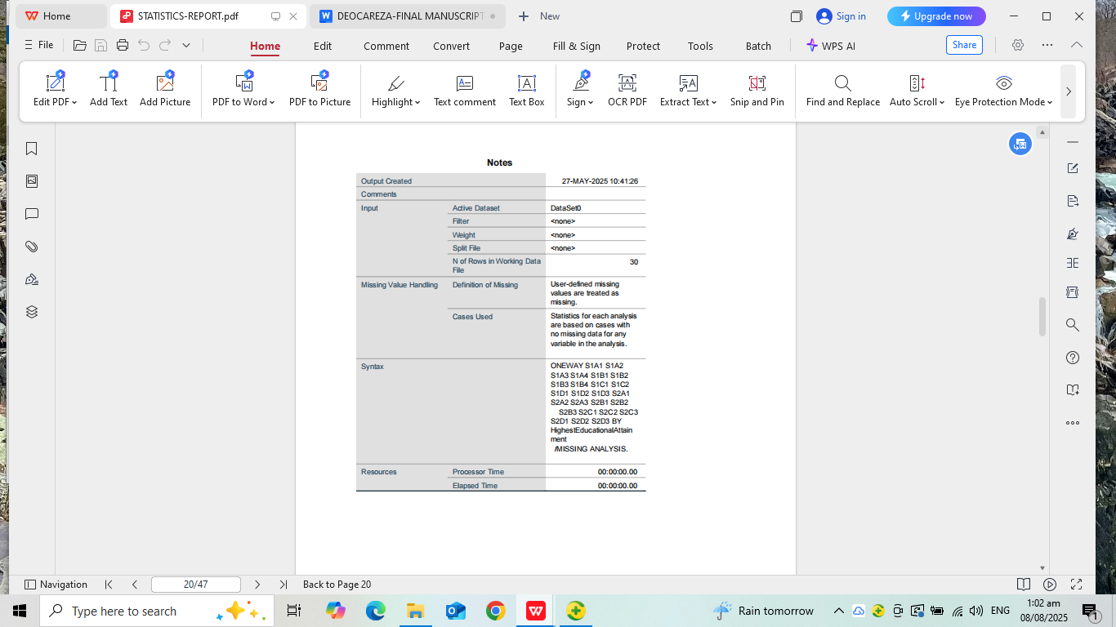

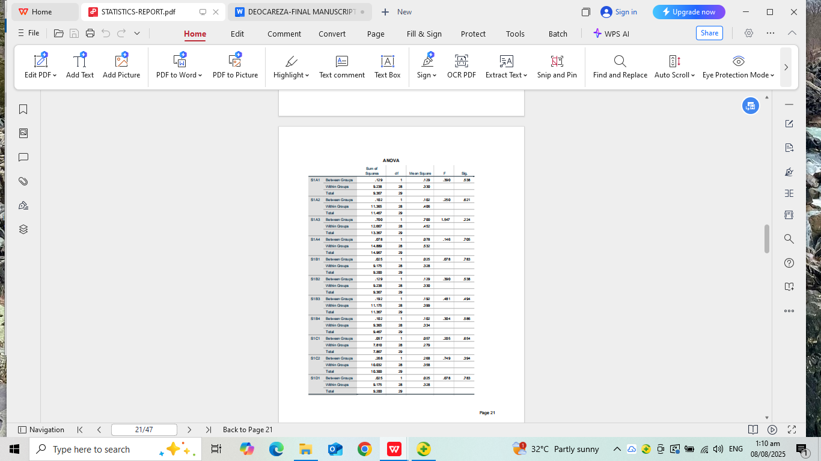

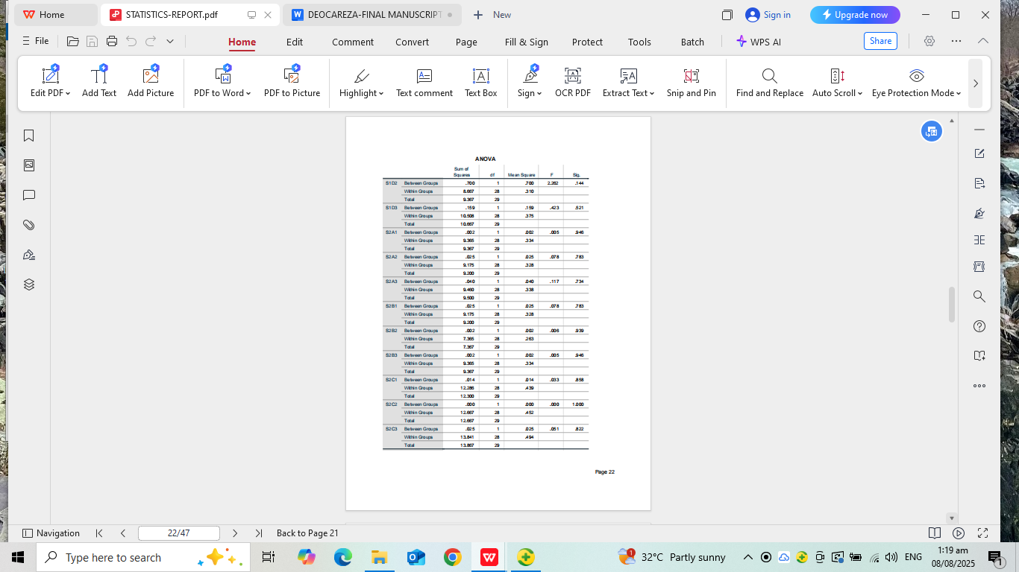

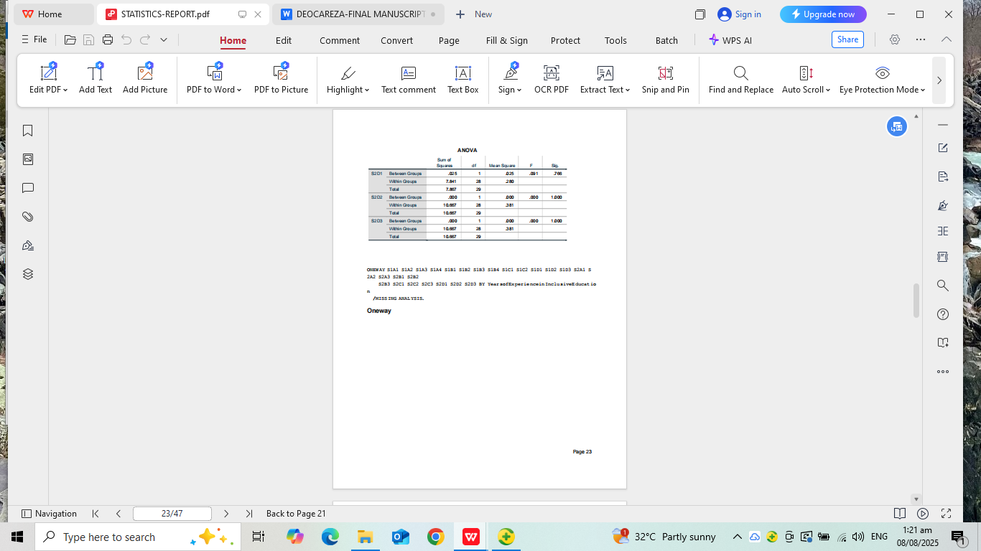

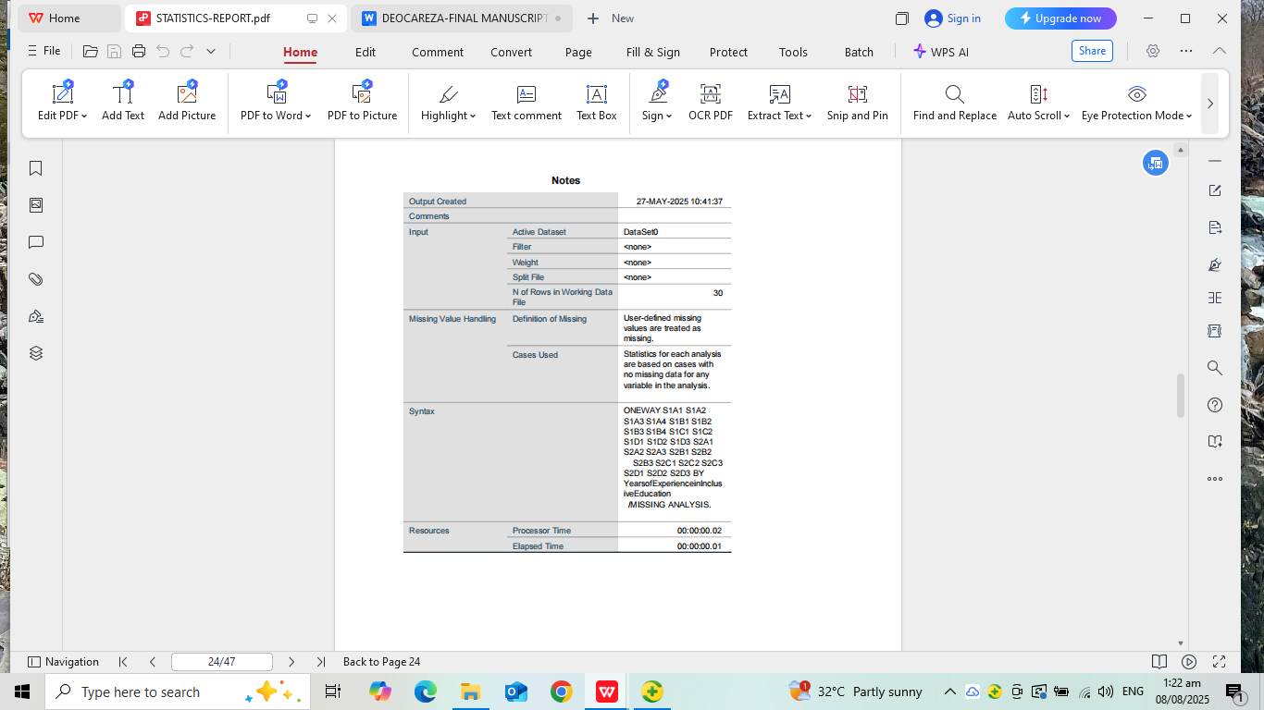

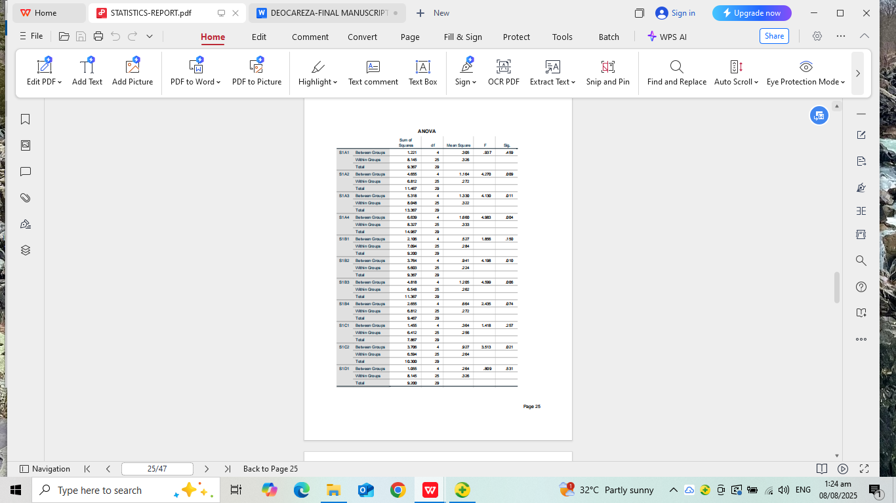

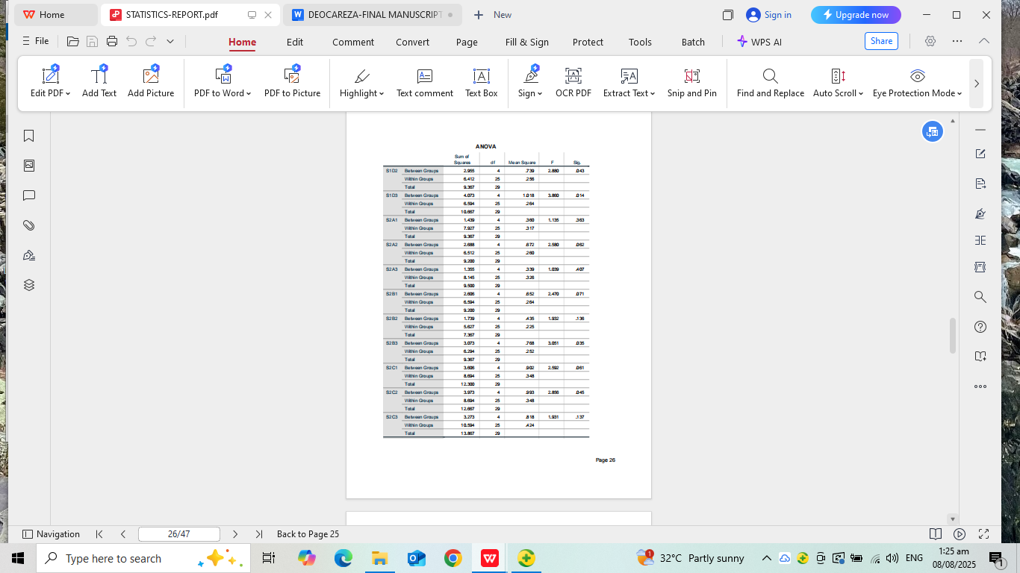

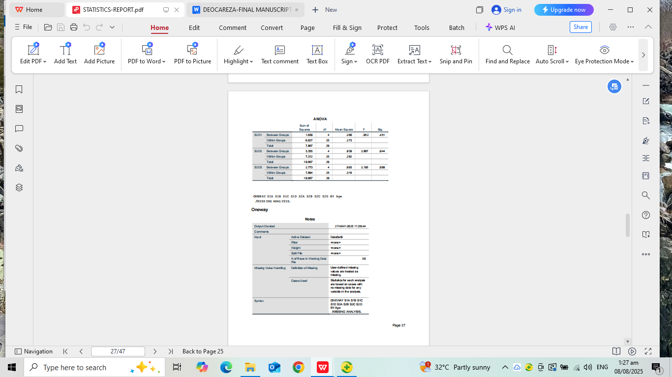

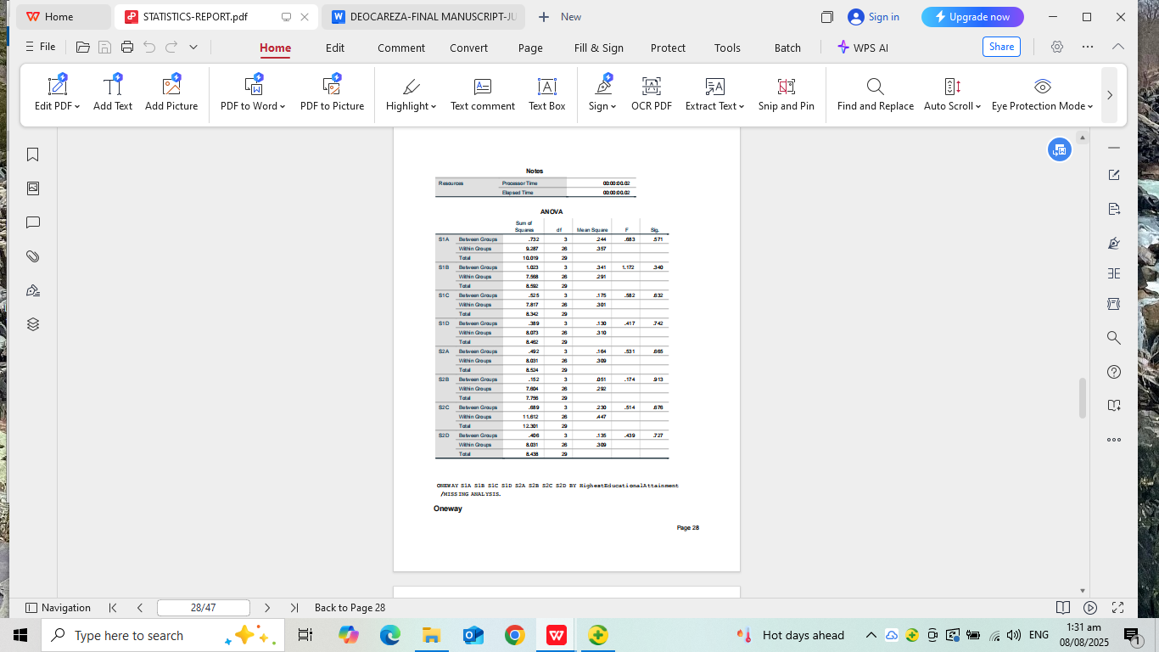

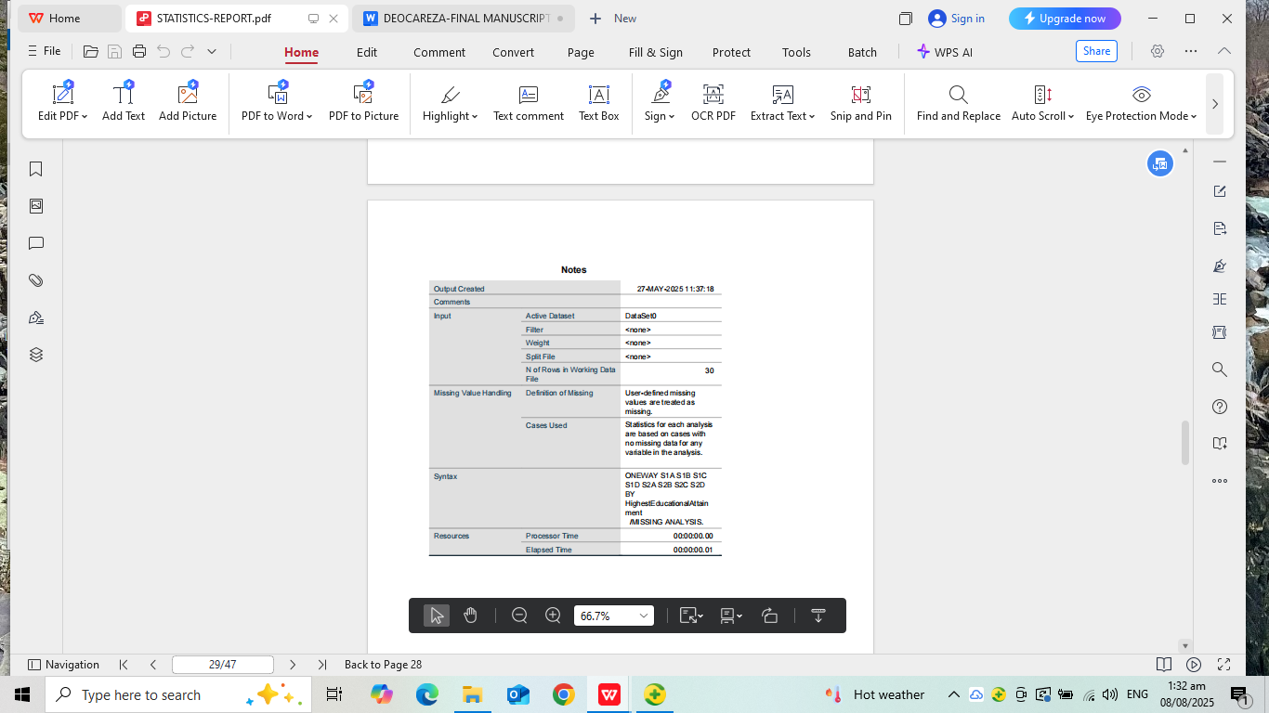

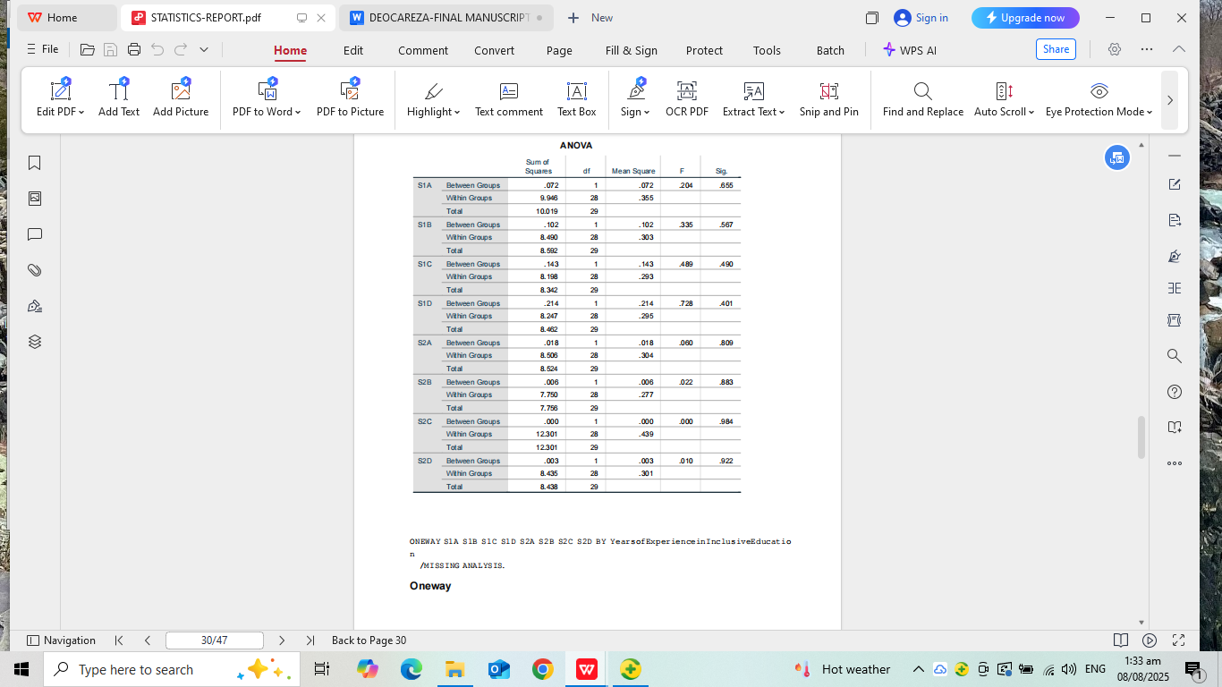

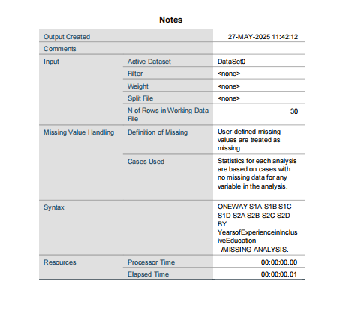

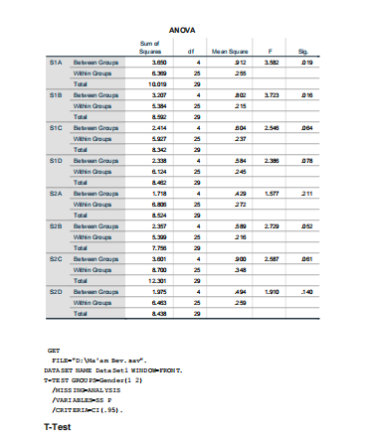

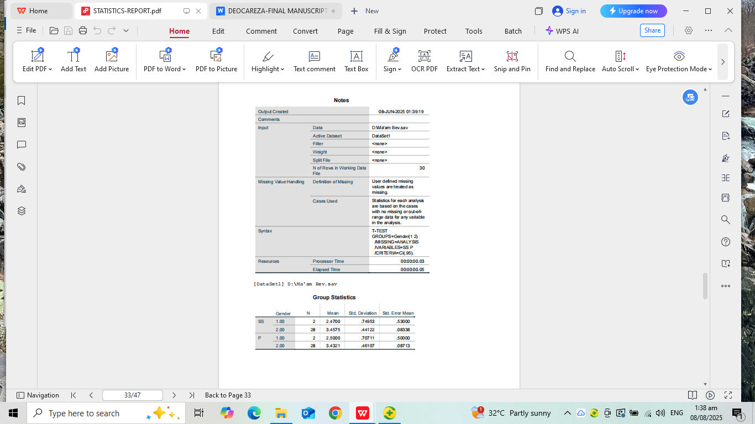

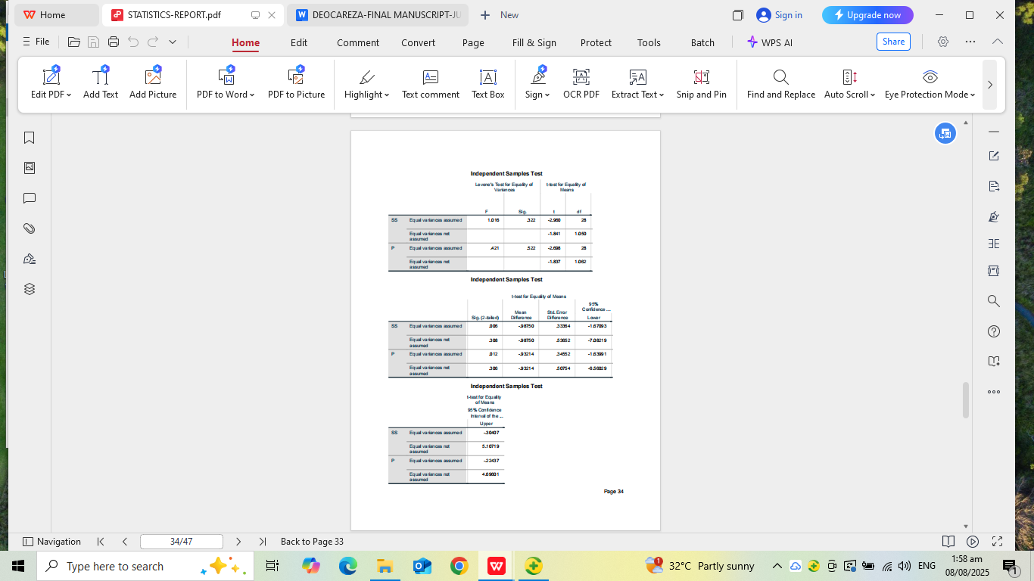

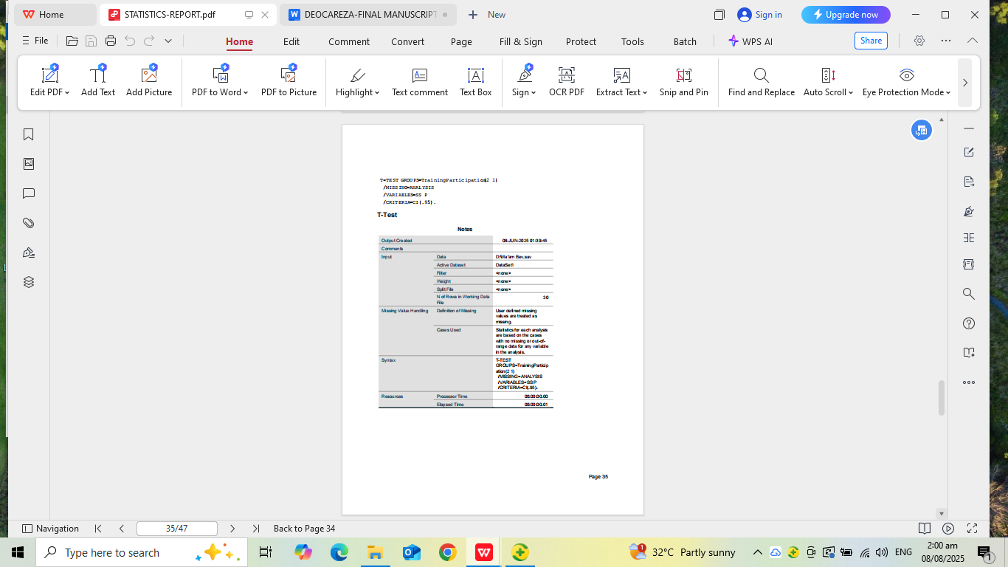

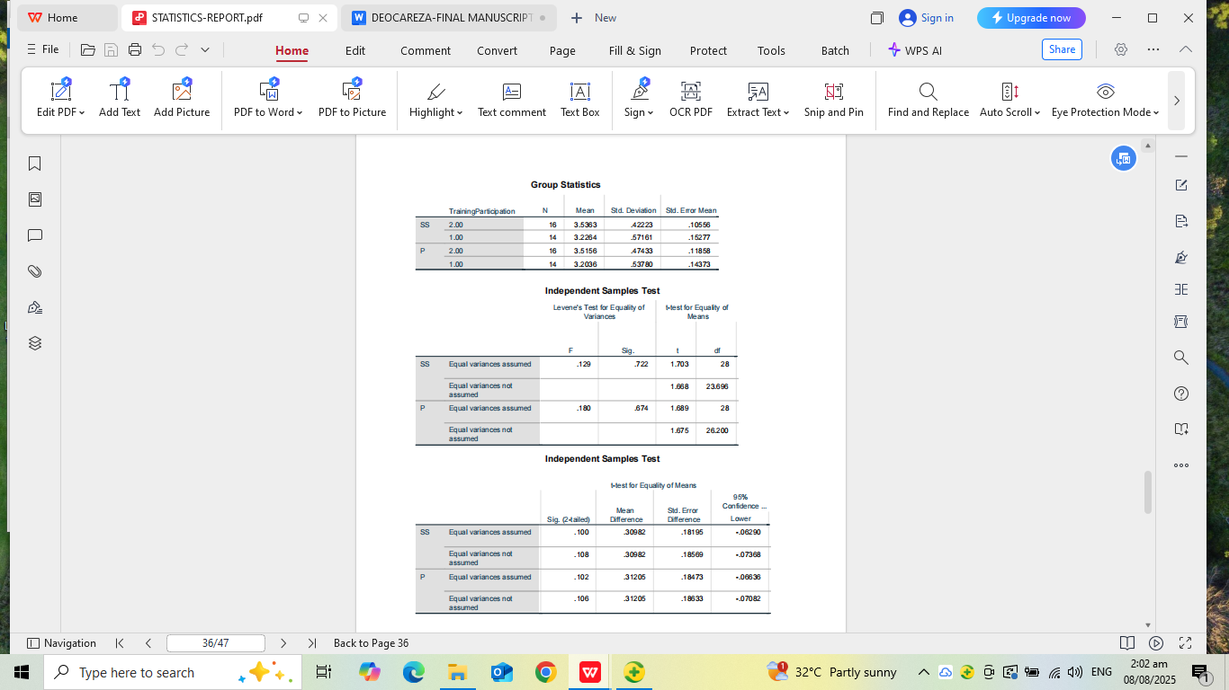

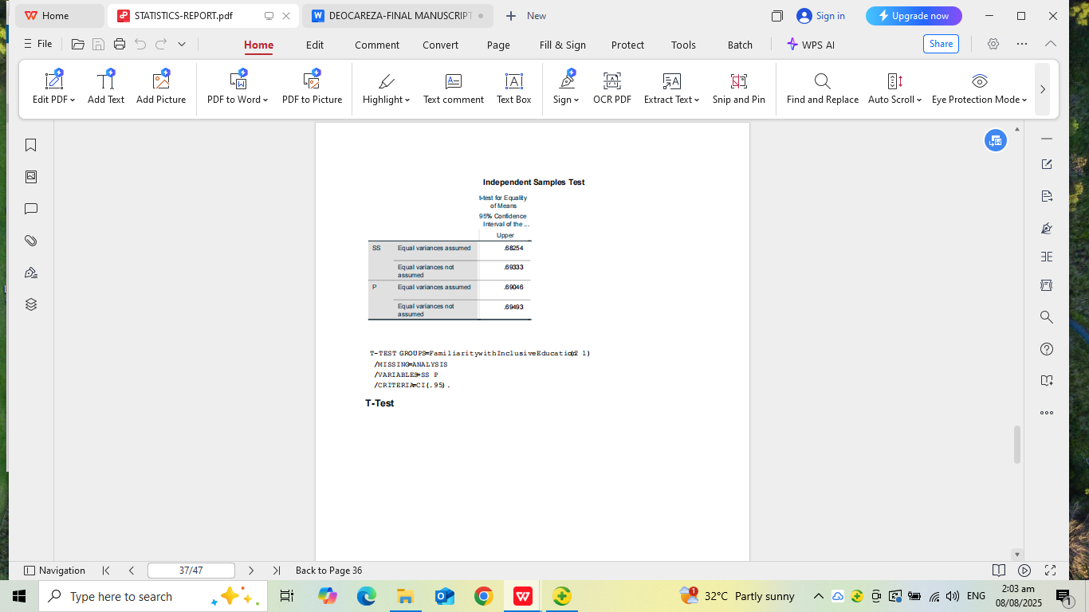

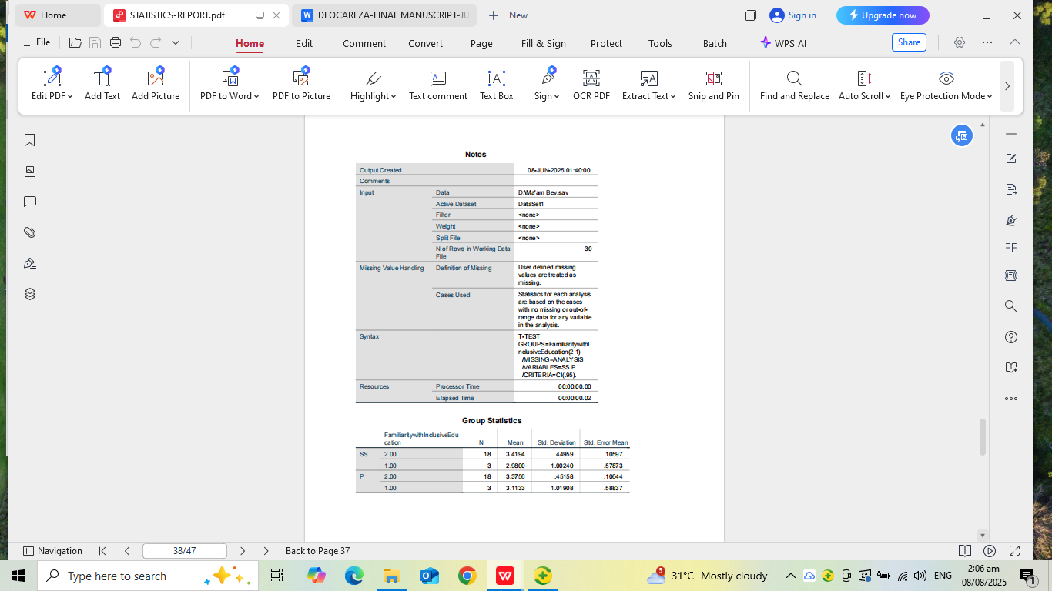

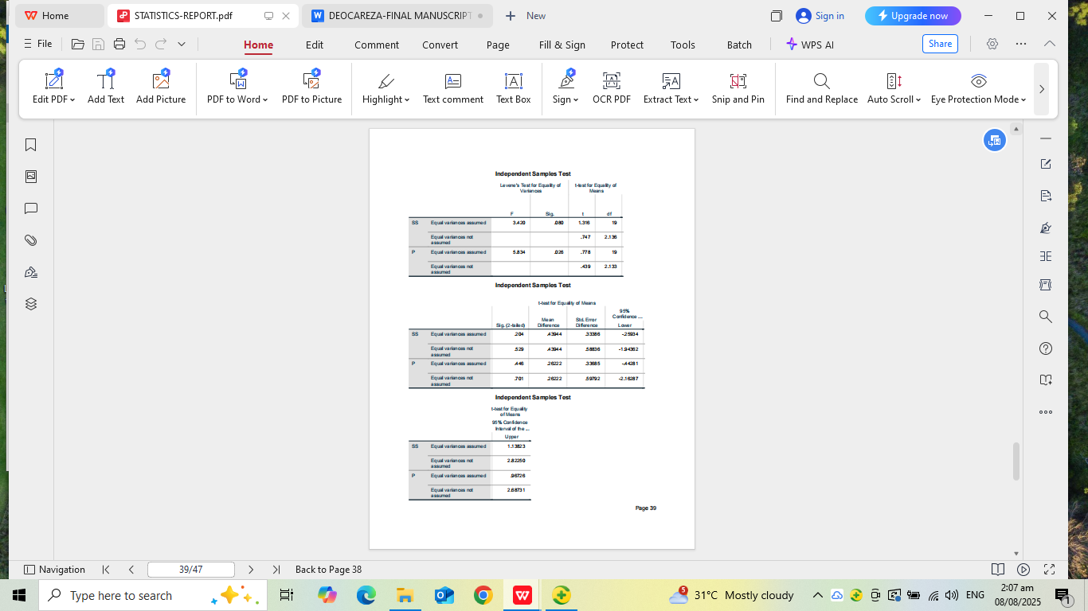

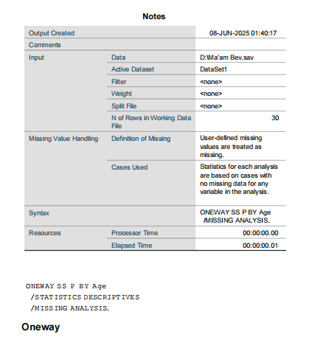

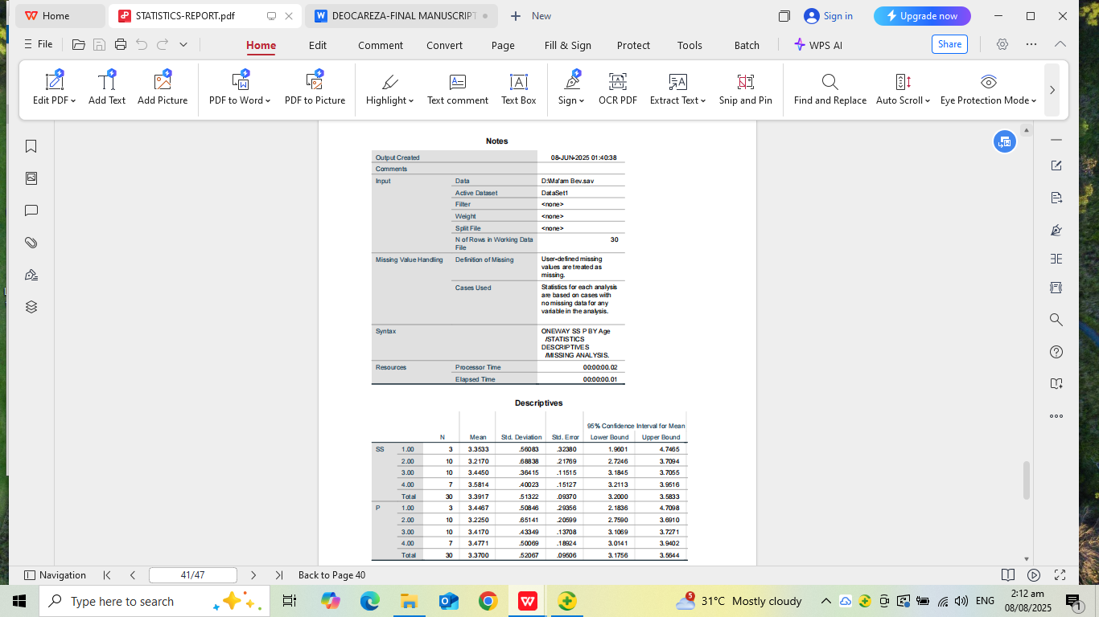

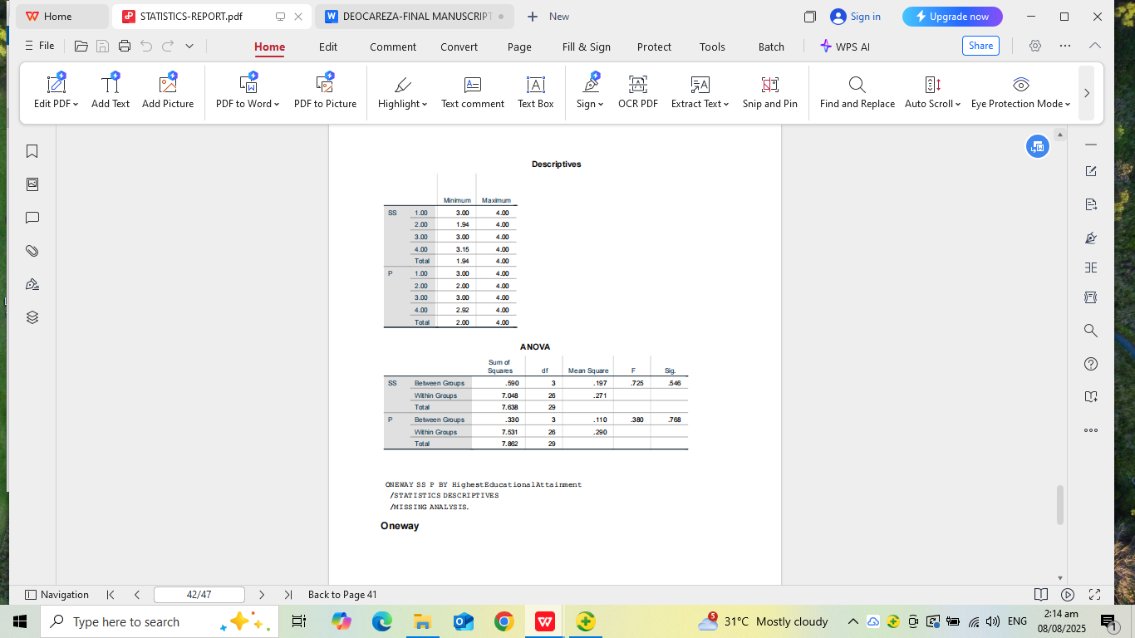

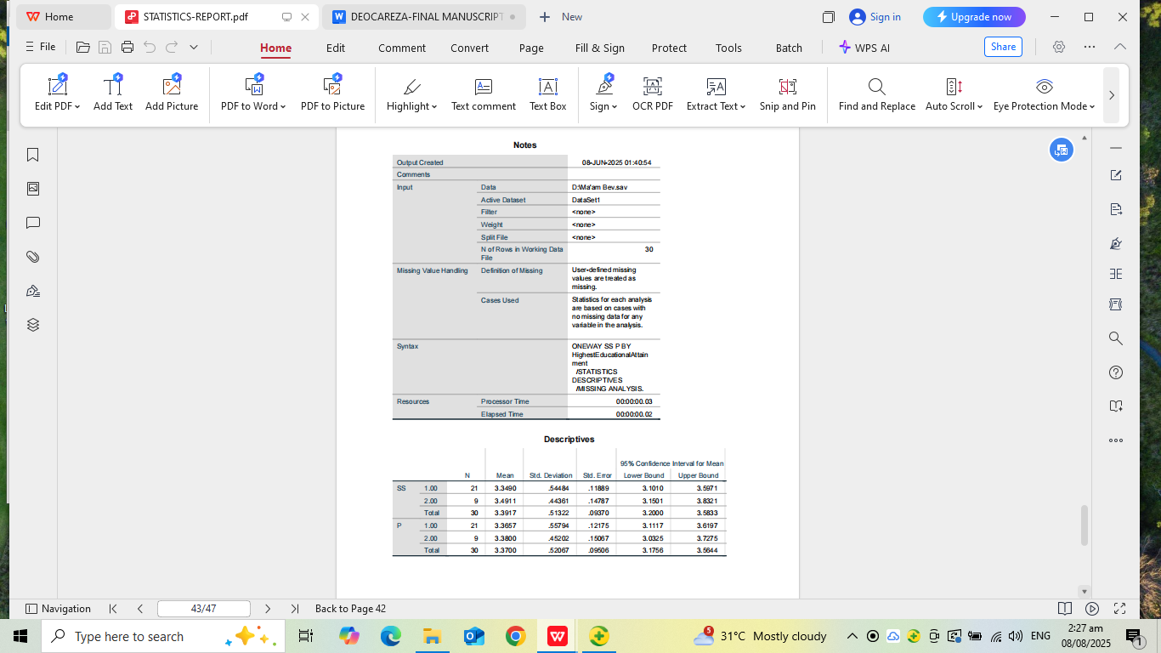

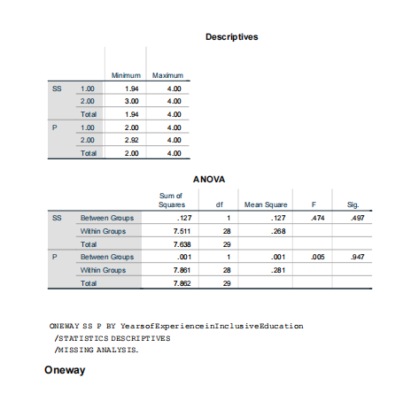

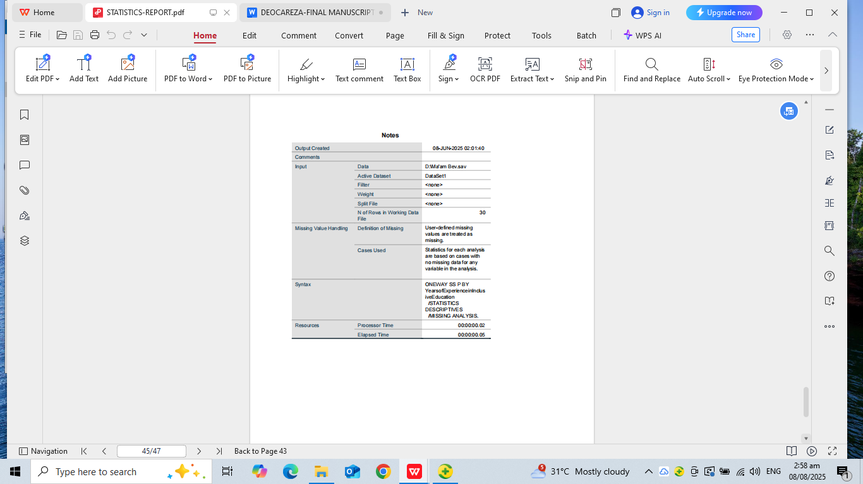

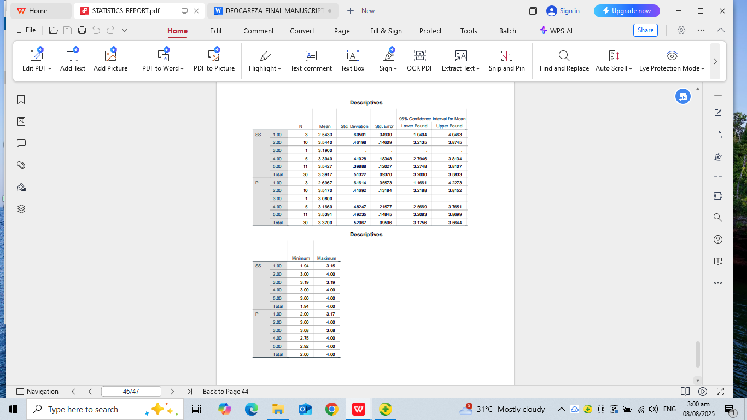

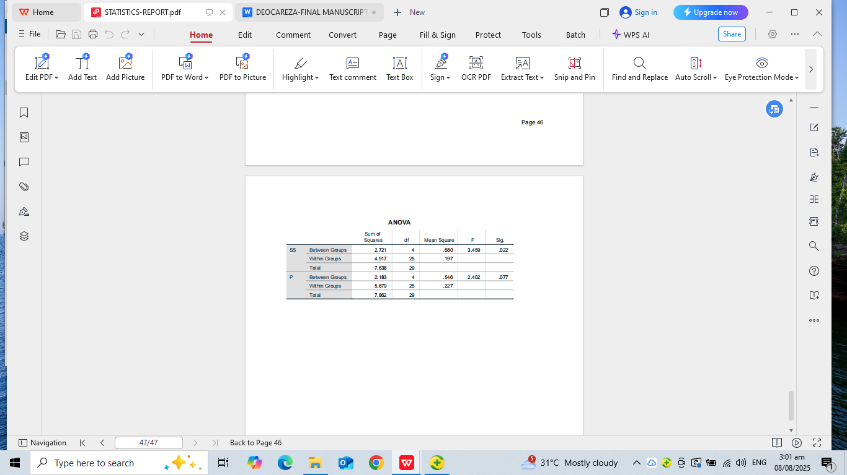

Ethical Approval Statement
This study was conducted in compliance with ethical research standards. Approval was granted by the Ethics Review Committee of the University of Perpetual Help System DALTA. Informed consent was obtained from all participants, ensuring confidentiality, voluntary participation, and the right to withdraw at any time. Data collected were used solely for academic purposes.

