Original Research Article
The Role of Project-Based Learning in the Independent Curriculum: A Study of
Teacher Perceptions

.
ABSTRACT

Objectives: to analyze teachers' perceptions of project-based learning (PjBL) as an effective method in implementing the Independent Curriculum, specifically to (1) identify teachers' understanding of the basic concepts and principles of PjBL; (2) analyze the implementation of project-based learning in the classroom; (3) determine the impact and role of PjBL on student motivation and learning outcomes based on teachers' perspectives.
Methods: This research is a descriptive quantitative study. The population of this study was all teachers who have implemented the independent curriculum. The sample was taken by purposive sampling, with 102 respondents participating who met the specified criteria. The questionnaire was designed using a Likert scale and divided into three main sections: understanding the concept of project-based learning, its application in the classroom, and the impact and role of project-based learning. The data analysis technique to obtain descriptive analysis results used the help of formulas in Spreadsheets on WPS Office.
Result: Teachers' perceptions of Project-Based Learning (PBL) were very positive, particularly in terms of conceptual understanding and impact on students. A total of 98.20% of teachers had a strong theoretical understanding of PBL principles, and they were also highly aware of its benefits, such as improved collaboration and motivation skills (both 94.12%) and critical thinking (88.24%). However, a gap was found between theory and practice. The greatest challenge was seen in classroom implementation, particularly in subject integration, which received only 78.43% approval. This figure indicates that the main obstacle lies not in teachers' understanding, but rather in practical aspects in the field.
Impact: This research provides a strong empirical foundation for policymakers and curriculum developers. The findings suggest that the focus of teacher training should no longer be solely on concepts but rather on practical and collaborative strategies, such as specific guidelines for integrating various subjects. This step is crucial for overcoming implementation barriers, ensuring optimal PBL implementation, and ultimately, effectively achieving the goals of the Independent Curriculum.

Keywords: chemistry, independent curriculum, learning, project, teacher perception

1. INTRODUCTION

Global developments, driven by the Industrial Revolution 5.0, necessitate a fundamental shift in education. The outdated paradigm, which focused solely on knowledge transfer, must evolve toward developing 21st-century skills, including critical thinking, collaboration, creativity, and communication (Rony et al., 2023). To meet these demands, many nations have reformed their curricula to be more student-centric (Johannis & Hung, 2023). Despite these efforts, the state of education in Indonesia faces significant challenges (Shaturaev, 2021). Data from the Programme for International Student Assessment (PISA) 2018 reveal that Indonesian students' scores in reading, mathematics, and science remain below the international average (OECD, 2019). This underscores the urgent need for pedagogical innovation to make education more relevant and responsive to global requirements (Bakar, 2021).
In response to these challenges, the Indonesian government launched the Merdeka Curriculum, a policy designed to grant schools and teachers greater autonomy in designing learning processes that align with local contexts and students' specific needs (Hunaepi & Suharta, 2024). However, despite this reformist spirit, the implementation of the Merdeka Curriculum presents complex challenges, particularly for teachers (Zainuddin, 2025). Structural issues within the Indonesian education system, such as limited infrastructure, a heavy administrative burden, and a lack of effective, sustained training, pose significant obstacles (Sparrow et al., 2020).
These issues are particularly evident in the application of Project-Based Learning (PjBL), one of the primary pedagogical approaches in the Merdeka Curriculum (Aisyah & Novita, 2025). While PjBL offers a profound learning model through practical experience, its on-the-ground implementation faces various hurdles (Belwal et al, 2021). A preliminary survey by the Ministry of Education in 2023 indicated that a majority of teachers struggle with designing, managing, and evaluating student projects. This finding is consistent with various empirical studies (Al Maktoum et al., 2024). For example, a study by Sari and Wibowo (2022) revealed that teachers' perceptions of PjBL vary significantly, influenced by factors such as training quality, resource availability, and increased workload Purba et al., 2023). Furthermore, in several pilot schools highlighted a gap between teachers' positive conceptual perceptions of PjBL and the practical difficulties they encounter in the field (Sormin et al., 2024). This dual burden not only affects their motivation but also their ability to optimally implement the curriculum (Wildani et al., 2025). These findings confirm that teacher perception is a crucial variable, as it directly influences how they implement PjBL and, ultimately, determines the overall success of the Merdeka Curriculum's implementation (Shihabuddin & Lestari, 2024).
Based on the preceding discussion, a significant research gap exists. To date, there is limited in-depth understanding of teachers' specific perceptions, including the challenges and support they need, in implementing PjBL within the context of the Merdeka Curriculum. Most existing research tends to be general or focuses more on student learning outcomes rather than the teachers' own perspectives and experiences. Therefore, this study aims to fill this gap by formulating the following research problem: "What are teachers' perceptions of Project-Based Learning in the context of the Merdeka Curriculum?"

2. material and methods

This study uses a quantitative approach with a survey method (Kittur, 2023). This approach was chosen to collect data from a large sample and systematically measure teacher perceptions, thus allowing for generalizability of the findings (Nardi, 2018).

Research Subjects and Location
The subjects of this study were teachers at the elementary school, junior high school and senior high school levels that had implemented the Independent Curriculum in Dairi Regency, North Sumatra Province, Indonesia. The sample will be drawn using a purposive sampling technique (Douglas, 2022) with the following criteria:
- Teachers who have taught using the Independent Curriculum for at least one semester.
- Teachers who have been involved in the implementation of the P5 project (Pancasila Student Profile Strengthening Project).
- Teachers from various subjects (e.g., science, social studies, language, etc.) to obtain more comprehensive data.

Research Instrument
The main instrument used is an online questionnaire (Google Forms) with a Likert scale of 1-5 (1 = Strongly Disagree, 5 = Strongly Agree) (Ruliyanti et al., 2021). This questionnaire was structured based on four main indicators and their function, presented in table 1 (Pan et al., 2021):

Table 1. Instrument of Research
Indicator | Function | Number of Statement
Understanding of Project-Based Learning Concepts | Measures teachers' knowledge of the basic principles, stages, and characteristics of Project-Based Learning (PjBL) | 1, 2, 3, 4
Classroom Application | Evaluates teachers' experiences in planning, managing, and assessing student projects. | 5, 6, 7, 8
Impact and role of Project-Based Learning | To determine the impact and role of Project-Based Learning (PjBL) on student motivation and learning outcomes from a teacher perspective. | 9, 10, 11, 12

Data Collection Procedures
The data collection procedure for this study is presented in Fig 1.

Fig 1. Data Collection Procedures

Collect data within a predetermined time period to ensure an adequate response rate.
Data Collection

Draft the questionnaire and validate it by expert validators (St Fatimah Azzahra, M.Pd)
to ensure content validity.
Preparation
The questionnaire is distributed online through approved teacher communication groups within schools.
Distribution

Fig 1. Data Collection Procedure

Data Analysis Techniques

The collected data will be analyzed using descriptive statistics. This analysis will include:
- Frequency, to examine the distribution of responses to each questionnaire item.
- Mean Percentage, to to examine the distribution of responses to each questionnaire item each indicator.
The data analysis technique to obtain descriptive analysis results used the help of formulas in Spreadsheets on WPS Office. The results of the analysis will be presented in histogram and narratives to provide a clear picture of teachers' perceptions of PjBL. .

3. results and discussion

The validity of the research instrument has been tested, with revisions made to two statements to ensure their operational aspects. This instrument was then used to collect data regarding teachers' perceptions of the role of Project-Based Learning (PjBL) in supporting the implementation of the Independent Curriculum. The perception data were classified into three indicators: (1) Understanding the PjBL Concept, (2) Implementation in the Classroom, and (3) Impact and Role of PjBL. The frequency distribution of responses (strongly agree = SA, agree = A, undecided = U, disagree = D, and strongly disagree = SDS) for each statement item is presented comprehensively in Table 2.

Table 2. Data Description
Indicator | Kode Soal | Statements | SA | A | U | DS | SDS
Understanding of Project-Based Learning Concepts | Q1 | I understand that project-based learning is a student-centered method. | 63 | 36 | 3 | 0 | 0
Understanding of Project-Based Learning Concepts | Q2 | I understand the difference between project-based learning (PjBL) and traditional project methods. | 32 | 64 | 5 | 1 | 0
Understanding of Project-Based Learning Concepts | Q3 | I understand the teacher's role as a facilitator in project-based learning. | 52 | 49 | 1 | 0 | 0
Understanding of Project-Based Learning Concepts | Q4 | I understand the connection between project-based learning and the dimensions of the Pancasila Student Profile. | 37 | 62 | 3 | 0 | 0
Classroom Implementation | Q5 | I feel I have sufficient guidance in planning effective learning projects. | 28 | 68 | 6 | 0 | 0
Classroom Implementation | Q6 | I have no difficulty integrating various subjects into one project. | 21 | 59 | 12 | 10 | 0
Classroom Implementation | Q7 | I am able to identify student interests and needs when designing projects. | 26 | 70 | 6 | 0 | 0
Classroom Implementation | Q8 | I have no difficulty conducting authentic assessments of student project outcomes. | 22 | 68 | 7 | 5 | 0
Impact and role of Project-Based Learning | Q9 | Project-based learning effectively enhances students' collaboration skills. | 35 | 62 | 4 | 1 | 0
Impact and role of Project-Based Learning | Q10 | Project-based learning helps students develop critical thinking skills. | 42 | 59 | 1 | 0 | 0
Impact and role of Project-Based Learning | Q11 | Project-based learning significantly contributes to achieving the dimensions of the Pancasila Student Profile. | 39 | 59 | 4 | 0 | 0
Impact and role of Project-Based Learning | Q12 | I have observed an increase in student learning motivation through project-based learning. | 40 | 56 | 5 | 1 | 0

Based on the table data, the Project-Based Learning (PjBL) Concept Understanding indicator had the highest percentage of "strongly agree" responses compared to other indicators. Second place was taken by the PjBL Impact and Role indicator. Meanwhile, the Classroom Implementation indicator had the lowest percentage of "strongly agree" responses.
- Understanding of Project-Based Learning Concepts
In general, teachers' perceptions of PjBL conceptual understanding are very positive. This is evident in the dominant percentage of respondents who strongly agree and agree with the positive statements, as shown in Figure 2.
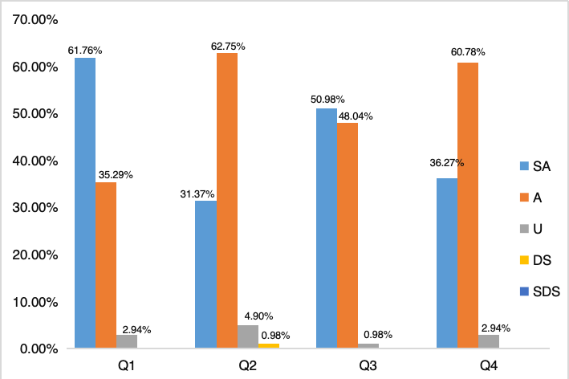
Fig 2. Data Tabulation (Percentage of Respondents) Indicators of Understanding PjBL Concepts

Based on the data, teachers demonstrate a strong conceptual understanding of Project-Based Learning (PjBL). This is evidenced by the high percentage of "strongly agree" and "agree" responses for the "Conceptual Understanding" indicator, which totals 98.20% of respondents (56.63% strongly agree and 41.57% agree). This solidifies the finding that teachers have a strong theoretical foundation. Specifically, the high response rate for items on the teacher's role as a facilitator and the connection between PjBL and the dimensions of the Pancasila Student Profile underscores a significant pedagogical paradigm shift. A combined 97.06% of respondents (38.33% strongly agree and 58.73% agree) for the "Impact and Role" indicator confirms that teachers are highly aware of the objectives of the Independent Curriculum.
Therefore, it can be concluded that the primary barrier to PjBL implementation does not stem from a lack of theoretical knowledge, but rather from practical aspects in the field. The "Classroom Application" indicator supports this, showing a much lower percentage of "strongly agree" responses (23.33%) and a noticeable percentage of "hesitant" and "disagree" responses (a total of 14.77%), highlighting the challenges faced during practical application. This robust conceptual foundation is a valuable asset that can be leveraged to develop strategies to overcome these implementation challenges.The data shows that most teachers feel they understand PjBL (Rubino, 2024).
The average score for all understanding indicators ranges from 4 (Agree) to 5 (Strongly Agree). This indicates that the majority of respondents strongly agree with the statements that test their understanding. The highest average (close to 5) indicates that teachers are very confident in their understanding of their role as facilitators, not just as transmitters of material. Responses are also very strong regarding the understanding of the relationship between PjBL and the dimensions of the Pancasila Student Profile, indicating an awareness of the objectives of the Independent Curriculum. The data shows that the main obstacle is not in teachers' theoretical understanding, but rather in practical aspects.
Based on the analysis, findings indicate that teachers' conceptual understanding of Project-Based Learning (PjBL) is at an excellent level, hal ini sejalan dengan literatur review yang menyatakan bahwa tidak ada temuan terkait kesalahan implementasi sintaks PjBL (Purba et al., 2022). This is reflected in the predominance of "strongly agree" and "agree" responses, indicating a strong theoretical foundation among respondents. Furthermore, the high percentage of responses to the item examining the teacher's role as a facilitator indicates a shift in the pedagogical paradigm from conventional teaching models to a student-centered approach (Alam, 2023). Furthermore, a deep understanding of the relationship between PjBL and the dimensions of the Pancasila Student Profile confirms that teachers have a high awareness of the objectives of the Independent Curriculum (Utari and Afendi, 2022). Therefore, it can be concluded that the main obstacles to PjBL implementation stem not from a lack of theoretical understanding, but from practical aspects in the field. This solid conceptual understanding provides valuable capital that can serve as a foundation for designing strategies to overcome implementation challenges.

2. Classroom Implementation
In contrast to the findings on conceptual understanding, teachers' perceptions of the implementation of Project-Based Learning (PjBL) in the classroom indicated significant challenges. This is evident from the average scores on the implementation indicators, which tended to be lower, ranging from 3.5 to 4.5. This range of scores indicates that teachers' perceptions ranged from "uncertain" to "agree," not as strong as their confidence in the conceptual understanding aspect. A comprehensive analysis of the percentage distribution of responses for each category (strongly agree, agree, undecided, disagree, and strongly disagree) is presented in Figure 3.

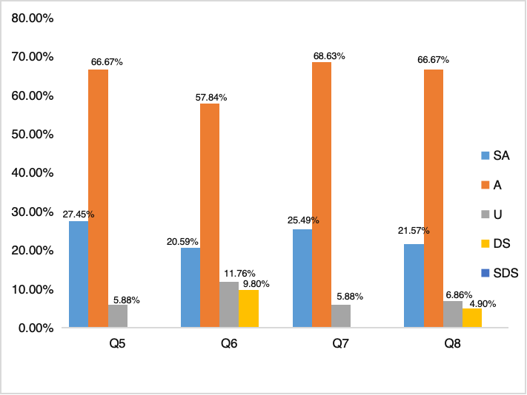
Fig 3. Data Tabulation (Percentage of Respondents) Indicators of Classroom Implementation

Based on the data presented, teachers' perceptions regarding the Classroom Implementation of Project-Based Learning (PjBL) reveal a mix of confidence and significant challenges. While a high percentage of respondents expressed agreement on several aspects, certain items indicate practical obstacles. Specifically, the findings suggest that teachers feel adequately supported in key areas. A combined 94.12% of respondents (27.45% strongly agree, 66.67% agree) reported having sufficient guidance in planning effective projects, and another 94.12% (25.49% strongly agree, 68.63% agree) felt confident in their ability to identify student interests and needs.
However, a clear weakness emerges regarding the integration of subjects. The item "I have no difficulty integrating various subjects into one project" has the lowest level of agreement, with only 78.43% of teachers responding "strongly agree" or "agree." This item also shows a significant percentage of hesitance (11.76%) and disagreement (9.80%). This highlights that while teachers may be confident in other areas of implementation, interdisciplinary integration remains a major obstacle (Malinić et al., 2021). The data also indicates that authentic assessment presents a moderate challenge, with 88.24% of teachers agreeing that they have no difficulty. The relatively high averages on other items (such as identifying student interests) indicate that most teachers feel quite confident in their abilities in this aspect of planning (Li et al., 2023)

3. Impact and role of Project-Based Learning
This section assesses respondents' perceptions of the impact of Project-Based Learning (PjBL) on students. Regarding the question of improving collaboration skills, almost all respondents (94.12%) strongly agreed or agreed that PjBL effectively improves students' collaboration skills. This is the strongest impact evident in the data. Regarding motivation and engagement, similar to collaboration, 94.12% of respondents also believed that PjBL successfully made students more motivated and actively engaged in learning. Regarding the question of developing critical thinking, the majority of respondents (88.24%) agreed that PjBL plays an important role in developing critical thinking skills. Regarding the question of improving problem-solving skills, although the percentage of agreement remained high (78.43%), there was more uncertainty (uncertainty and disagreement) in this area than in other indicators. This suggests that the impact of PjBL on problem-solving skills may not be as clearly felt as other impacts. More detailed results are presented in Figure 4.

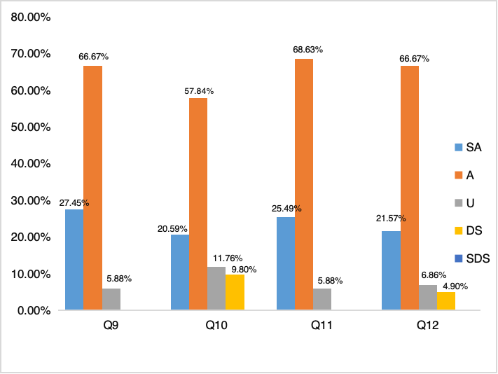
Figure 4. Data Tabulation (Percentage of Respondents) Impact Indicators and the Role of Project-Based Learning
In short, this graph highlights that PjBL is an effective and impactful learning method, with its main strengths clearly evident in the social and motivational aspects of students. The results of this study, overall, corroborate various educational theories, indicating that Project-Based Learning (PjBL) is highly effective. The high level of respondents' agreement on increased collaboration and motivation (both 94.12%) aligns with the views of scholars such as John W. Thomas and John Dewey, who emphasize the importance of contextual and social learning (Requena and González-González, 2024). Similarly, the high level of agreement on critical thinking (88.24%) supports constructivism theory, where students actively construct their knowledge. Meanwhile, although most respondents agreed that PjBL helps with problem-solving (78.43%), the higher level of doubt in this area suggests that its effectiveness depends heavily on appropriate project design and adequate teacher guidance.

4. Conclusion
This study concludes that teachers hold a largely positive perception of Project-Based Learning (PBL) and its role in the Independent Curriculum. They demonstrate a strong theoretical understanding of PBL principles and are highly aware of its benefits, particularly in fostering collaboration and student motivation. However, a significant gap exists between this conceptual understanding and its practical application. The data reveals that teachers face considerable challenges in the classroom, with the most notable difficulty being the integration of various subjects into a single project. This suggests that while teachers are conceptually prepared for PBL, they lack the practical skills and support needed for effective implementation. The research shows that we need a new approach to teacher training. Instead of focusing only on theory, educational leaders should provide more practical and collaborative support. This means creating clear guidelines for designing interdisciplinary projects and encouraging teachers from different subjects to work together. By doing this, we can overcome a key barrier to PBL and ensure the Independent Curriculum is implemented successfully.

Disclaimer (Artificial intelligence)
Author(s) hereby declare that NO generative AI technologies such as Large Language Models (ChatGPT, COPILOT, etc.) and text-to-image generators have been used during the writing or editing of this manuscript.

COMPETING INTERESTS DISCLAIMER:
Authors have declared that they have no known competing financial interests OR non-financial interests OR personal relationships that could have appeared to influence the work reported in this paper.

References
Aisyah, S., & Novita, D. (2025). Teachers’ perception of the implementation of project-based learning in early childhood education in Indonesia: Project-Based Learning: a perspective from Indonesian early childhood educators. Cogent Education, 12(1), 2458663. doi.org/10.1080/2331186X.2025.2458663
Alam, M. A. (2023). From teacher-centered to student-centered learning: The role of constructivism and connectivism in pedagogical transformation. Journal of Education, 11(2), 154-167. doi.org/10.25215/0401.086
Al Maktoum, S. B., & Al Kaabi, A. M. (2024). Exploring teachers’ experiences within the teacher evaluation process: A qualitative multi-case study. Cogent Education, 11(1), 2287931. doi.org/10.1080/2331186X.2023.2287931
Bakar, S. (2021). Investigating the dynamics of contemporary pedagogical approaches in higher education through innovations, challenges, and paradigm shifts. Social Science Chronicle, 1(1), 1-19. doi.org/10.56106/ssc.2021.009
Belwal, R., Belwal, S., Sufian, A. B., & Al Badi, A. (2021). Project-based learning (PjBL): outcomes of students’ engagement in an external consultancy project in Oman. Education+ Training, 63(3), 336-359. doi.org/10.1108/ET-01-2020-0006
Douglas, H. (2022). Sampling Techniques for Qualitative Research. In: Islam, M.R., Khan, N.A., Baikady, R. (eds) Principles of Social Research Methodology. Springer, Singapore. doi.org/10.1007/978-981-19-5441-2_29
Hunaepi, H., & Suharta, I. (2024). Transforming education in Indonesia: The impact and challenges of the Merdeka belajar curriculum. Path of Science, 10(6), 5026-5039. doi.org/10.22178/pos.105-31
Johannis, A. A., & Hung, D. W. L. (2023). Gradual shifts in policy and practice towards student-centric learning. In Moving Beyond Grades to Purposeful Learning: Lessons from Singaporean Research (pp. 19-37). Singapore: Springer Nature Singapore.
Kittur, J. (2023). Conducting quantitative research study: A step-by-step process. Journal of Engineering Education Transformations, 100-112. doi.org/10.16920/jeet/2023/v36i4/23120
Li, Q., Xie, Z., & Zeng, G. (2023). The influence of teaching practicum on foreign language teaching anxiety among pre-service EFL teachers. Sage Open, 13(1), 21582440221149005. doi.org/10.1177/2158244022114
Malinić, D., Stanišić, J., & Đerić, I. (2021). The experience of teachers in realisation of project-based learning based on interdisciplinary approach. Zbornik Instituta za pedagoska istrazivanja, 53(1), 67-120. doi.org/10.2298/ZIPI2101067M
Nardi, P. M. (2018). Doing survey research: A guide to quantitative methods. Routledge.
OECD. (2019). PISA 2018 Results (Volume I): What Students Know and Can Do. OECD Publishing. doi.org/10.1787/5f07c754-en
Pan, G., Seow, P. S., Shankararaman, V., & Koh, K. (2021). An exploration into key roles in making project-based learning happen: Insights from a case study of a university. Journal of International Education in Business, 14(1), 109-129. doi.org/10.2139/ssrn.3603881
Purba, L. S. L., Dasna, I. W., & Habiddin, H. (2022). Creativity in Project Based Learning: A Systematic Literature Study (2015-2021). Jurnal Pendidikan MIPA, 23(4), 1504-1514. doi.org/10.23960/jpmipa/v23i4.pp1504-1514
Purba, L. S. L., Dasna, I. W., & Wonorahardjo, S. (2023). Analysis of Product Dimension Creativity Competency Through Green Chemistry Project Based Learning in the Independent Curriculum. In book: The 9th Annual International Seminar on Trends in Science and Science Education (AISTSSE) 2022 (pp.295-301) doi.org/10.2478/9788367405195-041
Requena, C., & González-González, E. (2024). Effect of experiential learning on the ageist attitudes of higher education students. Educational Gerontology, 50(6), 481-491. doi.org/10.1080/03601277.2024.2306425
Rony, Z. T., Lestari, T. S., Ismaniah, Yasin, M., & Lubis, F. M. (2023). The complexity of leadership competence in universities in the 21st century. Cogent Social Sciences, 9(2), 2276986. doi.org/10.1080/23311886.2023.2276986
Rubino, S. (2024). Project-based learning and its impact on student engagement, well-being, and learning outcomes: A study of teachers’ perspectives. Arkansas State University.
Ruliyanti, T., Sumarni, W., & Ulum, M. (2021, November). The development of questionnaire instruments assisted by Google Form application to measure students’ cep characters on the stem integrated chemistry module. In 6th International Conference on Science, Education and Technology (ISET 2020) (pp. 5-10). Atlantis Press. doi.org/10.2991/assehr.k.211125.002
Shaturaev, J. (2021). Education in indonesia: financing, challenges of quality and academic results in primary education. Архив научных исследований, 6(6).
Shihabuddin, A. E., & Lestari, R. (2024, November). The Relationship between Learning Motivation and Students’ Perception towards Learning Outcomes of The Pancasila Student Profile Strengthening Project in The Kurikulum Merdeka. In 2nd Ibn Khaldun International Conference on Applied and Social Sciences (IICASS 2024) (pp. 78-93). Atlantis Press. doi.org/
Sormin, E., Simatupang, N. I., Purba, L. S. L., Azzahra, S. F., & Simanjuntak, F. N. (2024). Analysis of Increasing Students' Learning Interest Through the Implementation of the Project-Based Learning Model. Formatif: Jurnal Ilmiah Pendidikan MIPA, 14(2), 465-472. doi.org/10.30998/formatif.v14i2.28555
Sparrow, R., Dartanto, T., & Hartwig, R. (2020). Indonesia under the new normal: Challenges and the way ahead. Bulletin of Indonesian Economic Studies, 56(3), 269-299. doi.org/10.1080/00074918.2020.1854079
Utari, D., & Afendi, A. R. (2022). Implementation of Pancasila student profile in elementary school education with project-based learning approach. EduLine: Journal of Education and Learning Innovation, 2(4), 456-464. doi.org/10.35877/454RI.eduline1280
Wildani, M. S., Fauzi, A., & Solihin, M. (2025). Teacher Perception Towards the Implementation of Independent Learning Curriculum. Journal of Educational Management Research, 4(2), 265-277. doi.org/10.61987/jemr.v4i1.895
Zainuddin, Z. (2025). The Merdeka Curriculum and Local Wisdom: An Innovative Synergy in Shaping Student Character in South Sumatra, Indonesia. Journal of Cross-Disciplinary Sustainability Innovations, 1(1), 32-38.

