Investigation on Water Quality Status and sediment in a semi-urban water body of Sira

ABSTRACT
A comprehensive study on heavy metal contamination in the water and sediments of the Chikkere water body was conducted. WAWQI revealed that water quality was poor in April and very poor in August 2021, indicating significant pollution. Samples were analyzed using acid digestion and spectrophotometry. In April 2021, Si, Cu, Mn, and Zn exceeded the acceptable limits set by BIS standards, whereas in August 2021, these metals were within permissible limits. Sediment analysis showed the highest concentration of Fe. Statistically Pb and As correlated with Cu, Mn, and cladocera. Cr, Fe, and Co correlated with Zn (<0.05) and were negatively correlated with rotifers, cladocerans, and copepods. Protozoa correlated with Si, rotifers, and copepods (<0.01). Rotifers showed a positive correlation with cladocerans and copepods (<0.01) but a negative correlation with Zn, Cr, Fe, and Co. These findings underscore the impact of heavy metal contamination on water quality and aquatic biodiversity.
Key words: Water quality Index, Chikkere, Heavy metals, Sira, Tumkur district, Zooplankton, Tumkur district
INTRODUCTION
Water bodies like lakes and reservoirs are beautiful natural landscapes; however, due to industrialization, urbanization, and anthropogenic activities, they are under threat. Wastewater enters into the water bodies due to inadequate monitoring and maintenance by authorities. This has led to deterioration of the quality of water and a decline in aquatic life (1,2,3). Consequently, the load of heavy metals in flora and fauna consistently causes accumulation and bio-concentration in nearby water bodies (4); conversely, they are not easily degraded and tend to accumulate beyond safe limits (5,6). Their accumulation in aquatic ecosystems is a global concern (7). Mathematical equations rating the fitness of water bodies are represented through the water quality index (8), which helps to achieve the water quality monitoring in a doable and insightful manner (9).
Heavy metals, being metallic elements, can be toxic to organisms even at low concentrations (10). They have low solubility and they are absorbed and accumulated in bottom sediments (11). When not metabolized by organisms, they can become toxic as they accumulate in soft tissues, exceeding safe levels (12). Excess amounts of both nonessential and essential metals are toxic to various aquatic biota (13). Sediments are major sources of pollution, which may spoil water quality and human health due to high metal concentration (14); acting as sinks and carriers for pollutants in aquatic ecosystems, they can spread contaminants (15).
Therefore, monitoring heavy metals in aquatic bodies is crucial, as they affect the ecosystem's life. Heavy metal analysis in water and sediments and its impact on zooplankton diversity, further to find out water quality using WQI. This baseline dat of Chikkere waterbody. Hence, data reveals new findings related to heavy metals and quality of water.

METHODS AND MATERIALS
Study area:
Sira, a taluk headquarter, is situated approximately 50 kilometers away from Tumkur, a district headquarter. It is located along National Highway No. 4 at 662 meters above MSL. The coordinates of this water body fall under 130° 75' 25" N latitude and 760° 90' 70" E longitude (Fig -1). Water and sediment samples were collected for the April and August months during 2021. The physical parameters temperature, dissolved oxygen, and TDS were recorded on-site during the collection of samples. Enumeration of zooplankton was done with separately collected samples. The sampling, transportation, and analysis procedures followed the guidelines of APHA (16) and (17). Zooplankton collections were made using a Harron-Trantor net (0.0625 m² size) and a plankton net (No. 25 mesh size, 50 µ). Preservation and identification of specimens were done (18, 19, 20).
Water and sediment samples collected were transported to laboratories for further analysis. Water samples underwent digestion with a 5 ml di-acid mixture (HNO_{₃:}HCl—9:4₎ on a hot plate, filtered through Whatman No. 1 filter paper, and made up to a volume of 50 ml with double-distilled water. Analysis was conducted using the ICAPQNOVA ICP-MS instrument by Thermo Scientific. The water quality indices used worldwide is the Weighted Arithmetic WQI Method (WAWQI) (21). Average values of four samples (replicates) were taken into consideration for calculations both water and sediments and potability compared with the Bureau of Indian Standards (22).
The WQI values were determined independently.
The WAWQI methodology was adapted as follows:
Few parameters were chosen to measure the quality.
Each parameter is scaled for rating.
The unit weight (W_{i}) is calculated, and W_{i} is inversely dependent upon the standard value (Si) of the parameters recommended;
To find out WQI by totaling the subindex values.
WQI is calculated as the below equation:
WQI = ∑ qnWn / ∑Wn
i=1 i=1
Sediment material was collected with grabs from each point and stored in a cooler at 4°C. In the laboratory, samples were dried at 60°C, disaggregated using an agate mortar, and sieved to a fraction <63 µm (23, 24). Metal concentrations in sediments were measured based on dry weight (105°C). These methods comply with ISO standards 5667 parts 1, 12, and 15 and are commonly used in scientific publications (25, 26).
Statistical techniques were employed to analyze the data and establish correlations with other physicochemical parameters and zooplankton groups.
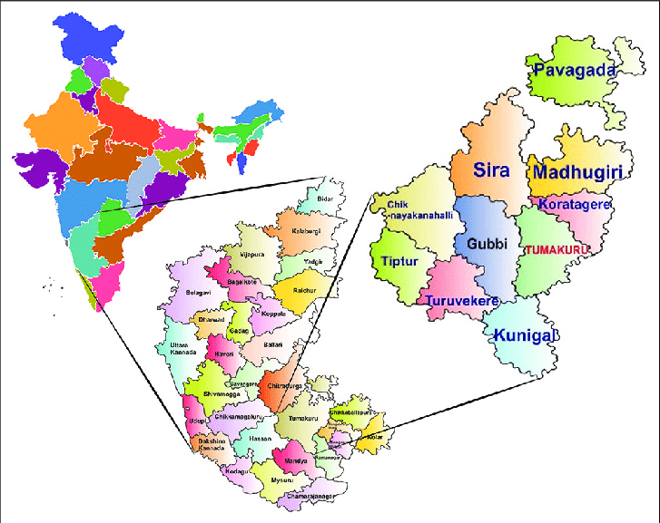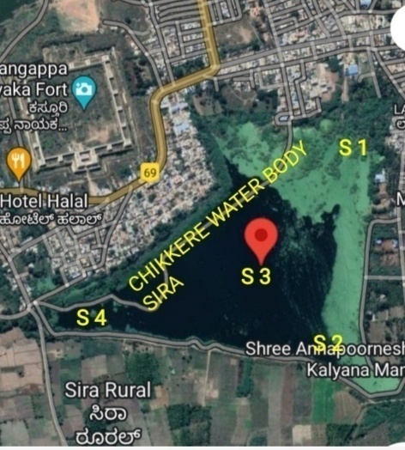
Fig. 1. Map of study area i.e., Chikkere water body of Sira (Sources Google Images).
RESULTS AND DISCUSSION
Physico-chemical parameters recorded during April and August 2021 (Table 4). Atmospheric and water temperatures were recorded at 24.8°C and 22.3°C in April and 23.5°C and 22.1°C in August 2021, respectively. 2085 μS/cm and 1065 μS/cm values were noticed for electrical conductivity, which are above the BIS limits. TDS, chloride, total alkalinity, and total hardness were observed within BIS permissible limits, whereas calcium (201 mg/l) and magnesium (138 mg/l) were slightly higher than BIS permissible limits, i.e., 200 mg/l calcium and 100 mg/l magnesium, respectively. Sulfate levels are below the acceptable limit of 200 mg/l as per BIS. Despite being essential for supporting life, the dissolved oxygen concentration was critically low. Present study results were in accordance with other workers (27).
Due to urbanization, water bodies are becoming dumping sites for landfill and sewage discharge, resulting in deterioration and abandonment. Year-round sewage discharge has polluted the water, making it unsuitable for drinking, fishing, recreation, and other domestic purposes due to high levels of TDS, BOD, and COD, leading to eutrophication and low DO. In the present work, DO was 1.6 mg/l and 3.8 mg/l in August 2021, respectively. Similarly, it causes acute stress, decreased fisheries, ecosystem imbalance, and organism death and contributes to poor water quality (28,29). Similar to our findings, the dry season revealed higher DO than the wet season in Lake Xingyun (30). The electrical conductivity values of more than 2085 and 1670 µmohs/cm were observed in April and August 2021, respectively. The high value is an indication of agricultural pollution and anthropogenic activities, and generally, semi-arid areas of India exhibit >500 electrical conductivity (31, 32). Physicochemical parameters analyzed indicated that only temperature, TDS, and electrical conductivity exceeded normal limits. Compared to the United Nations Economic Commission for Europe (UNECE) freshwater quality standards, most of the metals analyzed were in safe limits. According to UNECE, all metals fall under Class I, indicating minimal anthropogenic pollution in the water and in agreement with the drinking water BIS standards.
The WAWQI method is used to determine the WQI index, and the physicochemical parameters are assessed, compared, and evaluated against the BIS (10500:2012) drinking water quality standards. Table 5 shows WAWQI and its gradings accordingly, higher range of WQI depicts the poor health of a body of water, whereas a lower range indicates the good quality of water (Table 4). Chikkere water body values depicted 74.1947 (Table 6) in April; according to WAWQI, it's poor quality of water, and 96.91 (Table 7) in the month of August 2021 indicates very poor water quality. The obtained values were compared with BIS standards. (33) conversely reported that WQI of 148 samples computed using BIS standards resulted in deterioration of water quality in the post-monsoon season due to an increase in magnesium, calcium, and sulfates. (34) found that concentrations were higher during the monsoon season than the summer season in the Tigris River. (35) The WQI of Rawal Dam in Pakistan using five different data sets that revealed the applications of WQI on water samples and its own limitations, i.e., types of water, altitude, topography, sensitivity, and weight assigned to each parameter; one parameter with high concentration can affect the index classification.
Water and sediment heavy metal concentrations were in the order of Si>As>Mn>Fe>Cu>Pb>Cr>Co in water and Fe>Cr>Mn>Zn>As>Cu>Pb>Co in sediments, respectively. Except for manganese and copper, all values noted are below the BIS desirable standards (Table 3). More concentrations (Table 1) were Si (2.5 mg/lit), Mn (0.26 mg/lit), and Fe (0.1 mg/lit) compared to Cu (0.05 mg/lit), Zn (0.06 mg/lit), As (0.05 mg/lit), Cr (0.05 mg/lit), and Co (<0.02 mg/lit) during April, whereas in August 2021, Si (12 mg/lit) and other metals were within the range of BIS desirable standards: Mn (<0.1 mg/lit), Fe (<0.01 mg/lit), Cu (<0.03 mg/lit), Zn (<0.02 mg/lit), As (<0.01 mg/lit), Cr (<0.03 mg/lit), and Co (<0.03 mg/lit) in the month of. Similarly, in sediment samples, higher values of Fe (2.34 mg/lit), Cr (7 mg/lit), Mn (0.1 mg/lit), Zn (0.2 mg/lit), Cu (<0.03 mg/lit), Pb (0.01 mg/lit), As (<0.05 mg/lit), Cr (0.3 mg/lit), and Co (0.08 mg/lit) were found.
Copper is essentially required for many enzymes and industrial processes (36,37). Chikkere water body observed copper concentrations of 0.05 mg/l and <0.03 mg/l in water during April and August, respectively; likewise, sediments showed <0.03 mg/l in August. It could be due to agricultural, chemical, and sewage inputs into the water body (38). The extensive use of copper sulfate in agriculture practices may significantly contribute to its presence in water bodies. Zn, Cu, Fe, and NO₃ were correlated with the abundance of calanoid copepods, and PO₄ and NO₂ with the abundance of nauplius and herpecticoids (27).
Manganese is naturally present in marine water and bioaccumulates in certain lower trophic levels of organisms in the food chain (39). In water, 0.26 mg/l and 0.2 mg/l of manganese were noticed in sediments of the Chikkere water body. (40) reported higher values in summer, which are in agreement with the present findings; it may be due to evaporation and concentration. (41) reported higher values in the northeast monsoon season, which is opposite to the values noticed. (42) reported that Mn is transported in suspended form via surface runoff and erosion fragments.
Zinc is essential for sustaining life as a micronutrient, but higher concentrations can be phototoxic to aquatic flora and fauna (43,44). Zinc concentrations were found to be 0.06 mg/l in water and 0.1 mg/l in sediments in the Chikkere waterbody. Lead primarily originates from mining, smelting, and refining activities, and values observed were <0.05 mg/l in water and 0.1 mg/l in sediments. The assemblage of zooplankton recorded relatively high levels of Zn (25-106 μg/g), which is probably due to its importance as an essential element for plankton (45). Pb is one of the common heavy metals that, in general, beyond a desirable limit, is a metabolic poison and enzyme inhibitor (46) and hematological damage. (47) also leads to agricultural and industrial sectors contributing significantly to its presence. Arsenic, occurring naturally, can be exacerbated by leaching from aquifers due to phosphorus from various chemical fertilizers and industrial and sewage effluents (48). The present investigation revealed arsenic concentrations of <0.5 mg/l in water and <0.05 mg/l in sediments. (49,50) opined that regionally heavy metal concentration in zooplankton is heterogeneous and it does not show a consistent pattern; the fact that accumulation and impact of the heavy metals depend on pollution level, assimilation capacity, lifecycle, and elimination/uptake level, which is variable among planktonic groups.
Zooplankton communities reflect water quality, trophic levels, and the degree of eutrophication, making them effective indicators of aquatic ecosystems (51,52). In the present study, it is observed that water temperature, ranging from 20.2°C to 23.1°C, regulated the density and diversity of the dominant zooplankton population in the freshwater. Table 2 presents the rotifera higher values 401 and 451 No. of Ind./l in both April and August, 2021, respectively. Likewise, cladocera (330 No. of Ind./l and 271 No. of Ind./l), copepods (75 No. of Ind./l and 152 No. of Ind./l), and protozoa (11 No. of Ind./l and 118 No. of Ind./l) were respectively noticed subsequently in decreasing order. Fig. 3. depicts the higher concentration of protozoa, rotifer, and copepod recorded in August and the lowest in April. Similarly, cladocera were observed to be at a maximum in April and a minimum in August. Present results are in support of (53,54,55), and monsoon season months are favorable for higher density due to availability of food. However, also noticed results are opposite; with (56), higher rotifers, cladocera, and copepods were noticed during summer in Lake Saheb Bandh, West Bengal. Other workers have also reported similar observations by (51,57,58). Rotifers dominance is an indication of eutrophication (59,60). Higher zooplankton in summer may be due to more photosynthetic activity (61).
The metals like copper, manganese, lead, and arsenic have a significant correlation with Cladocera. whereas zinc, chromium, cobalt, and iron have negatively correlated with zooplankton groups. Likewise, protozoa has a positive correlation with copepod and silicon.
Statistically, metals are analyzed and revealed (Fig. 2) that Cu is positively correlated with Mn, Pb, and As, with <0.01 and <0.05 with Cladocera. Mn is positively correlated with Cu, Pb, and As, with <0.01 and <0.05 with Cladocera. Zn with Cr and Fe < 0.05. Similarly, Pb and As correlated with Cu and Mn and cladocera. Cr, Fe, and Co are with Zn (<0.05) and negatively correlated with rotifer, cladocera, and copepod. Protozoa with Si, rotifera, and copepoda (<0.01); rotifera with cladocera and copepoda (<0.01); and negatively with Zn, Cr, Fe, and Co. Copepoda with Si, protozoa, rotifera, and copepod (P<0.01)
CONCLUSION
Heavy metal analysis is prime and paramount for the parameter for monitoring any aquatic ecosystem. Comprehensive data collection and systematic monitoring of heavy metal concentrations are essential components of pollution control systems. However, sufficient manpower is necessary to maintain effective data monitoring and pollution control measures before ecosystem degradation sets in gradually.
The Water Quality Index of the Chikkere water is poor for the month of April 2021 and very poor for the month of August 2021. Due to surface runoff and anthropogenic pollution, pollution occurs during the monsoon season. Silicon, Mn, As, and Fe have resulted in higher concentrations compared to other heavy metals. Elevated levels of Cr, Fe, and Mn may be attributed to improper sewage water management, and reduced DO is posing significant threats to aquatic life if exposure continues unchecked. The combination of correlation analysis and WAWQI parameters remains comprehensive and relevant to local water quality management needs. The present work increases the understanding of the current state of the Chikkere water body, which helps to further monitoring. Heavy metals have an impact on phyto- and zooplankton and other organisms; they can be used as indicators for monitoring water bodies.

REFERENCES
- Kelkar U. Balachandra P. and Guratoo A.2011. Assessing Indian cities for vulnerability to climate change. In: 2nd International conference on environment science development. Vol 4, pp 246-250.
- Chaturvedi M. C. 2012. India’s waters; Environment, economy and development CRC Press, Boca Raton.
- Sharma B, Gulati A, Mohan G etal. 2018. Water productivity mapping of major Indian crops.
- Rosado S., Castillo F. Nambi I., Sadashivam R. Velleru H. and Fohrer N. 2024. Evaluating metal level and their toxocilty risks in an urban lake in Chennai, India. 21: (1849-1864.
- Yabe J., Ishizuka M., and Umemura T. Current levels of heavy metal pollution in Africa. J.2010. Veternary Medical Science. 72(10):1257-1263.
- Adakole J.A. and Abolude D.S. 2012. Pollutional Status of Kubanni Lake Through Metal Concentrations in Water and Sediment Columns, Zaria – Nigeria. Research Journal of Environmental and earth sciences.. Vol 4. (4).P 424-427.
- Zaidi J. and Pal A. 2017. Review on heavy metal pollution in major lakes of India: remediation through plants. Vol 11(6) pp255-265.
- Yogendra K. and E.T. Puttaiah (2008). Determination of water quality index and Suitability of an Urban Waterbody, Shimoga Town, Karnataka, Proceedings of 12th world Lake Conference 342-346.
- Abhijeet das 2025. Surface wwater quality evaluation of Mahanadi and its tributary katha Jodi river, Cuttack district, Odisha, using WQI, SRI and geosptail technique.Vol. 15.
- Lentech 2004
- Jain eta; 2008
- Suresh etal 2012.
- Mohamed E.A. Metwally. Mohamed A, Abu El Regal, Ahemad S. Abdekader Eman F Samad (2022). Heavy metal accumulation zooplankton and impact of water quality on its community structure. Arabian journal of Geosciences. 15;117.
- Yin H., Gao Y., Fan C.2011. Distribution, sources and ecological risk assessment of heavy metals in surface sediments from lake Taihu, China Envorn. Research Lett. 6. 044012 (11pp).
- Bai J., Cui B., Chen B., Zhang K., Deng W., Gao H., Xiao R., 2011. Spatial distribution and ecological risk assessment of heavy metals in surface sediments from typical plateau lake wetland China Ecol Modell. 222, 301-306
- APHA (American Public Health Association. Standard Methods for the Examination of Water and Wastewater (21st Edit.). American Public Health Association, Washington, DC. 2005
- Trivedi, R. K. and Goel, P. K. 1986. Chemical and biological methods for water pollution studies. Environmental Publications, Pp. 34-96.
- Needham, J.G. and Needham, P.R. 1962. A guide to the study of the freshwater biology. 5th edn. Holden-day, Inc., San Francisco, USA, Pp. 108.
- Tonapi G. J. 1980. Freshwater animals of India. An ecological approach, Oxford and IBH,.
- Battish, S. K. 1992. Freshwater zooplankton of India, New Delhi: Oxford and IBH Publication Co. (pp. 1–231).
- Brown etal 1972.
- BIS IS10500 2012). Indian Standard Drinking Water–Specification (Second Revision). Bureau of Indian Standards (BIS): New Delhi, India, 2012.
- Jones B., and Turki A. 1997. Distribution and speciation of heavy metals in surfacial sediments from the Tees Estuary, Northeast England. Mar. Pollu. Bullet. 34;768-779.
- Ouyang Y., Higman J., Thomson J. 2002. Characterization of spatial distribution of heavy metals in sediments from Cedar and Ortega rivers subbasin. J. Contam Hydrol. 54;19-35.
- Rosado D, Usero J., Morillo J. 2015. Application of new integrated sediment quality assessment method to Huelva estuary and its littoral of influence (Southwestern Spain). Mar. Pollu. Bullet. 98;106-114.
- Naifer etal 2018.
- Mohmmed etal 2022
- Ahmad T, Muhammad S, Umar M, Azhar MU, Ahmed A, Ahmad A, Ullah R (2024) Correction: spatial distribution of physicochemical parameters and drinking and irrigation water quality indices in the Jhelum River. Environ Geochem Health 46(9):362.
- Sharma K, Raju NJ, Singh N, Sreekesh S (2022) Heavy metal pollution in groundwater of urban Delhi environs: pollution indices and health risk assessment. Urban Clim 1(45):101233
- Zeng Y. Fengqin Chang, Xinyu Wen, Lizeng Duan, Yang Zhang, Qi Liu and Hucai Zhang (2022). Seasonal variation in the water quality and eutrophication of Lake Xingyun in Southwestern China. Water, 14, 3677. https://doi.org/10.3390/w14223677
- Fariz TR, Amalia AV, Jabbar A (2024) Estimation Of changes in water quality parameters in Rawa Pening lake based on remote sensing data. Indonesian J Conserv 13(1):1–7
- Zhou G, Zhou P, Wang G, Yu X, Fu J, Li S, Zhuo X (2024) New insights into the controlling factors of nitrate spatiotemporal char acteristics in groundwater of Dagu aquifer in Qingdao, China. Environ Pollut 15(361):124826.
- Vasanthavigar, M., Srinivasamoorthy, K., Vijayaragavan, K., Ganthi, R. R., Chidambaram, S., Anandhan, P., Manivannan, R. & Vasudevan, S. 2010. Application of water quality index for groundwater quality assessment: Thirumanimuttar sub basin, Tamilnadu, India. Environmental Monitoring and Assessment 171 (1–4), 595–609
- Chabuk, A., Al-Madhlom, Q., Al-Maliki, A., Al-Ansari, N., Hussain, H. M. & Laue, J. (2020). Water quality assessment Downloaded from http://iwaponline.com/ws/article-pdf/21/6/3225/933536/ws021063225.pdf by guest Downloaded from http://iwaponline.com/ws/article-pdf/21/6/3225/933536/ws021063225.pdf Arabian Journal of Geosciences 13 (14), 1–23
- Ahmed M, Rafia Mumtaz and Syed Mohammad Hassan Zaidi (2021). Analysis of water quality indices and machine learning techniques for rating water pollution: a case study of Rawal Dam, Pakistan. Water supply Vol. 21.6 Pp 3225-3250. doi: 10.2166/ws.2021.082.
- Bhavani etal 2009.
- Singare etal 2010.
- Kashyap R., Verma K.S. and Hukum chand. Heavy metal contamination and their seasonal variation in Rewalsar lake of Himachal Pradesh, India. The Ecoscan . 2015. 9 (1&2) 31-36.
- Acahry etal 2020.
- Rao, M. G., Venkatrao, A., & Beebi, S. K. (2005). Heavy metal transport in Kollem lake basin. IJEP, 25(10),899-904.
- Majagi etal 2008.
- Mahesh and Balasubramaniam (2008)
- Mavanga and Barifaijo 2006
- Asonye, C. C., Okolie, N. P., Okenwa, E. E and Iwuanyanwu, U. G. (2007). Some physico-chemical characteristics and heavy metal profiles of Nigerian rivers, streams and waterways. African Journal of Biotechnology. Vol 6(5)Pp.617-624.
- Mosoud etal 2019
- Gebrekidan Mebrahtu and Samuel (2011). Concentration of Heavy Metals in Drinking Water from Urban Areas of the Tigray Region, Northern Ethiopia.Zerabruk Volume 3(1):105-121.
- Mohod C. .V and Dhote J (2013). Review of heavy metals in drinking water and their effect on human health. International Journal of Innovative Research in Science, Engineering and Technology. Vol 2(7).Pp 2992-2996.
- Maest AS, Pasilis SP, Miller LG, and Nordstrom DK (1992). Redox geochemistry of arsenic and iron in Mono Lake, California, USA. In: Proceedings of the Seventh International Symposium on Water–Rock Interaction, pp. 507–511.
- Rejomon G., Dineshkumar P. K., Nair M., Muralidharan K R. (2009). Trace metal dynamics in Zooplanton from Bay of Bengal during summer monsoon.Environ Toxicol.25:622-633.
- Ju YR. Lo WT, Chen CF, Chen CW, Huang ZL, Dong CD. (2019). Effect of metals on Zooplankton abundance and distribution in the coast of subwestern Taiwan.Envi. Sci. Pollut. Res. 26 (33); 33722-33731.
- Ngodhe SO, Raburu PO, Achieng A.2013. The impact of water quality on species diversity and richness of macroinvertebrates in small water bodies in Lake Victoria Basin, Kenya. J Ecol Nat Environ. 6:32-41
- Salar and Alis 2014.
- Malik, D.S. and Panwar, P. 2016. Zooplankton diversity, species richness and their distribution pattern in Bhimtal Lake of Kumaun region, (Uttarakhand). Hydrology Current Research. 7(1): 1–7; doi: 10.4172/2157-7587.1000219
- Singh, S. and Sharma, R.C. 2020. Zooplankton diversity and potential indicator species for assessment water quality of high altitude wetland, Dodi Tal of Garhwal Himalaya, India. Academia Arena, 12(5): 1–16; doi: 10.7537/marsaaj120520.01
- Vijayapriya S, Latha R, Malathi, A .2019. Assessment of Zooplankton Diversity in Kosavampatti Lake at Namakkal District, Tamil Nadu. Int j pharm biol sci arch. 10(2):111-115
- Bera B (2021). Using zooplankton community to assess water quality and trophic condition of lake Saheb bandh, Purulia, West Bengal, India. Interntional Journal of Aquatic science. Vol 12 (2). Pp 4471-4498.
- Anita SM, Hatti, SS, Majagi S, Chitra J. 2019. Assessment of Zooplankton Diversity of Nagaral Dam, Chincholli, Kalaburagi. Res J Life Sci Bioinfor Pharm Chem Sci. 5(26): 269–281.
- Sharmila SJ, Shameem U. 2017. Zooplankton diversity indices and seasonal variations in Meghadrigedda reservoir, Visakhapatnam, Andhra Pradesh, India. European Journal of Biotechnology and Bioscience. 5(1): 4–11.
- Jagadeeshwara CT, Mahender J, Kumar S, 2015. Zooplankton diversity, abundance and seasonal variation of Nagulakunta water tank, Vinjapally, Karimnagar dist, Telangana state, India. Int J Sci Res. 4:1651-1654.
- Sulata K, Devashish K.2016. Zooplankton Diversity of a freshwater perennial pond in Silchar city of Assam, India. Am Int J Res Form Appl Nat Sci. 14(1):10-14.
- Manickam N, Bhavan PS, Santhanam P, 2018. Impact of seasonal changes in zooplankton biodiversity in Ukkadam lake, Coimbatore, Tamil Nadu, India and Potential future implications of climate change. J Basic Appl Zool. 79(15):1-10

DECLARATIONS
Ethics approval and Consent to participate: Not Applicable
Consent for publication: All author have given consent for publication.
Availability of data and material: No additional data is available. Same data is with the corresponding author.

Table 1 Showing the concentration of heavy metals in water and sediment samples (mg/lit)
Months | Cu | Mn | Zn | Pb | As | Cr | Fe | Co | Si
Apr.2021 | 0.05 | 0.26 | 0.06 | <0.05 | <0.5 | <0.05 | 0.1 | <0.02 | 2.5
Aug.2021 | <0.03 | <0.1 | <0.02 | <0.01 | <0.01 | <0.03 | <0.01 | <0.03 | 12
Apr 2021 (Sediments) | <0.03 | 0.1 | 0.1 | <0.01 | <0.05 | 0.3 | 2.34 | 0.08 | -
Table 2 Showing the zooplankton diversity in Chikkere water body (Total No. of Individuals/lit)
MONTHS | PROTOZOA | ROTIFERA | CLADOCERA | COPEPODA
Apr.2021 | 11 | 401 | 330 | 75
Aug.2021 | 118 | 451 | 271 | 152
Table 3. BIS and ICMR standards for Drinking Water quality
S/N | Heavy metal | BIS IS Desirable (mg/l) | ICMR (mg/l)
 | Cu | 0.05 | 3.0
 | Mn | 0.1 | -
 | Zn | 5 | -
 | Pb | 0.01 | 0.1
 | As | 0.01 | 0.05
 | Cr | 0.05 | 0.05
 | Fe | 0.3 | 1.0
 | Co | - | -
 | Si | - | -
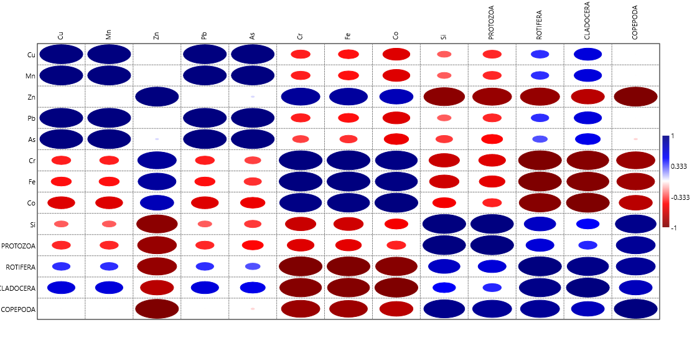
Fig. 2 Correlation of heavy metals with other parameters of Chikkere water body

Fig. 3. Depicts the Seasonal abundance of zooplankton of Chikkere water body.
Table 4. Showing the Physicochemical parameters of Chikkere water body
Months | AT | WT | Turbidity | TDS | TSS | EC | pH | DO | TA | TH | Ca | Mg | Cl | BOD | NO3 | SO4 | P
Apr.2021 | 24.8 | 22.3 | 71 | 1046 | 62 | 2085 | 8.6 | 1.6 | 426 | 362 | 201 | 138 | 265 | 32 | 4 | 128 | 0.3
Aug.2021 | 23.5 | 22.1 | 40 | 1095 | 26 | 1670 | 8.9 | 3.8 | 370 | 378 | 196 | 182 | 266 | 25 | 3.5 | 104 | 0.5

Table 5. Showing the WAWQI Value and its grading
SI No. | WAWQI Value | Rating of water quality | Usage Possibilities | Grading
1 | 0-25 | Excellent | Drinking, Irrigation, Industrial | A
2 | 25-50 | Good | Drinking, Irrigation, Industrial | B
3 | 50-75 | Poor | Irrigation and Industrial | C
4 | 75-100 | Very poor | Irrigation | D
5 | >100 | Unsuitable for drinking | Proper treatment is required for before use | E

Table 6. Showing the WQI of water samples of April 2021
Parameter | BIS Standards(Sn) | 1/Sn | ∑1/Sn | K=1/(∑1/Sn) | Wn=K/Sn | Ideal value (Vo) | Mean conc. Value (Vn) | Vn/Sn | Vn/Sn*100=Qn | WnQn
pH | 8.5 | 0.1176471 | 4.3549655 | 0.229622944 | 0.027014 | 7 | 8.6 | 1.011765 | 101.1765 | 2.733228
EC(s/cm) | 300 | 0.0033333 | 4.3549655 | 0.229622944 | 0.000765 | 0 | 2085 | 6.95 | 695 | 0.53196
TDS(ppm) | 500 | 0.002 | 4.3549655 | 0.229622944 | 0.000459 | 0 | 1046 | 2.092 | 209.2 | 0.096074
DO(mg/l) | 5 | 0.2 | 4.3549655 | 0.229622944 | 0.045925 | 14.6 | 1.6 | 0.32 | 32 | 1.469587
TA(mg/l) | 120 | 0.0083333 | 4.3549655 | 0.229622944 | 0.001914 | 0 | 426 | 3.55 | 355 | 0.679301
TH(mg/l) | 300 | 0.0033333 | 4.3549655 | 0.229622944 | 0.000765 | 0 | 362 | 1.20667 | 120.6667 | 0.092359
Ca(mg/l) | 75 | 0.0133333 | 4.3549655 | 0.229622944 | 0.003062 | 0 | 201 | 2.68 | 268 | 0.820519
Mg(mg/l) | 30 | 0.0333333 | 4.3549655 | 0.229622944 | 0.007654 | 0 | 138 | 4.6 | 460 | 3.520885
Cl(mg/l) | 250 | 0.004 | 4.3549655 | 0.229622944 | 0.000918 | 0 | 265 | 1.06 | 106 | 0.09736
NO3(mg/l) | 45 | 0.0222222 | 4.3549655 | 0.229622944 | 0.005103 | 0 | 4 | 0.088889 | 8.888889 | 0.045358
PO4(mg/l) | 5 | 0.2 | 4.3549655 | 0.229622944 | 0.045925 | 0 | 0.3 | 0.06 | 6 | 0.275548
SO4(mg/l) | 200 | 0.005 | 4.3549655 | 0.229622944 | 0.001148 | 0 | 128 | 0.64 | 64 | 0.073479
 |  | 0.6125359 |  |  | Wn=0.140652 |  |  |  |  | 10.43566
Overall Water quality index = 74.1974

Table 7. Showing the WQI of water samples of August 2021

Parameter | BIS standards Sn | 1/Sn | ∑1/Sn | K=1/(∑1/Sn) | Wn=K/Sn | Ideal value(Vo) | Mean conc. Value(Vn) | Vn/Sn | Vn/Sn*100=Qn | WnQn
pH | 8.5 | 0.1176471 | 4.3549655 | 0.229622944 | 0.027014 | 7 | 8.9 | 1.047059 | 104.7059 | 2.828573
EC(s/cm) | 300 | 0.0033333 | 4.3549655 | 0.229622944 | 0.000765 | 0 | 1670 | 5.566667 | 556.6667 | 0.426078
TDS(ppm) | 500 | 0.002 | 4.3549655 | 0.229622944 | 0.000459 | 0 | 1095 | 2.19 | 219 | 0.100575
DO(mg/l) | 5 | 0.2 | 4.3549655 | 0.229622944 | 0.045925 | 14.6 | 3.8 | 0.76 | 76 | 3.490269
TA(mg/l) | 120 | 0.0083333 | 4.3549655 | 0.229622944 | 0.001914 | 0 | 370 | 3.083333 | 308.3333 | 0.590003
TH(mg/l) | 300 | 0.0033333 | 4.3549655 | 0.229622944 | 0.000765 | 0 | 378 | 1.26 | 126 | 0.096442
Ca(mg/l) | 75 | 0.0133333 | 4.3549655 | 0.229622944 | 0.003062 | 0 | 196 | 2.613333 | 261.3333 | 0.800108
Mg(mg/l) | 30 | 0.0333333 | 4.3549655 | 0.229622944 | 0.007654 | 0 | 182 | 6.066667 | 606.6667 | 4.643486
Cl(mg/l) | 250 | 0.004 | 4.3549655 | 0.229622944 | 0.000918 | 0 | 266 | 1.064 | 106.4 | 0.097728
NO3(mg/l) | 45 | 0.0222222 | 4.3549655 | 0.229622944 | 0.005103 | 0 | 3.5 | 0.077778 | 7.777778 | 0.039688
PO4(mg/l) | 5 | 0.2 | 4.3549655 | 0.229622944 | 0.045925 | 0 | 0.5 | 0.1 | 10 | 0.459246
SO4(mg/l) | 200 | 0.005 | 4.3549655 | 0.229622944 | 0.001148 | 0 | 104 | 0.52 | 52 | 0.059702
 |  | 0.6125359 |  |  | 0.140652 |  |  |  |  | 13.6319
Overall Water quality index = 96.1991

