Original Research Article
The Spatio - Temporal Changes in Water Quality and Influences on the Phytoplankton, Zooplankton and Fish Species in Four Large Riverine Ecosystems in Lake Victoria Basin (Kenya).

ABSTRACT

Rivers and streams in the Lake Victoria Basin (Kenya) (LVBK) are vital for aquaculture, irrigation, hydropower, domestic use, and biodiversity conservation. However, increasing population, urbanization and pollution, and changes in landuse/landcover are factors that contribute to the modification of the riverine habitats which also serve as fish breeding areas. There are increasing concerns on the potential loss of biodiversity juxtaposition the expanding anthropogenic pressures but gaps exists on information available. This study was conducted during the persistent heavy short rains (November 2019) and dry conditions (March 2020), and was used to assess the environmental conditions of rivers Nzoia, Yala, Awach and Nyando using indices of physico-chemical parameters, nutrient levels, zooplankton, phytoplankton and fish species composition and abundance. Structural and abiotic differences were found in selected site habitats due to the high gradient variation from the lake shore areas. River drainage basins are extensive and under heavy agricultural and human activities with reduced soil cover which contributes to increasing loading of eroded soils and materials which impact the quality of surface water. We identified significant spatio-temporal variations in nutrient levels, biodiversity, and water quality indices across four major rivers, highlighting hotspots of eutrophication and biodiversity vulnerability. Sampled rivers exhibit high turbidity with variable concentrations of nutrient elements downstream. Results show seasonal and anthropogenic influences on the water quality in all the river channels, which is likely to impact resident species. The high abundance of diatoms and chlorophytes as dominant phytoplankton families, is an indication of cultural eutrophication. Turbidity favors the dominance of diatoms especially centric diatoms which are able to attach on detritus. Eight fish families (with 19 fish species) were found and were dominated the Cyprinidae group. We recommend improved catchment management, agricultural practices and protection existing forest areas with long-term river monitoring program.

Keywords: Lake Victoria basin; Major rivers; biodiversity; Fish species; water quality; Anthropogenic activities; Phytoplankton; Zooplankton

1. INTRODUCTION
Lake Victoria lake levels fluctuate annually and seasonally with significant decreases during drought seasons (Awange et al., 2008) and rapid rises during above average rainfall. Within the Lake Victoria basin, increased precipitation and lakeshore flooding has been recorded and the rise in lake levels in 2019 and 2020 were reported from different studies (Khaki and Awange 2021; Awange et al., 2013; Akurut et al., 2014). In documenting the increasing impacts of climate change within the larger lake basin, riverine ecosystems were not well prioritized for monitoring changes exerted by external natural and human related stressors. There is still need for more detailed ecological information in specific basins and sub-basins to answer the question on how climatic and watershed changes affect specific lotic ecosystem services and resident species. This study contributes to the growing number of ecological studies as documented by Achieng et al. (2020) to try and understand the cause of the declining fish communities in some of the large rivers (Rivers Mara in Kenya; Nyando, Nzoia and Sondu-Miriu). The effective monitoring of these riverine ecosystems has been hampered by lack of locally developed indices of water quality and accessibility of their extensive drainage basins. We also do not yet fully understand the type of impacts into the specific riverine channels in each sub-basin and effects from the different landscape gradients. Recent data shows a high spatial erosional vulnerability within the Nyando and Sondu-Miriu basins (Humphrey et al. 2025). Achieng et al. (2020) used the fish communities for the development of a fish based index of biotic integrity, but did not survey rivers Yala and Awach – Kibuon. This study explored the use of other common aquatic organisms and fish species in rivers Nzoia, Nyando, Yal and Awach – Kibuon for understanding the climatic impacts and watershed changes on the resident biodiversity.
The Nyando, Yala, Nzoia Sondu - Miriu, Awach -Kibuon and Kuja drainage basins form key ecosystems supporting a diverse aquatic biodiversity and associated terrestrial flora and fauna. Currently, the rivers studied are not regulated by reservoirs, unlike R. Sondu-Miriu hydroelectric power dam. However, they are threatened by pollution (uncontrolled and poor solid waste disposal and management; untreated waste water discharge into rivers; leaching of residual agricultural chemicals; diffuse surface runoffs and storm waters) from anthropogenic activities and increasing water demands. A comparison of Landsat image from 1973 and 2001 shows a significant increase in suspended sediment in the gulf (UNEP 2014). Expanding pond aquaculture will be sustained by protecting available water sources from rivers and their recharge areas. However, aquatic habitat loss can result from river channel modification, sedimentation, poor water quality and other invasive species, and hence a cause of concern to the aquatic biodiversity conservation and sustainability of the fisheries. Many biotic indices have been established based on macroinvertebrates, because they occupy a central role in the aquatic ecosystem by participating in the decomposition of organic matter and by constituting the major food source for other aquatic invertebrates, fishes, and some birds (Callisto et al., 2001). Unification of stream classification and the use of a common biotic index are impossible due to the differing geographic distributions of macroinvertebrate species and bio-typological differences among streams (Korycińska and Królak, 2006). Fish based Index of Biotic Integrity (FIBI) and macro-invertebrates provided tools for monitoring of rivers within the Lake Victoria basin (Raburu and Masese, 2012; Raburu et al., 2009). Early fish species assemblage reports show presence of rare species in the catches from the lake. Some fish species migrate up-to 80 Km upstream in major rivers (Whitehead 1959; Cadwalladr, 1965).
Future development plans of the river basins will heavily rely on relevant long-term documented biogeochemical information, flow data and ecosystem health indicators for use as decision making tools. Globally, there exists information gaps on detailed riverine biodiversity due to the complex nature of these ecosystems in terms of size, extent of the drainage network, location, accessibility and limited research resources; for frequent and long-term monitoring. Therefore, only the lower reaches of rivers Nzoia, Yala, Awach and Nyando were prioritized for sampling and monitoring of the changes in the main key nutrient elements and environmental conditions. The aim of the study was to assess the impacts of climate and watershed changes on the environmental conditions and the pollution status of the river channels using biological indicator organisms (phytoplankton, zooplankton and fish composition and abundance). The water colour, odour and presence of garbage or invasive aquatic vegetation can greatly influence the human perception on the water quality and its uses. In order to understand the perceptions of the immediate communities on the potential impacts affecting the riverine ecosystems within the L. Victoria Kenya basin, a socio-economic survey was conducted alongside the field sampling to help in understanding the challenges facing the immediate communities and other stakeholders around the study areas. This will contribute to the development of more relevant recommendations for promoting future development plans, protection of the biodiversity; and better utilization and management of the water resources.
2. material and methods

2.1 Study area
The Kenyan catchment area covers about 42,460 Km² (about 22% of the whole Lake Victoria basin catchment area). This study was conducted in November 2019 and March 2020, and focused on the lower reaches of rivers Nzoia, Yala, Awach Kibuon and Nyando (Figure 1a & b) as the most notable biodiversity hotspots for Lake Victoria. Georeferenced sampling stations for measurements of all indicator parameters followed a longitudinal transect from the mid reaches of the river channel, to the lake–river interface. Salient attributes of the station were recorded prior to sampling. Triplicate samples were collected objectively with consideration of the various microhabitats (the riffle, the pool and the run). Where possible; both sides of the river banks and the mid - section of the river channel were sampled, however sampling in the runs section of the river, was not always possible due to persistent high river flow, after the end of the rain season. For each river basin, the sampling stations were described as river mouth and upstream (located at the lowland and mid reaches of the river) (Supplementary Figure 1) as follows:-River Nyando (NY) sites (RM, river mouth; AHR, downstream Ahero bridge; CHEM, at Chemelil bridge and KRU, at Koru) ; River Awach – Kibuon (AW) sites (RM, river mouth; KBY, Kendu Bay bridge and KOK, at Kokwanyo bridge) ; River Yala (YA) sites (RM, river mouth at Goye bridge; DOM, at Dominion / Daraja bridge and WW at Bondo Water works); River Nzoia (NZ) sites (RM river mouth ; NYD at Nyandorera / Rwamba bridge and UGJ at Ugunja bridge).
2.2. Sampling and sample processing
2.2.1. Physico-chemical parameters and nutrient elements

Standard methods were used during sampling and in-situ data collection (APHA, 2005). Portable electronic water quality meters were used to measure the physical and chemical parameters (Temperature (ºC), dissolved oxygen (mg L⁻¹), conductivity (µS cm⁻¹), pH, salinity, oxidation reduction potential (ORP), and total dissolved Solids (TDS)). The water depth, flow velocity and channel width were also determined. Water samples for nutrient fractions and chlorophyll-a, were collected directly from the river using pre-treated 1 Litre polyethylene sample bottles. The bottles were labeled, filled, preserved using sulphuric acid and stored in cooler boxes at temperatures of about 4⁰C, for further laboratory analysis of dissolved nutrients (APHA 2005). The analyzed nutrient compounds were nitrates–N (NO₃–N), Ammonium–N (NH₄–N), Nitrites-N (NO₂–N), soluble reactive phosphorous (SRP) and silicates (SiO₂-Si. Water samples for total nitrogen (TN) and total Phosphorus (TP) were digested without filtration and analyzed following the same standard methods. Water samples for chlorophyll-a were filtered using Whatman® GF/C filters, wrapped in aluminum foil and stored in a desiccator for onward seston solvent extraction and spectrophotometric analyses (Wetzel & Likens 1991). Total alkalinity was measured by measuring the amount of acid needed to bring the sample to a pH of 4.5. Measurement of total hardness followed the same method using 0.02 N EDTA as titer.

2.2.2 Phytoplankton
Samples for phytoplankton analyses were collected from the surface. A portion of the sample (25 mL) was preserved using acidic Lugol’s solution. A 2 mL phytoplankton sub-sample was placed in an Utermöhl sedimentation chamber and left to settle for at least three hours. Phytoplankton species identification and enumeration were done usin a Zeiss Axioinvert 35 Inverted Microscope at 400x magnification. At least, ten fields of view were counted for the very abundant coccoid cyanobacteria and a 12.42 mm² transect was counted for the abundant and large algae. The whole bottom area of the

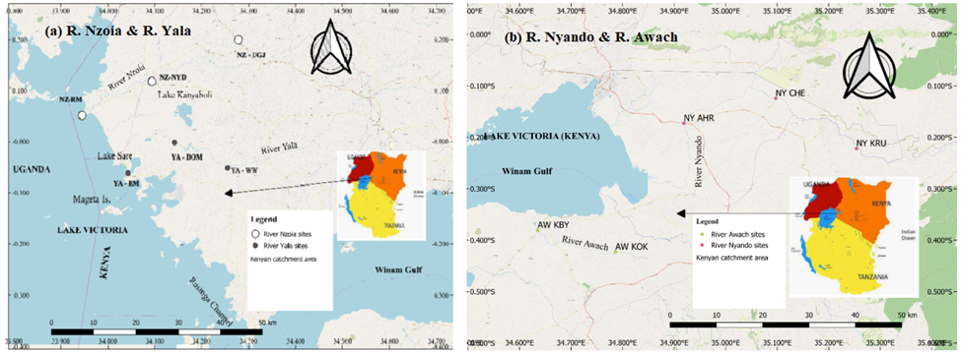
Fig. 1a and b A map showing sampling stations of the lower reaches and mid reaches of rivers Nzoia, Yala, Nyando and Awach Kibuon.

chamber was examined for the big and rare taxa under low (100x) magnification. Phytoplankton taxa were identified using the methods of (Huber –Pestalozzi 1968) as well as some publications on East African lakes (Cocquyt et al., 1993). Phytoplankton were estimated by counting all the individuals whether these organisms were single cells, colonies or filaments.

2.2.3 Zooplankton
Zooplankton samples were collected using a 1.0 m long Nansen type plankton net of 60 μm mesh size and mouth opening measuring 30 cm diameter. At the river mouths, the net was hauled vertically through the water column noting the depth while in the flowing river, water was taken by bucket of known volume and the water filtered the same net. The zooplankton samples were preserved in 5% formalin. In the laboratory each sample was made to a known volume, thoroughly shaken for uniform distribution and a sub-sample taken and placed in a counting chamber. Identification of the zooplankton was done using relevant. Estimates of abundance of crustacean zooplankton were made from counts of sub-samples under a Leica dissection microscope, at a magnification of x 25. The number of individuals per Litre of in the sample was determined by taking into account, Volume of the sample, number of organisms in the sub-sample, volume of the river/lake water filtered.

2.2.4 Fish species
At the river mouths, two monofilament fleets were set parallel to the shoreline away from direct water flow but within the river-lake inter-phase. The nets were left to soak for two hours before retrieval after which the fish were sorted into species level, and biological measurements done according to standard operating procedures for biological monitoring. Upstream, electro-fishing was done over a distance of 100m upstream on an average 30 minutes depending on accessibility and the shoreline characteristics. This was processed following the same procedures applied with the gillnet specimen.
Fish composition and abundance
Fish specimen were sampled using monofilament fishing nets (mesh sizes 0.5” - 2”) set for about 2 hours at sampling site. Sorting of the fish was done and individual fish isolated from the catch using morphological examination. The fish specimens were preserved for further laboratory examination, while the sex and maturity status of fish were also determined using Standard Operating Procedures (SOPs).
2.3. Data analysis
The physico - chemical data was analysed and explored for normality using the Microsoft Excel and SPSS software, and the descriptive statistics and mean values for each parameter provided. The significant differences in the mean values were evaluated using ANOVA where appropriate. The data on the zooplankton, phytoplankton, and fish species composition, abundance was evaluated using appropriate statistical software and metrics. Data analysis was done using Paleontological Statistics Software Package (PAST software, Version 4.03) (Hammer et al. 2001).
3. results

3.1. Physico - chemical characteristics and nutrient elements
The extensive river drainage basins are under the influence of varied human activities and channel characteristics differ longitudinally (Supplementary information Table 1). The temperature of the surface water (Table 1) decreased upstream while the D.O concentration showed a wide variation along the river channels, with the lowest D.O concentrations at lower reaches at Goye (4.18 mgL⁻¹ YA-RM). The river surface water was well oxygenated with most of the mean concentrations above 7.12 mgL⁻¹. Water conductivity and TDS decreased upstream, whereas the salinity showed a wide variation from 0.03 ‰ – 0.09 ‰. River Nyando water recorded the highest pH values ranging from 8.21 – 8.55. All the rivers showed the same general pattern in concentrations of water hardness and total alkalinity with less variation in both parameters. The total and dissolved nutrient concentrations were highly variable (Table 2). Total P and SRP concentrations ranged from a minimum and maximum value of 33.29 µgL⁻¹ (R. Yala RM) to 1,077.57 µgL⁻¹ (R. Nyando- Koru) and 5.33 µgL⁻¹ (R. Yala- RM) to 137 gL-1 (R. Awach – KBY) respectively. The mean SRP concentration in rivers Yala and Awach were significantly different (ANOVA, F_{.05; 3, 29}). The total N concentrations ranged from 276 µgL⁻¹ (R. Yala – RM) to 3,771.79 µgL⁻¹. The nutrient elements showed significant relationships in river water characteristics, but only the water temperature and depth were positively and significantly correlated with channel width. (Supplementary information Table 1)

3.2 Phytoplankton composition and spatial distribution
Composition of phytoplankton community in rivers is largely dominated by diatoms during November 2019 and March 2020, which contributed between 45 % in both sampling (Fig. 2). The diatom composition at AW-KBY, NY-CHEM and AW-KOK stations was over 79 % (November 2019); whereas, AW-KOK, NY-KRU, NY-CHEM and NZ-UGJ was slightly lower (at over 70%). Cyanophytes formed an equally important flora, contributing between 0 % and 65 % at NZ-UGJ in November 2019. In March 2020, R. Nyando recorded the highest content of this group (99%), but was lacking YA-DOM, YA-WW (Supplementary Figure 2). Euglenophytes contributed equally the same in most of the stations.

Table 1. Mean (±SD) values of the physic-chemical variables in surface water of the four rivers (n = sample size) at each sampling site.
(a)

Stations | n |  | Depth (m) |  | CW (m) |  | FV (ms⁻¹) |  | Temp (ºC) |  | D.O (mgl ⁻¹) |  | pH |  | Alt(m)
 |  |  | Nov19Mar20 |  | Nov19Mar20 |  | Nov19Mar20 |  | Nov19Mar20 |  | Nov19Mar20 |  | Nov19Mar20 |  | Nov19
NZ-RM |  | M | nd | nd | Nd | nd | nd | nd | 24.1 | 24.8 | 6.68 | 6.31 | 8.12 | 6.90 | 1142
 |  | ±SD | - | - | - | - | - | - | 0.1 | 0.28 | 0.98 | 0.04 | 0.36 | 0.71 | -
NZ-NYD |  | M | 2.5 | 3.0 | 40 | 24 | 0.9 | 0.59 | 23.8 | 24.7 | 6.53 | 6.30 | 8.22 | 6.4 | 1164
 |  | ±SD | - | 1 | - | 5 | 0.5 | 0.24 | 0.0 | 0.0 | 0.18 | 0.0 | 0.37 | 0.28 | -
NZ-UGJ |  | M | 2.5 | 1 | 45 | 50 | 0.5 | 1.16 | 23.2 | 25.1 | 7.75 | 7.54 | 7.88 | 8.79 | 1380
 |  | ±SD | - | 0.5 | - | 10 | 0.3 | 0.13 | 0.1 | - | 0.4 | - | 0.09 | - | -
Overall | 9 | M | 2.5 | 2.2 | 43 | 35 | 0.7 | 0.75 | 23.7 | 24.8 | 6.99 | 6.55 | 8.07 | 7.08 | -
 |  | ±SD | 0.6 | 1.3 | 10 | 16 | 0.5 | 0.35 | 0.37 | 0.2 | 0.79 | 0.55 | 0.3 | 1.06 | -
 |  | Min | 2 | 0.5 | 10 | 20 | 0.26 | 0.22 | 23.2 | 24.6 | 5.56 | 6.28 | 7.78 | 6.20 | -
 |  | Max | 3 | 4.5 | 30 | 60 | 1.8 | 1.21 | 24.2 | 25.1 | 8.40 | 7.54 | 8.54 | 8.79 | -
YA-RM |  | M | 1.8 | 1.5 | 50 | 82 | nd | 0.8 | 25.9 | 25.6 | 4.58 | 4.27 | 7.83 | 8.20 | 1134
 |  | ±SD | - | - | - | 23 | - | 0.11 | 0.0 | 0.0 | 0.35 | 0.32 | 0.05 | 0.4 | -
YA-DOM |  | M | 2.3 | 1 | 30 | 23 | 1.3 | 0.76 | 24.3 | 24.7 | 6.93 | 6.44 | 7.93 | 8.27 | 1153
 |  | ±SD | - | 0.6 | - | 9 | 0.0 | 0.07 | 0.2 | - | 0.43 | - | 0.08 | - | -
YA-WW |  | M | 1.3 | 0.6 | 35 | 22 | 1.2 | 0.86 | 23.3 | 24.7 | 7.47 | 7.49 | 7.68 | 7.35 | 1200
 |  | ±SD | - | 0.3 | - | 0.8 | 0.8 | 0.25 | 0.0 | 0.0 | 0.05 | 0.07 | 0.36 | 1.35 | -
Overall | 9 | M | 1.8 | 0.9 | 38 | 42 | 1.2 | 0.82 | 24.5 | 25.2 | 6.33 | 5.71 | 7.81 | 7.91 | -
 |  | ±SD | 0.5 | 0.5 | 12 | 32 | 0.7 | 0.18 | 1.14 | 0.5 | 1.36 | 1.63 | 0.22 | 0.79 | -
 |  | Min | 1 | 0.4 | 26 | 15 | 0.38 | 0.55 | 23.3 | 24.7 | 4.18 | 3.91 | 7.43 | 6.40 | -
 |  | Max | 2.5 | 1.5 | 60 | 105 | 2.0 | 1.25 | 25.9 | 25.6 | 7.53 | 7.54 | 8.10 | 8.60 | -
NY-RM |  | M | nd | 1 | nd | nd | nd | nd | nd | 27.2 | nd | nd | nd | 7.86 | -
 |  | ±SD | - | - | - | - | - | -- | - | 0.4 | - | - | - | 0.12 | -
NY-AHR |  | M | 1.3 | - | 18 | 17 | 1.1 | 1.3 | 23.3 | 25.4 | 7.12 | 7.33 | 8.25 | 8.10 | 1154
 |  | ±SD | - | 0.8 | - | 7 | 0.2 | 0.19 | 0.0 | - | 0.14 | - | 0.26 | - | -
NY-CHEM |  | M | 0.8 | 0.3 | 18 | 26 | 0.3 | 0.61 | 23.1 | 24.3 | 6.87 | 6.73 | 8.32 | 8.77 | 1198
 |  | ±SD | - |  | - | 2 | 0.0 | 0.26 | 0.0 | 0.3 | 0.38 | 1.37 | 0.12 | 0.06 | -
NY-KRU |  | M | 0.4 | 0.5 | 15 | 17 | 0.6 | 1.13 | 20.9 | 25.4 | 8.08 | 7.25 | 8.46 | 7.70 | -
 |  | ±SD | - | 0.1 | - | 8 | 0.2 | 0.1 | 0.06 | 0.0 | 0.04 | 0.14 | 0.04 | 0.46 | -
Overall | 12 | M | 0.5 | 0.6 | 17 | 20 | 0.9 | 1.03 | 22.4 | 25.6 | 7.35 | - | 8.34 | 8.06 | -
 |  | ±SD | - | 0.2 | 4 | 7 | 0.2 | 0.36 | 1.1 | 1.1 | 0.59 | - | 0.17 | 0.52 | -
 |  | Min | 0.2 | 0.2 | 10 | 10 | 0.22 | 0.22 | 20.9 | 24.1 | 6.46 | 5.76 | 7.95 | 7.20
 |  | Max | 1.5 | 1 | 20 | 30 | 1.46 | 1.5 | 23.3 | 27.5 | 8.10 | 7.35 | 8.55 | 8.81 | -
AW-RM |  | M | nd | nd | nd | nd | nd | nd | nd | 24.1 | nd | 5.2 | nd | 8.32 | -
 |  | ±SD | - | - | - | - | - | - | - | 2.2 | - | 0.2 | - | 0.13 | -
AW-KBY |  | M | 1.3 | 1.4 | 16 | 13 | 1.1 | 0.48 | 21.6 | 23.5 | 8.01 | 7.34 | 7.28 | 8.47 | 1156
 |  | ±SD | - | 0.1 | - | 2 | 0.1 | 0.04 | 0.2 | - | 0.23 | - | - | - | -
AW-KOK |  | M | 1.3 | 0.4 | 12 | 12 | 0.7 | 1.16 | 20.7 | 22.8 | 8.09 | 8.04 | 8.12 | 8.52 | 1216
 |  | ±SD | - | 0.1 | - | 3 | 0.1 | 0.27 | 0.0 | - | 0.11 | - | 0.16 | - | -
Overall | 9 | M | 1.3 | 0.9 | 14 | 13 | 0.9 | 0.87 | 21.1 | 23.7 | 8.05 | 6.19 | 7.70 | 8.39 | -
 |  | ±SD | 0.3 | 0.6 | 3 | 2 | 0.2 | 0.41 | 0.5 | 1.6 | 0.17 | 1.43 | 0.48 | 0.13 | -
 |  | Min | 1 | 0.3 | 10 | 10 | 0.7 | 0.44 | 20.7 | 21.7 | 7.88 | 4.87 | 7.23 | 8.18 | -
 |  | Max | 1.5 | 1.5 | 17 | 17 | 1.1 | 1.55 | 21.8 | 25.8 | 8.28 | 8.04 | 8.31 | 8.52 | -
(b)
Stations | n |  | Cond (µScm⁻¹) |  | TDS (mgl ⁻¹) |  | Alk (mgl ⁻¹) |  | Hard (mgl ⁻¹)) |  | ORP (mV) |  | Sal (‰)
 |  |  | Nov19Mar20 |  | Nov19Mar20 |  | Nov19Mar20 |  | Nov19Mar20 |  | Nov19Mar20 |  | Nov19Mar20
NZ-RM |  | M | 108.7 | 120.8 | 71.52 | 78.98 | 46 | 66 | 43 | 48 | -47.47 | 501.65 | 0.05 | 0.06
 |  | ±SD | 2.1 | 3.68 | 1.98 | 3.22 | 4 | 1 | 1 | - | 14.36 | 16.33 | 0.01 | 0.01
NZ-NYD |  | M | 103 | 128.9 | 61.03 | 84.73 | 48 | 132 | 42 | 56 | -84.3 | 355 | 0.06 | 0.03
 |  | ±SD | 1.1 | 0.0 | 6.36 | 0.24 | 6 | - | 3 | - | 6.92 | 41.86 | 0.01 | 0.04
NZ-UGJ |  | M | 88.23 | 129.2 | 62.48 | 83.85 | 44 | 64 | 42 | 48 | -53.97 | 74.90 | 0.04 | 0.06
 |  | ±SD | 0.15 | - | 5.77 | - | 2 | - | 0 | - | 13.1 | - | 0.0 | -
Overall | 9 | M | 100 | 125.7 | 65.01 | 82.25 | 46 | 87 | 42 | 51 | -61.91 | 357.64 | 0.05 | 0.05
 |  | ±SD | 9 | 4.9 | 6.6 | 3.41 | 4 | 39 | 0 | 5 | 19.91 | 175.68 | 0.01 | 0.02
 |  | Min | 88.1 | 118.2 | 56.25 | 76.71 | 41 | 64 | 40 | 48 | -82.60 | 74.9 | 0.04 | 0.05
 |  | Max | 111 | 129.2 | 73.45 | 84.9 | 54 | 132 | 46 | 56 | -37.50 | 513.2 | 0.06 | 0.06
YA-RM |  | M | 90.2 | 101.7 | 57.85 | 65.65 | 37 | 50 | 37 | 34 | -46.3 | 709.97 | 0.04 | 0.02
 |  | ±SD | 0.1 | 0.06 | 0.0 | 0.0 | 1 | - | 3 | - | 3.35 | 3.75 | 0.0 | 0.03
YA-DOM |  | M | 93.1 | 91 | 59.46 | 59.8 | 49 | 44 | 42 | 36 | -49.43 | 42 | 0.04 | 0.04
 |  | ±SD | 4.6 | - | 0.24 | - | 2 | - | 2 | - | 17 | - | 0.0 | -
YA-WW |  | M | 75.1 | 58 | 50.48 | 57.85 | 48 | 48 | 48 | 48 | -71.13 | 216.15 | 0.04 | 0.04
 |  | ±SD | 0.2 | 42.28 | 0.38 | 0.0 | 4 | - | 4 | - | 13.33 | 368.33 | 0.0 | 0.0
Overall | 9 | M | 86.12 | 85.47 | 55.93 | 62.08 | 45 | 47 | 42 | 39 | -55.73 | 434.03 | 0.04 | 0.03
 |  | ±SD | 8.7 | 28.7 | 4.15 | 3.98 | 6 | 3 | 5 | 8 | 15.98 | 350.07 | 0.0 | 0.02
 |  | Min | 74.9 | 28.1 | 50.05 | 57.85 | 36 | 44 | 34 | 34 | -82.6 | -44.3 | 0.04 | 0.01
 |  | Max | 98.3 | 101.8 | 59.6 | 65.65 | 52 | 50 | 52 | 48 | -37.5 | 713.8 | 0.04 | 0.05
NY-RM |  | M | nd | 207.6 | nd | 128.7 | nd | 108 | nd | 72 | nd | 7.7 | nd | 0.09
 |  | ±SD | - | 0.21 | - | 0.0 | - | - |  | - |  | 90.37 | - | 0.0
NY-AHR |  | M | 176.5 | 243.1 | 118.46 | 156.65 | 79 | 126 | 85 | 80 | 54.9 | 596.3 | 0.08 | 0.11
 |  | ±SD | 2.8 | - | 1.55 | - |  | - | 3 | - | 1.57 | - | 0.01 | -
NY-CHEM |  | M | 188.3 | 254.8 | 127.18 | 176.15 | 75 | 120 | 65 | 96 | 38.9 | 19.85 | 0.09 | 0.13
 |  | ±SD | 0.4 | 33.1 | 0.38 | 32.17 | 3 | - | 6 | - | 5.84 | 40.52 | 0.0 | 0.03
NY-KRU |  | M | 116.4 | 153.2 | 81.9 | 75.47 | 48 | 68 | 51 | 32 | 53.87 | 286.1 | 0.06 | 0.07
 |  | ±SD | 0.1 | 0.2 | 0.0 | 40.41 | 1 | - | 4 | - | 8.96 | 162.6 | 0.0 | 0.0
Overa1l | 12 | M | 160.4 | 203.4 | 109.18 | 124.1 | 67 | 106 | 67 | 70 | -49.22 | 174.93 | 0.08 | 0.10
 |  | ±SD | 33.4 | 47.1 | 20.82 | 50.6 | 15 | 26 | 16 | 27 | 9.45 | 244.91 | 0.01 | 0.03
 |  | Min | 116.3 | 153 | 81.9 | 28.8 | 46 | 68 | 46 | 32 | -60.6 | -71.6 | 0.06 | 0.01
 |  | Max | 188.7 | 278.2 | 127.4 | 198.9 | 82 | 126 | 88 | 96 | -32.4 | 596.3 | 0.09 | 0.15
AW-RM |  | M | nd | 97 | nd | 64.6 | nd | nd | nd | Nd | nd | 14.9 | nd | 0.04
 |  | ±SD | - | 23.7 | - | 12.8 | - | - |  |  | - | 54.8 |  | 0.01
AW-KBY |  | M | 69.47 | 73 | 48.33 | 48.75 | 37 | 40 | 65 | 36 | 33.33 | 60.5 | 0.03 | 0.03
 |  | ±SD | 0.67 | - | 0.39 | - | 11 | - | 7 | - | 1.08 | - | 0.0 | -
AW-KOK |  | M | 61.53 | 73.7 | 43.55 | 50.05 | 33 | 30 | 66 | 24 | 31.87 | 84.2 | 0.03 | 0.02
 |  | ±SD | 0.29 | - | 0.0 | - | 4 | - | 7 | - | 1.76 | - | 0.0 | -
Overall |  | M | 65.5 | 87.52 | 45.94 | 58.5 | 35 | 35 | 66 | 30 | 0.73 | 37.87 | 0.03 | 0.04
 |  | ±SD | 4.37 | 21.19 | 2.63 | 12.28 | 3 | 7 | 6 | 8 | 35.73 | 50.64 | 0.0 | 0.01
 |  | Min | 61.2 | 70.1 | 43.55 | 48.75 | 28 | 30 | 58 | 24 | -33.3 | -39.3 | 0.03 | 0.02
 |  | Max | 70.2 | 115.1 | 48.78 | 74.1 | 50 | 40 | 72 | 36 | 34.1 | 84.2 | 0.03 | 0.05

Conductivity = Cond; Total alkalinity = Alk; Hardness = hard; Water temperature = temp; Salinity = Sal; Oxidation reduction potential = ORP; Total dissolved solids = TDS.
Table 2 Mean (±SD) values of the nutrient concentrations in surface water (a – b) of the four rivers (Sample size, n = 3 and 1 during November 2019 and March 2020 respectively) at each sampling site.

Stations | N |  | TP (µgl⁻¹) |  | SRP (µgl⁻¹) |  | NO₂N (µgl⁻¹) |  | NO₃N (µgl⁻¹) |  | NH₄N
 |  |  | Nov. 19Mar. 20 |  | Nov. 19Mar. 20 |  | Nov. 19Mar. 20 |  | Nov. 19Mar. 20 |  | Nov. 19Mar. 20
NZ-RM |  | M | 129.95 | 343.29 | 27.0 | 2.0 | 11.22 | 6.27 | 30.01 | 1.58 | 71.15 | 32.19
 |  | ±SD | 16.43 | - | 13.64 | - | 0.76 | - | 3.16 | - | 16.73 | -
NZ-NYD |  | M | 169.0 | 279.0 | 43.11 | 8.67 | 16.57 | 9.30 | 35.37 | 22.33 | 78.02 | 11.56
 |  | ±SD | 37.88 | - | 22.69 | - | 1.09 | - | 4.47 | - | 2.01 | -
NZ-UGJ |  | M | 209.48 | 299.0 | 74.22 | 8.67 | 34.05 | 7.49 | 48.7 | 25.06 | 74.27 | 31.56
 |  | ±SD | 21.50 | - | 39.10 | - | 1.43 | - | 12.8 | - | 11.61 | -
Overall | 9 | M | 169.48 | 307.10 | 48.11 | 6.45 | 20.62 | 7.69 | 38.02 | 16.32 | 74.48 | 25.11
 |  | ±SD | 41.56 | 32.90 | 31.46 | 3.85 | 10.39 | 1.53 | 10.86 | 12.84 | 10.66 | 11.73
 |  | Min | 113.29 | 279.0 | 15.33 | 2.0 | 10.52 | 6.27 | 27.48 | 1.58 | 55.94 | 11.56
 |  | Max | 223.29 | 343.29 | 117.0 | 8.67 | 35.67 | 9.30 | 62.64 | 25.06 | 89.06 | 32.19
YA-RM |  | M | 57.57 | 114.71 | 19.59 | 2.0 | 2.23 | 0.52 | 5.16 | 2.94 | 46.35 | 83.44
 |  | ±SD | 21.99 | - | 15.44 | - | 0.63 | - | 0.88 | - | 36.37 | -
YA-DOM |  | M | 199.47 | 163.29 | 12.56 | 2.0 | 9.81 | 8.39 | 21.83 | 22.94 | 94.06 | 4.06
 |  | ±SD | 188.93 | - | 3.47 | - | 0.93 | - | 1.97 | - | 37.92 | -
YA-WW |  | M | 201.86 | 200.43 | 38.67 | 2.0 | 23.24 | 3.55 | 34.71 | 25.97 | 81.56 | 3.44
 |  | ±SD | 38.36 | - | 10 | - | 5.36 | - | 4.1 | - | 9.92 | -
Overall | 9 | M | 152.97 | 159.48 | 19.59 | 2.0 | 11.76 | 4.15 | 20.55 | 17.28 | 73.99 | 30.31
 |  | ±SD | 120.55 | 42.98 | 15.44 | 0.0 | 9.61 | 3.97 | 13.02 | 12.51 | 34.26 | 46.01
 |  | Min | 33.29 | 114.71 | 5.33 | 2.0 | 1.73 | 0.52 | 4.15 | 2.94 | 7.19 | 3.44
 |  | Max | 417.57 | 200.43 | 48.67 | 2.0 | 29.0 | 8.39 | 39.30 | 25.97 | 137.19 | 83.44
NY-RM |  | M | nd | 566.14 | nd | 25.33 | nd | 4.76 | nd | 12.33 | nd | 7.19
 |  | ±SD | - | - | - | - | - | - | - | - | - | -
NY-AHR |  | M | 306.14 | 579.0 | 57.55 | 70.33 | 43.24 | 11.12 | 59.40 | 29.91 | 59.48 | 10.31
 |  | ±SD | 13.09 | - | 3.85 | - | 11.57 | - | 12.51 | - | 15 | -
NY-CHEM |  | M | 878.05 | 320.43 | 92.56 | 35.33 | 32.94 | 15.36 | 50.82 | 35.36 | 49.06 | 12.81
 |  | ±SD | 253.14 | - | 25.51 | - | 1.09 | - | 3.87 | - | 7.58 | -
NY-KRU |  | M | 932.33 | 179.0 | 65.33 | 53.67 | 34.96 | 19.91 | 63.14 | 43.24 | 49.48 | 27.81
 |  | ±SD | 27.93 | - | 3.34 | - | 3.1 | - | 5.34 |  | 18.48 | -
Overall | 12 | M | 705.51 | 411.14 | 71.81 | 46.17 | 37.05 | 12.79 | 57.79 | 30.21 | 52.67 | 14.53
 |  | ±SD | 326.28 | 195.21 | 20.56 | 19.93 | 7.65 | 6.44 | 8.94 | 13.12 | 13.50 | 9.15
 |  | Min | 291.86 | 179.0 | 55.33 | 25.33 | 31.42 | 4.76 | 47.48 | 12.33 | 30.31 | 7.19
 |  | Max | 1077.57 | 579.0 | 122.0 | 70.33 | 56.58 | 19.91 | 73.85 | 43.24 | 76.56 | 27.81
AW-RM |  | M | nd | 220.43 | nd | 17.0 | nd | 46.58 | nd | 5.61 | nd | 36.56
 |  | ±SD | - | - | - | - | - | - | - | - | - | -
AW-KBY |  | M | 98.53 | 376.14 | 110.89 | 48.67 | 57.79 | 15.67 | 71.73 | 69.0 | 100.52 | 83.44
 |  | ±SD | 21.87 | - | 27.61 | - | 7.37 | - | 21.55 | - | 28 | -
AW-KOK |  | M | 248.52 | 574.71 | 93.11 | 65.33 | 71.73 | 11.42 | 77.48 | 69.0 | 79.27 | 30.31
 |  | ±SD | 4.13 | - | 32.93 | - | 11.17 | - | 3.94 | - | 1.3 | -
Overall | 9 | M | 173.55 | 390.43 | 102.0 | 43.67 | 64.76 | 24.56 | 74.61 | 65.87 | 89.90 | 50.11
 |  | ±SD | 88.35 | 177.57 | 28.87 | 24.55 | 11.40 | 19.19 | 14.21 | 5.42 | 21.20 | 29.04
 |  | Min | 73.29 | 220.43 | 63.67 | 17.0 | 49.3 | 11.42 | 54.76 | 59.61 | 77.19 | 30.31
 |  | Max | 253.29 | 574.71 | 137.0 | 65.33 | 79.91 | 46.58 | 95.97 | 69.0 | 131.56 | 83.44

(b)
Stations | N |  | TN (µgl⁻¹) |  | SiO₂Si (mgl⁻¹)
 |  |  | Nov. 19Mar. 20 |  | Nov. 19Mar. 20
NZ-RM |  | M | 791.26 | 140.21 | 22.0 | 0.62
 |  | ±SD | 39.65 | - | 2.57 | -
NZ-NYD |  | M | 894.95 | 236.53 | 22.12 | 0.45
 |  | ±SD | 42.05 | - | 2.04 | -
NZ-UGJ |  | M | 3496 | 388.11 | 21.79 | 1.9
 |  | ±SD | 284.58 | - | 2.96 | -
Overall | 9 | M | 1727.40 | 254.95 | 21.97 | 0.99
 |  | ±SD | 1335.13 | 124.97 | 2.22 | 0.79
 |  | Min | 757.56 | 140.21 | 19.17 | 0.45
 |  | Max | 3771.79 | 388.11 | 25.19 | 1.90
YA-RM |  | M | 291.26 | 9.16 | 20.98 | 0.01
 |  | ±SD | 13.43 | - | 0.80 | -
YA-DOM |  | M | 619.68 | 432.32 | 21.90 | 0.88
 |  | ±SD | 3.29 | - | 1.88 | -
YA-WW |  | M | 2620.74 | 413.37 | 23.17 | 1.96
 |  | ±SD | 213.12 | - | 0.29 | -
Overall | 9 | M | 1177.23 | 284.95 | 22.02 | 0.95
 |  | ±SD | 1097.14 | 239.03 | 1.40 | 0.98
 |  | Min | 291.26 | 9.16 | 19.75 | 0.01
 |  | Max | 2620.74 | 432.32 | 23.47 | 1.96
NY-RM |  | M | nd | 440.21 | nd | 1.90
 |  | ±SD | - | - | - | -
NY-AHR |  | M | 3202.84 | 468.63 | 27.10 | 3.21
 |  | ±SD | 175.67 | - | 1.47 | -
NY-CHEM |  | M | 3078.82 | 467.05 | 27.18 | 2.74
 |  | ±SD | 294.54 | - | 4.58 | -
NY-KRU |  | M | 3121.88 | 650.21 | 31.65 | 2.60
 |  | ±SD | 263.31 | - | 1.65 | -
Overall | 9 | M | 3134.51 | 506.53 | 28.65 | 2.61
 |  | ±SD | 222.96 | 96.67 | 3.40 | 0.54
 |  | Min | 2808.68 | 440.21 | 22.51 | 1.90
 |  | Max | 3397.84 | 650.21 | 33.56 | 3.21
AW-RM |  | M | nd | 508.11 | nd | 11.87
 |  | ±SD | - | - | - | -
AW-KBY |  | M | 2850.21 | 553.90 | 21.06 | 13.32
 |  | ±SD | 684.28 | - | 5.47 | -
AW-KOK |  | M | 2926.02 | 683.37 | 24.72 | 27.28
 |  | ±SD | 142.87 | - | 1.94 | -
Overall | 9 | M | 2888.11 | 581.79 | 22.89 | 17.49
 |  | ±SD | 444.06 | 90.90 | 4.18 | 8.51
 |  | Min | 2374.42 | 508.11 | 17.63 | 11.87
 |  | Max | 3634.42 | 683.37 | 27.37 | 27.28

Mean value = M; Minimum = Min; Maximum = Max; Standard deviation = ±SD; Total nitrogen and phosphorus = TN and TP; Soluble reactive phosphorus = SRP

Occurrences of other algal families such as Zygnematophyceae never appeared at YA-RM, YA-DOM, NY-NYD, AW-KOK, AW-KBY, NY-KRU and NY-CHEM. Dinoflagellates appeared in three stations in both sampling months, but they were below 7%. The phytoplankton species richness varied between, Diatoms, Chlorophytes, Cyanophytes and Zygnematophyceae which were the most diverse groups. In total there were 75 different species of algae identified from rivers during the November 2019 and 54 in March 2020. Of the 12 different species of cyanophytes encountered, Chroococcus sp., Cylindrospermopsis, Planktolyngbya spp. and Anabaena spp. were the most common genera in both months. Similarly, there were 16 species of chlorophytes encountered, of which Scenedesmus spp., Ankistodesmus fulcutus, Coelomoron spp. and Botryococcus were the most frequently encountered genera in November 2019. In March 2020, only six species were identified. The Zygnematophyceae family was represented by Cosmarium and Staurastrum taxa in both seasons. Only one species of dinoflagellates (Glenoridinium spp.) was encountered at NY-KRU and YA-WW. There were 29 different species of diatoms constituted mainly by of Aulacoisera, Cyclotella, Chodatella spp., fragillaria spp., Navicula spp., Surillella spp. Generally, the phytoplankton density ranged between 17 to 2 cells per litre (cells x 10⁶) in November 2019 and 0.6 to 4 cells (cells X 10⁶) in March 2020 (Fig. 3), with an average algal cells density of about 10 per cells x 10^{6.}.

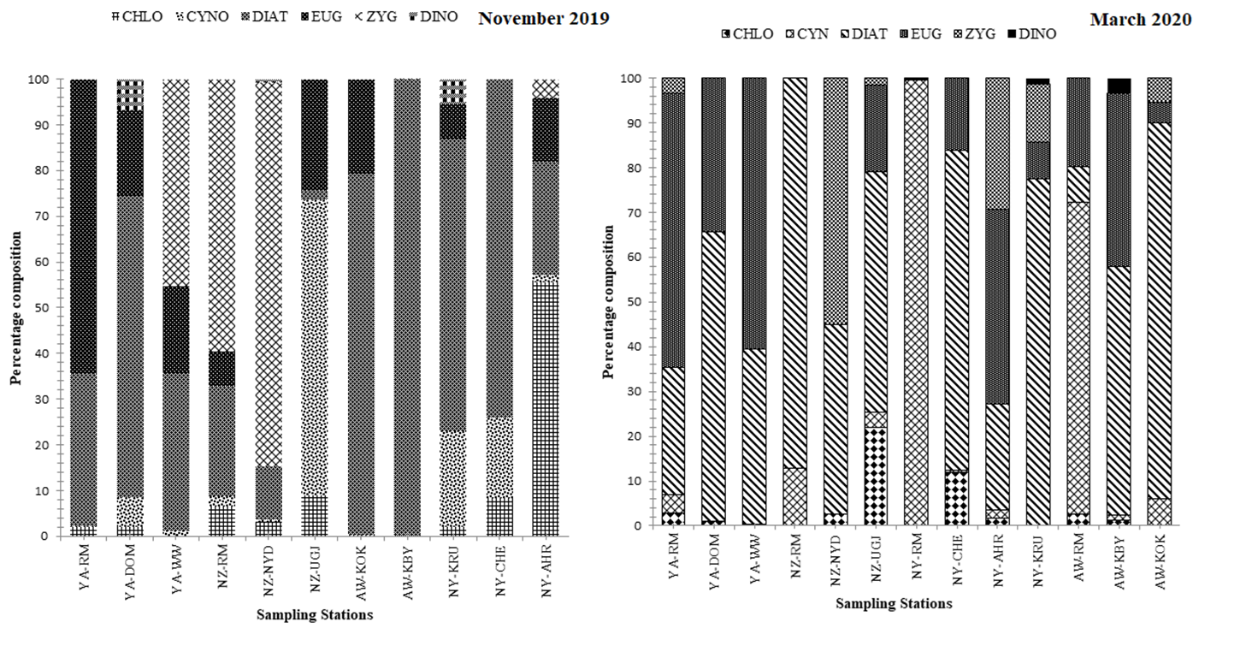
Fig. 2 Percentage composition of phytoplankton families as recorded at different sites of the rivers during November 2019 and March 2020.

cells were more in Nzoia river mouth and Awach Kendu had the highest of over 15 cells per litre 10⁶ while Bondo water works had the lowest with 2 per cells x 10⁶ and in March low density of phytoplankton were recorded with the highest. biovolume recorded at Nyando river mouth.

3.3 Zooplankton composition and spatial distribution
There were spatial variations in abundance, distribution and composition of the zooplankton during November 2019 compared to a relatively low zooplankton species diversity in March 2020. Cladocera and Copepods were not found at AW-KOK, AW-KBY, NY-AHR, and NZ-UGJ. The highest total zooplankton abundance was recorded at Yala river mouth (72.2 ind. L⁻¹), then followed by Nzoia river mouth (48 ind. L⁻¹). Zooplankton was more abundant at YA-RM than other stations which had no zooplankton (NY-AHR, NY-CHEM, AW-KBY, AW-KOK and NZ-UGJ (Fig. 4). Zooplankton community abundance in rivers in March sampling was dominated by copepods. The ratio of the immature to mature copepods ranged from 1.8 to 3.8 at NY-CHEM and YA-RM. Cladocera composition ranged from 2.5 to 15%.
Species distribution and composition
The four groups main groups of Zooplankton: Copepods, Cladocera, Rotifera and Ostracoda were represented in the samples collected from the rivers. Copepods were grouped into naupii, Cyclopoida and calonoida. Cladocera were represented by two species, Diaphanosoma excisum and Moina micrura, while seven species of rotifers were recorded. These included Brachionus calyciflorus, Ichocerca sp., Trichocerca sp., Brachionus sp., Filinia sp., Asplanchna spp., Lecane sp. The rotifers were the second highest at Nzoia river mouth (20.8%) and Yala river mouth (11.5 %). Dominance of the rotifera species is attributed to eutrophication in both seasons. Cladocerans were not recorded at NY-KRU and AW-KBY respectively. The prominance of Cyclopoida and copepoda groups in almost all the stations is a confirmation that they are detritus loving species. In almost all stations, there was a decrease in the proportion of calanoida, but nauplii proportion increased with increase in distance from the river upstream, in both periods.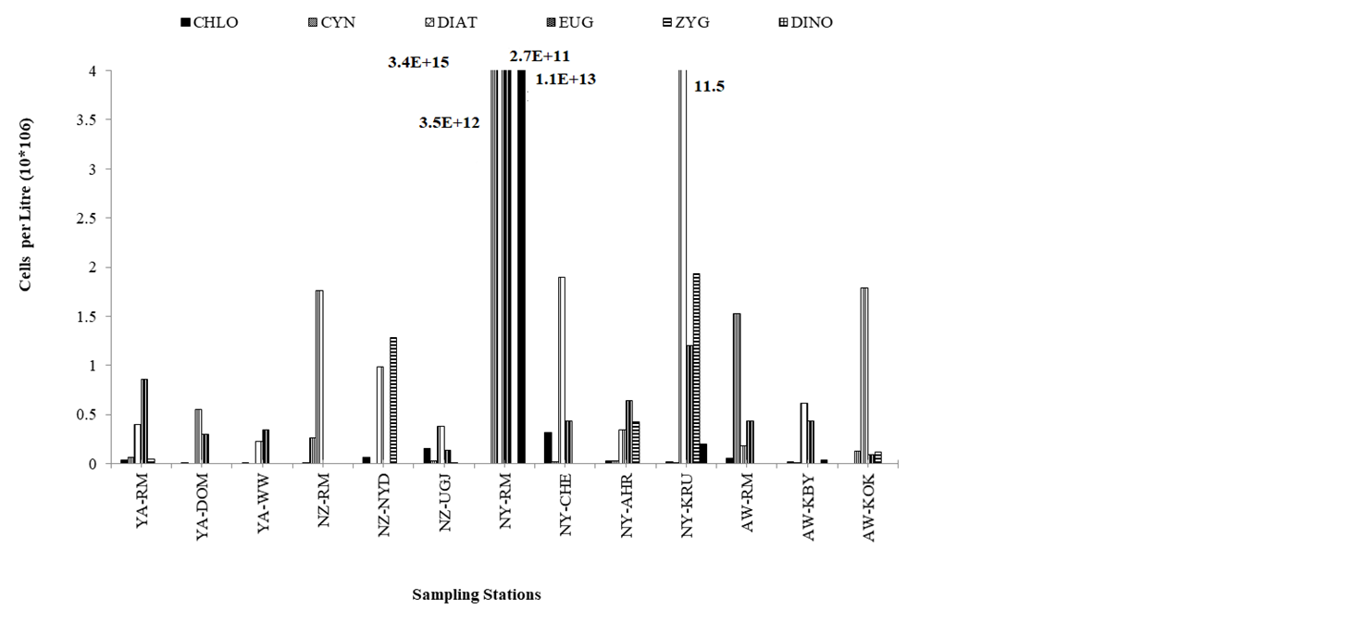
Fig. 3 Phytoplankton density (cells x10⁶ per litre) at each river site.
3.5. Fish species
During November 2019, a total of 9 fish families were found in the study sites and consisted of 19 fish species. The same stations were sampled in March 2020 and 18 species were encountered from 8 families (Supplementary information Table 2, Supplementary Figure 2). However, the river mouth stations in rivers Awach and

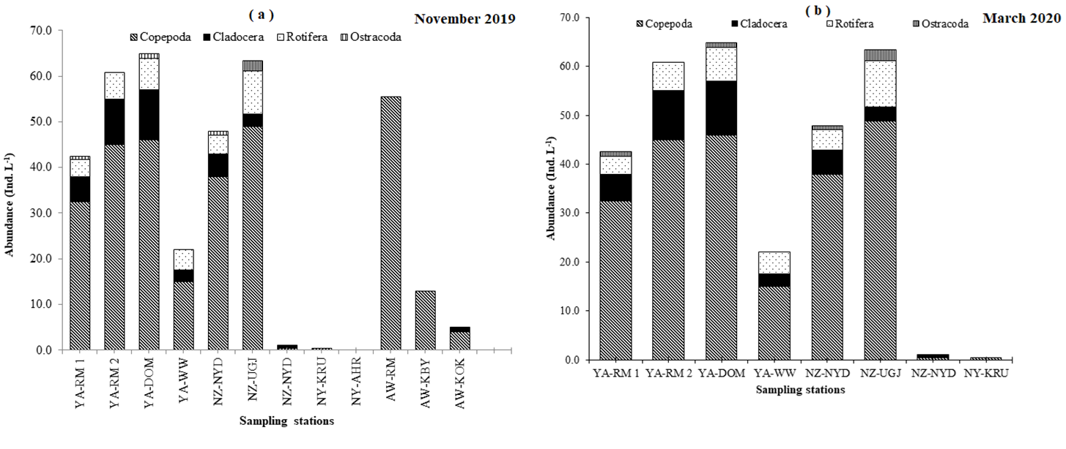
Fig. 4 Zooplankton spatial composition and distribution in November 2019 (a) and March 2020 (b).

Nyando were only accessed in March 2020. The Cyprinidae family formed the most dominant species, whereas the cichlids which were represented by O. niloticus and Haplochromis (recorded only in rivers Nyando and Yala). There was a higher percentage of mature B. jacksonii, M. frenatus, L. victorianus, Haplochromis, E. cercops, E. nyanzae, and immature L. altianalis. The length – weight relationships show a value of b of 2.8364 (R² = 0.900) for L. altianalis, 3.2703 (R² = 0.941) for E. nyanzae, 2.6023 (R² = 0.9377) for S. victoriae, 3.1563 (R² = 0.9325) for B. jacksonii, 2.3668 (R² = 0.9503) for M. frenatus, 2.4765 (R² = 0.776) for L. victorianus, and 2.9005 (R² = 0.718) for E. cercops. The values of b above 3 were indicative of positive allometric growth in E. nyanzae and B. jacksonii, and values below 3 were suggesting negative allometric growth for E. cercops, S. victoriae, L. victorianus, M. frenatus and L. altianalis fish species. The environmental conditions, food availability, and fish physiological conditions and responses may explain the differences in the species in rivers within the same geographical area.
Cichlidae
Haplochromis species (16 and 23 species in Nov 2019 and Mar 2020 respectively) were only recorded at Yala river mouth (a sandy / muddy area, with densely vegetated shorelines), whereas Awach-Kibuon river mouth only recorded 1 species (March 2020). The size ranged from 8.5 to 15.6 cm (TL) with a mean (± S.D) of 9.3 ± 0.4 cm, and a weight range of 11.5 ± 1.3 g (Nov 2019). In March, Haplochromis species size ranged from 8.5 to 15.6 cm TL, with a mean of 10.2 ± 0.3cm. The sex ratio (Males: Females) was 3:1. Three specimens of Nile tilapia (Oreochromis niloticus) were found in the uppermost station of R. Nyando (NY-KRU). O. leucostictus (6.8 to 10 cm TL, N = 2) and P. multicolor (mean TL = 3.7 ± 0.8 cm, n = 3) occurred in R. Yala at YA-DOM. The weights ranged from 0.6 to 1.6 g (P. multicolor) and 4.8 t0 17.5 g (O. leucostictus).
Cyprinidae
This was the most diverse taxa and consisted of E. nyanzae, E. cercops and L. altianalis, E. neumayeri, E. jacksonii, E. kerstenii, E. paludinosus, B. apleurogramma, L. altianalis, L. victorianus, and L. bynii (Supplementary information Table 4; Supplementary Figures 3a-3h). The largest sizes were recorded at sites above NY-RM in R. Nyando, NZ-NYD (R. Nzoia); YA-WW and YA-DOM (R. Yala). In both months, the weight and numbers of fish caught was dominated by E. nyanzae, E, cercops, L. altianalis, L. victorianus, Haplochromis and B. jacksonii fish species (Fig.6). E. cercops sizes ranged from 4 cm to 6.8 cm (November 2019) and 2.5 cm to 13.5 cm (March 2020), but with only significant spatial differences. Majority of the L. altianalis sizes were below 20 cm TL. The size ranges of E. nyanzae (TL) from R. Yala were significantly larger than those from Nyando. Males of E. nyanzae from R. Nyando were significantly larger (TL) than females. Higher numbers of E. nyanzae were caught in rivers Nyando, Awach Kibuon and Yala with sizes ranged from 2.8 cm to 10 TL cm. Sizes of E. nyanzae from R. Nzoia were smaller (majority of the fish species ranged from 3 cm – 8 cm TL) and significant temporal differences in total length were also observed in R. Yala.
The sizes of L. victorianus in Nzoia, Nyando and Yala showed no seasonal differences. The species of L. victorianus varied in size between rivers Nzoia (11.8 ± 6.6 cm) and Nyando (6.5 ± 2.9 cm) and between the two sampling periods, but were similar to those from R. Yala (13.1 ± 6 cm) during March 2020. In November 2019, lower numbers of L. victorianus were caught in rivers Yala (mean TL 14.1 ± 7.3 cm) and Nyando (15.4 ± 1.5 cm) alone. The mean sizes of B. jacksonii caught in rivers Nzoia (13.2 ± 3.2 TL cm) and Awach Kibuon (13.5 ± 1.7 TL cm) showed no spatio - temporal differences in total length. The electrofishing data shows high fluctuations in species diversity (Shannon-Weiner index) in river Nyando river stations as compared to the rest of the stations in rivers Yala and Nzoia (Figure 8).
The fish length–weight relationships exhibited good growth (Supplementary information Table 3) except for the observed low regression coefficient for the Haplochromines, L. victorianus and B. jacksonii. The values of Kn were mostly above 1 (based on weight ratios), but slightly lower than 1 values were obtained from weight – volume ratio (Kn) for E. nyanzae (Nzoia and Yala in March 2020). Very few fish samples were collected to determine the important food items contributing to the dietary needs of each of the fish species caught. However, most of the species displayed omnivory indicating availability of diverse food types. Uncommon food items such as pebbles and discarded soap were found in stomachs of S. victoriae and C. gariepinus respectively. An indication of the different food types in the less abundant species shows the commonly encountered phytoplankton and macroinvertebrates taxa in fish guts analysed
4 DISCUSSION
Global efforts and long-term monitoring of Lake Victoria shows clear increasing trends in water levels (NASA 2020, 2016) from 2008 to 2020, with sharp increase around 2019 - 2020. Intensification of seasonal rains results in increased erosion and soil bound nutrient losses into rivers and lake water, supporting the proliferation of algal blooms. Increased supply of unsettled suspended materials imparts coloration and high turbidity. As a physical pollutant, high levels of turbidity can also result in clogging of fish gills. Therefore, the changing water levels can influence aquatic habitats, fish reproduction, feeding, growth and species distribution, and other ecotone dynamics.

4.1 Physico-chemical parameters and nutrients elements
The study coincided with the extended rains experienced through-out 2019. The major rivers within the Lake Victoria Kenya basin form extensive drainage basins, extending to the high elevation highland areas, part of the Kenya water towers. This explains the longitudinal decrease in surface water temperature upstream. Increased turbulence in rivers during the rains results in well oxygenated surface waters, but this also results in transport of high levels of organic matter which contributes to lowered D.O levels, as water flows downstream, especially after inputs from surface runoffs and storm waters around urban and settlement areas. Water conductivity and TDS decreased upstream, with rivers Nyando and Awach recording the highest and lowest conductivity and TDS concentrations. River Awach-Kibuon surface water exhibited a characteristic brown colour, an indication of increased loading of silt from eroded soils within its catchment which is under heavy agricultural activities upstream; and passes through weathered rock formation with sandy top soils. This also results in increased ionic concentration downstream. Differences in water quality of the rivers emanates from the industrial discharges and human activities commonly found along the river channels and the wider catchment areas. This also explains the wide variations in total and dissolved nutrient concentrations. The highest total P were found in R. Nyando (1,077.57 µgL⁻¹ (KRU) and the lowest at the Yala river mouth area (5.33 µgL⁻¹). These are two contrasting stations as the Yala river mouth site is distinctly different and not part of the river channel. The river exits from Lake Sare after passage through the extensive swamp, where active filtration of sediment bound materials and nutrients exchanges occurs. River Nyando channel has a direct link with the lake; and receives industrial effluent discharges and nutrient leaching from farms using fertilizers. Much higher levels of nitrate–N concentration compared to NO₂–N were found in all rivers due to high oxidizing conditions experienced in rivers, except for the river mouth site in Yala river where a minimum value of 4.15 µgL⁻¹ (Nitrate–N) was recorded with less oxidizing conditions as reflected in the ORP values. High, but less variable Si concentrations between rivers are expected within the lake basin area due similar formations and increasing transport of land derived materials and leaching of minerals from exposed and weathered rock formations.
A comparison between data collected in March 2018 and November 2019 for rivers Yala and Nzoia shows similar trends for most of the parameters, but with differences in magnitude (Fig 5 to 7). Surface water temperature in rivers Yala and Nzoia was much higher in November 2019 than March 2018. Clearly, a higher TP, nitrate–N, nitrite–N, ORP and TDS, were observed March 2018 survey, but with lower Si and TN values. Other water quality variables show less distinct variations when comparisons were made between the two sampling periods. March 2018 is normally the time for the usual onset of the rainy season, and therefore the data reflects the dry conditions. Therefore, increased concentration with reduced water volume is expected due to reduced dilution effects. Significant associations were found for TP, TN and SRP in surface water. In general, lower TN and silicon contents were as a result of reduced influence from land source materials through erosion and runoffs. This explains the significant negative correlation between channel width, water depth and TN (Supplementary information Table 1). These habitat variables (water depth, channel width and flow velocity) were also significantly inter-correlated (positively). The flow velocity was significantly correlated with nutrients except ammonium–N and silicon concentrations.
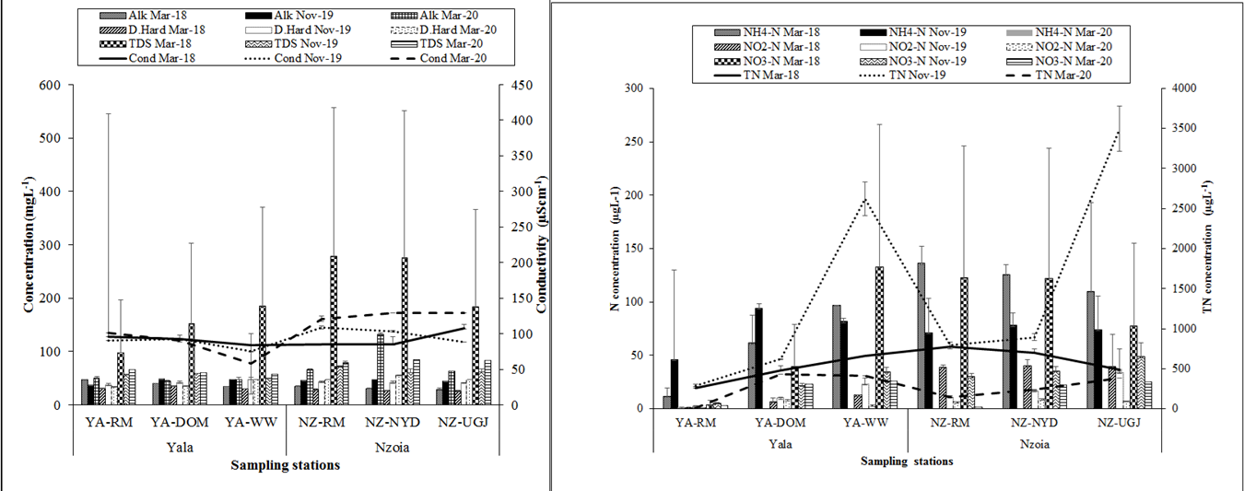
Fig. 5 A comparison of the mean (±SD) values of some water quality variables and nutrient concentration in rivers Yala and Nzoia during March 2018 (dry), November 2019 (wet season) and March 2020 (dry).
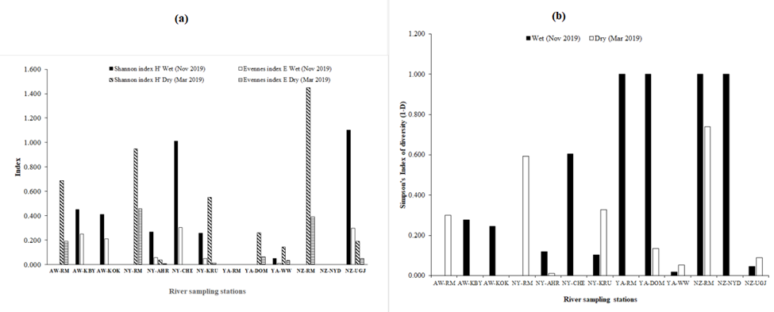
Fig. 6 A comparison of the mean (±S.D) values of some physico-chemical variables in rivers Yala and Nzoia during March 2018 (dry), November 2019 (wet season) and March 2020 (dry).

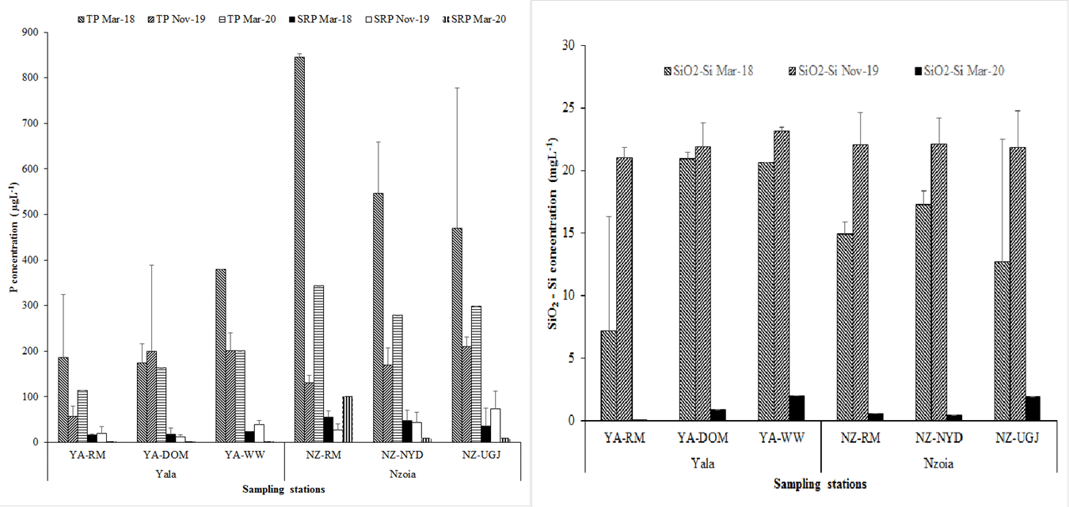
Fig. 7 A comparison of the mean (±S.D) nutrient concentrations in rivers Yala and Nzoia during March 2018 (dry), November 2019 (wet) and March 2020 (dry).
Fig. 8 Shannon – Weiner species diversity and evenness index (a), and Simpson’s index of diversity (b) for each river station sampled using electrofishing during November 2019 (wet season) and March 2020

4.2 Phytoplankton
Temporal changes of phytoplankton community structure is influenced by anthropogenic inputs of nutrient from the catchment areas, especially the farms surrounding rivers. Diatoms dominated in both surveys because of a direct supply of nutrients from agricultural lands and other anthropogenic activities. The study observed showed a high concentrations of algal families especially, Diatoms, Chlorophytes, Euglenophytes and Cyanophytes. The different ecological niches within the sampling stations are the most significant driving force, that cause predictable variations in phytoplankton composition. The high abundance of diatoms and chlorophytes, and dominance is an indication of cultural eutrophication (Kim et al., 2001). The dominance of Nitzschia spp., Surillella spp., Stephanodiscus sp. and Ampora spp. amongst others is a clear indication of trophic status in rivers. This is well correlated with the observed physio-chemical conditions recorded in the river sites. Turbidly favours the dominance of diatoms especially centric diatoms which are able to attach on detritus. The high nutrients enrichment seems to enhance growth, and is responsible for the increased algal density and more especially blue green algae which are proportionately high in most of the stations during the November 2019 and March 2020. The blue green species are known to prevail in nutrient rich lakes (Wetzel, 1983) and high light intensity areas and can attain high photosynthetic efficiencies.

4.3. Zooplankton
Rivers have a low zooplankton diversity and density. The low species diversity is attributed to sampling during the wet season as was reported in the previous surveys. This could be due to the limited habitat types, with respect to the small surface area and low water depth. However, being a juvenile fish diet, the high zooplankton abundances indicates a possibly low predation on the organisms. Fishes have been known to be able to deplete populations of zooplankton in aquatic ecosystem and the low diversity may be attributed low predation pressure from zooplanktivorous fishes, as well as the carnivorous zooplankton which feeds on algae, especially Merismopedia sp. The dominant algae are not easily digested by zooplankton, due to its fibrous nature and colonial formations. This impacts the zooplankton community species, especially rotifers found at YA-RM 1. The conditions for Branchionus spp. only favour predation species on the large bodied zooplankters. Occurrence of Cyclopoida genus is known to inhabit areas which are rocky, and could have arisen from the sweeping effect of water through the adjacent macrophytes as reported in both surveys. The latter is a new finding in the river ecosystem health, and shows that when there is a bigger number nauphii to mature copepods this shows a sign of eutrophication. There is need to focus on the same in future sampling activities, for both the temporal and spatial scales of the physico-chemical environment. These often determine levels of primary production and plankton dynamics in aquatic ecosystems, and hence affect the availability of other aquatic organisms, as well as fish.

4.4 Fish species
Most of the inflowing rivers into L. Victoria (Kenya) serve as important sources of water into fish culture ponds, and again receive effluents from such ponds. Oreochromis niloticus and Clarias gariepinus are fish species widely cultured in fish ponds within the lake basin. However, there are no reports of new species in the studied rivers. Previous biodiversity studies recorded 37, 28 and 25 fish species belonging to 11, 10 and 5 families in Lake Victoria (Kenya), satellite lakes and dams within the Kenyan catchment respectively. Centropomidae, Anabatidae, Propteridae, and Schilbeidae were the only families not represented in this riverine study. This study used monofilaments nets at river mouth sites (Yala, Awach and Nzoia) which were difficult to sample. River Nyando mouth was not accessible during this study, due to extensive coverage by aquatic macrophyte and water hyacinth. Electrofishing was used in the rest of the riverine stations. This is an effective gear for sampling rocky and vegetated riverine habitats, which harbor large assemblage of fish species. These habitats are of ecological benefit to the survival of prey species, as predatory fish species are unable to exploit fully.
From electrofishing gear, comparative data shows increasing number of species along the river channels, but obvious limitations arise due to the inability to access both sides of the river channels for sampling. These limitations can contribute greatly to the variations in fish species collected (decreased number at UGJ and NYD in R. Nzoia; and CHEM in R. Nyando) at each site. The rainy (wet) seasons are peak breeding periods for fish, and river mouth areas are recognized fish breeding and nursery grounds. This could explain the widespread distribution for the riverine species in the preselected lower river reaches sampled. Very small sized fish species can easily flow away with the current in very turbulent areas under high river flows, as effective electrofishing is not possible. According to Junge and Libosvarsky (1965), juveniles and small sized fish as a whole have a lower probability of capture than larger individuals under comparable conditions, as large individuals have larger nerve cells and muscles, which promote greater electrical stimulation. Also, these are habitats characterized by wide channels with patchy vegetated river banks and rocky river bed, with increased human activities (sand and rock harvesting). In river Awach, the sites were accessible but the water is very turbid and the habitat is of poor water quality due high erosion upstream and in nearby surrounding lands. Weathered rock formations and erodible soils contribute to the high suspended solids in river water. Shannon-Weiner species diversity index for electrofishing data shows high fluctuations in river Nyando stations, with the rest of the stations in Yala and Nzoia having less variable values. The low discharge conditions and high concentration of suspended sediments (Okungu & Opande, 2005), unfavourable conditions for fish in R. Awach could explain the low abundance in both stations, though having a high diversity value. The species composition in river stations, in both the wet (November 2019) and dry (March 2020) and conditions and using pooled data (Supplementary Figure 2) shows a high percentage (≥ 2%) of L. altianalis, E. cercops, E. nyanzae, B. jacksonii, C. gariepinus, and L. victorianus, E. cercops, L. altianalis, E. nyanzae, B. jacksonii, Haplochromis, M. frenatus, Synodontis victoriae, respectively. However, the effective sampling was a difficult task as the rain conditions persisted through-out the sampling times, and the dry conditions in March were accompanied by heavy rains.
Sedimentation around river mouths creates shallow exposed areas for fishing. A number of fish species undertake twice yearly breeding and spawning migrations up the river during the peak of the rainy seasons (April to June and mid-October to November). The species of interest are known to congregate at the river mouth prior to migrating upstream to spawn and includes Labeobarbus altianalis, Labeo victorianus, Clarias gariepinus, Marcusenius victoriae and Schilbe intermedius. For the critically endangered L. victorianus, a species endemic to the Lake Victoria drainage, this river is one of its last remaining refuges (Sayer et al., 2018). The common reed grass (phragmites) was found to dominate macrophytes occurring along the river banks upstream, but decreasing cover was noticeable at some exposed sites due encroachment of the river bank protected areas and sand harvesting. Its reduction can contribute to loss of aquatic habitat for fish breeding and other riverine species. Better understanding of the role that the traditional use of plants plays in the protection of these species may provide useful sustainable exploitation practices as they are part of the healthy riverine ecosystems.
Inflowing rivers into L. Victoria and associated wetlands are among the critical habitats for fish survival and conservation of biodiversity (Balirwa et al., 2005), with excessive fishing pressure when fish congregate to spawn, massive angling for bait, drainage of wetlands, siltation and pollution are major threats to their survival. The results show the wide distribution of riverine fish species, but continuous detailed investigations along specific drainage basins will support the generation of more information on their distribution and ecological conditions. The littoral inshore and river mouth areas are fish breeding zones, but other riverine species migrate upstream during their breeding seasons which mostly coincides with the two main rainy peaks (April – May and October – December). L. altianalis, C. gariepinus, L. victorianus, O. niloticus, S. victoriae breed several kilometers upstream R. Sondu-Miriu (Ochumba and Manyala 1992). Other fish species such as O. leucostictus are also known to breed throughout the year (McConnell, 1987). Few zooplankton prey items were recorded in fish probably due to digestion process. A lower abundance and diversity of zooplankton and high dominance by copepods was found in the river stations, and this could be attributed to low selectivity of copepods with high predation of zooplankton by zooplanktivorous fishes. Algae were common food items which showed their availability within the riverine environment. Currently, in some areas, fish cages are preferably sited in shallow or nearshore areas, which are areas of high species diversity. There is need to locate fish cages in suitable areas as cage aquaculture expands (Oketchi et al., 2025), by implementing best management practices especially for protecting the shallow littoral areas and river mouths. Increasing eutrophication coupled with the river discharges at the river mouths can potentially impact on the several endemic fish species that are sometimes only found in these areas, especially haplochromine cichlids.

4.5 Socio-economic aspects and impacts of pollution
Natural water resources with free access and multiple users, can attract many stakeholders with divergent interests for utilization of available water (abstraction, waste disposal), conservation of wetlands and fishery resources, and catchment or river basin management plans. River waters are commonly relied on for several uses and are therefore exposed to natural and diverse human impacts. The study identified all the pollutant types as important sources of pollution in rivers, except for litter and obnoxious weeds (R. Nyando). Silt, domestic washing and human and animal refuse were ranked highly as important pollutant sources in the four in-flowing rivers (Supplementary figure 4 and 5; Supplementary table 4).
Rivers are key routes for alien species introduction (e.g. water hyacinth entry into L. Victoria Uganda in 1990s through river Kagera), nutrients loading and silt deposition. Water hyacinth transport was observed along Yala river channel. The high temporal variations in flow regimes in tropical areas necessitates the development of more information on environmental flows in the rivers which is lacking for may basins and sub-basins. Key biodiversity areas involving riverine systems environmental flows should be determined (Sayer et al., 2018) to ensure effective management of both upstream and downstream threats originating outside these areas. Increasing precipitation resulted in widespread shoreline flooding with impacts to infrastructure (Supplementary Figure 6) at river mouth sites. This observation was supported by other new evidence of water level monitoring of Lake Victoria from space and employing models (Khaki et al., 2021). Water resource use conflicts can arise from human over abstraction, conservationist demand for protection of fish and aquatic habitats by controlled human activities of sand harvesting; encroachment of wetland and protected river bank areas; discharge of untreated effluents; opposing conservation measures; or lack of effective resource management plans involving all stakeholders and immediate communities. The study respondents (Supplementary information table 6) did not identify resource use conflicts as an impact of concerns. Poor river water quality was more perceived as the main impact from pollution. All pollution impacts (poor water quality, unsafe water, high costs of purification) were of concerns in utilization of water of river Awach, which reflects its overall low quality in comparison. As the population around the lake basin expands, yearly monitoring of priority contaminants, persistent organic contaminants and pharmaceutical residues in major river ecosystems is recommended to better understand and control emerging pollution sources, and inform both development and environmental management planning.

5 CONCLUSIONS
The river drainage basins are extensive, and under heavy agricultural and human activities resulting in decreasing soil cover; which contributes to the increased loading of eroded soils and the suspended materials imparts a heavy visually evident brownish colouration in most of the rivers. In contrast, clear waters of the Yala river mouth is an indication of reduced direct surface transport of such materials into the lake waters, as it passes through the swampy areas. Therefore, the seasonal rains and anthropogenic influences on the water quality were observed in all the river channels, which is also likely to impact on the resident species to some extent. Phytoplankton families were dominated by Diatoms, Chlorophytes, Euglenophytes and Cyanophytes. The different ecological niches at sampling stations were a major driving force in prediction of the compositional variations. The high abundance of diatoms and chlorophytes is an indication of cultural eutrophication. The river water turbidity favours the dominance of diatoms especially centric diatoms which are able to attach on detritus. Among the zooplankton, the ooccurrence of Cyclopoida genus, which is known to inhabit areas rocky, areas could have a risen from the sweeping effect of water through adjacent macrophytes. It is a new finding in the river ecosystem health, and there is need to focus on the same in future sampling activities. A total of 8 fish families were found, which consisted of 19 fish species. Less pertubed sites in rivers Nyando and Yala recorded high abundances, but the dominant species were from Cyprinidae family. The fish are exposed to increasing degradation of the natural riverine habitats due to the loading of land derived materials, causing increasing turbidity, which affects aquatic productivity. There exists a huge potential for conservation of non-commercial native fish species within the riverine habitats, as indicated by the high diversity and abundance of some of the taxa. It is not possible to effectively sample the riverine sites due to observed challenges of effective gears and accessibility. Therefore, in order to improve sample collection and representation of the extensive and diverse habitats in rivers, more techniques and mixed gears need to be employed, with focus on the smaller streams and tributaries. This should be accompanied by updated freshwater fish biodiversity hotspots guides for specific river drainage basins to understanding degradation impacts. The riverine biodiversity hotspots should be clearly identified in water resource management databases. To address the increasing degradation of riverine ecosystems, and to reduce resource use conflicts, which undermine biodiversity protection; there is need to develop, education, awareness and sensitization programes, involving the communities and different stakeholders in improved pollution control measures; adoption of cleaner production technologies and good agricultural practices; sustainable use and management of specific river basins.

REFERENCES
Achieng, A. O., Masese, F. O., & Kaunda-Arara, B. (2020). Fish assemblages and size spectra variation among rivers of Lake Victoria basin, Kenya. Ecological Indicators, 118, 106745.
Akurut, M., Willems, P., & Niwagaba, C. B. (2014). Potential impacts of climate change on precipitation over Lake Victoria, East Africa in the 21st Century, Water 6:2634-2659.
APHA (2005). Standard methods for the examination of water and wastewater. American Public Health Association, Washington, D.C.
Awange, J. L., Anyah, R., Agola, N., Forootan, E., & Omondi, P. (2013). Potential impacts of climate and environmental change on the stored water of Lake Victoria basin and economic implications. Water Resources Research, 49: 8160-8173.
Awange, J. L., Ogalo, L., Bae, K. H., Omondi, P., Omute, P., & Omullo, M. (2008). Falling Lake Victoria water levels: Is climate a controlling factor? Climate Change, 89: 281 – 297. DOI: 10.1007/s10584-008-9409-x
Balirwa, J. S. Wakwabi, E. & Katunzi, E. (2005). Critical habitats for fish survival and conservation of biodiversity. In: p. (97-105) LVFO 2005. The state of the fisheries resources of Lake Victoria and their management. Proceedings of the regional stakeholder’s conference, 24 – 25 February 2005, Entebbe, Uganda, ISBN 9970-713-10-2.
Cadawalladr, D. A. (1965). The decline in Labeo victorianus (Boulenger), (Pisces: Cyprinidae) fishery of Lake Victoria and associated deterioration in some indigenous fishing mfethods in the Nzoia river, Kenya. East African Agriculture and Forestry Journal, 30, 249–256.
Callisto, M., Moreno, P. & Barbosa, F. A. R. (2001). Habitat diversity and benthic functional trophic groups at Serra do Cipo, southeast Brazil. Rev Bras Biol., 61, 259–266.
Cocquyt, C., Vyverman, W. & Compere, P. (1993). A checklist of the algal flora of the East African Great Lakes (Malawi, Tanganyika and Victoria). National Botanic Garden of Belgium, Meise. 55
Darwall, W., Smith, K., Lowe, T., Jean-Christophe, V. (2005). The status and distribution of freshwater biodiversity in Eastern Africa, IUCN, SSC Freshwater Biodiversity Assessment Programme, IUCN, Gland, Switzerland and Cambridge, UK, VIII.
Hammer, O., Harper, D. A. T. & Ryan, P. D. (2001). PAST: Paleontological Statistics Software package for education and data analysis. Palaeontologia Electronica, 4:1-9.
Huber-Pestalozzi, G. (1968). Cryptophyceae, Chloromonadophyceae, Dinophyceae. Das Phytoplankton des Susswassers, 1. Teil (ed. G. Huber-Pestalozzi), 2. Aufl., pp. I-IX + 1-322. Schweizerbart’sche-Verlagsbuchhandlung, Stuttgart.
Humphrey, O. S., Isaboke, J., Osano, O., Aura, C. M., Blake, W. H., & Watts, M. J. (2025). Sediment and soil source apportionment using geochemical fingerprinting techniques in the Winam gulf, Lake Victoria. Catena, 255, 109053.
Junge, C. O. & Libosvarsky, J. (1965). Effects of size selectivity on population estimates based on successive removals with electric fishing gear. Zool. Listy, 14: 171-178.
Khaki, M. & Awange, J. (2021). The 2019-2020 rise in Lake Victoria monitored from space: Exploiting the state-of-the-art GRACE-FO and the newly released ERA-5 Reanalysis products. Sensors 21(13), 4304. https://doi.org/10.3390/s21134304
Kim, B., Park, J. H., Hwang, G., Jun, M. S. & Choi, K. (2001). Eutrophication of reservoirs in south Korea. Limnology 2, 223-229.
Korycińska, M. & Krolak, E. (2006). The use of various biotic indices for evaluation of water quality in the lowland rivers of Poland (exemplified by the Liwiec River). Pol J Environ Stud 15, 419–428.
McConnell, R. & Lowe-McConnell, R. H. 1987. Ecological studies in tropical fish communities. Cambridge University Press.
NASA (2020). Lake Victoria rising water levels. (9 December 2020). Accessed: 19th October 2021. .https://earthobservatory.nasa.gov/images/148414/lake-victorias-rising-waters.
NASA (2016). Lake Victoria’s falling waters (13 March 2016): Accessed 19th October 2021. https://earthobservatory.nasa.gov/features/Victoria/victoria.php.
Ochumba, P. B. O. & Manyala, J. O. (2008). A description of the fisheries of the Lower Sondu-Miriu river before the construction of the SMHPP. Aquaculture Research 23, 701-719.
Okechi, J. K., Peoples, N., Nyamweya, C. S., Orina, P. S., Cooperman, M. S. & Kaufman, L. (2025). Effects of Nile tilapia (Oreochromis niloticus) cage aquaculture in the world’s largest tropical lake. Journal of Great Lakes Research, 51, 102576.
Okungu, J. O., Njoka, S., Abuodha, J. O. Z. & Hecky, R. E. (2005). An introduction to Lake Victoria catchment, water quality, physical limnology and ecosystem status (Kenyan sector) In: Lake Victoria environment report water quality and ecosystem status November 2005, (Abuodha, J. O. Z., Hecky, R. E., eds.), Lake Victoria Environment Management Project, Kenya national water quality synthesis report.
Raburu, P. O. & Masese, F. O. (2012). Development of a fish - based index of biotic integrity (FIBI) for monitoring riverine ecosystems in the Lake Victoria drainage basin Kenya. River Research and Applications, 28, 23–38.
Raburu, P. O., Masese, F. O. & Aura, M. C. (2009). Macro-invertebrate index of biotic Integrity (M-IBI) for monitoring rivers in the upper catchment of Lake Victoria basin, Kenya. Aquatic Ecosystem Health and Management Society, 12, 197–205.
Sayer, C., Carr, J. & Darwall, W. (2018). A critical sites network for freshwater biodiversity in the Lake Victoria basin. Fisheries Management and Ecology, 26, DOI: 10.1111/fme.12285.
UNEP (2014). Environmental hotspots. Chapter 4, p (89–139). In: Kenya. Atlas of our changing environment, UNEP, Nairobi. 160 p.
Wetzel, R. G. & Likens G. E. (1991). Limnological analyses, 3rd edition. Springer-Verlag New York Inc. USA 429pp.
Wetzel, R. G. (1983). Limnology, 2nd Edition, Saunders College Publishing, Philadelphia.
Whitehead, P. J. P. 1959. The anadromous fishes of Lake Victoria. Rev. Zoo. Bot. Afr. 59, 329-263.

