Original Research Article
Spatial variation of anthropogenic pressures and their impact on the structure and carbon sequestration ability of Rhizophora racemosa stands in a peri-urban mangrove of Côte d’Ivoire (West-Africa)

.

ABSTRACT

Aims: To evaluate the spatial variation of anthropogenic pressures and their impacts on the stand structure and carbon stock of Rhizophora racemosa in the peri-urban mangroves of Abouabou Bay, Côte d’Ivoire.
Study Design: Descriptive and comparative ecological study based on a spatially stratified sampling design.
Place and Duration of Study: Amangoua-koi village (southeastern Abouabou Bay, Port-Bouët municipality, Abidjan, Côte d’Ivoire), surrounding the Felix Houphouet-Boigny international airport, from February to June 2025.
Methodology: Seven coastal sectors (Aero-canal, Amangoua-Koi, Darakodji, Agnikro, Abbeykro, Abouabou, and Kamboukro) of the Amangoua-koi village, representing a gradient of human disturbance, were surveyed. A total of 18 sites (each 1 ha) were established to inventory infrastructures, pollution sources, and R. racemosa structural attributes. Vegetation data were collected in 112 plots (200 m²), including tree height, diameter at breast height (DBH), stem density, and basal area. Total biomass of R. racemosa trees was estimated using a species-specific allometric equation, and carbon stock was derived with a 0.47 conversion factor. Chi-square tests assessed spatial variation in disturbance types, and generalized linear models (GLMs) or ANOVAs tested differences in structural and functional metrics among sectors.
Results: Significant spatial heterogeneity in anthropogenic pressures was observed (χ² = 84.99, P < .001). Darakodji showed the highest pollution levels; Kamboukro and Aero-canal exhibited the lowest. R. racemosa was absent from four sectors and sparse in Agnikro. Kamboukro and Aero-canal displayed superior stand attributes, with mean tree heights up to 10.12 ± 4.34 m and DBH values of 16.73 ± 8.96 cm. Stem density reached 18.44 ± 18.40 ind. 200 m⁻² in Kamboukro. Biomass ranged from 0 to 5,951.73 ± 6,146.82 kg 200 m⁻², and carbon stocks from 0 to 139.87 ± 144.35 t C ha⁻¹. Tidal connectivity and low disturbance were key to high carbon storage.
Conclusion: Localized human disturbance strongly influences mangrove structure and carbon dynamics. Conserving intact stands and restoring degraded sectors through hydrological rehabilitation and participatory management are essential for sustaining ecosystem services and supporting national climate commitments.

Keywords: Rhizophora racemosa, peri-urban mangroves, anthropogenic pressures, stand structure, total biomass, carbon sequestration, tropical coastal wetlands, Côte d’Ivoire

1. INTRODUCTION
Mangrove forests are vital coastal ecosystems situated at the land–sea interface in tropical and subtropical regions. They deliver essential ecological and socio-economic services, including shoreline stabilization, habitat provision, nutrient cycling, water purification, and substantial blue carbon sequestration (Alongi, 2008; Donato et al., 2011; FAO, 2023). Among dominant mangrove species, the red mangrove Rhizophora racemosa G. Mey (Rhizophoraceae) plays a key ecological role along the West African coast, forming dense monospecific stands (Fig. 1) that enhance coastal resilience and carbon storage (Komiyama et al., 2008; Rovai et al., 2018).
Despite their ecological significance, mangroves are among the most threatened ecosystems globally. Urban expansion, land reclamation, industrial and domestic pollution, infrastructure development, and overharvesting of wood have driven widespread degradation (Hamilton & Casey, 2016; Bunting et al., 2018). In West Africa, losses have been particularly severe: Côte d’Ivoire, for instance, has lost more than 90% of its mangrove cover since the 1970s, declining from ~500 km² to <60 km² (Ouattara & Cecchi, 2021). Such reductions not only compromise biodiversity and ecosystem services but also undermine the ability of mangroves to act as carbon sinks, potentially transforming them into net greenhouse gas sources (Lagomasino et al., 2019).
Urban and peri-urban mangroves are especially vulnerable. These ecosystems are often subjected to waste dumping, unregulated construction, informal housing, and untreated effluents, which profoundly alter soil conditions, hydrological regimes, and forest structure (Mohamed et al., 2009; Bosire et al., 2014; Ventura & Lana, 2014). While many studies have documented biodiversity loss and floristic shifts, fewer have assessed how these pressures specifically affect stand structure and carbon storage in monospecific R. racemosa stands.
Assessing the structural integrity and carbon dynamics of Rhizophora racemosa under varying levels of disturbance is critical for designing effective conservation and restoration strategies. Stand structure− measured through attributes such as density, diameter, and height− provides insights into regeneration potential and ecosystem stability. Biomass and carbon stocks, particularly in above- and below-ground pools, are sensitive indicators of anthropogenic disturbance (Komiyama et al., 2008; Donato et al., 2011). However, such analyses remain scarce in urban mangroves of Côte d’Ivoire, despite their importance for local livelihoods and climate mitigation.
Amangoua-koi village, located in the southeastern part of the Abouabou Bay, near Abidjan International airport, provides a relevant case study of a urban mangrove ecosystem subjected to intense human pressure. This area faces widespread dumping of solid and liquid waste, landfilling, and unsustainable harvesting of mangrove wood. R. racemosa is the only mangrove species present in the bay and plays a key role in shoreline stabilization and local microclimate regulation. However, increasing degradation threatens the structural integrity of its stands and may reduce their carbon storage potential.
In this context, the present study aims to analyze the spatial variation of anthropogenic pressures and their effects on R. racemosa stands across the main inhabited sectors of the village of Amangoua-Koi. Specifically, we (i) classified the study sites based on the intensity of human disturbance; (ii) evaluated the variation in stands structure of R. racemosa across these sites; and (iii) assessed differences in total carbon stock (above- plus below-ground) in relation to the disturbance gradient. By providing empirical insights into the links between anthropogenic pressure, structural degradation, and carbon loss, this study contributes to the design of more effective strategies for mangrove conservation and restoration urban coastal settings.
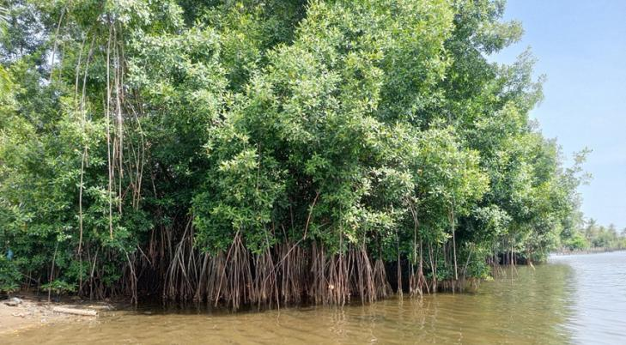
Fig. 1. Stand of the red mangrove Rhizophora racemosa along the shoreline of Abouabou Bay (Port-Bouët, Côte d’Ivoire).

2. material and methods

2.1 Description of the study area
The study was carried out along the shores of Abouabou Bay (5°15′–5°18′ N; 3°52′–3°56′ W), located on the southern margin of the Ébrié Lagoon within the municipality of Port-Bouët, Abidjan, Côte d’Ivoire (Fig. 2). The bay covers approximately 3.9 km² and is bordered by dense urban and industrial infrastructures, including the Félix Houphouët-Boigny International Airport, as well as residential settlements. These surroundings expose the mangrove ecosystem to strong anthropogenic pressures, such as deforestation, pollution, and land reclamation.
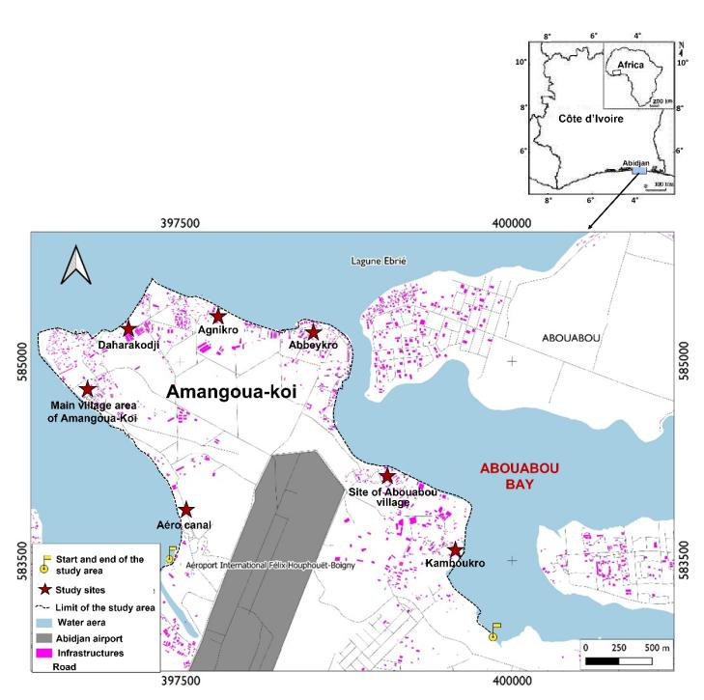
Fig. 2. Location of the study area

The region has a sub-equatorial climate characterized by two rainy seasons (April–July and September–October) alternating with two dry seasons, including a prolonged dry period from November to March. Annual rainfall ranges from 1,300 to 1,800 mm, with mean temperatures between 25 °C and 28 °C and relative humidity exceeding 80% during the rainy months (Brou, 2010).
Geologically, the area is underlain by Quaternary sedimentary deposits dominated by sands, silts, and clays. Soils are mostly pseudogley and hydromorphic Gleys, the latter being particularly associated with tidal zones and supporting mangrove development (Kouassi et al., 2015). Abouabou Bay is a microtidal system, with a tidal amplitude of about 1 m, and it receives considerable domestic and industrial effluents. These inputs lead to high turbidity, eutrophication, and accumulation of trace metals in sediments (Brou, 2010).
Vegetation is largely dominated by Rhizophora racemosa, while Acrostichum aureum and Pterocarpus santalinoides occur in degraded or peripheral areas (Egnankou, 1985; Egnankou et al., 2021). Floating invasive macrophytes such as Eichhornia crassipes and Pistia stratiotes are common in nutrient-enriched waters (Egnankou et al., 2021). Transitional zones host semi-aquatic and terrestrial species, while numerous introduced and cultivated plants are established along inhabited shores (Boussou et al., 2019). According to local community leaders, the bay was almost entirely surrounded by dense stands of R. racemosa in the 1980s. However, large-scale harvesting for fish smoking and bakery fuel, combined with negative perceptions of mangroves as mosquito habitats, resulted in significant deforestation and ecosystem degradation.
The faunal community includes benthic mollusks, burrowing crabs, and juvenile fish that use mangrove roots as nurseries (Gomez, 1975; Egnankou, 1985). The bay also supports both resident and migratory bird species (Egnankou, 2007). Current human activities include artisanal fishing, market gardening, livestock farming, and small-scale trade by both indigenous and migrant populations (Affian et al., 2009). Together with urban encroachment and pollution, these practices contribute to the continuous decline of mangrove cover and functionality in Abouabou Bay.

2.2. Study sites
The research was carried out along the southern shoreline of Abouabou Bay, within the peri-urban village of Amangoua-Koi. Seven contiguous coastal sectors were distinguished for sampling: Aero-canal, Amangoua-Koi, Darakodji, Agnikro, Abbeykro, Abouabou, and Kamboukro (Fig. 2). These sectors are subject to varying levels of anthropogenic disturbance. Pressures include progressive urban encroachment, discharge of household and industrial wastes, artisanal fishing activities, and small-scale agricultural practices. Together, these conditions create a heterogeneous socio-ecological mosaic, providing an appropriate framework for evaluating mangrove responses to increasing disturbance gradients.
To capture local-scale variation in anthropogenic pressures and stand structure of Rhizophora racemosa, three study sites were delineated for each sector. Site selection was guided by the presence of relatively continuous mangrove stands, thereby allowing meaningful comparisons of floristic diversity, forest stratification, and biomass stocks under different disturbance regimes. Due to accessibility constraints, only two sites could be installed at Darakodji, and a single site at Abouabou. Thus, a total of 18 sites were established across the seven sectors. Each site covered an area of 1 ha (100 m × 100 m), oriented perpendicularly from the lagoon edge toward the hinterland. In sectors with multiple sites, they were positioned 100 m apart to reduce spatial autocorrelation while ensuring representation of intra-sector heterogeneity.

2.3. Assessment of anthropogenic pressures
To assess the spatial variability of human disturbance, we adopted a standardized protocol based on direct field observations conducted systematically along all sites in each of the seven sectors. Two main categories of pressures were considered: (i) physical infrastructures, including transport facilities, recreational and event structures, agricultural and livestock facilities, and water and sanitation installations; and (ii) pollution sources, such as organic waste, plastic debris, chemical residues, and physical waste deposits. These categories were selected because they represent the most visible and recurrent forms of human disturbance in West African mangroves and are directly linked to changes in forest structure, floristic composition, and carbon dynamics (Ajonina et al., 2008; Rovai et al., 2018; Friess et al., 2020).
For each study site, the presence or absence of these variables was recorded in the field using standardized observation sheets (Appendix 1). This approach enabled systematic documentation of anthropogenic pressures and their distribution across the disturbance gradient. While the method focused on the occurrence and typology of pressures, it did not quantify their intensity (e.g., volume or mass of deposited waste), which could have provided additional insights into ecological impacts. This choice was deliberate, as it ensured comparability across sites with highly heterogeneous conditions and reduced biases linked to temporal fluctuations in waste accumulation.
Note that, for the assessment of human infrastructures, observations were made across the entire study site (1 ha). Concerning the assessment of pollution, a 100 m x 10 m transect, starting from the coastline, was established within each site.

2.4. Structural assessment of Rhizophora racemosa stands
Each transect was subdivided into three plots measuring 20 m × 10 m (200 m² each). In each plot, all Rhizophora racemosa trees with a diameter at breast height (DBH) of ≥ 5 cm were counted and measured. For each tree, total height (H, m) and stem circumference at breast height (CBH, cm) were recorded (Appendix 2). When the standard breast height position (1.3 m above ground) was above stilt roots, CBH was measured just above the highest stilt root, following Kauffman & Donato (2012). All these measurements were performed using diameter tapes and graduated poles.
Determination of total tree density (D)
Tree density reflects the number of trees per unit area and provides insight into the extent of space occupancy by woody vegetation. It was computed for each 200 m² plot using the following formula:
$D=\frac{N}{S}$ (1)
where:
D = density (trees per plot); N = number of trees recorded in the plot; S = surface area of the plot (200 m²).
Determination of basal area (G)
Basal area represents the cross-sectional area of tree stems at breast height (1.3 m) and is a reliable proxy for stand biomass and structural development. The basal area of each tree g_{i} and the total basal area per hectare (G) were calculated using the formulas:
$g_{i}=\frac{π}{4}{\left(\frac{{dbh}_{i}}{100}\right)}^{2}$ and (2)
$G=\frac{\sum_{i=1}^{n}{g_{i}}}{S}×10000$ (3)
where: dbh_{i}= diameter at breast height (in cm) of tree I; g_{i}= basal area of tree i (in cm²); G = total basal area per hectare (in m²/ha); n = total number of trees in the plot; S = surface area of the plot (in m²).

2.5. Estimation of total biomass and carbon stock
The estimation of the total biomass (B_{T}) of Rhizophora racemosa stands− which includes aboveground and belowground components− was conducted at the individual tree level followed by aggregation at plot and locality scales.
Individual biomass estimation
We used species-specific allometric equation developed by Zanvo et al. (2023) to estimate the B_{Ti} of each individual tree inventoried:
$B_{T_{i}}=1.07×e^{(0.66+0.68×\ln{(D^{2}H))}}$ (4)
where D is the DBH and H is the total height of individual tree i
Plot-level biomass aggregation
The total B_{T} per plot was obtained by summing the individual biomass values of all trees within each 200 m² plot.
${B_{T}}_{plot}=\sum_{i=1}^{m}{{B_{T}}_{i}}$ (5)
where m is the number of trees in the plot.
This biomass value, expressed in kilograms, was scaled up to per-hectare units and converted into metric tons using the following formula:
${B_{T}}_{plot, t/ha}=\frac{{B_{T}}_{plot}×10000}{200×1000}$ (6)
Sector-level biomass estimation
The mean B_{T} for each sector was calculated as the average of the biomass values from all plots surveyed in that sector:
${B_{T}}_{sector, t/ha}=\frac{1}{n}\sum_{i=1}^{n}{{B_{T}}_{plot, t/ha}}$ (7)
where 𝑛 is the number of plots established in the sector.
Carbon stock estimation
The total carbon stock (TCS) was derived by applying a standard carbon conversion factor to the B_{T} values. A conversion factor of 0.47, commonly used for tropical forests (IPCC, 2006), was adopted:
TCS= 0.47 × B_{T} (8)
The resulting carbon stock was expressed in metric tons of carbon per hectare (t C ha⁻¹), both at the plot level and averaged by sector.

2.6. Statistical analysis
All analyses were performed in R version 4.3.2 (R Core Team, 2024), with α set at 0.05. Categorical data on infrastructure and pollution types were summarized by sector, and chi-square tests were used to assess sectoral differences, with Monte Carlo simulations (10,000 replicates) applied when test assumptions were violated (Hope, 1968; Hope, 1969). Cramér’s V and standardized residuals were used to assess effect sizes and identify key associations (Agresti, 2013).
Variation in stem density of Rhizophora racemosa stands was analyzed using a generalized linear model (GLM) with a log link (Nelder & Wedderburn, 1972). Overdispersion was accounted for using quasi-Poisson or negative-binomial models as needed (Ver Hoef & Boveng, 2007). Estimated marginal means (EMMs) and Sidak-adjusted pairwise comparisons (Lenth, 2021) were obtained for all models.
Variation in tree height and DBH was tested using ANOVA or Games–Howell post-hoc tests where appropriate (Games & Howell, 1976). Basal area was similarly analyzed using Gaussian or Gamma GLMs depending on data distribution, while total biomass (B_{T}) and carbon stock (TCS) were compared across study sectors using ANOVA or Welch’s test based on Levene’s test results (Gastwirth et al., 2009).

3. results and discussion
3.1. Spatial variation of anthropogenic pressures
3.1.1. Intensity of infrastructures
Significant spatial contrasts were observed in the intensity and type of infrastructure recorded across the surveyed sectors of Amangoua-koi village. Recreational and event infrastructures accounted for the largest share of all anthropogenic installations (32%), followed by agricultural and livestock facilities (27%), transport and waterfront structures (23%), and water and sanitation infrastructure (18%) (Fig. 3). However, these overall proportions masked substantial sectoral variation in land-use pressures (Fig. 4).
The distribution of infrastructure types differed significantly between sectors (χ² = 84.99, simulated P < .001), with a moderate association strength (Cramér’s V = 0.289). Standardized residuals from the chi-square test revealed distinct patterns: recreational and event facilities were significantly overrepresented in Darakodji (P = .0016), suggesting a concentration of leisure-oriented land uses in this sector. In contrast, agricultural and livestock infrastructures were disproportionately prevalent in Aero-canal (P = .0022) and Kamboukro (P = .0093), reflecting the persistence of subsistence and peri-urban farming activities in these sectors. Transport and waterfront facilities dominated in Agnikro (P = .0115), while Kamboukro also showed an excess of water and sanitation installations (P = .0459), likely due to settlement expansion and associated infrastructure development.
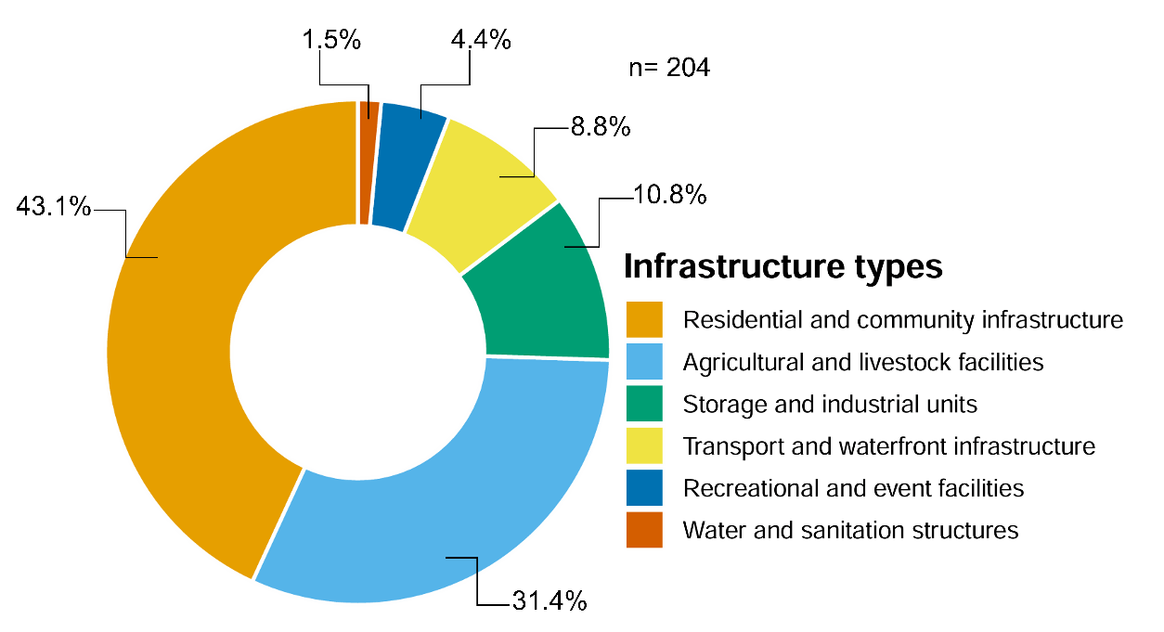
Fig. 3. Proportion of infrastructure categories recorded in the study area

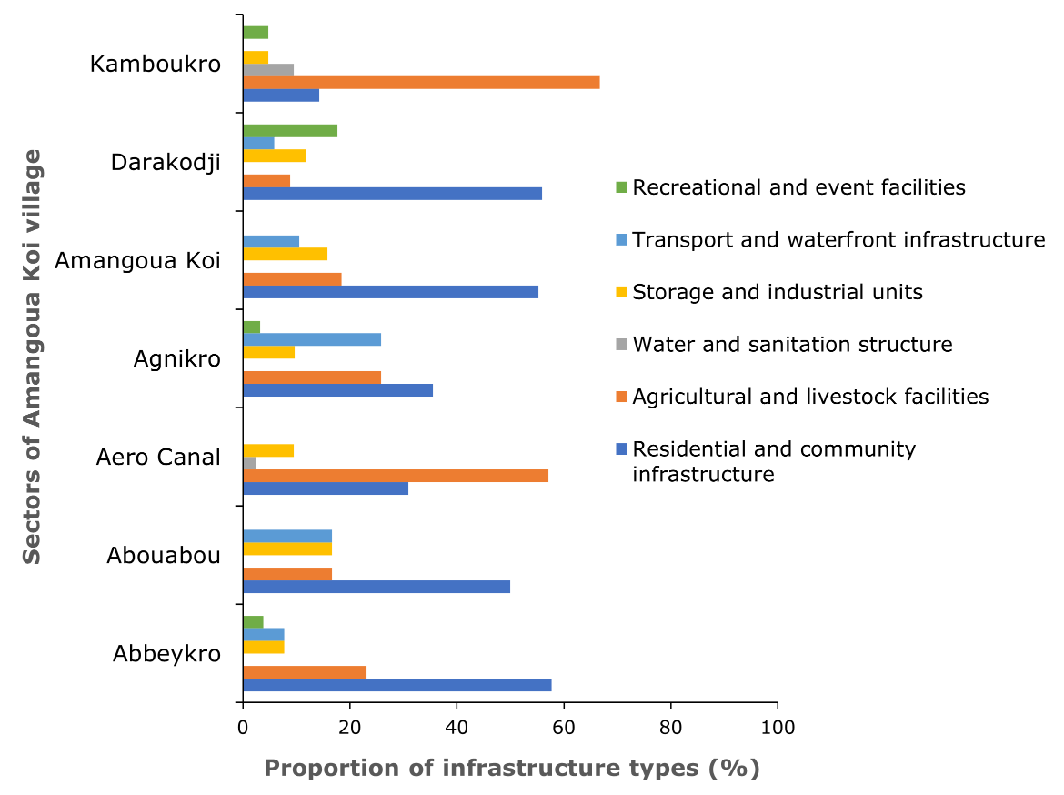
Fig. 4. Sectoral distribution of infrastructure categories across studied sectors

This spatial heterogeneity highlights the diversity of socio-economic functions assigned to different sectors. Agricultural dominance in more remote zones such as Aero-canal and Kamboukro aligns with findings from other West African peri-urban mangroves where food security and proximity to arable land drive mangrove conversion (Feka & Ajonina, 2011; Scales & Friess, 2019; Bonye et al., 2021;). Meanwhile, the predominance of recreational uses in Darakodji is emblematic of gentrification trends and commodification of coastal spaces at the urban fringe (Ekong & Ikurekong, 2015; Olatoye et al., 2023).
3.1.2. Intensity of pollution
Among the different types of pollution recorded, domestic solid waste and wastewater discharges were the most common (Fig. 5), together accounting for more than half of all observed cases. Other forms included hydrocarbon residues and construction debris, reflecting the diverse and diffuse sources of contamination in peri-urban mangrove settings.

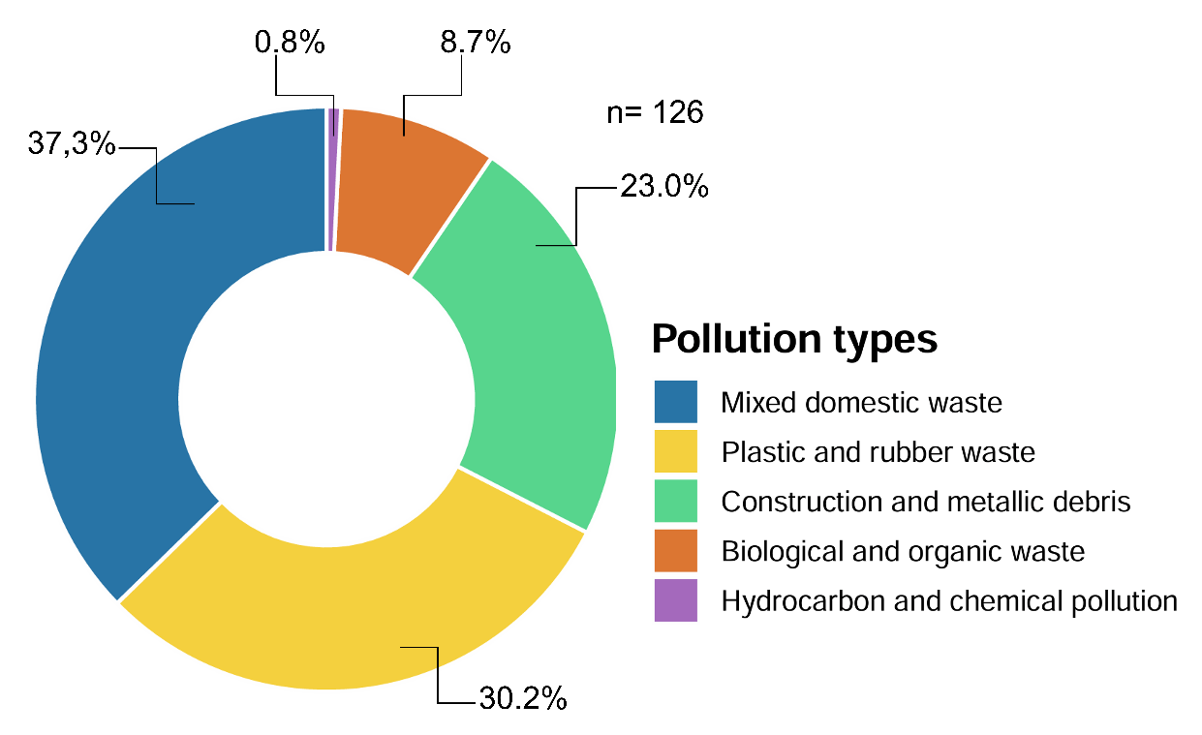
Fig. 5. Proportion of pollution categories recorded in the study area
Sectoral comparisons (Fig. 6) revealed that Darakodji stood out as the most polluted site, followed by Aero-canal and Agnikro. In contrast, Kamboukro exhibited minimal pollution signs, likely due to its relative remoteness and lower human density. Although the overall association between pollution types and sectors was marginally non-significant (χ² = 36.19, simulated P = .054), the moderate effect size (Cramér’s V = 0.268) suggested meaningful differences. Standardized residuals confirmed a statistically significant overrepresentation of pollution in Darakodji (P = .0040), positioning it as a localized environmental stress hotspot.
These spatial variations reflect patterns commonly observed in other rapidly urbanising mangrove systems, where poorly regulated development and inadequate waste management infrastructure lead to a concentration of pollution near urban fringes (Ekong & Ikurekong, 2015; Mahi et al., 2022; Olatoye et al., 2023). In Darakodji, the accumulation of pollutants likely results from informal waste disposal and inadequate sanitation systems, conditions frequently reported in Ivorian coastal settlements (Toule et al., 2018; Kouadio & Singh, 2021).
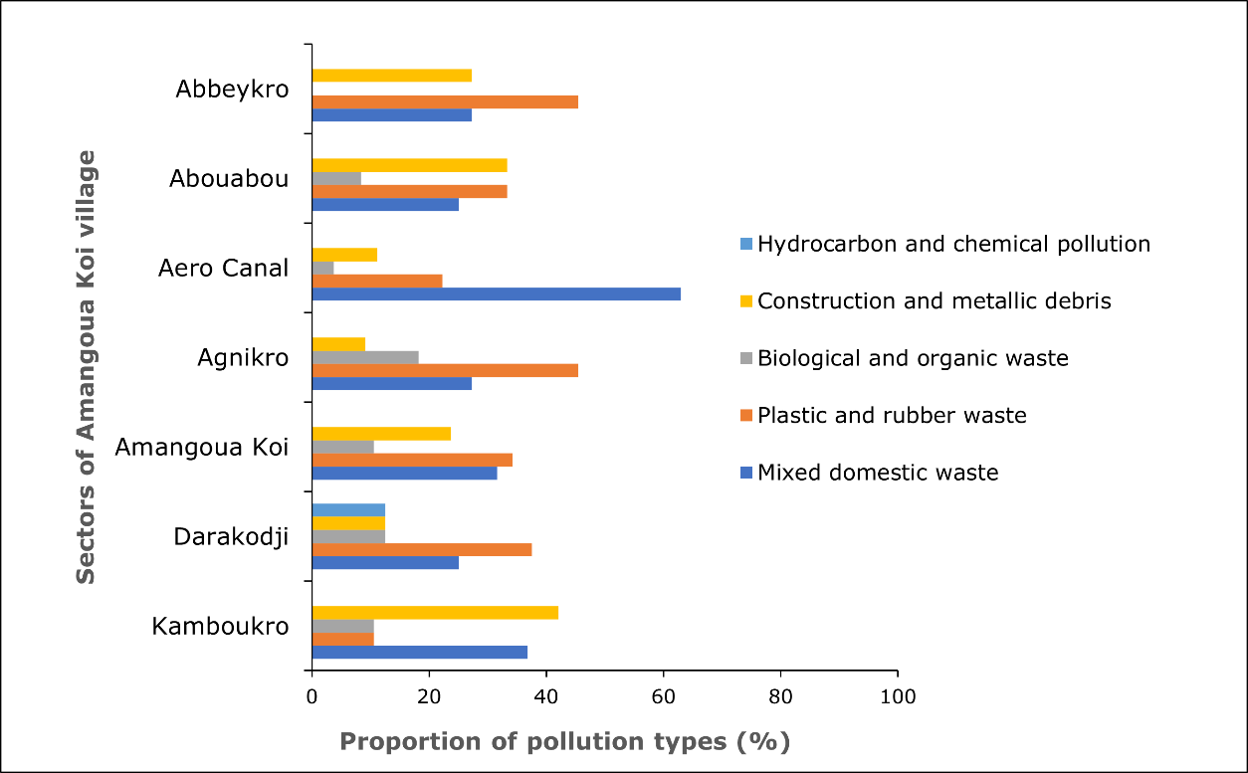
Fig. 6. Sectoral distribution of pollution types across studied sectors
The ecological consequences of such localized pollution are far from trivial. Organic and hydrocarbon-rich effluents can drastically alter sediment chemistry, inhibiting the germination and growth of mangrove species such as Rhizophora racemosa and disrupting the functional balance of microbial communities (Zhang et al., 2007; Alongi, 2008; Li et al., 2025). Moreover, the physical obstruction of pneumatophores by plastic waste and metallic debris may impair gas exchange and weaken the resilience of mangrove stands to other stressors.
Thus, even in the absence of a strong global statistical effect, the identification of pollution hotspots is essential. Site-specific management actions targeting waste control and sanitation infrastructure are urgently needed to prevent irreversible degradation and to maintain the ecological integrity of peri-urban mangrove ecosystems.
3.2. Structural attributes of Rhizophora racemosa
3.2.1. Tree height and stem diameter
The structural characteristics of R. racemosa exhibited substantial spatial heterogeneity across the study sectors. In four sites− Abbeykro, Abouabou, Amangoua-Koi, and Darakodji− the species was completely absent, suggesting advanced degradation or local extinction driven by high anthropogenic pressure or unsuitable edaphic-hydrological conditions.
Among the remaining sectors, both tree height and stem diameter at breast height (DBH) differed significantly (P < .001), pointing to pronounced variation in growth conditions. Mean tree height peaked in Kamboukro (10.12 ± 4.34 m) and Aero-canal (9.12 ± 3.49 m), whereas trees in Agnikro were significantly shorter (6.69 ± 1.31 m) (Fig. 7A). A similar trend was observed for DBH, with the largest trees found in Aero-canal (16.73 ± 8.96 cm), followed by Kamboukro (11.53 ± 5.56 cm), and the smallest in Agnikro (9.06 ± 2.35 cm) (Fig. 7B). These patterns suggest that Aero-canal and Kamboukro may offer more favorable conditions for Rhizophora racemosa growth, potentially due to higher tidal connectivity, lower disturbance frequency, or enhanced soil fertility.
The distributions of individual height and DBH values further illustrate structural contrasts among sectors. Fig. 7C reveals a right-skewed distribution of tree height in Aero-canal and Kamboukro, indicating the coexistence of both mature and regenerating individuals- an indicator of dynamic, yet functional, forest structure. In contrast, Agnikro displays a narrower and lower height range, consistent with growth suppression or past disturbance. Similarly, the density plots in Fig. 7D show that DBH values in Aero-canal extend into higher classes, whereas individuals in Agnikro are largely confined to smaller diameters, reflecting reduced growth potential or more frequent harvesting of large trees.
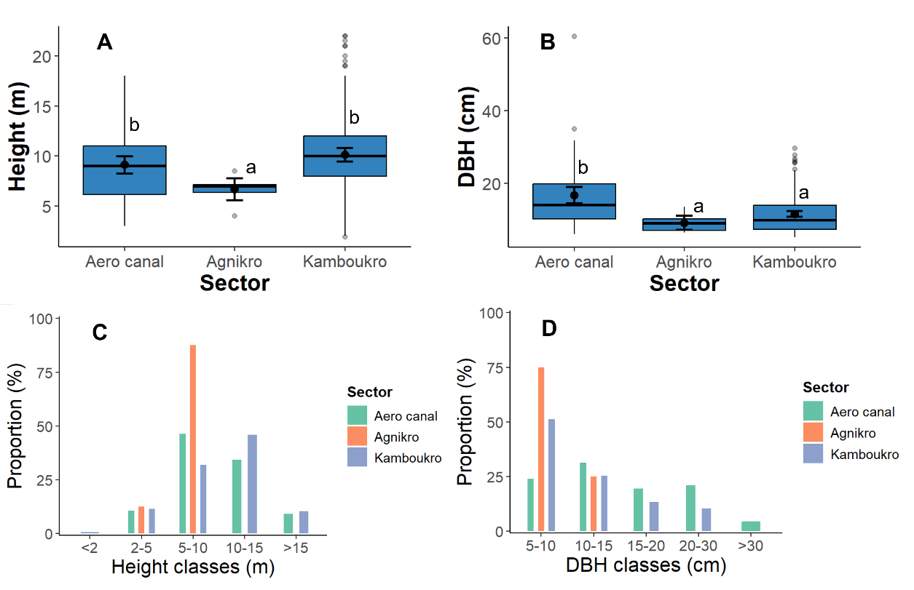
Fig. 7. Structural variation of Rhizophora racemosa across studied sectors
(A) Mean tree height (± SD); (B) Mean DBH (± SD); (C) Distribution of individual tree height; (D) Distribution of individual DBH.

Together, these results underscore the localized nature of structural differentiation in R. racemosa populations. The relatively favorable structural attributes in Aeroc-canal and Kamboukro align with field observations of lower human pressure and better hydrological exchange. Conversely, the dwarf stature observed in Agnikro may result from pollution-induced stress, altered salinity regimes, or sediment compaction- factors known to impair growth in mangroves (Duke et al., 1998; Alongi, 2015). Moreover, the complete disappearance of the species from certain sectors raises conservation alarms and signals the need for urgent restoration interventions in these zones.

3.2.2. Stem density and basal area
The spatial distribution of Rhizophora racemosa stem density and basal area exhibited significant heterogeneity across sectors. No individuals were recorded in Abbeykro, Abouabou, Amangoua-Koi, and Darakodji, indicating a 100% zero-occurrence rate in these sectors (Table 1). In contrast, Kamboukro displayed the highest stem density (18.44 ± 18.40 ind. 200 m⁻²) and basal area (11.85 ± 12.77 m² ha⁻¹), followed by Aero-canal (7.44 ± 8.53 ind. 200 m⁻² and 10.49 ± 12.27 m² ha⁻¹, respectively), with a moderate zero-occurrence rate of 33.3%. Agnikro supported only sparse populations, with a mean density of 0.89 ± 1.76 ind. 200 m⁻² and a basal area of 0.39 ± 0.67 m² ha⁻¹, and a high zero-occurrence rate (71.4%).
Table 1. Stem density and basal area of Rhizophora racemosa across studied sectors.
(Values are mean ± standard deviation. Different letters indicate significant differences between sectors at P < .05. n plots = number of plots per sector).
Sector | n plots | Average density  (ind. 200 m⁻²) | Mean basal area  (m² ha⁻¹) | Zero-occurrence rate
Abbeykro | 9 | 0 ± 0ª | 0 ± 0ª | 100%
Abouabou | 9 | 0 ± 0ª | 0 ± 0ª | 100%
Aéro canal | 9 | 7.44 ± 8.53^{b} | 10.49 ± 12.27^{b} | 33.3%
Agnikro | 9 | 0.89 ± 1.76ª | 0.39 ± 0.67ª | 71.4%
Amangoua-koi | 3 | 0 ± 0ª | 0 ± 0ª | 100%
Darakodji | 6 | 0 ± 0ª | 0 ± 0ª | 100%
Kamboukro | 9 | 18.44 ± 18.4^{c} | 11.85 ± 12.77^{b} | 33.3%

These stark contrasts reflect differences in both environmental suitability and disturbance levels. The high structural metrics observed in Kamboukro and Aero-canal suggest relatively favorable ecological conditions− such as adequate tidal flushing and substrate quality− combined with reduced anthropogenic pressure. Conversely, the complete absence of R. racemosa in four out of seven sectors underscores the severity of mangrove degradation in parts of the study area, likely driven by land reclamation, infrastructure encroachment, and unsustainable wood extraction (Dahdouh-Guebas & Koedam, 2008; Kauffman & Bhomia 2017).
Beyond their structural significance, these spatial differences have functional implications for mangrove ecosystem services. Since basal area is a key predictor of aboveground biomass and carbon stock (Komiyama et al., 2008; Adame et al., 2013), sectors with high basal area− particularly Kamboukro and Aero-canal− likely play a disproportionately large role in carbon sequestration, while degraded sectors may represent carbon emission hotspots or restoration priorities.
3.3. Biomass and carbon stock
The spatial pattern of total biomass and associated carbon stock reflected the profound influence of anthropogenic disturbance and hydrological integrity across the studied sectors (Table 2). Biomass differed significantly among sectors (P < .001), with complete absence of R. racemosa in Abbeykro, Abouabou, Amangoua-Koi, and Darakodji, resulting in null biomass and carbon stock values (0 ± 0 kg 200 m⁻² and 0 ± 0 t C ha⁻¹, respectively). In contrast, sectors with preserved or partially degraded stands exhibited markedly higher biomass: Kamboukro recorded the highest mean total biomass (5951.73 ± 6146.82 kg 200 m⁻²) and corresponding carbon stock (139.87 ± 144.45 t C ha⁻¹), followed by Aero-canal (3719.34 ± 4604.41 kg 200 m⁻² and 87.4 ± 108.2 t C ha⁻¹). Agnikro showed substantially lower values (176.60 ± 301.67 kg 200 m⁻²; 4.15 ± 7.09 t C ha⁻¹), consistent with the reduced density and basal area observed in that sector.
Table 2. Total biomass (above- plus belowground) and corresponding carbon stock by sector for Rhizophora racemosa stands.
Values are mean ± standard deviation. Different letters indicate significant differences between sectors at P < .05; n plots = number of plots per sector. Carbon stock was calculated as 0.47 × total biomass (BT) and converted to t C ha⁻¹ (IPCC 2006)
Sector | n plots | Tree average BT  (kg 200 m⁻²) | Tree carbon stock  (t C ha⁻¹)
Abbeykro | 9 | 0 ± 0ª | 0 ± 0ª
Abouabou | 3 | 0 ± 0ª | 0 ± 0ª
Aero-canal | 9 | 3719.34 ± 4604.41^{b} | 87.4 ± 108.2^{b}
Agnikro | 7 | 176.6 ± 301.67ª | 4.15 ± 7.09ª
Amangoua koi | 9 | 0 ± 0ª | 0 ± 0ª
Darakodji | 6 | 0 ± 0ª | 0 ± 0ª
Kamboukro | 9 | 5951.73 ± 6146.82 ^{c} | 139.87 ± 144.45^{c}

These results highlight the critical role of structural attributes in shaping carbon sequestration ability. Sectors with higher basal area and larger individuals- especially Kamboukro and Aero-canal− correspondingly stored more carbon, in agreement with previous findings in West African and tropical mangroves (Twilley et al., 1992; Komiyama et al., 2008; Murdiyarso et al., 2015). Conversely, the absence or degradation of woody stands due to overharvesting, land conversion, and infrastructural encroachment drastically reduced carbon pools. This reinforces the understanding that biomass accumulation in mangroves is a strong indicator of ecological integrity and carbon sink function.
Hydrological connectivity emerged as a pivotal driver of biomass dynamics. In Kamboukro and Aero-canal, maintained tidal exchange likely ensured adequate nutrient availability and seedling establishment, supporting the persistence of mature trees. By contrast, sites with blocked or altered tidal flows− due to embankments or infrastructure− exhibited impaired regeneration and biomass collapse. These mechanisms are consistent with degradation pathways documented in Southeast Asia and the Caribbean (Lovelock et al., 2017), underscoring the importance of restoring hydrological fluxes for mangrove resilience and climate mitigation.
3.4. Implications for mangrove conservation and management
The findings of this study underscore the profound influence of anthropogenic pressures on the structural integrity and carbon sequestration ability of peri-urban Rhizophora racemosa stands. Sectors exhibiting intense infrastructure development and pollution− particularly Abbeykro, Abouabou, Amangoua-Koi, and Darakodji− consistently showed null or severely reduced stem density, basal area, biomass, and carbon stock. These declines reflect the compound effects of direct pressures, such as wood harvesting and land reclamation, and indirect disturbances, including hydrological alteration and waste accumulation.
Conversely, sectors like Kamboukro and Aero-canal demonstrated higher structural complexity, with significantly greater tree height, diameter, basal area, and biomass, translating into markedly higher carbon storage. These zones appear to benefit from relatively intact hydrological regimes and lower disturbance intensity, highlighting their ecological value as remnant carbon reservoirs and propagule sources for natural regeneration and active restoration.
From a conservation perspective, a dual strategy is warranted. First, priority should be given to the legal protection and participatory management of well-preserved sectors, particularly Kamboukro and Aero-canal, to prevent further degradation and to maintain their role as biodiversity refugia and climate mitigation hotspots. Second, degraded sectors require urgent ecological rehabilitation measures, including the re-establishment of tidal flows, enrichment planting with native propagules, and enforcement of restrictions on wood extraction and land conversion.
At the landscape level, effective conservation of peri-urban mangroves must be embedded within integrated coastal zone management frameworks. This includes spatial planning to limit mangrove encroachment, improved sanitation infrastructure to reduce pollution loads, and community-based governance models that foster local stewardship and sustainable use, as successfully implemented in other West African contexts (Feka & Ajonina, 2011).
Finally, the conservation of structurally complex R. racemosa stands in Abouabou Bay carries implications beyond local biodiversity and livelihoods. These ecosystems represent critical natural climate solutions aligned with national REDD+ commitments and international carbon neutrality goals. Ensuring their persistence will require coordinated action across ecological, socio-economic, and policy dimensions.

4. Conclusion
This study provides empirical evidence of how spatially heterogeneous anthropogenic pressures shape the structural attributes and carbon storage ability of R. racemosa stands in a peri-urban mangrove system of Côte d’Ivoire. Across the landscape mosaic of Amangoua-koi village, distinct gradients of degradation were linked to variations in land use intensity, pollution exposure, and hydrological connectivity. The absence of R. racemosa in nearly half the sectors surveyed underscores the severity of local deforestation, while structurally intact sectors, such as Kamboukro and Aero-canal, highlight the resilience potential of mangroves in less disturbed conditions.
The results demonstrate that key structural parameters—such as tree height, basal area, and stem density—are reliable indicators of ecosystem health and are strongly correlated with biomass and carbon stocks. The loss of these attributes in degraded sectors reflects not only ecological degradation but also a decline in carbon sequestration potential, with critical implications for national and global climate mitigation strategies.
Importantly, this study reinforces the need for site-specific conservation and restoration strategies that reflect local disturbance dynamics. Protecting remnant stands and restoring degraded zones through hydrological rehabilitation, waste management, and participatory governance will be essential to safeguard the multifunctionality of peri-urban mangroves. In a rapidly urbanizing region like Abidjan, where land pressures are intensifying, the preservation of R. racemosa stands represents not only an ecological imperative but also a strategic investment in climate resilience, biodiversity conservation, and sustainable development.
Future research should explore long-term changes in ecosystem function and carbon fluxes in relation to restoration interventions and urban growth trajectories. Integrating ecological monitoring with social-ecological assessments will further enhance the design of adaptive and inclusive mangrove management strategies across urban coastal zones in West Africa.

References

Adame, M. F., Kauffman, J. B., Medina, I., Gamboa, J. N., Torres, O., Caamal, J. P. et al. (2013). Carbon Stocks of Tropical Coastal Wetlands within the Karstic Landscape of the Mexican Caribbean. PLoSONE, 8(2): e56569. https://doi.org/10.1371/journal.pone.0056569
Agresti, A. (2013). Categorical Data Analysis (3rd ed.). Hoboken, NJ: Wiley.
Ajonina, G. N., Diamé, A., & Kairo, J. G. (2008). Current status and conservation of mangroves in Africa: An overview. World Rainforest Movement Bulletin, 133, 1–8.
Alongi, D. M. (2008). Mangrove forests: Resilience, protection from tsunamis, and responses to climate change. Estuarine, Coastal and Shelf Science, 76(1), 1–13. https://doi.org/10.1016/j.ecss.2007.08.024
Alongi, D. M. (2015). The impact of climate change on mangrove forests. Current Climate Change Reports, 1(1), 30–39. https://doi.org/10.1007/s40641-015-0002-x
Bonye, S. Z., Aasoglenang, T. A. & Yiridomoh, G. Y. (2021). Urbanization, agricultural land use change and livelihood adaptation strategies in peri-urban Wa, Ghana. SN Soc Sci 1, 9. https://doi.org/10.1007/s43545-020-00017-1
Bosire, J. O., Kaino, J. J., Olagoke, A. O., Mwihaki, L. M., Ogendi, G. M., Kairo, J. G., et al. (2014). Mangroves in peril: unprecedented degradation rates of peri-urban mangroves in Kenya. Biogeosciences, 11, 2623–2634, https://doi.org/10.5194/bg-11-2623-2014
Bunting, P., Rosenqvist, A., Lucas, R. M., et al. (2018). The Global Mangrove Watch—A New 2010 global baseline of mangrove extent. Remote Sensing, 10(10), 1669. https://doi.org/10.3390/rs10101669
Dahdouh-Guebas, F., & Koedam, N. (2008). Long-term retrospection on mangrove development using transdisciplinary approaches: A review. Aquatic Botany, 89(2), 80–92. https://doi.org/10.1016/j.aquabot.2008.03.012
Donato, D. C., Kauffman, J. B., Murdiyarso, D., et al. (2011). Mangroves among the most carbon-rich forests in the tropics. Nature Geoscience, 4(5), 293–297. https://doi.org/10.1038/ngeo1123
Duke, N. C., Ball, M. C., & Ellison, J. C. (1998). Factors influencing biodiversity and distributional gradients in mangroves. Global Ecology and Biogeography Letters, 7(1), 27–47. https://doi.org/10.2307/2997695
Ekong, F. U., Ikurekong, E. E. (2015). Evolution of New Coastal Urban Lifestyles in West Africa: Implications for Planning Sustainable African Cities. Developing Country Studies, 5(6), 49–58.
FAO. (2023). The world’s mangroves 2000–2020. Rome. https://doi.org/10.4060/cc7044en
Feka, N. Z., & Ajonina, G. N. (2011). Drivers causing decline of mangrove in West-Central Africa: a review. International Journal of Biodiversity Science, Ecosystem Services & Management, 7(3), 217–230. https://doi.org/10.1080/21513732.2011.634436
Feka, N. Z., & Ajonina, G. N. (2011). Drivers causing decline of mangrove in West–Central Africa: A review. International Journal of Biodiversity Science, Ecosystem Services & Management, 7(3), 217–230. https://doi.org/10.1080/21513732.2011.634436
Friess, D. A., Rogers, K., Lovelock, C. E., Krauss, K. W., Hamilton, S. E., Lee, S. Y. et al. (2019). The State of the World's Mangrove Forests: Past, Present, and Future. Annual Review of Environment and Resources, 44, 89–115. https://doi.org/10.1146/annurev-environ-101718-033302
Games, P. A., & Howell, J. F. (1976). Pairwise multiple comparison procedures with unequal N’s and/or variances: A Monte Carlo study. Journal of Educational Statistics, 1(2), 113–125.
Gastwirth, J. L., Gel, Y. R., & Miao, W. (2009). The impact of Levene’s test of equality of variances on statistical theory and practice. Statistical Science, 24(3), 343–360. https://doi.org/10.1214/09-STS301
Hamilton, S. E., & Casey, D. (2016). Creation of a high spatio-temporal database of continuous mangrove forest cover for the 21st century (CGMFC-21). Global Ecology and Biogeography, 25(6), 729–738. https://doi.org/10.1111/geb.12449
Hope, A. C. A. (1968). A simplified Monte Carlo significance test procedure. Journal of the Royal Statistical Society. Series B (Methodological), 30(3), 582–598.
Hope, A. C. A. (1969). A simplified Monte Carlo significance test for contingency tables. Applied Statistics, 18(1), 13–20.
IPCC. (2006). 2006 IPCC Guidelines for National Greenhouse Gas Inventories. Volume 4: AFOLU. Institute for Global Environmental Strategies, Hayama, Japan. https://www.ipcc-nggip.iges.or.jp/public/2006gl/vol4.html
Kauffman JB & Bhomia RK (2017). Ecosystem carbon stocks of mangroves across broad environmental gradients in West-Central Africa: Global and regional comparisons. PLoS ONE, 12(11), e0187749. https://doi.org/10.1371/journal.pone.0187749
Kauffman, J. B., & Donato, D. C. (2012). Protocols for the measurement, monitoring and reporting of structure, biomass and carbon stocks in mangrove forests. CIFOR, Bogor, Indonesia. https://doi.org/10.17528/cifor/003749
Komiyama, A., Ong, J. E., & Poungparn, S. (2008). Allometry, biomass, and productivity of mangrove forests: A review. Aquatic Botany, 89(2), 128–137. https://doi.org/10.1016/j.aquabot.2007.12.006
Kouadio, K. I. & Singh, R. (2021). Impact of Urbanization on Forest and Lagoon Environments in Ivory Coast: Case of Abidjan. International Journal for Research in Applied Science & Engineering Technology, 9(4), 1287-1296.
Lagomasino, D., Fatoyinbo, T., Lee, S., Feliciano, E., Trettin, C., Shapiro, A., et al. (2019). Measuring mangrove carbon loss and gain in deltas. Environ. Res. Lett., 14 025002. https://doi.org/10.1088/1748-9326/aaf0de
Lenth, R. V. (2021). emmeans: Estimated Marginal Means, aka Least-Squares Means (R package version 1.x). https://CRAN.R-project.org/package=emmeans
Li, M., Ishfaq, M., González Quintero, V. A., Peng, D., Lang, T., Gao, C. et al. (2025). Impact of elevated environmental pollutants on carbon storage in mangrove wetlands: A comprehensive review. Ecological Indicators 2025, 178, 113830. https://doi.org/10.1016/j.ecolind.2025.113830
Lovelock, C. E., Feller, I. C., Reef, R., Hickey, S., & Ball, M. C. (2017). Mangrove dieback during fluctuating sea levels. Scientific Reports, 7(1), 1680. https://doi.org/10.1038/s41598-017-01927-6
Mahi, A. M. A., Yao, M. K., Claon, J. S., Trokourey, A. (2022). Metal Pollution, Ecological and Health Risks Status of the Open Waters from the Lagoon Area II of Ébrié System (Côte d'Ivoire). Asian Journal of Chemical Sciences, 11(3), 1-15. https://doi.org/10.9734/ajocs/2022/v11i319121
Mohamed, M.O.S., Neukermans, G., Kairo, J.G., Dahdouh-Guebas, F., Koedam, N. (2009). Mangrove forests in a peri-urban setting: the case of Mombasa (Kenya). Wetlands Ecol Manage, 17, 243–255. https://doi.org/10.1007/s11273-008-9104-8
Murdiyarso, D., Purbopuspito, J., Kauffman, J. B., Warren, M. W., Sasmito, S. D., Donato, D. C. et al. (2015). The potential of Indonesian mangrove forests for global climate change mitigation. Nature Climate Change, 5, 1089–1092. https://doi.org/10.1038/nclimate2734
Nelder, J. A., & Wedderburn, R. W. M. (1972). Generalized linear models. Journal of the Royal Statistical Society. Series A (General), 135(3), 370–384.
Olatoye, T. A., Kalumba, A. M., Mazinyo, S. P., & Odeyemi, A. S. (2023). Impact of Urban Expansion on Coastal Vegetation Conservation in Buffalo City Metropolitan Municipality, South Africa. International Journal of Social Ecology and Sustainable Development (IJSESD), 14(1), 1-21. https://doi.org/10.4018/IJSESD.326612
R Core Team. (2024). R: A language and environment for statistical computing. R Foundation for Statistical Computing, Vienna, Austria. https://www.R-project.org/
Rovai, A. S., Twilley, R. R., Castañeda-Moya, E., et al. (2018). Global controls on carbon storage in mangrove soils. Nature Climate Change, 8(6), 534–538. https://doi.org/10.1038/s41558-018-0162-5
Scales, I. R. & Friess, D. A. (2019). Patterns of mangrove forest disturbance and biomass removal due to small-scale harvesting in southwestern Madagascar. Wetlands Ecol Manage, 27, 609–625. https://doi.org/10.1007/s11273-019-09680-5
Toule, A. C., Koussemon, M., Adingra, A. A., N’gbesso N. K. (2018). Environmental health situation of three rural communities living in the immediate vicinity of Ebrié Lagoon, Côte d’Ivoire. Journal of the Cameroon Academy of Sciences, 14(1), 11-21. https://dx.doi.org/10.4314/jcas.v14i1.2
Twilley, R. R., Chen, R. H., & Hargis, T. (1992). Carbon sinks in mangroves and their implications to carbon budget of tropical coastal ecosystems. Water, Air and Soil Pollution, 64(1–2), 265–288. https://doi.org/10.1007/BF00477106
Ventura A. de O. B., Lana P. da C. (2014). A new empirical index for assessing the vulnerability of peri-urban mangroves. Journal of Environmental Management, 145, 289-298. https://doi.org/10.1016/j.jenvman.2014.04.036
Ver Hoef, J. M., & Boveng, P. L. (2007). Quasi-Poisson vs. negative binomial regression: How should we model overdispersed count data? Ecology, 88(11), 2766–2772. https://doi.org/10.1890/07-0043.1
Zanvo, S. M. G., Mensah, S., Salako, K. V., Glèlè Kakaï, R. (2023). Tree height-diameter, aboveground and belowground biomass allometries for two West African mangrove species. Biomass and Bioenergy, 176, 106917. https://doi.org/10.1016/jbiombioe.2023.106917
Zhang, C. G., Leung, K. K., Wong, Y. S., Tam, N. F. Y. (2007). Germination, Growth and Physiological Responses of Mangrove Plant (Bruguiera Gymnorrhiza) to Lubricating Oil Pollution. Environmental and Experimental Botany, 60 (1), 127–136. https://doi.org/10.1016/j.envexpbot.2006.09.002

APPENDIX

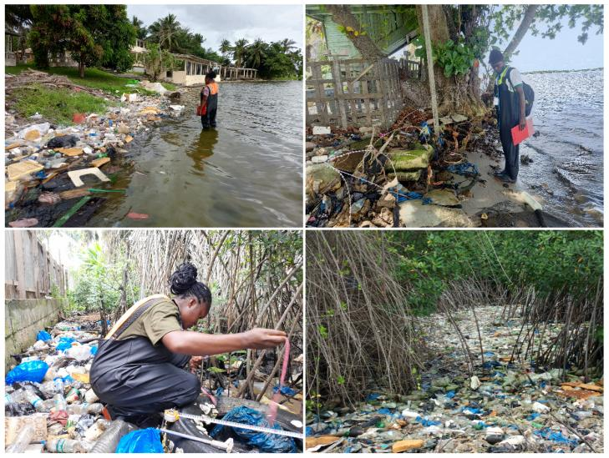

Appendix 1. Selection of field images taken during the documentation of infrastructure and pollution in the village of Amangoua-Koi.
The images illustrate various anthropogenic pressures observed during fieldwork in Amangoua-Koi, including physical infrastructure and visible pollution sources, which contribute to the degradation of local Rhizophora racemosa stands.

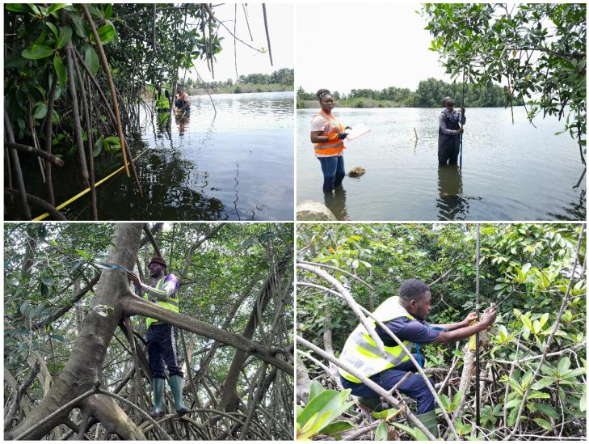

Appendix 2. Selection of field images recorded during the structural inventory of Rhizophora racemosa stands.
These images illustrate the fieldwork conducted to assess stand structure, including measurements of tree height, diameter at breast height (DBH), stem density, and basal area across different sectors of Abouabou Bay.

