Case report
Idiopathic Gingival Fibromatosis: A Case Report

ABSTRACT

Idiopathic gingival fibromatosis (IGF) is an uncommon condition characterized by diffuse gingival enlargement, independent of bacterial plaque, which may present as an isolated finding or in association with syndromes. Clinically, it manifests as a progressive, firm, and nodular gingival overgrowth that, in severe cases, may cover dental crowns, causing diastemas, esthetic and functional alterations, as well as difficulties in mastication and phonation. Its etiology is heterogeneous, with a possible genetic association on chromosome 2. Histologically, dense connective tissue, abundant collagen, and thickened epithelium are observed, warranting a comprehensive clinico-histopathological diagnosis. Treatment ranges from plaque control to gingivectomy in advanced cases. We report the case of a 12-year-old female presenting with generalized gingival enlargement, multiple diastemas, and deep bite, along with facial features such as midfacial hypoplasia and broad nasal bridge. Hematologic and imaging studies were unremarkable. Surgical management included quadrant-wise gingivectomy and gingivoplasty. Histopathological analysis confirmed dense collagenized fibrous tissue with inflammatory infiltrate, consistent with idiopathic gingival fibromatosis. Genetic studies ruled out clinically significant variants, and family evaluation revealed no similar cases. Twelve-month follow-up showed no recurrence and a notable improvement in function, esthetics, and self-esteem. IGF is a rare condition with significant psychological and functional impact. Surgical treatment, combined with strict oral hygiene and long-term follow-up, is effective in preventing recurrence. Interdisciplinary collaboration, particularly with genetics, is essential for comprehensive management.

Keywords: Periodontics; Gingiva; Gingival fibromatosis; Idiopathic; Plastic surgery

1. INTRODUCTION

Gingival fibromatosis (GF) is an uncommon disorder characterized by diffuse gingival overgrowth that may partially or completely cover the tooth surface. Unlike other forms of gingival hyperplasia, these lesions develop independently of plaque accumulation or removal. GF can present as an isolated disease or as part of a syndrome. The first report of this entity was made by Goddard and Gross in 1856, who described its initial clinical features¹⁻⁶.
Clinically, GF manifests as a slow, progressive increase in gingival volume, more frequently generalized and predominantly affecting the attached gingiva. In severe cases, the overgrowth can completely cover the dental crowns. The tissue is firm and nodular in consistency, with normal or erythematous color and irregular surface. Although often asymptomatic, it produces esthetic and functional consequences, including diastemas, impaired mastication, delayed tooth eruption, and, in extreme cases, inability to achieve proper lip closure. Severity varies, even among family members, and onset may be observed from birth or remain latent until eruption of deciduous or permanent teeth. Due to these characteristics, the American Academy of Periodontology included GF within periodontal manifestations in its 1999 classification, which remains in force today^{3,4}.
GF may occur as an isolated disease or as part of a syndrome, and it is likely to be genetically heterogeneous. Consequently, several chromosomes and chromosomal regions have been associated with GF. Mutations on chromosome 2 have been highlighted as a potential cause. Initially, the 2p13–p21 region of chromosome 2 was associated with a syndromic form of GF; however, subsequent studies identified 2p13–2p16 as the affected region. Interestingly, different genetic forms of GF show similar histological results, suggesting that mutations may affect different levels of the same cellular or molecular pathway².
Histologically, GF shows connective tissue with abundant collagen and thickened epithelium with elongated papillae, as well as calcified particles and small foci of bone tissue. These alterations are nonspecific, so accurate diagnosis requires proper clinico-histopathological correlation²⁻⁴.
Diagnosis is established through histopathological and genetic studies. Imaging and laboratory tests do not provide additional diagnostic value. The differential diagnosis must include mucogingival deformities such as Laband syndrome and Rutherford syndrome².
Management depends on disease severity. For minimal enlargement, debridement and meticulous plaque control are preferred. In severe cases, surgical removal by gingivectomy is indicated. Importantly, treatment success relies on plaque control and restoration of physiologic gingival contour⁴⁻⁸.
Case Report
A 12-year-old female patient was referred from a private clinic due to an asymptomatic enlargement in the upper and lower gingival regions with several years of evolution. The patient reported difficulty in chewing and dissatisfaction with the esthetics of her gums. During the anamnesis, the guardian stated that the patient had not taken any medications for a prolonged period and denied systemic pathologies relevant to the current condition. She was unaware of any family members presenting with a similar gingival condition. Figure 1.
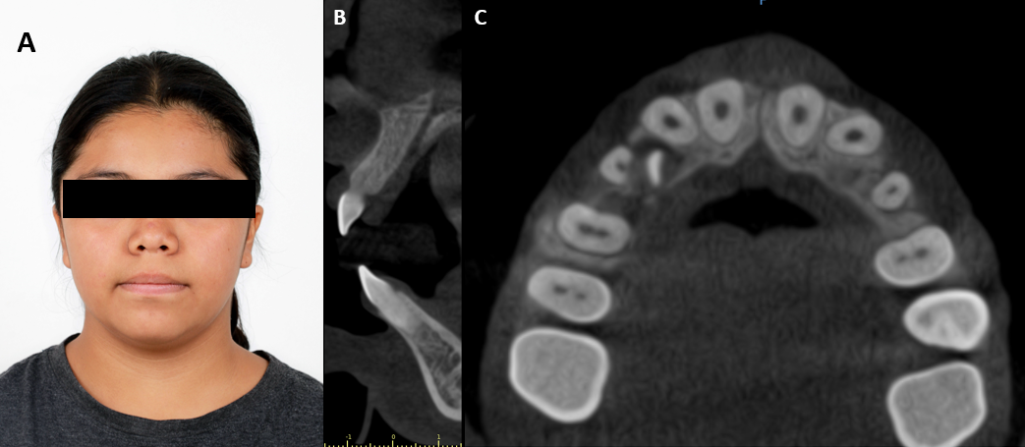
Figure 1: A) Extraoral photograph of a 12-year-old female showing midfacial hypoplasia, short nose, broad nasal bridge, and low-set ears. B and C) Coronal and axial sections showing no thickening of the vestibular cortical bone due to osseous growth.
On physical examination, midfacial hypoplasia, short nose, broad nasal bridge, and low-set ears were observed. Intraoral examination revealed generalized gingival hyperplasia in both arches, with color changes and areas of hyperkeratosis. The patient was normothermic, without dental mobility, presenting mixed dentition, multiple diastemas, and a deep bite. Figure 2.
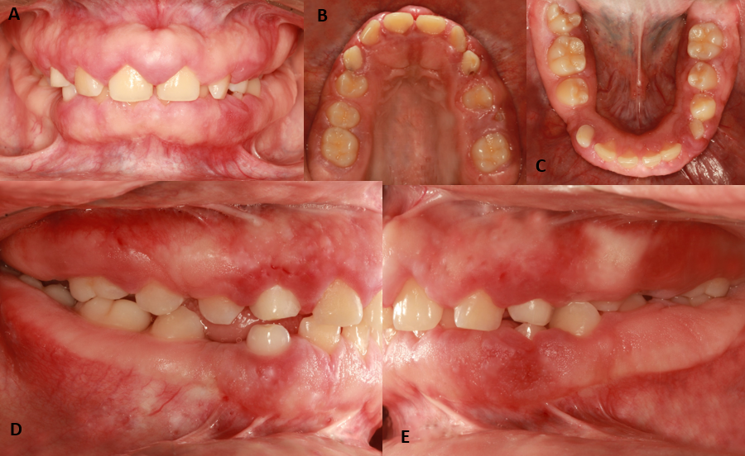
Figure 2: A) Diffuse gingival enlargement partially covering dental surfaces. B) Partially erupted crowns. C) Gingival enlargement involving palatal and lingual gingiva. D, E) Papillae with firm and hard consistency, presence of diastemas, and color changes.
Laboratory tests showed: hematocrit 39.9%, hemoglobin 13.30 g/dL, and platelets 208 x 10³/µL. Three-dimensional imaging studies revealed no architectural alterations of the maxillary cortical plates. Based on this information, a first surgical stage was scheduled. Figure 1.
Under local anesthesia with 2% lidocaine with epinephrine 72 mg, supraperiosteal infiltration was performed. Once adequate anesthesia was achieved, quadrant-based gingivectomy and gingivoplasty were carried out at 15-day intervals. An excisional biopsy of the free gingiva in the maxilla was performed.
Histopathological analysis reported four fusiform fragments of soft tissue. The largest measured 0.5 x 0.3 x 0.2 cm and the smallest 0.3 x 0.3 x 0.2 cm, with a smooth light-brown surface and firm consistency. All fragments were processed and stained with hematoxylin and eosin. Microscopically, dense, highly collagenized fibrous connective tissue with an inflammatory infiltrate arranged in a sheet-like pattern, composed of mature lymphocytes, plasma cells, eosinophils, and histiocytes, was observed. Melanin particles were also identified within the connective tissue and epithelium. The lesion was lined by stratified squamous parakeratinized epithelium with acanthosis and elongated, wide epithelial ridges. These findings confirmed the diagnosis of gingival fibromatosis. Figure 3.
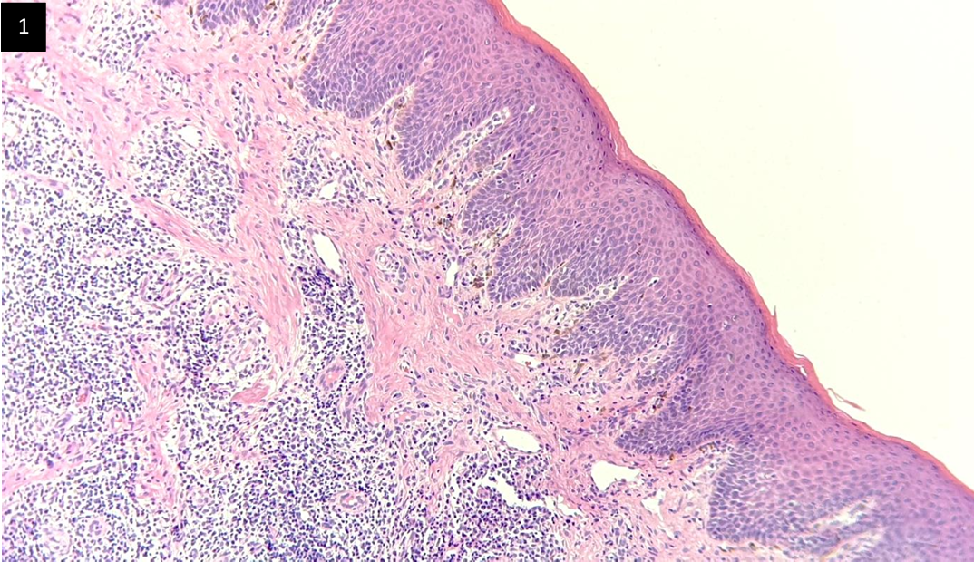
Figure 3: Intact epithelium, with fibrotic areas in the basal lamina and dense collagen fibers in connective tissue, with a high number of macrophages.
As part of the comprehensive diagnosis, the patient’s family was also evaluated. Father: intraoral examination revealed a thick gingival phenotype, gingival stippling, gingival melanosis in the premaxilla and chin regions, mandibular tori, dental calculus, multiple caries, and posterior crossbite. Mother: intraoral examination showed a medium gingival phenotype, gingival stippling, false anodontia of teeth 15, 25, 35, and 45, presence of metallic restorations, multiple caries, dental calculus, and a crown fracture in tooth 47. Sister: presented gingival melanosis, generalized gingivitis, biofilm, gingival hyperplasia, a gingival polyp in teeth 55, 54, 63, 64, and 65, root exposure of tooth 64, multiple caries, and crown destruction of tooth 65. Figure 4.
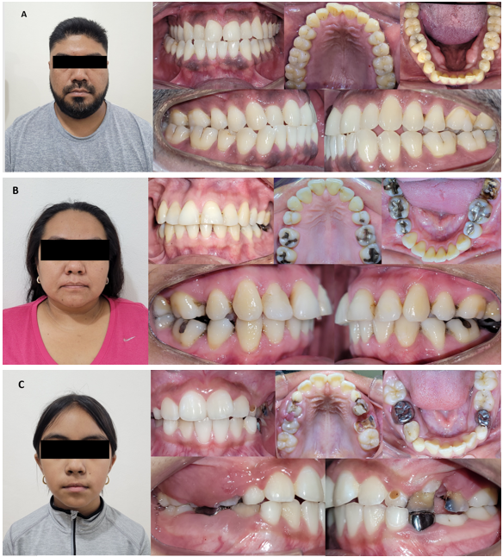
Figure 4: Extraoral and intraoral views of the patient’s family showing no gingival enlargement similar to the case reported. A) Legal guardian (father). B) Legal guardian (mother). C) Younger sister.
The patient was referred for genetic evaluation to determine whether a mutation or genetic origin was present. A DBS sample was analyzed and reported as follows: Primary finding: no variants reported. Secondary finding: no variants reported. Additional finding: no variants reported. No clinically significant variants were identified, including single nucleotide variants, small insertions/deletions, copy number variants, mitochondrial variants, repeat expansions, or structural variants relevant to the patient’s phenotype, as outlined in the Human Phenotype Ontology. These results confirmed the diagnosis of idiopathic gingival fibromatosis.
The 12-month postoperative examination revealed no evidence of recurrence. A marked improvement was observed in gingival color, volume, and contour, as well as in dental positioning, phonation, and mastication. The patient also exhibited improved psychological well-being, including higher self-esteem and better social behavior. Figure 5.
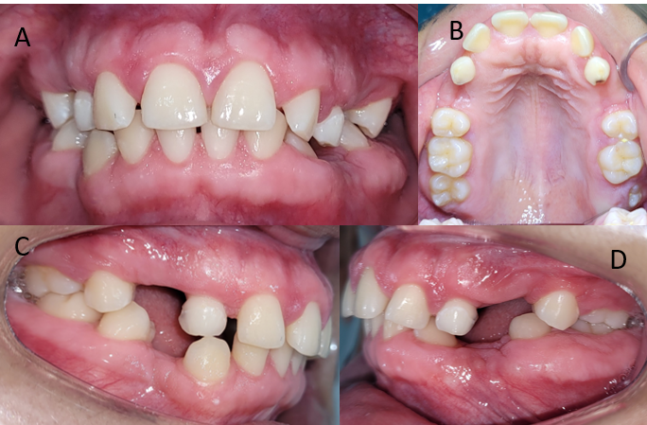
Figure 5: A) One-year postoperative frontal photograph showing decreased gingival volume with defined margins. B) Occlusal view of the maxilla showing reduced size and exposed crowns. C–D) Lateral photographs after extraction of teeth 14, 24, 34, and 44, showing anterior gingival festooning.
Discussion
Genetic testing, combined with radiographic analysis and clinical evaluation, was essential for establishing a definitive diagnosis. Patients with idiopathic gingival fibromatosis (IGF) must be carefully examined to exclude hereditary or syndromic conditions. In this case, no hereditary background was detected, confirming a sporadic presentation. Moreover, gingival tissue was the only affected site, excluding associations with hypertrichosis, intellectual disability, epilepsy, or syndromic involvement.
IGF usually manifests during the eruption of permanent incisors, though it may also present during the deciduous dentition stage. The slow and progressive gingival enlargement may be associated with inflammation, leukemic infiltration, intellectual disability, epilepsy, or hereditary syndromes. Drug-induced fibrous gingival enlargement has also been reported with phenytoin, calcium channel blockers, and cyclosporine. None of these factors were present in this patient.
Regarding treatment, gingivectomy and gingivoplasty are the preferred approaches, with variations in incision techniques. Harris RJ et al. (2014) employed an internal bevel incision at a 45° angle toward the tooth apex, followed by intrasulcular incision, collar removal, and refinement of interproximal areas. In contrast, Harris RJ et al. (2012) opted for an external bevel incision guided by probing depth, followed by internal bevel incision, collar removal, flap reflection, osseous recontouring, hemostasis, and suturing.
In this case, an external bevel incision was performed during gingivectomy, following the demarcated points, refined with a Kirkland knife, and combined with gingivoplasty and thinning through debridement, contouring, and festooning to improve gingival appearance.
Conclusion
Idiopathic gingival fibromatosis is an uncommon condition of unknown etiology and low recurrence rate, with significant emotional, functional, and esthetic implications. Effective management depends on disease severity and appropriate treatment planning. In this case, surgical planning significantly improved the patient’s oral health. No recurrence was observed after one year of follow-up, with improved esthetics, phonation, mastication, and psychological well-being.
Oral hygiene education, motivation, and continuous clinical monitoring are essential to prevent recurrence. Given its unknown etiology, all potential contributing factors described in the literature must be considered. Interdisciplinary collaboration between dental professionals and genetic specialists is fundamental for the optimal care of patients with abnormal gingival growth lacking an evident hereditary pattern.

References

- Wierna AI, Ansonnaud AM, Carino SN, Soria AG, González-Mac Donald M, Dip A. Unilateral idiopathic gingival fibromatosis: case report with four-year follow-up. Int J Odontostomat. 2015;9(1):19-24.
- Nayak PA, Abraham S, Prabhu RK, Joseph A. Idiopathic gingival fibromatosis. J Indian Soc Periodontol. 2011;15(4):350-4.
- Abiraami N, Shanmugasundaram S, Dhanasekaran M, Balaji VR, Prabu D. Idiopathic gingival fibromatosis: report of a rare case. J Pharm Bioallied Sci. 2014;6(Suppl 1):S186-8.
- Chaurasia A, Sujan S, Payal G, Govindarajan V. Hereditary gingival fibromatosis: a rare condition. Int J Clin Pediatr Dent. 2014;7(2):128-30.
- Jaju PP, Desai A, Desai R, Jaju SP. Idiopathic gingival fibromatosis: case report and its multidisciplinary management. J Indian Soc Periodontol. 2010;14(4):270-3.
- Bayar GR, Ozkan A, Şençimen M, Altuğ HA, Gülses A, Günhan Ö. Idiopathic gingival fibromatosis: a case report. Gulhane Med J. 2011;53(4):294-6.
- Harris RJ, López Álvarez A, Vega Gutiérrez M. Hereditary gingival fibromatosis: case report in a child. Rev Esp Cir Oral Maxilofac. 2014;36(1):38-41.
- Palacios-Sánchez B, Llamas-Martínez S, Patiño-Marín N, Carrillo-Ávila R. Gingival alterations not related to plaque. Rev Esp Periodoncia Implantol. 2006;16(1):27-35.
- Lindhe J, Lang NP, Karring T. Clinical periodontology and implant dentistry. 6th ed. Buenos Aires: Editorial Médica Panamericana; 2017.
- Gordon WD, Gross SD. Case of hypertrophy of the gums. Dent Reg West. 1856;9:276-82.
- Chaturvedi R, Yadav SPS, Yadav R, Gupta A, Sharma N. Idiopathic gingival fibromatosis associated with generalized aggressive periodontitis: a case report. J Can Dent Assoc. 2009;75(4):291-5.
- Strzelec K, Dziedzic A, Łazarz-Bartyzel K, Grabiec AM, Gutmajster E, Kaczmarzyk T, et al. Clinics and genetic background of hereditary gingival fibromatosis. Orphanet J Rare Dis. 2021;16(1):492.

