Case report
COMPOUND ODONTOMA IN A PEDIATRIC PATIENT: A CASE REPORT

.
ABSTRACT

Odontoma is the most common odontogenic lesion of the jaws and, according to the latest WHO classification, it corresponds to a benign hamartoma composed of enamel, dentin, pulp, and cementum arranged in a disorganized manner. Two types are distinguished: compound odontoma and complex odontoma. They are usually asymptomatic and often detected incidentally on radiographic examination, although they may cause delayed tooth eruption, pain, inflammation, and root resorption.
We report the case of an 8-year-old female patient who presented with retained deciduous teeth and delayed eruption of permanent teeth 11 and 21. Radiographic studies revealed a multilobulated radiopaque lesion consistent with a compound odontoma. Complete surgical removal was performed under local anesthesia, and the diagnosis was confirmed by histopathological examination.

Keywords: Compound odontoma; Odontogenic hamartoma; Odontogenic lesions; Tooth eruption.

1. INTRODUCTION

In 1867, the French physician, anthropologist, and surgeon Paul Broca first introduced the term “odontoma” to describe odontogenic tumors; he defined it as “any tumor of the jaws formed by the abnormal growth of the tissues that make up the dental organ”¹.
Odontogenic tumors represent approximately 3% of oral lesions, and odontomas are the most frequent, accounting for 22%. They are developmental anomalies caused by the proliferation and excessive growth of fully differentiated epithelial and mesenchymal cells, giving rise to functional ameloblasts and odontoblasts²⁻⁹.
The 5th edition of the World Health Organization (WHO) Classification of Head and Neck Tumours (2022–2024) defines odontoma as a malformative lesion composed of enamel, dentin, pulp, and cementum in a disorganized arrangement and surrounded by fibrous connective tissue. It is no longer considered a true tumor but a benign odontogenic hamartoma characterized by slow growth^{2,9-11}.
Early developmental stages include ameloblastic fibrodontoma, fibrodentinoma, and odontoameloblastoma. Differential diagnoses include supernumerary teeth, dentigerous cyst, cementoblastoma, osteoblastoma, or ameloblastic fibroma with calcifications^{3,8,11}.
Odontomas are classified as compound or complex. A compound odontoma shows complete histodifferentiation of dental tissues and is organized into multiple calcified structures resembling miniature teeth, most frequently found in the anterior maxilla (61%). A complex odontoma consists of an amorphous mass of fully differentiated tissues arranged in a disorganized manner, most commonly located in the posterior mandible (59%)^{1,3,6,10}.
They are usually diagnosed in childhood, during the first and second decades of life, as radiographic findings and due to impaction and prolonged retention of teeth, which are often the main reasons for consultation. No sex predilection has been reported⁹.
The etiology of these lesions remains unknown. Studies suggest a combination of local factors such as trauma during primary dentition, inflammatory reactions, and persistent infections; hereditary factors including Gardner’s syndrome, Hermann’s syndrome, familial adenomatous polyposis, and basal cell nevus syndrome; and developmental factors such as odontoblastic hyperactivity or persistence of a portion of the dental lamina (Serres’ rests) as possible causes^{3,8}.
Radiographically, odontomas present as dense radiopaque masses surrounded by a radiolucent rim, with sizes varying from 1 to 2 cm in diameter; however, lesions up to 7 cm have been reported⁴.
Treatment of odontomas requires complete surgical excision together with the associated soft tissues of the fibrous capsule. Orthodontic traction of impacted teeth may subsequently be required. Recurrence is rare but can occur when excision is performed at an early stage of lesion formation [4,10]. Depending on the size of the odontoma and the age of the patient, the surgical defect after excision may be reconstructed using an appropriate bone regeneration technique⁵.

2. Clinical CASE

An 8-year-old female patient presented with her guardian to a private dental office in San Miguel de Allende, Guanajuato, for evaluation. The main reason for consultation was “her baby teeth do not fall out.” Her guardians noted an irregularity in the normal eruption process of permanent dentition. The patient had no significant medical history and no family history of anodontia, supernumerary, or impacted teeth.
The guardian reported that in the days prior to consultation, the patient had complained of pain in the anterior region associated with teeth 51, 52, and 61 during mastication, and had also noted unpleasant halitosis despite a consistent oral hygiene routine. Moreover, despite mobility of the deciduous teeth, they did not exfoliate, and the permanent teeth failed to erupt.
Intraoral examination revealed deciduous teeth 51, 52, and 61 with slight mobility, and permanent tooth 21 partially erupted with marked gingival inflammation around the crown. Panoramic radiography showed a small, irregular, multilobular calcified lesion surrounded by radiolucent areas, located in the anterior maxilla in association with impacted teeth 11 and 12. A computed tomography (CT) scan was requested to assess extension, position, and size, which revealed a radiopaque mass with radiodensity similar to that of normal dental tissues such as enamel and dentin. Within it, six structures were observed, bounded by a thin radiolucent rim between the crowns of teeth 11 and 12 and the apices of teeth 51 and 52, delineated by a defined radiopaque border, resembling denticles of different sizes interposed with one another, ranging from 978–3000 HU. Figure 1.
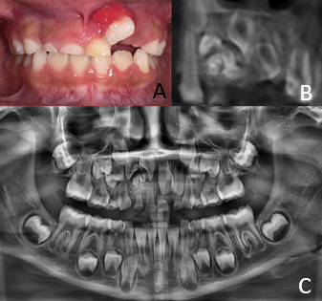
Figure 1: A) Intraoral panoramic photograph showing a pericoronal inflammatory process associated with tooth 21. B) Computed tomography image showing six bodies ranging from 978–3000 HU. C) Orthopantomograph showing radiolucent changes in the premaxillary region.
Based on clinical and radiographic findings, a preliminary diagnosis of compound odontoma was made, and surgical treatment for complete excision and biopsy was indicated. The patient was referred to the Centro Mexicano en Estomatología, Morelia Campus.
Under local anesthesia with 2% lidocaine and epinephrine, infiltration was performed in the anterior region for blockade of the superior alveolar nerve and nasopalatine foramen for palatal anesthesia. Simple extraction of teeth 51, 52, and 61 was performed. A linear incision was made at the alveolar ridge with a #15 scalpel blade, extending crevicularly around teeth 53 and 21. A full-thickness flap was elevated, and osteotomy was performed with a #8 round carbide surgical bur under saline irrigation until complete access to the lesion was achieved. Using thin straight elevators, a Lucas curette, and Axón forceps, the fragments and surrounding fibrous capsule were completely removed, leaving a clean cavity, which was irrigated with saline. Wound closure was achieved using 4-0 polyglycolic acid sutures with a continuous surget technique, obtaining complete hemostasis. Figure 2.
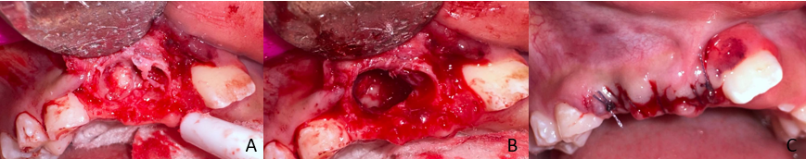
Figure 2: A) Flap elevation showing the presence of structures resembling dental organs.
B) Surgical bed after tumor removal. C) Reconstruction and approximation of layers with 4-0 suture.
Histopathological examination revealed six calcified fragments, each smaller than 1.2 cm, resembling teeth, whitish-yellow, shiny, and hard. One of them contained reddish soft tissue. A fibrous capsule was included in its entirety. Microscopically, the lesion consisted of multiple denticles surrounded by mature fibrous connective tissue forming a capsule. Each denticle showed histological organization similar to that of a normal tooth. At the periphery, an acellular clear zone corresponding to enamel lost during decalcification was observed. Beneath this, a well-organized tubular dentin layer resembling primary dentin was present. Irregular deposits of acellular and cellular cementum with variable appositional lines were found at the external surfaces of the denticles. In the center of some denticles, loose connective tissue containing fibroblasts and small blood vessels resembling dental pulp was observed. The interdenticular stroma consisted of dense fibrous connective tissue, without atypia or evidence of significant proliferative activity. Figure 3.
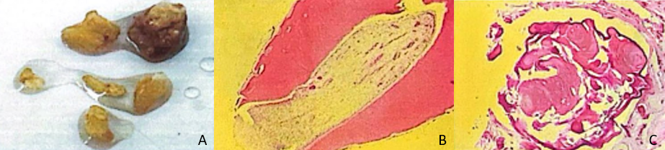
Figure 3: A) Fragments measuring 1.2 to 2 cm with dark reddish soft tissue. A capsule is completely included. B and C) Acellular clear space corresponding to enamel lost during decalcification. Beneath this space, a well-organized tubular dentin layer is observed, resembling primary dentin.

Discussion
According to the WHO Classification of Head and Neck Tumours (2022–2024), odontoma is the most common odontogenic tumor of the jaws and is defined as a benign hamartomatous lesion with disorganized maturation of dental tissues^{2,11}.
Odontomas are generally asymptomatic, slow-growing, and often discovered incidentally during radiographic examination. Although considered benign, they can cause complications such as delayed eruption, resorption of adjacent teeth, pain, inflammation, infections, and, in rare cases, cyst formation. In the present case, delayed eruption of permanent teeth 11 and 21 was observed, accompanied by pain and inflammation in the region associated with the odontoma. These lesions therefore require timely diagnosis and careful therapeutic management.
A 10-year retrospective study was conducted at the University of Tennessee Health Science Center (UTHSC), College of Dentistry, between January 1, 2013, and December 31, 2022. Clinical, radiographic, and pathological records of patients with odontoma diagnosis were reviewed. The study was approved by the UTHSC Institutional Review Board (IRB No. 2309422XM). During this period, 242 patients with histopathological and radiographic diagnoses of odontomas were identified. Compound odontomas were the most common type (71.4%) compared with complex odontomas (26.6%). Most compound odontomas were located in the anterior maxilla (69.3%), whereas most complex odontomas involved the posterior mandible (59.6%)⁴.
The treatment of choice is surgical excision of the odontoma with preservation of the impacted tooth. Factors such as the position of the tooth within the alveolar process, its morphology, and stage of root development are important considerations, as teeth with developing roots are more likely to erupt spontaneously after surgery [5]. In this case, the roots of impacted teeth 11 and 12 were in the process of odontogenesis, suggesting favorable outcomes for eruption and reducing the need for orthodontic traction.
Conclusion
Management of odontomas requires early diagnosis and appropriate clinical-radiographic follow-up to ensure a favorable prognosis. Although benign and slow-growing, late detection may result in irreversible complications in adjacent structures, such as tooth retention, root resorption, bone expansion, or the need for subsequent reconstructive procedures. Recurrence, though rare, may occur in cases treated at early ages or when inadequate curettage of the fibrous capsule allows residual cells to continue proliferating and form a new lesion. Therefore, long-term follow-up after surgical excision is essential to prevent complications and ensure functional and structural stability of the affected area.

References

- Broca P. Researches on the development of the teeth. Paris: Asselin; 1867.
- El-Naggar AK, Chan JKC, Grandis JR, Takata T, Slootweg PJ, editors. WHO Classification of Head and Neck Tumours. 5th ed. Lyon: International Agency for Research on Cancer; 2022.
- Philipsen HP, Reichart PA, Praetorius F. Mixed odontogenic tumors and odontomas: considerations on interrelationship. Review of the literature and presentation of 134 new cases of odontomas. Oral Oncology. 1997;33(2):86–99.
- Donnelly LA, Ferguson HW, Chen Y, Yu C, Stoelinga PJW. Odontomas in a 10-year retrospective study: clinical, radiographic, and histopathologic findings. Oral Surg Oral Med Oral Pathol Oral Radiol. 2023;135(2):176–184.
- Ragalli CC, Ferreria JL, Blasco F. Large complex odontoma: case report and review of the literature. Pediatr Dent. 2000;22(4):327–330.
- Serra-Serra G, Berini-Aytés L, Gay-Escoda C. Erupted odontomas: a report of three cases and review of the literature. Med Oral Patol Oral Cir Bucal. 2009;14(6):299–303.
- Amado Cuesta S, Gargallo Albiol J, Berini Aytés L, Gay Escoda C. Review of 61 cases of odontoma. Presentation of an erupted complex odontoma. Med Oral. 2003;8(5):366–373.
- Junquera L, de Vicente JC, Roig P, Olay S, Rodríguez-Recio O. Intraosseous odontoma erupted into the oral cavity: an unusual pathology. Med Oral. 2002;7(2):89–93.
- Hitchin AD. The aetiology of the calcified composite odontomes. Br Dent J. 1971;130(11):475–482.
- Hidalgo-Sánchez O, Leco-Berrocal MI, Martínez-González JM. Metaanalysis of the epidemiology and clinical manifestations of odontomas. Med Oral Patol Oral Cir Bucal. 2008;13(11):730–734.
- Kramer IRH, Pindborg JJ, Shear M. Histological Typing of Odontogenic Tumours. 2nd ed. Berlin: Springer-Verlag; 1992.

