Case report

Axenfeld-Rieger Syndrome in Childhood: Ocular and Systemic Manifestations: A Case Report

.
ABSTRACT

Aims:
Axenfeld-Rieger syndrome (ARS) is a rare congenital disorder characterized by anterior segment dysgenesis and systemic anomalies. Glaucoma develops in up to half of affected patients and represents the main cause of visual loss. We report a pediatric case illustrating the typical ocular and systemic features of ARS.
Presentation of Case:
A 7-year-old boy was referred for evaluation of abnormal iris appearance since birth. Ophthalmic examination revealed best-corrected visual acuity of 3/10 in both eyes, with corectopia, polycoria, and bilateral posterior embryotoxon. Intraocular pressure and fundus findings were normal. Systemic assessment disclosed craniofacial dysmorphism, dental anomalies including hypodontia and microdontia, and psychomotor developmental delay. Echocardiography and abdominal ultrasound were normal. The patient had a history of umbilical hernia repair in infancy. Based on these findings, the diagnosis of Axenfeld-Rieger syndrome was established. The child was scheduled for cosmetic iridoplasty and enrolled in long-term ophthalmic follow-up.
Discussion:
ARS is a genetically heterogeneous condition most frequently associated with PITX2 or FOXC1 mutations. It presents with highly variable ocular and systemic manifestations. Iris anomalies are the hallmark ocular sign, whereas glaucoma remains the most vision-threatening complication. Systemic features such as dental anomalies and umbilical hernia are frequent, highlighting the need for multidisciplinary evaluation.
Conclusion:
This case highlights the importance of early recognition of ARS, comprehensive systemic assessment, and lifelong ophthalmic follow-up to prevent irreversible visual loss

- Keywords: [Axenfeld-Rieger Syndrome, Anterior Segment Dysgenesis, Glaucoma, Congenital, Iris Abnormalities, Pediatric Ophthalmology]

1. INTRODUCTION

Axenfeld-Rieger syndrome (ARS) is a rare congenital disorder belonging to the spectrum of anterior segment dysgenesis anomalies. It is inherited most often in an autosomal dominant manner and is genetically heterogeneous, involving mutations in PITX2 and FOXC1 genes (Tümer & Bach-Holm, 2009; Reis et al., 2023). Clinically, ARS is characterized by a wide range of ocular findings, including posterior embryotoxon, iris hypoplasia, corectopia, and polycoria, often associated with a high risk of secondary glaucoma, which affects 30–50% of patients and represents the leading cause of visual morbidity (Shields et al., 1985; Seifi & Walter, 2018).
Beyond ocular features, ARS frequently manifests with systemic abnormalities such as craniofacial dysmorphism, dental anomalies, redundant periumbilical skin, and, less commonly, developmental delay or congenital malformations (Strungaru et al., 2007; Michels & Bohnsack, 2023). This phenotypic heterogeneity underscores the need for a multidisciplinary approach, as early diagnosis and long-term ophthalmic surveillance are crucial to prevent irreversible visual loss (Mandal & Pehere, 2016).
We report the case of a 7-year-old boy presenting with typical ocular manifestations and systemic features of ARS, emphasizing the importance of early recognition and comprehensive follow-up.

PRESENTATION OF CASE

A 7-year-old boy was referred to our ophthalmology department for evaluation of abnormal iris appearance noted since birth. His parents reported no family history of ocular malformations or systemic syndromes. The child had undergone surgical repair of an umbilical hernia during infancy and showed mild psychomotor delay.

-Ophthalmic examination revealed best-corrected visual acuity of 3/10 in both eyes. Slit-lamp evaluation showed marked corectopia, polycoria, and bilateral posterior embryotoxon.
(figure1).

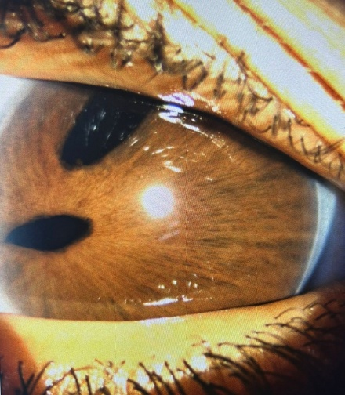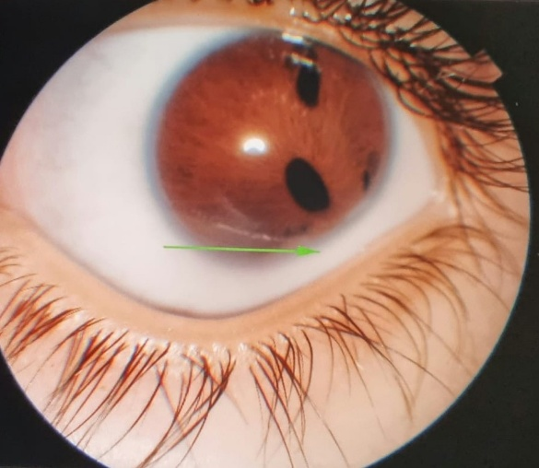
LE
RE

Figure 1. Slit-lamp photographic examination of the anterior segment in RE and LE: The image shows marked corectopia, polycoria , and a prominent bilateral posterior embryotoxon (white arrow)
The anterior chamber was deep and quiet, and crystalline lenses were clear. Intraocular pressure measured by applanation tonometry was within normal limits. Funduscopy demonstrated healthy optic discs with normal cup-to-disc ratios and unremarkable retina.

-Systemic evaluation revealed facial dysmorphism with broad nasal bridge and maxillary hypoplasia. Dental anomalies included: Hypodontia / Oligodontia (congenital absence of multiple permanent teeth hypodontia and microdontia), Microdontia (Small-sized teeth, sometimes conical in shape), Delayed eruption (late appearance of permanent teeth), Morphological and positional anomalies (malaligned teeth, rotations, or malocclusion). (figure 2).

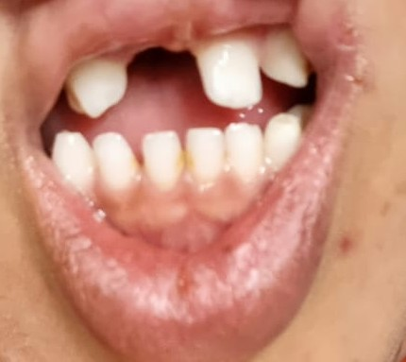

Figure 2. Dental anomalies in Axenfeld–Rieger syndrome: hypodontia/oligodontia, microdontia, delayed eruption, and morphological/positional abnormalities

-On clinical history, the parents reported that the child had undergone surgical repair of an umbilical hernia during early childhood. Abdominal examination revealed a well-healed umbilical scar, consistent with previous hernia surgery, with no evidence of recurrence or other abnormalities (figure 3).

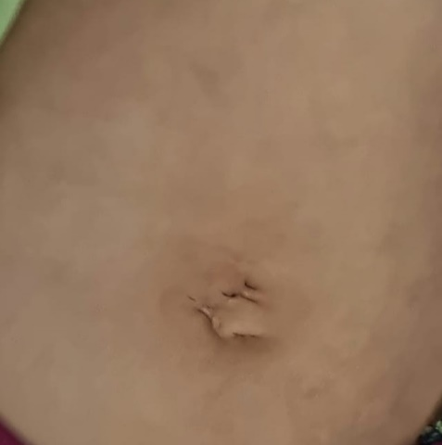

Figure 3. Clinical photograph showing a well-healed umbilical scar consistent with prior surgical repair of an umbilical hernia performed during early childhood

-Echocardiography and abdominal ultrasound were normal.
Based on the combination of ocular and systemic findings, a diagnosis of Axenfeld-Rieger syndrome was established.The patient was scheduled for cosmetic iridoplasty and enrolled in a long-term follow-up program for monitoring of intraocular pressure and optic nerve head status.

3. discussion

Axenfeld–Rieger syndrome (ARS) is a genetically heterogeneous condition within the spectrum of anterior segment dysgenesis, characterized by diverse ocular and systemic manifestations (Tümer & Bach-Holm, 2009). The present case illustrates the classic phenotypic features of ARS and emphasizes the importance of a multidisciplinary approach to both diagnosis and long-term management.

The ocular manifestations observed in our patient bilateral posterior embryotoxon, corectopia, and polycoria represent hallmark signs of ARS and reflect abnormal neural crest cell migration and differentiation during anterior segment development. These defects are often accompanied by anterior chamber angle dysgenesis, a well-recognized risk factor for secondary glaucoma (Shields et al., 1985). Although intraocular pressure and optic nerve morphology were normal in our patient, the lifetime risk of glaucoma remains high, with incidence rates approaching 50% by adolescence (Seifi & Walter, 2018; Zepeda et al., 2020). This finding reinforces the need for lifelong ophthalmic surveillance, including regular intraocular pressure measurement and optic nerve evaluation, to allow for early detection and intervention in glaucoma development.

Systemically, our patient demonstrated craniofacial dysmorphism, multiple dental anomalies (hypodontia, microdontia, delayed eruption, and malocclusion), a history of umbilical hernia repair, and psychomotor delay. These findings are consistent with previously reported systemic features of ARS, underscoring its multisystemic nature (Strungaru et al., 2007; Michels & Bohnsack, 2023). Dental abnormalities are among the most frequent non-ocular manifestations and are strongly associated with pathogenic variants in PITX2 and FOXC1, genes known to play critical roles in odontogenesis. Similarly, umbilical anomalies occur in approximately half of affected individuals and were present in this case (Strungaru et al., 2007).

Psychomotor delay, though less commonly reported, has been described in association with PITX2 mutations, which are also expressed during brain development (Reis et al., 2023). This observation supports recommendations for routine neurodevelopmental assessment and timely initiation of supportive interventions when indicated.
Genetically, ARS most frequently results from mutations in PITX2 or FOXC1, transcription factors essential for ocular, dental, craniofacial, and abdominal development (Tümer & Bach-Holm, 2009). While genetic testing was not performed in our patient, the constellation of clinical features strongly suggests an underlying mutation in one of these genes. Molecular confirmation, when available, facilitates precise genetic counseling, prognostic stratification, and family screening (Reis et al., 2023).

From a management perspective, this case highlights the necessity of early, coordinated, and multidisciplinary care, involving ophthalmology, pediatrics, dentistry, genetics, and neurology (Mandal & Pehere, 2016). Although cosmetic procedures such as iridoplasty may improve iris appearance, the principal focus of management remains on glaucoma prevention and preservation of visual function. Patient and family education, coupled with structured follow-up, are essential given the lifelong risk of delayed glaucoma onset.
In summary, this case exemplifies the characteristic ocular and systemic manifestations of ARS and reinforces the need for a holistic, multidisciplinary approach to optimize outcomes. Further studies correlating genotype with phenotype will be crucial in refining prognosis and guiding individualized management strategies.

4. Conclusion

Axenfeld-Rieger syndrome is a genetically heterogeneous disorder with variable ocular and systemic manifestations. Iris anomalies are characteristic, whereas glaucoma remains the most serious complication. Early recognition, comprehensive systemic evaluation, and lifelong ophthalmic follow-up are essential to preserve visual function.

CONSENT
All authors declare that ‘written informed consent was obtained from the patient for publication of this case report and accompanying images.
DATA AVAILABILITY
Not applicable
ETHICAL APPROVAL
As per international standards or university standards written ethical approval has been collected and preserved by the author(s).

References

- Shields MB, Buckley E, Klintworth GK, Thresher R. Axenfeld-Rieger syndrome. A spectrum of developmental disorders. Surv Ophthalmol. 1985;29(6):387-409.
- Tümer Z, Bach-Holm D. Axenfeld–Rieger syndrome and spectrum of PITX2 and FOXC1 mutations. Eur J Hum Genet. 2009;17(12):1527-39.
- Strungaru MH, Dinu I, Walter MA. Genotype–phenotype correlations in Axenfeld–Rieger malformation and glaucoma patients with FOXC1 and PITX2 mutations. Invest Ophthalmol Vis Sci. 2007;48(1):228-37.
- Seifi M, Walter MA. Axenfeld–Rieger syndrome. Clin Genet. 2018;93(6):1123-30.
- Mandal AK, Pehere N. Current concepts in the diagnosis and management of Axenfeld–Rieger syndrome. Indian J Ophthalmol. 2016;64(7):496-505.
- Michels KS, Bohnsack BL. Axenfeld–Rieger syndrome: new perspectives. Curr Opin Ophthalmol. 2023;34(5):403-10.
- Reis LM, Kariminejad A, van der Veken LT, Semina EV. Axenfeld-Rieger syndrome: more than meets the eye. J Med Genet. 2023;60(6):515-24.
- Zepeda EM, Branham K, Moroi SE. Management of glaucoma in Axenfeld-Rieger syndrome. Ophthalmol Glaucoma. 2020;3(6):482-91.
- Khandwala S, Lindberg E, Rattenbury S, Willoughby CE. Axenfeld-Rieger syndrome and anterior segment dysgenesis: an update. Eye (Lond). 2023;37(3):403-15.

