Review Article
The ECG Technician’s Guide to Reading like a Cardiologist: Bridging the Knowledge Gap in Clinical Rhythm Interpretation

Abstract
Despite the fact that electrocardiography (ECG) is still a crucial diagnostic technique for the majority of cardiac conditions, cardiologist and ECG technician interpretive abilities differ greatly. This study aims to fill that gap by offering an extensive, clinically focused handbook on rhythm interpretation for ECG techs. In addition to providing a methodical approach to recognising arrhythmias and other abnormalities, it focuses on improving the technician's capacity to recognise and understand the ECG waveform's primary components, such as P waves, PR intervals, QRS complexes, ST segments, and T waves. Because of the guide's emphasis on clinical use and simplicity of difficult topics, technicians are better prepared to read ECGs with more confidence and accuracy. It also investigates the connection between irregular heartbeats and internal cardiac and systemic diseases in order to encourage technicians to move beyond technical recording and actively engage in patient care. Relevant case studies, prevalent issues, and useful interpretative techniques are included to support practical application and real-world learning. This guideline encourages a more cooperative diagnostic process where technicians can contribute significantly to early detection and prompt clinical judgements, but it does not seek to replace cardiologists' more sophisticated analysis or suggest that they should make final diagnoses. Gaining proficiency in rhythm interpretation can help technicians improve patient triage, identify important patterns more quickly, and improve communication across interdisciplinary teams. The overall quality and adaptability of cardiac treatment in a variety of medical settings are improved when ECG technicians are given advanced interpretation skills.
Introduction
The electrocardiogram, or ECG, was originally invented in the early 1900s as a time-consuming experimental device but has evolved into one of the most widely used diagnostic tools in modern medicine. The ECG is critical in cardiovascular medicine, ranging from detection of potentially lethal arrhythmias to guiding therapeutic decisions in myocardial infarction. This evolution, extending for more than a century, is proof of the technology's continued relevance and unparalleled versatility amidst rapid medical development.¹
As monumental as the work of pioneers such as Willem Einthoven, who first documented the human ECG and charted the underlying PQRST waveforms, has become, the work of the ECG technician is a lesser-told but no less essential chapter in the continuing electrocardiographic saga. Allied health workers staffing the front clinical interface in the cardiac diagnostic sequence are these technicians. Patient preparation, proper machine calibration, accurate electrode placement, and in many cases the initial detection of meaningful patterns, are all within their domain. The accuracy of their work has direct impact on patient outcomes, treatment timetables, and diagnostic precision.² ³

ECG technologists are still woefully under-represented in the literature and under-estimated in healthcare discourse, however. Mis-placed leads, signal artefact, or mis-interpretation at acquisition can mimic or cover up potentially fatal conditions like myocardial infarction, according to research.⁴ Technicians are crucial to getting precise tracings quickly in high-acuity environments like emergency departments or cardiac care units, where life and death hang in the balance by the minute.
Technological advancement has revolutionized the ECG and technical expertise demanded of technicians, from galvanometers to cloud-based digital devices. ECG technicians are now more involved in remote ECG acquisition, initial triage, and even digital data processing as wearable’s and artificial intelligence become more common in cardiac diagnosis.⁵ Their function in contemporary cardiovascular care is not only on the rise but also becoming unavoidable.

From its humble beginnings with analog to its foray into artificial intelligence and mobile health, this overview documents the historical and technological progress of ECG interpretation. Further, it tries to redefine ECG technicians as indispensable, oftentimes underappreciated actors in the cardiac care continuum and not extras on the periphery.

How Cardiologists Think: A Systematic Framework
Identifying Patterns: The First Response
Trained cardiologists are generally able to diagnose a patient after an examination of an ECG in a matter of seconds. With visual memory built up over thousands of readings, hyperkalaemia, atrial fibrillation, and STEMI can be rapidly diagnosed.⁶ In acute situations, this intuitive process—which cognitive scientists frequently refer to as "System 1 thinking"—enables prompt triage.⁷
The Algorithmic Structure

Pattern recognition alone is not sufficient. Cardiologists have a methodical process to double-check their preliminary conclusions and not overlook anything. The standard procedure:
A methodical approach is based on the following sequence:
Rate → Rhythm → Axis → Intervals → Morphology⁸
It ensures that nothing significant is omitted, ranging from ischemia patterns to chamber enlargements and abnormal conduction.

Clinical Correlation: Contextualizing ECG
It's never possible to interpret an ECG alone. We are told to just ask whether the patient's symptoms can be explained on this ECG. Acute, chronic, or incidental? Inversions of T-waves, for instance, may be an ischemic marker in an elderly patient with chest pain, but may be innocuous in a young athlete ⁹. Everything in the history, medications, labs, and echocardiogram must be placed into it.
Comparing with Previous ECGs: The Undiscovered Gem
The prior ECG is among the most underutilized resources. But it's a cardiologist's diagnostic goldmine. Apart from precluding unnecessary alarms or false-negative pathology, comparison of recent findings to prior tracings helps distinguish between acute and chronic changes¹⁰. For instance, an on-going diagnostic puzzle can easily be reinterpreted by a prior recorded left bundle branch block (LBBB).
Red Flag Thinking: Finding Potential Killers First
Prior to moving on to a deeper analysis, cardiologists are instructed to screen on a regular basis for potentially dangerous tendencies. These are:

The Brugada syndrome

Wellens’ Syndrome

Hyperkalemia, as indicated by broad QRS and peaked T-waves

prolonged QT interval (risk of torsades) This "red flag scan" is a routine safety protocol designed to catch lethal illnesses before they are overlooked.¹¹

Breaking down the Basics with a Cardiologist’s Lens

ECG technicians, or techs, are essential to the diagnosis procedure because they collect and record vital cardiac electrical impulses. Nevertheless, they frequently lack the sophisticated knowledge that cardiologists provide to their interpretation of the data. Cardiologists interpret ECGs using a more thorough, clinical, and methodical approach that takes into account the patient's history, symptoms, and clinical context in addition to the rhythm. The disparities between what technicians usually observe and how cardiologists process and understand the ECG results are brought to light by this breakdown.
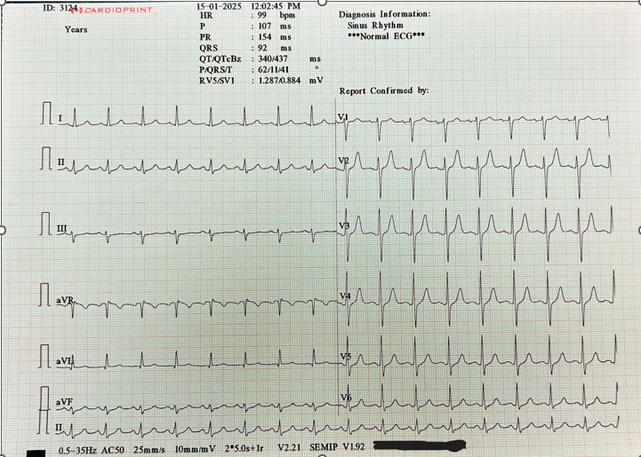

Fig-1 Normal ECG

Component: Heart Rate
What Techs See:
ECG technologists are directed to count the number of intervals between R-waves on an ECG strip in a manner that will enable them to simply compute the heart rate. They usually compute the rate and label it as bradycardia (less than 60 bpm), tachycardia (more than 100 bpm), or normal (60-100 bpm).
What Cardiologists Think:
They start with heart rate as well, but cardiologists don't just look at the number. For example, tachycardia is straight forward at the start, but context is paramount. Is it pathogenic, i.e., VT or AFib, or is it sinus tachycardia secondary to fever, anxiety, or dehydration? Cardiologists consider the source of the rhythm and how it relates to the clinical picture (e.g., an older patient with ischemic findings vs. a young patient with sinus tachycardia).¹²
Additionally, cardiologists take into account how the rate responds to therapies and track any changes over time to determine if the rate is getting better or getting worse as a result of interventions.

Component: Rhythm

What Techs See:
ECG technologists have learned to determine if a rhythm is regular or irregular. They attempt to determine if there are or are not P-waves, if R-R intervals are regular or irregular, and perhaps determine such rhythms as atrial flutter, sinus rhythm, or AFib.
What Cardiologists Think:
Cardiologists perform much more detailed analysis of rhythm. For example, a cardiologist evaluates the presence of abnormally irregular rhythms and considers the clinical history of the patient (e.g., post-surgery, heart failure, or hyperthyroidism) when diagnosing AFib. While lone atrial fibrillation is considered when AFib presents in a young patient with no structural heart disease, there is more serious underlying pathology occurring if the patient has heart failure.
Besides, cardiologists explore the cause of the abnormal heartbeat. For example, in atrial flutter, the focus is not only on the abnormal rhythm but also whether the ventricular rate is managed and whether the patient may be helped by ablation or by drug therapy.¹³
Component: ST Segments

What Techs See:
When ST-segment elevation or depression is observed by technicians, particularly in some leads, these can be highlighted for further review. STEMI's classic presentation of symptoms and ischemic changes (inverted or flat T-waves) are identified by technicians through training.
What Cardiologists Think:
Cardiologists look more broadly at the changes in the ST-segment. They look for a pattern that would be indicative of acute ischemia rather than chronic left ventricular hypertrophy (LVH) or pericarditis by examining the time, location, and contour of these changes. In order to be able to differentiate an acute event from a harmless change, they also examine for an accompanying increase in troponin or presentation.

For example, the cardiologist will have percutaneous coronary intervention (PCI) or thrombolytic therapy at the ready in the event of anterior STEMI. However, tiny ST depression, in the absence of concomitant clinical findings, may generate a suspicion of ischemia but will not necessarily need to be treated at once.¹⁴
Component: QRS Duration
What Techs See:
QRS complex duration can be quantified by the technicians in order to identify the QRS duration. Elevated QRS duration (greater than 120 ms) can be indicative of a bundle branch block (BBB) or other conduction disorders, for which they are conscious.
What Cardiologists Think:
Cardiologists consider other findings when evaluating QRS length. For instance, a left bundle branch block (LBBB), which may be a marker of underlying cardiac illness or left ventricular failure, may be indicated by prolongation of the QRS. The cardiologist will be aware of other findings, such as heart failure, but will be less focused on acute pathology if the patient has a chronic history of LBBB.
Moreover, cardiologists also look at the QRS complex shape to determine if it could be suggestive of arrhythmogenic right ventricular cardiomyopathy (ARVC), ventricular hypertrophy, or electrolyte imbalance.¹⁵
Component: T-Waves and QT Interval
What Techs See:
In addition to evaluating the QT interval for lengthening or shortening, technicians can spot abnormalities in T-wave shape, such as peaked T-waves in hyperkalaemia or inverted T-waves in ischemia.

What Cardiologists Think:

Cardiologists consider the clinical relevance of such anomalies and their detection. The cardiologist, for instance, may check serum potassium levels and determine whether the patient's disease can cause potentially fatal arrhythmias, though peaked T-waves tend to indicate hyperkalaemia.

When a patient comes in with a long QT interval, the cardiologist will consider drug-induced prolongation (secondary to antiarrhythmic medications, for example) and genetic disease such as Long QT Syndrome. To decide on the best course of action, the cardiologist will cross-check these findings with the patient's electrolytes, medications, and presentation.^{16,17}

ECG technicians can greatly improve their diagnostic accuracy by bridging the gap between the clinical insights cardiologists use and the technical components of ECG interpretation. In the end, better patient outcomes may result from a more thorough comprehension of rhythm interpretation, which begins with heart rate and rhythm and extends to ST-segment alterations, QRS morphology, and T-wave abnormalities. Technicians can make a more meaningful contribution to cardiovascular care decision-making by adopting the mind set of cardiologists.

Mastering the Subtleties: Red Flags Every Tech Should Know
STEMI Comparable
Critical coronary occlusion is characterized by subtle ECG patterns:

Winter Pattern: Proximal LAD occlusion is suggested by an up sloping ST depression with tall T-waves in V1–V4¹⁸.

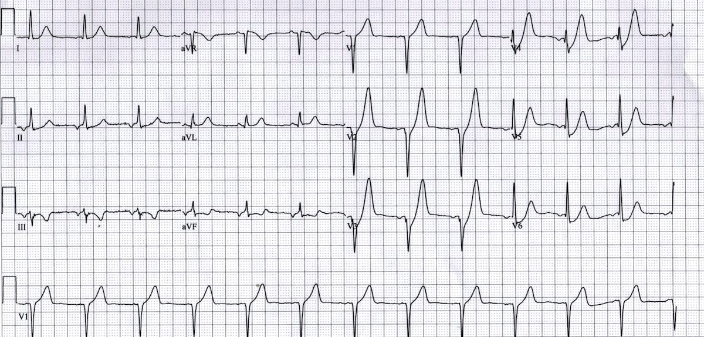

Fig 2¹⁸ Winter Pattern

Wellens Syndrome: Biphasic or deeply inverted T-waves in V2–V3 during pain-free periods are suggestive of severe LAD stenosis¹⁹.
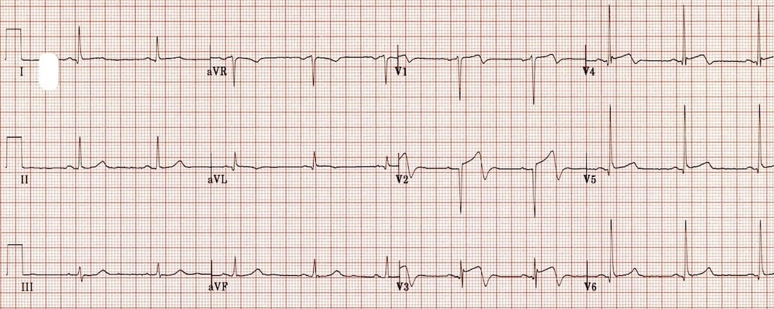

Fig 3¹⁹ Wellens Syndrome

Posterior MI: posterior wall infarction is diagnosed by ST depression and tall R-waves in V1–V3; posterior leads V7–V9 can be employed to confirm it²⁰.

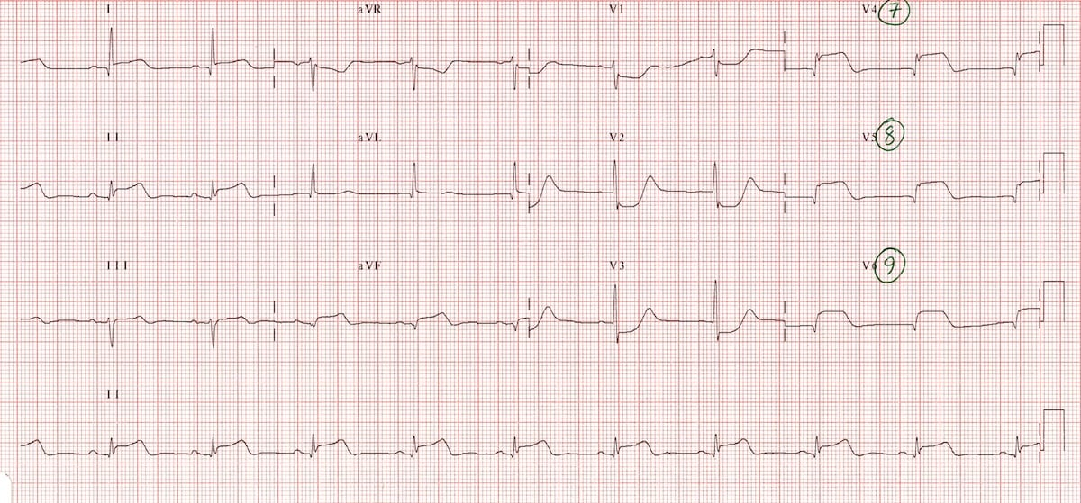

.Fig 4²⁰ Posterior MI

Risky Arrhythmias

Critical rhythms demanding immediate intervention:

Torsades de Pointes: Long QT is polymorphic VT, usually caused by drugs or electrolyte disturbance²¹.

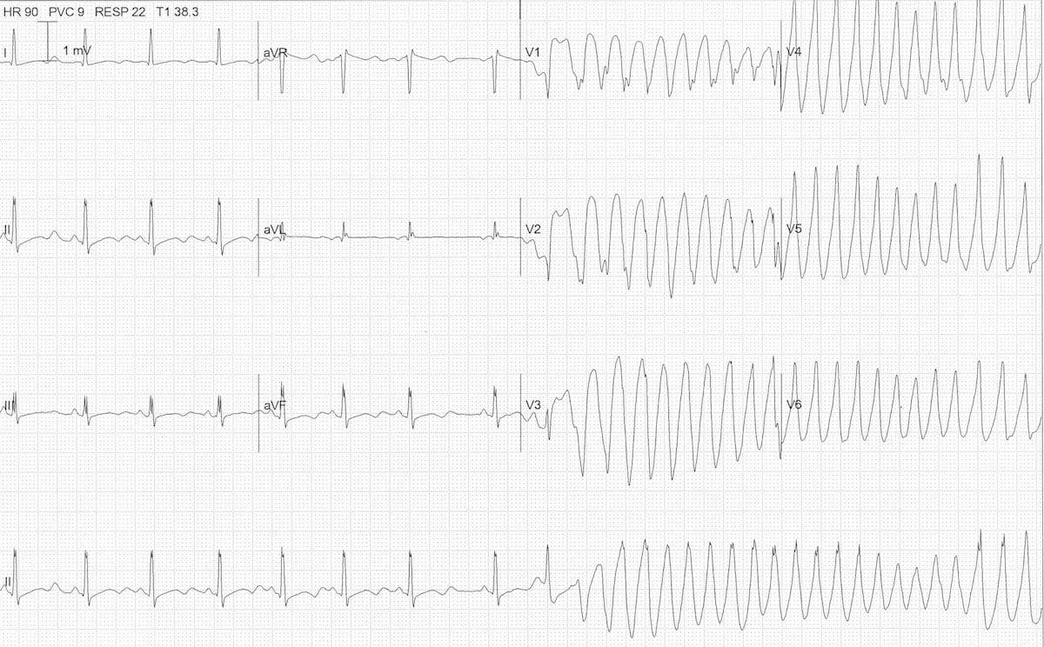

Fig 5²¹ Torsades de Pointes

Brugada Syndrome is characterized by sudden death with coved ST elevation in V1-V3 with RBBB pattern²².

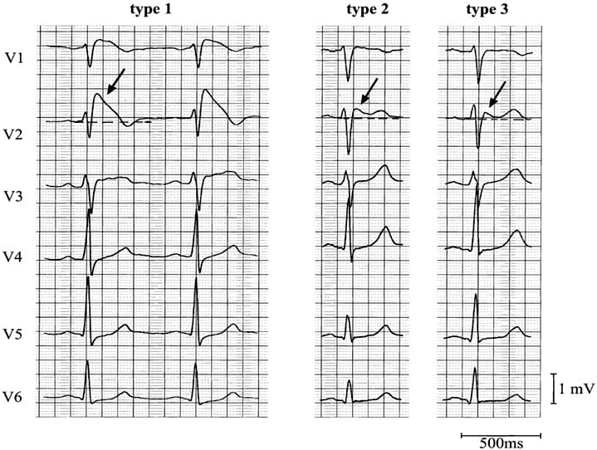
Fig 6²² Brugada Syndrome

Ventricular fibrillation may be preceded by R-on-T PVCs, QT prolongation, and repetitive ventricular ectopy²³.
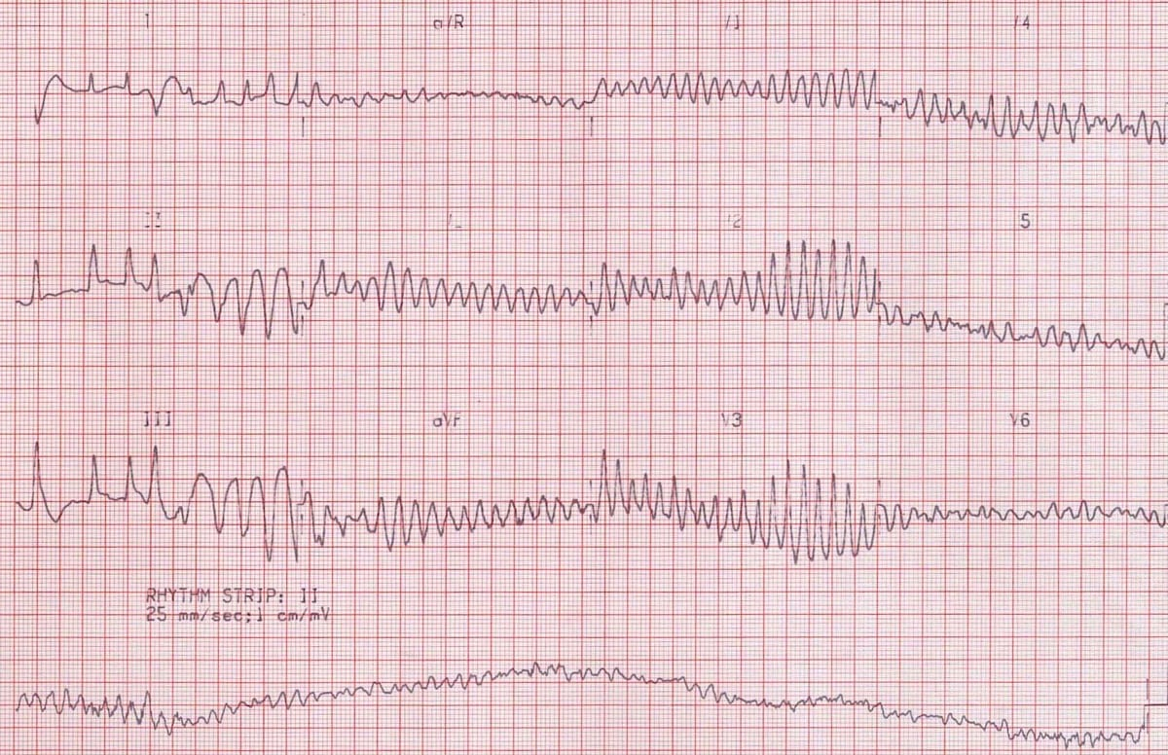
Fig 7²⁴ Ventricular fibrillation

Electrolyte Abnormalities
Physiological ECG signals are a result of metabolic derangements:

Hyperkalaemia: Sine-wave pattern, broadened QRS, and peaked T-waves in acute presentation²⁵.

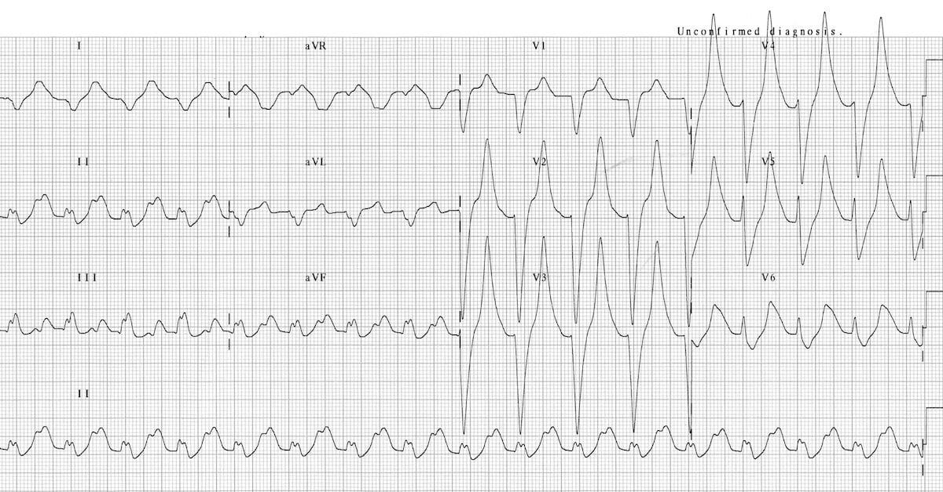

Fig 8²⁶ Hyperkalaemia

Hypokalaemia: Prolonged QT, U-waves, and flat T-waves put ventricular arrhythmias at risk²⁷.
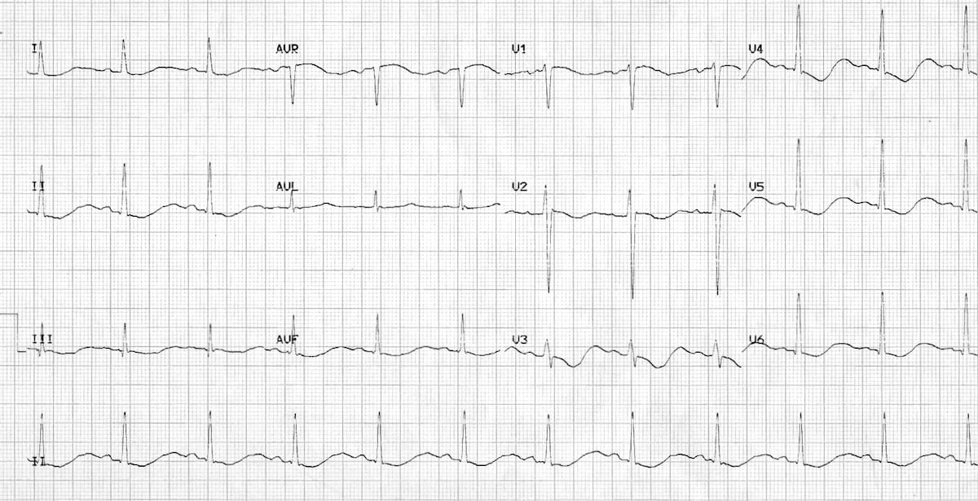

Fig 9²⁸ Hypokalaemia

Problems with the Pacemaker

Faults can include inappropriate pacing, capturing, or sensing, all of which are detectable by ECG and have the potential for fatal consequences²⁹

Preexcitation Syndrome
Other mechanisms that avoid conduction through AV nodes:

WPW syndrome: Wide QRS, delta wave, and short PR are presentations of WPW syndrome. Avoid AV nodal blockers as they may lead to AVRT or rapid AF³⁰.

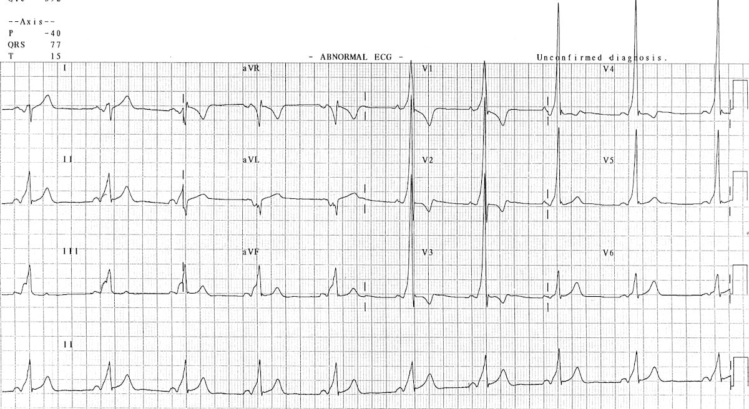

Fig 10³¹ WPW syndrome

LGL Syndrome: not as distinct but linked with SVT; diminished PR and normal QRS³¹.

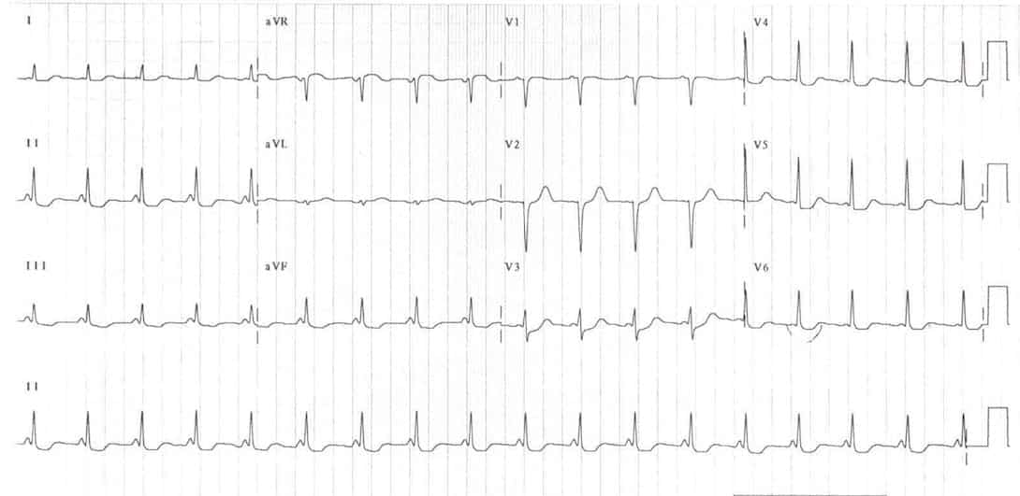
Fig 11³¹ LGL Syndrome

Tool | Function | Strengths | Limitations | Reference
Digital ECG Machines | Automated rhythm and interval analysis | Fast, integrated with EMRs | High error rates in subtle pathologies | ³²,³³
Calipers / ECG Rulers / Mobile Apps | Manual verification of intervals | Accurate measurements, low-cost | Requires training, slower than auto-read | ³⁴
ECG Databases | Case-based learning, interpretation practice | Free, peer-reviewed cases | No formal certification | ³⁵,³⁶
YouTube Channels | Video-based ECG tutorials | Visual, free, high-yield | Varies in clinical depth | —
Mobile ECG Apps | Reference and interpretation tools | Portable, interactive, exam prep | Some require subscriptions | ³⁴
Textbooks | Foundational and advanced ECG knowledge | Trusted, comprehensive | Heavier reading load | ³⁷,³⁸

Table 1 : Comparison of ECG Learning and Interpretation Tools

Recommended Resources (Expanded)

YouTube Channels
- MedCram – Concise clinical tutorials³⁹
- Simple Education – Electrophysiology-focused
- Strong Medicine – Core cardiology lectures⁴⁰

Mobile Apps
- ECG Guide by QxMD – Interpretation reference³⁴
- EP Calipers – Digital caliper for ECG intervals⁴¹
- Arrhythmia Recognition – Rhythm practice quiz app⁴²

Textbooks
- Dubin, D. Rapid Interpretation of EKGs – Visual, learner-friendly³⁷
- Huff, J. ECG Workout – Practice-driven⁴³
- Wagner, G. Marriott’s Practical Electrocardiography – Clinically rigorous³⁸
Clinical Scenarios: From Strip to Strategy
Case 1: The Hidden STEMI

Scenario: An automated ECG showed "normal" results for a 58-year-old man presenting with chest pain. But the technician noticed tall symmetrical T-waves and ST depression in V2–V4—the de Winter pattern, similar to STEMI.

Impact: Immediate cath lab activation. They stented a critical proximal LAD lesion.
Machines labeled it as "non-specific ST changes," and that is why it was important. A missed anterior STEMI was prevented because to the clinical intuition of the tech¹⁸.

Case 2: The Brugada Night Shift Save

Scenario: One evening, a young man has syncope. During V1–V2, the ECG showed a coved ST elevation, a normal Brugada pattern. It was dismissed as RBBB by the triage nurse.

Impact: It was flagged for emergent cardiology by the tech. The patient was placed on an ICD the next day.
Why it mattered: There was a high risk of sudden cardiac death. Pattern recognition saved this life²².

Case 3: Torsades in the Making

Scenario: The dialysis patient believed that he was "funny." The ECG showed major hypokalaemia with QTc of 560 ms and U-waves. Arrhythmia has yet to appear.
Impact: The group was told by the technician. Intra venous potassium and magnesium were given instantaneously.
Why it is important: A potentially fatal rhythm named Torsades de Pointes was prevented by adopting early intervention²¹.
Case 4: The Pacemaker That Didn't Fire
Scenario: An older woman developed vertigo following pacemaker implantation. No pacing spikes were observed on the ECG, suggesting pacing failure.
Impact: Lead dislodgement was established by prompt device interrogation. Repositioning was done within a few hours.
Why it mattered: Asystole could have been due to an overlooked defect²⁹.
Case 5: A Shortcut to Catastrophe
Scenario: A young patient with palpitations presented with a wide QRS, a delta wave, and a short PR—classic WPW. AV nodal blockers were recommended by the attending.
Impact: A warning was triggered by the tech. WPW with a bypass tract was confirmed by electrophysiology consultation. Do not use AV nodal blockers.
Why it was important: Ventricular fibrillation in AF was potentially brought about by the use of AV blockers³⁰.
The bottom line
Interpreting ECGs involves clinical judgment as well as pattern recognition. What does the patient now know this rhythm to be? In five minutes, what can it become?
The best ECG technicians read stories, not just strips.
Educational Roadmap for ECG Techs
Credentials That Count Professional certifications help verify ECG competency and expand clinical opportunities.

CCT: Core ECG, Holter, and stress testing knowledge.

CRAT: Focuses on rhythm comprehension, with special attention to telemetry.

RCES: Pro echocardiogram and EP lab skillset at an advanced level.

NCET: It is a mandatory qualification for beginning ECG technicians.

CCI (www.cci-online.org) and NHA (www.nhanow.com) offer all the above services^{44,45}.

Platforms for ECG and CME Learning
Keeping up with current standards and providing correct interpretations require constant education.

Interactive, case-based CME from SkillStat ECG Academy⁴⁶.

Weekly peer-reviewed cases on ECG with Dr. Amal Mattu.⁴⁷

LITFL ECG Library: In-depth ECG references and tutorials³⁵

ECGpedia is an open-learning site that is text book-like.³⁶

CME credit professional modules are provided by ACC ECG courses.⁴⁸

Habits of Expert Interpreters

Daily Practice: Going through ECGs on a regular basis enables you to recognize patterns.

Case Logging: Keeping a personal ECG journal enhances memory.

Teaching: Sharing knowledge consolidates basic concepts.

Clinical Framing: "What does this strip tell me about this patient?" should be your initial question.

Clinical reasoning is paramount, although memorizing patterns is useful⁴⁹.

Interprofessional Collaboration: ECG Techs as Clinical Partners
Not "Just a Tech"
ECG techs are often the first to spot potentially deadly outcomes. Results and team performance improve when they recognize their role as clinical partners, not button-pushers⁵⁰.

Escalate, Escalate Early Often
Ventricular rhythms, failure of pacing, and STEMI equivalents are a few red signals that need to be escalated immediately. Early reporting, though doubtful, may save lives and rescue treatment delay⁵¹.

Better Communication, Better Outcomes
Use simple language.
Mark important issues in ECG reports.
Be involved in multidisciplinary review to enable mutual learning and trust.
Cardiologists and ECG technicians must work together; it is not an alternative. Patient outcomes increase when responsibilities and communication channels are respected.

Conclusion: The Technician's Contribution to the Front Line of Cardiology
ECG technicians are front-line allies in cardiovascular care; they are more than observers. Giving them structured instruction, collaboration, and a culture of escalation changes outcomes in every aspect. An experienced technician does more than just order tests; they challenge bad negatives, uncover silent killers, and raise an alarm when seconds count.
A technologist's eyes can often recognize danger more rapidly than computer programs and even equate to early instincts of experienced cardiologists with experience, repetition, and training. Investing in IT training is a requirement for patient safety, not a treat.
Patients live longer when technologists are empowered.
That's how simple it is.

AI Assistance Statement:
"This article was prepared with the assistance of ChatGPT (OpenAI) for language refinement and content organization. All content was reviewed and finalized by the authors."

References
1. Willem Einthoven – Biographical. NobelPrize.org. Accessed April 11, 2025. https://www.nobelprize.org/prizes/medicine/1924/einthoven/biographical/
2. Shanmugam E, Doss CRMP, George M, et al. Effect of tolvaptan on acute heart failure with hyponatremia – A randomized, double blind, controlled clinical trial. Indian Heart Journal. 2016;68:S15-S21. doi:10.1016/j.ihj.2015.07.006
3. Marafioti V, Variola A. Pseudoinfarction pattern by misplacement of electrocardiographic precordial leads. The American Journal of Emergency Medicine. 2004;22(1):62-63. doi:10.1016/j.ajem.2003.09.014
4. Koupenova M, Freedman JE. Platelets and COVID-19. Circ Res. 2020;127(11):1419-1421. doi:10.1161/CIRCRESAHA.120.318218
5. Gatto J, Seegmiller P, Johnston G, Preum SM. Identifying the Perceived Severity of Patient-Generated Telemedical Queries Regarding COVID: Developing and Evaluating a Transfer Learning–Based Solution. JMIR Med Inform. 2022;10(9):e37770. doi:10.2196/37770
6. Freeman HJ. Dietary compliance in celiac disease. World J Gastroenterol. 2017;23(15):2635-2639. doi:10.3748/wjg.v23.i15.2635
7. Thinking, Fast and Slow. In: Wikipedia. ; 2025. Accessed April 12, 2025. https://en.wikipedia.org/w/index.php?title=Thinking,_Fast_and_Slow&oldid=1275502648
8. Sklavos T. ECG Interpretation: Conduction disease. Life in the Fast Lane • LITFL. April 19, 2020. Accessed April 12, 2025. https://litfl.com/ecg-interpretation-conduction-disease/
9. Tri-leaflet mitral valve anatomy: a rare occurrence leading to severe mitral valve regurgitation | European Heart Journal | Oxford Academic. Accessed April 12, 2025. https://academic.oup.com/eurheartj/article-abstract/36/26/1697/2293364?redirectedFrom=fulltext
10. Cardiac Resynchronization Therapy for Treatment of Chronic Subpulmonary Right Ventricular Dysfunction in Congenital Heart Disease | Circulation: Arrhythmia and Electrophysiology. Accessed April 12, 2025. https://www.ahajournals.org/doi/10.1161/CIRCEP.119.007157
11. Rezaie S. R.E.B.E.L. EM - Five ECG Patterns You Must Know. emDocs. May 23, 2016. Accessed April 12, 2025. https://www.emdocs.net/r-e-b-e-l-em-five-ecg-patterns-you-must-know/
12. D’Ancona G, Neuhausen-Abramkina A, Atmowihardjo I, Kische S, Ince H. Tri-leaflet mitral valve anatomy: a rare occurrence leading to severe mitral valve regurgitation. European Heart Journal. 2015;36(26):1697. doi:10.1093/eurheartj/ehv124
13. Vaduganathan M, Harrington RA, Stone GW, et al. Cangrelor With and Without Glycoprotein IIb/IIIa Inhibitors in Patients Undergoing Percutaneous Coronary Intervention. JACC. 2017;69(2):176-185. doi:10.1016/j.jacc.2016.10.055
14. Cardiac Resynchronization Therapy for Treatment of Chronic Subpulmonary Right Ventricular Dysfunction in Congenital Heart Disease | Circulation: Arrhythmia and Electrophysiology. Accessed April 12, 2025. https://www.ahajournals.org/doi/10.1161/CIRCEP.119.007157
15. Kashani A, Barold SS. Significance of QRS Complex Duration in Patients With Heart Failure. Journal of the American College of Cardiology. 2005;46(12):2183-2192. doi:10.1016/j.jacc.2005.01.071
16. QT interval. In: Wikipedia. ; 2025. Accessed April 12, 2025. https://en.wikipedia.org/w/index.php?title=QT_interval&oldid=1277972378
17. Burns E. T wave. Life in the Fast Lane • LITFL. August 1, 2018. Accessed April 12, 2025. https://litfl.com/t-wave-ecg-library/
18. Cadogan M, Buttner R, Buttner MC and R. De Winter T Wave. Life in the Fast Lane • LITFL. October 11, 2021. Accessed April 15, 2025. https://litfl.com/de-winter-t-wave/
19. Cadogan M, Buttner R, Buttner MC and R. Wellens Syndrome. Life in the Fast Lane • LITFL. August 1, 2020. Accessed April 15, 2025. https://litfl.com/wellens-syndrome-ecg-library/
20. Posterior MI. EMCrit Project. Accessed April 15, 2025. https://emcrit.org/ibcc/post/
21. torsades de pointes Archives. Life in the Fast Lane • LITFL. August 1, 2020. Accessed April 15, 2025. https://litfl.com/tag/torsades-de-pointes/
22. Larkin J, Cadogan M, Buttner R, Buttner JL Mike Cadogan and Robert. Brugada Syndrome. Life in the Fast Lane • LITFL. March 8, 2019. Accessed April 15, 2025. https://litfl.com/brugada-syndrome-ecg-library/
23. Ventricular fibrillation - Symptoms & causes - Mayo Clinic. Accessed April 15, 2025. https://www.mayoclinic.org/diseases-conditions/ventricular-fibrillation/symptoms-causes/syc-20364523
24. ECG-Ventricular-fibrillation-VF-original-VF-VT.jpeg (1200×776). Accessed June 9, 2025. https://litfl.com/wp-content/uploads/2018/08/ECG-Ventricular-fibrillation-VF-original-VF-VT.jpeg
25. Hyperkalemia. EMCrit Project. Accessed April 15, 2025. https://emcrit.org/ibcc/hyperkalemia/
26. Burns E, Buttner R, Buttner EB and R. Hyperkalaemia. Life in the Fast Lane • LITFL. August 1, 2018. Accessed June 9, 2025. https://litfl.com/hyperkalaemia-ecg-library/
27. Hypokalaemia ECG changes • LITFL • ECG Library. Accessed April 15, 2025. https://litfl.com/hypokalaemia-ecg-library/
28. Burns E, Buttner R, Buttner EB and R. Hypokalaemia. Life in the Fast Lane • LITFL. April 24, 2021. Accessed June 9, 2025. https://litfl.com/hypokalaemia-ecg-library/
29. Burns E, Buttner R, Buttner EB and R. Pacemaker Malfunction. Life in the Fast Lane • LITFL. August 1, 2018. Accessed April 15, 2025. https://litfl.com/pacemaker-malfunction-ecg-library/
30. Burns E, Buttner R, Buttner EB and R. Pre-excitation syndromes. Life in the Fast Lane • LITFL. March 1, 2021. Accessed April 15, 2025. https://litfl.com/pre-excitation-syndromes-ecg-library/
31. Pre-excitation syndromes • LITFL • ECG Library Diagnosis. Accessed June 9, 2025. https://litfl.com/pre-excitation-syndromes-ecg-library/
32. Zhang G, Cadogan M, Cadogan GZ and M. Lown–Ganong–Levine syndrome. Life in the Fast Lane • LITFL. August 3, 2018. Accessed April 15, 2025. https://litfl.com/lown-ganong-levine-syndrome/
33. Salerno SM, Alguire PC, Waxman HS. Competency in interpretation of 12-lead electrocardiograms: a summary and appraisal of published evidence. Ann Intern Med. 2003;138(9):751-760. doi:10.7326/0003-4819-138-9-200305060-00013
34. Mawri S, Michaels A, Gibbs J, et al. The Comparison of Physician to Computer Interpreted Electrocardiograms on ST-elevation Myocardial Infarction Door-to-balloon Times. Critical Pathways in Cardiology. 2016;15(1):22. doi:10.1097/HPC.0000000000000067
35. QxMD. The ECG Guide for iPhone. Medium. July 5, 2018. Accessed April 15, 2025. https://qxmd.medium.com/the-ecg-guide-for-iphone-67cb152378db
36. Cadogan M. ECG Library. Life in the Fast Lane • LITFL. Accessed April 15, 2025. https://litfl.com/ecg-library/
37. ECGpedia. Accessed April 15, 2025. https://en.ecgpedia.org/index.php?title=Main_Page
38. Fritz G. Dale Dubin: Rapid interpretation of EKG’s. 6th edition. Cover Publishing Company/2000. Tampa, Fla., USA. 388 pp. Intensive Care Med. 2001;27(11):1832-1832. doi:10.1007/s001340101100
39. Marriott’s Practical Electrocardiography. Accessed April 15, 2025. https://www.wolterskluwer.com/en/solutions/ovid/marriotts-practical-electrocardiography-4198
40. MedCram - Medical Lectures Explained CLEARLY. YouTube. Accessed April 15, 2025. https://www.youtube.com/channel/UCG-iSMVtWbbwDDXgXXypARQ
41. The Cardiovascular Exam / Heart Sounds (Strong Exam). Accessed April 15, 2025. https://www.youtube.com/watch?v=r9uo6Ljza6U
42. EP Calipers - Download and install on Windows | Microsoft Store. Microsoft Store - Download apps, games & more for your Windows PC. Accessed April 15, 2025. https://apps.microsoft.com/detail/9nblggh4xj2h?hl=en-US&gl=US
43. ECG Rhythm Quiz APK for Android - Download. Accessed April 15, 2025. https://ecg-rhythm-quiz.en.softonic.com/android
44. ECG Workout by Jane Huff. Wolters Kluwer. Accessed April 15, 2025. https://www.lww.co.uk/9781975174576/ecg-workout/
45. CCI Cardiovascular Credentialing International. CCI - Cardiovascular Credentialing International. Accessed April 15, 2025. https://cci-online.org/
46. Home | National Healthcareer Association | Allied Health Certifications. AscendBase. Accessed April 15, 2025. https://www.nhanow.com
47. ECG Academy - A Better Way To Read ECGs. Accessed April 15, 2025. https://www.ecgacademy.com/?utm_term=ecg%20academy&utm_campaign=**LP+ECG+Academy+(Global)+-+B&utm_source=adwords&utm_medium=ppc&hsa_acc=9907583306&hsa_cam=352234030&hsa_grp=23326570870&hsa_ad=663270810141&hsa_src=g&hsa_tgt=kwd-331828765635&hsa_kw=ecg%20academy&hsa_mt=b&hsa_net=adwords&hsa_ver=3&gad_source=1&gclid=CjwKCAjw5PK_BhBBEiwAL7GTPReAn5kuMBUYBV8FMH53OEB1sTLZ_02PV26GlYmLbmtHtxsy3kMhgxoCJREQAvD_BwE
48. ECG Weekly – Mastering ECG Interpretation To Save And Improve More Lives. Accessed April 15, 2025. https://ecgweekly.com/
49. ACC Online Courses. American College of Cardiology. Accessed April 15, 2025. https://www.acc.org/Education-and-Meetings/http%3a%2f%2fwww.acc.org%2fEducation-and-Meetings%2fOnline-Courses
50. Harrigan RA, Brady WJ, Chan TC. The ECG in Emergency Medicine. Emergency Medicine Clinics. 2006;24(1):xi-xii. doi:10.1016/j.emc.2005.08.002
51. Kopeć G, Magoń W, Hołda M, Podolec P. Competency in ECG Interpretation Among Medical Students. Med Sci Monit. 2015;21:3386-3394. doi:10.12659/MSM.895129
52. Nepper-Christensen L, Lønborg J, Hofsten DE, et al. Impact of diagnostic ECG-to-wire delay in STEMI patients treated with primary PCI: a DANAMI-3 substudy. doi:10.4244/EIJ-D-17-00857

