Case report
Patent Foramen Ovale: A Silent Culprit of Cryptogenic Ischemic Stroke

ABSTRACT
Introduction: Patent foramen ovale (PFO) is increasingly recognized as a potential risk factor for cryptogenic ischemic stroke in young patients without conventional vascular risk factors. Methods: We report the case of a 38-year-old man admitted with a superficial right sylvian infarct, in whom comprehensive diagnostic work-up including ECG, carotid Doppler ultrasound, and laboratory testing excluded atrial fibrillation, carotid disease, and thrombophilia. Results: Brain CT confirmed ischemic stroke, and secondary prevention with aspirin and atorvastatin was initiated. Contrast-enhanced transesophageal echocardiography revealed a 3-mm PFO with a significant right-to-left shunt (>20 bubbles during Valsalva maneuver), without atrial septal aneurysm or thrombus. No percutaneous closure was performed, and the patient remained recurrence-free during follow-up under medical management. Conclusion: This case underscores the role of systematic PFO evaluation in cryptogenic stroke, highlights the diagnostic value of imaging in detecting interatrial shunts, and emphasizes the need for individualized management. While randomized controlled trials have shown the benefit of PFO closure in high-risk patients, conservative therapy with antiplatelet agents and statins remains an appropriate evidence-based option in the absence of recurrence or additional risk features.
Keywords: Coronary Artery Ectasia ST-Elevation, Myocardial Infarction (STEMI) Thrombosis, Dual Antiplatelet Therapy, Coronary Angiography

INTRODUCTION
Patent foramen ovale (PFO) is recognized as a potential risk factor for ischemic stroke of undetermined origin, particularly in young patients. This anomaly, once regarded as a benign embryologic remnant, has been increasingly integrated into the diagnostic work-up of cryptogenic stroke, given its therapeutic implications in secondary prevention【1】.
The diagnosis of PFO relies primarily on cardiovascular imaging techniques. Contrast-enhanced transesophageal echocardiography (TEE) remains the gold standard for confirming interatrial shunt, while transcranial Doppler (TCD) ultrasound serves as a useful initial non-invasive screening tool【2. Therapeutic decisions whether medical management or percutaneous closure require multidisciplinary assessment based on patient age, shunt characteristics, and the estimated risk of recurrence.
The aim of this work is to present a clinical case of cryptogenic stroke associated with PFO and to discuss diagnostic and therapeutic strategies in light of recent recommendations.

CASE PRESENTATION
A 38-year-old patient, with no modifiable cardiovascular risk factors and no significant medical history, was admitted to the neurology department for a cryptogenic ischemic stroke (IS), without clinical sequelae. Upon admission, a complete diagnostic work-up was performed: the electrocardiogram (ECG) was normal, lipid profile did not reveal hypercholesterolemia, and Doppler ultrasound of the supra-aortic trunks showed no significant stenosis. Brain imaging by non-contrast computed tomography (CT) revealed a superficial right sylvian infarct without signs of intracranial hemorrhage.
The patient was started on aspirin at 100 mg/day for secondary prevention, in accordance with current recommendations for cryptogenic stroke without an indication for anticoagulation. Although the lipid profile was normal, atorvastatin at 40 mg/day was introduced as part of a long-term vascular stabilization strategy.
Due to the absence of an identified etiology, the patient underwent contrast-enhanced transesophageal echocardiography (TEE) with saline microbubbles and Valsalva maneuver. This revealed a significant right-to-left shunt, with the passage of more than 20 bubbles and an interatrial communication measuring 3 mm (Figure 1) (Figure 2), confirming the diagnosis of patent foramen ovale (PFO). No atrial septal aneurysm or intracardiac thrombus was detected. The patient did not undergo percutaneous closure, and clinical progression was favorable, with no recurrence during short-term follow-up.

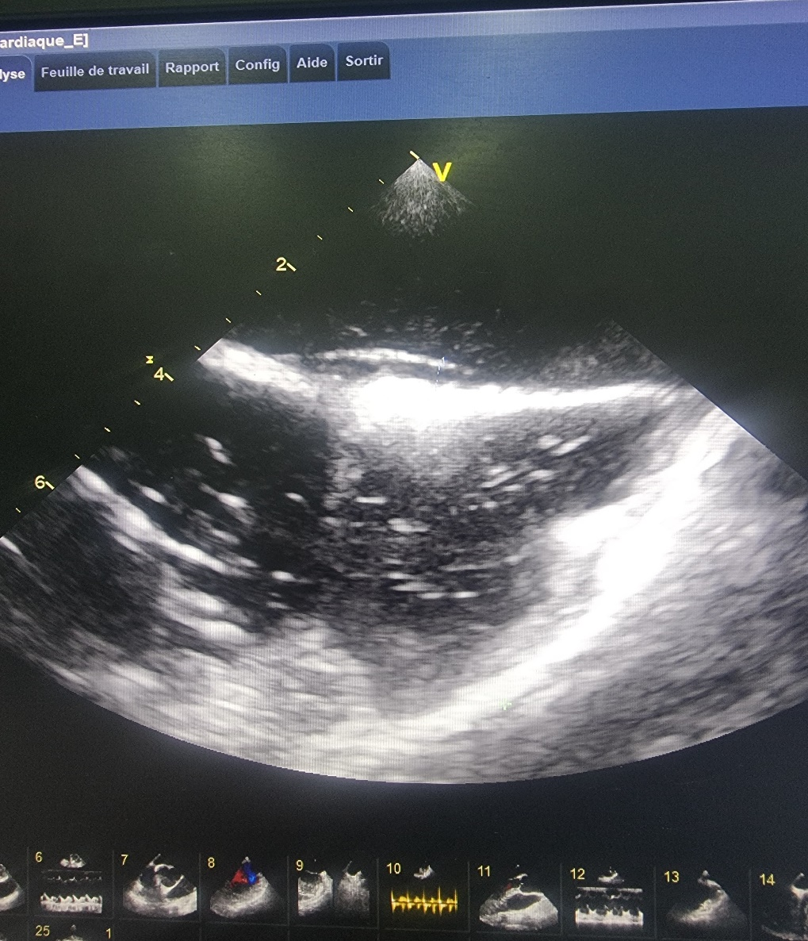
Figure 1: Transesophageal echocardiography demonstrating a patent foramen ovale measuring 3 mm

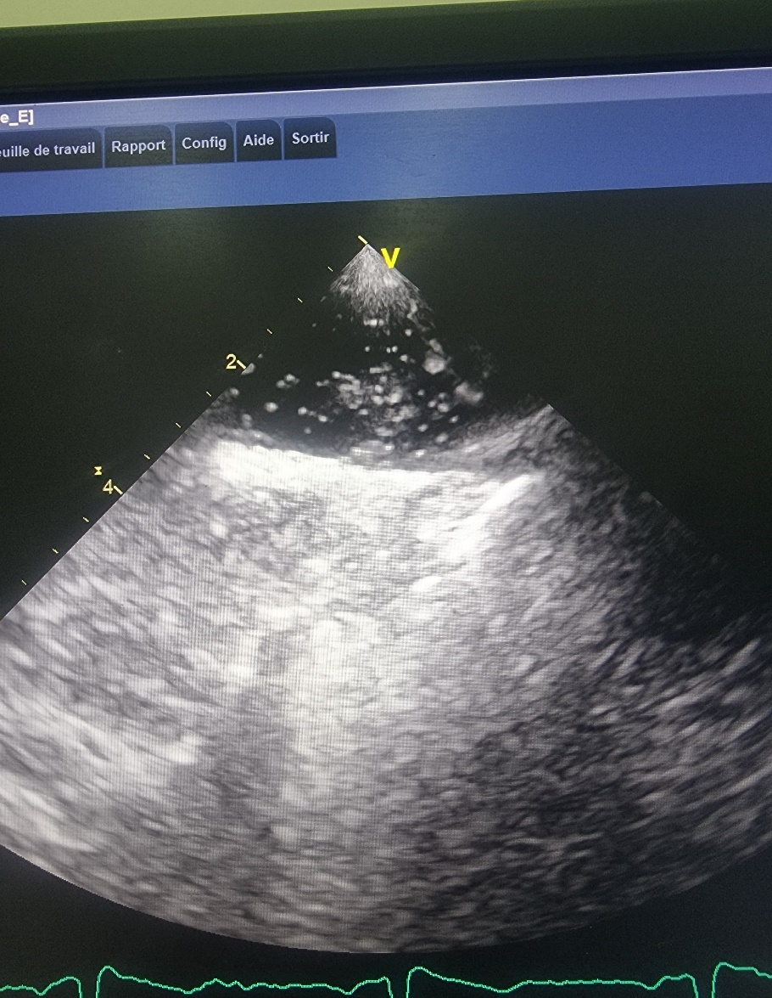
Figure 2: Transesophageal echocardiography showing a massive right-to-left shunt through a patent foramen ovale with more than 20 microbubbles.

DISCUSSION
In young patients with ischemic stroke and no evident cause, patent foramen ovale (PFO) is an etiology that should be systematically investigated. Present in approximately 20–30% of the general population, PFO is often asymptomatic. However, its prevalence increases to as much as 40% in patients under 60 presenting with cryptogenic stroke, suggesting a potential link between this anatomical variant and paradoxical embolism【1】. In this mechanism, a venous thrombus bypasses the pulmonary filter and crosses the interatrial septum through a right-to-left shunt, especially during transient increases in right atrial pressure, such as during Valsalva maneuvers
【2】.
In the presented case, the absence of cardiovascular risk factors, atrial fibrillation, carotid stenosis, or thrombophilia supports the hypothesis of a paradoxical embolism mediated by PFO. The diagnosis relied on identifying the interatrial shunt. Contrast-enhanced transesophageal echocardiography (TEE) is currently considered the reference examination【3】. It allows direct visualization of the interatrial communication, morphological assessment of the septum (e.g., presence of an aneurysm or Eustachian valve), and precise quantification of the shunt based on the number of bubbles seen in the left atrium following the Valsalva maneuver【4】. In this case, the PFO measured 3 mm and showed massive bubble passage, confirming a significant shunt.
As an alternative or complement to TEE, transcranial Doppler (TCD) with saline contrast is a sensitive, non-invasive, and reproducible tool for detecting right-to-left shunts【5】. This test is particularly useful as a first-line modality or when TEE is contraindicated or poorly tolerated. However, its main limitation lies in its inability to precisely localize the site of the shunt (e.g., cardiac vs. pulmonary origin), which necessitates TEE for accurate anatomical characterization. Furthermore, suboptimal acoustic windows may limit feasibility, especially in elderly patients or Asian women.
The management of PFO in secondary prevention of stroke remains a matter of debate. Antiplatelet therapy, anticoagulation, and percutaneous closure are the three main options. Several randomized controlled trials, including RESPECT, CLOSE, and REDUCE, have demonstrated that percutaneous closure of the PFO in selected patients significantly reduces the risk of stroke recurrence compared with medical therapy alone【6】. However, this benefit is mostly observed in younger patients (<60 years) with high-risk PFO features, such as large shunt or septal aneurysm.
In this patient, atorvastatin was initiated despite a normal lipid profile, in accordance with ESC/EAS 2021 and ESO 2024 guidelines, which recommend statin therapy for all patients with ischemic stroke, regardless of LDL-C levels【7】. The rationale is based on the pleiotropic effects of statins, including endothelial function improvement, plaque stabilization, and anti-inflammatory action. The SPARCL trial demonstrated a significant reduction in recurrent stroke with high-dose atorvastatin, even in patients without manifest dyslipidemia【8】.
Although the patient exhibited a profile suggestive of a causal relationship (young age, significant shunt, absence of alternative cause), no percutaneous closure was performed, due to the absence of recurrence and a reassuring clinical context. Aspirin therapy alone remains consistent with current recommendations in cases of first cryptogenic stroke with moderate-to-large shunt but no additional high-risk features.
The most recent European Stroke Organisation (ESO) 2024 guidelines highlight the need for embolic risk stratification, particularly using the Risk of Paradoxical Embolism (RoPE) score, to estimate the likelihood that the PFO is truly causative. A high RoPE score supports consideration of closure in the event of recurrence.

CONCLUSION
This case underscores the importance of a structured and individualized diagnostic and therapeutic approach in cryptogenic stroke. While TCD provides sensitive screening for right-to-left shunt, TEE remains essential for comprehensive anatomical assessment. In the absence of recurrence, conservative medical management may be adequate, provided that close neurological follow-up is ensured.

DECLARATION
I hereby declare that no generative AI technologies such as Large Language Models (ChatGPT, Copilot, etc.) and text-to-image generators have been used during the writing or editing of this manuscript.
CONSENT
Informed written consent was obtained from the patient to publish their clinical data.
ETHICAL APPROVAL
As per international standards or university standards, written ethical approval has been collected and preserved by the authors.

REFERENCES:
- Homma S, Sacco RL. Patent foramen ovale and stroke. Circulation. 2005;112(7):1063–72.
- Shah AH, Horlick EM, Kass M, Carroll JD, Krasuski RA. The pathophysiology of patent foramen ovale and its related complications. Am Heart J. 2024.
- Cabanes L, Coste J, Derumeaux G, et al. Interobserver variability in detection of PFO with transesophageal echocardiography. J Am Soc Echocardiogr. 2002;15:441–6.
- Saver JL, Mattle HP, Thaler D. PFO closure versus medical therapy for cryptogenic stroke: review. Stroke. 2018;49(6):1273–81.
- Pristipino C, Sievert H, D’Ascenzo F, et al. European position paper on the management of patients with PFO. Eur Heart J. 2019;40(38):3182–95.
- Søndergaard L, Kasner SE, Rhodes JF, et al. Patent Foramen Ovale Closure or Antiplatelet Therapy for Cryptogenic Stroke. N Engl J Med. 2017;377:1033–42.
- European Stroke Organisation (ESO). Guidelines on diagnosis and management of PFO after stroke. Eur Stroke J. 2024;9(1):800–34.
- Amarenco P, Bogousslavsky J, Callahan A, et al. High-dose atorvastatin after stroke or TIA. N Engl J Med. 2006;355:549–59. (SPARCL study)

