Case report
Extrinsic Pulmonary Artery Compression Mimicking Pulmonary Stenosis: A Case of Mediastinal Lymphoma

Abstract:
Background:
Pulmonary artery stenosis (PAS) is an uncommon cause of right ventricular pressure overload, most often congenital. Acquired PAS caused by extrinsic vascular compression is rare but can have serious hemodynamic consequences, including progressive right ventricular dysfunction and heart failure if not promptly diagnosed and well managed.
Case Summary:
A 37-year-old woman presented with progressive exertional dyspnea and signs of right heart failure. Transthoracic echocardiography showed moderate subvalvular pulmonary stenosis with severe tricuspid regurgitation and right heart dilation. Contrast-enhanced computed tomography (CT) revealed a large mediastino-pulmonary mass compressing the pulmonary artery and its branches. FDG- positron emission tomography scan demonstrated hypermetabolic activity of the mass and associated lymphadenopathy. CT-guided biopsy confirmed the diagnosis of lymphoma. The patient was admitted to the hematology-oncology department and was placed on chemotherapy.
Discussion :
This case underscores the importance of considering malignancy in the differential diagnosis of acquired pulmonary artery stenosis. Multimodal imaging is essential for accurate diagnosis and guiding management in patients presenting with unexplained right heart failure due to vascular compression.
Keywords :
Pulmonary artery stenosis, Right heart failure, Mediastinal lymphoma, Extrinsic vascular compression, Multimodality imaging

Introduction
Pulmonary artery stenosis (PAS) is an uncommon yet severe condition that can lead to progressive right ventricular pressure overload and ultimately right heart failure if not recognized early. While congenital PAS is well described in pediatric populations, acquired PAS in adults is rare and is most often caused by external compression from adjacent structures such as tumors, lymphadenopathy, or fibrosing mediastinitis. Clinical symptoms are often nonspecific and dominated by manifestations of right-sided heart failure, including dyspnea, peripheral edema, and fatigue.
Transthoracic echocardiography (TTE) remains the first-line imaging modality for detecting right ventricular overload and abnormal flow patterns suggestive of pulmonary outflow obstruction. However, in cases of extrinsic compression—especially when the stenosis is located distal to the pulmonary valve—echocardiographic assessment may be limited. In such instances, complementary imaging techniques like contrast-enhanced computed tomography (CT) or magnetic resonance imaging (MRI) are crucial for detailed anatomical evaluation and determining the underlying cause.
We report a rare case of acute right heart failure secondary to supravalvular pulmonary artery stenosis caused by an extrinsic mediastino-pulmonary mass. This case underscores the diagnostic challenges and highlights the essential role of multimodality imaging in identifying and characterizing the etiology of acquired pulmonary artery stenosis.

Case Report
We present the case of a 37-year-old female patient with no significant past medical history, who was referred to our cardiology department for evaluation of progressively worsening exertional dyspnea, which had recently advanced to New York Heart Association (NYHA) Class III. She also reported generalized fatigue, anorexia, and lower limb edema.
On clinical examination, the patient was afebrile with a blood pressure of 112/68 mmHg and a heart rate within normal range. Oxygen saturation was 95% in both pre-ductal and post-ductal measurements. Jugular venous distension was noted. There was a visible and palpable pulsation over the second and third left intercostal spaces in the mid-clavicular line. Cardiac auscultation revealed a loud systolic ejection murmur at the left sternal border, without an ejection click. The pulmonary component of the second heart sound was diminished and delayed. Signs of systemic venous congestion, including bilateral lower limbs pitting edema and hepatomegaly, were present. Pulmonary auscultation was unremarkable.
Electrocardiography showed right axis deviation, complete right bundle branch block, and a right ventricular hypertrophy (Figure 1).
Chest radiography revealed right-sided cardiomegaly, elevation of the cardiac apex, convexity of the mid-left cardiac border, decreased pulmonary vascular markings, and an opacity in the left hilar region merging with the mediastinal contour (Figure 2).

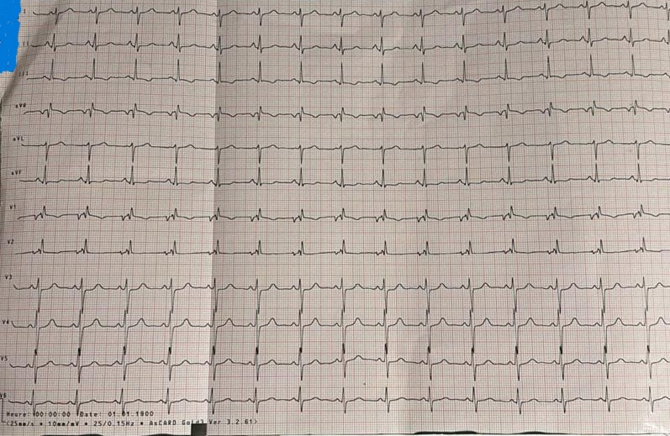
Figure 1 Electrocardiography

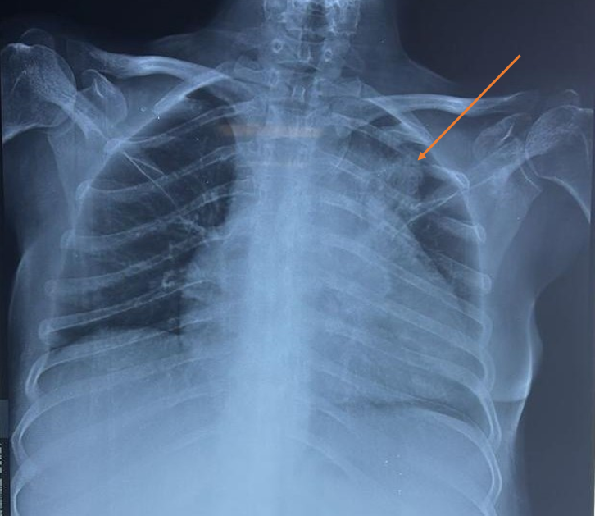
Figure 2 The chest radiography showed a massive opacity in the left hilar region that was continuous with the mediastinal shadow.
Transthoracic echocardiography (TTE) demonstrated marked dilatation of the right atrium and right ventricle, with preserved left ventricular function. Color and spectral Doppler interrogation revealed dynamic subvalvular pulmonary obstruction, with a peak flow velocity of 3.04 m/s and a corresponding pressure gradient of 37 mmHg, consistent with moderate subvalvular pulmonary stenosis (figure 3). Severe functional tricuspid regurgitation was present, quantified using the PISA method (effective regurgitant orifice area: 41mm2, regurgitant volume: 39ml) The inferior vena cava was dilated with diminished respiratory variability, and systolic flow reversal was noted in the hepatic veins—findings indicative of elevated right atrial pressure. No intracardiac shunts or anomalous pulmonary venous return were identified.
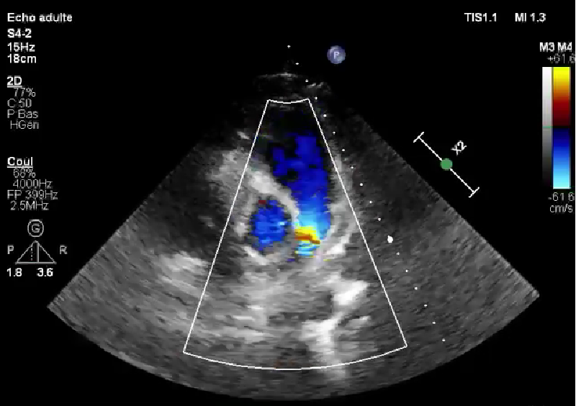
Figure 3 Transthoracic echocardiography (TTE)

Laboratory analysis revealed a mildly elevated B-type natriuretic peptide (BNP) level of 322 pg/mL. A paraneoplastic workup was notable for elevated lactate dehydrogenase (LDH), parathyroid hormone (PTH), serum calcium, uric acid, and carcinoembryonic antigen (CEA) levels.
Thoracic computed tomography angiography revealed a large anterior mediastino-pulmonary mass in the left upper lobe, with irregular borders and heterogeneous soft-tissue density. The mass encased the main pulmonary artery and its branches, producing significant external compression while maintaining luminal patency. Multiple irregular satellite nodules were seen in the same lobe, were also noted.
Fluorodeoxyglucose positron emission tomography (FDG-PET) demonstrated intense hypermetabolic activity in the main mass and satellite nodule, along with metabolically active lymphadenopathy in the mediastinum, right axilla, and subpectoral regions. No other hypermetabolic lesions were identified (Figure 4).
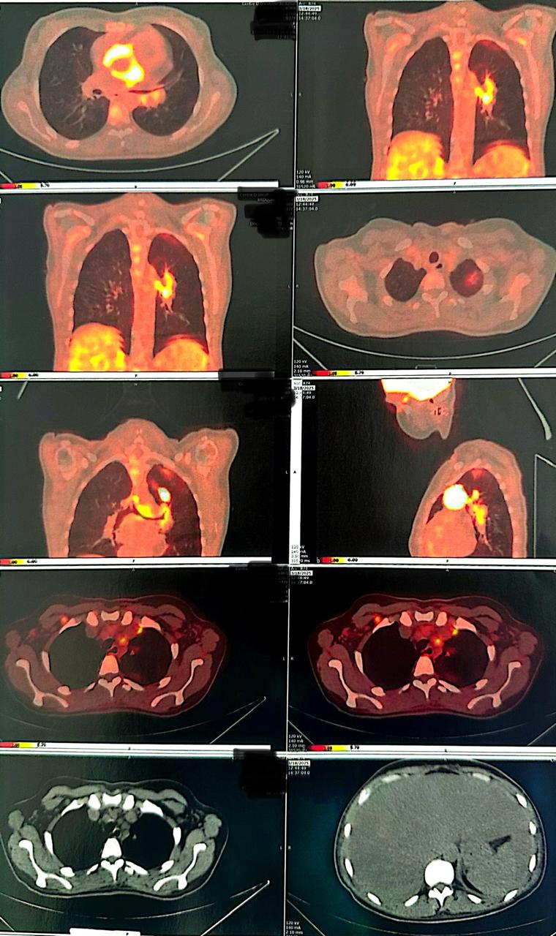
Figure 4 PET-Scan showed A hypermetabolic anterior left mediastino-pulmonary mass, associated with an active satellite pulmonary nodule.

A CT-guided percutaneous biopsy of the mass was performed, and histopathological analysis confirmed the diagnosis of Hodgkin lymphoma. The patient was referred to the hematology-oncology department, where she was started on systemic chemotherapy.

Discussion:
Pulmonary stenosis may be either congenital or acquired. The congenital form is the most common and typically results from abnormal development of the pulmonary valve. It is frequently associated with other congenital heart anomalies, being present in approximately 25% to 30% of cases, such as in tetralogy of Fallot, Noonan syndrome, complete transposition of the great arteries, pulmonary valve stenosis, persistent ductus arteriosus, ventricular septal defect, or other complex malformations (1)(2).
Acquired pulmonary stenosis is far less common, accounting for only 7% to 12% of cases (1), and can be categorized into two main types. The first type involves intrinsic disease of the pulmonary valve, such as degenerative or inflammatory changes. The second type—of particular relevance in this case report—results from extrinsic compression of the pulmonary artery by mediastinal masses (e.g., lymphomas, thymic tumors, teratomas) or by large vascular structures such as aortic aneurysms (3) (4).
Other causes of acquired pulmonary stenosis include postsurgical restenosis, inflammatory or infectious processes, and, more rarely, extrinsic compression of the right ventricular outflow tract by fibrous pericardial bands in the setting of constrictive pericarditis (5)(6).
Pulmonary artery stenosis can occur at any level along the pulmonary arterial tree and is traditionally classified into three anatomical types: valvular, subvalvular (infundibular), and supravalvular stenosis. The severity of the obstruction is typically graded as mild, moderate, severe, or critical, based on the peak pressure gradient measured by Doppler echocardiography. In the present case, attention is focused on the supravalvular form, which is characterized by an obstruction located distal to the pulmonary valve, often involving the main pulmonary artery or its branches (7).
Diagnosing pulmonary stenosis, particularly when acquired and presenting as isolated right heart failure, poses considerable challenges. The clinical manifestations are often non-specific and may mimic other causes of right-sided heart failure.
Patients typically present with progressive exertional dyspnea, fatigue, lower extremity edema, hepatomegaly, and jugular venous distension. In more advanced cases, signs such as ascites and right upper quadrant discomfort due to hepatic congestion may develop. A systolic ejection murmur best heard at the left upper sternal border, often accompanied by a diminished or delayed pulmonary component of the second heart sound, may raise suspicion for pulmonary outflow obstruction (8).
Echocardiography constitutes the cornerstone of initial assessment for pulmonary stenosis, irrespective of the anatomical subtype. Nonetheless, current echocardiographic parameters lack the specificity and sensitivity required to reliably detect a supravalvular component or to anticipate its therapeutic responsiveness (9).
Transthoracic echocardiography (TTE) can detect signs of right ventricular pressure overload, such as right ventricular hypertrophy and dilation, as well as interventricular septal flattening. Color and spectral Doppler imaging may reveal turbulent flow across the right ventricular outflow tract or pulmonary valve, with elevated peak systolic velocities—typically exceeding 3 m/s—suggestive of a hemodynamically significant obstruction. Nonetheless, in cases of extrinsic compression, particularly when the lesion is located beyond the pulmonary valve, the acoustic window may be insufficient to fully visualize the obstruction or identify its underlying cause. This limitation underscores the need for complementary imaging to accurately characterize the stenotic lesion and guide management(10).
Although TTE may be limited in cases of extrinsic compression, it nonetheless provides valuable hemodynamic information. In particular, it enables the assessment of stenosis severity, which can be classified—similarly to valvular pulmonary stenosis—based on peak systolic gradients measured by Doppler or invasive catheterization as mild (<30 mmHg), moderate (30–50 mmHg), or severe (>50 mmHg), according to American Heart Association guidelines.(11)
In addition, The PA:PV ratio, defined as the diameter of the main pulmonary artery (PA) divided by the average diameter of the superior pulmonary veins (PV), is a useful echocardiographic parameter to help differentiate supravalvular pulmonary stenosis (SVPS) from other forms of right ventricular outflow tract obstruction. A higher PA:PV ratio has been associated with SVPS and may serve as a non-invasive surrogate marker to support diagnosis and stratify patients based on anatomical severity(9).
Transesophageal echocardiography (TEE) offers superior imaging of the proximal pulmonary arteries and can better visualize external masses impinging on the pulmonary trunk or branches. It provides valuable hemodynamic information, including assessment of the pressure gradient across the obstruction using continuous-wave Doppler.
To achieve a comprehensive anatomical and etiological diagnosis, multimodal imaging is essential. Contrast-enhanced computed tomography (CT) or magnetic resonance imaging (MRI) can accurately define the anatomy of the pulmonary arteries and adjacent mediastinal structures. These modalities are particularly valuable in identifying extrinsic compression due to masses, vascular anomalies, or postoperative changes. Positron emission tomography (PET-CT) further assists in characterizing the metabolic activity of any detected masses and in staging potential malignancies(12).
The combined use of TTE for hemodynamic assessment and CT for anatomical clarification is therefore crucial in the comprehensive evaluation of pulmonary vascular abnormalities (10).
Cardiac catheterization remains the gold standard for the definitive hemodynamic assessment of pulmonary artery stenosis. It allows for direct measurement of pressure gradients across the stenotic segment, providing precise quantification of severity. Beyond diagnostic confirmation, catheterization also enables detailed anatomical evaluation through angiography, particularly in cases where non-invasive imaging is inconclusive. In selected patients, it serves as a platform for therapeutic intervention, including balloon angioplasty or stent placement. However, in cases of extrinsic compression by a mass, such interventions may be limited or contraindicated depending on the nature and extent of the compressive lesion.
Management of supravalvular pulmonary stenosis (SVPS) depends on the severity of obstruction, symptom burden, and underlying etiology. While endovascular approaches such as balloon angioplasty or stent implantation may offer temporary relief in selected cases, their efficacy is often limited in the context of extrinsic compression. Surgical intervention is generally preferred in anatomically complex or refractory lesions. When SVPS is caused by external compression from a mediastinal or pulmonary mass, definitive treatment relies on addressing the underlying pathology—typically through surgical resection, chemotherapy, or radiotherapy aimed at reducing or eliminating the mass effect. Therapeutic decisions must therefore be guided by a multidisciplinary evaluation that considers both the vascular and oncological aspects of the disease(11)(13).
The prognosis of pulmonary artery compression secondary to mediastinal or pulmonary tumors is generally poor and largely depends on the underlying etiology and the extent of vascular involvement. Malignant masses, particularly those arising from lung cancer, lymphoma, or metastatic disease, are often associated with aggressive behavior and limited therapeutic options(10).

Conclusion
Compression of the pulmonary artery by a mediastinal mass is a rare and often underrecognized cause of supravalvular pulmonary stenosis in adults. It may present with signs of right heart failure and should be suspected, especially when common etiologies are excluded. Transthoracic echocardiography remains essential for initial hemodynamic assessment, while cross-sectional imaging, particularly computed tomography, is crucial to identify the underlying cause. Definitive management focuses on treating the compressive lesion, with options ranging from surgical removal to oncologic therapies. Early recognition and a multidisciplinary approach are necessary to optimize outcomes of this severe uncommon entity.

Consent Statement
Written informed consent was obtained from the patient for the publication of this case report, including all clinical data and accompanying images. All authors have read and approved the final manuscript and agree with its submission.

References
1. Kamada M, Shinozaki S, Sawamura Y, Endo M, Ohmi M, Tabayashi K, et al. [Acquired pulmonary stenosis caused by mediastinal mature teratoma: a case report]. Kyobu Geka. 1999 Mar;52(3):243–6.
2. Anderson K, Cnota J, James J, Miller EM, Parrott A, Pilipenko V, et al. Prevalence of Noonan spectrum disorders in a pediatric population with valvar pulmonary stenosis. Congenit Heart Dis. 2019 Mar;14(2):264–73.
3. Gough JH, Gold RG, Gibson RV. Acquired pulmonary stenosis and pulmonary artery compression. Thorax. 1967 Jul;22(4):358–67.
4. Suda Y, Sugawara A, Kanao-Kanda M, Shirasaka T, Kamiya H, Kanda H. Awake intubation for thoracic aortic aneurysm causing esophageal stenosis with food residues and compression of the pulmonary artery and left bronchi: a case report. JA Clinical Reports. 2022 Jun 21;8(1):46.
5. Heaton J, Horenstein MS, Kyriakopoulos C. Pulmonary Stenosis. In: StatPearls [Internet]. Treasure Island (FL): StatPearls Publishing; 2025 [cited 2025 Apr 9]. Available from: http://www.ncbi.nlm.nih.gov/books/NBK560750/
6. Barros JL, Pérez Gómez F. Pulmonary stenosis due to external compression by a pericardial band. Br Heart J. 1967 Nov;29(6):947–9.
7. Khalil M, Jux C, Rueblinger L, Behrje J, Esmaeili A, Schranz D. Acute therapy of newborns with critical congenital heart disease. Transl Pediatr. 2019 Apr;8(2):114–26.
8. Evans DM, Borochovitz D, Kenny WM, Gorcsan J. Acquired supravalvular pulmonary artery stenosis after coronary artery bypass grafting. Am Heart J. 1990 Dec;120(6 Pt 1):1443–5.
9. Poupart S, Navarro-Castellanos I, Raboisson MJ, Lapierre C, Dery J, Miró J, et al. Supravalvular and Valvular Pulmonary Stenosis: Predictive Features and Responsiveness to Percutaneous Dilation. Pediatr Cardiol. 2021 Apr;42(4):814–20.
10. Jaffery Z, Ananthasubramaniam K. Isolated left pulmonary artery stenosis due to extrinsic compression by intra thoracic tumor: recognition of unusual Doppler flow pattern and correlation with computed tomography. Int J Cardiovasc Imaging. 2007 Aug;23(4):507–10.
11. Kumar V, Mahajan S, Jaswal V, Thingnam SKS. Surgical outcome of isolated congenital supravalvular pulmonary stenosis: a case series. European Heart Journal - Case Reports. 2019 Jun 1;3(2):ytz012.
12. Zhang H, Luo Q, Xie N, Zou L. Compression of the Pulmonary Artery and Coronary Artery Caused by Pulmonary Epithelioid Hemangioendothelioma: A Case Report. Heart Surg Forum. 2023 Feb 28;26(1):E131–3.
13. Batra K, Saboo SS, Kandathil A, Canan A, Hedgire SS, Chamarthy MR, et al. Extrinsic compression of coronary and pulmonary vasculature. Cardiovascular Diagnosis and Therapy. 2021 Oct;11(5):1125139–1121139.

