Case report

Ventricular Tachycardia with Preserved Left Ventricular Function and Non-Significant Coronary Lesions in a Patient with Colorectal Cancer History: Case Report

Abstract
Background: Ventricular tachycardia (VT) typically occurs in patients with impaired left ventricular function, but may also arise in those with preserved ejection fraction (EF), raising important diagnostic and therapeutic challenges. Cardiac magnetic resonance imaging (CMR) plays a key role in detecting myocardial fibrosis, which is increasingly recognized as an arrhythmogenic substrate independent of EF.
Case presentation: We describe a 79-year-old man with a history of colorectal adenocarcinoma surgery and prostate cancer, admitted for sustained non-syncopal VT. Coronary angiography revealed no significant lesions, but CMR demonstrated basal septal fibrosis with preserved EF (68%). During hospitalization, ischemic colitis was diagnosed following rectal bleeding. After multidisciplinary evaluation, the patient underwent implantation of a dual-chamber implantable cardioverter-defibrillator (ICD) for secondary prevention. He remained clinically stable at follow-up without recurrence of sustained VT.
Conclusion: This case illustrates that VT can develop in patients with preserved EF, with myocardial fibrosis serving as the underlying substrate. ICD implantation remains indicated for secondary prevention regardless of EF. The case also highlights the importance of multidisciplinary care in the setting of gastrointestinal and oncological comorbidities.

Keywords
Ventricular tachycardia, preserved ejection fraction, cardiac MRI, myocardial fibrosis, implantable cardioverter-defibrillator, ischemic colitis, oncology.

Introduction
Ventricular tachycardia (VT) is a major cause of morbidity and mortality worldwide, usually associated with structural heart disease and impaired left ventricular ejection fraction (LVEF). However, VT can occur in patients with preserved EF, challenging the traditional paradigm that EF alone is the dominant predictor of sudden cardiac death (SCD). Growing evidence shows that myocardial fibrosis, detectable by cardiac magnetic resonance imaging (CMR) with late gadolinium enhancement (LGE), is a critical predictor of arrhythmic risk even in patients with normal EF. The 2022 European Society of Cardiology (ESC) guidelines and the 2017 American Heart Association (AHA) guidelines emphasize ICD implantation for secondary prevention of SCD regardless of EF, provided the arrhythmia is not attributable to reversible causes. Here, we report a case of sustained non-syncopal VT in a patient with preserved EF and non-significant coronary lesions, in whom CMR revealed localized fibrosis. We also highlight the management complexities related to ischemic colitis and oncological comorbidities.

Case Presentation
A 79-year-old male with a history of rectal adenocarcinoma resected in 2020, prostate cancer treated with radiotherapy, hypertension, hyperlipidemia, and ischemic stroke four years earlier, presented on June 21, 2022 with palpitations. ECG documented sustained monomorphic VT. The episode was non-syncopal but associated with hemodynamic compromise. Intravenous amiodarone was initiated, along with dual antiplatelet therapy and anticoagulation.
Transthoracic echocardiography showed preserved EF (68%), mild septal hypertrophy, and no significant valvular abnormalities. Coronary angiography on June 24 demonstrated no significant coronary stenosis: the left main and circumflex arteries were normal, and the proximal LAD had a non-significant (<30%) lesion. Cardiac MRI on June 29 revealed late gadolinium enhancement localized to the basal septal subendocardium, consistent with post-ischemic fibrotic scar, confirming a substrate for VT despite preserved EF.
During hospitalization, the patient developed rectal bleeding. Colonoscopy (June 23) showed ischemic colitis grade II at the colorectal anastomosis site. CT angiography demonstrated occlusion of the inferior mesenteric artery with collateral revascularization. Bleeding was attributed to low-flow states during VT episodes.
After multidisciplinary evaluation (cardiology, gastroenterology, oncology), a dual-chamber ICD was implanted on July 7, 2022 for secondary prevention. The procedure was uneventful. Follow-up showed no recurrence of sustained VT and stable gastrointestinal status.
[Insert Figure 1: ECG during ventricular tachycardia]
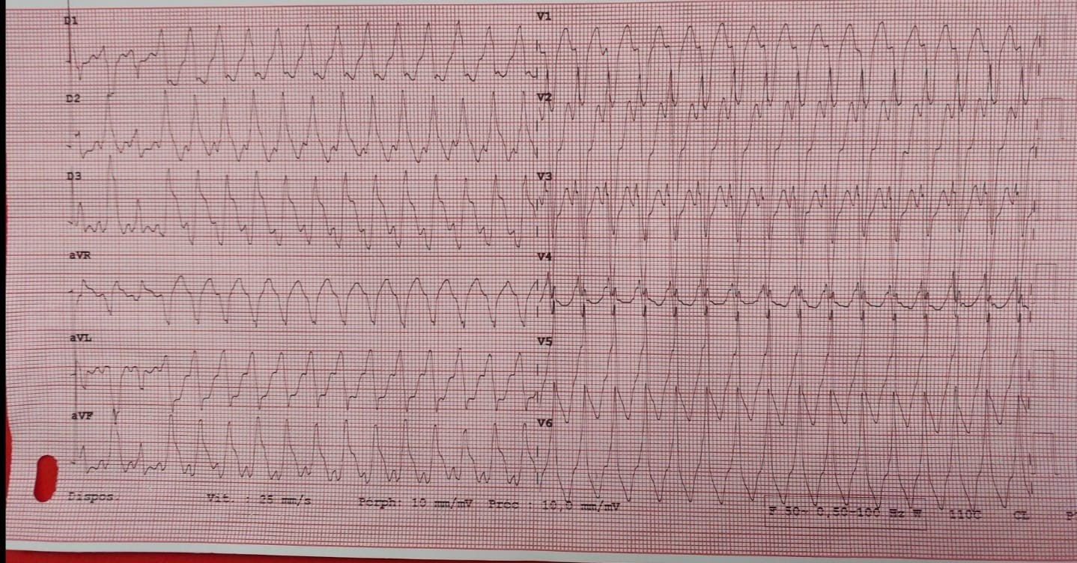

[Insert Figure 2: Transthoracic echocardiography (ETT) showing preserved EF]
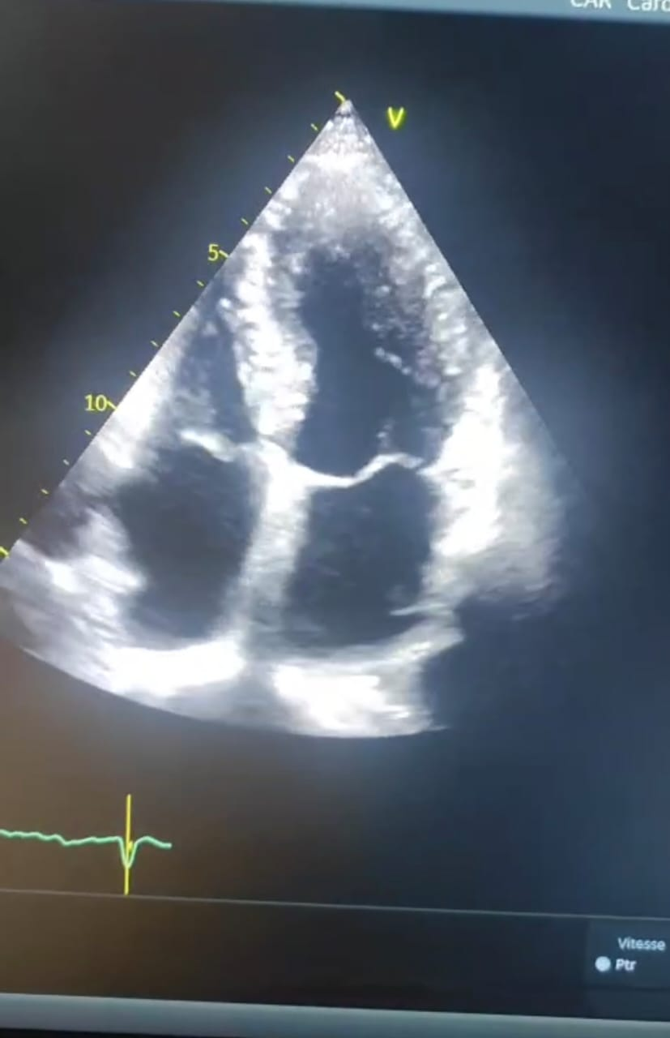
[Insert Figure 3: Chest radiograph post-ICD implantation]
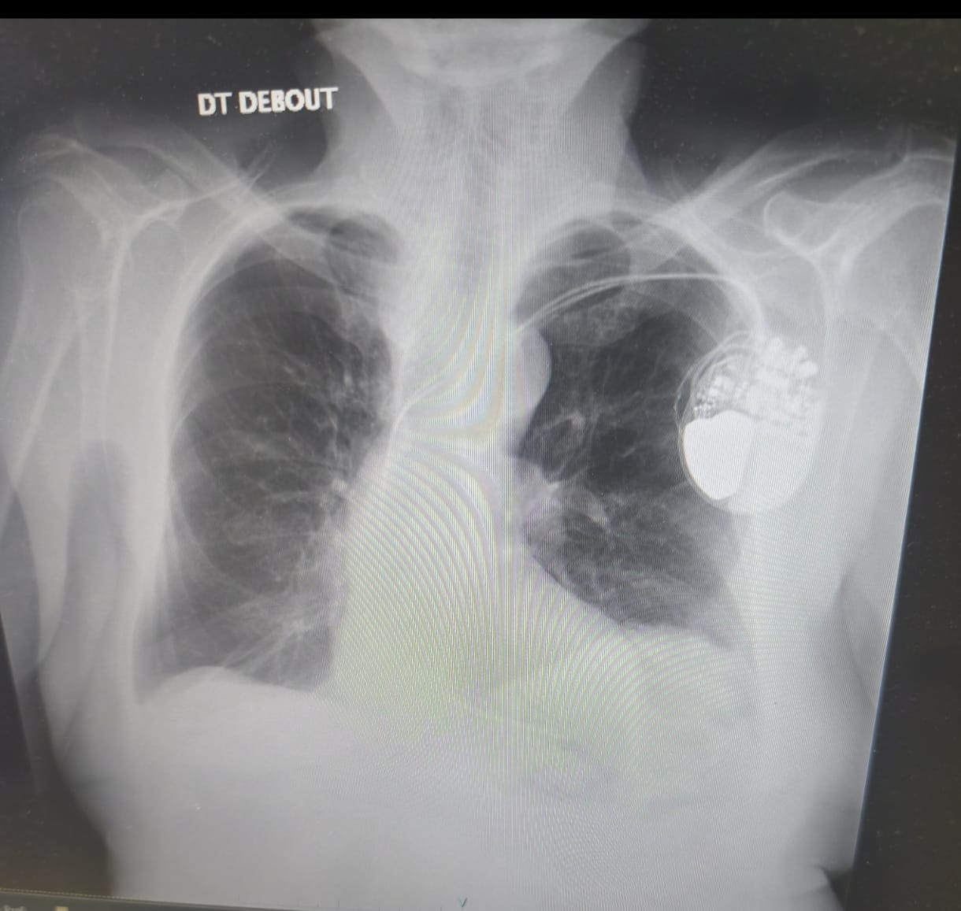

Discussion
This case underscores several important lessons. First, VT can arise in the setting of preserved EF, challenging the traditional reliance on EF as the primary determinant of arrhythmic risk. Second, CMR plays an indispensable role in identifying myocardial fibrosis, which serves as a substrate for VT. Third, ICD implantation is warranted for secondary prevention, even in the absence of reduced EF.
Historically, reduced EF has been the cornerstone of SCD risk stratification. However, numerous studies have demonstrated that scar burden detected by LGE-CMR strongly predicts arrhythmic events independent of EF. In fact, patients with preserved EF but significant scar may have comparable or even higher arrhythmic risk than some patients with reduced EF. In our case, preserved EF (68%) coexisted with localized septal fibrosis, providing a mechanistic basis for VT.
Trials such as AVID, CIDS, and CASH established the superiority of ICDs over antiarrhythmic drugs for survival in secondary prevention. Subsequent registry data confirmed that the benefit of ICD implantation extends to patients with preserved EF if they have survived sustained VT. Accordingly, both ESC (2022) and AHA/ACC/HRS guidelines (2017) recommend ICD implantation for secondary prevention in all patients with sustained VT not due to reversible causes, regardless of EF.
Our patient also highlights the importance of multidisciplinary management. Gastrointestinal bleeding complicated care: ischemic colitis was likely triggered by low-flow states during VT in the context of mesenteric artery occlusion. This required balancing antiplatelet therapy with bleeding risk, involving cardiology and gastroenterology teams. Furthermore, his oncological background underscores the increasing overlap between cardiology and oncology, a field known as cardio-oncology. Cancer survivors are at increased risk for cardiac arrhythmias due to both treatment-related and age-related factors.
Imaging integration was critical in this case. Echocardiography confirmed preserved EF, coronary angiography excluded significant CAD, CMR revealed the arrhythmogenic scar, and chest radiography confirmed proper ICD placement. Together, these modalities provided a comprehensive assessment. Future approaches may incorporate quantitative scar assessment, T1/T2 mapping, and electrophysiological imaging into risk stratification models. Our case contributes to the growing evidence base supporting a paradigm shift from EF-based to scar-based arrhythmic risk assessment.

Conclusion
We present a case of sustained VT in a patient with preserved EF and no significant coronary lesions, in whom CMR revealed localized fibrosis. ICD implantation was indicated for secondary prevention, consistent with guidelines. The case emphasizes the importance of CMR in arrhythmic risk stratification, validates ICD therapy even in preserved EF, and illustrates the need for multidisciplinary care in patients with complex comorbidities.

References
1. Priori SG, et al. 2022 ESC Guidelines on ventricular arrhythmias and the prevention of sudden cardiac death. Eur Heart J. 2022;43(5):399-478.
2. Al-Khatib SM, Stevenson WG, Ackerman MJ, et al. 2017 AHA/ACC/HRS Guideline for management of ventricular arrhythmias. Circulation. 2018;138:e272-e391.
3. Muser D, Santangeli P, Marchlinski FE. Ventricular arrhythmias in nonischemic cardiomyopathy: risk stratification and management. Circulation. 2020;141:873-885.
4. Disertori M, et al. Myocardial fibrosis predicts ventricular tachyarrhythmias and sudden death: meta-analysis. Eur Heart J. 2021;42(34):3379-3391.
5. Gulati A, et al. Fibrosis on cardiac MRI and arrhythmic risk. JAMA Cardiol. 2022;7(3):264-273.
6. Halliday BP, et al. Myocardial scar and arrhythmic risk stratification. Heart Rhythm. 2023;20(2):195-205.
7. Klem I, et al. Association between LVEF and SCD risk in VT patients. JACC. 2021;77(12):1507-1517.
8. Marrouche NF, et al. Imaging-based risk stratification of arrhythmias. Eur Heart J. 2022;43(16):1522-1535.
9. Cronin EM, et al. CMR and VT substrate characterization. Circ Arrhythm Electrophysiol. 2021;14:e009564.
10. Kuruvilla S, et al. Scar quantification by CMR predicts arrhythmic events. Circ Cardiovasc Imaging. 2020;13:e009675.

