Case report
INTRA MUSCULAR HYDATIDOSIS: A RARE CASE PRESENTATION

ABSTRACT :
Hydatidosis (Echinococcosis) - Infestation by the larval or cystic stage of Echinococcus granulosus (unilocular) and rarely by Echinococcus multilocularis (alveolar echinococcosis,multilocular cysts) (Zöller et al., 2022).Liver is the most common site for Hydatid cysts.A 40 year-old female patient, presented in OPD with chief complaints of swelling in the right thigh since 1 yr.No history of pain, trauma, fever, discharge from swelling, difficulty in walking, weakness, tingling/ numbness in the limb, loss of sensation, colour change in the limb.USG of thigh suggestive of large well defined multiloculated, anechoic, cystic lesion in intramuscular plane (quadriceps muscle) likely Hydatid cyst.MRI of the right lower limb confirmed diagnosis.The patient underwent Evacuation of intramuscular Hydatid cysts with intra op findings being multiloculated cyst within the quadriceps muscle planes with >200 clear fluid filled daughter cysts ranging from 0.5cm to 5cm.Post operative period was uneventful. Patient was discharged and follow-up was uneventful.

KEYWORDS: Hydatidosis, intramuscular echinococcosis.

1.INTRODUCTION:
Hydatid cysts are parasitic diseases transmitted to humans through dog feces; they are prevalent in countries wherein agriculture and livestock breeding are practiced. Echinococcus granulosus is the most common causative agent, while Echinococcus alveolaris is rare (Efe et al., 2025). In humans, hydatid cysts commonly affect the liver (55%-70%), followed by the lungs (18%-35%). The lungs and liver are simultaneously affected in 5%-13% of the patients. Moreover, hydatid cysts may affect several organs (Sadr et al., 2023; Fakhri et al., 2024). Hydatid cysts affecting the muscles account for approximately 1%-5% of all hydatid cysts. The aim of this report is to present a rare case of intramuscular hydatidosis in a 40 year-old female patient (Şimşek & Hattapoğlu, 2021; Haydar et al., 2024). In our case, imaging studies were important for probable diagnosis and surgical intervention was essential for both therapeutic and confirmation of a final diagnosis. After histopathological evaluation, a diagnosis of intramuscular hydatidosis involving right quadriceps femorais was made.

2.CASE PRESENTATION:
A 40 year old female, presented to OPD with chief complaints of swelling in the right thigh since 1yr which was insidious in onset, gradually progressed to current size, not associated with any pain, not associated with any aggravating or relieving factors.
No history of trauma, fever, discharge from swelling, difficulty in walking, weakness, tingling/ numbness in the limb, loss of sensation, colour change in the limb
No history of similar complaints in the past.
No history of any other swellings
No history of weight loss/bone pain/breathlessness/cough/dyspnea
Not a known case of DM/ HTN/ CVA/ CAD/ CKD/ PVD /EPILEPSY / ASTHMA.
Local examination of right lower limb:
Inspection:
- Patient had a single swelling of size 15*12 cms, ovoid in shape, on anterior and lateral aspect of thigh, extending from 7cm below anterior superior iliac spine to 3cm above knee joint involving about 40% of thigh circumference.
- Skin over swelling appears normal.
- Surface appears to be smooth and margins are well defined.
- No scars/sinuses/ulcers/discharge/engorged veins/pulsations.
Palpation:
- No local rise of temperature over the swelling
- Non tender
- A single ovoid swelling of size 18*14cm extending from 7cms below the anterior superior iliac spine and 6cms above tibial tuberosity and involves approximately 40% of the circumference of thigh
- Surface is smooth , margins are well defined
- Firm in consistency, uniform through out.
- Not compressible
- Skin over the swelling is pinchable
Percussion: Dull note over swelling
Auscultation: No bruit

Table 1 : CLINICAL COURSE

BLOOD TESTS | Hb – 13.5 gm%  WBC- 11600/mm3  PLC – 2.6 Lakhs/ mm3  Creatinine :0.9 mg/dl  RBS : 111 mg/dl  Na+/ K+ : 146/ 3.4 Meq/L
USG of the Right thigh | Evidence of large well defined multiloculated, anechoic, cystic lesion in intramuscular plane (quadriceps muscle) with multiple daughter cysts likely Hydatidosis.
CT of the Right thigh | Well defined multiloculated solid cystic lesion m/s 4.3*6.7cms noted in intramuscular plane (quadriceps muscle)
CT Brain | No e/o cystic lesions.Calcified granuloma in left parietal lobe.
CT Chest | Revealed well defined thin walled air filled cyst m/s 8.3*7.2mm noted in anterior segment of right upper lobe.  Mediastinum: Normal  Chest wall: Normal  Trachea: Normal  Bronchi: Normal
CT ABDOMEN: | Kidneys: left kidney simple renal cortical cyst m/s 1*1cm.  Liver: Normal  Spleen: Normal  Pancreas: Normal  Uterus: Normal  Bladder: Normal  Aorta/IVC: Normal
HISTOPATHOLOGY REPORT : | On gross examination, the specimen revealed a well-circumscribed, multilocular cystic lesion within skeletal muscle, containing multiple daughter cysts filled with clear or straw-colored fluid, and a thick, laminated whitish cyst wall. The surrounding muscle was compressed and showed areas of congestion and fibrosis.  Impression: Histopathological examination of the excised intramuscular lesion reveals features consistent with a hydatid cyst

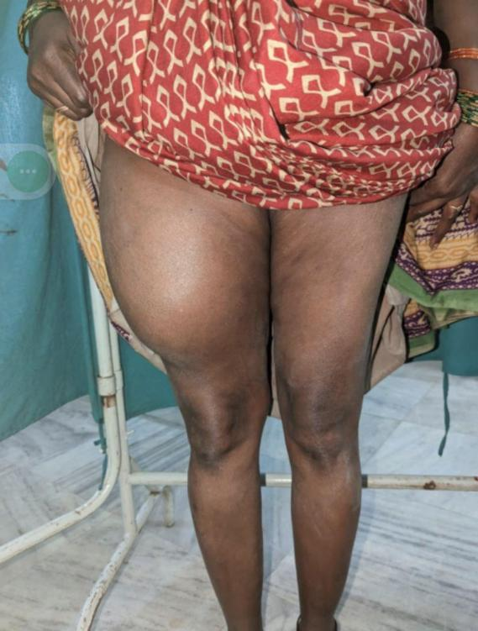
Fig.1 : Pre op picture.

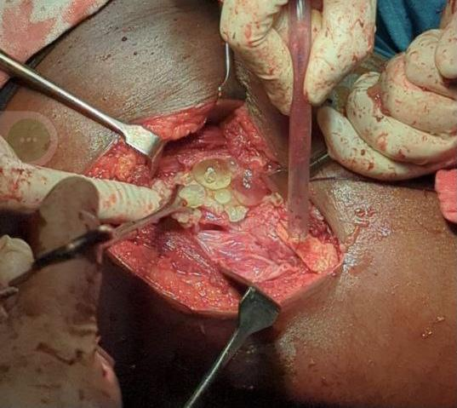
Fig 2: Intra op picture of intramuscular hydatid cysts.

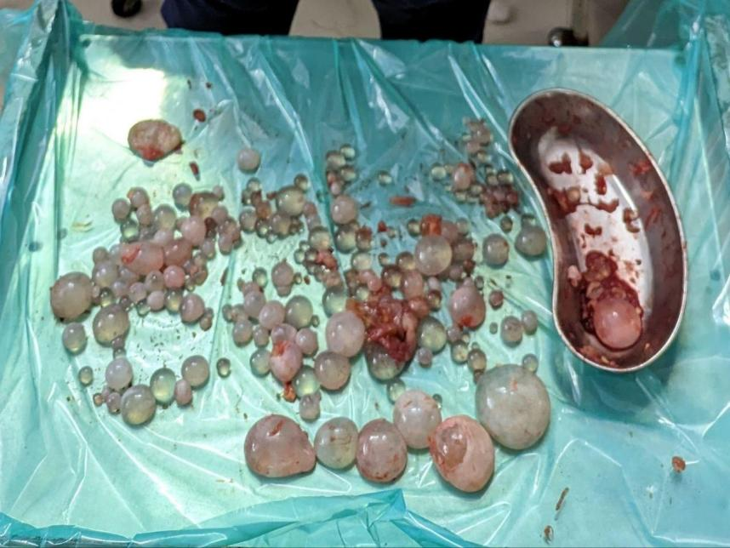
Fig 3: Picture showing multiple fluid filled cysts of varying sizes after evacuation.

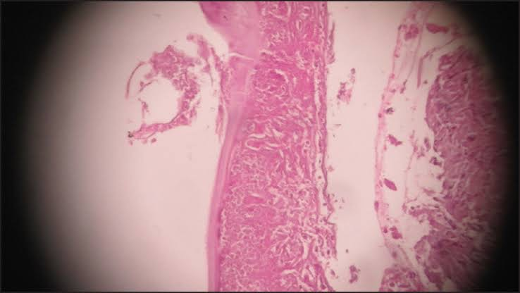
Fig 4 : histopathological image showing cyst wall along with daughter cyst.

3.DISCUSSION:
Intramuscular hydatid cysts are a rare clinical entity, accounting for a small fraction (1%-5%) of all hydatid disease presentations, primarily owing to the intrinsic hostile environment of skeletal muscle, which includes high lactic acid concentration and constant contractility that hinder cyst implantation and growth (1). This rarity often leads to diagnostic confusion, as such cysts masquerade as benign soft tissue tumors or abscesses. Clinically, patients present with a slow-growing, painless mass, frequently without systemic symptoms, making imaging indispensable for suspicion and diagnosis. Ultrasonography remains the initial, noninvasive modality that can reveal characteristic multiloculated cystic lesions with daughter cysts, classified by Gharbi criteria (2). Magnetic resonance imaging (MRI) is particularly valuable for delineating cyst morphology, detecting the pericyst and daughter cysts, and evaluating relations to adjacent structures, which guides surgical planning (3). Serum serological tests may lack sensitivity in isolated muscle cases, thus histopathological examination remains the definitive diagnostic tool after excision. The cornerstone of treatment is complete surgical excision with utmost care to avoid cyst rupture, which could lead to anaphylaxis and local recurrence. Intraoperative irrigation with scolicidal agents such as hypertonic saline and perioperative albendazole therapy significantly reduce recurrence risk (4). Long-term follow-up is necessary to monitor for potential recurrence or secondary cyst development. Awareness of this rare presentation in endemic areas is crucial to prevent delays in diagnosis and inappropriate management that may worsen outcomes.

4.CONCLUSION :
Isolated intramuscular hydatid cysts, although rare, should be part of the differential diagnosis when evaluating soft tissue masses, especially in patients from endemic regions or those engaged in farming and animal husbandry. Imaging techniques, particularly ultrasound and MRI, provide key diagnostic insights, while histopathology after surgical removal confirms the diagnosis. The preferred management strategy combines careful, complete surgical excision with adjunct antihelminthic therapy to minimize complications and recurrence. Educating clinicians about this atypical presentation ensures timely diagnosis, optimal treatment, and improved patient prognosis.

5.References :
- Urvi Antala, Raj Dangarosia, and Yash Patel. 2024. “Primary Gluteal Intramuscular Hydatid Cyst: A Case Report”. Asian Journal of Case Reports in Surgery 7 (1):114–119. https://journalajcrs.com/index.php/AJCRS/article/view/507.

- Şimşek S, Hattapoğlu S. Intramuscular hydatid cyst in the lower extremity: report of three cases. Rev Soc Bras Med Trop. 2021 Aug 20;54:e02552021. doi: 10.1590/0037-8682-0255-2021. PMID: 34431944; PMCID: PMC8405206.

- Lakhanpal V, Badgurjar M, Saxena P. An arcane case report of primary intramuscular hydatid cyst of thigh. International Journal of Surgery Case Reports. 2021;80:105595. doi:10.1016/j.ijscr.2021.01.089

- Adıyeke L, Cakır T, Duymus TM, Aydogmus S. Unexpected Diagnosis in Gluteal Region -A Primary Intramuscular Hydatid Cyst: A Case Report. J Orthop Case Rep. 2018 Mar-Apr;8(2):104-106. doi: 10.13107/jocr.2250-0685.1072. PMID: 30167426; PMCID: PMC6114221.

- Sadr, S., Lotfalizadeh, N., Abbasi, A. M., Soleymani, N., Hajjafari, A., Roohbaksh Amooli Moghadam, E., & Borji, H. (2023). Challenges and prospective of enhancing hydatid cyst chemotherapy by nanotechnology and the future of nanobiosensors for diagnosis. Tropical medicine and infectious disease, 8(11), 494.

- Fakhri, Y., Omar, S. S., Dadar, M., Pilevar, Z., Sahlabadi, F., Torabbeigi, M., ... & Mousavi Khaneghah, A. (2024). The prevalence of hydatid cyst in raw meat products: a global systematic review, meta-analysis, and meta-regression. Scientific Reports, 14(1), 26094.

- Şimşek, S., & Hattapoğlu, S. (2021). Intramuscular hydatid cyst in the lower extremity: report of three cases. Revista da Sociedade Brasileira de Medicina Tropical, 54, e0255-2021.

- Haydar, A. A., Rafizadeh, S. M., Rahmanikhah, E., Nozarian, Z., Aghajani, A., & Rajabi, M. T. (2024). Orbital intramuscular hydatid cyst causing compressive optic neuropathy: a case report and literature review. BMC ophthalmology, 24(1), 257.

- Zöller, G., Dellmann, C., Rodepeter, F., Görg, C., & Metzelder, S. (2022). Echinococcosis alveolaris (Fuchsbandwurmerkrankung)–eine überraschende Diagnose bei Nebenhodentumor. Die Urologie, 61(6), 657-659.

- Efe, Y. S., Ahmet, A., Ebru, T., Tolga, S., & Yildiray, Y. (2025, April). Echinococcal Liver Infections: Comparing Transplant Strategies for Granulosus and Alveolaris. In Transplantation Proceedings. Elsevier.

